A/HRC/62/CRP.1
1 July 2026

English only
Human Rights Council
Sixty-second session

Attacks against Ukraine’s Energy Infrastructure and Update on the human rights situation in Ukraine: 1 December 2025 to 31 May 2026
Office of the United Nations High Commissioner for Human Rights

I. Executive summary
1. This update on the human rights situation in Ukraine covers the period from 1 December 2025 to 31 May 2026.
2. Russian armed forces systematically and repeatedly targeted energy facilities across Ukraine throughout the 2025-2026 winter months, often using hundreds of weapons in coordinated attacks. These attacks damaged and destroyed energy generation, transmission and distribution facilities, which were already significantly degraded from previous attacks.
3. Russian attacks on transmission and distribution facilities triggered emergency electricity outages, often affecting millions of civilians across the country. In addition, damage to Ukraine’s power plants significantly reduced the country’s capacity to generate electricity. As electricity demand increased when temperatures dropped with the onset of winter, Ukraine suffered a large electricity deficit. The deficit forced Ukrainian authorities to impose scheduled rolling electricity cuts nationwide, leaving civilians with electricity for only a couple of hours per day in periods.
4. The 2025-2026 winter attacks also systematically and repeatedly targeted centralized heating infrastructure, which supplies heating and hot water to most Ukrainian urban households. The attacks disrupted heating to hundreds of thousands of civilians, leaving many without heating and hot water for weeks as temperatures fell below -20°C in the coldest winter in Ukraine since 2010.
5. The electricity and heating outages affected all aspects of civilian life across the country. Indoor temperatures plummeted to levels far below what the World Health Organization recommends as safe. Outages cut water supply in multi-story buildings, disrupted healthcare, closed schools, and drove some people to leave their homes. Persons in situations of vulnerability, including older persons, persons with disabilities, and women, suffered disproportionate harm.
6. Ukrainian armed forces also attacked electricity and heating infrastructure in the Belgorod region of the Russian Federation. There were reports that the attacks caused regional electricity and heating outages.
7. The attacks on energy infrastructure appear to have violated fundamental principles of international humanitarian law on the conduct of hostilities.
8. In this period, conflict-related hostilities caused more civilian deaths and injuries than in the same period of any year since the full-scale invasion, except 2022, continuing a trend of steadily rising civilian casualties. The Russian Federation’s large-scale use long-range weapons accounted for much of the increase. The increase in attacks with short-range drones along the frontline was the second main factor, which also hampered humanitarian assistance and evacuations and caused additional displacement.
9. The vast majority of civilians were killed and injured in territory controlled by the Government of Ukraine. The extensive use of short-range drones prevented evacuations and the delivery of basic goods in communities near the frontlines, including in territory occupied by the Russian Federation.
10. Russian armed forces executed at least 16 captured Ukrainian prisoners of war (POW) from mid-November to January. Nearly all released Ukrainian POWs interviewed by OHCHR described having been subjected to torture or other ill-treatment during their captivity, although several noted that treatment and conditions had gradually improved since late 2024. As before, around half of Russian POWs interviewed described torture or other ill-treatment at the initial stages of their captivity by Ukraine.
11. In occupied territory, Russian authorities continued to severely restrict freedom of expression, forcibly conscript protected persons into the Russian armed forces, and deny children access to a Ukrainian education.

II. OHCHR methodology
12. This report is based on the work of OHCHR’s United Nations Human Rights Monitoring Mission in Ukraine (HRMMU). In the reporting period, OHCHR carried out 180 field visits, 48 visits to places of detention, 78 visits to hospitals, transit centres for evacuees and collective centres for internally displaced persons (IDPs), monitored 33 trial hearings, and interviewed 1,926 victims and witnesses of alleged violations of international human rights and humanitarian law, as well as their relatives and lawyers, Government officials, members of civil society and other interlocutors. The report further draws from court documents, official records, and other relevant material, including from open sources. The report covers human rights violations and violations of international humanitarian law that occurred during the reporting period of 1 December 2025 to 31 May 2026, as well as incidents that occurred earlier, but were documented or verified during this timeframe.
INFOGRAPHIC
13. To document the impact of attacks on energy infrastructure, OHCHR conducted 56 field trips, met with 30 representatives of local authorities and conducted 132 interviews, including with residents of Government-controlled areas of Ukraine facing electricity, heating and water cuts, healthcare and education professionals, social workers, and heads of centres providing social services and other resources. OHCHR also reviewed technical assessments, open-source information and satellite imagery.
14. OHCHR has full access to territory controlled by the Government of Ukraine, including to detention facilities and internment camps for Russian POWs. Russian authorities have not granted access to the Russian Federation or to the parts of Ukraine that they occupy. OHCHR reiterates its request to the Russian Federation for access to occupied territory, in line with resolution 80/223 of the General Assembly, and to the territory of the Russian Federation.
15. OHCHR verified alleged violations and civilian harm in occupied territory of Ukraine by interviewing people from the occupied territory and by analyzing publicly available information, including information from multiple types of independent sources. Independent verification of alleged violations and civilian harm in the Russian Federation was in most cases not possible due to lack of access to the territory, lack of access to victims and witnesses, and lack of independent sources of publicly available information.
16. Findings that are included in the report meet the “reasonable grounds to believe” standard: namely where, based on a body of verified information, an ordinarily prudent observer would have reasonable grounds to believe that the facts took place as described, and where legal conclusions are drawn, that these facts meet all the elements of a violation.

III. Attacks on Energy Infrastructure

A. Background/Context
17. Before the Russian Federation launched its full-scale invasion of Ukraine on 24 February 2022, Ukraine’s electricity production capacity was around 38 gigawatts (GW). With the occupation of parts of Ukrainian territory by the Russian Federation, Ukraine lost access to major power plant capacity producing approximately 18 GW. In addition, attacks by Russian armed forces damaged and destroyed energy infrastructure in territory controlled by the Ukrainian authorities, with attacks being particularly intense between October 2022 and February 2023, and again between March and August 2024.
18. By summer 2024, occupation and damage from attacks had reduced Ukraine’s electricity production capacity from 38 GW to less than 10. As hot weather increased demand to 12 GW in the summer of 2024, the deficit forced authorities to implement scheduled electricity cuts of up to 12 hours per day in multiple regions.

B. Attacks winter 2025-2026

1. Attacks by Russian armed forces on electricity infrastructure in Ukraine
19. In October 2025, Russian armed forces intensified attacks on Ukraine’s energy infrastructure. Between October 2025 and March 2026, Russian armed forces struck electricity generation, transmission and distribution facilities at least 423 times, including in the context of 48 attacks that struck three or more regions in a single coordinated attack using multiple types of weapons and launch platforms. During these large-scale attacks, Russian armed forces typically deployed hundreds of long-range drones and missiles. For example, on 3 February 2026, Russian armed forces launched 71 cruise, ballistic and anti-ship missiles, as well as 450 long-range drones. The attack damaged at least 14 energy infrastructure facilities, including four combined heat and power plants, three thermal power plants, and seven power substations across six regions and the city of Kyiv.
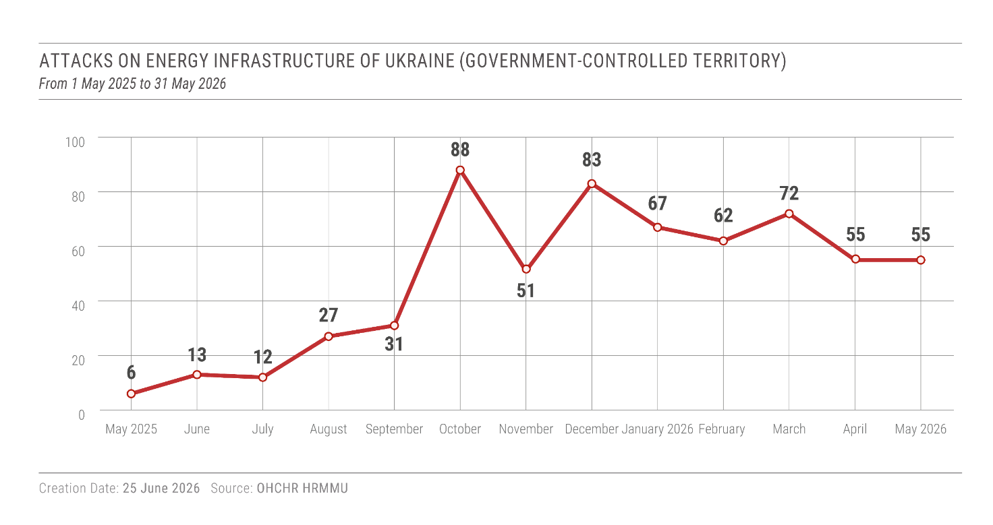
20. Russian armed forces also attacked electricity substations that connect Ukraine’s nuclear electricity plants to the electricity grid. The International Atomic Energy Agency raised concerns about Ukraine’s nuclear stability after visiting multiple substations damaged in late 2025 and early 2026.
21. Large-scale attacks triggered emergency electricity outages, sometimes affecting millions of civilians. For example, Ukraine’s Ministry of Energy reported that attacks on 8 January 2026 left 800,000 households in Dnipropetrovsk region without electricity. On 20 January, the Government of Ukraine reported that attacks caused outages for approximately 1,000,000 households in Kyiv city. OHCHR interviews with affected residents and the experience of OHCHR’s own staff in Ukraine confirm such outages.
22. While Ukrainian authorities often managed to restore electricity to many households within days, some areas were left without electricity for long periods. An attack on 12 December 2025 left some residents of Odesa without electricity for over 10 days. An attack on an electricity substation in Artsyz, Odesa region, caused a two-week outage between 13 and 31 December 2025.
23. While Ukrainian authorities had restored some of the electricity generation capacity damaged in previous attacks, the 2025-2026 winter attacks reduced it again. As temperatures dropped and winter consumption increased to up to 18 GW, Ukraine could only produce around 11 GW domestically.
24. As a result, Ukrainian authorities in October 2025 introduced rolling scheduled electricity cuts nationwide. Scheduled outages reached up to 22 hours in Kyiv and Kherson, with average daily duration of scheduled electricity outages for the month of January of up to 16 hours. The President of Ukraine declared a state of emergency in the electricity sector on 14 January 2026.

2. Attacks by Russian armed forces on centralized heating systems in Ukraine
25. Russian armed forces also attacked infrastructure providing centralized district heating during the 2025-2026 winter. Centralized heating, primarily produced by Combined Heat and Power Plants (CHPP) and Thermal Power Plants (TPP), provides heat and hot water to most urban households. For example, nearly 95 per cent of Kyiv’s three million residents rely on centralized district heating.
26. While previous large-scale attacks by Russian armed forces also struck heating infrastructure, the winter 2025-2026 attacks appear to have targeted such infrastructure more systematically. From October 2025 to March 2026, Russian armed forces launched at least 74 individual strikes on CHPPs in nine regions and Kyiv city. Kyiv city was particularly affected. Between October 2025 and March 2026, Russian armed forces struck Kyiv city’s three major CHPPs at least 40 times.
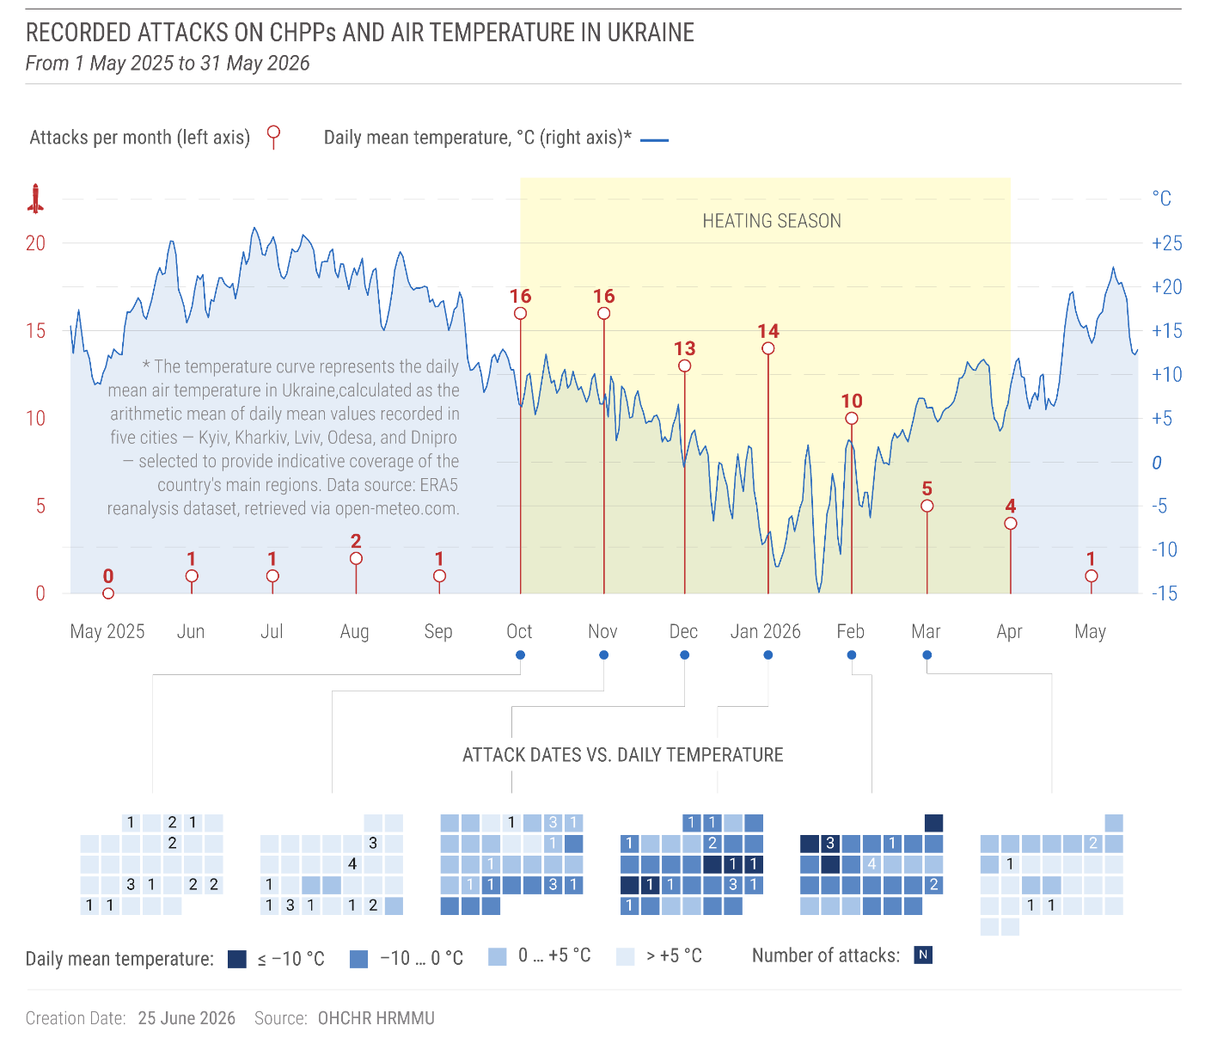
27. The attacks on CHPPs and TPPs immediately disrupted centralized heating. An overnight attack on 8-9 January 2026 was the first of many that cut central heating in Kyiv. According to city administration officials, the series of attacks repeatedly disrupted heat to around 5,600 apartment buildings, housing hundreds of thousands of families, effectively leaving many without heating for weeks. When CHPP-4’s operations were halted in February 2026 due to significant damage, the Government of Ukraine reported that heating was cut to around 500,000 residents in 1,100 multi-story apartment buildings, 118 schools and kindergartens, and 18 hospitals.
28. Russian armed forces also repeatedly attacked CHPPs in Chernihiv, Kharkiv, Kherson, and Kyiv regions. For example, Russian armed forces attacked the Kherson City CHPP at least eight times from November 2025 to February 2026. In Kharkiv, CHPP-5 was struck at least six times from October 2025 to February 2026, with Kharkiv authorities declaring a state of emergency on 3 February 2026, after an attack disrupted heating to 853 residential buildings (around 105,000 households).

3. Attacks by Ukrainian armed forces on electricity infrastructure in occupied territory and in the Russian Federation
29. Attacks by Ukrainian armed forces damaged electricity generation, transmission and distribution facilities in territory of Ukraine occupied by the Russian Federation. From October 2025 to March 2026, OHCHR documented that Ukrainian armed forces struck electricity generation, transmission or distribution facilities in occupied areas of Donetsk, Luhansk, Zaporizhziha, Kherson regions and the Autonomous Republic of Crimea at least 29 times, five of which damaged energy generation facilities.
30. Ukrainian armed forces also attacked electricity and heating infrastructure in the Belgorod region of the Russian Federation on at least seven different days in 2026, which caused temporary outages according to Russian authorities. On 8 February, for example, the governor of Belgorod region announced that attacks on energy infrastructure had cut heating to 80,000 people, gas supply to 3,000 people, and electricity to 1,000 people. Due to a lack of access and scarcity of publicly available independent information, OHCHR could not fully verify damage to specific facilities or the impact of the attacks on the civilian population.

C. Impact of attacks on energy infrastructure on the civilian population in Government-controlled areas of Ukraine

1. Adequate standard of living
31. The right to an adequate standard of living includes the right to housing and water. The loss of electricity, central heating, and water for extended periods of time, compounded by freezing temperatures, significantly degraded the standard of living for hundreds of thousands of civilians. The impact was particularly severe for people living in multi- storey buildings, which is the main mode of residence for an estimated 70 per cent of Ukraine’s urban population.

2. Heating
32. Many residents in Kyiv reported that temperatures in their apartments fell to between 6 and 15°C due to heating and electricity outages, with nightly outside temperatures on multiple occasions below -20°C. One woman showed OHCHR a photo of a thermometer in her apartment indicating a temperature of 0.5°C, well below the minimum indoor temperature of 18°C which the World Health Organization recommends to protect the health of the population during cold seasons.
33. The low indoor temperature significantly affected residents. One Kyiv resident said: “It’s impossible to do anything around the house. My body is just freezing. We’re thinking only about basic needs, like how to cook or how to warm up.” In Mykolaiv, a social worker shared the experience of an older woman to whom she provided social services: “The old woman tries to keep warm: heats water bottles, surrounds herself with them, uses gas for heating. In the cold, older people with joint problems experience increased pain, and their overall health deteriorates.”
34. With support from the international community, the Government of Ukraine introduced several mitigation measures: expanding and improving “Points of Invincibility” (including mobile heating points and overnight support points in Kyiv), designating some unheated residential buildings as critical infrastructure to avoid scheduled outages, and launching programs to provide energy solutions and targeted assistance to groups in a situation of vulnerability.

3. Water
35. Residents of multi-story apartment buildings lost access to water when electricity cuts disabled pumps required for water to reach the upper floors. Residents of a 16-story building in Odesa, for example, said that when electricity outages stopped elevators for a week in December 2025, those on upper floors had to purchase water in stores, and carry it up the stairs. This was especially difficult for older persons and persons with disabilities, who became dependent on assistance from relatives or neighbours.
36. In Kyiv, a 77-year-old woman described fetching water from a well 500 meters from her home in freezing temperatures: “My whole body froze while standing near the well. As I was carrying the bottles home, they froze to the hand trolley and my coat.”
37. The situation was further exacerbated by extreme cold weather in January and February 2026, when lack of heating caused water in pipes and sewers to freeze and burst across Kyiv and other cities. This affected not only drinking water but also sanitation. Households reported limiting bathing, dishwashing and handwashing, as well as sewer blockages and wastewater flooding due to water, electricity and heating outages.

4. Health and access to healthcare
38. Emergency electricity outages affected healthcare facilities across Ukraine, including in Kyiv, Zaporizhzhia and Odesa, despite measures to shield medical facilities from scheduled electricity cuts.
39. In Kyiv, emergency outages disrupted both primary and specialized health care: certain services requiring electricity, such as X-rays and ultrasounds, were suspended; and appointments and surgical procedures were rescheduled. Some medical facilities also lost heating. Administrators from several medical facilities in Kyiv told OHCHR that the temperature in some rooms in January 2026 fell as low as 3°C.
40. For example, a specialized facility in Kyiv conducting cardiac surgeries experienced three electricity and water outages of up to seven hours in January 2026. Backup generators provided electricity to the intensive care unit, blood bank, and operating rooms, but could not meet the facility’s full needs, requiring the rescheduling of appointments and procedures, including heart surgeries.
41. Healthcare and social workers faced extraordinary pressures throughout the winter. Social workers in Kyiv, who are primarily women, told OHCHR they had worked without a single day off for nearly a month while managing double their normal caseloads. One hospital administrator lamented “I see that the staff is overwhelmed. It is 10°C in [one nurse’s] apartment and she arrives at work already exhausted.”
42. People with chronic conditions which require refrigerated medication such as insulin were particularly affected. A man with diabetes told OHCHR that he had to bring all his insulin to his office when an attack on an electricity substation in Odesa caused a week-long electricity outage in his home.
43. The winter electricity and heating outages also affected mental health. Four IDPs from Mariupol now living in Government-controlled territory told OHCHR that the absence of electricity, heating, and water caused psychological suffering and brought up traumatic memories of their experience under occupation. Two psychologists working at a mental health hotline reported that power outages have been a contributing factor to the deterioration of people’s emotional well-being and worsening of their mental health.

5. Access to education
44. Widespread electricity and heating outages during extreme winter temperatures forced schools across Ukraine to extend winter holiday periods or switch to distance learning. Electricity outages also meant many students could not participate in live-streamed classes and had to watch the recorded lessons later.
45. In Kyiv, authorities extended the general winter holiday by two weeks, after which schools individually determined whether to re-open or conduct online classes due to the heating situation. According to local authorities, as of 16 February 2026, 77 preschools and 69 schools (15 per cent of the city’s education facilities) lacked heating. One principal told OHCHR that the temperature inside the school did not exceed 3°C; teachers conducted online classes wearing heavy winter coats. Another school administrator said they supported students by reducing homework and allowing extra time to finish assignments, as electricity outages made it difficult for students to complete their work. Compensatory classes in all subjects were also introduced.
46. Specialists in child development in an inclusive resource centre in Kyiv informed OHCHR that the temperatures in their premises did not exceed 6°C and the electrical system could not safely support heaters throughout the building, limiting activities to a single heated room. These conditions significantly reduced operational capacity: whereas child specialists previously conducted around four psychological developmental assessments per day, in February 2026 they carried out only eight per week. Psychological developmental and corrective sessions also effectively stopped, as no children attended them, including due to the cold premises.
47. Specialists and educators told OHCHR that children with disabilities suffered disproportionately from electricity cuts, loss of hot water, frequent air raid alarms, and the resulting changes to their personal schedules. A 10-year-old girl in a wheelchair living on the 16th floor was unable to visit an education centre as her building’s elevator could not operate, and children with autism experienced increased anxiety due to disruptions to their routine

6. Impact on persons in situations of vulnerability
48. The outages disproportionately harmed persons in situations of vulnerability, in particular older persons, persons with disabilities, women, persons living in poverty, and families with children.
49. People with reduced mobility, including older persons and persons with disabilities, were often not able to leave their apartments when elevators ceased functioning during electricity outages, which increased social isolation, prevented them from reaching shelters during air raid alarms, and in some cases affected their livelihoods. For example, a 49-year-old wheelchair user in Kyiv told OHCHR that he was unable to leave his fifth-floor apartment for a week in January 2026, preventing him from going to work or reaching a shelter during air raid alarms.
50. Electricity outages also limited possibilities for persons with mobility impairments to move around cities. In Kyiv, the authorities halted trolleybus service for approximately one and a half months following attacks on energy infrastructure in January 2026 to reduce electricity consumption. Replacement buses were less accessible for persons with disabilities. In Odesa, electric public transportation, including trams, which are frequently used by older persons, resumed operations only at the end of March 2026.
51. In several locations, including Odesa and Kyiv regions, dozens of persons with high support needs and reduced mobility were moved to hospitals or care institutions as they could no longer live independently due to lack of heating in their apartments.
52. Women, who in Ukraine do more unpaid care work than men, faced excess and compounding workloads, looking after children on extended school breaks, assisting family members with high support needs, and navigating household tasks without reliable electricity or water supply. OHCHR met several women with children at heating points because their apartments were cold. One woman displaced from Dnipropetrovsk region said that she was caring for her 8-year-old daughter since schools had closed and had not been able to work for a month because the building where she worked was too cold.
53. People living in poverty struggled to afford electric heating appliances, power banks, and prepared food. One woman at a Point of Invincibility in Kyiv reported that, even with her and her husband’s pay checks, they could not afford power banks to mitigate the impact of electricity outages and, due to the heating outage, they had to send their two children to live with their grandparents outside Kyiv who have an independent heating system. An IDP woman with a 4-year-old daughter told OHCHR that her monthly income only allowed her to purchase one week of ready-to-eat meals for her family.

7. Displacement
54. Electricity, water and heating outages contributed to displacement. Some people relocated within Ukraine, staying with relatives, moving to rural properties with wood or coal-fired heating, or relocating to areas with more stable electricity supply. For example, a family with a 6-year-old son left their apartment in Kyiv in January due to the lack of electricity, heating and water. They first stayed in a hotel outside Kyiv for two days before moving to a friend’s house because they could no longer afford the hotel.
55. The lack of basic services also influenced people’s decisions to flee abroad. People leaving Ukraine started citing lack of electricity, water, and heating among the top reasons for leaving in September 2025. In December 2025, January and February 2026, around 75 per cent of people who left mentioned either lack of electricity, water or heating. About one-third of respondents who left Ukraine in January and February 2026 said that stabilization of the electricity situation was a main factor influencing a future return decision.
56. In villages in Odesa region with ethnic Moldovan, Romanian and Bulgarian communities, local authorities reported that approximately 2,000 residents – particularly families with children – relocated to Bulgaria, Moldova and Romania for the winter period due to the electricity outages.

D. International humanitarian law analysis
57. Under international humanitarian law (IHL), energy infrastructure facilities, like other civilian objects, can only be considered a military objective if they make an effective contribution to military action, and if their total or partial destruction or neutralization offers a definite military advantage. There must be a close connection between the use of part of the energy infrastructure and the fighting, and only the specific part of the energy infrastructure used in such manner would constitute a military objective.
58. Against these standards, it is unlikely that power plants that are connected to a national grid could be considered, of themselves, legitimate military targets. As electricity can be readily redirected within an overall energy grid as required, the effect of attacking power plants connected to the national grid would be to reduce the overall electricity production capacity of a country. This does not necessarily substantially affect military activities drawing electricity, as these may continue to be supplied from other sources with priority. The military gain from simply reducing the overall electricity production capacity of a country is likely too remote, hypothetical and indeterminate to satisfy IHL requirements.
59. With the harshness of the winter in the region and outdoor temperatures falling below -20C, attacks on power plants and other infrastructure that provide heating to the civilian population at such times also likely violate the IHL prohibition on attacks on objects indispensable to the survival of the civilian population.
60. While other types of energy infrastructure – for example electricity transmission and distribution facilities – could become military objectives if they, for example, facilitate the provision of electricity to a military target such as a munitions factory, it is unclear whether any of the transmission and distribution facilities attacked met this criterion. Russian authorities have frequently claimed in general terms that targeted energy infrastructure was “used by the Ukrainian Armed Forces and Ukrainian military-industrial complex enterprises.” However, they have not provided concrete information to justify why any of these facilities should be considered military objectives.
61. Even in circumstances where a particular piece of energy infrastructure does represent a military objective under IHL, any attack against it must still comply with the fundamental principle of proportionality in attack.
62. The same IHL standards apply to deliberate attacks on energy infrastructure by Ukraine.
63. Furthermore, the scale and geographic scope of the attacks by the Russian Federation and the type of infrastructure targeted suggest that the attacks by the Russian Federation were not directed at specific facilities considered to constitute military objectives, but were rather aimed at disrupting the energy network of the country as a whole. Considering the entire energy infrastructure as a military objective would be incompatible with IHL.

IV. Impact of hostilities on the civilian population

E. Increased civilian casualties
64. Civilian casualties rose in the reporting period, continuing a trend of steadily increasing casualty numbers from year to year since 2023. Between 1 December 2025 and 31 May 2026, hostilities killed at least 1,272 civilians and injured 6,871 in Ukraine, a 40 per cent increase compared to the same period 12 months earlier (982 killed and 4,840 injured), and a 93 per cent increase compared to the same period 24 months earlier (905 killed and 3,314 injured). Among the casualties were 82 medical workers and 41 emergency service personnel. Casualties were documented in 24 regions of Ukraine and the city of Kyiv.
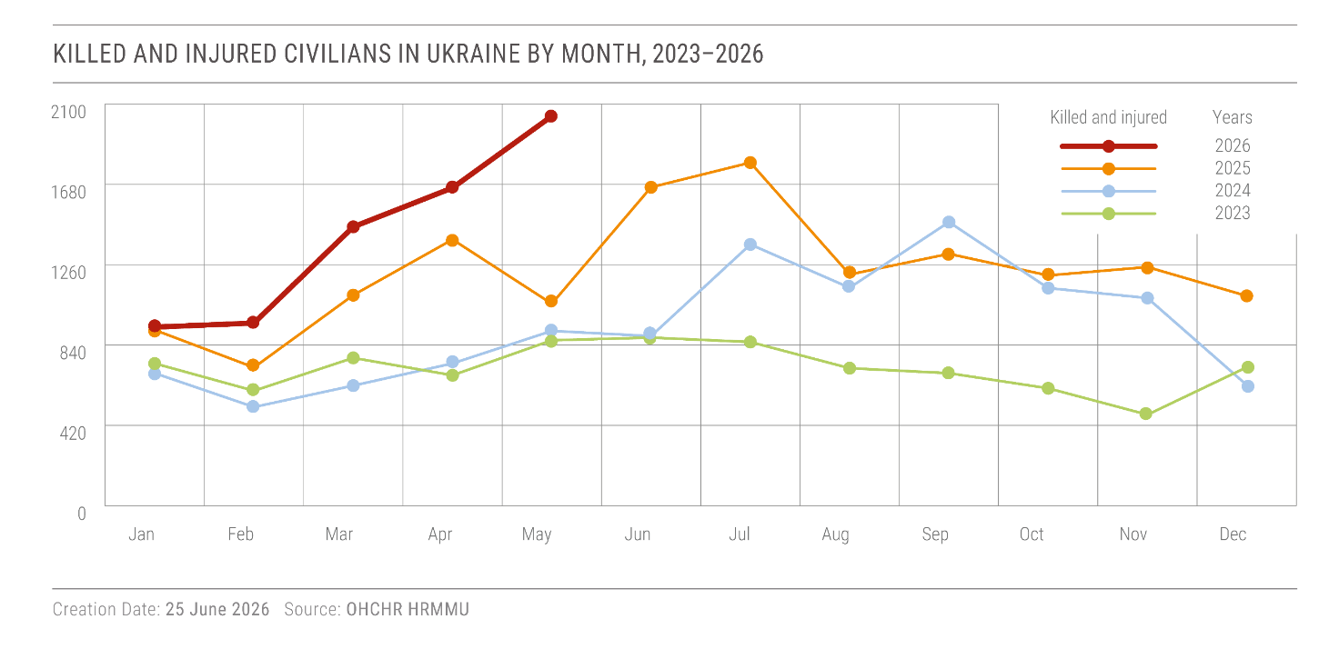
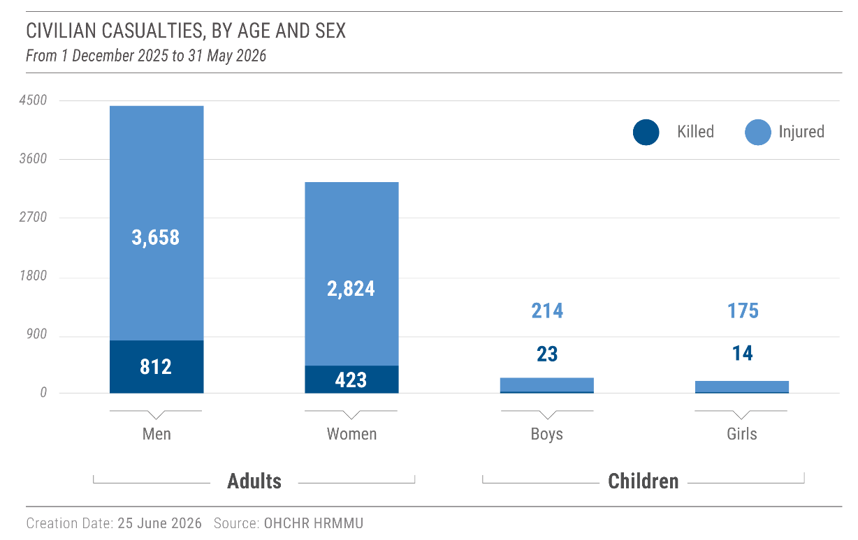
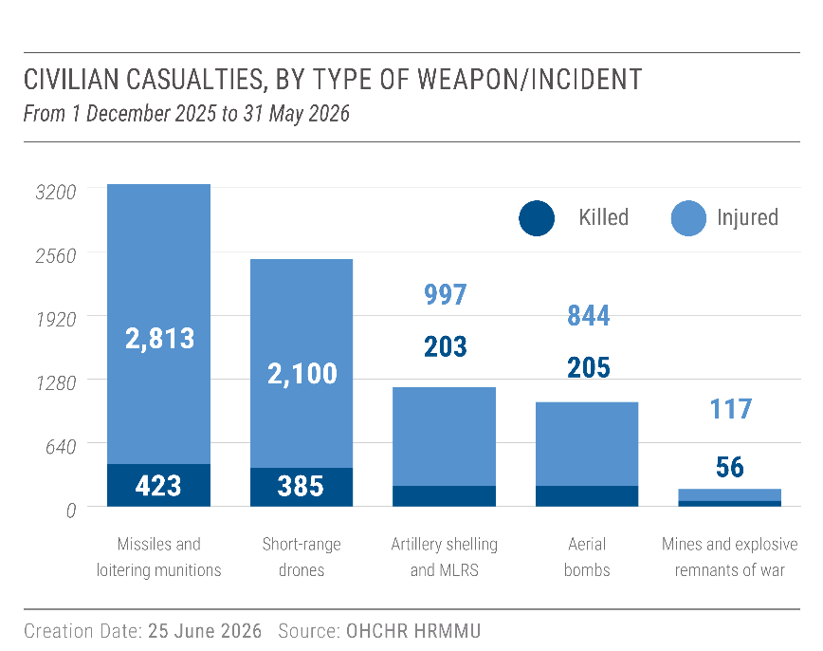
65. Ninety-six per cent of the casualties in Ukraine occurred in territory controlled by the government (1,166 killed and 6,679 injured). Long-range weapons (missiles and drones) killed and injured more civilians than other weapon types. For example, over a 24-hour period from 13 to 14 May, Russian armed forces launched 1,428 loitering munitions and 56 missiles across Ukraine. The attack killed 27 civilians (14 men, 10 women and 3 girls) and injured at least 83 (43 men, 36 women, 2 boys and 2 girls) in 8 regions and Kyiv city. Of these casualties, 24 were killed and 7 injured when a missile struck a residential building in Kyiv city around 4 am on 14 May.
66. Four per cent of the casualties occurred in territory occupied by the Russian Federation (106 killed and 192 injured). For example, in the late hours of 31 December 2025, drones struck a café and a hotel in the occupied village of Khorly, Kherson region, reportedly killing 29 people and injuring 31. OHCHR verified that at least 18 of those killed and injured were civilians (10 killed and 8 injured: 11 women, 3 men, 3 girls, and 1 boy). OHCHR also established that several of those killed and injured in this attack occupied official positions in the civilian administration in occupied territory. Occupying such civilian positions does not render an individual a legitimate target under international humanitarian law.
67. In another case, one or more weapons struck an educational complex in occupied Starobilsk, Luhansk region, during an attack in the city by Ukrainian armed forces on 21-22 May 2026. OHCHR verified that the strike killed 21 civilians (18 women, 3 men), many of them adult students, and injured others, including children.
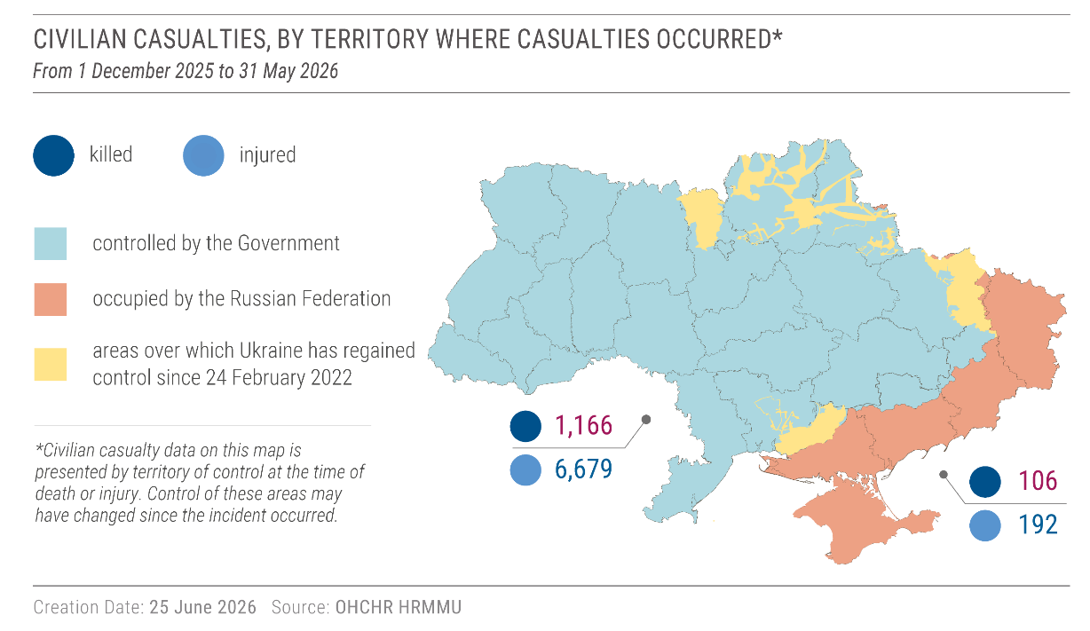
68. Russian authorities reported that at least 205 civilians were killed and 1,302 injured in attacks by the Ukrainian armed forces in 27 regions of the Russian Federation. OHCHR has established the identity of some of them; however, OHCHR has not been able to verify the circumstances of the incidents due to lack of access and limited publicly available information.

F. Frontline communities
69. The extensive use of short-range drones on both sides of the frontline caused large and increasing numbers of civilian casualties, prevented evacuations and delivery of humanitarian assistance, and caused further displacement.

1. Civilian casualties from short-range drones
70. Short-range drones were the second leading cause of civilian casualties in the reporting period. In December 2025, January and March 2026, short-range drones killed more civilians than any other weapon type in Ukraine. In total, short-range drones killed 385 civilians and injured 2,100, a 57 per cent increase from the same period 12 months earlier.
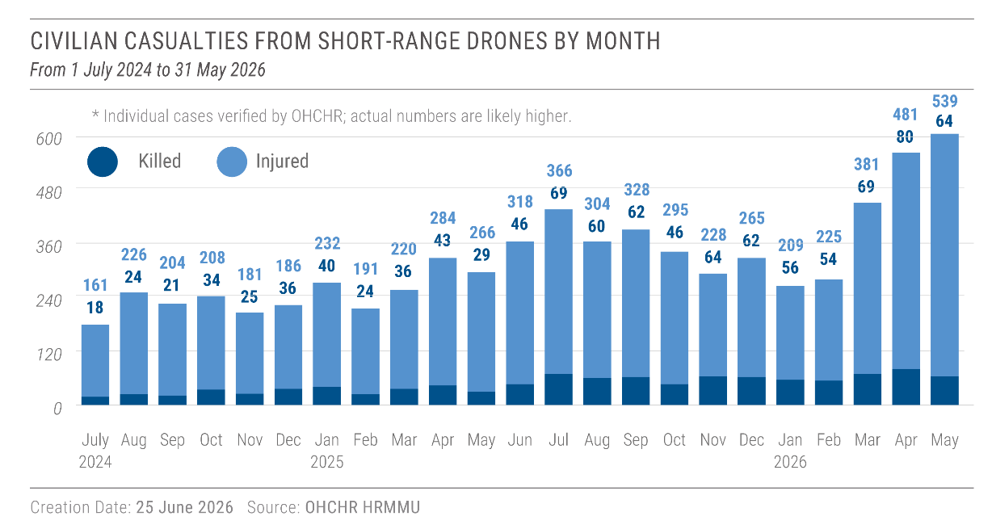
71. In Government-controlled territory of Ukraine, short-range drones killed at least 343 civilians and injured 1,975 in the reporting period. For example, on 4 April, in the frontline city of Nikopol, Dnipropetrovsk region, a morning attack on a local market involving short-range drones killed five civilians and injured 26, including a 14-year-old girl. Three days later, on 7 April, a short-range drone attack on a public bus killed four civilians and injured 17.
72. Short-range drones in occupied territory killed at least 42 civilians and injured 125.

2. Attacks on humanitarian vehicles and facilities
73. In at least 20 incidents in the reporting period, short-range drones were used to attack clearly marked humanitarian vehicles and facilities, all of them in territory controlled by the Government of Ukraine. The attacks killed three and injured 10 humanitarian workers. Most of the verified attacks took place during efforts to evacuate civilians from frontline communities. Under international humanitarian law, humanitarian relief personnel and objects are protected against attack.
74. For example, on 20 March 2026, a short-range drone struck a visibly identifiable humanitarian vehicle of the organization Proliska in Oleksiievo-Druzhkivka, Donetsk region, killing two women evacuees (aged 83 and 63) and injuring two other evacuees, a 65-year-old woman and a 66-year-old man. In another case, a short-range drone killed two men volunteers in Kozacha Lopan, Kharkiv region, on 22 January. The volunteers were delivering bread to local residents. On 13 May 2026, a short-range drone attacked a clearly marked truck from the UN World Food Programme delivering food to frontline communities in the Dnipropetrovsk region. On 14 May 2026, two short-range drones attacked twice within 20 minutes a UN vehicle in Kherson city. Short-range drones are usually equipped with cameras that provide operators with real-time view of the area and targets. Footage from the drones used in the 14 May 2026 attack posted online and verified by OHCHR clearly shows the UN markings on the vehicles.
75. The drone attacks on humanitarian workers forced humanitarian organizations to scale back or adjust operations in settlements located near the frontlines. Local authorities and NGOs reported to OHCHR that evacuations and humanitarian assistance had been reduced or suspended in some locations, or the modality of delivery had to be changed to avoid civilians gathering at a central point.

3. The situation in occupied Oleshky and Hola Prystan, Kherson region
76. Short-range drones, landmines, and attacks with other weapons also prevented the evacuation of civilians and the delivery of humanitarian assistance in occupied territory. The situation was particularly dire in Oleshky and Hola Prystan, occupied communities along the left bank of the Dnipro River in Kherson region.
77. Multiple residents from these communities told OHCHR that increased attacks by short-range drones and the presence of landmines along roads made it extremely dangerous to try to leave these communities. For example, on 17 January 2026, three civilians were killed in a mine explosion during evacuation from Oleshky. On 5 March 2026 at approximately 5:00 a.m., a drone attack killed two civilians and injured at least six who were waiting for the delivery of food.
78. The deteriorating security situation in Oleshky and Hola Prystan left many civilians effectively trapped. One community leader estimated that about 6,000 civilians still remained. A volunteer organization collected the names of about 200 people who would like to leave but were unable to do so because of the risk.
79. The threat from short-range drones and landmines also affected people’s access to healthcare and basic necessities. Ambulances often could not reach villages or evacuate the wounded. Those who needed emergency health care had to travel to other settlements under life-threatening conditions. Bodies of deceased civilians remained in homes or on the streets for extended periods of time due to the absence of recovery services. The lack of gas and electricity in the communities during the winter caused inside temperatures to drop to as low as 2°C.

4. Displacement and evacuation of civilians
80. From 1 December 2025 to 31 May 2026, over 60,000 civilians passed through transit centres as they were leaving frontline areas. The majority left from frontline areas in the Donetsk region, followed by Dnipropetrovsk, Kharkiv and Zaporizhzhia regions. About 38 per cent of evacuees were over the age of 60. Many of those who decided to leave frontline communities told OHCHR that the increased threat of drones was one of the main reason for their decision to leave.
81. On 10 February 2026, Ukrainian authorities adopted a law that provides for the mandatory evacuation of civilians from areas of active or potential hostilities and introduces the possibility of evacuation of children without parental consent and without adult accompaniment. Any nonconsensual separation of children from their parents must be exceptional, based on an individualized assessment of the child’s best interests, subject to judicial oversight, and accompanied by safeguards to maintain family contact and support reunification.

5. Attacks on railway and port infrastructure
82. Russian armed forces intensified strikes on railway infrastructure in territory controlled by the Government of Ukraine. OHCHR verified 142 attacks on railway infrastructure in 18 regions in territory controlled by Ukraine, an 82 per cent increase compared to the prior six months. The strikes damaged railway tracks, stations, locomotives, railway energy infrastructure and passenger trains en route, threatening a key mode of transportation for civilians who depend on it to transport essential goods and for evacuation from areas affected by hostilities. OHCHR also verified two attacks on railway infrastructure in occupied territory.
83. Russian armed forces also intensified attacks on port infrastructure in Odesa region, damaging port terminals, warehouses, industrial equipment as well as civilian vessels in the port area. In total, ОНСНR verified 57 attacks on port infrastructure in the region, a 248 per cent increase in comparison with the previous reporting period.

V. Prisoners of war

A. Ukrainian POWs held by the Russian Federation

1. Extrajudicial executions
84. Between mid-November 2025 and January 2026, OHCHR recorded credible allegations about the execution of 37 Ukrainian servicemen in 18 incidents, a significant spike. While some of the executions took place earlier, OHCHR has verified that at least 16 of the servicemen were executed in this period. In addition, on 11 April, Russian armed forces captured and executed four Ukrainian servicemen near the village of Veterynarne in Kharkiv region. Video material analyzed by OHCHR shows a Russian soldier shooting two of the Ukrainian POWs as they lay on the ground with their hands behind their heads, while two others lay motionless in the same position.
85. In total, since February 2022, OHCHR has verified that Russian armed forces executed 129 Ukrainian POWs and persons hors de combat (all men).

2. Torture or other ill-treatment
86. OHCHR interviewed 129 Ukrainian POWs (all men) repatriated in the reporting period. All but five of those interviewed provided detailed accounts of torture or other ill-treatment during their captivity, with 97 of them describing repeated such acts during prolonged periods in formal internment facilities. This information is consistent with OHCHR’s previous findings of widespread and systematic use of torture and ill-treatment against Ukrainian POWs in Russian captivity.
87. Forty interviewees reported that they suffered physical violence in the period between 1 December 2025 and 31 May 2026. For example, three POWs described how guards beat and tasered them as a “farewell” before leaving internment for prisoner exchange on 5 February 2026.
88. More than half of the released POWs said, however, that treatment or conditions in some facilities had slightly improved from late 2024, in particular when POWs stayed for prolonged periods in one facility. Physical violence during daily routines, for example during inspections in cells and walks to the shower, decreased, although guards usually still resorted to physical violence to punish POWs for breaking “rules”, which often were absurd or intended to humiliate the POWs. Of 49 POWs transferred in 2025-2026, 27 reported no serious physical violence during their admission to new facilities in 2025-2026.
89. Several of the released POWs also noted they had received more varied and nutritious food that was better cooked and that access to medical attention had improved, in particular availability of medication and access to specialized treatment such as dental assistance and simple surgeries.
90. OHCHR documented that two Ukrainian POWs (all men) died in a place of internment in the Russian Federation as a result of inadequate medical attention in January 2026. Additionally, OHCHR documented that four Ukrainian POWs (all men) died in places of internment during previous reporting periods as a result of torture or ill-treatment, including poor conditions of internment, or inadequate medical attention. In total, since February 2022, OHCHR has documented the deaths of 47 Ukrainian POWs and one retained medical personnel (all men) under such circumstances.

3. Trials and convictions
91. Twelve of the POWs interviewed had been convicted by a court in occupied Donetsk region in 2023-2025 for war crimes. The POWs provided consistent accounts suggesting that the proceedings had violated due process and fair trial guarantees provided for in international humanitarian law. The POWs described, among other violations, the use of torture to extract confessions and testimonies, inadequate legal assistance, and the publication of videos of confessions and testimonies that undermined the presumption of innocence.
92. Seven of the released POWs interviewed by OHCHR had been sentenced to life or 30 years in prison for involvement in the killing of civilians in Mariupol, though the cases appeared to lack evidence. According to the POWs, the convictions were based on confessions and testimonies extracted under torture.

B. Russian POWs held by Ukraine
93. During the reporting period, OHCHR interviewed 134 POWs (all men) captured by Ukraine, including 28 third-country nationals. Seventy-five interviewees reported having been subjected to torture or other ill-treatment. The violations predominantly occurred in transit facilities, where there is no independent monitoring, prior to transfer to official places of internment established by the Ministry of Justice. However, some cases of torture or ill-treatment were reported in these official places of internment.
94. Five POWs also reported having been required to work without payment while at a transit facility mentioned in a previous OHCHR report. They fortified buildings, dug trenches, and installed counter-drone nets. Some of the POWs said that they were at risk from drone attacks during this labour. IHL prohibits holding POWs in areas exposed to combat, compelling them to perform labour of a military character, imposing excessive durations of daily labour, and denying remuneration.
95. Three third-country national POWs expressed fear of being repatriated against their will to the Russian Federation, where they believed they could be forcibly redeployed to the frontline. This fear was linked to their prior experience of having been recruited despite not intending to join the Russian armed forces or participate in hostilities.
96. OHCHR documented that one Russian POW (man) in Ukrainian captivity died in an unofficial place of internment in October 2025. One Russian POW interviewed by OHCHR said that when he met the victim at a transit facility, he could barely walk, and he told him that he had been badly beaten. OHCHR also documented the extrajudicial execution of a Russian POW in April 2024. Since February 2022, OHCHR has documented the execution of 31 persons hors de combat (all men), including Russian POWs, by Ukrainian armed forces. The vast majority of these incidents occurred in 2022 and early 2023.

VI. Conflict-related sexual violence
97. In the reporting period, OHCHR verified 158 cases of conflict-related sexual violence (CRSV) perpetrated by Russian officials. Ten of the cases occurred in the reporting period, against seven POWs (all men), two civilian detainees (1 man and 1 woman), and one civilian in residential areas of occupied territory (1 woman). The documented cases confirm patterns of sexual violence that OHCHR has documented since 24 February 2022.
98. In total, since 24 February 2022, OHCHR has documented 817 cases of CRSV perpetrated by Russian officials against 652 men, 149 women, 14 girls and 2 boys, including 528 Ukrainian POWs (501 men and 27 women), 195 civilian detainees (143 men, 51 women and 1 boy), and 94 civilians in residential areas (8 men, 71 women, 14 girls and 1 boy).
99. OHCHR also verified 29 cases of CRSV perpetrated by Ukrainian officials. Five of the cases occurred in the reporting period, against three Russian and third country national POWs (all men), primarily in the initial stages of captivity before arrival at places of internment that are part of the infrastructure established by the Ministry of Justice, and two conflict-related civilian detainees (all men).
100. In total, since 24 February 2022, OHCHR has documented 108 cases of CRSV perpetrated by Ukrainian officials against 94 men and 14 women, including 59 Russian and third-country national POWs (all men) and 49 conflict-related civilian detainees (35 men and 14 women).

VII. Human rights in territory occupied by the Russian Federation
101. OHCHR interviewed 172 individuals (95 women, 77 men) from the occupied territory of Ukraine, including people who left occupied territory between 1 December 2025 and 31 May 2026. They described continuing severe restrictions of freedom of expression, arbitrary detention, unfair trials, forced conscription, and the imposition of the Russian educational system as some of the most important current human rights challenges in occupied territory, and many cited one or several of these issues as reasons for leaving occupied territory.

1. Restrictions on freedom of expression, arbitrary detention and unfair trials
102. In the reporting period, courts in occupied territory issued administrative fines or administrative arrest for up to 14 days against 164 individuals (76 women and 88 men) for expressing anti-war views, criticizing the occupation or the Government of the Russian Federation, supporting the Ukrainian armed forces, or otherwise expressing pro-Ukrainian views. Deprivation of liberty for legitimate exercises of freedom of expression constitutes arbitrary detention.
103. OHCHR also documented cases in which courts in the occupied territory handed down lengthy prison sentences on “terrorism” and “extremism”-related charges. These cases raise concerns under international human rights law, including with respect to the right to freedom of expression. For example, on 17 February 2026, a 52-year-old woman in the Kherson region was sentenced to six years’ imprisonment for two social media comments calling on Russian soldiers to surrender to Ukrainian forces. The actual number of such cases remains difficult to ascertain, as authorities and courts often do not disclose details of proceedings or the identities of those prosecuted.
104. At the same time, authorities expanded their control over communications. In January 2026, schools in occupied territory introduced the mandatory use of the “MAX” digital platform, requiring all communication, schedules and academic records to be managed through this system, raising concerns over privacy and confidentiality as the application requires full access to personal data. This follows a requirement in Russian Federation legislation that all new mobile and digital devices have pre-installed the MAX application. Health workers also reported being pressured to install and use the application as a data exchange platform to store documents.

2. Forced conscription
105. International humanitarian law prohibits an occupying Power from compelling protected person to serve in its armed forces. A 16-year-old boy from Kherson region received information about conscription obligations during mandatory information sessions at school. He said that some of his peers were enlisted immediately after graduating from secondary school. A similar pattern was confirmed in interviews with children and young adults from Luhansk and Zaporizhzhia regions.
106. Until 2025, the Russian Federation conducted two fixed conscription campaigns per year, the spring and autumn drafts. Since 1 January 2026, however, men of conscription age may be summoned to undergo administrative procedures that precede conscription throughout the year, which makes it harder for residents of the occupied territory to avoid conscription.

3. Right to education
107. Several families with children who left the occupied territory in the reporting period told OHCHR that they did so because they did not want to send their children to public schools in the occupied territory following the Russian curriculum or because they wanted their children to obtain a Ukrainian education.
108. Occupying authorities imposed compulsory school attendance, threatening parents with sanctions for refusing to send children to schools or attend military-patriotic classes, including documented threats of taking children into State custody. Two children, aged 15 and 16, told OHCHR that they had to hide the fact that they continued to follow the Ukrainian curriculum in Ukrainian language remotely, fearing pressure from school and local occupying authorities and risking administrative and criminal sanctions.
109. Some families specifically mentioned that they would like their children to learn Ukrainian or obtain an education in Ukrainian language. On 15 December 2025, a decision by the Ministry of Education of the Russian Federation entered into force that removed Ukrainian language instruction from the list of primary and basic general education in the Russian Federation and in the occupied territory.
110. Schools also incentivized children to join the “Yunarmiya” military-patriotic movement, including through preferential grading and more lenient examination conditions. In February 2026, authorities launched the third season of the “Zarnitsa 2.0” competition, which includes activities incorporating elements of military training.

4. Torture or ill-treatment of civilians
111. OHCHR interviewed 11 civilian men who were released during the reporting period after having been arrested or detained in occupied territory. Ten of them described having endured torture and other forms of ill-treatment in detention, including beatings, stress positions, electric shocks, prolonged standing or physical exercises and sleep deprivation. For example, a man in his thirties was detained in March 2022 due to his military service in the Ukrainian armed forces in 2016 and subsequently deported to the Russian Federation. In September 2025, when he arrived at a new detention facility with a group of detainees, the whole group was forced to kneel down with their heads between their knees and were beaten in the kidney or liver area. He said he received electric shocks daily during routine security checks. One month after his return to Ukraine, he said that he was still in a state of psychological shock.
112. OHCHR documented the deaths of four civilian men that occurred in previous reporting periods in formal and informal places of detention in occupied territory of Ukraine and the Russian Federation due to torture and inadequate conditions of detention. Since February 2022, OHCHR has documented the deaths of 43 Ukrainian civilians (34 men and 9 women) as a result of torture, inadequate medical assistance or inhuman conditions of detention in official and unofficial places of detention in occupied territory and the Russian Federation.

VIII. Human rights in Government-controlled territory

1. Freedom of Religion
113. As of 31 May 2026, court proceedings regarding the dissolution of the Kyiv Metropolis of the Ukrainian Orthodox Church (UOC) were continuing. Separately, the Supreme Court and an appellate court ruled in favour of the UOC in two other cases concerning the compliance by the UOC with Ukrainian legislation on religious organizations. In the reporting period, OHCHR analysed nine Supreme Court and appellate court decisions about church property and involving the UOC: three of the cases were decided in favour of the UOC, while six were decided in favour of the other party to the dispute.

2. Conscientious objection
114. Ukrainian law does not allow alternative (non-military) service for conscientious objectors during periods where martial law has been declared. In the reporting period, OHCHR documented 21 cases of conscription of conscientious objectors among members of Jehovah’s Witnesses, Baptist, Adventist and other religious communities. Under the ICCPR, the right of conscientious objection to military service allows no restrictions or derogation.
115. In 17 of these cases, officials involved in the conscription process used physical violence during and/or after the individual was apprehended. In some cases, staff in military training centers also threatened conscientious objectors with death and staged mock executions. In one case, in September 2025, staff members of a military training center threatened to shoot off the genitals of a clergyman with an assault rifle and twice pretended to execute him. The staff kept the clergyman for at least two days in a pit with other conscientious objectors. They shot them with training (non-lethal) weapons, beat them, forcefully undressed them, and threw a training (non-lethal) hand grenade at them, which exploded next to the clergyman.
116. To date, Ukrainian authorities had mainly prosecuted conscientious objectors for evading military service. However, in the reporting period, OHCHR documented four cases in which conscientious objectors were conscripted into military service and subsequently prosecuted for unauthorized departure from the military unit, or refusing to obey orders, charges that carry more severe criminal penalties.

3. Prosecution for collaboration activities
117. Ukrainian authorities issued verdicts in 633 cases on collaboration charges in the reporting period. In 77 per cent of the verdicts, court proceedings took place without the presence of the defendant, since most defendants were located in occupied territory or the Russian Federation. While such in absentia proceedings are allowable under international human rights law (IHRL), Ukrainian legislation does not give a person convicted in absentia the right to retrial if he or she is apprehended, counter to international human rights standards.
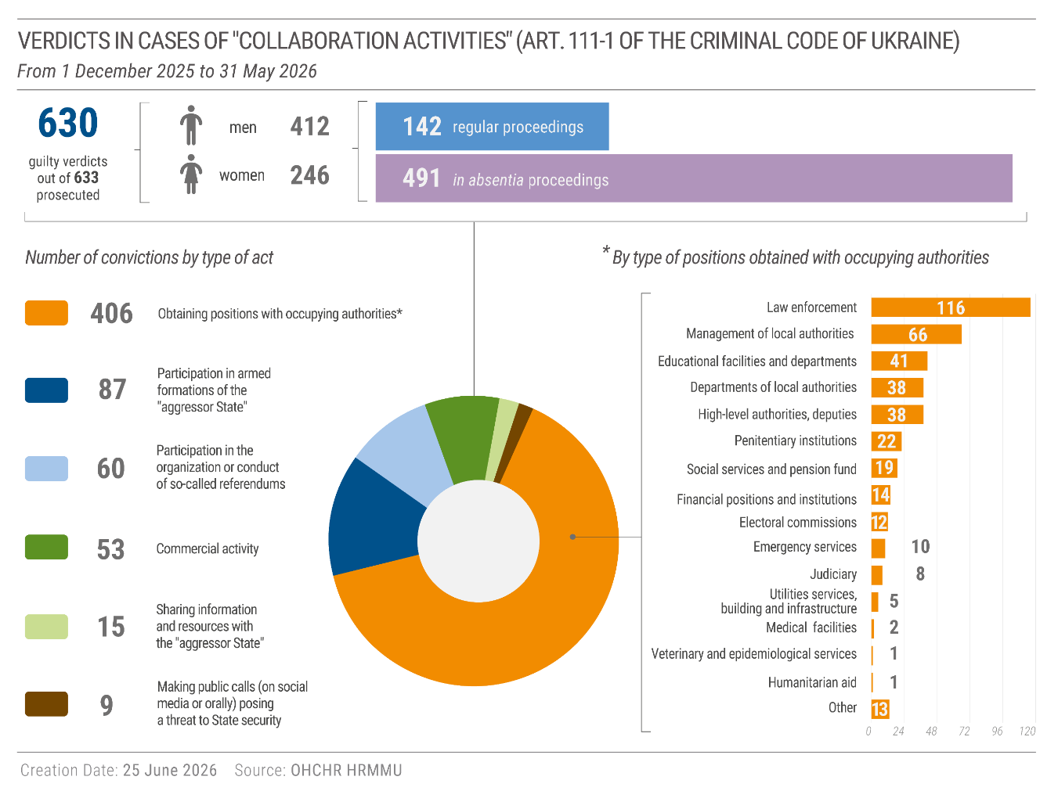
118. Courts continued to remand in custody defendants in collaboration cases pending investigation and trial, without sufficient consideration of its necessity or alternatives to deprivation of liberty. In one case, a 72-year-old man accused of collaboration with the occupying authorities in Kharkiv region has spent over three years in pre-trial detention, while his case remains pending in the first instance court.

4. Repatriation of Russian citizens
119. OHCHR interviewed eight Russian nationals who had been detained in Ukraine for the purpose of deportation to the Russian Federation. Seven of them expressed fears of persecution or ill-treatment upon return to the Russian Federation. Some of these Russian nationals have no property, family, or social links in the Russian Federation.
120. Prior to repatriating Russian nationals, Ukrainian authorities must conduct individualized assessments, with due process, of whether there are substantial grounds to believe that their life or freedom would be threatened on account of race, religion, nationality, membership of a particular social group or political opinion or where they may otherwise face a real risk of irreparable harm, including torture or ill treatment.

5. Draft new Civil Code of Ukraine
121. The draft of the new Civil Code of Ukraine, adopted by Parliament in its first reading on 28 April 2026, raises some concerns regarding equality and non-discrimination. The draft law defines couples as “family members” - a status linked to enjoyment of various rights and protections in Ukrainian law - only if they are spouses of the opposite sex, which excludes cohabitants and same-sex couples without providing an alternative legal framework to ensure the protection of their rights. The draft also prohibits same-sex couples from adopting children, and provides for the invalidation of a marriage in the event of a gender transition of one spouse. This may exacerbate existing gaps and worsen the human rights situation of families headed by same-sex couples and/or transgender people.

IX. Technical cooperation
122. OHCHR provided training to prosecutors on IHL standards relating to the issue of collaboration, including on coercion, duress and the protection of persons in occupied territory. In addition, OHCHR delivered portions of a workshop for Ukrainian regional prosecutors, National Police, and Security Service of Ukraine on 16 and 17 February 2026, on strategic investigations and case-building for complex war crimes cases.
123. OHCHR provided technical advice to participants during two workshops by the Team of Experts of the Office of the Special Representative of the Secretary-General on Sexual Violence in Conflict for the National Police and the Security Service of Ukraine on CRSV investigation and interview planning, as well as trauma-informed interviewing. OHCHR also provided technical advice during consultations convened by the Government of Ukraine on draft bylaws for implementation of Law No. 4067-IX on urgent interim reparations for CRSV survivors.
124. OHCHR provided comments on draft national policies from the perspective of IHRL and IHL, including on the National Human Rights Strategy and the policy on internal displacement, as well as contributions to the Expert Councils convened by the Ukrainian Parliament Commissioner for Human Rights. OHCHR supported the work of the Interagency Commission on the Application and Implementation of IHL in Ukraine under the Ministry of Development of Communities and Territories of Ukraine. In March 2026, this support enabled the launch of eight thematic Working Groups (for instance on the treatment of POWs and civilian detainees, children, environment, cultural property, etc.), including the development of their regulations and workplans. Several Working Groups have already held initial meetings and approved key documents.

X. Recommendations
125. OHCHR continues to advocate for the implementation of recommendations in its past reports, most of which remain relevant. The violations documented in the current reporting period highlight the need for further progress in protecting human rights, and, in particular, to implement the following recommendations:
126. To the Russian Federation:
(a) Immediately cease the use of armed force against Ukraine and withdraw military forces from the territory of Ukraine, as per United Nations General Assembly resolution ES-11/1 on the “Aggression against Ukraine”, adopted on 2 March 2022, and in line with the binding order of the International Court of Justice on provisional measures of 16 March 2022 for the Russian Federation to immediately suspend its military operations;
(b) Immediately cease and publicly condemn all acts of extrajudicial execution, torture, ill-treatment and sexual violence against both POWs and civilian detainees, and end all unlawful practices relating to detention;
(c) Comply with the obligations of an occupying Power under IHL and respect Ukrainian laws in force unless absolutely prevented from doing so;
(d) End the conscription of protected persons from occupied territory into its armed forces;
(e) End all forms of “patriotic”-military education and propaganda in schools and youth groups, and ensure that education respects the rights of the child and does not compel allegiance to the occupying Power or deny the use of their own language;
(f) Ensure the right to a fair trial, including access to effective legal representation;
(g) Respect the freedoms of expression and opinion, by ceasing all measures that seek to suppress Ukrainian identity and ending the prosecution of individuals for dissent, subject only to the strict limits provided in international human rights law.
127. To Ukraine:
(h) Sustain attention and assistance to those groups in a situation of vulnerability particularly affected by electricity and heating outages, including older persons, persons with disabilities, and families with children, paying due attention to gendered needs and challenges;
(i) Ensure that legislation governing mandatory evacuation protects the best interests of the child and their other rights, including through prevention of family separation, and addresses the specific needs of older persons and persons with disability;
(j) Treat POWs and conflict-related detainees in full compliance with IHL and IHRL, in particular by protecting them from torture or ill-treatment at all times, including during the initial stage of captivity;
(k) Fully uphold due process and fair trial guarantees for all individuals charged in conflict-related criminal cases in particular, and give due consideration to non-custodial measures of restraint for persons awaiting trial on “collaboration” charges;
(l) Take means necessary effectively to recognise, in domestic law, the right of conscientious objection to military service in accordance with the full scope of the right protected under art. 18 of the ICCPR;
(m) Amend the draft Civil Code to ensure it is in compliance with international standards and principles of equality and non-discrimination, including based on sexual orientation and gender identity.
128. To both Ukraine and the Russian Federation:
(n) Take all feasible precautions to avoid, and in any event minimize, civilian harm, including through the careful selection of means and methods of warfare and target verification, including by refraining from using explosive weapons with wide area effects in populated areas and ensuring that attacks with short-range drones target only military objectives;
(o) Ensure prompt, impartial and effective investigations into all alleged violations of IHL and IHRL and ensure that perpetrators, including members of the military and security forces and those in positions of command, are duly prosecuted and held to account; guarantee adequately-financed and prompt gender and age-sensitive reparation measures, and support to victims, including medical, psychological and legal support services, with particular attention to the specific needs of women, girls, men and boys.
(p) Immediately cease attacks on the electricity and heating infrastructure critical to the civilian population;
129. To the international community:
(q) Call for OHCHR, the International Committee of the Red Cross and other independent human rights monitors to have the fullest possible access to areas of Ukraine occupied by the Russian Federation and the Russian Federation, including places of internment and detention, in order to facilitate comprehensive monitoring. Continue to urge the Russian Federation and Ukraine to fully comply with IHRL and IHL, demand and work collectively to ensure accountability, including reparation for the victims and survivors of violations, and take all available measures to prevent further violations;
(r) Support efforts to repair and restore heating and electricity-generating and transmission capacity to meet the short, medium and long-term needs of the population;
(s) Continue to urge the Russian Federation to comply with the full range of its additional obligations as an occupying Power under IHL and IHRL;
(t) Provide financial, technical and other assistance to actors providing support to victims and survivors of gross human rights violations, including sexual and gender-based violence, with attention to the respective specific needs of women, girls, men and boys.

HRMMU was deployed on 14 March 2014 to monitor and report on the human rights situation throughout Ukraine, with particular attention to the Autonomous Republic of Crimea, eastern and southern regions of Ukraine, and to propose recommendations to the Government and other actors to address human rights concerns. See A/HRC/27/75, paras. 7-8.
OHCHR most recently requested access to occupied territory through a note verbale transmitted to the Russian Federation on 16 January 2026, to which no response has yet been received.
UNDP, “Towards a Green Transition of the Energy Sector in Ukraine: Update on the Energy Damage Assessment” (hereinafter: UNDP 2023 Assessment), June 2023.
UNDP 2023 Assessment; Kyiv School of Economics, “Assessment of Damages and Losses to Ukraine’s Energy Sector due to Russia’s Full-Scale Invasion”, May 2024.
See OHCHR, “Report on the Human Rights Situation in Ukraine: 1 August 2022 – 31 January 2023”, 24 March 2023 (hereinafter: OHCHR Report March 2023) and HRMMU, Attacks on Ukraine’s Energy Infrastructure: Harm to the Civilian Population, September 2024.
International Energy Agency (IAEA), Ukraine’s Energy Security and the Coming Winter, September 2025.
See OHCHR report, Treatment of prisoners of war and update on the human rights situation in Ukraine, 1 June to 31 August 2024, para. 82.
Ukrainian authorities report a higher number of attacks on energy infrastructure. The numbers used in this report relate to the number of attacks OHCHR has been able to verify through independent sources according to established methodology.
Ukrainian Air Force, official Telegram channel, 3 February 2026, available at: https://t.me/kpszsu/54449.
IAEA, Nuclear Safety, Security and Safeguards in Ukraine: Report by the Director General, GOV/2026/7, 25 February 2026.
Ministry of Energy of Ukraine, “Briefing by Acting Minister of Energy of Ukraine Artem Nekrasov on the Situation in the Energy System”, 8 January 2026. https://mev.gov.ua/novyna/bryfinh-vo-ministra-enerhetyky-ukrayiny-artema-nekrasova-shchodo-sytuatsiyi-v-enerhosystemi
President of Ukraine Volodymyr Zelenskyy, official Telegram channel, 20 January 2026
DiXi Group, Over four years of full-scale war, Russia has launched more than 60 massive attacks on Ukraine’s energy sector, 24 February 2026.
UN Development Programme, Energy brief 2026.
President of Ukraine Volodymyr Zelenskyy, official Telegram channel, 14 January 2026.
INSO, July 2024; UNDP 2024 rapid assessment, supra.
Chernihiv, Donetsk, Kharkiv, Kherson, Kyiv, Mykolaiv, Odesa, Poltava and Sumy regions.
Kyiv City Administration, Vitaily Klychko: After the attack on the capital, 5,635 high-rise buildings without heat, 20 January 2026.
Government of Ukraine, Denys Shmyhal visited one of Kyiv’s combined heat and electricity plants together with international partners, 25 February 2026.
OHCHR recorded attacks on 21 January, 6, 7, and 27 February, 8, 15 and 25 March 2026.
Governor of Belgorod region, Vyacheslav Gladkov, Telegram channel, 8 February 2026.
Due to lack of access OHCHR has been unable to verify the impact of attacks on energy infrastructure in the Russian Federation on the civilian populations. Publicly available information described some regional power outages, but not a deficit in the Russian Federation’s national production capacity leading to nationwide power outages.
International Covenant on Economic, Social and Cultural Rights, art. 11; Committee on Economic, Social and Cultural Rights, General Comment no. 15 (2002), The Right to Water.
Temperatures in Ukraine dropped significantly in January 2026, which was by some measures the coldest January in Ukraine since 2010. In a ten-day period, from 11 to 21 January, the daily average was between -8.3°C and -12.6°C. Kyiv Independent, “Chart of the week: Ukraine sees its coldest January in 16 years”, 11 February 2026
A higher minimum temperature may be necessary for vulnerable groups including children, older persons, and people with cardiorespiratory disease and other chronic illnesses. WHO, Housing and Health Guidelines, page 34.
A “Point of Invincibility” is a building, tent or vehicle set up by Ukrainian authorities where people can warm up, charge electronic devices, and receive other support.
UNICEF, Ukraine Winter Response for Vulnerable Families with Children 2025–2026, January 2026. https://www.unicef.org/ukraine/en/media/57991/file/UNICEF%20Winter%20Response%20Update%207_FINAL.pdf.pdf
Ministry of Development of Ukraine, Transport Accessibility: The Ministry of Development Has Released the Results of Its 2025 Monitoring (in Ukrainian), February 2026.
Women in Ukraine spend an estimated 16 hour more per week than men on unpaid care work, especially childcare. Ukraine RDNA4, February 2022 – December 2024, p. 85.
UNHCR, Ukraine Border Monitoring, January and February 2026, available at: https://www.unhcr.org/ua/en/border-monitorings.
Article 52(2), Protocol Additional to the Geneva Conventions of 12 August 1949, and relating to the Protection of Victims of International Armed Conflicts (hereinafter Protocol I).
See for instance ICRC, 2024 report on International Humanitarian Law and the Challenges of Contemporary Armed Conflict, https://www.icrc.org/en/report/2024-icrc-report-ihl-challenges, pp. 40-41.
33 Prosecutor v. Germain Katanga, Case No. ICC-01/04-01/07, Judgment pursuant to article 74 of the Statute, March 7, 2014, para. 893; Commentary to Additional Protocol I, para 2024; HPCR Manual, Commentary on Rule 1(w), para. 4.
Article 54(2) of Additional Protocol I.
See for example Summary of the Ministry of Defense of the Russian Federation on the progress of the special military operation (as of January 13, 2026), https://mil.ru/news/ae3f6e6c-e5d5-4207-95d3-9b31222b046d [accessed 4 June 2026].
Customary International Humanitarian Law Database, Rule 14.
See for instance ICRC, 2024 report on International Humanitarian Law and the Challenges of Contemporary Armed Conflict, https://www.icrc.org/en/report/2024-icrc-report-ihl-challenges, p. 40.
API art. 48, 43(2), 51(3).
Customary IHL Rules 31 and 32; Additional Protocol I, Arts. 70 and 71.
Telegram channel “Osvedomitel”, post No. 251484, 14 May 2026. https://t.me/osvedomitell/251484 (accessed 18 May 2026).
This includes persons who self-evacuated and persons who were evacuated by the Government or NGOs.
Protection Cluster Ukraine, Dashboard Transit Centers. Figures do not include civilians who self-evacuate and do not register at transit centres.
This amends the procedure established by Cabinet of Ministers Resolution no. 841 of 30 October 2013, which allowed for mandatory forced evacuation of children together with their parents or guardians.
Convention on the Rights of the Child, articles 3, 9.
This follows two earlier spikes in executions (in December 2023-February 2024, and August 2024-March 2025), see OHCHR, Report on the Human Rights Situation in Ukraine, 1 December 2023 to 29 February 2024, March 2024, paras. 54-56; OHCHR, Report on the Human Rights Situation in Ukraine, 1 September to 30 November 2024, December 2024, para. 49; OHCHR, Report on the Human Rights Situation in Ukraine, 1 December 2024 to 31 May 2025, June 2025, paras. 39-40.
OHCHR, Treatment of Prisoners of War and Update on the Human Rights Situation in Ukraine, 1 June – 31 August 2024, 1 October 2024, para. 28.
Under article 356 of the Criminal Code of the Russian Federation for use of banned means and methods of warfare
Geneva Convention III, Article 99
Geneva Convention III, Article 105
Geneva Convention III, Article 13, Additional Protocol I, Article 75
OHCHR has reviewed three of the judgments, which were consistent with the POWs accounts of the trial.
OHCHR, Report on the Human Rights Situation in Ukraine, 1 June 2025 to 30 November 2025, para. 66.
Geneva Convention III, arts. 23, 50, 53 and 62.
These cases were perpetrated against 83 Ukrainian POWs (all men), 60 civilian detainees (49 men, 11 women), and 15 civilians in residential areas where Russian armed forces were stationed (1 man, 14 women). In one case, a child was born of rape.
These cases were perpetrated against 11 Russian and third country national POWs (all men) and 18 conflict-related detainees (16 men, 2 women).
General comment no. 35 : Article 9, Liberty and security of person : Human Rights Committee, para. 17, available at: https://digitallibrary.un.org/record/786613?v=pdf.
OHCHR, Report on the Human Rights Situation in Ukraine, 1 June 2025 to 30 November 2025, para. 100;
Geneva Convention IV, Art. 51.
Russian Federation Ministry of Education, Order No. 729, October 2025, officially published in the official Government newspaper on 4 December 2025. https://rg.ru/documents/2025/12/08/minpros-prikaz729-site-dok.html?utm
For previous reporting on this case, see OHCHR, Report on the Human Rights Situation in Ukraine, 1 June to 30 November 2025, December 2025, para. 111.
Unified State Register of Court Decisions of Ukraine, Case No. 320/26027/23, decision dated 6 April 2026, available at: https://reyestr.court.gov.ua/Review/135500520; Unified State Register of Court Decisions of Ukraine, Case No. 855/11/25, decision dated 19 May 2026, available at: https://reyestr.court.gov.ua/Review/136810199.
See OHCHR, Report on the Human Rights Situation in Ukraine, 1 September to 30 November 2024, December 2024, paras. 90-91.
International Covenant on Civil and Political Rights, arts. 18 and 4. See also A/HRC/56/30 paras. 5-6, citing relevant decisions of the Human Rights Committee.
Criminal Code of Ukraine, arts. 402,407 and 409.
For the possibility of retrial, see Annex to Views of the Human Rights Committee, article 5, para. 4, of the Optional Protocol to the International Covenant on Civil and Political Rights, CCPR/C/66/D/699/1996/Corr.1, paras. 9.4-9.5.
The Human Rights Committee stated that pre-trial detention must be based on an individualised determination that it is reasonable and necessary, taking into account all relevant circumstances, including mitigating the risks of flight, interference with evidence or the recurrence of crime (General Comment No. 35, para. 38).
Convention against Torture, art. 3; Convention relating to the Status of Refugees, art. 33.
Draft Law No. 15150 at https://itd.rada.gov.ua/billinfo/Bills/Card/69589.
European Court of Human Rights, Maymulakhin and Markiv v. Ukraine, 1 June 2023, para. 80-81.

