A/HRC/61/CRP.3
22 January 2026

English only
Human Rights Council
Sixty-first session
Situation of human rights in Ukraine: 1 June to 30 November 2025
Office of the United Nations High Commissioner for Human Rights

I. Executive Summary
1. From 1 June to 30 November 2025, OHCHR recorded a significant escalation in hostilities across Ukraine, resulting in increased civilian harm. Civilian casualties surged in both frontline and urban areas, with July 2025 marking the highest monthly toll since April 2022. The vast majority of casualties occurred in territory controlled by the Government of Ukraine. The Russian Federation intensified its deployment of missiles and long-range drones, with hundreds of munitions launched in frequent large-scale overnight attacks.
2. In October 2025, Russian armed forces resumed large-scale coordinated strikes on energy facilities nationwide, launching eight major waves of attack on multiple regions simultaneously in the final two months of the reporting period. These attacks caused regional emergency power outages and long scheduled daily power cuts across the country, with heating and water supply disrupted in some areas.
3. Conditions in frontline areas continued to deteriorate. Short-range drones, aerial bombs and other explosive weapons killed and injured civilians and destroyed housing and other critical civilian infrastructure. In some frontline cities, medical and other essential services collapsed, catalysing increased displacement. Continued hostilities strained services for displaced persons and disrupted education across the country.
4. Between the end of May and August 2025, Ukraine and the Russian Federation conducted the largest exchanges of POWs and civilian detainees since 2022, leading to the release of more than three thousand persons from both sides. Released Ukrainian POWs reported that torture and ill-treatment, including sexual violence, and deaths in custody continued in 2025, particularly in facilities inside the Russian Federation, despite periods of respite, including prior to exchange. Since mid-November 2025, OHCHR recorded an increase in reports of executions of Ukrainian military personnel captured by the Russian armed forces. Interviews with released Ukrainian civilian detainees highlighted fair trial concerns, including the use of torture to extract confessions. POWs held by Ukraine described torture and ill-treatment in transit places before arrival at places of internment that are part of the interment infrastructure established by the Ministry of Justice.
5. In occupied territory, Russian occupying authorities continued to restrict civilians’ rights and violate fundamental provisions of international humanitarian law (IHL). The Russian Federation deported dozens of Ukrainians from occupied territory of Ukraine or from the Russian Federation to Georgia, though a lack of valid Ukrainian identity documents meant many were held at the Russian Federation -Georgia border. The occupying authorities continued to implement legislation allowing expropriation of allegedly abandoned residential property, publishing notices of potential abandonment of at least 4,500 homes during the reporting period, though people displaced from occupied territory could not verify the status of their properties.
6. Occupying authorities in Donetsk region introduced water rationing because of a serious water shortage due to damage from hostilities in 2022, lack of adequate maintenance of infrastructure, and dry weather. Residents in some areas received running water once every three days or less, and complained of poor water quality and a lack of sufficient pressure for household sanitation.
7. Summer camps and changes to the 2025-2026 school curriculum reinforced Russian “patriotic education” for children as young as three years old in occupied territory of Ukraine, while militarized competitive activities were held for children under oversight of soldiers from the Russian armed forces. Residents of occupied territory faced continued restrictions on freedom of expression, religion, and privacy, including prosecution for perceived pro-Ukrainian expression.
8. In territory controlled by the Government of Ukraine, authorities continued to prosecute Ukrainians on charges of collaboration for work that can be lawfully compelled by the occupying Power under IHL. The right to conscientious objection to military service has continued to be subjected to undue restrictions in law and practice.
II. OHCHR methodology
9. This report is based on the work of the United Nations Human Rights Monitoring Mission in Ukraine (HRMMU). In the reporting period, HRMMU carried out 185 field visits, 50 visits to places of detention, 36 visits to hospitals, transit centres for evacuees and collective centres for internally displaced persons (IDPs), monitored 25 trial hearings, and interviewed 1,830 victims and witnesses of alleged violations of international human rights and humanitarian law, as well as their relatives and lawyers, Government officials, members of civil society and other interlocutors. The report further draws from court documents, official records, and other relevant material, including from open sources. The report covers human rights violations and violations of international humanitarian law that occurred during the reporting period of 1 June to 30 November 2025, as well as incidents that occurred earlier, but were documented or verified during this timeframe.
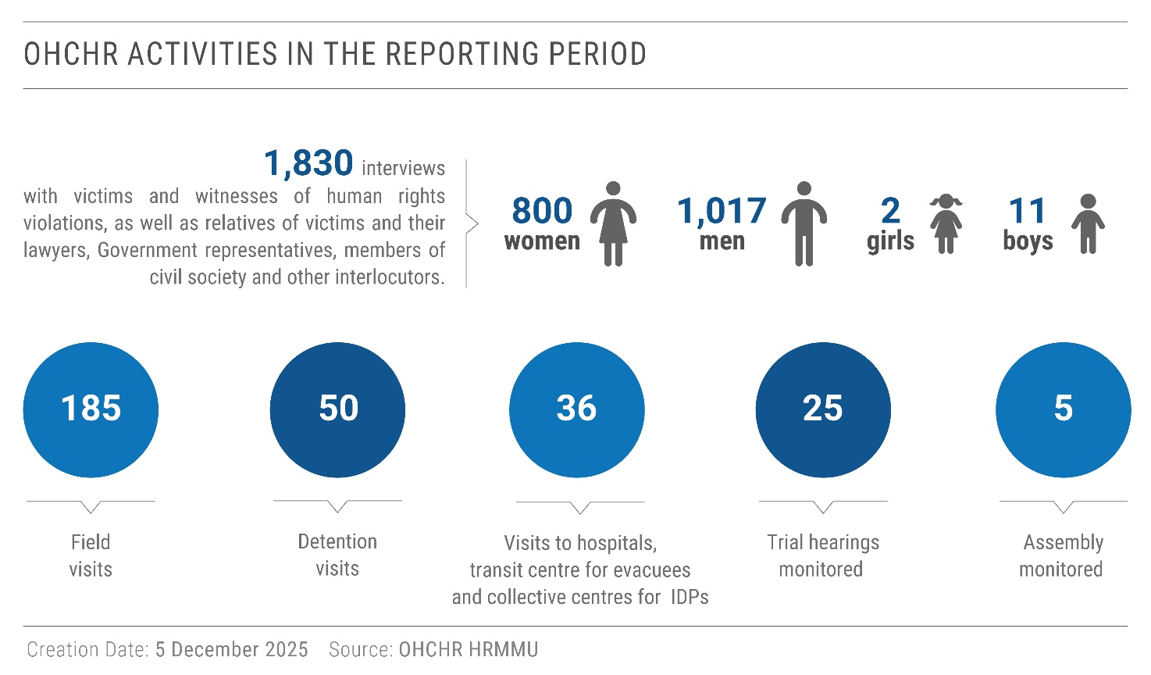
10. Findings are included in the report where they meet the “reasonable grounds to believe” standard: namely where, based on a body of verified information, an ordinarily prudent observer would have reasonable grounds to believe that the facts took place as described, and where legal conclusions are drawn, that these facts meet all the elements of a violation.
11. Verification of alleged violations in occupied territory of Ukraine was complicated by lack of access granted by the Russian Federation to OHCHR for independent monitoring despite repeated requests. In addition, individuals still faced difficulty moving from occupied territory to territory controlled by the Government of Ukraine as crossing points are absent, checkpoints within occupied territory are numerous, and travel requires vast detours through the Russian Federation. Many people in occupied territory were also hesitant to share accounts via telephone or electronic messaging services out of concern that conversations may be overheard or intercepted. OHCHR reiterates its request to the Russian Federation for access to occupied territory, in line with resolution 79/184 of the General Assembly.
III. Impact of hostilities on the civilian population
A. Increased civilian casualties in urban and frontline areas
12. Intense hostilities in frontline areas combined with frequent large-scale Russian missile and loitering munitions attacks in urban centres caused an increase in civilian casualties during the reporting period.
13. A total of 1,420 civilians were killed and 6,545 injured, including 4,435 men, 3,148 women, 229 boys and 153 girls, marking a 12 per cent increase compared to the same period 12 months earlier (1,201 killed and 5,899 injured), and a 37 per cent increase compared to the prior six months (979 killed and 4,840 injured). Sixty-one medical workers, 6 media workers, and 99 emergency service personnel were among the casualties.
14. OHCHR also documented 13 casualties among humanitarian workers, not only in frontline communities but also far from the frontline. For example, on 4 September 2025, during a Russian missile attack near Novoselivka, Chernihiv region, two humanitarian demining workers (men) were killed and several others were injured while working in a field clearing agricultural land. In another case, closer to the frontline, on 14 October 2025, near Bilozerka, Kherson region, Russian armed forces struck a United Nations humanitarian convoy with short-range drones. The convoy consisted of four clearly marked white vehicles transporting humanitarian assistance. Two trucks sustained serious damage.
15. Ninety-seven per cent of civilian casualties occurred in territory controlled by Ukraine (1,363 killed and 6,398 injured), while 3 per cent occurred in territory occupied by the Russian Federation (57 killed and 147 injured).
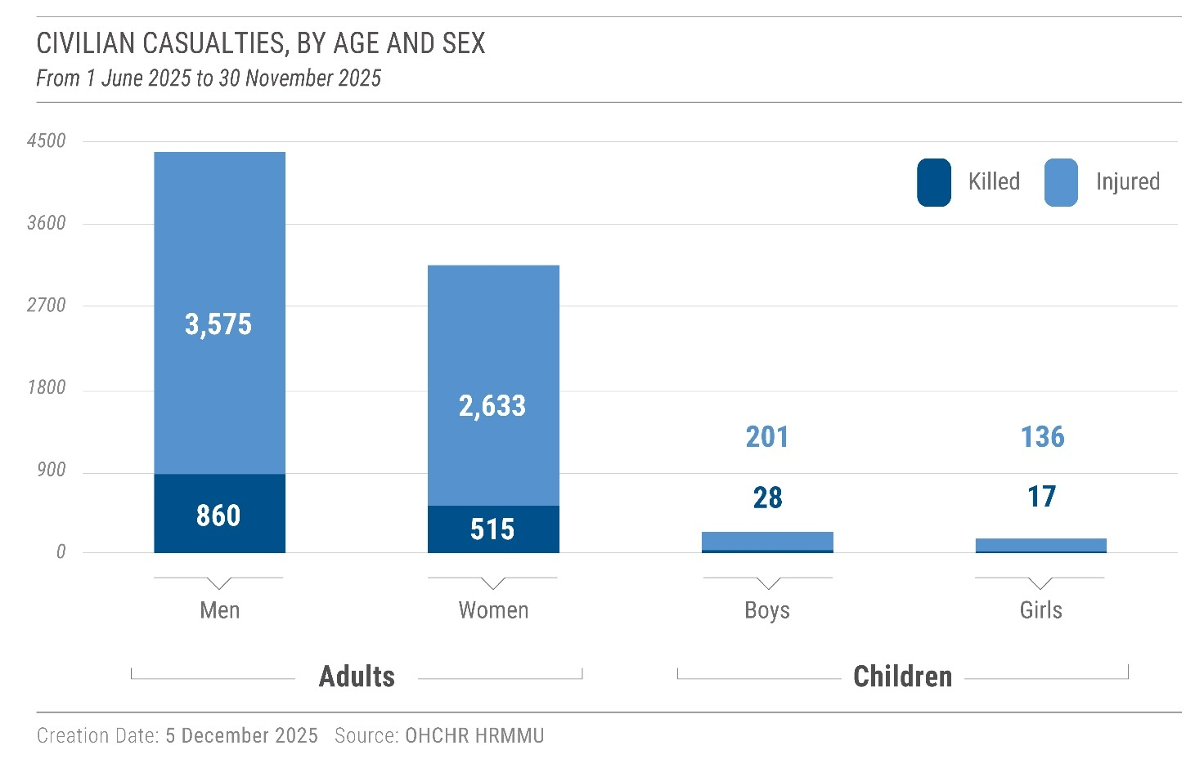
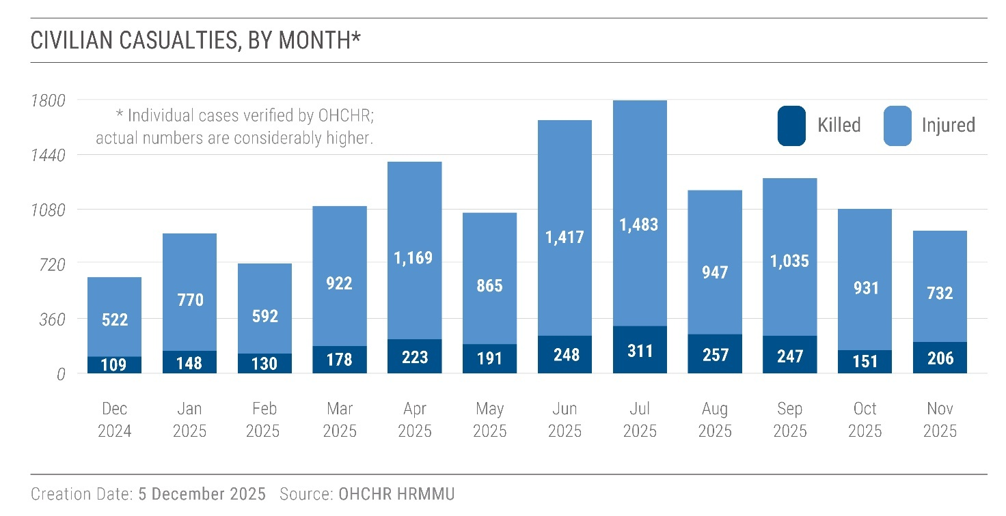
16. Civilian casualties rose sharply in June 2025, and July marked the highest monthly total of civilians killed and injured since April 2022. Sixty-two per cent of all civilian casualties were caused by explosive weapons with wide area effects used in frontline regions, with older persons disproportionately affected. Another 38 per cent of civilian casualties resulted from attacks by long-range missiles and loitering munitions deployed in urban areas, often far from the frontline. Such attacks routinely affected cities like Kyiv, Zaporizhzhia and Kharkiv, though civilians in some regions were also affected for the first time, including in Chernivtsi and Zakarpattia. OHCHR also documented significant destruction from the Russian Federation’s increased use of multiple launch rocket systems (MLRS) in urban frontline areas, such as Zaporizhzhia and Sumy City. MLRS that fire multiple unguided rockets, at rapid intervals, lack the precision necessary to effectively distinguish between military objectives and civilians and civilian objects in populated urban areas, as required under IHL.
17. Russian authorities reported that at least 146 civilians were killed and 1,154 injured in attacks by the Ukrainian armed forces in 18 regions of the Russian Federation. OHCHR has established the identity of some of them; however, the circumstances of the incidents remain subject to verification due to lack of access and limited publicly available information.
B. Intensification of long-range attacks on cities
Long-range weapons attacks
18. Between December 2024 and November 2025, the daily average number of loitering munitions (long-range drones) deployed by the Russian Federation nearly tripled, rising from approximately 60 to over 180. According to Ukrainian authorities, on the night of 6 September 2025 alone, Russian armed forces deployed 823 long-range munitions, the highest number since the beginning of the full-scale invasion of Ukraine in February 2022.
19. The deployment of hundreds of powerful missiles and drones in rapid succession in urban areas caused multiple civilian casualties. In some cases, Russian armed forces launched cruise missiles immediately after air raid alerts for massive drone attacks ended, leading to higher casualties as civilians left shelters.
20. On 31 July 2025, the Russian Federation deployed a reported 317 drones and missiles across Kyiv City, killing 31 civilians (14 men, 12 women, 3 boys and 2 girls) and injuring 171 others (79 men, 75 women, 10 girls and 7 boys): the highest number of casualties verified by OHCHR in the capital since the start of the full-scale invasion. OHCHR verified that a cruise missile, likely flying at low altitude, struck and destroyed an entire section of a residential building. Nine families lost at least two family members each. Overall, civilian casualties in Kyiv City more than quintupled from June to November 2025 (822) compared to the prior six months (154).
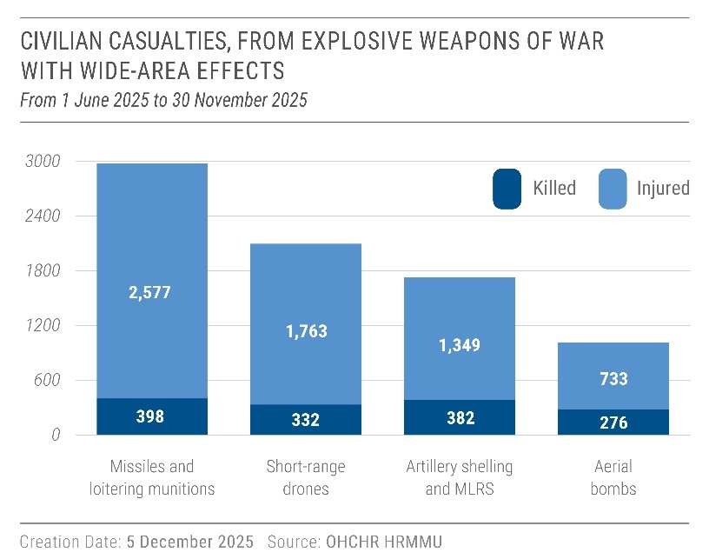
21. On 19 November 2025, the Russian Federation launched a reported total of over 500 drones and missiles across Ukraine, including the western regions of the country. Multiple long-range munitions or their remnants struck two residential buildings in Ternopil, killing at least 35 civilians (16 women, 12 men, 4 boys and 3 girls), and injuring dozens. This incident was the deadliest in the western part of Ukraine since the onset of the full-scale invasion.
22. Intensified long-range attacks launched by the Russian Federation damaged private property in cities far from the frontline. According to the Department of Construction and Housing of the Kyiv City State Administration, 2,489 multi-unit residential buildings in Kyiv were damaged since the full-scale invasion, more than 1,000 of which were damaged in 2025.
23. The use of explosive weapons with wide area effects in populated areas are likely to have indiscriminate impacts and as such raise serious concerns as to their compliance with international humanitarian law.
Attacks with cluster munitions
24. Air-delivered cluster munitions launched by Russian armed forces struck densely populated areas in at least five attacks in four regions, including previously unaffected areas. On 12 July 2025, during a large-scale attack that simultaneously struck multiple cities across Ukraine, a cruise missile exploded in a residential area in Chernivtsi, affecting the city for the first time since the full-scale invasion. Authorities stated that the missile contained a cluster warhead, and a video of the attack analysed by OHCHR appeared consistent with the use of cluster munitions.
25. Using cluster munitions in populated areas is incompatible with IHL due to their indiscriminate effects in such areas. IHL requires parties to a conflict to use means or methods of combat that in the prevailing circumstances are not likely to strike military and civilians or civilian objects without distinction.
C. Attacks on energy infrastructure
26. In October, Russian armed forces resumed large-scale coordinated strikes on energy facilities nationwide, launching eight major waves of attack on multiple regions simultaneously in the final two months of the reporting period. These attacks caused regional emergency power outages and scheduled power cuts across the country lasting up to 10 to 18 hours daily, with heating and water supply disrupted in some areas. In some areas, disruptions lasted more than 36 hours in the immediate aftermath of the attacks. Compared with previous periods, attacks in the reporting period also more frequently targeted natural gas infrastructure, resulting in damage to facilities and disruption of gas supplies to the civilian population.
27. The resumption of nationwide large-scale attacks on energy infrastructure came on the back of continuous smaller-scale targeted attacks throughout the reporting period. From May to September 2025, Russian armed forces launched region-specific, repetitive attack on energy facilities. For example, Russian armed forces attacked energy infrastructure in Sumy region for four consecutive days in late August. The attacks resulted in temporary power outages. Persistent attacks on energy facilities in Chernihiv region also caused significant disruptions to electricity and other services.
28. Ukraine’s authorities, energy companies and humanitarian agencies continued work to stabilize the system. However, the cumulative damage to Ukraine’s energy infrastructure from 2024 together with resumed large-scale strikes in autumn 2025 increased risks to civilians in the upcoming winter period when prolonged disruptions to electricity, heating and water may be critical.
29. In occupied territory, OHCHR also documented increased attacks on energy infrastructure by Ukrainian armed forces, mainly in areas close to the zone of active hostilities in Donetsk and Zaporizhzhia regions. For example, on 19 August 2025, a drone attack on an energy infrastructure in occupied areas of Zaporizhzhia region temporarily left settlements without electricity. On 18 November 2025, Ukrainian armed forces attacked two energy infrastructure facilities in occupied parts of Donetsk region, leading to power outages and the disruption of water and heating in some areas.
30. OHCHR has recorded and analysed publicly available information about attacks on energy infrastructure in the Russian Federation and their consequences. While there are reports of local power outages, publicly available information has not been sufficient to independently verify whether or which of these outages were linked to the attacks, the severity of the outages, or the impact on the civilian population. OHCHR reiterates its request to the Russian Federation to provide access to the areas of the Russian Federation affected by the war in Ukraine.
D. Intensification of hostilities in frontline communities
31. From June to November 2025, 62 per cent of all civilian casualties occurred near the frontline. While civilian casualties were recorded in occupied territory (e.g., in occupied Donetsk and Oleshky, Kherson regions), the vast majority occurred in areas controlled by Ukraine. Older persons, who stay behind in frontline areas (see para. 44), were disproportionately affected - 46 per cent of civilians killed in frontline areas were over 60 years old, although this age group makes up only 25 per cent of the population.
Attacks using short-range first-person view drones
32. Short-range drones, mainly equipped with first-person view (FPV) cameras, continued to be one of the most dangerous weapons for civilians in territory controlled by the Government of Ukraine, killing at least 307 civilians (230 men, 71 women and 6 boys) and injuring 1,677 (1,085 men, 554 women, 24 boys and 14 girls) in the reporting period. Rapid technological advances to FPV drones have extended their operational range, and newer variants are increasingly resistant to electronic interference, allowing them to infiltrate urban areas without triggering air alerts and to strike with greater precision at extended ranges. When operators do not properly distinguish between civilians and civilian objects on the one hand and combatants and military objectives on the other – either because they are unwilling or unable to do so – civilians are placed at extremely high risk.
33. On 27 July and 9 August, FPV drones attacked passenger buses in Ivolzhanske, Sumy region Inzhenerne, Kherson region, and Inzhenerne, Kherson region, killing 6 civilians (3 women and 3 men) and injuring at least 32 civilians (17 women and 15 men). Russian FPV drones, now modified to reach an extended range also struck central Zaporizhzhia City for the first time on 4 September 2025, injuring 4 women.
34. Short-range drones in occupied territory killed 25 civilians (13 men, 11 women and 1 boy) and injured 86 (43 men, 41 women, 1 boy and 1 girl), mainly in occupied areas of Donetsk, Kherson and Zaporizhzhia regions. For example, on 31 July, a drone struck a civilian vehicle in the occupied parts of Polohivskyi district of Zaporizhzhia region, killing three civilians, including one child, and injuring one other civilian passenger.
Attacks using aerial bombs
35. Powerful aerial glide bombs deployed by Russian armed forces killed 276 civilians and injured 733 in territory controlled by the Government of Ukraine. These air-dropped munitions pose a severe threat to civilians due to their destructive capacity and longer range. Civilian casualties from glide bombs mainly affected communities in Donetsk, Kharkiv and Zaporizhzhia regions. For example, on 28 July 2025, multiple glide bombs struck a penal colony in Bilenke, Zaporizhzhia region, killing 16 men prisoners and injuring at least 43. On 9 September 2025, a glide bomb killed 25 civilians (16 women and 9 men) and injured at least 19 (13 women and 6 men) in Yarova, Donetsk region. Most of the victims were collecting their pensions from a postal service vehicle in the town centre when the bomb struck nearby: 21 of those killed and 13 of those injured were over age 60.
E. Impact of hostilities on rights of civilians in frontline areas
“Your day starts with explosions. The explosions wake you up instead of an alarm. And they become closer and closer, louder and louder. You also go to bed with explosions, and you do not know whether you will wake up or not the next morning.”
– an evacuee in a transit centre describing his life in a frontline settlement in Dnipropetrovsk region.
Destruction of residential housing and civilian infrastructure
36. Highly destructive attacks have caused massive damage to residential housing and other critical infrastructure essential to civilian life in frontline areas. Displaced persons and local authorities from several smaller villages in frontline areas of Donetsk region informed OHCHR that for instance, most houses in Stavky, Bohorodychne and Rubtsy had been damaged or destroyed. Satellite imagery of frontline villages and towns confirmed significant damage to residential and civilian areas following the full-scale invasion.
37. More than 90 per cent of the 67,350 pre-2022 residents of Kostiantynivka, Donetsk region, an industrial city now less than 10 kilometres from the frontline, have been displaced. Despite the drastically reduced population, civilian casualties there in absolute terms increased by 79 per cent this year compared to the same period in 2024. In interviews at transit centres during the reporting period, 29 people who had just been evacuated from Kostiantynivka told OHCHR that most residential and civilian buildings, including healthcare, education and administrative centres, had been damaged or destroyed. The last hospital closed in September, and ambulances could not reach people in need due to the constant shelling. Ongoing hostilities disrupted critical utility supplies, including electricity, gas, and water, and prevented repair work. As a result, the remaining residents, mostly older persons, must carry large, heavy bottles from wells with drinkable water. An older woman described the situation in Kostiantynivka as “a nightmare and unbearable for a human being”.
38. In Donetsk, Kharkiv and Kherson regions, local authorities from 15 settlements located near the frontline told OHCHR that the majority of residents remaining were older persons and persons with disabilities. Mandatory evacuation of families with children had been announced in all of these settlements, and in 11 of them, it was ongoing since 2024. The remaining residents have little access to goods and services, including health care, food shops and cash withdrawal. Residents remained without electricity supply for prolonged periods of time (for more than 30 months in one settlement), which poses serious risks during winter months.
“I lived, worked hard and earned what I had, I overcame so many challenges and now I am here. I want to go back [home]. We lived a normal life, but they destroyed everything.”
– a 100-year-old woman in a wheelchair who had just been evacuated to a transit centre from a frontline village in Dnipropetrovsk region, about 10 km away from the frontline.
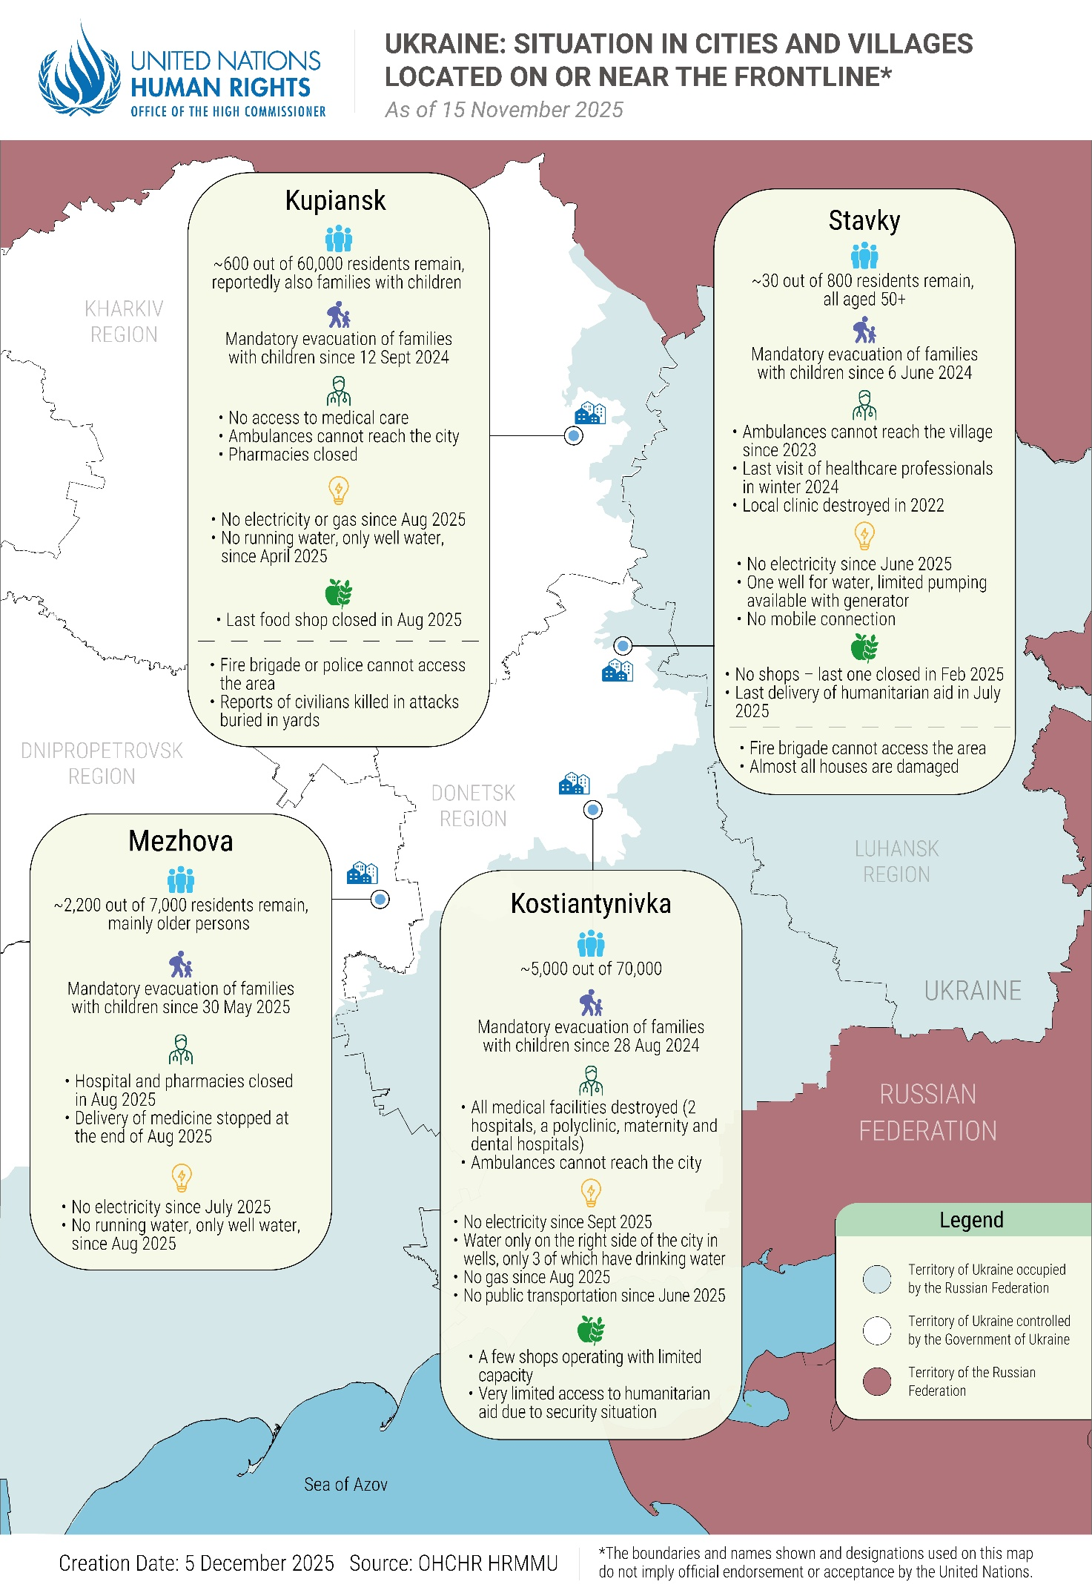
Right to health in frontline areas
39. Intensified hostilities led to the effective denial of the right to health in some areas due to the collapse of medical services following serious damage to health facilities. Beyond the immediate effects on residents, this damage will have long-term consequences for the healthcare system in these areas. In Kostiantynivka, for example, all medical facilities had been destroyed or shut down by the end of August, leaving paramedics and evacuation teams as the only lifelines for injured civilians.
40. Most health facilities still functioning in frontline regions were extremely short-staffed due to displacement and casualties among medical workers. A regional healthcare authority from Kharkiv reported that nearly 40 per cent of hospital positions were unfilled. A healthcare representative in Mykolaiv region said that acute personnel shortages had tripled the workload for remaining staff. After the only family doctor in one village in Kharkiv region left, a nurse kept the clinic running in a very limited capacity, primarily providing basic medicine and issuing death certificates. By September 2025, mobile pharmacies had stopped visiting the village, and in early October, the nurse also evacuated, leaving around 400 remaining residents, mostly older persons, without access to basic health services.
41. Thirty-eight IDPs told OHCHR they had had no or very limited access to medical care in frontline areas. A hospital representative in Mykolaiv region noted that patients over age 70 increasingly accumulated several serious health issues by the time they were admitted to the hospital, including severe bacterial infections and conditions requiring amputation. Many illnesses became chronic because patients could not seek prompt medical care, either due to the unavailability of medical services, the disintegration of social and family ties in frontline areas, or harmful coping mechanisms such as heavy alcohol consumption.
42. Hostilities in frontline areas either prevented civilians from traveling to receive specialized care, including for sexual and reproductive health, as well as newborn and child health, or forced them to further risk their lives to access it. A pregnant woman from a rural area in Kherson region told OHCHR she had to drive a long distance for prenatal checks. During one journey, a drone attacked her car, injuring her and her husband; her pregnancy was not harmed.
43. Intense hostilities and FPV drone attacks prevented ambulances and emergency services from reaching civilians in multiple frontline regions, including Donetsk, Dnipropetrovsk, and Kherson. A doctor in Dnipropetrovsk region said it had become impossible to apply rapid life-saving emergency protocols for traumatic injuries due to significant challenges to reach and evacuate injured civilians.
Forced displacement
44. New waves of displacement were triggered during the reporting period after civilian life became progressively untenable in frontline cities and towns, particularly in areas of Donetsk and bordering Dnipropetrovsk regions, as sustained attacks effectively destroyed residential buildings and essential infrastructure of entire towns. The vast majority of evacuees told OHCHR that they left their homes because the constant attacks had become unbearable or essential services had been shut down. An older woman from a frontline town in Dnipropetrovsk region said she had delayed her evacuation because she did not want to leave her home, but finally left after the post office closed and she could no longer receive her medication.
45. Ukrainian authorities reported that from 1 June to 21 November 2025, over 133,000 residents were evacuated from frontline areas, including around 16,500 children and 4,600 persons with limited mobility. The majority (67 per cent) evacuated from Donetsk region. Between June and November 2025, Ukrainian authorities announced the mandatory evacuation of families with children from at least 125 settlements in Donetsk, Dnipropetrovsk, Kharkiv and Zaporizhzhia regions, where more than 7,600 children still lived, including the cities of Druzhkivka and Dobropillia. Around 2,000 people were displaced from Korabelnyi district in August 2025 when Russian armed forces damaged the bridge linking it to Kherson city. More than half of the displaced were older persons.
46. In August 2025 alone, 11,000 newly displaced persons registered in transit centres, stretching the capacity of the humanitarian response. In the Pavlohrad transit centre in Dnipropetrovsk region, which has a capacity of 100 beds, nearly 400 people arrived in a single day. Authorities opened two new centres in Kharkiv and Dnipropetrovsk regions to address this increase.
47. Many of those displaced were older persons and persons with disabilities, who were often the last ones remaining: they were often unable or reluctant to leave areas under active hostilities due to financial constraints, limited information on future accommodation and types of support, and attachment to their land. NGOs carrying out evacuations continued to face funding shortfalls, along with difficulties identifying accommodation meeting the specific requirements of older persons or persons with disabilities, as not all transit centres were accessible and there was a severe shortage of accessible long-term housing.
48. Ukraine, individually through its available resources and international assistance, continues its efforts towards the progressive realization of economic and social rights, and to guarantee these rights without discrimination. In frontline areas, Ukraine has taken steps to meet its IHRL and IHL obligations to ensure access to healthcare, social protection and other services, with national and international humanitarian organizations providing many life-saving services. However, the security situation often limits the capacity of Ukrainian public employees and humanitarian actors (see para. 13). In long-term displacement, IDPs – particularly those in a vulnerable situation – continued to face challenges in accessing adequate housing and securing an adequate and durable standard of living.
49. Displaced individuals faced higher costs of living in safer areas, particularly for rent, which their incomes (including salaries, IDP allowances, and/or pensions) could not cover. Several IDPs told OHCHR that while they used to grow fruits and vegetables, or raise livestock for milk, meat and eggs, they now had to purchase these staples, which further stretched their already meagre budgets. IDPs also struggled to find work, as their education or professional background seldom aligned with limited job opportunities available in their host communities. During the reporting period, four displaced women told OHCHR that, as the only breadwinner of a household with children, they had had difficulty finding employment after being out of the job market for several years due to caregiving responsibilities, or because their children were often sick after their relocation. The coordinator of a collective centre in Zakarpattia region emphasized the crucial need for psychological support for displaced women.
50. Several Roma-led NGOs told OHCHR that Roma people had been displaced by the intensification of hostilities in eastern Ukraine in 2025. Because of societal discrimination, displaced Roma faced particular difficulties accessing housing and work in their host communities. Furthermore, the lack of valid identity documents, which often affected entire Roma families, limited their access to formal employment, pensions and social security, including benefits for families with children or with low income. OHCHR received information that at least two Roma families returned to unsafe areas close to the frontline due to a lack of documents and financial resources.
51. Some individuals in a vulnerable situation, especially older persons and persons with disabilities, stayed for prolonged periods in shelters inadequate for their requirements. OHCHR interviewed three men with disabilities, two of whom were wheelchair users, who lived in a modular town for IDPs without accessible bathrooms and with a gravel courtyard not suited for wheelchairs. They could not afford to move elsewhere and spent most of their monthly income on medicines, including painkillers. Some IDPs returned or considered returning to unsafe areas. For instance, a family with four children living in a collective centre told OHCHR that because they did not have money or work, they were considering returning to occupied territory, despite the associated risks.
F. Continued impact of hostilities on education
52. Ongoing hostilities continued to affect education across Ukraine in the 2025-2026 school year. Many schools only operated in online or hybrid formats due to safety risks. According to the Ukrainian Ministry of Education, approximately 2.290 million children studied in person, 681,000 in hybrid mode, and 315,000 completely online, with regional disparities depending on the security situation. Several teachers underlined to OHCHR that the absence of face-to-face interaction with peers and teachers impeded children’s social and emotional development. Many became withdrawn and disoriented, particularly primary school students who had not yet experienced in-person learning.
53. As of September 2025, 33 fully underground schools operate in Chernihiv, Kharkiv, Kherson, Sumy and Zaporizhzhia regions for safety. While these undergrounds schools balanced security concerns with access to in-person education, an interlocutor from Zaporizhzhia detailed the associated drawbacks, including the lack of natural light or outdoor spaces, which diminished children’s well-being, physical development and right to play. Some communities, like Kherson city, could not open underground schools because the hostilities, including extensive use of FPV drones, made it too dangerous for children to travel to school.
54. Education professionals in Dnipropetrovsk region told OHCHR that, due to the war, children with special educational needs had received specialized support, such as speech therapy and physical therapy, online for over three years. Online learning had negatively impacted learning outcomes, as information was often more difficult for children with special education needs to absorb through digital formats. This difficulty was compounded by disruptions due to hostilities and power outages.
IV. Prisoners of war
55. Between the end of May and August 2025, Ukraine and the Russian Federation conducted the largest exchanges of POWs since 2022, leading to the release of more than three thousand prisoners from both sides.
A. Ukrainian POWs held by the Russian Federation
Extrajudicial executions
56. OHCHR documented the extrajudicial execution of eight Ukrainian prisoners of war (POWs); seven of the incidents occurred in previous reporting periods. In September 2024, the Russian armed forces captured two Ukrainian soldiers. After interrogation, a Russian officer, allegedly the deputy commander of the battalion, first subjected one of the POWs to a mock execution. He then shot another POW twice in the head, killing him. In total, since 24 February 2022, OHCHR has documented the extrajudicial execution of 96 Ukrainian POWs and persons hors de combat (all men) by Russian armed forces.
57. Since mid-November 2025, OHCHR recorded an increase in reports of executions of Ukrainian servicepersons captured by Russian armed forces. OHCHR assessed the allegations related to at least four incidents, involving the killing of 10 men, as credible based on analysis of video and photo material published by Ukrainian and Russian sources. It continues to look into two more incidents involving the killing of eight more Ukrainian POWs.
“The most hideous thing was the hunger. Constant hunger. Bodily injuries are nothing in comparison to the hunger”
- Ukrainian POW on conditions of interment in pre-trial detention facility in the Russian Federation.
Torture, ill-treatment and deaths in custody
58. OHCHR interviewed 187 recently released Ukrainian POWs (all men). Most interviewees had been held captive for over two years, with some exceeding three years. 185 interviewees provided detailed accounts of torture and ill-treatment, including severe beatings, stress positions, electric shocks, suffocation, dog attacks, prolonged standing, exhausting physical exercise or labour, and humiliation, as well as dire conditions of detention. Of these interviewees, 141 (75 percent) disclosed having been subjected to sexual violence. At least 119 interviewees reported torture and ill-treatment occurring in 2025, with some subjected to violence shortly before their exchange. These findings corroborated OHCHR’s previous conclusion that Russian authorities had subjected Ukrainian POWs to torture, ill-treatment and inhumane conditions in a widespread and systematic manner.
59. POWs who remained for prolonged periods in the same facilities, both in the Russian Federation and in the occupied territory of Ukraine, often observed a decrease or cessation of torture and an improvement of conditions starting in 2024. However, such improvements were not consistent. For example, a large group of POWs transferred to a penal colony in Donetsk region in mid-June 2024 reported no violence during admission, while subsequent arrivals at the same facility were subjected to violent beatings between July and October 2024. The practice reportedly ended following an incident of a prisoner being beaten to death.
“During my whole time in the facility, we were beaten almost every day. The guards beat us almost every time we were leaving the cell for an inspection or to go to the medical unit or shower. After some time, I calculated that there was a 50 per cent chance of sustaining hits to my head during each ‘beating session’. Several times I was beaten so badly that my body hurt for weeks.”
– Ukrainian POW on treatment in 2025 in a pre-trial detention facility in the Russian Federation.
60. In 2025, torture and ill-treatment frequently occurred following the transfer of POWs to 10 detention facilities in 10 regions of the Russian Federation, most of which had not previously been used for internment of POWs. Interviewees were held in a so-called ‘strict detention regime’ and frequently described violent beatings, electric shocks and stress positions during admission and routine beatings during inspections or movement around the facility. Penitentiary personnel did not inform POWs about the names of the facility where they were held. Separately, some POWs described torture and ill-treatment during interrogations by investigators aimed at extracting confessions or accounts of war crimes, despite not having previously been questioned about such allegations in other places of detention. Nonetheless, interviewees noted some improvements in conditions from March to May 2025, which they associated with preparations for upcoming exchanges.
61. Recent findings also indicate the continued operation of at least three places of detention outside the designated internment locations—two in the occupied territory of Ukraine and one in the Russian Federation. Interlocutors reported torture and poor conditions in the two facilities in the occupied territory.
62. Recent interviews also allowed OHCHR to identify 31 penitentiary staff across 8 facilities in the Russian Federation and occupied territory of Ukraine, including senior officers, who were directly involved in torture and ill-treatment. For instance, a POW reported that in 2023, the head of security of a penitentiary facility in Rostov region, while intoxicated, had used a taser on him after becoming angered by the POW’s statement that, as a medic, he had not killed anyone during hostilities. In another case, two deputy chiefs of a penal colony in occupied territory of Ukraine ordered a guard to punish a POW who had been told to adjust a TV antenna on the roof. They accused the POW of trying to survey the territory because he spent “more time than needed” on the roof. The guard beat the POW so severely with a truncheon that his legs remained swollen and bruised for two weeks, leaving him barely able to walk.
63. OHCHR documented the deaths of 16 Ukrainian POWs (all men) in places of internment, as a result of torture and ill-treatment, including poor conditions of internment, or inadequate medical attention. Fifteen of these deaths occurred in previous reporting periods. For example, in July 2025, a Ukrainian POW died in a detention facility in the Russian Federation. He had a fever, was weak and could not walk properly for a month. Though other POWs made numerous requests that the prison authorities place the man in the infirmary, he did not receive any medical treatment and died in his cell. Since 24 February 2022, OHCHR has documented the death of 41 Ukrainian POWs and one retained medical personnel (all men) in places of internment, as a result of torture and ill-treatment, including poor conditions of internment, or inadequate medical attention in the occupied territory of Ukraine and the Russian Federation.
B. Russian and third-country national POWs held by Ukraine
Extrajudicial executions
64. OHCHR documented the extrajudicial execution of four Russian POWs by Ukrainian armed forces. For example, in October 2025, Ukrainian armed forces executed a severely wounded Russian soldier upon capture in Zaporizhzhia region. In addition, OHCHR recorded credible allegations of executions of three Russian military personnel captured by the Ukrainian armed forces based on analysis of video and photo material showing the executions or dead bodies; information about these incidents was published in media in November 2025. Since February 2022, OHCHR has documented the execution of 30 persons hors de combat (all men), including Russian POWs, by Ukrainian armed forces. The vast majority of these incidents occurred in 2022 and early 2023.
Torture and ill-treatment
65. OHCHR interviewed 137 POWs (all men), including 10 nationals of third countries, more than half (77), including 37 captured in 2025, provided accounts of torture or ill-treatment, namely being struck with fists or plastic sticks, during interrogation, transfer or internment in transit locations. They also noted that medical personnel in official places of internment did not ask them about the origin of the injuries they had received from beatings and did not provide them a copy of the medical examination report. The POWs did not know whether medical personnel notified the authorities of signs of potential torture and ill-treatment.
“I knew nothing, but they kept torturing me even more”
– Russian POW on torture during interrogation in a transit place.
66. Some POWs spent prolonged periods during transit in facilities that were not part of the internment infrastructure established by the Ministry of Justice, which in practice precludes access to independent monitors. Several POWs reported internment in such facility in Mykolaiv region in 2025, where they were held for periods lasting from several weeks to seven months prior to their transfer to a place of internment, part of the infrastructure established by the Ministry of Justice. Four interviewees held in this facility reported that the guards beat POWs collectively on occasion, or that they were beaten with batons while going to and from the toilet. Twelve POWs reported being interned in another unidentified location in 2025, where some POWs, particularly those willing to work, were held for up to one year. In both places, POWs had the possibility to periodically call their loved ones. Internment in facilities outside the structure set up formally by Ukraine to intern POWs increases risks of ill-treatment and other violations of the Third Geneva Convention and international human rights law.
67. The Office of the Prosecutor General of Ukraine reported that criminal investigations were ongoing into acts of torture and ill-treatment at a specific unofficial location of internment in Donetsk region between March and September 2024, as detailed in a previous OHCHR report. No suspects had been identified.
V. Conflict-related sexual violence
68. OHCHR documented 180 cases of conflict-related sexual violence (CRSV) perpetrated by Russian officials against 141 Ukrainian POWs (all men), 34 civilian detainees (32 men and 2 women) and 5 civilians in residential areas (3 women and 2 girls). Of these, at least 30 cases against POWs and 2 cases against civilian detainees occurred in 2025. The documented cases confirm patterns of sexual violence that OHCHR has documented since 24 February 2022. Further, on 30 November 2025, the Russian paramilitary group “Rusich” published a Telegram post with pictures of Ukrainian servicewomen, calling for them to be taken prisoner, after which “the male population itself knows what to do with them”.
69. In total, since 24 February 2022, OHCHR has documented 664 cases of CRSV perpetrated by Russian officials against 523 men, 124 women, 15 girls and 2 boys, including 449 Ukrainian POWs (422 men and 27 women), 135 civilian detainees (94 men, 40 women and 1 boy), and 84 civilians in residential areas (8 men, 60 women, 15 girls and 1 boy).
70. OHCHR also documented seven cases of CRSV perpetrated by Ukrainian officials against Russian POWs (all men), primarily in the initial stages of captivity before arrival at places of internment that are part of the infrastructure established by the Ministry of Justice. In addition, OHCHR documented six cases of CRSV perpetrated by Ukrainian officials against conflict-related detainees (two men and four women). Of these, three cases against Russian POWs and two cases against conflict-related civilian detainees occurred in 2025.
71. In total, since 24 February 2022, OHCHR has documented 79 cases of CRSV perpetrated by Ukrainian officials against 67 men and 12 women, including 48 Russian and third-country national POWs (all men) and 31 conflict-related detainees (19 men and 12 women).
VI. Human rights in territory occupied by the Russian Federation
A. Rights to life, physical and mental integrity, liberty and security
Extrajudicial executions
72. In September 2025, Russian armed forces executed a married couple (a man and a woman) and their neighbour (a man) in their home in the occupied part of Kherson region. According to reports, military personnel accused the neighbour of cooperating with the Ukrainian armed forces and the couple of hiding him. OHCHR has documented extrajudicial executions of at least 14 civilians (8 men and 6 women) in three occupied districts of Kherson region since November 2022, when Russian armed forces withdrew from Kherson city along the right bank of the Dnipro River. OHCHR continues to assess detailed reports of killing of 18 more civilians (13 men and 5 women) since November 2022 in the same area.
73. In total, since 24 February 2022, OHCHR has documented 182 extrajudicial executions, including in detention (148 men, 27 women, 5 boys and 2 girls) in areas controlled by the Russian armed forces.
Violations of procedural safeguards and fair trial rights affecting Ukrainian civilian detainees held by the Russian Federation
75. OHCHR interviewed 11 released Ukrainian civilian detainees (all men) who had been detained by Russian authorities before February 2022 in Donetsk or Luhansk regions, but were convicted by courts in occupied territory or the Russian Federation after the full-scale invasion for a variety of crimes, including high treason, illegal weapons possession, terrorism-related activities, sabotage and espionage. None of the civilian detainees interviewed had had a lawyer present during their initial interrogations. Nine interviewees provided credible and reliable information that they had been subjected to torture and ill-treatment during interrogations. In at least six cases, the verdicts of the court appeared to be based on confessions obtained during those interrogations. Two of the interviewees reported that they complained to judges about forced confessions, and investigations were subsequently launched. One interviewee described being threatened by officers of the Russian Investigative Committee to withdraw the complaint; the other recounted that the judges mocked him for complaining. In both cases, the claims were rejected.
76. On 31 July 2023, the Russian Federation introduced a law purporting to apply the entire criminal legislation of the Russian Federation to criminal offenses committed in occupied Donetsk, Luhansk, Zaporizhzhia and Kherson regions before 30 September 2022, contrary to the obligation under the law of occupation to respect – unless absolutely prevented from doing so -- the laws in force in the occupied territory. This also meant that Ukrainian civilians were sentenced for high treason against the Russian Federation for acts they allegedly had committed in the self-proclaimed ‘Luhansk people’s republic’ and ‘Donetsk people’s republic’ before 2022, in violation of the prohibition of retroactive criminal law under international human rights law. OHCHR recently interviewed six released civilian detainees who reported that this had occurred in their cases.
77. In addition, OHCHR interviewed 23 civilian men who were detained by the Russian Federation in occupied territory for more than three and a half years after the full-scale invasion without any apparent criminal process, while the Russian Federation has also not established any procedures for interning protected persons on security grounds. In another case, in 2024, a Russian-appointed court in Donetsk region sentenced a former member of the Ukrainian armed forces, detained since 2017, to six and a half years of imprisonment. After sentencing, he was directly released from court as the sentence was considered served due to his lengthy pre-trial detention. However, upon leaving the court building, he was immediately re-apprehended and detained for alleged curfew violations. Thereafter, the occupying authorities re-classified him under an asserted “POW status”, and he was deported to a place of internment in the Russian Federation. This practice does not afford the individual the procedural safeguards guaranteed by the Fourth Geneva Convention, such as the ability to challenge their detention.
Deportations
78. Under IHL, the occupying Power is required to respect the existing laws and institutions of the occupied territory as far as possible and to avoid making far-reaching changes to the existing order or intrinsic characteristics of the occupied territory.
79. In violation of this obligation, a Russian Federation decree of March 2025 set a deadline of 10 September 2025 for all Ukrainian citizens in occupied territory to “legalize” their stay by obtaining a Russian passport, residence permit or another legal basis for stay under Russian domestic law, or to risk deportation.
80. In 2025, the Russian Federation deported dozens of Ukrainian nationals to Georgia. Among this group were Ukrainians who had been serving criminal sentences received before February 2022 in prisons located in territory that the Russian Federation occupied and other civilians detained directly by the occupying authorities and then deported to prisons in the Russian Federation, in violation of the prohibition of deportation of protected persons from occupied territory. These individuals were deported a second time to Georgia upon their release from prison. Many of these individuals no longer held valid Ukrainian identity documents, which impeded their entry to Georgia. This resulted in at least 90 people detained at the Russian Federation border with Georgia between 1 June and 31 August 2025, where they did not have access to adequate medical care. One woman described to OHCHR that she had not had access to anti-retroviral therapy while detained at the border. People spent periods of up to 12 weeks in overcrowded conditions at the border, awaiting the issuance of documents that would allow them to cross the border. As of 30 November 2025, a group of Ukrainian civilians remains detained at the Russian Federation border with Georgia.
Conscription
81. On 1 October 2025, the Russian Federation began its annual military conscription campaign, which included protected persons in the occupied territory of Ukraine. The campaign’s outreach was more extensive than previous years, since for the first time, the occupying authorities issued digital conscription notices through “Gosuslugi”, a Russian Federation Government website used for digital services, including for residents of occupied territory. This increased the risk that Ukrainian people could be conscripted for a period of 12 months into an armed force at war with their own country, in violation of IHL.
B. Economic, social and cultural rights
Access to water
82. Under IHL, the occupying Power is obliged to ensure, to the fullest extent possible, public health and hygiene, and the basic needs of the local population. Under international human rights law (IHRL), which continues to apply in armed conflict, people have the right to an adequate standard of living, which includes the right to water.
83. On 18 July, the occupying authorities in Donetsk region introduced water rationing due to shortages, limiting access to running water in Donetsk and Makiivka to once every three days or less, with additional restrictions in other settlements.
84. Multiple factors reportedly contributed to the shortage. Hostilities in 2022 had already severely damaged the Siverskyi Donets canal, resulting in reduced reservoir levels in Donetsk region, exacerbated by dry weather since. Satellite imagery analysis indicates a significant degradation of the amount of water in the nine reservoirs in the occupied parts of Donetsk region. Between 2021 and 2025, the total water surface area of these reservoirs decreased by 38 per cent, with the Volyntsivske Reservoir reducing in size by over 90 per cent. Furthermore, the occupying authorities in Donetsk city stated that ageing, leaking and corroded water pipes further reduced available water. Though the occupying authorities installed a channel and pipe system to bring water from the Don River in the Russian Federation, experts in hydrology and water supply systems told OHCHR that this system lacked the capacity to meet the population’s needs.
85. The occupying authorities in Donetsk region instituted water trucking; however, residents told OHCHR that deliveries were irregular. Open sources reported that private vendors sold bottled water at inflated prices, making clean water unaffordable for many. Residents of affected areas confirmed water scarcity, reporting access to running water for only a few hours every two or three days or less. When available, water pressure was often insufficient for basic needs such as laundry or flushing toilets, and water quality was poor. OHCHR reviewed photos and videos from residents showing yellow or otherwise discoloured water, described as foul-smelling and unfit for consumption. The reports of poor water quality are particularly concerning given environmental hazards present in a region historically dominated by heavy industrial activity, including coal mining, chemical processing and metallurgy.
86. A woman from Donetsk told OHCHR that in late August her home received water only for a few hours every four days, with very low pressure. Her family could not fill enough containers to last until the next supply and resorted to buying water, which was expensive and had to be carried home. This was physically difficult for the woman, who lived with her mother and her daughter. After six days without water, the family had to leave their home on this account and relocate to another settlement in occupied territory.
87. Water needs are expected to increase in winter. Centralized heating systems in urban areas of occupied Donetsk region depend on the circulation of hot water through pipes and radiators. Experts informed OHCHR that they were concerned the shortage, if not addressed, could hinder the operation of these systems during the winter months. In addition, diverting water to heating systems risked further reducing availability for other household needs.
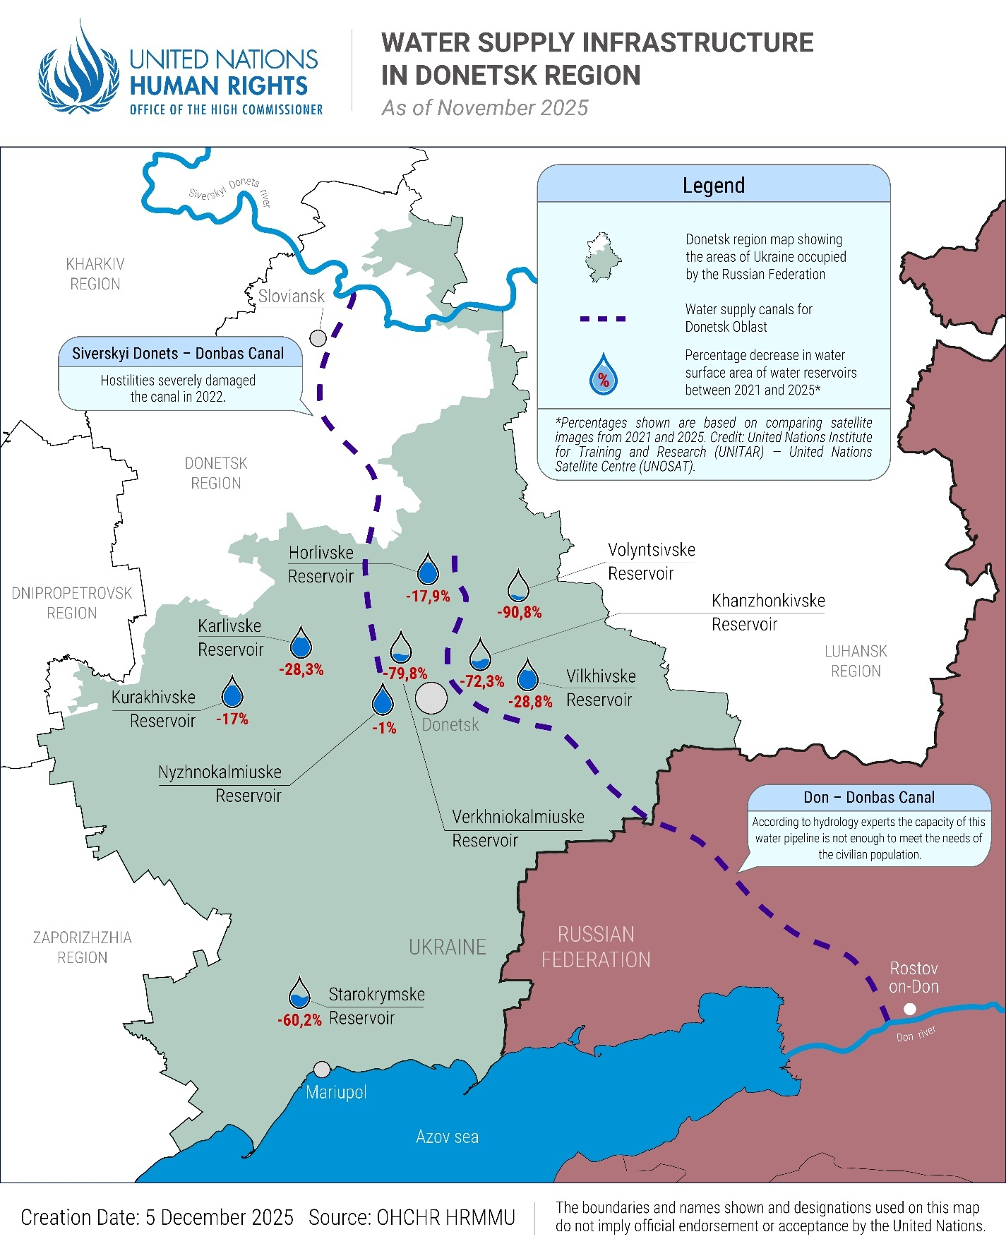
Housing, land and property rights
88. The occupying authorities continued implementing procedures to expropriate so-called “abandoned” residential property in accordance with legislation adopted in 2024, despite IHL provisions prohibiting an occupying Power from confiscating private property.
89. The legislation lists failure to pay utility bills and non-use of premises, which creates a safety risk to the building or persons, among criteria for identifying a property as potentially “abandoned”. Several IDPs in Government-controlled areas of Ukraine informed OHCHR that they regularly paid utility bills for their properties in occupied territory and that relatives maintained their homes in their absence. One IDP’s mother periodically resided in his apartment. Nevertheless, their apartments were all declared potentially “abandoned” by the occupying authorities.
90. OHCHR verified that occupying authorities issued notices identifying over 38,178 homes as potentially “abandoned”, including 4,500 during the reporting period. If ownership is not confirmed within 30 days of the notification, occupying authorities may register the property as “abandoned” under the law in question and begin judicial proceedings to transfer it to municipal ownership. Occupying authorities in Donetsk and Luhansk regions have published documents showing they have registered at least 5,557 properties as “abandoned”. However, persons displaced from occupied territory explained to OHCHR that they were unable to verify the status of their property and therefore were prevented from participating in legal proceedings, since Russian courts in occupied territory published only limited information about these cases online.
91. Once property has been transferred to municipal ownership, the municipality may allocate it to third parties. According to the occupying authorities in Mariupol, such apartments are added to the compensatory housing fund and allocated to citizens of the Russian Federation “whose residential properties were lost as a result of hostilities on the territory of the Donetsk People’s Republic,” in accordance with the applicable legislation. Third party individuals have reportedly already taken possession of a number of such apartments.
92. Property left behind by internally displaced persons should be protected against destruction and arbitrary and illegal expropriation, occupation, or use. The confiscation of residential property belonging to civilians in occupied territory violates IHL, and obstructs refugees and IDPs from exercising their right to return voluntarily to their homes in safety and dignity.
Right to Education
93. During children’s summer holidays and at the start of the school year, the occupying authorities continued implementing policies aimed at compelling Ukrainian children’s allegiance to the Russian Federation. These policies are in breach of the obligations of the occupying Power under IHL to facilitate the work of educational institutions in occupied territory of Ukraine, which include maintaining the existing curriculum and refraining from military propaganda at schools.
Militarization
94. Between June and September, children from the occupied territory of Ukraine participated in the Zarnitsa 2.0, a “patriotic”-military competition under the oversight of soldiers from the Russian armed forces. The competition included weapon handling, drone operation, first aid, obstacle courses and simulated combat exercises. During the period from June to September 2025, children from the occupied territory of Ukraine travelled to Volgograd, the Russian Federation, to participate in a Government programme called “Time of Young Heroes” organized by “VOIN” (the Centre for Military-Sports Training and Patriotic Upbringing of Youth), which was created in 2023. The programme instructed them in tactical drone use and combat medicine. Between May and October 2025, in occupied Sevastopol, children participated in so-called “drone battles” at a facility run by the Russian Ministry of Defence, where they were trained to operate aerial, ground and naval drones.
Summer camps
95. The Russian Federation incorporated “patriotic education” into summer camps attended by Ukrainian children in occupied territory during the summer of 2025. A policy adopted in March 2025 stated that recreational activities for children, including summer camps, shall aim to “preserve and strengthen traditional Russian spiritual and moral values, including [...] patriotism, civic responsibility, service to the State [...]” In camps, children celebrated “Motherland Day” and “Russian Flag Day,” attended lectures by Russian soldiers on “patriotism”, and participated in cultural and educational activities designed to promote the Russian language and culture as their own. The Government of the Russian Federation announced that 85,000 children from the occupied areas of Donetsk, Luhansk, Kherson and Zaporizhzhia regions attended these camps in 2025. A 17-year-old boy, who left occupied Ukrainian territory in the summer of 2025, told OHCHR that when he attended such a summer camp in occupied Crimea in 2024, children were required to sing the national anthem of the Russian Federation and to participate in ceremonies involving the display of the Russian flag. According to the boy, they were also exposed to Russian narratives that “Nazis” had persecuted residents in the Donbas region, and that Ukrainian soldiers had tortured children.
Changes to the curriculum
96. At the start of the 2025-2026 school year, the occupying authorities introduced mandatory “Conversations about Important Things” into preschools in occupied territory, involving children as young as three years old. These weekly lessons, in place since 2022 for schoolchildren aged seven and older, discuss topics like the “Day of the Defender of the Fatherland”. According to the Russian Ministry of Education, these lessons are for the “protection and strengthening of Russian spiritual values” and the “development of students’ value-based attitude towards their homeland.”
C. Civic space and fundamental freedoms
Freedom of expression and the right to privacy
97. IHRL guarantees the right to freedom of expression, which includes the freedom to seek, receive, and impart information. This right can be restricted only under certain circumstances and any restrictions must be necessary and proportionate. Under IHL, the occupying Power may take certain measures of control and security which are necessary as a result of war, instituted for a lawful purpose and proportionate.
98. The occupying authorities restricted expression through the application of Russian Federation legislation that sanctions the “public display of Nazi (…) or extremist symbols”. In occupied Crimea and Donetsk region, where court documents are publicly available, Russian-appointed courts convicted 38 people (15 women and 23 men) in Crimea and 4 people (1 women and 3 men) in Donetsk for acts that OHCHR assessed as legitimate exercises of their freedom of expression, including, for example, posting on their personal social media profiles items such as patriotic Ukrainian songs, and statements or images that mocked or criticized the occupying authorities. Information about the number of administrative offences in Luhansk, Zaporizhzhia and Kherson regions was not publicly available.
99. Public records further show that Russian-appointed courts convicted 209 individuals (144 women and 65 men) in Crimea and 12 individuals (5 women and 7 men) in Donetsk for the administrative offence of “discrediting the Armed Forces of the Russian Federation” during the reporting period. A DJ and a club owner were fined 300,000 roubles (US$3,624) each because the DJ played a song by a Ukrainian artist. In Crimea, two women were convicted for the criminal offence of “discrediting the Armed Forces of the Russian Federation” and sentenced to one year and eight months of forced labour and five and a half years of imprisonment.
100. Some residents said that they switched to speaking Russian in public spaces, such as grocery shops, when Russian soldiers or other representatives of the occupying Power were present, to avoid reprimand. A woman from Nova Kakhovka, occupied Kherson region, told OHCHR that displaying Ukrainian flags or symbols was forbidden. Another woman had seen a public poster announcing that wearing the Ukrainian coat of arms would be considered Nazism, which effectively stopped residents from displaying it. People feared reprisals even for activities in the privacy of their homes. A woman informed OHCHR that a Russian serviceperson came to her apartment and questioned her about watching a Ukrainian television channel. She believed someone had overheard the broadcast through her window and reported her to the occupying authorities.
“The atmosphere in our town is very tense. People are afraid of the occupation authorities and Russian soldiers. Before, we could move freely and communicate with each other, but life has now changed drastically. By 15:00 the streets are already empty, even though curfew starts late at night.”
- a woman from occupied Kherson region, describing restrictions on daily life under occupation
101. Access to independent information and communication has been severely curtailed. The occupying authorities have restricted the use of VPNs, audio and video calls on popular messenger apps, and blocked access to independent news sources and popular social media platforms. Residents of the occupied territory told OHCHR that some civil servants had been instructed to install a new messenger app called “Max” on their mobile phones for communication with supervisors and access to workplace chat groups. Cybersecurity researchers have raised concerns that this messenger does not protect personal data, infringing the right to privacy.
102. On 5 September, the Russian-appointed governor of occupied Zaporizhzhia region prohibited the use of “unlicensed” satellite television equipment, which can be used for receiving Ukrainian channels, and endorsed a satellite TV provider that broadcasts only pro-Russian channels. Some residents told OHCHR that the occupying authorities had visited them and ordered them to remove their current satellite receivers; the occupying authorities threatened that otherwise the equipment would be “shut down” by force.
103. Residents of occupied territory told OHCHR that Russian occupying authorities and military personnel stopped individuals on the street and at checkpoints to conduct intrusive inspections of their mobile phones for any perceived pro-Ukrainian content, including, for example, Ukrainian banking applications. OHCHR received reports of individuals being taken away, detained, or beaten following such inspections.
104. Cell phone inspections were also conducted in education institutions, including schools. A young woman recounted that, while attending a medical college in occupied Zaporizhzhia region, college personnel checked her phone multiple times for Ukrainian content. Students were encouraged to report classmates who spoke Ukrainian or watched Ukrainian news.
105. On 25 November 2025, a new decree was issued by the Russian Federation which notes the measures taken since 2023 to fully integrate occupied Donetsk, Luhansk, Zaporizhzhia, and Kherson regions into the “legal, social, educational, cultural and information space of the Russian Federation". Citing the need for “additional measures to strengthen all-Russian civic identity” in these regions, the decree mandates efforts to involve residents of these regions, including children, in Russian State initiatives, with a quantitative target of 2.56 million residents.
Freedom of religion and belief
106. The imposition of Russian legislation has restricted the freedom to manifest religion or belief in occupied territory. Applying its Code of Administrative Violations, the Russian Federation fined five individuals (three men and two women) and two organizations for illegal missionary activity, including for conducting worship services at home or failing to comply with rules on marking religious buildings and literature. In June, an evangelical woman living on a pension in Donetsk region was fined 10,000 roubles ($125) for gathering a praise group to sing religious songs in a private home, which was deemed an “illegal missionary activity.” Additionally, the court ordered the destruction of confiscated Bibles and hymnbooks because they were not marked with the name of the religious organization.
107. In October, the occupying authorities charged four Crimean Tatar women with involvement in a terrorist organization based on their suspected membership in Hizb ut-Tahrir, an Islamist organization banned under Russian law but not under Ukrainian law. All the women's husbands are currently in prison on related charges. In a closed session, the court ordered the women’s pretrial detention for two months, leaving one woman's five children without parents to care for them. This marks the first instance known to OHCHR of Crimean Tatar women facing such charges.
VII. Human rights in Government-controlled territory
A. Administration of justice
Prosecution for collaboration activities
108. The Office of the Prosecutor-General of Ukraine reported the launch of 10,495 investigations into “collaboration activities”. OHCHR analyzed verdicts of Ukrainian courts involving 326 individuals (194 men and 132 women) in cases collaboration activities. OHCHR assessed that at least 21 individuals (13 men and 8 women) were convicted for actions that could lawfully be compelled by the occupying Power under IHL, as work necessary to satisfy the needs of the population. For example, a court sentenced a woman from Luhansk region to five years of imprisonment and confiscation of property after she held a position for two months in the ‘pension fund’ of the occupation administration. The defendant and witnesses had stated in court that her functions were limited to helping with requests and distributing humanitarian assistance paid in roubles. Penalizing work that can be lawfully compelled by the occupying Power can deter work which provides for the basic needs of the civilian population. It also puts residents of the occupied territory in an impossible position where they can be lawfully compelled by the occupying authorities to conduct certain work, but risk facing prosecution and punishment from authorities of their own country.
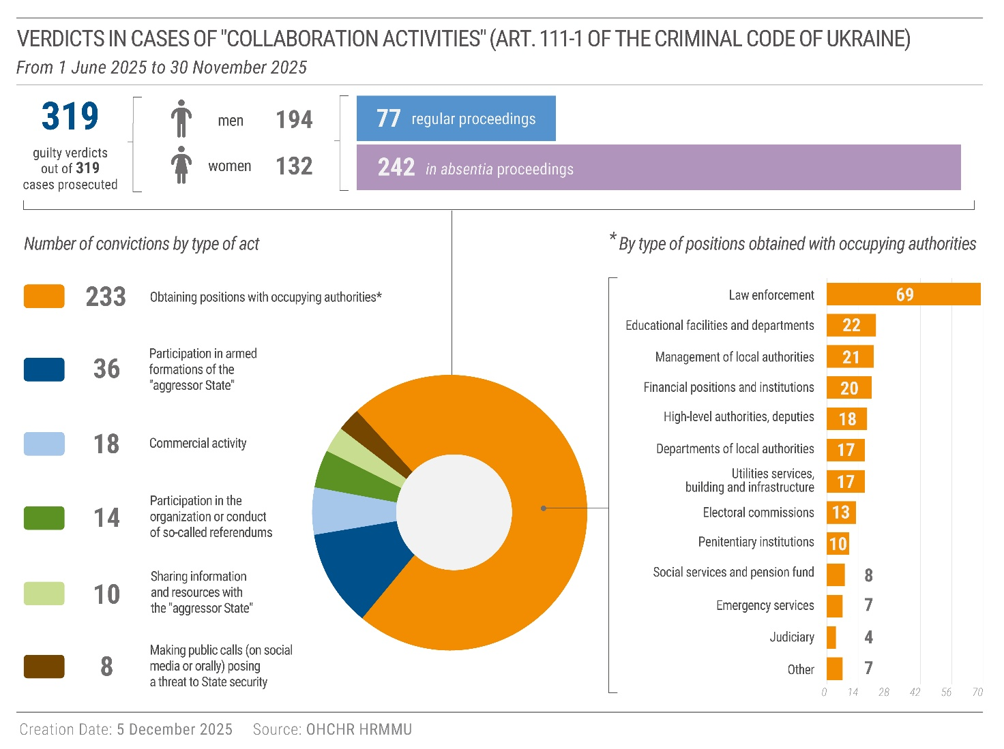
Russian civilians interned or detained by Ukraine
109. OHCHR interviewed five Russian nationals (four men and one woman) who were apprehended in Kursk region, Russian Federation, in August 2024, by Ukrainian forces, and subsequently transferred to Ukraine in circumstances which may amount to deportation of protected persons from occupied territory, and require further clarification. Despite their claims of not having any ties with the military, they continued to be interned together with Russian POWs in Ukraine and have not had their status reviewed. While the Fourth Geneva Convention allows for internment of protected persons when absolutely necessary for security reasons, the decision about internment must be periodically reviewed by a competent body and the internment can generally only take place within the occupied territory.
110. Some Russian nationals have been detained in Ukraine on immigration-related grounds and are held in facilities administered by the State Migration Service of Ukraine. OHCHR has sought access to these facilities, which has not yet been provided.
Loss of citizenship
111. The mayor of Odesa and a Metropolitan of the Ukrainian Orthodox Church both lost their Ukrainian citizenship by Ukrainian presidential decree issued in October and July 2025 respectively. Under current Ukrainian law, adults can lose their Ukrainian citizenship if they voluntarily acquire the citizenship of another State. The applicable procedure involves a commission making a recommendation to the President, who then issues a decree regarding revocation of citizenship. The decision may be challenged in court. However, State authorities have no obligation to inform individuals that consideration is being given to the termination of their Ukrainian citizenship. As a result, they may be deprived of fair opportunity to present their case in a proceeding that may adversely affect them, which raises concerns about procedural fairness.
B. Freedom of religion
112. In previous reports, OHCHR highlighted concerns about legal amendments related to religious organizations, noting they invoke “national security” as a ground for restricting freedom of religion or belief, although neither the International Covenant on Civil and Political Rights nor the European Convention on Human Rights include “national security” as a permissible ground for such a restriction. On 8 July 2025, based on the competencies assigned to it by the amended law, the State Service of Ukraine on Ethnic Policy and Freedom of Conscience concluded a study into the main legal entity of the Ukrainian Orthodox Church (UOC), the Kyiv Metropolis of the UOC. It found that the latter was affiliated with the Russian Orthodox Church (ROC), a prohibited religious organization under national legislation. Based on these findings, the State Service ordered the Kyiv Metropolis of the UOC to take formal steps to cut ties with the ROC within a 30-day deadline. The UOC did not take these steps. After expiry of the deadline, the State Service requested a court to dissolve the Kyiv Metropolis of the UOC and to seize its property. The case remains under consideration as of 30 November 2025.
113. OHCHR recorded two incidents of violence between different Orthodox communities over control of worship buildings, on 17 June in Chernivtsi city and on 6 August in Zhytomyr region. In one case, one UOC clergy member suffered injuries and required hospitalization. OHCHR understands that national police have opened an investigation into this case.
114. On 27 October, the Ukraine Supreme Court delivered its verdict in the case of a member of the Jehovah’s Witnesses who attempted to exercise his right of conscientious objection to mandatory military service, re-iterating its previous argument that the jurisprudence of European Court of Human Rights was not unconditionally applicable for such a large-scale war as waged against Ukraine. The man had earlier been sentenced to three years’ imprisonment for evading military service. The court upheld the sentence, but released the defendant on probation. Under the International Covenant on Civil and Political Rights (ICCPR), the right of conscientious objection to military service allows no restrictions or derogation.
C. Legal developments
Interim reparations for survivors of CRSV
115. The law on urgent interim reparations for survivors of CRSV, which guarantees free rehabilitation (including medical, psychosocial and other measures) and one-time financial support, fully entered into force on 18 June. The final provisions of the law required that the Cabinet of Ministers adopt the bylaws necessary for its implementation within six months of its publication on 18 December 2024. As of 30 November 2025, these bylaws had not yet been adopted, preventing the provision of urgent interim reparations to survivors.
Law on citizenship
116. In June 2025, amendments to the legislation on citizenship were adopted and will enter into force on 1 January 2026. The amendments permit multiple citizenships and update the rules on acquisition and loss of Ukrainian citizenship. At the draft stages of the legislation, OHCHR and civil society raised concerns that certain provisions risked depriving residents of occupied territory of their Ukrainian citizenship. The final version addressed this concern by explicitly providing that the acquisition of Russian Federation citizenship in occupied territory shall not be considered “voluntary”.
International legal developments
117. On 25 June 2025, the President of Ukraine and the Secretary-General of the Council of Europe signed an agreement establishing the Special Tribunal for the Crime of Aggression against Ukraine, with the Statute of the Tribunal annexed. The Tribunal, according to its Statute, is mandated to “investigate, prosecute and try persons who bear the greatest responsibility for the crime of aggression against Ukraine”, based on the territorial jurisdiction of Ukraine.
118. On 9 July 2025, the European Court of Human Rights delivered its judgment in the inter-State proceedings of Ukraine and the Netherlands v. Russia. The unanimous judgment of the Grand Chamber confirmed that the Russian Federation exercised effective control over parts of eastern Ukraine from 11 May 2014 and further extended its control through the full-scale invasion on 24 February 2022. The Court found that from May 2014 to September 2022 (the period falling within the temporal jurisdiction of the Court), the Russian Federation perpetrated numerous violations in occupied territory of Ukraine. Among other findings, the Court further concluded that the traumatizing effect on the children of being separated from parents and caregivers and the uncertainty and fear of being permanently and forcibly separated from their families amounted to inhuman and degrading treatment.
VIII. Technical cooperation
119. On 7 June, HRMMU delivered a training on UN human rights mechanisms for 20 young human rights defenders (15 women and 5 men). Participants learned about treaty- and charter-based bodies and how NGOs could engage with UN human rights mechanisms.
120. On 17–22 August, HRMMU participated in a summer school on international law and human rights for university students in Lviv, Ukraine. HRMMU representatives delivered lectures on the UN human rights system; human rights as a tool to promote justice, accountability and rule of law; and current human rights challenges in Ukraine. HRMMU also provided examples from other countries of how UN human rights field presences can help operationalize human rights norms and protections.
121. On 13–15 October, HRMMU provided technical advice to participants during a workshop by the Team of Experts of the Office of the Special Representative of the Secretary-General on Sexual Violence in Conflict for the Coordination Centre for Legal Aid Provision. The workshop focused on effective representation of survivors of CRSV in Ukraine.
122. On 10 November, HRMMU delivered an online training session for 14 military police officers from Ukraine and several NATO member states on how international human rights treaties affect military police powers and competencies.
123. On 11 November, HRMMU provided training to 24 prosecutors and judges (9 women and 15 men) from different offices across Ukraine on IHL standards relating to the issue of collaboration.
IX. Recommendations
124. OHCHR continues to advocate for the implementation of recommendations in its past reports, most of which remain relevant. The violations documented in the current reporting period highlight the need for further progress in protecting human rights, and, in particular, to implement the following recommendations:
125. To both Ukraine and the Russian Federation:
(a) Take all feasible precautions to avoid or at the very least minimise civilian harm, including through the careful selection of means and methods of warfare and target verification and refraining from using explosive weapons with wide area effects, including cluster munitions, in populated areas;
(b) Ensure prompt, impartial and effective investigations into all alleged violations of IHL and IHRL and ensure that alleged perpetrators, including members of the military and security forces and those in positions of command, are duly prosecuted and held to account; guarantee adequately-financed and prompt gender and age-sensitive reparation measures, and support to victims, including medical, psychological and legal support services, with particular attention to the specific needs of women, girls, men and boys.
126. To the Russian Federation:
(c) Immediately cease the use of armed force against Ukraine and withdraw military forces from the territory of Ukraine, as per United Nations General Assembly resolution ES-11/1 on the “Aggression against Ukraine”, adopted on 2 March 2022, and in line with the binding order of the International Court of Justice on provisional measures of 16 March 2022 for the Russian Federation to immediately suspend its military operations;
(d) Immediately cease all acts of extrajudicial execution, torture, ill-treatment and sexual violence against both POWs and civilian detainees, and end all unlawful practices relating to detention;
(e) Ensure humane conditions of internment of POWs, including adequate medical care, due conditions of transfer, and the right to maintain relations with the exterior, in accordance with Geneva Convention III;
(f) Provide the International Committee of the Red Cross full, regular and unimpeded access to all Ukrainian POWs and civilian detainees, and ensure that detainees are provided with information about their places of detention;
(g) Comply with the obligations of an occupying Power under IHL and respect Ukrainian laws in force unless absolutely prevented from doing so;
(h) Cease practices of deportation of Ukrainian civilians from occupied territory, repeal decrees that compel residents to obtain a Russian passport, residence permit or other legal basis for stay in Russian domestic law under threat of deportation, and ensure the safe and unimpeded return of all unlawfully transferred individuals;
(i) Immediately halt the conscription of protected persons from occupied territory into its armed forces and end all practices that pressure or compel them to register for military service, including through the mandatory use of State digital services;
(j) Fulfil its obligations under IHL to ensure public health and hygiene and access by the population to essential supplies by taking immediate and effective measures to restore an adequate, safe, and accessible water supply to the population, particularly in Donetsk region;
(k) Immediately end the confiscation of property in occupied territory and repeal the legislation that facilitates the expropriation of so-called “abandoned” properties;
(l) End all forms of “patriotic”-military education and propaganda in schools and summer camps, and ensure that education respects the rights of the child and does not compel allegiance to the occupying Power;
(m) Ensure the right to a fair trial, including access to effective legal representation;
Respect the freedoms of expression, opinion, and religion, by ceasing all measures that seek to suppress Ukrainian identity, ending the prosecution of individuals for dissent, and allowing religious communities to practice their faith freely, subject only to the strict limits provided in international human rights law.
127. To Ukraine:
(n) Treat POWs and conflict-related detainees in full compliance with IHL and IHRL, in particular by protecting them from torture or ill-treatment at all times, including during the initial stage of captivity;
(0) Ensure that people in frontline communities receive comprehensive information to enable them to take timely decisions about evacuation, and increase efforts to evacuate older persons and persons with disabilities from unsafe areas;
(p) Ensure that IDPs can access adequate housing and employment opportunities, with attention to the specific situations of the Roma community, persons with disabilities and older persons.
(q) Adopt without further delay the necessary bylaws and ensure sufficient funding for the implementation of the Law of Ukraine “On Legal and Social Protection of Persons Affected by Sexual Violence Related to the Armed Aggression of the Russian Federation Against Ukraine and Providing them with Urgent Interim Reparations”;
(r) Bring its law on collaboration activities in line with IHL and IHRL, and refrain from prosecuting individuals for conduct that can be lawfully compelled by the occupying Power under IHL;
(s) Provide OHCHR with access to persons detained on immigration-related grounds in facilities administered by the State Migration Service of Ukraine;
(t) Amend the law “On the protection of constitutional order in the sphere of activities of religious organizations” and ensure that its enforcement also fully complies with the requirements of IHRL;
(u) Take means necessary effectively to recognise, in domestic law, the right of conscientious objection to military service in accordance with the full scope of the right protected under art. 18 of the ICCPR.
128. To the international community:
(v) Continue to urge the Russian Federation and Ukraine to fully comply with IHRL and IHL, demand and work collectively to ensure accountability, including reparation for the victims and survivors of violations, and take all available measures to prevent further violations;
(w) Continue to urge the Russian Federation to comply with the full range of its additional obligations as an occupying Power under IHL and IHRL, particularly regarding the prohibitions on deportation, conscription, and the confiscation of property;
(x) Provide support to NGOs that conduct and facilitate the evacuation of persons with disabilities and older persons and continue assisting Ukraine in ensuring that IDPs can access adequate housing and employment opportunities, considering the specific situations of the Roma community, persons with disabilities and older persons.
(y) Provide financial, technical and other assistance to actors providing psychological services and other types of support to victims and survivors of gross human rights violations, including sexual violence, with attention to the respective specific needs of women, girls, men and boys;
(z) Call for OHCHR and other independent human rights monitors to have the fullest possible access to areas of Ukraine occupied by the Russian Federation, including places of internment and detention, in order to facilitate comprehensive monitoring and accountability;
(aa) Provide full support to the Government of Ukraine in its efforts to mobilize funding for urgent interim reparations under the Law of Ukraine “On Legal and Social Protection of Persons Affected by Sexual Violence Related to the Armed Aggression of the Russian Federation Against Ukraine and Providing them with Urgent Interim Reparations”.

HRMMU was deployed on 14 March 2014 to monitor and report on the human rights situation throughout Ukraine, with particular attention to the Autonomous Republic of Crimea, eastern and southern regions of Ukraine, and to propose recommendations to the Government and other actors to address human rights concerns. For more information, see A/HRC/27/75, paras. 7-8.
OHCHR most recently requested access to occupied territory through a note verbale transmitted to the Russian Federation on 26 February 2025, to which no response has yet been received. OHCHR appreciates the cooperation of the Government of Ukraine in providing access in Government-controlled areas.
The figures included in this section do not include the final total of verified civilian casualties in November 2025 due to the timing of the finalization of the report. The total number will likely rise as further casualties are verified.
Additional Protocol I to the Geneva Conventions, arts. 48 and 52.
Data provided in letter of the Kyiv City State Administration to OHCHR dated 20 November 2025.
Additional Protocol I to the Geneva Conventions, arts 48 and 51.
Additional Protocol I to the Geneva Conventions, art. 51, ICRC Customary Rule 12.
UN Human Rights Monitoring Mission in Ukraine, Attacks on Ukraine’s Energy Infrastructure: Harm to the Civilian Population, September 2024.
Based on records for which the age is known.
At least 427 civilians killed and injured (263 men and 164 women) from June to November 2025, compared to 238 killed and injured (118 men, 115 women and 5 girls) during the same period in 2024.
Ministry for Development of Communities and Territories of Ukraine, The 24-hour hotline operates as an emergency channel for people who need evacuation, 2 December 2025.
CCCM Cluster, Ukraine: CCCM Cluster East Hub Transit Centres, last consulted on 2 December 2025. Since these numbers only represent people who pass through a transit centre, the total number of evacuees is higher.
OHCHR, Report on the human rights situation, December 2024 to May 2025, July 2025, paras 88-92.
On 10 October 2025, the Cabinet of Ministers of Ukraine adopted Decree No. 1307 establishing a State information system on the coordination of evacuation and regulating the status of transit centres.
OHCHR, Treatment of Prisoners of War and Update on the Human Rights Situation in Ukraine, 1 June 2024 – 31 August 2024, para. 28.
This regime included practices such as 24-hour CCTV surveillance in cells, prohibition of any movement without explicit permission from penitentiary staff, forcible prolonged standing or work such as cleaning cells for the entire day every day, prohibition of communication with cellmates, and daily cell inspections.
By wearing balaclavas and not allowing POWs to look at them, e.g. by making POWs lie on the ground face down every time penitentiary personnel came to POWs’ cells.
POWs should have medical inspections at least once a month and adequate medical assistance. If required by their health status, they should be treated in military or civilian medical facilities. Seriously wounded and seriously sick prisoners of war should be directly repatriated (Third Geneva Convention, arts. 30, 31, 109 and 110).
Three of the four verified incidents occurred in 2024.
This occurred despite the fact that the Ukrainian Government has established legal procedures for medical examination and reporting on bodily injuries of POWs.
OHCHR, Report on the human rights situation in Ukraine, 1 September – 30 November 2024, para. 58.
OHCHR previously documented calls by “Rusich” for the execution of Ukrainian POWs. OHCHR, Treatment of prisoners of war and update on the human rights situation in Ukraine, 1 June 2024 - 31 August 2024, para. 52, and OHCHR, Report on the human rights situation in Ukraine, 1 December 2024 – 31 May 2025, para. 40.
Kakhovskyi and Skadovskyi districts, and areas of Khersonskyi district on the left bank of the Dnipro River.
For details on torture and ill-treatment, arbitrary detention, enforced disappearances and deaths in custody of civilian detainees held by the Russian Federation, see OHCHR, Treatment of Civilians Deprived of their Liberty in the Context of the Armed Attack by the Russian Federation against Ukraine, 23 September 2025.
Federal Law No. 395-FZ of 31 July 2023 “On the Application of the Provisions of the Criminal Code of the Russian Federation and the Criminal Procedure Code of the Russian Federation in the Territories of the Donetsk People's Republic, Luhansk People's Republic, Zaporizhzhia Region, and Kherson Region”; Fourth Geneva Convention, arts. 64 and 66; Hague Regulations, art. 43.
International Covenant on Civil and Political Rights (ICCPR) article 15(1).
Hague Regulations, art. 43; Fourth Geneva Convention, arts. 47 and 64; Additional Protocol I, art. 4. See also ICRC, Commentary to article 47 of the Fourth Geneva Convention.
Presidential Decree of the Russian Federation No. 159 of 20 March 2025.
Fourth Geneva Convention, art. 49. The deportation of a protected person is a grave breach of the convention; see Fourth Geneva Convention, art. 147.
Article 51 of the Fourth Geneva Convention provides that the occupying Power may not compel persons protected persons to serve in its armed or auxiliary forces.
Fourth Geneva Convention, arts. 55 and 56.
International Covenant on Economic, Social and Cultural Rights, art. 11; Committee on Economic, Social and Cultural Rights, General Comment no. 15 (2002), The Right to Water, para. 11.
United Nations Institute for Training and Research (UNITAR) – United Nations Satellite Centre (UNOSAT).
OHCHR, Report on the Human Rights Situation in Ukraine, 1 September – 30 November 2024, December 2024, paras. 81-83; and OHCHR, Report on the Human Rights Situation in Ukraine, December 2024 – 31 May 2025, 30 June 2025, paras. 65-71.
Hague Regulations, art. 46, Fourth Geneva Convention, art. 147. In addition, under international human rights standards, States should protect individuals from arbitrary displacement and forced eviction; arbitrary confiscation or expropriation of land as a punitive measure or means or method of war is prohibited. United Nations Principles on Housing and Property Restitution for Refugees and Displaced Persons (“Pinheiro Principles”), principles 5 and 10.
In violation of right to fair trial and effective remedy, ICCPR, art. 14, art. 2(3).
Vkontakte post, 24 July 2025, at https://vk.com/wall-214940037_19226; Law No. 141-RZ “On Support for Citizens Whose Residential Properties Were Lost as a Result of Hostilities on the Territory of the Donetsk People’s Republic”, 18 December 2024, at http://publication.pravo.gov.ru/document/8000202412230006?index=2 (accessed 5 December 2025).
Municipal district of Mariupol, at https://mariupol.gosuslugi.ru/dlya-zhiteley/novosti-i-reportazhi/novosti_743.html
Principle 21 of United Nations Guiding Principles on Internal Displacement.
ICRC Customary Rule 51, Hague Regulations, art. 46.
Pinheiro Principles 2 and 10.
Article 50 of the Fourth Geneva Convention. Hague Regulations, art. 45; and OHCHR, The impact of the armed conflict and occupation on children’s rights in Ukraine, 24 February 2022 – 31 December 2024, paras. 86-105.
For example, see https://tavria.tv/news/shkolniki-chaplinki-voshli-v-chislo-prizyorov-zarniczy-2-0-v-volgograde/ (accessed 25 September 2025).
Order no. 209 of the Ministry of Education of the Russian Federation, “On Approval of the Federal Program of Educational Work for Children’s Recreation and Health Organizations and the Calendar Plan for Educational Work”, 17 March 2025.
See https://t.me/government_rus/23377 (accessed 25 September 2025).
See A/HRC/59/33, Section VI. A.
See https://lug-info.ru/news/razgovory-o-vazhnom-nachnut-provodit-v-detsadah-vossoedinennyh-regionov/? (accessed 25 September 2025).
See https://edu.gov.ru/press/10273/v-novom-uchebnom-godu-nachnetsya-aprobaciya-proekta-razgovory-o-vazhnom-v-detskih-sadah/ (accessed 25 September 2025).
International Covenant on Civil and Political Rights, art. 19; Human Rights Committee General Comment 34, paras. 11, 21-36.
Fourth Geneva Convention, art. 27(4) and 2025 ICRC commentary, paras. 2348-235.
On 13 August 2025, the Russian telecommunications watchdog Roskomnadzor announced that it is blocking calls on WhatsApp and Telegram for security and anti-fraud reasons. See https://t.me/rian_ru/309806 (accessed 5 December 2025).
See: A/HRC/60/45, paras. 38, 43 and 50.
See announcement at https://t.me/BalitskyEV/6098 (accessed 5 December 2025).
Presidential decree no. 858, “On the strategy of the state national policy of the Russian Federation for the period until 2036” (25 November 2025), paras. 29, 36, 46, and 59.
See Article 5.26 of the Russian Code of Administrative Violations, including Part 5 (“foreigners conducting missionary activity”), Part 4 (“missionary activity with violations”), and Part 3 (“violation of naming requirements”).
As of 3 December 2025, see www.gp.gov.ua (consulted on 3 December 2025).
On 3 March 2022, Parliament amended the Criminal Code of Ukraine by introducing article 111-1 on “collaboration activities”. For analysis on the law, see OHCHR, Human Rights Situation During the Russian Occupation of Territory of Ukraine and its Aftermath, 24 February 2022 – 31 December 2023, paras. 167 – 168.
On the prohibition of deportation of protected persons from the occupied territory, see art. 49 of the Fourth Geneva Convention. See also art. 78 of the Fourth Geneva Convention.
Other grounds for loss of citizenship include voluntary enlistment into military service of another State, or if they were accepted into the Ukrainian citizenship as a result of fraud, deliberate submission of false information or false documents, including failure to fulfill certain obligations, such as termination of the foreign citizenship, 5 August 2025, at https://zakon.rada.gov.ua/laws/show/2235-14#n190 (accessed 5 December 2025).
See Human Rights Committee, General Comment no. 32: Article 14: Right to equality before courts and tribunals and to a fair trial, paras. 8-9, 12.
Law “On the protection of constitutional order in the sphere of activities of religious organizations” (Law No. 3894-IX). For more detailed analysis, see OHCHR, Report on the Human Rights Situation in Ukraine, 1 September – 30 November 2024, paras. 84 – 88.
Unified State Register of Court Decisions of Ukraine, Case No. 573/838/24, decision dated 27 October 2025, available at: https://reyestr.court.gov.ua/Review/131495382. In a dissenting opinion, two judges found that the state failed to fulfil its positive obligation to ensure alternative (non-military) service and that the complete exclusion of to the right to conscientious objection was impermissible under international human rights law. For details on the previous decision, see OHCHR, Report on the Human Rights Situation in Ukraine, 1 December 2024 – 31 May 2025, para. 85.
International Covenant on Civil and Political Rights, arts. 18 and 4. See also A/HRC/56/30 paras. 5 and 6, citing relevant decisions of the Human Rights Committee.
Law of Ukraine No 4067-IX “On Legal and Social Protection of Persons Affected by Sexual Violence Related to the Armed Aggression of the Russian Federation Against Ukraine and Providing them with Urgent Interim Reparations”, 20 November 2024, at https://zakon.rada.gov.ua/laws/show/4067-20#Text.
Law “On Amendments to Certain Laws of Ukraine on Ensuring the Exercise of the Right to Acquire and Retain Citizenship of Ukraine”, 18 June 2025, at https://zakon.rada.gov.ua/laws/show/4502-IX#Text.
Ibid.
The Parliament of Ukraine ratified the agreement on 15 July 2025.
Ukraine and the Netherlands v. Russia [GC], 43800/14, 8019/16, 28525/20 et al., 9 July 2025.
Including: indiscriminate military attacks; extrajudicial killings; forced labour; torture (including rape as a weapon of war); arbitrary detention of civilians; unjustified displacement and transfer of civilians; intimidation and persecution of journalists and religious groups; looting; destruction and expropriation of private property; suppression of the Ukrainian language in schools and indoctrination of school children; organized removal of children to Russia and their adoption there; discrimination on grounds of political opinion and national origin; and failure to investigate credible allegations of administrative practices or to provide any redress.
Judgment, para. 1595.

