A/HRC/58/CRP.1
18 March 2025

English only
Human Rights Council
Fifty-eighth session

Consolidated findings of the Independent International Fact-Finding Mission on the Islamic Republic of Iran*
Summary
The present conference room paper outlines consolidated findings from the Mission’s two years of investigations which reaffirm that, in repressing the protests that began on 16 September 2022, State authorities committed gross human rights violations, some of which amounted to crimes against humanity. It contains additional information and evidence related to the facts and circumstances in the context of the protests, including on the use of force, treatment in detention and related impunity. The Mission further expanded its investigations into the treatment of children, LGBTQ+ persons and ethnic and religious minorities, investigated protester deaths, dismissed by the State as “suicides”, and the wide use of “mock executions” as a form of psychological torture during detention.
Two and a half years after the protests began in September 2022, women and girls continue to face systematic discrimination, in law and in practice, that permeates all aspects of their lives, particularly with respect to the enforcement of the mandatory hijab. State authorities continue to enact new measures that suppress women and girls’ demands for rights. This conduct reflects the State’s persistent, ongoing persecutory conduct aimed at supressing women and girls’ rights to equality.
This persecutory conduct also extended to victims and their families who have been systematically suppressed to remain silent, as well as to those who have acted in solidarity, such as human rights defenders, lawyers, teachers, trade unionists and journalists, forcing many to leave Iran. Against this backdrop, the State intensified surveillance, restricted digital space even further and extended its repression beyond Iran’s borders, to silence those who speak up both inside the country and from abroad. Judicial harassment of victims and their families continued. Together, these actions demonstrate the concerted State effort to stifle dissent, perpetuating a climate of fear and systematic impunity that denies victims the rights to truth, justice, accountability and reparations.
Ten men have been executed so far, and at least 11 men and 3 women remain at imminent risk of being sentenced to death or executed in the context of the protests. The death penalty against women activists and women human rights defenders sharply escalated, particularly following their convictions for national security offenses, including in relation to their activism.
While there have been some efforts to provide accountability and compensation to victims of the protests, domestic avenues for redress remain inadequate. The State continues to deny responsibility for gross human rights violations, some of which the Mission found amounted to crimes against humanity. Obstacles to obtaining justice in Iran persist, including pervasive, continuous intimidation and threats against those seeking accountability in the judicial system, which fundamentally lacks independence. The Mission’s investigations, including through direct exchanges with the President-appointed “Special Committee to Investigate the 2022 unrest” also reaffirmed that redress and reparations to victims remained inadequate.
The Mission underscores that it is imperative that comprehensive accountability measures continue to be pursued in Iran, despite the obstacles identified by the Mission, and in their absence, outside the country, in accordance with the rights and expectations of victims and survivors. In this regard, the Mission outlines in this paper a roadmap for justice and accountability that the international community and other stakeholders may consider in this collective endeavour, including proposals for prosecutions, legal reforms, and assistance to victims and survivors, including through the provision of humanitarian visas and the establishment of a Victims' fund.
In this respect, the Mission deepened its investigations into the responsibility of State entities and officials for gross human rights violations and crimes under international law in relation to the use of force, detention, the judicial system and the mandatory hijab enforcement. This includes investigating the roles, structures, and responsibilities of the IRGC, the Basij, the Ministry of Intelligence, the Ministry of Interior, the police (FARAJA), including its special forces, and the “Morality Police”, the provincial governors, as well as the Judiciary. In light of their roles and authority within these entities, the heads of those entities bear responsibility.
Considering the gravity of its findings with respect to the commission of gross human rights violations and crimes against humanity, coupled with the risk of recurrence of violence against those who continue to express dissent or challenge the State and its policies, make it essential for the Human Rights Council to continue to be strongly seized of the situation of human rights in the Islamic Republic of Iran.
The Mission further found that the human rights concerns in Iran are extensive and complex and transcend both the temporal and material scope of the mandate entrusted to it by the Human Rights Council. The Mission therefore suggests that, upon completion of its mandate, the Council consider mandating an independent body to follow-up on the mission’s work. Such a body should continue to investigate allegations of serious human rights violations and crimes against humanity in Iran, both past and ongoing, the root causes of such violations and crimes, including structural and systemic discrimination against women, men and children, including on the grounds of gender, ethnicity and/or religion and/or political beliefs; monitor and follow up on domestic and international accountability; continue investigation of the responsibility of alleged perpetrators both State entities and individuals, by documenting, verifying, consolidating and preserving evidence for legal proceedings. The independent body should have an explicit mandate to cooperate with judicial authorities that comply with international human rights standards, and with other legal processes, or quasi-judicial bodies engaged in the protection of victims’ rights, in close consultation with victims, survivors, civil society, UN human rights mechanisms, including the Special Rapporteur on the human rights situation in the Islamic Republic of Iran and other relevant stakeholders.

Contents

I. Introduction 5
II. Methodology and standard of proof 6
III. Continuous persecution of women, girls and others supporting rights 6
A. Pervasive persecution against women and girls 7
B. Escalated repression against victims and their families 19
C. Others supporting rights and equality 24
IV. Increased use of the death penalty 28
A. Executions in the context of the “Woman, Life, Freedom” movement 29
B. Gendered impact 30
V. Update on the Mission’s investigations 38
A. Use of force resulting in killings and injuries 39
B. Tehran and Alborz province 40
C. Arbitrary arrests and detention 46
D. Torture and ill-treatment in detention 47
E. Rape and other forms of sexual and gender-based violence 49
F. Ethnic and religious minorities 50
G. Protester deaths dismissed by the State as “suicides” 67
H. LGBTQ+ persons 74
VI. Children 81
A. Children’s right to freedom of peaceful assembly in Iran 81
B. Use of Force resulting in killing and injury of children 83
VII. Digital space 108
A. Digital space in the context of the September 2022 protests and the “Women, Life, Freedom” movement. 109
B. Deactivated SIM cards 110
C. Controlling content of Instagram pages 111
VIII. Displacement 113
A. Inability to remain 115
B. Inability to return to Iran 119
IX. Transnational repression 121
A. Aggressive rhetoric reflective of state policy 121
B. Human rights defenders, including journalists 122
C. Victims, witnesses and others expressing support for the September 2022 protests 124
D. Repression by proxy 125
E. Family members of victims 126
F. Family members of human rights defenders including journalists 126
G. Impact 126
X. Findings 127
A. International Human Rights violations 127
B. Crimes under International Law 128
C. Violations and crimes as investigated since March 2024 129
D. Responsibility 130
E. Use of force 132
F. Detention 139
G. The Judicial System 143
H. Violations of international human rights law and crimes under international law in relation to the Judiciary 150
I. Mandatory hijab enforcement 158
XI. Accountability 162
A. Introduction 162
B. Impunity and lack of domestic accountability avenues 162
C. Situation of victims, families, and supporters 166
D. The State’s systemic denial of responsibility 170
E. International accountability avenues 172
XII. Conclusions and recommendations 191
Annex I 196

I. Introduction
1. On 22 November 2022, the Human Rights Council convened a special session and adopted Resolution S-35/1 on the deteriorating situation of human rights in the Islamic Republic of Iran, especially with respect to women and children. Pursuant to this Resolution, the Council established the Independent International Fact-Finding Mission on Iran (“the Mission”) to thoroughly and independently investigate alleged human rights related to the protests that began on 16 September 2022, especially with respect to women and children; establish the facts and circumstances surrounding the alleged violations; and collect, consolidate and analyse the evidence of such violations and preserve that evidence, in view of cooperation in any legal proceedings.
2. The Mission presented its first report to the Council at its fifty-fifth session in March 2024, in which it concluded that there were reasonable grounds to believe that gross human rights violations and international crimes, including crimes against humanity, were committed by State authorities in the context of the protests. The Mission also submitted an accompanying conference room paper which contained its detailed findings, analysis and recommendations.
3. On 4 April 2024, the Human Rights Council extended the Mission’s mandate through Resolution 55/19 for a period of one year, to ensure, among others, that the large amount of evidence of human rights violations in the Islamic Republic of Iran related to the protests that began on 16 September 2022, especially with respect to women and children, is fully and effectively documented, verified, consolidated and preserved. The Mission interpreted this aspect of its mandate as inter alia aimed at supporting accountability efforts, including the pursuit of truth, equality, justice and reparations for victims and their families.
4. In paragraph 2 of Resolution 55/19, the Human Rights Council requested the Mission to present its final report and recommendations at its fifty-eighth session during a joint interactive dialogue with the Special Rapporteur on the human rights situation in the Islamic Republic of Iran. The Mission presented its report to the Human Rights Council (A/HRC/58/63) accompanied by the present detailed conference room paper. This paper expands on the Mission’s investigations, analysis and conclusions contained in the report submitted to the Council, including information and evidence that established additional facts and circumstances of gross human rights violations and crimes against humanity in the context of the protests. To support accountability efforts for victims, the Mission also presents herein a roadmap for accountability, truth, justice, equality, reparations, and other measures to ensure effective redress for victims and survivors.
5. In its resolutions S-35/1 and 55/19, the Council called on the Government of Iran to cooperate fully with the Mission, including by granting it unhindered access to the country, and providing information necessary to fulfil its mandate. Since the start of the mandate, the Mission sent 36 information requests to the Government (see Annex I). While acknowledging responses to five such letters, the Mission regrets that the rest remained unanswered and that in the responses received, the Government did not provide the underlying information requested, including names, locations, nature of crimes, court documents, or medical and forensic reports. Requests for meetings to discuss substantive issues with Iran’s Permanent Representative in Geneva have not received a positive response.
6. The Mission reviewed information made available by the Government, including its subsequent response to the Mission’s draft mandated report, shared with the Permanent Mission of the Islamic Republic of Iran on 27 February 2025 for factual comments, ahead of its release. Relevant factual and verifiable information received by the Government was reflected in both the mandated report (A/HRC/58/63) as well as in this conference room paper, where applicable. The Mission acknowledges the report summarizing the findings of the State-appointed “Special Committee to investigate the 2022 unrest,” published in March 2024 after the Mission presented its first report to the Human Rights Council. It welcomes the third online meeting held with the Special Committee on 3 March 2025 to further clarify numerous areas relevant to the Mission’s investigations, in particular in relation to the Special Committee’s work on accountability. It regrets however the lack of verifiable information shared by the Special Committee, to allow the Mission to fully assess the Special Committee’s effectiveness in providing redress to victims and their families.
7. The Mission expresses its gratitude to victims, witnesses and civil society organizations providing information, who came forward with their experiences despite ever-increasing security risks against them and their families, including well-founded fears of reprisals for cooperating with the Mission and civil society organizations.

II. Methodology and standard of proof
8. The Mission was guided by methodologies and best practices of the United Nations entities and bodies, ensuring a victim-centred approach, with specific attention paid to the gender dimension of the violations and crimes documented.
9. In all its activities, the Mission continued to ensure strict adherence to the principles of “do no harm,” independence, impartiality, objectivity, transparency and integrity, in accordance with the standard investigation methodology of the Office of the High Commissioner for Human Rights. Due to protection concerns, the Mission withheld or redacted details, such as names, dates or locations, to protect the identity of individuals due to fear of further harm to victims or their families, and/or reprisal.
10. The Mission has collected and preserved over 38,000 evidence items. This includes interviews with 287 victims, witnesses and others providing information, both remotely and during field visits, as well as official information, including that made available by the Government of the Islamic Republic of Iran directly to the Mission or the UN human rights mechanisms, on official websites and State or state-affiliated media outlets. It also includes information received by credible human rights organizations; expert reports, including forensic and military analysis, open-source and hundreds of secondary sources to corroborate and contextualize the information gathered.

III. Continuous persecution of women, girls and others supporting rights
11. Pursuant to its mandate and terms of reference, the Mission continued to investigate the situation of women and girls in the aftermath of the protests. In doing so, the Mission specifically sought to ascertain whether the Government of the Islamic Republic of Iran had taken steps to address the deep-rooted and institutionalized discrimination against women and girls in Iran, in accordance with the rights and demands of the women, men and children who protested in the 2022 nation-wide protests under the banner of “Woman, Life, Freedom.”

A. Pervasive persecution against women and girls
“Unveiling causes social ills and the fall of the human character of women. It causes increase in mental and psychological tension in society (..) and leads to trampling faith and moral virtues of the society, spread of social corruption, increase in sexual violence against women and the destruction of the Iranian Islamic culture.”
Extract from a court verdict
12. Two and a half years after the protests began in September 2022, women and girls continue to face systematic discrimination, in law and in practice, that permeates all aspects of their lives. This is particularly with respect to the enforcement of the mandatory hijab which the Government linked to women and girls’ access to fundamental rights and freedoms.
13. Beginning in April 2024, following a meeting in March 2024 among representatives of the highest echelons of the State, including the former President, the Head of the Judiciary, and the FARAJA, Government authorities increased repressive measures and policies through which they continued to encourage, sanction, and endorse human rights violations against women and girls flouting the mandatory hijab laws. Such measures expanded existing restrictions on women’s and girls’ access to fundamental rights, including the right to education. Concurrently, and at the request of the Judiciary, the FARAJA launched the so-called “Noor” plan, a large-scale police operation to enforce the mandatory hijab, which led to a surge in arbitrary arrests, violence, and criminal prosecution against women and girls for their alleged non-compliance (see para. Sub-section 2).
14. Despite pre-election assurances by the new President, Dr. Masoud Pezeshkian, to ease strict enforcement of mandatory hijab laws, State authorities continued to enact new measures to suppress women and girls’ rights, and continued repression against those expressing solidarity with the “Woman, Life, Freedom” movement. As of September 2024, according to credible information, prosecution against women and girls for flouting the mandatory hijab increased. In parallel, the Government resorted to aerial surveillance and increased reliance on State-sponsored vigilantism in an apparent effort to shift the responsibility for enforcing hijab compliance to businesses and private individuals, portraying it as a civic responsibility and legal duty shared by the wider community. State rhetoric has also shifted towards justifying the refusal of women and girls to wear the mandatory hijab with their purported lack of awareness or education. This led to the reported establishment in November 2024 of a “clinic” for teenage girls in Tehran to undergo “scientific and psychological treatment for hijab removal” (see below).
15. The Mission’s investigations show that violent enforcement of the mandatory hijab continues, including by the “Morality Police” as well as through the deployment of “patrols” referred to as “ambassadors of kindness” (see sub-section 2). The Mission also received reports that, though the Vozara detention facility appears to no longer be serving as a detention facility for women and girls allegedly flouting the mandatory hijab laws, women continued to be arrested and detained in various police stations operated by the Public Morality Security Police, including in Tehran City.

1. Increased restrictions of women and girls’ access to fundamental rights through the enforcement of the mandatory hijab laws
16. According to Iran’s Judiciary news agency (Mizan), during several meetings held with the late President Ebrahim Raisi of the Islamic Republic of Iran in February and March 2024, the Head of the Judiciary, Gholamhossein Mohseni Ejei, tasked relevant government institutions with authority for monitoring and enforcing compliance of the mandatory hijab laws to take joint responsibility for combating “social anomalies.” In a speech on 3 April 2024, the Supreme Leader underscored that the Government and the Judiciary have a legal obligation to enforce the mandatory hijab laws, and women and girls, irrespective of their religion, or lack thereof, or beliefs, have a legal obligation to comply with these laws.
17. Following this, measures to enforce the mandatory hijab significantly increased. For example, on 13 April 2024, the Commander of Tehran’s police force, Abbas Ali Mohammadian, announced the launch of the so-called “Noor” plan. Mr. Mohammadian emphasised that the “Noor” plan would involve the deployment of police officers across all Iranian provinces, to “confront individuals promoting social anomalies by appearing without the hijab.” These individuals, he noted, would first receive a warning from the police for non-compliance with the mandatory hijab and then, if they ignored the warnings, be informed of possible legal action against them. Shortly thereafter, the Head of the Judiciary “urged” in particular the FARAJA to take concrete measures to enforce compliance with the mandatory hijab, in accordance with its “legal duties” and for the remaining institutions to assist the FARAJA in this regard.
18. On 6 August 2024, the head of the Traffic Police, Taimur Hosseini, confirmed that the traffic police, as with all police units, would be responsible for monitoring and enforcing the mandatory hijab.
19. On 18 September 2024, Iran’s Prosecutor General, Mohammad Mohavedi Azad, said that the “disease of improper hijab” in society “must be eliminated.”

2. Arrests, detention and criminal prosecution of women and girls for alleged violations of the mandatory hijab laws
20. As noted above, on 13 April 2024, the Commander of Tehran’s FARAJA, Abbas Ali Mohammadian, had announced the launch of the so-called “Noor” plan. In support, Hassan Hassanzadeh, IRGC Commander for Tehran, announced on 21 April 2024 the establishment and deployment of the so-called “ambassadors of kindness” whom he described as a “trained group” whose members would support enhanced monitoring and compliance with the mandatory hijab laws in public spaces, including at markets, parks, and in public transport.
21. On 23 April 2024, the FARAJA Commander-in-Chief, Ahmad Reza Radan, confirmed that the “Noor” plan had been endorsed by the Parliament and Judiciary. A credible human rights organization reported that, in 2024, the Government acted against an estimated 30,629 women for alleged violations of the mandatory hijab laws, with at least 644 of those women arrested for “improper” hijab. Of those 644, at least 618 were arrested and detained in the context of the “Noor” plan alone.

Increased policing of women and girls
22. Consistent with the above information, one woman told the Mission how “it all began with the Noor plan” when, in the aftermath of the FARAJA announcement (above), women and girls began posting pictures of themselves without the mandatory hijab on social media in acts of defiance. She described how, shortly thereafter, from 14 April 2024 onwards, women “Morality Police” officers and the so-called “ambassadors of kindness” deployed by the IRGC (see para. 20) were already deployed to metro stations and city squares in Tehran City to monitor hijab compliance.
23. Indeed, since the “Noor” plan began, one witness, a legal service provider, had received an estimated “75 to 120” requests for legal assistance every month from women countrywide found to have violated the mandatory hijab laws. The Mission reviewed a number of these requests which demonstrated that, in most cases, women had been arrested for such alleged violations by members of the “Morality Police” and security forces while on the street, or in a public park, or inside their vehicles. According to the information reviewed, women not wearing the hijab reported been photographed by unknown individuals and subsequently received “warnings,” in the form of text messages on their mobile phones from the police, reminding them to comply with the mandatory hijab laws.
24. This information also indicated that, upon arrest, women alleged to have violated the mandatory hijab laws were ushered to local police stations, including to the Morality Security Police, where they were forced to sign a pledge committing them to wear the mandatory hijab to secure their release.
25. Other credible information obtained by the Mission indicated that many women and teenage girls no longer wear the mandatory hijab, including in Markazi, Razvi Khorasan as well as in Tehran provinces. Others, especially in more traditional communities, noted that the increased presence of the security forces and the “Morality Police” created an atmosphere of palpable fear and anxiety, preventing some from walking outside. In one case, a woman described how, after the “Noor” plan was launched in Tehran City, she noticed that security officers had increased in numbers, “like an army against women,” and that the “Morality Police” officers were “snatching” women and girls off the street on allegations of non-compliance.
26. For example, according to open sources, Aida Shakarami, the elder sister of 16-year-old Nika Shakarami (see Section V.D.), was arrested on 17 April 2024 for violating the mandatory hijab laws. Ms. Shakarami was detained in both Evin and Shahr-e-Rey prisons (commonly known as Garchak prison), before being released on bail on 23 April 2024. Later, on 24 June 2024, her lawyer confirmed that Ms. Shakarami was reportedly charged with “inciting immorality and indecency” and “disobedience to officers” for refusing to wear the mandatory hijab.

Physical violence during arrests, including gender-based violence
27. Some women arrested in the context of the “Noor” plan in Tehran were transferred to a police station known as “Gisha”, which one witness described as the “new Vozara detention facility.” She recalled how the “Gisha” police station was operated by the Morality Security Police, where women were registered for violating the mandatory hijab laws, and on occasion, asked to sign a pledge committing them to wear the mandatory hijab.
28. In one case investigated by the Mission, a woman and a close female relative of hers, were arrested by the “Morality Police” in an undisclosed city, in the context of the “Noor” plan for not wearing the mandatory hijab in public. Upon their arrest, both were taken to a white van of the “Morality Police”, where officers pinned them on the ground to restrain their movement. One of the victims suffered a leg injury, after a “Morality Police” officer violently shoved her into the van. They were then transferred to a police station in the same city, forced to sign a pledge committing themselves to wearing the mandatory hijab in public and released on the same day.
29. Credible information received by the Mission also indicated that “Morality Police” officers continued to beat women and girls arrested and detained for allegedly violating the mandatory hijab laws. In one case, a woman arrested in one province in May 2024 was beaten by a “Morality Police” woman officer inside a white van to which she was taken after her arrest. After the victim explained that she was on her way to undergo breast surgery, the woman officer mocked, ridiculed, and kicked the victim’s breasts. The victim was then taken to the Public Security Police station, where the same officer continued beating her. Reportedly, the victim was beaten so severely that she had to be transferred to a medical facility.
30. The Mission further reviewed, verified, and analysed video footage which showed “Morality Police” and security officers violently arresting women and girls alleged to have violated the mandatory hijab laws. The footage showed women and girls being arrested while being hit, kicked, or slapped by security forces as well as by men and women “Morality Police” officers while on the street, near metro stations, or in a public park. These incidents occurred in several cities including Rasht, Borujen, and Tehran. The video footage also showed how after the arrests, women and girls were violently shoved into police cars or “Morality Police” operated white vans, with some fighting back against the arrests.
31. For example, in a video published in early May 2024, a police officer in Tehran City, is shown violently beating a woman without a hijab and shoving her into a police car, while she is heard screaming “let go of me, you will break my neck.” On 14 May 2024, after the video went viral, the Government announced that the police officer concerned had been suspended pending further investigation. At the time of publication of this report, no further information was made available on the progress of the reported investigation.
32. In another video published on social media, women “Morality Police” officers were seen beating two girls not wearing the mandatory hijab on a street in Tehran City, and attempting to forcibly shove them into a white van. The incident occurred on 21 June 2024. According to official media, the mother of one of the child victims, aged 14 years old at the time of the arrest, filed a complaint against the woman “Morality Police” officer for beating her daughter (see Section XI).

Criminal prosecution of women and girls defying the mandatory hijab laws
33. The Mission analysed court documents, summons, and judgments rendered against women for alleged violations of the mandatory hijab laws. These documents were provided through submissions, which the Mission deemed credible. Based on the information contained therein, the Mission established that, between May and September 2024, women continued to appear before Criminal or Revolutionary Courts in cities throughout several provinces including Isfahan, Tehran, and Gilan. Credible information also indicated that, as of September 2024, after President Pezeshkian took office, criminal prosecution for non-compliance increased compared to the first half of 2024.
34. In most cases, women had been identified on the street, in their cars, or after posting pictures of themselves on social media while not wearing the mandatory hijab. Women were subsequently sentenced by criminal courts, including Branch 1089 and 1091 of the Criminal Court (“morality court”) at the Ershad Judicial Complex in Tehran City. Court documents also showed that, in most cases, women were sentenced based on evidence referred to as “reports provided by security forces” or “pictures submitted by the police” which confirmed the identity of the victim and served as a “proof of indecency in public.” Most women had to pay a fine and in at least one case, a woman’s bank account was closed. In another case, mitigating circumstances, including by expressing remorse, were considered for the commutation of a flogging sentence to a monetary fine.
35. Other credible information received by the Mission also indicated that, while in most cases women were made to pay a fine, in one case a woman in a minority-populated province was forced to write a letter of repentance, which she did out of fear of otherwise being arrested or flogged. According to the submission, prosecutorial authorities additionally issued orders for women to attend “education classes” and read specific books for people with “doubts about the Islamic Republic” on topics including the “female personality of mandatory hijab and freedom”. Women were then asked to record themselves while reading and sending an audio file summarizing the content to the authorities within a certain time. Prosecutorial and/or judicial officials also reportedly threatened some women with sexual violence, flogging, imprisonment, or the death penalty during proceedings.

Flogging
36. On 23 November 2024, Roshnak Alishah was lashed 14 times for “disturbing public chastity” as part of her sentence by Branch 1907 of the Ershad Judicial Complex. The victim had been arrested on 3 November 2024 in connection with a video she posted online which showed her without the mandatory hijab, confronting a man on a motorcycle. In their response to the Mission’s request for information about this case, the Government stated that Roshnak Alishah was ”convicted pursuant to applicable legal provisions,” without denying that the flogging took place as part of her sentence. This is the second woman to be sentenced to corporal punishment in 2024, following another woman who was lashed 74 times for posting a picture of herself without the mandatory hijab.
37. Mehdi Yarahi, a well-known singer in Iran, was lashed 74 times in early March 2025, as part of an earlier sentence in connection with a song he wrote during the protests criticising the mandatory hijab and advocating for women’s rights including their right to choose what to wear. Mehdi Yarahi had been arrested in August 2023 and sentenced in early 2024 by a criminal court in Tehran to 74 lashes and two years and eight months imprisonment.”
38. The Mission reiterates its previous findings that corporal punishment such as flogging constitutes torture and amounts to a violation of the right to security of the person.

Sedigheh Vasmaghi
39. On the morning of 16 March 2024, Dr. Sedigheh Vasmaghi, a prominent Iranian Islamic scholar and critic of the mandatory hijab, was arrested by four security police officers including a woman in her home in Tehran City. During her arrest, officers confiscated her phone and laptop, and tried to force her to wear the hijab, which she refused to do. Prior to her arrest, Dr. Vasmaghi had received a summons to appear before the Evin prosecutor’s office, though the legal grounds or reason(s) for this were not made clear.
40. During interrogations, Dr. Vasmaghi was told by an interrogator that she was being charged with violating the mandatory hijab laws (without further explanation), and for “propaganda against the state” for posting earlier on social media that “[her] vote is valuable, so I will not cast my vote in an [election] box that does not belong to the people” in relation to the parliamentary elections.
41. During her detention, as Dr. Vasmaghi refused to wear the mandatory hijab, prison authorities denied her family visits and access to the medical care required for her eye condition. This aggravated her health condition and rendered her increasingly vulnerable. To protest how the authorities linked compliance with the mandatory hijab to her right to family visits while in detention, Dr. Vasmaghi organized sit-ins in the Evin prison yard, when she was joined by others, including Narges Mohammadi.
42. On 2 April 2024, and only after her health condition became critical, Dr. Vasmaghi, still not wearing the mandatory hijab, was transferred to a hospital, then sent back to Evin prison, despite her pleas to remain under medical care. On 29 April, amid mounting concerns over her health, she was released on bail. Dr. Vasmaghi’s health condition had deteriorated in detention, impacting her eyes, heart, and blood pressure.

3. Increased surveillance to monitor hijab compliance in public places, and in vehicles

Enhanced surveillance
43. The Mission previously documented the far-reaching use of technology by the Government of Iran to monitor women’s and girls’ compliance with the mandatory hijab laws. This included expanding the coverage of CCTV cameras in April 2023, as well as the reported use of artificial intelligence to monitor and identify women not wearing the mandatory hijab on the street or in vehicles.
44. In May 2024, State authorities escalated these measures and, additionally, resorted to aerial surveillance to further expand monitoring of hijab compliance in public spaces. In one example, a drone equipped with a camera was deployed on 10 May 2024 to identify women and girls not wearing the mandatory hijab during the 35th Tehran International Book Fair in Tehran. In another example, on 16 May 2024, state-affiliated media (Mehr news) published video footage showcasing the use of drones on the island of Kish (southern coast of Iran) to monitor women’s and girls’ compliance with mandatory hijab laws.
45. The Government also continued to monitor online expression for compliance with the mandatory hijab laws. In one example, on 23 April 2024, Kyomars Aziti, the FARAJA commander of western Tehran province, announced that, in the context of the “Noor” plan, the police had blocked 21 Instagram accounts of women with large followings for non-compliance. He further noted that the police “continuously monitor social media accounts” and advised that “individuals need to comply with the laws, regulations and the social norms” to avoid punishment. Earlier, in March 2023, Bijan Nobaveh, a member of Parliament, announced a “plan” to use surveillance to identify women without the mandatory hijab, send them official warnings through messages, and de-activate their SIM cards and internet services in cases of non-compliance (see also Section VII).

Confiscation of vehicles for alleged violations of the mandatory hijab laws
46. On 23 June 2024, Iran’s police information centre announced that 8,000 vehicles, previously impounded for hijab-related violations, had been released to their owners. Later, on 5 October 2024, Sardar Abbas Ali Mohammadian, the chief of FARAJA Tehran, noted that, in response to the “many inquiries” from people, the police had decided to release confiscated vehicles seized through monitoring via the “Nazer” application (see sub-section 3 of this section).
47. Evidence collected, including copies of text messages and credible information obtained by the Mission indicated that vehicle confiscation of women for non-compliance persisted throughout 2024 until at least late January 2025.
48. Credible information obtained by the Mission showed that, in early 2024, vehicles of women not complying with the mandatory hijab laws had been confiscated in several provinces throughout Iran, including in Tehran, Isfahan, Markazi, Hamedan, and West Azerbaijan. Upon confiscation, vehicles were transferred to public parking lots, often near a police station, including of the Public Morality Security Police. Vehicles were released only after women presented themselves to the police station associated with their place of residence, and paid the incurred administrative fees, including for parking. Women witnesses described the release process as lengthy, expensive, and heavily bureaucratic, requiring them to wait for hours at the police station to recover their vehicles, on occasion along with “hundreds” of other women.
49. This information demonstrated that women, who had already received a text message informing them of hijab violations, generally expected that they could be stopped at any point and their vehicles impounded regardless of the location. In one case, a woman was left on a highway near Tehran City, along with her family, after her vehicle, “flagged” for several hijab-related violations, was spotted by the police. Her vehicle was immediately confiscated after she was stopped. Another woman, whose vehicle was confiscated for hijab violations near an airport in an undisclosed city in early 2024, explained that the licence plate had been caught on CCTV camera which then alerted the police to stop her and confiscate her vehicle.
50. According to credible information, the confiscation of vehicles had serious consequences for many women. Some explained that they were no longer able to drive their sick, elderly parents to the hospital, and had to postpone vital medical appointments, with their parents’ health deteriorating as a result. For others who required a car to get to their work, such confiscation meant that they were left with no income for weeks at a time. Women also described that vehicles were returned to them in poor condition and/or damaged, adding to the financial cost already endured from the bureaucratic confiscation process.
51. The Mission obtained a copy of the “Nazer” mobile application, which allows individuals, vetted by the State, to report to the police instances of non-compliance by women and girls with the mandatory hijab laws and regulations, while they are in vehicles. In September 2024, the coverage of “Nazer” was expanded to include monitoring of women in ambulances, public transport or taxis. Individuals who have access to this application include the police, and citizens who have gone through an alleged vetting process by the State. The “Nazer” application is accessible on the official FARAJA website and functions through the National Information Network (NIN) on state-controlled internet. When connected to “Nazer,” users may select the type of violation to report, including “improper hijab” or “removal of hijab.” Users can then add the location, date, time, and license plate number of the vehicle where the alleged violation occurred, which then creates a “flag” on the vehicle. Once the user files this “violation” into the system, the application generates a text message in real time to the registered owner of the vehicle.

Arezou Badri
52. On 22 July 2024, a police officer in Noor city, Mazandaran province, shot at a moving vehicle in which 31-year-old Arezou Badri, a shopkeeper and mother of two, was travelling as a passenger. She suffered serious injuries to her spinal cord and lung and was left paralysed.
53. On 22 August 2024, state-affiliated media (Tasnim) announced that, according to FARAJA, this incident was “not related to the hijab”. Instead, it claimed that the shooting occurred after the driver “disobeyed police orders to stop”, thus “fleeing the scene”, and that the car had tinted windows and was spotted in a “crime-ridden” area. According to Iranian media (Shargh Daily), the Head of the Armed Forces of the Judiciary announced that the police officer who shot at the car had been detained, pending the results of an investigation. In response to the Mission’s request for information on the case, Government stated that “officers discharged their weapons to effectuate the vehicles‘ stoppage in accordance with statutory regulations governing the use of firearms“. Credible information indicated that, in or around September 2024, the said official was released and has since returned to his position in the same police station he worked at prior to the incident.
54. Ms. Badri was transferred to Vali-e-Asr hospital in Tehran, where she remained guarded by security forces, with officers constantly present in her hospital room, including during family visits. Moreover, authorities have reportedly exerted pressure on Ms. Badri, her family and lawyer, forcing her and her father to give an interview to state media confirming that she was “doing well”.
55. The Mission notes that, prior to the shooting, the vehicle had already been registered by the police for mandatory hijab related violations. Credible information indicated that the windows of the car were down before the officer shot at the car, and that he may therefore have observed Ms. Badri’s lack of compliance with the mandatory hijab.
56. Regardless, the Mission recalls that using lethal force against a person who does not pose an imminent threat of death or serious injury is unlawful, may only be used as a method of last resort, and constitutes a violation of the right to life. Subsequently reported pressure, and threats against Ms. Badri’s family members, to remain silent and to withdraw their complaint, including the reported arrest of her brother by security forces, are further indicative of State efforts to conceal potentially incriminating information from entering the public domain, and are in violation of the State’s obligation to investigate.

4. Impact on fundamental rights and the “Law on Protecting the Family through the Promotion of the Culture of Chastity and Hijab”

“Law on Protecting the Family through the Promotion of the Culture of Chastity and Hijab”
57. On 30 November 2024, the finalized text of the “Law on Protecting the Family through the Promotion of the Culture of Chastity and Hijab” was published by Iranian media. Two days earlier, on 28 November 2024, Iran’s Parliament Spokesperson announced that the Law was set to come into force on 13 December 2024.
58. The Law has yet to be signed by the President before it can be officially implemented. On 4 January 2025, Iranian media (Farau) announced that the Supreme National Security Council has “stopped the promulgation” pending further amendments. On 7 January 2025, Fatemeh Mohajerani, the spokeswoman for the administration of President Pezeshkian, announced that "some provisions of the law could have had social consequences, and with these considerations, and with wisdom, it was postponed." She added that though the law was for now postponed, “the important point about the hijab and chastity law is that the opinion of the institutions is superior to the personal opinion of individuals.” According to the High Council for Human Rights of the Islamic Republic of Iran, in response to the Mission’s request for further information on the status of promulgation, “at present a domestic discourse exists regarding whether the enforcement mechanism for violations of this law should be penal or civil in nature, and such deliberation will, in due course, yield a legally binding and legislatively determined resolution.”
59. The Mission notes that the draft text, as it stands now, presents numerous areas of concern.
60. First, key terms in the pending law are vague and remain open to broad interpretation, and in violation of the principle of legal certainty. These include Article 50, which defines “unveiling” as the conduct of women and girls not wearing the mandatory hijab. “Nudity” and “indecency” are not defined in the Law, leaving a large margin for interpretation in practice. The term “bad dressing” for women and girls is defined as “exposing any body parts below the neck, other than the hands and feet, or wearing clothing that “contributes to or incites the commission of sin by others”.
61. Second, the pending law appears to criminalize the promotion or propagation of the vaguely formulated acts of “nudity, indecency, unveiling, or bad dressing” in collaboration with foreign entities, including media outlets and civil society organizations and conduct deemed to have amounted to “corruption on earth” under Article 286 of the Islamic Penal Code, may incur the death penalty. According to the High Council for Human Rights of the Islamic Republic of Iran, the reference to Article 286 of the Islamic Penal Code relates to the “punishment for establishing centers of corruption and prostitution and bears no relevance to hijab“.However, even the term “centers for corruption and prostitution,“ is vague, and there therefore remains a risk that, in the absence of clear definitions, organised advocacy against the mandatory hijab may incur the death penalty.
62. Third, under the pending law, women may also be sentenced to flogging, up to 10 years of imprisonment, loss of employment, exclusion from higher education and denial of access to government and business services, alongside other restrictions on fundamental rights, including travel bans, which impede freedom of movement.
63. Under the pending law, women would also be subjected to fines of up to USD $12,000, in a country where the average annual salary amounts to approximately USD 17,000 and the most typical annual salary is half of that. Those unable to pay the fines could face imprisonment, have their assets frozen, or be blocked from renewing driver’s licences or passports.
64. Finally, the pending law appears to establish a two-tiered society by creating incentives such as tax benefits or preferential registration of NGOs promoting the mandatory hijab. In contrast, it punishes those who do not comply, restricting women and girls’ access to fundamental human rights even further.
65. Businesses are also mandated to enforce the pending law or face closure or face heavy fines. Business owners may face imprisonment for a third offence, or fines, if they allow women and girls without the mandatory hijab on their premises and/or are found to be “promoting” lack of compliance.

5. Rights impacted
66. Though not officially promulgated, existing provisions related to the mandatory hijab continue to be enforced unabated.

Right to education
67. A new facial recognition software was reportedly installed on 20 April 2024 at the entrance gate of the Amirkabir University of Technology in Tehran to monitor women students’ compliance with the mandatory hijab laws. Reportedly, security forces stationed at the gate of the University denied access for “un-Islamic attire” to around 200 women students who did not wear the chador, and to men students who wore t-shirts or sportswear.
68. On 21 April 2024, according to media reports, students gathered at the University to protest these increasingly repressive measures, which they deemed to have intensified after the launch of the “Noor” plan. Following this protest, on 25 April 2024, the Deputy Minister of Culture and Education reportedly announced 16 forthcoming “hijab and chastity plans” to be implemented in 600,000 girls’ schools across Iran.

Other rights impacted, including the right to work
69. According to credible information obtained by the Mission, women who refused to comply with the mandatory hijab laws continued to be denied access to social and economic rights, including employment, banking services, and transport, boarding planes in cities in Fars, Alborz, and Tehran provinces. In one such case, a young woman was rejected from a government position for which she had applied and competed, after she refused to wear a chador during an interview and explained her choice not to attend Friday prayers.
70. The mandatory hijab laws and regulations also restrict women athletes, with many choosing to forego the hijab despite requirements to wear it when competing in public, including abroad. In one case investigated by the Mission, a woman athlete described how the imposition of the hijab has hindered the performance of women in sports, and how she herself she had been pressured by the Iranian authorities to wear the mandatory hijab during interviews on Iranian television, in an effort to “promote” the mandatory hijab given that she was a public figure. She described being harassed, summoned for interrogation by the IRCG intelligence, and forced to travel with representatives of the Government, who would ensure that athletes do not do “anything wrong,” including appearing without the hijab in public when abroad. According to the witness, after some women athletes left Iran, the Government imposed further restrictions on those traveling for international tournaments. For example, women athletes have been sometimes asked to provide “guarantees” to be allowed to travel, such as the deed to their home or ensuring that their family members remained in Iran while they were abroad. When the witness appeared at an international tournament abroad without the mandatory hijab she was subsequently pressured to apologise and declare publicly that she had been “influenced by Western media” to do so.

Closing of businesses leading to exclusion from economic opportunities
71. The Government also continued its practice of closing private businesses, including cafes, restaurants, and commercial offices, for not enforcing the mandatory hijab laws. On 15 April 2024, the bookstore of Zhina Modares Gorji, a Kurdish woman human rights defender (see para. 76) was closed in Sanandaj City, Kurdistan province, for non-compliance with the mandatory hijab laws. On 8 July 2024, Iranian authorities closed temporarily the office of Turkish Airlines in Tehran for the same reason. A credible human rights organization reported that, in 2024, the Government closed at least 365 private businesses countrywide for non-compliance with the mandatory hijab laws.

6. Eradicating initiatives and support to women’s human rights
72. State efforts to repress women’s initiatives were apparent through the increased use of death sentences rendered against women activists and women human rights defenders following convictions for national security offenses (see also Section IV). Women human rights defenders were sentenced to lengthy prison sentences, while others with suspended sentences remain at constant risk of being sent back to prison should they engage in any form of activism. Some imprisoned women activists and human rights defenders also faced new charges and additional sentencing for pursuing their activism while in prison.

Women human rights defenders
73. On 10 March 2025, four women human rights defenders, namely Leila Pashaei, Soheyla Motaei, Soma Mohammad-Rezaei and Baran Saedi were arrested by intelligence officers in Sanandaj and Degholan cities in Kurdistan province. Another woman activist and writer Nina Golestani was arrested on the following day in Rasht, Gilan province. The arrests took place in the immediate aftermath of celebrations of International Women's Day in Sanandaj. The Mission reviewed a video footage of the peaceful women’s gathering to mark International Women’s Day. These arrests raising concerns that the women were arrested for exercising their rights to freedom of expression and assembly. These arrests are illustrative of the continuous State efforts to repress women human rights activism.
74. Earlier, on 12 March 2024, 11 women’s rights activists, including 10 women and one man, were convicted by Branch 3 of the Revolutionary Court in Rasht, Gilan province on national security charges including “propaganda against the State”, “assembly and collusion against national security”, as well as “membership in an “illegal group” were each sentenced to 6 years and 47 days, while one was sentenced to 9 years and 10 days. Collectively, these 11 activists were sentenced to over 60 years in prison for protected conduct including their activism. The women had been arrested in August 2023 in several cities in Gilan province, approximately one month before the first anniversary of the death in custody of Jina Mahsa Amini, which they were planning to mark. Following their temporary release in July 2023, the women reported torture, ill-treatment, threats, and sexual harassment during interrogations. All began serving their prison sentences in Lakan prison in or around July 2024. In October 2024, Jelveh Javaheri was conditionally released after her sentence was overturned by Iran’s Supreme Court.
75. In August 2024, an additional five women activists were also sentenced by Branch 3 of the Revolutionary Court in Rasht to a combined total of 20 years in prison for “propaganda against the state” and “assembly and collusion against national security”.
76. In June 2024, Zhina Modares Gorji, the Kurdish women’s rights defender mentioned above, who had already been arrested by plainclothes agents during the protests in September 2022 in Sanandaj City, Kurdistan province, was sentenced to 21 years in prison and internal exile by the Revolutionary Court in Sanandaj. Court documents showed that for her public support for the protests, including on social media, she was convicted of the offenses of “forming illegal groups with the aim of overthrowing the state”, “collaborating with hostile groups and governments,” and “propaganda against the state” On 7 October 2024, the Kurdistan Court of Appeal reduced her sentence to 16 months, which she began serving on 2 November 2024.
77. Golrokh Ebrahimi Iraee, a woman human rights defender, has remained in Evin prison for over 30 months since her arrest in late September 2022. In April 2023, she was sentenced to six years in prison and a ban on residing in Tehran for her support to the protests by Branch 26 of the Tehran Revolutionary Court. In June 2023, Ms. Iraee announced that she would not ask for a pardon because she believed she was unjustly arrested and detained on the basis of her human rights work.
78. Fatemeh Sepehri, aged 61 years, an outspoken critic of the Supreme Leader, has remained in Vakilabad Prison, Mashad City, Khorasan Razvi province, for over 30 months. According to open sources, Ms. Sepehri had been arrested on 22 September 2022 after she called on people to continue protesting. In February 2023, Branch 1 of the Revolutionary Court in Mashad sentenced her to 18 years of imprisonment (10 of which implemented) on charges including “propaganda against the state” and “insulting the Supreme Leader”. In mid-2024, two of her brothers were sentenced to five and eight years of imprisonment (of which three and five implemented) by the Revolutionary Court in Mashad after raising concerns about her health condition in prison. In January 2025, her lawyer was reportedly sentenced to one year of imprisonment for “propaganda against the State.” She had been previously imprisoned for nine months in 2019, along with 13 other women, before being released on medical furlough twice on 13 May 2020 and 14 November 2023. Her arrest related to a letter she signed in June 2019 calling for Iran's Supreme Leader to step down.
79. In late 2023, Ms. Sepehri was reportedly hospitalized due to her deteriorating health and underwent a heart surgery. She was returned to Vakilabad prison within a week, without having fully recovered. She has been reportedly denied medical care while in prison for her health condition, including diabetes and high blood pressure.
80. Women’s rights activists who had received concurrent suspended sentences for opposing the mandatory hijab laws, are at constant risk of being imprisoned, should they engage in any form of activism, whether real or perceived. A notable example of this is the case of Sepideh Rashnu, who was arrested in July 2022 following an altercation with a female hijab enforcer on a bus for not wearing a “proper hijab.” On three occasions between July 2022 and July 2024, Ms. Rashnu had been ordered to begin her prison sentence of 3 years and 11 months, all of which were postponed. In August 2022, Ms. Rashni was initially sentenced to three years and seven months, and in 2023, received an additional prison sentence of four months for publishing a picture of herself on social media without the mandatory hijab. In October 2023, Ms. Rashnu was barred from attending a hearing because she refused to wear the mandatory hijab in court. In May 2023, Ms. Rashnu was suspended from her university for two semesters.
81. Men have also been criminalised for their advocacy against the mandatory hijab. For example, activist Reza Khandan, the husband of prominent human rights defender Nasrin Sotoudeh, was arrested on 23 December 2024 in Tehran and transferred to Evin prison to serve a three-year and a half sentence, reduced on appeal, on national security charges including collusion and “propaganda activities against state” for producing and distributing “no-to-mandatory-hijab” pins in 2019.
82. Moreover, at least six other men activists against the mandatory hijab reportedly remain in Evin prison at the time of finalizing this report. These include activists who had been ordered to serve their prison sentence and/or received additional charges in the second half of 2024 for their activism against the mandatory hijab.

Narges Mohammadi
83. In October 2024, Branch 2 of the Criminal Court in Tehran sentenced Nobel Peace Prize Laureate Narges Mohammadi to an additional six months of imprisonment in Evin prison, for protesting the execution of protester Reza (Gholamreza) Resaei (see Section IV). Narges Mohammadi suffers from heart disease, acute knee and back pain, a herniated spinal disc, and gastro-intestinal disorder. Her health significantly deteriorated after she was denied medical care on at least nine occasions between September and October 2024, in apparent acts of reprisal for her ongoing human rights advocacy. Earlier, in July 2024, after more than a month’s delay, she was sent to a hospital for an angiography due to her heart problems. There, doctors also noticed masses in her breast and performed a biopsy. Despite contrary medical advice, Ms. Mohammadi was made to return to Evin prison. On 27 October 2024, Ms. Mohammadi was transferred to a hospital in Tehran.
84. Narges Mohammadi was released on medical leave on 4 December 2024, after her health significantly deteriorated. At the time of writing, Ms Mohammadi remained on medical furlough.

B. Escalated repression against victims and their families
“Our lives have been destroyed.”
Family member, 2024
85. Victims and families of protesters killed or executed during the “Woman, Life, Freedom” movement, continued to be targeted for violence and repression by the State. Families are monitored closely by security forces who prevent them from mourning, and repeatedly subject them to threats, intimidation, harassment, arrests, and detention if they speak about the circumstances of their loved one’s deaths or attempt to organize commemoration ceremonies for them. Likewise, victims, including those blinded from security forces’ use of force, were threatened and intimidated into remaining silent, while left to battle the long-lasting physical and psychological effects of their injuries. Judicial and prosecutorial authorities routinely dismiss or delay legal complaints lodged by families or victims alike (see Section XI).
86. Despite well-founded fears and risk associated with their safety and security as outlined below, families continue to speak up about their loved ones to try and ensure that they are not forgotten. Likewise, victims continue to advocate for their rights, equality and dignity, and in pursuit of even a modicum of justice for the violations they and others have suffered. Their struggle is part of the broader fight for truth, justice, equality and accountability by many others countrywide. They continue to refuse to accept the entrenched and systematic discrimination and impunity for State violence that prevails in the Islamic Republic of Iran.
Victims
“You should not follow up on your case. You don’t have the right to do so. We have not found anybody. You have been shot by “terrorists,” so drop the charges.”

Judge to a victim from protest-related violence, Revolutionary Court, Tehran province, 2023
87. Victims continue to bear the lasting physical and psychological scars inflicted during the protests. Many victims of the State’s brutal response to the September 2022 protests, including those who sustained pellet injuries to their eyes are now blinded, and effectively “branded” while left to battle the compounding psychological and socio-economic consequences stemming from the injuries. Many were initially denied medical care in public hospitals, while others feared seeking medical care due to the high risk of potential arrest in medical facilities. In the limited cases where protesters were able to access medical care at public hospitals, medical staff changed medical reports to hide injuries caused by ammunition including pellets, in order to shield them from further repressive measures. In many cases, victims underwent repeated surgeries after relocating abroad, only to be told by doctors that pellets had been lodged so deeply into their heads or bodies, that it was not possible to remove them, rendering them extremely vulnerable to infections and long-term health complications.
88. Individuals who merely published information on eye injuries sustained during the protests, were tracked down by security officers, likely on the basis of their social media profiles, and repeatedly harassed, intimidated, and threatened to not engage in public activities related to their own injuries or those sustained by others.
89. In one case, a male protester who was sentenced in September 2022 by a Revolutionary Court in East Azerbaijan province to three years of imprisonment and a travel ban on charges of “acting against national security,” described how after he was released on bail in late 2022, he was repeatedly followed by plainclothes agents and requested to go to an IRGC building for interrogations. On one occasion, plainclothes agents followed him on the street, and after stopping him, told him that he should “comply with their orders to confess” to his role in the protests. The victim was also warned that there would be “serious consequences” should he refuse to do so.
90. Released detainees who had received State pardons in 2023 in connection with the protests were equally threatened, intimidated, and called in for interrogations by security forces even after their release. In one case investigated by the Mission, a protester who had been arrested, detained and tortured while in the custody of the Ministry of Intelligence in Tehran province, was charged with “propaganda against the State”, and pardoned in early 2023, after his trial was delayed for months. The victim described how around two weeks after his release, he began receiving phone calls from the Ministry of Intelligence officials who called him to their building for further interrogations. Fearing another arrest, the victim fled Iran.
Families of victims of protest-related violence in the context of the “Woman, Life, Freedom” movement
“Baba, let's create a special sign so that if I call you on video and show it to you, you'll know that I've been arrested, and should hang up immediately.”
Child to her father human rights defender who fled Iran in 2023,
Sistan and Baluchestan province
91. Family members of killed or executed protesters continue to mourn the loss of their loved ones in a highly oppressive environment. Families are doubly victimized: first, by having lost a loved one, and second, by being themselves persecuted by the State simply for demanding truth, justice, and accountability for the deaths. The emotional toll and suffering they endure is exacerbated by the persistent efforts of State security forces to suppress public mourning and personal expressions of loss, aimed at keeping alive these families’ memories of their deceased relatives. By not providing public apologies, including acknowledgement of the facts and acceptance of responsibility, the State continues to deny families’ the right to truth, justice, accountability and reparations (see also Section X).

Heightened levels of violence on or around anniversaries of the protests
92. The Mission previously established that security forces intensified repressive measures against family members prior to memorial ceremonies marking the first death anniversary of their loved ones in September 2023, commemorative ceremonies such as their birthdays, and when families attempted to gather and honour their memory at gravesites. During the second anniversary of the protests in 2024, security forces engaged in a similar pattern of conduct, escalating this repression and violence against grieving families through increased threats to, and intimidation and arrests of, family members to silence and prevent them from gathering, especially in peak-protest locations. That this practice has continued against the same families for over two years demonstrates the persistent, systematic, and deliberate nature of State efforts to prevent potential incriminating information from entering the public domain, to punish and humiliate families for seeking accountability, and ultimately, to deny them the right to truth, justice and accountability.
93. Emblematic in this regard is the case of the family of Jina Mahsa Amini, whose parents were prevented in September 2024, for a second time, from commemorating the death of their daughter. In January 2025, Ms. Amini’s father was charged with “propaganda against the State” by a Revolutionary Court in Saqqez after protesting the death sentence of Kurdish activist Pakshkan Azizi (see Section IV).
94. In another case, several family members of a child protester killed in one province were stopped as they travelled to the city cemetery to honour the victim’s memory. Security forces raided their vehicle and confiscating personal items. Female family members were harassed, forcibly undressed, and subjected to invasive searches, while male family members were beaten and threatened with rape. Security forces then pointed a gun at the head of a child family member, who collapsed to the ground from fear, and was hospitalised for at least 10 days.
95. Open-source information collected and verified by the Mission further indicated escalated repression against family members during the second anniversary of the protests, in or around September 2024. In one example, Nasrin Shakarami, the mother of Nika Shakarami (see Section V.G), was arrested on 16 October 2024 in Khorramabad, Lorestan province. According to media sources, she was arrested after she announced publicly that security officers had prevented her from holding a memorial ceremony for her daughter. Earlier, on 19 September 2024, security forces reportedly had closed the main route to the Hayat al-Ghaib cemetery, where Nika was buried, in an apparent effort to prevent the family to gather at her gravesite.
96. Open-source information and reports by credible human rights organizations indicated arbitrary arrests and detention of victims’ families in minority-populated provinces, namely in Kurdistan and West Azerbaijan. For example, on 3 September 2024, Siavash Soltani, the son of Kobra Sheikh Saqqa, was arrested by security officers during a raid on his home and released on bail several days later.The Mission previously documented the killing of Ms. Saqqa in Mahabad on 27 October 2022, as well as violence against her family during the commemoration of 40 days of her death in late October 2022.
97. That night, on 3 September 2024, Ramiyar Abubakri, aged 16 years, was reportedly beaten and arrested by intelligence officers in his home in Mahabad City. Ramiyar is the brother of Zaniar Aboubakri, a protester killed along with Ms. Saqqa, above.
98. Less than two weeks later, on 15 September 2024, Mona Soltani was also reportedly arrested and brought to an unknown location in West Azerbaijan province after security forces raided her home. Ms. Soltani is the mother of Shahryar Mohammadi, a protester killed during protests in Mahabad in November 2022. Another family member of Ms. Soltani was reportedly arrested and beaten by security forces in November 2023.
99. On the same day, 15 September 2024, Ahmad Hasanzadeh, the father of Mohammad Hasanzadeh, another protester shot and killed in November 2022 during a protest in Bukan, West Azerbaijan province, was also reportedly arrested, held in an unknown location, and denied contact with his family, effectively disappeared. He was released on 17 September 2024. On 30 October 2024, Solmaz Hasanzadeh, Hasanzadeh’s sister, was reportedly sentenced to a year in prison for “propaganda against the State,” for publicly advocating for justice for her brother. Mr. Hasanzadeh and his daughter, Solmaz Hasanzadeh, had been arrested previously on 30 July 2024 during a graveside ceremony to commemorate Mohammad’s birthday.
100. In the days preceding the first anniversary of the death of Armita Garavand on 30 October 2024, reports of threats and harassment against her family also emerged. A human rights organization reported that her family was prevented by security forces from posting a photo on social media of a floral wreath they had prepared to bring to her grave. Reportedly, security forces prohibited the family from marking the anniversary with some forces stationed near her gravesite to prevent anyone from gathering.

Persistent harassment and intimidation of family members
101. While repression increased during the protest anniversary, violence by State security forces against victims’ families continued as a matter of practice. One family member described receiving threats that are “ongoing and never ending” since the killing of his sibling in late 2022 during protests in West Azerbaijan province. The family has been repeatedly harassed and subjected to death threats by security forces, including IRGC intelligence officials, to not speak up or post information on social media about their relative, or alternatively enduring the “same outcome.”
102. In another case, in 2023 in West Azerbaijan province, according to media reports, the father of one protester suffered a heart attack after security forces harassed him relentlessly over the whereabouts of his son, who had fled the country earlier. Similarly, according to media reports, the father of a child victim who was found dead in her home in one province in late 2022, suffered a heart attack which led to his death. The father had reportedly died due to the persistent pressure by security forces to keep silent and to stop seeking justice for the death of his daughter.
103. Security forces also threatened, harassed and intimidated family members of rape survivors arrested and detained in the context of the protests. In one case, the home of a rape survivor’s family was raided by security officers in plainclothes at least twice in 2024. Security forces, moreover, inquired about the current whereabouts of the victim and told the family that they had been placed under surveillance, and that their mobile phones were being monitored.

Families of protesters executed or sentenced to death
104. Families of executed protesters or others who had been sentenced to death in relation to the protests were equally arrested and subjected to criminal prosecution for speaking up. For example, according to public reporting, Maryam Mehrabi, the sister of Mahmoud Mehrabi, sentenced to death on 6 May 2024 (see Section IV), was herself arrested on 19 June 2024 in her home in Isfahan, allegedly along with her two children, a claim later denied by Iranian media. She was reportedly kept in solitary confinement and denied access to a lawyer and contact with her family. According to a credible human rights organization, she was sentenced on 30 July 2024, by Branch 1 of the Revolutionary Court in Isfahan to six years imprisonment, two years suspension from her work, and a two-year travel ban on charges of “propaganda against the state “and “inciting people to commit acts of violence” for her social media activism against her brother’s death sentence.
105. Likewise, Rana Kourkouri (Shahinpour), the sister of Mojahed Kourkouri (see Section IV.), had been outspoken on his case on social media since his initial arrest in December 2022. According to credible information, she had received several summon orders in 2023 for “inciting and provoking people to war and killing of each other with the intent to disrupt the country’s order” issued by a Revolutionary Court in July 2023 and was ultimately arrested in early July 2024 in her home in Pakdasht City, Tehran province. According to credible information, she was held for 13 days in a detention facility operated by the IRGC and subjected to lengthy and violent interrogations on her social media posts relating to her brother. She was then transferred to Evin prison. On 10 August 2024, she was additionally charged with “propaganda against the system”, before being released on bail later that month.
106. Court documents and information provided by the Government of the Islamic Republic of Iran showed that in May 2024, Mashaallah Karami, the father of executed protester Mohammad Mehdi Karami (see Section V), was sentenced to six years in prison by Branch 2 of the Revolutionary Court in Karaj, on charges of “propaganda against the State” “acquiring money through illegal means” and “money laundering” and “blasphemy.” On 17 August 2024, he was further sentenced by Branch 102 of the Criminal Court in Nazar-Abad, to 7 years and 8 months imprisonment on charges of money laundering and 14 months imprisonment on charges of “illicit acquisition of wealth”. In addition, the court issued a fine of 19 billion Iranian Rial and ordered the seizure of his assets in relation to financial assistance. In an August 2024 interview with Iranian media outlet (Shargh Daily), his lawyer said that the funds and assets were collected through public donations to support Karami’s family in their ordeal. On 30 January 2025, the Karaj Court of Appeal reduced his prison sentence to one year while retaining the seizure of his assets.

Economic and social isolation of family members of killed or executed protesters
107. In addition to the above, some family members were also denied employment, dismissed from or demoted to lower-level positions, leaving them isolated and financially struggling. For example, in an Instagram post, the sister of one protester killed in late 2022, explained that she had been denied employment because of her family’s link to the protests. Despite completing all job application steps successfully, the employer ultimately rejected her, citing the potential risk of repercussions from the authorities.

C. Others supporting rights and equality
108. Persecutory conduct and repressive measures including arrests, detention, and criminal prosecution also continued, including against human rights defenders, lawyers, journalists, teachers, artists and others expressing support towards the “Woman, Life, Freedom” movement. Many such individuals, moreover, continued to be closely monitored by the State, including through their social media, preventing them from doing their work and engaging openly in activism. This conduct forms part of a broader pattern of State efforts to curtail freedom of expression and dissenting voices, to ultimately prevent communities from keeping the spirit of the “Woman, Life, Freedom” alive.

1. Journalists
109. In a welcome development, in February 2025, Iran’s Supreme Leader pardoned and closed the cases of journalists Niloofar Hamedi and Elahe Mohammadi, for their 2022 reporting on the case of Jina Mahsa Amini, after having been arbitrarily detained for 17 months.
110. The situation of journalists, however, remains worrying. According to credible information, a staggering number of 79 journalists had been arrested and detained since the protests began in September 2022. As of June 2024, 25 were reported to be in prison with at least 14 facing national security charges including “propaganda against the state,” “conspiring against national security,” or “publishing lies, defamation, slander, threats” for doing their work.
111. Journalists were subjected to arbitrary arrest and detention, without clear charges, and, on occasion, held in unofficial detention facilities. In one case investigated by the Mission, a woman journalist was arrested by IRGC officials from her home in Tehran province in 2023. The witness stated that she was first brought to a “safe house” and held there for one day, effectively disappeared. She was transferred to Ward 2-A, located within Evin prison, known to be operated by the IRGC. She described how during interrogations, IRGC officials blindfolded her and questioned her relentlessly about her support for the protests, accusing her of providing related information to international media outlets. IRGC officials also questioned her about her previous detention in the custody of the Ministry of Intelligence, and her rape while there. On one occasion, IRGC officials forced her to walk by the prison cell where she had been raped. She described how this left her trembling for hours, and agonising over the likelihood of being assaulted again. She spent 27 days in detention, including 17 days in solitary confinement, in conditions amounting to enforced disappearance.
112. When journalists were brought before courts, they were most often charged with “anti-state propaganda,” “collusion against national security,” or of “cooperating with foreign media outlets”, sentenced to lengthy prison sentences and prohibited from using social media. Such judicial measures effectively discredit journalistic work, including when revealing the truth for violations during the protests, and restricted their ability to carry out their profession altogether.
113. Judges also restricted the conditional release of some journalists. In May 2024, Vida Rabbani, a woman activist and journalist, was denied conditional release by Branch 36 of the Tehran Court of Appeals, reportedly because of the “need to punish such criminals” and to “maintain public order.” Vida Rabbani has been repeatedly detained since 2019 in relation to her work and activism. She is currently being held in Evin prison in Tehran, serving the first of two sentences totalling 11 years for advocating and reporting on human rights violations in the country. In December 2022, she was sentenced to seven years and three months in prison on national security charges namely “assembly and collusion against national security” and “propaganda against the state.” In another case in August 2022, Vida Rabbani was sentenced to 10 years in prison by the Tehran Revolutionary Court for her online activities. Vida Rabbani suffers from several health conditions, including chronic headaches and optic nerve inflammation. Despite a temporary release on medical furlough in June 2023, she was ordered to return to Evin prison on 3 October 2024 where she reported being subjected to sexual harassment by prison guards during a body search.
114. Judges also issued lengthy suspended sentences against journalists, effectively placing them in a situation of extended self-censorship. In one case investigated by the Mission, a woman journalist who had been arrested in late 2022 for her alleged support to the protests, was handed a suspended sentence of more than 10 years by a Revolutionary Court in Tehran province, for “propaganda against the State” and “assembly and collusion against national security.” She stated that she was also sentenced to a travel ban and prohibited from using social media as a complementary punishment, which she described as rendering her “de facto banned from working as a journalist.”

2. Teachers trade unionists and academics
115. On 29 August 2024, President Pezeshkian announced he had requested that Masoud Mezikian, Iran’s new Minister of Science, Research and Education, reinstate expelled or suspended university teachers, following up on a key promise made during his election campaign to reinstate academics and students who had been dismissed, expelled or forced into retirement because of their views.
116. During the period under review, and both prior to and following the President’s August 2024 announcement, the Mission found that repression of teachers and unionists remained markedly visible through the increased prosecutions on national security charges, brought against them and trade unionists who had been previously arrested for their support to the protests. For example, in January 2023, after repeated harassment and intimidation by security forces for her support to the protests, a woman teacher and a trade unionist was charged and convicted on national security grounds including “association and collusion” and “propaganda against the State.” During the proceedings, Judge Salavati presiding, told her that she was not “fit” to have a lawyer, and questioned her extensively on her support for the protests and to victims of protest-related violence, and on her trade union activities. He continuously insulted and harassed her, telling her that she should be “home with her husband,” and that she was not a “worthy” person for having engaged in activism. When she asked for a copy of her indictment so she could know of the charges against her, she was told by judicial authorities that Branch 15 does not provide court documents to defendants due to concerns that they may use these for “propaganda purposes against the Government.” She was sentenced to six years imprisonment and a travel ban and prohibited from taking part in political activities.
117. In November 2024, Mohammad Habibi, a teacher and a member of the board of directors of the Iranian Teachers' Trade Association of Tehran, was called in to serve a six-month prison sentence in Evin prison, Tehran City, and released in February 2025. He had been sentenced in July 2024 by Branch 2 of the Revolutionary Court in Sharyar for “gathering and colluding against national and external security” for posting social media posts protesting the alleged poisoning of schoolgirls during the protests. In 2023, he was dismissed from his teaching position due to his continued advocacy for the right to education and his union activities for teachers.
118. In September 2024, several members of teachers trade unions in Gilan, Kurdistan, and Khuzestan provinces had their benefits or contracts suspended by the provincial body of the Ministry of Education for their support to the protests.
119. Separately, another witness noted that the intelligence services sent a list of 100 teachers to the representatives of the Ministry of Education at the provincial level, requesting that the teachers be banned from school ranking, or from receiving contractual benefits, the ability to compete for a higher grade, as well as salary increments.
120. Witnesses also noted that teachers’ profiles were screened by security forces, including the IRGC, on the basis of their allegiance and support of the “values of the Islamic Republic.” In one case, a teacher who had been arrested in Kurdistan province in late 2022 by intelligence officers, explained that judicial and prosecutorial authorities questioned him extensively on his religious values, morality, and the importance of educators in promoting these values to students.

3. Artists, writers, and other members of Iran’s creative community
121. Musicians, writers, poets, singers, painters, actors, film directors, and public personalities perceived to influence the public, remain under heavy and undue restrictions to their artistic freedom, in continuation of broader patterns of State control of the information narrative.
122. Iran remains one of the countries with the highest number of imprisoned women writers. Forty-nine writers were arrested and detained in Iran during 2023. Though the number dropped from 57 recorded in 2022, many of the released writers faced additional punitive measures for exercising their right to freedom of expression, including reported dismissal from work or travel bans. Others lost their homes, after being forced to put up their property deeds to post bail.
123. The Mission investigated the case of a woman writer and academic who was not allowed to publish her academic work on at least two occasions in 2023, after being arrested, charged, and sentenced for her activities in support of the protests. She recalled that, after her sentence, the head of the University concerned explained that they had “received a call” and been “told” not to publish her work.
124. Other members of Iran’s creative community faced similar constraints, including censorship of their artistic activities. Film directors interviewed by the Mission, for example, noted that, to release a film in Iran, they had to first obtain a license from the Islamic Guidance Office at the Ministry of Islamic Culture and Guidance, and prior to this submit for approval the film scenario names of the actors and crew, and the film itself. Witnesses also noted that the Guidance Office moreover requires that film directors remove any images or dialogue on political or social issues that may not conform with State ideology, including in relation to the mandatory hijab. Additionally, women actresses who refuse to wear the mandatory hijab or who have been seen in public without one, cannot be cast in films.
125. Witnesses also described that such content scrutiny and heavy censorship requirements have forced film directors to shoot films in hiding, and in isolated areas, to preserve their artistic freedom. Often, however, security forces stormed film crews while filming, and arrested and detained members of the crew, while harassing and interrogating others. In such cases, film directors were not allowed to resume filming. In other cases, film directors have been prosecuted, effectively criminalizing artistic freedom. In one emblematic case, a renowned film director in Tehran was convicted on national security charges including “propaganda against the state” for making a film without a license. He was sentenced to 74 lashes and his property was confiscated.
126. Further, witnesses described that actors, film directors, and other members of the creative community were subjected to economic isolation, with their bank accounts frozen, assets seized, and credit cards confiscated. Such measures punished specifically those who refused to abide by State-imposed censorship as they were unable to invest in independent film productions. This effectively left them with no realistic opportunities for exercising their artistic freedom.
127. Film directors were often forced to release their films abroad, and then disseminated back to Iran through private users via social media. Interviewees noted that, after the protests in September 2022, Government authorities and security forces including the IRGC, increased investments into the film industry to align production with State ideology, to restrict independent film production, and, as such, further limit artistic freedom.
128. Public figures, including well-known actors, have been particularly targeted. Actor Mohammad Sadeghi Ahangar, was first interrogated by plainclothes agents in an unofficial facility in Tehran after he shaved his head in support of the “Woman, Life, Freedom” movement. He was released only after he pledged not to engage in any activism online. In July 2023, as he posted a live video on social media, criticising the return of the “Morality Police” to the streets in Tehran, around 20 plainclothes agents stormed into his home and arrested him. He was taken to an unknown facility then to Branch 28 of the Revolutionary Court in Tehran, where Judge Eftekhari was presiding, and sentenced to five years imprisonment on charges of “disturbing national security.”
129. In another example, on 14 December 2024 in Mazandaran province, singer Parestoo Ahmadi and two male members of her band, were briefly arrested after she performed an online concert without wearing the mandatory hijab. On 15 December 2024, state media (IRNA) denied other media reports of her arrest, noting that she was called for interrogations and released the same day, and that a case had been filed against her for violating Iran’s “cultural and legal norms” and for releasing a video without a license.
130. On 24 October 2024, Samin Yacin, a rapper, who supported the protests through his social media platform, was temporarily released on medical furlough after 26 months of detention in Rajai Sahr prison in Karaj, Alborz province. In detention, he was subjected to torture including a mock execution and was forcibly hospitalized twice at a psychiatric hospital in Tehran.

IV. Increased use of the death penalty
131. The State also increased reliance on the death penalty in the aftermath of the protests. While the Government continues withholding data on executions and death sentences, credible human rights organizations recorded an escalation of executions in the aftermath of the protests, with credible number of 973 persons recorded to have been executed in 2024, which is a 17 per cent increase from 2023. This also represents a notable, three-fold increase from 2021, the year before the protests.
132. To illustrate, according to one credible human rights organization, in 2023, the number of executions rose to 853, the highest number recorded in the last eight years. This represents a 48 per cent increase from 2022 and a 172 per cent increase from 2021. This data also showed that Iran’s ethnic and religious minorities have been disproportionately affected by this surge in executions. The Baluch minority, which constitutes about 2 per cent of the Iranian population, accounted for 20 per cent of those executed, or 166 men and 6 women. At least 82 men from Kurdish-populated provinces were also executed, while 14 other Kurdish individuals were executed in other parts of the country. The Kurdish minority account for around 6 per cent of the Iranian population. More than half of the executions (481) were for drug-related offences.
133. In a joint statement dated 2 September 2024, United Nations Special Rapporteurs noted that in the months preceding the second anniversary of the protests in September 2024, executions spiked again with 93 individuals executed in August 2024 alone. This number is twice as many as the 45 executions reported in July 2024.

A. Executions in the context of the “Woman, Life, Freedom” movement
134. Between December 2022 and the time of publication, the Government of Iran had executed 10 men in connection with the protests. Nine protesters were executed between December 2022 and January 2024, following gross fair trial violations and absent due process guarantees. The Mission previously found that these executions amounted to unlawful and arbitrary deprivation of the right to life and were in violation of the prohibition against torture and ill-treatment.
135. In the early morning hours of 6 August 2024, a tenth protester, Reza (Gholamreza) Resaei, a young Kurdish man of Yeresani faith, was executed in secret, and without prior notice to his family or lawyer. A credible human rights organization reported that his family was forced by the State to bury him in a remote area, far from his home, and in the presence of security forces.
136. Reza Rasaei had been sentenced to death on 7 October 2023 by Branch 1 of the Criminal Court in Kermanshah for his alleged involvement in the killing of IRGC official Nader Birami, on 18 November 2022 during a commemorative ceremony of a local singer in Sahneh, Kermanshah province. According to the Government of the Islamic Republic of Iran, Reza Resaei was convicted of premediated murder, by means of multiple stab wounds and the incident was recorded by a drone, and the footage used as evidence. Requests by the Mission for the underlying evidence in relation to this case however, remained unanswered.
137. The mission reviewed video footage published on 19 November by state-affiliated media (Mehr News), and another published on 6 August 2024 (Aparat) which showed several individuals people, some of whom were masked, beating and kicking Nader Bayrami at the protest site in Shahneh. Additionally, one witness told the Mission that “tens of protesters” were present at the site, many of whom beat Nader Bayrami.
138. Reza Resaei was executed following a trial marred by gross fair trial violations, on the basis of a confession obtained under torture that was used to convict him. Prior to his sentence, he was subjected to enforced disappearance for at least 15 days, and was deprived from medical care, family visits and access to a lawyer of his choice. On 16 December 2023, the Supreme Court upheld his death sentence, despite co-defendants reportedly retracting their testimonies about Resaei’s involvement in the murder, and a forensic medical examiner providing testimony challenging his involvement. On 16 January 2024, Resaei’s lawyer’s request for a judicial review was rejected. The court reportedly dismissed exculpatory evidence including key witness testimonies and his lawyer’s submissions on the flawed investigations.

B. Gendered impact
139. The Government has escalated the use of the death penalty against women activists and women human rights defenders, after convictions of national security offenses, including for their activism and support to the “Woman, Life, Freedom” movement. This is indicative of retaliatory tactics against such women for their role in the protests, and for their unabated defiance against laws and policies that fundamentally discriminate against them. The increased use of the death penalty against women activists is also indicative of State efforts not only to undermine women’s agency at the individual level, but also to instil fear within broader activist networks to ultimately discourage others from engaging in activism (see also Section III).
140. A credible human rights organization recorded that, of the 241 women executed between 2010 and 2024, at least 31 (13 per cent) were executed in 2024 alone, the highest number recorded in at least 17 years. With executions regularly carried out in secrecy; details were available only in 75 of the 114 recorded executions. Of those 75, 69 per cent were charged with murder of their spouse, with 15 of those reported to have been victims of domestic violence and marital rape. At least eight of the women executed were reported to have been victims of child marriage, three of whom were minors when committing the alleged murder. Absent comprehensive laws on violence against women, including the lack of criminalisation of martial rape, these executions reflect yet another aspect of the systemic gender discrimination that hinders women’s right to a fair trial within the Iranian judicial system, and increases their vulnerability to the death penalty. Other laws that may exacerbate disproportionate impact on women in the context of trial proceedings, including when resulting in the death penalty, include inter alia the right to divorce, lower age of criminal responsibility for girls (see also Section VI), child marriage, and inheritance laws.
141. Not a single woman had been executed in Iran for national security offenses from 2011 to December 2023 — and the first such execution occurred one year after the start of the 2022 protests. Between December 2023 and 2024, the Government executed four women, three of whom on charges of “espionage.” At least two of the women belonged to the Kurdish minority.
142. In this context, and as part of the increased use of the death penalty in the aftermath of the protests, three women human rights defenders and activists, namely Sharifeh Mohammadi, Pakhshan Azizi and Varisheh Moradi were convicted for national security offenses and sentenced to death between July 2024 and early 2025.

Sharifeh Mohammadi
143. On 4 July 2024, Sharifeh Mohammadi, a labour rights and women’s rights activist, originally from East Azerbaijan province and residing in Rasht City, Gilan province, was sentenced to death by Branch 1 of the Revolutionary Court in Rasht after being convicted of “armed rebellion against the State” (baghi). Ms Mohammadi’s death sentence was overturned in October 2024 and sent for retrial. On 13 February 2025, after a retrial, Branch 2 of the Revolutionary Court in Rasht upheld the death sentence, thereby placing her at immediate risk of execution.
144. Her charges stem from her prior activism with the Coordination Committee for Creating Labour Organizations, which the Court linked to the Komala party, considered a “terrorist” organization by the State. Her trial was marred by serious fair trial violations, including violations of her rights to defence, to be assisted by legal counsel of her own choosing, to a public hearing, and to be heard by an independent and impartial court.
145. According to reports, prior to receiving the death sentence, Ms. Mohammadi was tortured, and denied contact with her family and lawyer while held in solitary confinement in an unofficial detention facility operated by the Ministry of Intelligence. Upon transferring her to a prison in Sanandaj, the prison authorities recorded her as being in poor physical state, with bruises and signs of beating visible on her body. On 28 February 2024, Ms. Mohammadi was moved to Lakan Prison, Gilan province, after being pressured to withdraw her complaint about her torture and ill-treatment in Sanandaj.
146. Upon receiving the death sentence, Ms. Mohammadi was reportedly further interrogated. Her husband was arrested in June 2024 and held for nine days, for demanding information on her fate and whereabouts. Ms. Mohammadi’s arrest appears to be linked to her labour and human rights activism in support of women’s human rights defenders arrested in Gilan province ahead of the first anniversary of the death in custody of Jina Mahsa Amini, as well as her past affiliation with the “Coordination Committee to Aid the Formation of Labour Unions”, an organisation that operated openly in the country and that had sought official authorisation to hold meetings.

Pakhshan Azizi
147. Pakhshan Azizi, a Kurdish women’s rights activist, originally from Mahabad City, is the second woman to be sentenced to death for “armed rebellion against the State” (baghi) in July 2024, a penalty upheld by Iran’s Supreme Court in January 2025. In its response to the Mission, the Government stated that her charges inter alia stem from her alleged membership in Kurdistan Free Life Party (PJAK) which the Government considers a “terrorist” organization, and her “deployment to Iran during the first anniversary of the protests.” On 5 February 2025, Iran’s Supreme Court rejected her request for judicial review, placing her at imminent risk of execution.
148. The Mission received information from the non-governmental organisation with which Ms. Azizi was affiliated, indicating that she worked as a social and humanitarian worker in the north-east of the Syrian Arab Republic, primarily focusing on women and children, and was not involved in armed activities. She had initially been arrested earlier in 2009 as a student at a protest against the execution of an Iranian Kurdish man, and detained for four months. Upon her release, she left Iran and relocated to the Syrian Arab Republic.
149. According to credible information, on 7 August 2023, after returning to the country, Ms. Azizi was arrested during a raid on her home in Kharazi (Tehran) by Ministry of Intelligence officials. She was subsequently brought to Ward 209 in Evin prison, before being transferred on 11 December 2023 to the women’s ward in Evin. During the raid, intelligence officers confiscated her personal computer, which reportedly contained information about her humanitarian activities.
150. On 28 May 2024, Ms. Azizi was brought to a Revolutionary Court to stand trial. During the hearing, Ms. Azizi refused to wear the mandatory hijab, and was barred from attending the proceedings. During the second trial session, held on 17 July 2024, Ms. Azizi was sentenced to death on charges of “armed rebellion against the state” for her alleged membership of the Kurdistan Free Life Party (PJAK) as well as for the support she provided to families of those killed during the September 2022 protests.
151. Ms. Azizi was not present in court when she was sentenced to death. She first learned about the sentence through her lawyers, who were informed only after it had been announced. In the months preceding the sentence, Ms. Azizi was reportedly subjected to torture and ill-treatment, solitary confinement, and deprived of family visits and access to a lawyer for at least one month. She was able to speak to her lawyers of choice only a few weeks before the first court session and reportedly met them in person for the first time at her trial. Her lawyers were allowed access to the case file only a few weeks before her trial, in violation of her right to an adequate defence.

Varisheh Moradi
152. Varisheh Moradi was sentenced to death on charges of “armed rebellion against the State” (baghi) by a Revolutionary Court in Tehran in early November 2024. In its response to the Mission, the Government stated that her charges stem from, inter alia, her alleged membership of the PJAK, “dissemination of false information on the status of women,” “issuing directives for the removal of the hijab to domestic affiliates for their involvement in the protests, including a video where she was dressed in a military attire,” and “armed entry into the country, to coordinate riots and meetings with families of deceased individuals associated with terrorist groups.” As of March 2025, the case of Ms. Moradi is pending review before Iran’s Supreme Court.
153. Ms. Moradi had been on a hunger strike for over 20 days to protest the death sentences rendered against Ms. Azizi and Ms. Mohammadi. Her health deteriorated shortly thereafter, and prison authorities transferred her to a medical facility outside of Evin prison, though only once and for a day.
154. In June 2024, Ms. Moradi was brought to Branch 15 of the Revolutionary Court in Tehran, Judge Salavati presiding, on charges of “armed rebellion” through membership in the East Kurdistan Free Women Society, which the Government linked to PJAK, also considered a “terrorist” organization. During the hearing, Judge Salavati prohibited Ms. Moradi’s lawyer of choice from speaking and presenting her defence. Ms. Moradi refused to attend the second court hearing, held in early August 2024, in protest at the death sentences applied against Ms. Azizi and Ms. Mohammadi, as noted above.
155. Credible information obtained by the Mission indicated that Ms. Moradi had been arrested on 1 August 2023 by plainclothes officers in Sanandaj City, Kurdistan province, and beaten. She was reportedly first brought to an intelligence detention facility in Sanandaj, where she was reportedly subjected to physical and mental abuse, leading to seizures and other health complications, including injury to her spine. In late August 2023, Ms. Moradi was transferred to Ward 209 of Evin prison, where she remained for four months, during which she was denied medical care, and the opportunity to speak to her family or a lawyer. In December 2023, after she was transferred to the women’s section in Evin, she was finally able to speak to her family and receive a brief visit which was monitored. In or around March 2024, Ms. Moradi was transferred back to Ward 209, and placed in solitary confinement for another three to four months, during which she was, again, prohibited family visits and access to a lawyer.
156. One witness stated that Ms. Moradi was involved with women’s organizations, including the East Kurdistan Free Women Society, through which she supported vulnerable women and children.

1. Other individuals at risk of execution following a death penalty sentence, or criminal charges that carry the death penalty

Ekhbatan trial
157. At the time of publication of this conference room paper, and in addition to the above, at least 11 men remain at imminent risk of being sentenced to death or executed in relation to the protests.
158. In an alarming development, six young individuals were convicted on 12 December 2024 in a group trial, and sentenced to death for quesas (“retribution”) by Branch 13 of the Criminal Court in Tehran, in what became commonly known as the “Ekhbatan” trial. The Court issued death sentences for Milad Armoun, Alireza Kafaei, Amir Mohammad Khosheghbal, Navid Najaran, Hossein Nemati, and Alireza Bamerzpournak, on charges of “participation in murder and intentional assault” in connection with the death of Basij agent Arman Ali-Varadi. The latter died on 28 October 2022 at a hospital in Tehran City, due to injuries sustained two days earlier, on 26 October, from beatings during a protest in the Ekhbatan neighbourhood in Tehran City.
159. Two of the defendants, Milad Armoun and Navid Najaran, have remained in custody since their initial arrests in late 2022. The remaining four, namely Alireza Barmarzpournak, Alireza Kafaei, Amir Mohammad Khosheghbal, and Hossein Nemati were arrested and released on bail in February 2024, before being arrested again on 3 November 2024 on the same charges after the bail was revoked. All six defendants are currently held in Ghezel Hesar Prison in Karaj, Alborz province.
160. On 3 November 2022, Hassan Rahimi, the head of Tehran police, announced that CCTV cameras had identified 15 individuals in connection with the killing of Arman Ali-Varadi. He noted that of those, five individuals had been arrested, and had subsequently confessed to their involvement in the killing of Arman Ali-Varadi. Shortly thereafter, on 7 November 2022, Hassan Hassanzadeh, the head of Rasoulollah IRGC base, announced that 14 of the 15 suspects had now been arrested. Media reports indicated that about 50 people were arrested in connection with the killing of Arman Ali-Varadi, most of whom had been released.
161. On 9 November 2022, Iranian media (Mashregh news) posted a video that showed three defendants who had been arrested in Tehran City by the IRGC, with their faces blurred, describing how they allegedly killed Arman Ali-Varadi. One of them is heard naming others as present on the night of the killing. In another video released on 3 November 2022, Hassan Rahimi, Tehran police chief, was shown asking defendant Milad Armoun: "Why did you commit the crime?”. In response, Armoun, who is shown blindfolded and without a lawyer present, replies that he did not “have a knife.”
162. The trial has been marred by reports of gross fair trial violations, including allegations of confessions obtained under torture resulting in self-incrimination, including on camera. According to a credible human rights organization, defendants have denied the above allegations, noting that a CCTV footage allegedly incriminating them was in the possession of the IRGC intelligence, was neither produced in Court during the proceedings nor shared with their lawyers. The Mission’s request to the Government of the Islamic Republic of Iran for the underlying information on the case remained unanswered.

Mojahed (Abbas) Kourkouri
163. On 29 December 2024, following a re-trial, the Ahwaz Revolutionary Court upheld the death sentence against Mojahed (Abbas) Kourkouri, for a second time. Earlier, on 11 December 2024, the death sentence was overturned by Iran’s Supreme Court, for lack of evidence, and sent for retrial.
164. As noted above, Kourkouri’s sister, Rana Kourkouri, was arrested, detained, interrogated, and ultimately charged with “propaganda against the State” in August 2024 for advocating for her brother’s release (Section III. B).
165. The Mission previously noted that the family of Kian Pirfalak, who Mojahed Kourkouri was accused of killing, consistently denied the involvement of the defendant and insisted that their son was killed by a security officer. The Mission also noted that confessions used to convict him were reported to have been obtained under torture, and previously provided in-depth analyses of the violations and irregularities in his trial.

Shahriar Bayat
166. Court documents obtained by the Mission indicated that, on 14 February 2024, Shahriar Bayat, aged 64, was convicted of “corruption on earth” and “blasphemy against the Prophet” and sentenced to death by Branch 13 of the Tehran Criminal Court. His charges stem from comments he had made on social media and messaging applications in support of the “Woman, Life, Freedom” movement. According to credible information, he had been posting stories on his Instagram account and other social media platforms against the Supreme Leader and the Prophet Mohammad. Mr. Bayat’s appeal has been pending before Iran’s Supreme Court for over a year.
167. Mr. Bayat was reportedly on a medical furlough when, on 17 March 2024, he was instructed to report to Evin prison on the last day of his leave. Upon return to Evin, Mr. Bayat learned that his case had been sent to a Criminal Court, and that he had been sentenced to death.
168. According to credible information, Mr. Bayat had been arrested on 25 October 2022 by the Ministry of Intelligence at his home in Shahriar, Tehran province. He had been initially taken to Greater Tehran Prison before being transferred to Evin prison. Mr. Bayat had been already sentenced in March 2023 by Branch 1 of the Revolutionary Court in Shahriar to 18 years of imprisonment for the same online activities in support of the protest, which includes one-year imprisonment for “propaganda against the state,” two years for “insulting the founder of the Islamic Republic,” five years for “assembly and collusion against national security,” and 10 years for “disrupting national security and being a member of illegal groups.”

Mehrab Abdollahzadeh
169. According to a credible human rights organization, Mehrab Abdollahzadeh, of Kurdish ethnicity, was sentenced to death in mid-September 2024 by Branch 1 of the Revolutionary Court in Urmia, West Azerbaijan, on charges of “armed rebellion against the State” (baghi) in connection with the alleged killing of Basiji officer Abbas Fatemiyah. According to state-affiliated media (Tasnim), on 25 September 2022, at a protest site in Urmia, Abbas Fatemiyah was beaten with a metal bar, and died three days later.
170. The judgment was reportedly issued on 19 September 2024 and communicated to him on 21 October 2024. His case is currently pending review before Iran’s Supreme Court.
171. Mr. Abdollahzadeh had been reportedly arrested during a protest on 22 October 2022 at Valiasr Complex in Urmia City, West Azerbaijan province. According to a credible human rights organization, upon arrest, he was transferred to Urmia Central Prison. His case was first sent to the Public and Revolutionary Prosecutor’s Office in Urmia, before being transferred to Branch 1 of the Revolutionary Court in the same city. After three court sessions, he was reportedly sentenced to death for his alleged “involvement in the premeditated murder” of said Basiji officer. He was reportedly subjected to torture while in detention.

Manouchehr Fallah
172. Manouchehr Fallah was sentenced to death by Branch 2 of the Revolutionary Court in Rasht on charges of “enmity against God” (moharebeh). The court hearing was reportedly held online in February 2025. According to media reports, Manouchehr Fallah, had been arrested in July 2023 at Rasht Airport, Gilan province.
173. He had reportedly served part of his sentence and was due to be released in May 2024. However, on 21 December 2024, Branch 3 of the Revolutionary Court in Rasht sentenced Mr. Fallah to 22 months in prison on charges of “insulting the Supreme Leader” and “propaganda against the state.” Instead, his case was returned to the Prosecutor’s office, with new charges of "enmity against God" and "armed rebellion" reportedly for placing a sound blast bomb near a court in Rasht City He has reportedly been denied access to a lawyer of his choice since his arrest.

Pejman Soltani
174. On 15 January 2025, Pejman Soltani, a 32-year-old Kurdish man, was sentenced to death by a Criminal Court in West Azerbaijan on charges allegedly related to the killing of Mohammad Ali Mohammadi. Court documented obtained by the Mission showed that Mr. Soltani, along with three other individuals, namely Kaveh Salehi, Razgar Beigzade Babamiri, and Ali Ghasemi, were all convicted for importing Starlink devices to enable internet access when the Internet was shut down during the protests.
175. Mr. Soltani was additionally convicted of being a member of a Kurdish armed group, collaborating with a “hostile government,” and participating in the killing of Mr. Mohammadi. Rezgar Beigzadeh Babamiri and Ali Ghasemi have been sentenced to 15 years and 10 years, respectively, while Kaveh Salehi has been acquitted of the charge of "participation in murder.
176. Mr. Soltani had been reportedly arrested by the Ministry of Intelligence in the Spring of 2023 at his home in Bukan, West Azerbaijan province and transferred to Urmia. According to court documents, Mr. Soltani's charges include “armed rebellion (baghi) through his alleged involvement in the killing of Mohammad Ali Mohammadi with the intent of opposing and overthrowing the Islamic Republic of Iran, enmity against God (moharebeh) through acts such as setting fire to public property, including the burning of the Government Sanctions Office building, and throwing a grenade into the Governor’s Office of Bukan, and involvement in an organized assassination and the premeditated murder of Mohammad Ali Mohammadi, collaboration with hostile governments (Israel), membership in separatist insurgent groups, including the Kurdish Revolutionary Association (Anjoman-e Shureshgaran-e Kurdistan), Shamaran, Komala, and PAK, and participation in the smuggling of Starlink satellite devices, propaganda against the Islamic Republic of Iran on social media, conspiracy and collusion with the intent to act against national security.”
177. According to a credible source, the Revolutionary Court of Urmia has filed another case against the four defendants on charges including “war against God (moharebeh), armed rebellion (baghi), as well as “sending medicine,” and “smuggling of Starlink.” This case has not yet been concluded.
178. On 15 July 2024, state-affiliated media (Tasnim) published a video on the smuggling of Starlink into Iran. In this video, two of the defendants stated that the Kurdish Revolutionary Association sent them a list of identified “Jaash” (collaborators), and they were instructed to kill them. One defendant confessed that he and his fellow accomplice were waiting for a person on the list, and when he left his house, they shot him in the back.

Death sentences overturned or commuted
179. During the reporting period, a number of death sentences of protesters were overturned or commuted. Notably, these developments were all preceded by advocacy by the United Nations human rights mechanisms, including United Nations Special Procedure mandate holders, and Mission, as well as credible international human rights organisations, which highlights the importance of continued advocacy in relation to death penalty cases. It is important to note that in many cases, death sentences may be reinstated if they have not been overturned by final appeal.

Mamusta Mohammad Khezrnejad
180. On 10 June 2024, Mizan News Agency reported that his death sentence was commuted to life imprisonment after he reportedly expressed “remorse and pledged good behaviour.”
181. Mamusta Mohammad Khezrnejad, a Sunni cleric from West Azerbaijan province, and his son were arrested on 19 November 2022 in Bukan, after the former delivered a speech during the funeral of a protester in Urmia, during which he had reportedly condemned the killing of protesters and criticised the Government. Court documents reviewed by the Mission showed that Branch 3 of the Revolutionary Court in Urmia convicted Mamusta Khezrnejad of “corruption on earth” and sentenced him to death. The court further sentenced him to 16 years imprisonment following conviction of “acting to harm the integrity or independence of the country” and “propaganda against the system” in a trial marred by fair trial and due process violations, including “confessions” underpinning the judgment that, according to credible information, were obtained under torture.

Mahmoud Mehrabi
182. The death sentence against Mahmoud Mehrabi was overturned on 8 October 2024. He had publicly criticized corruption amongst local officials and expressed support towards the “Woman, Life, Freedom” movement on social media. He had been charged with 187 counts including “corruption on earth”, and his death sentence was issued by Branch 5 of the Revolutionary Court of Isfahan on 5 May 2024. The judge only read the death sentence orally, and neither Mahmoud Mehrabi nor his court-appointed lawyer were provided a copy of the order, due to purported “national security” concerns, as the judge explained to the lawyer. His lawyer appealed the death sentence on 15 May 2024.
183. According to a credible source, Mahmoud Mehrabi had been arrested on 1 February 2023 by IRGC intelligence officers, who raided his home and confiscated electronic devices, before taking him to the security ward of Dastgerd prison, operated by the Isfahan intelligence services. His lawyer and family were not informed of his fate or whereabouts for 45 days. During interrogations, he was kept blindfolded, beaten on his head and stomach, and hung by his arms from a ceiling by security forces who wore masks to conceal their identities. For at least six months after, he was denied medical care including for the injuries he suffered. On 16 March 2023, Mahmoud Mehrabi was released on bail, before being re-arrested by security agents, only hours later the same day. Security officers transferred him to Ward Alef-Ta Dastgerd prison, where he was finally brought to a hospital to undergo surgery for his injuries suffered during interrogations. He was transferred back to the prison the same day. While recovering, Mahmoud Mehrabi was kept in unsanitary conditions and forced to sleep on the floor. Prison guards, moreover, refused to provide him with his prescribed, post-surgical medication.

Toomaj Salehi
184. On 22 June 2024, amidst an international outcry, Iran’s Supreme Court overturned the conviction of and death sentence against Toomaj Salehi, an Iranian rapper sentenced to death in 2023 in the context of the protests. On 1 December 2024 Salehi was released after two years in prison.

State response
185. The Mission acknowledges receiving responses from the Government of Itan to some of the Mission’s information requests sent during its mandate (see para. 5, and Annex I). In said responses, the State addressed the cases of seven individuals who had been charged or sentenced to the death penalty. These include Reza Resaei, Mojahed Karkouri, Varisheh Moradi, Sharifeh Mohammadi, and Pakhshan Azizi (above). The Government also addressed the case of Mahmoud Mehrabi whose death sentence was overturned, Toomaj Salehi (Section IV), who was released, and Mashallah Karami (Section III.B)
186. The Mission also acknowledges subsequent information received by the Government in March 2025, in which Iran’s High Council for Human Rights addressed the capital trials on the killing of Mr. Aliverdi (commonly known as the “Ekhbatan trial,” Section IV), as well as Mr. Ajamian (Section V).
187. The Mission notes however that, in the responses received, the Government did not provide the underlying information as requested by the Mission. Such information includes court documents and verdicts, forensic, medical records as well as other supporting documents that served the relevant courts to establish guilt beyond reasonable doubt and sentence to death or execute individuals in the context of the protests. Additionally, the responses provided consistently refuted allegations of torture made by the defendants, though without indicating whether such claims had been investigated, and if they were, on which basis they were dismissed.
188. As noted above, the Mission’s investigations showed that the related trials were characterised by gross fair trial rights violations, and that credible reports of torture, inflicted prior to the execution and/or during interrogations, were received by the Mission in relation to defendants. The lack of detailed information and independent verification, coupled with the selective nature of the responses provided by the State, prevents the Mission from making a full assessment of the information received according to the Mission’s methodology. The Mission reiterates the importance of full, transparent, and consistent cooperation to ensure that all concerns are adequately addressed and that victims' rights to truth, justice, accountability, and reparations are meaningfully upheld.

V. Update on the Mission’s investigations
189. Given its continuing lack of access to the country, restrictions imposed by the Government on online communications, and harassment of victims and their families during the Mission’s first mandate, the Mission found it important to conduct further investigations into additional geographical areas and pattern violations, which require additional attention and where the impact on victims have been severe.
190. The Mission thus strengthened its investigations into violations against children in the context of the protests, and against particular groups, including women, ethnic and/or religious minorities and LGBTQ+ persons. It also focused on alleged targeted killings or extra-judicial killings and State declared “suicides” of protesters. In relation to use of force, the Mission prioritized investigations where security forces used military-grade and other lethal weapons and ammunition. The Mission also obtained new evidence that substantiated information received during the Mission’s first mandate, in particular in relation to the use of lethal force by security forces.
191. The Mission collected, verified, consolidated, and preserved evidence for additional killings and injuries, arbitrary arrests, torture and ill-treatment, rape and other forms of sexual and gender-based violence perpetrated in the context of the protests in at least 17 provinces in Iran.

A. Use of force resulting in killings and injuries
“When the pellets penetrated my face, it felt as if stones were hitting me. I screamed that I could not see because I thought that the agent would stop shooting. But instead, I heard him saying: “I will kill you”.
Plainclothes agent to a woman during a protest, now blinded,
3 November 2022, Karaj City, Alborz province.
192. Investigations, including first-hand accounts, medical reports, death and/or burial certificates, photographic and audio-visual material, forensic, military and ballistic analysis, and information obtained by credible human rights organizations, reaffirmed previously established patterns of unnecessary and disproportionate use of lethal force resulting in deaths and injuries of protesters and bystanders who did not pose an imminent threat of death or serious injury.
193. This new evidence showed additional instances of the use of firearms by security forces, including assault rifles and shotguns loaded with ammunition containing metal pellets, that resulted in killings and injuries of protesters and bystanders, including of children. The IRGC and FARAJA special forces, intelligence, Basiji, and plainclothes agents resorted to the use of lethal force to disperse protests and used close-range gunfire to target protesters’ faces, heads and genitalia. Victims were singled out after engaging in acts demonstrating their support for the protests, such as chanting slogans or honking their vehicle horns, or when providing medical care to injured protesters or while fleeing violence.
194. Pursuant to established patterns, injuries to protesters and/bystanders led to serious, life-changing injuries, including widespread blinding of victims, full or partial, including of children. The Mission’s investigations to date showed that eye injuries were caused by unnecessary and disproportionate use of force by security forces in at least eight provinces in Iran.

Alleged violence by protesters
195. The Mission strengthened the evidentiary basis of its previous finding that protesters were largely peaceful and posed no imminent threat to life or injury, while being met with lethal force by security forces. The Mission deemed it important however to conduct further investigations into the Government’s own allegations that protesters used violence, which reportedly resulted in the death of 79 law enforcement officers and hundreds of injured security personnel. In this context, the Mission amassed and reviewed a substantial amount of audio-visual material depicting violence by individuals at protest sites, including some who threw Molotov cocktails at police vehicles or beat police officers in Amal, Rasht, Ilam, Parand cities.
196. This includes a review of two incidents raised by the Special Committee to investigate the 2022 unrests. For example, according to state-affiliated media (ISNA), Hassan Yousefi, a FARAJA senior official, was stabbed on 17 November 2022 at a protest at the Behesht-e-Mohammadi Cemetery in Sanandaj City, Kurdistan province, organized to commemorate 40 days of the killing of protesters in Sanandaj at the Behesht-e-Mohammadi Cemetery in Sanandaj City, Kurdistan province. Video footage, published by Iranian media, showed a man covered in blood, purporting to be Mr. Yousefi, lying on the ground. The video showed another man with a mask standing near him. In another case, in Amol City, Iranian media announced that a police officer, Milad Ali Naghi, was beaten and injured to his neck at a protest site in late September 2022. Video footage published by Iranian media and reviewed by the Mission showed Mr. Ali Naghi injured and with blood visible on his neck and chest. In an interview with Mr. Ali Naghi published in September 2022 by Iranian media, he noted that while “rioters" were throwing stones and bricks and officers were defending themselves with shields, a masked man came by and stabbed him with a knife.
197. In this context, the Mission carried out further investigations into emblematic cases, including the killing of a Basij officer at a protest site in Karaj City, Alborz province, on 3 November 2022 (see paras. 202-218).

B. Tehran and Alborz province
198. The Mission investigated additional killings and injuries during protests in Alborz, East Azerbaijan, Gilan, Hormozgan, Isfahan, Khorasan Razvi, Kurdistan, Kermanshah, Mazandaran, West Azerbaijan and Tehran provinces.
199. The below examples are emblematic of the use of lethal force by security forces in terms of impact on the victims, their geographical and contextual scope, the alleged perpetrators involved, and the State response to violations during the protests.

2 October 2022, Sharif University, Tehran City
200. During the “Woman, Life, Freedom” movement, the crackdown on the protests at Sharif University in Tehran City became emblematic of the State’s repression of students. On 2 October 2022, security forces stormed the campus and surrounding areas, shot at student protesters, with shotguns and paintball, and used tear gas, injuring and arresting many. One victim described going that day to Sharif University to support the student protests. When approaching the campus, he began honking his car horn to show solidarity. Around 10 armed members of the security forces then approached his car. One officer, who the victim assessed was standing approximately two meters away, shot him in the face with a shotgun, leaving him blinded in his left eye.
201. The Mission was able to corroborate through ballistic analysis of a bullet found inside the car of the victim that he had been shot with a shotgun using a cartridge of birdshot containing metal pellets. Military analysis of the bullet and a picture of the weapon provided by the victim indicated that the weapon used was most likely an Escort MPA-TS semi-automatic rifle, made by a foreign manufacturer abroad. This weapon has a 76 mm chamber with a short barrel and is specifically designed for the use of law enforcement agents.
202. Six months later, on 18 March 2023, state media (IRNA) confirmed that students had been arrested on 2 October 2022, without referencing the use of force by security forces to repress protests on campus that day. The article noted that “a small gathering took place at the campus of Sharif University” which then “turned into swearing and fighting amongst the students.” People then “spread rumours about an attack on the University” on social media, which escalated the events and families rushed to the campus “with concern.” The article then noted that “most of the arrested students had been released,” after the Minister of Education and Science visited the campus that day and followed up on the events. Open-source information reviewed by the Mission indicated that the students had indeed been released, with some suspended for one or two semesters afterwards.

3 November 2022, Karaj City, Alborz province
203. On 3 October 2022, Iran’s Supreme Leader made his first public speech after the start of the protests. He referred to the death in custody of Jina Mahsa Amini as a “sad incident”, condemned the “riots”, and noted that the security forces were the “greatest victims of the protests” along with the “Iranian nation,” indicating endorsement of the already violent repression, and further encouraging measures to quash the protests. Protests increased significantly shortly thereafter, spreading to at least 18 cities in 16 provinces, including Alborz province.
204. The Mission conducted six interviews with victims and witnesses, and reviewed credible information, medical reports, photographic and audio-visual material and official statements in relation to a protest that took place on 3 November 2022 in Karaj City.
205. It found that, between 9 and 10 a.m., protesters gathered at the Behesht-e Sakine cemetery in Karaj, near the Karaj-Qazvin highway, to mark the 40th day, following the death of Hadis Najafi, killed as a result of lethal force by security forces on 21 September 2022 in this city. Consistent with video footage, witnesses confirmed that a large crowd had convened that day, after calls for a protest by Hadis’ family the day before, on 2 November. Following this call, some members of her relatives were arrested.
206. One witness noted that, when she arrived at the cemetery at around 9 a.m., security forces were already present inside, and some people were chanting as they walked towards Hadis’ grave site. As protesters approached the gravesite, security forces, including police officers dressed in black, Basiji and plainclothes agents, began shooting in the air, causing protesters to disperse. Protesters then ran towards the highway, and some jumped off the fence of the cemetery to escape. Meanwhile, security forces stationed at the exit gate of the cemetery reportedly prevented protesters from leaving, unless they could prove that they were there to visit a family member’s grave.
207. According to another witness, at around 10:30 a.m., protesters on the highway began chanting “Death to the dictator” and “They took away our Hadis and brought back her corpse.” Witnesses reported that shooting continued until at least 2 p.m. while protesters blocked the highway, including by setting tires on fire, to prevent security forces from approaching the crowd. Video footage verified by the Mission also confirmed the presence of helicopters hovering overhead.

Killings and injuries
208. The Mission spoke with three protesters who were injured that day, including one who was left fully blinded as a result. One of these victims, a woman human rights defender, described how she was shot with ammunition containing metal pellets as she was running towards the highway after security forces began shooting at protesters inside the cemetery. She had been wearing the hijab and explained that women were targeted for supporting the protests, irrespective of whether they wore the hijab. She had previously suffered another pellet injury to her back and legs, while at a protest in Tehran City. Another victim, a woman protester, was shot with over 160 pellets by a plainclothes agent as she was trying to hide behind a truck on the highway.
209. Mehid Hazrati, 17-year-old protester, was killed that day. According to Iranian media (Mashregh news), Mehid died after he was “shot to the forehead with a bullet.” A witness described seeing how one agent stomped on Mehid’s chest after he had been shot. Other members of the security forces then took the body away. On 27 November 2022, the Chief of Justice of Alborz province confirmed to state-affiliated media (ISNA) that the case was under investigation, without providing further information. Credible information and open-source material indicated that at least two other protesters were killed that day, including Nima Nouri and Sepher Azami.

State response
210. According to official state-affiliated media (ISNA), “rioters” gathered on 3 November 2022 at the Karaj city cemetery under the “pretext” of commemorating 40 days of the death of Hadis Najafi. The article notes that protesters “caused unrest, threw stones and wood and destroyed public property.” Video footage and photographic material verified by the Mission showed that a police car and a police checkpoint on the highway were damaged and set on fire, and police officers were injured inside vehicles on the highway.
211. Consistent with video footage published by state-affiliated media (Mehr News), on 05 November 2022, another Iranian media outlet (Mashregh News) reported that the Alborz Governor visited the “victims of the recent riots” at a local hospital noting that “five police officers and several people as well as one cleric” were injured that day. The Mission found no information regarding any investigations carried out by the State in relation to the injuries of the reported individuals. Rather, victims, injured that day and interviewed by the Mission, described that they were repeatedly threatened by security forces which prevented some from filing a complaint for fear of reprisal. One victim, now blinded, described that he filed a complaint despite such fears, but that the complaint “went nowhere.”

Seyyed Ruhollah Ajamian
212. On 30 November 2022, state-affiliated media (ISNA) announced that, as “rioters attempted to block the Karaj-Qazvin highway,” a “traffic disruption and clashes with law enforcement officers and the Basiji” ensued. Mr. Ajamian, a Basij officer, had come to the protest site “unarmed,” to “control the gathering and reopen the highway”, without “anyone assigning him with such a mission.” Several “thugs” then “beat Mr. Ajamian to death” causing him “multiple blows” using “knives, machetes, stones and boxing gloves,” which then led to his death. Earlier, on 4 November 2022, Iranian media (Meshregh News) referenced a meeting between the Karaj IRGC Commander and the family of Mr. Ajamian in which the official “pledg[ed] to take revenge for the pure blood of this oppressed martyr from the evil doers and thugs.”
213. Also on 30 November 2022, several state-affiliated media agencies, including the Judiciary, announced that the trial on the case of Seyyed Ruhollah Ajamian had begun, and that 13 men, including Seyyed Mohammad Hosseini and Mohammad Mehdi Karami, three boys aged 17 years, and a woman, have been indicted for his killing. In a group trial of 16 persons, the defendants were charged and convicted of vaguely worded criminal charges of “corruption on earth” (moharabeh), which carries the death penalty.
214. On 7 January 2023, two months after their arrest, Seyyed Mohammad Hosseini and Mohammad Mehdi Karami were executed. The remaining defendants were sentenced to imprisonment between 3 to 15 years, including to serve prison in internal exile, while one was pardoned.
215. Referencing a forensic report, Iran’s Judiciary news agency (Mizan) noted that Mr. Ajamian died of a heart attack following severe internal bleeding due to being stabbed multiple times to his torso with a knife. Another article published by Mizan noted that based on “numerous evidence and documents, crime scene footage, forensic report, and statements by the defendants,” Seyyed Mohammad Hosseini and Mohammad Mehdi Karami had been found guilty of committing “multiple crimes” which cumulatively amounted to “corruption on earth”, and, in turn, led to the imposition of the death penalty. These crimes, the Judiciary explains, included “crimes against national security, disturbing public order, participating in illegal gatherings, blocking highways and obstructing traffic, attacking officers while on duty, destroying public and private property, gathering and colluding with the intent to commit crimes against national security, and crimes against the physical integrity of individuals, which caused severe disruption of public order and insecurity in the country and led to the martyrdom of unarmed Basij guard.”
216. In its response to the Mission in March 2025, the Government confirmed the said charges and noted that the trial was carried out in line with international standards, and that the defendants were not subjected to torture in detention.
217. In reference to the statements provided by the defendants as noted by the Judiciary (para. 215) and the Government response to the Mission in March 2025, the Mission previously found that confessions obtained under torture were used to convict both Mr. Karami and Mr. Housseini. In sentencing them to death, the Court also relied on video footage, the excerpts of which were shown in trial as evidence, and analysed by the Mission. The footage showed Mr. Ajamian being beaten and dragged on the ground on the highway by individuals wearing masks, with at least one hitting him with what appears to be a rock. While the video showed Mr. Ajamian unconscious on the ground, no blood is visible on his clothes or body that could be indicative of the multiple stabbing to his torso that led to his death. Witness testimonies indicated that some protesters asked those beating him to “stop” and not to “drag him on the ground.” Though clearly in the possession of the State, no other evidence that the Court relied upon to convict and sentence Mr. Hosseini and Mr. Karami to death was made public, including the forensic report attesting to the weapon used and the injuries caused, as referenced by the Judiciary.
218. Both Mr. Karami and Mr. Hosseini were denied access to a lawyer of their own choice, and their right to presumption of innocence was grossly violated. Already on the first day of the trial, official media, including Mizan, referred to the defendants as “rioters”, “murderers”, “evil doers” and “thugs”. There is no information publicly available on the precise allegations made against each of the 16 defendants in relation to the killing, and the lack of specific charges (solely) on the act of killing instead of several acts of protest-related violence that were deemed to have amounted to “corruption on earth,” which effectively led to the death penalty, and the subsequent executions. In this regard, the Mission notes that it is highly unlikely that such information could have been meaningfully assessed by the Court for all 16 defendants in such a short period of time, during hasty proceedings in a trial consisting of only four sessions with each one defendant having one hearing only.
219. Combined, the lack of detail provided by the State authorities indicates that the defendants’ guilt may not have been proven beyond reasonable doubt. The Mission thus reaffirms its previous findings that Seyyed Mohammad Hosseini’s and Mohammad Mehdi Karami’s death sentences were unlawful, most notably due to gross violations of fair trial and due process guarantees, and in violation of their right to life and the prohibition against torture and ill-treatment. The Mission moreover notes that these executions took place after the Supreme Leader’s first speech addressing the protests (above), and amid subsequent repeated calls by State authorities, including the Head of the Judiciary, for expediting trials of protesters, for harsh punishment, and the implementation of death sentences.

New patterns of use of lethal force identified
220. New evidence collected, analysed and preserved by the Mission strengthened previous findings that security forces resorted to the use of lethal force against individuals who did not participate in or otherwise show support to the protests. This provided further indication of the unlawfulness of the State’s use of lethal force in the context of the protests. Witness interviews and credible information indicated that FARAJA special forces and plainclothes agents shot at persons with ammunition containing metal pellets, after merely spotting them in the vicinity of a protest, or protest epicentres in Alborz and Mazandaran provinces. Victims sustained serious, life-changing injuries including in one case where a victim was left paralysed from the waist down.
221. In Tehran and Kermanshah provinces, victims were shot and injured, and subsequently beaten so severely by security forces, that the agents assumed they had died as a result. Victims were then left to bleed on the street, or thrown outside of security forces’ vehicle, until found and transported by fellow protesters to nearby hospitals.

Targeting of protesters’ genitalia
222. The Mission, moreover, deepened its investigations into incidents whereby security forces shot men and women at close range to the genitalia with pellets in West Azerbaijan and Kurdistan provinces. Such injuries have particularly serious consequences on victims, due to the impact on their reproductive capacities, including infertility or pregnancy complications. In both cases investigated victims were shot with ammunition containing multiple pellets by security forces, including the FARAJA special forces, and while providing medical care to wounded protesters. In one case, in late 2022 in Kurdistan province, a woman was shot at with multiple pellets to her knees, legs, chest and abdomen, affecting her ovaries and womb. While she was laying on the ground agonising in pain, security officers then beat and kicked her, resulting in multiple fractures to her pelvic bones. Later, doctors confirmed to the victim that, due to her injuries, she could no longer get pregnant.

Use of lethal force resulting in killings of protesters
223. Witness statements and credible information obtained by the Mission indicated additional instances of killings of men and women protesters by security forces, including plainclothes agents and the IRGC, using firearms, including assault rifles, between September and November 2022 in Isfahan, Khorasan Razvi, Kurdistan, Mazandaran and West Azerbaijan provinces (see also sub-section D of this Section).
224. In one case investigated by the Mission, in late September 2022, a man was killed after security forces shot him with a firearm during a protest in Mazandaran province. He was taken to the hospital by fellow protesters and pronounced dead shortly thereafter. The family was informed of his death, after the body had been already transferred to the hospital morgue, and an autopsy had been performed, without informing them. The victim’s funeral was conducted in the presence of security forces, and the family was repeatedly harassed during the first and second anniversary of his death. His death certificate listed the cause of death as due to “being struck with hard or sharp object”, which, the burial certificate then listed as “bullet.”
225. The Mission also obtained credible information indicating additional instances of killings of protesters in Mazandaran, Isfahan, Khorasan Razvi, Kurdistan and West Azerbaijan. In some of the reported cases, death documentation obtained by the Mission listed victims’ cause of death as due to “penetration of a metal object” in the body, or from a “velocity projectile impact.” For example, on 22 September 2022, a woman was shot and killed with an automatic rifle near a protest site in Isfahan province. The victim had left the protest site and was on her way home when plainclothes agents, in a civilian unmarked vehicle, chased her into an alley. Earlier, while at the protest, an agent had filmed her burning her hijab. In September 2022, Hojatoleslam Asadollah Jafari, the head of the Isfahan Provincial Judiciary, confirmed that investigations were underway and stated that the victim had been killed by “unknown individuals who shot with a shotgun far away from a protest site.”
226. The Mission did not obtain any further information regarding the progress of the reported investigation by the State, including from the State despite an information request sent by the Mission’s to the Government (see Annex I, no.35). Instead, and consistent with established patterns (see Section III. B), credible information indicated that the victim’s brother and father were arrested by intelligence officers during a ceremony at her grave while commemorating her birthday. Both were reported to have been released on bail after one month in detention.

C. Arbitrary arrests and detention
“I was hoping that they [intelligence officers] would read a longer verse of the Koran before the execution, so I could live just a minute longer, but they did not. Instead, they read the shortest one. Then, suddenly, they stopped, and I was taken back to the detention facility.”
Protester, held in an unofficial detention facility, subjected to mock execution,
Gilan Province, late 2022
227. The Mission’s additional evidence, including witness statements, the review of court documents, and credible information, reaffirmed patterns of widespread arbitrary arrests by security forces of women, men and children in connection with the protests. This information further reaffirmed widespread patterns of torture and ill-treatment in the context of detention in both official and unofficial facilities, of individuals arrested and detained for their participation in or support for the protests.

Arbitrary arrests and detention
228. Security forces, including the FARAJA special forces, IRGC and the Ministry of Intelligence, carried out widespread arrests of women, men and children, including students, medical professionals, teachers, lawyers, media activists, and others supporting the “Woman, Life, Freedom” movement between September 2022 and at least June 2023 in Gilan, Khorasan Razvi, Isfahan, East Azerbaijan, Kermanshah, Kurdistan, Sistan and Baluchestan, Isfahan, Izeh, West Azerbaijan and Tehran provinces. Victims were arrested at protest sites, during house raids, on the street, their workplaces and educational establishments.
229. Further investigations reaffirmed the involvement of men plainclothes agents who also carried out large-scale arrests before transferring detainees, including in ambulances, to both official and unofficial facilities, including unofficial facilities operated by the IRGC and the Ministry of Intelligence in Kurdistan, West Azerbaijan, East Azerbaijan, Gilan, Sistan and Baluchestan, and Tehran provinces.

D. Torture and ill-treatment in detention
“Didn’t you want to make your family proud? Then stand up proudly. Do not kneel. Stand up for the Revolution! Now, say your prayers, before I shoot you in the head.”
Police officer to a woman protester, Criminal Police Investigation Unit (Agahi), 2023, Gillan province
“You, girl, and your [younger] generation – you must all die.”
Security officer to a young woman protester, held by the Agahi, November 2022, Karaj province
230. The Mission established additional instances of torture and ill-treatment in detention against women, men and children arrested and detained in connection with the September 2022 protests (see also Section VI). Such acts were documented between September and December 2022 and at least June 2023, in the custody of the police, the Criminal Investigation Unit of the FARAJA (Agahi), the Ministry of Intelligence and the IRGC in unofficial facilities located in Alborz, Khuzestan, Khorasan Razvi, West Azerbaijan, East Azerbaijan, Tehran, Kurdistan, Isfahan, Gilan, Sistan and Baluchestan provinces.
231. Torture was carried out in Ward 240 as well as Ward 2-A and Ward 209 of Evin prison, Tehran City. Security wards 2-A and 209 in Evin official prison were reported to have been solely operated by the IRGC and the Ministry of Intelligence, respectively.
232. Victims, including children, reported being subjected to lengthy interrogations, including throughout the night, flogging, sexual violence, beatings, including with batons, kicking, death threats, and prolonged solitary confinement, which caused severe mental distress and emotional harm to them, in acts amounting to torture. Such acts terrorized detainees, including children, resulting in some urinating on themselves out of fear. Detainees were routinely denied access to a lawyer, and/or contact with their families for days at a time, in acts also amounting to enforced disappearance.
233. Detainees were usually transferred to official prisons, after security forces coerced them to confess to their role or participation in the protests. The Mission collected new evidence relating to detention conditions in central prisons in Mahabad, West Azerbaijan province, and Tabriz, East Azerbaijan province. Once transferred to these official facilities, detainees were held in squalid conditions in overcrowded cells, including with children, with some being forced to sleep on the floor, or in pairs on bunk beds, with their access to medical care limited or denied. As in the case of Evin prison, security forces routinely denied medical care to detainees, including victims who displayed pellet injuries and visible signs of beatings on their faces and bodies. This evidence reaffirmed the Mission’s previous findings of detainees being held in conditions amounting to ill treatment and in some cases, torture.

Mock executions
“If you feel that my voice is shaking, this is normal. I am terrified, but you need to hold your head up high. At least I will die with a purpose.”
Woman protester, forced to record a message to her family before she was subjected to a mock execution, Gilan 2023
234. New investigations revealed an emerging and deeply troubling trend of the use of mock executions by security forces against detained protesters, including prior to detainees being sentenced to death, in an act amounting to torture. The Mission investigated such instances in official and unofficial detention facilities in Alborz, Gilan, Kermanshah, Khuzestan and Tehran provinces. The Mission had previously documented the use of mock executions against women held in unofficial detention facilities operated by the Ministry of Intelligence in West Azerbaijan province.
235. Mock executions served as a tool to extract confessions from detainees, to punish and humiliate detainees, while inducing profound fear, leaving no physical evidence of harm. Victims were made to believe that they were about to be executed, only for the act to be halted at the very last moment.
236. In almost all the cases of mock executions investigated by the Mission, victims, both women and men, including children, were arrested by plainclothes agents, some wearing surgical masks to conceal their identities, and then taken to unofficial detention facilities operated by the IRGC or the Ministry of Intelligence (see also Section VI). At one point during their detention, most of these victims were forcibly taken out of their cells, transferred to another detention facility, including in one case to an official prison, and placed on chairs with nooses around their necks. Two women were subjected to a mock execution at gunpoint, including one who was subjected to such execution through a firing squad.
237. In one such case investigated by the Mission, a man protester was arrested inside his home by 15 plainclothes agents, blindfolded, beaten and taken to an unofficial detention facility operated by the intelligence in an undisclosed province. Security forces forcibly injected him with an unknown substance and left him in solitary confinement for 15 days. During interrogations, security forces beat him and threatened him with execution. In early 2023, after being threatened with execution for over a week, intelligence officers took him out of the cell and brought him to an official prison. There, prison guards and intelligence officers placed him on a chair and put a noose on his neck. Minutes later, after officers told him that “his time has not come yet,” he was removed from the cell and taken back to the unofficial facility, where he remained for one additional month.

E. Rape and other forms of sexual and gender-based violence
“This is the end of the world [for you]. The courtyard [of the prison] is filled with corpses, and your body will soon be one of them. You are a slut and a whore, and we will use you as we wish. Your body is dirty and deserves to be fed to the vultures. This is what you deserve."
Security officer to a woman protester, rape survivor, prior to raping her
238. On the basis of first-hand accounts and credible information, the Mission established additional cases of rape and other forms of sexual and gender-based violence, including gang rape, threats of rape and genital electrocution, intrusive body searches, and gendered insults and harassment against women, men and children, arrested for their participation in or support to the September 2022 protests. Rape and other forms of sexual and gender-based violence were documented to have occurred between September 2022 and (at least) early 2023 during transfers to, and inside, official and unofficial detention facilities operated by the Police Criminal Investigation (Agahi), IRGC and the Ministry of Intelligence in Gilan, Isfahan, Alborz and Kurdistan provinces. Sexual and gender-based violence was routinely accompanied by sexist and misogynistic insults directed against women protesters, owing to their participation in the protests, with security officers often justifying violence against them with the “freedom they wanted” or “the revolution [they] had asked for”.
239. For example, in one case investigated by the Mission, one woman protester was arrested in 2023 by plainclothes agents and a woman officer in her home. She was beaten severely by the agents and forced to undress in front of them. She was subsequently transferred to a detention facility operated by the Agahi in one city, where she was subjected to harsh interrogations up to eight hours, and beatings including with belts and chains, in acts amounting to torture and ill-treatment. She was repeatedly told that her body was “worthless” and told that “this is the revolution” she had asked for. On two occasions in this facility, she was subjected to a mock execution including once through a firing squad. When investigators failed to obtained confession, a senior official, whom she referred to as a “captain”, took her to a room, handcuffed her and tied her legs with a belt onto a bed, and raped her. At least one other woman was subjected to sexual violence at this facility during that time while the victim was held.
240. Ten days later, she was then transferred to an official prison, before being again transferred for further interrogation in facilities operated by the Ministry of Intelligence and the Intelligence Unit of the IRGC, where she was beaten daily. At some point during her detention, she was transferred to a “house,” where she was raped again and gang-raped by at least four men who bore no insignia. As she begged them to stop, intelligence officers laughed at her and imitated her pleas as “sounding like an animal.” She was held in detention for a total of around six months, during which she was prevented family visits and access to a lawyer.
241. Security officers, moreover, perpetrated sexual violence against a woman protester immediately after she was shot and injured at a protest site. The victim described that she was assaulted after a plainclothes agent lodged over 200 metal pellets into her body near a protest site in one province.
242. Security officers also capitalized on prevailing sexual taboos and impunity for sexual violence in the country, to silence, punish, humiliate and terrorize victims. To prevent them from participating in the protests altogether, survivors were harassed, and forced to relive traumatic experiences, including with threats by security officers to release CCTV footage that showed them being raped in unofficial detention facilities run by the Ministry of Intelligence.
243. Acts of sexual and gender-based violence also occurred in official prisons. Detained women protesters were forced to undress, subjected to intrusive body searches, made to squat naked in front of female prison guards, and asked to “shake their breasts” to confirm that they were not hiding anything inside their bodies. The Mission previously found that intrusive body searches, naked squats, and cavity searches have been a common practice in official prisons in Tehran province since at least 2018.

F. Ethnic and religious minorities
244. In its March 2024 report, the Mission concluded that ethnic and religious minorities, primarily living in Iran’s western, northwestern, and eastern provinces - specifically Kermanshah, Kurdistan, West Azerbaijan, East Azerbaijan, and Sistan and Baluchestan were disproportionately affected by the Government’s response to the protests that began on 16 September 2022. The Mission found that deep-rooted structural discrimination against ethnic and religious minorities in Iran was the root cause, or “enabler,” of the gross human rights violations and crimes under international law, including crimes against humanity, committed against their members in the context of the protests.
245. This section outlines emblematic incidents in ethnic and religious minority populated border provinces that demonstrate the disproportionate use of force by State forces repressing the protests in these regions compared to other regions. The information below provides additional evidence that supplements the Mission’s previous findings that members of ethnic and religious minorities, in particular Kurds and Baluch, were victims of crimes against humanity, including murder, imprisonment, torture, rape and other forms of sexual violence, enforced disappearances, and other inhumane acts, as well as of persecution on gender grounds intersecting with ethnicity, religion and political beliefs. In addition, the Mission sought to further deepen its investigations into the indicia that the crime against humanity of persecution on both ethnic and religious grounds may have been committed.

1. Additional factual findings in the context of the September 2022 protests
246. The Mission previously examined the structural, legal, and socio-economic factors that underpin ongoing institutionalized discrimination against and marginalisation of ethnic and religious minorities in Iran. As noted, ethnic and religious minorities have suffered decades-long structural discrimination, lack of political representation, widespread poverty and impunity for violations suffered. In a welcome development, following President Pezeshkian coming to office, in October 2024, a Sunni Baluch man was appointed as Governor of Sistan and Baluchestan. and an ethnic Kurd woman was appointed as Governor in Kurdistan province.

2. Use of force resulting in killings and injuries in the context of the September 2022 protests
Zahedan, Sistan and Baluchestan province

Challenges
247. At the outset, the Mission notes the serious, multi-faced challenges in verifying deaths from the protests 2002 in Zahedan City. First, many Baluch do not possess birth certificates or identification documents, in the absence of which families cannot officially register the death of a loved one. Even if families were able to register deaths, many feared arrest or detention for their participation or support to the protests, should they visit Government civil registry offices. Others feared that the State may remove the bodies of their loved ones from hospitals and took their bodies and “just buried them”, leaving them with no official documentation to attest for the death. Finally, unlike in other parts of the country, abundant audio-visual material was not available on the protests in Sistan and Baluchestan province. Information received by the Mission indicates that many Baluch protesters may not have possessed smart phones, due to their poor socio-economic status, or alternatively, opted not to record footage at the protests due to fear of reprisals. The frequent and prolonged internet shutdowns in the province, as documented by the Mission previously, may have also contributed to less audio-visual evidence being available.

Incidents investigated
248. The Mission prioritised further investigations into the protests in Zahedan on 30 September 2022, more commonly referred as “Bloody Friday” protest and others that followed in Zahedan a year later, in 2023, including the first anniversary on 29 September, and another key event on 20 October. It conducted additional interviews with victims and witnesses, analysed credible information, and reviewed over 42 videos and open-source material.
249. All three protests took place near important religious sites that carry a profound spiritual value for members of the Baluch ethnic and religious minority, both at the individual and at the community level. These include the Grand Mosalla, Makki Mosque and the Dar-Al-Alum seminary in Zahedan City. The Mission sought to establish whether the fact that these incidents took place near such sites of worship was in and of itself indicative of the security forces’ intentional targeting of individuals on the basis of their ethnic and religious identity.

30 September 2022, “Bloody Friday”
250. The Mission previously reported that, according to credible information, 103 worshippers, protesters, and bystanders, including 13 children, were killed by live ammunition, and an estimated 350 others were injured. The Mission previously found that, in repressing the protests that day, security forces resorted to use of lethal force, which was generally unnecessary and, in some instances, disproportionate to the alleged threat to public order posed by some of the protesters and thus resulted in a higher number of unlawful killings, including extrajudicial executions, than in other protests.

Grand Mosalla, between 11:45 a.m. and 3 p.m.
251. On 30 September 2022, Friday prayers at the Grand Mosalla took place between 11:45 a.m. and 12:30 p.m., with worshippers continuing to pray until between 12:55 and 1 p.m. Meanwhile, at around 12:30 p.m., a group of men gathered to protest in front of police station number 16, situated across the street some 100 meters away from the Grand Mosalla. Witness testimony and video footage showed that protesters chanted, while some sporadically threw stones at the police station.
252. At around 12:55, security forces, including plainclothes agents, stationed on the rooftop of police station number 16, opened fire on the protesters who had gathered peacefully in front of the police station. Witness accounts and video footage indicated that security forces first fired single shots in the air with firearms, including AK47, and then, immediately after, tear gas at the protesters gathered in the street. At around 1 p.m., one witness saw that a man was shot and injured while he was standing on the balcony of his home in a building close to the Grand Mosalla.
253. Shortly thereafter, at around 1 p.m., more people gathered, and some engaged in throwing stones and bricks at the police station. In response, at least five members of the security forces, including plainclothes agents on the rooftop of the police station, shot both indiscriminately and directly, at protesters and bystanders, including boy children, over a sustained period of time, with assault rifles, including AK47, and submachine guns. Credible information obtained by the Mission indicated that plainclothes agents, IRGC, and Basij forces also engaged in shooting from positions on the rooftops of nearby buildings and hills in proximity to the Grand Mosalla, including the Madani, Khramshahr, and Razi streets.

The case of Hasti Naroie
254. According to credible information, when security forces opened fire at around 1 p.m. at protesters in front of police station number 16, Hasti Naroie, a seven-year-old Baluch girl from Zahedan, was inside the women’s section of the Grand Mosalla. She had come with her paternal grandmother for Friday prayers and was there when the shooting outside began.
255. On 26 November 2022, Iranian media (Hamshahri online) aired an interview with Hasti’s father and grandmother who confirmed that, on 30 September, Hasti attended prayers in the women’s section and was at the prayer site when she was killed. Her father denied that she had been killed by security forces and stated that her death may have been caused by a stone thrown at her, or her being crushed in the crowd. In the same interview, however, Hasti’s grandmother explained that Hasti was killed with a “sharp object” while they were both inside the Grand Mosalla. She further stated that she saw Hasti’s dead body on the ground after the shooting outside the Grand Mosalla had begun.
256. Witness interviews and video footage confirmed that security forces positioned on the rooftop of the police station used tear gas to shoot at the protesters gathered on the street. One witness, a worshipper, explained that when shooting began at around 1 p.m., he attempted to leave the compound. As he was on his way out, he saw a tear gas canister that fell right in front of him, seconds before he was able to exit the Grand Mosalla. Another witness noted that the tear gas mainly affected the women’s section due to its proximity to police station number 16. According to a credible source, Hasti died due to serious injuries sustained after tear gas was shot inside the Grand Mosalla. A credible human rights organization and open-source indicated that Hasti Naroie was killed after a gas canister hit her on the head.
257. Though there are conflicting accounts regarding the exact cause of Hasti's death, it is highly likely that the child died after a canister struck her on the head. The Mission assesses that her death resulted from actions by the security forces in violation of the principle of precaution, in very close proximity (less than 100 meters) to the women’s section of the Grand Mosalla, a location where it was clearly foreseeable that only women and girls were praying at the time of the events.

Inside the Grand Mosalla (men’s section)
258. The Grand Mosalla is a prayer site located around 600 meters from Makki Mosque, the main Sunni Mosque in Zahedan City. It is a large structure with metal columns, covered with a burlap fabric. The prayer area is to the south-west of the police station, which means that the worshippers have their backs towards its entrance. The Grand Mosalla may accommodate up to 7,000 worshippers during Friday prayers.
259. Witness interviews and credible information obtained by the Mission indicated that security forces were not inside the Grand Mosalla at the time of the incident. The Mission established that shooting by security forces at protesters took place from the rooftop of the police station and caused damage to the structure of the Grand Mosalla.
260. The Mission sought to gather additional information related to the allegations that security forces shot at worshippers inside the Grand Mosalla. In this regard, one witness who was inside the Grand Mosalla when the shooting began at around 1 p.m., described seeing bullets falling from above onto the prayer site, which he saw injured some of the worshippers. Likewise, another witness, located within 30 meters of the exit of the prayer site, stated that he saw a worshipper being shot in the head and killed while praying.
261. One witness explained that, while escaping the Grand Mosalla at around 1 p.m., he saw bullet holes on the trees within the compound. Military analysis of pictures of bullet holes provided to the Mission, confirmed the presence of impact points consistent with the use of small arms and machineguns to the walls inside the Grand Mosalla complex.
262. Consistent with the above, analysis by a military expert for the Mission assessed that when assault rifles such as AK-47 and submachine guns are fired indiscriminately into the air in residential areas, ammunition could also impact the Grand Mosalla, given that the prayer site is located only 100 meters from the police station, and it is thus within the effective range of 300 meters of the weapon used. Additionally, the firing position on the rooftop of the police station of the security forces – an elevated position vis-à-vis the protesters on the street – could allow the said forces not only to directly shoot at protesters in front of the police station, but also into the Grand Mosalla. If there was a line of sight between the shooter (on the top of the police station) and the worshippers inside the Grand Mosalla, for example through cracks in the burlap fabric that covers the site, worshippers could also have been shot at directly and injured, including fatally.
263. The Mission was unable to determine whether the Grand Mosalla or the worshippers inside were targeted by security forces. The Mission deems, however, that both the casualties inside and the damage to the Grand Mosalla, were at the very least a foreseeable consequence of an intentional act, due to the nature of the weapons employed in the close vicinity of the site. International human rights law provides that law enforcement operations and actions shall be planned and conducted while taking all necessary precautions to prevent, or at least minimize, the risk of recourse to force by law enforcement officials and members of the public, and to minimize the severity of any injury that may be caused. The factual analysis of the information gathered does not indicate that such precautions were taken.

Killings and injuries, including of children
264. As the news of the shooting began spreading within the community in Zahedan, people began frantically searching for relatives who they knew had gone to attend the Friday prayers that day. One witness searched for his minor brother - aged around 16 years old - for hours, and finally found his body at Makki Mosque with at least eight other bodies. He explained that the child was covered in dust when he saw him, and bore a visible gunshot wound to his chest. Fearing arrest at the hospital, the family decided to take the child’s body home, before burying him in haste later that day. Fearing reprisals by the State, the family did not ask for a death or burial certificate attesting to the cause of the death.
265. The witness also described seeing a civilian car burning, and several plainclothes agents armed with AK47s and Winchester rifles shooting and killing a Baluch man on Jameh street, close to Makki Mosque. As he continued towards Makki Mosque, the witness saw military vehicles and plainclothes agents on the rooftops of buildings. One of these agents, he noted, shot and likely killed a woman on the street.
266. Another witness, a child, recalled seeing a young man who had been injured and was lying on the street in front of the Grand Mosalla. As the child went to his rescue, he was shot in the leg and began bleeding profusely. The witness said that security officers were “blindly shooting at everyone”. At the Khatam hospital, the witness saw people who had been shot in the head or back, some of whom were left on the floor because due to lack of beds to accommodate them all.

Makki Mosque, 30 September 2022, between 6:45 and 7:20 p.m
267. Later, towards 6:45 pm., after the Maghreb (sunset) prayers, people went back to the streets. By the time protesters gathered at Makki Mosque, security forces, including the IRGC intelligence unit, had already surrounded the area around the religious site.
268. According to state-affiliated, members of security forces were killed that evening, including the Deputy Intelligence of the IRGC, Sardar Seyed Hamidreza Hashemi, known as Mohammad Mousavi, and two other IRGC officials, Mohammad Amin Azarshokr and Mohammad Amin Arefi. On 1 October 2022, the Governor of Sistan and Baluchestan also confirmed the death of Yaser Shahbakhsh and Abdul Majid Riji, both referred to by the State as members of Jaish al-Adl (above).
269. Witness interviews and credible information obtained showed that after Maghreb prayers, at around 6:45 p.m., Mohammad Mousavi, along with other IRGC agents, arrived at Makki Mosque. One witness indicated that as Mohammad Mousavi arrived, he began shooting directly at protesters from inside his car.
270. Consistent with witness statements, video footage reviewed and analysed by the Mission showed that many were injured as a result, and some of the bodies were brought inside Makki Mosque. Credible information received by the Mission also indicated that, at around 7 p.m., one man was shot and injured with ammunition containing metal pellets by the security forces. He was subsequently brought to the hospital, where he saw that other injured protesters were also being brought in for treatment.
271. Witnesses noted that, as shooting continued and people only had “sticks and bricks to protect themselves”, Yaser Shahbakhsh, described as “being armed” and from a family “with arms”, reportedly went back to his home, took a gun, and came back to Makki Mosque. There, he shot and killed Mohammad Mousavi along with four other members of the security forces. Security forces then killed Yaser.
272. Ballistic analysis of bullet casings found near Makki Mosque indicated that at least three different types of ammunition designated for military purposes were used that evening in Zahedan. These include: (i) 7.62 x 25 mm, munition of submachine guns such as PPS 34, PPK 40 or PPSH, with an effective range of 150 meters; (ii) 5.56 x 45 mm munition, associated with assault rifle such as Sayyad 5.56, Fajr 224, MASAF-1 and Fateh or HK53 and KH-2002 Khaybar, with effective range of around 350 meters and (iii) 7.62 x 39 mm munition which is associated with weapons such as AK47s, with an effective range of around 300 meters. The Sayyad is known as the Iranian version of the M16 platform, while the Fajr 24 is similar to the M4 carbine platform. The Sayyad and Fajr automatic rifles, along with MASAF-1 and Fateh are known to be part of the Iranian arsenal.

Accountability
273. Immediately after the incident, state-affiliated media (Tasnim) stated that an armed group, Jaysh al-Adl, claimed responsibility for the “terrorist attacks” in Zahedan. The news outlet claimed that this armed group attacked three police stations and fired at police station number 16, a claim that the group rejected. On 6 October 2022, Mowlana Abdolhamid, the most prominent Friday prayer imam in Zahedan, refuted State claims regarding the involvement of the group, and called for calm.
274. The Government of the Islamic Republic of Iran has acknowledged that 35 people died during the incidents in Zahedan, including worshipers in the mosque, people outside the police station and armed persons “who died as a result of clashes” as well as “innocent civilians killed by criminals in different areas of the city” while acknowledging “the failure of some officers” and the chief of police station No. 16, who was, according to the Government, dismissed from his job. The Government further stated that ”compensation for the damage caused to the innocent victims and their families was placed on the agenda.”
275. On 11 October 2022, Jalil Rahimi Jahanabadi, a member of Parliament’s Security Commission, told Iranian media (Ham-Mihan) that the Commission had set up an investigation committee that was to prepare its final report, and submit it to Parliament. In its November 2022 report, Iran’s High Council for Human Rights (HCHR) referenced a state investigation into the events in Zahedan. No further information, including relating to the announced State investigations or the potential mechanism set up by Parliament, has been made public by the Government, or shared with the Mission, despite requests for information made to the Government by the Mission (see Annex I).
276. Information relating to legal proceedings initiated into the events of the “Bloody Friday” is equally scarce. On 11 May 2023, the head of Iran's Judiciary Organization of the Armed Forces, Pour Khaghan, stated that a total of 26 indictments had been issued, and 11 low-ranking officers had been charged and convicted for “shooting leading to murder.” The remaining 15 had been charged and convicted for “abuse of power and illegal shooting.”
277. On 11 June 2023, a month later, Zahedan’s Military prosecutor, Hossein Ali Mir, confirmed that sentences had been passed against 15 individuals, some of whom had since lodged an appeal against the judgments. Relating to the remaining 11 low-ranking officers, he clarified that further evidence was pending consideration, including personal identifiable information, which was reportedly missing at earlier stages of the proceedings. He then noted another on-going case involving several senior commanders who were facing charges for “negligence, failure to comply with the law, and providing false reports,” without clarifying further.
278. In a statement issued on 7 February 2024, Mowlana Abdolhamid welcomed State efforts to hold perpetrators of the “Bloody Friday” events accountable for “intentional killing,” and expressed hopes for an impartial trial and accountability for the victims, adding that a hearing had been scheduled for 8 February 2024. Reportedly, court sessions were held in early February 2024 in Zahedan, however, the judge did not hear victims’ statements, and instead asked them to accept compensation, which they refused.
279. On 13 November 2024, Mowlana Abdolhamid, in a meeting with families of victims, asked for “blood money” to be given by the perpetrators of the killings in Zahedan. He acknowledged that investigations had been conducted by State authorities, though he assessed the proceedings as not being satisfactory for the victims, including bringing perpetrators to justice, namely “qisas”.
280. On 12 January 2025, Ali Movahedi-Rad, head of the Sistan and Baluchestan Judiciary, reportedly announced that, the charge of “murder” was dropped due to difficulties in identifying the perpetrator(s), and thus, officers were sentenced to up to 10 years imprisonment and “blood money” payments. State-affiliated media has not, to date, published additional information on these trials, including the names of those who had been sentenced to imprisonment. This raises serious concerns on whether State investigations were conducted in good faith, and whether accountability measures were truly meaningful, especially given the public interest in this trial, including because it resulted in the highest number of victims reported throughout the protests.
281. Information gathered by the Mission indicates that in early March 2025, the “Foundation of Martyrs and Veterans Affairs”, under the supervision of the Supreme Leader and the President, reportedly revoked the eligibility for “blood money” compensation/diyeh of at least eight injured Baluchis from Bloody Friday 2022. The officials reportedly pressured the injured families to accept claims that they had been shot and injured by rioters, armed groups, or members of hostile foreign countries in order to receive compensation.
282. Victims and their families confirmed that, to date, no meaningful accountability, justice or reparations had been provided for the injuries suffered or for the killings of their loved ones. Victims and families of killed protesters, including children, were repeatedly threatened and harassed by security forces to withdraw their legal complaints and accept “bloody money” instead, which they consistently refused. In one case, a boy child victim, who suffered 45 per cent disability after sustaining a serious injury to his leg, described being continuously harassed by security forces who called him for months to force him to withdraw his complaint, and accept money instead.
283. The Mission finds that in the absence of information regarding the full extent of the accountability measures taken, including the prosecution of said law enforcement officers coupled with the documented pattern of harassment of those seeking justice, the Government’s accountability measures remain inadequate.

29 September 2023, first anniversary of “Bloody Friday”
284. The Mission carried out additional interviews with victims and witnesses, and analysed and verified over 30 videos publicly available in relation to the events of 29 September 2023, held immediately before the first anniversary of “Bloody Friday”.
285. On this basis, the Mission established that, on 29 September 2023, following prior calls for a protest on social media, some 300 individuals, including around 100 children and others who had travelled to Zahedan for the anniversary, attended Friday prayers at the Grand Mosalla in Zahedan. Video footage showed security forces stationed in vehicles near tents erected by residents earlier, carrying out security checks and verification of personal documentation of worshippers on their way to attend the Friday Prayers.
286. After the prayers ended, worshippers began marching peacefully towards Makki Mosque, situated some 800 meters from the Grand Mosalla. Other worshippers walked towards Madani street, also in the direction of the Grand Mosalla. Witnesses described that, as worshippers marched towards Makki Mosque, unknown individuals, whom they believed were plainclothes security forces, also joined the crowd. As protesters approached Makki Mosque chanting: “My martyred brother, I will fight for your blood”, these unidentified persons began throwing stones at riot police officers already stationed near the Mosque. Witnesses noted that some of these stones also fell inside Makki Mosque.
287. Video footage and witness accounts indicated that, in response, security forces dressed in black and plainclothes agents positioned near Makki Mosque and nearby streets opened fire against the protesters, with tear gas, shotgun, and machine guns. Protesters then dispersed, and some hid inside Makki Mosque seeking refuge. In one video, protesters including children could be seen throwing stones as the security forces ran towards them.

Injuries
288. One witness described that wounded protesters were brought to Makki Mosque and treated at a medical centre inside the religious site. The same witness noted that, at this centre, medical staff provided care to around 40 injured protesters, including children, most of whom bore multiple pellet injuries to their face and body. At least one victim reportedly was blinded as a result. A witness also noted that, as many Baluch people lack official documentation, including birth certificates and IDs, protesters did not seek medical care at hospitals fearing arrests and potential deportation (see also para. 215).

Arrests
289. Witness interviews, video footage and a credible human rights organization also indicated that security forces engaged in mass arrests of protesters in front of Makki Mosque, including boys as young as 15 years of age. Security forces chased, kicked and beat many of the boys with batons as they arrested them. Another witness described that most of the arrested boys originated from families in the most impoverished parts of Zahedan area, and that they had been eager to join the protest that day to express their anger at the killings and injuries during the “Bloody Friday” events. A credible human rights organization estimated that between 80 to 110 individuals, including some 32 boys, were arrested that day in Zahedan, Khash and Mirjaveh cities.

State response
290. On 29 September 2023, Iran’s former Deputy Interior Minister, Majid MirAhmadi, confirmed in state-affiliated media (Tasnim) that, earlier that day, “a small group threw stones at security forces, who dispersed them with warning shots and tear gas." On 8 October 2023, the Chief Police Commander for Sistan and Baluchestan province confirmed that protesters were arrested on 29 September 2023, noting that many of them were released shortly thereafter.

20 October 2023, Dar-Al-Alum seminary
291. Throughout 2023, protests in Zahedan continued regularly on Fridays after mid-day prayer, with reports of security forces using tear gas, shotguns, and machine guns to repress and disperse protests, causing injuries to protesters, including to children. According to a credible human rights organization, in early 2024, owing to the violence and numerous arrests reportedly carried out after each Friday protest, Mowlana Abdolhamid called on the community to instead “protest in silence” to avoid further harm.
292. In one emblematic case, on 20 October 2023, protesters gathered in front of Dar-al-Alum, a prominent Sunni madrasa (religious school) located on Khayam Street, where the city hospital is located, and close to Makki Mosque. Dar-al-Alum is headed by Mowlana Abdolhamid and is one of the most important educational establishments for Sunni Islamic education in Sistan and Baluchestan province. The school plays a critical role in preserving the cultural heritage and religious identity of the Sunni minority in this province.
293. One witness described how, during previous protest gatherings, protesters would usually seek refuge from State violence inside the Dar-al-Alum school. Reportedly, the IRGC and the Ministry of Intelligence requested that Dar-al-Alum close its doors to fleeing protesters, but the school declined.
294. The Mission conducted additional interviews with victims and witnesses and reviewed 14 videos available publicly in relation to the events on 20 October 2023. Witness interviews indicated that trucks carrying weapons were seen near the protest site, and drones were seen hovering in the sky, reportedly deployed to identify protesters for potential arrests later. Plainclothes agents were also present during the protest, filming the protesters.
295. A witness to the events recalled that at around noon after prayers security officers resorted to the use of teargas against protesters gathered near Makki Mosque and the Daral-Al-Alum school. The witness noted that Makki Mosque had closed doors to prevent any violence inside. This led to some youngsters entering Dar-Al-Alum, which in turn, enabled the security forces to enter inside through a path that allows individuals entry to the mosque via the school. Video footage showed security forces stationed near Makki Mosque and the Dar-Al-Alum school, shooting teargas and spraying a yellow-coloured substance against protesters. Video footage also showed children with blood on their faces, indicating that they may have sustained injuries during the protest.
296. Witness interviews and video footage indicated that security forces also carried out mass arrests that day, including of many children, some as young as eight years old. One witness noted that security forces asked people where they prayed that day and arrested those who replied that they had done so at Makki Mosque.
297. On 21 October 2023, the Dar-al-Alum school issued a statement condemning the violent State response to the protests, including the mass arrests and injuries inflicted on worshippers. The statement further noted that security forces entered the residential complex of Dar-Al-Alum without presenting the staff with a warrant, searched homes inside the school, and assaulted several teachers, arresting one.

Security context
298. The Mission factually assessed these incidents considering the Government’s report noting that armed groups were present in Zahedan at the time of the protests and posed a threat to security and safety by “attacking a police station and attempting to seize it, destroying and setting public property on fire, in addition to sparking riots in the city and attacking two other police stations.”
299. The Mission acknowledges the long history of armed movements in Sistan and Baluchestan province. Although a complete review of the security situation in this province is outside the scope of this Mission’s mandate, during the reporting period alone, several security incidents by armed groups that led to deaths of security forces were publicly reported.
300. For example, on April 2024, Jaish al-Adl, an armed opposition group active in Sistan and Baluchestan province and considered a “terrorist” group by the Government, claimed an attack on several locations in Chabahar and Rask, including the headquarters respectively of the local naval forces and of the IRGC, along with an Intelligence Department office, and a police station. Eleven officers were reported to have been killed.
301. In October 2024, according to media reports, Jaish al-Adl claimed an attack on a patrol unit of FARAJA near the city of Taftan (Sistan and Baluchestan) which killed 10 officers on 26 October 2024. On 23 November 2024, the spokesperson of the IRGC ground force of Quds base announced that following this incident 26 members of “terrorist teams” in the region had been killed, 50 people arrested and 12 surrendered
302. The Mission emphasizes, however, that, while it is plausible that armed elements were present on 30 September 2022, particularly in the evening, the protest on 30 September was largely peaceful and driven by long-standing unaddressed grievances rooted in decades-long structural discrimination against minorities in Iran. The Government acknowledged that the shooting of “police forces” resulted in “injuries and loss of life” of worshippers and “by-passers” who did not take part in the “unrest.” The Mission previously found that, during “Bloody Friday,” the use of force was generally unnecessary and, in some instances, disproportionate to the alleged threat to public order posed by some of the protesters, resulting in a higher number of unlawful killings, including extrajudicial executions, than in other protests in the country.
303. The unnecessary and disproportionate use of live ammunition in the vicinity of the Grand Mosalla, where it was clearly foreseeable that worshippers, including children, were present, resulted in a credible number of 103 killings and many more injuries of bystanders and worshippers in violation of the rights to life and personal security. Such use was also evidenced by the disproportionately high number of child victims in Zahedan. Evidence of injuries during the “Bloody Friday” anniversary as well as near the Dar-Al-Alum seminary a year later, is further indicative of the recurrent unnecessary and disproportionate use of lethal force by the security forces in Zahedan, including in the context of law enforcement operations in the close vicinity of populated Sunni mosques.

Kermanshah, Kurdistan and West Azerbaijan provinces
“Why did you take him to the operating room? Did you want to save him? If you resuscitate him, we will shoot him again, this time with the final bullet.”
Security officer to medical staff, West Azerbaijan hospital
Statement by NGO obtained by the Mission
304. The Mission’s investigation confirmed previous identified patterns in which provinces populated by the Kurdish ethnic and religious minority were disproportionately affected by the State’s violent response to the protests.

Militarised use of force
305. While weapons and ammunition designed for military purposes were employed to suppress protests in other parts of the country (see Section IV. A.), new evidence reaffirmed that security forces deployed to protests in Kermanshah, Kurdistan and West Azerbaijan provinces used military-grade weapons more frequently and in a more consistent manner, causing killings and injuries of protesters. Such weapons included firearms, automatic and semi-automatic assault rifles, such as AK47s, and military grade weapons including Degtyarov-Shpagin Krupnokaliberny (known as DShK), Heckler & Koch G3 (Gewehr 3), as well as shotguns with ammunition containing metal pellets (see also above, Section V.A).
Presence of military grade weapons at protest sites

Saqqez, Kurdistan province, 17 September 2022
306. The Mission deepened its investigation into the protests in Saqqez City, Kurdistan province, the hometown of Jina Mahsa Amini, on the day of her funeral on 17 September 2022. This protest was emblematic in that security forces resorted to lethal force that led to the first documented injuries of protesters, only a day after the protests began in front of Kasra hospital in Tehran City.
307. The Mission previously found that some 3,000 to 5,000 protesters had gathered on 17 September at Ms. Amini’s grave site in Aychi cemetery, and marched towards Saqqez City passing by Enqelab Square, towards Ghods Square, near the Governor’s office. A new witness, a (former) conscript, described how armed security forces, including the IRGC and IRGC intelligence forces, were present on site, and filming the protesters. Once in Saqqez City, the witness saw that many security forces were already stationed at Ghods Square. These included the FARAJA special forces and IRGC, who had been deployed with military vehicles equipped with weapons and water cannons. Around 20 security officers armed with AK-47s, and snipers armed with rifles and tripods, were deployed on the rooftop of the Governor’s office. In front of the Governor’s office, the witness saw security forces dressed in black and dark green uniforms, armed with Kalashnikov, Winchester rifles, tear gas, and batons.
308. When protesters gathered in and around Ghods Square, the Governor of Saqqez, accompanied by members of the security forces, addressed the protesters, asking them to go home. When they refused, security forces opened fire with shotguns loaded with metal pellets and shot tear gas and water cannons at them. As chaos ensued, one victim ran towards an adjacent alley to hide. As he was hiding, he saw several IRGC officials pass by him on motorcycles. Angered by their response to the protest, the victim walked towards the corner of the alley and threw rocks at them. Minutes later, a second group of security forces on motorcycles emerged. The victim described how as they approached him, one of the agents pointed a shotgun at him and shot him three times at close range with ammunition containing pellets. The victim sustained serious injuries to his arm, chest, and face, leaving him blind in the right eye. The victim was bleeding profusely and almost collapsed as a result. When he was transferred to a hospital later that day, he was harassed and threatened by security forces who remained at the hospital until he was released.

Mahabad, West Azerbaijan province, November 2022
309. In Mahabad, West Azerbaijan province, primarily inhabited by the Kurdish minority, protests were met with a particularly violent response. During a protest in late November 2022, a witness described how security forces shot at protesters while plainclothes agents on motorcycles surrounded the crowd. As security forces kept the headlights of their motorcycles on, protesters were effectively “blinded” by the lights, which prevented many from escaping. The witness described that, to help protesters escape, he started a fire. Security forces, including FARAJA special forces, IRGC, and plainclothes agents, then opened fire at the protesters with what he assessed were shotguns and assault rifles, including AK-47 and G3, a military grade weapon that rapidly fires fully automatic rounds, and thus multiple bullets or ammunition.

Piranshahr, West Azerbaijan province, November 2022
310. Another witness to protests in Piranshahr, West Azerbaijan province, reported seeing security forces using shotguns, pistols (Colt), as well as assault rifles, including AK-47s, and heavy military grade weaponry such as DShK. Likewise, one witness to a protest in Sanandaj, Kurdistan province on 17 November 2022, reported seeing security forces armed with Winchester rifles, paintball guns, shotguns, and automatic and semi-automatic rifles such as AK-47s. He described the security forces as wearing khaki uniforms and balaclavas.

Use of military grade weapons resulting in killings and injuries of protesters
311. The Mission found additional instances of killings of protesters in Kurdish-populated provinces.

Javanroud, Kermanshah province, 20 and 21 November 2022
312. The Mission obtained additional evidence in relation to the cases of Erfan Kakaee and 16-year-old Bahaoddin Veisim, who were killed during a protest on 20 November 2022 in Javanroud city (Kermanshah province). This evidence confirmed that Erfan Kakaee was likely killed after security forces shot him in the back with an automatic rifle or DShK after he engaged in a verbal communication with security forces and pled with them to stop shooting at protesters. New evidence additionally indicated that, that night, protesters gathered in front of the hospital to keep guard of the body of Erfan Kakaee. Security forces then went to the protest site and shot firearms into the air to scare off and disperse them.
313. Witness testimony confirmed that, after the funeral on the day after, at around 10:30 a.m., protesters returned to Javanroud City. Upon reaching Behdari street (official name Teleghani street), they were met by armed IRGC forces in IRGC uniforms, who fired tear gas at first, before firing assault rifles, firearms and DShk directly at the protesters. Plainclothes agents also shot at the protesters from the rooftop of buildings, known within the community to be hosting the intelligence services. Some protesters also threw stones after security forces fired live ammunition at them. One victim described how, while hiding near Behdari street, at around 11 a.m., security forces shot and injured him with a firearm, resulting in him losing one kidney. The victim was taken to a hospital in secrecy by fellow protesters, where medical staff extracted two bullets from his body. Military analysis of one of the bullets recovered from the victim’s body indicated that he had been shot with an AK47.

Mahabad, West Azerbaijan province, 27 October 2022
314. The Mission obtained additional evidence in relation to the death of Shahou Kherzi who was killed along with five others on 27 October 2022 during a protest in Mahabad, West Azerbaijan province.
315. This evidence indicated that, after security forces shot at protesters to disperse the crowd, Shahou Khezri, along with other protesters, fled into adjacent alleys near Molla Jami Square. Before he was shot and killed, he was standing on an empty street near the square known to host several security agencies, including the Ministry of Intelligence, where snipers had been seen by other protesters. As he was standing alone on the street, Mr. Khezri was shot with a firearm in the head. Given new evidence as well as patterns of use of lethal force at the time, the fact that he was a protester, and the presence of snipers, Shahou Khezri was likely killed by a sniper positioned on the rooftop of one of these buildings.

Other instances of documented killings of protesters
316. The Mission obtained death and burial certificates issued by civil registry offices in Kurdish-populated provinces attesting to the deaths of individuals who, according to a credible human rights organization, had been killed in the context of the protests between September and November 2022. These killings occurred in protest hotspots such as Oshenaviye, Balu, Bukan, and Mahabad in West Azerbaijan province, as well as Sanandaj and Divandareh in Kurdistan province. Some of the death certificates listed as cause of death “being struck with hard or sharp objects,” or “war equipment used outside of the context of the war.” Others referred to deaths following serious brain injuries, hypothermic shock, or internal bleeding, without providing specific information on what led to these injuries at first place.
317. Other credible information obtained by the Mission indicated further instances of killings of protesters by security forces who shot at victims with firearms during or after protests in West Azerbaijan and Kurdistan provinces.
318. In one such case, a man protester was shot and killed with a firearm in late November in Bukan, West Azerbaijan province, after he was chased by five plainclothes agents in an unmarked civilian vehicle. Credible information indicated that he had been forced into a dead-end street and was immediately shot at by the security forces chasing him. The victim was then left on the street, bleeding, with reports indicating that neighbours were afraid to go outside and take him in, despite hearing his cries for help and for his mother. Around an hour after he was shot at, the victim was found by his friends who took him – still alive – to a hospital in Bukan, where he later died. His death certificate indicated that he had sustained “extensive brain tissue damage, skull fractures, cranial bone shattering, and high-velocity projectile impact.”

Militarized environment, and impact on protesters
319. On 19 September 2024, state-affiliated media (ISNA) announced that individuals, referred to as members of a “terrorist group”, had been “ambushed” by security forces at the Mariwan border crossing in Kurdistan province, near the border with Iraq. According to the Hamza Sayyed al-Shohada headquarters of the IRGC Ground Forces, a number of these individuals were killed, including one who reportedly belonged to the Komala party. Similar security incidents were also reported earlier in June 2023, with reports indicating that at least one IRGC official was killed on 16 June.A new military base has been reportedly established in Kosalan mountain following these events.
320. In the context of a militarized environment, witnesses described how, as protests progressed in Sanandaj, Kurdistan province, individuals became more vigilant in protecting themselves from potential violence by security forces during or after protests. One witness described how he wore a specific outfit when taking to the streets, to minimize the risk of being identified later by CCTV cameras on the basis of his attire. Another witness described how protesters began forming “groups” through which they helped others find shelter in case of violence, or how to keep a certain distance from each other in order to minimize the risk of being shot at. In Mahabad, West Azerbaijan province, according to a witness, protesters collected information on the presence of CCTV cameras and identified escape routes in the vicinity of peak protest locations in the city, to help them escape in case of violence.
321. Interviewees also described how security forces, including plainclothes agents, whom they believed belonged mostly to the IRGC, or the Ministry of Intelligence, were deployed to protest sites in Kurdistan and Kermanshah provinces. One witness recalled that plainclothes agents usually deployed to protest sites in white, civilian unmarked vehicles. On one occasion, in November 2022, after protesters identified one such vehicle at a protest site in Sanandaj City, plainclothes agents came to the site, exited the vehicle, and began shooting at the crowd. In response, protesters set fire to the vehicle, causing the agents to flee. Later, they searched the vehicle and found firearms, and documents containing personally identifying information of protesters including copies of their IDs and pictures of them protesting. These documents also included protesters’ names, home addresses, and places of work, suggesting that security forces monitored protesters’ movements. Another witness, also in Sanandaj City, described how protesters began recognizing plainclothes agents in the crowds based on their waist bags in which they carried weapons, and surgical masks or hats which they wore to conceal their identities. Another witness described how, in Javanroud, he was able to differentiate between the sound of automatic rifles and DshKs machine guns, as security forces in this province carried AK47 as a matter of practice.

East Azerbaijan province
322. New evidence also strengthened the Mission’s investigation of security forces’ use of force in East Azerbaijan province, where the Azerbaijani Turk minority primarily resides. One witness described a protest in a park on 20 September 2022 in a city in East Azerbaijan province. He recalled that the protest was peaceful, and protesters held banners stating, “[Women have] the right to choose their clothing.” Later in the evening, as they lit candles to mark the end of the protests, FARAJA officers came to the site and began urging them to go home. Many of the protesters were arrested upon leaving the site. Another witness told the Mission that, during protests the following day, he saw anti-riot police firing tear gas and shooting at protesters while they chanted “From Tabriz to Kurdistan, my life for Iran.”
323. The Mission further received credible information that a significant number of killings resulting from the use of lethal force occurred in provinces populated by Azerbaijani Turk ethnic minorities, but due to time and resource constraints was unable to conduct further investigations into the situation in these regions.

Arbitrary arrests and detention
324. The Mission’s additional evidence, including first-hand accounts by witnesses and credible information, showed additional instances of arbitrary arrests and detention between September and December 2022 in provinces with large concentrations of ethnic and religious minorities, including East Azerbaijan, Kermanshah, Khuzestan, Kurdistan, Sistan and Baluchestan, and West Azerbaijan provinces. Victims were arrested at protest sites, during house raids, on the street, and after sustaining physical injuries from security forces use of lethal force.
325. In East Azerbaijan province, new witnesses indicated that protesters were taken to an unofficial detention facility known as the “Ashura building,” located near a major highway in Tabriz City. This facility was reported by victims to have been operated by the IRGC intelligence unit.

3. Torture, ill-treatment, and sexual and gender-based violence in detention
326. The Mission’s additional evidence, including first-hand accounts and credible information, reaffirmed previously established patterns of torture, ill-treatment, and sexual and gender-based violence against detained persons, including children, who were arrested in the context of the protests (see also Section VI). Such violations, when carried out against minorities were often characterised by discriminatory undertones, in line with prevailing discrimination against ethnic and religious minorities in Iran.

Disproportionate use of unofficial detention sites in minority-populated regions
327. New evidence showed that ethnic and religious minorities, including children, were most often held in unofficial detention facilities operated by the IRGC, IRGC intelligence and the Ministry of Intelligence in West Azerbaijan, Kurdistan and East Azerbaijan provinces. To extract confession, victims were interrogated for hours, beaten severely including with belts, kicked, punched, subjected to waterboarding, suspended from the ceiling by their arms, forcibly medicated with unknown substance(s), or forced to witness fellow detainees being tortured in front of them. Victims were also forced to clean cells with their bare hands and placed in solitary confinement for up to 50 days, deprived of sleep, and subjected to sensory stimulation. Security forces also used death threats against detained ethnic and religious minorities, as well as threats of inflicting sexual violence to their spouses, which instilled deep feelings of vulnerability, humiliation, and shame, especially amongst members of minorities from more conservative communities.

Discriminatory language used in interrogations and detention settings
328. The above acts were frequently accompanied by discriminatory characterisations by the security officers interrogating minorities, who often humiliated and ridiculed their cultural, spiritual, and religious beliefs and values. Detainees were referred to with degrading and dehumanizing insults including “dogs,” or ”mountain goats” as well as “violent Kurds,” “terrorists,” and/or “separatists,” and questioned as to whether they carried weapons, or on their alleged links to political parties or known religious leaders in their communities. In East Azerbaijan province, a man detained in an unofficial facility in late September 2022, was hit by an IRGC officer after he responded to a question in Turkish instead of Persian. When allowed to telephone their relatives, members of linguistic minority communities were, moreover, prohibited from speaking in their mother tongue and instead forced to speak in Persian, even when families could not understand them. In another example, security officers questioned a Kurdish activist during interrogations in 2024 over, among other things, his wife’s participation in the protests, and referred to a death in a forest fire of his Kurdish friend as “سقط شدند“ – a term in Persian used to describe the death of an animal rather than a human.

Discrimination intersecting on ethnic, religious and gender grounds
329. Women belonging to ethnic and religious minorities experienced distinct harms that were compounded by pre-existing discrimination and violence against them both as women, and as ethnic and religious minorities. In one case, a woman belonging to an ethnic and religious minority group was arrested in September 2022 and detained by intelligence officers during a protest in a minority-populated province in Iran. The witness described how during interrogations, intelligence officers mocked her physical appearance, ridiculed her cultural values, and told her: “You [minority group], it will be better for us if you all die; your entire generation should be destroyed. As a woman belonging to [the minority group], how do you even dare to stand against the State?”
330. Men belonging to minority groups were also threatened with sexual violence, including electrocution to the genitalia, rape, and with the rape of their female family members during interrogations in unofficial detention facilities. In one such case investigated by the Mission, a man protester was arrested in late September 2022 after a protest in East Azerbaijan province, where the Azerbaijani Turk minority primarily resides. He recalled how plainclothes agents arrested, blindfolded, and handcuffed him, before shoving him into an unmarked vehicle and transferring him to an unofficial detention facility. Based on his surroundings, the victim believed that he was first taken to at a facility known as “Yakhchiyan” and then transferred to a second unofficial facility, the “Ashura building”, both reportedly operated by the IRGC intelligence. During the transfer and his detention at the “Ashura” building, he was beaten, stripped naked, and repeatedly threatened with electrocution and rape with a wooden stick unless he confessed to his role in the protests.

Trials and sentencing of individuals belonging to ethnic and religious minorities
331. New evidence reaffirmed that members of ethnic minorities were charged at a higher rate with national security offenses for terrorism-related charges, including “gathering and colluding to commit crimes against security,” “disrupting public order,” and “propaganda against the system.” In most cases, criminal charges stemmed from activities such as participating in the protests, expressing support towards the movement on social media, or supporting victims and/or families of protest-related violence.

4. Activists and human rights defenders of minority background
332. According to a credible human rights organization, eight Kurdish activists were allegedly arrested in Tehran, Hamedan, and Gilan-e-Gharb between 29 July and 15 August 2024. Six of them were arrested in the evening of 13 August, while the two others were arrested in July and August. All eight had been reportedly transferred to a detention facility in Kermanshah. The victims were reportedly part of an environmental campaign “Save Zagros.” On 15 August, the Public and Revolutionary Prosecutor of Kermanshah, Hamidreza Karimi, reportedly stated that “For some time now, two channels on the social networks Instagram and Telegram have been operating in one of the western cities of the province with the aim of dividing people. In view of the activities of these two channels, security and intelligence forces have acted under a court order to identify the administrators of these channels”.
333. Some Baluch women human rights defenders were also arrested in the context of their activism for similar protected conduct.
334. In the context of the protests, there have been reports that the Baha’i religious minority has come under increased pressure, suggesting that the authorities have used the protests to intensify the persecution of the Baha’is. As part of broader State measures targeting women and girls in Iran, Baha’i women were specifically targeted. For example, 10 Baha’i women who had been arrested in October 2023 in Isfahan City, were reportedly sentenced to a total of 90 years in prison, for their activism. Eight of the women had been sentenced to 10 years imprisonment and a fine; the remaining two had been sentenced to five years each. At least 11 other Baha’i women were reportedly arrested in house raids in January 2025.According to a credible human rights organization, women comprise two-thirds of all Baha’i prisoners in Iran, with a significant number being arbitrarily arrested after the protests and with their whereabouts unknown.

G. Protester deaths dismissed by the State as “suicides”
“If you push too hard [to challenge the State’s narrative], you will end up like your [dead] relative.”
Intelligence officer to the relative of a protester whose death was declared a “suicide”
NGO statement obtained by the Mission
335. The deaths of some protesters and supporters of the “Woman, Life, Freedom” movement have been officially declared as “suicide” by the State, and/or reported by state media as such. This characterization persists despite credible information from family members, and human rights organizations contesting the official narratives on the cause(s) and circumstances of these deaths.
336. The Mission acknowledges the significant challenges in investigating these cases to determine the actual cause(s) and circumstances of the deaths. It expresses serious concern, however, that the State response to these deaths is reminiscent of its handling of other killings of individuals at or near protest sites, and as such, forms part of a systematic pattern to conceal the truth and evade potential responsibility for the deaths. This includes delayed or flawed investigations into the deaths, contradictory State narratives on the cause(s) of deaths, withholding information such as medical, toxicology and forensic reports to attest for a “suicide,” including in cases where the Mission found indicia of physical violence perpetrated by State agents concomitant to or preceding the death. It also includes credible information from family members contesting the official narratives on the cause(s) of the deaths, coupled with persistent threats and arrests, denial of commemorative services, criminal charges and sentencing, including to flogging, for questioning or refusing to corroborate the State narrative, and seeking justice for the death of their loved ones. Some of the victims were, moreover, reported to have been monitored by security forces prior to their deaths due to their role in the protests, suggesting that they may have been deliberately targeted. Together, these elements are indicative of State responsibility for the violation of the right to life and denial of justice with respect to these deaths.

Sarina Saedi
337. In one such example, 15-year-old Sarina Saedi from Sanandaj City, Kurdistan province, was killed after being reportedly hit with batons on her head by security forces during a protest to mark 40 days of the death of Jina Mahsa Amini on 27 October 2022 in Sanandaj. Credible information indicated that Sarina was on her way back home from school, and was chanting slogans along with other children, when the group was stopped by security forces in plainclothes on motorbikes. As the girls attempted to escape, they were chased into a dead-end street, where security forces beat them with batons, including Sarina who sustained a blow to her head. When fellow protesters came to their rescue, the security forces left the site, and the girls rushed back home.
338. That night, after Sarina went home, she reportedly briefly lost consciousness and collapsed on the ground. After she regained consciousness, her family reportedly took her to bed to rest. On the next day, 28 October 2022, around noon, Sarina was found unresponsive. She was pronounced dead later that day after her family rushed her to a hospital. Minutes after the family was informed of her death by the medical staff, intelligence officials reportedly stormed the hospital, accompanied by a judge and journalists. Security forces threatened the grieving father that unless he confirmed that Sarina had committed suicide, he would not receive her body. Her father then agreed and announced on state-affiliated media (Mehr News) that his daughter had committed suicide “likely because of problems with her mother,” adding that the doctors told him that she “ate something and was poisoned.” In the same video, a person introduced as “a school staff member at Sarina’s school”, noted Sarina’s “history of suicide attempts” adding that “perhaps she had a history of suicide attempts last year.” Security forces also reportedly confiscated Sarina’s mobile phone and did not return it to the family.
339. Security forces did not allow her family to attend her funeral. According to reports, when she was brought to the hospital, Sarina’s body bore visible injuries and doctors informed the family that she had died from internal bleeding caused by multiple blows to the head. Her death certificate however reportedly listed the cause of death as “unknown.” In an interview on the evening of her death, the Governor of Sanandaj, Hassan Asgari, announced that preliminary investigations showed that “the cause of Sarina’s death was the result of an “accident or suicide using psychoactive medicine and narcotic drugs”, without providing further information. According to information later received by the Mission from the Government of the Islamic Republic of Iran, Sarina died of suicide at home using methadone.
340. According to a credible human rights organization, on 3 July 2023, Sarina’s father was summoned for trial to the Criminal Court II in Bukan, West Azerbaijan province. When he went to the court, officials there informed him that he had been tried in his absence and that the court had already issued its judgment, convicting him of “disturbing public order” in relation to a gathering he had organized to commemorate Sarina’s 16th birthday. He was sentenced to six and a half months in prison and 40 lashes and later released on bail pending appeal.

Nika Shakarami
341. The Mission gathered additional evidence on the suspicious death of 16-year-old Nika Shakarami on 21 September 2022, in Tehran. Nika Shakarami took part in the protests in Tehran’s Keshavarz boulevard on 20 September 2022. Video footage shows that she had been active that day in the protests, and that she might have been running away, possibly from security forces pursuing her around 8 pm that evening.
342. The Mission found credible information that Nika Shakarami went into hiding in a building in Tehran, "Amir-Akram Crossroads, where she may have been lured by plainclothes intelligence agents. From there, credible information indicated that Nika communicated by phone with others until around 4.40 am. The next morning at 7.30 am, neighbours of the building from which she had allegedly fallen found her lifeless body on the ground.
343. According to the Government, Nika Shakarami’s death “bears no connection to the protests” and her injuries were “consistent with injuries sustained from a fall from height.” The mission found however credible information to the contrary, which indicated that Nika Shakarami’s death was not caused by a fall from a building, but was due to a heavy lethal blow to her head and face, which took place prior to any fall.
344. For several days, Nika’s family was unable to locate her. It was not until 29 September that her family saw her dead body at Tehran’s Kahirzak morgue. According to credible information, some of Nika’s family members were subsequently interrogated and arrested. Nika’s mobile phone was never returned to the family.
345. On 1 May 2024, the Prosecutor’s Office in Tehran filed charges against several journalists who re-posted an investigative report by an international media outlet on the circumstances surrounding the death of Nika Shakarami. Hadi Kasaie Zadeh, a journalist and editor-in-chief of the Meydan-e Azad newspaper, was also arrested in this context, and, according to human rights organizations, held in an unofficial detention facility for one day. In May 2024, he was charged with “publishing false information” over an article he wrote about the death of Nika Shakarami.

Sarina Esmailzadeh
346. The Mission conducted additional investigations into the death of Sarina Esmailzadeh, another 16-year-old protester from Karaj, Alborz Province, who died on 23 September 2022 in similar circumstances as Nika Shakarami, above.
347. Sarina Esmailzadeh was last seen protesting on 23 September 2022 in Karaj, where, according to a credible human rights organization, she suffered blows to her head, which led to her death. On 7 October 2022, the Alborz Prosecutor, Hossein Fazeli Harikandi announced that 16-year-old Sarina Esmailzadeh had died after falling from a roof in a neighbourhood in Karaj. He declared the cause of death to have been suicide which he claimed she had a history. He also called the news that Sarina had been killed by security forces as “claims made by hostile media” and said that the location of death had been one of the “disturbance-free areas in Karaj.”
348. In early October 2022, state media broadcast a report claiming Sarina had died by suicide, after jumping from the fifth floor of a building.
349. According to credible information, her family was handed Sarina’s body wrapped in a shroud and was not permitted by security forces to perform customary rituals such as washing the body. Security and intelligence agents maintained a heavy presence at the funeral, intimidating the grieving family and mourners. Agents violently dispersed people gathered at the memorial service, held on the 40th day after her death, and reportedly arrested several family members. Intelligence agents threatened Sarina's older brother, warning him that they would kill him if the family spoke out about the true cause of her death. Sarina’s mobile phone was confiscated by the agents and never returned. Documentation attesting to the death of Sarina was not provided to the family.

Atefeh Na’ami
350. Atefeh Na’ami was a 37-year-old woman, originally from Ahwaz, who had relocated to Karaj, Alborz province, and participated in the protests there. She wrote slogans which she disseminated from her balcony, urging people to join the protests.
351. On 26 November 2022, Atefeh’s lifeless body was found in her apartment in Karaj. Credible information indicated that, on 19 November 2022, she sent a cryptic text message noting that she was “fine”. Two days earlier, on 17 November 2022, Atefeh was reported to have been at her balcony, chanting slogans along with protesters gathered on the street in front of her residential building in Karaj. When security forces shot tear gas at the protesters, Atefeh hid inside her home. Later that evening, Atefeh was reported to still have been well and at her home. Between 19 and 26 November 2022, her family had no information about Atefeh’s fate or whereabouts.
352. On 26 November 2022, Atefeh’s body was found on her apartment balcony, with a gas hose on her chest, placed close to her mouth. According to credible information, she was found half naked, in her underwear, with bruises on her arm, stomach and outer tight, and covered with a blanket. Her home appeared untidy, and the balcony door had been left open. A distinctive smell from her body indicated that it had started to decompose, while the bruises appeared to have started to fade.
353. According to credible information, when a local police unit came to Atefeh’s apartment that evening, they reportedly assessed she had been killed. The Police Criminal Investigation Department of Alborz Province in Karaj, in a report, declared that Atefeh’s body was found on the balcony, covered with a blanket, with a gas hose placed underneath. It noted that a police unit was dispatched in the evening, which then concluded, on-site, that her death had been caused by gas poisoning. In another report, the same police department noted that police officers were present at the scene and found handwritten notes.
354. In its response to the Mission dated 6 March 2025, the Government confirmed that the Ms. Na’ami was found dead in her residence on 26 November 2022, without mentioning that the body was found on the balcony. It also notes that handwritten notes that contained “testamentary along with warnings on the risk of gas poisoning or explosion” were found in her apartment. The Government stated that “on-site” forensic examination determined that the gas valve in her residence was fully open at the time the body was found, and that an official forensic report certified the cause of death as “asphyxiation due to inhalation of natural gas.”
355. The Mission’s investigations showed however that a forensic examination did not confirm the presence of gas in Atefeh’s blood, and no traces of “poison” or “drugs” were found. Forensic analysis obtained by a credible human rights organization noted that gas asphyxiation through the mouth, without anything obstructing breathing through the nose, is highly unlikely. This is particularly relevant given that, according to evidence collected, Atefe’s body was found on the balcony covered with a blanket where the wind and airflow would dilute the gas, making it difficult to reach lethal concentration.
356. Credible information obtained by the Mission also indicated that State investigations into her death were rushed, and that the first police officer who assessed her death as murder has been removed from the case. This information also indicated that Atefeh was buried only hours after security forces allowed her funeral to take place and threatened family members to not gather at her gravesite. The family was not allowed to see the body, and, reportedly, they were also not allowed the body to be washed prior to the funeral. Moreover, this credible information showed that some family members were threatened and detained, including just before her first death anniversary in 2023.
357. Credible information obtained by the Mission also indicated that, reportedly, in the evening of 21 November, an altercation took place inside Atefeh’s apartment, followed by screaming, and the sounds of a breaking glass. Several unknown men were reportedly seen entering Atefeh’s residential building that night.

Aida Rostami
358. Aida Rostami was a 36-year-old physician in Tehran, who shared medical advice and home treatment guidelines for injured protesters, assisting and treating injured individuals in secret.
359. According to credible information, on 11 December 2022, Dr. Rostami reportedly said in a text message to a friend that she had twice escaped from security forces chasing her during protests in Tehran. According to this information, Dr. Aida Rostami disappeared on 12 December 2022 after leaving her workplace in Tehran City. In her last phone call to a relative, she mentioned she was heading home but never arrived.
360. According to credible information, on 13 December 2022, the police informed her family that she had died in a car accident and asked them to collect her body from the forensic medical facility. Bruises and fractures were reportedly visible on her body, and her left eye had been stitched shut. Dr. Rostami’s mobile phone was not returned to her family. Some of her friends reportedly sent her text messages on the evening of her disappearance, which had been marked as read, though no response was received.
361. Dr. Rostami was buried in Tehran in the presence of security forces. On 20 January 2023, at the memorial service on the 40th day of her death, security forces attacked the grieving family, and beat, arrested and briefly detained her brother. Her family was reportedly pressured to remain silent and accept “suicide” as the cause of her death.
362. On 13 September 2023, security agents arrested Aida's brother, after he issued a public appeal to doctors on the anniversary of her death. On 14 November 2023, the Revolutionary Court in Gorgan reportedly sentenced him to eight months in prison, which was later converted to a fine on charges of “propaganda against the State.”
363. In its response to the Mission dated 6 March 2025, Iran’s High Council for Human Rights stated that Dr. Rostami died due to suicide after jumping off a bridge, noting that she had a history of suicide attempts. The Government noted that “shoelaces [were found] attached to the pedestrian bridge” which proved that she had committed suicide.
364. Earlier, on 16 December 2022, the Judiciary’s news agency, Mizan, stated that her death was a suicide. The agency published a report alleging that Dr. Rostami, following an argument with a man accompanying her, had thrown herself off a pedestrian bridge. On the following day, 17 December 2022, Mizan aired a video confessions from said man, who claimed that on the night of the incident, Dr. Rostami, under the influence of medication, argued with him and then jumped from the bridge. Also on 17 December 2022, another Iranian media outlet (Kayhan newspaper) dismissed her death as "anti-regime" media propaganda, adding that she had a relationship with the accompanying man, who, according to the paper, told investigators he had grown suspicious of her relationship with another person.

Saman Ghader-Beyg
365. Saman Ghader-Beyg was a 34-year-old man protester, originally from Karizeh village, near Saqqez town, Kurdistan province, who had relocated to Bukan, West Azerbaijan province.
366 According to credible information, after posting a story on social media in support to the protests, he was summoned by the IRGC intelligence unit in Bukan, interrogated for several hours and then released. On or around 7 November 2022, a week before his death, he was beaten with a baton by security forces in front of his shop in Bukan. He sustained an injury to his head as a result.
367. According to credible information, a week after the reported beating, on 13 November 2022, Mr. Ghader-Beyg attended a protest in Bukan but never returned home. When relatives attempted to reach him on his phone, he did not answer.
368. In its response to the Mission, the Government noted that Mr. Ghader-Beyg died after ingesting “aluminum phosphide which he took due to stress stemming from financial issues.” The Government noted that his death “merely coincided with the protests”, and that claims that he had died from a “gunshot fired by law enforcement personnel” were false.
369. The Mission’s investigations found that, on 14 November 2022 according to credible information, his family received a phone call from an unknown individual, informing them that Saman had been sent to a hospital in Mahabad City after having been in a car accident. When the family went to the hospital, they were not allowed to see him and instead told to go to the police station. There, the family was informed that he had sustained minor injuries in a car accident, that the driver had been released, and that Saman’s car had been left on the outskirts of Mahabad City. Later, when the car was discovered, no damage from the reported accident was observed. Saman’s mobile phone and other electronic devices were also not found in the vehicle.
370. Saman’s body was, meanwhile, transferred to another hospital in Urmia, West Azerbaijan. Once at this hospital, the family was reportedly informed that Saman had committed suicide after ingesting pills. The doctors did not perform an autopsy examination, and his family received his body on 15 December 2022.
371. Saman was buried on the day after, in the presence of the security forces. Reportedly, his body bore visible marks of beatings, and blood was visible on his ears and face. His death certificate reportedly listed the cause of death as “behavioral disorder,” even though no autopsy was performed or a sample from his stomach examined at the hospital. His family was reportedly threatened on several occasions and pressured to accept the State narrative that he had committed suicide.

Conclusion
372. Considering the new evidence gathered, the Mission’s factual assessment of the death of Nika Shakarami is that she did not commit suicide but was killed on the night of 20 to 21 September 2022 in or around a building located in Tehran. The State’s response to the case was highly unsatisfactory and characterised by a complete lack of transparency in violation of its obligation to investigate. This includes the absence of a forensic report; obstruction of the identification of the victim by her parents for no less than nine days after her death, ongoing pressure on family members to remain silent, and preventing them from mourning her death. Cumulatively, these are all indicative of the State’s involvement in her killing.
373. Likewise, in relation to the alleged suicides of children Sarina Saiedi and Sarina Esmailzadeh, as well as adults Atefeh Na’ami and Saman Ghader-Beyg, and Dr. Aida Rostami, evidence gathered, credible including reports of violence suffered prior, indicates that the deaths resulted from physical violence by State agents, rather than suicide. Additionally, the State also withheld information attesting to the cause and circumstances of the deaths, including medical, forensic and/or toxicology reports, in violation of the State obligation to provide such documentation. This, combined with established patters of persistent, systematic pressure on family members of killed or executed protesters, (see also Section III.B) is equally indicative of the State’s involvement in these deaths.

H. LGBTQ+ persons
“Westerners call you LGBTQ+, but you are part of the sexually deranged.”
LGBTQ+ person detained in the context of the protests
374. LGBTQ+ persons actively participated in the protests in solidarity with the broader “Woman, Life, Freedom”, movement, raising the rainbow flag as a symbol of support, while highlighting their own human rights grievances. The Mission conducted interviews with lesbian, gay, bisexual, transgender and queer persons who had been victims of violence during protests in Tehran, West Azerbaijan, Kurdistan and Kerman provinces, and analysed submissions from credible human rights organizations. It reviewed domestic legislation reflecting institutionalized discrimination against including structural and legal factors underpinning this discrimination based on sexual orientation, gender identity and expression, that has persisted against LGBTQ+ persons in Iran for decades. The Mission also reviewed official statements that contained dehumanizing, homophobic and transphobic rhetoric, a contributing factor to the repression against LGBTQ+ persons.
375. Iran remains one of the very few countries in the world where homosexuality is criminalised and can incur the death penalty. According to data collected by a credible human rights organization, at least 166 persons have been executed on charges of “homosexual acts” in Iran since 1979. Children have reportedly also been subjected to the death penalty when charged and convicted of such acts.
376. According to information from the Government of the Islamic Republic of Iran, received by the Mission, the Government claims that “the criminalisation and penalisation of homosexuality do not constitute a violation of the Islamic Republic of Iran’s human rights obligations.”
377. This statement is at odds with the United Nations Human Rights Committee’s authoritative interpretation of Iran’s obligations. In November 2023 the Human Rights Committee reiterated its concerns regarding Iran’s criminalization and punishment of consensual same-sex relations with the death penalty and other severe punishments which violate Iran’s obligations under the ICCPR. While the Committee acknowledged the diversity of morality and cultures among peoples, it recalled that State laws and practices must always be subject to the principles of universality of human rights and non-discrimination. The Committee recalled that the Islamic Republic of Iran should a) Repeal or amend the provisions of the Islamic Penal Code in order to decriminalize same-sex consensual relations between adults; in particular, it should ensure that the death penalty is not imposed for such relations or for advocating for the rights of lesbian, gay, bisexual and transgender persons; (b) Ensure that all acts of violence against persons due to their actual or perceived sexual orientation or gender identity and against human rights defenders who advocate on behalf of sexual or gender minorities are effectively investigated, that perpetrators are brought to justice and that victims are provided with reparation; and (c) Ensure that all persons held in prison or other places of detention solely on account of their actual or perceived sexual orientation or their consensual sexual activities are released.

1. Decades of discrimination, prosecution and hate speech
378. There is a long history of discrimination against LGBTQ+ persons in Iran. As the State wrongfully perceives their sexual orientation as a mental disorder or a medical condition, health professionals regularly impose “conversion therapy” on LGBTQ+ persons, a “method” rooted in the erroneous assumption that sexual orientation or gender identity expression can be changed and that it is an inherent biological dysfunction, and that it relies on pharmaceutical approaches such as medication or hormone or steroid therapy. Individuals who are assessed by officials to fail to “convert” their sexual orientation will often be pressured to undergo surgery to modify their sex, in the misguided belief that it will modify their sexual orientation. The dehumanizing rhetoric employed by State officials, portraying lesbian, gay and bisexual persons as “immoral” and “animalistic,” has further served as a tool to legitimize violence against them, including during and after the 2022 protests.
379. The effects of this discriminatory legal system are compounded by the discrimination and violence LGBTQ+ persons are subjected to by their own families and communities, as well as in public and private settings, including schools. The educational system is segregated and enforces a binary vision of society and stereotypes on masculinity and femininity. LGBTQ+ persons have also been denied access to education, employment, free consent to medical treatment and often forced to marry, among other issues.Additionally, LGBTQ+ persons regularly encounter hostility from healthcare providers or are denied access to medical services altogether.
380. Gender segregation, especially in education, combined with laws and policies enforcing the mandatory hijab on women and girls, and gender stereotypes promoted and enforced by the State, have rendered gender non-conforming women more vulnerable to abuse and arrest.

2. Criminalization of consensual same-sex relations in Iran
381. In addition to the above, Iran imposes severe penalties, including the death penalty and flogging, for consensual same-sex relations under the 2013 Islamic Penal Code (Articles 233–240), with the death penalty becoming mandatory after a third conviction. Punishments range from 100 lashes for certain offenses to execution in specific cases, while other acts, such as kissing or touching, carry penalties of 31 to 74 lashes.
382. These provisions are discriminatory, as they impose disproportionate and extreme punishments for private, consensual behaviour. They specifically target LGBTQ+ persons and introduce harsher penalties based on gender, religion and role in the act. Non-Muslims face stricter punishments, including the death penalty in situations where a Muslim partner would not receive it. Additionally, some provisions fail to differentiate between consensual and coerced acts.
383. The criminalization of consensual same-sex relations in Iran, and prevailing societal attitudes, have contributed to an environment of heightened risk for LGBTQ+ persons, who face the persistent threat of stigmatization and the fear of their sexual orientation or gender identity being revealed without their consent to their families and close social circles. This climate results from and fosters deep social stigma and discourages many from speaking openly about the human rights violations they have faced, including in relation to protests, based on their gender identity, expression and/or sexual orientation. These social and legal barriers, compounded by surveillance and the risk of reprisals, have also made it particularly difficult and dangerous for LGBTQ+ persons to engage with the Mission.

Criminalized online activism and expressions by LGBTQ+ persons
384. The expression of diverse sexual orientations and gender identities online may equally be criminalized and prosecuted under the “immorality and indecency” provisions in Articles 639 and 640 of the Islamic Penal Code, punishable by imprisonment, flogging and fines.
385. Additionally, the government has utilized Article 6 of the 1986 Press Law, as well as Articles 14 and 15 of the 2009 Law on Computer Crimes, to shut down publications and websites discussing sexual orientation, labelling them as containing “immoral content” or violating “public chastity.” In 2017, under the Law on Computer Crimes, six administrators of Telegram accounts were arrested for “promoting homosexuality.” These laws, along with those criminalizing consensual same sex relations, foster a climate of fear, compelling many LGBTQ+ individuals to live in secrecy and also creating barriers to them reporting sexual violence and rape for fear prosecution and re-victimization.

Hijab and gender expression
386. Iran’s institutionally discriminatory system of laws and policies and elements of gender segregation have also affected LGBTQ+ persons. While lesbian women, trans women, and non-binary people who might want to, among other things, stop wearing the hijab, men who identify as gay, transgender, or non-binary and who wish to express their gender identity through make-up, gender non-conforming attire, and acts often associated with “feminine” behaviour have reportedly been punished.
387. Credible information indicated that a transgender woman was frequently subjected to discrimination while working at her job and highlighted that if she did not wear the mandatory hijab, her vehicle was “flagged” for hijab violations. She was repeatedly summoned by the Morality Security Police, who berated her, refusing to recognize her as transgender woman though simultaneously insisting on her wearing the mandatory hijab.

State homophobia, biphobia and transphobia
388. The vision of society enforced by the laws and policies governing LGBTQ+ persons, has led to their vilification and demonization, at the highest levels of the State, effectively endorsing violence against them. State officials, including XX, have overtly referred to LGBTQ+ persons as “immoral” and “corrupt,” “animalistic, “sick” and “diseased,” “agents from the West,” “imperialistic,” “counter revolutionary” even when there is no indication of their holding views of this kind. Such discourse not only fosters and entrenches stigma and discrimination but also legitimizes institutionalized repression and incites violence against LGBTQ+ persons.

3. LGBTQ+ persons in the context of the September 2022 protests
389. Victims frequently explained to the Mission that the September 2022 protests differed significantly from earlier demonstrations, particularly in the scale and nature of LGBTQ+ participation from their onset. This shift may be attributed to the active involvement of Generation Z, and to broader long-standing demands for the eradication of fundamentally discriminatory laws and policies, including against LGBTQ+ persons.
390. In the context of the “Woman, Life, Freedom” movement, State authorities have portrayed LGBTQ+ people as “influenced by western culture,” thus framing their participation in the protests as part of a broader external conspiracy aimed at destabilizing the country. For example, the Ministry of Intelligence and the Intelligence Organization of the IRGC in a joint statement in October 2022, referred to LGBTQ+ persons not only as “sexual deviants,” but also as being trained by “the west” and thus responsible for the “riots.”

Arrest, detention and treatment in detention
391. Additional investigations conducted during the reporting period strengthen findings of previous patterns of cruelty directed at protesters on the basis of their actual or perceived sexual orientation or gender identity.
392. New evidence showed that security forces sought to identify and detain individuals who stood out during the protests, such as those whose physical appearance, including their gender expression, made them more noticeable. LGBTQ+ persons were arrested on intersecting grounds of their political or other opinion and sexual orientation, gender identity and gender expression, and targeted for arrests for posting online, or displaying slogans or signs during the protests, including symbols associated with the LGBTQ+ community, such as the rainbow or transgender pride flags.

Discrediting LGBTQ+ persons’ demands for equality in the context of the protests
393. One witness noted that following the protests, Iranian state media produced extensive propaganda campaigns aimed at demonizing LGBTQ+ persons, and queer and transgender individuals in particular. In another case, in one province, interrogators pressured a gay man to confess to burning a picture and collaborating with foreign intelligence agencies. When he refused, they threatened him with criminal prosecution on the basis of his sexual orientation. The interrogators eventually coerced him into recording a confession on video, in which he was forced to say that he had been encouraged by LGBTQ+ organizations abroad to participate in the protests.
394. Likewise, a transgender woman and human rights defender explained that she had been arrested on two occasions during the protests, first by Ministry of Intelligence agents and again by IRGC intelligence. During her interrogation, she was questioned and vilified on multiple grounds, including her gender identity, ethnicity, activism and support to the protests. Her interrogators accused LGBTQ+ persons of making sexual promiscuity “easier” in Iran, and of threatening the sanctity of the family.
395. In another example, a young man, an actor, and LGBTQ+ activist, explained that he used his social media posts to shed light on the violations against LGBTQ+ persons, and to advocate for their human rights, by posting a video of himself shaving his head in support of the protests, and a picture of him applying lipstick in solidarity with LGBTQ+ persons. He was immediately summoned for interrogation immediately and then harassed and pressured to cease his LGBTQ+ activism. He was arrested again in July 2023 after criticizing the reinstatement of the “Morality Police.” Following his arrest, which he broadcast live on Instagram, he was detained for 40 days. He was then sentenced to five years in prison for “encouraging people towards corruption and obscenity through the promotion of homosexuality,” among other charges.

Dehumanizing, degrading speech on grounds of sexual orientation and gender identity in the context of interrogations
396. In one case investigated by the Mission, a gay man who had been arrested in the past owing to his sexual orientation, explained that he initially refrained from participation in the protests but engaged in symbolic activism through social media and other creative methods. For example, he used the rainbow icon along with a brown heart and the male sign on all his posts in an act of solidarity. As the protests escalated, he began taking videos of the demonstrations and sending them to media outlets outside Iran. In late 2022, as he was coming back from work, three plainclothes officers arrested him. They handcuffed him, blindfolded him and put him in a car. He remained in detention for more than 20 days including in an IRGC unofficial detention facility, where he was repeatedly interrogated, and subjected to threats of execution on the basis of his sexual orientation, and sexual harassment. He appeared before a Revolutionary Court and was charged with spreading lies, acting against national security, being in contact with diaspora networks and participating in protests. He was forced to pledge that if arrested again, he would be tried for all previous incidents and his professional license would be revoked.
397. In another case, a gay man recounted that, as his interrogators were looking for evidence of activism, they ridiculed him based on his sexual orientation and called him a “kuni” (“faggot”). They repeatedly insulted and degraded him, asking him “what do you want from this society of faggots?” “You turned out to be a faggot yourself!”, “Get naked and let’s see what you have and if it is like us.” Another victim, arrested twice during the protests, told the Mission that the agents were yelling at him saying “Do you call yourself a man or a woman; you have no honour. What is your gender after all? What is your sexuality?”

Heightened vulnerability to torture and gender-based violence in detention
398. In some instances, security forces became aware of individuals’ sexual orientation or gender identity at the time of their arrest, through searches of their residences or inspections of their electronic devices. Once aware, they used this information against victims during questioning, resulting in their being singled out for abuse and acts of sexual violence or harassment. At times the authorities exploited the acquired knowledge of their sexual orientation and gender identity, by threatening disclosure to their families or workplaces, including to coerce confessions.
399. For example, a gay man was threatened by his interrogators that they would tell his family that “they have not provided society a man.” The witness said the pressure of the interrogation was so heavy that he “would have preferred to die.”
400. Likewise, a woman victim who is bisexual noted that after her arrest and during interrogation, a significant portion of the interrogation focused on her intimate relationships, particularly with her partner. The interrogators taunted her by saying, “Feminists believe it is better to live without men. You hate men. You think you can manage everything with just women.” She added that the interrogators’ verbal abuse was highly invasive and sexualized. They frequently referred to her sexual relationships in a demeaning manner, creating an environment of psychological intimidation.

Confessions obtained under threat of the death penalty
401. In a context where consensual same-sex relationships are punishable with the death penalty , security officers frequently threatened LGBTQ+ persons with the death penalty to extract confessions. Such threats were also accompanied by sexual and gender-based violence, in addition to derogatory, homophobic and dehumanizing slurs while in detention, in line with deep-rooted discrimination, in law and in practice, against them.
402. To illustrate, one victim, a transgender girl protester and a minor at the time of the arrest, explained that she had experienced sexual assault by security forces during her detention. When the officers came to arrest her, they pushed her into a nearby building and dragged her through underground hallways. She was blindfolded while the officers touched her body in a sexual manner. One officer leaned in close, and she could feel his breath as he said, “Tonight you came here because you wanted [name of her boyfriend who was used to lure her to the place] to do this to you.” The witness stated she was then threatened with rape by the officer who continued to touch her. When she later recounted these events to her interrogator, he dismissed her account, telling her that she was hallucinating. During further questioning, while she was blindfolded in the interrogation room, an officer touched her backside in a violent manner and whispered to her, “You took to the streets for these reasons. At least let me give you a good time.” The witness emphasized that her gender identity was a central factor in her arrest and mistreatment, with the IRGC intelligence agents repeatedly accusing her of promoting “sexual perversion.” Her interrogators asked invasive personal questions about her relationships and accused her of being homosexual, threatening her with the death penalty.
403. A trans woman protester described that her interrogator told her: “you’re a boy dressed like a girl, you want it, don’t pretend you’re tight down there.” She also described how she was threatened with the death penalty.
404. Credible information obtained by the Mission reaffirmed the above patterns of violence against detained LGBTQ+ persons based on their sexual orientation and gender identity. In one such case, a young LGBTQ+ activist was arrested and detained in one province by plainclothes agents. He described that his interrogators had printed all the content of his phone and showed it to him and said: “just say goodbye, you will be sentenced to death, just sign”. Prison guards and interrogators forced them to undress, touched them sexually, and made homophobic insults in a manner that made them feel that the abuse was targeted, persistent and aimed at humiliating them due to their sexual orientation. The guards frequently used slurs such as “faggot” and made sexually suggestive comments, implying that the abuse was both punitive and sexually motivated. A prison guard told them: “I thought you liked it rough,” after making sexual advances. The victim stated that the abuse was not directed at other prisoners, indicating that it was specifically because of their perceived sexual orientation.

Conclusion
405. Official narratives that deliberately conflated diverse sexual orientations and gender identities with a perceived affiliation with foreign entities or a promotion of “Western ways of life”, relying on and exacerbated by pre-existing stigma and harmful stereotypes about LGBTQ+ persons, resulted in them being a specifically targeted group in the context of the protests. This was further compounded by discriminatory laws and policies, which created a permissive environment for gross human rights violations to be committed against LGBTQ+ persons. The evidence thus suggests that the State’s actions constituted an intentional campaign to target and suppress LGBTQ+ persons through violence and discrimination. The Mission previously concluded that Iran committed the crime against humanity of persecution on grounds of gender in the context of the protests. Based on the evidence collected, the Mission finds that LGBTQ+ people were specifically targeted for such acts of gender persecution based on their sexual orientation, gender identity and gender expression, intersecting with their activism and political beliefs.

VI. Children
" I want to help achieve the freedom we all deserve and fight for the change we desperately need."
A 15-year-old boy protester on why he joined the protest
406. Participation by children and youth, including girls and young women, has been a key feature of the “Woman, Life, Freedom” protests. The movement resonated particularly strongly among them for its roots in gender equality and human rights. Against the backdrop of rising unemployment, economic hardship, and political repression, children and youth turned to activism to express their grievances and to demand a future that offers more freedom, economic opportunities, and social justice. Some 25 per cent of Iran’s approximately 85 million population are under the age of 15 years, with a further 22 per cent aged between 15 and 29. The rise in the use of social media platforms in Iran has also allowed young activists to coordinate protests, share their personal experiences, and amplify their messages beyond the limitations of traditional State-controlled media, often using ways to circumvent State-enforced restrictions (see Section VII).
407. Given their developmental stage, participation in protests impacts children and youth in ways that are different to adults. Engaging in social movements can shape their social and political awareness, sense of agency, and understanding of social justice, while also contributing to their personal growth and education. The active participation of children and young people in social and political change movements is a powerful force, and one capable of reshaping the future of nations. In Iran, this generation stands at the forefront of demands for freedom, with youth-led protests marking a pivotal shift in the country’s political landscape.
408. This builds on, and strengthens, the findings contained in the Mission’s previous reports with respect to gross human rights violations and crimes against humanity committed against children and youth, in the context of the protests. The findings below are based on additional investigations conducted over the reporting period. This includes evidence gathered through interviews with children and/or their parents or legal guardians, judgments and other court documents, medical records as well as official Government information, including from state media. The Mission also reviewed a wide range of open-source information, as well as photographic and audio-visual material. The Mission further consulted medical forensic specialists and legal practitioners, academics working on child rights and lawyers who represented child protesters at trials for protected conduct in the context of the “Woman, Life, Freedom” movement.
409. In conducting interviews with children, the Mission prioritized the safety and well-being of child victims and witnesses. To achieve this, it was essential to create a safe, trusting environment where children felt comfortable sharing their experiences. The process was also designed to be child-centred, ensuring that the questions were age- and gender- appropriate, sensitive, and non-threatening. In certain cases (see para. 9), information was redacted or withheld to protect the child's identity and safety, especially when revealing details could put the child or their family at risk of further harm or retaliation. Ethical guidelines and legal protections were strictly followed, including obtaining informed consent and/or assent from a parent or legal guardian.

A. Children’s right to freedom of peaceful assembly in Iran
410. The Islamic Republic of Iran is bound by its obligations under international human rights law, including the Convention on the Rights of the Child (CRC), and its article 15, which guarantees children the right to freedom of association and to freedom of peaceful assembly. Article 21 of the ICCPR further grants the right to peaceful assembly to "everyone." The United Nations Human Rights Committee (UNHRC) has emphasized that "children benefit from all of the civil rights enunciated in the Covenant," which includes the right to peaceful assembly.
411. These provisions guarantee children the right to join groups, form associations, and take part in peaceful protests or demonstrations. They further acknowledge the importance of children’s participation in civic life and their capacity to influence social change, while also recognizing that certain restrictions may be applied in exceptional circumstances, such as to maintain public order or protect others' rights.
412. State parties have both negative and positive obligations concerning the right to peaceful assembly. Notably, Article 24(1) of the ICCPR offers children special measures of protection, which the UNHRC has clarified are supplementary to the measures States must take under Article 2. Furthermore, the recognition of children’s right to peaceful assembly under Article 15 of the UNCRC, when considered alongside the four general principles of the Convention, establishes states' obligations to respect, protect, and facilitate children’s right to peaceful assembly.
413. In accordance with Article 4 of the UNCRC, states must establish a legal and procedural framework that enables children to exercise this right effectively. This includes a thorough assessment of existing domestic laws, ensuring alignment with the UNCRC, and considering the needs and views of children.
414. The Committee on the Rights of the Child has emphasized the importance of ensuring that children can freely express their views and participate in peaceful assemblies, even as they develop their understanding of political and social issues. Similarly, the UN Committee on Economic, Social, and Cultural Rights (CESCR) also underscores the importance of these rights in fostering democratic societies where children can freely engage in movements for social and political change, without fear of repression or discrimination.
415. Iranian domestic law does not provide an explicit right of peaceful assembly to children. The 1979 Constitution offers limited protection of the right to freedom of expression for all citizens, including children. In accordance with article 27, “public gatherings and marches may be freely held, provided arms are not carried and that they are not detrimental to the fundamental principles of Islam.” The lack of a clear definition of the "fundamental principles of Islam" makes this provision subject to broad and discretionary interpretation. A similar qualification made by the Islamic Republic of Iran in the form of a reservation to the UNCRC, is considered incompatible with customary international law reflected in article 19(C) of the Vienna Convention, as it contradicts the object and purpose of the treaty itself.
416. Moreover, it is recalled that under the Iranian Penal Code the age of criminal responsibility is linked to the “age of maturity”, which is nine years-old for girls and 15-years old for boys (Art. 147). This is particularly worrying in the context of the exercise of the right to freedom of peaceful assembly and the all too frequent characterization of national security offences or as “illegal gatherings” under the Penal Code, carrying severe penalties, from which children are not exempted. The low age of criminal responsibility coupled with the disparity between genders, in and of itself constitute violations of the rights of the child under the UN CRC and other human rights treaties to which Iran is a State party.

B. Use of Force resulting in killing and injury of children
417. Under international law, any use of force must comply with the fundamental principles of legality, necessity, proportionality, precaution and non-discrimination […] and those using force must be accountable for each use of force”. In its previous report, the Mission expounded on the specific standards and principles applicable to the use of force in the context of protests, and the additional obligations applicable with respect to those who are particularly vulnerable to greater risks and harmful consequences of the use of force, such as children.
418. It is recalled that children, by their very nature, are less likely to present a serious threat, but are more likely to suffer serious consequences from the use of force, which has a direct impact on the assessment of the requisite necessity and proportionality in the use of force. Equally, precaution should be applied to avoid or minimize the use of force in a law enforcement context involving children, due to their greater vulnerability to physical and mental harm, and the significant power imbalance between children and those involved in enforcement of the law. The application of an even higher threshold is envisaged when it comes to firearms and ammunition, including the use of less-lethal weapons, due to the potential harmful consequence for children. According to the principles of the UN Code of Conduct for Law Enforcement Officials, “The use of firearms is considered an extreme measure. Every effort should be made to exclude the use of firearms, especially against children.”
419. The Mission previously found that the number of children killed in the context of the protest ranged between 57 to 68. Credible information further referenced that children belonging to persecuted minorities of Iran were the most affected. According to a credible source over 60 per cent of the children killed during the protests were from Baluch and Kurd ethnic religious minorities. Additionally, credible information from a human rights organisation found that at least 16 Kurdish children were killed in the context of the protests, and that among them, 69 per cent were killed as a result of the use of live ammunition. The Mission carried out additional investigations into the killing and injury of child protesters and bystanders that resulted from the unnecessary and disproportionate use of lethal force by security forces in the context of the protests.
420. Seventeen new direct accounts of victims, witnesses and family members were obtained, detailing circumstances surrounding the use of lethal force resulting in killings and injuries of 23 children. Pictures, videos, medical records, death and burial certificates, official reports of the Government and Iranian State or State-affiliated media were also reviewed and used to corroborate patterns and incidents involving the use of force leading to unlawful death and/or severe injuries of children.
421. The Mission found a pattern of attacks by security forces, leading to death and/or injury of children, as young as seven, who either actively participated in the protests, or were injured and/or killed as bystanders.

1. Injuries and deaths resulting from use of shotguns loaded with ammunition containing metal pellets
422. The Mission found that children were killed following the unlawful firing at close range of weapons loaded with ammunition containing metal pellets, by the security forces, or due to injuries consistent with severe beatings and/or multiple blows with batons to the head, resulting in skull fractures and brain bleedings (see also Section V).
423. In several cases investigated by the Mission, security agents used shotguns loaded with metal pellets, at very close range and at times directed at children’s heads and faces. An independent forensic expert review of medical reports relating to child injuries resulting from multiple metal pellets, further reaffirmed the very close distance of the shootings, which was evidenced by the presence of flame burns on the skin surrounding the entry of the pellets.
424. A review of evidence indicates that kinetic impact projectiles (KIP) and ammunition loaded with pellets such as birdshot caused serious injury, disability and even death of children. This was particularly the case when shots were fired at close range and used against a child with smaller stature and thinner body tissue such as younger children. According to medical experts, when compared to adults, children are more likely to suffer greater injury and harm from such weapons, due to thinner muscle mass, feeling pain stronger, and being at greater risk of psychological trauma.

a. Kumar Daroftadeh, Piranshahr, West Azerbaijan province
425. According to credible information, on 30 October 2022, 16-year-old, Kumar Daroftadeh, was fatally shot by plainclothes security forces after he went out to watch a football match in Piranshahr, West Azerbaijan province. He was shot twice at a very close range. According to credible information, the second shot was fired after he had already fallen to the ground and was begging the agent not to shoot him again. On that day, there was no protest organised in Piranshahr, and Kumar was with his friends in front of a shop when a vehicle approached them, and the agents started shooting using shotguns loaded with metal pellets. Security agents had reportedly been looking for the child during the days preceding the incident, as they considered him a protest leader, indicating that he had been targeted.
426. Kumar was alive when the agents took him to the police investigation department in Piranshahr. Even though he sustained fatal injuries he was kept at the police department for nearly half an hour. Further information indicated that security personnel at the police station prevented provision of emergency medical support.
427. Evidence analysed by the Mission indicated that nearly 300 pellets had been lodged in the child’s torso, with marks of burning on parts of the body impacted by the pellets, indicative of shooting at close-range. Further evidence obtained by the Mission indicated that the cause of death was due to the use of non-combat equipment from multiple high-velocity projectile striking the child’s right side and legs.
428. The Government of the Islamic Republic of Iran does not dispute that Kumar Daroftadeh was killed by shotgun pellets, but claims that “unidentified assailants” were responsible for his death, without providing details as to any investigations conducted into the circumstances surrounding the killing. Moreover, the Government claims that the incident occurred when Kumar and 20 other young individuals were “engaged in acts of rioting”. The Mission reviewed available open-source information and was not however able to confirm that protests took place in Piranshahr during that day, let alone Kumar’s participation therein.
429. Information about Kumar’s whereabouts was initially withheld by the Imam Khomeini hospital in Piranshahr as well as the police investigation department. It was only by accident that the family found Kumar’s blood-soaked clothes at the hospital`s dumpster, and realised he was there. After the family agreed to bury their son’s body outside Piranshahr, they were finally given access to their son’s corpse. On 31 October 2022, the burial procession was held in a small village called Zyokeh, on the outskirts of the child’s home town, Piranshahr. In video footage published online, Kumar`s father, spoke of his son’s funeral in which he said (in Kurdish): "I am fortunate that he was martyred for freedom and our homeland". Immediately after the burial ceremony Kumar’s father was arrested by security forces, and only released after several hours of interrogation. Over the past year, Kumar's family has been repeatedly pressured, threatened, and detained by security agents for demanding justice for their son’s killing.

b. Deaths and injuries resulting from use of firearms
430. The Mission investigated several cases of children, as young as 10 years of old, who were shot by live ammunition at close range, including some who had been shot multiple times to the body, in a manner indicating that victims were targeted.

Karvan Ghader Shokri, Piranshahr, West Azerbaijan
431. Sixteen-year-old Karvan Ghader Shokri was killed in the city of Piranshahr, West Azerbaijan province on 20 November 2022. Karvan was present at a protest organised in Piranshahr that day, which had begun peacefully but escalated around the evening, when IRGC officers started violently attacking and attempting to disperse the protesters. At around 8 p.m., Karvan’s family received information that Karvan had been fatally shot and brought to Imam Khomeini Hospital in Piranshahr. He was shot with live ammunition, containing two bullets, one entering his pelvic area, damaging his kidney, and the second one of his legs.
432. After Karvan was shot, security agents reportedly prevented protesters from getting near him. In a story published by Iranian media (Ferrau), Karvan’s father described how his son was alive as he was rushed to hospital where he remained in the out-patient ward for nearly two hours but was not taken to the operating room in time to save his life.
433. At Karvan’s funeral, the boy’s father reportedly said: "as the father of the martyr, I thank all the brothers and sisters. When this beautiful hero was born, I named him Karvan in memory of the Martyrs' Caravan of Kurdistan, and now I dedicate him to the Martyrs' Caravan”.
434. The family remained under pressure by the intelligence agents, and were repeatedly summoned and threatened. Demands from the family members to identify and hold accountable those responsible for the killing of Karvan were not successful. On the other hand, the agents of the Ministry of Intelligence of the province stated that the Komala, a Kurdish democratic party which the Government considers a “terrorist” group, were responsible for the child’ death.

Amin Marefat, Oshnavieh, West Azerbaijan
435. On 21 September 2022, 16-year-old Amin Marefat was fatally shot and killed in Oshnavieh, West Azerbaijan province. The shooting occurred between 7:30 and 8:30 pm, while Amin was participating in the protests on the street.
436. According to a witness account, which was corroborated by an official government report, Amin was taken to Nabi-e-Akram hospital after being shot. He was admitted to the emergency ward, but despite efforts to resuscitate him, he died around 9:00 pm. His body was transported for burial by his family and relatives that same evening.
437. Credible information indicates that the shooting was carried out by IRGC agents, who were deployed during the evening to disperse the protesters. A witness account corroborated by additional openly available sources revealed that on the same evening, another young protester, Milan Haghighi, who was 21-year-old and had been injured, was also brought to the hospital and died the following day.
438. Video footage obtained by the Mission showed Amin Marefat's lifeless body being washed. This video footage and additional evidence obtained by the Mission indicated that he was killed by a bullet that entered his chest and exited below his shoulder.

c. Killings resulting from teargas canisters used as KIP
439. Another pattern investigated by the Mission relates to children struck by teargas canisters, causing fatal injuries (see also Section V.D, “Bloody Friday”).

Abolfazl Amir-Ataei, Tehran
440. The Mission investigated the killing of 16-year-old Abolfazl Amir-Ataei, following his participation in a protest in Tehran City on 21 September 2022.
441. On 21 September 2022 Abolfazl Amir-Ataei joined the protest that took place around Namaz square, in Tehran. The young boy was shot from a very close range of approximately three to four meters, causing major wounding to part of his skull. A video analysed by the Mission shows Abolfazl’s body lying on the road with significant bleeding coming from the back of his head. Abolfazl was hit at the back of his skull by a tear gas canister fired at close range, leading to prolonged loss of consciousness, and leaving him in a coma for over eight months.
442. Intelligence agents who were present at the hospital where Abolfazl was admitted told the family that he was hit by a rock thrown by “anti-government groups.” The family was however informed that a rock could not have led to such an outcome, as his skull had been completely shattered, noting that a projectile launched from a weapon was rather the cause. Medical records reviewed by the Mission equally contained a reference to the injury and the cause as being “gunshot wounds.”
443. Abolfazl remained in intensive care for three and half months, during which time he remained unresponsive. After unsuccessful treatments at the hospital, he was discharged and remained in a vegetative state until his death on 26 May 2023, due to complications from his injury, despite undergoing nine separate surgeries to his skull.
444. The family lodged a complaint on 20 August 2024 at Branch 23 of the Court of Appeal of Tehran. The prosecutor of the Rey, Tehran, maintained that Abolfazl was hit on the head by a "hard object" while riding a motorcycle. Forensic reports referred to by the Court noted that the cause of death was the result of a “pulmonary infection due to complications from brain haemorrhaging.” The forensic report also noted that a “small metallic object the size of three to four millimetres was found under the skin on the left side of the head during the autopsy.” Addressing this, the Court noted that despite police investigation and the examination of CCTV footage, it was not possible to establish how the injury occurred, and who was responsible for it. As a result, the court documents state that the case falls under Article 487 from the Islamic Penal Code which requires compensation in the form of diyeh or “blood money,” which the family refused (see also Section X).

d. Government response to reported killings of children
445. The Mission found a discernible pattern of distortion and false narratives propagated by the Government in their response to the deaths of children during the protests. In many cases, the authorities attributed the deaths of individual children to “suicide” (see also Section V) or being victims of “terrorist groups,” “unknown armed individuals,” or “rioters,” concealing the circumstances surrounding their deaths. In several cases, security and intelligence officers pressured victims' families to adopt and publicly repeat specific State narratives about their children's deaths, or to accept diyeh (blood money) where the perpetrators could not be identified. These narratives were often broadcast on state media outlets, such as Mizan, Iran’s Judiciary media news agency. Families were consistently threatened with consequences for sharing their own accounts, including on social media, and funeral ceremonies were rushed, heavily securitized, and held at locations selected by the authorities.
446. On 30 October 2022, Iran’s High Council for Human Rights (HCHR) released its findings on the “death of 23 children during the riots.” Instead of providing detailed evidence around the investigations, the report simply repeated official narratives. The report failed to meet the standards for investigating unlawful deaths, particularly those outlined in the United Nations Principles on the Effective Prevention and Investigation of Extra-legal, Arbitrary, and Summary Executions (1989) and the Minnesota Protocol of 1991.

Incidents leading to traumatic injuries
447. The Mission investigated several cases that are emblematic of the nature and scale of the traumatic injuries sustained by children during the protests. These include the case of a 14-year-old boy from Sanandaj City, Kurdistan province, who was shot by an IRGC special unit on 21 November 2022, sustaining no less than 150 pellet wounds to different parts of his body.
448. In another case, a girl from West Azerbaijan province, was on her way to school when she was shot by security forces on 30 October 2022, near the school she attended. The girl suffered a traumatic injury with serious damage to her liver that left her hospitalised for three months.
449. On 1 October 2022 in a protest organised in the city of Rasht, Gilan province a 17-year-old girl joined the protest together with her mother and was injured by security forces using metal pellets, leaving her blind in the left eye, and with partially impaired vision in her right eye.
450. Likewise, during a protest in West Azerbaijan province in mid⁻September 2022 a 10-year-old girl, who was accompanying her father in the protest, was shot and injured. The young girl was shot with a shotgun loaded with metal pellets, and around 19 metal pellets penetrated different parts of her body and vital organs. The girl continues to suffer from headaches and chest pains. All the 19 metal pellets remain lodged in her skull and lungs and the family was advised that procedures for removal could be life threatening.

Life-changing injuries of four young boys in a southern province
451. The Mission investigated the cases of four young boys aged between 9 and 14-years-old, who sustained life-changing injuries during a protest in a southern province in September 2022.
452. The youngest victim, 9 years old, sustained severe injuries to his internal organs as the bullet punctured his abdomen damaging his intestine. A witness described how the boy was hit by a rifle bullet. Because of his young age and the severe impact of the bullet, the boy was required to undergo several surgeries. Although the boy was discharged from the hospital, he is expected to never regain his normal physical and mental status.
453. The second child, who was 14 years old, was similarly shot by live ammunition. Three bullets penetrated his body around the area of his bladder, pelvis and right thigh. Medical certificates reviewed by the Mission described his injury as resulting from a gunshot.Due to his critical condition the boy required multiple surgeries and remained under intensive care for over ten days. Witnesses further noted that the boy continued to receive treatment for over seven months. Due to the extent of the injury to his kidneys and bladder, his doctors inserted a catheter to control his body fluids. The boy has been impacted psychologically and has since stopped going to school.
454. The third child, also 14 years old, was also shot with live ammunition, resulting in a severe injury to his skull. Due to the damage to nerves and part of his brain, his mobility and vision have been impaired. Witnesses described that due to the severity of his medical condition and impact on his skull he underwent cranioplasty procedures to repair missing parts of the skull. He was kept in an intensive care unit for over 20 days. A witness further recounted that the boy exhibited abnormal behaviour after the injury, and most of the time has been confined to his home.
455. The oldest victim, a 16-year-old boy, was shot and injured around his calf. Photographs of the injury reviewed by the Mission show deep lacerations to his entire calf area. In total, he has undergone 15 unsuccessful surgeries to restore his ligaments. As a result of medical complications during the surgical procedures, the boy experienced paralysis and faces the risk of amputation of one of his legs.

Barriers to access medical care among injured children
456. Injured children and families reported that due to fear of being identified and arrested by security forces they avoided seeking medical care, particularly at public hospitals. For similar reasons, some reported relying on home remedies to treat injuries, while others resorted to private clinics. In some instances, children were left on the ground, unattended after being injured at protest sites, or their transfer to hospital was delayed and/or life-saving procedures were not administered at medical facilities in time.

2. Arrest, detention and treatment in detention

a. Legal standards
457. In accordance with the CRC, a child’s deprivation of liberty should be a measure of last resort and only used for the shortest duration necessary. Pre-trial detention should not be used except in the most serious cases, and even then, only after community placement has been carefully considered.” Similarly, according to the United Nations Rules for the Protection of Juveniles Deprived of their Liberty (“the Havana Rules”), such deprivation of liberty should be limited to exceptional cases. These principles are also reinforced by the United Nations Standard Minimum Rules for the Administration of Juvenile Justice (“the Beijing Rules”) and the United Nations Guidelines for the Prevention of Juvenile Delinquency (“the Riyadh Guidelines”).Additionally, the best interests of the child must be a primary consideration in any decision to initiate or continue the deprivation of liberty.
458. When children are arrested, notice of the arrest and the reasons for it should also be provided directly to their parents, guardians, or legal representatives. The confidentiality of the information must be ensured, and notice must be provided without delay, to avoid the risk of harm, including sexual violence. The Havana Rules state that detention before trial should be avoided as much as possible, and only used in exceptional circumstances. Consequently, all efforts must be made to apply alternative measures. When preventive detention is deemed necessary, juvenile courts and investigative bodies must prioritize the prompt processing of these cases to ensure the detention period is as brief as possible.
459. In accordance with the CRC, confinement must be age-appropriate, which includes the separation of children from adults, unless it is deemed contrary to the child’s best interests. Furthermore, the child has the right to maintain contact with his/her family through correspondence and visits, except in exceptional cases.
460. The Committee further emphasized safeguards for children deprived of their liberty. It stated that incommunicado detention is prohibited for individuals under the age of 18. Similarly, solitary confinement should never be used for children. Any separation from others should be for the shortest duration possible and only as a last resort to protect the child or others. Restraints should not be used to enforce compliance and must never involve the intentional infliction of pain. Article 40(1) of the Convention emphasizes the importance of promoting the child's reintegration into society and supporting their development as a constructive member of the community.
461. Juvenile justice under Iranian domestic law is primarily regulated by the Criminal Procedure Code. According to the Criminal Procedure Code, a specialized juvenile police unit has been established. Special police handle cases of persons aged under 18 as the first line of intervention at the police station. However, as evidenced in a multitude of cases investigated by the Mission, a range of law enforcement and security entities are involved in the arrest of children as well as subsequent transfer and detention. In the same vein, the law has set out the establishment of juvenile correction centres for boys and girls below the age of 18, who are convicted and sentenced to punishment involving deprivation of liberty, as well as for those juveniles who have been detained while awaiting court judgments and orders as exceptional grounds. In reality, however, correctional facilities for children, particularly for girls, are lacking in many administrative towns with the exception of selected provincial capitals, resulting in practice in the incarceration of children in adult prisons, which in turn, poses a significant risk to their well-being. Additionally, the limited availability of specialized legal representation and specialised support services exacerbates the challenges faced by children entangled in the legal system.
462. The “Children and Adolescents Protection Act (CAPA)” was adopted in June 2020. The CAPA applies to all persons under the age of 18 years old. It identifies several categories of children at risk or in need of protection, including children in detention or children in conflict with the law.
463. It outlines a multi-sectoral approach, assigning roles to key stakeholders such as government ministries, media, and citizens. According to the CAPA, cases involving at-risk children, including those engaged in criminal proceedings, will be handled by Family Courts with the support of social workers, unless they fall under the jurisdiction of criminal courts.
464. The Act prioritizes protecting children and adolescents from abuse, neglect, exploitation, and violence, while promoting their health, education, and overall development. It establishes preventive measures against physical and psychological abuse and envisages stricter penalties for violations of children's rights. Additionally, the law calls for the creation of rehabilitation and support systems for vulnerable children, along with specialized training programmes for professionals working with children and adolescents. The law stresses that children and adolescents should not be tried or sentenced as adults but instead should receive non-punitive measures such as education, counselling, and rehabilitation. It encourages alternative sentences aimed at reintegrating young offenders into society, ensuring their fundamental rights are respected throughout legal proceedings.

b. Arrest and detention of children
“Due to the overwhelming number of children and young people arrested during the protests, prison facilities quickly became overcrowded. I have witnessed children being detained in containers in my hometown”
A lawyer discussing patterns of detention of children in East Azerbaijan province

Patterns of arbitrary arrests and detention
465. Additional evidence gathered by the Mission strengthened findings of arbitrary arrests and detention of children in the context of the protests. Children were often rounded up during mass arrests and detained without clear individual justification. In some cases, children were arrested without any connection to the protests at all, further raising concerns about the use of detention as a tool to punish children and youths for their pivotal support to the protests.
466. As with adult protesters, children were arrested and detained for a wide range of protected conduct, including for leading the protests. In one case, a young boy described how he was arrested while writing slogans on the street and walls in one province. He said that around 10 plainclothes agents, some on motorbikes, attacked him using teargas and batons. After he fell to the ground bleeding, they put him in handcuffs, blindfolded him and used an electric shocker and taser. At that moment he realised that he had wet himself, as the agents beat him again and mocked him calling him “filth, scum…” and used homophobic language. Another young boy who was at the time 16 years-old, was arrested on the basis of a WhatsApp message sent to a close friend to join a protest. A 16-year-old girl was arrested for burning a tyre during a protest and charged with the crime of “waging war against God.”
467. At the time of their arrest or initial detention, children reported being physically abused, including being punched, beaten with batons, kicked, slapped, thrown to the ground, and stomp on. They were then blindfolded, handcuffed, and taken to detention facilities, some of which were unofficial. They were held for days or even weeks without being informed of the reasons for their arrest or detention. During this period, these children were denied the opportunity to contact their families or seek legal representation, in acts amounting to enforced disappearance.
468. Children further described harrowing accounts of their experiences after their arrests, being thrown into ambulances, and placed in unmarked cars and transported to detention facilities operated by various agencies. In one case, a lawyer who followed up the cases of a group of young detainees in East Azerbaijan province reported that the boys were arrested and thrown into a dump truck. They were blindfolded and initially held in Basij-run detention facility, before being transferred to an unofficial detention facility operated by the IRGC.
469. In another example, a 16-year-old boy described being arrested with his friend, also aged 16. No one told him about the reason for his arrest or detention. Both were blindfolded, put in the floor and trunk of a car, and transported to a Basij detention facility. They were then transferred to an IRGC detention centre, where they remained blindfolded. The boy reported that interrogators beat him with a hosepipe and held him in solitary confinement for one day. During this time, he was not allowed visits from family members or a lawyer.
470. Indeed, many of the children arrested were violently assaulted, beaten and kicked, resulting in all types of injuries such as broken arms and legs, teeth, and fingers, with bruises and visible wounds on the lips, face or legs.
471. The Mission also investigated cases where children who had been injured, including severely, during the protests, were subsequently detained, instead of taken to receive medical care. In one example, according to credible information, a girl arrested during a protest in Tehran province recounted that her arm was broken after being hit with a baton during her arrest. Despite her injury, she was kept in detention for two weeks without any medical treatment, enduring severe pain. It was only after the second week that she was taken to a hospital, where she received a cast and treatment before being returned to the detention facility. During her entire time in detention prior to receiving medical care, she used a scarf from a female detainee to wrap and support her broken arm.
472. Essential safeguards were eroded at the time of arrest and transfer of children to detention facilities, with children held in conditions amounting to enforced disappearance. Agents carrying out the arrests consistently failed to inform the children of the reasons for their arrest or the locations where they were being taken for detention. Additionally, information on the arrest and the places of detention was denied to families, with some families receiving conflicting information, and being forced to search for their missing children across security forces’ buildings. Family members described their anguish at not knowing about their children's fate or whereabouts.
473. There were instances where children's access to family visits was conditioned upon admission of guilt or the provision of written confessions. One former child detainee explained that he was forced to confess and sign a paper, and was told that unless he did so, he would not be allowed to see his family. Fearing the consequences, he signed the paper without reading its contents. Once he signed, the officers allowed him to meet his family.
474. Credible information received by the Mission indicated that a 14-year-old boy was detained for four weeks, before his family was finally able to locate him at a police station in Niavaran street, Tehran province. Once found, the family said the boy's hand had been burned with cigarettes. Due to the shock, he did not speak a word for three weeks.
475. Some children were held for days or weeks, while others faced prolonged detention lasting months, often without being charged, tried, or convicted. In some cases, young boys and girls were arrested and detained multiple times. For instance, a 16-year-old girl from Saqqez, Kurdistan province, described how she was arrested and detained on four separate occasions within the span of just one month. In another case, a 15-year-old who participated in protests in West Azerbaijan province was arrested and detained three times.

c. Forced confessions
476. According to Iranian law, all initial investigations related to children aged under 18 must be initiated either by the Special Prosecutor’s Office for Juveniles or Juvenile Courts, not the police. Law enforcement officers are obliged to immediately hand over the arrested child to the Prosecutor’s office or the Juvenile Court, without exceptions. Contrary to this, a number of cases examined by the Mission showed that the initial investigations of children were found to be handled by a range of law enforcement and security agencies, with many children subjected to coercive interrogation processes.
477. Former child detainees who spoke with the Mission described their interrogation experiences as being marked by an atmosphere of intimidation and coercion, detailing various forms of mistreatment and abuse, with no proper protections or safeguards in place. Some children recounted being asked to sign blank papers or documents they could neither read nor understand. In many cases, children had no access to a lawyer or a parent during their interrogation, not informed of their rights, and pressured to incriminate themselves or their peers, often under the threat of violence or harsher punishment. Signing forced confessions or accepting various demands from their interrogators, such as providing the names of individuals with active roles in the protests, was used as a condition to secure their release.
478. A former child detainee from Tehran province reported that her interrogators threatened her with a death sentence and execution, stating also, they would execute her parents and break into her family’s house to arrest and bring everyone to the detention facility. They pressured her to admit that she had been deceived and influenced by social media and foreign media networks, claiming that this was the reason she joined the protests. Another girl from Kurdistan province, who was threatened with the execution of her family members, reportedly developed extreme fear and suicidal ideations, after her release.
479. Many more former child detainees shared similar accounts of physical and psychological threats aimed at breaking any form of resistance, subjecting them to a life of fear and isolation after being released. They were warned not to join any protests on the streets or engage in similar online activities. One child interviewed by the Mission recalled being detained in a dark cell for 72 hours, during which she received various threats of execution. While blindfolded, the agents dictated a confession that she was forced to sign.

d. Detention, location and conditions
“During the protest days there were very large number of child detainees, they [authorities] were short of detention facilities, and as a result they resorted to keep children and others in all kinds of unofficial detention facilities.”
Legal practitioner, statement obtained by the Mission
480. Detaining children and adults together inevitably leads to negative consequences for children. The Committee on the Rights of the Child in its General Comment No. 24 reaffirmed the established principle that children must be detained separately from adults. The Committee emphasized that there is substantial evidence showing that placing children in adult prisons endangers their safety, well-being, and prospects for staying free of crime and reintegrating into society.
481. In its previous report, the Mission highlighted the scale of arrests and the significant proportion of children and young people among those detained. Additional evidence gathered during the reporting period further reaffirmed not only the high number of children arrested and detained in connection with the protests, but also that authorities routinely placed these children in regular adult detention facilities.
482. Indeed, children were detained in a range of official and unofficial detention facilities that belonged to among others, the IRGC intelligence, Basij, the Ministry of Intelligence, and the police. In one example, a group of boys, aged between 15 and 17 years, were all arrested and taken into an industrial shed where they spent days in appalling conditions. After a few days of detention there, the boys who were perceived as leaders of the protests were separated and taken to a central prison, while the rest remained detained in the shed until they were released on bail.
483. Describing the lack of a standardized and uniform approach to the arrest and subsequent detention of children, a lawyer stated: “the facility where children are detained following their arrest depends on the affiliation of agents carrying out the arrest. Security or intelligence agents transfer children to a detention facility they are affiliated with. These entities keep the children in their own facilities before handing them over to an official prison. For example, according to this witness, the Basij transfer children to a Basij base, while the police intelligence unit takes arrestees to the investigative department of the police or a police station. The IRGC and its intelligence use their own official and irregular detention facilities. The same applies to those arrested by Ministry of Intelligence agents.
484. Children held in adult prisons have been the target of sexual and physical abuse by adult inmates and are at greater risk of suicide. The Mission interviewed a legal practitioner from a western province who was involved in supporting child detainees at a central prison. According to the interviewee, many teenage male protesters arrested during the protests were placed in the adult men’s section of the prison. The source further recounted cases of children being molested by adult prisoners, as well as instances of child detainees being held with individuals convicted of drug offenses. Reportedly, despite the dangers such incidents posed to the lives of child detainees being brought to the attention of the prison director, the director responded that they were overwhelmed by the high number of detainees brought to the facility at that time and could not realistically arrange for the separation of the children.
485. A former detainee of Tabriz central prison told the Mission that within a few weeks of the start of the protests, he saw over 100 children kept together with adults. He stated that nearly half of the detainees in the facility were minors and that the majority of them were kept incommunicado, with their parents not aware of their arrests or their fate and whereabouts. Another former detainee from Fars province described the conditions of his cell, stating that in a cell designed for 35 people, there were at least 60 prisoners, 12 of whom were children.
486. A former detainee of Ward 209 of Evin prison explained that there were girls between 14 and 16 years old detained in the same facility, six of them were brought within a week from the start of the protest, they looked frightened, and some were often crying. The witness said that one of the girls had a broken leg and arm, and she was not able to walk.
487. With respect to the conditions of detention, consistent accounts were received that reaffirmed the Mission's previous findings. Notably, the facilities where children were detained were unhygienic, overcrowded, with insufficient beds, no proper toilets or sanitary facilities, and no access to medical care. There have been persistent reports from those detained about both the poor quality and insufficient quantity of food. Some former child detainees reported being denied food for two or more days.
488. The Mission reaffirms its previous findings that such conditions and treatment amount to inhuman, cruel or degrading treatment and, in some cases, to torture.

3. Torture and ill-treatment
“From my experience, children detained in facilities run by the IRGC are often harshly treated. They are frequently subjected to torture, and I am aware of cases involving children with broken jaws, injuries to internal organs, and broken hands and fingers.”
Interview with a legal practitioner who represented cases of children
“Children who are kept in detention for extended periods, such as a month or more, without their cases brought before a court, often experience this when authorities seek to build more cases or, in some instances, when the children have been tortured and bear visible marks. In such cases, the authorities typically wait for the wounds to heal before bringing the children to court. “
Interview with a legal practitioner in Iran
489. Studies have long established that deprivation of their liberty, regardless of the conditions in which children are held, profoundly and negatively impact their health and development. Exposure to ill-treatment and adverse detention conditions can cause even greater or irreversible damage to children than to adults. For the same reason, the threshold at which treatment or punishment may amount to torture or ill-treatment is lower in the case of children, and in particular in the case of children deprived of their liberty.
490. The Mission previously established that children were subjected to torture, as well as cruel, inhuman and degrading treatment in the context of the protests. Additional evidence gathered over the reporting period further strengthened and corroborated these widespread practices, including patterns of physical and psychological torture against young boys and girls who were detained in a range of facilities across Iran.
491. Although the reasons for subjecting children to acts of torture vary, the most common one among the cases investigated, was to force a confession of guilt. Other motives for torturing children included forcing them to disclose the identities of protest leaders, or to intimidate them in order to prevent them from engaging in future activism.
492. In the cases investigated, additional methods of torture were found beyound those already documented in the Mission’s previous reports. For example, former child detainees reported that they were exposed to freezing temperatures. In one example, a group of boys, the youngest being 12 years, arrested during a protest in a southern province described being taken to a yard within a detention facility operated by the intelligence, and forced to get into a pool with water at near freezing temperature, while agents verbally insulted and abused them with religious slurs referring to their Sunni faith. The children were also forced to remove their clothes and then the agents burned their bodies with cigarettes. The children were pressured to confess and admit that they participated in the protests after receiving instructions from “foreign networks”.
493. Another boy, aged 16, was taken to an IRGC detention facility and detained for 45 days where he was beaten, leading to a broken jaw.
494. Similarly, another 16-year-old boy was arrested and detained by IRGC intelligence agents on 7 December 2022, in Kurdistan province. He was held in solitary confinement for four days at an IRGC intelligence detention facility and beaten daily including with a hosepipe to force a confession.
495. Another emblematic case investigated by the Mission relates to a boy who was arrested and detained for 22 days at the Agahi (police criminal investigation), then transferred to a juvenile correction center. A witness statement corroborated by additional openly available sources confirmed that the boy was tortured by the prison guards with a hosepipe, severely beaten and, and then further threatened with rape using a Coca Cola bottle. Finally, he was forced to confess on camera to being affiliated with “foreign dissident groups,” and his confession was broadcast by a number of State affiliated media outlets, including state media Islamic Republic of Iran Broadcasting (IRIB). Due to extreme distress resulting from the physical pain and humiliation he suffered, the boy attempted to commit suicide by drinking detergent.

Solitary confinement
496. The Mission found a consistent pattern of the use of solitary confinement of children ranging from several hours to several days. Children and witnesses who spoke directly with the Mission described experiences of children being placed in solitary confinement in detention facilities of the IRGC intelligence, Ministry of Intelligence and Basij camps. For example, a girl from one minority-populated province who was arrested and detained by IRGC intelligence agents in the context of the protests, was kept naked in a dark room alone for 72 hours.
497. Another girl from West Azerbaijan province described how during solitary confinement she tried to take her life using a thread from the carpet and a water tap to cut her wrists.
498. The Special Rapporteur on torture and other cruel, inhuman or degrading treatment or punishment has indicated that the imposition of solitary confinement, of any duration, on children constitutes cruel, inhuman or degrading treatment or punishment or even torture;a view equally shared by the Committee against Torture, the Subcommittee on Prevention of Torture and the Committee on the Rights of the Child.

Other forms of psychological torture
499. Some detainees stated that they witnessed or heard other children and/or adult detainees being subjected to torture and ill-treatment and bearing clear signs of torture and ill-treatment or sustaining injuries because of physical abuse. One girl said: “there were horrible sounds of beating and smashing people towards the walls and doors. I looked down from my blindfold and saw blood stains. I turned my head and looked to the left side. I saw a boy sitting close to the wall, his face covered in blood. The blood was coming down to his chest, his upper body was naked, and he was wearing pants but no shirt; I couldn't recognize his face; it was full of blood. He held his hand, screaming and moaning as if his arm was broken.”
500. Child detainees were also subjected to mock executions (see also Section V). In one example, a boy recounted how he was made to watch mock executions of other detainees, and then told it was “his turn." A mother of a 15-year-old boy interviewed by the Mission described how her son was beaten by agents of the Intelligence Office in an attempt to extract information about her activities and whereabouts, in an act amounting to torture. They wanted access to the boy’s phone to read his messages. When he refused, they beat him harshly.
501. Released child detainees reported that interrogators sometimes used unknown drugs during interrogation sessions, which affected their memory. In one instance, according to credible information, a young girl explained that agents forced her to swallow an unknown pill. Shortly after, she felt dizzy and could not remember anything. The following day, her cellmate informed her that she had been taken for interrogation and had signed a confession. Although she recognized her own handwriting, she did not remember anything about it. Later, she learned from other detainees who had similar experiences, and they referred to the pill as the “confession pill.”

4. Rape and other forms of sexual and gender-based violence
502. Building on its previous findings, the Mission gathered additional evidence reaffirming patterns of rape and other forms of sexual and gender-based violence, including rape and threats of sexual and gender-based violence against girls and boys detained in the context of the protests.
503. A psychiatric counsellor from a western province shared with the Mission an account of a 15-year-old boy who was arrested and detained in an industrial shed reportedly administered by the police. According to the counsellor, his patient was taken out of the shed by two guards, thrown to the ground and forced to perform oral sex on one of the guards, while the other guard held him down to the ground. He was told by the guards that they “can rape you on all parts of your body, and nobody can stop us.”
504. In February 2023, a 17-year-old girl from one province was arrested by the “Morality Police” taken to a secluded part of a public park and raped.
505. Another witness stated how, in late 2022, a girl protester in a western province was reportedly arrested, thrown into a van, and raped while blindfolded by security forces.
506. Child detainees were also touched on their private parts and routinely threatened with sexual violence and rape by security forces. Such threats included threatening to cut their genitalia or showing them video footage of the rape of other detainees, telling them that they would be next. According to credible information, one girl was reportedly forced to witness an incident of rape to intimidate her.
507. The Mission found that children were threatened with rape by use of objects, including Coca Cola bottles. For example, one boy from a western province who was detained at an IRGC intelligence facility, was told to remove his trousers and to bend over. The agents then threatened to put a “bottle inside him”.
508. The threat of rape and other forms of sexual and gender-based violence were also used against female family members to intimidate and pressure children to confess “guilt”. In some cases, interrogators made sexist and derogatory statements against family members and threatened to sexually assault or rape their mothers or sisters.
509. Child detainees, particularly girls, reported being forced to undergo acts that were sexually humiliating and degrading. One girl, who was 14 years old at the time of her arrest, for example, recalled that, after being detained, she was placed in a room then four men came and beat and forced her to remove her clothes. She said that the men squeezed her breast and smelt her hair as one of them kissed her neck and used sexually offensive language calling her a “whore” who “wants freedom only to get laid.”

Prevailing Impunity
510. Like adults, child victims who suffered torture and ill-treatment have been prevented from seeking justice and accountability. In addition to the broader obstacles faced by victims, as also outlined in this and the previous report of the Mission (see Section X), child torture survivors expressed their immense fear and lack of confidence to lodge complaints against the authorities, including in the face of further threats of violence against themselves or their family members. In one case, a group of boys from a minority province who were detained and beaten in a Basij base, were forced to confirm in writing that they were well-treated, precluding the possibility of lodging a legal complaint.

5. Impact on children
“My son was arrested and detained on three separate occasions over the course of a year and a half and endured immense pain, mentally and physically. He was once very ambitious, sociable, joyful, and committed to his schoolwork. However, after what the authorities put him through, his life took a completely different turn for the worse."
Statement of a mother of a 15-year-old child detainee
511. Studies have shown that children are particularly vulnerable to the physical and psychological effects of traumatic events. The earlier the trauma is experienced, the more likely it is to result in lasting consequences.
512. Many child victims and witnesses consistently reported that their lives never returned to normalcy after being released from detention or sustaining traumatic injuries in the context of the protests. They highlighted examples such as the inability to continue schooling, remaining isolated and afraid of socializing with friends, and developing a deep fear of the outside environment. Additionally, some victims were unable to engage in physical activities, such as play, due to physical impairments resulting from their injuries, further impacting their quality of life and well-being.
513. Experts who spoke with the Mission expressed concern about child victims’ limited access to support services, often driven by fear and other barriers, risking enduring and lasting emotional, social, and psychological damage, with many suffering from suicidal ideations. In one case investigated by the Mission, the parents of a child who had been shot at and injured said they were left with no other choice but to tie their son up with rope every evening to prevent him from committing suicide.

Physical impact
514. Cases investigated by the Mission of child victims have identified a wide range of long-lasting physical medical conditions. These include extreme fatigue, feelings of numbness or loss of physical sensation, loss of muscle control or muscle or joint pains, vision impairment, mobility restrictions, headaches, and gastro-intestinal dysfunctions, amongst others.
515. In one example, a child who recovered from injury to his internal organs after being shot with live ammunition, still experiences extreme fatigue and is not able to engage in normal physical activities.
516. Another girl who sustained severe injury to her liver after being shot at near a protest site, was unable to control her bowel movements, and suffers from insomnia and nightmares, and is no longer able to attend school as a result.

Mental and psychological impact
517. The Mission interviewed several experts, including clinical psychologists who have provided support to child victims and former child detainees in the context of the protests. According to these experts, many of these children suffer from suicidal ideations and depression and other mental and psychological disorders.
518. A submission from a credible organization highlighted the widespread psychological complications faced by former child detainees, including those diagnosed with post-traumatic stress disorder (PTSD). These children often exhibit symptoms such as frequent flashbacks, sleep disturbances (including insomnia and nightmares linked to their periods of detention, torture, and abuse), eating disorders, anxiety, and depression.
519. Witnesses and experts recounted cases of children who attempted to commit suicide while in detention or after their release. One expert consulted by the Mission emphasised the particular impact on children who experienced solitary confinement even for a short duration. As children are still in the process of neurobiological, psychological, social, and moral development, the negative consequences from exposure to traumatic events such as those experienced in detention may be more enduring for a child than an adult. For similar reasons, solitary confinement causes permanent psychological damage and may lead to self-harm, psychosis, and suicide. These children may face challenges in socializing with their peers. These impacts unless responded to properly may permanently affect their lives.
520. One child who spoke to the Mission said that he never felt “normal” again after the events he experienced over the past two years. Despite counselling, he is not able to sleep, often suffers from panic attacks, and is generally tearful, having witnessed executions and having been subjected to sexual assault during detention. He has stopped going to school due to profound feelings of shame and isolation.

Impact on parents
521. The social and emotional impact from children’s exposure to trauma also impacted parents. Parents reported having a significant increase in responsibilities because their previously independent child now often need assistance with daily activities.
522. For example, a 15-year-old child who was shot with live ammunition during a protest in a southern province suffered from severe traumatic injury to his brain and nerves resulting in impairments in mobility, as well as in his cognitive and intellectual ability. The boy became fully dependent on the care of his mother, who was also forced to give up her employment to attend to her son full time.
523. Another mother whose daughter sustained severe skull base fractures and cerebral haemorrhage from an incident involving her child running from security forces, recounted how her own personal life was completely changed as a result. She described how her daughter’s injury was “almost like her own death”.

Impact on education
524. In its previous report the Mission detailed the costs borne by school children for their involvement in the protest movement and for exercising their right to freedom of peaceful assembly. During the reporting period, the Mission gathered further information on how school children were routinely sanctioned by school authorities for leaving classes to take part in protests. Some were threatened or punished with expulsion or suspension and others were prevented from accessing the school gates.
525. Many child victims reported having withdrawn from school after their injury or release from detention. In other cases, due to the physical or psychological impact of their experiences, their performance dropped, and they became less attentive in class.

6. Trial Proceedings involving children in the context of the protest
“I am against the Islamic Republic, as I participated in the riots about Jina. If I repeat this action, the Government has the right to arrest me even if I am under the age of 18.”
Extract from a written “confession” coerced from a girl, September 2022, Kurdistan province
526. The Mission deepened its investigation into trial proceedings against children in the context of the protests. The investigation aimed to assess the adherence to international legal standards and, where applicable, Iran’s own domestic laws in relation to judicial proceedings against children in the context of the protests.

a. Children’s right to a fair trial in Iran
527. The administration of justice for children in Iran is characterised by a complex interplay of Islamic Sharia, civil law, and international human rights law. While the Islamic Republic of Iran has made amendments to domestic legislation concerning children in conflict with the law towards alignment with international juvenile justice standards, significant gaps remain.
528. It is recalled that the 2013 Islamic Penal Code categorizes children into four age groups (under 9, 9-12, 12-15, and 15-18 years) irrespective of gender, each subject to different rules (Article 88 to Article 95).
529. Articles 146 and 147 of the Islamic Penal Code also specify the age of criminal responsibility at 9 lunar years for girls and 15 lunar years for boys. Criminal responsibility for crimes punishable by hudud (punishments fixed by God) or qisas (retributive justice) is maintained at the same age of maturity, that is, 9 lunar years for girls and 15 lunar years for boys. These crimes carry mandatory punishments such as death, flogging and amputation, removing the court’s discretion regarding sentencing and the consideration of individual circumstances, age, and mitigating factors. In contrast, the age of responsibility for the frequently less serious ta’zir crimes (crimes for which the judge has discretion as to the sentence imposed) is 18 years for all children. In such circumstances, convicted children are sentenced to correctional measures.
530. This is at odds with international standards, which require the establishment of a minimum age of criminal responsibility that reflects when a child has the adequate mental capacity and moral competence to be punished for crimes. In its General Comment No. 24, the Committee on the Rights of the Child encouraged States parties to increase the minimum age of criminal responsibility to 14 years, and to continue to increase it to a higher age level.
531. The imposition of the death penalty on children is also prohibited under international law and is widely regarded as a jus cogens norm, meaning it is universally accepted as a fundamental principle.
532. The UN CRC Articles 37 and 40 explicitly emphasize that children involved in legal proceedings should be treated in a manner that promotes their sense of dignity, takes into account their age and maturity, and ensures their rehabilitation and reintegration into society. Given their vulnerability, children are entitled to specific guarantees that protect their rights while ensuring justice.
533. Provisions governing children involved in judicial proceedings are found in the Criminal Procedure Code, which came into force in 2015. According to Article 304, offenses committed by all individuals under 18 must be prosecuted in the Juvenile Courts.
534. The law recognizes several protection measures for children in Juvenile Courts. According to Article 285, all initial investigations with respect to children under 18 must be initiated by the Special Prosecutor’s Office for Juveniles or Juvenile Courts, not by the police. Law enforcement officers are obliged to immediately hand over the arrested child to the prosecutor’s office or the Juvenile Court without exception. Article 287 stipulates that during the preliminary investigation, the court decides whether the children should stay with parents or legal or appointed guardians or whether pre-trial detention is necessary.
535. The Code of Criminal Procedure establishes specialized courts for children and adolescents, which are composed of a specialist judge and a qualified adviser with expertise in child development. According to Article 298, a Juvenile Court is formed with the presence of a judge and a counsellor. However, the counsellor’s opinion is advisory. The counsellors are scholars and academics in educational sciences, psychology, criminology, and social work or experts familiar with children’s care and needs (Article 410).
536. These courts are designed to handle cases involving children in a manner that takes into account their developmental needs and ensures appropriate treatment. Children above the age of maturity (9 lunar years for girls and 15 lunar years for boys) however, who are accused of qisas or hudud crimes (serious offenses with fixed punishments), or certain ta'zir crimes (less serious crimes with discretionary sentences), do not appear before the specialized children's courts. Instead, they are tried in the First Criminal Court's special adolescents' division. The general criminal court still preserves jurisdiction over “serious crimes” – which are offenses punishable by at least 10 years imprisonment and which can carry capital sentences. Under the Criminal Procedure Code, a specific sub-branch of the general criminal court, and not the special juvenile court, is designated to have jurisdiction over serious crimes.
537. The right to legal and other appropriate assistance for children in the context of criminal proceedings is firmly grounded in international human rights law. The United Nations Principles and Guidelines on Access to Legal Aid in Criminal Justice Systems emphasize that children should receive priority for legal aid, which must be accessible, age-appropriate, effective, and responsive to the specific legal and social needs of children.
538. According to Article 415 of the Criminal Procedure Code, the presence of a lawyer is obligatory for certain types of crimes, particularly those involving severe punishments or complex legal proceedings. In case the child or their family fails to appoint a lawyer, the court will appoint a lawyer for the accused child. The Office of Legal Aid in the Juvenile Court appoints a pro bono lawyer for children who cannot afford legal representation. Court-appointed attorneys are supposed to provide the children with legal expertise, guidance, and advocacy to ensure that their best interests are considered throughout the legal process. However, the presence of lawyers in preliminary investigations is severely restricted for all citizens including children (Article 48). Children have the right to appeal against all Juvenile Court decisions (Article 445). Children committing crimes can be accompanied by their parents in court hearings, and the law also requires the presence of a social worker in proceedings (Article 413). Prosecution can be done without the child’s presence for the best interest of children under the religious age of puberty (Article 414). Additionally, the Code contains provisions to protect the privacy of child defendants, ensuring that sensitive information is handled with care.
539. Despite legal provisions recognizing children's rights in criminal proceedings, security forces and judicial officials may prevent a child defendant from accessing a lawyer of their choice when they are charged with a national security offense or another serious crime punishable by death, life or lengthy imprisonment, or amputation or other crimes as defined by Article 302 of the Criminal Procedure Code. Furthermore, the Criminal Procedure Code grants the authorities the ability to block any detainee’s communication with their family if they deem it necessary, further restricting the rights of juveniles during their detention and trial. Under Article 415 of the Criminal Procedure Code, which specifically deals with juvenile and child defendants, the presence of an attorney is not required in trials for less serious tazir crimes, meaning a public defender would not be provided in such cases. Under the Criminal Procedure Code, authorities may also block a detainee’s communication with family if they deem that necessary.
540. Finally, under the 2013 Islamic Penal Code capital punishment can be applied to individuals below the age of 18 years old, in relation to qisas and hudud crimes. However, Article 91 of the Islamic Penal Code, provides a limited exception and alternatives to capital punishment for individuals below the age of eighteen who commit crime under qisas and hudud category “if they do not comprehend the nature of the offense committed or illegitimacy thereof, or where doubts arise as to their having reached full mental growth and development.” Since this provision does not fully abolish capital punishment, the sentencing and execution of child offenders continued even after the amendments to the Penal Code, which came into effect in 2013. This puts Iran among the few countries imposing and executing the death sentence for crimes committed by children below the age of 18.
541. While the Penal Code grants judges some discretion in sentencing for tazir crimes, hudud and qisas crimes typically carry mandatory punishments, including death, flogging, imprisonment, or fines. However, as an exception, Article 88 of the Islamic Penal Code allows judges to mitigate hudud and qisas punishments, with the assistance of judicial advisors, if they determine that the offender is not mature enough to fully comprehend the nature of their crime. While this is a positive provision, there is some indication that the court has used overly simplistic measures to determine maturity, such as assessing whether a defendant has grown body hair. Moreover, mitigating a sentence on the basis of psychological maturity is completely at the discretion of the judge, even in the case of the new Juvenile Courts.

b. Trial proceedings involving children
542. Through a review of court documents, interviews with children and other witnesses such as family members and lawyers, the Mission established patterns of fair trial violations, among others, the denial of legal representation, the use of coerced confessions, and the lack of family participation during proceedings.

Denial of the opportunity to challenge arbitrary detention
543. Every child deprived of their liberty has the right to challenge the legality of their detention before a competent, independent, and impartial authority, and to receive a prompt decision regarding any such action. The UN Committee on the Rights of the Child has further recommended that every child arrested and detained should be brought before a competent authority within twenty-four hours to assess the legality of their detention or its continuation. Similarly, any charges brought against children should be adjudicated promptly, especially when the child is in detention.
544. As outlined earlier, contrary to these standards, children were often held in appalling detention conditions for extended periods without the opportunity to challenge the legality of their detention. Corroborated accounts indicate that officials in charge of specific detention facilities refused to bring detainees to court unless their investigation was complete, which in many cases involved obtaining a forced confession. In some instances, children were detained for months before being brought to court. In one case reported by a lawyer, officials at an IRGC-operated intelligence detention facility refused to release a child detainee, even after the family provided a release order and furnished bail.

Excessive physical restraint and the presumption of innocence
545. There have been credible reports that children have been brought to court or the prosecutor's office in handcuffs and required to remain in handcuffs throughout the proceedings, a practice that raises significant concerns regarding the treatment of children within the justice system and the presumption of innocence. The Mission noted that handcuffing children in court undermines their right to be treated with dignity and can further traumatize them, making it harder for them to meaningfully participate in the proceedings. Furthermore, such treatment violates international standards and children's rights to dignity and protection from cruel, inhuman, or degrading treatment, as outlined in the CRC.
546. In one example, a 15-year-old boy told the Mission that he was brought from a police station to a court in Isfahan province and remained in handcuffs throughout the entire proceedings. The handcuffs were only removed once he was returned to the police station. Similar reports of unnecessary physical restraint, including children being kept in handcuffs during interactions with prosecutors, have also been reported, highlighting the mistreatment of children in the judicial process.

Fair trial rights
547. Children involved in the protests were subjected to the same restrictions and criminalisation of protected conduct as adults merely for exercising their rights to freedom of expression, association, peaceful assembly, and access to information. Iran’s Penal Code, which includes multiple provisions criminalizing free expression, has led to children being accused of crimes such as "propaganda against the state," "insulting the supreme leader," moharebeh, ”and "creating public disturbances." These charges carry severe penalties, including long prison sentences and even the death penalty. Children accused of participating in protests, in various roles, were routinely brought before Iran’s Revolutionary Courts and faced serious criminal charges.
548. The Mission investigated cases of child protesters accused and tried before Juvenile Courts. In one such case, a 16-year-old child protester was arrested and brought before a Juvenile Court in West Azerbaijan province. The boy was accused of “assembly and collusion to commit crimes against national security” and moharebeh, which carry the death penalty. He was reportedly tortured and coerced into confessing while in detention and never provided with legal counsel. On 2 July 2023, the judiciary’s news agency, Mizan, reported on his conviction, stating that he was sentenced to two years’ imprisonment for “assembly and collusion to commit crimes against domestic and foreign security.” The report also mentioned that the court set bail at 5 billion tomans; as the family could not afford this amount, the boy remained in custody. He was eventually released after spending 264 days at the Urmia Correction and Rehabilitation Center.
549. Analysis of official documents, Iranian media reports, and human rights organizations' findings revealed a consistent pattern of bypassing Juvenile Courts with respect to children involved in protests, especially those construed as political or security offenses, who were often diverted to Revolutionary Courts. While the law mandates Juvenile Courts to exclusively hear criminal cases involving individuals under 18, this practice undermines the legal protections intended to safeguard children. It disregards established procedures meant to ensure their rights during trial, exacerbating the lack of due process and fairness for children in the justice system. A lawyer highlighted this issue, citing a case in East Azerbaijan province where five girls accused of writing protest slogans were tried in a Revolutionary Court, emphasizing that such instances were common during the protests.
550. Many cases investigated by the Mission corroborated a similar pattern of trials of child protesters before Revolutionary Courts. In one case, for example, a boy aged seventeen, arrested in early December 2022 for participating in a protest and later implicated in the death of a Basij agent, faced a contentious legal process involving disputed jurisdiction between a Revolutionary, Criminal and Juvenile Court. According to credible information, the boy was kept in solitary confinement for an extended period and subjected to intense psychological pressure in an attempt to force him to confess to a crime he did not commit. The case, initially brought before a Revolutionary Court, was transferred to a Juvenile Court following an objection from the boy's lawyer. However, within days, the Juvenile Court referred the case to a Criminal Court, creating a conflict over jurisdiction. Eventually, the Supreme Court ruled that the Revolutionary Court should adjudicate the case, despite the fact that the boy was under eighteen at the time of the alleged crime and the initiation of the proceedings. Eventually, the Revolutionary Court convicted the boy and sentenced him to two years of imprisonment.

The Principle of Proportionality
551. In the realm of children’s access to justice, international standards, particularly the CRC and the Beijing Rules on the Administration of Juvenile Justice, emphasize the principle of ‘proportionality’ as a critical element in the criminal prosecution of children. The principle asserts that charges and sentencing decisions should take into account not only the gravity of the offense but also the individual circumstances of the child, such as age, reduced culpability, and specific needs. Furthermore, it emphasizes the importance of considering the long-term needs of society when determining appropriate legal outcomes for children. This approach aims to ensure that the justice system responds to children in a manner that is fair, rehabilitative, and aligned with their rights.
552. However, in the context of the protests, children faced the same security or political charges as adults for their involvement in protests and they did not receive differentiated treatment. They were not afforded any form of leniency or sentence mitigation despite their status. This was evident in the charges in the form of indictments of children that the Mission was able to receive and review. In one case, a child who was arrested for writing slogans, was charged before Revolutionary Court with the offense of "insulting the Supreme Leader."

Due process
553. Children’s meaningful participation in judicial proceedings requires proactive support and child-friendly treatment from all judicial and prosecutorial officials, regardless of their role. Ensuring effective participation and creating an environment where children feel comfortable throughout trial proceedings demands that officials, particularly judges, use appropriate questioning methods to address a child’s specific needs. This approach is essential to protect child defendants from intimidation and fear, which could hinder their ability to participate effectively. By fostering a supportive atmosphere, officials can ensure that children's rights are upheld and that they are not unduly affected by the stress and trauma of the judicial process.
554. In several cases, judges exhibited aggressive behaviour towards children during court proceedings, particularly in cases involving political or security-related charges. Children were subjected to harsh questioning, with some judges reportedly using intimidating language. Witnesses described situations where judges showed little interest in hearing the child's version of events, instead resorting to threats of severe punishment. For example, one child stated that the judge threatened him with execution at the start of the trial.Another statement from a lawyer referred to a judge threatening a group of child defendants, saying, he would “hang all of them unless they admitted their guilt." The judge further added that they needed to confess in order to benefit from a reduction in their sentence.
555. The Mission found that there was a lack of effort to ensure that children understood the proceedings and the outcomes of individual hearings. This was further compounded by a consistent pattern of withholding written judgments, with decisions being communicated solely through brief verbal announcements during the conviction and sentencing of children.
556. Children also reported that they were not given enough time or opportunity to speak or present their side of the story during trial proceedings. Additionally, crucial information, including the official charges, were often not provided to accused children or their families in a timely manner, hindering their ability to prepare their defence. For example, a child tried before a Revolutionary Court explained that he received the official charge only six days before the court date. The child further described the hearing as brief, lasting only a few minutes, during which the judge was the only one to speak about the alleged crime.
557. One lawyer explained that in late November 2022, he attended a proceeding involving a 15-year-old girl who was tried before a Revolutionary Court in Tabriz for the crime of “propaganda against the state”. The lawyer was present representing another case when the judge pronounced the judgment and sentenced the girl to one year in prison. The sentence was communicated verbally, and the judge instructed the girl and her family to take note of it. However, they were not provided with a written copy of the judgment. The girl reportedly was not represented by a lawyer during the trial proceedings.

Reliance on forced confessions
558. Additional evidence collected and analysed over the reporting period further reaffirmed a persistent pattern of reliance on confessions obtained through threats of violence or coercion during the prosecution of children. In some instances, child defendants, when appearing before a judge, asserted that their initial confessions had been made under duress; however, these claims were not given due attention. This disregard is further compounded by the courts' failure to address visible marks of torture or physical violence on children and their refusal to consider challenges presented on the validity of the coerced confessions.
559. More worryingly, threats and psychological coercion were reportedly directed at child defendants by both prosecutors and judges. In several reported cases, officials pressured a child defendant to affirm an initial confession made under threats of violence or coercion.
560. One child interviewed by the Mission stated that he was detained at a juvenile detention facility (Kanoon) but was never brought before a judge. One day, while at the facility, he was told that he would be connected virtually to a courtroom and would speak with a judge. The judge asked him to confirm the statements displayed on a computer screen regarding an earlier confession he had made. The boy replied that the statement was coerced after he was severely beaten and that he had not committed any crime. However, the judge responded that since he had signed the statement, he should be held responsible.
561. An informed source from a southern province, who documented trial proceedings involving children, reported that prosecutors and judges often based their decisions on the versions provided by security and intelligence officers, which frequently included confessions obtained under coercion. Meanwhile, families regularly complained about not being heard or considered during the legal process, further highlighting the systemic disregard for the rights and due process of children facing criminal charges.

7. Legal or other appropriate assistance
562. The right to legal or other appropriate assistance is perceived to bea crucial prerequisite for children accessing justice and an essential element of fair and child-friendly treatment. This right is particularly important for children, as their age and inexperience can present additional challenges that hinder their ability to participate effectively in criminal proceedings.
563. Accused children are entitled to both legal and other appropriate assistance, and access to such support must be provided promptly. The CRC guarantees that children who are accused or suspected of a crime have the right to legal or other appropriate assistance in preparing and presenting their defence. In its General Comment No. 24, the Committee on the Rights of the Child further recommends that States provide effective, free legal representation for all children facing criminal charges before judicial, administrative, or other public authorities.
564. Credible information obtained by the Mission indicated that children accused of serious security offenses appeared before Revolutionary Courts often without any legal representation.
565. Children were brought to Revolutionary and Criminal Courts as well as to Juvenile Courts. Interviews with children and witnesses revealed that, in practice, children rarely had access to legal counsel, especially before trial or during interrogation. One witness noted that children were assigned court-appointed lawyers, but it was common for these lawyers advising the children to accept the charges and to admit guilt, on the understanding that doing so might lead to their release or commutation of their sentence.
566. In other cases, families reported being forced to engage their own lawyer after the judge refused to arrange for a court-appointed one. This practice further highlights the lack of legal safeguards for accused children, as many, especially those from marginalized and economically disadvantaged communities, cannot afford private legal representation. As a result, this denial of a fair opportunity to access legal counsel exacerbates the violation of their right to a fair trial and undermines their ability to effectively defend themselves during proceedings.

8. Other support services
567. Iran’s law envisions the availability of multi-disciplinary support for accused children during and after proceedings, which includes assistance from professionals such as social workers, psychologists, in addition to legal counsel. These professionals are intended to be linked to the relevant courts or benches, providing support and guidance to the children on trial throughout the proceedings. However, both interviewed children and professionals reported that this provision has not been effectively translated into practice.

9. Accompaniment by parents or legal guardians
568. Under international human rights standards, parents or legal guardians have the right to be involved in the trial of their children. The CRC emphasizes the importance of ensuring that parents or guardians are informed of their child's situation and have the opportunity to provide support and assistance throughout the legal process. Parents should be notified of all proceedings involving their child and, where appropriate, be allowed to participate in hearings to ensure the child’s best interests are represented. This participation is vital to ensure the child’s right to a fair trial, as parents or guardians are best positioned to understand the child's needs, provide guidance, and advocate for their rights.
569. However, the Mission found that parents or guardians were routinely denied involvement in the cases of their children. Describing such challenges, the father of a 15-year-old boy from Illam province, described how his son had been tortured and forced to sign a confession. He recounted that both he and the boy’s mother requested to attend the hearing, but they were denied entry. Their earlier request to be present during the session with the prosecutor, was equally denied. When the boy’s mother insisted on attending the session, she was arrested.
570. In another case, a 16-year-old child from Isfahan, was brought before two different branches of court explained that on both occasions, his sister, mother, and father came to attend the hearing. However, they were not allowed to enter the courtroom. Instead, they were forced to wait outside the court premises and could only see the boy from a distance.

10. Respect for privacy
571. Children’s right to privacy must be safeguarded at all stages of judicial proceedings. This is critical to protect any child involved in the process and to foster their meaningful participation. Publicly disclosing information about children in criminal cases not only exposes them to significant harm but also subjects them to social stigma, which can negatively impact their welfare and hinder their rehabilitation. Iran’s laws, particularly Article 413 of the Criminal Procedure Code, recognize the importance of this right, stipulating that juvenile criminal hearings must not be public unless otherwise approved by the court. The law also prohibits the broadcast of trial proceedings and confessions of accused children, as well as the release of photographs or the identity of the accused child. Similar safeguards to protect the right to privacy of children involved in criminal proceedings are contained under the Children and Adolescents Protection Act (2020).
572. However, there have been instances where these legal protections have been violated. These include cases where trial proceedings involving children, and confessions made by child suspects were aired on national media. One example includes footage of a trial revealing the visual identities of children, another, a video interview with a young boy arrested during protests. Such practices not only infringe upon children’s right to privacy, but also undermine their dignity, violate the principle of the presumption of innocence and can lead to social stigmatization.

VII. Digital space
“Take over cyberspace; you should steer it. Let your thoughts, news, and analysis flow into the digital world -not the other way around."
Iran’s Supreme Leader in a public speech on 18 April 2023
573. Digital space has been a critical forum in Iran, enabling people to communicate, organize, express their views, and seek truth and justice. In response, the State has leveraged digital tools to silence dissent, rendering those a powerful instrument for continuing repression, with technology amplifying and extending State control to restrict freedom of expression, association, and control narratives.
574. In addition to having impose internet shutdowns during protests and developing its own National Internet Network (NIN), the State has restricted the use of international mobile applications and engages in widespread surveillance. These tools are not only used to curtail freedom of expression but also to monitor and target human rights defenders, including journalists, and to intimidate, stifle dissent and silence critical views. Repression thus extends beyond physical spaces, affecting online platforms where many seek to express themselves freely, effectively silencing victims and human rights defenders.

A. Digital space in the context of the September 2022 protests and the “Women, Life, Freedom” movement.
575. The Mission previously found that, in the context of the protests, State authorities resorted to shutting down and throttling the Internet and blocking messaging and social media applications such as Instagram and WhatsApp, in violation of the right to freedom of expression as enshrined in Article 19 of ICCPR to which Iran is a party.
576. A new source indicated that, immediately after the protests began in September 2022, provincial governors, with the approval of the Supreme Council of Cyberspace, also disabled and shutdown VPNs alongside the Internet.
577. Over the course of 2024, the Government escalated repressive measures, with officials continuing online restrictions using new methods such as deactivating individual SIM cards and seizing Instagram accounts. Already during the protests, security forces confiscated protesters’ phones upon arrest and in detention, examined the content of victims’ social media accounts, and on occasions deactivated their accounts. A witness told the Mission that after their arrest in December 2022, one intelligence officer confiscated their mobile phones and took control of their Instagram account, with some posting in their names.
578. A document purportedly leaked from the Prosecutor’s office by Anonymous OpIran in November 2022, and reviewed by the Mission, showed that the Government created an online environment favouring local services and applications over international ones by limiting the accessibility and affordability. This document also included alleged email exchanges between start-up companies and the Prosecutor’s office, showing their collaboration in controlling cyberspace through various tools such as facial recognition technology, developing domestic applications and creating an “Electronic Evidence Documentation System,” a tool used to capture screenshots of chats and gather information on virtual accounts.
579. The Government itself has not questioned the authenticity of the above document, but rather the involvement of the then Minister of Telecommunication Office, noting that the “email [exchanges] were fake” (above). While the Mission is not in a position to authenticate the alleged leaked document, however, information from other sources corroborated some of these practices providing indicia of the document’s authenticity. For example, a credible source informed the Mission that start-up companies collaborating with the Government must grant the IRGC access to their street camera systems. The source added that the IRGC and security forces have access to e-governance information using facial recognition to authenticate users (for banking and other applications), which is more recent than the images contained in the National ID database.
580. Credible information obtained by the Mission indicated that private companies in Iran developing censorship and filtering tools have been asked by State-owned Iran Infrastructure Communications Company and internet providers such as Irancell and Hamraheh Aval to develop such technologies and tools.
581. In May 2024, the Parliament approved the “Judicial Transformation and Excellence plan,” noting that, to protect people’s mental health, they should “prevent crime in cyberspace.” This plan enables access by the Government to citizens’ banking and SIM card data, including their private data.
582. In March 2024, the Supreme Council of Cyberspace passed a resolution banning VPNs and requiring Iranian users to access blocked foreign platforms via domestic platforms under Iranian laws and regulations. According to this resolution, users first connect to a similar Iranian domain through an intermediary service instead of the original service. This would potentially facilitate extensive surveillance of users who use their information to log in to these websites.
583. Simultaneously, the Government continues to tether access to services to registering on local platforms on which they have more control on user’s data. For example, individuals must register on local apps such as “Bale,” “Gap,” and “Shaad” to access daily services, such as online schooling, register at universities or perform bank transactions. Against this background, a report published in December 2024 by the Open Technology Fund (OTF) audited three Iranian apps, namely “Eitaa”, “Rubika,” and “Bale,” and found that all three monitor users' activities, potentially accessing plain text messages and tracking which websites users visit.
584. In addition, the Government has also passed regulations to control users' data and privacy in digital space. For example, in July 2024, the Iranian Parliament approved a provision in the Seventh Development Plan that mandates the Ministry of Culture and Islamic Guidance, in collaboration with other government branches, to launch a system for monitoring and tracking individuals' activities in digital space and in real-time. The plan aims to analyse society’s lifestyle and cultural transformation to “prevent social harms,” raising concerns regarding individuals' privacy and access to personal data. The Mission has no further details on the implementation of this Plan.

B. Deactivated SIM cards
585. As of early September 2024, Iranian authorities launched a campaign to deactivate SIM cards as part of a broader crackdown on civil society. The deactivation also targeted online business owners who featured photos of women without mandatory hijab on their accounts (see also Section III.A) or posted political content on social media. This deactivation effectively removed access to services such as bank accounts and online shopping, which requires phone verification. The SIM card deactivations were reportedly carried out by Government entities, including the Prosecutor-General’s Office, FATA (Iran’s Cyber Police) and the IRGC Intelligence. Individuals whose SIM cards were deactivated were forced to visit security intelligence offices, where they were interrogated in relation to their activism.

Human rights defenders and journalists
586. The Mission found that individuals, including journalists, women human rights defenders and student activists were seemingly singled out for such measures in or around September 2024.
587. For example, one witness explained that their SIM card was suddenly deactivated, and without prior notice. The witness explained that after a month of following up, they went to the IRGC building, where they were interrogated in relation to their activism for several hours and asked to remove social media posts. The witness noted that both the IRGC intelligence and the Ministry of Intelligence often bypass the judicial process and issue informal summons without official warrants. Deactivating SIM cards means restricted access to some services, individuals have no choice but to go to the intelligence offices, where they are subjected to interrogation on their activism.
588. Credible information obtained by the Mission also indicated that a victim, who had been previously arrested in connection with the protests in one province, had their SIM card deactivated. When they followed up at the Prosecutor’s office, they were interrogated by intelligence agents and pressured to remove their social media posts and close their account. Intelligence agents also warned them that failure to comply would result in criminal charges and a prison sentence. The victim was no longer able to access their bank account.
589 Other credible information indicated that at least 20 individuals had their SIM cards deactivated, which resulted in the same banking restrictions. The information indicated that the SIM card of one human rights defender was deactivated reportedly by order of the IRGC intelligence. That individual had to remove all their posts from both Instagram and X (formerly Twitter) to have their SIM card reactivated.

State role
590. On 19 September 2024, Iranian media, Shargh Daily, published a news report with the interviews of four individuals (two journalists, a former journalist/activist, and a student activist) whose SIM cards had been deactivated without prior notice, upon the orders of Iran’s Prosecutor’s Office at the Cyberspace Affairs Department.
591. Likewise, in a report published by a credible digital rights organization in October 2024, over 50 individuals were interviewed, including former political prisoners, anti-mandatory hijab activists and online store owners from five different cities. The report indicated that their SIM cards had been suspended as part of a coordinated operation involving various State entities, including the Prosecutor’s Office, Iran’s Cyber Police (FATA), and the IRGC Intelligence. Each entity reportedly played a role at different stages of the deactivation process. According to the report, individuals with multiple SIM cards only saw the one actively used for banking, university-related applications, or daily services deactivated.
592. Both public reports highlighted cases where individuals were asked to delete social media posts and sign pledges not to share similar content in the future.

C. Controlling content of Instagram pages
593. On 22 November 2023, Iranian media (Etemad-Online) published an article noting a wave of Instagram page blockages in Iran, purportedly for publishing “criminal content.” A message stating that the page had been blocked by judicial order appeared on these profiles, with some cases indicating that the page administrators were, moreover, under investigation. The affected Instagram pages mostly belonged to fitness, healthcare, fashion and beauty related businesses, deemed to have promoted “improper hijab” and reportedly caused financial damage to business owners. For example, in February 2025, authorities reportedly blocked a business's account “Cenan Bakery,” because of posting a video in which women were not wearing hijab.
594. Open-source information reviewed by the Mission also indicated that, as of November 2023, over 50 Instagram accounts were seized by the Iranian authorities due to “improper content.” After reportedly summoning and pressuring the account administrators or owners, authorities demanded users’ passwords and took complete control of these accounts. The content of the accounts reportedly disappeared overnight, with the only remaining image being a poster stating: “the account has been shut down by judicial order.” Separately, another media article noted that some seized Instagram pages belonged to women and women actors and were shut down for non-compliance with the mandatory hijab laws (see also Section III.A).
595. The Government has attempted to justify the blocking of social media platforms such as Instagram and WhatsApp due to the lack of compliance with Iran digital space policies. Over the past two years, Iranian officials have sought to communicate with META to establish an office in Iran. In December 2022, the Government reportedly sent a letter to META requesting it to open a representative office in the country. However, according to Firoozabadi, former secretary of Iran's Supreme Council of Cyberspace, META never responded. Later, in December 2024, Sattar Hashemi, the Minister of Information and Communications Technology, stated that President Pezeshkian’s administration is planning to advocate for and engage in diplomacy with tech companies such as META and X (formerly Twitter) to ensure that these companies comply with Iranian policies in order for the Government to remove blocking (or filtering) of these applications in Iran. Additionally, in December 2024, the Supreme Council of Cyberspace held a session to unblock WhatsApp and Google Play. However, the details of this session have not yet been published, and it remains unclear whether WhatsApp has been fully unblocked in Iran.
596. In August 2024, Iranian officials reportedly closed the account of online Zara Esmaeili comedian. All her posts were deleted and subsequently replaced with a poster from the judiciary. According to a credible human rights organization, 11 Instagram pages were seized in 2024 for encouraging people to boycott Iran’s presidential elections. Separately, the Mission obtained a copy of six Instagram accounts that were seized from businesses or individuals with high numbers of followers.

Conclusion
597. This censorious approach aligns with the Government’s continuous attempts to control cyberspace and impose stricter control on platforms such as Instagram, even though they are already filtered. Authorities are also pushing users towards local platforms on which they have more control over users’ data.
598. Deactivating individuals’ SIM cards without prior notice and seizing their social media accounts constitute violations of the rights to privacy. Additionally, compelling individuals to delete social media content and interrogating them solely for their activism online violates their right to freedom of expression.

VIII. Displacement
599. Repressive measures and persecutory conduct, including through threats and intimidation, arrests, detention, criminal prosecution and sentencing, are systematically used by the Government to stifle dissent, including pre-emptively. The State has historically, in the wake of previous protests, resorted to these punitive measures to isolate and silence critical voices. This pattern of conduct was reproduced during the September 2022 protests and the “Woman, Life, Freedom” movement that followed (see Section III and Section V).
600. Amongst these punitive measures as outlined above, are also judicial sentences of internal exile or “banishment” (tab’eed), which in practice involve forcibly relocating individuals to remote parts of the country, separating them from their families, livelihood and communities. The Mission found that prominent women human rights defenders, activists, including women’s rights activists and some of minority backgrounds, as well as direct victims and witnesses of the protests, were sentenced to reside or serve a prison sentence in internal exile following conviction on national security charges for their activism and/or support to the protests.
601. In parallel, this State repression and persecutory conduct engendered an environment of palpable fear and duress, which left hundreds of victims and witnesses with no choice but to leave Iran. These departures occurred in the context of a coercive environment.
602. The continuous harassment and threats against victims’ families still inside Iran, combined with the credible risk they face should they return to Iran, including arrest, detention, harsh sentences and potentially the death penalty, prevent victims who had fled abroad from returning to their homes. Once abroad, victims and witnesses remain under severe pressure, harassment, and surveillance, another factor equally preventing their return (see also Section IX). As long as the discriminatory laws and policies that criminalise dissent and fundamentally discriminate against women and girls, as well as minorities, remain in place, victims and witnesses from the September 2022 protests will effectively continue to be prevented from returning to Iran.

Internal exile as a means of forcibly relocating individuals
603. According to the Islamic Penal Code of Iran, internal exile is a form of punishment that may be imposed against individuals charged and convicted for national security offenses, including moharebeh (“waging war against God”), a vaguely formulated capital offense. Articles 284 and 285 of the Islamic Penal Code additionally stipulate that, when in internal exile, individuals are placed under surveillance and prohibited from socializing, gathering, and contacting others for a minimum period of one lunar year (354 days). The maximum duration of the internal exile is not specified, and may be decided at the discretion of a judge on case-by-case basis.
604. The punishment of internal exile is regulated by the “Regulation on how to implement the rulings of hudud, qisas, amputation, injuries, flogging and exile” (“the Regulation”), enacted in 2018 by the then Head of Judiciary, late former President Ebrahim Raisi. Chapter VI of the Regulation – titled “Implementation of exile and negation of land, forced residence and prohibition of residence” – reaffirms the provisions of the Islamic Penal Code applicable to internal exile (above). It adds that an exiled person is allowed to work in the place of exile, but is prohibited from traveling and using communication devices such as the telephone or Internet. Regarding the place of exile, Article 135 of the Regulation clarifies that the Ministries of Interior, Intelligence, and Justice produce a list of “appropriate” places of exile, which must be approved by Iran’s High Council of National Security, before being sent to the Judiciary. In 2020, Iranian media published a list containing 36 cities where convicted persons could be sent to exile. The list includes towns in Iran’s border provinces, such as Sistan and Baluchestan province, Iran’s poorest region, and Khuzestan, which reportedly has the third-highest rate of unemployment in the country.
605. Witness testimonies and court documents obtained by the Mission showed that, in the context of the September 2022 protests, and for their activism including in relation to the “Woman, Life, Freedom” movement, protesters, journalists, lawyers, women rights activists, and human rights defenders have been sentenced to internal exile, following conviction for national security offenses, including “waging war against God”. Amongst those sentenced to exile were rapper Saman Yasin (see Section III.C), as well as human rights defenders of minority backgrounds, including Zhina Modares Gorji (Section III. sub-section 6).
606. According to this information, victims were sentenced by Criminal or Revolutionary Courts to serve such sentences, either as imprisonment in exile in a prison away from their place of residence, or to reside in exile in remote parts of the country. Victims were sentenced to serve the punishment of internal exile in cities in Zanjan, Kerman, and Hamedan provinces for a duration between 1 to 21 years. For example, Nasim Gholami Simyari, a women’s rights activist, who was charged with “armed rebellion against the state” for her support to the “Woman, Life, Freedom” movement, was sentenced, inter alia, to reside for 21 years in exile in Angoran city, Zanjan province. Once exiled, she would be prohibited from “exchang[ing], convers[ing] or see[ing] others” while “under the observation of the judicial authorities with the collaboration of penal authorities for the duration of that time.”
607. Indeed, credible information indicated that, once in internal exile, victims were left at the place of exile with nothing but prison clothes, without any support or financial assistance, and thus reliant on the local community to help them obtain food and shelter. Residents who interact with exiled individuals are reportedly summoned by security forces and prohibited from further interaction. Any breach of exile conditions, such as discussing the reasons for their conviction or the unauthorized departure from the exile location, results in a prison sentence and return to internal exile.

A. Inability to remain
“Go! Because if you stay, they will kill you.”
Father to his daughter who ultimately fled Iran in early 2023
608. The Mission interviewed 186 victims, witnesses, and their family members who fled violence and persecution in the context of the protests that began on 16 September 2022. The Mission found that the severity of this continuous persecutory conduct, coupled with on-going application of discriminatory laws and policies that perpetuated violence against victims and witnesses, created an environment of fear and duress, and compelled these individuals and/or their family members to ultimately flee Iran.
609. Victims consistently reported their difficulties in deciding to leave Iran, and that they had preferred to remain close to their families, and within their own communities. When victims recalled the multifaceted harms they had suffered during the protests, including relentless threats, harassment, and intimidation they faced for months or years at a time, a common narrative emerged amongst them: in these circumstances, victims were faced with a coercive climate in which the threat of violence caused by fears of arbitrary arrest, detention, and criminal prosecution, compelled them to flee Iran.
Departures incited by State officials, including judicial officials
610 Security forces resorted to threats of violence and duress, coercing victims to flee Iran. In one such case, in Kurdistan province, the mother of a child protester was persistently threatened by security forces, and her husband briefly detained after the family lodged a complaint against the authorities for the harm suffered. She explained that, in late October 2022, she received a call from an intelligence officer who threatened her by saying that she “should not forget that she had a second daughter”, and to “recall what happened to Kian Pirfalak.” She understood this to be a direct threat to the safety of her family. The witness explained that the threat made her decide to leave the country along with her spouse and daughters. Another victim in Tehran province, recalled how she was forced to leave Iran with her family, after she began receiving messages in which security forces threatened to kill her. Her husband was also dismissed from his job. Her son had been killed after a gas canister struck him to the head during a protest in Tehran in late September 2022, and the threats became more frequent after she posted pictures of her son on social media.
611. Along with threats and intimidation by security forces, protesters or their families were additionally pressured to leave the country by judicial officials. Judges at Criminal and Revolutionary courts in Alborz, East Azerbaijan, West Azerbaijan, and Tehran provinces explicitly told victims that they “should leave” to avoid facing “serious” charges. In one case, a judge warned the parent of a child to “take him out of the country, as the outcome of his case would be “severe.” While these warnings were not threats of direct physical violence, the looming threat of serious criminal charges, including some potentially incurring the death penalty, facing criminal prosecution, and possible conviction compelled victims to ultimately flee Iran.
612. In one such case, the family of a woman protester killed during protests in one province, explained that they had been “offered” relocation abroad by a judge, including visas, tempting them to leave the country. This occurred prior to the first anniversary of the killing of the woman protester and was likely because authorities wanted to prevent another gathering at her grave. When the family refused to leave, intelligence officers began threatening them to leave over the phone. Other families who had been particularly vocal about the loss of their loved ones were also reportedly threatened by State officials to leave the country, and some had done so.
613. Likewise, in April 2024, a woman, who had been arrested and detained in Tehran province for flouting the mandatory hijab laws in public, described how, during her court hearing before a Revolutionary Court of Teheran, the judge told her that she “should go” to live abroad, if she did not wish to follow the “rules” in Iran.

Protesters with physical injuries from security forces use of force, including ocular injuries
614. In its previous report, the Mission found that physical injuries inflicted on protesters and others, in particular ocular injuries, were often the result of security forces deliberately targeting their faces with ammunition containing rubber bullets or metal pellets, effectively “branding” them as “protesters”, the impact of which is exacerbated in a context where protests remain criminalized. During the reporting period, the Mission investigated how injured protesters were subsequently impacted in their communities and lives due to these visible physical remnants of their activism in the context of the “Woman, Life, Freedom” movement.
“I would rather be blind, than end up at the hands of security forces in prison”
Protester who sustained eye injury on his refusal to go to a hospital
September 2022, West Azerbaijan province
615. These injuries were moreover difficult to conceal, due to both their impact and the specific type of ammunition used, placing victims at higher risk of arrest and detention, including at hospitals where security forces were known to be present and monitoring the admission of wounded protesters. The Mission previously reported that, according to a witness, medical personnel were instructed to report anyone who came seeking medical help for injuries sustained from bullets, metal pellets, and beatings with batons.
616. The Mission found that many injured protesters were forced to leave the country to seek medical care after not receiving adequate care, or foregoing assistance altogether in fear of reprisal. In addition to the lack of available medical care, their “decision” to leave was rooted in credible fears of arrests, detention, criminal prosecution, and sentence, including the death penalty, given the distinctive nature of the injuries they suffered. One victim recalled how, after sustaining a pellet injury to his eye, he was able to receive basic care at a private hospital in Tabriz, though his condition continued to deteriorate after he was discharged. He noted that, even though he tried to go back to his life, he was repeatedly threatened by security forces, because “protesters with eye injuries were constantly under the radar of the Government”. This intimidation, combined with fear of potential arrest and his worsening eye condition, forced him to leave Iran in November 2022.
617. Another victim, who was shot in his face and body with multiple metal pellets during a protest in Kurdistan province, left Iran in similar circumstances. In late October 2022, while at a friend’s house, his father called him and told him not to come home as security forces had come to arrest him. Terrified, he went into hiding in a mountain area, from where he was able to see security forces raid his home. He left Iran immediately after, realising he would not have been able to go back to his home. Fearing for the safety of his family, he left in the night, without telling anyone he was leaving or where he left to.
618. Other victims described that they had been suspended from university, or dismissed from work, which contributed to their decisions to leave abroad. In one case, a protester who was shot in her face with pellets and left blinded in one eye, described how she was threatened for weeks by security forces before receiving a summons to appear in court on national security charges for organizing “riots”. After her co-workers realized that she had received her injury at a protest, she was dismissed from her job and unable to pursue her university degree despite repeatedly re-applying. This, combined with her deteriorating eyesight due to having developed an infection from the remaining pellets lodged into her face, left her with no other choice, but to leave Iran.

Amplified fears of arbitrary arrests and detention in the context of a militarized environment
619. Victims’ fears of arrests and detention were significantly amplified in West Azerbaijan province, where security forces resorted to a particularly militarized response to repress the protests, including with military grade weapons and the deployment of military equipment (see Section V.D).
620. In Mahabad, a peak-protest city populated predominantly by Kurdish minorities, witnesses described how between October and November 2022, people fled to neighbouring cities, fearing violence. These departures occurred after reports began circulating on social media that “many” people had been killed across Iran’s Kurdish-populated provinces, and additional security forces were deployed from Alborz and Tehran provinces to the cities of Mahabad, Urmia, Piranshahr and Oshenaviye.
621. Witnesses also recalled that, with the arrival of additional security forces to Mahabad in October 2022, arrests of protesters correspondingly increased. Victims were arrested on the street and during house raids, with one witness noting that between 21 and 26 October 2022, security forces patrolled during the day and raided homes arresting youths at night. Another noted that, on the night of 19 October 2022 alone, around 100 people were arrested in their homes.
622. Another victim stated that he fled his home in late October 2022, on the evening when two of his friends – also activists – were arrested in their homes by intelligence officers. These arrests left him fearful his own arrest was imminent. A few days later, after the victim had already fled Iran, intelligence officers raided his home and his workplace, confiscating personal items, including his passport, electronic devices, as well as his work permit and university diploma.

Detention survivors
623. In most cases, the survivors fled while on bail or medical furlough, as they feared heavy penalties, including the death sentence, especially given the surge in executions in the aftermath of the protests. Others, including those pardoned by the State, feared a second arrest, in particular after security forces began intimidating them and openly monitored their post-release activities. Some victims also recalled that they feared potential mistreatment in detention, which they ascribed as being the main reason for leaving Iran.
624. Security officers weaponized sexual and cultural taboos, especially in conservative communities, to punish and silence victims for supporting the movement. In one case, a rape survivor described how the potential risk of rape, and the associated shame prevalent in traditional families, was used to pressure survivors’ families to prevent women from going to the streets altogether. In some cases, security forces recorded the rapes of detained women and men, and threatened victims with releasing the recordings if they were to speak up or engage in activism. One survivor who was raped multiple times while in the custody of the Ministry of Intelligence in one province, recalled how she was threatened by intelligence officers with the release of CCTV footage showing her in detention, including the rapes she had endured, to prevent her from supporting the protests. This, combined with the lack of specialized services for survivors and the chronic lack of accountability in Iran for rape and sexual violence by State actors, compelled rape survivors interviewed by the Mission to leave Iran.

Cumulative effects and surveillance
625. Victims described that, in addition to the pressure they endured from the State, and in the context where digital space is increasingly shrinking (see Section VII), security forces also monitored their movements, which was another factor that made them leave Iran. In one case the brother of a killed child protester, recalled how he was forced to leave his sick mother behind, after he received death threats by intelligence officers, and his family was relentlessly harassed and intimidated, with security forces following and “observing every movement” they made. The witness further noted that, this persistent pressure and monitoring made him feel so unsafe, that he feared for his life.
626. The extent of surveillance measures employed by the State contributed to sowing distrust amongst communities, leaving survivors further traumatized and ultimately leaving Iran. One woman, a detention and torture survivor, described that, though activists received support from friends and family for speaking up, the broader community remained silent in fear of reprisal. To protect themselves, communities may avoid associating with those perceived to be politically active, especially if they had been arrested and detained for participating in the protests. She recounted how, upon her return to her town in West Azerbaijan province, after she had been released from an unofficial detention facility operated by the Ministry of Intelligence, she felt alienated from her own community. This, combined with her experiences in detention for which she was unable to speak up and seek support domestically, compelled her to leave Iran.

B. Inability to return to Iran
627. Victims’ “decisions” to leave their homes and families behind was typically taken in haste and fear, on occasion without informing anyone to avoid reprisals against their loved ones. Some victims left at night, without personal documentation or the financial ability to sustain themselves (or their children) and absent any clear prospects for their future lives abroad.
628. Some victims first fled to neighbouring cities in the province of origin, before ultimately relocating to a bordering country. While some obtained visas relatively quickly, other victims remained in neighbouring countries with uncertain immigration status, fearing possible refoulement to Iran, while also battling the physical consequences and trauma of the violations they suffered. For most, adequate medical care and psychological support was only available after the victims fled the region. Some victims also reported being arrested, beaten or otherwise mistreated by the authorities of neighbouring countries, while in transit.
629. The consequences of the violations and crimes endured by victims during the protests, persist. These are most apparent regarding relate to victims who sustained physical injuries from the protests, including those with ocular injuries. Many of these victims live with multiple pellets lodged in their heads and bodies, on occasion so deep that doctors abroad are unable to remove them. These victims continue to suffer from serious health complications and are at serious risk of infection, in addition to acute, chronic, or complex psychological trauma. Their full recovery was also delayed or precluded as, on occasions, victims were not provided with the medical reports from hospitals in Iran, including as a result of security forces confiscating such documentation after their departure. Likewise, detention survivors, including torture and rape survivors, continue to bear the physical and psychological consequences of the harms they suffered, as they too attempt to navigate a new life abroad beyond their communities and most often without their families.
630. For most Iranians abroad who fled since September 2022, the prospect of return is not realistically possible as long as discriminatory laws and policies, that provide no protection and instead criminalize their support for the protests and their activism, remain in place. In many cases, these laws and policies enabled the brutal violence against them in the first place. In addition, victims who suffered physical injuries, in particular ocular injuries, continue to bear visible scars further preventing their return as they bear a “proof” of their support to the protests. The challenges to return to their homes are further exacerbated when, for example, victims’ bank accounts were frozen prior to, or after they went abroad, or when they had been dismissed from their jobs or expelled from their university. With many having lost their jobs, businesses, or educational opportunities as a result of on-going discriminatory laws and practices, returning is equally unrealistic.
631. As noted, the fear of these on-going persecutory acts, including arrest, detention, and criminal prosecution, also prevent victims from going back. These fears are further amplified by continuous threats by the security officers, as well as summon orders for some, effectively indicating that a legal case has been opened against them. While some left during release on bail or medical furlough, others were not informed, nor were they able to verify, whether a case had been brought against them. When cases were lodged, the offenses were unknown. The families of victims who remained in Iran were equally threatened, harassed and summoned after victims’ departures for their activism both while in Iran and abroad, further providing an obstacle to their potential return (see also Section IX).

Conclusion
632. The Mission reiterates its previous findings that the sentence of internal exile amounts to the crime against humanity of other ‘other inhumane acts’, as committed in the context of a widespread and systematic attack against women, girls, and others supporting human rights in the context of the protests. The Mission also notes that, by resorting to internal exile, the State has intentionally displaced individuals on the basis of their activities and dissenting/political opinions, to a pre-designated location within the country, against their will, and in a manner that is forced in nature. The vaguely definition of national security offenses that warrant exile, in particular the crime of “waging war against God”, is subject to abuse and has allowed judges to impose this sentence against human rights defenders and activists, and others expressing dissent, to ultimately silence, isolate, and prevent them from engaging in activism. By internally exiling individuals to specific locations within the country, including economically deprived provinces, the State has also violated individuals’ right to freedom of movement, and the right to reside in a place of one’s choice within the territory, which includes protection against all forms of forced displacement within the country.
633. Beyond this measure, discriminatory laws and policies, combined with persistent patterns of physical and judicial harassment of protesters, perpetuate a cycle of violence, where dissent is criminalized. Together, these factors create a pattern of displacement, preventing people from remaining in their homes or rebuilding their lives in safety, while entrenching further isolation and marginalization. While these discriminatory laws and policies may not explicitly be designed to deport individuals, this legal framework, that infringes on victims’ fundamental rights, creates coercive conditions that ultimately have forced them to leave Iran.

IX. Transnational repression
“Anyone who has engaged in media activity against Iran, even for a single day, will face consequences. The day will come when they see that nothing remains for them.”
Excerpt from state-affiliated media
634. Even those victims and witnesses who fled the country and engaged in activism from abroad remain vulnerable to threats, intimidation, and harassment online and offline, as State authorities have extended their repression beyond the borders of Iran. Iranian journalists reporting from abroad as well as Iranian human rights defenders and victims who have spoken out and fled were particularly targeted. Not only were these claims credible, but they also had faced significant consequences for their families, with relatives detained, interrogated, or faced with other forms of retaliation, including loss of employment. This extraterritorial threat against people located on the territory of another State resulted in human rights violations, including of freedom of expression, the right to privacy, right to life, and right to be free from torture, in addition to the palpable fear caused by repeated threats, including by proxy when directed against families inside Iran.
635. The Mission obtained 17 first-hand accounts of human rights defenders, including some of minority background who were subjected to various forms of physical threats and repression, including assassination attempts, reportedly by Iranian intelligence agents, while abroad. The Mission also reviewed official statements (below) reports by credible human rights organizations and analyzed open-source material that, combined, indicated an increase in transnational repression in the aftermath of the September 2022 protests.

A. Aggressive rhetoric reflective of state policy
636. Between October and December 2022, in response to their extensive coverage of the protests, Iran’s Ministry of Foreign Affairs designated as “terrorist” organizations four major international Persian-speaking media outlets, including BBC Persian, Iran International, Radio Zamaneh and Radio Farda.
637. In October 2022, Mohammad Mehdi Esmaeili, the then Minister of Culture and Islamic Guidance, emphasized the need to file legal cases against media “terrorism” implicating London-based news outlets and television (TV) channels “operating against Iran,” without clarifying which outlets.
638. Within a few days, on 29 October 2022, Hossein Salami, the Commander-in-Chief of the IRGC noted that: “We are telling the Al-Saud regime and the media under their control, who orchestrate conspiracies [against Iran]: Be careful, we will come for you. Think about what might happen to you. But don't be too calm. We will take away your peace.”
639. Less than two weeks later, on 8 November 2022, Ismael Khatib, former Iranian Intelligence Minister, stated that the Islamic Republic of Iran had designated the “Saudi-linked TV channel known as Iran International as a terrorist organization.” He added that journalists and affiliated staff would be “tracked down by the Ministry of Intelligence.” On 28 November 2022, a member of the parliament noted that: “The hostile Persian-language media should know that we will not let them go, and they will pay for their actions.”
640. On 20 December 2022, Ismael Ghaani, Commander of the IRGC Quds Force, stated that “anyone who has engaged in media activity against Iran, even for a single day, will face consequences. The day will come when they see that nothing remains for them.”

B. Human rights defenders, including journalists
641. The Mission investigated several cases where human rights defenders including journalists in the United Kingdom (UK), the Netherlands and in Iran’s neighbouring countries, were targeted for kidnap or assassination by individuals alleged to be agents of the Iranian intelligence. Open-source information reviewed by the Mission indicated similar instances in the United States and Canada (below).
642. In May 2024, several United Nations independent experts condemned the escalating violence, threats and intimidation against Iranian journalists abroad. In April 2024, a credible human rights organization conducted interviews and online survey in the UK with 52 journalists, employers, and other stakeholders, highlighting the increased targeting and harassment of both Iranian journalists abroad and their families in Iran, in particular in the aftermath of the September 2022 protests. Earlier, in February 2023, the UK Minister for Security noted that, since the start of 2022, there had been 15 credible threats to kill or kidnap British or UK-based individuals by the Iranian Government. Also in February 2023, The Guardian interviewed 15 Iranian activists who reported having been targets of threats and harassment in European countries, including Switzerland, Germany, the UK, France and Spain. In a statement dated 30 May 2024, United Nations Special Procedures Mandate holders noted that, due to the risk to its staff, Iran International was reportedly forced to temporarily close its London studios in February 2023 for six months, on the advice of British police.
643. In its response to the Mission’s request for information, the Government of the Islamic Republic of Iran, denied allegations of threats or abduction plots against certain media outlets. At the same time, the Government reiterated its previous claims that certain media outlets have engaged in disinformation; distortion of statements by Iranian officials; misrepresentation of events; and violation of journalistic neutrality. The Government further states that these practices are in “stark violation” of international media conventions, the regulatory standards of Ofcom (the UK media regulator) and “Iran International’s own publicly stated professional ethics guidelines”. The Mission notes that no complaints with Ofcom against Iran International or BBC Persian in relation to the protests, have been adjudicated, contrary to the Government’s claims.

Sima Sabet and Fardad Farahzad, United Kingdom
644. On 21 December 2023, ITV News published an article referencing an assassination plot referred to as “The Wedding.” According to ITV News, IRGC agents attempted to assassinate two Iran International reporters, Sima Sabet and Fardad Farahzad, codenamed “The Bride and The Groom.” ITV reported that, Iranian “spies” offered a smuggler $200,000 to assassinate the reporters outside their London studio. Reportedly, the plan changed from employing a car bomb to stabbing Sabet and Farahzad with a knife.
645. According to witness statements, the attack was planned for October 2022, but the victims only became aware of the plot after an ITV reporter contacted them in late 2023. One witness told the Mission that they believed Sabet and Farahzad were targeted due to the growing popularity of their TV show, including because of their reporting on violations against minorities during the protests.
646. The Iranian embassy in London denied any responsibility for the plot, dismissing the ITV news report as resembling a “Hollywood scenario.”
647. In another case investigated by the Mission, a former Iranian journalist informed the Mission that the police in his country of residence had twice warned him that he was being monitored by Iranian intelligence agents. The witness stated that once, while he was traveling, police advised him not to return to the country due to the risk of an “attack” from state-affiliated agents. A human rights defender told the Mission that in late 2024, two armed men with covered faces arrived at his doorstep. The men claimed they wanted to speak with the homeowner. The witness stated that, based on the information they provided, it was clear they had been monitoring him. Evidence reviewed by the Mission indicates that the witness had received death threats due to his activities during the protests, particularly related to one minority province.
648. On 29 March 2024, Iran International journalist Pouria Zeraati was stabbed outside his London home, while approaching his car. He was transferred to a hospital and released after two days. He later had to relocate to another country for safety reasons. According to media reports, UK police reported that two Romanian men were involved in Zeraati’s attack, and they had reportedly fled the UK after the attack. On 4 December 2024, according to media reports, the Romanian authorities arrested two Romanian men in relation to Zeraati’s stabbing, whom they extradited to the UK. The UK authorities have not made public any link to Iran. Iran’s chargé d'affaires, Mehdi Hosseini Matin, denied responsibility for the attack.
649. Open-source information reviewed and analysed by the Mission also indicated that, on 6 June 2024, an Iranian journalist, Siamak Tadayon Tahmasebi, survived an alleged assassination attempt in the Netherlands. Tahmasebi alerted the police when two armed men reportedly tried to enter his home. The suspects were arrested; one of them was reported to have been linked to a previous failed assassination of a Spanish politician supporting the Iranian opposition and was wanted for murder in another country. Previously, in August 2022, Iran’s Ministry of Intelligence had issued a statement accusing Mr. Tahmasebi of leading a “terrorist” group linked to Israel.
650. Since September 2022, Iranian American journalist and activist Masih Alinejad has been alleged to be the target of multiple assassination plots orchestrated by operatives linked to the IRGC. In October 2024, the United States federal prosecutors charged IRGC Brigadier General Ruhollah Bazghandi and six other Iranian operatives with conspiring to assassinate Ms. Alinejad on American soil. In November 2024, additional charges were announced against three men involved in a separate alleged IRGC-backed plot to assassinate Ms. Alinejad during a scheduled public appearance in Connecticut, United States. The suspects had reportedly surveilled the venue and planned to execute the attack during her speech. This plot was foiled by the authorities, highlighting the persistent threats Ms. Alinejad faces due to her outspoken criticism of human rights violations in Iran, particularly in relation to the situation of women and girls.

C. Victims, witnesses and others expressing support for the September 2022 protests
651. Victims abroad were subjected to transnational threats on their mobile phones, on occasion accompanied by physical and online threats and defamation campaigns.

Threats via text messages, phone calls and mobile messaging applications
652. The Mission reviewed copies of text messages sent to victims abroad, in which they were threatened to remain silent, and told that they “cannot hide” and were “not safe.” Such messages were usually sent by unnamed persons who did not introduce themselves, with the exception of one case investigated by the Mission whereby the unnamed sender said in a text message that he was an “official from Iran’s Ministry of Intelligence.” The latter then threatened the victim that “today or tomorrow [they] will be killed.” In most cases, unknown senders sent messages to victims’ registered phones abroad, indicating that they were aware of the victim’s country of residence, further amplifying fears for their safety even abroad.
653. Victims, activists and human rights defenders were also threatened through WhatsApp messages and/or anonymous calls. One victim explained that they had received phone calls threatening to throw acid on their face. A witness noted that death threats had been sent by unnamed individuals to a human rights defender of a minority background outside Iran. In another case, a lawyer outside Iran, who was active during the “Woman, Life, Freedom” movement, received threatening phone calls between December 2022 and February 2023. The person making these calls introduced himself as an “agent” of the Islamic Republic’s intelligence service and threatened the lawyer to stop political activities.
654. Challenges remain to establish whether such threats are state-sponsored, or from independent individuals. The nature of the threats as noted above however, coupled with the persistent pressure on their family members who had remained in Iran (below), indicate that these threats were part of coordinated action against individuals considered critical of the Government of Iran.

Online harassment and threats
655. Victims, in particular women, were also subjected to cyberbullying and online sexual harassment. In some cases, online threats prompted the police in the countries of residence to intervene to ensure protection of human rights defenders and/or journalists.
656. In one case investigated by the Mission, a victim recalled that she was subjected to a defamation campaign after she left a Persian-speaking media outlet in mid-2023. She stated that she had received messages saying, “You must die because you humiliated us.” Later, after her resignation, her name appeared “everywhere,” and discussions about her surfaced on unverified X (formerly Twitter) accounts. Furthermore, she mentioned that some accounts published fake chats on social media, falsely alleging she had been sexually harassed.
657. In late 2022, the head of a human rights organization focusing on minority rights abroad was subjected to death threats in state-affiliated media for expressing her support for the protests and the “Woman, Life, Freedom” movement.
658. According to a credible information, one Iranian artist known for addressing social and political issues in Iran through her artwork was subjected to threats following the protests. She received messages wishing her the “same fate” as victims of the protests for her artwork honouring them. After posting her artwork on social media in late 2022, she was targeted with more death threats, including warnings that she was not safe abroad. As a result of these threats, the police visited her home, took security measures, and began monitoring her case. In February 2023, the German intelligence agency contacted a prominent activist, informing them that they had information indicating that they were a target both in digital space and offline.

D. Repression by proxy
659. To exert pressure on victims, activists, human rights defenders, and journalists abroad, security officers subjected their families in Iran, including children, to threats, intimidation, harassment, arrests interrogation and, in some cases, criminal prosecution. Families were also subjected to asset freezes, and on occasion, dismissed from work or experienced pension loss. After designating major Persian-speaking media outlets abroad as “terrorist” organizations (above), the Iranian government also banned financial transactions associated with individuals working with those media.
660. According to a report published by a credible human rights organization, based on information gathered in 2023 from dozens of Iranian journalists who had fled to the UK, around 60 per cent reported that their families had faced threats or harassment related to their work.

E. Family members of victims
661. In one case investigated by the Mission, intelligence officers in one province arrested and detained the spouse and children of a victim who had been shot and injured during protests in late 2022. To prevent him from speaking publicly about his injury, intelligence officers confiscated the mobile phone of his minor daughter, took a picture of her while in detention, and sent it to him.

F. Family members of human rights defenders including journalists
662. The Mission previously reported that family members of journalists, including BBC Persian, have been contacted and threatened by security forces, arrested and charged, in an apparent attempt to exert pressure on them and prevent them from further reporting. Interview statements and credible information indicated that threats against families of journalists persisted one year later, targeting individuals in connection with their activities.
663. For example, one witness, a journalist, recalled that intelligence officers briefly detained his siblings in a building operated by the Ministry of Intelligence in one province. They questioned the siblings about whether they had provided information to the witness regarding the protests. The officers also threatened the siblings with arrest and sexual violence against their children and confiscated the mobile phone of one sibling.
664. Likewise, the sibling of another journalist was arrested and detained after intelligence officers raided their home in 2023, confiscating their mobile phone and personal laptop. They were held in solitary confinement in Evin Prison and interrogated about the journalist’s work, colleagues and sources of information. The officers threatened the victim with the arrest of other family members to force a confession of cooperation with foreign media.
665. In another case, the partner of a human rights activist was summoned for interrogation by security forces who asked them to convince a witness to collaborate with the Government. The victim was also threatened that another family member would lose their job if they did not comply. Similarly, another witness told the Mission that his elderly father was frequently summoned and pressured to convince him to stop his activism. The adult child of another journalist was repeatedly summoned for interrogations by intelligence agents and questioned on their work abroad.

G. Impact
666. As a result of this continuous repression, many activists and journalists were forced to cut contact with their families in Iran. One victim told the Mission that, to protect their family, they only communicated with some family members through intermediaries. Another witness said that a family member in Iran was arrested and interrogated on her work abroad. The same source added that the detained family member was terminated from their job, and that the family was forced to block the witness on social media platforms to ensure the detained relative’s safety.
667. Another witness told the Mission that every time they walked down the street, they had to be cautious of being followed. Others shared that they could no longer trust their friends, as they did not know who was an enemy and who was a friend. Another victim explained that she had lost her social life entirely, stating that she could not visit coffee shops or restaurants out of fear of being attacked.
668. The States in which victims reside, are under an obligation to respect their human rights and protect them against violence by the States from which they have escaped. This obligation should entail the duty to protect, which is triggered whenever any Government knows or ought to know of a real and immediate threat or risk to someone’s life. This includes, but is not limited to, a duty to warn the individual of an imminent threat to their life. The obligation to protect, including the duty to warn, is imposed on all Governments agencies and institutions, and thus includes Intelligence Agencies. The obligation to protect applies regardless of the status of person. i.e. whether they are a citizen or alien in the territories of the State. The obligation to protect, including the duty to warn, demands that any risk assessment considers whether some individuals may be particularly at risk because of their identity or activities, such as journalists or human rights defenders.

X. Findings

A. International Human Rights violations
669. The Mission previously found that there are reasonable grounds to believe that serious human rights violations were committed by the Iranian authorities in the context of the protests that began on 16 September 2022. As reflected in the Mission’s current report, and detailed in this document, and its previous report and document A/HRC/55/CRP.1, these violations include violations of the rights to life, not to be subjected to torture and ill-treatment, to security and liberty of the person, to a fair trial and due process, to an effective remedy, to freedom of religion or belief, of expression, of peaceful assembly and of association; the rights to privacy, health, education, livelihood and work; and the rights to equality and non-discrimination on the grounds of sex, gender, ethnicity, age, religion or belief, political or other opinions. Violations of the rights of women and children were particularly severe, as were violations of the rights of ethnic and religious minorities.
670. Discriminatory domestic laws and policies applicable to women and girls, as well as to ethnic and religious minorities and LGTBQ+ persons, which themselves violate international human rights laws and standards, were a cause and enabler of serious human rights violations, including of civil, political, economic, social and cultural rights.
671. The domestic legal and policy framework in Iran lacks proper safeguards for the protection of fundamental rights and freedoms, in particular the rights to freedom of expression, association and of peaceful assembly, and to fair trial rights and guarantees. This has led to violations of these rights, as well as to unlawful deaths, including in the form of extra-judicial executions and the enforcement of the death penalty, arbitrary detention, torture and ill-treatment. Violations are compounded by the lack of an effective remedy, including due to the lack of independence of the judiciary, and serious procedural and legal flaws in Iran’s judicial system, preventing victims and families from seeking and obtaining truth, justice, and reparations from the State.

B. Crimes under International Law
672. The Mission previously concluded that many of the serious human rights violations it found in the context of the protests that began on 16 September 2022 also amount to crimes against humanity, specifically those of murder, imprisonment, torture, rape and other forms of sexual violence, persecution, enforced disappearance and other inhumane acts committed as part of a widespread and systematic attack directed against a civilian population, namely women, girls and others expressing support for human rights.
673. Examining the contextual elements (chapeau elements) necessary for findings of crimes against humanity, the Mission previously concluded that an attack occurred in the context of the protests that began on 16 September 2022. It also found, based on the civilian nature of the victims, the collective nature of the crimes, and the high number of victims targeted in the course of the attack, that this attack was directed against a civilian population. The Mission considered that the attack was “widespread”, based on the high number of victims, the wide range of locations in which victims were found and, in particular, the prevalence across the country of the recurring patterns of violations amounting to crimes; and “systematic” because of the organized nature of the crimes and the improbability of their random occurrence. The crimes were committed as part of a pattern of organized conduct, following instructions, encouragement and endorsement by high-level State authorities and senior members of State institutions, and implemented by a large number of physical perpetrators.
674. Lastly, based on the evidence of the conduct of the State authorities, the Mission was satisfied that the underlying acts were committed in furtherance of a State policy. It noted that while each indicator considered may itself be sufficient to show the existence of a policy, in aggregate they show that violations were committed as part of a State policy. The Mission takes note of a number of directives and instructions that the Government of the Islamic Republic of Iran has stated that it had issued to the security forces calling for restraint and non-lethal use of force during the protests. The Mission was not able to verify the said instructions, despite requests to the Government of Iran for copies in accordance with its methodology. It is therefore unable to consider the instructions referred to by the Government as exculpatory evidence of an absence of State policy. That said, the existence of such directives and instructions can be evidence of de facto authority in relation to use of force by security forces, and lead to the examination whether concrete measures to prevent and punish violations were taken by the person issuing them.
675. The Mission then turned to examining whether the material and mental elements of the underlying acts were met. Based on the elements of crime, the Mission concluded that there are reasonable grounds to believe that murder, imprisonment, torture, enforced disappearance, rape and sexual violence, persecution on gender grounds, and other inhumane acts as underlying acts of crimes against humanity were committed in the context of the protests that began on 16 September 2022.
676. On the mental element, the Mission concluded that members of relevant State entities generally knew that there was an attack directed against the civilian population and that their acts were part of that attack, or they at least knowingly took the risk of participating in the implementation thereof.

C. Violations and crimes as investigated since March 2024
677. During its second mandate, the Mission significantly strengthened its evidence underpinning the findings in its previous reports. The Mission thus reaffirms that the Iranian authorities committed gross human rights violations in the context of the protests, many of which amount to the crimes against humanity of murder, imprisonment, torture, rape and other forms of sexual violence, persecution, enforced disappearance and other inhumane acts, committed as part of a widespread and systematic attack directed against a civilian population, namely women, girls and others expressing support for human rights, including ethnic and religious minorities, and LGBTQ+ persons.
678. Additional investigations further reaffirmed the disproportionate impact of these crimes against humanity on children, who were among those at the forefront of the protests. Contrary to Iran’s obligations to respect the “best interests of the child,” authorities did not differentiate between child protesters and adults, subjecting them to harsh treatment in the streets, in detention and within judicial institutions.
679. The Mission also found that ethnic and religious minorities, in particular Kurds and Baluchis, as well as LGBTQ+ persons, were victims of crimes against humanity and affected as separate persecuted groups. As part of the targeted civilian population, the mission found that the authorities acted with aggravated discriminatory intent against Kurds and Baluchis as well as LGBTQ+ persons, for their participation and support to the protests. Considering decades-long deep-rooted structural and institutional discrimination and marginalisation of these groups, the State created a permissive environment for such criminal conduct. Other groups subjected to discrimination and violence were considered, however, the scope of the Mission’s mandate coupled with a lack of resources for further investigations did not allow the Mission to arrive at additional conclusions in this regard.
680. While the protests have subsided during the mandate period, persecutory conduct has taken on more insidious forms such as a sharp rise in death sentences and executions, arbitrary detention, including following grossly unfair trials, judicial and physical harassment and threats and intimidation. The Mission finds that persecutory conduct on gender grounds continues in the form of on-going repression of women and girls defying the mandatory hijab laws, as well as of protesters and their families and other groups advocating for equality, truth, and justice. The escalating use of the death penalty, especially against women, to intimidate, silence and deter both women and the broader population, from speaking out or taking to the streets again is alarming. Hundreds of protesters who now live with permanent disabilities, including blinding, or face ongoing psychological trauma for their advocacy for equality and rights under the banner of “Woman, Life, Freedom,” remain victims of this persecution.
681. In parallel, and in lieu of addressing the legitimate grievances of the protesters, State authorities have continued to enforce and even expand the scope of discriminatory laws and policies against women and children, and those acting in solidarity with protesters, and to deny victims and survivors truth, justice or reparations. The State apparatus has continued to criminalize acts of defiance or dissent through arbitrary detentions, threats, harassment, torture, increased surveillance and the tightening of civic space, both in Iran, and abroad through transnational repression. Such conduct indicates the continued persecutory intent of the authorities. Given the mission’s earlier findings of crimes against humanity and the continuing nature of some of those crimes, exacerbated by systematic impunity, there is a real risk of recurrence of gross violations of the right to life and other crimes, as documented in the Mission’s reports.

D. Responsibility

State and individual criminal responsibility
682. The human rights violations and crimes under international law outlined in the Mission’s report give rise to State responsibility. A State is responsible for all acts that are attributable to it and constitute a breach of an international obligation.
683. In addition, the crimes under international law give rise to individual criminal responsibility, either under domestic criminal law or under international law. As part of the investigation into the identities of alleged perpetrators, the Mission continued to analyse the structures and the chain of command of the entities involved in crimes. It focussed in particular on indicators which are relevant to establish individual criminal responsibility pursuant to articles 25 and 28 of the Rome Statute, and relevant jurisprudence of international and national criminal courts and tribunals.

Modes of liability considered
684. Persons of interest are investigated in relation to the following modes of liability: superior responsibility, ordering, aiding and abetting, and co-perpetration. In order to be included in the “confidential list”, an individual should at least be allegedly liable under superior responsibility.

Findings
685. In its detailed findings in document A/HRC/55/CRP.1 and in this document, the Mission systematically demonstrated where State entities or persons exercising governmental authority acted or failed to take all reasonable, necessary measures to prevent, protect and punish in relation to the violations found. The role of the different entities in relation to the violations committed is detailed in document A/HRC/55/CRP.1 and further below. As also established by the Mission’s reports, acts and conduct outlined constitute a breach of Iran’s international obligations under international treaty and customary law. The Mission thus continues to be satisfied that Iran is responsible for the violations found.
686. The Mission further expanded its investigation into the roles, structures, and responsibilities of the IRGC, the Basij, the Ministry of Intelligence, the Ministry of Interior, the police (FARAJA), including its special forces, and the Morality Security Police, the provincial governors, as well as the Judiciary. The findings in relation to the related four areas of investigation, critical for elements of the crimes against humanity, including gender persecution namely the use of force, detention, the judicial system and the mandatory hijab enforcement, are detailed below.
687. In light of their roles and authorities within the entities listed above, there are reasonable grounds to believe that the former Minister of Interior, Ahmad Vahidi; Minister of Intelligence, Esmail Khatib; Head of the Judiciary, Gholam-Hossein Mohseni-Eje'I; IRGC Commander in Chief, Major General Hossein Salami; and the FARAJA Commanders-in-Chief, Hossein Ashtari (former) and Ahmad Reza Radan bear responsibility in accordance with Iran’s obligations under international law.
688. In the context of its preservation mandate, the Mission conducted a detailed mapping of the structures of State entities. The Mission also collected and analysed material on the identities and responsibility of alleged perpetrators. This information is included in a confidential list, which will be submitted to the UN High Commissioner for Human rights at the end of the Mission’s mandate.
689. Consistent with the practice of United Nations fact-finding bodies, the Mission employed the “reasonable grounds” standard in making factual determinations on responsibility and patterns of conduct by entities. The Mission followed the established methodology for this standard of proof of requiring at least one credible direct source of information, independently corroborated by at least one or more additional credible sources of information, to consider individual incidents and patterns established and to reach factual conclusions. In cases where there was a single credible direct source, the Mission relied on corroboration by a pattern of behaviour, such as the methods or modus operandi, the location, and/or the perpetrators. The Mission also refers to “credible” reports or information where it has assessed the information as valid and the source as reliable and credible but has not been able to establish a fact on reasonable grounds to believe.
690. The Mission analysed the evidence collected pursuant to its mandate from the Human Rights Council including attribution of responsibilities under human rights and international criminal law. The Mission is an investigative not a judicial body. As such, any final determination of criminal responsibility should be made by judicial authorities following proceedings meeting fair trial standards and due process guarantees under international human rights law. Lastly, the Mission created profiles of entities, incidents, and of persons of interest. The Mission recommends that the investigation on the structures and the profiles continues, in particular in relation to collecting additional linkage evidence for purposes of legal proceedings.

E. Use of force

Human rights violations and crimes under international law
691. The Mission concluded that there are reasonable grounds to believe that the crimes against humanity of murder, persecution on the grounds of gender and of other inhumane acts were committed against these victims as part of a widespread or systematic attack directed against a civilian population in the context of the protests that began on 16 September 2022.
692. Serious use of force violations by security forces led to devastating and life-changing injuries. The Mission is satisfied that such acts inflicted great suffering and serious injury to body or to mental or physical health, and that they were of a character similar to any other act referred to in article 7 (1) (k) of the Rome Statute, in the meaning of “other inhumane acts of a similar character intentionally causing great suffering, or serious injury to body or to mental or physical health”.

Responsibility
693. In its findings in document A/HRC/55/CRP.1, the Mission examined in particular the role and responsibility of the FARAJA, the “Morality Police”, the IRGC, including the Basij, and the security councils in Iran and the Supreme Leader in relation to the use of force in the context of the unlawful death in custody of Jina Mahsa Amini, and the repression of protesters, women human rights defenders and others challenging institutionalized discrimination against women and demanding human rights.
694. The Mission identified entities involved in specific use of force incidents. In the current mandate period, the Mission deepened and expanded its investigation on the use of force, including on the roles and responsibilities of these State entities and individual alleged perpetrators.
695. Specifically, the investigation in this mandate period has focused on creating an extensive mapping of the entities and structures of the police forces, including special forces, and the IRGC, including the Basij, at national level, and in Tehran, Sistan and Baluchestan, Mazandaran, Kurdistan, West Azerbaijan, and Kermanshah provinces, as well as with respect to the governors in said provinces. The mapping also includes IRGC structures at regional level and structures of some security forces in the cities of Zahedan, Amol, Saqqez, Divandareh, Sanandaj, Mahabad, Banneh, and Javanroud.
696. Furthermore, the Mission investigated the responsibility of security forces in relation to specific and emblematic use of force incidents, which led to deaths and serious injuries, and where there are reasonable grounds to believe that they amounted to crimes against humanity. For these illustrative and non-exhaustive incidents, the Mission collected the evidence linking the incident and the entities responsible for crimes under international law, in accordance with its standard of proof. The Mission recommends that the investigation into linkage evidence in relation to use of force incidents continues.

Use of force incident leading to the death of Jina Mahsa Amini
697. The Mission concluded that the death in custody of Jina Mahsa Amini was brought about by external causes. It established the existence of evidence of trauma to Ms. Amini’s body, inflicted while in the custody of the “morality police”. As previously stated, based on the evidence and patterns of violence by the “morality police” in the enforcement of the mandatory hijab on women, the Mission is satisfied that Ms. Amini was subjected to physical violence that led to her death. On that basis, the “Morality Police” bears responsibility for her unlawful death.

Use of force incidents in Saqqez, Kurdistan province, on 17 and 19 September 2022

698. On 17 September 2012, the Governor of Saqqez, who takes part in the City Security Council, together with the City Police Commander, addressed protesters in Saqqez near the Governor’s office asking them to go home. When the protesters refused to disperse, the FARAJA started shooting at them. The Mission previously concluded that, during this incident, one victim was killed unlawfully by the FARAJA as a result of the use of metal pellets. Evidence showed that the FARAJA, including its special forces, were present at the protest and confirmed that special forces fired over 40 cartridges filled with metal pellets. A witness also saw special units from the IRGC/SEPAH with black and muddy green leopard uniforms, carrying AK-47s, Winchesters, paintballs, teargas canisters, and batons. Another witness saw the police, IRGC, Basij and plainclothes agents. Evidence also indicated that there was coordination between the different forces. One witness had the impression that one group of IRGC forces that passed by informed the other group, which shot at him. Witnesses referred to the use of walkie-talkies, IRGC forces on motorcycles swarming the protesters, agents on the rooftop of the Governor’s office equipped with AK-47s, and the Governor being surrounded by security forces when addressing the protesters.
699. Evidence further showed that the Chief of Police in Kurdistan province and the Military Office of the Prosecutor in the province had knowledge of the unlawful killing.

Use of force incident in Divandareh, Kurdistan province, on 19 September 2022

700. As previously stated, the Mission is satisfied that at least one victim was killed unlawfully by security forces as a result of the use of live ammunition during a protest in Divandareh. There is credible information that there was a heavy security presence in the hospital, both while the victim was hospitalised and when he later died of his injuries on 21 September 2022. Furthermore, there is credible information that on the same day another person was killed unlawfully by security forces as a result of use of force. According to credible information, both victims were shot by SEPAH (IRGC) in protests around the SEPAH base. Evidence showed that as the protesters did not disperse, IRGC forces in uniform and plainclothes forces were deployed to support FARAJA forces, indicating coordination. Security forces first fired into the air and, as the protesters did not disperse, started shooting directly at the crowd. A ballistic analysis showed the use of assault rifles, AK-47s and G3s in particular, shotguns, rifles and submachine guns. Video footage showed that the IRGC and FARAJA discharged firearms directly at unarmed protesters who were throwing stones.
701. In a media interview on 21 September 2022, the Governor of Kurdistan province confirmed that three people had been killed during “unlawful protests” on 19 September, including one individual shot with live ammunition in Divandareh. However, he denied that firearms and live ammunition were used by any security forces. The Chief of Police of Kurdistan acknowledged the death of four individuals, blamed the deaths on “anti-revolutionary” groups and stated that three were killed with “war bullets” and one with a shotgun.

Use of force incidents in Mahabad, West Azerbaijan province, on 19 September and on 12 and 26 October 2022

702. As previously stated, there is credible information that on 19 September, at a protest in Mahabad, a victim was injured unlawfully by security forces as a result of the use of a weapon loaded with ammunition containing pellets, resulting in serious injuries to his eye, face, legs and back. Before the incident, a person identifying himself as the commander of the Special Guard Forces of West Azerbaijan stated via loudspeaker that he had received orders to shoot with live ammunition if people did not go home from the protest. The victim believes he was shot by the IRGC. Evidence showed that IRGC and its special forces and FARAJA special forces were present, indicating coordination, and that forces were armed with teargas canisters, shotguns, and AK-47s.
703. The Mission also found credible information that on 12 October, at a protest in Mahabad, at least two victims were injured unlawfully by members of the security forces with weapons loaded with ammunition containing pellets, including metal pellets, used at close range, and that electricity was switched off in the street before the use of force incident. The injuries resulted in numerous blindings. Evidence also showed that up to 150 to 200 FARAJA special forces dressed in black, IRGC, and Basij forces and plainclothes officers were present, indicating coordination. The forces were wearing hats, masks and shields and using tear gas and pellets.
704. Furthermore, as previously found, there are reasonable grounds to believe that on 26 October 2022, at a protest in Mahabad, a victim was killed unlawfully by security forces as a result of the use of a firearm. The burial certificate indicates that the cause of death was “severance of internal organs within the chest and the resulting extensive internal bleeding” caused by “an incendiary penetrative object entering the right side of the chest and exiting through the opposite side” as a result of “being struck with a hard incendiary object (combat weapon ammunition)”. Evidence shows that on 26 October the IRGC, FARAJA’s special forces, and forces in plainclothes were present. Additionally, there is credible information on security forces being stationed at the street level and on rooftops of buildings, including buildings belonging to the police and IRGC forces, some armed with Dragunov SVD rifles. The security forces fired metal pellets.

Use of force incident in Balou, West Azerbaijan province, on 21 September 2022

705. The Mission previously established that in Balou village on the evening of 21 September, at a protest, two victims were killed unlawfully near the Basij base by plainclothes Basij agents or security agents associated with the base as a result of lethal force. The Mission has reviewed the death certificate of one of the victims. Judicial complaints also reveal that the other victim was shot in the chest with an AK-47 bullet at a protest near the Basij base. Witness testimony also revealed that the police forces and Basij coordinated their operations at the protest.

Use of force incident in Amol, Mazandaran province, on 21 September 2022

706. The Mission concluded that a victim who was filming the protests was unlawfully killed as a result of the use of lethal force by security forces on 21 September 2022 in Amol at a protest outside the Governor’s’ office. Forensic analysis showed that the victim had been shot with live ammunition from an assault rifle. The weapon used was either an G3 or an AK-47 assault rifle, which have similar ammunition calibre and are both part of the arsenal of the Iranian security forces. Video footage from the time of the incident depicted a man wearing a white medical mask who can be seen firing a weapon from inside the compound of the Governor’s office and the sounds of two gunshots leading up to a third one, which appeared to have hit the victim.
707. While insisting, a month after the incident, that the victim had been shot from ground level, rather than from an elevated position, a senior police official’s statement did not contain a denial that shots were fired from the Governor’s office or that the man shooting was a state agent. The Mission is satisfied that the victim was shot by the security forces.

Use of force incident in Sanandaj, Kurdistan province, on 8 October 2022

708. As stated previously, there are reasonable grounds to believe that on 8 October 2022, at a protest in Sanandaj, one person was injured unlawfully by a member of the security forces after being shot at close range with a tear gas cannister, as well as with multiple rubber projectiles, resulting in blinding in one eye. The witness stated that 90 per cent of the forces present were FARAJA and that he was shot at by FARAJA forces. Plainclothes officers were also present. Furthermore, the Mission found that at the same protest on the same day, another victim was killed unlawfully by armed plainclothes officers as a result of lethal force, possibly using shotguns. The Chief of Police Forces in Kurdistan province confirmed that the victim had been fatally shot with live ammunition while passing through “rioters”, and attributed the killing to the “anti-revolutionaries,” stating that no police forces were present in the area.
709. The Mission has reviewed other public statements by the authorities in the aftermath of the incident, which show knowledge, awareness, a functioning line of reporting and command, as well as a failure to prevent and repress. In this regard the statement of the Governor of Kurdistan, reported by the media, is indicative. He referred to the presence of police, SEPAH, and Basij forces during protests on 8 and 9 October in Sanandaj, indicating knowledge of the deployment and coordination between forces. He acknowledged that there were deaths among the protesters, but blamed armed groups. He furthermore stated that he regularly provides reports to the Ministry of Interior, and its Minister. Equally, three days after the use of force incident in Sanandaj, on 11 October 2022, the then Minister of Interior, on his visit to the FARAJA headquarters in Kurdistan province, in Sanandaj, congratulated the police forces on the occasion of the “week of the police” and stated that the “police force should act decisively and authoritatively in the face of rioters in order to maintain and ensure stable public security”. He emphasized the necessity of carrying out operational work in this current situation by the police and said “[t]oday's enemy is seeking to induce despair and insecurity with psychological operations and using new initiatives, so FARAJA should take the necessary initiatives by using the new knowledge system against the plots of the enemy”.

Use of force incident in Baneh, Kurdistan province, on 27 October 2022

710. As stated previously, there are reasonable grounds to believe that on 27 October 2022, at a protest in Baneh, a victim was killed unlawfully by security forces as a result of use of force. Analysed video footage showed the victim being shot at in his car by two plainclothes agents, who had gotten out of one vehicle, while uniformed IRGC agents watched on from a second vehicle behind the first vehicle. Forensic analysis determined that the victim was shot with an SVD rifle and that the size of the victim’s wound is indicative of a high caliber ammunition (7.62 x 54 mm) that penetrated from a very short range. After the shooting, but prior to the victim’s death, media reported the government stating that security forces had shot rioters in Baneh.
711. The Mission also conducted an analysis of audio-visual material on security forces in Baneh finding it consistent with those present in video footage of the victim’s shooting.

Use of force incident in Javanroud, Kermanshah province, on 21 November 2022

712. As previously stated, there is credible information that on 21 November 2022, at a protest in Javanroud, at least six men and a child were killed unlawfully, and at least 80 people, including children, were injured unlawfully by security forces as a result of use of force. Ballistic analysis determined that at least one victim was shot with a SVD sniper rifle, with the security forces present carrying SVD rifles. Evidence showed that security forces primarily consisting of the IRGC forces were present during the incident and that those forces were equipped with assault rifles, machine guns, including AK-47s, Uzi, Dshk machine guns mounted on vehicles, and qannaseh, meaning Dragunov SVD rifles.

Use of force on “Bloody Friday” in Zahedan, Sistan and Baluchestan province

713. The Mission previously found that uniformed and plainclothes security forces opened fire with AK-47s and sniper rifles from the roof of police station number 16 towards protesters, with heavy fire and non-stop shooting by AK-47s and other assault rifles directed at protesters and bystanders from the police station and security forces stationed in proximity to the Grand Mosalla. There is credible information that AK-47s were shot towards and in the vicinity of the Grand Mosalla, where it was foreseeable that as some worshippers were still performing prayers. Witnesses stated that the IRGC, Basij and armed plainclothes agents were present, indicating coordination. Ongoing judicial proceedings inside Iran against low-ranking officers for the events of “Bloody Friday” as discussed above, implies an acknowledgement of wrongdoing.

Blinding incidents in Tehran from September to November 2022

714. The Mission investigated several use of force incidents that took place in Tehran during protests, which resulted in blindings and other serious injuries. These incidents revealed a pattern of serious ocular and other injuries suffered by victims in Tehran, especially from September to November 2022.
715. Representative of these incidents is the case of a witness who was injured during a protest in western Tehran on 15 October 2022 when shot by plainclothes agents with paintball bullets. The bullets hit her in her right eye, and on her back and legs. According to the witness, forces present were from the Basij, SEPAH (IRGC), Ministry of Intelligence, and police. The victim was left blinded on the right eye due to the shooting. The Mission has obtained a forensic pathology evaluation based on 22 detailed medical documents confirming a severe traumatic injury to the right eye and the subsequent medical treatment. The analysis confirmed a traumatic eye injury is suggestive of blunt force, which is consistent with the victim’s testimony of being shot in the eye with a paintball gun. The Mission is satisfied that the victim was shot by a plainclothes agent.

Conclusion
716. The Mission has reviewed a large number of statements by the authorities in relation to specific use of force incidents, as well as generally on use of force by security forces repressing the protests that began on 16 September 2022. These statements are evidence of knowledge and awareness of the use of force resulting in deaths and serious injuries, as well as last harm of protesters and bystanders and indicative of responsibility, including by failing to prevent and repress crimes committed by their subordinates.
717. Many of these statements by, inter alia, the then Minister of Interior, the IRGC Commander-in-Chief, IRGC Commander of Air Forces, the National Security Council, and provincial and city governors, were referred to in document A/HRC/55/CRP.1. During the current mandate period, the Mission continued collecting more statements and analysing them. These include relevant statements referenced above under the specific use of force incidents.
718. For instance, on 26 September 2022, the then Minister of Interior stated that the FARJAJA “acted very well and intelligently during the recent riots”. On 15 October 2022, only a week after the use of force incident in Sanandaj on 8 October, the head of the FARAJA special forces noted in relation to the police reaction to the protests in general: “according to the existing conditions and in the current environment, the special unit entered the scene to provide security”. He stated that “[t]he men in black are the special police units of the country” and that “they are hard police, not soft police”. According to him, the special forces “have shown that they are decisive and powerful in dealing with rioters and riots”. He referred to a “sound system” through which they first “speak with those individuals and people who are standing in front of [them] and describe the situation and give them warning. In this case the line of people and those who just came to protest will be separated from the rioters and that small crowd who will remain before [them] will be prosecuted.”
719. As described above and in document A/HRC/55/CRP.1, authorities have also acknowledged in their statements the death of protesters as a result of the use of force, in the course of the issuance of death certificates or during judicial proceedings. This started with the Governor of Kurdistan province acknowledging on 21 September that three persons had already been killed. He further stated that “we have emphasized in the Security Council that we must act with complete restraint, and that no military or law enforcement action should be taken unless there is a serious need. […] But at the same time, we will take firm and serious action against those armed individuals who aim to disturb the security of the society.”
720. Turning to the knowledge and awareness of the use of force by security forces held by the highest leadership level, the Mission is satisfied that the authorities at the highest level of the State, including the Supreme Leader and members of the Security Councils, were fully aware of the serious human rights violations and crimes under international law committed during the protests, as well as in the context of the mandatory hijab enforcement.
721. The Mission recalls that de jure, the Supreme Council for National Security, which deals with internal and external security, reports to the Supreme Leader according to article 176 of the 1979 Constitution, and that the National Security Council operates below the Supreme Council for National Security, and one of the main responsibilities of the National Security Council in order to discharge its overall coordination role, is to receive information and news related to sensitive security, political, and social events, which would include nation-wide protests. Moreover, the City Security Councils have an obligation to provide all relevant information to the Provincial Security Councils, and the latter to the National Security Council. De facto, these official reporting lines are corroborated by official statements, in particular, ones that show that the Supreme Leader and members of the Security Councils were privy to relevant information on crimes.
722. Violations and crimes in the context of use of force were also well-documented in numerous statements by UN human rights mechanisms and entities, coverage by the media and civil society, and public victim accounts, including on social media all publicly available at the time of the events. However, there was neither an effort by state authorities to acknowledge the violations and crimes, nor were there measures taken to systematically prevent them and punish perpetrators. Instead, the authorities at the highest level of the State repeatedly denied the crimes and blamed the victims themselves or private actors, as shown in this document and in document A/HRC/55/CRP.1.
723. Based on its investigation, there are reasonable grounds to believe that officials at all levels within the police chain of command, including the Commander of the Police, provincial commanders and other lower-level commanders, as well as superiors within the “morality police”, failed to prevent and repress crimes committed by their subordinates, and thus bear responsibility for the crimes of their subordinates and should therefore be investigated. Equally, the Mission is satisfied that officials at all levels within the IRGC chain of command, including the IRGC Commander-in-Chief and other commanders, failed to prevent and repress crimes committed by their subordinates and thus bear responsibility for the crimes of their subordinates and should therefore be investigated. As extensively discussed in document A/HRC/55/CRP.1 and in the present document, these entities, alongside others, failed, in the context of the protests, to promptly, impartially, independently, thoroughly, effectively, and transparently investigate deaths and serious injuries caused by use of force; have intimidated and harassed victims of use of force incidents, the families of use of force victims and others seeking truth, justice and accountability; and instead criminalized protected conduct by protesters and those supporting them.
724. Furthermore, there is prima facia indication that the crimes were within the effective authority and control of the authorities at the highest level of the State, including the Supreme Leader and members of the security councils, that those authorities had the required knowledge of the criminal conduct of subordinates, and failed to take necessary and reasonable measures within their power to prevent or repress crimes committed by their subordinates.
725. Officials at all levels, who had effective authority and control and the requisite knowledge and failed to prevent and repress crimes committed by their subordinates, bear responsibility for the events. Acts and omissions may also give rise to responsibility for, inter alia, ordering, soliciting or inducing the commission of a crimes described in this document and in A/HRC/55/CRP.1 or aiding, abetting or otherwise assisting in their commission or attempted commission. Individual determinations of responsibility depend on the roles and circumstances of an individual at the relevant times and the specific evidence in relation to the material and mental elements of liability and the underlying crimes with respect to that individual.
726. In this context, the Mission notes the evidently coordinated, either simultaneous or phased, deployment of security forces affiliated with several entities, including the FARAJA, its special forces, the IRGC, including Basij, and plainclothes officers at the protests covered in this section, including in Saqqez, Divandareh, Tehran, Sanandaj, Mahabad and Zahedan. Credible information suggests that in the case of the presence of the IRGC, other forces would be subordinate to the orders of that force. That said, the Mission notes that modes of liability such as aiding, abetting or otherwise assisting in the commission or attempted commission of crimes may incur the responsibility of members of other forces cooperating with the physical perpetrator and the force he or she is affiliated with.
727. The Mission also observed the involvement of plainclothes officers in many of the use of force incidents amounting to crimes. The practice of deploying plainclothes officers in the context of protests in Iran is prevalent and not limited to the protests that started on 16 September 2022. Yet, many witnesses and victims provided credible information on the affiliation of such plainclothes officers with State security forces and in some cases also attributed plainclothes officers to specific entities on the basis of evidence they were able to provide. In each of the cases referred to above that involved plainclothes officers, uniformed security forces appeared alongside them in the law enforcement response to the protests and evidence showed cooperation between the forces.

F. Detention

Human rights violations and crimes under international law
728. The Mission previously concluded that in the context of arrests and detentions of protesters, women human rights defenders and others challenging institutionalized discrimination against women and demanding human rights, crimes against humanity of imprisonment, torture, rape and other sexual violence, enforced disappearance, persecution on the grounds of gender and other inhumane acts were committed.

Responsibility
729. In its detailed findings in A/HRC/55/CRP.1, the Mission examined in particular the roles and responsibilities of the State Organization for Prisons (“Prisons Organization”), the Ministry of Intelligence and the IRGC in the detention of protesters, women human rights defenders and others challenging institutionalized discrimination against women and demanding human rights. The Mission had evidence that the IRGC operates its own separate network of detention facilities outside the authority of the Prisons Organization, including exercising control over Ward 2A and Section 325 within Evin prison in Tehran. Separately, the Ministry of Intelligence administers a distinct set of detention facilities, including Ward 209 within Evin prison and unofficial detention centres throughout the country.
730. In the current mandate period, the Mission deepened and expanded its investigation on detention, including on the roles and responsibilities of these State entities. The investigation has focused on wards 209 and 2A within Evin prison and on the IRGC detention facility in Saqqez, Kurdistan, as well as the practice of maintaining unofficial detention facilities. The Mission recommends that the investigation into linkage evidence in relation these and other sites continues.

Evin Prison Ward 209
731. In 2003, following its visit to Evin prison, the United Nations Working Group on Arbitrary Detention noted in relation to Ward 209 that it “was able to visually verify the existence of this ‘prison within a prison’ through which most of the prisoners, in particular political prisoners, interviewed by the Group had passed”. It described Ward 209 as one of the “solitary confinement wings”. The Working Group noted that it had “been confronted with a strategy of widespread use of solitary confinement for its own sake and not for traditional disciplinary purposes, as the Group noted during its truncated visit to sector 209 of Evin prison. This is not a matter of a few punishment cells, as exist in all prisons, but what is a ‘prison within a prison’, fitted out for the systematic, large-scale use of absolute solitary confinement, frequently for very long periods.” In this regard, the Working Group noted that “it appears to be an established fact that the specific use of this kind of detention has allowed the extraction of ‘confessions’ followed by ‘public repentance’ (on television)”.
732. Despite two decades apart, the Mission’s investigation showed similar practices in place in Ward 209, including the women’s ward. Many high-profile women human rights activists are or were being held in Ward 209 for interrogation, isolation and punishment, including since the protests that began on 16 September 2022. They include Narges Mohammadi, Varishe Moradi, Neda Naji, and Nahid Taghavi. Women held in Ward 209 have made regular public denouncements of patterns of sexual and gender-based violence in this ward. Foreigner Alessia Piperno also was detained in Ward 209.
733. The Mission interviewed many witnesses, including women, who had been detained in Ward 209 after 16 September 2022 and who all stated that the ward was run by the Ministry of Intelligence rather than the Prisons Organization and contains solitary cells. Witnesses also named the head of the ward. One witness described Ward 209 as a detention centre within Evin prison. Another witness explained that the Ministry of Intelligence is hierarchically higher than the Director of Evin Prison. Witnesses described being arrested by police, plainclothes officers, and Ministry of Intelligence agents before being transferred and detained in Ward 209.
734. Witnesses described being interrogated and subjected to ill-treatment. Some were interrogated daily, others described being blindfolded during interrogation, being denied access to a lawyer, being forced to sign confessions, and being threatened with rape during interrogation. Some were beaten and subjected to insults and swearing by the interrogators or other security officers. Some named their interrogator during the interview with the Mission or identified them as being officers of the Ministry of Intelligence. An “escalation of sexual assaults and harassment against women particularly since 2022” was described, which is particularly threatening and dangerous for women in isolation.
735. During detention and after interrogation, some witnesses were brought before investigators and judicial officers of the Evin Prosecution Office and the Revolutionary Court of Tehran, including branches 15 and 28.

Evin Prison Ward 2A
736. Witnesses described being detained at Ward 2A, a detention centre run by the IRGC Intelligence in Evin. They described psychological torture and long solitary confinement. They also reported being taken to the Prosecution office in Evin and before Branches 15 and 26 of the Revolutionary Court of Tehran, and at least in one case sentenced to imprisonment on national security charges.
737. Open-source information corroborates the role of IRGC Intelligence in running Ward 2A.

Saqqez IRGC Detention
738. Witnesses described being detained in an IRGC-operated detention facility in Saqqez, Kurdistan during the protests. One witness recalled how they were arrested by agents of the IRGC Intelligence Organization 114, beaten on the way to the IRGC detention centre, and upon, arrival, beaten and injected with drugs. For example, during his detention there, one witness was tortured repeatedly. Another witness, who was repeatedly arrested, was taken to Intelligence 113 on one occasion. There she was subjected to sexual violence, threatened, insulted based on her Kurdish identity and left in a room naked.

Unofficial detention sites
739. A number of witnesses and victims including children have been detained at unofficial sites, which many of them have not been able to locate subsequently. Often the agents arresting and detaining them at those sites were in plainclothes. On one occasion agents moving the detainee wore Basij uniforms. However, witnesses were able to provide information that connected those plainclothes agents to the Ministry of Intelligence, to safe houses run by SEPAH, and to IRGC Intelligence.
740. Witnesses described being brought to an unofficial detention site upon arrest, held incommunicado and interrogated there, then either released or transferred to official detention sites, where they were registered, and then later brought before the prosecutor’s office or a court, where some of them were convicted, including of “enmity against God” (moharabeh), which may incur a death sentence. One witness was taken to court four times, and each time complained that he had been beaten in detention. Every time he would complain, he was beaten more upon return to his cell. Other witnesses also described being tortured during interrogation and asked to sign charges against them, or subjected to mock executions, and rape and other forms of sexual and gender-based violence. The Mission previously established that rape and other forms of sexual and gender-based violence were used during interrogations between November and December 2022 against women and men in unofficial detention facilities.

Conclusion
741. The Mission previously found that the Ministry of Intelligence is under the direct supervision of the Supreme Leader and was fully operational with a working chain of command at the time of the crimes found. Based on the existing chain of command, the Mission is satisfied that the crimes that took place in Ward 209 of Evin prison were within the effective authority and control of the Ministry of Intelligence hierarchy in general, including the Minister of Intelligence.
742. On the required knowledge by the superior of the criminal conduct of subordinates, it is apparent to the Mission that considering the consistent patterns of violations and crimes found in document A/HRC/55/CRP.1 and in this document in relation to detention facilities run by the Ministry of Intelligence across Iran, the Ministry of Intelligence’s hierarchy has the prerequisite knowledge. The violations and crimes in Ward 209 were also well-documented in publications by UN human rights mechanisms and entities, coverage by the media and civil society, and public victim accounts, including on social media. In these circumstances, superiors within the hierarchy, including the Minister of Intelligence, knew or had reason to know that their subordinates were committing the crimes established. Furthermore, the Mission has not found evidence that superiors prevented or repressed commission of such crimes or submitted the matter to the competent authorities for investigation and prosecution.
743. The Mission concludes that there are reasonable grounds to believe that the Ministry of Intelligence hierarchy, including the Minister of Intelligence, bear responsibility for the crimes of their subordinates in Ward 209 of Evin Prison pursuant to Article 28 of the Rome Statute. They should therefore be investigated.
744. Turning to Ward 2A in Evin Prison, the Mission notes its findings in A/HRC/55/CRP.1, that the Supreme Leader is the highest authority of the IRGC; that the crimes found were within the effective authority and control of the IRGC hierarchy and to specific IRGC commanders within; that knowledge of crimes can be ascribed to the IRGC hierarchy and to specific IRGC commanders within; and that there is prima facia indication that officials at all levels within the IRGC chain of command, including the IRGC Commander-in-Chief and other commanders, failed to prevent and repress crimes committed by their subordinates. Upon analysis, the Mission is satisfied that these findings apply equally to crimes committed in Ward 2A and the IRGC detention in Saqqez. In particular in relation to 2A, the violations and crimes were also well-documented, including in statements by UN human rights mechanisms and entities.
745. The Mission therefore concludes that there are reasonable grounds to believe that the IRGC chain of command, including the IRGC Commander-in-Chief, bear responsibility for the crimes of their subordinates in Ward 2A of Evin Prison and at the IRGC Detention in Saqqez pursuant to Article 28 of the Rome Statute and should therefore be investigated.
746. In addition to responsibility under article 28 of the Rome Statute, the Mission notes that the acts of actors within the Ministry of Intelligence hierarchy, including the Minister of Intelligence, and the IRGC chain of command, respectively, may give rise to other modes liability pursuant to article 25, such as co-perpetration, aiding, abetting or otherwise assisting in the commission or attempted commission of a crime and acting with a common purpose.
747. Individual determinations of responsibility depend on the roles and circumstances of an individual at the relevant times and the specific evidence in relation to the material and mental elements of liability and the underlying crimes.
748. The Mission considers that further investigation is needed into the roles and responsibilities of the Judiciary and the Prisons Organisation in the administration of wards 209 and 2A of Evin prison, in particular. Media reported on 31 December 2023 that the Head of the Judiciary visited Evin Prison and its security ward for the second time. The Mission notes the general lack of independent oversight of prisons.
749. It is worth noting that the Mission found that some of the most violent torture, sexual violence and ill-treatment in detention took place in unofficial facilities run mainly by the IRGC, Agahi and the Ministry of Intelligence. Due to the unofficial, at times unidentifiable, location and lack of information on management and staffing of those sites, the Mission was not able to identify the specific individuals responsible. It notes that some victims of forced confessions at unofficial sites were later tried and convicted.

G. The Judicial System

Introduction
750. The judicial system in Iran played a pivotal role in the repression of the 2022 protests and the persecution of protesters, supporters, families, women human rights defenders and others expressing support for human rights in this context. They were also responsible for serious fair trial violations. Prosecutors and judges enforced discriminatory laws against women and girls, in particular in relation to the mandatory hijab , which led to arbitrary detention and State-sanctioned torture and ill-treatment, such as lashing. Setting the tone for the whole of the Judiciary, the Head of the Judiciary himself threatened the most severe punishment for “enemy agents promoting social abnormalities”. Prosecutors and judges, particularly in the Revolutionary Courts, used and relied upon “confessions” extracted under torture and coercion, convicted protesters and others on vaguely formulated charges and sentenced them to death. The Judiciary also failed to adequately supervise conditions of detention and allegations of torture and ill-treatment of detainees. As such, Judges and prosecutors have contributed towards sustaining and indeed actively enforcing the State policy of a system of institutionalized and structural discrimination.
751. Jurisprudence at international and national level demonstrates that, in certain circumstances, judges and prosecutors may incur individual criminal responsibility for their acts. Examining the role and responsibility of judicial actors in the commission of crimes against humanity of torture, persecution and other inhumane acts, the Mission investigated emblematic cases, which are illustrative of the instrumental role that some judges play in the repression of the protests and in the system of persecution on gender and political grounds, in some cases intersecting with discrimination on ethnic and religious grounds.
752. The emblematic cases illustrate the existence of a category of judges, who are committed to the repression of the protests and to upholding the system of persecution, including by violating international human rights law and, even domestic law.
753. This sub-section discusses first international and national jurisprudence and findings on the responsibility of judges and prosecutors in the commission of human rights violations and crimes under international law; then the violations and crimes found in relation to the judiciary in Iran, and to judges in particular; and lastly, a number of emblematic cases representative of the patterns identified by the Mission.
754. In the context of the emblematic cases, the Mission also analysed the roles and responsibilities within the Judiciary and indicators relevant to establish individual criminal responsibility pursuant to article 25 of the Rome Statute, including commission of a crime, joint perpetration pursuant to a common plan or common purpose, or aiding, abetting or otherwise assisting in its commission.
755. The Mission considers the emblematic cases as indicative of responsibility of the Judiciary and believes that further investigation is needed establish individual criminal responsibility of judges and prosecutors for the crimes against humanity of murder, imprisonment, torture, persecution and other inhumane acts found.

Applicable law: Judges and prosecutors in a persecutory system
756. From the outset, the Mission notes that judicial independence refers to the principle that judges must enjoy a level of protection from civil lawsuits or criminal proceedings in relation to their work. Judicial and prosecutorial actors rarely face individual responsibility before courts at international and national level. However, as detailed below, existing jurisprudence of international and domestic courts and findings by United Nations investigative bodies and a truth and reconciliation commission clearly show that, as with other State actors, in certain circumstances judges and prosecutors have been connected to the commission of serious human rights violations and crimes and, in some instances, have been convicted of crimes under international law, such as crimes against humanity. Discussed below are the most relevant jurisprudence and findings in relation to the responsibility of judicial and prosecutorial actors for violations and crimes.
757. It is worth noting that in addition to the cases detailed below, there has been some discussion under domestic refugee and immigration law on the responsibility of judges for the commission of crimes against humanity, in particular in relation to the “exclusion clause” contained in the 1951 Refugee Convention, in its article 1F.

Post-World War II jurisprudence

758. After the second world war, former judicial and prosecutorial actors of Nazi Germany and Imperial Japan were tried before military tribunals and commissions established by Allied forces, and, in some cases, found guilty of war crimes, crimes against humanity and murder. Convictions of judges were based on evidence of their denial of fundamental fair trial rights and due process guarantees, in some cases resulting in the execution of the death penalty against the defendants before them.

United States Military Commission trials in Shanghai
759. In 1946, the United States Miliary Commission held three trials in Shanghai in relation to the arrest, investigation, trial and execution of United States airmen, including among the accused 11 judges of Japanese Military Tribunals. In the first trial, judges Ryuhei Okada and Yusei Wako, two accused of four, were convicted of war crimes and sentenced, respectively, to five years and nine years of hard labour. They were found guilty of denying the accused a fair trial by accepting and using false and fraudulent evidence, upon which the accused were sentenced to death.
760. In the second trial, six of the eight accused were judges, who were convicted for war crimes for denying a fair trial. Specifically, falsified evidence had been used; little or no evidence was connected to the charges; the accused were denied defence counsel and the opportunity to obtain evidence or witnesses on their own behalf; the greater part of the proceedings was not interpreted to the accused, though they were conducted in a different language to theirs; and all the trials had been completed in one day. Judge Yoshio Nakano received a life imprisonment, and judges Masaharu Matsui, Jitsuo Date, Ken Fujikawa and Tadao Ito were sentenced to 40, 30, 30 and 20 years of imprisonment, respectively.
761. Lastly, in the third trial, three of six accused were judges, who were also convicted of war crimes. They were found guilty of denying a fair trial as no defence counsel had been provided; the accused had not had the opportunity to prepare his own defence or secure evidence on his own behalf; no witnesses had been called; and the entire proceedings had not lasted more than two hours. Judges Koichi Yamaguchi and Nishigai Kubo were sentenced to life imprisonment, and judge Masamori Watanabe was sentenced to 50 years’ imprisonment.

Permanent Military Tribunal at Strasbourg

762. In 1946, in the case against Robert Wagner and six others, the Permanent Military Tribunal at Strasbourg held a trial against seven German officials who, during the occupation of the Alsace, were involved in legal proceedings resulting, inter alia, in the execution of the death penalty. In particular, accused Richard Huber, the former president of the Special Court at Strasbourg, had pronounced death sentences against 14 Alsatians after a trial during which the most fundamental fair trial guarantees had been disregarded. This included the denial of any proper preparation for the accused; lack of evidence connecting the charge to the accused; and a trial that had lasted less than a day. Richard Huber was found guilty of complicity in the murder of the 14 Alsatians under French law and sentenced in absentia to death. While the tribunal found that Richard Huber had acted under pressure by the head of the civilian government in occupied Alsace, it rejected Huber’s defence of superior orders.

The United States Military Tribunal Nuremberg

763. In 1947, in the case against Josef Altstötter and Others, the United States Military Tribunal Nuremberg (Military Tribunal III) held a trial against 16 accused, including six judges. It was alleged that the defendants had participated in carrying out a governmental plan and programme for the persecution and extermination of Jews and Poles. In relation to racial persecution, the judges, in particular, had distorted and then applied the laws and decrees against Poles and Jews in disregard of every principle of judicial behaviour.
764. The overt acts of the judges were thus seen and understood as deliberate contributions toward the effectuation of the policy of the Party and State. In relation to the actus reus, the material element, the tribunal found that the following facts must be proven: a great pattern or plan of racial persecution and extermination; and the specific conduct of the individual defendant in furtherance of the plan.
765. In the case of Oswald Rothaug, the former senior public prosecutor of the People's Court and Chief Justice of the Special Court, the Tribunal found that the trials conducted by Rothaug in three cases that resulted in death sentences and subsequent executions, lacked the essential elements of legality. His court was merely an instrument of the Nazi State of persecution and extermination. The tribunal found that the individual cases it examined showed the essence of the charges against Rothaug in that he participated in the national programme of racial persecution and that he identified with this national programme and personally ensured its accomplishment. The tribunal found the defendant guilty of crimes against humanity as defined by Control Council Law No. 10.
766. In relation to the degree of his guilt, the tribunal noted that despite the defendant’s objections that his judgments were based solely upon evidence introduced before him in court, the tribunal was firmly convinced that in innumerable cases, Rothaug’s opinions were formed and his decisions made, and in many instances publicly or privately announced, before the trial had commenced and certainly before it was concluded. The Tribunal found that Rothaug formed his opinions from dubious records submitted to him before trial. His manner and methods made his court an “instrumentality of terror” and won the fear and hatred of the population. The Tribunal sentenced Oswald Rothaug to life imprisonment.
767. In addition, the Tribunal considered a prosecutor’s pattern of false labelling of minor acts as “high treason”, the latter incurring the death penalty, making him an accessory to the crime. According to the Tribunal, there was an unwarrantable extension of the concept of high treason in order to invoke the death penalty and this constituted a war crime and a crime against humanity. In the case of Ernst Lautz, Chief Public Prosecutor of the People's Court, who selected only the cases possible to incur a death penalty sentence, the Tribunal found him guilty of participating in the national programme of racial extermination of Poles by means of the perversion of the law of high treason. Lautz used a wide discretion and interpretive power to charge minor acts as other acts incurring the death penalty.
768. It is worth noting that the evidence before the Tribunal sought to show that the system for the administration of justice was, as such, incapable of delivering fair trials. It focused on the German legal system and the widespread, governmental policies that led to the denial of fair trial. The Tribunal noted that the Nazi system forced the judges into one of two categories. In the first, were “judges who still retained ideals of judicial independence and who administered justice with a measure of impartiality and moderation” while themselves being “threatened and criticized and sometimes removed from office”. In the second category were judges such as Rothaug, “who with fanatical zeal enforced the will of the [Nazi] Party with such severity that they experienced no difficulties and little interference from party officials.” The tribunal noted that it “is not concerned with the legal incontestability under German law of [the] cases [it examined]”. The execution of the defendants in Rothaug’s trials “was in conformity with the policy of the Nazi State of persecution, torture, and extermination of [Jews and Poles]”. Rothaug was “the knowing and willing instrument in that programme of persecution and extermination”.

Transitional justice processes
769. Judicial and prosecutorial actors have also been found responsible for violations and crimes in the context of transitional justice process, in particular in South Africa and Latin America. While a truth and reconciliation commission, as the one in South Africa, is not mandated to establish the individual criminal responsibility of individual judges, its findings on the role of the judiciary in a State system perpetuating gross human rights violations are indicative. Other examples include the truth commissions in Argentina, Brazil, Chile Colombia and Peru.

South Africa Truth and Reconciliation Commission

770. The Truth and Reconciliation Commission (TRC) in South Africa thoroughly examined the role of the judiciary in the gross human rights violations committed by the authorities of Apartheid South Africa. In its findings in its report presented to the President of South Africa, Nelson Mandela, in 1998, it noted that “[t]he longevity of apartheid was in part due to the superficial adherence to the ‘rule by law’ by the National Party, whose leaders sought and relied on the aura of legitimacy which ‘the law’ bestowed on unjust apartheid rule. […] [T]he judiciary and the magistracy and the organised legal profession collaborated, largely by omission, silence and inaction, in the legislative and executive pursuit of injustice.”
771. Moreover, the TRC found that there were examples where the judiciary and the magistracy and the organised legal profession actively contributed to the entrenchment and defence of apartheid through the courts. The TRC noted in particular the “[c]ollusion with the police regarding the torture of detainees and those in police custody” evidenced by, inter alia, judges and magistrates routinely rejecting evidence of assault and torture and accepting “uncritically the evidence of police witnesses over that of the accused”. The TRC also referred to the “participation of judges in producing the highest capital punishment rate in the ‘western’ world, an execution rate which impacted overwhelmingly on poor black male accused”.
772. The TRC found that judges and magistrates accepted the testimony of detainees despite the fact that most of them knew that the testimony had been obtained under interrogation and torture whilst in detention. According to the TRC, the judiciary and the magistracy thus indirectly sanctioned this practice and, together with the leadership of the former apartheid state, must be held accountable for its actions. In its findings on state responsibility for torture, the TRC concluded that the “state perpetuated a state of impunity by tolerating and sanctioning the practice of torture.”
773. The TRC rejected the argument made particularly by judges of their impotence in the face of the exercise of legislative power by a sovereign parliament. According to the TRC, this was a flawed argument since parliamentary sovereignty and the rule of law work hand in hand and are premised on a political system that is fundamentally representative of all people subject to the parliament. However, this never applied in Apartheid South Africa, and the situation in Apartheid South Africa “required something more by way of response from the judiciary and the legal profession”. The TRC, therefore, came to the conclusion that a concerned stand by a significant number of judges could have moved the Government formally to curtail the jurisdiction of the courts”.

Truth Commissions in Latin America

773bis. The National Commission on the Disappearance of Persons (Comisión Nacional sobre la Desaparición de Personas, CONADEP) found that impunity was a planned element of the crimes committed in Argentina under the military dictatorship. In analysing the role of the judiciary, CONADEP found that it allowed the military junta to thrive by granting it legality. The judicial process became almost inoperative and thus was part of the State’s repressive apparatus.
773ter. The Truth Commission for Brazil was unequivocal in its conclusion that the Judiciary formed an integral part of a system to repress any dissent or resistance to the dictatorship. The commission found that the Judiciary that was largely committed to interpreting and applying the legal system in unequivocal agreement with the dictates of the dictatorship.
773quater. The Valech Commission of Chile affirmed that the impunity provided by the judiciary fueled the use of arbitrary detentions for political reasons and the practice of impunity during the dictatorship. It held that ‘the guarantees of impunity that the judiciary - on its own initiative or under pressure from executive authorities - offered to agents of repression encouraged the perpetuation and intensification of political imprisonment and torture”.
773quinquies. Similarly, the Truth Commission of Peru considered the “entire system of violations of the fundamental rights of the accused” which was “crowned by poorly substantiated judicial rulings lacking legal grounds”. This made it a deficient institutional structure contributing to widespread impunity for crimes and violations of human rights. The Commission concluded that the judicial system was co-responsible for the human rights violations that occurred.

Criminal Justice in Argentina

774. Argentina has investigated at least 48 cases of judges, prosecutors and members of the judiciary involved in crimes against humanity during their military dictatorship. Several cases have been adjudicated by different tribunals in the country. In one case, as part of Argentina’s prosecution of crimes against humanity of officials of former regimes, the Federal Oral Tribunal Number 1 of Mendoza held a trial against two former federal judges, Luis Francisco Miret and Rolando Carrizo, former federal prosecutor Otilio Romano, and former public defender Guillermo Petra Recabarren, for their failure to investigate habeas corpus petitions filed by relatives of 20 persons, who had disappeared during Argentina’s military dictatorship that ruled the country from 1975 to 1983. In 2017, the four former judicial officials were convicted of the crimes against humanity of murder, unlawful deprivation of freedom and torture and were sentenced to life imprisonment.

United Nations investigative bodies
775. At least 13 independent commissions of inquiry, fact-finding missions and other investigative bodies established by the Human Rights Council have, in their findings, connected judges and prosecutors to the commission of serious human rights violations and, in some instance, of crimes under international law. Some investigative bodies also made findings on the responsibility of judicial and prosecutorial actors. For instance, the Commission of Inquiry on Human Rights in the Democratic People's Republic of Korea found that the Office of the Public Prosecutor and the judiciary, alongside other named State entities, were implicated in human rights violations and crimes against humanity.
776. The Commission of Inquiry on Burundi also had reasonable grounds to believe that judicial personnel, alongside other officials of other named State entities, were the main alleged perpetrators of crimes against humanity committed during the period considered in its report.
777. The Independent International Fact-Finding Mission on the Bolivarian Republic of Venezuela found reasonable grounds to believe that prosecutorial and judicial actors played a significant role in the commission of violations and crimes against real or perceived opponents of the Government.

Relevance in relation to the Iranian judicial system
778. Beyond confirming that judges and prosecutors can and should be held responsible for their role in the commission of serious human rights violations and crimes under international law, the jurisprudence and findings above are particularly relevant in their analysis of the role of individual judges in helping to uphold a State system of persecution or repression. Through their acts and omissions, they provided legal legitimacy to this system and contributed to its effectiveness.
779. In the case of Nazi Germany, overt acts by some judges and prosecutors were found to be deliberate contributions to a common pattern or plan of persecution and extermination. The death penalties that the convicted judge imposed in his official role was in conformity with the policy of persecution including through considering minor offenses to be high treason, denying fundamental due process rights, or rejecting exculpatory evidence. In the case of Apartheid South Africa, the TRC found instances where judges actively contributed to the entrenchment and defence of apartheid through the courts, including by routinely rejecting evidence of torture and handing down significant numbers of death sentences. The TRC noted the aura of legitimacy which “the law” bestowed on unjust apartheid rule. It highlighted how the judiciary collaborated in the legislative and executive’s pursuit of injustice and actively contributed to the entrenchment and defence of apartheid.
780. In both, Nazi Germany and Apartheid South Africa, the system for the administration of justice was found incapable of delivering fair trials. Both the Military Tribunal Nuremberg and the TRC rejected arguments of the judiciary’s impotence in the face of the laws and found that the judiciary had discretion and interpretive power. The Military Tribunal at Nuremberg identified a specific category of judges who enforced the will of the Nazi Party “with such severity that they experienced no difficulties and little interference” from the latter. The TRC held that a strong stance by a significant number of judges could have influenced the Government formally to curtail the jurisdiction of the courts.

H. Violations of international human rights law and crimes under international law in relation to the Judiciary
781. The Mission made extensive findings on the role of the judiciary in relation to serious human rights violations such as the violation of the right not to be subjected to torture, the right to life, the right to a fair trial and due process, and the rights to freedom of expression and of peaceful assembly. In some cases investigated by the Mission, these violations amount to crimes against humanity of murder, imprisonment, torture, persecution and other inhumane acts.
782. In this context, it is worth recalling the absolute prohibition of torture under the ICCPR and the arbitrary nature of any death sentence imposed following the violation of the fair trial guarantees provided for in article 14 of the ICCPR, before examining the responsibility for crimes under international law of judges involved in such gross human rights violations.

Torture, imprisonment and persecution
783. The Mission has found that many defendants on trial before Iranian judges raised allegations of torture resulting in coerced confessions. However, such instances of torture allegations or otherwise casting doubt on the veracity of the “confessions” were not investigated. In fact, judges systematically dismissed complaints of rape, torture and ill-treatment, and instead relied on confessions obtained under torture to convict protesters.
784. The absolute prohibition of torture means that statements elicited as a result of torture or ill-treatment, or other forms of coercion, must be excluded as evidence in criminal proceedings (hereafter “torture-tainted evidence”) except if a statement or confession obtained in violation of article 7 of the ICCPR is used as evidence that torture or other treatment prohibited by this provision occurred. International human rights law thus prohibits judges from relying on torture-tainted evidence to convict defendants. The act of a judge relying on torture-tainted evidence to convict and sentence thus not only amounts to a violation of the right not to be subjected to torture pursuant to article 7 of the ICCPR, but also a violation of the rights to liberty, not to be subjected to arbitrary detention, and to a fair trial, pursuant to articles 9 and 14 of the ICCPR, respectively.
785. The prohibition on relying on torture-tainted evidence is also reflected in the Rome Statute of the International Criminal Court and its jurisprudence, which applies a dual test requiring a violation (torture) and a detrimental effect (e.g. imprisonment).
786. If the conduct is committed as part of a part of a widespread or systematic attack directed against a civilian population and the elements of crime are otherwise met, relying on torture-tainted evidence for conviction and imprisonment raises the question of the responsibility of the judge for the crimes against humanity of imprisonment and of torture, as well as in relation to members of the targeted group, the crime against humanity of persecution as set out in the Rome Statute.
787. For the crime against humanity of imprisonment pursuant to Article 7 of the Rome Statute, a perpetrator must have imprisoned the victim or otherwise severely deprived them of physical liberty; the gravity of the conduct must be such that it was in violation of fundamental rules of international law; and the perpetrator must have been aware of the factual circumstances that established the gravity of the conduct. As discussed below in relation to the emblematic cases, in some cases investigated by the Mission, some judges have relied on “confessions” and other torture-tainted evidence, in violation of fundamental rules of international law, to issue convictions and prison sentences, while being well aware of the factual circumstances of the violation. This gives rise to their responsibility.
788. For the crime against humanity of torture pursuant to Article 7 of the Rome Statute, a perpetrator must have inflicted severe physical or mental pain or suffering upon the victim, who was in the custody or under the control of the perpetrator; where such pain or suffering did not arise only from, and was not inherent in or incidental to, lawful sanctions. None of the judges in cases investigated by the Mission were alleged to be physical perpetrators of the torture, such torture occurred. However, in some cases, as discussed below in relation to the emblematic cases, while the victim was in the custody of the State and was conducted by State officials, while the judges failed to investigate those allegations. As such, this can give rise to responsibility of joint perpetration of a crime pursuant to a common plan or common purpose or aiding, abetting or otherwise assisting in its commission.
789. The crime against humanity of persecution pursuant to Article 7 of the Rome Statute has been extensively discussed in the detailed findings of the first mandated report of the Mission. In particular, a perpetrator must severely deprive, contrary to international law, the victim of fundamental rights; must target the victim by reason of the identity of a group or collectivity or target the group or collectivity as such; on political, racial, national, ethnic, cultural, religious, gender, or other recognized grounds; and the conduct must have been committed in connection with any act referred to in article 7 (1) of the Rome Statute or any crime within the jurisdiction of the Court. As discussed below, in some emblematic cases, individual judges have based their convictions and prison sentences against members of the targeted group on “confessions” and other torture-tainted evidence, amounting to a severe deprivation of the fundamental right not to be tortured and arbitrarily deprived of liberty. This was done on gender and political grounds, in some cases with aggravated discriminatory intent against on ethnic and religious minorities. This gives rise to responsibility of committing a crime, as well as of joint perpetration of a crime pursuant to a common plan or common purpose or aiding, abetting or otherwise assisting in its commission.

Death penalty, murder and persecution
790. Prosecutors in Iran have broad discretion in the charging of crimes. Similarly, Judges have broad discretion in the application of the death penalty in Iran. The Mission has previously found that vaguely worded and broadly defined charges including “waging war against God” (moharebeh) and “spreading corruption on earth” (efsad-e fel arz), were commonly used in the cases of individuals prosecuted in connection with the protests. Iran’s High Council for Human Rights has explicitly confirmed that the death penalty may be imposed for the charge of “waging war on God”, even where there are no allegations of intentional killing. A report by the Council pertaining to the execution of Mohsen Shekari, as discussed below, states that “[a]ccording to the law, brandishing a weapon is well enough to be considered moharebeh. It is not that a person has to be killed so that moharebeh is perpetrated. Anyone who strikes fear into the hearts of people and creates terror in society is considered a moharebeh. As far as moharebeh is concerned, there is no need to harm someone with a weapon; as soon as the weapon is brandished, the material element of the aforesaid criminal act has been fulfilled.” The report mirrors statements made by the Judiciary’s Spokesperson, Massoud Setayeshi, on 10 December 2022.
789. Indeed, Mohsen Shekari was sentenced to death on charges of moharebeh in the absence of allegations of intentional killing. Broadly defined offences contravene the principles of legality under international human rights law, grant over-broad discretion and interpretive powers to prosecutorial and judicial authorities, and are commonly used to repress real or perceived dissent and opposition including in the context of protests. While under domestic law in Iran, these offences may incur death sentences, sentencing is largely at the discretion of each judge, which further confirms their pivotal role in death penalty cases.
790. Moreover, as the Human Rights Committee has stated, a violation of the fair trial guarantees provided for in article 14 of the ICCPR in proceedings resulting in the imposition of the death penalty render the sentence arbitrary in nature, and in violation of the right to life in article 6 of the ICCPR. Equally, the Committee has also noted that criminal convictions resulting in the death penalty that are based on information procured by torture or cruel, inhuman or degrading treatment of interrogated persons violate articles 6, 7 and 14 (3) (g) of the ICCRR. Any death sentence imposed by a judge acting in violation of the right to a fair trial and, in some cases, in violation of the right not to be subjected to torture, amounts to an arbitrary deprivation of life. Yet, the Mission established that many judges imposed the death penalty following trials violating fundamental fair trial rights, including the principle of legality.
791. If the conduct is committed as part of a widespread or systematic attack directed against a civilian population and the elements of crime are otherwise met, the imposition of the death penalty under these circumstances raises the question of the responsibility of the judge for the crimes against humanity of murder, if the execution is carried out; torture; and, in relation to members of the targeted group, the crime against humanity of persecution as set out in the Rome Statute.
792. For the crime against humanity of murder pursuant to Article 7 of the Rome Statute, the Elements of Crimes of the International Criminal Court state, inter alia, that the perpetrator must have killed the victim or “caused death”. International tribunals have previously analysed “causing death” as either the physical perpetration of the act, or where the accused bears criminal responsibility by an action or omission that resulted in the death of the victim. The Mission considers that the imposition of a death sentence by a judge, which is subsequently carried out, constitutes “causing death”. As discussed below in relation to some emblematic cases, death sentences have been carried out following sentences imposed by judges in violation of the rights to a fair trial and, in some instances, in violation of the right not to be subjected to torture. As such, this gives rise to individual criminal responsibility of joint perpetration of a crime pursuant to a common plan or common purpose or aiding, abetting or otherwise assisting in its commission.
793. For the crime against humanity of torture pursuant to Article 7 of the Rome Statute, in addition to the elements discussed above, it is worth noting that in relation to the cases investigated by the Mission, the pain and suffering caused by the death sentence cannot be considered to arise from or be inherent in or incidental to a lawful sanction, since such death sentence followed serious fair trial violations, and in some cases, were based on torture-tainted evidence and thus cannot be considered lawful under international law. As discussed below in relation to the emblematic cases, some cases investigated fall into this category. As such, this may give rise to individual criminal responsibility of joint perpetration of a crime pursuant to a common plan or common purpose or aiding, abetting or otherwise assisting in its commission.

Other inhumane acts
794. The Mission found severe violations of fair trial rights and the minimum guarantees in criminal proceedings of article 14 of the ICCPR, to be similar in nature and gravity to the other crimes against humanity. These include violations of the principle of legality, the right to be presumed innocent, not to incriminate oneself, to a lawyer of one’s choice, and to examine evidence against oneself and to present a defence. Equally, the Mission considered the sentence imposed by Revolutionary Courts of forced residency in certain cities, known as “internal exile”, met the criteria of “similar character” and thus constitutes another inhumane act. As discussed below, in some cases investigated by the Mission, judges blatantly violated the most fundamental fair trial rights thus giving rise to responsibility.

Emblematic Cases
795. Based on credible sources, including witnesses, the Mission is satisfied that the system of justice within Revolutionary Courts proves a pattern of non-adherence to internationally recognized fair trial standards. The Mission investigated several cases in which judges at the Revolutionary Courts knowingly based their convictions and prison or death sentences on “confessions” and other torture-tainted evidence and after denying the defendants a fair trial. Such torture occurred while the victim was in custody of the State and was conducted by State officials.
796. This is particularly glaring as, based on its investigations, the Mission has concluded that credible information points to specific branches within Revolutionary Courts being prioritised to address security-related cases and in particular, following the 2022 protests, such cases related to protesters.
797. While the emblematic cases discussed below are only in reference to proceedings before the Revolutionary Courts, it must be reiterated that for a persecutorial judicial system to thrive, it relies on more actors than those discussed in this section. The role and influence of the Supreme Court, Attorney General, prosecutors, interrogators and intelligence entities, as well as individual judges within the judicial system in these and other torture and death penalty related cases, should be investigated further. Equally the role of the Judiciary in supervising the conditions of detention should be further investigated.
798. The Mission documented more than 70 cases before Revolutionary and Criminal Courts related to its mandate. In addition to the emblematic cases below, which focus on death penalty and torture-tainted evidence, this included cases before Branch 1 of Criminal Court 1 of Tehran; Branch 1052 of the Criminal Court of Tehran; Branch 1094 of the Criminal Court of Tehran (Ershad Judicial Complex); a Criminal Court in Saqqez; Branch 2 of the Criminal Court of Bukan; Branch 112 of the Criminal Court 2 of Urmia; Branch 112 of Criminal Court 2 of Tabriz; Branch 112 Criminal Court 2 of Tabriz; Branch 2 of the Criminal Court of Isfahan; and Branch 2 of Criminal Court 1 of Kermanshah; as well as Branch 2 of the Revolutionary Court of Tehran; Branch 26 of the Revolutionary Court of Tehran, Branch 1 of the Revolutionary Court of Tabriz, Branch 1 of the Revolutionary Court of Isfahan, Branch 5 of the Revolutionary Court of Isfahan, the Revolutionary Court in Zahedan, Branch 1 of Revolutionary Court in Mashhad, Branch 1 of the Revolutionary Court in Karaj, Revolutionary Court in Sari, Branch 1 of the Revolutionary Court in Rasht, Branch 3 of the Revolutionary Court in Rasht, the Revolutionary Court in Ahvaz, Branch 1 of the Revolutionary Court of Sanandaj, and Branch 2 of the Revolutionary Court of Urmia. The Mission also received credible information on cases before Branch 1090 of the Criminal Court 2 of Tehran (Ershad Judicial Complex); Branch 1099 of Criminal Court 2 of Tehran (Ershad Judicial Complex); Branch 1191 of Criminal Court 2 of Tehran (Quds Judicial Complex); Branch 36 of the Court of Appeals of Tehran Province.
799. These cases involve, inter alia, violations of the rights to freedom of expression; of peaceful assembly; of religion and belief; not to be discriminated against; not to be subjected to torture and gender-based violence; and to a fair trial including the right to a lawyer of one’s own choosing, the presumption of innocence, prohibition of double jeopardy, and the right to appeal. The cases targeted journalists, lawyers, women human rights defenders, individuals subjected to hostage-taking, artists, children, members of ethnic and religious minorities, LGBTQ+ persons, and women and girls defying or perceived to defy the mandatory hijab rules.

Branch 26 of the Revolutionary Court in Tehran

Reliance on torture tainted evidence

800. According to a witness, Pakhshan Azizi’s lawyer raised the issue of torture, but the judge ignored it. In a letter written in July 2024 while in prison, Pakhshan Azizi detailed the torture she had endured, which included threats of mock executions and five months of solitary confinement. She was sentenced by Branch 26 of the Revolutionary Court in Tehran to death on 17 July 2024 on charges of effective efforts and activities while using weapons for promoting the objectives of groups against the Islamic State and armed rebellion; and membership in opposition group PJAK (Kurdistan Free Life Party). Her allegations of torture have yet to be investigated.
801. Nasim Gholami Simiyari was convicted on charges of “assembly and collusion against national security,” “propaganda against the regime,” and “armed rebellion”. She has denied the charges and stated that her confessions were obtained through torture including prolonged interrogations and solitary confinement.

Death penalty

802. Mahan Sadrat Marani, a 22-year-old protester, was sentenced to death for alleged acts that did not amount to the “most serious crimes”. Branch 26 of the Revolutionary Court in Tehran sentenced him to death after convicting him of the charge of “waging war on God” (moharebeh) through “wielding a cold weapon (a knife) in a manner that caused insecurity and fear in the surrounding area”. Mahan Sadrat Marani denied the charges. He was sentenced to death within a month of the start of his case on 3 November 2022 and his access to a lawyer denied. This is in line with the Judiciary’s directive for speedy trials and punishments and violates the fundamental rights to a fair trial, including adequate time for the preparation of the defence and to communicate freely with counsel of the accused’s choosing. It also stands in contrast to the length of trial proceedings before Revolutionary Courts before and in cases unrelated to the September 2022 protests, as stated above.
803. In January 2024, after a retrial was ordered by the Supreme Court on the basis of article 474 of the Code of Criminal Procedure, which allows for granting of judicial review requests where new evidence comes to light or on the basis of new developments, Branch 26 of the Revolutionary Court in Tehran issued a new ruling and sentenced Marani to 10 years in prison to be served in internal exile. He was sentenced to an additional six years in prison for the other charges against him.

Branch 15 of Revolutionary Court in Tehran

Reliance on torture tainted evidence

804. A witness, who had been tortured upon arrest, said that the official who was in charge of accepting new prisoners at Evin prison realized that his injuries were serious and said he could not accept him in Evin prison because he “had broken bones in a thousand places in his body.” In that condition, he explained that he was returned to a FARAJA security station. He also explained that days after his release, he was brought before Branch 15 of the Revolutionary Court. The whole trial lasted 10 minutes. The presiding judge kept making “obscene comments” during the trial. He said, “[i]f they broke your arm and leg, they did a good job.” The presiding judge told him “I will sentence you to five years”. Eventually, the witness was pardoned as part of a general pardon.

Death penalty and torture

805. Varisheh Moradi had been arrested on 1 August 2023, by plainclothes officers in Sanandaj, Kurdistan province, who beat her. She was reportedly first brought to an intelligence detention facility in Sanandaj and subjected to physical and mental abuse, leading to seizures and other health complications, including injury to her spine. In late August 2023, Ms. Moradi was transferred to Ward 209 of Evin prison, where she was denied the ability to speak to her family or access to a lawyer. Only in December 2023, after she was transferred to the women’s general ward. According to credible information, in June 2024, Ms. Moradi was brought to Branch 15 of the Revolutionary Court in Tehran on charges of “armed rebellion” through membership in the East Kurdistan Free Women Society. During the hearing, the presiding judge prohibited Ms. Moradi’s lawyer of choice from speaking and presenting her defence. Ms. Moradi refused to attend the second court hearing, held in early August 2024, in protest of the death sentences applied against Ms. Azizi and Ms. Mohammadi.
806. Mohammad Ghobadlou was reported to have been tortured and ill-treated including by being beaten in detention, denied medication for his bipolar disorder, and held in solitary confinement. A publicly available forensic report, dated 20 October 2022, reviewed by the Mission recorded bruising and injuries on Mohammad Ghobadlou’s right arm, right elbow and left shoulder blade.
807. Mohammad Ghobadlou who suffered from long-term mental disability, was arrested in September 2022. The Mission has previously reported on the serious irregularities in Mohammad Ghobadlou’s case. Mr. Ghobadlou was charged in and underwent two separate trials for “corruption on earth”, and “murder”, respectively before Branch 15 of the Revolutionary Court and Branch 1 of Criminal Court 1 in Tehran. In contravention of the principle of protection against double jeopardy, he received two death sentences, one by the Revolutionary Court, on 16 November 2022, and one by the criminal court, on 24 December 2022 for offences stemming from the same alleged acts. He was executed in January 2024.

Presumption of innocence

808. On 29 October 2022, Mizan news agency reported that several individuals accused in connection with the “recent riots” had appeared before the presiding judge where an official banner behind the judge introduced the court as “court for dealing with the charges against recent rioters”.

Branch 28 of the Revolutionary Court in Tehran

Death Penalty

809. According to official statements, Mohsen Shekari was arrested on 25 September 2022 for blocking a street in Tehran, “while wielding a machete and threatening people to join and accompany him.” No allegations of intentional killing were made against Mohsen Shekari. According to the Judiciary’s News Agency, Mizan, his court hearing was held on 1 November 2022. Iran’s High Council for Human Rights stated that Mohsen Shekari was convicted of moharebeh for brandishing a weapon with intent to kill, create terror and deprive people of freedom and security, as well as intentionally wounding an on-duty security officer with an arme blanche [cold weapon], blocking Tehran’s Sattar Khan Street, and disturbing the order and security of the society” by the Revolutionary Court on 20 November 2022”. Mohsen Shekari reportedly was not allowed to have access to his independently appointed lawyer and his family members were not allowed to attend his court hearing. Mohsen Shekari was executed on 8 December 2022, only three weeks after he was sentenced to death.
810. As explained above, a report by Iran’s High Council for Human Rights pertaining to the execution of Mohsen Shekari explicitly confirmed that the death penalty may be imposed for the charge of “waging war on God” where there are no allegations of intentional killing.
811. The Mission has found that by executing individuals for crimes not amounting to “the most serious crimes” and/or following summary proceedings that severely violated international human rights law, authorities of the Islamic Republic of Iran unlawfully and arbitrarily deprived at least Mohsen Shekari and others of their right to life and violated the prohibition of inhuman or degrading treatment or punishment. It is also worth noting that the judge acted within his discretion.

I. Mandatory hijab enforcement
“And if we want to prevent our society to being plunged into corruption and turmoil, we should keep women in hijab.”
“The Supreme Leader’s Views of Hijab”, 6 January 2010

Human rights violations and crimes under international law
812. The Mission concluded that there are reasonable grounds to believe that the crime of torture under international law and the crimes against humanity of murder, imprisonment, torture, rape and other sexual violence, persecution and other inhumane acts were committed in the context of the mandatory hijab enforcement.
813. The mandatory hijab laws are being violently enforced in Iran. As extensively described, this enforcement involved unnecessary use of force against women who allegedly violated mandatory hijab laws and regulations, and their arrest, detention and criminal prosecution, including on national security charges. It has also led to acts of sexual violence, torture and other physical violence against such women. In the case of Jina Mahsa Amini, the enforcement of the mandatory hijab led to her unlawful death in custody. Victims included women and girls defying the mandatory hijab in various ways, both offline and online, women rights defenders, and others showing solidarity for gender equality and human rights.

Responsibility for mandatory hijab enforcement
814. The Mission previously examined the roles and responsibilities of the “morality police” and other police forces in the enforcement of the mandatory hijab. It recalls in particularly its finding that the Police Commander has authority over the “morality police”. In the current mandate period, the Mission deepened and expanded its investigation, including on the roles and responsibilities of these and other State entities. This investigation has revealed the involvement in mandatory hijab enforcement of the senior leadership alongside law enforcement and the Judiciary, in a whole-system effort and following an agreed plan. As discussed below, the implementation of the plan followed high-level meetings and statements by senior leadership figures.

Mandatory hijab enforcement from September 2022 to 2023
815. For the purposes of investigating the responsibility for the death of Jina Mahsa Amini and other violations and crimes committed in the context of the mandatory hijab enforcement until March 2024, the Mission deemed it necessary to examine the roles and acts of State entities, including prior to Jina Mahsa Amini’s arbitrary arrest and unlawful death. The Mission previously extensively discussed the roles and responsibilities of various State entities in the mandatory hijab enforcement leading up to the unlawful death of Jina Mahsa Amini.
816. After the outbreak of the protests in September 2022 and when the public or street protests had largely subsided, State officials began calling, in late December and early January 2023, for a joint coordinated response by responsible institutions, including ministries, the police, and the judiciary, to “fulfil their legal obligations” and enforce implementation of the mandatory hijab laws. On 7 December 2022, a spokesperson before the Majles said those who violated the law on mandatory hijab “must be held accountable” or “face social exclusion”. On 10 January 2023, the Judiciary announced a decree ordering the country’s police forces to “firmly confront the removal of the veil by women and girls”. On 6 March 2023, the Head of the Judiciary announced that “all officials are endeavouring with support from the judiciary and the executive, to use all resources to confront individuals who, in order to assist the enemy, commit this sin [of not wearing the hijab] which violates public decency and order”. On 30 March 2023, the Ministry of Interior warned that “[n]o form of retreating or tolerance with regards to [breaches] of traditional principles, rules, and values has taken place and shall take place”, and promised that the judiciary, law enforcement, and other relevant bodies would take joint action “against those breaking the norms”.
817. In a 16 July 2023 statement, the FARAJA spokesperson warned that “legal action” would be taken against women and girls who transgressed mandatory hijab laws. On 17 July 2023, official media reported the forthcoming deployment of “standby judges” along with the “foot patrols” to adjudicate directly on the spot as to whether women who did so would be detained or released with a warning. In a July 2023 judgement against a woman for mandatory hijab violations, the judge referred to the removal of the hijab as an “anti-social act” and a form of “psychological disease”.

March 2024 meeting and the “Noor” plan
818. In relation to the responsibility for gross human rights violations and crimes against humanity committed since March 2024, the Mission also examined new developments relating to the roles and acts of State entities.
819. As discussed above in Section IIIA., during several meetings held with late President Raisi in February and March 2024, the Head of the Judiciary tasked government institutions responsible for monitoring and enforcement of the mandatory hijab to take joint responsibility for enforcement and urged the FARAJA to take concrete measures of enforcement in accordance with its “legal duties,” and for the remaining institutions to assist the FARAJA. In a 3 April 2024 speech, the Supreme Leader underscored that the Government and the Judiciary have a legal obligation to enforce the mandatory hijab laws, and women and girls, irrespective of their religion, or lack thereof, or beliefs, have a legal obligation to comply with these laws. Thereafter, on 6 April 2024, the Head of the Judiciary called publicly on the FARAJA, the Ministry of Interior, and the Judiciary to make “better use” of the existing mandatory hijab laws.
820. Finally, as also elaborated above in Section III.A., on 13 April 2024, the Commander of Tehran’s police force announced the launch of the so-called “Noor” plan comprising the deployment of police officers across all Iranian provinces, to “confront individuals promoting social anomalies by appearing without the hijab.” Equally, on 21 April 2024, the IRGC Commander for Tehran announced the establishment and deployment of the so-called “ambassadors of kindness” supporting enhanced monitoring and compliance with the mandatory hijab laws in public spaces. On 23 April 2024, the FARAJA Commander-in-Chief confirmed that the “Noor” plan had been endorsed by the Parliament, Judiciary, and the Government. Pro-government media reported on the same day that the then Minister of Interior at a public event referred to the FARAJA’s role in implementing the “Noor” plan and expressed his appreciation. On 27 April 2024, the Director-General of Cultural and Artistic Affairs of the Ministry of Education reportedly announced 16 forthcoming “hijab and chastity plans” to be implemented in 600,000 girls’ schools across Iran. On 6 August 2024, the head of the Traffic Police confirmed that the traffic police, as with all police units, would also be responsible for monitoring and enforcing the mandatory hijab. On 18 September 2024, Iran’s Prosecutor-General said that the “disease of improper hijab” in society “must be eliminated”. As described above, the messaging by the authorities at national level was mirrored by statements and action at provincial level.

Enforcement through the Judiciary
821. As detailed in document A/HRC/55/CRP.1 and this document, mandatory hijab laws were also enforced by the judicial system. The Mission established that court judgments against women found to be in violation of the mandatory hijab laws have been rendered by criminal courts, including those part of the Ershad Judicial Complex such as Branch 2 District 38 “morality court” in Tehran city. Women actors, human rights defenders, influencers, and others advocating against the mandatory hijab on social media received harsh punishments such as flogging, constituting State-sanctioned torture.

Conclusion
822. The unlawful use of force against, the arbitrary detention and criminal convictions of women who were alleged to have violated the mandatory hijab laws amounted to gross human rights violations, including persecution on the grounds of gender. In some instances, they amounted to crimes against humanity of imprisonment, torture, persecution and other inhumane acts.
823. These violations and crimes followed after policy-setting at the top of the State executive, legislative and judiciary and widespread implementation by State entities. The facts detailed above, including the numerous official statements from the highest levels of all branches of Government, are evidence relevant to establishing the existence of a common plan or an agreement on the violent enforcement of the mandatory hijab involving the commission of crimes under international law, and thus to the modes of liability of co-perpetration, pursuant to article 25 (3) (a) of the Rome Statute.
824. As shown above, the Supreme Leader, the then President, the former Minister of Interior, the Head of the Judiciary, the FARAJA Commander-in-Chief, the Attorney General and IRGC Commander for Tehran, in particular, contributed to the formulation of an agreed plan to use repressive measures, which involved the commission of crimes under international law, to enforce the mandatory hijab. Senior leadership figures agreed on a policy of hijab enforcement which they conveyed to all organs of the State, demanding an all-system action to enforce the hijab with the means and methods available. This plan was subsequently implemented by State entities, including law enforcement and the judiciary.
825. The Mission recalls that to incur responsibility, the policy around which an agreement is formed need not be criminal, as long as it involves the commission of crimes to achieve it. Furthermore, the joint perpetrator may contribute to the commission of the crimes in ways other than by realising a material element of the crimes.
826. There is prima facie evidence that State actors involved at different levels have made essential contributions to the common plan involving crimes (co-perpetration) and have done so intentionally and with full awareness of the plan and their contribution. None of the actors had overall control over the crimes because they all depended on one another for their commission, they all shared control because each of them could have frustrated the commission of the crimes and thus the implementation of the common plan, by refusing to perform their task.
827. Equally, in relation to responsibility pursuant to article 28 of the Rome Statute, there is prima facie indication that the crimes as detailed in this sub-section were within the effective authority and control of the authorities at the highest level of the State, in particular, the Supreme Leader, the then President, the former Minister of Interior, the Head of the Judiciary, the FARAJA Commander-in-Chief, the Attorney General and IRGC Commander for Tehran; had the required knowledge of the criminal conduct of subordinates enforcing the mandatory hijab; and have failed to take necessary and reasonable measures within their power to prevent or repress crimes committed by their subordinates. The violations and crimes committed in context of the mandatory hijab enforcement were also well-documented in publications by UN human rights mechanisms and entities, coverage by the media and civil society, and public victim accounts, including on social media. There is therefore reasonable grounds to believe that, pursuant to bear responsibility for the crimes of their subordinates who are.
828. Lastly, low and mid-level actors, who have significantly or otherwise contributed to these crimes while enforcing the mandatory hijab, or failed to prevent or repress their commission, bear responsibility for acting with a common purpose and aiding and abetting pursuant to article 25 of the Rome Statue. The criminalisation of women for hijab violations creates a climate of impunity around its enforcement that allows for a plethora of human rights violations to take place including arbitrary detention, torture, ill-treatment, and sexual violence. While these violations may not be intended by those orchestrating the common plan as discussed above, they form a significant contribution to the realization of the plan, or in other ways contribute to the overall effectiveness of the plan. These low and mid-level actors should therefore be investigated.
829. Individual determinations of responsibility depend on the roles and circumstances of an individual at the relevant times and the specific evidence in relation to the material and mental elements of liability and the underlying crimes and require further investigation.

XI. Accountability
“I am seeking justice not only for [my relative], who was killed during the protests, but also for my mother, who died out of sorrow over the loss.”

Family member of a killed protester

A. Introduction
- Pursuant to its mandate to support legal proceedings, the Mission continued examining avenues for accountability inside Iran for victims of serious human rights violations and crimes under international law. It reiterates that Iran bears the primary responsibility to afford accountability, including truth, justice and reparations to victims. Accordingly, the Mission reviewed new developments in domestic investigations related to the protests, to ascertain whether Iran has fulfilled its obligation towards victims, survivors and their families.

B. Impunity and lack of domestic accountability avenues

The “Special Committee to investigate the 2022 unrest”, criminal prosecutions and disciplinary action
- The Mission is aware of several domestic investigations and criminal prosecutions related to the 2022 protests, including by the “Special Committee to investigate the 2022 unrest”, established by the President of Iran; investigations and reported prosecutions in relation to “Bloody Friday” (see Section V.F.2); and two criminal proceedings against members of security forces for killings of a protester and a supporter of the protests (see below). As discussed below, the information available to the Mission regarding these investigations and legal proceedings indicates that they do not meet the applicable international human rights standards. Moreover, in relation to the vast majority of human rights violations established by the Mission, it did not find any evidence of accountability, including criminal investigations, prosecutions of the perpetrators, or any other forms of redress for victims.

The Special Committee to investigate the 2022 unrest” (“the Special Committee”)

- From the outset, the Mission recalls and reiterates its previous conclusion that the investigations carried out by the Special Committee do not meet the international human rights standards applicable to domestic investigations, in particular in relation to independence, impartiality, transparency, thoroughness and effectiveness.
- The Mission acknowledges the findings of the Special Committee published in March 2024 and reflected the High Council for Human Rights of Iran’s March 2025 response to the Mission. Its overall conclusion was that “despite some few violations committed by some law enforcement forces, these violations don’t reflect in any way or manner the principled behavior of the government and were caused by the behavior of an individual.” The Committee further stated that “in addition, there has been the necessary will to deal with such infractions in law enforcement and judicial institutions.”
- The Committee systematically attributed deaths and injuries of protesters to different circumstances, suggesting that none of the victims were killed or injured as a result of the intentional use of lethal force by State security forces in the absence of an imminent threat of death or serious injury. For example, according to the Special Committee’s report, published in March 2024, 90 of the victims who died during the protests were allegedly carrying and using weapons, including “white” weapons, in “clashes” and “attacks” on military and law enforcement headquarters, critical infrastructure and law enforcement personnel. The Mission firstly recalls its finding that the majority of protesters were peaceful. Further, a protester carrying or using any weapon in a “clash” or “attack” does not per se meet the standard to justify the use of lethal force by the law enforcement agencies, which requires the presence of an individualized and imminent threat of death or serious injury. The Special Committee has not shared with the Mission, or published, its case-by-case assessment. In the absence of such information, there remains therefore the presumption that State security forces are responsible for the unlawful deaths of these 90 victims. Stating otherwise would be a reversal of the burden of proof, which under international human rights law and in these circumstances lies with the State. Equally, no case-by-case assessment regarding the deaths of the 112 “passers-by” referred to by the Special Committee was made available. According to the Special Committee, these individuals lost their lives at the hands of “rioters” and “terrorists”. The lack of transparency and thoroughness of the investigation into any alleged unlawful deaths and injuries of protesters, also starkly contrasts with the details established by the Special Committee in relation to reported injuries and deaths among the security forces in the context of the protests.
- In its recommendations, the Special Committee does not make any reference to whether criminal investigations or prosecutions have been or need to be conducted in respect of the violations found by the Mission. The Special Committee does, however, suggest that, in light of “the severe damage to public and private properties and places, as well as physical injuries to some people and law enforcement forces and the need to compensate for all these damages”, “a mechanism is set up by providing the necessary credit to pay damages or compensation if a right is established”. The Mission was informed that the Special Committee conducted investigations in several provinces such as Mazandaran, Gilan, Kurdistan, and Alborz with the goal of identifying victims harmed during the “Woman, Life, Freedom” movement, and that based on the information gathered the Special Committee had identified over 40 individuals, including women and children, who were eligible for compensation. It was also informed that “621 judicial cases have been filed against law-enforcement officials […] [o]f which 563 cases have culminated in judicial rulings”, including the payment of 740 billion toman. However, the Committee neither provided a detailed breakdown of the number of criminal convictions or acquittals, administrative measures, and compensation paid to victims, nor did it give details on the underlying human rights violations adjudicated. The Mission also has not received any of the supporting material to be able to fully verify the Special Committee’s assertions.
- In the course of its investigations, the Mission consistently asked victims and their family members if they had received compensation from the Special Committee. To date, the Mission has not interviewed any individual who has confirmed having spoken to the Special Committee, or received compensation. Victims and families to whom the Mission spoke, were, moreover, generally unaware of the existence or purpose of the Special Committee, with one witness noting that some victims had allegedly been contacted by the Committee, and had been asked to confess that “terrorists” had injured them and not representatives of the State.
- The Special Committee’s recommendations do not include any measures to bring domestic legislation in line with Iran’s obligations under international human rights law, in particular on the rights of peaceful assembly, to freedom of expression and the right to life. It has rather recommended that “the bill on how to hold assemblies and demonstrations” be ratified as soon as possible. The Mission notes that this bill unduly restricts the right of peaceful assembly as it states that the freedom of holding an assembly does not extend to “cases where the subject matter, purpose or quality of holding an assembly or marches involve[s] […] the following […] any disrespect to the principles of belief or the sanctities of the Islamic religion”. Such a general and broadly defined restriction does not meet international human rights standards. Limitations to the right of peaceful assembly must pass the test of legality, meaning that they are laid out clearly in the laws, in advance and according to the appropriate procedures, and that they do not confer unfettered or sweeping discretion on those charged with their enforcement. They must be for legitimate purposes, including national security or public safety, public order, the protection of public health or morals, and the protection of the rights and freedoms of others. Any restrictions imposed must be the least intrusive among the measures that might serve the relevant protective function and must not be disproportionate to the legitimate aim the measure achieves. The Human Rights Committee has noted that “[r]estrictions on peaceful assemblies should only exceptionally be imposed for the protection of ‘morals’. If used at all, this ground should not be used to protect understandings of morality deriving exclusively from a single social, philosophical or religious tradition, and any such restrictions must be understood in the light of the universality of human rights, pluralism and the principle of non-discrimination”.
Criminal proceedings against security forces for killing a protester and a supporter of the protests

- In an apparent contradiction to the Committee’s findings, the Mission is aware of at least two cases of criminal proceedings in Iran against security forces for use of force violations that resulted in the killings of a protester and a person reportedly supporting the protests. The Mission notes that such proceedings must comply with international human rights law and standards, in particular regarding the State’s obligations to protect the right to life, fair trial and due process guarantees, and the rights of victims and their families to truth, justice and reparation.
- As previously stated, violations of fair trial guarantees in proceedings resulting in the imposition of the death penalty render any sentence arbitrary in nature and constitute a violation to the right to life and may also amount to a violation of the prohibition against torture and ill-treatment.

Jafar Javanmardi

- On 31 October 2023, Jafar Javanmardi, a former Commander of the FARAJA in Anzali Bandar, Gilan province, was sentenced to death for killing a young protester, Mehran Sammak. Mr. Sammak was fatally shot with ammunition containing metal pellets on 29 November 2022 in Anzali Bandar soon after he honked his car horn during protests celebrating the defeat of Iran’s football team during the 2022 FIFA World Cup.
- The Mission referred to the case of Mr. Sammak in its 26 April 2024 letter to the Government of Iran. Subsequently, in its document entitled “An enlightening report regarding the case of the death of Mr. Mehran Sammak Moghaddam”, Iran’s High Council for Human Rights confirmed that Mr. Sammak was fatally shot in Anzali Bandar after he honked his car horn. It noted that, as soon as the incident occurred, the Prosecutor of Anzali Bandar initiated an investigation into the death, which led to the arrest of Jafar Javanmardi on 4 December 2022. As the “crime was committed in the context of [his] military duties”, the case was sent to the Gilan Military Prosecutor, and then to the Gilan Military Court on charges of “intentional shooting”. As a result, Mr. Javanmardi was sentenced to death for the killing, and to three years of imprisonment for not assisting a person in need. The Iran’s High Council for Human Rights noted that the sentence was overturned on appeal and sent back to the Gilan Military Court. The court examined witness statements, CCTV footage, the details of a phone conversation between Mr. Javanmardi and other officers, and Javanmardi’s account noting that others shot at Mr. Sammak, though without providing an alibi, as noted by the Iran’s High Council for Human Rights. The Gilan Military Court upheld the sentence, including the death penalty, on 25 March 2024.
- On 1 May 2024, IRGC-affiliated Fars news reported that “on the basis of a follow-up with the Judiciary”, the death sentence rendered against Jafar Javanmardi is “not final due to flaws in the judgment”. The article further expressed concerns about the ruling, claiming that, given that the incident “occur[ed] amidst a police operation and riots,” such a judgment could “undermine police effectiveness.”
- It is worth observing that Mr. Javanmardi was sentenced to death through qisas.

Shahram Barzboy

- On 14 January 2024, Shahram Barzboy, a Basij agent, was convicted and sentenced to death by Branch 5 of the Military Court in Tehran for the murder of Mohammad Jame-Bozorg. On 1 September 2024, Branch 26 of the Supreme Court upheld his death sentence.
- On 22 September 2022, Mohammad Jame-Bozorg had sheltered protesters at his home in Malard, Tehran province. Security forces chased the protesters into his front yard, but Mr. Jame-Bozorg prevented them from entering. Two days later, on 24 September, security forces returned to his home wearing masks, concealing their identity, and attempted to arrest him. Mr. Jame-Bozorg refused to comply with their orders in the absence of an arrest warrant and engaged in an argument with the forces. Security forces then shot Mr. Jame-Bozorg in the face at close range inside his home.
- On 27 April 2023, Iranian media (Shargh Daily) reported that Mr. Jame-Bozorg’s family had filed a complaint, and the prosecutor transferred the case to the Tehran Military Court for further investigation. After the investigation, the Public Prosecutor’s Office arrested 14 suspects and charged 12. On 13 January 1024, the Tehran Military Court sentenced the first defendant, Mr. Barzbov, to death, three others to imprisonment and seven others were acquitted.

Lack of prosecutions

- The Mission is not aware of other criminal prosecutions in relation to use of force violations in other parts of Iran such as in Kurdistan, East Azerbaijan or West Azerbaijan provinces, where it found gross human rights violations, some amounting to crimes against humanity (see also Section V). Neither has the Mission obtained any evidence of criminal investigations or prosecutions for cases of torture, rape and sexual violence, enforced disappearances, arbitrary detention or deaths in custody. Moreover, the general narrative of the Government of Iran remains unchanged, generally referring to the “widespread violence perpetrated by rioters and terrorist elements”, thus seemingly justifying any unnecessary and disproportionate use of force, and arbitrary arrests and detention that occurred during the protests.

Disciplinary action against a police officer in the context of the mandatory hijab enforcement
- In relation to the mandatory hijab enforcement, the Mission is aware of one case reported in Mashhad in May 2024, in which, according to State media, a police officer was arrested and suspended following “illegal behaviour” while arresting a woman for alleged non-compliance. The Police Information Center is quoted stating that the “FARAJA has emphasized many times that it will not tolerate any kind of unconventional treatment and behavior and will deal with the erring officers against the regulations and take action to check their eligibility to continue serving.” The Mission has not found information on any further action taken in this case, whether on sanctions against or reinstatement of the police officer, or on the adoption of institutional measures, such as training of the police, following this incident.

C. Situation of victims, families, and supporters

Criminalization of conduct protected under international human rights law

- The Mission collected additional evidence of prosecutions for protected conduct, including participating in peaceful protests and expressing online support for the protests. New evidence reaffirmed that judges in Criminal and Revolutionary Courts cooperated with and relied upon information provided by security and intelligence agencies to convict protesters. Evidence revealed a bias against defendants and the dismissal of complaints of torture and ill-treatment, even when raised by children. Instead, the Mission found cases where judges relied on confessions extracted under torture as the basis for convictions.
- Protesters were also tried in groups, including in minority populated provinces. One witness described seeing a judge in Tabriz dealing with “seven or eight people [protesters] at a time,” charging them all with the offense of “disturbing public order.” Another witness recalled seeing around “60 to 70” detainees, including children, signing pledges in front of a judge in a city court in Sistan and Baluchistan province.

Denial of justice, truth and reparations against victims and families in the context of the protests

- Victims interviewed by the Mission consistently referred to the prevailing impunity in Iran and risks associated with the State retaliating should they lodge a complaint for the harm they suffered.
- Victims also expressed their views that it would be futile to complain against the State, given that the State security forces had caused the initial harm to them. Moreover, child victims of torture expressed fear and lack of confidence to lodge complaints against the authorities, and reported further threats of violence against them or their family after release from detention. Victims, including child victims, and their families were pressured to adopt official narratives about violence committed by “rioters”, “armed groups,” or members of “hostile foreign countries.” In the context of children's deaths, security and intelligence personnel pressured victims' families to adopt and publicly repeat specific narratives about the deaths, including “suicide” (see also Section V.G).
- Victims in some cases had to commit in writing to not making any complaints against Iranian authorities. For example, child victims of ill-treatment in detention from a minority province were forced to confirm in writing that they were well-treated, in an apparent attempt to pre-empt the possibility of their making a future complaint.
- In the few cases where victims lodged a complaint, however, security forces raided their homes, threatened, intimidated and harassed them to withdraw complaints and remain silent, or otherwise tried to dissuade them. Judicial authorities criminalized victims and dismissed legal complaints, including in cases where victims provided evidence of their injuries, by way of medical reports or video footage of the incidents. One victim was advised by their chosen lawyer to not mention that they had sustained injuries while participating in the protests, but rather to claim that they were injured as bystanders. According to their lawyer, such claim would avoid potential criminal charges brought against them for participation in the protests by prosecutorial officials.
- Another victim who described have been beaten and sustaining gunshot injuries to his face and body during a protest in Tehran, also lodged a complaint against the FARAJA special forces with the office of the prosecutor of the armed forces. The victim was referred to the Legal Medicine Organisation where he was examined by a doctor. Subsequently, the FARAJA started to pressure the victim to drop the complaint, stating they would investigate themselves. The office of the prosecutor of the armed forces told the victim that they were instructed not to proceed with the case, which had been referred to the prosecutor of the Revolutionary Court. The latter could not proceed because a weapon was used in the incident and referred the case to the Supreme Court to decide on jurisdiction. The Supreme Court in turn referred the case back to the office of the prosecutor of the armed forces. The suspects in the victim’s case, however, denied their involvement and insisted that the video footage was insufficient to establish the identity of the perpetrators. The victim continued to face pressure including repeated interrogations and death threats from the FARAJA and IRGC intelligence to drop the case and was told that the Ministry of Intelligence was building a case against him. Under pressure, he left Iran.
- In other cases, judicial authorities capitalised on disenfranchised victims to compel them to withdraw legal complaints and instead accept “blood money”. For example, a victim, sole bread winner in a family from disadvantaged economic background, who had sustained pellet injuries in late 2022, filed a complaint before a prosecutor’s office. Prosecutorial authorities asked the victim to write in the complaint that they had been shot at by an “unknown individual”, which the victim refused to do. The victim provided a medical report confirming the injuries sustained, and video footage from the night of the shooting obtained from a CCTV camera in a store located close to the location where the victim was shot. After reviewing the complaint and these materials, prosecutorial authorities told the victim that the video was “unclear” and that they could find no evidence of the shooting. The victim was ultimately offered “blood money”. Given their family’s disadvantaged economic background, compounded by the fact that the injured victim was no longer able to support the family as the primary breadwinner, they felt compelled to accept. Other victim families were also reportedly threatened to take “blood money”.
- The Mission notes that the offer of “blood money” represents a form of acknowledgement by the State of wrongdoing and responsibility. That said, under these circumstances, it also serves as a tool to avoid accountability and deny victims of serious human rights violations and their families the rights to truth, justice and reparation. Rejecting “blood money” and insisting on their rights, risks subjecting victims and their families to reprisals.
- Victims stated that when they attempted to seek relief from the domestic system, the State failed to respond. Consistent with previously established patterns and as described in this document, family members of victims were also arrested, interrogated, criminally prosecuted, and according to open sources, on occasions disappeared as a means to punish them for seeking accountability for the deaths of their loved ones (see Section III.B). In one case, a family member of a child killed during protests in late 2022 was repeatedly summoned for interrogation by intelligence officers after they filed a complaint to a criminal court. The court transferred the case to a military court, and no information has been shared with the family since. In other cases, family members, including children, in Kurdistan, Sistan and Baluchistan, and Mazandaran provinces, were charged and convicted by Revolutionary Courts of “propaganda against the State” for organizing memorial ceremonies, lodging a complaint, or merely attending the graves of their killed loved ones in 2023.
- The Mission also continued to document that families of victims have been prevented from holding memorial ceremonies, arrested at their loved one’s grave during such commemorations, and faced arrest and prosecution for organizing a gathering to commemorate the birthday of a deceased victim (see Section III.B). The Mission recalls that commemorations and tributes to victims are forms of reparation to which the victims are entitled, and that no such memorialisation has to date been initiated by the State.
- Families advocating for their loved ones sentenced to death or executed in the context of the 2022 protests and gender persecution also faced intimidation, harassment, arrests and prosecution (see Section III.B).

Denial of justice, truth and reparations against victims and families in the context of alleged mandatory hijab violations

“Even if you continue with your complaint, what do you think it would lead to? Maximum they would execute that officer. It would be better for you to just agree and get your money.”
Senior State official to a woman victim, Tehran, 2024

- Women and girls alleged to have violated the mandatory hijab laws and regulations were equally pressured to withdraw complaints for violence suffered and were criminalised for seeking accountability for the violence they had sustained during arrests and detention by the police or “Morality Police” (see also Section III.A).
- In one emblematic case investigated by the Mission, a woman was arrested by a police officer for not wearing the mandatory hijab inside a metro station. The witness described how upon her arrest, the police officer told her that, by not wearing the hijab, she was intending to instigate “a riot.” She was transferred to a police station and kept handcuffed and restrained to a chair, while the police officer put his hand on her face and stroked it in a manner. The witness described how she sustained a further injury to her arm while attempting to protect herself from being tasered by the police officer. The victim was then taken to a station of the Morality Security Police in the same city, and released shortly thereafter, pending a court proceeding for which she was told by the police she would receive a notification. The following day, after she publicized on social media her experience in detention, the victim was re-arrested and taken to an official prison before being released later the same month. She was sentenced by a Revolutionary Court in Tehran to a suspended five-year prison sentence, and issued a fine, on charges of disseminating false information for disclosing publicly the treatment she endured while first detained.
- In another case, according to Iranian media, on 21 August 2024, following the violent arrest of two girl children by “Morality Police” officers for not complying with the mandatory hijab, one of the women officers filed a case before a juvenile court against one of the girls. The “Morality Police” officer said she had suffered an injury to her finger during the arrest. The mother of the accused child was later reportedly threatened by judicial authorities at the juvenile court, not to file a complaint against the “Morality Police” officers who had detained and beaten her daughter. According to Iranian media, the mother had been told that the officers were “not law enforcement officers,” and as a result, the case has been sent to the General Prosecutor's Office. In August 2024 Ahmad Reza Radan, the FARAJA Commander-in-Chief, stated that the “Molarity Police” officer was “unprofessional,” but that the “girls also violated the [mandatory hijab] law. In January 2025, the case was still pending.

Lawyers pursuing truth and justice for victims

- Lawyers have continued to be threatened, summoned for interrogations, arrested, detained, and subjected to criminal prosecution for representing victims or their families, or for stating publicly their readiness to provide legal aid to victims.
- The Mission continued its investigation into State repression against lawyers for carrying out their professional duties vis-a-vis their clients, as part of the wider effort to obstruct victims’ and their families’ efforts to obtain justice, truth and reparations and to supress the right to freedom of expression. In October 2022, 13 lawyers, all members of the Bar Association of East Azerbaijan province, were arrested after they pledged, in a joint statement published on social media, to provide legal aid to children and students who had been arrested in connection with the protests. Following this, all 13 lawyers were summoned and interrogated by intelligence officers, while at least one was charged and convicted with “acts against national security,” “propaganda against the State,” and “encouraging people to war and violence using social media” simply for their offer of providing legal services.
- In an apparent case of a reprisal against an individual for cooperating with the United Nations, according to public reporting, in August 2024 and despite serious heart problems, 76-year-old lawyer Mohammad Seifzadeh was ordered by Branch 29 of the Revolutionary Court in Tehran to begin his prison sentence, which had been rendered in May 2024 following a conviction on charges of “propaganda against the State” and “publishing falsehoods”. He had signed a joint letter with other Iranian human rights defenders calling on the United Nations Secretary-General to speak out against executions in Iran. The letter had been published in December 2022 after the first execution in the context of the protests took place.

D. The State’s systemic denial of responsibility
- The Mission also considered institutional and structural practices that allow the State to evade responsibility for serious human rights violations committed by its representatives.

Lack of data and transparency
- The Mission highlights the general lack of transparency in relation to actions of State entities in the context of the protest that began on 16 September 2022. As discussed above, the Special Committee has not ensured sufficient transparency and to the contrary, has actively obscured data on killings, injuries, arrests and detentions. There therefore remains a chronic lack of data, including disaggregated data on protesters or supporters, real or perceived, killed, injured, arrested, and detained, as well as on healthcare provided to injured protesters. On legal proceedings, information remains generic. There is also only limited data on executions following a death sentence as information is published on only some, not all, executions. According to a source, the authorities rarely “[announce] executions publicly and often carry them out in secrecy, making reporting difficult and in turn severely hindering accountability”. Independent statistics, free from political interference, are fundamental tools to inform and hold those in power accountable for their policy actions or inactions.
- Witnesses also have stated that judges refused to provide written judgements to defendants and their lawyers under the pretext of national security or to avoid it being used for “propaganda”. The general public also does not have access to judgements. The Mission recalls that the State’s obligation under the ICCPR to provide access to information applies to all branches of government including the judicial.

Use of force and arbitrary arrests carried out by plainclothes agents and the joint deployment of multiple security forces
- The Mission recalls that any use of force by law enforcement officials should be in accordance with the principle of accountability. The routine deployment of plainclothes security forces across the country to repress the protests, including through their use of unnecessary and disproportionate force and making arbitrary arrests, prevents victims from identifying the specific affiliation of individuals committing violations against them in this context. Such measures give the perpetrator a sense of anonymity and impunity and in turn allow the State to deny responsibility. Other ways with which security forces have disguised their identity to commit violations, such as the use of unmarked vehicles, the wearing of surgical masks, and the use of ambulances to transport forces, further demonstrate efforts by the State to avoid responsibility for violations by its security forces.
- In one case, a man protester described that he lodged a complaint against the IRGC and the Ministry of Intelligence before the Revolutionary Court in one minority province, after he sustained eye injuries after being shot with pellets during a protest. As evidence for the injury he sustained, the victim provided video footage to the court, which showed plainclothes agents wearing masks and shooting at him. During the first court session before the Revolutionary Court, the judge told the victim to “drop the complaint” as he had been shot “by terrorists.” The victim said that the complaint was ultimately dismissed, after the Court found that it was not possible to ascertain the identity of the shooters, as the perpetrators bore no insignia and their faces were not visible. The victim lodged another complaint with the Military Prosecutor of this province. Immediately after, plainclothes agents raided his home and told him that he had already been warned earlier when he filed his first complaint, and that, if he refused to withdraw this complaint, they would “kill his wife and child, and make it look like an accident”. Both the victim and his lawyer were continuously threatened, resulting in the victim eventually leaving Iran.
- Moreover, most cases of use of force violations found by the Mission were characterised by the deployment of multiple security entities, including the FARAJA, its special forces, the IRGC, including Basij, and plainclothes officers. The Mission observes that the lack of transparency in relation to the command structures on the ground when policing an assembly further leads, in the case of unnecessary or disproportionate use of force, to a lack of accountability by State entities, and thus by the State. In case of a use of force violation in the context of protests, victims and the public are unaware of the person to whom the physical perpetrator reported, and under whose orders they operated, allowing relevant State entities and the Government of Iran to deny responsibility.
- The repression following these violations carried out by representatives from all relevant State institutions, including the Government and its ministries, security and intelligence entities, and members of the Judiciary directed against victims, their families, lawyers and journalists seeking truth and justice for use of force violations, is additional evidence of a concerted and institutionalized effort to deny responsibility for human rights violations by the State.

Unofficial detention facilities, torture, rape and enforced disappearance
- The use by the IRGC and the Ministry of Intelligence of unofficial detention sites run prevents victims of enforced disappearance, torture, sexual violence, ill-treatment, solitary confinement and arbitrary detention, including children, from identifying perpetrators and attributing them to a specific State entity. Moreover, the Mission established that the most serious forms of torture, rape and sexual violence were carried out at those unofficial sites, and on occasions perpetrated by plainclothes agents, suggesting that these facilities exist by design to create an isolated, rights-free zone to extract confessions, abuse, severely punish and intimidate. The existence of these sites allows the State to deny responsibility for violations committed in such settings and constitutes a purposefully built accountability gap.

E. International accountability avenues

Introduction
- In light of the above outlined obstacles to accountability for victims, survivors and their families in Iran, the Mission continued reviewing available avenues for accountability outside the country, as an option for those seeking truth, justice, equality and reparation. Building upon the Mission’s first report and accompanying conference room paper, this section provides insights into the expectations of victims and survivors regarding, truth, equality, justice and reparations. It also provides an update on justice initiatives that may provide avenues for ensuring accountability for human rights violations and crimes under international law, including gender persecution, in Iran, in third States and at regional and international level. This section further sets out proposals for upholding the right to reparations of victims in practice. It then highlights some key obstacles to accountability initiatives outside Iran. Lastly, it summarizes available legal avenues outside Iran for victims in the form of a roadmap.

Victims’ perceptions and expectations of accountability and reparations
“I don’t want to imagine a future where we see the perpetrators of these crimes posting on Instagram. Perpetrators need to be held accountable,”
Victim at the Munich consultation, November 2024
- In line with its victim-centred approach, the Mission has consistently sought the views of victims, survivors and their families about their understanding of truth, justice, and reparations, in order to ensure that the Mission’s eventual recommendations regarding accountability measures are meaningful, inclusive and reflective of victims’ expectations.
- Accordingly, in November 2024, the Mission organized a formal consultation with victims and survivors of the 2022 protests, who had been forced to flee Iran and have since found safety in Germany. A total of 52 victims, survivors and their family members participated in the one-day meeting held in Munich, Germany. Participants included women, men and youth, including LGBTQ+ persons, as well as ethnic Kurds, Baluchi and Turk Azerbaijani. The victims included those subjected to the use of force, including through pellet injuries, almost all blinded, as well as those who had faced arbitrary arrest, violations in detention, including torture, and unfair trials.
- Victims and survivors expressed their expectations for comprehensive accountability measures including justice, transformative reparations and guarantees of non-recurrence by the State.

Truth

- Participants expressed frustration that their expectations for justice, accountability and human rights have not been met yet. They underscored the importance of truth-telling and the need to be perceived, not only as victims and survivors, but also as individuals who stood for freedom and equality. Some participants referred to the need for access by independent bodies to Iran to be able to more comprehensively expose the truth. Some referred to the Mission as having given them the opportunity to tell their stories and the human rights violations endured but also articulated the need for more opportunities for victims and survivors to expose the truth and “to be seen”.
- Participants discussed the notion of victimization and agreed that victims include both those directly victimized, their family members and the wider community who have to live with the consequences of the violations committed.

Justice

- Participants expressed their strong expectation for justice and accountability and for individual perpetrators to be brought to account. One participant noted that “access to justice starts with the punishment of perpetrators”.
- Recognising the structural and institutional limitations for justice and accountability in Iran, they referred to the absence of the rule of law and an independent justice system in Iran, rendering justice for victims at the domestic level impossible. Some participants referred to the domestic legal framework being inadequate and unable to uphold basic human rights and being itself a “tool of repression”. Some referred to the lack of equality between women and men and the lack of separation of law from religion in Iran as key obstacles to justice and accountability. Others also referred to the need to address institutional discrimination against ethnic minorities within the justice system, for any hope of accountability.
- Victims highlighted the need for structural domestic reforms in laws, practices, and institution to secure justice. They also spoke of the need of international efforts, due to the lack of accountability domestically. Referring to various forms of justice, many referred to the need to bring perpetrators to account in foreign countries, including under universal jurisdiction.
- Some participants emphasized the harm caused by blanket unilateral economic sanctions against the state, particularly their undue impact on ordinary citizens, including victims and their families, who are struggling to meet basic needs, with many facing increasing economic hardship.
- In contrast to these blanket sanctions, many perceived targeted sanctions against individuals on human rights grounds regarding travel bans and account freezes affecting them and their family members as a form of justice. Others said that such sanctions could be counter-productive for potential accountability avenues outside Iran if they prevent travel, and consequent arrest and prosecution, of alleged perpetrators abroad. Participants referred to the need for the international community to ensure that no weapons, ammunition or surveillance technology of single or dual use is supplied to Iran for use in its repression.

Guarantees of non-recurrence

- Many referred to the lack of political will on the part of the authorities to acknowledge, let alone address, cycles of impunity, identifying the possibility of another round of repression as a “ticking timebomb”. Participants said that without an overhaul of the legal and justice system, there was a real risk of recurrence of violence. Many referred to the need for urgent and concrete measures to be taken by Iran, including to abolish the death penalty and halt executions as a clear signal of political will to guarantee non-recurrence. Participants also emphasized that the inaction or lack of adequate response of the international community, particularly those with significant influence, further perpetuates violations.

Humanitarian assistance

- Many participants referred to Germany’s providing asylum or visas to them as a “lifeline” but asked for other countries to do more, including to help political prisoners and others unable to leave Iran. Many referred to having “lost everything” such as property, family ties, community, employment, with their departure from Iran, and finding it difficult to find employment and social inclusion in their new host countries. Some referred to the need to expedite visas to other countries and to provide medical treatment for victims and survivors.
- Participants also discussed the need to establish a victims’ fund to support humanitarian assistance to victims who fled Iran that would also allow them to earn their own livings, and financial independence.

Next steps

- The Mission recognises that the consultations conducted do not ensure a fully representative assessment of expectations and notions of redress by victims and survivors. As per the UN Secretary-General Guidance note on transitional justice, consultations should not be construed as one-off events but as on-going processes that continuously capture the needs of victims, which may change throughout what are often decades-long transitions. This dedicated consultation builds on active listening to victims through the course of the Mission’s mandate and should be understood as part of a process that will go beyond the mandate of the mission.

Accountability: New developments and avenues
- In accordance with the strong expectations of victims and survivors, the Mission reviewed and mapped out new accountability avenues outside Iran, building on those already outlined in its previous reports.

New legal avenues in domestic courts

- In its detailed findings in document A/HRC/55/CRP.1, the Mission extensively mapped out avenues for establishing jurisdiction, in particular universal jurisdiction, the option of opening structural investigations in some national jurisdictions, including Argentina, Belgium, France, Germany, the Netherlands, Sweden, and Switzerland, the rights of victims in legal proceedings in some jurisdictions, including England and Wales and South Africa avenues for legal cooperation, the role of the international community in light of the violations, and other areas of accountability, including the responsibility of corporations.
- Since then, there have been new relevant developments at the domestic level in some countries. This includes notably a universal jurisdiction case in Canada. In December 2024, after previously having been charged with multiple terrorism-related offences, Ahmed Eldidi, a dual Canadian/Syrian national, was charged with offences under Canada’s Crimes Against Humanity and War Crime Act (CAHWCA) for acts committed in Syria, including the war crimes of murder and torture. In this context, the Mission notes that CAHWCA Section 6(4) incorporates crimes against humanity as defined in Article 7 of the Rome Statute as a crime punishable under Section 6(3) of the CAHWCA, and that Canada, on its behalf and that of Australia and New Zealand, has called universal jurisdiction “a critical tool in delivering justice and accountability where the territorial State is unwilling or unable to exercise jurisdiction” in the General Assembly’s Sixth Committee.

Accountability avenues for foreign nationals arbitrarily detained and hostages

- The Mission recalls that in the context of potential avenues for the exercise of extra-territorial jurisdiction, countries may establish jurisdiction when either the perpetrator or the victim of a crime is a national. In this regard, it is worth noting the situation of foreign or dual nationals held arbitrarily in the context of the protests.
- The Mission continued to investigate cases of victims of the so-called hostage diplomacy where the cases fell within the scope of its mandate and primarily where victims were arbitrarily detained during the protests in Iran. With a view to mapping out potential avenues for accountability and redress for them specifically, the Mission also took into account the surrounding facts and circumstances.
- Some victims with whom the Mission spoke, wanted to see legal action taken against the State and entities or individuals involved in hostage-taking, including by their own States or civil action. Currently, however, most countries that provide redress to former foreign nationals detained abroad do so in the framework of support to victims of terrorism. In some jurisdictions, the only way these victims can receive assistance is if the State declares their detention an act of terrorism. The Mission is aware of one jurisdiction where the country of the victim’s nationality provides an option of filing a lawsuit against the detaining State to obtain compensation. That country has dedicated officials available to assist ex-hostages and their families.
- Victims in particular, expressed the need for a formal recognition of their status as victims, financial assistance, legal action against perpetrators, and support systems that are harmonized across jurisdictions. Former hostages have also expressed the value of the opinions issued by the United Nations Working Group on Arbitrary Detention, or parliamentary inquiries as a form of recognition by the international community of their status as hostages and victims of arbitrary detention. One former hostage stated that the EU should implement a coherent policy to recognize ex-hostages as victims and offer appropriate support.
- According to information received, more recently, at least one country offers a Compensation Fund for Victims of Acts of Terrorism and Other Offenses, providing a holistic approach to support, including medical, psychological, and incapacity-related issues. Two other countries also have frameworks in place to address the financial and psychological needs of ex-hostages. Yet another country, is covering legal fees of ex-hostages, which alleviates a significant financial burden for those seeking justice or compensation. One former hostage stated that States should establish a European fund to cover legal and mental health expenses for ex-hostages and develop European Union-wide directives to harmonize support mechanisms for victims, ensuring equal treatment across member states.
- Victims also believe there should be coordination among States whose nationals are detained in Iran.
- In relation to consular assistance, victims highlighted the need for the consular State to request to be an observer at the trials of their nationals before Revolutionary Courts.
- In addition to the views of victims, the Mission also refers to the recommendations by the UN Special Rapporteur on torture and other cruel, inhuman or degrading treatment or punishment in her recent report entitled “Torture and other cruel, inhuman or degrading treatment or punishment: hostage-taking as torture”. The Special Rapporteur recommends that States, inter alia, establish a national specialized office or envoy of appropriate seniority on hostage-taking that supports victims and families; recognize that both hostages and their family members constitute victims who are entitled to effective reparation, rehabilitation and support; and establish available, accessible and appropriate support systems to assist hostages and their families that address the psychological, physical and economic consequences of being taken hostage (and in cases of sexual torture, reproductive and other specialized support).

New legal avenues at the International Criminal Court

- The Mission previously noted that the International Criminal Court (ICC) may exercise jurisdiction over crimes that allegedly occurred partially on the territory of States parties.In a new development, on 27 November 2024, the ICC Prosecutor announced that he was filing an application for a warrant of arrest before Pre-Trial Chamber I of the International Criminal Court in respect of the situation in Bangladesh/Myanmar. This case remains potentially relevant in a context in which persecution on gender grounds continues after victims have left Iran, or where their displacement to a third country may have been forced. Additional analysis would be required to ascertain whether such conduct may fall within the jurisdiction of the International Criminal Court, by way of an article 15 submission.

New legal avenues for victims of gender persecution

- The Mission recalls that jurisprudence in relation to gender persecution is scarce, not only in the context of domestic courts, but also in the context of international tribunals. In the reporting period, however, there have been significant developments before both international and regional courts in relation to defining gender persecution, that may pave the way for domestic jurisdictions to follow suit.
- For example, on 26 June 2024, Mr. Al Hassan Ag Abdoul Aziz Ag Mohamed Ag Mahmoud was convicted of the crimes against humanity of torture, persecution on religious grounds and other inhumane acts, and war crimes, before the International Criminal Court. For the first time before the ICC, the charges included the crime against humanity of persecution on gender grounds. The majority also found Mr. Al Hassan liable for persecution on gender grounds under Article 25(3)(d) of the Rome Statute. However, with one judge accepting the defence of duress and mistake of law, the Trial Chamber acquitted Mr. Al Hassan on this count.
- On 25 January 2025, the Prosecutor of the ICC filed two applications for warrants of arrest before Pre-Trial Chamber II of the International Criminal Court in the Situation in Afghanistan. The Prosecutor submitted that there are reasonable grounds to believe that the Supreme Leader of the Taliban, Haibatullah Akhundzada, and the Chief Justice of the “Islamic Emirate of Afghanistan”, Abdul Hakim Haqqani, bear criminal responsibility for the crime against humanity of persecution on gender grounds, under article 7(1)(h) of the Rome Statute. The Prosecutor’s Office concluded that these two Afghan nationals are criminally responsible for persecuting Afghan girls and women, as well as persons whom the Taliban perceived as not conforming with their ideological expectations of gender identity or expression, and persons whom the Taliban perceived as allies of girls and women. According to the Prosecutor’s Office, the ongoing persecution entails numerous severe deprivations of victims’ fundamental rights, contrary to international law, including the right to physical integrity and autonomy, to free movement and free expression, to education, to private and family life, and to free assembly. These severe deprivations of fundamental rights are alleged to have also been committed in connection with other Rome Statute crimes, including murder, imprisonment, torture, rape and other forms of sexual violence, enforced disappearance, and other inhumane acts.
- On 4 October 2024, the Court of Justice of the European Union issued a judgment addressing persecution on the grounds of gender in the context of Afghanistan. The court noted that “the repression that Afghan women face if they do not comply with the restrictions imposed by the “Taliban regime” alone could amount to acts of persecution and said that to “attain the required level of seriousness”, their intensity, cumulative effect, and the consequences they have for the woman affected, must be assessed. It noted that “even if, taken separately, the discriminatory measures against women that restrict access to healthcare, political life and education and the exercise of a professional or sporting activity, restrict freedom of movement or infringe the freedom to choose one’s clothing do not constitute a sufficiently serious breach of a fundamental right,…those measures, taken as a whole, affect women to an extent that they attain the level of severity required to constitute acts of persecution.” Further stating that “given that those measures have a cumulative effect and are applied deliberately and systematically, they blatantly and relentlessly deny Afghan women fundamental rights related to human dignity on account of their gender.
- In all of the above cases, the factors considered are analogous to the Mission’s own analysis with respect to the cumulative effect of restrictions on women and girls amounting to gender persecution in Iran. Women and girls who are victims and survivors of the protests in Iran, may therefore be able to rely on the jurisprudence of the International Criminal Court as well as the Court of Justice of the European Union, including in the context of asylum proceedings.

Reparations and other avenues for redress

State responsibility and victims’ right to reparations

Victims’ right to reparations and remedy
- Victims’ right to a remedy and reparations is enshrined in international and regional human rights treaties. In addition, several human rights treaties concerning serious international crimes contain specific provisions on victims’ rights, including the right to complain to competent authorities, to receive information, to be protected against acts of incrimination and to obtain reparations.
- The right to a remedy is consolidated in the 2005 United Nations Basic Principles and Guidelines on the Right to a Remedy and Reparation for Victims of Gross Violations of International Human Rights Law and Serious Violations of International Humanitarian Law (“Basic Principles”). The Basic Principles stipulate that victims have the right to an “adequate, effective and prompt and appropriate reparation” for violations of their rights that shall reflect the gravity of the harm(s) suffered. The Basic Principles outline five primary forms of reparation measures which seek to address the harms suffered, acknowledge wrongdoing, and implement reforms including for restitution, compensation, rehabilitation, satisfaction, and guarantees of non-repetition. These measures are not mutually exclusive but should complement each other, to allow for comprehensive reparations. In all cases, reparations must be victim-centric and gender sensitive. In the context of the commission of gross human rights violations and crimes against humanity, some of the harms, and the reparations due, will not only have an individual but also a collective nature.

Guarantees for non-recurrence: structural discrimination against women and girls in Iran as the root cause of continuous violations

- The Mission previously found that the structural, deep-rooted discrimination, in law and in practice, against women and girls, was the root cause, or the “enabler,” as well as the trigger, for the gross human rights violations and crimes under international law that occurred in the context of the protests, and the “Woman, Life, Freedom” movement that followed.
- Beyond criminal justice, Iran has a duty to provide reparations, including guarantees of non-recurrence, as part of both victims’ right to remedy and broader societal measures. Guarantees of non-recurrence address the root causes of violations by implementing systemic changes. Measures for cessation are crucial for non-recurrence, as they aim to ensure that unlawful conduct stops. This fundamental obligation is critical in ensuring the rights of victims that are subjected to a normative deprivation of rights, such as, inter alia, unwarranted restrictions of the rights of women or minorities, or for continuous violations including arbitrary detention.
- In the context of systematic discrimination against women and girls, guarantees of non-recurrence involve structural reforms to cease current deprivations of rights, prevent future violations, and ensure gender equality. These include legal reforms to amend laws, regulations and policies which do not adhere to principles of legality, necessity, and proportionality, or lack legitimate grounds, and that have facilitated gross human rights violations and crimes against humanity in the context of the protests. Additionally, enforcing gender-sensitive policies, ensuring civilian oversight of security forces, and justice system reforms, including guarantees for women’s right to access judicial positions, the training of state officials, on stereotypes, discrimination, gender sensitivity, and specific international human rights standards, need to be implemented to prevent future discrimination and violence.
- In this context, CEDAW General Recommendation No. 40 emphasises a transformative approach aimed at dismantling discriminatory structures through giving guidance to State parties on achieving equal and inclusive representation of women in decision-making spaces. As outlined in the Recommendation, States parties are obligated to eliminate prejudices and practices rooted in notions of gender inferiority, superiority, or stereotypical roles for men and women. This approach is particularly relevant in contexts where there exists an “institutionalized regime of systematic oppression and domination of women.” The recommendation provides a new approach to governance based on parity as a core principle and a leading force of transformative change. It stresses the need to review norms, policies, and practices with a view to achieving parity in all spheres of decision making, including taking measures to ensure that women can hold public office and perform public functions on an equal footing to men. It calls for inclusive approaches that account for the diverse experiences of all women, including those facing multiple and intersecting forms of discrimination.

Restitution

- Restitution relates to restoring victims to the situation they would have been in if the violation had not occurred or allowing them to move forward to an equal footing. This involves taking measures to restore, or ensure, essential rights such as to public participation and access to education, civil and political rights, including the freedoms of assembly, expression, and political participation, facilitating full reintegration into society. Additionally, victims should receive compensation for medical and psychological short and long-term treatment. This process should also encompass measures such as releasing individuals who have been detained and expunging any criminal records resulting from protest-related charges.
- It is equally important to emphasize the concept of transformative reparations, which aims not only to address individual harm, but also to challenge and rectify the underlying structural inequalities and discrimination that perpetuate violence against women. Reparations should go beyond monetary compensation, and promote systemic change and empower affected women, thereby ensuring non-repetition of such violence. Victims should not merely be returned to a state of inequality, but rather, the reparations process should actively improve the guarantee of rights and hence their overall situation.

Compensation

- In relation to compensation, reparative measures may seek to make up for the harm caused by quantifying it and addressing it financially. It should be noted however that recognizing such harm can extend beyond economic loss to include physical, mental, and in some cases, moral damage, with a focus on the individual victim. Financial compensation should be provided to offset the harm suffered by those who have experienced physical injuries, psychological trauma, as well as torture, rape and other forms of sexual violence or arbitrary arrest or detention or enforced disappearances. This compensation should also address economic losses, including reparations for lost employment, or disruptions in education, as has often been the case for victims in the context of the protests in Iran.

Rehabilitation

- Rehabilitation includes the provision of social, medical, and psychological care, along with legal services, with a focus on the individual victim. This approach aims to restore the physical and mental well-being of victims by addressing the harm caused by violations, particularly the psychological and social impacts. For instance, victims should have access to medical rehabilitation for injuries sustained and receive psychological support, including therapy. Social services such as housing and education, coupled with trauma-informed care tailored to the specific needs of survivors, including those affected by sexual violence, are also essential. Educational programmes and scholarships are vital to help reintegrate victims into society, by promoting skill development, and offering avenues to employment, particularly because many of the protest victims were forced to cease university studies in Iran and thus deprived of gaining skills or knowledge and resulting career opportunities. Such measures are also important to strengthen knowledge and skills on human rights advocacy of the victims who have become activists and human rights advocates after fleeing Iran, following the violence they or their families had experienced.
- Additionally, compensation for medical or psychological including long-term treatment or therapy should be made available, and families of those killed, particularly dependents, should receive compensation for the harm suffered and psycho-social support. Financial compensation must however be accompanied by other measures as described in this section, in order to achieve comprehensive reparations, as noted above. In this context, the Mission reiterates its previous finding that “blood money” (diyeh), offered to some victims in the context of complaints lodged against the authorities, does not constitute satisfactory compensation, and even less adequate redress because it does not come with recognition of responsibility and acknowledgement of the harm suffered.

Satisfaction

- As an integral step towards accountability, measures should be taken for the cessation of ongoing violations, the verification of facts, formal apologies, full disclosure of the truth or truth-telling, and the issuance of judicial sentences. State recognition and acknowledgment of the suffering of victims is crucial for restoring their dignity. This can be achieved through symbolic acts such as public acknowledgments and apologies, delivered via statements or memorials. Establishing truth commissions or similar mechanisms to document and validate the violations suffered is essential, as is memorialization through the creation of monuments, museums, and the organization of public commemorative events, such as days of remembrance. Transparent judicial processes must be ensured, including through dissemination of information about the progress and outcomes of judicial processes.

Obligation of the State to provide reparations to victims of human rights violations and non-repetition

- The obligation to provide reparations to victims of gross human rights violations derives from the obligation to respect and ensure respect for human rights and is reflected in various international treaties and instruments, including some to which Iran is a State Party. Human rights mechanisms and have also developed extensive jurisprudence on victims’ right to reparation.
- As stated by the Human Rights Committee, the duty of States, including Iran as a State party to the ICCPR, to make reparations to individuals whose rights under the ICCPR have been violated is a component of effective domestic remedies and implies a right of the victims. The Human Rights Committee also noted that “the purposes of the Covenant would be defeated without an obligation integral to Article 2 of the ICCPR to take measures to prevent a recurrence of a violation of the Covenant.”
- In practice, however, opportunities for Iranian victims to obtain accountability, justice and reparation are elusive. As outlined in this section, the Government has systematically failed to provide accountability and adequate redress to individual victims and groups. The State has not publicly disclosed the truth, made apologies or accepted responsibility for the violations that occurred during the protests, or for the discriminatory character of its laws or policies. It has instead taken concerted measures to conceal violations through dismissing legal complaints, and exerting pressure on victims and families to remain silent (see Section III.B).

A proposal for an Iran victims fund

- In light of the absence of prospects for victims and survivors to receive reparations in the near future in Iran, the international community may consider ways to support and actively promote their right to reparations without delay. In 2005, the United Nations General Assembly, acknowledged that, where the perpetrating party is either unable or unwilling to meet their obligations, the international community should endeavour to support victims of gross human rights violations and crimes under international law. The recognition of such third-party obligations provides both a legal and moral basis for support by the international community to Iranian victims.
- Given this recognition of obligations on the part of the international community towards victims of gross human rights violations and crimes under international law, the Mission proposes that consideration be given to the establishment of a Victims’ Fund. Such a fund should be developed in close consultation with victims and Iranian civil society organizations, and aimed at providing individual, collective or hybrid reparative measures to Iranian victims and survivors in the near or long-term. Such a fund could be established through an international organization, multilateral agreement, or national law. It could, moreover, specifically include provisions for victims of gender persecution in Iran and other crimes against humanity and gross human rights violations.
- A potential Iran victims fund should complement the efforts of other international bodies focusing on Iran, to ensure that victims and communities play a central role in the fund’s oversight, leadership, and operation. Careful consideration should be paid to ensure that victims and survivors are included and meaningfully represented in their individual and collective claims, including those in Iran, and regardless of their location.
- Pursuant to the principle of “do no harm”, compensation avenues should consider the particular security situation for victims and survivors inside Iran, and the absence of opportunities for these victims to obtain adequate reparations domestically.
- Consultations with victims and survivor communities could also be held to discuss the group(s) of victims affected, the focus on reparative and rehabilitation measures and whether and how to support accountability, help victims heal, and provide support through educational opportunities, social or income-generating assistance. This is of particularly crucial importance for victims who have suffered physical harm including blindness caused by security forces’ use of lethal force and live with multiple metal pellets lodged in their bodies. It is equally important for torture and rape survivors, who endure both the physical and psychological consequences of the harms suffered oftentimes without adequate support and in isolation. The continuous efforts by Iranian civil society organizations are essential in this regard, to ensure that violations are adequately documented, evidence is gathered, and victims’ right to remedy is safeguarded.
- The following modalities could be explored.

Individual, collective or hybrid measures related to reparations

- Individual support may take the form of a support award to help repair the harm caused, valued the same for each victim or tailored to the violation(s) each victim experienced, their harm, or needs. In this regard, establishing a register of damages where victims could file claims documenting the violation(s) and harm suffered may offer a reasonable option for victims in Iran. Similar registers have been established in other country situations, such as Ukraine where, in May 2023, following a recommendation from the UN General Assembly, the Council of Europe established the Register of “Damage Caused by the Aggression of the Russian Federation Against Ukraine.” This initiative was joined by Canada, Japan, the United States and the European Union, and serves as a “record, in documentary form, of evidence and claims information” on injury and harm to persons, entities and the State of Ukraine. The Register does not adjudicate on claims, and as such is intended to be linked to a separate, international compensation mechanism to be established in the future.
- Reparative and remedial measures may also be provided collectively through targeted programming, with the support of Iranian civil society and other international NGOs, institutions or organizations with expertise in supporting victims. An Iran victims fund could contract directly with implementing partners to carry out the programming. For example, the BOTA Foundation was established in 2007 by the Swiss, United States (US), and Kazakh government alongside the World Bank, to restitute $115 million USD in disputed corrupt assets that had been stolen from Kazakhstan, to underserved Kazakh populations. The Foundation administered three collective support programs implemented by NGOs, namely: (i) a conditional cash transfer program for families; (ii) a tuition program providing needs-based scholarships for youth; and (iii) a social service program, providing grants, training and workshops to local organizations.
- Individual and collective measures are not mutually exclusive. A potential Iran victim fund could thus adopt a hybrid model to provide compensation to victims, and collective support to communities. Such is the case of the Trust Fund for Victims at the International Criminal Court (ICC), which in addition to implementing Court-ordered reparation awards directed against a convicted person, or from voluntary contributions, also provides funding to implementing partners for broader reparative measures to communities affected by atrocity crimes.

Near-term, long-term or hybrid measures

- With no realistic prospects for victims receiving compensation for the harm suffered in the near future, a key consideration is whether a potential Iran victims fund should provide reparative measures in the near-term to respond to the ongoing needs of victims and survivors or preserve assets for disbursement in the future. For example, in 2021, the Global Survivors Fund for survivors of conflict-related sexual violence began working with the Association of Detainees and Missing Persons of Sednaya Prison in Syria (ADMSP) on an “interim reparative measures” project for around 1,000 Syrian survivors of conflict-related sexual violence who are based in several cities in Türkiye. In the context of this project, the individual measures consisted of medical care, grants for business support, cash grants for livelihood support, psychological care, and education support for survivors. The form of collective reparations is selected, designed, and implemented by survivors themselves.
- The victims fund may also adopt a hybrid model allowing for immediate disbursement of funding, while still preserving a portion of funds to also support reparations in the future. A potential Iran victims fund could then, for example, follow a hybrid model such as that of the Bikini Resettlement Trust Fund, which aids descendants of people forced to leave the Bikini Atoll Island because of US nuclear testing. The Bikini Resettlement Trust Fund was intended to use accumulated interest on investments for near-term support to rehabilitate the island and provide scholarships to students studying abroad, while preserving the possibility to eventually finance the resettlement of the displaced population back to the island.

Establishment through an international organization, intergovernmental agreement or national law

- There is presently no international institution with a clear mandate to process claims of Iranian victims or receive funds linked to violations in Iran and administer those funds in support of Iranian victims. States may therefore need to either create a new body to serve as an Iran victims fund or expand the mandate of an existing institution and commit resources so it can serve that purpose.
- The General Assembly or the Human Rights Council could establish a register of damages to receive and process claims, as it did with the UN General Assembly created the UN Register of Damage Caused by the Construction of the Wall in the Occupied Palestinian Territory (“UNRoD”).. Likewise, the General Assembly could also establish a fund for victims akin to the UN Voluntary Fund for Victims of Torture, to collect voluntary contributions from States, or the establishment of an escrow fund to provide compensation for victims as a result of violations committed by the Iranian State.
- Additionally, the European Union could establish an Iran victims fund including a register of damages to identify victims, as per precedent by the Council of Europe in the case of Ukraine. The EU could equally establish a fund through the European Commission, akin to the Madad Fund which is a UNICEF partnership with the EU Regional Trust Fund to reach children affected by the Syria crisis -- to collect voluntary contributions from EU and non-EU Member States paid from funds linked to violations in Iran to finance reparative and remedial measures for Iranian victims.
- States could establish an Iran victims fund also through bilateral or multilateral agreements, following the BOTA Foundation or Syria Recovery Trust Fund models. Through memoranda, States or international organizations could establish an independent foundation to pool funds linked to violations in Iran and return those funds back to Iranian victims. States that could lead in establishing a fund to include those with significant assets linked to violations in Iran and those leading accountability efforts. International organizations such as the World Bank could also support the fund, as is the case with the BOTA Foundation.
- An individual State other than Iran could also establish an Iran victims fund through national laws that repurpose certain assets for the benefit of victims of international crimes. For example, in 2022, the Canadian Parliament amended two pieces of legislation to allow Canada-based assets of foreign nationals associated with grave breaches of international peace and security to be seized and used to compensate victims. States may therefore establish a fund for victims of serious crimes carried out by the Government of Iran by identifying existing funds within their jurisdiction linked to such violations. These could include a judgment allowing monetary compensation (in civil cases), sanctions, fines and penalties, forfeiture orders, funds frozen by sanctions on the Islamic Republic, or other such revenue. States could then develop a legal framework allowing the transfer of such funds to the families of the victims.
- Individual States may also consider establishing a fund akin to the Bikini Resettlement Trust Fund model. However, that example arose in the context of a particular State that sought to provide reparations to foreign victims of that State’s own actions. In the Iranian context, it is not clear what State would be similarly moved to set up a fund with respect to violations committed by the Iranian Government on its own territory. The US Victims of State Sponsored Terrorism Fund (USVSST) is perhaps the closest example of such a mechanism in that it establishes a legal framework for earmarking funds seized from foreign states (including Iran) to compensate a designated class of victims. However, that mechanism is limited in terms of the violations eligible for compensation (i.e., “acts of international terrorism”) and is accessible primarily to US persons who can obtain a favourable U.S. court judgment.

Other avenues to financial reparations

- Other funding sources, including state budgets of third states, the assets owned by perpetrators, corporate contributions, international development assistance, may also be used to finance reparations.
- One potential source of funding for a victims’ fund for Iran is through recovery of assets held abroad from perpetrators of gross human rights violations or crimes under international law following conviction. Should future cases be brought under universal jurisdiction or other forms of jurisdiction in third States, and lead to conviction, such measures could be considered to provide compensation to victims, as well as other forms of individual and collective reparations.
- International courts can also order convicted individuals to pay reparations, but as noted above, this avenue remains limited for Iranian victims in the absence of explicit jurisdiction of the International Criminal Court. A viable option to ensure that the right to reparations is through the ICJ, given that legal standing of a third-party has been recognized under the July 2022 ICJ Judgment in The Gambia vs Myanmar.
- Another means of financing reparations could be through the repurposing of the interests imposed on Iranian companies or banks for sanction breaches. Instead of these funds going into general government funds, they can be redirected towards a victims’ fund to provide compensation. This may include financial gains from sanctioned assets, such as dividends from shares, interest from bank accounts, rental income from properties, or returns from financial instruments, that could be redirected to victim compensation. Such revenues from sanctioned assets are unlikely to be made accessible to victims inside Iran however, rendering this option not fully adequate to ensure that reparations are meaningful and provided to all without distinction.
- In October 2023, Belgium announced that it would invest €1.7 billion in Ukraine using tax revenue generated from frozen Russian central bank assets. This case is unique however as revenues belonged to Euroclear, a Belgium-based bank holding these assets, by contract, as opposed to traditional cases when such revenues traditionally (and per contract) belong to the owner.

Additional measures for redress

- In addition to the above, other forms of redress may be considered to address harms experienced by victims of gross human rights violations and crimes against humanity. Such measures should be seen as complementary and aimed at restoring dignity and promoting social healing. Symbolic measures such as truth telling and solidarity, should also be explored as a form of recognition to mitigate the harm, in particular given that justice and redress remain inaccessible at the domestic level. Specific measures that promote digital memorialization, or establish digital and physical spaces of memory and conscience, can play a critical role to ensure a modicum of truth, amplify voices of victims, or enable remembrance and build a discourse to confront and challenge the repressive and persecutory practices documented in this report.
- In relation to survivors of sexual violence for example, initiatives may include the organisation of survivors’ hearings, the building of archives and production of audio-visual material as a form of memorialisation and public awareness raising, and the organisation of people’s and women’s human rights courts or tribunals to address the gaps or absence of justice. Victims’ associations and civil society should consider, in consultation with survivors, whether initiatives to facilitate acknowledgment and empowerment of survivors could have a reparative value and mitigate the stigmatisation they experience. International advocacy can also play a crucial role in supporting Iranian victims by leveraging the influence of Member States to encourage Iran to fulfil its reparations obligations.

Obstacles to international avenues: trends

Detention of foreign and dual nationals and hostage diplomacy

- As stated in its detailed findings in document A/HRC/55/CRP.1, many foreign nationals or Iranian dual nationals who have been detained by the Iranian authorities can be considered to be victims of the so-called hostage diplomacy. Rather than abandoning this practice in recent years, it appears that there has been a trend during the reporting period of tying the release of foreign hostages by Iranian authorities to an exchange or release of Iranian nationals arrested or convicted for crimes, by the authorities of other States. Particularly relevant in terms of international accountability is the reported exchange of a Swedish-Iranian dual citizen on the one hand, and a former Iranian official convicted in Sweden for war crimes and murder on the other hand.
- While most of the cases of those affected by “hostage diplomacy” and exchanges precede the protests that began on 16 September 2022, this practice represents an obstacle to accountability also for violations found by the Mission in the context of the “Woman, Life, Freedom” movement. Any practice of using hostages to achieve the release of Iranians facing prosecution or having been convicted of crimes under international law in other jurisdictions violates the rights of victims to truth, justice and reparation, and runs counter to accountability efforts. Moreover, it is likely to have a chilling effect on future efforts.
- According to media reports, Cecilia Sala, an Italian journalist arrested and detained in Iran in December 2024, was subjected to a prisoner swap three weeks into her detention. Ms. Sala was reportedly exchanged with Mohammad Abedini Najafabadi who had been arrested by Italian authorities at the behest of the United States for his alleged role in supplying drone technology used to kill three US soldiers in a drone attack in Jordan.
- In this context, the Mission is deeply alarmed by the death in custody in Iran in October 2024, of a German Iranian national, Jamshid Sharmahd, on whose behalf a criminal complaint against judicial authorities in Iran for crimes against humanity had been submitted earlier to the German Federal Prosecutor.

Attacks against the international justice system and alleged double standards

- The Mission notes that under international human rights law, all victims have rights to justice, truth and reparations. Available international avenues for accountability should be open for all of them. In this context, the Mission observers with great regret and concern, attacks by certain states which aim at undermining the legitimacy of the International Court of Justice and the International Criminal Court in particular. Such attacks against international justice and the suggestion that international law should apply to some States and their representatives, but not to others, thus applying or giving a perception of a double standard, can only be at the detriment of the victims of gross human rights violations and crimes under international law found by the Mission
- Accusations of a double standard in the application of international law do not absolve any state from its own obligations under international law to respect and ensure the human rights of persons within their territories and subject to their jurisdiction, including the rights of victims to truth, justice and reparation. The Mission thus has not considered this argument when assessing responsibility for gross human rights violations and crimes under international law in Iran in relation to its mandate.

Roadmap
- The Mission emphasises that the Iranian authorities have the primary duty to provide redress to victims, including truth, justice and reparations, and guarantees of non-recurrence. The obstacles outlined above include the demonstrated lack of political will on the part of the Islamic Republic of Iran to recognise the range of human rights violations and crimes committed, let alone provide meaningful redress. It thus remains incumbent on the international community to remain seized of the question of accountability in support of victims and survivors.
- The Mission calls upon the international community, including Member States, to hold the perpetrators to account. Member States should explore avenues for international accountability as the only genuine option to bring a modicum of justice to the countless victims of violations in Iran. As such, accountability efforts should address, both the serious human rights violations and crimes under international law, including crimes against humanity, established by the Mission, and the structures enabling, furthering and perpetuating those violations and crimes. Beyond criminal accountability, and as noted above, there is also a need to pursue remedies and reparations, informed by an understanding of the causes and consequences of human rights violations and international crimes. These comprise structural and systemic discrimination against women, men and children, including on grounds of gender, ethnicity and/or religion and/or political belief. Member States are also urged to grant protection to victims and survivors, in particular women and girls, fleeing persecution for their involvement in or defence of human rights in the context of the protests in the Islamic Republic of Iran. This includes granting asylum and humanitarian visas, and providing medical and other life-saving assistance, and, where applicable, police protection. The Mission therefore recommends the following concrete steps be taken within the available legal avenues outside Iran for victims of human rights violations and crimes under international law in Iran.

Provide immediate safety, protection and humanitarian assistance to victims, survivors and their supporters
- Accountability is only possible when victims and survivors are safe and secure enough to avail themselves of these rights. As documented by the Mission, many victims and survivors have been compelled to flee Iran, often at a tremendous personal cost. The Mission has extensively detailed the threats that victims, survivors, families and supporters face inside and outside Iran and their need for protection. The Mission emphasizes the importance of extending temporary protection or granting humanitarian visas for victims of human rights violations. Victims who have sustained life-changing injuries during the protests, including blindings, visibly branding them; women challenging institutionalized discrimination; and individuals facing persecution on gender, ethnic or religious grounds as found by the Mission should have access to such temporary protection and visas. During its two years of investigations, the Mission encountered and worked with numerous human rights organisations and Iranian diaspora groups that have been instrumental in providing care, including medical and psychosocial support, to victims and survivors. It is essential that these organisations are supported financially to continue to carry out their crucial support functions sustainably.
- Victims, their family members or supporters –including journalists, doctors, and lawyers, who are facing transnational threats and repression in third countries, should also be provided protection by the authorities of the States in which they reside. This includes the establishment of dedicated hotlines for victims in emergency situations and specialised units within law enforcement and individual police or other protection measures, where needed. Highlighting specific instances of death threats, targeted killings, and suspicious “suicides” will help expose the State practice. States should also adopt measures including improving transparency and informing the public of incidents, ensuring timely collaboration between their intelligence entities and the police investigating cases, legislating on and investigating the collection and transmission of information on the activities of the diaspora, and informing and protecting systematically at-risk individuals and organizations to counter the State’s intimidation tactics abroad. Enabling the effective investigation of threats is critical to protect those at risk and dismantle the networks that perpetuate cycles of violence domestically and abroad.
- In relation to digital threats, social media platforms should ensure that they are safe for their users, including by reestablishing or strengthening community standards, taking into account the risks faced by users in the Iranian context, ensuring that moderation of content is proactive and not overly reliant on reporting of breaches by users or third parties. They should also establish a transparent, well-resourced trusted partner program specific to emergencies and develop an accountability mechanism on the criteria for flagging, removal and public reporting in consultation with Iranian and expert civil society groups. The Mission also invites social media companies to monitor and dismantle unauthentic coordinated behaviours and address online hate speech, especially against women, LGBTQ+ people and minorities. It notes that, under some circumstances, online threats and smear campaigns can rase to the threshold of inhumane treatment or torture, and have actual and future consequences for those targeted, including women, children and young people.

Consult victims and survivors

- Broad and inclusive consultations, including with victims and survivors of gross human rights violations and crimes under international law, are a key component of effective future accountability, including truth, justice and reparations. Such consultations, and victims’ participation in general, contribute to successful accountability in various ways. They increase the likelihood that accountability measures will capture the diverse views of victims and survivors on justice, effective redress and appropriate non repetition measures. Consultations also increase the legitimacy of future accountability measures because the process of consulting is itself a measure of the recognition and empowerment of victims, their families and affected communities, and it helps them gain or regain a place in the public sphere that they were denied and allows their voices to be included in public discourse. The undertaking of broad and inclusive consultations is in line with the pursuit of establishing an inclusive society based on the rule of law.
- The Mission thus recommends that States, OHCHR, human rights mechanisms and civil society continue engaging and consulting victims, including inside Iran, at every step of the pathway to realising their rights to equality, truth, justice and reparation including through adequate non-repetition measures.

Support truth-telling

- The international community, civil society and other relevant stakeholders, including the UN human rights systems should continue to support initiatives that allow the guarantee of the right to truth for victims, society as a whole, and future generations. This can be in the form of creating investigative bodies such as the Fact-Finding Mission, or civil society initiatives, people’s tribunals or truth commissions. Such mechanisms contribute towards the realisation of the right to the truth of victims and their families and are integral to both individual and collective healing processes. While truth commissions meeting international human rights standards are set up inside the country in which human rights violations took place, civil society organizations and the international community have in the past organized truth-seeking processes at the national and international level. The Mission notes that a complementary international or state-supported truth-seeking process in relation to the human rights violations in Iran found by the Mission could give value and voice to victims. There cannot be non-repetition without understanding what happened, to whom, how and why.

Explore options for the establishment of a Victims’ Fund

- Consideration should be given to the establishment of a Victims’ Fund. Such a Fund should be developed in close consultation with victims and Iranian civil society organizations, and aimed at providing individual, collective or hybrid reparative measures to Iranian victims, survivors and their family members in the near or long-term. Such a fund could be established through an international organization, multilateral agreement, or national law. It could, moreover, specifically include provisions for victims of gender persecution in Iran. Ideally, such a Fund should benefit Iranian victims both inside and outside the country. Further research should be conducted in terms of mapping potential Iranian assets to support the sourcing of such a fund, alongside voluntary contributions from Member States, including from those who have adopted feminist foreign policies.

Establish jurisdiction and open investigations

- The Mission notes that many victims and witnesses of crimes under international law, including of torture and crimes against humanity, reside outside Iran. Some victims, albeit few, are nationals of the countries in which they reside. Moreover, alleged perpetrators may have assets in, or travel to, countries that may exercise universal jurisdiction.
- States should establish territorial jurisdiction in the case of transnational repression and persecution, as well as extra-territorial jurisdiction, including on the basis of the nationality principle (especially passive personality jurisdiction, i.e. that the victim is their national) and the principle of universal jurisdiction without procedural limitations, such as requiring a link between the alleged perpetrator and the prosecuting State.
- States should also apply Article 5 (2) of the Convention against Torture to the acts of physical or psychological torture found by the Mission. This provision requires States parties to that Convention to establish extra-territorial jurisdiction if the alleged victim is a national of the State party. In addition, the Convention further requires “each State Party to take measures as may be necessary to establish its jurisdiction over such offences in cases where the alleged offender is present in any territory under its jurisdiction, and it does not extradite him”. This obligation requires at a minimum that the State party “immediately make a preliminary inquiry into the facts”.
- In addition, States parties to the Rome Statute should apply relevant domestic criminal codes and specific crimes against humanity laws to non-nationals present in their territory with respect to crimes found by the Mission. Against this background, States should consider opening structural investigations into the general situation linked to the protests of 2022 without an identified suspect, or take similar proactive steps, especially where victims of the violations described in the Mission’s report or perpetrators may be present on their territory. This would allow the authorities in such States to secure high-quality evidence at an early stage, including on contextual elements and structures, with the aim of eventually opening an investigation against a specific perpetrator should they be found within the territory of the State concerned.
- In this context, States should conduct a mapping of relevant crimes, victims, structures of responsible entities, and perpetrators and their travels, and submit requests for assistance to the Mission and to the United Nations to receive relevant information and material in accordance with the United Nations rules and regulations and the Mission’s mandate and terms of reference.

Explore potential legal avenues at the International Court of Justice (ICJ) and/or International Criminal Court (ICC)

- Some human rights violations in Iran found by the Mission also fall within the scope of ICERD. In its 2024 review of Iran, the Committee on the Elimination of All Forms of Racial Discrimination has already raised concerns about “grave human rights violations and abuses committed during the response of law enforcement agencies against protesters belonging to ethnic and ethno-religious minority groups and in provinces inhabited mainly by them, which include disproportionate and intentional excessive use of force, extrajudicial killings, torture, rape and other forms of sexual violence – including violent attacks by private parties against women and girls as a form of structural and intersecting discrimination – arbitrary detention, racial profiling during police checks, and Internet shutdown and the blockage of social media platforms in the aftermath of the protest”.
- The jurisdictional clause contained in ICERD provides for the referral of a dispute that is not settled to the International Court of Justice for decision. Pursuant to this, Member States may enter into negotiations with Iran with regard to the latter’s compliance with its substantive obligations under ICERD, including in the context of the Human Rights Council. Alternatively, they may bring the matter to the attention of the Committee on the Elimination of Racial Discrimination pursuant to Article 11 of ICERD. Particularly relevant in relation to the human rights violations in Iran described in this document, international law also allows States parties to invoke before the ICJ the responsibility of another State party for breach of obligations erga omnes partes.
- If the Court were to be seized of this issue, victims of the human rights violations in Iran described in this document could benefit from provisional measures it may issue, and possibly reparations, as potentially the only viable option for victims and for the right to reparations to be meaningful. When facing ongoing violations and impunity, where there is requisite jurisdiction and standing, the Mission deems it important for human rights protection that State parties to a human rights treaty demand the compliance by another State party with obligations under that treaty to bring the particular violation to an end.
- Iran is not party to the Rome Statute of the International Criminal Court and has not made a declaration accepting its jurisdiction. There is also no Security Council referral in relation to Iran. That said, in the past, victims in other situations have submitted communications to the ICC under article 15 of the Rome Statute requesting that the Prosecutor exercise jurisdiction over crimes under international law committed by a non-national in a country that is not a state party, by alleging that the crimes occurred partially on the territory of a State that is a party. There may be a possibility for such communications to be filed in relation to human rights violations related to the protests in Iran that began on 16 September 2022, as laid out in relation to gender persecution, building on recent jurisprudence and developments at the International Criminal Court.

XII. Conclusions and recommendations
- The Mission reiterates its recommendations made in A/HRC/55/CRP.1 that have remained unfulfilled and makes additional recommendations as follows:
- To the Government of the Islamic Republic of Iran:

- The Mission urges the Government, as a matter of utmost priority, to:
- Immediately halt all executions of protesters and put in place a moratorium on the use of the death penalty, with a view to abolition;
- Immediately and unconditionally release all persons arbitrarily deprived of their liberty in the context of the protests, especially women and children;
- Ensure that their family members are immediately informed of the whereabouts of detained individuals;
- Cease and desist from any practices, including those described in the present report, that amount to torture or cruel, inhuman and degrading treatment, including acts of sexual and gender-based violence and the use of solitary confinement and enforced disappearances;
- End the use of temporary or unofficial places of detention and provide urgent and unconditional medical and health care to those in detention;
- Provide children who endured or witnessed serious human rights violations linked to the protests appropriate survivor-centred and child friendly services including psycho-social, medical and other support services.
- Provide access to justice and due process to all protesters charged with offences, in line with international human rights standards;
- Ensure victims and their families the right to mourn their loved ones without threat, intimidation or fear of reprisals;
- End the harassment, including judicial harassment, of protesters, their families, supporters and those expressing solidarity with them;
- End the harassment, including judicial harassment, of those seeking truth, justice and reparations for victims in the context of the protests, including victims and their families, journalists, lawyers, medical professionals and human rights defenders;
- Undertake, effective, thorough, independent, impartial and transparent investigations, into the violations of international law, human rights, and international criminal law described in this document, in accordance with international standards.
- The Mission also urges the Government of Iran to:
- Repeal vaguely worded criminal offences in the Islamic Penal Code and other laws that are used to criminalize and punish the exercise of human rights, including the rights to freedom of expression and of peaceful assembly and association, as described in this conference room paper;
- Repeal all laws and policies relating to the mandatory hijab, and ensure women and girls' rights to freedom of expression and autonomy;
- Disband the “Gasht-e-Ershad,” or “morality police” and end all repressive policy and institutional measures taken and envisaged, including the use of digital technology for purposes of surveillance to repress women and girls exercising their fundamental human rights;
- Repeal all laws that discriminate including on grounds of gender, sex, religion and ethnicity, sexual orientation and/or identity as documented in this conference room paper;
- Amend laws and regulations in line with international human rights norms and standards on the use of force, and issue binding directives i. strictly prohibiting the use of heavy machine guns, and other weapons designed to be used in warfare (conduct of hostilities) in policing of any protests; ii. prohibiting the use of any firearms, including any weapon containing metal pellets, to disperse crowds; iii. prohibiting the use of weapons or ammunition categorized as less-lethal outside of the parameters as defined by 2020 United Nations Human Rights Guidance on less-lethal weapons in law enforcement; and iv. strictly limiting the use of firearms where necessary to protect against an imminent threat of death or serious injury and any intentional lethal use of firearms only when unavoidable to protect life, strictly adhering to the principles of legality, precaution, proportionality, non-discrimination and accountability;
- Cease equipping security forces with ammunition containing metal pellets as a tool of public order management and remove such ammunition from their stockpile;
- Reform doctrines and training on public order management emphasizing less-lethal tactics and equipment in accordance with International Human Rights Law and a de-escalatory, communicative approach that facilitates peaceful assembly;
- Raise the minimum age for criminal responsibility, and ensure the equal treatment of boys and girls within the justice system in accordance with international human rights standards;
- Uphold the absolute prohibition of torture and ill-treatment by defining torture as a crime in national legislation in line with international law and standards and introduce the necessary safeguards;
- Repeal all legislation, in particular provisions of the Islamic Penal Code, which sanction punishments amounting to torture, including flogging and amputation;
- Uphold fair trial rights and due process, including access to a lawyer of one’s own choosing from the time of arrest, and during interrogations, and prompt access to medical examinations by an independent doctor upon being taken into custody, during transfers, and periodically during detention;
- Allow unimpeded access and monitoring of detention centres by international and independent organizations and observers, including impromptu visits; and allow regular consular visits and assistance for foreign citizens and for Iranian citizens with dual nationality;
- Unequivocally condemn sexual and gender-based violence (SGBV) and bring the definition of rape in Iranian law in line with international law and standards: repeal laws that deter victims from reporting SGBV, that contain discriminatory standards of proof or that lead to impunity for SGBV;
- Cease undue restrictions on digital space and repression of online activities; and ensure surveillance and other digital tools are not used to unduly restrict the exercise of fundamental freedoms, especially the rights of women and girls to freedom of expression and autonomy;
- Put an end to all online and offline hate speech, incitement to violence and threats, especially against women, LGBTQI+ people and minorities, in accordance with international standards;
- Eliminate the practice of arbitrarily arresting and detaining foreign or dual nationals for purposes of “hostage diplomacy”, which undermines the rule of law and bypasses accountability and justice efforts in third States for victims of crimes and violations in Iran. Immediately and unconditionally release those currently held in detention;
- Ratify the Convention against Torture and Other Cruel, Inhuman or Degrading Treatment or Punishment and its Optional Protocol, the Convention on the Elimination of All Forms of Discrimination against Women, the International Convention on the Protection of the Rights of All Migrant Workers and Members of Their Families, the International Convention for the Protection of All Persons from Enforced Disappearance and their respective Optional Protocols, including those allowing for individual communications; ratify the Second Optional Protocol to the International Covenant on Civil and Political Rights on the abolition of the death penalty, as well as the Rome Statute of the International Criminal Court.
- To Member States
- Member States should show solidarity with the women, children and men who courageously stood up for equality, dignity and rights as part of the ‘Woman, Life, Freedom’ movement, by taking the following measures:
- Fully respect the principle of non-refoulement and offer protection to journalists, women human rights defenders and victims of human rights violations who have fled Iran to their territories;
- Take appropriate gender- and age-sensitive measures to protect their rights, and enable them to lead dignified lives, including through the enjoyment of the right to work, full access to public and social services as well as medical, psychological and psychosocial support for victims of gross human rights violations, including torture, rape and other forms of sexual and gender-based violence.
- Accelerate asylum applications by victims of the protests, ensuring that survivors of SGBV and linked repression have access to safe legal pathways out of Iran;
- Provide funding for psychological trauma support programmes, with a focus on trauma therapy for women and children, noting the specific gendered crimes and violations they have suffered, as well as for injured protesters, particular those with ocular injuries, given the impact of these injuries on their physical and mental well-being;
- Ensure protection of Iranian nationals on their territory who are at risk of retaliation for their solidarity with the protests, and explore avenues for accountability, including by warning them of threats and investigating threats;
- Explore the provision of reparations to victims, including restitution, compensation, rehabilitation, satisfaction (e.g. commemorations and tributes to the victims) and guarantees of non-repetition;
- Establish territorial jurisdiction in cases of transnational repression and persecution, and extra-territorial jurisdiction including on the basis of universal jurisdiction without limitations such as requiring a prerequisite link with the State in question or applying immunities;
- Consider opening structural investigations into the general situation linked to the protests of 2022 without an identified suspect, especially where victims of the violations described in this report may be present on their territory;
- Refrain from applying immunity ratione materiae with respect to crimes against humanity, torture, including rape when amounting to torture, and enforced disappearance to ensure accountability for such crimes;
- Take legal action to ensure integral reparations for victims and their families;
- Individually or jointly consider creating a victims’ reparation fund;
- Respect and ensure that at all stages of legal proceedings, the rights of victims including protection, remedy, and reparation, including for the human rights violations described in the present document. In particular:
    - In consultation with the victims, their representatives, and civil society with a track record on defence of human rights, particular care should be taken to ensure their safety and the safety of their family members, taking into account that some family members may be abroad, including through broad and effective protective measures;
    - In legal proceedings, victims’ knowledge of the facts, including in relation to the violations described, is essential. Building trust among victim communities, providing support, including in relation to immigration matters, informing the victims about legal processes, not only ensures increased cooperation, but also increased access to relevant evidence;
    - In the context of criminal proceedings, victims of human rights violations who reside outside Iran, including those described in this conference room paper, should benefit from full participation, including any damages awarded by a court;
    - Take measures to ensure that no retaliation is exercised against victims, their family members or those that act in solidarity with them using domestic and international avenues to respond to threats of or confiscation of property, harassment, arbitrary detention, or any type of retaliation;
- Take measures to further increase legal cooperation, including in relation to the human rights violations in Iran described in the present report and in particular consider signing and ratifying the Ljubljana-Hague Convention; and authorities in the European Union should consider, as appropriate, setting up a joint investigation team to carry out investigations in relation to the violations described;
- Recognize that both foreign and dual nationals and their family members held in Iran for the purpose of engaging in “hostage diplomacy” constitute victims who are entitled to effective reparation, rehabilitation and support;
- Support efforts of civil society organizations to document and preserve information and evidence of violations and crimes committed in the context of the protests and beyond, for future accountability purposes as well as for reparations;
- Refrain from providing weapons or equipment that may be used in the context of repression by the State in accordance with due diligence obligations;
- Separately, States parties to the ICERD should enter into negotiations with Iran with regard to the latter’s compliance with its substantive obligations under ICERD or bring the matter to the attention of the Committee on the Elimination of Racial Discrimination pursuant to Article 11 of ICERD.
- Support efforts of civil society organizations to document and preserve information and evidence of violations and crimes committed in the context of the protests and beyond, for future accountability purposes as well as for reparations;
- To the UN and its human rights system, including the Human Rights Council
- The Human Rights Council should remain seized of the human rights situation in the Islamic Republic of Iran, especially in follow-up to the report of this Mission and ensure its preventive role and consider mandating an independent body to follow-up on the work of the FFM Iran;
- The UN human rights mechanisms, including the Special Procedures and treaty bodies, should ensure follow-up of the findings of this Mission;
- Ensure coordination and complementarity in approaches to human rights work and engagement on the Islamic Republic of Iran, with a view to leveraging respective mandates for purposes of increased human rights protection in the country;
- The Human Rights Council should consider formally transmitting the report to the Secretary- General for the attention of all relevant United Nations bodies, including the General Assembly and the Security Council;
- The Security Council include on its formal agenda a briefing by the Mission on its findings in the context of the September 2022 protests in view of possible further action or follow up.
- To the private sector
- In line with the Guiding Principles on Business and Human Rights, private companies have responsibilities to respect human rights, and should seek to prevent or mitigate adverse human rights impacts that are directly linked to their operations, products or services, including through their supply chains;
- Given their impact on human rights, social media companies must invest in consistent transparency reporting with a view to informing the public and the media in a timely manner about content restrictions requested by States and about organized hostile operations, and social media companies should have effective remedy processes in order to guarantee accountability;
- Ensure that social media platforms are safe for their users, including by strengthening community standards, taking into account the risks faced by users in the Iranian context, ensuring that moderation of content is proactive, in order to address doxing, smearing, threats and incitement to violence and hate speech, and not overly reliant on reporting of breaches by users or third parties;
- Establish a transparent, well-resourced trusted partner programme specific to emergencies and develop an accountability mechanism on the criteria for flagging, removal and public reporting in consultation with Iranian and expert civil society groups;
- Monitor and dismantle unauthentic coordinated behaviours and address online hate speech, especially against women, LGBTQ+ persons and minorities.

Annex I
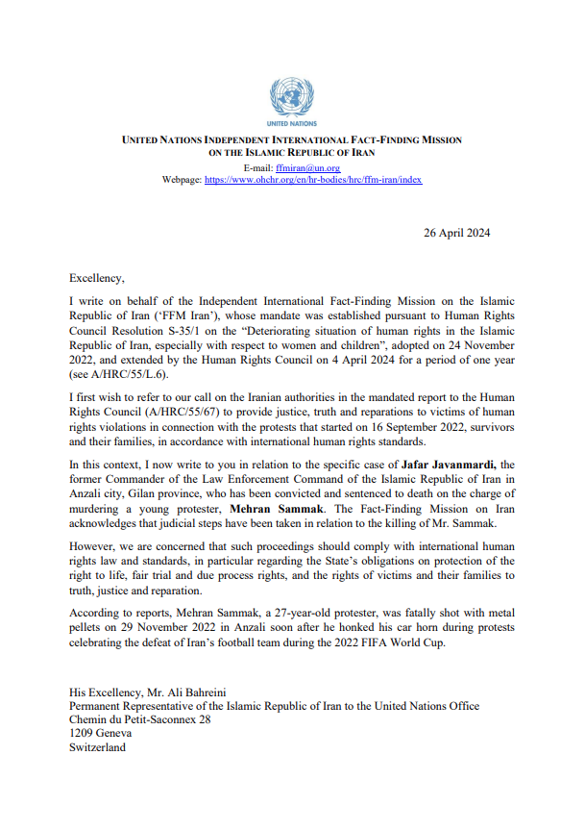
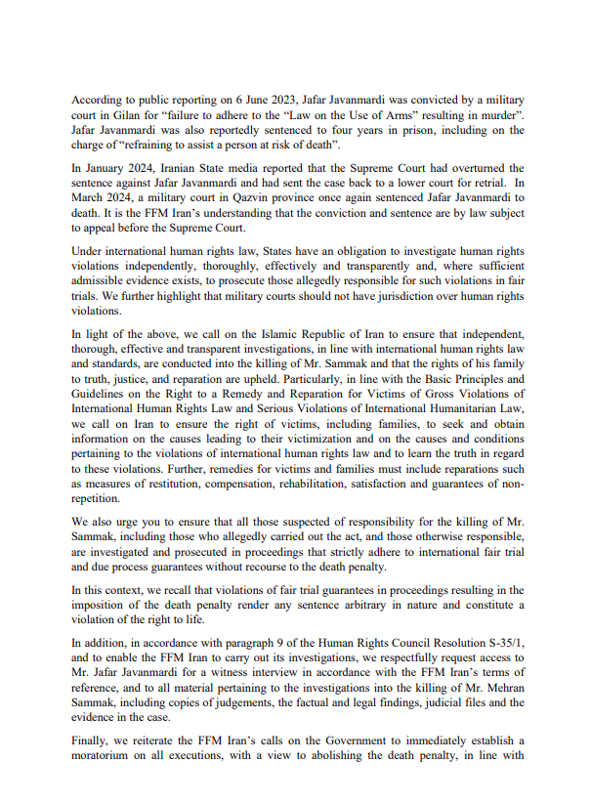
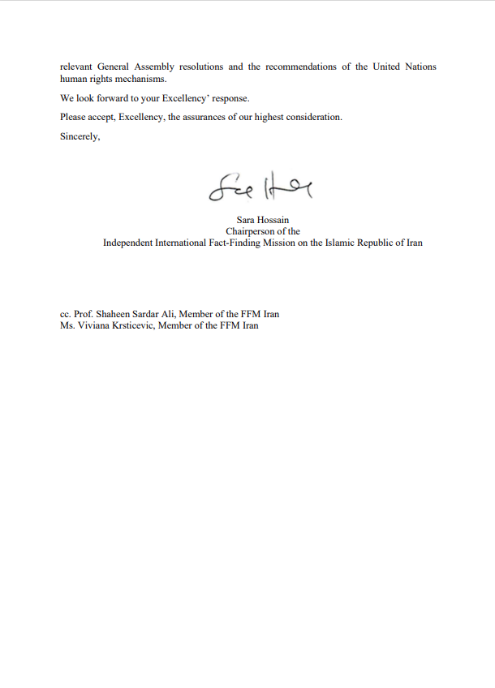
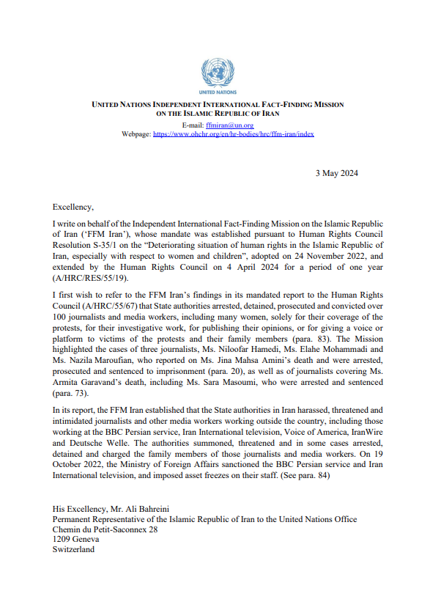
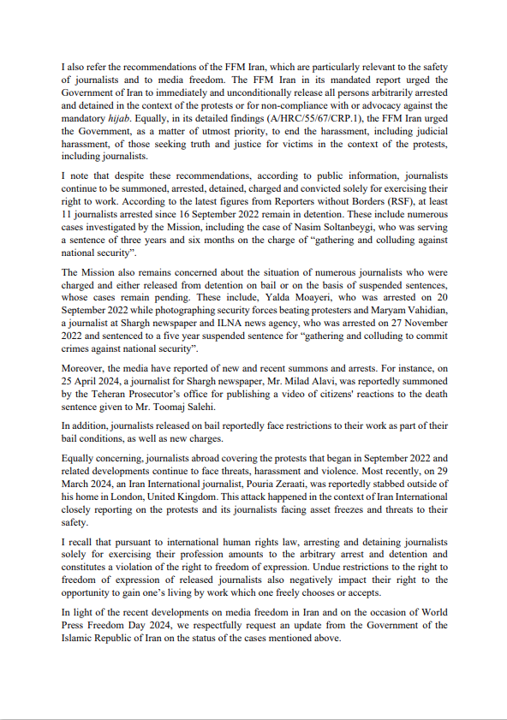
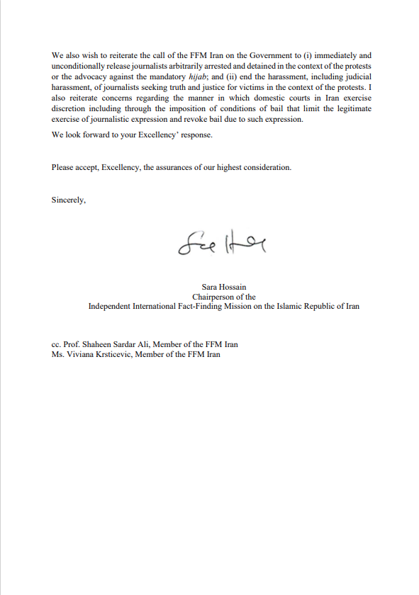
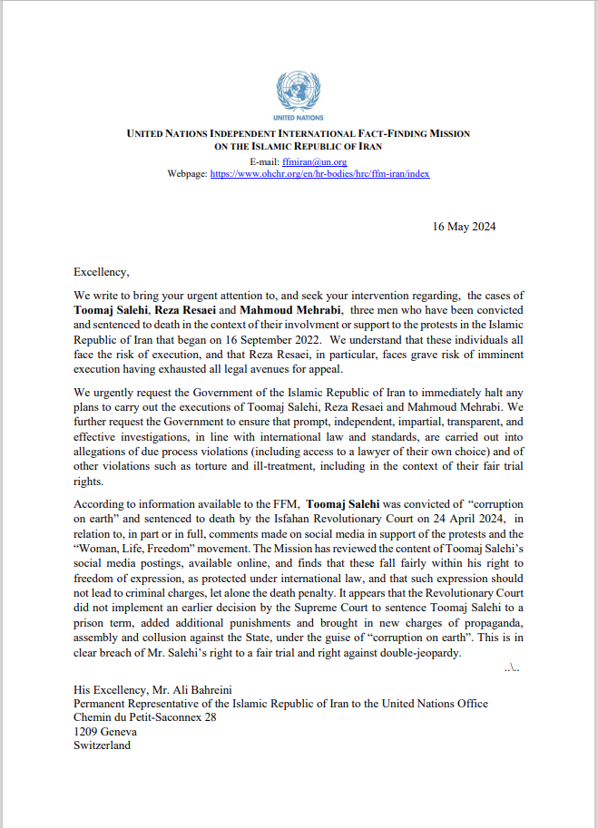
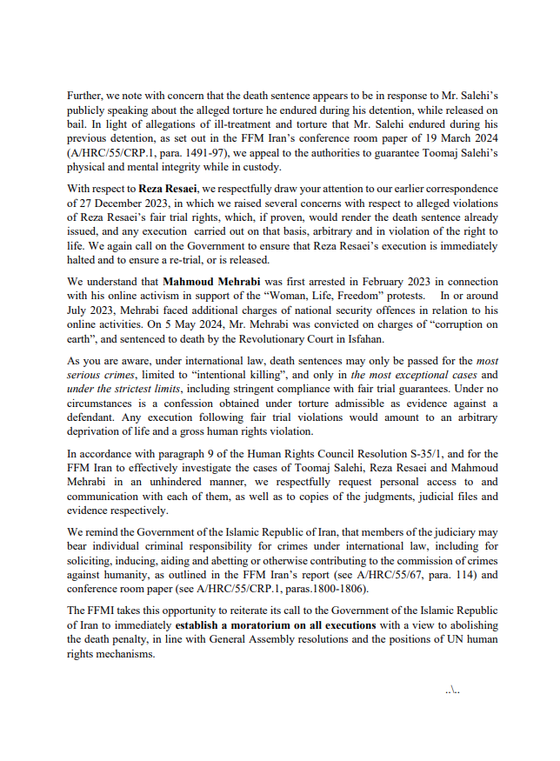
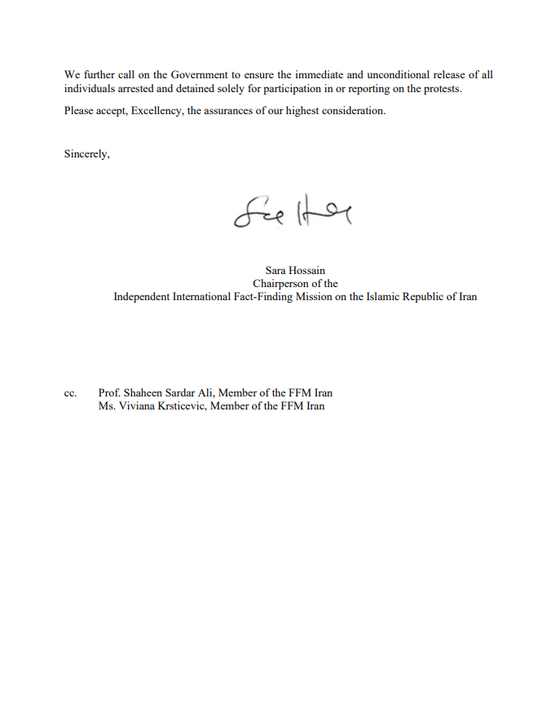

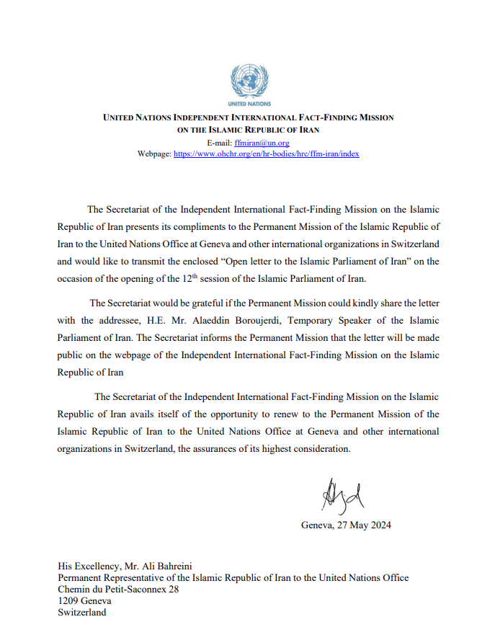

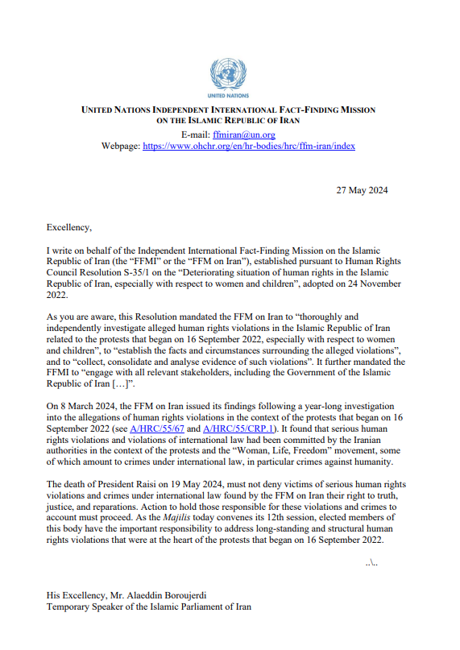

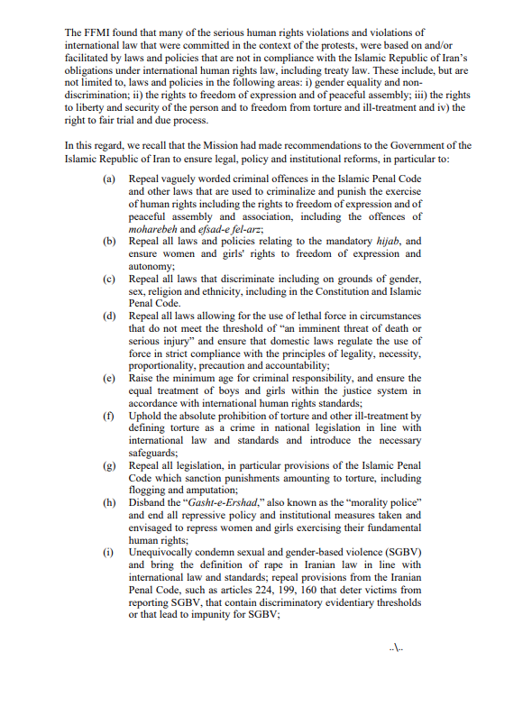

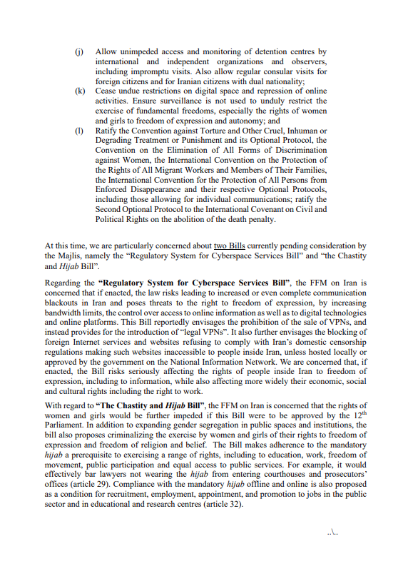

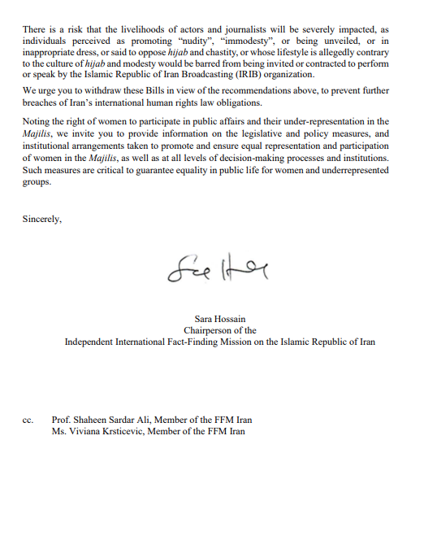

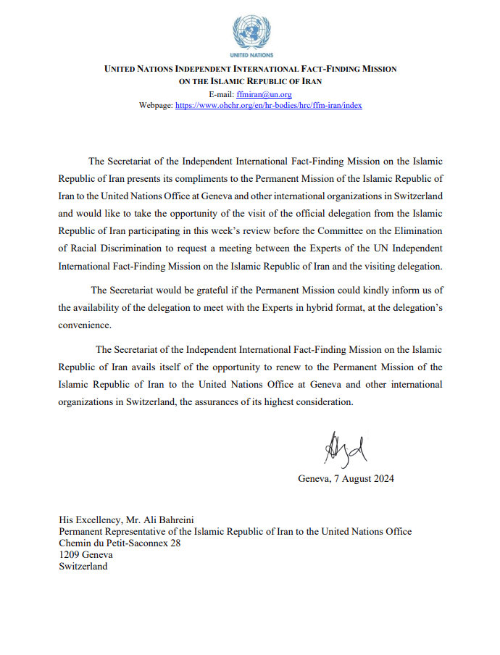

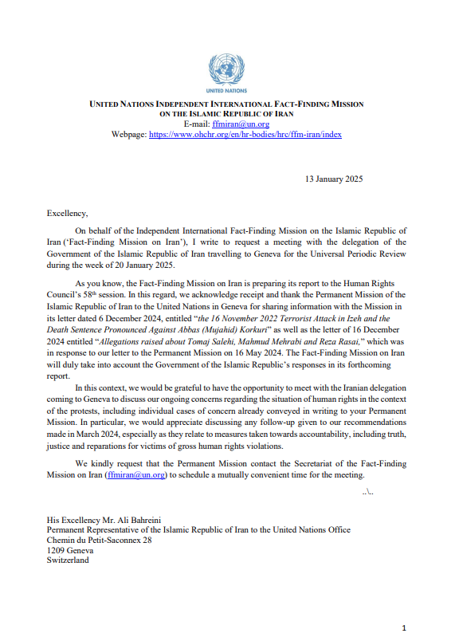

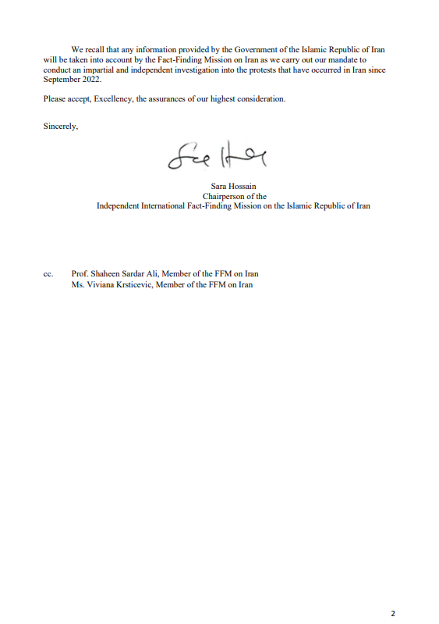

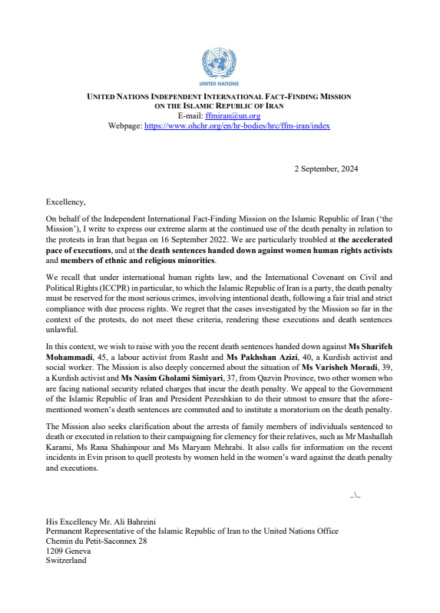

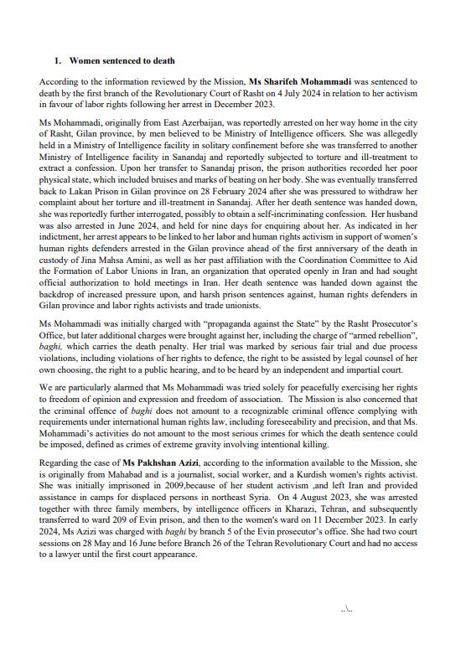

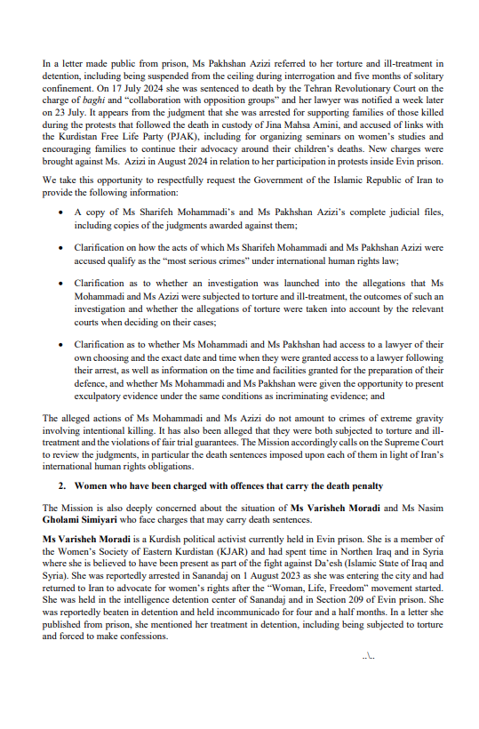

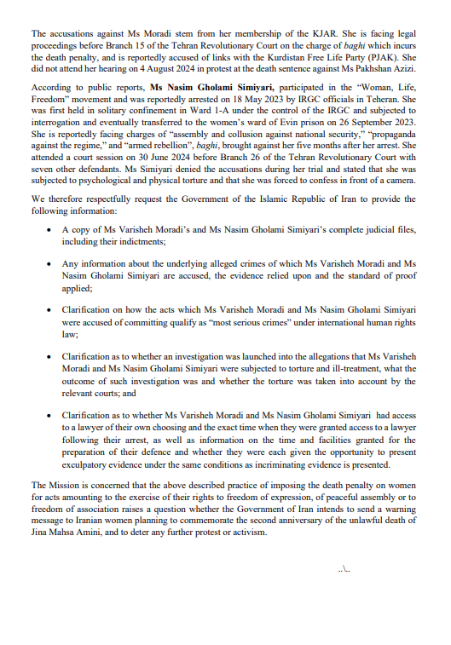

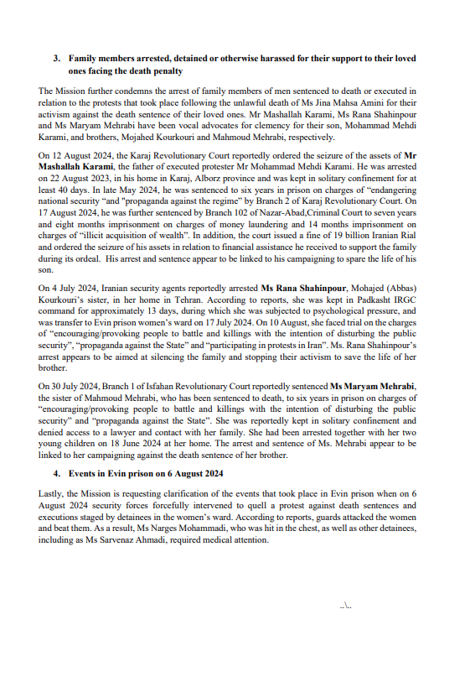

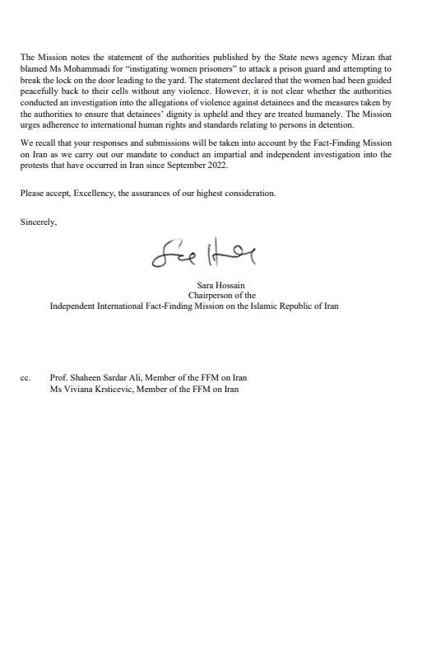

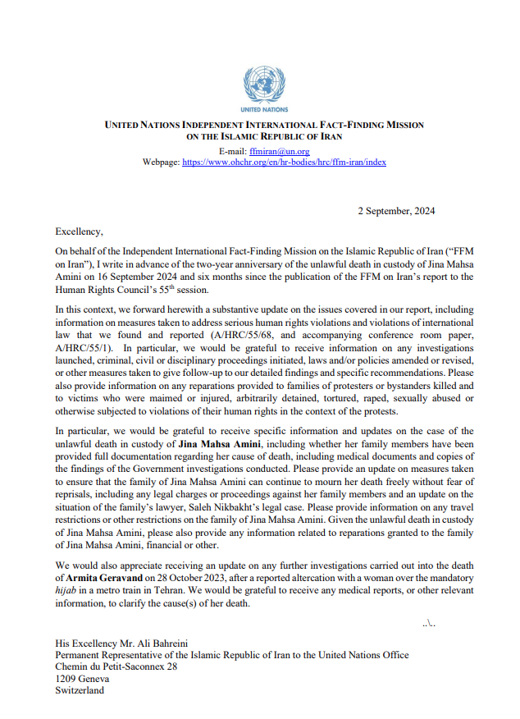
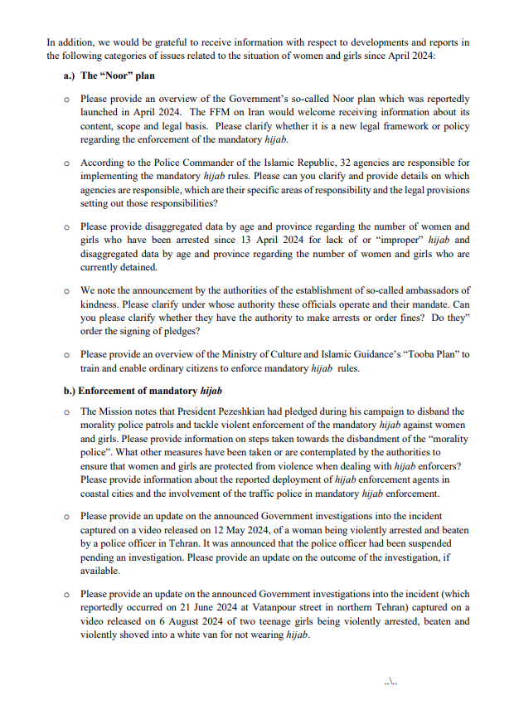
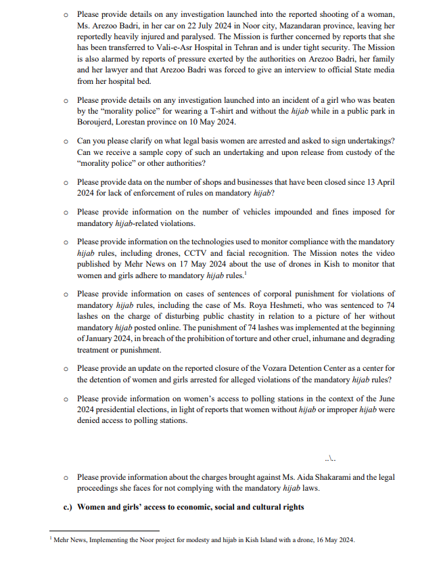

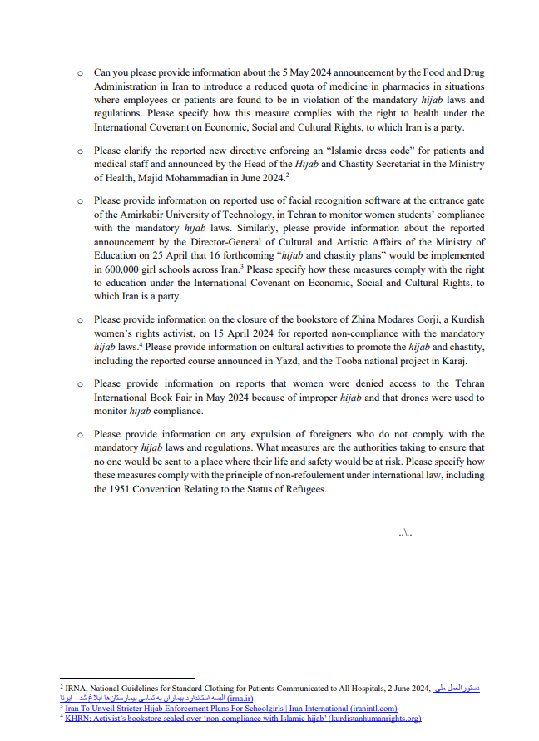
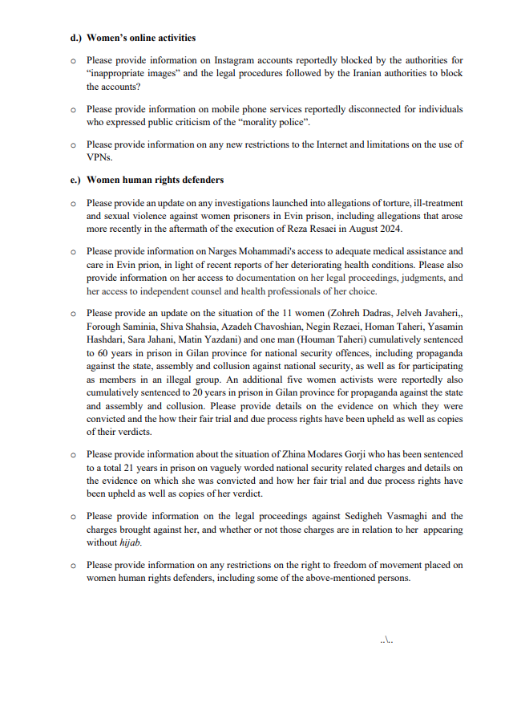
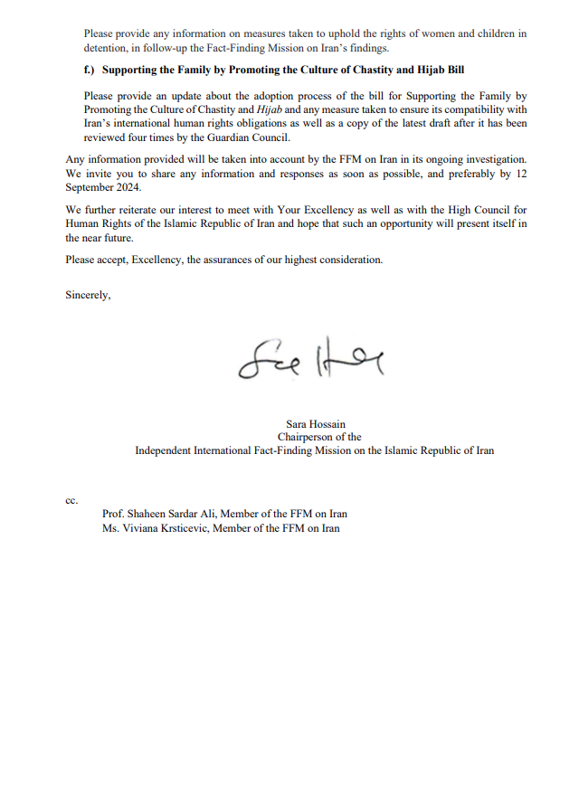
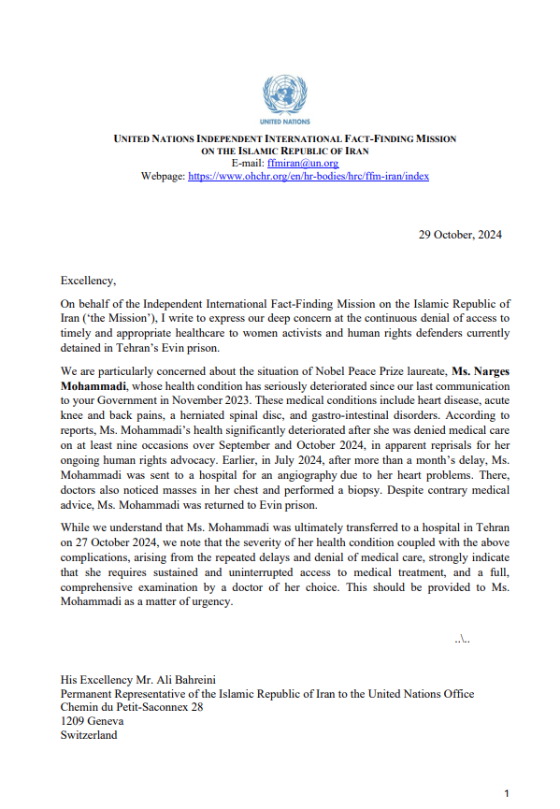
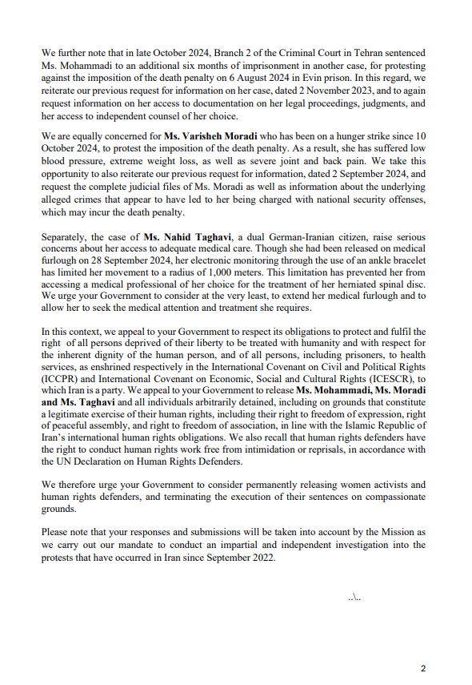
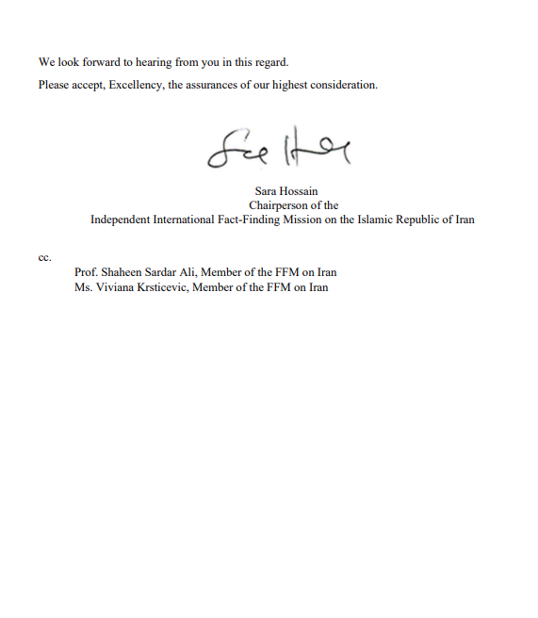

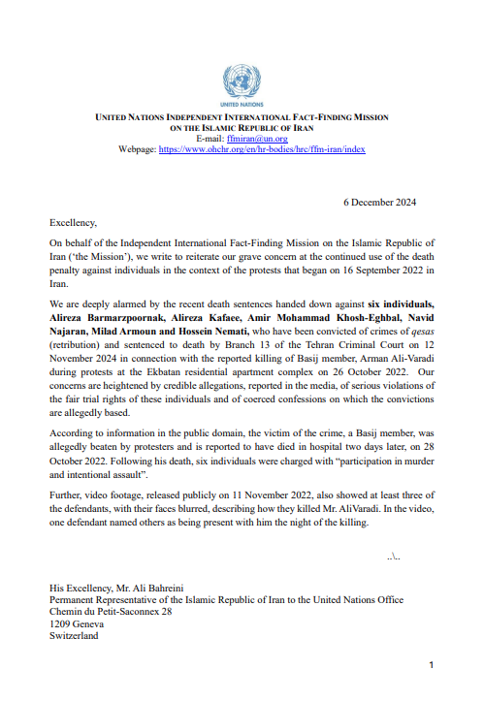

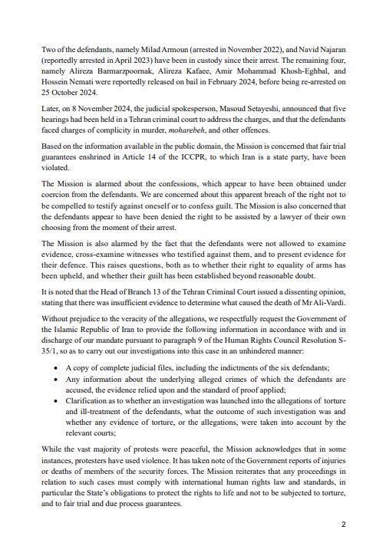

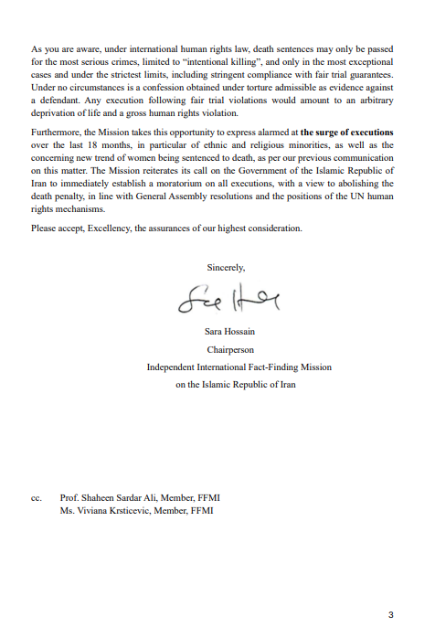

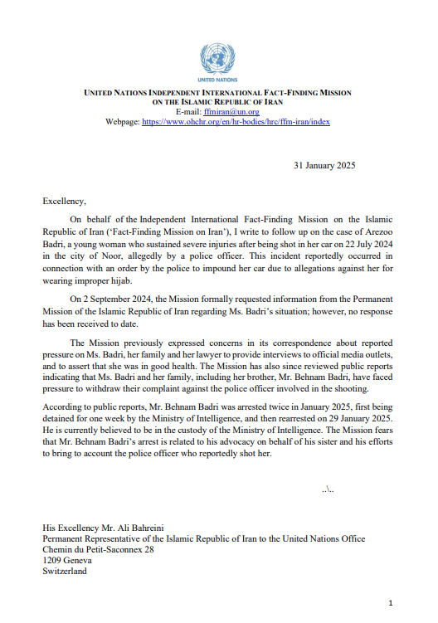

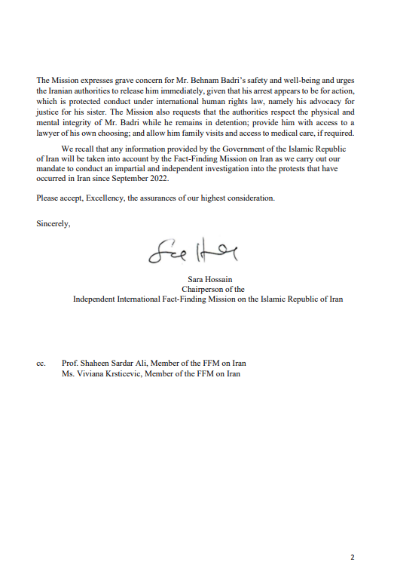

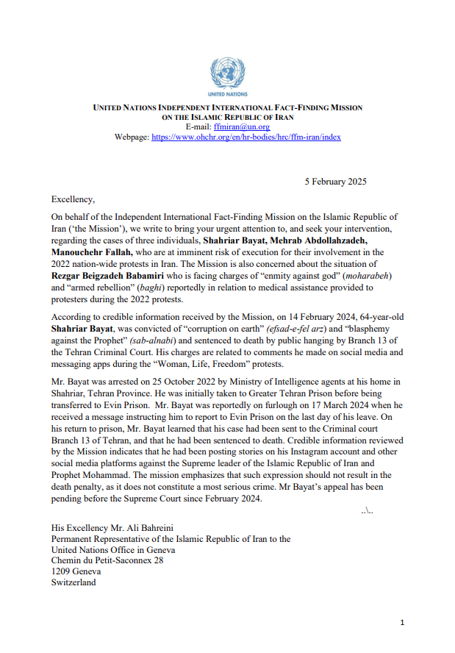
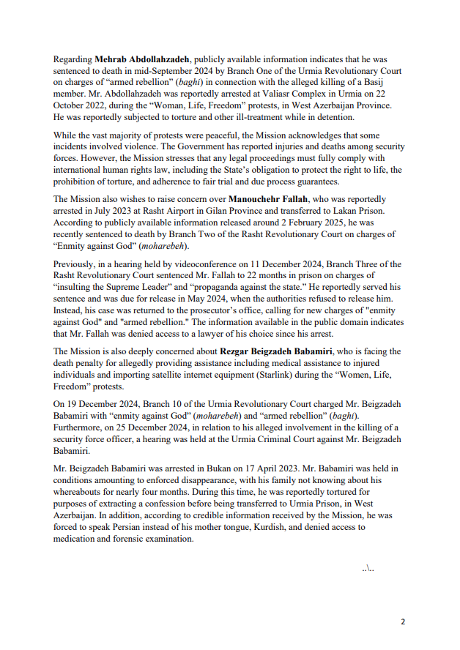
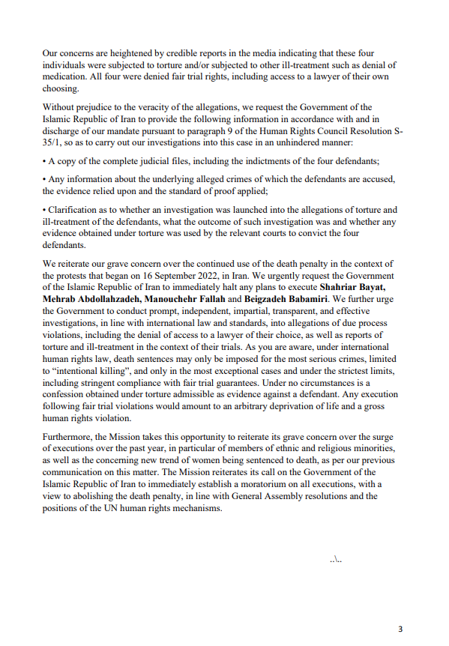
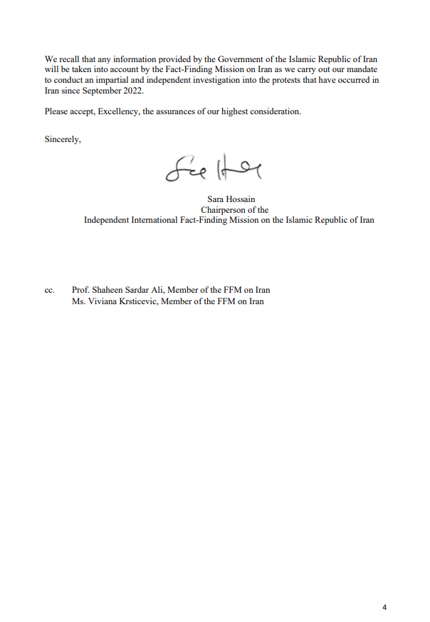
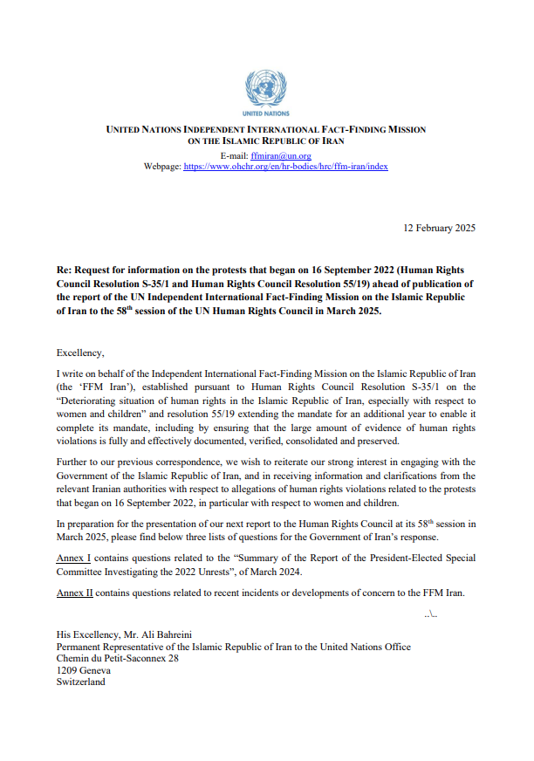
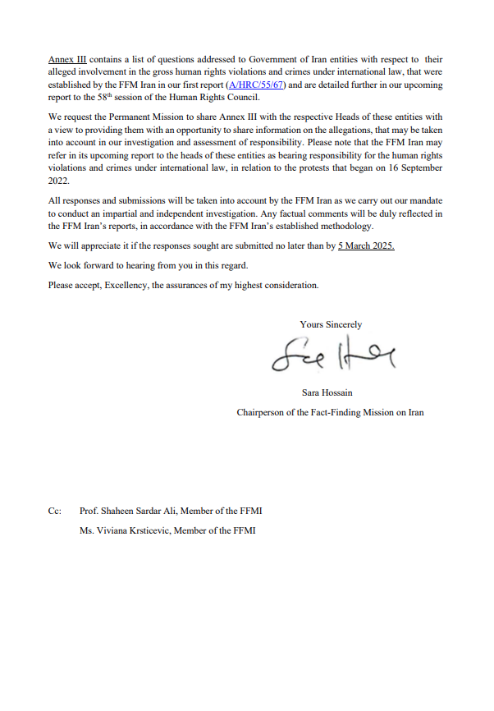
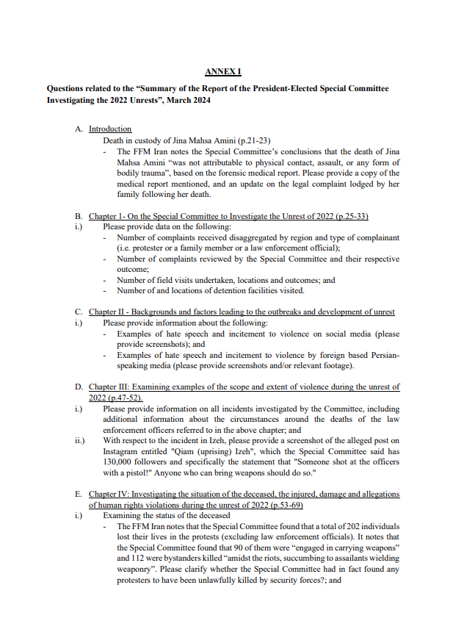
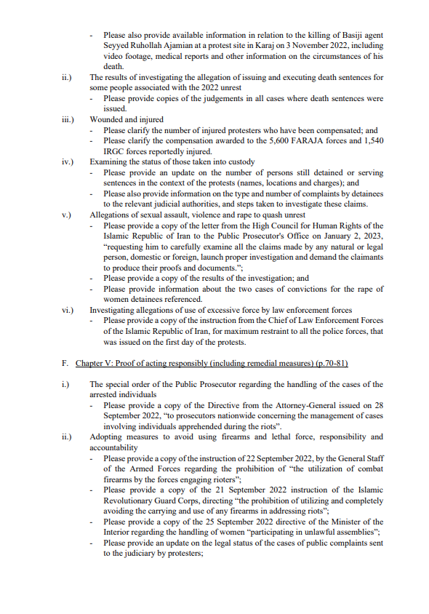
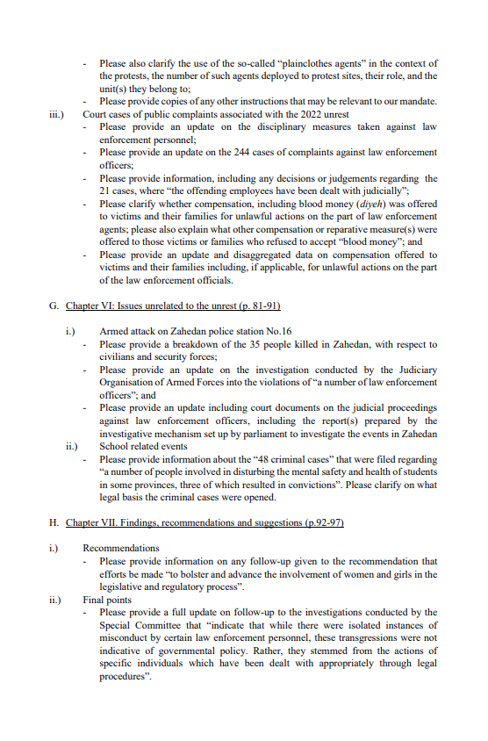
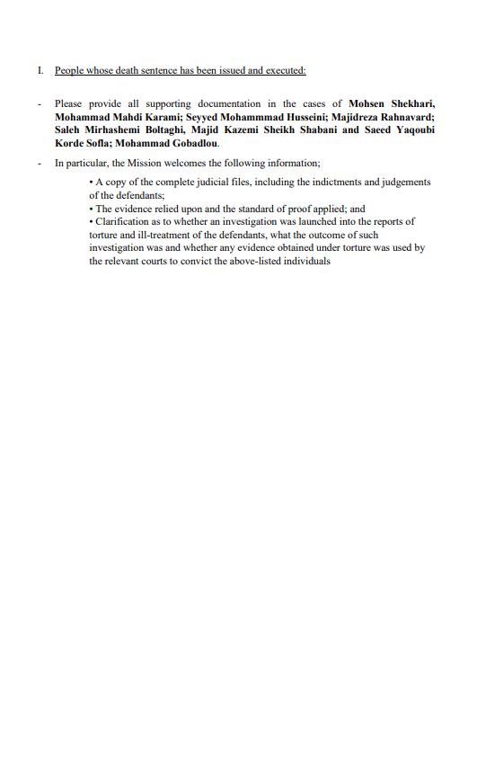
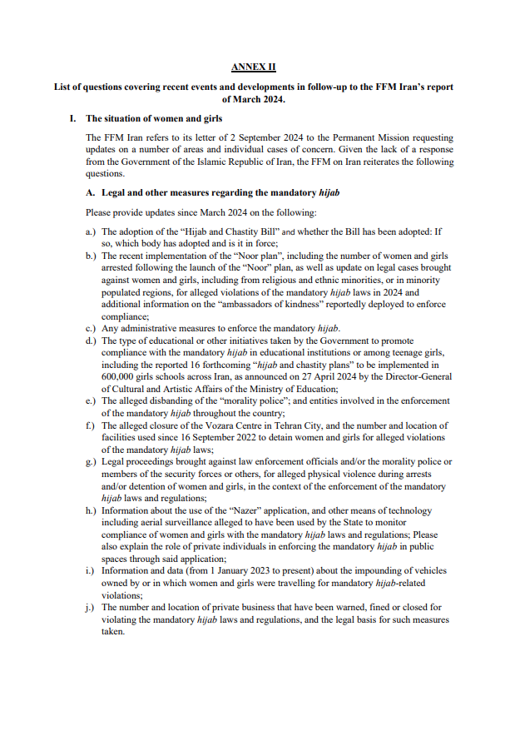
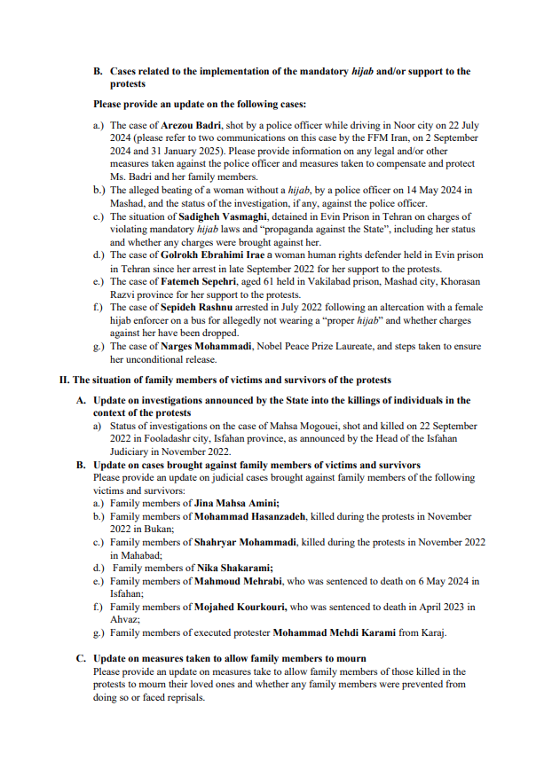
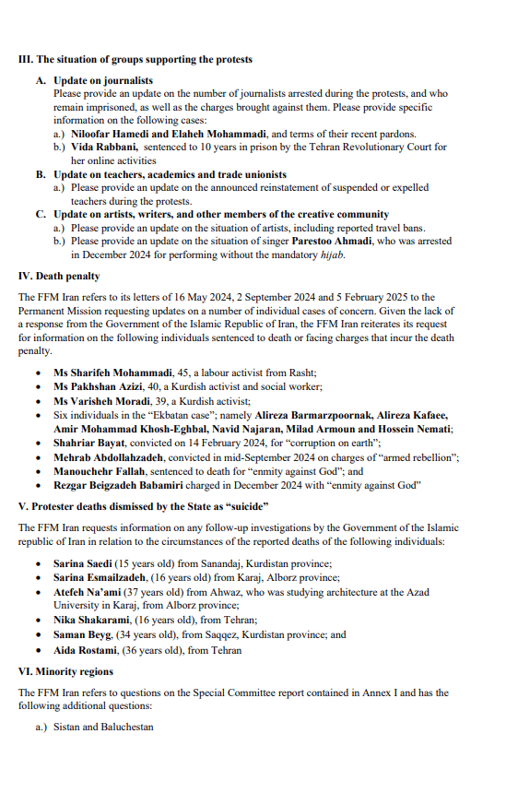
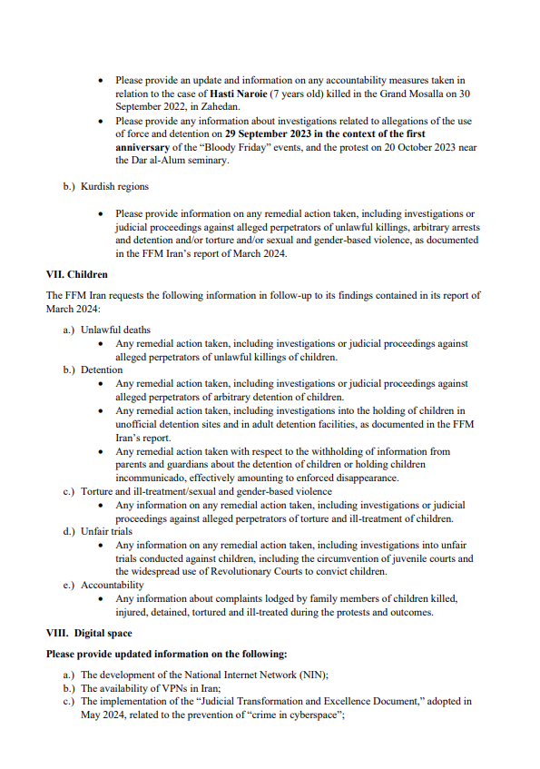
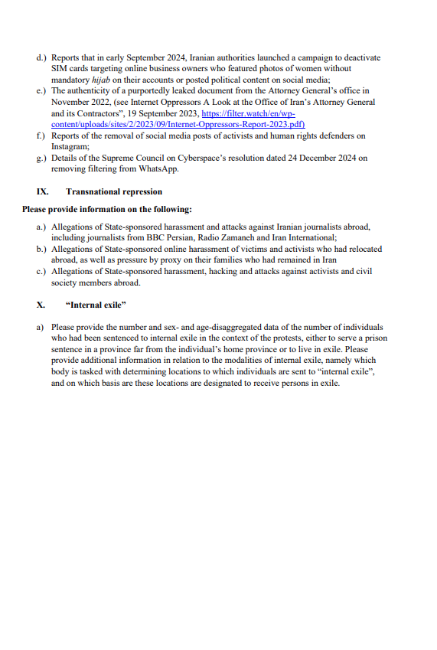

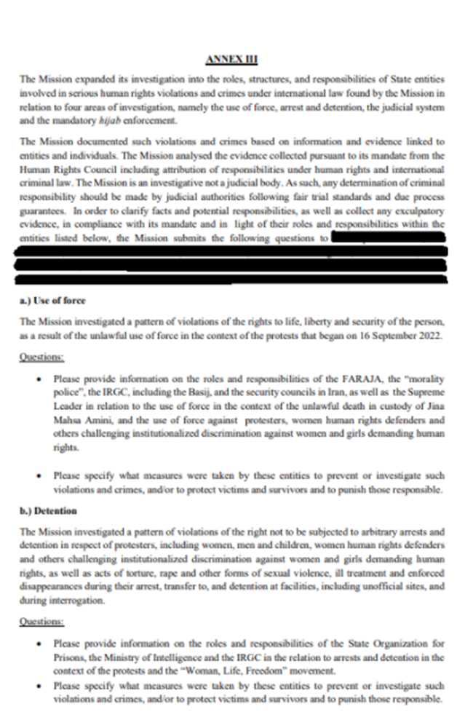
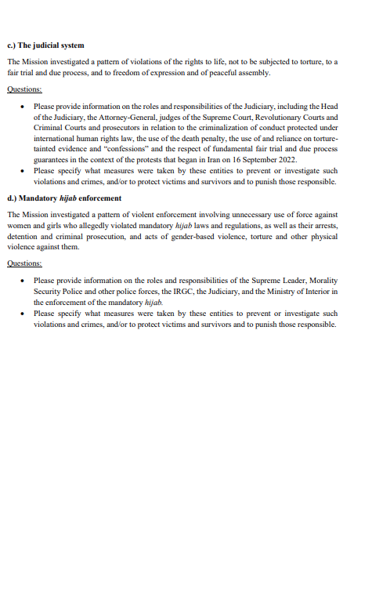

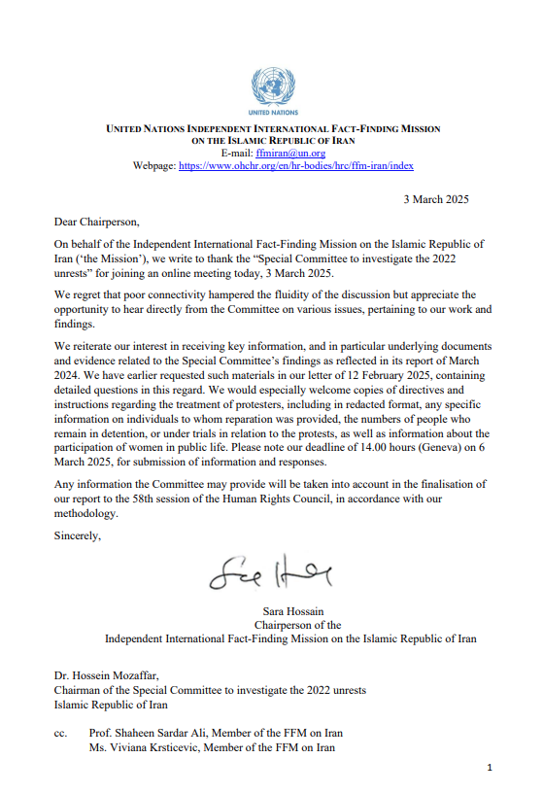

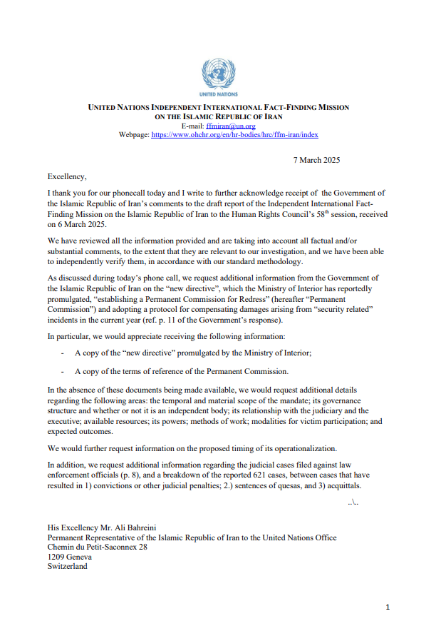
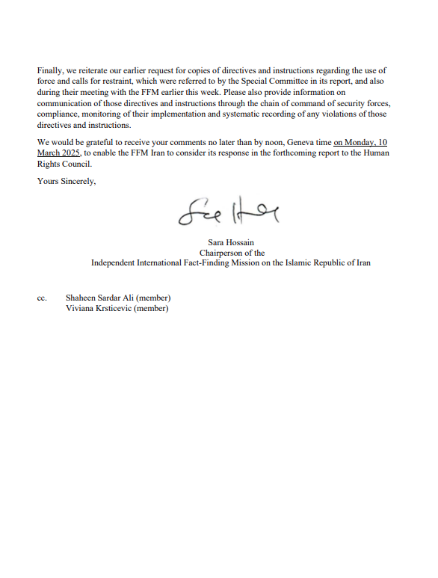

* The information contained in the present document should be read in conjunction with the official report of the Independent International Fact-Finding Mission on the Islamic Republic of Iran (A/HRC/58/63), submitted to the Human Rights Council at its fifty-eighth session, pursuant to Council resolution 55/19.
A/HRC/RES/S-35/1.
A/HRC/55/67.
A/HRC/55/CRP.1.
A/HRC/RES/55/19, para. 2.
Ibid.
See Commissions of Inquiry and Fact-Finding Missions on International Human Rights and Humanitarian law, Guidance and Practice, Office of the High Commissioner for Human Rights, Chapter II. The Mission’s terms of reference are available from https://www.ohchr.org/en/hr-bodies/hrc/ffm-iran/index.
A/HRC/55/CRP.1, paras. 38-41.
The Mission availed itself of official translations where they were available. In all other instances, translations are unofficial translations.
See Berkeley Protocol on Digital Open Source Investigations available at https://www.ohchr.org/sites/default/files/2022-04/OHCHR_BerkeleyProtocol.pdf . The Mission has reviewed hundreds of pieces of video footage and verified them to the extent that was possible. Where it has relied on audio-visual material to make findings, it has accepted that the material is credible and authentic, in line with its standard of proof.
For the Mission’s detailed methodology, see A/HRC/55/CRP.1, paras. 30-43.
“What would Pezeshkian do with the morality patrols?”, Asr Iran, 18 August 2024; “The hijab law and the Noor project are the Achilles heel of the President’s Government”, Etemad, 18 August 2024.
See A/HRC/55/CRP.1, para. 215.
“At the end of last year, in a meeting with Raisi, we emphasized that Faraja should come to the fore for the issue of the hijab!”, Etemad online, 23 March 2024.
“Supreme Leader: the issue of hijab has become a challenge”, Entekhab, 3 April 2024.
“The "Noor" project has started to deal with the removal of the hijab: This is equivalent to breaking the law,” ISNA, 14 April 2024; see also “Police implements hijab and chastity plan in Tehran”, Tabnak, 11 April 2024.
“The Faraja has inherent and legal duties in the field of chastity and hijab, according to various laws and resolutions of the Supreme Council of the Cultural Revolution. Today, we all have responsibility for social abnormalities and must fulfil our duties.”, Mizan, 22 April 2024.
The hijab plan has been communicated to all specialized units and police, including the traffic police”, Keyhan, 6 August 2024; “Reduction in Traffic Violations/Entry of Pedestrians to Detect Hijab in Cars”, Tasnim News, 6 August 2024.
“Iran Prosecutor General: the disease of improper or bad hijab in the society must be eliminated”, Mehr News, 18 September 2024.
“Commander of the Tehran Revolutionary Guards: Trained groups of ‘Kind Ambassadors’ are following up on the observance of the hijab in public places more seriously”, Entekhab, 22 April 2024. See also “Ambassadors of Mehr reminds and clarifies about chastity and hijab in public places in Tehran”, Mehr News, 22 April 2024.
“Radan: When people’s eyes get used to indecency, they gradually become zealous”, Khabafoori, 27 April 2024. See also “Radan: dealing with the unveiling of the hijab continues strongly: Parliament support for the implementation of the Noor plan”, Hamshahri online, 24 April 2024.
“Annual Analytical and Statistical Report on Human Rights in Iran for the year 2024”, HRANA, 26 December 2024.
FFM-IRAN-D-003927 (FFMI Interview).
FFM-IRAN-D-002306-FFM-IRAN-D-002335 (FFMI Submission).
FFM-IRAN-D-002306-FFM-IRAN-D-002335 (FFMI Submission).
FFM-IRAN-D-002549 (FFMI Submission).
“Sister of Iranian slain teen killed in anti-government protests released from prison”, Radio Farda, 23 April 2024.
“Aida Shakarami charged with inciting immorality and indecency”, HRANA, 30 May 2024. See also https://x.com/dadban4/status/1796095237997133915.
FFM-IRAN-D-003927 (FFMI Interview); FFM-IRAN-D-002016 (FFMI Interview).
FFM-IRAN-D-003927 (FFMI Interview).
FFM-IRAN-D-058001 (FFMI Interview).
FFM-IRAN-D-002087 (FFMI Submission).
FFMI-IRAN-D-00323 (FFMI Collection of videos).
Video on file with the Mission.
“Police reaction to video of illegal encounter of an officer during the arrest of a woman/offender arrested and suspended”, ISNA, 14 May 2024.
Video on file with the Mission.
“Police reaction to the video of a fight between several female officers and a girl wearing a hijab”, ISNA, 7 August 2024.
“Police reaction to the video of the fight between several female officers and two girls”, ISNA, 7 August 2024.
FFM-IRAN-D-002306-FFM-IRAN-D-002335 (FFMI Submission); FFM-IRAN-D-002599 (FFMI Submission).
FFM-IRAN-D-004568 (FFMI Interview); FFM-IRAN-D-005107 (FFMI Submission); FFM-IRAN-D-002306-FFM-IRAN-D-002335 (FFMI Submission).
FFM-IRAN-D-002599 (FFMI Submission).
FFM-IRAN-D-002306-FFM-IRAN-D-002335 (FFMI Submission).
FFM-IRAN-D-002599 (FFMI Submission). See also A/HRC/55/CRP. 1, para. 1287.
“Roshnak Molaei flogged in Qarchak prison for violating hijab laws”, HRANA, 3 December 2024.
Response to the FFM Iran, High Council for Human Rights of the Islamic Republic of Iran, 6 March 2025.
See A/HRC/55/CRP.1, para. 1282.
“Mehdi Yarahi received 74 lashes”, Asr Iran, 4 March 2025.
See “Medhi Yarahi sentenced to 2 years and 8 months in prison”, Fars News, 9 January 2024.
A/HRC/55/CRP.1, para. 1300.
FFM-IRAN-D-002940 (FFMI Interview).
A/HRC/55/CRP.1, paras. 1247-1250.
“Using a quadcopter to control women's hijab at the Tehran Book Fair”, Alainpersian, 10 May 2024. See also “Iran turns Tehran book fair into a hijab battleground”, Iran International, 12 May 2024; “Iran deploys drones, surveillance to enforce hijab rules”, Iran Wire, 10 May 2024.
“Implementation of the special Noor plan for chastity and hijab in Kish Island with a drone”, Mehr News Agency, 16 May 2024.
"Implementation of the ‘Noor Plan’ on Instagram; 21 Popular Pages Blocked", Digiato News, 23 April 2024.
“Blocking the phone and internet lines of unveiled women if warnings are ignored”, Shargh Daily, 15 March 2023.
“Release of 8,000 impounded hijab cars on the occasion of Eid Ghadir Khumm”, Ekhtebar, 23 June 2024.
“Clearence of impounded vehicles through the Nazer application in the field of hijab”, Mehr News, 5 October 2024.
FFM-IRAN-D-00568 (FFMI Interview); FFM-IRAN-D-002599 (FFMI Submission); FFM-IRAN-D-002306-FFM-IRAN-D-002335 (FFMI Submission).
FFM-IRAN-D-002599 (FFMI Submission).
FFM-IRAN-D-002599 (FFMI Submission).
FFM-IRAN-D-002599 (FFMI Submission).
FFM-IRAN-D-003767 (FFMI Submission).
FFM-IRAN-D-003767 (FFMI Submission); FFM-IRAN-D-003752 (FFMI Meeting); FFM-IRAN-D-003754 (FFMI Submission).
FFM-IRAN-D-002941 (FFMI Submission); FFM-IRAN-D-004279 (FFMI Communication). See also “Iranian woman shot over hijab law left paralyzed, says activist”, Iran International, 27 December 2024.
“An important point about Arezou Badri and not paying attention to the order to stop by the police”, Tasnim News, 22 August 2024. See also Response to the FFM Iran, High Council for Human Rights of the Islamic Republic of Iran, 6 March 2025.
“Was the attacker of Arezou Badri arrested?”, Shargh Daily, 17 August 2024.
Response to the FFM Iran, High Council for Human Rights of the Islamic Republic of Iran, 6 March 2025.
Information on file with the Mission; FFM-IRAN-D-058009 (FFMI Communication).
FFM-IRAN-D-058010 (FFMI Communication); FFM-IRAN-D-005163 (Video); “Arezou Badri is doing well”, IRNA, 20 August 2024.
FFM-IRAN-D-002938 (FFMI Investigation Note); FFM-IRAN-D-002941 (FFMI Communication).
FFM-IRAN-D-058010 (FFMI Communication).
“The full text of the controversial chastity and hijab law”, Entekhab, 30 November 2024.
FFM-IRAN-D-005191 (Document).
“The Supreme National Security Council, and not another authority, has blocked the promulgation of the law”, Farau, 4 January 2025.
“Government Spokesperson: The Hijab and Chastity Law was rightly postponed/Some provisions of the law could have had serious social consequences”, Entekhab, 7 January 2025.
Response to the FFM Iran, High Council for Human Rights of the Islamic Republic of Iran, 6 March 2025.
The Mission undertook a comprehensive analysis of the draft law as published by state-affiliated media on 30 November 2024, which will be published at an appropriate time.
Article 48.
Response to the FFM Iran, High Council for Human Rights of the Islamic Republic of Iran, 6 March 2025.
Article 67 specifies that the punishments outlined in Article 638 of the Islamic Penal Code, including flogging, applies to anyone who “publicly engages in forbidden acts” and/or “offends public decency”.
Article 56.
Article 40.
“University students in Iran protest hijab enforcement, boycott classes”, Iran International, 22 April 2024.
“Universities targeted in crackdown against women”, Iran Wire, 22 April 2024.
“Implementation of 16 chastity and hijab projects in schools”, Hammihan Online, 27 April 2024; “Implementation of 16 chastity and hijab projects in schools”, ISNA, 25 April 2024.
FFM-IRAN-D-002599 (FFMI Submission).
A/HRC/55/CRP.1, paras. 266, 1476.
FFM-IRAN-D-004965 (FFMI Communication).
“Activist’s bookstore sealed over non-compliance with Islamic hijab”, Kurdistan Human Rights Network, 16 April 2024.
“Details and reasons for the sealing off of the office of Turkish Airlines”, Tasnim News, 9 July 2024.
“Annual statistical report on human rights conditions in Iran”, HRANA, 26 December 2024.
“Gilan court confirms 60-year sentence for 11 activists”, Iran Wire, 29 May 2024.
“Iranian women’s rights activists sentenced to long prison terms”, Radio Farda, 28 March 2024.
“Jelveh Javaheri released from Lakan prison in Rasht”, Front Line Defenders.
Instagram post on file with the Mission.
FFM-IRAN-D-002536 (FFMI Interview); FFM-IRAN-D-003994 (FFMI Submission).
According to the HCHR, Golrokh Ebrahimi was sentenced to five years imprisonment. The HCHR confirmed that she has not sought a pardon, despite being eligible to do so. Response to the FFM Iran, High Council for Human Rights of the Islamic Republic of Iran, 6 March 2025.
“Golrokh Iraee refused to ask for pardon or appear before a court of appeal”, Front Line Defenders.
“Arrest of Fatemeh Sepehri, a Vocal Critic of Ayatollah Khamenei, and Other Civil Activists”, BBC Persian, 22 September 2022.
While one of her brothers had been released, the other remain in prison. See https://x.com/FemenaNet/status/1836415019791114262?mx=2. See also “Iranian dissident Sepehri sentenced to further 18 1/2 years for comments about Israel”, Radio Farda, 13 June 2024.
“Mashhad: Khosrow Alikordi, Kurdish lawyer, sentenced to one year in prison”, Hengaw, 19 January 2025.
X post on file with the Mission.
“Report on the Latest Situation of Fatemeh Sepehri in Vakilabad Prison, Mashhad”, HRANA, 15 January 2025.
A/HRC/55/CRP.1, para. 376.
“Appeals Court issues verdict; Sepideh Rashnu sentenced to 4 months in prison in second case/ Rashno's lawyer: She faces 3 years and 11 months in prison”, Shargh Daily, 5 December 2023. See also “Everything you need to know about Sepideh Rashnu, Iranian writer persecuted for defying the mandatory hijab”, Iran Human Rights Documentation Center, 26 July 2024.
“Everything you need to know about Sepideh Rashnu, Iranian writer persecuted for defying the mandatory hijab”, Iran Human Rights Documentation Center, 26 July 2024.
See A/HRC/55/CRP.1, paras. 1439-1441.
FFM-IRAN-D-004985 (FFMI Interview).
FFM-IRAN-D-004813 (FFMI Communication).
FFM-IRAN-D-058119 (FFMI Communication).
FFM-IRAN-D-001422 (FFMI Interview).
See A/HRC/55/CRP.1, paras. 573-584.
FFM-IRAN-D-000374 (FFMI Interview); FFM-IRAN-D-000508 (FFMI Interview); FFM-IRAN-D-000513 (FFMI Interview); FFM-IRAN-D-000100 (FFMI Interview); FFM-IRAN-D-000825 (FFMI Interview); FFM-IRAN-D-000507 (FFMI Interview); FFM-IRAN-D-000425 (FFMI Interview); FFM-IRAN-D-000529 (FFMI Interview); FFM-IRAN-D-001512 (FFMI Interview); FFM-IRAN-D-001659 (FFMI Interview); FFM-IRAN-D-001018 (FFMI Interview); FFM-IRAN-D-001510 (FFMI Interview); FFM-IRAN-D-000532 (FFMI Interview); FFM-IRAN-D-001675 (FFMI Interview); FFM-IRAN-D-000590 (FFMI Interview); FFM-IRAN-D-003773 (FFMI Interview); FFM-IRAN-D-005039 (FFMI Interview); FFM-IRAN-D-005037 (FFMI Interview); FFM-IRAN-D-004907 (FFMI Interview); FFM-IRAN-D-004908 (FFMI Interview); FFM-IRAN-D-005063 (FFMI Interview); FFM-IRAN-D-005036 (FFMI Interview); FFM-IRAN-D-004909 (FFMI Interview); FFM-IRAN-D-004923 (FFMI Interview); FFM-IRAN-D-005040 (FFMI Interview); FFM-IRAN-D-004970 (FFMI Interview); FFM-IRAN-D-004906 (FFMI Interview); FFM-IRAN-D-004908 (FFMI Interview).
FFM-IRAN-D-005040 (FFMI Interview).
FFM-IRAN-D-001468 (FFMI Interview); FFM-IRAN-D-003725 (FFMI Interview); FFM-IRAN-D-004909 (FFMI Interview); FFM-IRAN-D-004885 (FFMI Interview).
FFM-IRAN-D-004909 (FFMI Interview).
A/HRC/55/CRP.1, paras. 889-891.
FFM-IRAN-D-004887 (FFMI Interview); FFM-IRAN-D-004885 (FFMI Interview); FFM-IRAN-D-000744 (FFMI Interview).
FFM-IRAN-D-004887 (FFMI Interview).
FFM-IRAN-D-004893 (FFMI Interview).
A/HRC/55/CRP.1, paras. 1512-1515.
FFM-IRAN-D-004610 (FFMI Interview); FFM-IRAN-D-004923 (FFMI Interview); FFM-IRAN-D-001008 (FFMI Interview).
FFM-IRAN-D-004528 (FFMI Social Media Post).
FFM-IRAN-D-058002 (FFMI Interview).
See A/HRC/55/CRP.1, paras. 771-775.
“Iranian authorities arrest mother of teen killed in 2022 protests”, Iran Wire, 17 October 2024; “Nasreen Shakrami, Nika's mother, was arrested”, Radio Farda, 19 October 2024.
FFM-IRAN-D-004816 (FFMI Social Media Post).
“Siavash Soltani”, Kurdistan Human Rights Network; “Siavash Soltani arrested by security forces”, HRANA, 3 September 2024. See also HRC/55/CRP.1, para. 66.
See A/HRC/55/CRP.1, para.1531 and Annex III, paras. 64-66.
“Iran Arrests Teen Brother of Slain 2022 Protester”, Iran International, September 3, 2024.
A/HRC/55/CRP.1, Annex III, paras. 64-65.
“Iran arrests mother of slain protester, ahead of Woman, Life, Freedom uprising anniversary”, Iran International, 15 September 2024; “Mahabad: Arrest of 16-year-old Ramyar Abu Bakri by security forces”, Kolbar News, 03 September 2024.
“Iran arrests father of protester slain during 2022 uprising”, Iran Wire, 16 September 2024.
“Iranian court sentences sister of protest victim to one year in prison”, Iran Wire, 30 October 2022.
“Urmia prison, Solmaz Hasanzadeh release after eight days of hunger strike and solitary confinement on bail”, Kurdpa, 13 August 2023.
“Increased pressure by security agencies on the family of Armita Garavand; one year after her state-sanctioned murder”, Hengaw, 27 October 2024.
FFM-IRAN-D-058012 (FFMI Interview).
FFM-IRAN-D-004919 (FFMI Interview).
Information on file with the Mission.
FFM-IRAN-D-000124 (FFMI Interview); FFM-IRAN-D-004571 (FFMI Submission).
FFMI-IRAN-D-051389 (FFMI Interview).
“The Judiciary's Reaction to the Alleged Arrest of Maryam Mehrabi and Her Children”, Hamshahri online, 19 June 2024; “Narration of the Judiciary News Agency on how Maryam Mehrabi was arrested,” Asriran, 19 June 2024.
“Maryam Mehrabi, Sister of Mahmoud Mehrabi, Political Prisoner Sentenced to Death, Is Sentenced to Six Years in Prison”, Hengaw, 4 August 2024. See also “Maryam Mehrabi Sentenced to Six Years in Prison and Additional Punishments”, HRANA, 5 August 2024.
See A/HRC/55/CRP.1, paras. 523-528.
FFM-IRAN-D-003703 (FFMI Communication).
An enlightening report regarding the baseless and unsupported allegations of the so-called fact-finding mission regarding life-deprivation punishments, High Council for Human Rights of the Islamic Republic of Iran, January 2025, p. 6.
Information on file with the Mission.
“Lawyers request to hold an in-person meeting in the Court of Appeal regarding the security charges of Masha Allah Karmi / No verdict has been issued on Mr. Karmi's ‘money laundering’ charge, but the Revolutionary Court requests the confiscation of his property”, Shargh Daily, 12 August 2024.
"Mashallah Karami's sentence has been reduced", Shargh Daily, 30 January 2025.
FFM-IRAN-D-005062 (FFMI Interview); FFM-IRAN-D-003068 (FFMI Interview).
Social media post on file with the Mission.
“Explanation from the Judiciary Media Center on the cases of Niloufar Hamedi and Elaheh Mohammadi”, Mizan, 11 February 2025.
“Presidential Election in Iran: the ongoing repression of journalists must end now”, Reporters Without Borders”, 28 June 2024.
FFM-IRAN-D-004063 (FFMI Interview); FFM-IRAN-D-002539 (FFMI Interview); FFM-IRAN-D-003771 (FFMI Interview).
FFM-IRAN-D-058003 (FFMI Interview).
FFM-IRAN-D-004063 (FFMI Interview); FFM-IRAN-D-002537 (FFMI Interview); FFM-IRAN-D-004922 (FFMI Interview).
A/HRC/55/CRP.1, para. 1427.
Instagram post on file with the Mission.
“New court ruling for journalist Vida Rabbani”, Khabar Online, 31 December 2022.
See also “Vida Rabbani sentenced to seven years and three months in prison”, Frontline Defender, 31 December 2022.
”Iran: Journalist Vida Rabbani alleges sexual assault by prison officers during body search in Evin prison”, International Federation of Journalists, 12 November 2024.
FFM-IRAN-D-058103 (FFMI Interview).
“Immediate order of Pezeshkian to Minister of Science regarding expelled university professors and students: return them and hire them back”, Aftab News, 29 August 2024. See also “Pezeshkian’s promise: Has he fulfilled his commitment to reinstating expelled academics?”, Iran Wire, 18 September 2024. The Mission previously reported on mass dismissal of teachers as noted by the then Minister of Education, Reza Morad Sahraei, who on 21 September 2023 said that “[t]his year nearly 20,000 school principals were changed to make a difference in schools.” According to the Government of the Islamic Republic of Iran, the same Minister subsequently clarified that such changes did not reflect a “purge”, but rather that they were part of a natural process in the administrative and educational system. See Examining the inauthentic, non-legal and political report of the so-called Fact-finding Mission, High Council for Human Rights of the Islamic Republic of Iran, March 2024, p. 37.
FFM-IRAN-D-004310 (FFMI Interview); FFM-IRAN-D-005064 (FFMI Interview); FFM-IRAN-D-003068 (FFMI Interview); FFM-IRAN-D-004311 (FFMI Interview); FFM-IRAN-D-004808 (FFMI Interview); FFM-IRAN-D-002989 (FFMI Interview); FFM-IRAN-D-003868 (FFMI Interview); FFM-IRAN-D-002460 (FFMI Interview).
The victim could not appeal the verdict because, according to her, Judge Salavati did not send notice of the judgment to the Court of Appeal within the 15-day deadline, as required by law. See FFM-IRAN-D-004311 (FFMI Interview).
“Mohammad Habibi released from prison”, Front Line Defenders.
“Mohammad Habibi begins serving six-month prison sentence”, Front Line Defenders; FFM-IRAN-D-004821 (Document).
FFM-IRAN-D-004311 (FFMI Interview); FFM-IRAN-D-005064 (FFMI Interview).
FFM-IRAN-D-004311 (FFMI Interview).
FFM-IRAN-D-004311 (FFMI Interview); FFM-IRAN-D-002460 (FFMI Interview).
FFM-IRAN-D-002460 (FFMI Interview).
FFM-IRAN-D-003777 (FFMI Interview); FFM-IRAN-D-003929 (FFMI Interview); FFM-IRAN-D-003928 (FFMI Interview); FFM-IRAN-D-003796 (FFMI Submission); FFM-IRAN-D-003925 (FFMI Submission).
FFM-IRAN-D-003925 (FFMI Submission).
FFM-IRAN-D-003868 (FFMI Interview).
FFM-IRAN-D-004311 (FFMI Interview); FFM-IRAN-D-002460 (FFMI Interview). See also "Actresses who removed their hijabs cannot act in new films," Shargh Daily, 23 October 2023; “Which actors were banned for removing the Hijab”, Fars, 25 October 2023.
FFM-IRAN-D-003929 (FFMI Interview); FFM-IRAN-D-003869 (FFMI Interview).
FFM-IRAN-D-058004 (FFMI Interview).
FFM-IRAN-D-003929 (FFMI Interview); FFM-IRAN-D-003869 (FFMI Interview).
FFM-IRAN-D-003929 (FFMI Interview); FFM-IRAN-D-003869 (FFMI Interview).
FFM-IRAN-D-003929 (FFMI Interview); FFM-IRAN-D-003869 (FFMI Interview). See also “Cinema made by the IRGC; a look at the work of the Media Organization”, BBC Persian, 27 November 2024.
FFM-IRAN-D-004303 (FFMI Interview).
“Parastoo Ahmadi was released this morning”, Shargh Daily, 14 December 2024. See also “Iran releases songstress after brief arrest over concert without hijab”, Iran International, 14 December 2024.
“The arrest of Parasto Ahmadi was denied”, IRNA, 15 December 2024.
FFM-IRAN-D-004983 (FFMI Interview). See also A/HRC/55/CRP.1, paras. 1482-1486.
“Iran Human Rights and ECPM Annual Report on the Death Penalty in Iran 2024”, Iran Human Rights, 20 February 2025.
“Do not let them kill us: Iran’s relentless execution crisis since the 2022 uprising”, Amnesty International, 4 April 2024; FFM-IRAN-D-004369 (FFMI Submission).
“Iran: UN experts alarmed by surge in executions, demand moratorium on death penalty” 2 September 2024.
See A/HRC/55/67, para. 64.
For background of his case, see A/HRC/55/CRP.1, para. 960.
“Iran: Shocking secret execution of young man in relation to ‘Woman Life Freedom’ uprising”, Amnesty International, 6 August 2024.
FFM-IRAN-D-005042 (FFMI Interview); FFM-IRAN-D-005094 (Official Document).
Response to the FFM Iran, High Council for Human Rights of the Islamic Republic of Iran, 6 March 2025.
FFM Iran letters to the Permanent Mission of the Islamic Republic of Iran, 27 December 2023 and 16 May 2024.
“The moment of martyrdom of security defender Nader Bayrami”, Mehr News, 19 November 2022; “Report on the confessions of the murderer Nader Bayrami”, Aparat Media, 6 August 2024.
FFM-IRAN-D-058025 (FFMI Communication).
Information on file with the Mission; FFM-IRAN-D-058025 (FFMI Communication).
Information on file with the Mission. See also “Iran: Shocking secret execution of young man in relation to ‘Woman Life Freedom’ uprising”, Amnesty International, 6 August 2024.
FFM-IRAN-D-058026 (FFMI Interview); “Iran: Further Information: Tortured Man Facing Protest-Related Execution: Reza Resaei”, Amnesty International, 8 February 2024.
“Iran Human Rights and ECPM Annual Report on the Death Penalty in Iran 2024”, Iran Human Rights, 2024.
There is no comprehensive law on violence against women. Domestic violence and marital rape are both not criminalized. See also A/HRC/55/CRP.1, paras. 294-295.
“Women and the Death Penalty in Iran: A Gendered Perspective”, Iran Human Rights, 2025. See also A/HRC/55/CRP.1, paras. 285-295.
See also A/HRC/55/CRP.1, footnote 1343.
“Women and the Death Penalty in Iran: A Gendered Perspective”, Iran Human Rights, 2025.
“Workers Rights Activist Sharifeh Mohammadi Resentenced to Death at Retrial”, Iran Human Rights, 13 February 2025.
Response to the FFM Iran, High Council for Human Rights of the Islamic Republic of Iran, 6 March 2025.
FFM-IRAN-D-058011 (FFMI Interview).
Information on file with the Mission; FFM-IRAN-D-058011 (FFMI Interview).
FFM-IRAN-D-002535 (FFMI Submission).
Response to the Mission by the Government of Iran, dated 6 March 2025. See also “Iran: Further Information: Kurdish Activist at Risk of Imminent Execution: Pakhshan Azizi”, Amnesty International, 14 February 2025.
“Iran: Further Information: Kurdish Activist at Risk of Imminent Execution: Pakhshan Azizi”, Amnesty International,14 February 2025.
FFM-IRAN-D-003859 (Document).
FFM-IRAN-D-003861 (FFMI Interview); “Iran: Further Information: Kurdish Activist at Risk of Imminent Execution: Pakhshan Azizi”, Amnesty International, 14 February 2025.
FFM-IRAN-D-003861 (FFMI Interview).
See FFMI-00448 (FFMI Communication) See also “Iran: Further Information: Kurdish Activist at Risk of Imminent Execution: Pakhshan Azizi”, Amnesty International, 14 February 2025.
FFM-IRAN-D-003861 (FFMI Interview).
FFM-IRAN-D-058005 (FFMI Interview).
Response to the Mission by the Government of Iran, dated January 2025.
“Kurdish Political Prisoner, Varisheh Moradi Stays in Abeyance in Evin Prison Amid Continued Deprivation of Visitation and Phone Call Rights”, Hengaw, 27 August 2024; “Kurdish activist on hunger strike in Iranian prison”, Iran Wire, 11 October 2024.
FFM-IRAN-D-058008 (FFMI Interview); “Kurdish Political Prisoner, Varisheh Moradi Stays in Abeyance in Evin Prison Amid Continued Deprivation of Visitation and Phone Call Rights”, Hengaw, 27 August 2024.
FFM-IRAN-D-058006 (FFMI Interview).
FFM-IRAN-D-058007 (FFMI Interview).
FFM-IRAN-D-004034; information on file with the Mission.
"Ward 2-Alef of Evin Prison: Continuation of the Detention of the Four Defendants in relation to "Ekbatan Complex" Case", HRANA, 21 May 2024.
“Ekbatan case: Four defendants transferred to Qezl-e Hassar prison after final defense session “, HRANA, 3 November 2024.
FFM-IRAN-D-004819 (FFMI Video).
“14 individuals involved in the martyrdom of ‘Arman Aliwardi’ have been arrested”, Mashregh News, 7 November 2022.
“Ekbatan case: Two new advisors appointed, six death sentences issued”, Iran Wire, 14 November 2024.
“Video Details of Arman Alivardi's martyrdom”, Mashregh News, 9 November, 2022.
“Statements of the criminal who stabbed martyr Alivardi”, Mehr News, 3 November 2022.
“Six More Young Protesters Sentenced to Death in Iran After Grossly Unfair Trial”, 14 November 2024, Center for Human Rights in Iran.
Letter from the FFM Iran to the Permanent Mission of the Islamic Republic of Iran in Geneva, 6 December 2024.
FFM-IRAN-D-003703 (FFMI Interview). See also A/HRC/55/CRP.1, paras. 525, 943, 957.
“Mojahed Kourkour was sentenced to death again”, Radio Farda, 29 December 2024.
“Execution Sentence of Mojahed Kourkour Revoked by Country Supreme Court”, HRANA, 11 December 2024.
See A/HRC/55/CRP.1, paras. 526-527.
See A/HRC/55/CRP. 1, Section V.E.
FFM-IRAN-D0005219 (Court Document).
FFM-IRAN-D-005197 (Image); FFM-IRAN-D-005199 (Image); FFM-IRAN-D-005199 (Image); FFM-IRAN-D-005200 (Image); FFM-IRAN-D-005201 (Image); FFM-IRAN-D-005202 (Image); FFM-IRAN-D-005203 (Image); FFM-IRAN-D-005204 (Image); FFM-IRAN-D-005206 (Image); FFM-IRAN-D-005207 (Image).
FFM-IRAN-D0005219 (Court Document).
FFM-IRAN-D-005218 (FFMI Communication).
“The death sentence for Shahriar Bayat was issued in an ambiguous judicial process”, HRANA, 2 April 2024. FFM-IRAN-D-005212 (Court Document).
“Urmia: Mehrab Abdollahzadeh and Hamid Hosseinnejad sentenced to death”, HRANA, 24 November 2024. See also “Death sentence of Kurdish political prisoner referred to Supreme Court”, Kurdistan Human Rights Network, 18 February 2025.
“Funeral of martyred security defender in Urmia”, Tasnim News, 25 September 2022.
“Death sentence of Kurdish political prisoner referred to Supreme Court”, Kurdistan Human Rights Network, 18 February 2025.
“The issuance of the death sentence for Mehrab Abdollahzadeh, one of the detainees of the nationwide protests”, Iran Wire, 30 November 2024.
“Death sentence of Kurdish political prisoner referred to Supreme Court”, Kurdistan Human Rights Network, 18 February 2025.
“Report on the latest situation of eleven Kurdish citizens and activists sentenced to death and eight other citizens at risk of receiving the death penalty”, Kurdistan Human Rights Network, 13 December 2024.
“Two More Political Prisoners Join Dozens at Risk of Political Executions in Iran”, Center for Human Rights in Iran, 4 February 2024.
“Who is Manouchehr Fallah that has been sentenced to death?”, Iran Wire, 6 February 2025.
“Six months after completing his sentence; Uncertainty for Manouchehr Fallah in Lakan Prison, Rasht”, HRANA, 20 October 2024; “Who is Manouchehr Fallah that has been sentenced to death?”, Iran Wire, 6 February 2025.
“Who is Manouchehr Fallah that has been sentenced to death?”, Iran Wire, 6 February 2025.
FFM-IRAN-D-004809 (Court Document).
FFM-IRAN-D-004809 (Court Document).
FFM-IRAN-D-004809 (Court Document).
“Urmia: Death sentence and imprisonment issued for three detainees of the 2022 protests", Kurdpa, 9 February 2025.
FFM-IRAN-D-004809 (FFMI Interview).
FFM-IRAN-D-004960 (FFMI Interview).
“In this video, you will see an account of the strike by the Unknown Soldiers of Imam Mahdi (AJ) against these team formations and anti-security activities”, Tasnim news, 15 July 2024.
“Mohammed Khadranjad sentence was reduced by one degree and his death sentence was changed to imprisonment”, Mizan online, 10 June 2024.
FFM-IRAN-D-001533 (Official Document); FFM-IRAN-D-001532 (FFMI Submission).
FFM-IRAN-D-002278 (FFMI Interview).
FFM-IRAN-D-002278 (FFMI Interview).
Toomaj Salehi is an Iranian rapper who was arrested in October 2022 for posting videos of himself on social media in support of the protests. He was released on bail in July 2023, after nine months in prison, and re-arrested in November 2023 after he posted a video saying that he had been tortured while in custody. He was sentenced to death in April 2024 for “spreading corruption on Earth”, apparently in response to the said video. See also A/HRC/55/CRP.1, paras. 1487-1492.
“Toomaj Salehi’s death sentence overturned”, Khabar Online, 22 June 2024.
Response to the FFM Iran, High Council for Human Rights of the Islamic Republic of Iran, 6 March 2025.
The Mission reaffirms its previous findings that security forces were killed and injured and found instances of violence by protesters but concluded that the large majority of protests were peaceful. See also A/HRC/58/CRP.1., Chapter V.
FFM-IRAN-D-003773 (FFMI Interview).
For the Mission’s detailed analysis of patterns of use of force by security forces in the context of the September 2022 protests, see A/HRC/55/67, paras. 22-32; A/HRC/55/CRP.1, paras. 436- 615, Annex III.
FFM-IRAN-D-005031 (FFMI Interview); FFM-IRAN-D-004919 (FFMI Interview); FFM-IRAN-D-004900 (FFMI Interview); FFM-IRAN-D-004925 (FFMI Interview); FFM-IRAN-D-004969 (FFMI Interview); FFM-IRAN-D-005062 (FFMI Interview); FFM-IRAN-D-004908 (FFMI Interview); FFM-IRAN-D-004907 (FFMI Interview); FFM-IRAN-D-004909 (FFMI Interview); FFM-IRAN-D-004906 (FFMI Interview); FFM-IRAN-D-005037 (FFMI Interview); FFM-IRAN-D-005039 (FFMI Interview); FFM-IRAN-D-004923 (FFMI Interview); FFM-IRAN-D-005040 (FFMI Interview); FFM-IRAN-D-004970 (FFMI Interview); FFM-IRAN-D-004974 (FFMI Interview); FFM-IRAN-D-004920 (FFMI Interview); FFM-IRAN-D-005036 (FFMI Interview); FFM-IRAN-D-004615 (FFMI Interview); FFM-IRAN-D-003773 (FFMI Interview); FFM-IRAN-D-003776 (FFMI Interview); FFM-IRAN-D-003770 (FFMI Interview); FFM-IRAN-D-003725 (FFMI Interview); FFM-IRAN-D-004188 (FFMI Interview); FFM-IRAN-D-004283 (FFMI Interview); FFM-IRAN-D-003999 (FFMI Submission); FFM-IRAN-D-002542 (FFMI Submission); FFM-IRAN-D-004007 (FFMI Submission); FFMI-00332 (FFMI Submission); FFMI-00498 (FFMI Submission).
FFM-IRAN-D-001381 (FFMI Video); FFM-IRAN-D-001380 (FFMI Video); FFM-IRAN-D-005235 (FFMI Video); FFM-IRAN-D-001377 (FFMI Video); FFM-IRAN-D-005226 (FFMI Video); FMM-IRAN-D-005164 (FFMI Video); FFM-IRAN-D-005224 (FFMI Video).
“Police explanations about the events in Sanandaj; How did ‘Martyr Yousefi’ attain martyrdom?", Tasnim News, 17 November 2022.
"The moment of Colonel Hassan Yousefi's martyrdom in the Sanandaj unrest", AkharinKhabar, 18 February 20222.
“Milad Ali Naghi, a member of the police command, was drowned in blood by rioters Amol", Alef, 24 September 2022.
“Narrative of a policeman whose throat was slit by rioters”, Raja News, 24 September 2022.
FFM-IRAN-D-005031 (FFMI Interview); FFM-IRAN-D-004919 (FFMI Interview); FFM-IRAN-D-004925 (FFMI Interview); FFM-IRAN-D-004900 (FFMI Interview);FFM-IRAN-D-004969 (FFMI Interview); FFM-IRAN-D-004282 (FFMI Interview); FFM-IRAN-D-004908 (FFMI Interview); FFM-IRAN-D-004907 (FFMI Interview); FFM-IRAN-D-004909 (FFMI Interview); FFM-IRAN-D-004906 (FFMI Interview); FFM-IRAN-D-005037 (FFMI Interview); FFM-IRAN-D-005039 (FFMI Interview); FFM-IRAN-D-004923 (FFMI Interview); FFM-IRAN-D-004970 (FFMI Interview); FFM-IRAN-D-004974 (FFMI Interview); FFM-IRAN-D-004920 (FFMI Interview); FFM-IRAN-D-005036 (FFMI Interview); FFM-IRAN-D-004615 (FFMI Interview); FFM-IRAN-D-003773 (FFMI Interview); FFM-IRAN-D-003776 (FFMI Interview); FFM-IRAN-D-003770 (FFMI Interview); FFM-IRAN-D-003725 (FFMI Interview); FFM-IRAN-D-004188 (FFMI Interview); FFM-IRAN-D-004283 (FFMI Interview).
A/HRC/55/CRP.1, para. 1322.
FFM-IRAN-D-003776 (FFMI Interview); FFM-IRAN-D-004925 (FFMI Interview); FFM-IRAN-D-003066 (FFMI Submission).
FFM-IRAN-D-004059 (FFMI Report).
“A review of the most important events of 1401/What a year we have had!”, IRNA, 18 March 2023.
Information on file with the Mission.
“Ayatollah Khamenei’s full speech to students”, Aparat, 3 November 2022; “‘A Bitter Incident’: Ayatollah Khamenei on Death of Mahsa Amini”, NBC News, 4 October 2022.
Iran Crisis Update, 3 October 2022. See also “Iran's Supreme Leader Ali Khamenei endorses repression amid protest movement.” Le Monde, 4 October 2022.
FFM-IRAN-D-005031 (FFMI Interview); FFM-IRAN-D-004981 (FFMI Interview); FFM-IRAN-D-003773 (FFMI Interview); FFM-IRAN-D-001509 (FFMI Interview); FFM-IRAN-D-001508 (FFMI Interview); FFM-IRAN-D-001507 (FFMI Interview); FFM-IRAN-D-001008 (FFMI Interview); FFM-IRAN-D-004606 (FFMI Submission).
See A/HRC/55/CRP.1, Annex III, paras. 23-26.
FFM-IRAN-D-004981 (FFMI Interview); FFM-IRAN-D-003773 (FFMI Interview); FFM-IRAN-D-001008 (FFMI Interview).
FFM-IRAN-D-001507 (FFMI Interview); FFM-IRAN-D-001508 (FFMI Interview); FFM-IRAN-D-003773 (FFMI Interview).
FFM-IRAN-D-003773 (FFMI Interview).
FFM-IRAN-D-004981 (FFMI Interview).
FFM-IRAN-D-001507 (FFMI Interview); FFM-IRAN-D-001508 (FFMI Interview); FFM-IRAN-D-003773 (FFMI Interview); FFM-IRAN-D-005031 (FFMI Interview).
FFMI-IRAN-D-004221 (Video).
FFM-IRAN-D-004981 (FFMI Interview).
FFM-IRAN-D-003773 (FFMI Interview).
The suspicious manner of Mehdi Hazrati's death is under close judicial investigation”, Mashregh News, 3 November 2022.
FFM-IRAN-D-005031 (FFMI Interview).
“Mehdi Hazrati case is under investigation”, ISNA, 27 November 2022.
FFM-IRAN-D-005031 (FFMI Interview); FFM-IRAN-D-001508 (FFMI Interview); FFM-IRAN-D-003773 (FFMI Interview). See also “Nima Nouri, 18-year-old protester, asked her father to not beg for his dead body”, BBC Persian, 23 January 2024; “Sepher Azami injured on 3 November and died”, Kurdistan Human Rights Network, 3 November 2022.
“Martyr Ajmian case / Corruption on Earth’ charges for 15 defendants in the case”, ISNA News, 30 November 2022.
FFM-IRAN-D-005164 (Video).
“Alborz Governor visits victims of riots in Karaj + pictures”, Meshregh News, 5 November 2022. See also “Fars report on violent clashes in Karaj and injuries to police officers”, Faraz, 3 November 2022; FFM-IRAN-D-005164 (Video).
FFM-IRAN-D-003773 (FFMI Interview).
FFM-IRAN-D-005031 (FFMI Interview).
"Martyr Ajmian case / ‘Corruption on Earth’ charges for 15 defendants in the case", ISNA, 30 Nov 2022; “The most controversial case of the martyred Basij in the center of Karaj”, Shahre Khabar, 30 November 2022.
“How did the rioters martyr Martyr Ajamian”, Meshreq News, 4 November 2022.
“Martyr Ajmian case / ‘Corruption on Earth’ charges for 15 defendants in the case", ISNA News, 30 November 2022; “The investigation into the case of martyr Ajamian in Karaj took less than a month, corruption on earth for all defendants”, Mizan News Agency, 30 November 2022. See also “Martyr Ajamaian's case proceeded carefully and in a timely and expedited manner in a transparent lawful process according to the special order of the Head of the Judiciary”, Mizan News Agency, 5 November 2023.
A/HRC/55/CRP.1, para. 913.
“Martyr Ajamaian's case proceeded carefully and in a timely and expedited manner in a transparent lawful process according to the special order of the Head of the Judiciary”, Mizan News Agency, 5 November 2023.
“Overview of details of the case of Roohollah Ajamian/issuance of hefty sentences for perpetrators of his martyrdom, including death penalty and long-term imprisonment and internal exile”, Mizan, 2 November 2023.The charges are also noted in the Government’s response to the Mission, dated 6 March 2025.
Response to the Mission from the Government of Iran, dated 6 March 2025.
FFMI-IRAN-D-050483 (FFMI Submission).
FFMI-00518 (Videos); “The most controversial case of the martyred Basij in the center of Karaj”, Shahre khabar, 30 November 2022.
FFMI-00518 (Videos); “The most controversial case of the martyred Basij in the center of Karaj”, Shahre khabar, 30 November 2022.
FFM-IRAN-D-001509 (FFMI Interview).
FFM-IRAN-D-001509 (FFMI Interview); FFM-IRAN-D-001507 (FFMI Interview).
“The investigation into the case of martyr Ajamian in Karaj took less than a month, corruption on earth for all defendants”, Mizan News Agency, 30 November 2022.
“How did the rioters martyr Martyr Ajamian”, Meshreq News, 4 November 2022.
“Martyr Ajmian case / ‘Corruption on Earth’ charges for 15 defendants in the case", ISNA, 30 Nov 2022; “The most controversial case of the martyred Basij in the center of Karaj”, Shahre khabar, 30 November 2022.
A/HRC/55/CRP.1, para. 951.
A/HRC/55/CRP.1, para. 954.
“Friday Imam of Karaj expresses gratitude for robust action by the Judiciary in cases of recent riots”, Mizan News Agency, 17 December 2022; “227 members of parliament request the Judiciary to take a robust stance against those inciting the recent riots”, IRNA, 6 November 2022; “The President: The nation has open arms for those deceived / No mercy for enemies”, Mizan News Agency, 27 December 2022.
“Mohseni Ejeie: Trial and punishment of the recent riots' agents and actors must be conducted as early as possible”, ISNA, 7 November 2022; “The instruction of the Head of the Judiciary to relevant judicial and law enforcement and security authorities for identification, prosecution and expedited and robust punishment of actors threatening people's lives / Robust and lawful proceedings in rioters' cases continues”, Mizan News Agency, 4 December 2022; “Proceeding of rioters’ cases and murderers of security martyrs in a robust manner within minimum time and in accordance with lawful standards”, Mizan News Agency, 5 December 2022.
FFM-IRAN-D-003439 (FFMI Interview); FFM-IRAN-D-003999 (FFMI Submission)
FFM-IRAN-D-003770 (FFMI Interview); FFM-IRAN-D-003999 (FFMI Submission).
FFM-IRAN-D-001388 (Forensic Report).
FFM-IRAN-D-004919 (FFMI Interview); FFM-IRAN-D-058013 (FFMI Interview).
FFM-IRAN-D-058023 (FFMI Interview).
FFM-IRAN-D-004830 (FFMI Submission).
FFM-IRAN-D-004900 (FFMI Interview). Upon registering death, families of deceased individuals may obtain both a death and a burial certificate. Both documents attest to the death of the person however, it is the burial certificate that usually contains more detailed information on the cause of death. In the context of the protests, families of killed protesters were most often provided with a death certificate thus providing limited information on the cause of death. Burial certificates have also been provided to families, though less frequently.
FFM-IRAN-D-004830 (FFMI Submission).
“Isfahan Judiciary's Explanation of the Murder of a Woman in the Fooladshahr Riots”, Mashregh news, 24 September 2022; “Fars News Reporter's Account of Mahsa Mogouei’s 40th-Day Memorial in Fooladshahr”, Fars news, 3 November 2022.
FFM-IRAN-D-004014 (FFMI Submission).
FFM-IRAN-D-003777 (FFMI Interview).
For the Mission’s analysis over the widespread nature of arbitrary arrests carried out in the context of the protests, see A/HRC/55/CRP.1, Section V.B.
For the Mission’s analysis of patterns of torture and ill-treatment in the context of the protests, see A/HRC/55/CRP.1, paras. 682-713.
FFM-IRAN-D-004896 (FFMI Interview); FFM-IRAN-D-004895 (FFMI Interview); FFM-IRAN-D-004892 (FFMI Interview); FFM-IRAN-D-004901 (FFMI Interview); FFM-IRAN-D-004922 (FFMI Interview); FFM-IRAN-D-004920 (FFMI Interview); FFM-IRAN-D-004919 (FFMI Interview); FFM-IRAN-D-003929 (FFMI Interview); FFM-IRAN-D-003771 (FFMI Interview); FFM-IRAN-D-004887 (FFMI Interview); FFM-IRAN-D-004909 (FFMI Interview); FFM-IRAN-D-002536 (FFMI Interview); FFM-IRAN-D-002540 (FFMI Interview); FFM-IRAN-D-002537 (FFMI Interview); FFM-IRAN-D-003777 (FFMI Interview); FFM-IRAN-D-003701 (FFMI Interview); FFM-IRAN-D-003702 (FFMI Interview); FFM-IRAN-D-004310 (FFMI Interview); FFM-IRAN-D-004062 (FFMI Interview); FFM-IRAN-D-003068 (FFMI Interview); FFM-IRAN-D-002461 (FFMI Interview); FFM-IRAN-D-004241 (FFMI Interview); FFM-IRAN-D-004971 (FFMI Interview); FFM-IRAN-D-004281 (FFMI Submission); FFM-IRAN-D-003999 (FFMI Submission).
FFM-IRAN-D-002536 (FFMI Interview); FFM-IRAN-D-002537 (FFMI Interview); FFM-IRAN-D-002539 (FFMI Interview); FFM-IRAN-D-003777 (FFMI Interview); FFM-IRAN-D-004909 (FFMI Interview); FFM-IRAN-D-003999 (FFMI Submission); FFM-IRAN-D-004895 (FFMI Interview); FFM-IRAN-D-004896 (FFMI Interview).
FFM-IRAN-D-058014 (FFMI Interview).
FFM-IRAN-D-004571 (FFMI Submission).
FFM-IRAN-D-004467 (FFMI Interview); FFM-IRAN-D-004896 (FFMI Interview); FFM-IRAN-D-004895 (FFMI Interview); FFM-IRAN-D-004901 (FFMI Interview); FFM-IRAN-D-004887 (FFMI Interview); FFM-IRAN-D-004909 (FFMI Interview); FFM-IRAN-D-003702 (FFMI Interview); FFM-IRAN-D-003701 (FFMI Interview); FFM-IRAN-D-002536 (FFMI Interview); FFM-IRAN-D-003777 (FFMI Interview); FFM-IRAN-D-004310 (FFMI Interview); FFM-IRAN-D-002461 (FFMI Interview); FFM-IRAN-D-002540 (FFMI Interview); FFM-IRAN-D-002460 (FFMI Interview); FFM-IRAN-D-003999 (FFMI Submission).
FFM-IRAN-D-000593 (FFMI Interview); FFM-IRAN-D-000095 (FFMI Interview); FFM-IRAN-D-000507 (FFMI Interview); FFM-IRAN-D-000530 (FFMI Interview); FFM-IRAN-D-000511 (FFMI Interview); FFM-IRAN-D-000744 (FFMI Interview); FFM-IRAN-D-004062 (FFMI Interview); FFM-IRAN-D-004922 (FFMI Interview); FFM-IRAN-D-005048 (FFMI Interview); FFM-IRAN-D-005110 (FFMI Interview).
FFM-IRAN-D-004896 (FFMI Interview); FFM-IRAN-D-004895 (FFMI Interview); FFM-IRAN-D-004901 (FFMI Interview); FFM-IRAN-D-004887 (FFMI Interview); FFM-IRAN-D-004909 (FFMI Interview); FFM-IRAN-D-003777 (FFMI Interview); FFM-IRAN-D-004310 (FFMI Interview); FFM-IRAN-D-003702 (FFMI Interview; FFM-IRAN-D-002536 (FFMI Interview); FFM-IRAN-D-002461 (FFMI Interview); FFM-IRAN-D-002540 (FFMI Interview); FFM-IRAN-D-002460 (FFMI Interview); FFM-IRAN-D-003999 (FFMI Submission).
FFM-IRAN-D-004310 (FFMI Interview).
FFM-IRAN-D-003777 (FFMI Interview); FFM-IRAN-D-004310 (FFMI Interview); FFM-IRAN-D-003702 (FFMI Interview); FFM-IRAN-D-002536 (FFMI Interview); FFM-IRAN-D-002461 (FFMI Interview); FFM-IRAN-D-002540 (FFMI Interview); FFM-IRAN-D-002460 (FFMI Interview); FFM-IRAN-D-004188 (FFMI Interview); FFM-IRAN-D-005034 (FFMI Interview); FFM-IRAN-D-003999 (FFMI Submission).
A/HRC/55/CRP.1, Section V. C. 4.
FFM-IRAN-D-004919 (FFMI Interview); FFM-IRAN-D-003702 (FFMI Interview); FFM-IRAN-D-058215 (FFMI Interview); FFM-IRAN-D-004241 (FFMI Interview).
A/HRC/55/67 paras. 50-51.
FFM-IRAN-D-004467 (FFMI Interview).
FFM-IRAN-D-003702 (FFMI Interview); FFM-IRAN-D-004887 (FFMI Interview); FFM-IRAN-D-005042 (FFMI Interview); FFM-IRAN-D-004983 (FFMI Interview); FFM-IRAN-D-004467 (FFMI Interview); FFM-IRAN-D-003068 (FFMI Interview); FFM-IRAN-D-003777 (FFMI Interview).
See A/HRC/55/CRP. 1, para. 707.
Special Rapporteur of the Human Rights Council on torture and other cruel, inhuman or degrading treatment or punishment, A/HRC/43/49, paras. 46-47.
FFM-IRAN-D-003702 (FFMI Interview); FFM-IRAN-D-004887 (FFMI Interview); FFM-IRAN-D-004983 (FFMI Interview); FFM-IRAN-D-003777 (FFMI Interview).
FFM-IRAN-D-004467 (FFMI Interview); FFM-IRAN-D-003068 (FFMI Interview).
FFM-IRAN-D-003777 (FFMI Interview).
FFM-IRAN-D-004467 (FFMI Interview).
For the Mission’s detailed analysis of rape and other forms of sexual and gender-based violence, see A/HRC/55/CRP.1, paras. 714-738.
FFM-IRAN-D-004467 (FFMI Interview); FFM-IRAN-D-004571 (FFMI Submission); FFM-IRAN-D-004901 (FFMI Interview); FFM-IRAN-D-004909 (FFMI Interview); FFM-IRAN-D-004906 (FFMI Interview); FFM-IRAN-D-004982 (FFMI Interview); FFM-IRAN-D-003929 (FFMI Interview).
FFM-IRAN-D-003869 (FFMI Interview); FFM-IRAN-D-004467 (FFMI Interview); FFM-IRAN-D-004571 (FFMI Submission); FFM-IRAN-D-004901 (FFMI Interview); FFM-IRAN-D-004906 (FFMI Interview); FFM-IRAN-D-004982 (FFMI Interview); FFM-IRAN-D-003929 (FFMI Interview).
FFM-IRAN-D-058114 (FFMI Interview).
FFM-IRAN-D-004980 (FFMI Interview).
/HRC/55/CRP.1, paras. 715.
FFM-IRAN-D-004982 (FFMI Interview); FFM-IRAN-D-003929 (FFMI Interview).
FFM-IRAN-D-003772 (FFMI Interview); FFM-IRAN-D-003869 (FFMI Interview).
See A/HRC/55/CRP.1, paras. 720-721.
A/HRC/55/67, para. 93.
A/HRC/55/CRP.1, paras. 1715-1725.
A/HRC/55/CRP.1, Section XI.
A/HRC/55/CRP.1, para. 1727.
The gozinesh criteria – based on which a mandatory screening is conducted in relation to recruitment for Government jobs and State corporations – limits eligibility to candidates who pledge loyalty to the Islamic Republic, Iran’s state religion Shi’a Islam, and the principle of Velâyat-e Faqih, or governance of a Muslim jurist. This practice excludes followers of “non-recognized” religions (above), as well as Sunni Muslims (despite their constitutionally afforded protections) from employment opportunities in the public sector. High-level decision-making political positions, including of the Iranian President, are reserved for Shi’a Muslims, and/or candidates who adhere to the “absolute rule of the Islamic jurist.” This excludes all religious minorities, including “recognized” Sunni Muslims, leading to a pattern of a legal and de facto exclusion of these minorities from the highest-ranking levels of government. The Iranian Government has however, stated that as of early 2022, the total number of Sunni judges in Iran amounts to a total of 85 judges, including 5 women and 80 men. The Baha’is are barred from entering employment in the public sector altogether and have faced restrictions on their engagement in the private sector, including closure of private businesses. For the Mission’s detailed analysis of the structural, socio-economic, legal and other underlying contributing factors to the deep-rooted structural discrimination against minorities in Iran, see A/HRC/55/CRP.1, paras. 986-1022.
“Iran appoints first female governor in Kurdistan”, IRNA, 19 October 2024. See also “Get to know Mansour Bijar better”, Mehr News, 30 October 2024.
“We have individuals without birth certificates”, IRNA, 24 July 2022.
FFM-IRAN-D-002438 (Meeting Note).
A/HRC/55/CRP.1, paras. 1150-1152.
The Mission notes that the protest on 30 November 2022 in Zahedan, also known as the “Bloody Friday,” falls under the Mission’s mandate for its gender component, namely the reported rape of a 15-year-old Baluch girl in Chabahar and associated impunity with violations committed against women and girls, including of minority background. The Mission also notes that the protest occurred during the broader protest wave, was triggered by long-standing grievances stemming from decades-long discrimination, widespread poverty and pervasive impunity for violations committed against these communities, which markedly culminated during the “Woman, Life, Freedom” movement.
For the Mission’s detailed analysis on the “Bloody Friday” events on 30 September 2022 in Zahedan, see A/HRC/55/CRP.1, paras. 1027-1046.
FFM-IRAN-D-000517(FFMI Interview); FFM-IRAN-D-000522 (FFMI Interview); FFM-IRAN-D-000745 (FFMI Interview).
FFM-IRAN-D-001534 (FFMI Interview); FFM-IRAN-D-000745 (FFMI Interview); FFM-IRAN-D-000522 (FFMI Interview); FFM-IRAN-D-000517 (FFMI Interview).
FFM-IRAN-D-003437 (FFMI Interview); FFM-IRAN-D-001534 (FFMI Interview); FFM-IRAN-D-000745 (FFMI Interview); FFM-IRAN-D-000522 (FFMI Interview); FFM-IRAN-D-000517 (FFMI Interview); FFM-IRAN-D-005175 (FFMI Submission).
FFM-IRAN-D-003437 (FFMI Interview); FFM-IRAN-D-004910 (FFMI Interview); FFM-IRAN-D-000745 (FFMI Interview); FFM-IRAN-D-004888 (FFMI Interview); FFM-IRAN-D-000500 (Video); FFM-IRAN-D-005175 (FFMI Submission).
FFM-IRAN-D-003437 (FFMI Interview).
FFM-IRAN-D-003437 (FFMI Interview); FFM-IRAN-D-004910 (FFMI Interview); FFM-IRAN-D-005175 (FFMI Submission).
A/HRC/55/CRP.1, para. 1040; FFM-IRAN-D-003437 (FFMI Interview); FFM-IRAN-D-005175 (FFMI Submission); FFM-IRAN-D-004060 (FFMI Military Analysis); FFM-IRAN-D-004058 (FFMI Communication); FFM-IRAN-D-001473 (Video); FFM-IRAN-D-001479 (Video).
FFM-IRAN-D-005175 (FFMI Submission); FFM-IRAN-D-001477 (Statement); FFM-IRAN-D-001476 (Statement).
FFM-IRAN-D-003437 (FFMI Interview).
FFM-IRAN-D-005056 (Video). See also “Iran: killings of children during youthful anti-establishment protests”, Amnesty International, 9 December 2022.
FFM-IRAN-D-004888 (FFMI Interview); FFM-IRAN-D-004910 (FFMI Interview); FFM-IRAN-D-001473 (Video); FFM-IRAN-D-001479 (Video).
FFM-IRAN-D-004888 (FFMI Interview).
FFM-IRAN-D-004910 (FFMI Interview).
FFM-IRAN-D-003437 (FFMI Interview).
See also “Iran: killings of children during youthful anti-establishment protests”, Amnesty International, 9 December 2022.
“Eyewitness of Zahedan's ‘Bloody Friday’: In the women's prayer room, we first thought it was only tear gas, but it was shooting,” BBC Persian, 27 September 2024.
FFM-IRAN-D-004060 (FFMI Military Analysis); FFM-IRAN-D-004058 (FFMI Communication).
FFM-IRAN-D-000745 (FFMI Interview); FFM-IRAN-D-004910 (FFMI Interview); FFM-IRAN-D-005175 (Submission); FFM-IRAN-D-001534 (FFMI Interview); FFM-IRAN-D-000522 (FFMI Interview).
FFM-IRAN-D-004910 (FFMI Interview).
FFM-IRAN-D-001534 (FFMI Interview).
FFM-IRAN-D-000522 (FFMI Interview).
FFM-IRAN-D-004060 (FFMI Military Analysis); FFM-IRAN-D-004058 (FFMI Communication); FFM-IRAN-D-004910 (FFMI Interview).
FFM-IRAN-D-004060 (FFMI Military Analysis); FFM-IRAN-D-004058 (FFMI Communication).
FFM-IRAN-D-004910 (FFMI Interview).
FFM-IRAN-D-004910 (FFMI Interview).
FFM-IRAN-D-004910 (FFMI Interview); FFM-IRAN-D-004888 (FFMI Interview).
FFM-IRAN-D-000745 (FFMI Interview); FFM-IRAN-D-004910 (FFMI Interview).
“The martyr of Sistan and Baluchestan Army’s Deputy intelligence killed”, Tasnim News, 1 October 2022. See also “Martyrdom of 3 Basij and IRGC forces in Zahedan terrorist incident”, Defa Press, 1 October 2022.
“The death of two members of Jaish al-Zalm and the martyrdom of three members of the IRGC and the Basij forces in Zahedan”, Student News Network, 1 October 2022.
FFM-IRAN-D-000745 (FFMI Interview); FFM-IRAN-D-004910 (FFMI Interview); FFM-IRAN-D-005175 (FFMI Submission.
FFM-IRAN-D-000745 (FFMI Interview).
FFM-IRAN-D-005049 (Video); FFM-IRAN-D-000745 (FFMI Interview); FFM-IRAN-D-004910 (FFMI Interview).
FFM-IRAN-D-005175 (FFMI Submission).
FFM-IRAN-D-005175 (FFMI Submission); FFM-IRAN-D-000745 (FFMI Interview); FFM-IRAN-D-004910 (FFMI Interview).
FFM-IRAN-D-004060 (FFMI Military Analysis).
“Jaish al Zalam claimed responsibility for today’s terrorist attack in Zahedan”, Tasnim News, 30 September 2022.
https://t.me/mediaadl/156 Media, Jaish al-Adl Telegram account, 1 October 2022.
https://t.me/molanaabdolhamid/5163; “Details of the Zahedan Bloody Friday incident from the words of Sheikh al-Islam Maulana Abdul Hamid”, SunniOnline Channel -YouTube, 2 October 2022. See also “Zahedan's ‘Bloody Friday’: Maullavi Abdolhamid denies the role of Jaish al-Adl and similar groups”, BBC Persian, 6 October 2022.
Summary of the Report of the Special Committee to investigate the 2022 unrests, March 2024, pp. 84-85.
Examining the inauthentic report of the so-called Fact-Finding Mission, High Council for Human Rights of the Islamic Republic of Iran, March 2024, p. 43.
“The Fact-Finding Committee begins its work”, Hammihan online, 12 October 2022.
A/HRC/55/CRP.1, paras. 1042-1043.
See also A/HRC/55/CRP.1, Annex I, “List of questions on reports of the Government of the Islamic Republic of Iran in relation to the protests that began on 16 September 2022”, pt. 7.
"The indictment has been issued for 26 people in the Zahedan 8 Mehr incident", IRNA, 11 May 2023.
“Details of the latest status of the Zahedan Black Friday case; Shooting of 11 people that resulted in murder / Filing a case against commanders who failed to act or comply with government regulations”, Etemad Online, 11 June 2023.
“Mulawi Abdul Hamid reaction to the formation of the ‘Bloody Friday Zahedan’ court”, Ensafnews, 7 February 2024.
“Security Forces in Bloody Friday massacre on trial in Iran”, Iran International, 8 February 2024.
“New government insist, incidents in Zahedan and Khash should be resolved”, Abdolhamid official website, 13 November 2024.
“Explanation of the latest details of the Mehr 8 Zahedan incident case by the Chief Justice of Sistan and Baluchestan”, ISNA, 12 January 2025.
FFM-IRAN-D-002590-002593 (Court Documents); FFM-IRAN-D-005237 (FFMI Investigation Note); “Removing the wounded of the Bloody Friday in Zahedan from the Martyrs Foundation list; the Islamic Republic's double game with the families of the victims", Baluch Activist Campaign, 10 March 2025.
FFM-IRAN-D-004888 (FFMI Interview); FFM-IRAN-D-003412 (FFMI Interview); FFM-IRAN-D-004888 (FFMI Interview).
FFM-IRAN-D-004888 (FFMI Interview).
FFM-IRAN-D-004888 (FFMI Interview); FFM-IRAN-D-003437 (FFMI Interview); FFM-IRAN-D-003412 (FFMI Interview); FFM-IRAN-D-000745 (FFMI Interview).
Video compilation on file with the Mission.
A/HRC/55/CRP.1, para. 1047.
FFM-IRAN-D-000745 (FFMI Interview); FFM-IRAN-D-005051 (Video); FFM-IRAN-D-005052 (Video); FFM-IRAN-D-005053 (Video); FFM-IRAN-D-005054 (Video).
FFM-IRAN-D-003553 (FFMI Interview); FFM-IRAN-D-004888 (FFMI Interview); FFM-IRAN-D-003437 (FFMI Interview); FFM-IRAN-D-003412 (FFMI Interview); FFM-IRAN-D-000745 (FFMI Interview).
FFM-IRAN-D-000745 (FFMI Interview); FFM-IRAN-D-003437 (FFMI Interview).
Video on file with the Mission.
FFM-IRAN-D-000745 (FFMI Interview).
FFM-IRAN-D-000745 (FFMI Interview); FFM-IRAN-D-001535 (FFMI Interview).
FFM-IRAN-D-000745 (FFMI Interview); FFM-IRAN-D-004910 (FFMI Interview); FFM-IRAN-D-003437 (FFMI Interview).
FFM-IRAN-D-003437 (FFMI Interview).
FFM-IRAN-D-004910 (FFMI Interview).
On file with the Mission.
“Deputy Interior Minister: chaos project failed in Zahedan”, Tasnim News, 29 September 2023.
“The release of a number of people who were arrested during the illegal gatherings in Zahedan”, Tasnim News, 8 October 2023.
A/HRC/55/CRP. 1, para. 1048.
FFM-IRAN-D-002438 (FFMI Meeting note).
FFM-IRAN-D-004910 (FFMI Interview).
FFM-IRAN-D-000745 (FFMI Interview); FFM-IRAN-D-004910 (FFMI Interview).
FFM-IRAN-D-004910 (FFMI Interview).
Video on file with the Mission.
FFM-IRAN-D-000745 (FFMI Interview); FFM-IRAN-D-004910 (FFMI Interview); Video on file with the Mission.
FFM-IRAN-D-004910 (FFMI Interview).
Statement on file with the Mission.
Armed attack of Extremist and Terrorist agents in Zahedan, High Council for Human Rights of the Islamic Republic of Iran.
Armed attack of Extremist and Terrorist agents in Zahedan, High Council for Human Rights of the Islamic Republic of Iran.
"Terrorist group Jaish al-Dalum attacks military and police bases in Rask and Chabahar", Mashregh news, 4 April 2024.
“At least 10 police officers killed in southeastern Iran ambush”, Andalou Ajansi, 26 October 2024. See also Security Council Press Statement on Terrorist Attack in Taftan, Sistan and Balouchestan, Iran, dated 30 October 2024.
“The death and arrest of 76 terrorists in the Sistan and Baluchestan security martyrs exercise”, IRNA, 23 November 2024.
“The death of two members of Jaish al-Zalm and the martyrdom of three members of the IRGC and the Basij forces in Zahedan”, Student News Network, 1 October 2022; FFM-IRAN-D-000465 (Video); “New footage of the attack on Zahedan police station 16”, Fars News, 5 October 2022.
“Summary of the report of the Presidential Committee on the 2022 unrests”, March 2024, pp. 82-86; A Collection of Explanatory Reports Regarding the Death of Mahsa Amini and the Recent Riots in Iran, High Council for Human Rights of the Islamic Republic of in Iran, p. 99.
A/HRC/CRP.1, para. 1046.
FFM-IRAN-D-004015 (Statement).
FFM-IRAN-D-004305 (FFMI Interview); FFM-IRAN-D-003725 (FFMI Interview); FFM-IRAN-D-004282 (FFMI Interview); FFM-IRAN-D-005036 (FFMI Interview); FFM-IRAN-D-004974 (FFMI Interview); FFM-IRAN-D-005040 (FFMI Interview); FFM-IRAN-D-002279 (FFMI Interview).
For the Mission’s detailed analysis on the 17 September 2022 protests in Saqqez, Kurdistan province, see A/HRC/55/CRP.1, Annex III, paras. 4-8.
FFM-IRAN-D-004282 (FFMI Interview).
A/HRC/55/CRP.1, Annex III, paras. 4-8; FFM-IRAN-D-004907 (FFMI Interview).
FFM-IRAN-D-004282 (FFMI Interview).
FFM-IRAN-D-004305 (FFMI Interview).
FFM-IRAN-D-004283 (FFMI Interview).
FFM-IRAN-D-003725 (FFMI Interview).
For the Mission’s analysis on the protests that took place in Javanroud 20 and 21 November 2022, see A/HRC/55/CRP.1, paras. 1048-1058.
FFM-IRAN-D-004974 (FFMI Interview).
FFM-IRAN-D-004974 (FFMI Interview).
FFM-IRAN-D-004974 (FFMI Interview).
FFM-IRAN-D-005022 (FFMI Military Analysis).
A/HRC/55/CRP.1, Annex III, paras. 63-67.
FFM-IRAN-D-004188 (FFMI Interview); FFM-IRAN-D-001849 (Statement); FFM-IRAN-D-001850 (Statement).
FFM-IRAN-D-004645 (FFMI Submission); FFM-IRAN-D-004007 (FFMI Submission).
FFM-IRAN-D-004007 (FFMI Submission).
FFM-IRAN-D-004015 (Statement).
“Destruction of a terrorist team entering Iran from the Marivan border in Kurdistan”, ISNA, 19 September 2024.
“PJAK kills IRGC soldier in Kurdistan clashes”, Rudawnet, 17 June 2023. “One IRGC Officer was killed”, IRNA, 17 June 2023.
“PJAK kills IRGC soldier in Kurdistan clashes”, Rudawnet, 17 June 2023.
FFM-IRAN-D-004919 (FFMI Interview); FFM-IRAN-D-001422 (FFMI Interview); FFM-IRAN-D-004923 (FFMI Interview); FFM-IRAN-D-004974 (FFMI Interview).
FFM-IRAN-D-004923 (FFMI Interview).
FFM-IRAN-D-001422 (FFMI Interview).
FFM-IRAN-D-002279 (FFMI Interview).
FFM-IRAN-D-004974 (FFMI Interview); FFM-IRAN-D-004923 (FFMI Interview).
FFM-IRAN-D-001422 (FFMI Interview).
FFM-IRAN-D-001422 (FFMI Interview).
FFM-IRAN-D-004923 (FFMI Interview).
FFM-IRAN-D-004974 (FFMI Interview).
FFM-IRAN-D-058015 (FFMI Interview).
FFM-IRAN-D-003701 (FFMI Interview).
FFM-IRAN-D-002338 (FFMI Submission).
FFM-IRAN-D-004895 (FFMI Interview); FFM-IRAN-D-004919 (FFMI Interview); FFM-IRAN-D-005035 (FFMI Interview); FFM-IRAN-D-058016 (FFMI Interview); FFM-IRAN-D-004283 (FFMI Interview); FFM-IRAN-D-001422 (FFMI Interview); FFM-IRAN-D-002536 (FFMI Interview); FFM-IRAN-D-003777 (FFMI Interview); FFM-IRAN-D-002539 (FFMI Interview); FFM-IRAN-D-004061 (FFMI Interview); FFM-IRAN-D-003999 (FFMI Submission).
FFM-IRAN-D-005035 (FFMI Interview); FFM-IRAN-D-058116 (FFMI Interview).
For the Mission’s analysis of structural factors that form the basis of institutional discrimination against minorities in Iran, in law and in practice, see A/HRC/55/CRP.1, paras. 986-1022.
FFM-IRAN-D-004895 (FFMI Interview).
FFM-IRAN-D-004188 (FFMI Interview); FFM-IRAN-D-003702 (FFMI Interview); FFM-IRAN-D-004061 (FFMI Interview); FFM-IRAN-D-003777 (FFMI Interview); FFM-IRAN-D-002540 (FFMI Interview); FFM-IRAN-D-005034 (FFMI Interview); FFM-IRAN-D-004919 (FFMI Interview); FFM-IRAN-D-004895 (FFMI Interview); FFM-IRAN-D-058115 (FFMI Interview).
FFM-IRAN-D-000589 (FFMI Interview); FFM-IRAN-D-002536 (FFMI Interview); FFM-IRAN-D-002537 (FFMI Interview); FFM-IRAN-D-003702 (FFMI Interview); FFM-IRAN-D-004188 (FFMI Interview); FFM-IRAN-D-058215 (FFMI Interview); FFM-IRAN-D-004919 (FFMI Interview).
FFM-IRAN-D-004909 (FFMI Interview); FFM-IRAN-D-002535 (FFMI Interview).
FFM-IRAN-D-002538 (FFMI Interview).
FFM-IRAN-D-002540 (FFMI Interview).
FFM-IRAN-D-004909 (FFMI Interview); FFM-IRAN-D-002461 (FFMI Interview).
FFM-IRAN-D-058015 (FFMI Interview).
FFM-IRAN-D-003702 (FFMI Interview); FFM-IRAN-D-003701 (FFMI Interview); FFM-IRAN-D-002540 (FFMI Interview); FFM-IRAN-D-004919 (FFMI Interview); FFM-IRAN-D-004241 (FFMI Interview); FFM-IRAN-D-058016 (FFMI Interview).
“IRCG intelligence arrests eight civilians, activists from Gilan e-Gharb”, Kurdistan Human Rights Network, 27 August 2024.
For the Mission’s detailed analysis on this and similar cases involving Kurdish and Baluch women human rights defenders, see A/HRC/55/CRP.1, paras. 1420-1423.
A/HRC/55/CRP.1, paras. 1113-1117; FFM-IRAN-D-002534 (FFMI Interview).
Ibid. See also “Iran: Experts alarmed at systematic targeting of Baha’i women”, UN Special Mandate holders, 23 December 2024.
A/HRC/55/CRP.1. para. 1115.
“Ten Baha'i women in Iran sentenced to a total of 90 years in prison”, Iran International, 21 October 2024. “Iran sentences 10 Baha’I women to 90 years.” Iran Wire, 21 October 2024.
“Two days before the UN reviews Iran’s human rights record, the Iranian government detains 11 Baha’i women for their faith”, Baha’i International Community, 22 January 2025.
“Baha’I Women Under Attack in Iran: Authorities Escalate Arrests and Summonses”, Baha’i International Community, 7 May 2024.
FFM-IRAN-D-005047 (Statement).
FFM-IRAN-D-005058 (FFMI Interview); FFM-IRAN-D-058017 (FFMI Communication); FFM-IRAN-D-004900 (FFMI Interview). See also “Iran: Respect families’ right to commemorate loved ones killed during uprising without reprisals on one-year anniversary”, Amnesty International, 21 August 2023.
FFM-IRAN-D-005058 (FFMI Interview); FFM-IRAN-D-058018 (FFMI Communication); FFM-IRAN-D-004570 (FFMI Interview).
FFM-IRAN-D-058035 (FFMI Communication); “Sarina Saedi, a 15-year-old Teenager Killed by Severe Baton Blows in Sanandaj”, Radio Zamaneh, 11 January 2023.
FFM-IRAN-D-058036 (FFMI Communication); “Sarina Saedi, a 15-year-old Teenager Killed by Severe Baton Blows in Sanandaj”, Radio Zamaneh, 11 January 2023.
“Details of Sarina Saedi's death explained by her father”, Mehr News, 29 October 2022.
FFM-IRAN-D-058037 (FFMI Communication); “Sarina Saedi, a 15-year-old Teenager Killed by Severe Baton Blows in Sanandaj”, Radio Zamaneh, 11 January 2023.
“Sarina Saedi, a 15-year-old Teenager Killed by Severe Baton Blows in Sanandaj”, Radio Zamaneh, 11 January 2023.
“Sarina Saeedi's father's statements about his daughter's death", Mehr News, 29 October 2022.
Response to the FFM Iran, High Council for Human Rights of the Islamic Republic of Iran, 6 March 2025, Annex 1.
“Iran: harassment of families of victims unlawfully killed during protests must end”, Amnesty International, 21 August 2023.
FFMI-00519 (FFMI Submission).
“Videos show Iranian teen protester’s final hours”, CNN, 27 October 2022 https://www.youtube.com/watch?v=udmMlKN4LWY.
FFM-IRAN-D-004979 (FFMI Communication).
Response to the FFM Iran, High Council for Human Rights of the Islamic Republic of Iran, 6 March 2025, Annex 1.
FFM-IRAN-D-005132 (Confidential Information); FFM-IRAN-D-005123 (Confidential Information); FFM-IRAN-D-004979 (FFMI Communication); FFM-IRAN-D-002546 (FFMI Submission).
FFM-IRAN-D-002546 (FFMI Submission); FFM-IRAN-D-004979 (FFMI Communication).
FFM-IRAN-D-004979 (FFMI Communication).
“Iran targets journalists who covered teenager’s death”, Iran International, 7 May 2024; “Journalist Hadi Kasaie Zadeh arrested”, HRANA, 21 June 2024.
“Iran: killings of children during youthful anti-establishment protests”, Amnesty International, 9 December 2022. See also “Iran Human Rights Confirms State Killing of 16-year-old Protester Sarina Esmailzadeh”, Iran Human Rights, 7 October 2022.
“Alborz Justice Department's explanation about the death of Sarina Esmaeilzadeh”, Mashregh News, 7 October 2022.
The story of the death of Nika and Sarina: from rumors to reality”, Iran Online, 8 October 2022; “Sarina Esmaeilzadeh's mother exposes the lies of anti-Iranian media”, Mizan, 11 October 2022; “Justice: Sarina Esmaeilzadeh committed suicide by jumping off a neighbour’s roof”, Aftabnews, 06 October 2022.
FFM-IRAN-D-058027 (FFMI Communication); “Sarina Esmailzadeh, a girl who laughed in the dark and cried in the light”, Radio Zamaneh, 1 November 2022; “Iran Human Rights Confirms State Killing of 16-year-old Protester Sarina Esmailzadeh”, Iran Human Rights, 7 October 2022. FFM-IRAN-D-058028 (FFMI Communication). See also “Iran: killings of children during youthful anti-establishment protests,” Amnesty International, 9 December 2022.
FFM-IRAN-D-058029 (FFMI Communication).
FFM-IRAN-D-058019 (FFMI Communication); FFM-IRAN-D-004570 (FFMI Communication).
FFM-IRAN-D-004570 (FFMI Communication).
FFM-IRAN-D-058119 (FFMI Communication); FFM-IRAN-D-058020 (FFMI Communication).
FFM-IRAN-D-004022 (FFMI Submission); FFM-IRAN-D-058119 (FFMI Communication); FFM-IRAN-D-058020 (FFMI Communication).
ABC FFM-IRAN-D-058017 (FFMI Communication); FFM-IRAN-D-058021 (FFMI Communication).
FFM-IRAN-D-004020 (FFMI Submission); FFM-IRAN-D-004021 (FFMI Submission).
FFM-IRAN-D-004020 (FFMI Submission); FFM-IRAN-D-004021 (FFMI Submission). FFM-IRAN-D-058018 (FFMI Communication); FFM-IRAN-D-058022 (FFMI Communication).
FFM-IRAN-D-004020 (FFMI Submission; FFM-IRAN-D-004021 (FFMI Submission).
FFM-IRAN-D-004024 (Official Document); FFM-IRAN-D-004025 (Official Document).
Confidential information on file with the Mission.
FFM-IRAN-D-058019 (FFMI Communication); FFM-IRAN-D-058023 (FFMI Communication).
FFM-IRAN-D-004022 (FFMI Submission).
FFM-IRAN-D-004574 (FFMI Submission).
FFM-IRAN-D-004574 (FFMI Submission).
FFM-IRAN-D-004574 (FFMI Submission).
FFM-IRAN-D-004574 (FFMI Submission).
“Arrest of Armin Rostami in Tehran”, HRANA, 14 September 2023. See also “Aida Rostami: one person’s story”, Abdorrahman Boroumand Center for Human Rights in Iran.
“Storytelling for the death of someone who fell from an overpass following a personal dispute / Arrest of the suspect who accompanied Aida Rostami on the day of the accident”, Mizan Online, 16 December 2022.
“What is the truth behind Aida Rostami's death”, Mizan Online, 17 December 2022.
“Aida Rostami, the new subject of hostile media for murderous propaganda”, Kayhan, 17 December 2022.
FFM-IRAN-D-005047 (Statement).
FFM-IRAN-D-005047 (Statement).
FFM-IRAN-D-005047 (Statement).
Response by Iran’s High Council for Human Rights to the Mission, dated 6 March 2025.
FFM-IRAN-D-005047 (Statement).
FFM-IRAN-D-005047 (Statement).
Information on file with the Misson.
FFM-IRAN-D-005047 (FFMI Submission).
The Minnesota Protocol on the Investigation of Potentially Unlawful Death, 2016.
FFM-IRAN-D-004971 (FFMI Interview).
FFM-IRAN-D-000742 (FFMI Interview); FFM-IRAN-D-002537 (FFMI Interview); FFM-IRAN-D-002539 (FFMI Interview); FFM-IRAN-D-003771 (FFMI Interview); FFM-IRAN-D-004303 (FFMI Interview); FFM-IRAN-D-004922 (FFMI Interview); FFM-IRAN-D-004921 (FFMI Interview); FFM-IRAN-D-004971 (FFMI Interview); FFM-IRAN-D-005030 (FFMI Interview); FFM-IRAN-D-004967 (FFMI Interview); FFM-IRAN-D-005222 (FFMI Interview); FFM-IRAN-D-004978 (FFMI Interview).
FFM-IRAN-D-002599 (FFMI Submission); FFM-IRAN-D-004364 (FFMI Submission); FFM-IRAN-D-004363 (FFMI Submission).
As recognised by the International Criminal Court, LGBTQI+ persons, including LGBTQI+ men and women, are targeted by acts of gender persecution. See ICC Policy Paper on the Crime of Gender Persecution, p. 3-5 and paras. 5, 6, 9, 11, 45, 51, 64.
FFM-IRAN-D-005221 (FFMI Submission).
Response to the FFM Iran, High Council for Human Rights of the Islamic Republic of Iran, 6 March 2025, p.5.
CCPR/C/IRN/CO/4, 23 November 2023.
CCPR/C/IRN/CO/4, 23 November 2023, paras. 15–16; CCPR/C/IRN/CO/3, 29 November 2011, para. 10; CRC/C/IRN/CO/3-4, 14 March 2016, paras. 31, 32, 53, 54, 71, 72, 77, 78; A/76/160, 16 July 2021, para. 35.
The World Health Organization has emphasized that “in none of its individual manifestations does homosexuality constitute a disorder or an illness”. See WHO/PAHO (2012), “‘Cures’” for an illness that does not exist”, Washington DC, United States.
The World Health Organization has emphasized that “sexual orientation itself generally appears as an integral personal characteristic that cannot be changed”. See WHO/PAHO (2012), “‘Cures’” for an illness that does not exist”, Washington DC, United States.
United Nations and regional human rights mechanisms have emphasized that treating LGBTIQ+ people as ill or disordered is one of the root causes of the violence and discrimination that they face. "Pathologization – Being lesbian, gay, bisexual and/or trans is not an illness" For International Day against Homophobia, Transphobia and Biphobia”, United Nations Special Procedures, 12 May 2016.
Report on Conversion therapy, United Nations Independent Expert on protection against violence and discrimination based on Sexual Orientation and Gender Identity – IESOGI.
“Diagnosing Identities, Wounding Bodies: Medical abuses and other human rights violations against lesbian, gay and transgender people in Iran”, Justice for Iran and 6Rang, 2014.
The Committee on the Rights of the Child expressed concerns that “lesbian, gay, bisexual, transgender and intersex children continue to face discrimination because of their real or perceived sexual orientation or identity and that the same-sex sexual behaviour of adolescents above the current age of criminal responsibility is criminalized and punished with penalties ranging from flogging to the death penalty”. The Committee also recommended that the “State party decriminalize same-sex relations and take measures to eliminate discrimination against LGBTI children”. The Committee also voiced its concerns about the fact that “LGBTI children have no access to information about gender identity or sexual orientation and that transgender persons are forced to undergo surgical treatment” and it urged “the State party to take measures to provide LGBTI children with access to information on gender identity and sexual orientation. Furthermore, it urges the State party to put an end to forcible surgical treatment of transgender persons”, CRC/C/IRN/CO/3-4, 14 March 2016, paras. 31, 32, 71, 72.
“Denied Identity: Human Rights Abuses Against Iran’s LGBT Community”, Iran Human Rights Documentation Center, 30 July 2014; “Diagnosing Identities, Wounding bodies: Medical abuses and other human rights violations against lesbian, gay and transgender people in Iran”, Justice for Iran and 6Rang, 2014.
FFM-IRAN-D-004967 (FFMI Interview). See also ‘Hidden wounds; A research report on violence against LGBTI in Iran”, 6Rang, 14 September 2020; Center for Human Rights in Iran, Fact-Sheet, LGBTQ rights in Iran, August 2021. Asylum Research Center, Iran: Query response on the situation and treatment of the LGBTQI+ community, January 2024. Additionally, in 2024, the Iranian Psychological Association issued a statement opposing workshops on "Suicide Among LGBTQ Individuals," arguing that LGBTQ topics are neither a priority nor a societal concern in Iran. The statement claims that most Iranians, including educated individuals, are unfamiliar with the term LGBTQ, and that such behaviour is viewed as immoral, deviant, or a mental illness in many societies, including in Islamic teachings. The Association questions the relevance of such workshops, citing a lack of local data and expressing concerns that the content would be based on Western perspectives. They suggest that the workshops aim to gradually normalize LGBTQ issues in Iranian society, which they consider culturally inappropriate. See statement from the Iranian Psychological Association Regarding the organization of workshops on homosexuality, PCO Iran, 18 September 2024.
Article 6 of the Press Law stipulates that the press is free, except for items that “undermine Islam’s bases and commandments” and “violate public chastity.”
“LGBTQ rights in Iran”, Center for Human Rights in Iran, August 2021.
“Breaking the Silence: Digital media and the struggle for LGBTQ rights in Iran”, Small Media, 2018.
“War on bodies and minds: Gender persecution of LGBTIQ+ protesters in the context of the 2022-23 Iran uprising”, 6Rang, September 2023.
FFM-IRAN-D-002599 (FFMI Submission).
FFM-IRAN-D-004363 (FFMI Submission).
“The degeneration of societies is the consequence of distancing oneself from the concept of monotheism”, Khamenei.ir, 27 December 2023.
"The statement from the Organization of Psychology and Counselling regarding the organization of unconventional workshops on the subject of homosexuality", Organization of Psychology and Counselling, 18 September 2024.
“Raisi: Western countries attack the foundation of the family with homosexuality”, DidBanIran, 13 July 2023.
"Iran defends execution of gay people" DW, 6 June 2019. See also “It is a great honour to violate homosexual rights: Official hate speech against LGBT people in Iran”, 6Rang, December 2017, p. 7. In 2021, the former Special Rapporteur on the situation of human rights in the Islamic Republic of Iran expressed concern with respect to the treatment of LGBTQ+ persons in Iran, including the use of “hateful terms” by senior officials. He noted that criminalization of consensual same-sex acts legitimizes the use of violence, including torture, beatings and rape, by state officials and private individuals, and that incidents of violence remain largely under-reported because of victims’ fear of persecution, A/HRC/46/50, 11 January 2021, paras. 27-28.
“Silencing protests: Official hate speech against LGBT people as a tool of suppression”, 6rang, March 2023.
“Silenced Voices, Rising Movement: The Fight for LGBTQ+ Rights in Iran”, Heinrich-Böll-Stiftung, 4 April 2024.
“The unsuccessful demolition project”, SNN, 29 October 2022.
A/HRC/55/CRP.1, paras. 733-735.
FFM-IRAN-D-004967 (FFMI Interview); FFM-IRAN-D-004978 (FFMI Interview); FFM-IRAN-D-004363 (FFMI Submission).
FFM-IRAN-D-004967 (FFMI Interview).
FFM-IRAN-D-005030 (FFMI Interview).
FFM-IRAN-D-004971 (FFMI Interview).
FFM-IRAN-D-004303 (FFMI Interview).
FFM-IRAN-D-004303 (FFMI Interview).
FFM-IRAN-D-005030 (FFMI Interview).
FFM-IRAN-D-005030 (FFMI Interview).
FFM-IRAN-D-004971 (FFMI Interview).
FFM-IRAN-D-002537 (FFMI Interview); FFM-IRAN-D-002539 (FFMI Interview); FFM-IRAN-D-004922 (FFMI Interview).
FFM-IRAN-D-002539 (FFMI Interview).
FFM-IRAN-D-004922 (FFMI Interview).
FFM-IRAN-D-004921 (FFMI Interview); FFM-IRAN-D-004971 (FFMI Interview); FFM-IRAN-D-005030 (FFMI Interview).
FFM-IRAN-D-004971 (FFMI Interview).
FFM-IRAN-D-004971 (FFMI Interview).
FFM-IRAN-D-002537 (FFMI Interview); FFM-IRAN-D-004303 (FFMI Interview); FFM-IRAN-D-004971 (FFMI Interview); FFM-IRAN-D-005030 (FFMI Interview); FFM-IRAN-D-004967 (FFMI Interview).
FFM-IRAN-D-005030 (FFMI Interview).
FFM-IRAN-D-004310 (FFMI Interview).
“Many young Iranians lose their fear in struggle for “freedom”, Reuters, 3 November 2022; Iranian youth and the protest movement in 2023: Drivers and limitations, Middle East Institute, 16 January 2024.
A/HRC/55/CRP.1, para. 1312. See also, “Cyber activism in Iran: A Case Study”, 25 September 2024.
Youth, protests and the polycrisis, United Nations Children’s Fund (UNICEF), March 2024; United Nations, Youth 2030: The United Nations Youth Strategy, 2018.
FFM-IRAN-D-004171 (FFMI Submission); “Youth at the Heart of Iran’s Uprising”, Al Jazeera, November 2022.
Human Rights Committee, General Comment No. 31 Nature of the General Legal Obligation Imposed on States Parties to the Covenant, para. 6.
Article 2 of the ICCPR stipulates that everyone shall have the right to freedom of expression. See also, Human Rights Committee, General Comment No. 17: Article 24 (Rights of the Child), para 1.
The four general principles of the UNCRC: non-discrimination (article 2 UNCRC), the best interest of the child (article 3 UNCRC), the right to parental direction and guidance consistent with a child’s evolving capacities (article 5 of UNCRC), the right to life, survival and development of the child (article 6 UNCRC) and the right of the child to be heard (article 12 UNCRC).
Daly, Aoife, ‘Article 15: The Right to Freedom of Association and to Freedom of Peaceful Assembly’, in “A Commentary on the United Nations Convention on the Rights of the Child,” edited by André Alen et al., Martinus Nijhoff Publishers, Leiden, 2016, p. 2.
UN CRC, General Comment No. 12: The Right of the Child to be Heard, CRC/C/GC/12, 20 July 2009; UN CRC, General Comment No. 22: On children’s rights in relation to the digital environment, CRC/C/GC/25, March 2021.
UN Committee on Economic, Social and Cultural Rights (CESCR), General Comment No. 21: Right of everyone to take part in cultural life, E/C.12/GC/21, 21 December 2009.
A/HRC/55/CRP.1, para. 432.
See Concluding Observations of the Committee on the Rights of the Child, Islamic Republic of Iran, CRC/C/IRN/CO/3-4, 14 March 2016, paras. 9-10.
In its concluding observations in 2016, the UN Committee on the Rights of the Child recommended that Iran “take the necessary measures to ensure full respect for the right of children to freedom of expression, association and peaceful assembly, and that those rights not be subjected to undue and vague limitations but that restrictions to those rights comply with international standards.” The Committee further urged Iran “to review its legislation in order to ensure that children under the age of 18 years are exempt from criminal responsibility for such content-based offences.” See UN Committee on the Rights of the Child, Concluding Observations on the combined third and fourth periodic reports of the Islamic Republic of Iran, CRC/C/IRN/CO/4.4, paras. 47-48, 14 March 2016.
CCPR/C/GC/37, para. 78.
A/HRC/55/CRP.1, paras. 443-456.
FFM-IRAN-D-004171 (FFMI Submission).
OHCHR, Guidance on Less-Lethal Weapons, para. 2.7; CCPR/C/GC/37, para. 87.
United Nations Code of Conduct for Law Enforcement Officials, A/RES/34/169, commentary to art. 3.
A/HRC/55/CRP.1, para. 480.
“Iran: Authorities covering up their crimes of child killings by coercing families into silence”, Amnesty International, 9 December 2022.
FFM-IRAN-D-002504 (FFMI Submission).
FFM-IRAN-D-003437 (FFMI Interview).
FFM-IRAN-D-002515 (Video); FFM-IRAN-D-002511 (Video); FFM-IRAN-D-002504 (FFMI Submission); FFM-IRAN-D-004218 (FFMI Interview).
FFM-IRAN-D-005058 (FFMI Interview); FFM-IRAN-D-004968 (FFMI Interview); FFM-IRAN-D-004217 (FFMI Interview); FFM-IRAN-D-004219 (FFMI Interview).
FFM-IRAN-D-005036 (FFMI Interview); FFM-IRAN-D-004612 (FFMI Interview); FFM-IRAN-D-004218 (FFMI Interview); FFM-IRAN-D-005027 (FFMI Submission). See also “Gunshot Wounds Forensic Pathology”, Rijen Shrestha, Tanuj Kanchan, Kewal Krishan, 17 April 2023.
“Lethal in Disguise 2: How Crowd-Control Weapons Impact Health and Human Rights”, INCLO and Physicians for Human Rights, 22 March, 2023.
FFM-IRAN-D-058112 (FFMI Interview); “Kumar Daroftadeh: How Doctors were prevented to Attempts to Save a 16-Year-Old’s Life”, BBC Persian, 13 May 2024.
FFM-IRAN-D-058002 (FFMI Interview).
FFM-IRAN-D-058012 (FFMI Interview); “Kumar Daroftadeh: How Doctors were prevented to Attempts to Save a 16-Year-Old’s Life”, BBC Persian, 13 May 2024.
FFM-IRAN-D-058112 (FFMI Communication); FFM-IRAN-D-004001 (Photo).
FFM-IRAN-D-004002 (Official Document).
Response to the FFM Iran, High Council for Human Rights of the Islamic Republic of Iran, 6 March 2025, Annex 1.
FFM-IRAN-D-058112 (FFMI Interview); “Kumar’s Father Speaks Out: How Can My Child’s Killer Face Their Own Child?”, Radio Zamaneh, 12 November 2022.
FFM-IRAN-D-058012 (FFMI Interview); “Kumar’s Father Speaks Out: How Can My Child’s Killer Face Their Own Child?”, Radio Zamaneh, 12 November 2022.
FFM-IRAN-D-058002 (FFMI Interview).
FFM-IRAN-D-005098 (Video).
“The anniversary of the government murder of Kumar, a 16-year-old teenager, a victim of the revolutionary uprising of Woman, Life, Freedom in Piranshahr”, KURDPA, 30 October 2023.
FFM-IRAN-D-003312-FFM-IRAN-D-003319 (FFMI Submission).
FFM-IRAN-D-004217 (FFMI Interview); FFM-IRAN-D-004219 (FFMI Interview); FFM-IRAN-D-004283 (FFMI Interview).
FFM-IRAN-D-004283 (FFMI Interview); “Karvan Was Taken by Two Bullets”, Etemad Online, 27 November 2022, “How 16-Year-Old Karvan Qader Shakari from Piranshahr Was Killed”, Hadese24, 27 November 2022; FFM-IRAN-D-005091 (Video).
FFM-IRAN-D-004283 (FFMI Communication).
“Karvan Was Taken by Two Bullets”, Etemad Online, 27 November 2022; "The Narration of the Father of "Qadir Shukri's Caravan" from the Day of the Accident", Ferrau, 27 November 2022.
"The Narration of the Father of "Qadir Shukri's Caravan" from the Day of the Accident", Ferrau, 27 November 2022; “Karvan Was Taken by Two Bullets”, Etemad Online, 27 November 2022.
FFM-IRAN-D-004283 (FFMI Communication). See also “How 16-Year-Old Karvan Qader Shakari from Piranshahr was killed”, Hadese24, 27 November 2022.
FFM-IRAN-D-005043 (FFMI Interview).
The Additional Results of Investigations Conducted by the High Council for Human Rights Regarding Allegations about Deaths of Under-18 Individuals, High Council for Human Rights of the Islamic Republic of Iran, 30 October 2022.
FFM-IRAN-D-005043 (FFMI Interview).
FFM-IRAN-D-005043 (FFMI Interview); “Killing of children during youthful anti-establishment protests”, Amnesty International, 9 December 2022.
FFM-IRAN-D-005043 (FFMI Interview); “Exclusive: Father of Milan Haghighi, Teenager who was Killed in Oshnavieh, We Will Stay in the Streets Until Full Freedom”, VOA News, 23 September 2022.
FFM-IRAN-D-005088 (Video).
FFM-IRAN-D-004040 (Statement); FFM-IRAN-D-058030 (FFMI Communication).
FFM-IRAN-D-004178 (Video); information on file with the Mission.
FFM-IRAN-D-058031 (FFMI Communication).
FFM-IRAN-D-058032 (FFMI Communication).
FFM-IRAN-D-058033 (FFMI Communication).
Information on file with the Mission; FFMI-00479 (FFMI Submission).
FFM-IRAN-D-058034 (FFMI Communication); see also information on file with the Mission.
FFM-IRAN-D-058030 (FFMI Communication); see also information on file with the Mission.
Information on file with the Mission.
A/HRC/55/CRP.1, para. 605. See The Additional Results of Investigations Conducted by the High Council for Human Rights Regarding Allegations about Deaths of Under-18 Individuals, 30 October 2022.
“How 16-Year-Old Karvan Qader Shakari from Piranshahr Was Killed”, Hadese24, 27 November 2022.
The Mission notes that this also aligns with the Government’s own explanations.
The Additional Results of Investigations Conducted by the High Council for Human Rights Regarding Allegations about Deaths of Under-18 Individuals, High Council for Human Rights of the Islamic Republic of Iran, 30 October 2022.
OHCHR, The Minnesota Protocol on the Investigation of Potentially Unlawful Death (2016).
FFM-IRAN-D-005037 (FFMI Interview).
FFM-IRAN-D-004283 (FFMI Interview).
FFM-IRAN-D-005037 (FFMI Interview).
FFM-IRAN-D-004612 (FFMI Interview).
FFM-IRAN-D-004217 (FFMI Interview); FFM-IRAN-D-004219 (FFMI Interview).
FFM-IRAN-D-004219 (FFMI Interview).
FFM-IRAN-D-004219 (FFMI Interview); FFM-IRAN-D-004217 (FFMI Interview).
FFM-IRAN-D-004219 (FFMI Interview).
FFM-IRAN-D-004217 (FFMI Interview); FFM-IRAN-D-004219 (FFMI Interview).
FFM-IRAN-D-004219 (FFMI Interview).
FFM-IRAN-D-005036 (FFMI Interview); FFM-IRAN-D-004217 (FFMI Interview).
FFM-IRAN-D-005037 (FFMI Interview).
FFM-IRAN-D-004218 (FFMI Interview); FFM-IRAN-D-004283 (FFMI Interview).
Convention on the Rights of the Child, art. 37(b); UN CRC General Comment No.24 (2019), para. 90.
UN CRC General Comment No 24 (CRC/C/GC/24) para 85-86. Similar referenced are contained in Article 13 of the United Nations Standard Minimum Rules for the Administration of Juvenile Justice (“The Beijing Rules”), in section III of the United Nations Rules for the Protection of Juveniles Deprived of their Liberty 33, in section II of the United Nations Standard Minimum Rules for Non-custodial Measures (“The Tokyo Rules”).
United Nations Rules for the Protection of Juveniles Deprived of their Liberty, GA745/113, 14 December 1990, Rule 2.
United Nations Standard Minimum Rules for the Administration of Juvenile Justice, GA 40/33, 29 November 1985.
United Nations Guidelines for the Prevention of Juvenile Delinquency, GA 45/112, 14 December 1990.
Convention on the Rights of the Child, art. 3 (1); UN CRC General Comment No.24 (2019), para. 90.
Human Rights Committee, General Comment No. 35 (2014), para. 28.
United Nations Rules for the Protection of Juveniles Deprived of their Liberty (Havana Rules), Rule 17, December 1990.
UN CRC, General Comment No.24 (2019), para. 95.
International Covenant on Civil and Political Rights, art. 10; Convention on the Rights of the Child, art. 40; Bejing Rules, para. 5.1.
Article 31 of the Criminal Procedure Code 2015.
Article 525 of the Criminal Procedure Code 2015.
FFM-IRAN-D-003747 (FFMI Submission); FFM-IRAN-D-000691 (FFMI Report).
Children and Adolescents Protection Act (2020), art. 29, art. 2(e).
FFM-IRAN-D-004241 (FFMI Interview).
FFM-IRAN-D-004241 (FFMI Interview); FFM-IRAN-D-004217 (FFMI Interview); FFM-IRAN-D-005035 (FFMI Interview).
FFM-IRAN-D-002461 (FFMI Interview); FFM-IRAN-D-004288 (FFMI Interview)
FFM-IRAN-D-004310 (FFMI Interview).
FFM-IRAN-D-005035 (FFMI Interview).
FFM-IRAN-D-003112 (FFMI Submission).
FFM-IRAN-D-004310 (FFMI Interview); FFM-IRAN-D-002461 (FFMI Interview); FFM-IRAN-D-004288 (FFMI Interview); FFM-IRAN-D-004061 (FFMI Interview).
FFM-IRAN-D-005034 (FFMI Interview); FFM-IRAN-D-005035 (FFMI Interview); FFM-IRAN-D-004241 (FFMI Interview).
FFM-IRAN-D-003106 (FFMI Submission).
FFM-IRAN-D-002461 (FFMI Interview); FFM-IRAN-D-004310 (FFMI Interview); FFM-IRAN-D-005035 (FFMI Interview).
FFM-IRAN-D-005035 (FFMI Interview).
FFM-IRAN-D-002461 (FFMI Interview).
FFM-IRAN-D-003110 (FFMI Submission).
FFM-IRAN-D-004288 (FFMI Interview).
FFM-IRAN-D-005034 (FFMI Interview).
FFM-IRAN-D-005034 (FFMI Interview).
FFM-IRAN-D-005035 (FFMI Interview); FFM-IRAN-D-003106 (FFMI Submission); FFM-IRAN-D-003110 (FFMI Submission).
FFM-IRAN-D-003110 (FFMI Submission).
FFM-IRAN-D-004061 (FFMI Interview).
FFM-IRAN-D-004310 (FFMI Interview); FFM-IRAN-D-004288 (FFMI Interview); FFM-IRAN-D-003110 (FFMI Submission).
FFM-IRAN-D-004310 (FFMI Interview).
FFM-IRAN-D-003110 (FFMI Submission).
FFM-IRAN-D-004302 (FFMI Interview); FFM-IRAN-D-005035 (FFMI Interview); FFM-IRAN-D-003112 (FFMI Submission).
FFM-IRAN-D-004061 (FFMI Interview).
FFM-IRAN-D-004288 (FFMI Interview).
Article 285 of the Criminal Procedure Code.
FFM-IRAN-D-004302 (FFMI Interview); FFM-IRAN-D-005034 (FFMI Interview); FFM-IRAN-D-002461 (FFMI Interview).
FFM-IRAN-D-003110 (FFMI Submission).
FFM-IRAN-D-005041 (FFMI Interview).
FFM-IRAN-D-005034 (FFMI Interview).
FFM-IRAN-D-004061 (FFMI Interview).
FFM-IRAN-D-005035 (FFMI Interview).
UN CRC General Comment No 24, para. 92; Anna Volz, “Stop the Violence! The overuse of pre-trial detention, or the need to reform juvenile justice systems”, Defence for Children International, Geneva, July 2010, p. 16, as cited in A/HRC/28/68, para. 43.
A/HRC/55/CRP.1, para. 627.
FFM-IRAN-D-005035 (FFMI Interview); FFM-IRAN-D-005034 ( FFMI Interview); FFM-IRAN-D-004241 (FFMI Interview); FFM-IRAN-D-003112 (FFMI Submission); FFM-IRAN-D-003106 (FFMI Submission); FFM-IRAN-D-002460 (FFMI Interview); FFM-IRAN-D-004061 (FFMI Interview); FFM-IRAN-D-001018 (FFMI Interview); FFM-IRAN-D-003112 ( FFMI Submission); FFM-IRAN-D-003107 ( FFMI Submission).
FFM-IRAN-D-002461 (FFMI Interview); FFM-IRAN-D-004310 (FFMI Interview); FFM-IRAN-D-004241 (FFMI Interview).
FFM-IRAN-D-005034 (FFMI Interview).
FFM-IRAN-D-005035 (FFMI Interview).
FFM-IRAN-D-005037 (FFMI Interview); FFM-IRAN-D-004613 (FFMI Submission).
FFM-IRAN-D-005034 (FFMI Interview).
FFM-IRAN-D-005035 (FFMI Interview).
FFM-IRAN-D-003112 (FFMI Submission).
FFM-IRAN-D-003107 (FFMI Submission).
FFM-IRAN-D-005034 (FFMI Interview); FFM-IRAN-D-003110 (FFMI Submission); FFM-IRAN-D-003106 (FFMI Submission).
FFM-IRAN-D-004310 (FFMI Interview); FFM-IRAN-D-003106 (FFMI Submission); FFM-IRAN-D-003112 (FFMI Submission).
FFM-IRAN-D-005035 (FFMI Interview).
FFM-IRAN-D-005035 (FFMI Interview).
Report of the Special Rapporteur on torture and other cruel, inhuman or degrading treatment or punishment, A/HRC/28/68, para. 33.
Report of the Special Rapporteur on torture and other cruel, inhuman or degrading treatment or punishment, A/HRC/28/68, para. 33.
A/HRC/55/CRP.1, paras. 773-778.
FFM-IRAN-D-002461(FFMI Interview); FFM-IRAN-D-004310 (FFMI Interview); FFM-IRAN-D-004061 (FFMI Interview).
FFM-IRAN-D-004288 (FFMI Interview); FFM-IRAN-D-005041 (FFMI Interview); FFM-IRAN-D-005034 (FFMI Interview); FFM-IRAN-D-004968 (FFMI Interview).
A/HRC/55/CRP.1, para. 763.
FFM-IRAN-D-004217 (FFMI Interview).
FFM-IRAN-D-005035 (FFMI Interview).
FFM-IRAN-D-002461(FFMI Interview).
FFM-IRAN-D-004302 (FFMI Interview); FFM-IRAN-D-001525 (Statement); “The Sexual Assault of at Least 7 Detainees in the Central Prison of Zahedan”, Radiozameneh, 7 March 2023.
Information on file with the Mission.
FFM-IRAN-D-004302 (FFMI Interview); information on file with the Mission.
FFM-IRAN-D-005041 (FFMI Interview); FFM-IRAN-D-004061 (FFMI Interview); FFM-IRAN-D-002461 (FFMI Interview).
FFM-IRAN-D-002461 (FFMI Interview).
FFM-IRAN-D-002460 (FFMI Interview); FFM-IRAN-D-004288 (FFMI Interview).
FFM-IRAN-D-005041 (FFMI Interview).
FFM-IRAN-D-004061 (FFMI Interview).
FFM-IRAN-D-005191 (FFMI Submission).
Report of the Special Rapporteur on torture and other cruel, inhuman or degrading treatment or punishment, A/HRC/28/68, para. 44.
A/HRC/28/68, para. 44.
FFM-IRAN-D-005191 (FFMI Submission).
FFM-IRAN-D-004310 (FFMI Interview).
FFM-IRAN-D-004290 (Photograph).
FFM-IRAN-D-005191 (FFMI Submission); FFM-IRAN-D-002461 (FFMI Interview).
FFM-IRAN-D-005034 (FFMI Interview); FFM-IRAN-D-004613 (FFMI Submission).
FFM-IRAN-D-005041 (FFMI Interview).
FFM-IRAN-D-005034 (FFMI Interview).
FFM-IRAN-D-002461 (FFMI Interview); FFM-IRAN-D-004310 (FFMI Interview), FFM-IRAN-D-004061 (FFMI Interview).
FFM-IRAN-D-003112 (FFMI Submission); FFM-IRAN-D-004283 (FFMI Interview).
FFM-IRAN-D-004302 (FFMI Interview); FFM-IRAN-D-002461 (FFMI Interview)
FFM-IRAN-D-002461 (FFMI Interview).
FFM-IRAN-D-004310 (FFMI Interview); FFM-IRAN-D-005034 (FFMI Interview).
FFM-IRAN-D-004310 (FFMI Interview); FFM-IRAN-D-004217 (FFMI Interview).
FFM-IRAN-D-004061 (FFMI Interview).
A/HRC/55/CRP.1, Section XI.
FFM-IRAN-D-004061 (FFMI Interview); FFM-IRAN-D-005041(FFMI Interview); FFM-IRAN-D-004310 (FFMI Interview); FFM-IRAN-D-005034 (FFMI Interview); FFM-IRAN-D-004302 (FFMI Interview); FFM-IRAN-D-003110 (FFMI Submission); FFM-IRAN-D-003109 (FFMI Submission).
FFM-IRAN-D-004310 (FFMI Interview); FFM-IRAN-D-002461 (FFMI Interview); FFM-IRAN-D-005034 (FFMI Interview); FFM-IRAN-D-005041(FFMI Interview).
FFM-IRAN-D-004288 (FFMI Interview).
Assessing the Consequences of Childhood Trauma on Behavioral Issues and Mental Health Outcomes, Frontiers in Psychiatry, 22 July 2022.
FFM-IRAN-D-004219 (FFMI Interview); FFM-IRAN-D-004217 (FFMI Interview).
FFM-IRAN-D-005037 (FFMI Interview); FFM-IRAN-D-005041(FFMI Interview); FFM-IRAN-D-004613 (FFMI Submission); FFM-IRAN-D-005037 (FFMI Interview); FFM-IRAN-D-005032 (FFMI Interview); FFM-IRAN-D-005041(FFMI Interview).
FFM-IRAN-D-004219 (FFMI Interview); FFM-IRAN-D-004217 (FFMI Interview).
FFM-IRAN-D-005037 (FFMI Interview); FFM-IRAN-D-004219 (FFMI Interview); FFM-IRAN-D-004217 (FFMI Interview); FFM-IRAN-D-005034 (FFMI Interview); FFM-IRAN-D-004283 (FFMI Interview).
FFM-IRAN-D-004219 (FFMI Interview).
FFM-IRAN-D-004283 (FFMI Interview).
FFM-IRAN-D-005041(FFMI Interview); FFM-IRAN-D-005034 (FFMI Interview); FFM-IRAN-D-005037 (FFMI Interview); FFM-IRAN-D-005032 (FFMI Interview).
FFM-IRAN-D-004613 (FFMI Submission).
FFM-IRAN-D-004302 (FFMI Interview); FFM-IRAN-D-005037 (FFMI Interview).
FFM-IRAN-D-005041(FFMI Interview); FFM-IRAN-D-005037 (FFMI Interview).
FFM-IRAN-D-005037 (FFMI Interview).
FFM-IRAN-D-004310 (FFMI Interview).
FFM-IRAN-D-005033 (FFMI Interview); FFM-IRAN-D-005037 (FFMI Interview).
FFM-IRAN-D-004217 (FFMI Interview).
FFM-IRAN-D-005033 (FFMI Interview)
FFM-IRAN-D-003068 (FFMI Interview); FFM-IRAN-D-005034 (FFMI Interview); FFM-IRAN-D-004283 (FFMI Interview)
FFM-IRAN-D-002461 (FFMI Interview); FFM-IRAN-D-004310 (FFMI Interview); FFM-IRAN-D-004288 (FFMI Interview).
FFM-IRAN-D-004217 (FFMI Interview); FFM-IRAN-D-004219 (FFMI Interview); FFM-IRAN-D-004288 (FFMI Interview).
FFM-IRAN-D-004061 (FFMI Interview).
FFM-IRAN-D-004331 (FFMI Submission).
UN CRC, General Comment No. 24 (2019), paras. 27-28.
UN CRC, General Comment No. 24 (2019), paras. 79-80; A/HRC/28/68, paras. 36-37.
Articles 298, 409 and 410 of the Criminal Procedure Code.
Article 315 of the Criminal Procedure Code, A/HRC/40/67, para. 51.
Articles 306 and 315 of the Criminal Procedure Code.
FFM-IRAN-D-004331 (FFMI Submission).
Article 413 of the Criminal Procedure Code; see also the Children and Adolescents Protection Act (CAPA) in 2020, art 19.
Article 48 of the Criminal Procedure Code.
Article 415 of the Criminal Procedure Code.
Article 415 of the Criminal Procedure Code.
Article 415 of the Criminal Procedure Code.
Islamic Penal Code, arts 88 and 91.
FFM-IRAN-D-004331 (FFMI Submission).
Capital punishment of children is a clear violation of article 37 (a) of the CRC, article 6 (5) of the ICCPR and the UN Standard Minimum Rules for the Administration of Juvenile Justice. “Neither capital punishment nor life imprisonment without possibility of release shall be imposed for offences committed by persons below eighteen years of age.”
Islamic Penal Code, art. 88.
A/HRC/40/67, para. 61, Joint alternative report by civil society organizations, “Rights of the child in Iran”, March 2015.
CRC/C/GC/24, paras. 54, 89, 90.
FFM-IRAN-D-005035 (FFMI Interview).
UNODC, Training Programme on the Treatment of Child Victims and Child Witnesses of Crime for Prosecutors and Judges, 2015, CRC/C/GC/24, para. 95.
FFM-IRAN-D-004310 (FFMI Interview).
FFM-IRAN-D-005035 (FFMI Interview).
A/HRC/55/CRP.1, paras. 823-829.
FFM-IRAN-D-003106 (FFMI Submission); FFM-IRAN-D-004288 (FFMI Interview); FFM-IRAN-D-004310 (FFMI Interview); FFM-IRAN-D-002461 (FFMI Interview); FFM-IRAN-D-004302 (FFMI Interview); FFM-IRAN-D-003112 (FFMI Submission).
“16-Year-Old Kurdish Student Farhad Navaei Released After 9 Months in Prison”, VOA News, 9 August 2023; “Kurdish child detained in protests released after nine months”, Kurdistan Human Rights Network, 10 August 2023.
“Farhad Navaei is Being Held at the Juvenile Correction and Rehabilitation Center”, Mizanonline, 3 July 2023; “16-Year-Old Kurdish Student Farhad Navaei Released After 9 Months in Prison”, VOA News, 9 August 2023.
FFM-IRAN-D-005035 (FFMI Interview); FFM-IRAN-D-004170 (FFMI Submission); FFM-IRAN-D-004052 (FFMI Submission).
FFM-IRAN-D-004170 (FFMI Information Report).
FFM-IRAN-D-004052 (FFMI Submission).
“The Story of 229 Days of Uncertainty for an Accused”, Shargh Daily, 31 July 2023; FFM-IRAN-D-004052 (FFMI Submission).
FFM-IRAN-D-004052 (FFMI Submission).
FFM-IRAN-D-004052 (FFMI Submission); “Ali Rezaie Sentenced to Two Years in Prison, Human Rights Activists News Agency”, HRANA, 30 July 2024.
CRC/C/GC/24, para 76, Beijing Rules, Rule 5.
FFM-IRAN-D-004310 (FFMI Interview).
Access to justice for children, Report of the United Nations High Commissioner for Human Rights, A/HRC/25/35, CRC/C/GC/24, paras 44-46; United Nations Standard Minimum Rules for the Administration of Juvenile Justice ("The Beijing Rules"), adopted by General Assembly resolution 40/33 of 29 November 1985, Para 14.
FFM-IRAN-D-004302 (FFMI Interview); FFM-IRAN-D-002461 (FFMI Interview); FFM-IRAN-D-004310 (FFMI Interview); FFM-IRAN-D-003112 FFMI Submission).
FFM-IRAN-D-004310 (FFMI Interview).
FFM-IRAN-D-003112 (FFMI Submission).
FFM-IRAN-D-004052 (FFMI Submission); FFM-IRAN-D-005035 (FFMI Interview); FFM-IRAN-D-003747 (FFMI Submission).
FFM-IRAN-D-004310 (FFMI Interview).
FFM-IRAN-D-005035 (FFMI Interview).
FFM-IRAN-D-004288 (FFMI Interview); FFM-IRAN-D-004310 (FFMI Interview).
FFM-IRAN-D-004310 (FFMI Interview); FFM-IRAN-D-002461 (FFMI Interview); FFM-IRAN-D-003112 (FFMI Submission).
FFM-IRAN-D-002461 (FFMI Interview).
FFM-IRAN-D-004302 (FFMI Interview).
Article 37(d) of the Convention on the Rights of the Child.
Article 40(2)(b)(ii) of the Convention on the Rights of the Child.
UN CRC General Comment No 24, para 51.
FFM-IRAN-D-005035 (FFMI Interview); FFM-IRAN-D-004310 (FFMI Interview); FFM-IRAN-D-000691 (FFMI Submission).
FFM-IRAN-D-002461 (FFMI Interview); FFM-IRAN-D-004310 (FFMI Interview); FFM-IRAN-D-004288 (FFMI Interview); FFM-IRAN-D-004241 (FFMI Interview); FFM-IRAN-D-005035 (FFMI Interview).
FFM-IRAN-D-002461 (FFMI Interview); FFM-IRAN-D-004288 (FFMI Interview); FFM-IRAN-D-004241 (FFMI Interview); FFM-IRAN-D-003112 (FFMI Submission).
FFM-IRAN-D-005035 (FFMI Interview).
FFM-IRAN-D-003110 (FFMI Submission); FFM-IRAN-D-003112 (FFMI Submission); FFM-IRAN-D-005035 (FFMI Interview).
Article 410 of the Criminal Procedure Code 2015; The Children and Adolescents Protection Act (CAPA) in 2020, art 38.
FFM-IRAN-D-004241 (FFMI Interview); FFM-IRAN-D-004310 (FFMI Interview); FFM-IRAN-D-003747 (FFM Submission).
CRC/C/GC/24, paras 56-57.
FFM-IRAN-D-005035 (FFMI Interview); FFM-IRAN-D-004288 (FFMI Interview).
FFMI-00521 (FFM Submission).
FFM-IRAN-D-004310 (FFMI Interview).
UN CRC art 16, CRC/C/GC/24, paras 66-71.
The Children and Adolescents Protection Act (CAPA) in 2020, art 19.
FFM-IRAN-D-000691 (FFMI Submission). See also “Proceeding in the case of Ajamian’s martyrdom in Karaj within less than a month/ corruption on earth charge for 15 accused persons in the case”, Mizan News Agency, 30 November 2022.
FFM-IRAN-D-004302 (FFMI Interview); FFM-IRAN-D-000691 (FFMI Interview).
“Remarks in the Ramadan Meeting with Students”, Khamenei.ir, 18 April 2023.
A/HRC/55/CRP.1, Section VII.
A/HRC/55/CRP.1, Section VII.
FFM-IRAN-D-004301 (FFMI Interview). See also “Internet Outage in Iran: from November to August 2019”, Filter Watch, 24 September 2021.
FFM-IRAN-D-005030 (FFMI Interview).
“Internet Oppressors A Look at the Office of Iran’s Attorney General and its Contractors”, Filter Watch, 19 September 2023.
"The prosecutor's office remains silent on the hacking of its servers: The public relations department of the Ministry of Communications denies the letter attributed to Zarepour", Peivast, 8 November 2022.
FFM-IRAN-D-004301 (FFMI Interview). See also “Internet Oppressors A Look at the Office of Iran’s Attorney General and its Contractors”, Filter Watch, 19 September 2023.
FFM-IRAN-D-004301 (FFMI Interview).
FFM-IRAN-D-004572 (FFMI Submission).
FFM-IRAN-D-004820 (FFMI Document).
“Strategies to Increase the Share of Domestic Traffic and Counter Circumvention Tools,” Majlis Research Center, 6 March 2024.
“Next-Generation Filtering; Phishing with Governable Templates Analytical”, Filter Watch, 5 April 2024.
“Forcing the Use of Domestic Messengers; What Happens to Our Security?”, Iran Wire, 5 February 2024.
“Iranian Messaging Apps, Security Audit”, OTF, December 2024; “How were the messengers Eta, Rubika, and Yes identified as unsafe”, Shargh, 23 December 2024.
Law on the Seventh Five-Year Development Plan of the Islamic Republic of Iran (1403-1407), Majlis Research Center, 8 July 2024.
“The system for continuous monitoring and tracking of people's lifestyle will be launched”, ISNA, 7 November 2023.
“With the Majli’s approval, people's lives will be monitored and tracked; what's the story?”, Aftab News, 7 November 2023.
FFM-IRAN-D-004904 (FFMI Interview); FFM-IRAN-D-004336 (FFMI Submission); FFM-IRAN-D-005026 (FFM Investigation Note).
FFM-IRAN-D-004904 (FFMI Interview); FFM-IRAN-D-004336 (FFMI Submission); FFM-IRAN-D-005026 (FFM Investigation Note).
FFM-IRAN-D-004904 (FFMI Interview).
FFM-IRAN-D-004336 (FFMI Submission).
FFM-IRAN-D-005026 (FFM Investigation Note).
FFM-IRAN-D-005026 (FFM Investigation Note).
"Punishment by blocking SIM cards”, Shargh News, 19 September 2024.
“SIM Card Deactivation: A Pilot Scheme for Widespread Citizen Suppression”, Filter Watch, 29 October 2024.
“The start of a new wave of Instagram page blockages; pursued under the charge of content creation”, Etemed online, 22 November 2023.
“Media reaction to the controversial "Cenan" video on Instagram”, ILNA, 23 February 2025; FFM-IRAN-D-005189 (Screenshot).
FFM-IRAN-D-005055 (FFMI Investigation Note).
“Posters That Swallowed the Posts: Is it Legal to Shut Down Instagram Accounts?”, Filter Watch, 24 January 2024.
“How were Instagram pages blocked and virtually sealed in Iran?”, Radio Farda, 6 April 2024.
“The head of the National Center for Cyberspace: Meta's lack of response to Iran's letter is a prelude to the legal blocking of Instagram”, Digiato, 17 December 2022.
“Hashimi: Negotiations with Meta and X to lift the filter are part of the government's plan”, Tasnim News, 19 December 2024.
“Urgent / remove blocking of WhatsApp and Google Play”, Tabnak, 24 December 2024.
“The Instagram account of Zara Esmaeili, the singer, was blocked following her arrest”, Radio Farda, 8 August 2024.
“Due to calls for boycotting the elections, 11 Instagram pages were blocked”, HRANA News,1 March 2024.
Information on file with the Mission.
A/HRC/55/CRP.1. paras. 76-98.
In addition to moharebeh, internal exile may be imposed for crimes of “adultery” (art. 229) and “homosexuality (art. 243).
Article 282 of the Islamic Penal Code.
Article 285 of the Islamic Penal Code stipulates that: “Where banished, the armed violator of public security shall be kept under surveillance, and shall not have socialization, association and social contacts with others”. Additionally, article 284 notes that “The term of banishment shall not be less than one year, at any rate, even though the armed violator of public security repents after arrest; he or she shall remain banished, should he or she does not repent.”
FFM-IRAN-D-003986 (FFMI Submission).
Art 135, Regulation on how to implement the rulings of Hudud, Quesas, Amputation, Injuries, Flogging and Exile, 2018.
Art 142 of the Regulation.
Art 135, Regulation on how to implement the rulings of Hudud, Qisas, Amputation, Injuries, Flogging and Exile, 2018.
“Unveiling the list of exile in Iran”, Hamshahr online, 12 August 2022.
See A/HRC/55/CRP.1, paras. 1004-1005.
FFM-IRAN-D-004274 (Confidential Document); FFM-IRAN-D-004275 (Confidential Document); FFM-IRAN-D-000523 (FFMI Interview); FFM-IRAN-D-000147 (FFMI Interview); FFM-IRAN-D-000743 (FFMI Interview); FFM-IRAN-D-001507 (FFMI Interview); FFM-IRAN-D-002536 (FFMI Interview); FFM-IRAN-D-001726 (FFMI Interview); FFM-IRAN-D-000744 (FFMI Interview); FFM-IRAN-D-001509 (FFMI Interview); FFM-IRAN-D-001896 (FFMI Interview); FFM-IRAN-D-001507 (FFMI Interview); FFM-IRAN-D-003986 (FFMI Submission). See also A/HRC/55/CRP.1, para. 825-826, 935, 955, 1564.
FFM-IRAN-D-004983 (FFMI Interview).
FFM-IRAN-D-003994 (FFMI Submission).
FFM-IRAN-D-000523 (FFMI Interview); FFM-IRAN-D-000147 (FFMI Interview); FFM-IRAN-D-000743 (FFMI Interview); FFM-IRAN-D-001507 (FFMI Interview); FFM-IRAN-D-002536 (FFMI Interview); FFM-IRAN-D-001726 (FFMI Interview); FFM-IRAN-D-000744 (FFMI Interview); FFM-IRAN-D-003986 (FFMI Submission). See also A/HRC/55/CRP.1, para. 825-826, 935, 955, 1564.
FFM-IRAN-D-004274 (Confidential Document); FFM-IRAN-D-004275 (Confidential Document).
FFM-IRAN-D-003986 (FFMI Submission).
FFM-IRAN-D-003773 (FFMI Interview).
Mission consultation with victims, November 2024.
FFM-IRAN-D-000524 (FFMI Interview); FFM-IRAN-D-000067 (FFMI Interview); FFM-IRAN-D-000425 (FFMI Interview); FFM-IRAN-D-000587 (FFMI Interview); FFM-IRAN-D-000595 (FFMI Interview); FFM-IRAN-D-000450 (FFMI Interview); FFM-IRAN-D-000591 (FFMI Interview); FFM-IRAN-D-000768 (FFMI Interview); FFM-IRAN-D-000529 (FFMI Interview); FFM-IRAN-D-000532 (FFMI Interview); FFM-IRAN-D-000589 (FFMI Interview); FFM-IRAN-D-000110 (FFMI Interview); FFM-IRAN-D-000531 (FFMI Interview); FFM-IRAN-D-000533 (FFMI Interview); FFM-IRAN-D-000588 (FFMI Interview); FFM-IRAN-D-001009 (FFMI Interview); FFM-IRAN-D-001011 (FFMI Interview); FFM-IRAN-D-001726 (FFMI Interview); FFM-IRAN-D-000124 (FFMI Interview); FFM-IRAN-D-002004; FFFM-IRAN-D-001008 (FFMI Interview); FM-IRAN-D-001506 (FFMI Interview), FFM-IRAN-D-000725 (FFMI Interview); FFM-IRAN-D-000523 (FFMI Interview); FFM-IRAN-D-000511 (FFMI Interview). FFM-IRAN-D-004288 (FFMI Interview); FFM-IRAN-D-004615 (FFMI Interview); FFM-IRAN-D-003770 (FFMI Interview); FFM-IRAN-D-003777 (FFMI Interview); FFM-IRAN-D-004282 (FFMI Interview); FFM-IRAN-D-005061 (FFMI Interview); FFM-IRAN-D-004974 (FFMI Interview); FFM-IRAN-D-004893(FFMI Interview); FFM-IRAN-D-005062 (FFMI Interview);FFM-IRAN-D-058116 (FFMI Interview), FFM-IRAN-D-004970 (FFMI Interview) ; FFM-IRAN-D-005033 (FFMI Interview); FFM-IRAN-D-004906 (FFMI Interview); FFM-IRAN-D-004907 (FFMI Interview)FFM-IRAN-D-004908 (FFMI Interview) ; FFM-IRAN-D-004923 (FFMI Interview).
FFM-IRAN-D-003770 (FFMI Interview); FFM-IRAN-D-005062 (FFMI Interview); FFM-IRAN-D-005033 (FFMI Interview); FFM-IRAN-D-004615 (FFMI Interview); FFM-IRAN-D-000529 (FFMI Interview).
Kian Pirfalak was a 9-year-old boy who was killed by security forces during a protest on 16 November 2022 in Izeh, Khuzestan province. See A/HRC/55/CRP.1 paras. 523-528.
FFM-IRAN-D-005033 (FFMI Interview).
FFM-IRAN-D-005062 (FFMI Interview).
FFM-IRAN-D-001506 (FFMI Interview); FFM-IRAN-D-004288 (FFMI Interview); FFM-IRAN-D-001008 (FFMI Interview); FFM-IRAN-D-003927 (FFMI Interview).
FFM-IRAN-D-004288 (FFMI Interview).
FFM-IRAN-D-001008 (FFMI Interview); FFM-IRAN-D-001506 (FFMI Interview); FFM-IRAN-D-004288 (FFMI Interview).
FFM-IRAN-D-001008 (FFMI Interview).
FFM-IRAN-D-003927 (FFMI Interview).
FFM-IRAN-D-004908 (FFMI Interview).
See A/HRC/55/CRP.1, para. 540.
FFM-IRAN-D-000374 (FFMI Interview); FFM-IRAN-D-000508 (FFMI Interview); FFM-IRAN-D-000513 (FFMI Interview); FFM-IRAN-D-000100 (FFMI Interview); FFM-IRAN-D-000825 (FFMI Interview); FFM-IRAN-D-000507 (FFMI Interview); FFM-IRAN-D-000425 (FFMI Interview); FFM-IRAN-D-000529 (FFMI Interview); FFM-IRAN-D-001512 (FFMI Interview); FFM-IRAN-D-001659 (FFMI Interview); FFM-IRAN-D-001018 (FFMI Interview); FFM-IRAN-D-001510 (FFMI Interview); FFM-IRAN-D-000532 (FFMI Interview); FFM-IRAN-D-001675 (FFMI Interview); FFM-IRAN-D-000590 (FFMI Interview); FFM-IRAN-D-004615 (FFMI Interview); FFM-IRAN-D-003773 (FFMI Interview); FFM-IRAN-D-005036 (FFMI Interview); FFM-IRAN-D-058115 (FFMI Interview); FFM-IRAN-D-004923 (FFMI Interview); FFM-IRAN-D-005040 (FFMI Interview); FFM-IRAN-D-004970 (FFMI Interview); FFM-IRAN-D-005039 (FFMI Interview); FFM-IRAN-D-004907 (FFMI Interview); FFM-IRAN-D-005037 (FFMI Interview); FFM-IRAN-D-004908 (FFMI Interview).
FFM-IRAN-D-004979 (FFMI Interview).
FFM-IRAN-D-004282 (FFMI Interview).
FFM-IRAN-D-000374 (FFMI Interview); FFM-IRAN-D-001018 (FFMI Interview); FFM-IRAN-D-003868 (FFMI Interview); FFM-IRAN-D-000588 (FFMI Interview); FFM-IRAN-D-000589 (FFMI Interview).
FFM-IRAN-D-000532 (FFMI Interview).
FFM-IRAN-D-004979 (FFMI Interview); FFM-IRAN-D-000532 (FFMI Interview); FFM-IRAN-D-004919 (FFMI Interview).
FFM-IRAN-D-001515 (FFMI Interview); FFM-IRAN-D-004979 (FFMI Interview); FFM-IRAN-D-004919 (FFMI Interview); FFM-IRAN-D-000532 (FFMI Interview.
FFM-IRAN-D-001515 (FFMI Interview).
FFM-IRAN-D-000532 (FFMI Interview).
FFM-IRAN-D-000532 (FFMI Interview).
FFM-IRAN-D-000588 (FFMI Interview); FFM-IRAN-D-004061 (FFMI Iran); FFM-IRAN-D-000768 (FFMI Interview); FFM-IRAN-D-001726 (FFMI Interview); FFM-IRAN-D-000124 (FFMI Interview); FFM-IRAN-D-002540 (FFMI Interview); FFM-IRAN-D-004188 (FFMI Interview); FFM-IRAN-D-003701 (FFMI Interview); FFM-IRAN-D-000147 (FFMI Interview); FFM-IRAN-D-000768 (FFMI Interview); FFM-IRAN-D-004919 (FFMI Interview), FFM-IRAN-D-004982 (FFMI Interview); FFM-IRAN-D-004061 (FFMI Interview).
FFM-IRAN-D-058215 (FFMI Interview); FFM-IRAN-D-004887 (FFMI Interview).
FFM-IRAN-D-005037 (FFMI Interview); FFM-IRAN-D-004907 (FFMI Interview).
For the Mission’s overall analysis over the use of rape and other forms of sexual and gender-based violence in the context of the protests, see A/HRC/55/CRP.1, paras. 714-738. FFM-IRAN-D-000588 (FFMI Interview); FFM-IRAN-D-001020 (FFMI Interview); FFM-IRAN-D-004061 (FFMI Interview); FFM-IRAN-D-002540 (FFMI Interview).
FFM-IRAN-D-000124 (FFMI Interview).
FFM-IRAN-D-004982 (FFMI Interview); FFM-IRAN-D-000147 (FFMI Interview); FFM-IRAN-D-001726 (FFMI Interview); FFM-IRAN-D-000124 (FFMI Interview).
FFM-IRAN-D-004982 (FFMI Interview).
FFM-IRAN-D-002540 (FFMI Interview); FFM-IRAN-D-004061 (FFMI Interview); FFM-IRAN-D-004982 (FFMI Interview).
FFM-IRAN-D-004982 (FFMI Interview), FFM-IRAN-D-004968 (FFMI Interview); FFM-IRAN-D-005058 (FFMI Interview); FFM-IRAN-D-004909 (FFMI Interview).
FFM-IRAN-D-004968 (FFMI Interview).
FFM-IRAN-D-000589 (FFMI Interview); FFM-IRAN-D-000588 (FFMI Interview); FFM-IRAN-D-004969 (FFMI Interview).
FFM-IRAN-D-000588 (FFMI Interview).
FFM-IRAN-D-000592 (FFMI Interview); FFM-IRAN-D-000590 (FFMI Interview); FFM-IRAN-D-000588 (FFMI Interview); FFM-IRAN-D-004904 (FFMI Interview); FFM-IRAN-D-004907 (FFMI Interview); FFM-IRAN-D-058015 (FFMI Interview).
FFM-IRAN-D-000425 (FFMI Interview); FFM-IRAN-D-002279 (FFMI Interview); FFM-IRAN-D-058016 (FFMI Interview).
FFM-IRAN-D-004908 (FFMI Interview); FFM-IRAN-D-000425 (FFMI Interview); FFM-IRAN-D-004322 (FFMI Interview); FFM-IRAN-D-000529 (FFMI Interview); FFM-IRAN-D-004893 (FFMI Interview); FFM-IRAN-D-004923 (FFMI Interview).
FFM-IRAN-D-004908 (FFMI Interview).
FFM-IRAN-D-004908 (FFMI Interview); FFM-IRAN-D-000533 (FFMI Interview); FFM-IRAN-D-004979 (FFMI Interview); FFM-IRAN-D-004969 (FFMI Interview).
FFM-IRAN-D-002004 (FFMI Interview); FFM-IRAN-D-004612 (FFMI Interview); Victims’ consultation, Germany.
FFM-IRAN-D-003679 (FFMI Interview); FFM-IRAN-D-004982 (FFMI Interview).
FFM-IRAN-D-000373 (FFMI Interview); FFM-IRAN-D-001506 (FFMI Interview); FFM-IRAN-D-003068 (FFMI Interview); FFM-IRAN-D-004311 (FFMI Interview); FFM-IRAN-D-003868 (FFMI Iran); FFM-IRAN-D-002460 (FFMI Interview); FFM-IRAN-D-002989 (FFMI Interview); FFM-IRAN-D-004310 (FFMI Interview); FFM-IRAN-D-005039 (FFMI Interview); FFM-IRAN-D-004969 (FFMI Interview); FFM-IRAN-D-005064 (FFMI Interview); FFM-IRAN-D-004808 (FFMI Interview).
FFM-IRAN-D-000424 (FFMI Interview); FFM-IRAN-D-000597 (FFMI Interview); FFM-IRAN-D-000529 (FFMI Interview). FFM-IRAN-D-004923 (FFMI Interview); FFM-IRAN-D-004919 (FFMI Interview); FFM-IRAN-D-004982 (FFMI Interview); FFM-IRAN-D-004920 (FFMI Interview); FFM-IRAN-D-058116 (FFMI Interview).
FFM-IRAN-D-001726 (FFMI Interview); FFM-IRAN-D-000744 (FFMI Interview); FFM-IRAN-D-004887 (FFMI Interview); FFM-IRAN-D-004303 (FFMI Interview); FFM-IRAN-D-004919 (FFMI Interview); FFM-IRAN-D-003777 (FFMI Interview).
FFM-IRAN-D-000424 (FFMI Interview); FFM-IRAN-D-004919 (FFMI Interview); FFM-IRAN-D-004923 (FFMI Interview).
FFM-IRAN-D-004923 (FFMI Interview); FFM-IRAN-D-005039 (FFMI Interview); FFM-IRAN-D-005029 (FFMI Interview); FFM-IRAN-D-004908 (FFMI Interview); FFM-IRAN-D-004919 (FFMI Interview); FFM-IRAN-D-058115 (FFMI Interview); FFM-IRAN-D-003777 (FFMI Interview); FFM-IRAN-D-000513 (FFMI Interview).
See also A/HRC/55/CRP.1, Section XI.
ICCPR, article 12. See also HRC, General Comment No. 27 (1999), para. 7.
“Anyone Who Has Engaged in Media Activities Against Iran Will Face Consequences”, Mehr News, 20 December 2022.
FFM-IRAN-D-001503 (FFMI Interview); FFM-IRAN-D-001500 (FFMI Interview); FFM-IRAN-D-001013 (FFMI Interview); FFM-IRAN-D-000749 (FFMI Interview); FFM-IRAN-D-000146 (FFMI Interview); FFM-IRAN-D-000597 (FFMI Interview); FFM-IRAN-D-000529 (FFMI Interview); FFM-IRAN-D-000513 (FFMI Interview); FFM-IRAN-D-000110 (FFMI Interview); FFM-IRAN-D-000742 (FFMI Interview); FFM-IRAN-D-004905 (FFMI Interview); FFM-IRAN-D-004904 (FFMI Interview); FFM-IRAN-D-004902 (FFMI Interview); FFM-IRAN-D-004901 (FFMI Interview); FFM-IRAN-D-001006 (FFMI Interview); FFM-IRAN-D-005060 (FFMI Interview); FFM-IRAN-D-005029 (FFMI Interview). See also “Watch out because we’re coming for you”, Reporters Without Borders, 17 April 2024.
Statement by the Ministry of Foreign Affairs dated 19 October 2022 and 12 December 2022. FFM-IRAN-D-004823 (FFMI Information Report); FFM-IRAN-D-004822 (FFMI Information Report).
“Today, the oppressors, led by Zionists and Americans, commit every act that violates human rights under the guise of human rights claims”, Mizan News, 25 October 2022.The statement refers to the belief that Iran-International TV was founded by Saudi Arabia. See Response to the FFM Iran, High Council for Human Rights of the Islamic Republic of Iran, 6 March 2025.
“General Salami’s Strong Warning to the U.S. and Saudi Arabia: We Will Take Away Your Peace, We Will Bury Your Dreams”, Tasnim News, 29 October 2022.
“The UK Will Pay the Price for Its Actions to Destabilize Iran: The Iran International Network Has Been Designated as a Terrorist Organization”, Fars News, 8 November 2022.
“Tehran Representative's Warning to Hostile Media: we will hold you accountable!”, Donya Eqtesad, 28 November 2022.
“Anyone Who Has Engaged in Media Activities Against Iran Will Face Consequences”, Mehr News, 20 December 2022.
FFM-IRAN-D-004905 (FFMI Interview); FFM-IRAN-D-004904 (FFMI Interview); FFM-IRAN-D-004902 (FFMI Interview).
“Violence and threats against journalists reporting on Iran from abroad must stop, warn UN experts”, United Nations Special Procedure mandate holders, 30 May 2024.
“Watch out because we’re coming for you”, Reporters Without Borders, 17 April 2024.
“Security Threat to UK-based Journalists”, UK Parliament, 20 February 2023.
“Security Threat to UK-Based Journalists”, The Guardian, 20 February 2023.
“Violence and threats against journalists reporting on Iran from abroad must stop, warn UN experts”, United Nations Special Procedure mandate holders, 30 May 2024.
Response to the FFM Iran, High Council for Human Rights of the Islamic Republic of Iran, 6 March 2025.
Response to the FFM Iran, High Council for Human Rights of the Islamic Republic of Iran, 6 March 2025.
“‘The Wedding': Iranian spy plot to kill two news presenters in London uncovered by double agent”, ITV News, 21 December 2023.
FFM-IRAN-D-004905 (FFMI Interview); FFM-IRAN-D-004904 (FFMI Interview).
FFM-IRAN-D-004904 (FFMI Interview).
“Iranian Embassy: Denial of Assassination Plot Against Two Iran International Hosts”, Asr Iran, 24 December 2023.
FFM-IRAN-D-004902 (FFMI Interview).
FFM-IRAN-D-004901 (FFMI Interview).
“Pouria Zeraati: Stabbed Iran International TV host leaves hospital”, BBC News, 1 April 2024.
“Two men charged over stabbing of Iranian journalist in UK”, BBC News, 5 December 2024.
“Iran International Host Fled the UK”, ISNA News, 16 July 2024.
“Un délinquant de Villejuif suspecté d’avoir tenté d’assassiner un dissident iranien aux Pays-Bas”, 26 June 2024.
“Un délinquant de Villejuif suspecté d’avoir tenté d’assassiner un dissident iranien aux Pays-Bas”, 26 June 2024.
“Un délinquant de Villejuif suspecté d’avoir tenté d’assassiner un dissident iranien aux Pays-Bas”, 26 June 2024.
“Revealing the Identities of Two Leaders of Terrorist Operations Based in Denmark and the Netherlands”, ISNA news, 30 August 2023.
“US charges Iran Revolutionary Guard official in alleged plot to kill a human rights activist in NYC”, The Associated Press, 22 October 2024.
“2 New York Men Charged in Monthslong Plot to Kill Iranian Activist”, The New York Times, 10 November 2024.
FFM-IRAN-D-000749 (FFMI Interview); FFM-IRAN-D-000146 (FFMI Interview); FFM-IRAN-D-000597 (FFMI Interview); FFM-IRAN-D-000529 (FFMI Interview).
FFM-IRAN-D-000588 (FFMI Interview); FFM-IRAN-D-000587 (FFMI Interview); FFM-IRAN-D-000749 (FFMI Interview); FFM-IRAN-D-000146 (FFMI Interview); FFM-IRAN-D-000597 (FFMI Interview), FFM-IRAN-D-000529 (FFMI Interview), FFM-IRAN-D-000513 (FFMI Interview).
FFM-IRAN-D-000513 (FFMI Interview).
FFM-IRAN-D-004898 (FFMI Interview); FFM-IRAN-D-005029 (FFMI Interview).
FM-IRAN-D-000529 (FFMI Interview).
FFM-IRAN-D-004901 (FFMI Interview).
FFM-IRAN-D-005060 (FFMI Interview).
“Watch out because we’re coming for you”, Reporters Without Borders, 17 April 2024.
FFM-IRAN-D-001511 (FFMI Interview); FFM-IRAN-D-004575 (FFMI Submission).
FFM-IRAN-D-004905 (FFMI Interview).
Information on file with the Mission.
FFM-IRAN-D-004575 (FFMI Submission).
FFM-IRAN-D-000742 (FFMI Interview).
FFM-IRAN-D-004905 (FFMI Interview).
FFM-IRAN-D-004823 (FFMI Interview); FFM-IRAN-D-004822 (FFM Information Report).
“Watch out because we’re coming for you”, Reporters Without Borders, 17 April 2024.
FFM-IRAN-D-000513 (FFMI Interview).
A/HRC/CRP.1, paras. 1474-1475.
FFM-IRAN-D-004905 (FFMI Interview); FFM-IRAN-D-004904 (FFMI Interview); FFM-IRAN-D-000110 (FFMI Interview); FFM-IRAN-D-005029 (FFMI Interview); FFM-IRAN-D-004901 (FFMI Interview); FFM-IRAN-D-005108 (FFMI Interview). See also “Treatment by the authorities of family members of dissidents residing abroad “, CEDOCA, 16 October 2024.
FFM-IRAN-D-004905 (FFMI Interview); FFM-IRAN-D-004904 (FFMI Interview).
FFM-IRAN-D-000110 (FFMI Interview).
FFM-IRAN-D-005029 (FFMI Interview).
FFM-IRAN-D-004901 (FFMI Interview).
FFM-IRAN-D-005108 (FFMI Interview).
FFM-IRAN-D-004905 (FFMI Interview).
FFM-IRAN-D-001006 (FFMI Interview).
FFM-IRAN-D-004902 (FFMI Interview).
FFM-IRAN-D-000742 (FFMI Interview); FFM-IRAN-D-004902 (FFMI Interview).
FFM-IRAN-D-004905 (FFMI Interview).
General comment No. 36 (2018) on article 6 of the International Covenant on Civil and Political Rights, on the right to life; A/HRC/41/36, Section III
A/HRC/55/CRP.1, paras. 1605-1608.
See A/HRC/55/CRP.1.
A/HRC/55/CRP.1, paras. 1610, 1624-1647. The Mission assessed the conduct of the State authorities from the perspective of international criminal law. The Mission referred to the definitions of crimes as set out in the Rome Statute of the International Criminal Court, as reflective of customary law binding on all States, as well as authoritative jurisprudence of international courts and tribunal. In particular, when examining this conduct from the perspective of crimes against humanity, the Mission has relied on the definition contained in article 7 of the Rome Statute. Possible divergences from customary law were taken into account.
A/HRC/55/CRP.1, para. 1611.
A/HRC/55/CRP.1, para. 1612.
A/HRC/55/CRP.1, para. 1613.
A/HRC/55/CRP.1, paras. 1614-1623.
The Mission notes that there is no assertion by the Government of the existence of similar directives in relation to the other areas of investigation discussed below, namely on detention, the judicial system, and the enforcement of the mandatory hijab.
A/HRC/55/CRP.1, paras. 1625-1626.
A/HRC/55/CRP.1, paras. 1627-1629.
A/HRC/55/CRP.1, paras. 1630-1632.
A/HRC/55/CRP.1, paras. 1633-1634.
A/HRC/55/CRP.1, paras. 1635-1638.
A/HRC/55/CRP.1, paras. 1657-1703.
A/HRC/55/CRP.1, paras. 1639-1643.
A/HRC/55/CRP.1, paras. 1644-1647.
See analysis on the Government of Iran’s assertion on compensation being paid to some individual victims.
A/RES/56/83, Annex, Responsibility of States for internationally wrongful acts, art. 2 (based on the International Law Commission draft articles. See also arts. 4, 5, 8 and 11.
Superior responsibility is the criminal liability of superiors for failing to act (prevent or punish/repress) in relation to crimes committed by their subordinates. It has the following elements: a. superior/subordinate relationship; b. effective command/control/authority/responsibility over the perpetrator/act; c. knowledge (or “should have known” / disregarded information) of subordinates committing crimes; d. failure to act to prevent or punish/repress; e. awareness regarding the effective control and result of failure to act.
A form of liability that requires a person in a position of authority to instruct another person to commit a crime. It has the following elements: a. perpetrator gave an express / implied order to another person (who committed a crime) over whom the perpetrator was in a position of authority (question of fact; can be informal or temporary; not need to be formal); b. the crime was attempted or committed in execution of or otherwise in furtherance of an order issued by the perpetrator; c. the perpetrator intended to order the commission of the crime, or was aware of the substantial likelihood that the commission of the crime would be a consequence of their acts; d. awareness that the crime was attempted / committed in execution of / otherwise in furtherance of an order issued by the perpetrator.
A form or liability under which the aider and abettor carries out acts for the purpose of facilitating the commission of such a crime, including providing the means for its commission. Aiding has been defined as "giving assistance to someone" and abetting as involving "facilitating the commission of an act by being sympathetic thereto" (effectively jurisprudence says it can be either aiding or abetting). It has the following elements: a. assistance with an effect on the principal crime (ICC does not require “substantial” effect); b. for the purpose of facilitating the commission of the principal crime.
A form of joint perpetration of a crime pursuant to a common plan or common purpose. The Rome Statute distinguishes between joint perpetration pursuant to a common plan and perpetration following a common purpose. The Joint perpetration has the following elements: a. existence of a common plan/agreement between persons; b. the perpetrator’s essential contribution to the common plan involving the commission of the crime; c. the perpetrator fulfilled the mental elements of the crime (mens rea); d. the perpetrator and the other co-perpetrators are all mutually aware and mutually accept that implementing their common plan may result in the realization of the objective elements of the crime (actus reus); e. awareness of the essential contribution to the implementation of the common plan; f. the perpetrator was aware of the factual circumstances enabling them to exercise joint control over the crime. Common purpose perpetration has the following elements: a. group of persons acting with a common purpose attempted or committed the crime; b. the perpetrator contributed to the (attempted) commission of the crime by the group of persons; c. the perpetrator's contribution was intentional; d. the contribution was made with the aim of furthering the criminal activity / criminal purpose of the group, where such activity or purpose involves the commission of a crime under international law or the contribution was made in the knowledge of the intention of the group to commit the crime.
ee below on the confidential list.
A/HRC/55/CRP.1, paras. 1742-1823.
See sub-sections below on use of force, detention, the judicial system and the mandatory hijab enforcement.
On the established practice of UN human rights investigative bodies producing confidential lists, please see OHCHR publication “Who is responsible?”
This includes the mandate under resolution 55/19 and any successive mandates.
See for detailed legal analysis, A/HRC/55/CRP.1, Section XI B and D. Specifically on gender persecution in the context of the use of force, see paras. 1673-1675.
See A/HRC/55/CRP.1, Section V and Annex III.
A/HRC/55/CRP.1, paras. 1743-1772.
A/HRC/55/CRP.1, paras. 1773-1777.
A/HRC/55/CRP.1, paras. 1778-1795.
A/HRC/55/CRP.1, paras. 1816-1823.
See A/HRC/55/CRP.1, sections III, V, VI and Annex III.
See A/HRC/55/67, para. 19.
See A/HRC/55/CRP.1, para. 1822.
See A/HRC/55/CRP.1, paras. 499, 1153, 1154, Annex III.
FFM-IRAN-D- 004282 (FFMI Interview).
FFM-IRAN-D-000450 (FFMI Interview).
See A/HRC/55/CRP.1, Annex III; FFM-IRAN-D-000450 (FFMI Interview); FFM-IRAN-D- 004282 (FFMI Interview).
FFM-IRAN-D-001680 (Official Documents); FFM-IRAN-D-001672 (Official Documents). See “New details of the killing of four people in Kurdistan/The killings are counter-revolutionary work”, IRNA, 21 September 2022. For detailed analysis see A/HRC/55/CRP.1, para. 603, and Annex III, para. 16.
See A/HRC/55/CRP.1, Annex III.
See A/HRC/55/CRP.1, Annex III.
FFM-IRAN-D-001674 (Ballistic Analysis).
See A/HRC/55/CRP.1, Annex III.
“Details of the killing of three persons in Kurdistan from the Governor/the enemy is pursuing fabricated killings”, Tasnim News, 21 September 2022.
“New details of the killing of four people in Kurdistan/The killings are counter-revolutionary work”, IRNA, 21 September 2022.
See A/HRC/55/CRP.1, paras 464, 488; FFMI-IRAN-D-050239 (FFMI Interview).
See A/HRC/55/CRP.1, Annex III.
See A/HRC/55/CRP.1, Annex III.
FFM-IRAN-D-001826 (Official Documents).
See A/HRC/55/CRP.1, Annex III.
FFM-IRAN-D-001800 (Official Documents).
FFM-IRAN-D-001802 (Official Documents).
FFM-IRAN-D-001803 (Official Documents).
FFM-IRAN-D-001515 (FFMI Interview).
See A/HRC/55/CRP.1, Annex III. See also FFM-IRAN-D-004325 (FFMI Submission).
FFM-IRAN-D-001815 (Ballistic Analysis).
Video on file with the Mission.
Video on file with the Mission. See for full analysis A/HRC/55/CRP.1, Annex III.
“Another lie from the anti-revolutionaries…”, Fars News, 23 October 2022.
See A/HRC/55/CRP.1, Annex III. See also FFM-IRAN-D-001512 (FFMI Interview).
“Details about the killing of the driver of Pride by anti-revolutionaries in Sanandaj/no one has been arrested yet…”, Tasnim News, 8 October 2022.
“What is going on in Sanandaj? The governor explained”, Khabar Online, 13 October 2022.
“Interior Minister: Anti-revolutionary groups came to the field in the riots under the guidance of global arrogance”, Tasnim News, 11 October 2022.
See A/HRC/55/CRP.1, paras. 465, 506, Annex III. See FFM-IRAN-D-001691 (Video).
FFM-IRAN-D-001844 (Forensic Report). See also FFM-IRAN-D-001691 (Video).
“Last night’s riots in Baneh left 2 dead and 2 injured”, Young Journalists Club, 28 October 2022.
FFM-IRAN-D-001679 (Forensic Report).
CCTV Footage on file with the Mission.
See A/HRC/55/CRP.1, paras. 1048-1058.
FFM-IRAN-D-001677 (Ballistic Analysis).
See A/HRC/55/CRP.1, paras. 1048-1058.
See A/HRC/55/CRP.1, paras. 1028-1045.
FFM-IRAN-D-000529 (FFMI Interview). See also information on file with the Mission.
FFM-IRAN-D-001727 (Forensic Report).
See in particular A/HRC/55/CRP.1, para. 1822, as well as sections V and XI and Annex III.
The former Minister of Interior also stated that “the police officers at the scene of riots were very good and widespread and on time, and they were able to foil the conspiracies and seditions of the enemies with their actions”. See “Minister of Interior: The police force acted very well and appropriately in the recent events; He was able to thwart conspiracies”, Entekhab, 26 September 2022.
“Commander/Sardar Karami the Commander of Special Unit of FARAJA”, Khabar Online, 15 October 2022 (referring to Fars news).
“An important order of the Kurdistan Security Council; New details of the death of 3 people in Kurdistan protests…”, Hamshahri Online, 21 September 2022.
Law on the Determination of Duties and Organization of the National Security Council.
1993 Law on the Determination of Duties and Organization of the National Security Council, articles 1B, 5B and E.
See A/HRC/55/CRP.1, paras. 1816-1826. See also “Suppression order from the barracks; Decoding Ali Khamenei's speech”, IranWire, 3 October 2022; “Iran’s Khamenei backs police over Mahsa Amini protests, may signal tougher crackdown,” Reuters, 3 October 2022; “Governor: Tehran is safe”, IRNA, 29 September 2022.
See e.g. Press release, “Iran: Crackdown on peaceful protests since death of Jina Mahsa Amini needs independent international investigation, say UN experts”, Special Rapporteur on the rights to freedom of peaceful assembly and of association; Special Rapporteur on the situation of human rights in the Islamic Republic of Iran; Special Rapporteur on Torture and Other Cruel, Inhuman or Degrading Treatment or Punishment; Special Rapporteur on violence against women and girls, its causes and consequences; Special Rapporteur on the promotion and protection of the right to freedom of opinion and expression; Special Rapporteur on the situation of human rights defenders; Working Group on arbitrary detention; Working Group on discrimination against women and girls; Working Group on enforced or involuntary disappearances; Special Rapporteur on extrajudicial, summary or arbitrary executions; 26 October, 2022; Spokesperson for the UN High Commissioner for Human Rights Jeremy Laurence, “Iran: Critical situation”, 22 November 2022.
See e.g. “Iran: Killings of children during youthful anti-establishment protests”, Amnesty International, 9 December 2022; “Iran: At least 82 Baluchi protesters and bystanders killed in bloody crackdown”, Amnesty International, 6 October 2022; “Iran: Leaked documents reveal top-level orders to armed forces to ‘mercilessly confront’ protesters, Amnesty International, 30 September 2022; “Iran: Security Forces Violently Repress Anniversary Protest, Human Rights Watch, 22 November 2022; Iran: ‘Bloody Friday’ Crackdown This Year’s Deadliest, Human Rights Watch, 22 December 2022; “Iran Protests: Massacre in Kurdish Areas Feared as Security Forces Launch Lethal Crackdown”, Center for Human Rights in Iran, 21 November 2022.
See A/HRC/55/CRP.1.
A/HRC/55/CRP.1, sections V, X, XI. See also below on the Special Committee to investigate the 2022 unrest.
On impunity, see also below.
See below for analysis on deployment of multiple security entities and the systemic denial of responsibility of the State.
FFM-IRAN-D-005059 (FFMI Meeting).
See for analysis on the use of plainclothes officers and the systemic denial of responsibility of the State, section IX A.
A/HRC/55/CRP.1, paras. 1629, 1632, 1634.
A/HRC/55/CRP.1, paras. 1803-1809, 1814.
A/HRC/55/CRP.1, para. 1808.
E/CN.4/2004/3/Add.2, paras. 32 (3), 36, 54, 55.
See e.g. “Jailed Rights Activists Recounts Ordeal Of Women In Evin Prison”, Iran International, 20 January 2023; “Women Activists Increasingly Sentenced to Death as Political Executions in Iran Surge”, Center for Human Rights in Iran; 30 July 2024.
“Alessia Piperno ad Asti: ‘Vi racconto i miei giorni nel carcere di Evin’, La Stampa, 6 February 2025.
See e.g. FFM-IRAN-D-000593 (FFMI Interview); FFM-IRAN-D-000095 (FFMI Interview); FFM-IRAN-D-000507 (FFMI Interview); FFM-IRAN-D-000530 (FFMI Interview); FFM-IRAN-D-000511 (FFMI Interview); FFM-IRAN-D-000744 (FFMI Interview); FFM-IRAN-D-004062 (FFMI Interview); FFM-IRAN-D-004922 (FFMI Interview); FFM-IRAN-D-005048 (FFMI Interview); FFM-IRAN-D-005110 (FFMI Interview).
FFM-IRAN-D-000593 (FFMI Interview).
FFM-IRAN-D-000095 (FFMI Interview); FFM-IRAN-D-000530 (FFMI Interview); FFM-IRAN-D-000593 (FFMI Interview); FFM-IRAN-D-000507 (FFMI Interview).
See e.g. FFM-IRAN-D-000095 (FFMI Interview); FFM-IRAN-D-000593 (FFMI Interview); FFM-IRAN-D-000507 (FFMI Interview); FFM-IRAN-D-000530 (FFMI Interview); FFM-IRAN-D-000511 (FFMI Interview); FFM-IRAN-D-005048 (FFMI Interview); FFM-IRAN-D-004986 (FFMI Interview). See also, “Letter from Evin Prison”, Narges Mohammadi, 6 September 2023 (published by PEN International).
FFM-IRAN-D-000507 (FFMI Interview); FFM-IRAN-D-000511 (FFMI Interview); FFM-IRAN-D-000095 (FFMI Interview); FFM-IRAN-D-004922 (FFMI Interview); FFM-IRAN-D-005048.
FFM-IRAN-D-004063 (FFMI Interview); FFM-IRAN-D-000744 (FFMI Interview); FFM-IRAN-D-003702 (FFMI Interview). See also FFM-IRAN-D-000129 (Statement).
See e.g. “Lack of information about Fatemeh Mousavi's fate in the second week of detention”, Prison Atlas, 9 July 2023. See also “Mojgan Ilanloo released/transferred from Evin to Taleghani Hospital”, Etemad online, 15 February 2023.
FFM-IRAN-D-000826 (FFMI Interview); FFM-IRAN-D-004061 (FFMI Interview). See also FFM-IRAN-D-000134 (Statement).
See e.g. FFM-IRAN-D-000067 (FFMI Interview); FFM-IRAN-D-000589 (FFMI Interview); FFM-IRAN-D-000588 (FFMI Interview); FFM-IRAN-D-001726 (FFMI Interview); FFM-IRAN-D-000953 (Statement); FFM-IRAN-D-004909 (FFMI Interview); FFM-IRAN-D-005035 (FFMI Interview). See also FFMI-Iran-D-050033 (FFMI Interview); IRAN-D-0500135 (FFMI Interview); FFM-IRAN-D-000099 (FFMI Interview); FFM-IRAN-D-001517 (FFMI Interview); FFM-IRAN-D-000768 (FFMI Interview); FFMI-IRAN-D-050085 (FFMI Interview); FFMI-Iran-D-060023 (Statement); FFMI-Iran-D-050106 (FFMI Interview).
FFM-IRAN-D-000067 (FFMI Interview); FFM-IRAN-D-000589 (FFMI Interview); FFM-IRAN-D-000588 (FFMI Interview); FFM-IRAN-D-001726 (FFMI Interview); FFMI-IRAN-D-050085 (FFMI Interview); FFM-IRAN-D-000697 (FFMI Interview); FFM-IRAN-D-000953 (Statement).
FFM-IRAN-D-000067 (FFMI Interview); FFM-IRAN-D-000109 (FFMI Interview); FFM-IRAN-D-000763 (FFMI Interview); FFM-IRAN-D-000532 (FFMI Interview); FFM-IRAN-D-000533 (FFMI Interview). See also FFMI-IRAN-050088 (FFMI Interview); FFMI-IRAN-D-050122 (FFMI Interview); FFMI-IRAN-D-050134 (FFMI Interview); FFM-IRAN-D-050123 (FFMI Interview); FFM-IRAN-D-000126 (FFMI Submission); FFM-IRAN-D-000128 (FFMI Submission); FFM-IRAN-D-000133 (FFMI Submission); FFM-IRAN-D-001633 (FFMI Submission); FFM-IRAN-D-001644 (Statement); FFM-IRAN-D-001645 (Statement); FFM-IRAN-D-001517 (FFMI Interview); FFM-IRAN-D-000768 (FFMI Interview); FFM-IRAN-D-000514 (FFMI Interview); FFM-IRAN-D-000520 (FFMI Interview); FFM-IRAN-D-000823 (FFMI Interview); FFM-IRAN-D-000689 (FFMI Interview); FFM-IRAN-D-000935 (Statement); FFM-IRAN-D-001623 (FFMI Submission).
See for detailed analysis on the indicators, A/HRC/55/CRP.1, paras. 1811-1814.
See e.g. A/HRC/55/CRP.1, paras. 660, 689, 740, 745, 748, 754, 756, 757, 1808.
See e.g. “Jailed Rights Activists Recounts Ordeal Of Women In Evin Prison”, Iran International, 20 January 2023; “Women Activists Increasingly Sentenced to Death as Political Executions in Iran Surge”, Center for Human Rights in Iran; 30 July 2024; “Letters from Inside Iran’s Evin Prison”, The Dial, 9 January 2024.
On the lack of investigations, see also A/HRC/55/CRP.1, sections V and XI.
See for detailed analysis, A/HRC/55/CRP.1, paras. 1778-1795.
See e.g. A/HRC/55/CRP.1, paras. 1461, 1462, 1808.
“The second visit of the Chief Justice to Evin Security Prison”, Sharg Daily, 31 December 2023.
See “Independent watchdog paramount to torture prevention: UN experts”, OHCHR, 22 December 2022. Iran is not a State party of the Convention against Torture and other Cruel, Inhuman or Degrading Treatment or Punishment, including its Optional Protocol.
See also below on accountability.
See A/HRC/55/67, para. 113.
“The Head of the Judiciary threatens the most severe punishment for enemy agents promoting social ‎abnormalities”, Tasnim news, 31 May 2023.
A/HRC/55/CRP.1, paras. 1609 -1610.
This principle is crucial to ensure that judges are impartial and free from external pressure and political implications in the course of their work. However, while judges must be immune to retaliation, this principle does not imply absolute immunity and excludes serious judicial misconduct. These include judicial corruption and judicial conduct for which accountability is required under international law. These acts are therefore recognised as giving rise to a judge’s individual criminal, civil or disciplinary responsibility. See International Commission of Jurists, Judicial Accountability - A Practitioners’ Guide, June 2016, pp. 8 and 11. Under international law, the acts of judicial officials constitute an act of the State just as for any other State official. The State is thus responsible for all judicially perpetrated or judicially complicit human rights violations even if the judge's conduct was "lawful" under the State's domestic law. International Commission of Jurists, Judicial Accountability - A Practitioners’ Guide, June 2016, p. 8; see also Human Rights Committee, Dissanayake v. Sri Lanka, Comm. 1373/2005, U.N. Doc. A/63/40, Vol. II, at 109 (HRC 2008), para. 8.2.
See e.g. Demiye v. Canada (Minister of Employment and Immigration), A-137-93; Mohamud v. Canada (Minister of Employment and Immigration) (1994) 83 F.T.R 257.
See Trial of Lieutenant General Harukei Isayama and Seven Others, Law Reports of Trials of War Criminals, Volume V, pp. 60-65.
See Trial of Lieutenant-General Shigeru Sawada and Three Others, Law Reports of Trials of War Criminals, Volume V, pp. 1-24.
Trial of General Tanaka Hisakasu and Five Others, (Law Reports of Trials of War Criminals, Volume V, pp. 66-81.
Permanent Military Tribunal at Strasbourg, Trial of Robert Wagner, Gauleiter and Head of the Civil Government of Alsace during the Occupation, and six others, 23 April to 3 May 1946, and Court of Appeal, 24 July 1946, Law Reports of Trials of War Criminals, Volume III, pp. 23-55. The 14 Alsatians had been facing a prosecution for the alleged killing of a border guard during their attempt to flee to Switzerland.
US Military Tribunal, Nuremberg, Trial of Josef Altstötter and Others, Law Reports of Trials of War Criminals, Judgment of 4 December 1947, p. 1063.
US Military Tribunal, Nuremberg, Trial of Josef Altstötter and Others, Law Reports of Trials of War Criminals, Judgment of 4 December 1947.
US Military Tribunal, Nuremberg, Trial of Josef Altstötter and Others, Law Reports of Trials of War Criminals, Judgment of 4 December 1947.
As such, the tribunal stated that he “participated in the crime of genocide”. It is worth noting that it did not find the defendant guilty of crime of genocide as it was not a separate crime under Control Council Law No. 10.
The tribunal also found the former chief judge of the Special Court at Nuremberg, Rudolf Oeschey, and the former president of the Court of Appeals in Hamburg and later (former) State Secretary in the Ministry of Justice, Curt Rothenberger, guilty and sentenced them, respectively, to life imprisonment and to 7 years of imprisonment. The tribunal acquitted the chief justice of the Special Court, Hermann Cuhorst; the chief justice of the Fourth Senate, People's Court, Günther Nebelung; and the chief justice of the First Senate, People's Court, Hans Petersen. In relation to Günther Nebelung, the tribunal found insufficient evidence was guilty of inflicting the punishments which he imposed on racial grounds or that he used the discriminatory provisions of the decree against Poles and Jews to the prejudice of the Poles whom he tried. See US Military Tribunal, Nuremberg, Trial of Josef Altstötter and Others, Law Reports of Trials of War Criminals, Judgment of 4 December 1947.
US Military Tribunal, Nuremberg, Trial of Josef Altstötter and Others, Law Reports of Trials of War Criminals, Judgment of 4 December 1947, p. 1029.
US Military Tribunal, Nuremberg, Trial of Josef Altstötter and Others, Law Reports of Trials of War Criminals, Judgment of 4 December 1947, p. 1121.
US Military Tribunal, Nuremberg, Trial of Josef Altstötter and Others, Law Reports of Trials of War Criminals, Judgment of 4 December 1947, p. 1025.
Truth and Reconciliation Commission of South Africa Report, Volume Five, p. 253.
Truth and Reconciliation Commission of South Africa Report, Volume Five, p. 253-254.
Truth and Reconciliation Commission of South Africa Report, Volume Six, part 5, para 41.
Truth and Reconciliation Commission of South Africa Report, Volume Six, part 5, para 41.
Truth and Reconciliation Commission of South Africa Report, Volume Five, p. 254.
CONADEP, Nunca Mas Report, Part III, The Judiciary during the Repression.
Report of the National Truth Commission, December 2014, Volume 1, pp. 933ff, in particular para. 71.
Report of the National Commission on Political Imprisonment and Torture (Valech I), November 2004, p. 174.
Final Report of the Truth and Reconciliation Commission, August 2003, Volume III, Chapter 2.6, pp. 279, 282. See also for Colombia, “Hay futuro si hay verdad”, Final Report of the Commission for the Clarification of Truth, Coexistence and Non-Repetition, Volume 2 - Findings and Recommendations, August 2022, in particular pp. 447-449, 464-468, 677.
“48 former judges, prosecutors and judicial officials are being investigated for crimes against humanity”, Las Noticias del Ministerio Público Fiscal, 14 August 2019. See also Federal Criminal Cassation Court, Chamber 3, Montoya, Bernardo Alfredo, et al., Judgement, 21 March 2024; “Dossier of sentences handed down in crimes against humanity trials in Argentina”, Office of the Prosecutor for Crimes against Humanity, December 2024; “Córdoba: In a remand process, a 7-year prison sentence was requested for a former judicial secretary for failing to investigate crimes during the last dictatorship”, Las Noticias del Ministerio Público Fiscal, 13 March 2025.
Federal Oral Tribunal Number 1 of Mendoza, Sentence No. 1718, 26 July 2017. Chamber IV of the Federal Court of Criminal Cassation upheld the sentence. See Federal Criminal Cassation Court, Chamber 4, Judgement, Petra Recabarren, Guillermo et al., 5 September 20219; “Judges' trial: The Court of Cassation upheld the life sentences of four judges for crimes against humanity in Mendoza”, Las Noticias del Ministerio Público Fiscal, 6 September 2019. The Mission notes that Luis Francisco Miret and Otilio Romano have died; and judgment against Guillermo Petra Recabarren is still under appeal but has not been overturned.
See A/HRC/12/48; A/HRC/21/50; A/HRC/24/46; A/HRC/25/65; A/HRC/28/69; A/HRC/31/CRP.1; A/HRC/29/CRP.1; A/HRC/30/CRP.2; A/HRC/25/CRP.1; A/HRC/36/54; A/HRC/36/CRP.1; A/HRC/39/63; A/HRC/39/CRP.1; A/HRC/45/CRP.1; A/HRC/48/68; A/HRC/45/CRP.7; A/HRC/42/CRP.1; A/HRC/31/CRP.3; A/ HRC/52/83; A/HRC/52/63; A/HRC/52/CRP.5; A/HRC/55/CRP.4; A/HRC/55/CRP.5; A/HRC/49/71; A/HRC/52/68; A/HRC/45/33; A/HRC/48/69; A/HRC/48/CRP.5; A/HRC/54/57; A/HRC/54/CRP.8.
A/HRC/25/CRP.1.
A/HRC/45/CRP.1.
A/HRC/48/CRP.5.
A/HRC/55/CRP.1, sections V D and XI C, as well as above.
A/HRC/55/67, paras. 55-56.
Human Rights Committee, general comment No. 20 (1992), para. 12; Human Rights Committee, general comment No. 32 (2007), paras. 6, 41, 60; Human Rights Committee, general comment No. 35 (2014), para. 58. It is worth noting that Article 169 of the Islamic Penal Code, enacted on 21 April 2013 states that “A confession obtained under coercion, duress, torture, or physical or psychological abuse has no value or validity, and the court is obliged to reinvestigate the accused.” Article 38 of the Constitution prohibits forced confessions, oaths, and testimonies, stating that "Any form of torture for obtaining confessions or acquiring information is prohibited. Forcing a person to testify, confess, or take an oath is not allowed [...]”. See also Article 578 of the Islamic Penal Code.
Article 69(7) of the Rome Statute precludes the reliance of evidence “obtained by means of a violation of this Statute or international recognized human rights” if the violation “casts substantial doubt on the reliability of the evidence” or “would be antithetical to and would seriously damage the integrity of the proceedings”. In Al Hassan, the Trial Chamber held that there must be a causal link between the violation and the gathering of the evidence. See ICC, ICC-01/12-01/18-1475-Red, Prosecutor v. Al Hassan Ag Abdoul Aziz Ag Mohamed Ag Mahmoud, Public redacted version of ‘Decision on requests related to the submission into evidence of Mr Al Hassan’s statements’, Trial Chamber, 20 May 2021, para 33), i.e. torture must occur in the process of evidence gathering. See also “Commentary: The Prosecutor v. Al Hassan and the exclusion of evidence obtained by torture”, Fair Trials, 30 June 2021. “As the International law prohibits reliance on torture evidence because i) it is involuntary, inherently unreliable and violates right to a fair trial; ii) to rely on such evidence undermines the rights of the torture victim; iii) it indirectly legitimizes torture and in so doing taints the justice system and iv) prohibiting reliance on the fruits of torture acts as a form of deterrence and prevention. This prohibition in principle extends to cruel, inhuman and degrading treatment and should cover derivative evidence.”
See A/HRC/55/CRP.1, para. 1720.
As stated in A/HRC/55/CRP.1, the Mission referred to the definitions of crimes as set out in the Rome Statute of the International Criminal Court, as reflective of customary law binding on all States, as well as authoritative jurisprudence of international courts and tribunal. In particular, when examining this conduct from the perspective of crimes against humanity, the Mission has relied on the definition contained in article 7 of the Rome Statute. Possible divergences from customary law are noted where relevant. See A/CN.4/680, International Law Commission, First report on crimes against humanity by Sean D. Murphy, Special Rapporteur, para. 122. See also A/70/10, Report of the International Law Commission, 14 August 2015, p. 59, para. 8.
Triffterer noted on the criteria of severity of the deprivation, that there is no indication in the various drafts of the provision of what was meant by “severe”. It can be argued that the detainee is “subjected to torture or other cruel, inhuman or degrading treatment or punishment, including crimes of sexual violence, or other intimidation”. However, “[s]ince the definition necessarily considers ‘imprisonment’ to be a ‘severe deprivation of physical liberty’ by the use of the word ‘other’ to describe ‘severe deprivation of liberty’, there is no requirement to demonstrate that a particular imprisonment is ‘severe’”. See Triffterer, art. 7, p. 202.
ICTR jurisprudence provides guidance on factors taken into account when assessing whether the imprisonment constitutes a crime against humanity: whether the initial arrest was lawful, by considering, for example, whether it was based on a valid warrant of arrest, whether the detainees were informed of the reasons for their detention, whether the detainees were ever formally charged, and whether they were informed of any procedural rights; and whether the continued detention was lawful. Importantly, it found that when a national law is relied upon to justify a deprivation of liberty, this national law must not violate international law. See ICTR in Prosecutor v. Ntagerura, ICTR-99-46-T, 25 February 2004, para. 702.
See Rome Statute, Article 25 (3)(a), which provides for the responsibility of those who committed violations “whether as an individual, jointly with another or through another person, regardless of whether that other person is criminally responsible”.
A/HRC/55/CRP.1, paras. 1648ff.
In relation to the last element, it is worth noting that the mens rea of the crime can be proven on the basis of the same conduct. See Decision on the Confirmation of Charges Pursuant to Article 61(7)(a) and (b) of the Rome Statute, ICC-01/09-01/11-373, Pre-trial Chamber II, 23 January 2012, para. 281.
For findings on severity, see A/HRC/55/CRP.1, para. 1655.
“Explanations of the Judiciary’s Spokesperson about Mohsen Shekari's execution”, Mizan News Agency, 10 December 2022.
A/HRC/55/CRP.1, para. 969.
A/HRC/55/CRP.1, para. 831.
The Mission evaluated the laws of the state, as well as credible sources including, court documents and witnesses speaking to this broad discretion and interpretive powers of both prosecutors and judges. See FFM-IRAN-D-004274 (Court document); FFM-IRAN-D-004275 (Court document); FFM-IRAN-D-004276 (Court document); FFM-IRAN-D- 004931 (FFMI Interview); FFM-IRAN-D-005090 (FFMI Submission). See for instance Article 282 of the Islamic Penal Code which offers four potential punishments for the crime of moharabeh, and Article 283 which speaks of the Judge’s discretion in choosing any of the four potential punishments. See also Article 10 of the Islamic Penal Code which emphasizes an interpretation in favor of the accused. This is also clear in practice as seen in certain cases involving the charge of moharabeh. See FFM-IRAN-D- 004896 (FFMI Interview). The Mission is also aware of instances where charges of baghi have not resulted in a death sentence. For instance, in the case of Nasim Gholami Simiyari who instead incurred imprisonment, lashings and exile, yet again proving the discretionary power of judges. Note that Nuremberg Military Tribunal under Control Council Law No.10 found a prosecutor’s mislabelling of minor acts as ‘high treason’, to be a deliberate act intended to invoke the death penalty and thus constituting a crime against humanity. See US Military Tribunal, Nuremberg, Trial of Josef Altstötter and Others, Law Reports of Trials of War Criminals, Judgment of 4 December 1947, p. 1029.
Human Rights Committee, general comment No. 36 (2019), para. 41.
Human Rights Committee, general comment No. 36 (2019), para. 54.
See analysis in A/HRC/55/CRP.1, para. 938 – 964.
The Nuremberg Military Tribunal under Control Council Law No.10 established that a judge’s denial of fair trial rights resulting in the death penalty, was viewed as an act in furtherance of the Nazi policy of persecution, torture and extermination. The judge’s acts were found to amount to crimes against humanity, p. 1154 - 1156). Similarly, a prosecutor’s reliance on discriminatory laws for the sole purpose of incurring the death penalty, made him an accessory to the crime. Further, the prosecutor’s acts were found to amount to both war crimes and crimes against humanity, p. 1128). US Military Tribunal, Nuremberg, Trial of Josef Altstötter and Others, Law Reports of Trials of War Criminals, Judgment of 4 December 1947, p. 1028.
ICTY, IT-99-36-T, Prosecutor v. Brđanin, Judgment, Trial Chamber, 1 September 2004, para 381- 382; ICTR, ICTR-96-4-T, Prosecutor v. Akayesu, Judgment, Trial Chamber, 2 September 1998, para 589; See also analysis in Volume 2: Elements of Crimes under International Law, Gideon Boas, James L. Bischoff and Natalie L. Reid, Cambridge University Press (2009), pp. 57-58.
The Nuremberg Military Tribunal under Control Council Law No.10 established that a judge’s denial of fair trial rights resulting in the death penalty, was viewed as an act in furtherance of the Nazi policy of persecution, torture and extermination. The judge’s acts were found to amount to crimes against humanity, p. 1154 - 1156). Similarly, a prosecutor’s reliance on discriminatory laws for the sole purpose of incurring the death penalty, made him an accessory to the crime. Further, the prosecutor’s acts were found to amount to both war crimes and crimes against humanity, p. 1128). US Military Tribunal, Nuremberg, Trial of Josef Altstötter and Others, Law Reports of Trials of War Criminals, Judgment of 4 December 1947, p. 1028. The International Criminal Court established two requirements, the existence of an agreement or common plan between two or more persons, and a co-ordinated essential contribution by each co-perpetrator resulting in the realisation of the objective elements of the crime. See ICC, Prosecutor v. Lubanga, Decision on the Confirmation of Charges, No. ICC-01/04-01/06-803-tEN, Pre-Trial Chamber I, 29 January 2007, para. 342, quoting ICTY, IT-97-24- T, Prosecutor v. Stakić, Judgment, Trial Chamber, 31 July 2003, para. 440. See also discussion in Triffterer (3ed), art. 25, pp. 991-992.
A/HRC/55/CRP.1, para 1642. Note that the Nuremberg Military Tribunal under Control Council Law No.10 established that a judge’s denial of fundamental fair trial rights and due process guarantees, in some cases resulting in the execution of the death penalty against the defendants before them, amounts to crimes against humanity. See US Military Tribunal, Nuremberg, Trial of Josef Altstötter and Others, Law Reports of Trials of War Criminals, Judgment of 4 December 1947.
FFM-IRAN-D-004931 (FFMI Interview); FFM-IRAN-D-004929 (FFMI Interview); FFM-IRAN-D-004928 (FFMI Interview).
Material on file with the Mission.
FFM-IRAN-D-004482 (FFMI Submission).
The Mission also received credible information on sentences issued by Branch 26 of the Revolutionary Court of Tehran against women protesters and against women allegedly violating mandatory hijab laws. Convictions reportedly included “gathering and colluding with the intention of committing a crime” sentenced with five years in prison, “propaganda activities” sentenced with eight months in prison, and “uncovering the veil” sentenced with fifteen million rials as cash fine and “additional punishment”. See FFM-IRAN-D-005138 (Official Document).
FFM-IRAN-D-003861 (FFMI Interview).
FFM-IRAN-D-003861 (FFMI Interview); FFM-IRAN-D-005188 (FFMI Submission). See also “Women Activists Increasingly Sentenced to Death as Political Executions in Iran Surge”, Center for Human Rights in Iran, 30 July 2024.
FFM-IRAN-D-003861 (FFMI Interview); information on file with the Mission.
FFM-IRAN-D-004276 (Official Document). See also “Women Activists Increasingly Sentenced to Death as Political Executions in Iran Surge”, Center for Human Rights in Iran, 30 July 2024.
FFM-IRAN-D-004271 (FFMI Interview). See also “Women Activists Increasingly Sentenced to Death as Political Executions in Iran Surge”, Center for Human Rights in Iran, 30 July 2024.
A/HRC/55/CRP.1, para 935. See also Prisoner Profile of Mahan Sadrat Madani, United for Iran; “Iran: List of Individuals at Risk of Execution in Connection with Nationwide Protests”, Public Statement, Amnesty International, December 2022.
A/HRC/55/CRP.1, paras. 875 - 876. See also “Iran: Death penalty sought in sham trials”, Amnesty International, 16 November 2022.
A/HRC/55/CRP.1, para. 935.
The Mission also received credible information on sentences issued by Branch 15 of the Revolutionary Court of Tehran against women protesters and against women allegedly violating mandatory hijab laws. Convictions reportedly included a woman sentenced to a cash fine of 30 million rials for revealing the hijab. See FFM-IRAN-D-005144 (Official Document).
FFMI-IRAN-0500116; A/HRC/55/CRP.1, para. 801.
FFM-IRAN-D-000130; FFMI-IRAN-0500236 (FFMI Interview).
Moradi faces charges of “baghi” or armed rebellion defined in article 287 of the Islamic Penal Code. These accusations are related to Moradi's work with the “Women's society of Eastern Kurdistan” (KEJAR). See Response to the FFM Iran, High Council for Human Rights of the Islamic Republic of Iran, 6 March 2025.
See Section V. B.
A/HRC/55/CRP.1, para. 958.
A/HRC/55/CRP.1, paras. 963-964.
A/HRC/55/CRP.1, para. 963.
A/HRC/55/CRP.1, para. 952.
The Mission also received credible information on sentences issued by Branch 28 of the Revolutionary Court of Tehran against women protesters and against women allegedly violating mandatory hijab laws. Convictions reportedly included a woman sentenced to four years imprisonment on the charges of gathering and collusion, and to eight years imprisonment on the charge of encouraging corruption (removing the hijab and encouraging others); nine years of imprisonment for a woman protester on charges of encouraging people to commit corruption by revealing her hijab in a protest; and eight years imprisonment for the charge of “encouraging corruption by removing the hijab and throwing the headscarf into the fire”. See FFM-IRAN-D-004482 (FFMI Submission); FFM-IRAN-D-005070 (Court document); FFM-IRAN-D-005084 (Court document); FFM-IRAN-D-005077 (Court document).
Mohsen Shekari: A Report on Death Penalty & Execution of Sentence, The High Council for Human Rights of the Islamic Republic of Iran, 13 December 2022, p.1.
Mohsen Shekari: A Report on Death Penalty & Execution of Sentence, The High Council for Human Rights of the Islamic Republic of Iran, 13 December 2022, p.1.
Mohsen Shekari: A Report on Death Penalty & Execution of Sentence, The High Council for Human Rights of the Islamic Republic of Iran, 13 December 2022, p.3.
“Uncle of first executed protester of ‘woman, life, freedom’ movement: we had to sign a pledge to stay quiet”, Radio Zamaneh, 14 December 2022; “One Person’s Story: Mohsen Shekari”, Abdorrahman Boroumand Center for Human Rights in Iran. The mission has also reviewed credible witness accounts which show a pattern of violations of fair trial rights within Branch 28 including the right to a lawyer of one’s choice, to present a defence, and following summary proceedings that violated international human rights law. See FFM-IRAN-D-000095 (FFMI Interview); FFM-IRAN-D-001514 (FFMI Interview).
“The rioter who blocked Sattar Khan Street in Tehran executed/ the person had injured a member of the security forces”, Mizan News Agency, 8 December 2022.
A/HRC/55/CRP.1, para. 969.
“The Supreme Leader’s Views of Hijab”, Khamenei.ir, 6 January 2010.
A/HRC/55/CRP.1, paras. 1625-1626.
A/HRC/55/CRP.1, paras. 1628-1629.
A/HRC/55/CRP.1, para. 1631.
A/HRC/55/CRP.1, para. 1637.
A/HRC/55/CRP.1, paras. 1722-1727.
A/HRC/55/CRP.1, para. 1641.
A/HRC/55/CRP.1 sections III, VIII.
A/HRC/55/CRP.1, paras. 1773-1777.
See A/HRC/55/CRP.1, paras. 1773. Also, on the “morality police” in Tehran being under the authority of the Tehran police chief, see "Baharestan vs. ‘Pursuit’”, Shargh Daily, 20 September 2022; “The uniforms of the Ershad patrol officers have cameras; in the case of ‘Mahsa Amini’, they did not have cameras”, Shargh Daily, 19 September 2022.
The Mission’s first mandate period.
See A/HRC/55/CRP.1, section IV.
See A/HRC/55/CRP.1, Section VIII.
A/HRC/55/CRP.1, para. 1210.
A/HRC/55/CRP.1, para. 1206.
A/HRC/55/CRP.1, para. 1208. It is worth noting that as early as October 2022, the Police Chief of West Azerbaijan, when referring to the protests in the country, placed the issue of the hijab into the context of foreign interference. He stated that the “behavior of some girls without hijab has become a pretext for creating insecurity in the country.” “Those who object to the hijab should know that the hijab is the enemy's excuse for creating unrest in the country, and their main issue is something else”. He said that the hijab constituted “national unity against the separatists” and separatists were using the issue to create conflicts inside the country. See “Police chief of West Azerbaijan: The separatists were the cause of riots”, IRNA, 3 October 2022.
A/HRC/55/CRP.1, para. 1208.
/HRC/55/CRP.1, para. 1286; FFM-IRAN-D-000850. See also judgement against a woman protester, who had “disturb[ed] the peace” and “attempted to remove the hijab” by Branch 1191 of Criminal Court 2 of Tehran (Quds Judicial Complex), in which the judge states that the protests were caused by the “malice of sworn foreign enemies and deceived domestic ones in order to harm the Islamic system and the homeland and achieve their goals and objectives”. The woman protester was sentenced to a fine of ten million rials for the crime of revealing the hijab in the context of a protest in October 2022; see FFM-IRAN-D-005150. The same branch issued the same sentence of a 10 million rials fine against a woman protester for the “crime of revealing the veil”. The judge relied, inter alia, on the report of the IRGC on the causes of the protests, i.e. the malice and hatred of the foreign and deceived domestic enemies “to strike at the Islamic system and the homeland”; see FFM-IRAN-D-005158 (Official Document).
On “ambassadors of kindness”, see above.
“Minister of Interior: Respecting human dignity, the police warns the few who do not follow the hijab law”, ISNA, 23 April 2024.
See above, as well as on Razavi Khorasan province, see “Implementation of Noor Gami plan to protect the family”, Defapress, 11 May 2024; “The servants of Fatemi hijab praised the performers of Noor project of Saman police station of Mashhad”, Defapress, 14 May 2024.
See A/HRC/55/CRP.1, para. 1278-1288. See also FFM-IRAN-D-004482 (FFMI Submission).
See A/HRC/55/CRP.1, sections VIII (B) and (C), and XI (A), (B) and (C), covering the period until March 2024.
ICC, Decision on the confirmation of charges against Charles Blé Goudé, ICC-02/11-02/11-186, 13 December 2014, para. 134.
See ICC, Pre-Trial Chamber, ICC-01/04-01/06-803 tEN, Prosecutor v. Thomas Lubanga Dyilo, Decision on the confirmation of charges, 29 January 2007, paras. 342, 366, 367; ICC, Pre-Trial Chamber, ICC-01/05-01/08-42, Prosecutor v. Jean-Pierre Bemba Gombo, Decision Pursuant to Article 61(7)(a) and (b) of the Rome Statute on the Charges of the Prosecutor Against Jean-Pierre Bemba Gombo, 15 June 2009, para. 371; ICC, Pre-Trial Chamber, ICC-02/05-03/09-121-Corr-Red, Prosecutor v. Banda, A.N., Corrigendum of the "Decision on the Confirmation of Charges, 7 March 2011, para. 160.
See e.g. “Iran: Crackdown on hijab law”, OHCHR, 26 April 2024; “Repressive enforcement of Iranian hijab laws symbolises gender-based persecution: UN experts”, OHCHR, 14 April 2023.
See e.g. “How Iran has intensified its crackdown on women under cover of war”, The Guardian (YouTube), 24 April 2024; “Iran: compulsory headscarf crackdown is 'terrorising' women and girls - new testimonies”, Amnesty International UK, 6 March 2024.
See, ICC, Pre-Trial Chamber, ICC-01/09-01/11-373, Prosecutor v. William Ruto et al, Decision on the Confirmation of Charges Pursuant to Article 61(7)(a) and (b) of the Rome Statute, 23 January 2012, para. 354. See also discussion in Triffterer (3ed), art. 25, pp. 1011-1012.
FFM-IRAN-D-004900 (FFMI Interview).
For previous findings, see A/HRC/55/67, paras. 116-117; A/HRC/55/CRP.1, para. 1851.
A/HRC/55/67, para. 117; A/HRC/55/CRP.1, paras. 1839-1844.
See for more discussion on the Special Committee’s work and findings, A/HRC/55/CRP.1.
Response to the FFM Iran, High Council for Human Rights of the Islamic Republic of Iran, 6 March 2025.
“White weapons” include by definition knives, hammers, batons, etc.
See “Summary of the Report of the President-Elected Special Committee Investigating the 2022 Unrests”, Special Committee Investigating the 2022 Unrests, March 2024, p. 53.
The use of force also must be necessary and proportionate. See A/HRC/55/CRP.1, paras. 444-457.
OHCHR and United Nations Office on Drugs and Crime, “Resource book on the use of force and firearms in law enforcement” (New York, United Nations, 2017), under “7.3. Use of force during assemblies”.
In relation to injured protesters, the Special Committee stated that “there is no specific statistics on the number of injured people”, pointing at the “lack or referral to medical centres, judicial authorities”, or the minor nature of the injuries. No information is available on whether genuine attempts were made at an investigation on the number of injuries of protesters and into the reasons for victims’ underreporting. Whereas Special Committee presented specific statistics for injuries among the FARAJA and the IRGC and Basij. See p. 57.
“Summary of the Report of the President-Elected Special Committee Investigating the 2022 Unrests”, Special Committee Investigating the 2022 Unrests, March 2024, p. 95
FFM-IRAN-D-005024 (FFMI Submission); FFM-IRAN-D-005025 (FFMI Submission).
The Government has also communicated to the Mission that the Ministry of Interior has promulgated a new directive establishing a “Permanent Commission for Redress” and a protocol for compensating damages arising from “security-related” incidents this year, without providing further information regarding the scope of its mandate. The Mission has not received further information, yet. See Response to the FFM Iran, High Council for Human Rights of the Islamic Republic of Iran, 6 March 2025.
See also above.
FFM-IRAN-D-004970 (FFMI Interview); FFM-IRAN-D-005040 (FFMI Interview); FFM-IRAN-D-005024 (FFMI Submission).
“Summary of the Report of the President-Elected Special Committee Investigating the 2022 Unrests”, Special Committee Investigating the 2022 Unrests, March 2024, pp. 95-96.
See “Full details on the bill on how to hold rallies and marches”, Mashregh News, 9 May 2023.
ICCPR article 21; Human Rights Committee, general comment No. 37 (2020), paras. 36-40, 46.
“Woman, Life, Freedom: Victims’ Fight for Accountability Amid Repression”, Abdorrahman Boroumand Center for Human Rights in Iran, November 2024.
See Annex I, Mission’s letter to the Government of Iran, dated 26 April 2024.
FFM-IRAN-D-002120 (FFMI Document).
“Execution sentence of Colonel Javanmardi is not implementable now”, Fars news, 1 May 2024.
“Death sentence for an officer”, Ham-Mihan Newspaper, 14 January 2024.
“Woman, Life, Freedom: Victims’ Fight for Accountability Amid Repression”, Abdorrahman Boroumand Center for Human Rights in Iran, November 2024, p. 16.
FFMI-IRAN-D-00468 (FFMI Document); “Woman, Life, Freedom: Victims’ Fight for Accountability Amid Repression”, Abdorrahman Boroumand Center for Human Rights in Iran, November 2024.
Murder in the morning”, Shargh Daily, 27 April 2023
FFMI-IRAN-D-00468 (FFMI Document); “. “Woman, Life, Freedom: Victims’ Fight for Accountability Amid Repression”, Abdorrahman Boroumand Center for Human Rights in Iran, November 2024, p. 15.
Response to the FFM Iran, High Council for Human Rights of the Islamic Republic of Iran, 6 March 2025.
“Police reaction to the video of an officer's illegal treatment while arresting a woman/the errant officer was arrested and suspended”, ISNA, 14 May 2024.
See e.g. FFM-IRAN-D-003777 (FFMI Interview); FFM-IRAN-D-003999 (FFMI Submission); FFM-IRAN-D-004310 (FFMI Interview); FFM-IRAN-D-002537 (FFMI Interview); FFM-IRAN-D-004887 (FFMI Interview).
See also above.
See e.g. FFM-IRAN-D-002460 (FFMI Interview); FFM-IRAN-D-002461; FFM-IRAN-D-004887 (FFMI Interview); FFM-IRAN-D-004310 (FFMI Interview); FFM-IRAN-D-004271 (FFMI Interview).
FFM-IRAN-D-003701 (FFMI Interview).
FFM-IRAN-D-002540 (FFMI Interview).
FFM-IRAN-D-000524 (FFMI Interview); FFM-IRAN-D-001766 (FFMI Submission); FFM-IRAN-D-001654 (FFMI Interview); FFM-IRAN-D-004970 (FFMI Interview)
FFM-IRAN-D-004061 (FFMI Interview); FFM-IRAN-D-005041 (FFMI Interview); FFM-IRAN-D-004310 (FFMI Interview); FFM-IRAN-D-005034 (FFMI Interview); FFM-IRAN-D-004302 (FFMI Interview); FFM-IRAN-D-003110 (FFMI Submission); FFM-IRAN-D-003109 (FFMI Submission).
“How was Karvan Ghadershekri, a 16-year-old boy from Piranshahri murdered?”, Hadese24, 27 November 2022; “Death of 16-year-old Sarina Saedi from Sanadaj in the unrest?”, Hamshahri Online, 29 October 2022.
See regarding Siavash Mahmudi, “Woman, Life, Freedom: Victims’ Fight for Accountability Amid Repression”, Abdorrahman Boroumand Center for Human Rights in Iran, November 2024, p. 24.
FFM-IRAN-D-004310 (FFMI Interview); FFM-IRAN-D-003896 (FFMI Interview); FFM-IRAN-D-005034 (FFMI Interview); FFM-IRAN-D-004968 (FFMI Interview); FFM-IRAN-D-005041 (FFMI Interview).
FFM-IRAN-D-003770 (FFMI Interview); FFM-IRAN-D-003439 (FFMI Interview); FFM-IRAN-D-005041 (FFMI Interview). See also “Woman, Life, Freedom: Victims’ Fight for Accountability Amid Repression”, Abdorrahman Boroumand Center for Human Rights in Iran, November 2024.
FFM-IRAN-D-003770 (FFMI Interview); FFM-IRAN-D-003439 (FFMI Interview); FFM-IRAN-D-004920 (FFMI Interview). See also “Woman, Life, Freedom: Victims’ Fight for Accountability Amid Repression”, Abdorrahman Boroumand Center for Human Rights in Iran, November 2024.
E.g. FFM-IRAN-D-004188 (FFMI Interview).
FFM-IRAN-D-003770 (FFMI Interview).
FFM-IRAN-D-003439 (FFMI Interview). See also above sections IV, VI and VII. For Zahedan, see also Policy Paper: They have dehumanized us - Minority rights violations during the ‘Woman, Life, Freedom’ movement in the Islamic Republic of Iran, 5 August 2024, p. 12.
See regarding Mohammad Arian Khoshgovar, “Woman, Life, Freedom: Victims’ Fight for Accountability Amid Repression”, Abdorrahman Boroumand Center for Human Rights in Iran, November 2024, pp. 18-19.
A/HRC/55/CRP.1, section V, and XI F.
See also “Woman, Life, Freedom: Victims’ Fight for Accountability Amid Repression”, Abdorrahman Boroumand Center for Human Rights in Iran, November 2024.
FFM-IRAN-D-004218 (FFMI Interview).
Information on file with the Mission.
A/Res/60/147, para. 22 (g).
FFM-IRAN-D-002941 (FFMI Interview).
FFM-IRAN-D-003927 (FFMI Communication).
“Complaint by Noor agent against a 14-year-old”, Khabar online, 21 August 2024.
Instagram post on file with the Mission. “The story of Nafas Haji Sharif's mother on the hidden aspects of the complaint case against the Gasht-e-Ershad", Shargh, 9 September 2024. See also, “Nafs' mother: None of the officers involved in Nafs' treatment were judicial officers", Ensaf News, 23 January 2025.
"Radan's reaction to the film arrest of two 14-year -old girls by Guidance Patrol", Asr-e-Iran, 11 August 2024.
A/HRC/55/CRP.1, paras. 1557-1581.
FFM-IRAN-D-005035 (FFMI Interview).
“Ruthless Retaliation: Human Rights Lawyer Summoned to Prison Amid Heart Problems”, Centre for Human Rights in Iran, 14 August 2024.
E.g. by age, gender, location, date, ethnicity.
See “Summary of the Report of the President-Elected Special Committee Investigating the 2022 Unrests”, Special Committee Investigating the 2022 Unrests, March 2024, pp. 56-57.
FFM-IRAN-D-004369 (FFMI Submission).
See OHCHR, Human Rights-Based Approach to Data, Guidance Note to Data Collection and Disaggregation, pp. 18-19.
On file with the Mission.
See articles on the responsibility of States for internationally wrongful acts of the International Law Commission, arts. 4–5; A/HRC/49/38, para. A/HRC/49/38, para. 23. See also Human Rights Committee, general comment No. 34 (2011), para. 18.
See OHCHR and United Nations Office on Drugs and Crime, “Resource book on the use of force and firearms in law enforcement” (New York, United Nations, 2017), p. 7 and references therein.
See A/HRC/55/CRP.1, sections V, VI C, IX, X, and Annex III; also see above.
See A/HRC/55/CRP.1, Section V; also see above.
See A/HRC/55/CRP.1, Section V A; also see above.
FFM-IRAN-D-004188 (FFMI Interview).
See A/HRC/55/CRP.1, Section V A, and Annex III; also see above.
See Human Rights Committee, General comment No. 37 (2020), para. 77. “Clear command structures must exist to underpin accountability, as must protocols for recording and documenting events, ensuring the identification of officers and reporting any use of force.”
See A/HRC/55/CRP.1, Section V B; see also above.
Note that the Human Rights Committee found that among the safeguards that are essential for the prevention of torture and the protection of persons in any form of detention against arbitrary detention and infringement of personal security, is that detainees are be held only in facilities officially acknowledged as places of detention. See Human Rights Committee, General comment No. 35 (2014), para. 58.
For the Mission’s detailed analysis on accountability avenues outside Iran, see A/HRC/55/CRP.1, paras. 1859-1917.
A/HRC/55/CRP.1, Section XI, paras. 247-252
Due to security reasons and well-founded fears of reprisals, victims and survivors inside Iran were not able to participate and this section does not reflect their views.
Guidance Note on Transitional Justice: A Strategic Tool for People, Prevention and Peace, June 2023.
See A/HRC/55/CRP.1.
A/HRC/55/CRP.1, paras. 1864 ff.
A/HRC/55/CRP.1, paras. 1871 ff.
A/HRC/55/CRP.1, paras. 1875 ff.
A/HRC/55/CRP.1, paras. 1882 ff.
A/HRC/55/CRP.1, paras. 1885 ff.
A/HRC/55/CRP.1, paras. 1887 ff.
“Individual held for alleged terror plot now faces charges for War Crimes”, Royal Canadian Mounted Police, 17 December 2024. It is worth noting that Mr. Eldidi was granted citizenship in May 2024 and thus cannot be legally deported.
See “Statement delivered by CANZ”, Sixth Committee, 78th Session, Item 84 “Scope and Application of the Principle of Universal Jurisdiction”, 12 October 2023.
FFM-IRAN-D-001391 (FFMI Interview); FFM-IRAN-D-001392 (FFMI Interview).
FFM-IRAN-D-001392 (FFMI Interview).
Information on file with the Mission.
Information on file with the Mission.
FFM-IRAN-D-001391 (FFMI Interview).
FFM-IRAN-D-001391 (FFMI Interview); FFM-IRAN-D-001392 (FFMI Interview).
FFM-IRAN-D-001391 (FFMI Interview); FFM-IRAN-D-001392 (FFMI Interview).
FFM-IRAN-D-001391 (FFMI Interview).
FFM-IRAN-D-001392 (FFMI Interview).
FFM-IRAN-D-001392 (FFMI Interview). See also Vienna Convention on Consular Relations, 1963.
A/HRC/58/55, para. 87 (i)-(k).
A/HRC/55/CRP.1, para. 1903.
“Statement of ICC Prosecutor Karim A.A. Khan KC: Application for an arrest warrant in the situation in Bangladesh/Myanmar”, 27 November 2024.
On article 15 submission, see A/HRC/55/CRP.1, para. 1904.
Ibid., paras 1727-1736.
Ibid., para. 1785.
“Statement of ICC Prosecutor Karim A.A. Khan KC: Applications for arrest warrants in the situation in Afghanistan”, 23 January 2025. The applications are pending with an ICC Pre-Trial Chamber.
Court of Justice of the European Union, AH, FN, v Bundesamt für Fremdenwesen und Asyl, C-608/22 and C-609/22, Judgement of the Court, 4 October 2024, paras. 42-46. On this case, see also UNHCR, Statement on the concept of persecution on cumulative grounds in light of the current situation for women and girls in Afghanistan: Issued in the context of the preliminary ruling reference to the Court of Justice of the European Union in the cases of AH and FN v. Bundesamt für Fremdenwesen und Asyl (C-608/22 and C-609/22), 25 May 2023.
Article 8 of the Universal Declaration of Human Rights; article 2 of the International Covenant on Civil and Political Rights; article 14 of the Convention against Torture and Other Cruel, Inhuman or Degrading Treatment or Punishment; article 39 of Convention on the Rights of the Child; and article 6 of the International Convention on the Elimination of All Forms of Racial Discrimination; Articles 12 and 2 of the International Convention for the Protection of All Persons Against Enforced Disappearances
See also A/78/181, Report of the Special Rapporteur on the promotion of truth, justice, reparation and guarantees of non-recurrence, para. 2, ft. 4.
Convention against Torture and Other Cruel, Inhuman or Degrading Treatment or Punishment, opened for signature 10 December 1984, 1465 UNTS 85 (entered into force 26 June 1987), arts.13, 14 (UNCAT); International Convention for the Protection of All Persons from Enforced Disappearance, opened for signature 20 December 2006, 2716 UNTS 3 (entered into force 23 December 2010), arts.12, 15, 24 (CED). See also International Law Commission’s Draft Articles on Prevention and Punishment of Crimes against Humanity, Report of the International Law Commission: Seventy-First Session, UN Doc. A/74/10 (2019), ch. IV (CAH Articles).
A/RES/60/147.
See A/78/181, Report of the Special Rapporteur on the promotion of truth, justice, reparation and guarantees of non-recurrence. See also “The handbook of reparations”, edited by Pablo de Greiff, The International Center for Transnational Justice, Oxford University Press. 2006.
CEDAW/C/GC/3640, para. 11.
Report of the Special Rapporteur on violence against women, its causes and consequences, Rashida Manjoo, 23 April 2020, A/HRC/14/22.
ICCPR, Arts. 2(3), 9(5) and 14(6); CERD, Art 6; CRC, Art 39.
A/69/518, para. 17.
Human Rights Committee, General Comment No. 31 on the Nature of the General Legal Obligation Imposed on States Parties to the Covenant, UN Doc CCPR/C/21/Rev.1/Add.13 (2004), para 17.
See also “Summary of the Report of the President-Elected Special Committee Investigating the 2022 Unrests”, Special Committee Investigating the 2022 Unrests, March 2024.
United Nations Security Council Resolution 60/147, para. 16.
FFM-IRAN-D-004519 (FFMI Submission).
FFM-IRAN-D-004519 (FFMI Submission).
Council of Europe Committee of Ministers, Resolution CM/Res(2023)3 (16 May 2023); See also UN General Assembly, Resolution ES-11/5 (14 November 2022).
In the 1990s, investigations began in a case that would later be dubbed “Kazakhgate.” James Giffen, an American businessman, had helped parcel off oil concessions in western Kazakhstan by channelling bribes to the country’s President Nursultan Nazarbaev and former Prime Minister Nurlan Balgimbaev to broker oil deals. As part of the settlement of the case against Giffen, millions of dollars frozen in a Swiss bank account along with the interest accrued were to be returned to the people that were hit hardest by the corruption. As a result, the Governments of Kazakhstan, the Swiss Confederation, the United States, and the World Bank came together to establish the BOTA Foundation — an independent organization dedicated to serving Kazakhstan’s most vulnerable populations. See “Achieving development impact with an inclusive asset-return model: the case of the BOTA foundation in Kazakhstan, IREX.
IREX & Save the Children, The BOTA Foundation: Final Summative Report (2015), p.5, 7, 14-43; FFM-IRAN-D-004519 (FFMI Submission).
Trust Fund for Victims, Assistance Programmes; FFM-IRAN-D-004519 (FFMI Submission).
FFM-IRAN-D-004519 (FFMI Submission). See also “Syria study on opportunities for reparations for survivors of conflict-related sexual violence”, Global Survivors Fund, August 2023.
Established by the United States in the 1900s with over US$100 million recognizing that the United States destroyed Bikini Atoll with nuclear testing.
FFM-IRAN-D-004519 (FFMI Submission).
Register of Damage, Rules and Regulations Governing the Registration of Claims (24 January 2021).
FFM-IRAN-D-004519 (FFMI Submission).
FFM-IRAN-D-004519 (FFMI Submission); See also “Reparations are affordable: pathways to financing reparations owed to survivors of conflict-related sexual violence”, Global Survivors Fund.
S.C. 1992, c. 17 and S.C. 2017, c. 21.
FFM-IRAN-D-004519 (FFMI Submission).
FFM-IRAN-D-004519 (FFMI Submission). See below on hostage and foreign nationals arbitrarily detained.
Report of the Special Rapporteur on the promotion of truth, justice, reparation and guarantees of non-recurrence, Fabián Salvioli “Financing of reparation for victims of serious violations of human rights and humanitarian law” A/78/181. See also “Reparations are affordable: pathways to financing reparations owed to survivors of conflict-related sexual violence”, Global Survivors Fund. See also “Syria study on opportunities for reparations for survivors of conflict-related sexual violence”, Global Survivors Fund, August 2023.
Report of the Special Rapporteur on the promotion of truth, justice, reparation and guarantees of non-recurrence, Fabián Salvioli “Financing of reparation for victims of serious violations of human rights and humanitarian law” A/78/181, paras. 38-43.
A/HRC/55/CRP.1, para. 1897.
States must ensure that such tax systems are designed in view of potential legal challenges and ensure that taxing profits of frozen assets does not violate international property rights or due process.
Report of the Special Rapporteur on the promotion of truth, justice, reparation and guarantees of non-recurrence, Fabián Salvioli “Financing of reparation for victims of serious violations of human rights and humanitarian law” A/78/181, para. 14. Euroclear sent its first payment of 1.55 billion euros ($1.7 billion) in July after the EU passed legislation that applied a windfall tax to the profits generated by Russia's assets immobilized in response to the full-scale invasion.
“The handbook of reparations”, Edited by Pablo de Greiff, The International Center for Transitional Justice, Oxford University Press, 2006
See also “Syria study on opportunities for reparations for survivors of conflict-related sexual violence”, Global Survivors Fund, August 2023.
A/HRC/55/CRP.1, para. 1585. See also A/HRC/58/55, paras. 17, 28-29, 37-38.
“Iran tells Italy it seeks prisoner swap for jailed Italian journalist”, Iran International, 3 January 2025.
“Asadollah Asadi returns to the country”, Mizan Online, 26 May 2023; “Belgian Prime Minister defends prisoner exchange with Iran, Etemad Online, 29 may 2024; “Assadi, a diplomat imprisoned in Belgium, was released”, Tabnak, 26 May 2023; “Iran frees jailed Belgian aid worker in prisoner swap”, Le Monde, 26 May 2023. According to the source, Belgium and Iran conducted a prisoner exchange with officials saying Tehran released Olivier Vandecasteele, a Belgian aid worker, in exchange for Assadollah Assadi, an Iranian diplomat convicted of attempting to bomb a meeting of exiles in France.
“Iran, Sweden exchange prisoners in Omani-mediated deal”, Al Jazeera, 15 June 2024. According to the source, Iran and Sweden completed a prisoner swap involving the release of Hamid Nouri, a former Iranian official, in exchange for Johan Floderus, a European Union diplomat, and Saeed Azizi, a Swedish-Iranian citizen. Mr. Floderus was facing charges of spying for Israel, potentially carrying a death sentence. As for Hamid Nouri, on 19 December 2023, the Svea Court of Appeal upheld the district court judgment and sentenced the defendant to life in prison for war crimes and 24 accounts of murder committed in 1988 on the basis of universal jurisdiction and sentenced him to life imprisonment. See Civil Rights Defenders, “Report 58: The Court of Appeal’s verdict”, Trial Reports, 22 December 2023.
“Iran tells Italy it seeks prisoner swap for jailed Italian journalist”, Iran International, 3 January 2025. “Italian journalist Cecilia Sala released from Iran jail, returns home”, Al Jazeera, 8 January 2025.
See also “Iran: Experts deplore the death in custody of victim of arbitrary detention”, OHCHR, 12 February 2025.
Criminal complaint against judicial authorities in Iran: German Federal Public Prosecutor must investigate crimes against humanity: Case of German Iranian citizen Jamshid Sharmahd, ECCHR. The Mission notes that in 2022, the Working Group on Arbitrary Detention issued an opinion concluding that the detention of Jamshid Sharmahd was arbitrary. See A/HRC/WGAD/2022/27, 1 September 2022.
See “Summary of the Report of the President-Elected Special Committee Investigating the 2022 Unrests”, Special Committee Investigating the 2022 Unrests, March 2024, p. 19.
Updated Set of principles for the protection and promotion of human rights through action to combat impunity, addendum to the Report of the independent expert to update the Set of principles to combat impunity, Diane Orentlicher, Commission on Human Rights, E/CN.4/2005/102/Add.1, 8 February 2005.
See Guidance Note of the Secretary General on Transitional Justice: A Strategic Tool for People, Prevention and Peace, United Nations, October 2023.
For truth commissions at a national level, see OHCHR, Rule-of-law tools for Post-conflict States – Truth commissions, 2006.
See A/HRC/55/CRP.1, paras. 1905-1908.
FFM-IRAN-D-004519 (FFMI Submission).
On general examples of international travel and assets of officials of the Islamic Republic of Iran, see FFM-IRAN-D-001389 (FFMI Submission).
See for detailed analysis A/HRC/55/CRP.1, paras. 1860 ff.
Article 5 (1) of the Convention against Torture provides for jurisdiction based on the territoriality principle (the offence having been committed on the state's own territory), the active personality principle (nationality of the perpetrator) or the passive personality principle (nationality of the victim). The Mission notes that Article 7 of the ILC Draft Articles on Prevention and Punishment of Crimes Against Humanity also provides for the establishment of national jurisdiction.
See Questions related to the Obligation to Prosecute or Extradite, (Belgium v. Senegal), International Court of Justice, Judgment, 20 July 2012.
See Concluding observations of the ICERD on the combined twentieth to twenty-seventh periodic reports of the Islamic Republic of Iran, CERD/C/IRN/CO/20-27, para. 28(a).
Separately, in the Barcelona Tractions case, the Court referred to obligations erga omnes, namely “the obligations of a State towards the international community as a whole” and noted that “[i]n view of the importance of the rights involved, all States can be held to have a legal interest in their protection”. The Court went on to refer to the prohibition of racial discrimination as an example of an obligation erga omnes. See International Court of Justice, The Barcelona Traction, Light and Power Company, Limited (New Application: 1962) (Belgium v Spain), Second Phase, Judgment, 5 February 1970, [1970] ICJ Rep 3, at 32, paras. 33-34. See also International Court of Justice, Application of the International Convention on the Elimination of All Forms of Racial Discrimination (Georgia v. Russian Federation), Order on provisional measures, 15 October 2008, para. 126. See also International Court of Justice, Application of the International Convention for the Suppression of the Financing of Terrorism and of the International Convention on the Elimination of All Forms of Racial Discrimination (Ukraine v. Russian Federation), Order on provisional measures, 19 April 2017, para. 81; International Court of Justice, Application of the International Convention on the Elimination of All Forms of Racial Discrimination (Qatar v. United Arab Emirates), Order on provisional measures, 23 July 2018, para. 51. For detailed discussion, see A/HRC/55/CRP.1, paras. 1894 ff.
See A/HRC/55/CRP.1, paras. 1898 ff.
In, The Gambia v. Myanmar, The Gambia requested the International Court of Justice to adjudge and declare that Myanmar “must perform the obligations of reparation in the interest of the victims of genocidal acts who are members of the Rohingya group, including but not limited to allowing the safe and dignified return of forcibly displaced Rohingya and respect for their full citizenship and human rights and protection against discrimination, persecution, and other related acts, consistent with the obligation to prevent genocide under Article I [of the 1948 Convention on the Prevention and Punishment of the Crime of Genocide]”. See Application instituting proceedings and Request for the indication of provisional measures, 11 November 2019, para. 112. See also above on the case against Myanmar.
See e.g. Global Rights Compliance, Article 15 Communication submitted to the Prosecutor of the International Criminal Court on the Deportation, Deprivation of the Right to Return and Persecution of Tamil Civilians by Sri Lankan Authorities, 27 October 2021; Tamil Rights Group (TRG) and International Tamil Refugee Assistance Network (I-TRAN), Communication under Article 15 of the Rome Statute: Request to Open a Preliminary Examination into Crimes Committed Against Eelam Tamils in the Territories of States Parties (Deportation and Persecution), 9 November 2021.
See A/HRC/55/CRP.1, paras. 1903-1904.

