 |  | A/HRC/58/64
 | Advance unedited version |  | Distr.: General  14 March 2025  Original: English
Human Rights Council
Fifty-eighth session
24 February–4 April 2025
Agenda item 4
Human rights situations that require the Council's attention
Situation of human rights in Myanmar
Report of the Special Rapporteur on the situation of human rights in Myanmar*
Summary
The people of Myanmar are confronting two major challenges in 2025: oppression and violence by an increasingly desperate military junta at home and now the sudden withdrawal of critical support from abroad.
As the military junta’s control of Myanmar continues to shrink, its forces have doubled down on familiar patterns of violence and oppression, escalating aerial assaults on villages, executing villagers en masse, and perpetrating widespread sexual violence against women and girls. More than 100,000 homes and civilian structures have been torched by junta forces since the coup.
3.5 million people have been displaced by armed conflict and the junta’s attacks, half the population has fallen into poverty, and there is an imminent risk of famine. Landmine casualties, the number of political prisoners, and the portion of the population facing acute food insecurity have all reached record highs while rates of tuberculosis, malaria and cholera are on the rise.
The positive impact of actions taken by some Member States have demonstrated the importance and effectiveness of international support for human rights in Myanmar. But the withdrawal of support by the international community is undermining the capacity of the people of Myanmar to succeed, worsening a humanitarian crisis, and threatening to destabilize the region.
The Human Rights Council has been called the conscience of the United Nations. Now, more than ever, the people of Myanmar need its members to take a strong public stand for human rights and against the sudden breakdown of international support. This is a privilege not enjoyed by human rights defenders, humanitarian aid providers and UN agencies who worry that doing so might further compromise their ability to deliver critical services in the midst of a deepening humanitarian crisis.
The Special Rapporteur urges Council Member States to protect and defend human rights and human decency in Myanmar with strong words and principled action. The stakes could not be higher.
- Introduction
- While the hopes of the people of Myanmar have been elevated by a strong and resilient national movement of resistance and the weakening of the country’s brutal military junta, they are now being forced to contend with a sudden loss of support from the international community. This loss, in the midst of oppression and violence by an increasingly desperate junta, is threatening the lives, wellbeing and safety of millions of people from Myanmar.
- The impact of this sudden withdrawal of support is already becoming clear. Refugees have perished after being denied care that had been keeping them alive. Camps for those displaced by junta attacks have lost access to clean water and must find ways to replenish limited food stocks. Rehabilitation services for those with disabilities have been shut down. There is growing fear among medical service providers that drug-resistant tuberculosis, for which Myanmar is a global hotspot, could spread to neighboring countries. Aid agencies warn of imminent, devastating cuts to food rations for refugees.
- These reckless measures threaten the lives and wellbeing of the people of Myanmar, where twenty million people are in need of humanitarian aid. Impending famine puts millions at risk of starvation. Those providing life-saving and life-sustaining services to vulnerable populations have been left with few options.
- The withdrawal of foreign support comes on the heels of the devastation wrought by a military junta that deposed a democratically elected government over four years ago. The military junta has led the country down a path of violence and destruction, proving that it is unable to restore order in the country or extricate itself from a crisis of its own making. Instead, it has repeatedly demonstrated its own brutality and utter disregard for the human rights and wellbeing of the people of Myanmar.
- Throughout 2024, the junta was dealt setback after setback as opposition groups launched highly successful military offensives. Resistance forces now control vast regions along Myanmar’s borders and are threatening key towns and cities, transportation networks, and arms manufacturing centers in the country’s heartland. As its control of the country melts away, the junta has doubled down on familiar patterns of violence and oppression.
- In the final three months of 2024, the junta carried out more airstrikes on civilian targets than in any previous quarter. Soldiers have executed villagers en masse, dismembered the bodies of victims, and raped women and girls. Junta forces have burned more than 100,000 homes and civilian structures since the coup.
- Nowhere is the situation more dire than in Rakhine State, where the junta is battling the Arakan Army. All parties to the conflict, including Rohingya armed groups, have been accused of grave human rights abuses. Hundreds of thousands of civilians—Rohingya, Rakhine, and other ethnic minorities—have been displaced. Most are completely cut off from humanitarian assistance due to the junta’s blockade of aid into Rakhine State. They are left to fend for themselves as meagre food supplies disappear, fields lay fallow, and disease spreads. The UN has warned of imminent famine, with over two million people at risk of starvation.
- A devastating humanitarian crisis is simultaneously gripping every corner of Myanmar. As exhibited in charts throughout this report: Displacement has risen steadily every year since the coup, reaching 3.5 million at the end of 2024; half the population has fallen into poverty; Myanmar’s economy has shrunk by nine percent since 2020 and is expected to contract further in the next year; landmine casualties, the number of political prisoners, and the portion of the population facing acute food insecurity have all reached record highs; rates of tuberculosis, malaria and cholera are on the rise.
- Meanwhile, since the coup, international criminal enterprises have flourished in Myanmar. Myanmar is now the world’s largest producer of opium, a major exporter of synthetic drugs, and a hub for cyber scam operations that run on the labor of trafficking victims and extort billions of dollars from people around the world.

- In recent months, the junta has increasingly touted its plans to hold elections in 2025, notwithstanding its extremely limited and rapidly diminishing territorial control. By the junta’s own admission, the farcical “census” operation it performed in late 2024 was only “successfully carried out” in 145 of 330 townships. Beyond the obvious fact that the junta lacks the capacity to administer a credible election, the conditions imposed by the junta make clear that polls held on its terms would be neither free nor fair. Political leaders remain in prison, in hiding or exiled, all credible opposition parties have been banned, independent media has been crushed, and dissenting opinions are outlawed.
- Action by Member States have made a significant difference. From supporting human rights defenders, to reducing the military junta’s access to weapons used to attack civilians, to saving lives with humanitarian aid, the international community has demonstrated the importance and effectiveness of standing with and for a people under siege.
- The military junta is increasingly isolated and desperate, but the sudden erosion of support from the international community is undermining the capacity of the people of Myanmar to succeed, worsening a humanitarian crisis, and threatening to destabilize the region.
- A change of course is imperative. It is literarily a matter of life or death.
- The junta attacks civilians as it continues to lose ground
- In 2024, the junta lost control of long stretches of Myanmar’s borders and vast swathes of territory in the face of concerted offensives by resistance forces. The Three Brotherhood Alliance, a coalition of armed groups, expelled the junta from nearly all of northern Shan State, including its regional military command in Lashio. In Kachin State, the Kachin Independence Army solidified its control over the Myanmar-China border, seized key rare earth mining hubs, and captured strategic positions threatening the junta’s supply corridors. The Arakan Army became the dominant force in Rakhine State. In December, it seized Maungdaw, the junta’s last position along the Bangladesh border, and the regional military command in Ann. Chin forces captured junta bases and towns throughout Chin State.
- Resistance groups also made headway in Myanmar’s heartland, with junta forces adopting a defensive posture in Sagaing, Magway, Mandalay and Bago Regions. Opposition groups attacked junta positions in increasingly close proximity to Mandalay, Myanmar’s second city, and Pyin Oo Lwin, the location of the military’s Defense Services Academy.
- This momentum has carried into 2025. The Kachin Independence Army has captured Mansi and driven junta forces from bases in Bhamo, both key towns in southern Kachin State. The Arakan Army seems poised to attack Sittwe and possibly cement its control of all of Rakhine State. It has expanded attacks into Ayeyarwady Region, where the military had not faced a significant military challenge since the coup. The Arakan Army has also captured posts along the borders with Bago and Magway Regions, threatening key military infrastructure, including arms and munitions factories along the Irrawaddy River.
- According to the Armed Conflict Location & Event Data (ACLED) Conflict Index, Myanmar was the second most conflict-affected nation in 2024, trailing only Palestine, and had the most active armed groups of any country in the world.
- The National Unity Government claims that the junta has control over only 107 of 330 townships nationwide, a figure that is consistent with estimates by independent groups. While quantitative measures of territorial control depend heavily on the methodology and definitions applied, there is no doubt that the junta’s territorial control is limited and shrinking. The junta’s report on its “census” operation, implemented in late 2024, stated that the “census was successfully carried out” in only 145 of 330 townships and that 38 percent of the population count was derived from estimates using remote sensing. Although data emerging from this farcical exercise is hardly reliable, these figures constitute a telling admission by the junta that its administrative reach is severely constrained.
- While the weakening of the junta has been encouraging to people throughout Myanmar, its murderous campaign of violence and rampant human rights violations have been devastating.
- Junta airstrikes against civilian targets have been accelerating. ACLED recorded 240 airstrikes and drone attacks targeting civilians in the last quarter of 2024. This total is the largest recorded since the coup and over seven times greater than the average quarterly total in the year preceding the beginning of an opposition offensive in northern Shan State in October 2023.
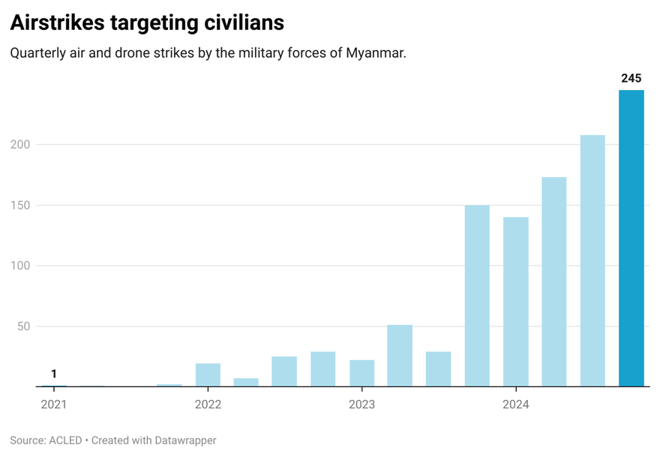
- In recent months, the Special Rapporteur has received reports of airstrikes that have killed or injured civilians in towns, villages, displacement sites, markets, teashops, mining sites, medical clinics, schools, religious buildings and locations hosting festivals or celebrations. Junta airstrikes usually come without warning and often at night, making it more likely that civilians are unable to flee or take shelter. Human rights groups have reported that junta forces have often raided and pillaged villages after airstrikes, deepening concerns about shelter and food security.
- The arrival of the new year was marked by a series of deadly airstrikes that left scores of civilians dead. On 30 December 2024, junta jets bombed Karen New Year celebrations in eastern Myanmar. On New Year’s Eve and New Year’s Day, junta jets reportedly attacked villages and displacement camps in Kayah, Shan and Rakhine States and Bago and Mandalay Regions, killing at least a dozen civilians, including children. On 8 January, junta airstrikes killed at least 40 civilians and destroyed hundreds of homes in a village in Ramree Township, Rakhine State. On 11 January, junta jets reportedly bombed gold mines in an area seized by the Kachin Independence Army in 2024, killing at least 15. On the same day, junta planes also targeted civilian areas in Kyauktaw, Rakhine State, including a crowded marketplace, reportedly killing at least 10.
- Junta forces have killed more than 6,300 civilians since the coup, according to the Assistance Association for Political Prisoners.

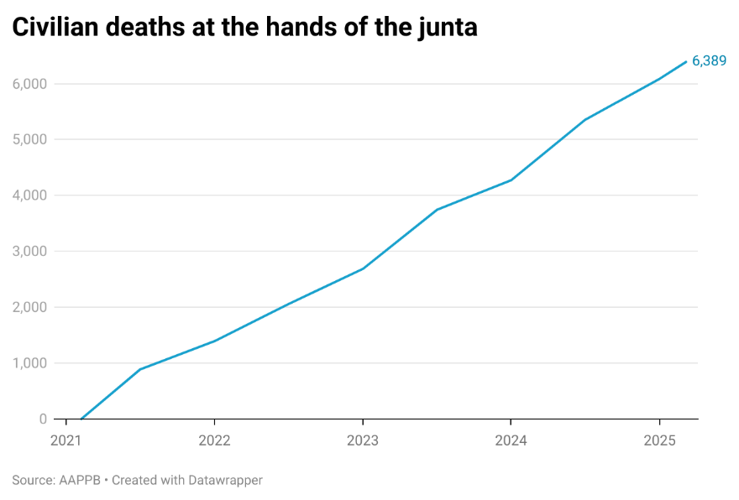
- Junta soldiers are responsible for mass killings in conflict areas. In October, the military carried out a brutal campaign of retributive violence in Budalin Township, Sagaing Region following an opposition attack on junta soldiers the previous month. Junta forces reportedly executed about two dozen villagers in the township and mutilated the bodies of some victims. In one village, soldiers decapitated and dismembered victims and placed their heads and body parts on top of a fence.
- Junta forces reportedly burned hundreds of homes during the rampage in Budalin Township, reflecting the military’s widespread use of arson since the coup. According to independent researchers, over 100,000 civilian structures have been burned since the coup.
- As described in the Special Rapporteur’s July 2024 conference room paper on the gendered impacts of the coup, sexual and gender-based violence is a dark shadow that follows women, girls and LGBT people throughout Myanmar. Junta forces have committed widespread rape and other forms of sexual violence, often characterized by the utmost cruelty and dehumanization. Members of resistance forces have also been responsible for abuses against women, girls and LGBT people. Since the publication of the report, the Special Rapporteur has continued to receive many credible reports of sexual violence committed by junta forces and other armed groups.
- The number of civilian casualties from landmines and unexploded ordnance continues to climb, as the expanding footprint of armed conflict in Myanmar is followed by landmine contamination in new areas. According to the Landmine Monitor, in 2023 Myanmar surpassed Syria as the country with the most landmine casualties in the world. The UN recorded 1,082 casualties from landmines and unexploded ordnance in 2024, topping the previous year’s record high.

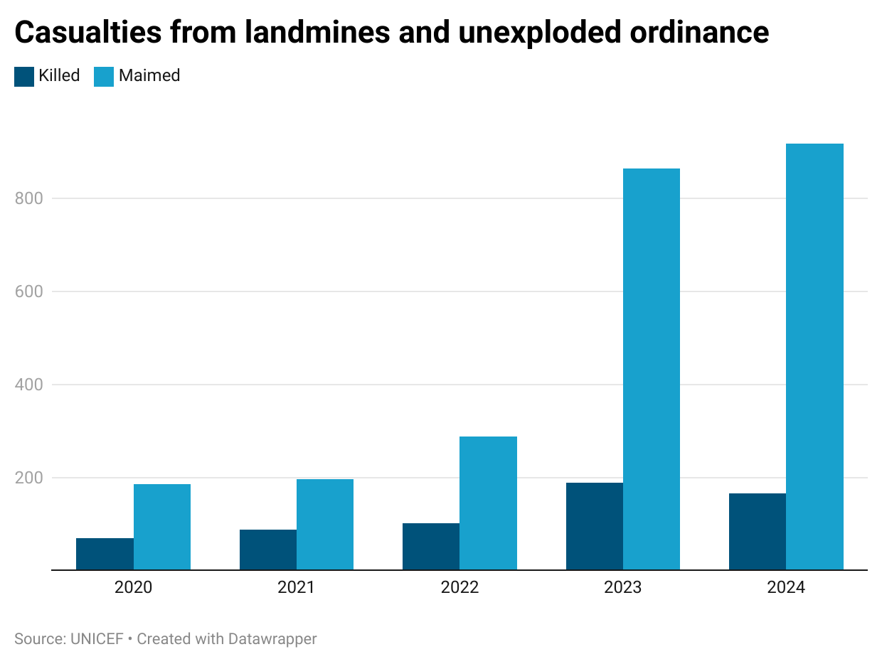
- People with disabilities have been disproportionately impacted by armed conflict. The Special Rapporteur has received many reports concerning the killing, torture and rape of people with disabilities. Many people have failed to receive warning of impending airstrikes or attacks by junta forces because of visual, auditory or mental impairment, or have been unable to flee in advance of such attacks. The Special Rapporteur is currently engaged in research for a forthcoming conference room paper that will detail the impact of the coup on persons with disabilities.
- Rakhine State and the Rohingya
- The conflict between the Arakan Army and junta forces in Rakhine State has created a humanitarian crisis that is impacting the lives of both ethnic Rakhine and Rohingya people as well as members of other minorities. The conflict has been joined by Rohingya armed groups, with all parties to the conflict accused of human rights abuses. Rohingya civilians, who have faced decades of violence, persecution and discrimination, are again facing dire threats in their homeland.
- The junta has been unsparing in its use of violence against civilians in Rakhine State, as it has been elsewhere in Myanmar. Junta shelling and airstrikes on towns and villages have killed hundreds of people, including Rakhine, Rohingya and other minorities. Meanwhile, junta soldiers are also responsible for massacres, such as the May 2024 slaughter of a least 50 Rakhine villagers in Byain Phyu village near Sittwe.
- In Rakhine State, junta forces have used civilians as human shields, confiscated food aid, and set up bases in villages, camps for internally displaced people and the compounds of humanitarian organizations. The junta has forcibly recruited thousands of Rohingya men and boys, sending them to the front lines of the fight against the Arakan Army and involving them in attacks on Rakhine civilians.
- Rohingya armed groups—including the Arakan Rohingya Salvation Army (ARSA) and Rohingya Solidarity Organization (RSO)—have cynically aligned with junta forces in attacks on the Arakan Army. They have reportedly been involved in the killing of Rakhine civilians and the systematic burning of Rakhine villages. In correspondence with the Special Rapporteur, the United League of Arakan, the Arakan Army’s civilian wing, shared detailed accounts of crimes committed by ARSA and RSO, including killings, torture, kidnappings, rape and abductions. While the Special Rapporteur was unable to verify these accounts, they are consistent with reports he has received from other sources.
- Rohingya armed groups have also forcibly recruited thousands of Rohingya men and boys from refugee camps in Bangladesh. Many have been abducted or coerced with threats of violence and then transported across the border to join the conflict in Rakhine State. Some recruits have reportedly been handed over to the junta upon their transfer to Rakhine State. Many Rohingya are unaware of the whereabouts of family members who have been forcibly recruited by armed groups.
- The Special Rapporteur has also received reports of grave human rights abuses committed by the Arakan Army against Rohingya civilians in Rakhine State. Arakan Army soldiers have been accused of indiscriminate attacks, killings, arson attacks, arbitrary arrest and detention, torture and forced recruitment. The Special Rapporteur has spoken with eyewitnesses who described killings and arson attacks by the Arakan Army targeting Rohingya populations. These accounts are consistent with independent analysis of satellite imagery of Buthidaung and Maungdaw Townships at the time they were taken over by the Arakan Army. In January 2025, video footage emerged of Arakan Army soldiers slashing the throats of captured junta soldiers with knives in an apparent execution of prisoners of war. An Arakan Army spokesperson subsequently confirmed the responsibility of Arakan Army soldiers for the killings and said that the perpetrators had been punished, without providing further details.
- The Arakan Army has promptly responded to the Special Rapporteur’s correspondence concerning alleged human rights abuses. The Special Rapporteur has also met with the leadership of the Arakan Army. The Arakan Army has repeatedly and vehemently denied allegations of systematic abuses against the Rohingya, including attacks on civilians and arson attacks. The Arakan Army further told the Special Rapporteur that the execution of junta soldiers was a “unique and isolated incident” and that the squad leader involved in the event was subsequently killed in action. The Arakan Army’s Major General Twan Mrat Naing has agreed to an unbiased, independent investigation of human rights abuses in Rakhine State and invited the Special Rapporteur to conduct such an inquiry when security conditions allow.
- According to UN figures, since 2023 more than 360,000 people have been displaced by the conflict in Rakhine State, bringing the total number of those displaced in the state to approximately 570,000. The true number of those displaced in Rakhine State is likely much higher.
- Displaced people in Rakhine State are almost completely cut off from international assistance. The Arakan Army has been accused of imposing severe movement restrictions on Rohingya in conflict areas in Rakhine State, preventing them from conducting agriculture and fishing or pursuing other livelihoods. The Arakan Army denies these allegations and has communicated to the Special Rapporteur that in other areas under their control, Rohingya enjoy increased freedom of movement. Displacement, conflict and junta-imposed telecommunications blackouts make it extremely difficult to verify the location and conditions of displaced and vulnerable communities. Nevertheless, available information suggests an unfolding humanitarian catastrophe in Rakhine State.
- In November 2024, a UNDP report warned that Rakhine State “could face acute famine imminently.” UNDP cited research indicating that domestic food production would only cover 20 percent of needs by March – April 2025, leaving over two million people at risk of starvation. Reports received by the Special Rapporteur indicate that many are at risk of death from starvation, disease and exposure. Humanitarian workers in Bangladesh have told the Special Rapporteur that new arrivals from Rakhine State exhibit visible signs of severe malnutrition, including uncontrollable shaking. According to UN data, at the end of 2024, 82 percent of the population of Rakhine State had “catastrophic” levels of humanitarian need, the highest need level.
- Displaced and conflict-affected people in Rakhine State have been left to fend for themselves, almost completely cut off from humanitarian assistance due to armed conflict and the junta’s blockade of aid into Rakhine State. The junta has only granted travel authorizations for Sittwe Township, and even those have been provided only intermittently. The Arakan Army has reportedly provided food and medical assistance to some displaced and vulnerable people, including Rohingya, and has made urgent appeals for international assistance.
- At least 50,000 Rohingya refugees have crossed into Bangladesh since the resumption of conflict between the Arakan Army and the junta in 2023. Many Rohingya have paid smugglers to help them cross the Naf River and enter Bangladesh. Rohingya armed groups have also extorted those seeking to flee Rakhine State.
- In late 2024, the interim government of Bangladesh approved assistance and biometric enrolment for new arrivals, easing their access to rations and other services in refugee camps. However, they are yet to be able to formally register as refugees with UNHCR.
- In early March 2025, the World Food Programme warned that a severe funding shortfall would require that rations for Rohingya refugees in Bangladesh would be cut from US$12.50 per person per month to US$6 starting 1 April unless fresh funding is secured. Less severe cuts to food rations in 2023 caused rates of acute malnutrition to spike and led many Rohingya to adopt harmful coping strategies. If rations are indeed cut by more than half, the impact on Rohingya refugees would be devastating. Health indicators would plummet, and desperation would feed violence, human trafficking, child marriage, sexual exploitation and irregular migration.
- Given the grave threats in Rakhine State and desperate conditions in the refugee camps in Bangladesh, an increasing number of Rohingya are deciding to risk their lives to seek shelter and safety elsewhere. According to UN data, more than 7,800 Rohingya attempted to flee Myanmar by boat in 2024, an 80 percent increase on the previous year. At least 657 perished or went missing at sea. Boats of Rohingya refugees reached Indonesia, Malaysia, Thailand and Sri Lanka. Women and children accounted for 74 percent of those making these journeys in 2024. More than 1,000 Rohingya have already attempted sea crossings in early 2025.
- While important steps have been taken by some governments to carry out rescue and disembarkation of boats at sea, many governments have failed to meet their human rights obligations to Rohingya refugees arriving on their shores and at their borders. There are reports of boats being pushed back and Rohingya being refouled at borders. Across the region, most Rohingya remain unable to register as refugees, which leaves them undocumented, at risk of indefinite detention, and lacking access to services, including education and healthcare.
- The cooperation of multiple parties is necessary to avert an impending humanitarian catastrophe in Rakhine State. The interim government of Bangladesh, UN agencies and the Arakan Army have all told the Special Rapporteur that they are ready to coordinate on the delivery of humanitarian assistance to displaced and vulnerable populations. However, to date, little to no aid has made its way across the border. Potential attacks by Rohingya armed groups and junta airstrikes further complicate relief efforts.
- In December 2024, the UN General Assembly passed a resolution calling for the holding of a “high-level conference … on the situation of Rohingya Muslims and other minorities in Myanmar.” Plans are currently being made to hold the conference, which would bring together governments, UN officials and agencies and other key stakeholders, in the second half of 2025. The conference offers an opportunity for governments, donors and UN officials and agencies to develop a concrete plan of action to address the crisis in Rakhine State and elsewhere in Myanmar, generate political will towards its implementation, and commit the resources necessary to ensure it succeeds.
- A humanitarian crisis engulfing a nation
- People throughout Myanmar are facing a devastating humanitarian crisis.
- More than 3.5 million people are now displaced in Myanmar, according to UN figures. Approximately 40 percent of those displaced are children. Civil society organizations often report higher levels of displacement at the local level, suggesting that the true number of those displaced could be significantly greater. Additionally, there are more than 1.3 million refugees from Myanmar in neighboring countries.
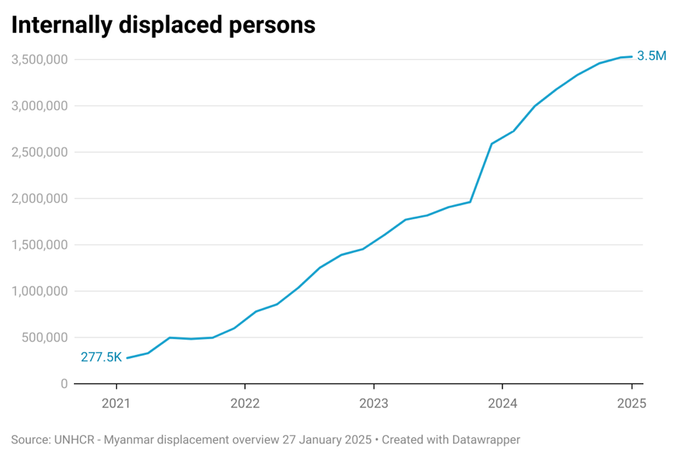
- Many displaced people have been forced to relocate multiple times as the junta attacks displacement camps, hiding places, or villages hosting those displaced. As displacement becomes prolonged, with many unable to return to their homes for years on end, conditions for displaced people have become bleak. Protection concerns, inadequate shelter and sanitation, and shortages of food, water and medicines have taken a toll on displaced communities.
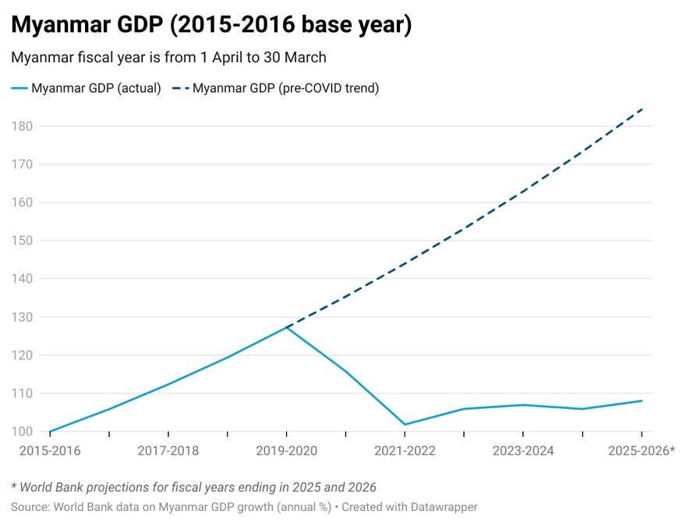
- Roughly half of Myanmar’s population is now living below the poverty line, with another quarter at risk of falling into poverty. Prior to the coup, only a quarter of people were living in poverty. Myanmar’s economy grew by 27 percent between 2015 and 2019. From 2020 to 2024, it shrank by 9 percent. The World Bank predicts that Myanmar’s economy will contract further in 2025. The kyat has lost 80 percent of its value since the coup. In a one-year period, food prices have more than doubled in some areas, with runaway prices leaving many families unable to afford adequate nutrition. Price ceilings imposed by the junta have led to shortages of food and other goods.
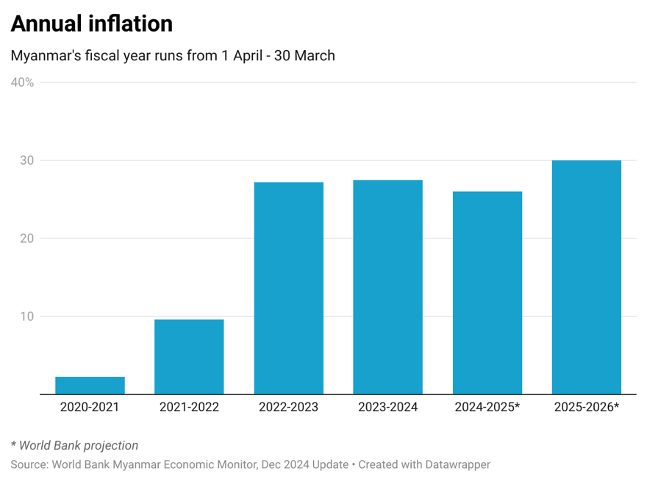
- Myanmar electricity output has decreased by a third since the coup, according to the junta’s Ministry of Electric Power. Blackouts have become common, disrupting lives and business. In Yangon and other urban areas, neighborhoods receive electricity only during two blocks of four or fewer hours each day on a rotating basis.
- 19.9 million people, more than a third of Myanmar’s population, require humanitarian assistance, of whom 6.3 million are children. By comparison, prior to the coup, the UN projected that one million people, primarily stateless Rohingya and people facing prolonged displacement in Rakhine and Kachin States, were in need of humanitarian assistance.
- 15.2 million people face acute food insecurity, driven in large part by armed conflict and displacement. Additionally, massive floods during the 2024 monsoon season inundated fields, disrupted planting and harvests, killed animals, and destroyed food stores, seed stocks and agricultural equipment. Following the floods, prices for agricultural inputs skyrocketed, further impacting farming. Land area under rice cultivation has shrunk by 16 percent since 2021. The World Health Organization has named Myanmar as one of its “hunger hotspots” of highest concern for 2025.
- A December 2024 report by Reuters revealed that the junta has threatened and arrested researchers to suppress data on widespread food insecurity in Myanmar, at times succeeding in blocking the implementation of research projects or keeping reports out of the public domain. The Integrated Food Security Phase Classification, a food security monitor, has removed information about Myanmar from its website out of fear for the safety of its researchers.
- Outbreaks of malaria, dengue and cholera have affected diverse communities, including in urban areas such as Yangon. 1.5 million children have missed routine vaccinations since 2018. The UN has warned about the potential for outbreaks of measles in displacement camps.
- The junta is using hunger and deprivation as weapons of war, systematically blocking the delivery of rice, other food, medicine and supplies to conflict areas. In some cases, the junta has destroyed food aid or confiscated humanitarian supplies for its own use. Humanitarian organizations have told the Special Rapporteur that their efforts are severely constrained because of armed conflict, military checkpoints, onerous bureaucratic processes imposed by the junta, the withholding of registration, visas and travel authorizations, intimidation, extortion and harassment. According to the UN, humanitarian actors had “extreme access difficulties” in 95 percent of townships in Sagaing Region, Rakhine and Kachin States, and Southeast Myanmar.
- Hospitals and medical clinics are frequently targeted in junta airstrikes. Insecurity Insight recorded 345 attacks on health care—including the destruction or occupation of health buildings and the killing or arrest of health workers—in 2024.
- Schools have also been targeted in junta airstrikes and shelling. Over 20 percent of children are out of school. Children with disabilities (30 percent) and stateless children (44 percent) are even more likely to be out of school.
- The suspension of foreign aid by the United States government has had a devastating impact on humanitarian relief efforts in Myanmar and support for refugees from Myanmar. Emergency food aid was reportedly exempted from the 90-day pause on foreign assistance and an additional waiver was provided for “life-saving humanitarian assistance.” The brutal fact remains that numerous programs benefiting Myanmar people, including refugees in neighboring countries, have been suspended or terminated on short notice. Local civil society organizations told the Special Rapporteur that their programs had been terminated only days after they received a notice granting them an exemption that would allow their work to continue. Medical clinics and rehabilitation centers in refugee camps have been shuttered, and funding for safe houses for those at risk of arrest has been suspended. The US government has also paused refugee resettlement under the United States Refugee Admissions Program, potentially impacting tens of thousands of refugees from Myanmar, some of whom were scheduled to be resettled in the US imminently.
- Military conscription
- In February 2024, the junta initiated a program of conscription under the People’s Military Service Law, a 2010 law that had not previously been utilized. As of January 2025, the junta had reportedly trained nine groups of 5,000 conscripts, although reports indicate that it has struggled to fill each conscript class. Many draft-eligible people have gone into hiding, joined opposition armed groups, or fled to neighboring countries.
- Junta officials often capture conscripts during nighttime inspections of households for unregistered guests, a common practice by previous military regimes revived by the junta shortly after the coup. Military and police officers have also frequently abducted young men from the streets, sending them directly for medical tests and military training. Credible reports indicate that private individuals may be collecting fees for abducting or transporting draft-eligible men to be handed over to the military for training. Young men are changing their daily patterns to avoid abduction and conscription, often sleeping away from their homes and not going on the streets after dark, when abductions are more frequent.
- In January 2025, the junta passed bylaws to the People’s Military Service Law. The bylaws require local administrators to identify individuals eligible for conscription, who will then be given medical examinations and registered as prospective conscripts. An individual who has received a draft order is prohibited from leaving the country without permission.
- When announcing the conscription program in early 2024, the junta stated that women would be exempt from conscription, yet in recent months, junta administrators have begun adding the names of women to lists of those eligible for conscription. The Special Rapporteur has also received credible reports of the conscription of children under the age of 18.
- The junta’s conscription program has had a massive impact on Myanmar society. When husbands and fathers are taken, families are often left without their primary breadwinners and wives and children are more vulnerable to violence and exploitation. Psychological trauma plagues both conscripts and their families, who worry that their loved ones may be killed or injured. With so many young people conscripted or fleeing to avoid conscription, businesses have trouble finding workers and agricultural fields go untended, deepening food insecurity. The impact of the conscription program has become a regional issue, with increasing numbers of young people fleeing Myanmar to neighboring countries.
- Political prisoners
- The junta has arrested more than 28,000 people on political grounds since the coup, of whom more than 21,000 remain behind bars, according to the Assistance Association for Political Prisoners. 124 political prisoners are currently on death row, with an additional 44 people sentenced to death in absentia.
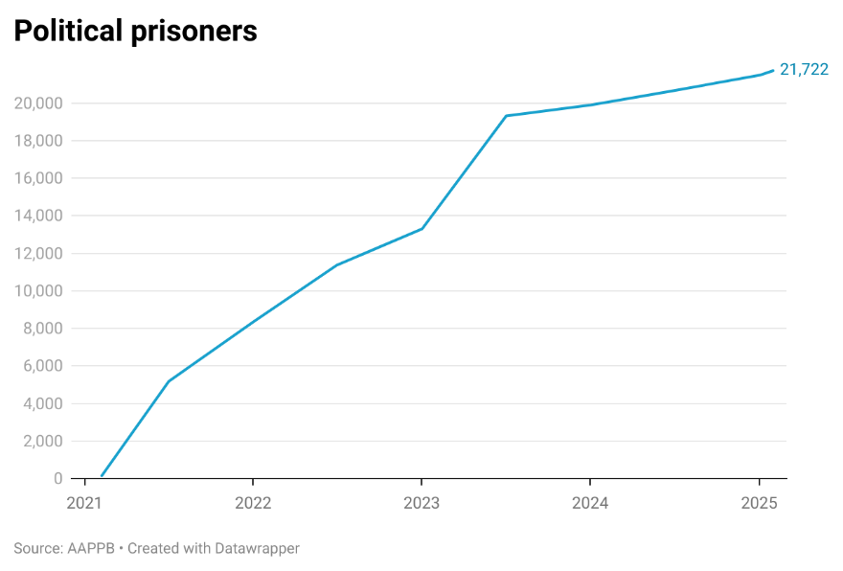
- Political prisoners include peaceful protesters, politicians, teachers, entertainers, lawyers, doctors, nurses, activists, humanitarian workers, religious leaders and many other people from all walks of life. In 2024, Myanmar was one of the top three imprisoners of journalists globally. The junta has come to rely heavily on the Counter-Terrorism Law, which carries penalties of up to life imprisonment or death, to try and convict political prisoners. 87 percent of those sentenced in 2024 were convicted under the Counter-Terrorism Law.
- Former State Counsellor Aung San Suu Kyi and former President Win Myint remain in the custody of the junta, as do many other political leaders and officials from the previous civilian government. The whereabouts of Aung San Suu Kyi, who is reportedly in bad health, is unknown, although she is believed to be held somewhere in Naypyidaw, the capital.
- The conditions for political detainees in Myanmar’s prisons are life threatening, contributing to severe physical and mental suffering. Prisons are overcrowded, with prisoners often forced to sleep with overlapping body parts. Prisoners receive insufficient food that is often dirty, undercooked, rotten and lacking in nutritious value. A porridge of boiled rice, with little or nothing else in it, is commonly provided as a meal. Toilet and bathing facilities are unsanitary and grossly insufficient for the number of prisoners that use them. As a result, skin diseases are common.
- The junta has often transferred political prisoners to remote prisons as a means of punishment. Between July 2023 and September 2024, there were 20 mass transfers of political prisoners. Lawyers and family members often have trouble reaching these prisons, leaving prisoners isolated and without food or other goods that could otherwise be provided by visitors.
- At least 242 people have died in prison or during interrogation, including 46 in 2024. Many have died because of inadequate medical treatment. Former political prisoners told the Special Rapporteur that paracetamol was the only treatment provided to prisoners, regardless of the conditions from which they were suffering. Prison authorities have prevented lawyers and families from delivering medicines to ailing political prisoners or demanded that they buy medicines from prison authorities at an exorbitant price. Prisoners with severe injuries or medical conditions are often denied transfer to a hospital for treatment.
- Former political prisoners describe horrific experiences of torture by junta forces. The Special Rapporteur has received reports of severe beatings with fists, guns and rods; stabbing or cutting; burning of the skin; electrocution; pulling out fingernails and teeth; stress positions; hanging by ropes; denial of food or water; sleep deprivation; mock executions; waterboarding; shackling, including with iron rods placed between the feet; and the prolonged use of blindfolds or hoods, often in conjunction with other torture techniques. Torture is most common during periods of interrogation but sometimes persists after political prisoners are transferred to prisons. Political prisoners who have been involved in hunger strikes or protests in prison have often been subject to retaliatory torture, including the prolonged use of solitary confinement.
- Women and LGBT people are especially vulnerable to violence, and in particular sexual violence, while in the custody of security forces. Soldiers, police and prison officials employ tactics intended to humiliate and degrade detainees on the basis of their gender and sexual orientation. Sexual violence, invasive body searches and sexualized threats and lines of questioning are especially common during periods of interrogation. Many female former political prisoners have reported being interrogated without female officers present. In August 2024, prison officers brutally assaulted a group of female political prisoners who had held a hunger strike. Prison facilities provide little privacy for women, who often lack access to basic hygiene products.
- The experience of arrest and detention leaves many former political prisoners with lasting psychological trauma. Many struggle to reintegrate into their communities, as family members, neighbors and potential employers fear association with individuals who have been targeted by the junta.
- Drugs, crime and trafficking
- Violence, lawlessness and corruption following the coup have allowed drug production, cyberscam operations, human trafficking and other illicit activities to proliferate in Myanmar over the past four years. Myanmar’s chaos is spilling across its borders, impacting its neighbors and people worldwide.
- Myanmar became the world’s largest producer of opium in 2024, a title that it claimed from Afghanistan. Myanmar is also a major supplier of synthetic drugs, including methamphetamines and ketamine, within the region. Multiple armed groups have been implicated in the production and transportation of drugs across borders.
- Illegal wildlife trade has also reportedly flourished since the coup.
- Cyberscam operations continue to flourish in Myanmar, giving rise to rampant human trafficking and claiming victims around the world. Following opposition offensives in northern Shan State and China’s crackdown on cyberscam hotspots near its borders in 2023 and 2024, many criminal syndicates moved their operations south to an area along the Thailand border that already hosted large scam centers. An estimated 100,000 people are involved in cyberscam operations in Myanmar that collect billions of dollars in payments from victims around the world.
- Many of those working in cyberscam centers are trafficking victims lured by offers of employment. After being forcibly transported into Myanmar and having their passports confiscated, they are unable to leave and forced to work long hours building online relationships with individuals and soliciting payments, often for fraudulent investment opportunities. In early 2025, public reporting on the trafficking of several high-profile Chinese nationals to scam centers brought renewed attention to trafficking networks bringing foreign victims to Myanmar through Thailand. China has recently engaged with Thailand, the junta, and armed groups along the Thailand-Myanmar border in order to address human trafficking and cyber-crime challenges, with significant numbers of victims repatriated in recent weeks. However, the cyberscam industry continues to enslave thousands of workers and victimize populations around the world.
- The junta’s plans for sham elections
- Throughout 2024, the junta touted its plans to hold elections in 2025. Beginning in October 2024, the junta carried out a farcical “census” operation, purportedly to support the development of voter lists for elections.
- It would be utterly impossible to hold a free and fair election under current conditions in Myanmar. Key political leaders, including Aung San Suu Kyi, remain behind bars or have been driven into hiding or exile. The junta has banned all credible opposition political parties. Journalists are arrested and imprisoned for reporting on the actions of the junta. People expressing support for opposition groups on social media are charged with sedition or counter-terrorism offenses.
- It is also clear that the junta lacks the capacity to administer an election. The junta has acknowledged its inability to carry out a nationwide election, stating that it will hold an election in stages, with polls first held in areas in which its control is not contested. In its own preliminary census report, the junta admitted that the census was “successfully carried out” in less than half of the country’s townships. The administrative demands of an election would be far greater than those of the shambolic census.
- The National Unity Government, ethnic resistance organizations and other opposition groups and institutions have denounced the junta’s election plans. If the junta goes through with its plans, it will almost certainly spur further violence and division in Myanmar.
- Some foreign governments have offered tentative endorsements of the junta’s election plans or have committed to monitoring the election or providing technical support. However, most governments have recognized the absurdity and danger of the junta’s plans and have refrained from endorsing the proposed elections. Following an informal regional meeting on the Myanmar crisis in Thailand in December 2024, Thailand’s Foreign Minister said, “If there is an election, ASEAN would want an inclusive process that included all stakeholders.” Malaysia’s Foreign Minister went further, saying, “We told them the election is not our priority. Our priority is to stop the violence.” The UN Secretary General said that elections held alongside the junta’s violence and oppression “risk exacerbating instability.”
- Per Myanmar’s constitution, elections must be held within six months after the end of a nationwide state of emergency. On 31 January 2025, the junta extended the state of emergency that had been in place since the coup for a further six months. This action may indicate that the junta is not planning elections until, at the earliest, late 2025 or early 2026.
- Digital rights
- Since the coup, Myanmar has descended into a digital dictatorship, severely undermining people’s access to information, freedom of expression, privacy and online safety. Myanmar was tied for last place in Freedom House’s 2024 ranking of internet freedom around the world.
- The junta continues to rely on large-scale internet and telecommunications shutdowns to control access to information. According to Access Now, Myanmar experienced more internet shutdowns than any other country in the world in 2024. The Myanmar Internet Project has recorded at least 339 internet and mobile network shutdowns since the coup, including at least six nationwide internet blackouts. In 2024, there were at least 130 internet shutdowns across 82 different townships, with both Rakhine and Kachin States experiencing state-wide blackouts. The junta has cracked down on efforts to circumvent communications blackouts including by arresting those using satellite internet services.
- The junta has often imposed internet and telecommunications shutdowns prior to launching airstrikes and indiscriminate attacks on civilian populations. People from conflict-affected areas have told the Special Rapporteur that communications restrictions prevented them from receiving warnings about impending airstrikes. Internet and telecommunications blackouts have also impeded responses to natural disasters. Many communities were reportedly unaware of the approach of Cyclone Yagi, which led to widespread flooding across seven states and regions, in September 2024. Limited connectivity also hampered cyclone relief efforts.
- Since the coup, many people in Myanmar have turned to virtual private networks (VPNs) to circumvent internet censorship and protect their privacy. In May 2024, the junta began deploying new technology to block the use of VPNs, severely impeding access to independent media outlets, business websites and social media platforms, including Facebook.
- In addition to technically blocking VPNs, junta security forces often manually search the phones of people in Myanmar for VPN applications, including at roadside checkpoints. Many have been fined or arrested merely for having a VPN application on their phones, which soldiers and police officers take as evidence of association with armed groups or opposition activities.
- People that continue to find ways to access the internet and share critical opinions risk detention and violence. Nearly 2,000 people have reportedly been arrested for social media posts that are perceived to criticize the junta or support opposition groups.
- In January 2025, the junta imposed a Cybersecurity Law that consolidates many of the most restrictive elements of the junta’s policies concerning digital rights. The law formalizes the ban on VPN usage, prescribing criminal penalties for establishing VPNs or offering VPN services without authorization. It gives officials authority to suspend or close digital platforms and imposes a duty on platforms to monitor and censor a broad range of vaguely defined content, including information that “disrupts unity [or] peace and order” or is “not suitable for public viewing.” The law also creates new criminal penalties for online speech and requires digital platforms to provide user data to authorities upon request.
- The junta acquires weapons, technology and funds from abroad
- In order to carry out its campaign of brutality and oppression, the junta relies on foreign governments and companies to sell it weapons, dual-use technologies, and supplies used in the domestic production of weapons and munitions. The junta also depends on foreign financial institutions to facilitate the purchase of these goods.
- In June 2024, the Special Rapporteur published “Banking on the Death Trade: How Banks and Governments Enable the Military Junta in Myanmar,” the third in a series of papers examining the junta’s acquisition of weapons and related materials. The paper identified US$630 million in military procurement by the junta that passed through the international finance system between 1 April 2022 and 31 March 2024.
- The paper highlighted an encouraging trend: between the first and second year of the period examined by the report, junta military procurement through the international finance system dropped by 33 percent. This development was directly linked to US sanctions on Myanma Foreign Trade Bank (MFTB), a junta-controlled bank, and Singapore’s crackdown on entities using its jurisdiction to supply the junta. However, the report also described the junta’s efforts to reroute its supply chains and find new financial pathways for military procurement, including by purchasing goods from Thai-based companies and using Myanma Economic Bank (MEB) to make payments.
- In July 2024, the Government of Thailand announced the formation of a task force, led by the Bank of Thailand and the Anti-Money Laundering Office, to investigate the Special Rapporteur’s findings and provide guidance to Thai financial institutions. The Special Rapporteur provided additional information to the task force, including the names of Thai and Myanmar companies involved in junta military procurement.
- On 30 December 2024, the Bank of Thailand and Anti-Money Laundering Office released a joint statement describing action they had taken to prevent the use of the Thai financial system contributing to “warfare that leads to human rights violations” and other illicit activity. Among these actions were requiring Thai banks to stringently verify beneficial ownership of clients and customers, conduct “enhanced customer due diligence” for high-risk customers, and establish criteria for requesting additional documentation for transactions involving high-risk customers. The statement further indicated that the Bank of Thailand and Anti-Money Laundering Office’s investigation “found that some financial institutions did conduct transactions with individuals listed in the [Special Rapporteur’s] report, but no evidence was found linking these transactions to arms procurement.”
- The Special Rapporteur’s findings were based on his review of both open source and confidential materials that provide incontrovertible evidence of the connection of Thai banks to junta military procurement. The Special Rapporteur has written to the Bank of Thailand and Anti-Money Laundering Office seeking further information on the scope and methodology of its investigation.
- As part of his ongoing investigation, the Special Rapporteur has identified over US$50 million in junta military procurement passing through the international finance system from July to October 2024. All payments originated with MEB, underscoring the importance of sanctions targeting MEB.
- Over US$30 million of the transactions identified by the Special Rapporteur passed through Thai banks. Bangkok Bank’s role in junta military procurement appears to have increased during that time period. However, in correspondence with the Special Rapporteur in early 2025, Bangkok Bank stated that it had decided to terminate its correspondent banking relationship and SWIFT RMA arrangement with MEB based on its assessment that there was a “heightened risk of the government owned and controlled bank being used to facilitate restricted procurements.” The Special Rapporteur commends Bangkok Bank for taking this important step and urges all other foreign financial institutions that have a banking relationship with MEB to do the same.
- The junta continues to exploit gaps in sanctions regimes to purchase weapons and repatriate foreign revenues. To date, only Canada has sanctioned MEB. Neither the European Union nor United Kingdom have sanctioned MFTB. Dozens of individuals and entities that are part of the junta’s arms supply networks—and that have been identified in the Special Rapporteur’s reporting—remain unsanctioned.
- The junta secures domestic currency through taxation and the mass printing of paper kyat, which has driven massive inflation. However, it also relies on two key sources of revenue from abroad to obtain the foreign currency income that it requires.
- The first is the export of natural resources, primarily hydrocarbons. At the time of the coup, revenues from the export of natural gas and oil totaled at least US$1.5 billion annually and were the largest source of foreign currency for the state. European Union sanctions on the state-owned Myanma Oil and Gas Enterprise (MOGE) have helped block a portion of euro-denominated revenues, but Myanmar still earns at least US$55 million monthly from selling natural gas to Thailand. United States sanctions banning the provision of financial services that benefit MOGE have not prevented Thai banks from processing these payments.
- As sanctions have tightened and reduced the junta’s ability to bring in export revenues, it has turned to exchange rate manipulation to bring in foreign currency. The junta forces exporters and those remitting foreign currency, including migrant workers outside Myanmar, to exchange foreign currency at unfavorable exchange rates, amounting to the large-scale expropriation of earnings from Myanmar companies and citizens. Credible economic analysis suggests that the junta could be expropriating as much as US$1.8 billion annually in this manner, which would make it the junta’s largest source of foreign currency.
- Accountability
- Available evidence suggests that junta forces have committed acts that likely constitute crimes against humanity and war crimes. Myanmar military officers also bear responsibility for international crimes committed prior to the 2021 military coup, including, potentially, the crime of genocide in relation to attacks on the Rohingya.
- These crimes are the result of the policies of the Myanmar military—including policies that disregard the principle of distinction between civilian and military targets—and orders given by senior military officers, suggesting the criminal responsibility of senior military and junta leaders, including Senior General Min Aung Hlaing.
- Human rights abuses committed by non-state armed groups, including those opposing the junta, may also constitute crimes under international law. It is essential that all those responsible for international crimes and other human rights violations are held accountable for their actions, regardless of their political alignment.
- In November 2024, International Criminal Court (ICC) Prosecutor Karim Khan announced that his office had requested an arrest warrant for Min Aung Hlaing in relation to the crimes against humanity of deportation and persecution of the Rohingya. As Myanmar is not a state party to the Rome Statute of the ICC, the Prosecutor’s investigation is limited to crimes that have been committed at least in part on the territory of Bangladesh or other states parties to the ICC. The Prosecutor’s statement indicated that his office would soon file applications for additional arrest warrants. At the time of writing, the Court had not ruled on the Prosecutor’s request and the Prosecutor had not announced any additional applications for arrest warrants.
- In 2024, Ireland, Slovenia, the Democratic Republic of Congo, and Belgium filed declarations of intervention in the genocide case brought against Myanmar at the International Court of Justice (ICJ). They joined Gambia, which filed the case in 2019, and Canada, Denmark, France, Germany, the Maldives, the Netherlands and the United Kingdom, which filed declarations in 2023. In 2020, the ICJ issued provisional measures requiring Myanmar to prevent genocidal acts, preserve evidence of possible acts of genocide, and submit regular reports to the Court. In 2025, the ICJ should begin hearings on the merits of the case.
- In February 2025, a court in Argentina issued arrest warrants for 25 individuals in a universal jurisdiction case concerning allegations of genocide and crimes against humanity committed against the Rohingya population between 2012 and 2018. 23 of those targeted with arrest warrants were senior military officers, including junta leader Min Aung Hlaing. Arrest warrants were also issued for Aung San Suu Kyi and Htin Kyaw, who were State Counsellor and President, respectively, at the time of the genocidal attacks on the Rohingya.
- While much attention has been focused on international cases concerning Myanmar, human rights defenders, opposition forces and emerging Myanmar governance institutions have been taking important steps to hold perpetrators accountable for their crimes and build the foundations for robust justice processes and structures in the future.
- The National Unity Government, ethnic armed organizations and other opposition groups have drafted codes of conduct, set up complaints mechanisms, and established courts in areas under their control. These institutions face significant challenges, including inadequate funding, weak chains of command, and limited cooperation between armed groups. Nevertheless, the Special Rapporteur is encouraged by reported cases of armed groups holding their own members to account.
- In many cases, armed groups have claimed to have acted to hold their members accountable for abuses but have provided little information about steps taken. Increased transparency and rule of law is required as opposition groups continue to take territory and establish their own administrative structures.
- The Special Rapporteur remains concerned by the widespread impunity for human rights violations in Myanmar. People in Myanmar regularly tell the Special Rapporteur that they feel that they have no recourse when they experience human rights violations, including abuses by opposition forces. These concerns are particularly prevalent for women and girls who have experienced sexual and gender-based violence.
- The National Unity Consultative Council (NUCC) has developed a Transitional Justice Policy Framework to ensure justice for victims of human rights violations and break a cycle of impunity that has gripped Myanmar for its entire post-colonial history. NUCC members told the Special Rapporteur that they hope to promote a restorative justice approach while pursuing accountability and truth-seeking for past, present and ongoing human rights violations. The NUCC is developing a prosecution policy to guide the development of independent local and international judicial proceedings and evidence collection with a victim-centered approach. The National Unity Government’s Ministry of Human Rights and Ministry of Justice are also developing plans for courts and other justice mechanisms in a future, democratic Myanmar.
XII. Conclusions and Recommendations
- The Special Rapporteur implores UN Member States to consider the terrible consequences of a radical reversal of support for human rights and the people of Myanmar. Draconian cuts to critical lifesaving programs and support for civil society have undermined those building the foundation for a future democratic and rights-respecting nation.
- The Special Rapporteur urges, in the strongest of terms, that the United States and other UN Member States that have announced cuts to vital programs and services to the people of Myanmar immediately reverse course. Concerns about the efficacy or efficiency of these programs should be addressed in an orderly and systematic manner that allows humanitarian actors to establish transition plans and identify alternate sources of support.
- Immediately and dramatically cutting off critical aid, while denying providers the opportunity to plan and seek life-saving options, is as unnecessary as it is cruel.
- Members of the Human Rights Council are in a strong position to take a principled public stand on these developments. Throughout each session, delegations see and hear tangible evidence of why human rights matter and what exactly is at stake. They are in a position to speak up and push back. This is a privilege not enjoyed by human rights defenders, humanitarian aid providers and UN agencies, who worry that doing so might further compromise their ability to deliver critical services on the front lines of a humanitarian crisis. The Human Rights Council has been called the conscience of the United Nations. The Special Rapporteur recommends that Council Member States issue a call to conscience on behalf of all those under siege and those whose voices are muted.
- The international community should deny the junta access to the weapons and foreign revenues that it uses to sustain its campaign of terror. The Special Rapporteur’s conference room papers on the junta’s access to weapons and weapons materials, and the use of the international finance system to procure them, have been followed by actions that have led to a significant decline in the junta’s access to powerful weapons of war that it continues to use against civilian targets. These are important steps that demonstrate the effectiveness of principled action by those in both the public and private sectors. It is time to build on these steps and further weaken the capacity of the junta to commit atrocities against the people of Myanmar. The Special Rapporteur urges that Member States:
(a) Impose targeted sanctions on the junta’s major sources of revenue and the financial institutions that it uses to repatriate revenues and purchase weapons, including Myanma Economic Bank and Myanma Oil and Gas Enterprise;
(b) Sanction arms-dealing networks and entities involved in the provision of aviation fuel to the Myanmar military;
(c) Halt the sale, transfer or transshipment of weapons, dual-use technologies and aviation fuel to Myanmar;
(d) Engage financial institutions located in their jurisdictions to ensure they are conducting enhanced due diligence on all transactions related to Myanmar, while terminating relationships with Myanmar state-owned banks.
- The Special Rapporteur urges private and public financial institutions to:
- Terminate or freeze all financial relationships with Myanmar’s state-owned banks, including Myanma Economic Bank;
- Undertake enhanced due diligence on all business relationships and transactions related to Myanmar in accordance with Financial Action Task Force guidelines and its “call for action” on Myanmar;
- Terminate relationships or decline to process transactions where a customer or counterparty does not cooperate with enhanced due diligence actions.
- Member States and the international community should deny the junta the legitimacy it seeks to justify its oppression of the people of Myanmar. This begins with denouncing the junta’s plans to hold sham elections and engaging the National Unity Government and other emerging governance structures that are building the foundation for a democratic and rights-respecting nation.
- To end impunity and ensure accountability for international crimes committed in Myanmar, Member States should:
- Refer the situation in Myanmar to the Prosecutor of the International Criminal Court under article 14 of the Rome Statute, requesting an investigation into alleged crimes that have been committed against the people of Myanmar;
- Support efforts to hold perpetrators of atrocity crimes accountable in impartial and independent courts, including the International Criminal Court, the International Court of Justice and national courts in countries with universal jurisdiction laws;
- Support the National Unity Government and other governance institutions in developing robust courts and justice mechanisms, and support the development of locally-owned transitional justice efforts.
- Member States should devote the resources and political capital necessary to address the devastating humanitarian crisis in Rakhine State and along the Bangladesh-Myanmar border, including by:
- Supporting and participating in the High-Level Conference on the Situation of Rohingya Muslims and Other Minorities in Myanmar to be held in the second half of 2025;
- Contributing robust financial resources to humanitarian relief for internally displaced people in Rakhine State, Rohingya refugees in Bangladesh, and other Rohingya communities across the region.
- UN officials, humanitarian agencies, Bangladesh and the Arakan Army should urgently coordinate the delivery of life-saving cross-border aid to internally displaced people and other vulnerable populations in Rakhine State, including Rakhine, Rohingya and other ethnic groups on the basis of need. Bangladesh should accept all Rohingya refugees fleeing violence and persecution in Myanmar, register new arrivals, and ensure access to education and livelihoods for Rohingya refugees.
- UN Member States, UN agencies, international donors and international humanitarian organizations should provide the requisite levels of humanitarian aid to address the rapidly deteriorating conditions in Myanmar, including by:
- Ensuring a proportional response to humanitarian needs, ensuring aid reaches displaced and vulnerable populations, especially women, girls and LGBT people, and providing robust funding for local organizations that are best placed to meet the needs of affected communities and possess the expertise, knowledge, trust and networks to provide effective assistance;
- Lifting measures that hinder the delivery of aid to those most in need, including by supporting unregistered organizations, adopting flexible reporting requirements, allowing the transfer of funds outside the formal banking system of Myanmar, and enabling the delivery of cross-border aid to internally displaced persons;
- Ensuring programs are developed in partnership with local women’s, LGBT and disability groups so that program design and activities respond appropriately to the local context and the particular needs of these populations;
- Accepting refugees from Myanmar, providing them with the support required under international standards, expanding opportunities for resettlement and other durable solutions, and respecting the principle of non-refoulement.
- ASEAN and its Member States should:
- Acknowledge the flagrant violations of the Five-Point Consensus by the State Administration Council;
- Prohibit junta officials, or officials from junta-controlled bodies, from representing Myanmar at any ASEAN summits or functions;
- Engage with the National Unity Government and the National Unity Consultative Council as key parties representing the will and interests of the people of Myanmar;
- Facilitate the delivery of humanitarian aid to all populations in need, including by supporting cross-border humanitarian assistance delivered through local civil society organizations.
- Member States, United Nations agencies, international donors and international humanitarian organizations should formally recognize and engage with the National Unity Government as well as the National Unity Consultative Council, ethnic resistance organizations and civil society leaders in Myanmar.
- The National Unity Government, ethnic armed organizations and other armed groups and emerging governance institutions should:
- Take all necessary and reasonable measures to ensure accountability for human rights abuses committed by opposition forces;
- Strengthen dialogue between each other to advance the political and constitutional framework for a future peaceful, democratic and rights-respecting Myanmar.

* The present report was submitted to the conference services for processing after the deadline so as to include the most recent information.
Armed Conflict Location & Event Data, “Conflict Index,” December 2024, https://acleddata.com/conflict-index/.
Special Rapporteur on the situation of human rights in Myanmar, “Courage amid crisis: gendered impacts of the coup and the pursuit of gender equality in Myanmar,” 1 July 2024, UN Doc. A/HRC/56/CRP.8.
International Campaign to Ban Landmines, “Landmine Monitor 2024,” November 2024, https://backend.icblcmc.org/assets/reports/Landmine-Monitors/LMM2024/Downloads/Landmine-Monitor-2024-Final-Web.pdf.
See, Special Rapporteur on the situation of human rights in Myanmar, “Call for inputs: Status of the rights of persons with disabilities in Myanmar,” https://www.ohchr.org/en/calls-for-input/2025/call-inputs-status-rights-persons-disabilities-myanmar.
Special Rapporteur on the situation of human rights in Myanmar, letter to Twan Mrat Naing, 21 August 2024, https://spcommreports.ohchr.org/TMResultsBase/DownLoadPublicCommunicationFile?gId=29307; United League of Arakan, response to Special Rapporteur, 26 August 2024, https://spcommreports.ohchr.org/TMResultsBase/DownLoadFile?gId=38620.
UNDP, “Rakhine: A Famine in the Making,” 7 November 2024, https://www.undp.org/asia-pacific/publications/rakhine-a-famine-in-the-making.
United League of Arakan, Department of Health, “Emergency Appeal for Essential Medicines for Displaced Persons in Maungdaw Town and Surrounding Areas,” 16 August 2024, https://www.arakanarmy.net/post/emergency-appeal-for-essential-medicines-for-displaced-persons-in-maungdaw-town-and-surrounding-area.
UNHCR, Operation Data Portal, Myanmar Situation, https://data.unhcr.org/en/situations/myanmar.
OCHA, “Myanmar Humanitarian Needs and Response Plan 2025,” December 2024, https://myanmar.un.org/sites/default/files/2024-12/Myanmar%202025%20HNRP%20-%20English%20version.pdf.
Poppy McPherson, Devjyot Ghoshal, Steve Stecklow and Ruma Paul, “Myanmar junta intimidates aid groups in effort to hide hunger crisis,” Reuters, 16 December 2024, https://www.reuters.com/investigates/special-report/famine-data-myanmar/.
UNODC, “Myanmar Opium Survey 2024 Cultivation, Production, and Implications,” December 2024, https://www.unodc.org/roseap/uploads/documents/Publications/2024/Myanmar_Opium_Survey_2024_web.pdf.
Freedom House, “Freedom of the Net 2024: The Struggle for Trust Online,” October 2024, https://freedomhouse.org/report/freedom-net/2024/struggle-trust-online.
Access Now, “Lives on hold: internet shutdowns in 2024,” 24 February 2025, https://www.accessnow.org/internet-shutdowns-2024/.
Special Rapporteur on the situation of human rights in Myanmar, “Banking on the Death Trade: How Banks and Governments Enable the Military Junta in Myanmar,” UN Doc. A/HRC/56/CRP.7, 26 June 2024, https://www.ohchr.org/sites/default/files/documents/hrbodies/hrcouncil/sessions-regular/session56/a-hrc-56-crp-7.pdf. See also, “Enabling Atrocities: UN Member States’ Arms Transfers to the Myanmar Military,” UN Doc. A/HRC/49/CRP.1, 22 February 2022, https://www.ohchr.org/en/press-releases/2022/02/myanmar-un-expert-urges-security-council-resolution-stop-weapons-fueling; “The Billion Dollar Death Trade: The International Arms Networks that Enable Human Rights Violations in Myanmar,” UN Doc. A/HRC/53/CRP.2, 17 May 2023, https://www.ohchr.org/sites/default/files/documents/countries/myanmar/crp-sr-myanmar-2023-05-17.pdf.

