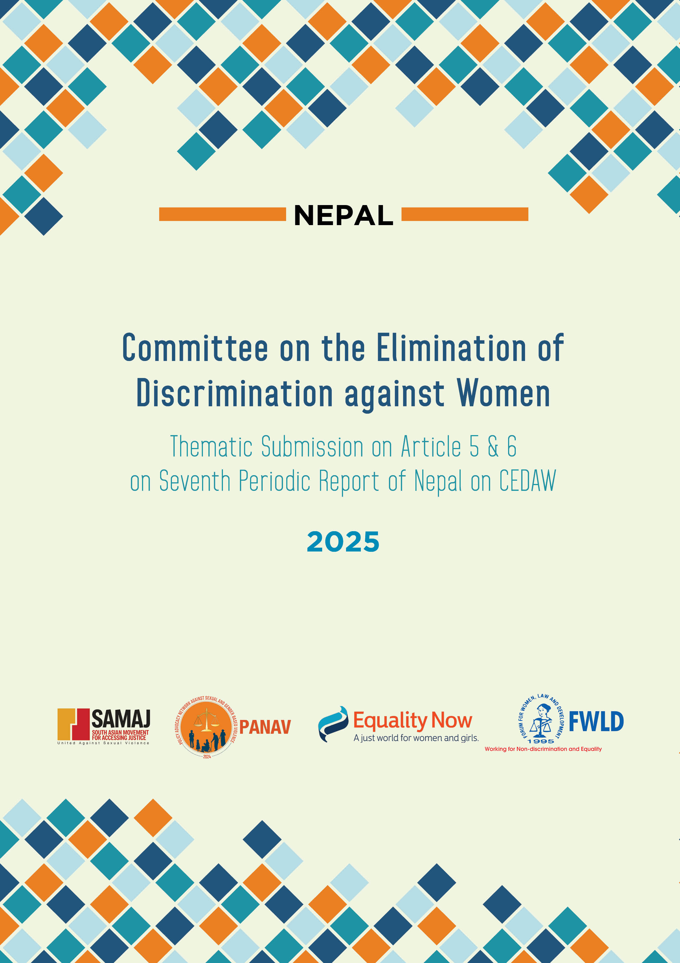

Committee for the Elimination of Discrimination against Women
Human Rights Treaties Division (HRTD)
Office of the United Nations High Commissioner for Human Rights (OHCHR)
Palais Wilson - 52, rue des Paquis
CH-1201 Geneva, Switzerland
By email: ohchr-cedaw@un.org

6 January 2025

Re: Information on Nepal for consideration by the Committee for the Elimination of Discrimination against Women at its 90th session (3 Feb 2025 - 21 Feb 2025).

Introduction

- We respectfully present this report to supplement the sixth periodic report submitted by Nepal scheduled for review by the Committee on the Elimination of Discrimination against Women ("the Committee") during its 90th session (3 Feb 2025 - 21 Feb 2025). This report is submitted jointly by FWLD, PANAV, SAMAJ, and Equality Now.
- Forum for Women, Law, and Development (FWLD) is a non-governmental organization founded on May 29, 1995, with ECOSOC status under the United Nations. FWLD is dedicated to protecting, promoting, and realizing human rights. Committed to eliminating all forms of discrimination, it leverages the law as a tool to secure the rights of women, children, minorities, and other marginalized groups.
- A Policy Advocacy Network against Sexual and Gender-based Violence (PANAV) was formed in 2024 to unify civil society organizations and ensure their meaningful participation in policy advocacy for the reformation of laws against sexual and gender-based violence. The Network has members from the national level, Lumbini Province, and Madhesh Province.
- The South Asian Movement for Accessing Justice: United Against Sexual Violence (SAMAJ), of which Equality Now is the Secretariat, is a coalition of 18 organizations and individuals that works towards ending sexual violence in South Asia through legal reforms and support services.
- Equality Now is an international human rights NGO with ECOSOC status with the mission to achieve legal and systemic change that addresses violence and discrimination against all women and girls around the world. Founded in 1992, Equality Now is a global organization with partners and supporters in every region. Ending sexual violence, ending sexual exploitation, ending harmful practices, and achieving legal equality are the main areas of Equality Now’s work.
- The issues and practices detailed in our report highlight the State's failure to fulfill its duty to protect women and girls from all forms of sexual violence under the Convention on the Elimination of All Forms of Discrimination against Women (‘the Convention’). The legal provisions and practices detailed in our submission highlight the failure of the State to comply with its duty to provide equal protection under the law to survivors of sexual violence (Article 2(c) of CEDAW) and the failure of law enforcement to protect women from sexual violence (Article 2(c) and (e)). Nepal has also failed to implement criminal law provisions to effectively prosecute sexual violence and gross manifestations of violence against women (Article 2 (b)). The failure of the State in its non-compliance with the obligation to address stereotypical attitudes towards women is contrary to Articles 2 (f) and 5 (a) of the Convention and the obligation to combat violence against women and provide access to justice to survivors, as provided in General Recommendations 19, 33 and 35 of the CEDAW Committee.

Implementation of previous CEDAW recommendations on ending sexual violence
The amendment of the National Criminal Code in 2022 increased the statute of limitations in sexual violence cases, including rape, to up to two years. Also, the Ministry of Federal Affairs and General Administration issued a circular in October 2024 to all the 753 local levels, requesting them to act in line with the recent directive of the Office of Attorney General to ensure that no rape case is settled through reconciliation between the perpetrators and victims, whether voluntary or under coercion and undue influence. This circular was issued following reports of agreements being reached between the perpetrators and victims/survivors of rape in the presence of local representatives of different parts of the country to settle out of court. The Women, Children, and Senior Citizen Service directorate, which falls under the Crime Investigation Department, has rapidly expanded its presence in all 77 districts in Nepal with 240 units to strengthen support for victims/survivors of sexual violence.
Critical areas of concern on access to justice barriers to getting justice for rape
- The definition of rape under the National Penal Code includes penile penetration of the vagina, mouth, and anus. However, when the means of penetration are fingers or other objects, only penetration of the vagina is included within the definition of rape and not penetration of other bodily orifices. Thus, non-consensual sexual acts such as insertion of objects or fingers into the anus or mouth are not included within the definition of rape.
- Conviction for rape cases is low in Nepal. The low conviction rate results in impunity for perpetrators of rape In Nepal, which means that the number of rape cases that are reported, investigated, tried, and convicted is far less than the actual number of rape incidents that take place across the country.
- The amendment of the National Criminal Code in 2022, which increased the statute of limitations in cases of sexual violence, including rape. However, the window set by the law is still narrow, and it impedes access to justice for rape victims/survivors as they are unable to get justice for rape once the period set by the statute of limitations for rape has expired.
- Nepali law does not contain any specific provisions prohibiting the introduction of evidence as to the past sexual history of the rape victim/survivor during the trial process in rape cases. In practice, this has left victims/survivors vulnerable to the defense raising irrelevant questions or accusations affecting the dignity of the victim/survivor during the rape trial, and judges often do not intervene to prohibit such questions. This facilitates the secondary victimization of survivors during the legal proceedings, as well as enabling impunity for the perpetrator since it looks to judge the general character of the victim/survivors rather than focus on the evidence in the case and the actions of the alleged perpetrator.
- Disbelief in the testimonies of rape victims/survivors by law enforcement agencies, blaming survivors for having “provoked” the rape, and discriminatory attitudes towards survivors of sexual violence from family and community members, as well as criminal justice system officials, results in cases not being reported or being dropped. The biggest hurdle is getting past the police station, where the rape victim/survivor faces neglect and discrimination and is forced to relive the trauma due to insensitive questioning by police officers.
- Marital rape was criminalized under Nepali law after a landmark Supreme Court decision declared that the earlier penal provision, which did not criminalize marital rape, was unconstitutional. This was a welcome judgment. However, the National Criminal Code states that a husband who commits rape on his wife shall be liable to a term not exceeding five years, which is lower than the penalty applicable in other cases of rape (imprisonment of 7-10 years in cases of rape of adult women over the age of 18, with the penalty increasing in cases of child rape depending of the age of the child). This disproportionately low penalty for marital rape promotes the impression that sexual violence in intimate partner settings is not as serious a crime as so-called “stranger rape” and promotes an unwelcome hierarchy of rape that undermines the notion of consent and risks perpetuating the myths and stereotypes that so often inhibit justice for rape victims/survivors. The term 'not exceeding five years' signifies that a specific minimum term is not mandated, giving the court discretion in sentencing, which can lead to inconsistent and potentially lenient punishments for marital rape, allowing for a relatively short jail term.
- Another major obstacle to justice is community intervention resulting in mediation or “compromises” between perpetrators and the rape survivor/victim, whereby the victim is coerced into agreeing not to cooperate during the criminal process. Though such mediation is not permitted under law for rape cases, the police are also often complicit in facilitating mediation between perpetrators and victims. The family often carries out such mediation without even consulting the victim, which can sometimes result in forced marriage between the perpetrator and the victim, resulting in further trauma.
- Bodies set up to deal with conflict-related victims/survivors of sexual violence, such as the Truth and Reconciliation Commission (TRC,) still do not have executive chairpersons and members, making such bodies ineffective in dealing with conflict-related sexual violence. Also, conflict-related victims/survivors of sexual violence are deprived of justice when they are unable to file complaints of sexual violence within the period of the statute of limitations for rape.
- Nepali laws recognize the rape victims’/survivors’ rights with compensation as a right. However, the provisions supporting victims' rights are scattered across various laws, leaving room for discretion rather than guaranteeing their rights.
Key recommendations for ending sexual violence in Nepal

- Ensure that all forms of unwelcome sexual penetration are covered within the definition of rape.
- Remove the statute of limitations for reporting cases of rape, ensuring that victims/survivors have unrestricted access to justice regardless of the time elapsed since the offense. Amend the Truth and Reconciliation Commission Act, 2014, removing the statute of limitation in conflict-related sexual violence crimes and providing appropriate reparation to victims/survivors.
- Explicitly prohibit the introduction of evidence relating to the past sexual history of the victim/survivor.
- Ensure that the penalties for marital rape are at least commensurate with applicable penalties for other forms of rape. Amend Section 219(4) of the National Criminal Code and introduce a mandatory minimum sentence for marital rape to ensure consistent punishment.
- Amend the Nepali Penal Code to make permanent the provisions included in the “Ordinance made to amend few sections on Sexual Violence,” particularly the provision prohibiting forced mediation or reconciliation between rape victims/survivors and perpetrators of their families.
- Raise awareness on the provisions related to compensation of rape for sexual violence victims/survivors and enact an umbrella law to support victims/survivors of sexual violence, addressing different areas such as rescue, compensation, interim relief, treatment, psychosocial counseling, legal counseling, social rehabilitation, etc.
- Ensure that all forms of sexual violence offenses that are filed with the police are investigated and prosecuted as a priority. Proactively address delays in the trial process and ensure that trials are completed speedily in rape cases.
- Provide sensitization training to law enforcement personnel to address the lack of gender sensitivity among police officers in dealing with rape cases.
- Ensure that survivors of sexual violence and families of rape victims are sufficiently supported throughout the legal proceedings, including by ensuring that they are informed about the criminal justice process and their rights under the law and are updated regularly on progress throughout the proceedings.
- Improve data collection on rates of prosecution and convictions in sexual violence cases to ensure efficient multi-sectoral response to provide holistic support services to survivors.

Information about FWLD: https://fwld.org/
Information about SAMAJ: https://equalitynow.org/south-asian-movement-for-accessing-justice-samaj/
Information about Equality Now: https://equalitynow.org/
Three years for rape survivors who are minors. In those cases, the minors will be able to file a case within three years of them turning 18. The three year statute of limitation also applies to women with disabilities and women aged 70 years or older. See more at: Lawmakers hold public dialogues over the statute of limitations in rape cases https://www.undp.org/nepal/news/lawmakers-hold-public-dialogues-over-statute-limitations-rape-cases
Authorities warned against settling rape case through reconciliation https://thehimalayantimes.com/kathmandu/authorities-warned-against-settling-rape-case-through-reconciliation
For rape survivors in Nepal, police is not always their friend https://kathmandupost.com/national/2019/07/17/for-rape-survivors-in-nepal-police-is-not-always-their-friend
Section 219, National Penal Code, 2017.
Sexual Violence in South Asia: Legal and Other Barriers to Justice https://equalitynow.storage.googleapis.com/wp-content/uploads/2024/06/24130115/EN-ESV-South-Asia-Report-Update-03-PDF-1.pdf
Rape and violence are on the rise - https://nepalnews.com/s/issues/rape-and-violence-are-on-the-rise
Forum for Women Law and Development, IWRAW-AP, Court Watch Monitoring on Sexual and Gender Based Violence Cases in Trial in Selected District Courts, December 2018, http://fwld.org/wp-content/uploads/2019/01/Case-monitoring-final.pdf
For rape survivors in Nepal, police is not always their friend https://kathmandupost.com/national/2019/07/17/for-rape-survivors-in-nepal-police-is-not-always-their-friend
Ms. Meera Dhungana v. His Majesty's Government, Ministry of Law, Justice and Parliamentary Affairs and Others [Nepal Supreme Court, 2000].
CREHPA, UCL, Tracking Cases of Gender-Based Violence in Nepal: Individual, institutional, legal and policy analyses, 2013, https://nepal.unfpa.org/sites/default/files/pub-pdf/TrackingCasesofGBV.pdf
https://www.nhrcnepal.org/nhrc_new/doc/newsletter/GPV_Report.pdf
WOREC Nepal and Isis-WICCE, Unveiling Justice: Rape Survivors Speak out A Research Report on Access to Justice for Rape Survivors in Nepal 2007-2010, 2011, https://worecnepal.org/uploads/publication/document/205613797Unveiling%20Justice-Rape%20Sur%20vivors%20Speak.pdf

