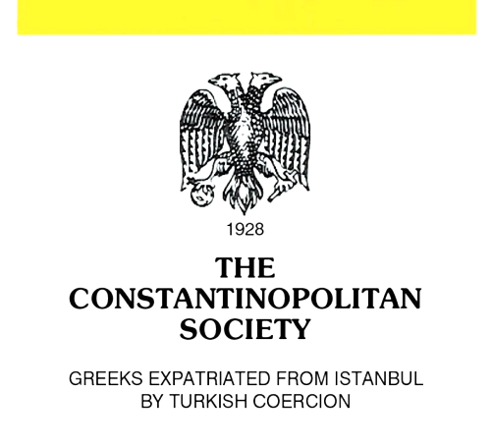
Non Governmental Organization
117 Dimosthenous Str., 176 72 Kallithea, Greece
Tel.: (+30) 210 951 7072
e-mail: conpolitan@gmail.com
web: http://cpolitan.gr

Written Information on Human Rights
and Religious Freedoms of the Greek Minority in Τürkiye

Submitted to
United Nations
International Covenant on
Civil and Political Rights
Human Rights Committee
142nd session
Geneva, 14 October – 8 November 2024

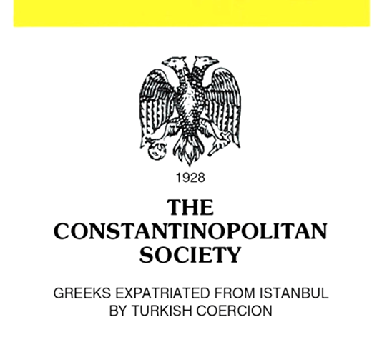
Non Governmental Organization
117 Dimosthenous Str., 176 72 Kallithea, Greece
Tel.: (+30) 210 951 7072
e-mail: conpolitan@gmail.com
web: http://cpolitan.gr

Written Information on Human Rights
and Religious Freedoms of the Greek Minority in Τürkiye

Non-Muslim minorities in Τürkiye have suffered numerous injustices, as a result of discriminatory and oppressive state policies. Especially, the annihilation of the Greek Minority in Τürkiye is the continuation of the Genocide that had systematically exterminated the Greek populations of Asia Minor, Eastern Thrace, Imbros, Tenedos and İstanbul through combined means of massacres, mass deportations and atrocities of 1914 - 1922 which resulted in the expulsion of more than 1,300,000 Greeks from their native land.
It is humanly impossible to describe all the state practices that led to the extermination of the Greek Minority of İstanbul, so we will mention only a few:
In 1929, the total burning of 5,000 Greek residences of Tatavla (Kurtulus), the most renowned Greek suburb of İstanbul.
In 1932, Law 2007, passed by the Turkish National Assembly, banned Greeks from the exercise of thirty professions, in order to force them to leave the country.
In 1941, all Christians between 18 and 45 years old were dragged to the army and were scattered in the depths of Asia Minor to construct roads and military
2/7

buildings under the most adverse circumstances. Due to unbearable hardships, thousands of them died.
In 1942, the Turkish Government put into force the Law 4305, known as “Varlik Vergisi”, using as criteria religion and ethnicity, imposed a burdensome wealth tax on property, which aimed at the financial extinction of minorities in Τürkiye.
In 1955, the Turkish Government, in a cold-blooded perfectly prepared and professionally organized manner, launched a murderous pogrom against Greek Minority in İstanbul with destruction and looting of thousands of houses, school buildings, stores as well as many other sanctuaries and holy shrines.
In 1964, the mass deportations of a total of 40,000 Greeks from İstanbul and the implementation of an inhumane plan to forcibly depopulate the islands of Imbros and Tenedos from Greek residents.
All those atrocities and oppressive measures later on stand as a historical affirmation that the permanent goal of every successive Turkish regime is to totally annihilate the Greek Minority in Τürkiye. After the Lausanne Treaty (1923), there were still over 130,000 Greeks in İstanbul. Since then, as a consequence of systematic persecutions by the Turkish State, these policies have led to the dramatic decline of the Greek population of Τürkiye, from over 100,000 in the 1950’s to less than 2,000 at present.
In contrast, the thriving Muslim minority in Greek Thrace numbers around 120,000 members at present, while the two minorities were equal in number at the time the Lausanne Treaty was signed. The numbers speak for themselves.

Persisting shortcomings
The Greek minority in Τürkiye continues to suffer numerous injustices, as a result of discriminatory and oppressive policies. The rule of law regarding minorities often is not respected. The Turkish Grand National Assembly has repeatedly rejected the prospect of giving the floor to minority representatives or invite them in parliamentary committee gatherings to share their insight with the rest of the lawmakers.
The property rights of the Greek Minority Foundations continue to be violated. The most serious shortcomings are the following:
- The new Law does not provide for the return of “seized/fused foundations” and their properties. The management of them has been assumed by the General Directorate of Foundations (GDF). The provisional article 7 does not allow for the holding of new elections for the 23 seized foundations.
- Article 5 provides for the establishment and management of new foundations in accordance with the Turkish Civil Code (TCC). However, TCC in article 101 (4) does not allow the establishment of foundations of non-

3/7

Muslim minorities. Unfortunately, the new Regulation for elections (June 2022) does not include any provisions concerning the handover of the management of seized/fused foundations, whose management and administration had been taken over.
Finally, the new regulation does not bring minority communities freedom or allow foundations to be run democratically. It extends state control, and sometimes authorizes direct intervention into minority affairs.

Religious freedom issues
The Turkish government has not so far alleviated or done away with serious restrictions on freedom of religion or belief, including state policies and suffocating regulations of the past that deny legal personality to the Ecumenical Patriarchate, its right to own, maintain property, train clergy and offer religious education.
- Greek Orthodox Theological School of Halki
The Greek Orthodox Theological School of Halki, which had been operating since 1844, the only Greek Orthodox educational institution in Τürkiye for training its religious leadership, remains closed since 1971. The Turkish government closed the seminary in accordance with a constitutional decision that banned the operation of private institutions of higher learning, a decision that served to effectively force the closure of religious and theological schools in the country. Although the Turkish government and officials have at times expressed support for reopening the seminary, no concrete steps have been taken.
Therefore, the Theological School of Halki should be allowed to reopen for the sake of the Greek Minority survival as well as for the survival of the Ecumenical Patriarchate itself – a 17 centuries-old religious institution based in Istanbul. It is a matter of respect for the freedom of religion, as well as the protection of minority rights.
- Hagia Sophia - Chora (Kariye) Legal Status
In 2020, a Turkish court has arbitrarily revoked the Hagia Sophia’s legal status as a museum since 1935 and President Recep Tayyip Erdogan immediately issued a decree ordering Hagia Sophia, considered one of the world’s greatest Byzantine monuments, included in the UNESCO World Heritage sites, to be opened as a mosque for Muslim prayers. President Erdoğan said its conversion into a mosque rests on “the right of the sword”. It clearly consists a hate rhetoric, which not only puts the sacred heritage of Τürkiye’s Greek Minority at risk, but also threatens their lives, making them potential targets of hate crimes. Since that conversion, the Hagia Sophia has been vandalized several times. Imperial Gate in Hagia Sophia has been badly damaged and the decorative emblem was stolen.

4/7

Also, a number of tiles of the priceless marble floors in Hagia Sophia have been damaged by heavy machines used to clean the site.
Furthermore, a Turkish higher court issued a decision permitting the Chora (Kariye) Museum, a former Greek Orthodox church, to be converted back into a mosque. It should be noted that Τürkiye violated international laws, and more specifically its commitments under the Provisions of the 1972 UNESCO World Heritage Convention. The Turkish authorities adopted those measures without consulting its non-Muslim citizens and without further notice, as obliged, to the World Heritage Committee of UNESCO.
The three churches of Panayia Kafatiani, Aya Yani and Aya Nikola in the suburb of Karaköy-Galata in İstanbul, as well as their 50 immovable properties, continue to be illegally and forcibly occupied by the self-declared and non-existent “Turkish Orthodox Patriarchate (TOP)”. Those three churches and their properties should be immediately returned to their legal owner which is the Ecumenical Patriarchate and be granted full legal status, so as to be able to elect their governing bodies and freely administer and manage its own foundations.
Of great concern is the fact that the Turkish authorities did not permit Ecumenical Patriarchate to hold the sacred celebrations of the Virgin Mary’s Day on August 15, 2024 at the Panagia Soumela Historical Monastery in Trabzon. Also, the government again did not permit the Ecumenical Patriarchate to hold annual services at St. Nicholas Monastery in Cappadocia.
Educational issues
Despite some favorable regulations, Greek Minority schools still face a number of procedural difficulties and bureaucratic obstacles.
- Minority schools are still treated as private schools and they are being deprived of state funds, even though it is foreseen by the Lausanne Treaty. Consequently, their outdated infrastructure does not meet the current requirements and training needs regarding the use of new technologies and digital tools to improve the educational process. This policy leads to discrimination against minorities and further degradation of the education provided to them
- The registration and attendance of European and other nationalities students to Greek minority schools is only permitted as “guest students”, without receiving graduation certificates and, as a consequence, those students are not admitted to universities etc.
- Due to intended bureaucratic, time-consuming procedures, the approval of new schoolbooks is delayed at the expense of the educational requirements.
5/7

- Anti-minority references continue to exist in schoolbooks used for teaching in Τürkiye. Some of them include discriminatory, xenophobic statements against Greek Minority.
All these measures are inevitably leading to the gradual dissolution of the Greek Minority schools protected under the Lausanne Treaty (Articles 40 & 41).

Discriminatory practices - Status of Societal Respect for Religious Freedom – Religion-based hate crimes
All members of non-Muslim minorities continue to be treated by the Turkish authorities as “aliens”. As a consequence, the members belonging to the non-
Muslim minorities are excluded from posts in public sector and services, the police forces, the army or the judiciary.
In 2010, the ECtHR ruled that a mandatory listing of religious affiliation on Turkish identity cards violated the European Convention. Thereafter, the Turkish Parliament passed a law removing the requirement from the front of the cards. The new identity cards, which went into effect on January 2, 2017, do not show the holders’ religious identification, although it is a non-required biodata point on the card’s microchip. Concerns remain that microchips on national identification cards may contain information regarding the holder’s religious identity, which could lead to discrimination in the workplace and other places where the microchip can be read. Minority communities remain concerned that a biodata field on religious affiliation could lead to discrimination if the field is left blank or lists a faith other than Islam.
Hate speech and intimidation directed against Greek Minority remain a serious problem. Attacks or acts of vandalism on minority worship places continued and need to be investigated. On August 23, 2024, Aghios Eleftherios Greek Orthodox deep-rooted cultural heritage and religion cemetery in Kurtuluş suburb of İstanbul was vandalized. This is still another act of contempt for religious freedom that has taken place without any reaction from the Turkish government.
Denial of succession rights
Turkish authorities de facto deny to Greek citizens the right to inherit property in Τürkiye. The Turkish administration, by means of arbitrary and deliberate actions and/or omissions has been and still is expropriating the real estate of the Greek minority. Ignores or interprets at will the amended legislation on property acquisition, whereas it does not confer any real estate property rights to ethnic Greeks and hinders access of interested persons or their legal representatives to the cadastral registries. The descendants of expatriated minority Greeks are deprived of their hereditary rights and forced to liquidate or sell their properties.

6/7

In this context, not only the restitution of the Turkish Republic citizenship to Greek minority members living abroad should be facilitated, but Turkish authorities should primarily issue permanent residence and work permit to those who are willing to live in Τürkiye._

7/7

Note: The submitted written information could be published on the Committee’s website.

