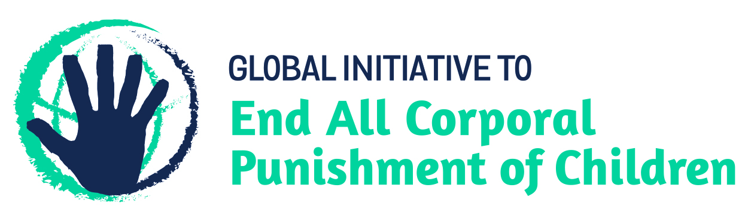
Ending family violence in Nicaragua – challenging physical punishment of girls and boys
Information for the Committee on the Elimination of Discrimination Against Women, Pre-Sessional Working Group for the 77th session,
from the Global Initiative to End All Corporal Punishment of Children (www.endcorporalpunishment.org), January 2020

This briefing provides an update on Nicaragua in light of the new prohibition of corporal punishment of girls and boys in all settings, through the enactment of the Family Code 2014.
We hope the Committee on the Elimination of Discrimination Against Women will welcome the enactment of an explicit prohibition of all violent punishment in its examination of Nicaragua. We further hope the Committee will, in its concluding observations on the seventh/tenth state party report, recommend that Nicaragua ensure that no form of violence within the domestic sphere is condoned, including by parents against their children, and ensure that the prohibition of corporal punishment is adequately monitored and enforced in all settings, and that positive, non-violent and participatory forms of child rearing and discipline are promoted through awareness campaigns and training programmes.

1 The prohibition of all corporal punishment in Nicaragua
1.1 In 2014, the National Assembly of Nicaragua approved the new Family Code 2014, which was published in the Official Gazette on 8 October 2014. Article 280 states (unofficial translation): “The father, mother, or other family members, guardians or other persons legally responsible for the son or daughter have the responsibility, the right and duty to provide, consistent with the child’s evolving capacities, appropriate direction and guidance to the child, without putting at risk his or her health, physical integrity, psychological and personal dignity and under no circumstances using physical punishment or any type of humiliating treatment as a form of correction or discipline. The Ministry of Family, Youth and Children, in coordination with other state institutions and society shall promote forms of positive, participatory and non-violent discipline as alternatives to physical punishment and other forms of humiliating discipline.” The Code came into force on 8 April 2015.
1.2 In 2012, the “right to disciplinary punishment” of children was removed from the Penal Code 2008 by Law No. 779 Comprehensive Law against Violence against Women and Reforming Law No. 641 Penal Code 2012. Article 155 of the Penal Code as amended prohibits domestic violence and states (unofficial translation): “Domestic violence. Whoever carries any force, violence or physical or psychological intimidation against a person who is a spouse or partner in a stable union or is linked by a stable affective relationship, children, adolescents, older persons, persons with disabilities, the daughters and sons own spouse, partner or ascendants, descendants, collateral relatives by blood, marriage, adoption, or under guardianship. For children and adolescents, the right to disciplinary correction may not be claimed. Those responsible for this crime will be imposed the following penalties: (a) minor injuries, the penalty shall be one to two years in prison; (b) serious injury, the penalty is three to seven years in prison; (c) very serious injury, the penalty is five to twelve years in prison. In addition to the prison terms outlined above, the perpetrators of domestic violence, will be imposed disqualification for the same period of the rights arising from the relationship between mother, father and children, or the person under guardianship.” The linking of punishment with injury was considered to show a lack of clarity as to whether or not all physical punishment of children was unlawful; the new Family Code enacted in 2014 provides the necessary clarification of complete prohibition.

Briefing prepared by the Global Initiative to End All Corporal Punishment of Children
www.endcorporalpunishment.org; info@endcorporalpunishment.org

