BRIEFING ON CHAD FOR THE COMMITTEE AGAINST TORTURE, SESSION 75 - November 2022
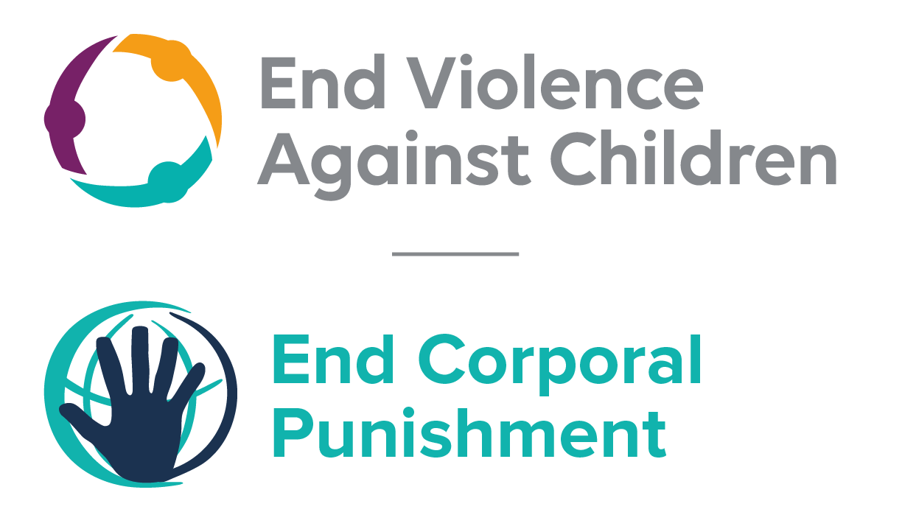
The Global Partnership to End Violence Against Children
September 2022

This briefing describes the legality of corporal punishment of children in Chad. In light of the obligation under international human rights law to prohibit all corporal punishment of children, the recommendation of the UN Secretary General’s Study on Violence against Children, the repeated recommendations to prohibit all corporal punishment made to Chad by the Committee on the Rights and other human rights treaty bodies, and considering the global commitment to ending all violence against children in the context of the 2030 Agenda for Sustainable Development, we hope the Committee will:
• in its concluding observations on the second report of Chad, recommend that legislation is immediately enacted to explicitly prohibit corporal punishment of children in all settings including the home, and to repeal all legal defences for its use.

Summary of necessary legal reform to achieve full prohibition
Prohibition is still to be achieved in the home, alternative care settings, day care and penal institutions.
We have been unable to establish whether or not legislation confirms a right of parents and others with parental authority to administer physical punishment, but legal provisions against violence are not interpreted as prohibiting all corporal punishment in childrearing. The near universal acceptance of corporal punishment in “disciplining” children necessitates a clear statement in law that all corporal punishment, however “light”, is prohibited.
Alternative care settings – Prohibition should be enacted in legislation applicable to all alternative care settings (foster care, institutions, places of safety, emergency care, etc).
Day care – Corporal punishment should be prohibited in all early childhood care (nurseries, crèches, kindergartens, preschools, family centres, etc) and all day care for older children (day centres, after-school childcare, childminding, etc).
Penal institutions – Legislation should prohibit corporal punishment as a disciplinary measure in all institutions accommodating children in conflict with the law.

- The report of Chad to the Committee Against Torture

  - The second report of Chad states that article 167 of the draft children’s code provides that “corporal punishment for the purposes of correcting or disciplining children is prohibited”. Paragraph 2 establishes that “the child’s parents, legal guardian or custodian shall ensure that discipline is administered in such a way that the child is treated with humanity and respect for their inherent dignity”.
  - The Government highlighted that in practice, there continue to be cases where corporal punishment and that this is being addressed through the coordination work of “increasingly active organisations”. As at September 2022, it appears that a legislation fully prohibiting corporal punishment has not be enacted.

- Current legality of corporal punishment in Chad

  - Home: Corporal punishment is lawful in the home. According to article 222 of the Constitution 1996 (amended 2005), international treaties have supremacy over domestic legislation when they are ratified and published. However, corporal punishment is not explicitly prohibited in law and provisions against violence and abuse in the Penal Code, the Constitution and Act No. 06/PR/2002 on the promotion of reproductive health are not interpreted as prohibiting corporal punishment in childrearing.

  - National laws are being reviewed with a view to harmonisation with international standards, and in 2009 the Government signalled its commitment to prohibition by clearly accepting the recommendation to take legislative measures to address and prevent corporal punishment in all settings made during the Universal Periodic Review of Chad. However, the Government rejected recommendations to prohibit made during the UPR in 2013. Recommendations made in 2018 received a mixed response, with a recommendation to “continue measures to prohibit corporal punishment” supported and another to put an end to corporal punishment noted.

  - A draft Child Protection Code and a draft Code on the Person and the Family are under discussion. In 2014, proposed amendments to the Criminal Code addressed harmful practices but did not include prohibition of corporal punishment. When examined by the UN Human Rights Committee in 2014, the Government replied to a question about progress towards prohibiting corporal punishment only by stating it is prohibited in schools. The Government also stated that parents “generally opposed” corporal punishment. New Criminal Code and Criminal Procedure Code were adopted in December 2016: we have been unable to examine the text of the Criminal Procedure Code but there are no indications corporal punishment was addressed. There is no explicit prohibition in the Criminal Code 2017.

  - Alternative care settings: In 2014, the Government reported to the Human Rights Council that corporal punishment is prohibited by law in public institutions. We have yet to identify prohibiting legislation. There is no explicit prohibition of corporal punishment in other forms of alternative care, where it is lawful as for parents (see under “Home”).

  - Day care: In 2014, the Government reported to the Human Rights Council that corporal punishment is prohibited by law in public institutions. We have yet to identify prohibiting legislation. There is reportedly an Early Childhood Strategy which advises against corporal punishment in day care – we have no further information. There is no explicit prohibition of corporal punishment in other early childhood care and in day care for older children.

  - Schools: Corporal punishment is considered unlawful in schools, under Law No. 016/PR/06 on the education system, though it is not explicitly prohibited. Article 113 states (unofficial translation): “The right to physical and moral integrity of pupils and students is guaranteed. As such, the following are prohibited: - physical abuse or any other form of violence or humiliation….” In reporting to the Committee Against Torture in 2020, the Government indicated that corporal punishment in schools is effectively prohibited in accordance with several laws in force, including and order of the Ministry of Education of 1997.

  - Penal institutions: In 2014, the Government reported to the Human Rights Council that corporal punishment is prohibited by law in public institutions. We have yet to identify prohibiting legislation. Act No. 019/PR/2017 of 28 July 2017 on the prison system has been adopted but we have been unable to examine the text. Article 9 of Decree No. 269/PR/MIS/IGSP/1995 on the Code of ethics of the national police states that the use of force should be limited to what is strictly necessary and commensurate to the goal to be achieved, and article 10 prohibits violence and inhuman or degrading treatment against persons under the responsibility of the police, but there is no explicit prohibition of corporal punishment.

  - Sentence for crime: Corporal punishment is unlawful as a sentence for crime under Act No. 07/PR/1999 concerning criminal procedures for children aged 13-18 years and Act No. 04/PR/1998 on the organisation of the judiciary. The Constitution (art. 18), the Penal Code 2017 (art. 342) and Act No. 06/PR/2002 prohibit torture and degrading and humiliating treatment.

Recommendations by human rights treaty bodies and during the UPR

  - CRC: On two occasions, the Committee on the Rights of the Child recommended that Chad prohibit corporal punishment in all settings; in its concluding observations on the state party’s initial report in 1999, and on the state party’s second report in 2009.

  - CAT: In its concluding observations on the state party’s initial report in 2009, the Committee Against Torture recommended that Chad prohibit corporal punishment in families, educational and religious establishments, alternative care institutions and places of juvenile detention.

  - ACERWC: In its concluding observations on the state party’s first-fourth report in 2017, the African Committee of Experts on the Rights and Welfare of the Child recommended that Chad prohibit corporal punishment of children in all settings, including in families, schools, and alternative care settings.

  - UPR: At the first cycle of the Universal Periodic Review of Chad in 2009, a recommendation to
prevent all forms of violence against children in all settings, including corporal punishment was made and accepted by the Government. At the second cycle in 2013, a recommendation to enact legislation to prohibit corporal punishment in all settings was made and rejected by the Government. During the third cycle examination, the Government gave mixed response to recommendations to prohibit corporal punishment in all settings.

4 March 2020, CAT/C/TCD/2, Second periodic report submitted by Chad under article 19 of the Convention pursuant to the simplified reporting procedure- due in 2012, paras 108 and 109
5 October 2009, A/HRC/12/5, Report of the working group, para. 82(37)
27 March 2014, A/HRC/25/2 Advance Unedited Version, Draft report of the Human Rights Council on its twenty-fifth session, para. 561
28 December 2018, A/HRC/40/15, Report of the Working Group, paras. 114(187) and 115(9)
Ibid, para. 582
18 February 2014, CCPR/C/TCD/Q/2/Add.1, Reply to list of issues, para. 26; 19 March 2014, CCPR/C/SR.3048, Summary record of 3048th meeting, para. 11
19 March 2014, CCPR/C/SR.3048, Summary record of 3048th meeting, para. 45
See http://tchadinfos.com/tchad/tchad-adoption-du-nouveau-code-penal/ and http://tchadinfos.com/politique/tchad-le-code-de-procedure-penale-est-adopte/, both accessed 7 November 2017
27 March 2014, A/HRC/25/2 Advance Unedited Version, Draft report of the Human Rights Council on its twenty-fifth session, para. 569
27 March 2014, A/HRC/25/2 Advance Unedited Version, Draft report of the Human Rights Council on its twenty-fifth session, para. 569
4 March 2020, CAT/C/TCD/2, Second periodic report submitted by Chad under article 19 of the Convention pursuant to the simplified reporting procedure- due in 2012, paras 106 and 107
27 March 2014, A/HRC/25/2 Advance Unedited Version, Draft report of the Human Rights Council on its twenty-fifth session, para. 569
30 August 2018, A/HRC/WG.6/31/TCD/1, National report to the UPR, para. 11
24 August 1999, CRC/C/15/Add.107, Concluding observations on initial report, para. 25
12 February 2009, CRC/C/TCD/CO/2, Concluding observations on second report, paras. 45 and 46
4 June 2009, CAT/C/TCD/CO/1, Concluding observations on initial report, para. 32
July 2017, Concluding observations on first/fourth report, para. 24
5 October 2009, A/HRC/12/5, Report of the working group, para. 82(37)
31 October 2013, A/HRC/WG.6/17/L.12 Unedited Version, Draft report of the working group, para. 110(74)
27 March 2014, A/HRC/25/2 Advance Unedited Version, Draft report of the Human Rights Council on its twenty-fifth session, para. 561
28 December 2018, A/HRC/40/15, Report of the Working Group, paras. 114(187) and 115(9)

