Country Policy and Information Note

Iraq: Humanitarian situation

Version 1.0
August 2022

Preface
Purpose
This note provides country of origin information (COI) and analysis of COI for use by Home Office decision makers handling particular types of protection and human rights claims (as set out in the Introduction section). It is not intended to be an exhaustive survey of a particular subject or theme.
It is split into 2 parts: (1) an assessment of COI and other evidence; and (2) COI. These are explained in more detail below.
Assessment
This section analyses the evidence relevant to this note - that is information in the COI section; refugee/human rights laws and policies; and applicable caselaw - by describing this and its inter-relationships, and provides an assessment of, in general, whether one or more of the following applies:
- a person is reasonably likely to face a real risk of persecution or serious harm
- that the general humanitarian situation is so severe that there are substantial grounds for believing that there is a real risk of serious harm because conditions amount to inhuman or degrading treatment as within paragraphs 339C and 339CA(iii) of the Immigration Rules/Article 3 of the European Convention on Human Rights (ECHR)
- that the security situation is such that there are substantial grounds for believing there is a real risk of serious harm because there exists a serious and individual threat to a civilian’s life or person by reason of indiscriminate violence in a situation of international or internal armed conflict as within paragraphs 339C and 339CA(iv) of the Immigration Rules
- a person is able to obtain protection from the state (or quasi state bodies)
- a person is reasonably able to relocate within a country or territory
- a claim is likely to justify granting asylum, humanitarian protection or other form of leave, and
- if a claim is refused, it is likely or unlikely to be certifiable as ‘clearly unfounded’ under section 94 of the Nationality, Immigration and Asylum Act 2002.
Decision makers must, however, still consider all claims on an individual basis, taking into account each case’s specific facts.
Country of origin information
The country information in this note has been carefully selected in accordance with the general principles of COI research as set out in the Common EU [European Union] Guidelines for Processing Country of Origin Information (COI), April 2008, and the Austrian Centre for Country of Origin and Asylum Research and Documentation’s (ACCORD), Researching Country Origin Information – Training Manual, 2013. Namely, taking into account the COI’s relevance, reliability, accuracy, balance, currency, transparency and traceability.
The structure and content of the country information section follows a terms of reference which sets out the general and specific topics relevant to this note.
All information included in the note was published or made publicly available on or before the ‘cut-off’ date(s) in the country information section. Any event taking place or report/article published after these date(s) is not included.
All information is publicly accessible or can be made publicly available. Sources and the information they provide are carefully considered before inclusion. Factors relevant to the assessment of the reliability of sources and information include:
- the motivation, purpose, knowledge and experience of the source
- how the information was obtained, including specific methodologies used
- the currency and detail of information
- whether the COI is consistent with and/or corroborated by other sources.
Multiple sourcing is used to ensure that the information is accurate and balanced, which is compared and contrasted where appropriate so that a comprehensive and up-to-date picture is provided of the issues relevant to this note at the time of publication.
The inclusion of a source is not, however, an endorsement of it or any view(s) expressed.
Each piece of information is referenced in a footnote. Full details of all sources cited and consulted in compiling the note are listed alphabetically in the bibliography.
Feedback
Our goal is to provide accurate, reliable and up-to-date COI and clear guidance. We welcome feedback on how to improve our products. If you would like to comment on this note, please email the Country Policy and Information Team.
Independent Advisory Group on Country Information
The Independent Advisory Group on Country Information (IAGCI) was set up in March 2009 by the Independent Chief Inspector of Borders and Immigration to support him in reviewing the efficiency, effectiveness and consistency of approach of COI produced by the Home Office.
The IAGCI welcomes feedback on the Home Office’s COI material. It is not the function of the IAGCI to endorse any Home Office material, procedures or policy. The IAGCI may be contacted at:
Independent Advisory Group on Country Information
Independent Chief Inspector of Borders and Immigration
5th Floor
Globe House
89 Eccleston Square
London, SW1V 1PN
Email: chiefinspector@icibi.gov.uk
Information about the IAGCI’s work and a list of the documents which have been reviewed by the IAGCI can be found on the Independent Chief Inspector’s pages of the gov.uk website.

Contents
Assessment 5
1. Introduction 5
1.1 Basis of claim 5
2. Consideration of issues 5
2.1 Credibility 5
2.2 Exclusion 5
2.3 Convention reason(s) 6
2.4 Risk 6
2.5 Protection 7
2.6 Internal relocation 7
2.7 Certification 7
Country information 8
3. Geography and demography 8
4. Economy 9
4.1 Overview 9
4.2 Employment 10
5. Humanitarian situation 11
5.1 Overview 11
5.2 People in need – numbers and location 12
5.3 Education 14
5.4 Food security 16
5.5 Healthcare including Covid-19 18
5.6 Shelter and non-food items (NFI) 20
5.7 Water, sanitation and hygiene (WASH) 22
5.8 Humanitarian response plan (HRP) 24
Terms of Reference 25
Bibliography 26
Sources cited 26
Sources consulted but not cited 26
Version control 27

Assessment
Section 1 updated: 15 August 2022

Introduction

Basis of claim
    - That the general humanitarian situation in Iraq is so severe that there are substantial grounds for believing that there is a real risk of serious harm because conditions amount to torture or inhuman or degrading treatment as defined in paragraphs 339C and 339CA(iii) of the Immigration Rules/Article 3 of the European Convention on Human Rights (ECHR).
Back to Contents
Section 2 updated: 15 August 2022

Consideration of issues

Credibility
    - For information on assessing credibility, see the instruction on Assessing Credibility and Refugee Status.
    - Decision makers must also check if there has been a previous application for a UK visa or another form of leave. Asylum applications matched to visas should be investigated prior to the asylum interview (see the Asylum Instruction on Visa Matches, Asylum Claims from UK Visa Applicants).
    - In cases where there are doubts surrounding a person’s claimed place of origin, decision makers should also consider the need to conduct language analysis testing (see the Asylum Instruction on Language Analysis).
Back to Contents

Exclusion
    - Decision makers must consider whether there are serious reasons for considering whether one (or more) of the exclusion clauses is applicable. Each case must be considered on its individual facts and merits.
    - If the person is excluded from the Refugee Convention, they will also be excluded from a grant of humanitarian protection (which has a wider range of exclusions than refugee status).
    - For guidance on exclusion and restricted leave, see the Asylum Instruction on Exclusion under Articles 1F and 33(2) of the Refugee Convention, Humanitarian Protection and the instruction on Restricted Leave.

Official – sensitive: Start of section
Decision makers must consider referring these cases to Special Cases Unit.
For more information see the guidance on Special Cases Unit cases and the SCU referral form.
Official – sensitive: End of section
Back to Contents

Convention reason(s)
    - A severe humanitarian situation does not in itself give rise to a well-founded fear of persecution for a Refugee Convention reason.
    - In the absence of a link to one of the 5 Refugee Convention grounds necessary to be recognised as a refugee, the question to address is whether the person will face a real risk of serious harm in order to qualify for Humanitarian Protection (HP).
    - However, before considering whether a person requires protection because of the general humanitarian and/or security situation, decision makers must consider if the person faces persecution for a Refugee Convention reason. Where the person qualifies for protection under the Refugee Convention, decision makers do not need to consider if there are substantial grounds for believing the person faces a real risk of serious harm meriting a grant of HP.
    - For further guidance on the 5 Refugee Convention grounds see the Asylum Instruction, Assessing Credibility and Refugee Status.
Back to Contents

Risk
    - Humanitarian conditions are, in general, not likely to be so severe as to result in a breach of paragraphs 339C and 339CA (iii) of the Immigration Rules/Article 3 of the European Convention on Human Rights (ECHR). However, decision makers must consider each case on its merits. There may be cases where a combination of circumstances means that a person will face such as breach.
    - In the country guidance case of SMO & KSP (Civil status documentation; Article 15) Iraq CG [2022[ UKUT 110 (IAC), heard on 4 to 5 October 2021 and promulgated on 16 March 2022, the Upper Tribunal held:
‘The living conditions in Iraq as a whole, including the Formerly Contested Areas, are unlikely to give rise to a breach of Article 3 ECHR or (therefore) to necessitate subsidiary protection under Article 15(b) QD. Where it is asserted that return to a particular part of Iraq would give rise to such a breach, however, it is to be recalled that the minimum level of severity required is relative, according to the personal circumstances of the individual concerned. Any such circumstances require individualised assessment in the context of the conditions of the area in question.’ (paragraph 6 of part A of the headnote. The headnote for Civil Status Identity Documentation is at paragraphs 11 – 22 of part C).
    - At the time of writing there are not very strong grounds supported by cogent evidence to depart from the findings of SMO & KSP (Civil status documentation; Article 15) Iraq CG [2022[ UKUT 110 (IAC).
    - In assessing whether an individual case reaches this threshold, decision makers must consider:
- where the person is from (as humanitarian conditions are more severe in some areas than others, and this may also impact on whether the person becomes an IDP on return, if they were not already prior to leaving the country)
- a person’s individual profile and circumstances, including, but not limited to, their age, gender, state of health and ethnicity and means to support themselves
- vulnerability to discrimination because of perceived or actual affiliation to extremist groups
- whether the person has the ability to relocate to another area and access a support network.
    - For more information to assess individual cases see Humanitarian situation.
    - For guidance on Humanitarian Protection see the Asylum Instruction, Granting humanitarian protection. For further guidance on assessing risk, see the Asylum Instruction on Assessing Credibility and Refugee Status.
Back to Contents

Protection
    - The state is not able to provide protection against a breach of Article 3 because of the general humanitarian conditions should this occur in individual cases.
    - For further guidance on assessing risk, see the instruction on Assessing Credibility and Refugee Status and Granting humanitarian protection.
Back to Contents

Internal relocation
    - Internal relocation may be possible for an individual depending on their circumstances and what civil documentation they possess. See the CPIN Iraq: Internal relocation, civil documentation and returns for more information. when considering the possibility of non-Kurds relocating to the IKR, the findings of SMO & KSP (Civil status documentation; Article 15) Iraq CG [2022[ UKUT 110 (IAC) state that “particular care must be taken in evaluating whether internal relocation to the IKR for a non-Kurd would be reasonable. Given the economic and humanitarian conditions in the IKR at present, an Arab with no viable support network in the IKR is likely to experience unduly harsh conditions upon relocation there.” (See para 35).
    - For further guidance on considering internal relocation and factors to be taken into account see the Asylum Instruction on Assessing Credibility and Refugee Status.
Back to Contents

Certification
    - Where a claim is refused, it is unlikely to be certifiable as ‘clearly unfounded’ under section 94 of the Nationality, Immigration and Asylum Act 2002.
    - For further guidance on certification, see Certification of Protection and Human Rights claims under section 94 of the Nationality, Immigration and Asylum Act 2002 (clearly unfounded claims).
Back to Contents

Country information
Section 3 updated: 15 August 2022

Geography and demography
    - Estimates of Iraq’s population vary according to different sources. According to the United Nations Population Fund, Iraq’s population in 2022 is 42,200,000 people. According to the CIA World Factbook Iraq has an estimated population of 40,462,701 in 2022.
    - On 9 September 2020 MapAction published the below map showing the population density of Iraq:
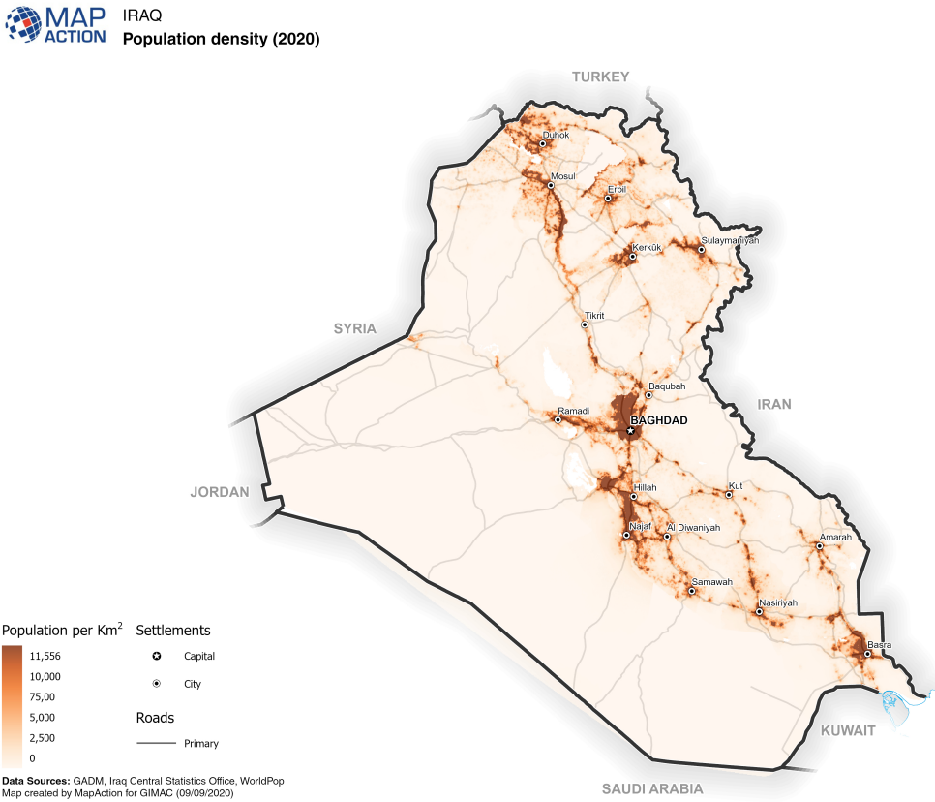
Back to Contents

Section 4 updated: 15 August 2022

Economy

Overview
    - On 27 March 2022 the UN Office for the Coordination of Humanitarian Affairs (UNOCHA) published a report (the UNOCHA report) on the projected humanitarian situation in Iraq in 2022. The report entitled ‘2022 Humanitarian Needs Overview: Iraq’ stated:
‘In 2020, the Iraqi economy contracted by 15.7 per cent due to OPEC [Organization of the Petroleum Exporting Countries] oil cuts and COVID-19. Partially in response to this, the GoI [Government of Iraq] devalued the currency by 18.5 per cent in December 2020, which had a significant impact on citizens. However, oil prices recovered in 2021 (from US$45 per barrel to above $79 per barrel by November 2021), leading to predictions of a $10 billion budget surplus for the year. Accordingly, the World Bank predicts that Iraq’s GDP will grow by 2.6 per cent in 2021, 7.3 per cent in 2022 and 6.3 per cent in 2023.
‘… Despite increasing oil revenues and the reversal of initial economic shocks caused by COVID-19, future stability and prosperity of the country and her people is not assured. Any reduction in the price of oil; failure to implement necessary fiscal reforms; electionrelated instability; delays in widespread vaccination; and deterioration in security conditions amidst high regional geopolitical tensions would undermine the economic stability of the country.’
    - On 16 June 2022 the World Bank stated that:
‘Iraq’s economy is gradually emerging from the deep recession caused by the pandemic and the plunge in oil prices in 2020. After contracting by more than 11 percent in 2020, the economy grew by 2.8 percent in 2021 supported by the solid expansion of non-oil output, in particular services, as COVID-19 movement restrictions were eased. Oil GDP also started growing in the second half of 2021 as OPEC+ production cuts started to be phased out. Higher oil revenues pushed Iraq’s overall fiscal and external balances into a surplus in 2021, however, fiscal rigidities and high level of unaccounted arrears remain.
‘… [T]he turnaround in oil markets has improved Iraq’s economic outlook in the medium term. The economy is projected to grow in 2022-24 by 5.4 percent on average per year in 2022-24 as oil production increases in line with production capacity and higher investments finance by the oil windfall drives non-oil GDP growth. In the absence of structural reforms, the limited absorptive capacity of the economy remains a binding constraint on Iraq’s growth potential and macroeconomic stability.’
Back to Contents

Employment
    - With regards to employment, the UNOCHA report stated:
‘Loss of income and livelihoods, prompted by COVID-19 in 2020, increased vulnerabilities and aggravated the humanitarian needs of IDPs and returnees. As of January 2021, the national unemployment rate was more than 10 percentage points higher than the pre-pandemic 12.7 per cent, and while some jobs have since been recovered, unemployment remains particularly high among IDPs and returnees, with women and people previously employed in the informal sectors mostly affected…As a result, unemployment and debt levels among conflict-affected households are higher in 2021 compared to 2020…’
    - The same report stated:
‘The precarious socioeconomic situation compels many to resort to negative coping strategies, exposing both adults and children to grave protection risks. The situation disproportionately affects women and people living with disabilities who often find it harder to find employment and be self-sufficient due to institutional and cultural barriers; and children who get married or engage in work to support their families. On average, among conflict-affected communities, 1 per cent of children are married and 6 per cent work to contribute to the family’s income; however, these issues are known to be underreported.’
    - The same report observed that:
‘While some camp residents find seasonal work or find employment within or near the camps, many adults are unemployed and seeking work. In the camps, 28 per cent of households have at least one adult member unemployed and seeking work, while 90 per cent of households report taking on debt to afford health care, food, education and basic household expenditures. IDPs in camps note increased competition, jobs being too far away and lack of qualifications as the main barriers to employment. In-camp IDP households with members living with disabilities and female-headed households are two and three times more likely, respectively to face unemployment compared to the rest of the households…’
    - With regards to employment opportunities for out-of-camp IDP households, the UNOCHA report stated:
‘Insufficient and inadequate food consumption is the result of limited or no income which is exacerbated by lack of livelihoods opportunities. Some 30 per cent of out-of-camp IDP households have at least one family member who is unemployed and seeking work. Many adults cannot find employment due to increased competition which is an issue for 73 per cent of out-of-camp IDPs households; perceived lack of opportunities for women (inclusive of both the failure of the market to open certain jobs for women and the perceived social and cultural barriers) noted by 17 per cent of the households; and lack of qualifications which is a barrier for 12 per cent of the households.’
With regards to employment opportunities for returnees, the UNOCHA report observed that:
‘Some 25 per cent of all households that have returned to their areas of origin have at least one family member above the age of 18 who is unemployed and seeking work, an increase from 18 per cent in 2020. Although returnees are more likely to rely on paid public sector jobs than IDPs, reliance on informal commerce or daily labour has reportedly also increased among returnees since 2020… Returnees cannot find employment primarily because of increased competition for jobs.’
Back to Contents
Section 5 updated: 15 August 2022

Humanitarian situation

Overview
    - The UNOCHA report stated: ‘Four years after the end of large-scale military operations against ISIL [Islamic State of Iraq and the Levant], the humanitarian context in Iraq remains fragile, characterized by protracted internal displacement; eroded national social cohesion; extensive explosive ordnance contamination; and incomplete rehabilitation of housing, basic services and livelihoods opportunities.
    - In a Country Brief published in May 2022, the World Food Programme summarized that ‘In Iraq, intermittent conflict and impact of climate change continue to affect the lives of people of Iraq. In the post-conflict context, there are approximately 1.2 million internally displaced persons (IDPs) and 4.1 million people in need of humanitarian assistance. Insecurity, lack of livelihoods, and destroyed or damaged housing hamper people's ability to return home.’
    - In a report by the UN Assistance Mission for Iraq (UNAMI), it was stated that:
‘Persons with disabilities in Iraq, who have been disproportionately affected by armed conflict, violence and other emergencies, experience multiple challenges in accessing equitable services, thereby hindering full enjoyment of their rights and meaningful participation in society. Their situation has been worsened by the COVID-19 pandemic, which has compounded obstacles they face in accessing protection and humanitarian
assistance.’
    - The USSD annual report covering the human rights situation in 2021 noted:
‘Government forces, including the ISF and PMF, established or maintained roadblocks that reportedly impeded the flow of humanitarian assistance to communities in need, particularly in disputed territories such as the Ninewa Plain and Sinjar in Ninewa Province…
‘Security considerations, unexplode ordnance, destruction of infrastructure, COVID-19 curfews, and travel restrictions, as well as official and unofficial access restrictions, limited humanitarian access to communities in need…
‘Out of the estimated 2.4 million persons in need of humanitarian assistance in the country, in September alone more than 18,000 were affected by restrictions imposed on humanitarian movements, according to the UN Office for the Coordination of Humanitarian Affairs (OCHA). OCHA reported that while there were occasionally location- and context-specific restrictions on humanitarian NGO operations, these were usually temporary and eventually resolved. There were few to no areas where humanitarian NGOs were categorically prevented from working. There were, however, areas of high sensitivity where militias or local security actors were less comfortable with NGOs’ presence, which generally diminished the scale and pace of humanitarian operations in those areas.’
    - In a report of the UN Secretary-General on Children and Armed Conflict in Iraq, it is stated that ‘During the reporting period [1 August 2019 to 30 June 2021], the country task force verified 317 grave violations against 254 children… Denial of humanitarian access was the second most verified violation, with 62 verified incidents.’. It is worth noting that the estimated number of children (persons under the age of 16 years) in Iraq has been put at 16,140.142.
Back to Contents

People in need – numbers and location
    - The UNOCHA report stated:
‘Protracted displacement has come to characterize the post-conflict environment in Iraq; about 1.2 million people remain internally displaced, more than 90 per cent of whom fled their areas of origin more than four years ago; more than two thirds fled between January 2014 and March 2015. Returns have largely stagnated, with the number of displaced Iraqis only decreasing by 35,000 people from December 2020 to September 2021. Spontaneous returns remain slow in most areas and are often unsustainable due to unresolved challenges in areas of origin, including limited infrastructure, services and livelihoods; safety and security issues; and social tensions.’
‘Of the 6.1 million people originally displaced, 2.5 million [6.17% of the population] continue to face humanitarian needs, including 728,000 IDPs [Internally Displaced Persons] and 1.7 million returnees; of these just under 1 million people are in acute need, including 382,000 IDPs and 579,000 returnees.
‘The overall number of people in need (PIN) in Iraq decreased from 4.1 million people in the 2021 HNO to 2.5 million people in the 2022 HNO, a decrease of 41 per cent that partially reflects the stabilizing socioeconomic impact of COVID-19 and partially the result of a narrower focus on people with multiple humanitarian needs that require life-saving and life-sustaining assistance, rather than longer-term development and recovery assistance. [see paragraph 4.2.3 for more information]
‘The 2.5 million people in need include 180,000 in-camp IDPs, 549,000 IDPs displaced outside camps; and 1.7 million people who have returned to their areas of origin. Among them, there are 685,000 women, 543,000 girls, 676,000 men and 550,000 boys.’
    - The same source also produced the following map showing the number and location of the people in need across Iraq and also the breakdown of people in need by sex, age and disability:
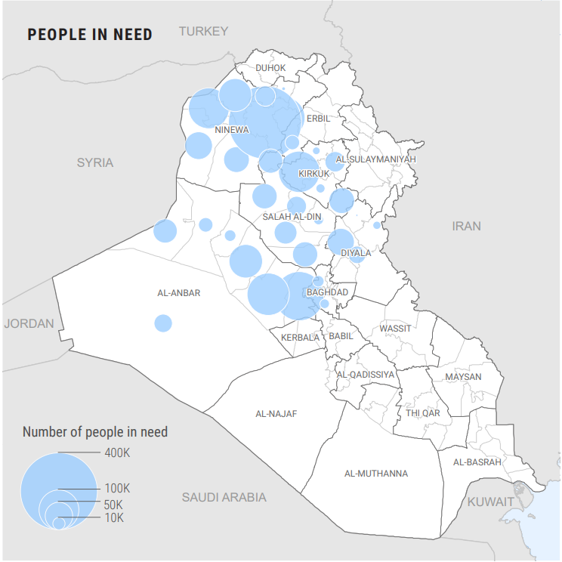
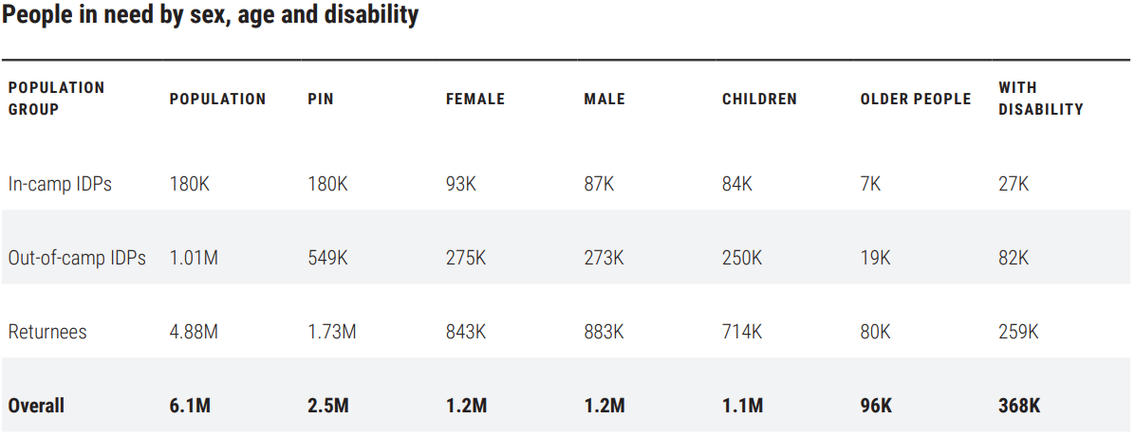
    - On 27 March 2022 UNOCHA published its humanitarian response plan for Iraq in 2022. The report stated the following regarding a refinement to the criteria used for assessing humanitarian needs which decision makers should take into account when reading the following sections:
‘..., the humanitarian community in Iraq refined the criteria for assessing humanitarian needs. The revised criteria aimed to better identify people with the highest levels of vulnerability, particularly those with a multitude of needs, focusing on those needs that are a direct result of the impact of the ISIL crisis.
‘As a result of this revised approach to humanitarian needs analysis the 2022 Humanitarian Needs Overview (HNO) for Iraq identified 2.5 million people in need (PIN), of whom 961,000 people have acute humanitarian needs, reaching extreme or catastrophic levels……[t]he number of people in need decreased by 41 per cent compared to last year, while the number of people in acute need, reaching extreme or catastrophic levels, decreased by 61 per cent. This reduction is largely attributable to the narrower definition of humanitarian needs, and does not reflect significant improvement in the lives of internally displaced persons (IDPs) and returnees in Iraq.’
Back to Contents

Education
    - The UNOCHA report stated that approximately 681,000 IDP and returnee children need education support which is a decrease of 57% from 2021. The report clarifies that: ‘The decrease in education needs is largely due to the adoption of a narrower definition of humanitarian education needs, focused on access to distance learning, school enrolment rates, barriers to accessing education opportunities, and lack of civil documentation.’
    - Regarding the affected population the same source stated:
‘In-camp IDPs: Overall, 80 per cent of school-aged children (49,000 school-aged children) displaced in camps have emergency education needs, and 50 per cent are in acute need. Overall, their greatest need is for civil documentation, with nearly 24 per cent of in-camp IDP households having at least one child reportedly missing a key individual document, hindering access to education services. Camp populations are among the most vulnerable, and often lack the resources and facilities to access distance education.
‘Out-of-camp IDPs: An estimated 121,000 schoolaged children displaced outside formal camps need education assistance. Out-of-camp IDP children face significant barriers to accessing both in-person and remote learning opportunities. Their greatest need is for support with education costs, with one third of out-of-camp IDPs reporting that the cost of schooling is the main barrier hindering attendance Psychosocial support is also a critical need with 11 per cent of out-of-camp IDP households reporting that their children have experienced psychosocial distress.
‘Returnees: Nearly 511,000 school-aged returnee children face challenges in accessing education. An estimated 12 per cent of school-aged returnee households reported that children had dropped out of school in the previous year. Increased dropout rates are likely attributable to child labour, early marriage or barriers to accessing remote learning modalities.’
    - The same source additionally stated:
- IDP and returnee children’s physical, cognitive and mental well-being continues to be impacted by the years of armed conflict and protracted displacement, and by the COVID-19 pandemic. School offers a protective environment against negative coping mechanisms. Protection threats related to child recruitment into armed groups and explosive hazards are higher for boys, while girls are at increased risk of targeted kidnappings, rape, sexual violence and forced marriage, with serious mental and physical health consequences.
- Female-headed households are generally more likely to engage in negative coping strategies, with child marriage being slightly more prevalent in female-headed households. Children in female-headed households are also significantly more likely to engage in family or non-structured work than children in male-headed households. Furthermore, school-aged girls living with disabilities are three times more likely to experience gender-based violence (GBV).
- In 2021, an estimated 223,000 vulnerable displaced and returnee girls and boys dropped out of school, an increase of 8 per cent compared to the 2018-2019 school year, which was the last full school year without COVID-19-related school closures.
- Of the 681,000 children with emergency education needs, more than 485,000 vulnerable boys and girls have not enrolled in school and are missing civil documentation, have psychosocial distress or are exposed to explosive hazards. National identity cards are necessary to access essential services, including school registration for formal education in places of displacement or returns areas.
- People without documentation are more likely to experience other negative conditions such as increased risk of eviction, reliance on negative coping strategies, having at least one child unable to access distance learning, increased exposure to child protection risks, and little or no access to improved sanitation.
- In 2021, approximately 650,000 vulnerable displaced and returnee girls and boys did not access distance learning or in-person education, facing severe barriers. Among these, 21 per cent (138,000) experience severe barriers that put their health and safety at risk.
- Access to online and blended education resources remains a serious challenge for displaced and returnee children due to the lack of reliable internet connectivity, unreliable electricity supply, inability to afford proper equipment for remote engagement, and related unfamiliarity with such programmes.
    - The same source additionally produced the following maps showing the numbers of people in need of educational support and the severity of that need in each governorate:
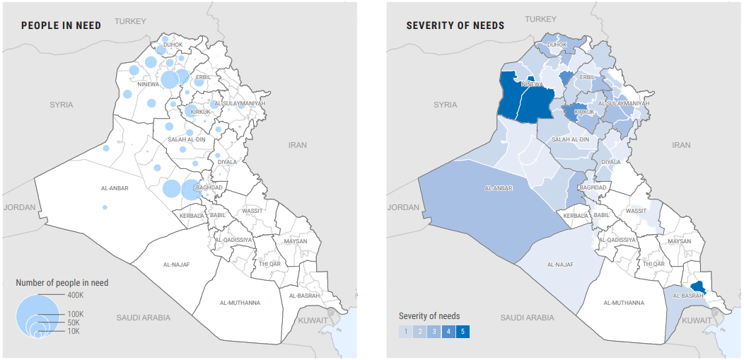
Back to Contents

Food security
    - The UNOCHA report stated that ‘[a]pproximately 730,000 IDPs and returnees in 101 districts face challenges meeting their daily food needs… The number of people in need has remained similar to 2021, while the number of people in acute need has decreased by 48 per cent.’ Regarding the affected population the same source stated:
‘In-camp IDPs: All IDPs living in formal camps continue to rely on food assistance to meet all of their daily food needs. While nearly all (96 per cent) in-camp IDPs report little to no hunger, most continue to rely on external assistance to avoid deterioration of their food security status…
‘Out-of-camp IDPs: An estimated 130,000 IDPs living out of camps are food insecure. Governorates with the most food insecure out-of-camp IDPs are Erbil (50,000), Ninewa (18,000), Duhok (15,000) and Al-Sulaymaniyah (11,000)… Compared to IDPs living in camps, they more frequently face moderate or severe hunger, and rely on crisis- and emergency-level coping strategies, such as child labour or child marriage to generate income to meet their basic food needs. The number of food insecure out-of-camp IDPs has slightly increased compared to 2021, linked to secondary displacement due to camp closures and challenges for out-of-camp IDPs in accessing livelihoods opportunities…
‘Returnees: An estimated 420,000 returnees are food insecure and lack access to livelihoods. Returnees living in critical shelter are up to five times more likely to experience food insecurity than those in more sustainable dwellings. Governorates with the highest number of food insecure returnees are Ninewa (158,000), Al-Anbar (124,000), Salah Al-Din (59,000) and Kirkuk (28,000).’
    - The same source additionally stated:
- Food insecurity among IDPs and returnees in Iraq continues to be primarily linked to their displacement status, resulting in high levels of aid dependency, particularly in camps, as well as challenges establishing sustainable livelihoods and accessing predictable income sources.
- This is particularly true for people missing civil documentation required for employment or to access the government’s social safety nets, and for people living in displacement or returns areas with limited job opportunities.
- Of the 730,000 IDPs and returnees with humanitarian food security needs, 626,000 have borderline or poor food consumption, 425,790 of whom are returnees, 179,629 out-of-camp IDPs and 21,000 in-camp IDPs. Of the mentioned total, 213,000 individuals face poor food consumption and severe hunger.
- The highest levels of food insecurity are found in Al-Falluja District (189,000 people), followed by Al-Hawiga (49,000), Heet (50,000), Erbil (49,000) and Al-Hatra (31,000) districts.
- Among out-of-camp IDPs, those missing core civil documentation are three times more likely to experience food insecurity, while among returnees, female-headed households are nearly three times more likely to face moderate or severe hunger. For both population groups, households with a family member living with disabilities are 2-3 times more likely to experience food insecurity.
    - The same source additionally produced the following maps showing the numbers of people in need of food assistance and the severity of that need in each governorate:
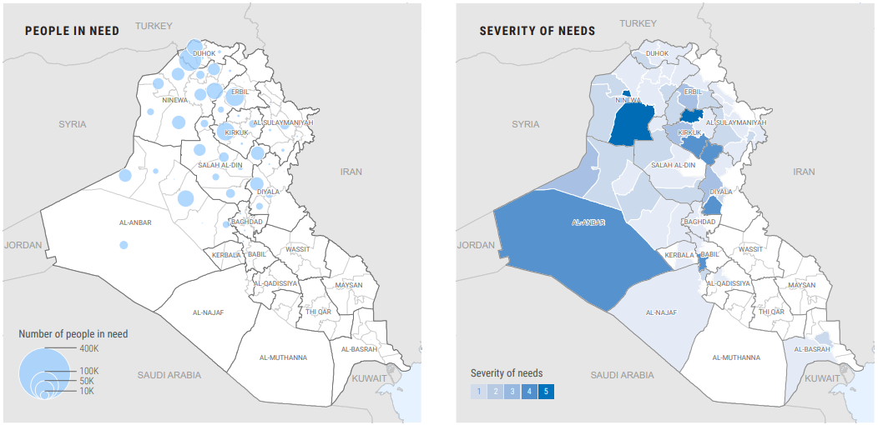
    - On 16 June 2022, the World Bank stated that: “Iraq’s existing food security challenges have intensified with the recent surge in global commodity prices, while domestic food production fell short of demand from the country’s rapidly growing population.”
5.4.5 In a report of the UN Secretary General on the implementation of resolution 2576 (2021), it was observed that:
‘The conflict in Ukraine had a severe impact on global supply chains during the reporting period, negatively affecting food prices and wheat imports and threatening food security in Iraq. In that regard, WFP noted a 16 per cent increase in the average price of vegetable oil in Iraq during the first two weeks of March, while the average price of wheat flour increased by 9 per cent at the national level during the same period. The year-on-year increase in the price of wheat flour was 26 per cent.’
Back to Contents

Healthcare including Covid-19
    - The UNOCHA report stated ‘[a]pproximately 1.7 million IDPs and returnees in 59 districts need essential primary health-care services, a decrease of 30 per cent from 2021. Among them, about 231,000 IDPs and returnees are in acute need, a decrease of 64 per cent from 2021.’ Regarding the affected population the same source stated:
‘… Nearly 142,000 IDPs residing in camps require comprehensive primary health-care services to minimize morbidity and mortality from communicable and non-communicable diseases, as well as alleviate mental health and physical rehabilitation needs. Cost was cited by nearly 90 per cent of in-camp IDP households as a barrier to accessing health care. Furthermore, more than 50 per cent of in-camp IDP households reported spending more than 25 per cent of their total household expenditure on health care…
‘… More than 300,000 out-of-camps IDPs have challenges meeting their basic health care needs due to barriers accessing primary health-care services, including unavailability of health services and lack of documentation, the latter mainly in accessing hospital services. Out-of-camp IDPs are often not eligible for free health care due to lack of accepted documentation of displacement status, which is required to access free, public services provided by the government…
‘… Approximately 1.2 million returnees are estimated to need essential health-care services, including 64,000 returnees who are in acute need…’
    - The same source additionally stated:
- Iraq’s public health system has been severely impacted by years of conflict, emigration of healthcare practitioners, and limited physical infrastructure.
- Humanitarian health needs are most severe in Al-Rutba, Al-Amadiya, Sumail, Zakho, Baquba, Al-Hawiga, Daquq, Dibis, Al-Baaj, Al-Shikhan, Sinjar and Samarra districts.
- Individuals living in critical shelter are 7.8 times more likely to have low access to primary health-care services within one hour of travel.
- An estimated 44 per cent of returnee households and 47 per cent of out-of-camp IDP households reported having an unmet health need in the past three months due to the prohibitive cost of health-care services.
- Although access to health care for IDPs and returnees has improved since 2015, there are still risks for the most vulnerable populations caused by increased water scarcity and future waves of COVID-19, which could exacerbate health needs in the year ahead.
    - The same source additionally produced the following maps showing the numbers of people in need of health assistance and the severity of that need in each governorate:
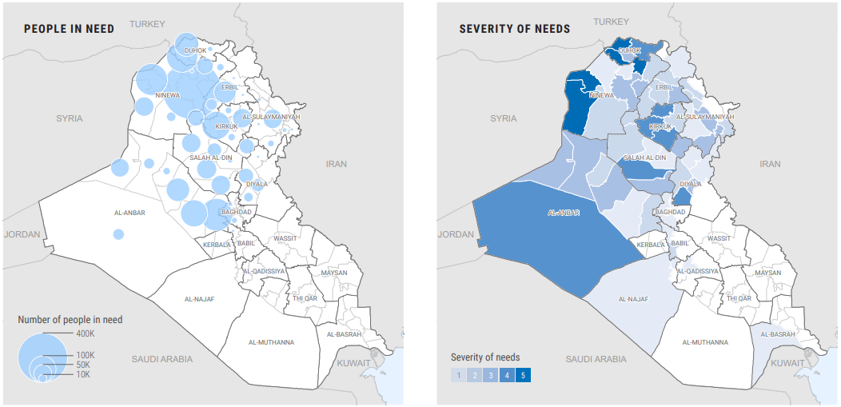
    - According to the World Health Organization’s (WHO) Covid-19 dashboard, as of 22 June 2022 there have been 2,333,443 confirmed cases of Covid-19 and 25,229 deaths. As of 20 June 2022, a total of 18,589,241 vaccine doses have been administered.
Back to Contents

Shelter and non-food items (NFI)
    - The UNOHCA report stated’[a]pproximately 1 million people need emergency shelter and non-food items (NFI) support, a 60 per cent reduction since 2021. Among them, over 533,000 people are in acute need. The decrease in needs is primarily due to a narrower definition of humanitarian shelter needs, focusing on people living in critical shelter, including tents, unfinished and abandoned structures, makeshift shelter, and non-residential, public and religious buildings; and in sub-standard shelter that poses risks to residents’ health, safety and dignity. A far greater number of conflict-affected people, particularly returnees, have shelter needs that require longer-term solutions falling outside the scope of the humanitarian response.’ Regarding the affected population the same source stated:
‘In-camp IDPs: All 180,000 in-camp IDPs live in critical shelter and depend on humanitarian support for regular tent replacement and replenishment of worn-out NFIs, including fuel for cooking and heating. Of these about 134,000 are particularly vulnerable as they are in urgent need of tent replacement and NFI replenishment.
‘… Up to 197,000 out-of-camp IDPs have emergency shelter and NFI needs. This includes 143,000 out-of-camp IDPs who live in critical shelter, including in tents, unfinished and abandoned structures, makeshift shelter, and non-residential, public and religious buildings. Of these, 122,000 people are estimated to be in acute need due to living in unfinished and abandoned buildings or makeshift shelter…
‘… Overall, 661,000 returnees have humanitarian needs related to shelter and NFIs. This includes the 7 per cent of the overall returnee population who live in critical shelter (331,000 individuals) and 260,000 who live in shelter conditions that pose direct threats to their health, safety and dignity. Of them, 42 per cent are in acute need, with almost all (83 per cent) concentrated in 10 districts.’
    - The same source additionally stated:
- Government-led camp closures in the final three months of 2020 led to a reduction in the number of people living in camps
- Of the 657,000 people who live in critical shelter, most are in Sumail District in Duhok Governorate, Sinjar District in Ninewa Governorate and Al-Falluja District in Al-Anbar Governorate.
- Additionally, 620,000 people – some of whom also live in critical shelter – are in need of humanitarian shelter assistance due to living in shelters exposed to hazards… or lacking safety and security... Most are concentrated in Al-Mosul District in Ninewa, and Al-Ramadi and Al-Falluja districts in Al-Anbar.
- Among out-of-camp IDPs, families missing documentation are five times more likely to be at risk of eviction.
- The most cited shelter improvement needs across all population groups are the insufficient insulation from cold and hot weather… including rain leakage, the need for improved privacy… and improved safety, and protection from hazards… Overcrowding in informal sites and other out-of-camp settings due to insufficient housing options greatly impacts out-of-camp IDPs. Access to affordable essential household items, a prerequisite for a minimum standard of living, continues to be a challenge, with about 15 per cent of the affected population reporting that they do not have at least one essential item, including mattresses, bedding items and cooking utensils, despite regular large NFI distributions by humanitarian actors.
    - The same source additionally produced the following maps showing the numbers of people in need of shelter and non-food item assistance and the severity of that need in each governorate:
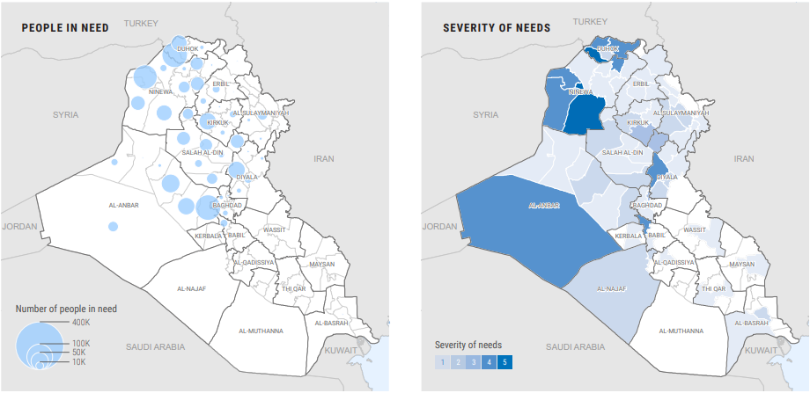
Back to Contents

Water, sanitation and hygiene (WASH)
    - The UNOHCA report stated ‘[a]pproximately 1.6 million IDPs and returnees in 62 districts need emergency WASH support, a 38 per cent reduction since 2021. Among them, 694,000 IDPs and returnees are in acute need of assistance, a decrease of 54 per cent from 2021. The decrease in needs is primarily due to the adoption of a narrower definition of humanitarian WASH needs.’
    - Regarding the affected population the same source stated:
‘… As of November 2021, about 180,000 IDPs reside in camps that require comprehensive and continuous WASH services to ensure sufficient quantity and quality of water, operation of WASH facilities, and solid waste management. The greatest need is for access to an adequate quantity of water; just 67 per cent of in-camp IDPs report that they have access to enough water…
‘… Approximately 37 per cent of IDPs living in out-of-camp settings have humanitarian WASH needs, with 154,000 of those experiencing acute needs. There has been a 13 per cent increase in needs among out-of-camp IDPs from 2021, with IDPs living in informal settlements and unable to return to their areas of origin, being a major driver of this increase. The greatest need is for improved water quality, which is required by 234,188 out-of-camp IDPs, followed by increased water quantity, required by 177,000…
‘… More than 1.1 million returnees have emergency WASH needs, with 397,000 of those in acute need. Among them, the greatest need is for improved water quality, which is required by 89 per cent of the returnees in need…’
    - The same source additionally stated:
- In 2021, there has been a reduction in humanitarian WASH needs for conflict-affected populations in Al-Anbar, Baghdad, Duhok, Kirkuk, Ninewa and Salah Al-Din.
- However, in Al-Basrah, Al-Sulaymaniyah, Diyala and Erbil, an increase in WASH needs is observed. These governorates are facing water shortages due to a decrease in rainfall in the Tigris and Euphrates river catchment in the 2020-2021 rainy season, coupled with insufficient release of water upstream.
- The highest severity of needs is in hard-to-reach districts hosting out-of-camp IDPs and returnees. The top districts in terms of severity are Sinjar, Al-Baaj and Al-Hatra, all in Ninewa Governorate, which have access issues and high numbers of returnees in areas recovering from ISIL occupation.
- High severity of needs is also evident in locations recently impacted by water scarcity issues. Al-Basrah, while only hosting 2,304 IDPs, has over 50 per cent of those IDPs in severe need of WASH support.
- Districts with large caseloads of in-camp IDPs also have severe needs, particularly seen in Zakho and Sumail districts in Duhok Governorate.
    - The same source additionally produced the following maps showing the numbers of people in need of WASH assistance and the severity of that need in each governorate:
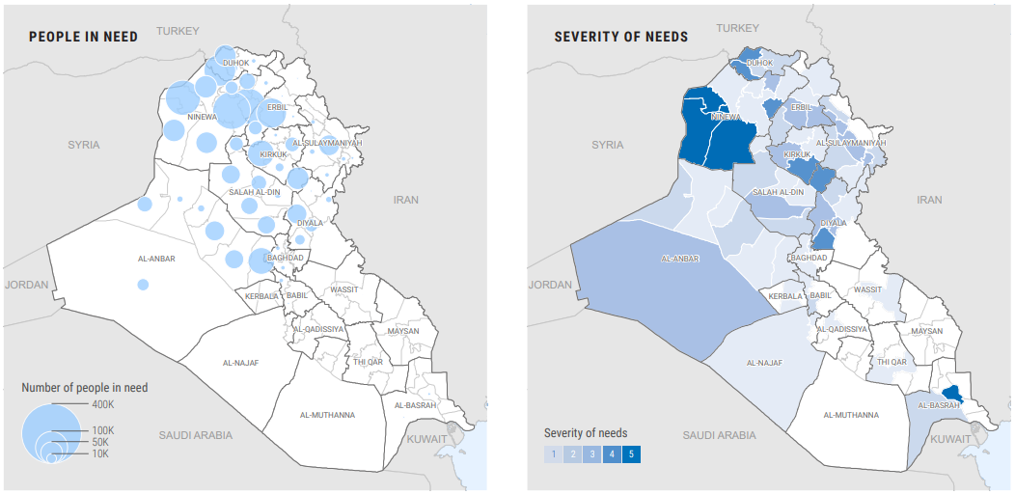
Back to Contents

Humanitarian response plan (HRP)
    - On 13 April 2022 UNOCHA published a humanitarian update which looked at events between January and March 2022. The bulletin provided a summary of UNOCHA’s humanitarian response plan (HRP) for 2022 which stated:
‘Based on the tighter humanitarian needs analysis and the agreed targeting criteria, the 2022 Iraq HRP will prioritize life-saving and life-sustaining humanitarian assistance for 991,000 Iraqi IDPs and returnees, including 180,000 IDPs in formal camps, 234,000 IDPs living in out-of-camp areas, and 577,000 returnees. The total cost of the response, as outlined in the HRP, amounts to US$400 million. The 2022 HRP focuses on providing safe and dignified living conditions, protecting IDPs and returnees from physical and mental harm related to the impact of the ISIL crisis.
‘Humanitarian actors seek to improve unsafe living environments for people living in camps, informal sites or other critical shelter—or in areas with EO contamination—while also providing specialized protection services to the people most at risk of rights violations, violence, abuse and other serious protection risks. Humanitarian partners will provide support to vulnerable IDPs and returnees to access essential services that they are otherwise unable to access, either because they face specific barriers or because they live in areas where services and infrastructure have not yet been rehabilitated. The most acutely vulnerable IDPs and returnees will be supported with emergency food assistance, emergency livelihoods support and temporary cash to meet their most basic needs and avoid reliance on harmful negative coping mechanisms for their survival.
‘The 991,000 acutely vulnerable people who will be the focused target of this HRP, are located across 14 of the 18 governorates of Iraq. The six governorates with the highest target populations are Ninewa (356,000 people), Al-Anbar (166,000), Duhok (155,000), Salah Al-Din (92,000), Kirkuk (66,000) and Diyala (55,000). The largest numbers of in-camp IDPs targeted through the HRP are in Duhok (110,000), Ninewa (45,000), Erbil (14,000) and Al-Sulaymaniyah (11,000), while the governorates hosting the most out-of-camp IDPs are Ninewa (60,000), Duhok (46,000), Erbil (34,000) and Al-Anbar (24,000). For returnees, the largest number is also in Ninewa (249,000), followed by Al-Anbar (141,000), Salah Al-Din (73, 000), Kirkuk (54,000) and Diyala (45,000).’
Back to Contents

Terms of Reference
A ‘Terms of Reference’ (ToR) is a broad outline of what the CPIN seeks to cover. They form the basis for the country information section. The Home Office’s Country Policy and Information Team uses some standardised ToR, depending on the subject, and these are then adapted depending on the country concerned.
For this particular CPIN, the following topics were identified prior to drafting as relevant and on which research was undertaken:
- Humanitarian conditions
  - socio-economic indicators, including statistics on life expectancy, literacy, school enrolment, poverty rates, levels of malnutrition
  - socio-economic situation, including access and availability to:
    - food
    - water for drinking and washing
    - accommodation and shelter
    - employment
    - healthcare – physical and mental
    - education
    - support providers, including government and international and domestic non-government organisations
    - variation of conditions by location and/or group
  - internally displaced persons (IDPs) – numbers, trends and location

Back to Contents

Bibliography

Sources cited
CIA World Factbook, ‘Iraq – People and Society’, updated 1 July 2022. Last accessed: 26 July 2022
MapAction, ‘Iraq – Population density (2020)’, 9 September 2020. Last accessed: 26 July 2022
United Nations Office for the Coordination of Humanitarian Affairs (UNOCHA),
‘Humanitarian Needs Overview 2022: Iraq’, 27 March 2022. Last accessed: 20 June 2022
‘Humanitarian Response Plan 2022: Iraq’, 27 March 2022. Last accessed: 23 June 2022
‘Iraq: Humanitarian Bulletin, January – March 2022’, 13 April 2022. Last accessed: 23 June 2022
United Nations Population Fund, ‘World Population Dashboard Iraq’, no date. Last accessed: 26 July 2022
World Bank, ‘Iraq Economic Monitor, Spring 2022: Harnessing the Oil Windfall for Sustainable Growth’, 16 June 2022. Last accessed: 26 July 2022
World Health Organization, ‘Iraq: WHO Coronavirus Disease (COVID-19) Dashboard with Vaccination Data’, 22 June 2022. Last accessed: 23 June 2022
Back to Contents

Sources consulted but not cited
Reuters, ‘Covid-19 Tracker – Iraq’, 23 June 2022. Last accessed: 23 June 2022
United Nations Development Programme, ‘Human Development Report 2020’, 15 December 2020. Last accessed: 13 June 2022
World Bank, ‘Literacy rate, adult total (% of people ages 15 and above) Iraq’, 2017. Last accessed: 13 June 2022
Back to Contents

Version control
Clearance
Below is information on when this note was cleared:
- version 1.0
- valid from 15 August 2022

Official – sensitive: Start of section
- this version approved by: Martin Stares, Head of CPIT
- approved on: 15 August 2022

Official – sensitive: End of section

Changes from last version of this note
First version of a discrete CPIN focussing on the humanitarian situation.
Back to Contents

United Nations Population Fund, ‘World Population Dashboard Iraq’, no date
CIA World Factbook, ‘Iraq – People and Society’, last updated 1 July 2022
MapAction, ‘Iraq – Population density (2020)’, 9 September 2020
UNOCHA, ‘Humanitarian Needs Overview 2022: Iraq’, (page 15), 27 March 2022
World Bank, ‘Iraq Economic Monitor, Spring 2022: Harnessing the Oil Windfall…’, 16 June 2022
UNOCHA, ‘Humanitarian Needs Overview 2022: Iraq’, (page 28-29), 27 March 2022
UNOCHA, ‘Humanitarian Needs Overview 2022: Iraq’, (page 29), 27 March 2022
UNOCHA, ‘Humanitarian Needs Overview 2022: Iraq’, (page 43-44), 27 March 2022
UNOCHA, ‘Humanitarian Needs Overview 2022: Iraq’, (page 13), 27 March 2022
World Food Programme, WFP Iraq; Country Brief; May 2022, 31 May 2022
UN Assistance Mission for Iraq, Iraq; Common Country Analysis 2021, 2022
USSD, 2021 Country Report on Human Rights Practices: Iraq, 12 April 2022
UN Security Council, Children and armed conflict in Iraq; Report of the Secretary-General [S/2022/46], 26 January 2022
UNOCHA, ‘Humanitarian Needs Overview 2022: Iraq’, (page 61), 27 March 2022
UNOCHA, ‘Humanitarian Needs Overview 2022: Iraq’, (page 52), 27 March 2022
UNOCHA, ‘Humanitarian Needs Overview 2022: Iraq’, (page 62), 27 March 2022
UNOCHA, ‘Humanitarian Response Plan 2022: Iraq’, (page 6), 27 March 2022
UNOCHA, ‘Humanitarian Needs Overview 2022: Iraq’, (page 78), 27 March 2022
UNOCHA, ‘Humanitarian Needs Overview 2022: Iraq’, (page 78), 27 March 2022
UNOCHA, ‘Humanitarian Needs Overview 2022: Iraq’, (page 78), 27 March 2022
UNOCHA, ‘Humanitarian Needs Overview 2022: Iraq’, (page 78-79), 27 March 2022
UNOCHA, ‘Humanitarian Needs Overview 2022: Iraq’, (page 71), 27 March 2022
UNOCHA, ‘Humanitarian Needs Overview 2022: Iraq’, (page 83), 27 March 2022
UNOCHA, ‘Humanitarian Needs Overview 2022: Iraq’, (page 83), 27 March 2022
UNOCHA, ‘Humanitarian Needs Overview 2022: Iraq’, (page 84), 27 March 2022
UNOCHA, ‘Humanitarian Needs Overview 2022: Iraq’, (page 72), 27 March 2022
World Bank, ‘Iraq Economic Monitor, Spring 2022: Harnessing the Oil Windfall…’, 16 June 2022
UN Security Council: ‘Implementation of resolution 2576 (2021); Report of the …’, 29 April 2022
UNOCHA, ‘Humanitarian Needs Overview 2022: Iraq’, (page 86), 27 March 2022
UNOCHA, ‘Humanitarian Needs Overview 2022: Iraq’, (page 86), 27 March 2022
UNOCHA, ‘Humanitarian Needs Overview 2022: Iraq’, (page 87-88), 27 March 2022
UNOCHA, ‘Humanitarian Needs Overview 2022: Iraq’, (page 73), 27 March 2022
WHO, ‘Iraq: WHO Coronavirus Disease (COVID-19) Dashboard…’, 22 June 2022
UNOCHA, ‘Humanitarian Needs Overview 2022: Iraq’, (page 95), 27 March 2022
UNOCHA, ‘Humanitarian Needs Overview 2022: Iraq’, (page 95), 27 March 2022
UNOCHA, ‘Humanitarian Needs Overview 2022: Iraq’, (page 95-96), 27 March 2022
UNOCHA, ‘Humanitarian Needs Overview 2022: Iraq’, (page 75), 27 March 2022
UNOCHA, ‘Humanitarian Needs Overview 2022: Iraq’, (page 98), 27 March 2022
UNOCHA, ‘Humanitarian Needs Overview 2022: Iraq’, (page 98), 27 March 2022
UNOCHA, ‘Humanitarian Needs Overview 2022: Iraq’, (page 98-99), 27 March 2022
UNOCHA, ‘Humanitarian Needs Overview 2022: Iraq’, (page 75), 27 March 2022
UNOCHA, ‘Iraq: Humanitarian Bulletin, January – March 2022’, (page 2), 13 April 2022

