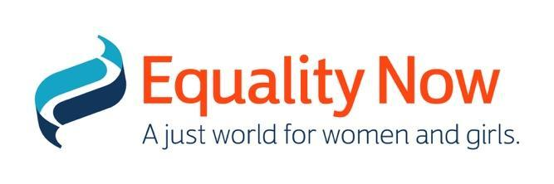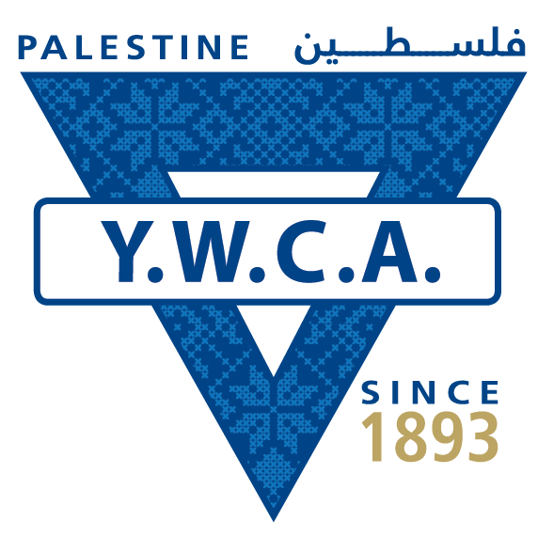

Committee against Torture
Human Rights Treaties Division (HRTD)
Office of the United Nations High Commissioner for Human Rights (OHCHR)
Palais Wilson - 52, rue des Pâquis
CH-1201 Geneva (Switzerland)
Switzerland
By E-mail: cat@ohchr.org

13 June 2022

Information on Palestine for Consideration of the List of Issues Prior to Reporting by the Committee against Torture at its 74th Session (12 - 29 July 2022)

Introduction

- We respectfully submit this report for consideration for the formulation of the List of Issues Prior to Reporting for Palestine by the Committee against Torture (‘the Committee’) during its 74th Session (12 July - 29 July 2022). Our submission details our concerns with regard to laws related to child marriage, trafficking and forced labour, and different forms of sexual and gender-based violence in violation of the Convention against Torture (‘the Convention’), specifically in regard to articles 2 (on state obligation to effect judicial, administrative and legislative measures to prevent torture and ill-treatment) read together with General Comment 2 on the gendered and intersectional nature of torture and ill-treatment, article 10 (on state obligation to educate law enforcement and public officials on prohibition against torture), article 14 (on state obligation to ensure that the existing legal system provides redress for victims of torture) and article 16 (on state obligation to prevent acts of torture within its jurisdiction).

Information about the authors of the submission

- Equality Now is an international human rights NGO with ECOSOC status with the mission to achieve legal and systemic change that addresses violence and discrimination against women and girls around the world. Founded in 1992, Equality Now’s main areas of work are ending sexual violence, ending sexual exploitation, ending harmful practices and achieving legal equality.

- The Young Women’s Christian Association (YWCA) is a non-profit Palestinian association established in Jerusalem in 1918 and includes an umbrella of four grassroots associations in Jerusalem, Ramallah, Jericho and Bethlehem. The YWCA aspires to establish a free, democratic civil society that enables women and youth to exercise and protect their political, economic, and social rights. The YWCA of Palestine is affiliated with the World YWCA which works to empower women, young women, and girls in more than a hundred countries across the globe and enjoys special consultative status in the United Nations Social and Economic Council (ECOSOC).

Legal Exception for Child Marriage
- In Palestine, courts in the West Bank are used to interpret provisions of a marriage contract, including minimum ages of marriage in accordance with the different religious interpretations. In 2019, a Presidential decree - with partial jurisdiction in Palestinian territories - raised the minimum age for marriage for both boys and girls to 18 years old. However, the law provides for an exception to this rule, which gives the right to the judge without clear perimeters to marry off a girl if he/she believes it is in the child’s best interest. Granting such broad authority to the judge is disadvantageous to the child. It legitimises child marriage which is defined as the formal or informal union or marriage before 18 years.

- There is limited data on child marriage in Palestine. The most recent verified data from UNFPA and UNICEF in 2014 indicates that 15% of girls between the ages of 20 and 24 were married before 18 years, and 1% were married before 15 years. In 2015, the Palestinian Central Bureau of Statistics (PCBS) indicated that 23.7% of the married population in Gaza had been married before the age of 18 years.

- Many factors are driving child marriage in Palestine. Socioeconomic factors are key, but the occupation (which impacts girls in intersecting and complex ways) is also relevant: child marriages are seen as a coping strategy against the financial struggle and uncertainty – by marrying her off, a young girl’s family believes they can alleviate their economic burdens.

- The laws relating to women are scattered in various national legislations and inconsistent with international human rights standards. With no Palestinian Legislative Council (PLC) convening since 2007, Palestinian law-making has been restricted and has lacked unity. In consequence, reforms of the law relating to women have been limited to Presidential decrees and the different legal frameworks that are concurrently implemented in Gaza and on the West Bank further complicate the prevention and response to sexual and gender based violence. No changes on discriminatory legislation related to family status laws or penal laws and no comprehensive GBV protection laws have yet been adopted.

- Under several international treaties, including the UN Convention on the Rights of the Child, anyone under 18 years is considered a child. Although Palestinian law also recognizes a child as below 18 years, and a presidential order decreed the minimum age of marriage as 18 years, however, the exception clause allowing child marriage presents a conflict in laws. Traditions and customs allow child marriage and with this conflict of laws, law enforcement’s role becomes less clear and it is ambiguous which legal standard takes precedence and should be enforced. Furthermore, the judicial discretion – regularly informed by social or religious pressure – highlights non-compliance with CEDAW Art. 16(2); as well as Articles 2 and 16 of the CAT since the Committee has found that child marriage amounts to torture or cruel, inhuman or degrading treatment.

- As a result, access to justice for women and girls is hindered by multiple factors including ignorance of the legal proceedings and processes that allow them to access their rights. Customs and traditions that are embedded in patriarchy, coupled with stigma and shame, continue to hinder women’s access to courts when they need to. Only 18 % of judges in Palestine are women. This shortage in the number of female judges presents another layer of a hindrance for women and girls to access justice.

We respectfully ask the Committee to request further information from the State of Palestine on the following issues:

- What are the government’s plans to amend the law and set an absolute minimum age of 18 (Gregorian calendar) for marriage, applicable to both young men and women, equally and without exceptions?
- What measures has the government taken to begin systematic and comprehensive monitoring and establish a data collection system for child marriage in Palestine?

Child trafficking
- In 2020, the Palestinian Authority undertook limited efforts to eliminate the worst forms of child labour in the West Bank under its control. The Ministry of Social Development conducted an inspection campaign in Nablus aimed at stemming child labour. It is pertinent to note that child trafficking manifests in multiple forms including forced and/or illicit activities, human trafficking and dangerous tasks. Existing gaps in the legal frameworks in the West Bank and the Gaza Strip’s fail to adequately protect children from the worst forms of child labour, including child trafficking.

- Both article 95 of the Labour Law for the West Bank and the Gaza Strip and article 14 of the Palestinian Child Law for the West Bank and the Gaza Strip provides a minimum age of 18 years for hazardous work, nevertheless, it is important to note that an adequate legal system and protection measures that meets international standards and safeguard children from child trafficking, forced labour and commercial sexual exploitation is lacking.

We respectfully ask the Committee to request further information from the State of Palestine on the following issues:
- When will the government amend its labour laws and policies - in particular article 1 of Minister of Labour’s Decree on Hazardous Work for the West Bank and the Gaza Strip (31) - to ensure that forced labour and child trafficking is prohibited and the law conforms to international standards?
- What plans does the government have to amend the Penal Code, specifically articles 306 and 310 of the Jordanian Penal Code for the West Bank and Articles 167 and 172(5) of the Penal Code for the Gaza Strip, to prohibit commercial sexual exploitation of children?

Sexual Violence: Rape and Incest
- According to the 2011 Palestinian Central Bureau of Statistics (PCBS) Violence Survey, an average of 37% of women are victims of gender-based violence (GBV) in Palestine; in the Gaza Strip, this percentage increases to 51%. These statistics also include incidences of rape and incest. Women and girls who report cases of rape and incest are faced with the strong stigma that can lead to murder by their family members because being raped is believed to be undignifying and brings shame and dishonour to the family.

- Marital rape is not criminalised in Palestine. For instance, Article 292 of the Jordanian Penal Code (as applicable in the West Bank) identifies that rape can only happen against an unmarried female. Similar language in Article 152 of the Penal Code 1936 (as applicable in Gaza) contains a specific exception for marital rape.

We respectfully ask the Committee to request further information from the State of Palestine on the following issue:
- When will the government adopt provisions to explicitly penalise marital rape in Palestine?

See Paragraph 22 of General Comment on Art 2 CAT/C/GC/2
Decree Law No 21 of 2019 in regard to setting the age of marriage in Palestine, issued by the President of Palestine on 04/11/2019. See also Girls not Brides, Palestine Country Profile, https://www.girlsnotbrides.org/learning-resources/child-marriage-atlas/regions-and-countries/palestine/
Articles 6, 7 of the Family Rights Law (1954), http://www.dcaf.ch/Publications/Palestinian-Women-and-Security-A-Legal-Collection
Palestinian Multiple Indicator Cluster Survey (MICS), PCBS, UNICEF and UNFPA, 2014
Palestinian Multiple Indicator Cluster Survey (MICS), PCBS, UNICEF and UNFPA, 2014
“Little Women”: Adolesence and Child Marriage in Palestine, International Women’s Initiative - Global Policy Brief 2021 https://www.theiwi.org/gpr-reports/palestine-adolescence-child-marriage
Committee Against Torture, Concluding Observations on the initial report of Sierra Leone; CAT/C/SLE/CO/1, 20 June 2014
https://archive.unescwa.org/publications/women-judiciary-state-palestine
https://www.dol.gov/sites/dolgov/files/ILAB/child_labor_reports/tda2020/West-Bank-and-the-Gaza-Strip.pdf
https://www.dol.gov/agencies/ilab/resources/reports/child-labor/west-bank-and-gaza-strip
https://www.dol.gov/agencies/ilab/resources/reports/child-labor/west-bank-and-gaza-strip
Violence Prevalence Survey, PCBS, 2011
UNDP, State of Palestine: Gender Justice and the Law, 2018, https://arabstates.unfpa.org/sites/default/files/pub-pdf/Palestine.Country.Assessment.Eng_.pdf

