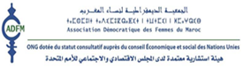
Joint Submission to the
Committee on the Elimination
of Discrimination Against Women

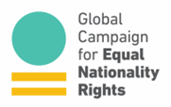
82nd Session
13 June – 1 July 2022

MOROCCO
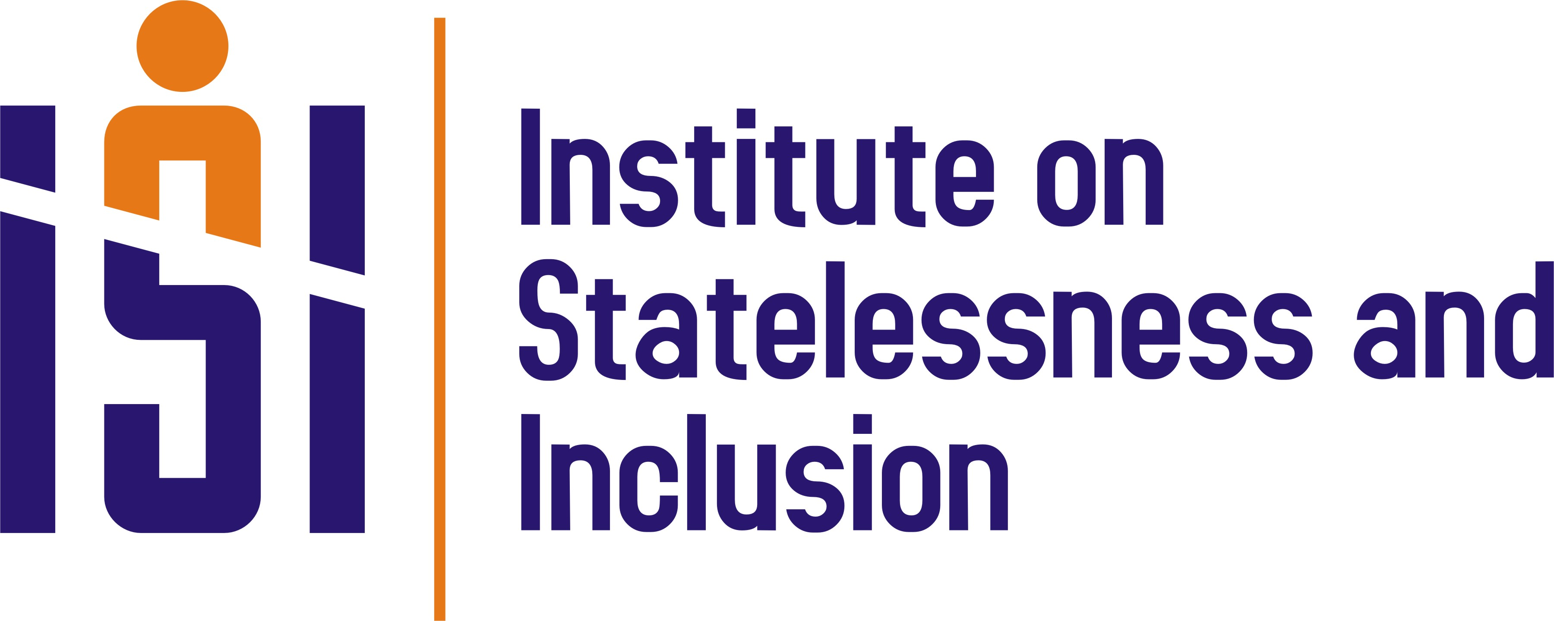
Association Démocratique des Femmes du Maroc Institute on Statelessness and Inclusion
Global Campaign for Equal Nationality Rights

16 May 2022

Joint Submission
to the Committee on the Elimination of Discrimination Against Women
at the 82nd Session

MOROCCO

Introduction

- Association Démocratique des Femmes du Maroc (ADFM), the Institute on Statelessness and Inclusion (ISI), and the Global Campaign for Equal Nationality Rights respectfully submit make this joint submission to the Committee on the Elimination of Discrimination Against Women (Committee), on the right to a nationality and human rights challenges pertaining to statelessness in Morocco.

- This submission focuses on gender discrimination in Morocco’s Nationality law, particularly the denial of Moroccan women’s right to confer Moroccan nationality on their noncitizen spouse on an equal basis with Moroccan men.

- We applaud reforms enacted by the Government of Morocco in 2007, which enshrined the equal rights of Moroccan women and men to confer citizenship on their children. We were pleased to have the Government of Morocco champion the benefits of these reforms, as a cosponsor of the Global Campaign for Equal Nationality Rights’ High Level Side Event during the 62nd UN Commission on the Status of Women in 2018. We welcomed statements made by Morocco’s then Minister of Family, Solidarity, Equality and Social Development, who emphasized that gender-equal nationality laws benefit society as a whole and expressed strong support for amending remaining discriminatory provisions in Morocco’s Nationality Code, in order to uphold Moroccan women’s right to confer nationality on a noncitizen spouse on an equal basis with Moroccan men.

- We urge the Government of Morocco to realise this commitment and enact reforms to uphold gender equality in all Nationality Code provisions. Affected families continue to suffer as a result of women’s unequal ability to confer nationality on their spouse.

Previous recommendations by human rights bodies

- In Morocco’s previous review during the 40th Session, the Committee on the Elimination of Discrimination Against Women stated that:

- While noting with satisfaction the improvement in the personal status of women in the State party, including the fact that every child born to a Moroccan mother, whether in Morocco or abroad, is entitled to acquire his or her mother’s nationality, the Committee remains concerned about various forms of discrimination related to their personal status, such as the non-acquisition of the Moroccan nationality by the foreign husband of a Moroccan wife in circumstances where a non-Moroccan wife of a Moroccan husband would acquire Moroccan nationality, and the loss of the Moroccan nationality of a Moroccan wife who acquires her husband’s foreign nationality. The Committee urges the State party to amend without delay all discriminatory provisions affecting women’s rights in the Nationality Code, in order to harmonize it fully with the Convention. The Committee encourages the State party to conduct this task in consultation with women’s organizations.

- The Human Rights Committee also made recommendations to Morocco regarding gender discrimination in its nationality law:
- The Committee welcomes the recognition of the principle of equality in the
Constitution of 2011 but is still concerned, however, about: (a) the continued existence of legislative provisions that discriminate against women, particularly as regards a matrimonial regime that continues to permit polygamy, divorce, child custody, legal guardianship of children, inheritance and the transmission of nationality to a foreign spouse; (b) the high number of polygamous marriages; and (c) the increase in early marriages (arts.2, 3, 23, 24 and 26). The State party should: (a) repeal or amend all provisions that discriminate against women in order to give full effect to the principle of equality enshrined in the Constitution; (b) take adequate measures to reduce the incidence of polygamy with a view to bringing about its abolition; and (c) amend the legal provisions that allow for exceptions to the minimum age for marriage. (Human Rights Committee)

- Further, Morocco was previously reviewed during the 1st, 13th and 27th sessions of the UPR, in 2008, 2012 and 2017 respectively. During the last review, Morocco accepted 60 recommendations related to gender equality and the rights of women, with the state noting that it considered 52 of these recommendations to be in the process of implementation. These recommendations include:

- Repeal the provision preventing Moroccan women from transmitting nationality to their foreign husband (Congo);

- Strengthen the existing legal framework to protect women against all forms of violence and eliminate all discriminatory gender-based legal norms (Chile);

- Continue to put into place practical measures at the local and national levels to ensure gender equality and combat discrimination against women (Singapore);

- Amend domestic legislation to remove all forms of gender-based discrimination and protect the rights of women and children (Australia);

- Strengthen legislation to ensure gender equality, in particular to prevent violence against women and stop early and forced marriages (Republic of Korea);

- Further progress in the fight against all forms of discrimination and violence against women, putting into operation the Authority for Gender Equality and Action against All Forms of Discrimination (Spain).

Morocco clarified in its follow-up with the Human Rights Council that it was in the process of implementing Congo’s recommendation (144.132) to repeal the nationality law provision which denied women the right to confer nationality on their spouse on an equal basis with men.

Morocco’s International obligations

- Morocco has international obligations to protect the right to non-discrimination on the basis of sex, the right to a nationality and the rights of stateless persons on the basis of other UN and regional treaties to which it is a party. In addition to the Convention on the Elimination of All Forms of Discrimination against Women (see article 9 as well as articles 2, 15, and 16), these include, among others, the International Covenant on Civil and Political Rights (see articles 2 and 24.3), the International Covenant on Economic, Social and Cultural Rights (see articles. 2.2 and article 3), the Convention of the Rights of the Child (see articles 2, 3, 7 and 8), the International Convention on the Elimination of All Forms of Racial Discrimination (see article 5(d)(iii)) and the Convention on the Rights of Persons with Disabilities (see article 18).

- Other relevant regional declarations include the Arab Declaration on Belonging and Legal Identity, supported by the Arab League Secretariat in 2018. This Declaration urges all Arab League Member States to uphold women and men’s equal right to confer nationality on their children and spouse and to remove reservations to CEDAW Article 9. The Declaration also calls for action to ensure universal birth registration and legal provisions to combat childhood statelessness.

Gender Discrimination in Morocco’s Nationality Law

- Though the Constitution of Morocco enshrines equality for women and men, Morocco’s Nationality Code (amended 2007) denies Moroccan women the right to confer their nationality on their noncitizen spouse on an equal basis with Moroccan men (art. 10). After five years of residence in Morocco, the spouse of a Moroccan man can acquire Moroccan nationality with an application to the Minister of Justice. The noncitizen spouse of a Moroccan woman may apply for naturalization, according to the general terms of naturalization and without preferential treatment on the basis of marriage, after legally residing in the country for five years. The naturalization procedure is complex and can remain pending without success for years. This situation causes major disadvantages for affected families, as the foreign husband is subject to the conditions established for foreigners staying in the country, which limits their ability to reside in the territory and their right to work, in addition to other limitations affecting foreigners.

- Moreover, Article 19 of the Code introduces a new discrimination by providing that “Moroccan women who marry a foreigner and acquire, as a result of their marriage, the nationality of the husband and have been authorised by decree prior to the conclusion of the marriage, to renounce their Moroccan nationality, shall lose their Moroccan nationality.”

- Gender discrimination in Morocco’s nationality law denies women equality under the law, as enshrined in the Constitution, further exacerbating a sexist and discriminatory framework for women’s role in the family and society. Women’s unequal ability to confer nationality on spouses also negatively impacts women’s ability to freely choose a spouse, to form a family, and to ensure family unity. By denying women equal rights with men to confer nationality on their spouse, Morocco’s Nationality Code threatens the right of Moroccan children to know and be cared for by their father, as he may face obstacles to residing with his family in Morocco without citizenship. This discrimination can also perpetuate statelessness, when the spouse of a Moroccan woman is stateless or may lose his nationality due to prolonged absence from his country of origin. Stateless persons face wide-ranging human rights violations and hardships, including obstacles to accessing healthcare, social services, formal employment, property rights, inheritance, freedom of movement, and identity documentation. Stateless persons are also at a greater risk of human trafficking, arbitrary detention, and lack of access to justice. Gender discrimination in Morocco’s nationality law also contributes to the root cause of gender-based violence by undermining women’s equal status in society.

Other nationality/statelessness issues

- In addition to articles seeking to ameliorate gender-based discrimination, the 2007 Nationality Code reform also included a step forward by granting, in the 2nd paragraph of article 9, Moroccan nationality by Kafala (support by a couple or a woman of a child born of unknown parents, of an unknown father and abandoned by his mother and any children of badly behaved or destitute parents), thus solving other cases of statelessness. However, the rights of succession and filiation are still not granted to the persons concerned.

Recommendations
The discriminatory laws and practices outlined above cause grave human rights violations and undermine women’s equal citizenship. We call on the Government of Morocco to take urgent steps to align its legislation and practice with international law, including the right to non-discrimination and every person’s right to a nationality.
We respectfully urge the CEDAW Committee to make the following recommendations to the government of Morocco:

- Reform the Nationality Code to uphold the right of Moroccan women to confer nationality on their noncitizen spouse on an equal basis with, and under the same conditions required of Moroccan men; and
- Guarantee women and men’s equal right to apply for the forfeiture of their nationality in the event of acquisition, through marriage, of the nationality of their spouse in cases where a Moroccan citizen is forced, by decree, to renounce their Moroccan nationality prior to the conclusion of marriage.

Association Démocratique des Femmes du Maroc (ADFM) is a non-governmental, non-profit, feminist and autonomous association with ECOSOC status. It was founded in 1985. ADFM’s mission is to protect and promote the human rights of women as universally recognized, particularly via advocacy, capacity building, networking and reporting. ADFM has been accompanying the UPR process since its inception, coordinating the reports submitted to the Human Rights Council by women’s rights NGOs in Morocco, starting from the first cycle of UPR. https://adfm.ma/
The Institute on Statelessness and Inclusion (ISI) is the first and only human rights NGO dedicated to working on statelessness at the global level. ISI’s mission is to promote inclusive societies by realising and protecting everyone’s right to a nationality. The Institute has made over 80 country specific UPR submissions on the human rights of stateless persons. ISI has also compiled summaries of the key human rights challenges related to statelessness in all countries under review under the 23rd to the 40th UPR Sessions. https://www.institutesi.org/.
The Global Campaign for Equal Nationality Rights mobilizes international action to end gender discrimination in nationality laws. It executes its mission through its coalition of national, regional, and international organizations and activists, including steering committee members Equality Now, Equal Rights Trust, Family Frontiers, the Institute on Statelessness and Inclusion, Nationality For All, Women’s Learning Partnership, and Women’s Refugee Commission. https://equalnationalityrights.org/
Committee on the Elimination of Discrimination against Women, ‘Concluding comments of the Committee on the Elimination of Discrimination against Women – Morocco’, CEDAW/C/MAR/CO/4, (8 April 2008), paras 40-41, available at: https://www.ohchr.org/en/documents/concluding-observations/cedawcmarco4-concluding-comments-committee-elimination.
See Universal Periodic Review – Morocco: https://www.ohchr.org/EN/HRBodies/UPR/Pages/MAIndex.aspx.
UN Human Rights Council, 'Report of the Working Group on the Universal Period Review: Morocco, A/HRC/36/6, (13 July 2017), para.144, available at: https://documents-dds-ny.un.org/doc/UNDOC/GEN/G17/190/71/PDF/G1719071.pdf?OpenElement.
UN Human Rights Council, ‘Report of the Working Group on the Universal Periodic Review - Morocco Addendum’, A/HRC/36/6/Add.1, (5 September 2017), para 16, available at: https://documents-dds-ny.un.org/doc/UNDOC/GEN/G17/259/65/PDF/G1725965.pdf?OpenElement.
See: https://treaties.un.org/Pages/ParticipationStatus.aspx?clang=_en.
Code de la Nationalité Marocaine (version consolidée en date du 26 octobre 2011 - http://www.refworld.org/pdfid/501fc9822.pdf / In Arabic - http://www.ism.ma/basic/web/ARABE/Textesdeloiarabe/LoiNation/LoiNation.pdf

