BRIEFING ON CUBA FOR THE COMMITTEE AGAINST TORTURE, SESSION 73- April/May 2022
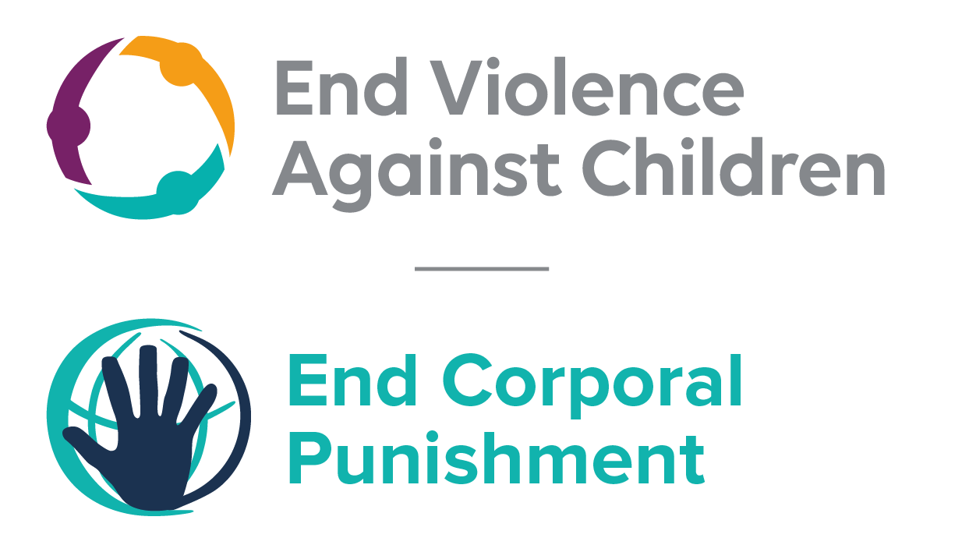
The Global Partnership to End Violence Against Children, March 2022

This briefing describes the legality of corporal punishment of children in Cuba. In light of the obligation under international human rights law to prohibit all corporal punishment of children, the recommendation of the UN Secretary General’s Study on Violence against Children, the repeated recommendations to prohibit all corporal punishment made to Cuba by the Committee on the Rights of the Child and the Committee on the Rights of Persons with Disabilities , and considering the global commitment to ending all violence against children in the context of the 2030 Agenda for Sustainable Development, we hope the Committee will:
• in its concluding observations on the third report of Cuba, recommend that legislation is immediately enacted to explicitly prohibit corporal punishment of children in all settings including the home, and to repeal all legal defences for its use.

Summary of necessary legal reform to achieve full prohibition
Prohibition is still to be achieved in the home, alternative care settings, day care and schools.
The Family Code 1975 permits “moderate” punishment of children by parents (art. 86) and guardians (art. 152). These provisions should be repealed. The near universal social acceptance of corporal punishment in childrearing necessitates clarity in law that no level of corporal punishment is acceptable, as well as prohibition of all corporal punishment and other cruel or degrading forms of punishment, in the home and all other settings where adults have parental authority.
Alternative care settings – Prohibition should be enacted in legislation applicable to all alternative care settings (foster care, institutions, places of safety, emergency care, etc).
Day care – Corporal punishment should be prohibited in all early childhood care (nurseries, crèches, kindergartens, preschools, family centres, etc) and all day care for older children (day centres, after-school childcare, childminding, etc).
Schools – Prohibition should be enacted of corporal punishment in all education settings, public and private.

- The report of Cuba to the Committee Against Torture
  - The third periodic report of Cuba states that corporal punishment is prohibited in the penal system institutions under article 6 of the prison regulation and article 30(11) of the Criminal Code 1987. However, the report does not refer to prohibition of corporal punishment of children in other settings.

- Current legality of corporal punishment in Cuba

  - Home: Corporal punishment is lawful in the home. The Family Code 1975 permits “adequate and moderate correction” of children by parents (art. 86) (unofficial translation): “Parents are empowered to reprimand and moderately and adequately correct children under their guardianship.” There is a similar provision in relation to guardians (art. 152): “All children under guardianship must give respect and obedience to the tutor. He/she will rebuke and correct them moderately.” Provisions against violence and abuse in the Family Code, the Criminal Code 1987, the Children and Youth Code and the Constitution do not include prohibition of all corporal punishment in childrearing.

  - In 2011, in response to the recommendations on the issue by the Committee on the Rights of the Child, the Government asserted that “corporal punishment is not allowed in any law, or lower-ranking legal rules, or family practice, school or social institutions”. The Government repeated this assertion to the Committee in 2018, stating “corporal punishment is not allowed in the law or lower-ranking norms, nor in family or school practice, and they are not socially tolerated” (unofficial translation). In fact, there is no explicit prohibition in current law of all corporal punishment in childrearing and it appears that the “right of correction” is still on the statute books.

  - The Government had initially indicated its commitment to prohibiting all corporal punishment of children, by adopting in 2011 the Regional Roadmap on Violence against Children along with the Central American Governments of Mexico and the Dominican Republic. The Roadmap included a recommendation to adopt national legislation to explicitly prohibit all corporal punishment and to repeal provisions allowing for “moderate” punishment/correction. In the same year, the Government had reported that a draft new Family Code was under discussion that would remove the provision for “adequate and moderate correction”. However the End Corporal Punishment no longer considers Cuba committed to prohibiting all corporal punishment of children without delay, as the Government has not taken any clear action since then to indicate that it intends to pursue law reform.

  - Alternative care settings: Corporal punishment is lawful in alternative care settings under the right of correction of parents and guardians in articles 86 and 152 of the Family Code 1975 (see under “Home”). In 2011/2012 the Government stated to the Committee on the Rights of the Child that corporal punishment is prohibited in institutions but cited only the Resolution relating to education (see under “Schools”).

  - Day care: Corporal punishment is lawful in day care under the right of correction of parents and guardians in articles 86 and 152 of the Family Code 1975 (see under “Home”). In 2011/2012 the Government stated to the Committee on the Rights of the Child that corporal punishment is prohibited in institutions but cited only the above-mentioned Resolution relating to education (see under “Schools”). We have been unable to examine the text of this Resolution but any prohibition would presumably apply only to educational provision (preschools, etc) and not to all forms of early childhood care and day care for older children.

  - Schools: The Government has stated that corporal punishment is prohibited in schools, but we have yet to verify that prohibition is explicit. In commenting on recommendations issued in 2011 by the Committee on the Rights of the Child, the Government stated that Resolution 165/2006 of the Ministry of Education approving the Regulations on the discipline of work in educational activities (Resolución 165 de 2006 del Ministerio de Educación que aprueba el Reglamento Ramal de la disciplina del trabajo en la actividad educacional) prohibits corporal punishment in schools.

  - Penal institutions: Corporal punishment is prohibited as a disciplinary measure in penal institutions under article 6 of the prison regulation. Article 30(11) of the Criminal Code 1987 states that “those sanctioned may not be subjected to corporal punishment, nor is it admissible to employ against them any measure entailing humiliation or a loss of dignity”.

  - Sentence for crime: Corporal punishment is unlawful as a sentence for crime under article 30(11) of the Criminal Code 1987 (see under “Penal institutions”).

Recommendations by human rights treaty bodies and during the UPR
  - CRC: In its concluding observations on the state party’s initial report in 1997 and on the second report in 2011,the Committee on the Rights of the Child has recommended to Cuba that measures are taken to protect children against corporal punishment through a public awareness campaign and a legislation to explicitly prohibit corporal punishment in all settings.

  - CRPD: In its concluding observations on the state party’s initial report, the Committee on the Rights of Persons with Disabilities recommended that the Government expedite the law reform process to prohibit corporal punishment of children, including children with disabilities, in all settings, particularly at home and in institutions where children still live.

  - UPR: At the third cycle of the Universal Periodic Review of Cuba in 2018, a recommendation to adopt legislation explicitly prohibiting corporal punishment was issued and noted by the Government.

20 June 2011, CRC/C/CUB/CO/2 Advance Unedited Version, Concluding observations on second report, paras. 36 and 37
Opiniones del Gobierno de la República de Cuba sobre el documento CRC/C/CUB/CO/2 contentivo de las Observaciones finales del Comité de los Derechos del Niño sobre el segundo Informe periódico de Cuba (?2011), pp. 7-8
[2018], CRC/C/CUB/3-6, Initial report, para. 120
http://www.gacetaoficial.cu/html/codigo%20de%20lafamilia.html#T2, accessed 28 March 2014
Regional Road Map on Violence against Children, adopted in 2011, 1 and 2 December in Santo Domingo, as a follow-up to the recommendations of the UN Study on Violence against Children, available at http://srsg.violenceagainstchildren.org/sites/default/files/political_declarations/Hoja%20de%20Ruta%20Final%20EVCN%20Centroamericano%20Dic%202012.pdf, accessed 21 February 2015
27 April 2011, CRC/C/CUB/Q/2/Add.1, Written replies to the Committee on the Rights of the Child, para. 36
http://www.gacetaoficial.cu/html/codigo%20de%20lafamilia.html#T2, accessed 28 March 2014
http://www.gacetaoficial.cu/html/codigo%20de%20lafamilia.html#T2, accessed 28 March 2014
See for example [2018], CRC/C/CUB/3-6, Initial report, para. 125
http://www.gacetaoficial.cu/html/codigo%20de%20lafamilia.html#T2, accessed 28 March 2014
18 June 1997, CRC/C/15/Add.72, Concluding observations on initial report, paras. 19 and 35
3 August 2011, CRC/C/CUB/CO/2, Concluding observations on second report, paras. 36 and 37
11 July 2018, A/HRC/39/16, Report of the Working Group, para. 24(317)
18 September 2018, A/HRC/39/16/Add.1 Advance unedited version, Report of the Working Group: Addendum, paras. 8 and 9

