A/HRC/48/CRP.6
4 October 2021

English only
Human Rights Council
Forty-eight session
13 September–8 October 2021
Agenda item 10
Technical assistance and capacity-building

Situation of human rights in Ukraine
(1 February – 31 July 2021)*
Office of the United Nations High Commissioner for Human Rights

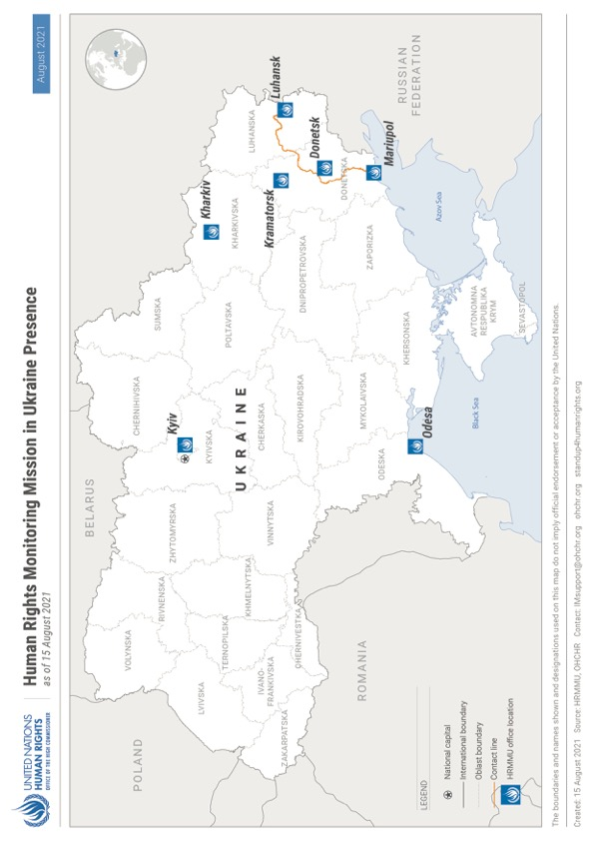
I. Executive summary
1. This thirty-second report by the Office of the High Commissioner for Human Rights (OHCHR) on the human rights situation in Ukraine covers the period from 1 February to 31 July 2021. It is based on the work of the United Nations Human Rights Monitoring Mission in Ukraine.
2. During the period under review, the number of ceasefire violations in the conflict zone considerably increased compared with the preceding six months, resulting in increased civilian casualties and damage to civilian objects. OHCHR documented 62 civilian casualties occurring in the reporting period, a total of 15 people killed (11 men, three boys and one girl), and 47 injured (30 men, 13 women, three boys and one girl), representing a 51 per cent increase compared with the preceding six months. Thirteen civilian casualties resulted from active hostilities, while 47 resulted from mine-related incidents and handling of explosive remnants of war. In addition, one man was also killed in a security incident and one woman was beaten by a soldier. Residents in the conflict zone complained about psychological distress due to the resumption of hostilities after a prolonged period of relative silence. The availability of weapons also resulted in grave incidents of domestic violence affecting women and children.
3. OHCHR is concerned that in March and April 2021, both self-proclaimed ‘Donetsk people’s republic’ and self-proclaimed ‘Luhansk people’s republic’ issued ‘decrees’ establishing the forced recruitment of 400 men into armed groups. Such recruitment can expose civilians to extreme danger, strips them of their civilian status and protection otherwise afforded them by international humanitarian law, and places them at risk of prosecution and imprisonment.
4. The conflict continued to impact over 3.4 million civilians, including due to COVID-19-related movement restrictions, mostly imposed by armed groups. These restrictions resulted in a 95 per cent reduction in the number of crossings of the contact line in eastern Ukraine, compared with the same period in 2019. Restrictions of the freedom of movement also affected the rights to education, family life, health, work, social security, adequate standard of living, and access to judicial and civil documentation. OHCHR welcomes the enactment by the Government of law No. 1583-IX on 22 July 2021, releasing civilians from administrative responsibility for travelling from territory controlled by ‘Donetsk people’s republic’ and ‘Luhansk people’s republic’, to Government-controlled territory via the Russian Federation rather than through official entry-exit crossing points (EECPs), by crossing the Ukrainian-Russian state border not controlled by the Government. Pensioners registered as residing in armed group-controlled territory continued to have access to their pension hindered due to the Government’s continued linking of payment of pensions to registration as internally displaced.
5. The conflict and resulting economic hardship negatively affected the civilian population living near the contact line, including due to a lack of public transport and passable roads, lack of access to clean water and sanitation, difficulties in receiving medical aid, including ambulance services, and inability to visit/receive family members due to COVID-19 restrictions and checkpoints.
6. OHCHR welcomes the implementation of Cabinet of Ministers Resolution No. 947 establishing a compensatory mechanism for civilians whose housing in Government-controlled territory have been destroyed by the hostilities. OHCHR is concerned by the adoption, on 28 April 2021, of a regulation of ‘Donetsk people’s republic’ that allows for the expropriation of immovable property that has been abandoned by civilians.
7. OHCHR is concerned that the draft framework law on transitional justice elaborated by the Ministry for Reintegration of Temporary Occupied Territories is not in line with relevant international standards on transitional justice.
8. Allegations that workers in territory controlled by ‘Luhansk people’s republic’ have been threatened with a salary reduction, or dismissal if they did not obtain Russian citizenship are also concerning, as this may amount to a form of discrimination and thus be contrary to international human rights law.
9. OHCHR, which enjoys unimpeded access to official places of detention in Government-controlled territory, documented arbitrary detention and ill-treatment by law enforcement officials of individuals believed to be linked or affiliated with self-proclaimed ‘republics’. OHCHR also received reports from prisoners in Oleksiivska penal colony No. 25 in Kharkiv that they faced pressure to withdraw complaints about torture.
10. During the reporting period, OHCHR continued to have no access to detainees and places of deprivation of liberty in territory controlled by self-proclaimed ‘republics’ amidst continued credible allegations of torture and ill-treatment in a number of facilities. OHCHR nonetheless documented 13 cases of conflict-related arbitrary detention in the territory, including five of which occurred in 2021.
11. In territory controlled by self-proclaimed ‘republics’, protection of victims of domestic violence, notably women and children, remained of concern over the reporting period due to lack of resources and support, as well as restrictions imposed on civil society.
12. OHCHR commends the Government’s efforts to prosecute conflict-related human rights violations regardless of the affiliation of alleged perpetrators, notably the 1 July 2021 conviction of an officer of the Security Service of Ukraine (SBU) for the abduction and killing of a civilian in 2017. Other court proceedings related to accountability, including for killings and violent deaths during the Maidan protests and on 2 May 2014 in Odesa, have also progressed, however, the slow advancement of other trials related to these events remains of concern.
13. OHCHR remains concerned about the constitutional crisis caused by the suspension, dismissal and criminal prosecution of two judges of the Constitutional Court, jeopardising the independence of the judiciary and rule of law in the country.
14. In the vast majority of assemblies monitored by OHCHR, law enforcement agencies provided adequate security measures. Attacks against opposition political party Partiia Shariia have decreased, but online threats continued, as do judicial proceedings against this party and others. OHCHR also documented five violent attacks, threats and intimidation against six human rights defenders (four men and two women). In territory controlled by self-proclaimed ‘republics’, the ability to enjoy freedom of peaceful assembly remains limited. OHCHR is aware of a small number of events in which participants were critical of ‘authorities’, such as protests by coal miners about unpaid wages which started in April 2021, and local residents contesting a lack of access to water in June 2021.
15. OHCHR is concerned that individual sanctions imposed against Parliamentarian Taras Kozak and his eight companies, which led to the closure of television channels “112 Ukraine”, “ZIK” and “NewsOne”, are not in line with international standards on the right to freedom of expression. During the reporting period, OHCHR recorded five incidents of attacks against journalists and media workers in relation to their activities, and seven cases of hate speech and threats against individuals who publicly criticised the State language law, or expressed opinions perceived as pro-Russian or in favour of the Russian language. In territory controlled by self-proclaimed ‘republics’, criticism of those in charge and participation in public affairs continued to be discouraged, with OHCHR documenting three cases of arbitrary detention of individuals who expressed opinions on social networks.
16. Two cases of violence related to tensions between Orthodox communities were documented in territory controlled by the Government, while actors of self-proclaimed ‘republics’ continued to restrict the activities in territory they control of several evangelical Christian denominations.
17. OHCHR documented six incidents of discrimination, violence and manifestation of intolerance targeting individuals belonging to minority groups or holding alternative or minority opinions, lesbian, gay, bisexual, transsexual and intersex (LGBTI) persons, Roma and other ethnic groups, and persons with disabilities. Women among these groups were found to be particularly marginalized, as they are often subjected to intersectional discrimination.
18. OHCHR remains concerned about the situation of homeless people throughout the country. The lack of social support and housing for persons with disabilities discharged from hospitals and long-term care facilities places them at risk of homelessness. The situation of persons with intellectual and psychosocial disabilities in long-term care facilities is equally concerning, as is the situation with sexual and reproductive rights of women in these facilities. Amendments to the eligibility criteria for housing subsidies to pay for utilities, introduced in April 2021 have also further reduced access of groups in vulnerable situations to these subsidies, affecting their right to an adequate standard of living. In territory controlled by ‘Luhansk people’s republic’, lack of income due to salary arrears affected the right to an adequate standard of living.
19. In the Autonomous Republic of Crimea and the city of Sevastopol, Ukraine, occupied by the Russian Federation (Crimea), freedom of peaceful assembly continued to be restricted by the Russian Federation, including with a blanket requirement of pre-authorization for public assemblies and prosecutions for participation in single-person pickets. Torture and ill-treatment by the Federal Security Service (FSB) continued to be documented, as well as violations of fair trials rights. The cancellation by the Parliament of Ukraine of non-resident taxpayer status for people originating from Crimea is welcomed, as it will ease access to public services.
20. During the reporting period, OHCHR engaged in technical cooperation to build the capacity of the Government of Ukraine to strengthen human rights standards in governance. OHCHR provided technical expertise, such as on arbitrary detention, torture and ill-treatment in the context of armed conflict in eastern Ukraine and on economic and social rights, to a variety of national actors within ministries, Parliament, the Supreme Court, the Ombudsperson’s office, regional and local administrations, the military and law enforcement, and civil society including human rights defenders.
II. OHCHR methodology
21. The report is based on information gathered during 92 field visits, 12 visits to places of detention, 82 court hearings, 75 assemblies and 1,156 interviews with victims and witnesses of human rights violations, as well as relatives of victims and their lawyers, Government representatives, members of civil society and other interlocutors. It also draws from information obtained from court documents, official records, open sources and other relevant material. Findings are based on verified information collected from primary and secondary sources that are assessed as credible and reliable. They are included in the report where the “reasonable grounds to believe” standard of proof is met, namely where, based on a body of verified information, an ordinarily prudent observer would have reasonable grounds to believe that the facts took place as described and where legal conclusions are drawn, that these facts meet all the elements of a violation. While OHCHR cannot provide an exhaustive account of all human rights violations committed throughout Ukraine, it obtains and verifies information through a variety of means in line with its methodology, and bases its conclusions on verified individual cases.
22. OHCHR applies the same standard of proof when documenting conflict-related civilian casualties. In some instances, documenting conflict-related civilian casualties may take time before conclusions can be drawn, meaning that numbers of civilian casualties are revised as more information becomes available. OHCHR applies the “reasonable grounds to believe” standard in attributing a civilian casualty to a particular party based on the geographic location where it occurred, the direction of fire, and the overall context surrounding the incident.
23. Information in this report is used in full respect of informed consent by all sources as to its use as well as OHCHR’s assessment of any risk of harm that such use may cause. This may entail removing identifying details to ensure the confidentiality of sources.
24. The report also draws on undertakings by Ukraine to implement the Sustainable Development Goals (SDGs) stemming from the UN Sustainable Development Summit in September 2015 (see image below).
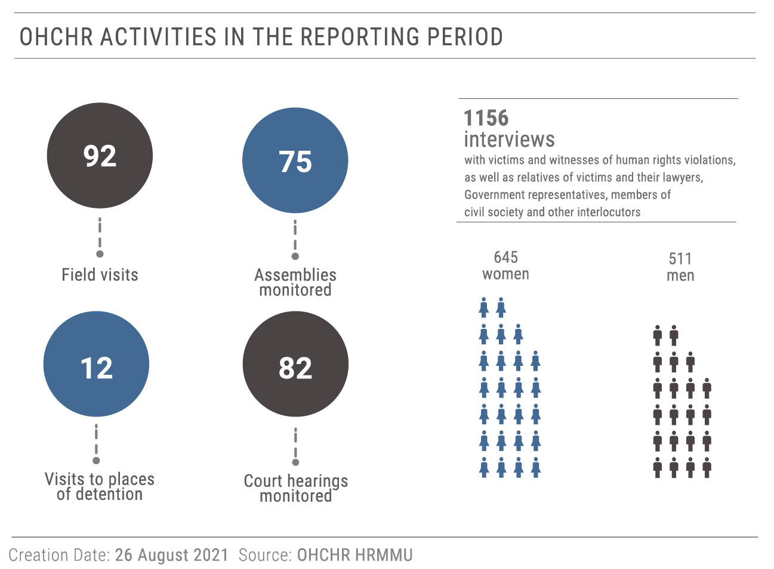

SDGs stemming from the UN Sustainable Development Summit in September 2015

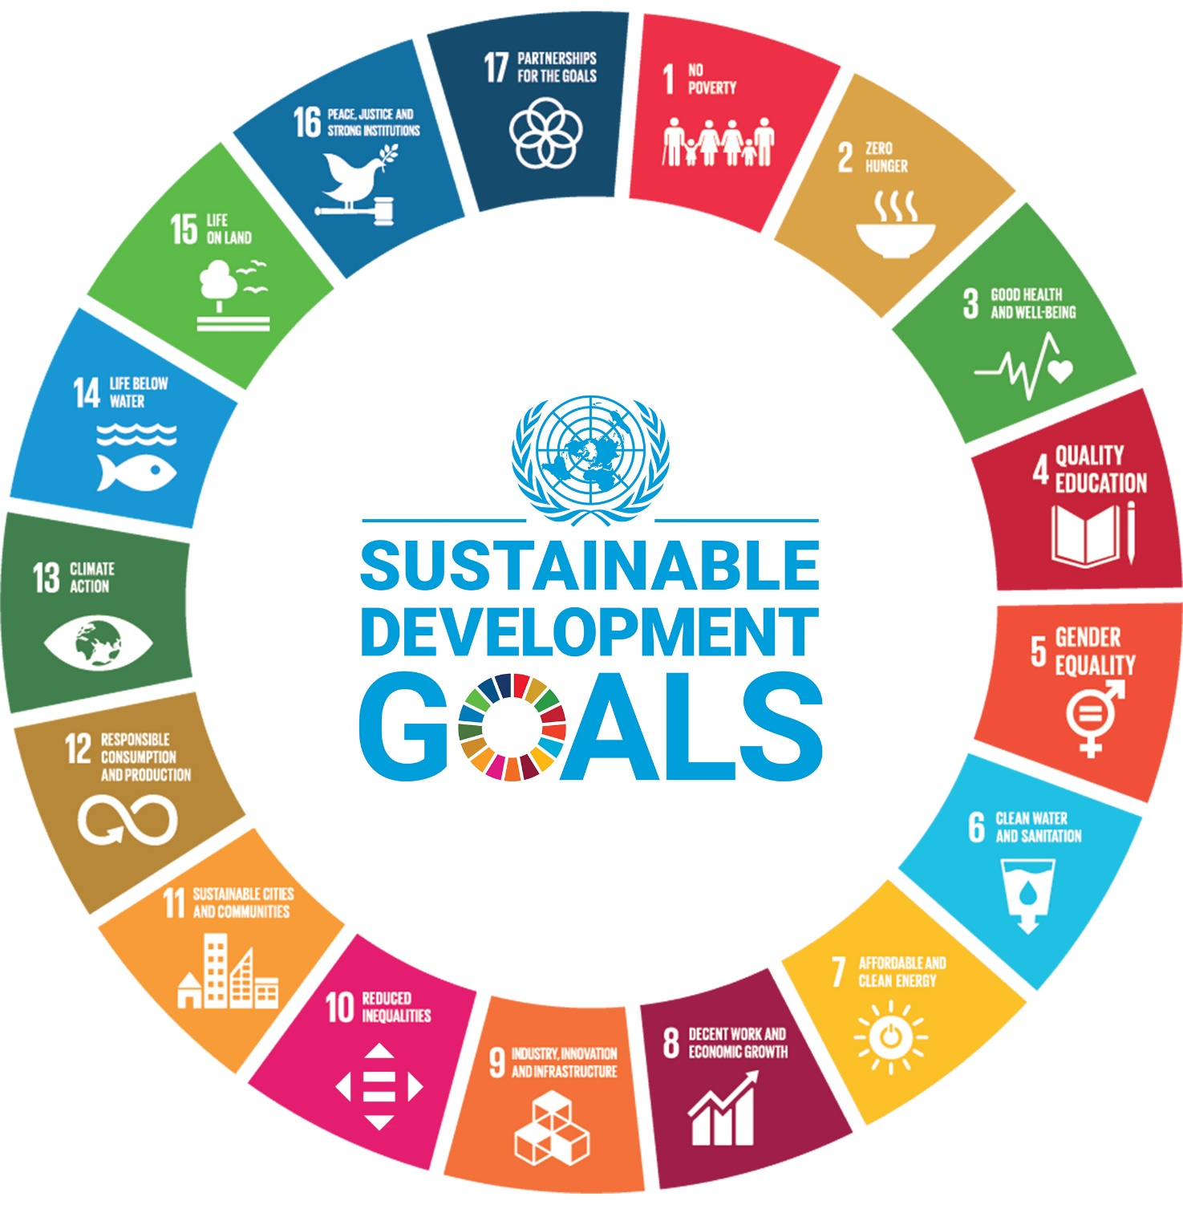

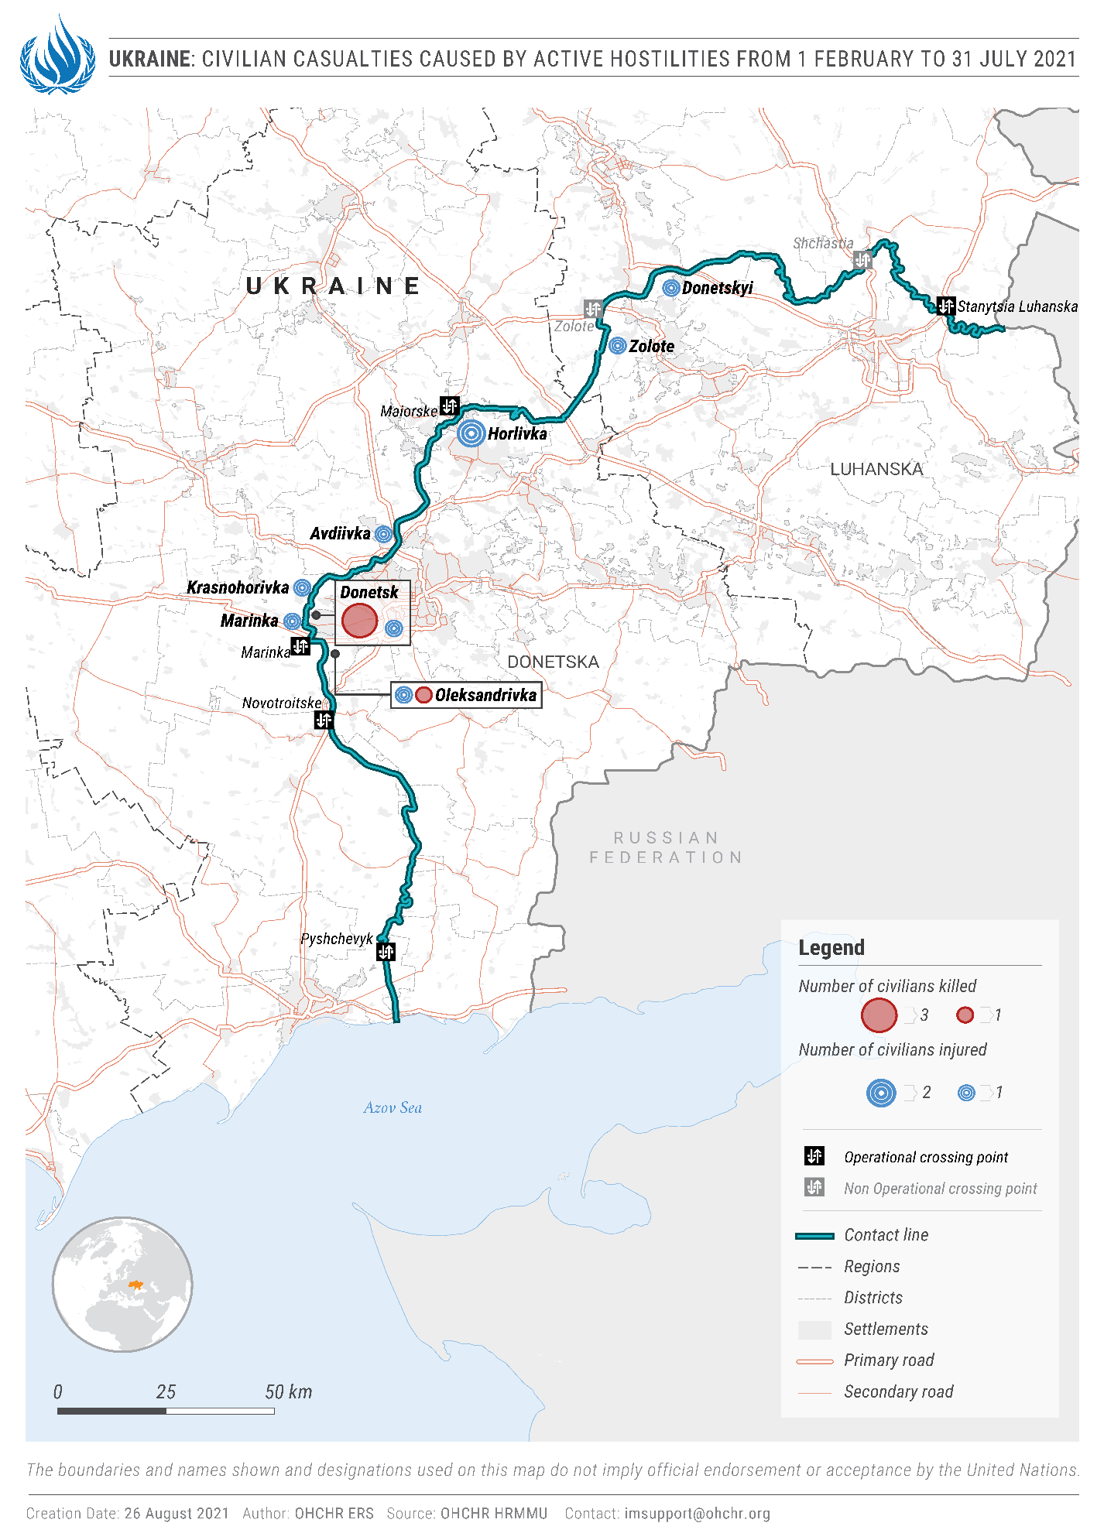

III. Impact of hostilities
“The device exploded one to two metres from the house, near the windows. My husband was our family’s main breadwinner so I’m left without financial or any other support.”

- A woman whose spouse was killed in Government-controlled part of Zolote (Luhansk region).

A. Conduct of hostilities and civilian casualties
25. During the reporting period, the number of ceasefire violations in the conflict zone considerably increased, as reported by the OSCE Special Monitoring Mission (SMM) to Ukraine. They were 369 per cent higher than during the preceding six months from 1 August 2020 to 31 January 2021 (39,806 and 8,484, respectively). This growth resulted in an increase in civilian casualties caused by active hostilities, as well as increased damage to civilian objects, which peaked from mid-March to mid-May. However, the number of civilian casualties decreased in June and July, to levels seen in the second half of 2020, which were the lowest for the entire conflict period.
26. The reporting period marked one year since the enactment on 27 July 2020 of a package of measures to strengthen the ceasefire regime that was agreed by the Trilateral Contact Group in Minsk. OHCHR civilian casualty records for 2019-2021 clearly demonstrate that the enactment of the package has resulted in a significant decrease in civilian casualties caused by active hostilities: from 27 July 2020 to 26 July 2021: 18 casualties (five killed and 13 injured), an 81 per cent decrease compared with the preceding 12 months, from 27 July 2019 to 26 July 2020, when 93 such casualties (nine killed and 84 injured) were recorded.
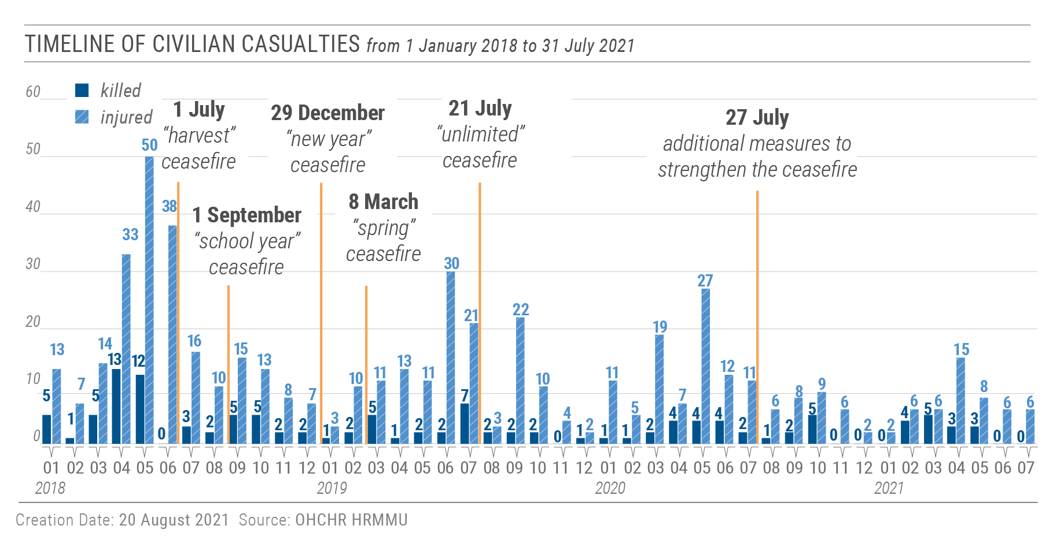
1. Civilian casualties in the reporting period
27. From 1 February to 31 July 2021, OHCHR recorded 62 civilian casualties: 15 killed (11 men, three boys and one girl) and 47 injured (30 men, 13 women, three boys and one girl), a 51 per cent increase compared with the preceding six months (41 civilian casualties – eight killed and 33 injured).
28. Thirteen civilian casualties resulted from active hostilities: four killed (all men) and nine injured (seven men and two woman). Seventy-seven per cent of these (four killed and six injured) were recorded in territory controlled by self-proclaimed ‘republics’, and 23 per cent (three injured) in the Government-controlled part of Donetsk region. For example, on 14 April 2021, a man was killed by mortar shelling in armed group-controlled Donetsk; and on 19 June 2021, a man was injured by heavy machine gun fire in Government-controlled Avdiivka (Donetsk region). In addition, one man was killed by small arms fire in a security incident in the Government-controlled part of Donetsk region that was not related to exchanges of fire across the contact line.
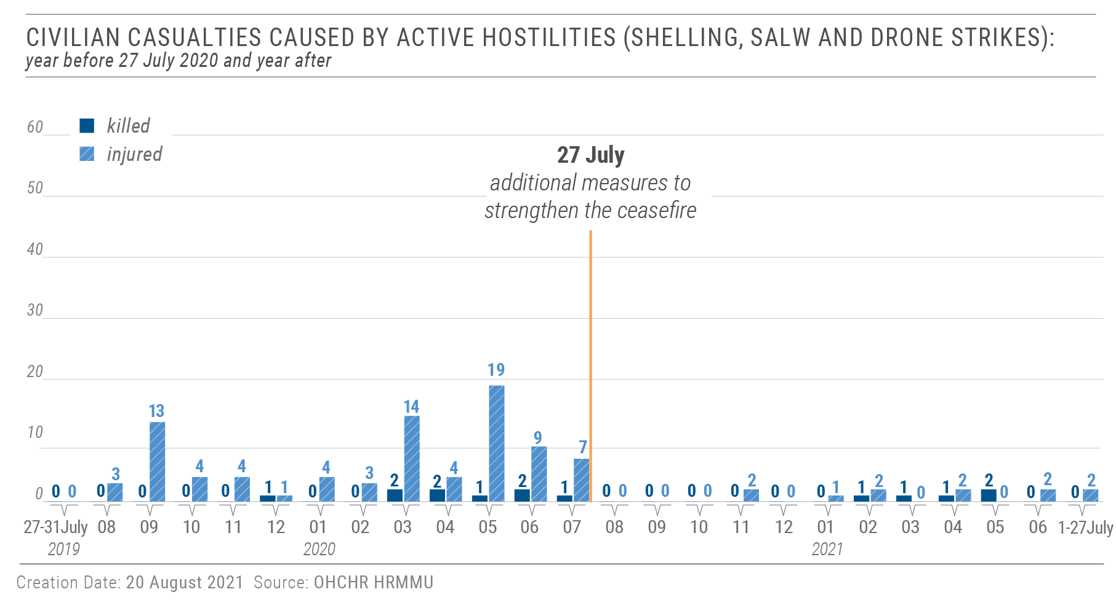
29. Forty-seven civilian casualties resulted from mine-related incidents and handling of explosive remnants of war: ten killed (six men, three boys and one girl) and 37 injured (23 men, ten women, three boys and one girl). Eighty-one per cent (six killed and 32 injured) were recorded in territory controlled by self-proclaimed ‘republics’, and 19 per cent (four killed and five injured) in Government-controlled territory. For example, on 6 April 2021, one boy was killed and another boy injured by the detonation of an unidentified explosive device in armed group-controlled Slovianoserbsk (Luhansk region); and on 15 April 2021, a man was injured in a mine-related incident near Government-controlled Hnutove (Donetsk region).
30. In one particularly striking case, on 23 February 2021, an 80-year-old man was killed by an antipersonnel mine in his own yard in the Government-controlled part of Zolote (Luhansk region). On 13 October 2018, his 43-year-old daughter-in-law and 17-year-old granddaughter had been killed by mortar shelling in the armed group-controlled part of Zolote.
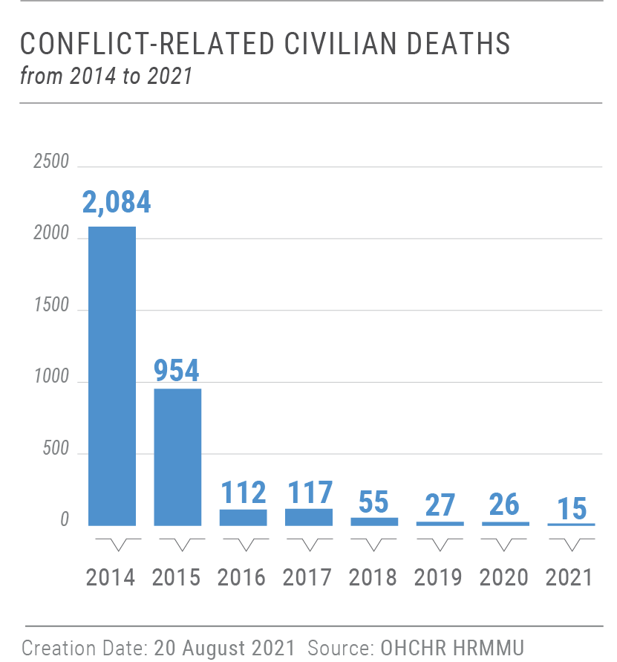
31. The intermingling of armed actors with the civilian population and proliferation of small arms and light weapons in the conflict zone also led to increased gender-based violence, including domestic violence. For example, a drunk soldier in the Government-controlled part of Donetsk region beat and injured an 85-year-old woman. In February, a resident of armed group-controlled Chystiakove (formerly Torez) in Donetsk region, detonated a hand grenade when his wife attempted to leave the house with their seven-year-old son because he had threatened her. Both were injured, and the boy subsequently died in hospital. In June, the ‘Donetsk people’s republic’ ‘ministry of interior’ reported that they had detained a man in Donetsk who threatened to kill his wife and daughter, and detonated a hand grenade causing multiple injuries to both.
2. Civilian casualties during the entire conflict period
32. During the entire conflict period, from 14 April 2014 to 31 July 2021, OHCHR recorded a total of 3,092 conflict-related civilian deaths (1,839 men, 1,064 women, 102 boys, 50 girls, and 37 adults whose sex is unknown). Taking into account the 298 deaths on board Malaysian Airlines flight MH17 on 17 July 2014, the total civilian death toll of the conflict has reached at least 3,390. The number of injured civilians is estimated to exceed 7,000.
3. Attacks on civilian objects
33. OHCHR continued to record security incidents in the conflict zone that affected civilian objects (other than civilian housing). From 1 February to 31 July 2021, OHCHR recorded 27 such incidents caused by shelling and SALW fire across the contact line: 22 (81 per cent), in armed group-controlled territory and five (19 per cent) in Government-controlled territory. Ten incidents affected electricity supplies, seven affected educational institutions, six affected water and sanitation facilities, three affected gas supplies and one affected a medical facility. Though none of these incidents resulted in civilian casualties, they endangered the lives of civilians in and near these institutions, and affected the population’s access to basic services.
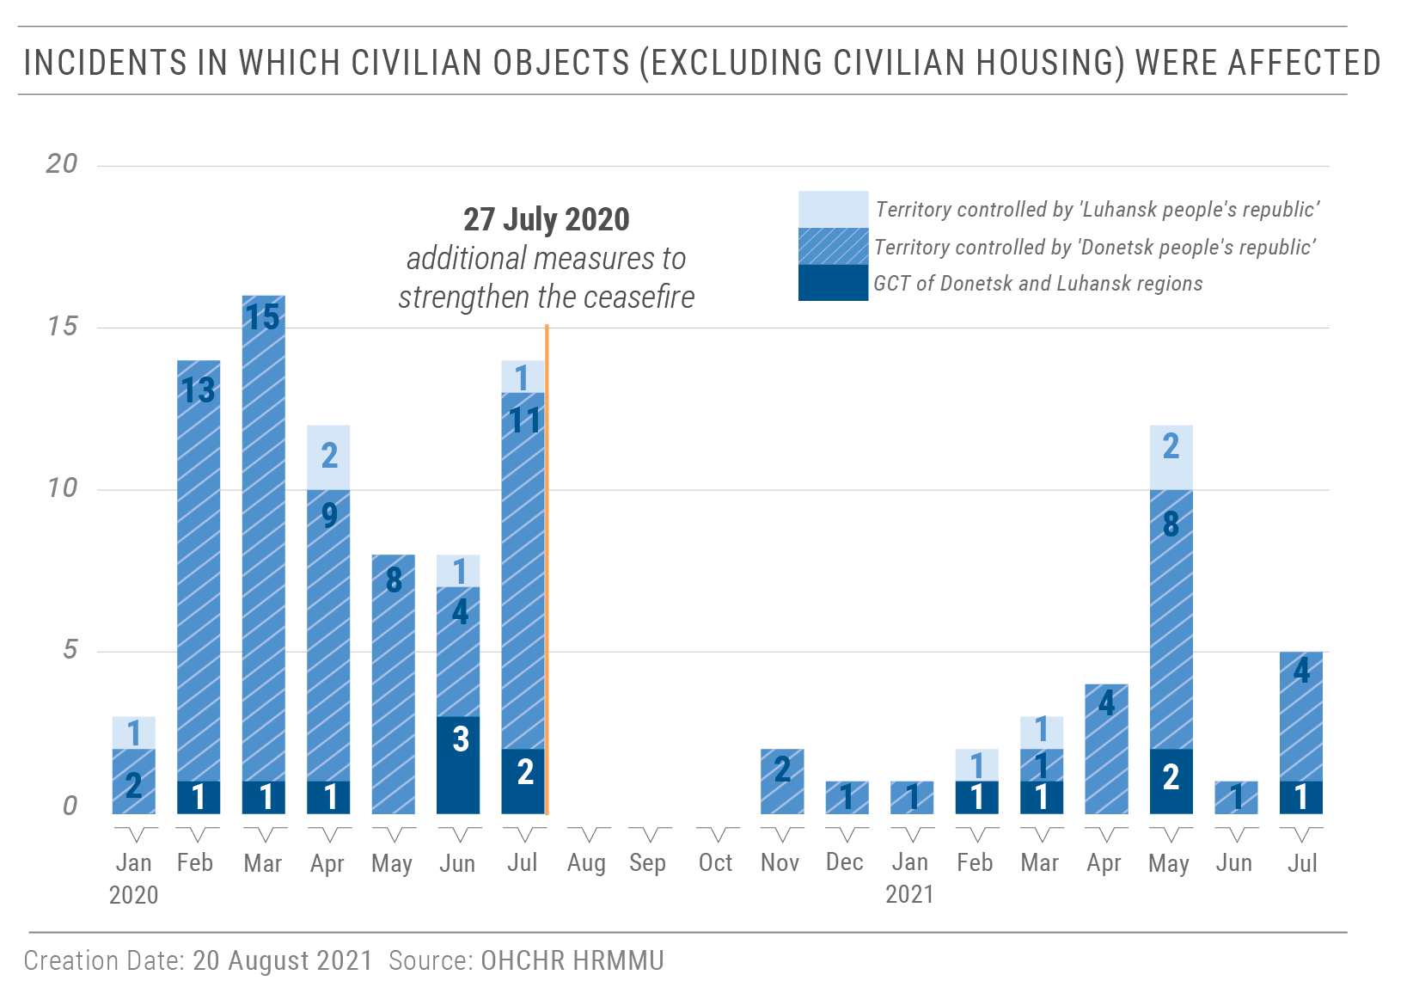
34. For instance, on 4 May 2021, a mortar shell landed on the territory of the Marinskyi Central District Hospital in Krasnohorivka, which endangered the hospital staff and 45 patients, shattered windows, and resulted in an electricity outage until the next morning. On 7 May 2021, shelling close to the 3rd Lift Pumping Station of Siverskyi Donets Donbas channel de-energized its booster pumping station “Maiorsk”, putting the water supply of 3.1 million people residing on both sides of the contact line at risk. On 31 May 2021, a school in the armed group-controlled part of Zolote (Luhansk region) sustained damages from small arms fire.
4. Recruitment in territory controlled by self-proclaimed ‘republics’
35. In March and April 2021, both self-proclaimed ‘republics’ issued ‘decrees’ establishing the forced recruitment of 400 men (200 in each self-proclaimed ‘republic’) into armed groups.
36. Such forced recruitment by armed groups raises a number of concerns. It exposes young male civilians to involuntary lethal danger, stripping them of the protection afforded to civilians by international humanitarian law. It also burdens them with an undue risk of criminal prosecution. A refusal to be recruited makes them criminally liable under the regulations adopted in the territory controlled by self-proclaimed ‘republics’ and those recruited would be exposed to a risk of prosecution and imprisonment under Ukrainian legislation. The practice of forced recruitment also raises concerns with regard to its compatibility with the rights to freedom of thought, conscience and religion.
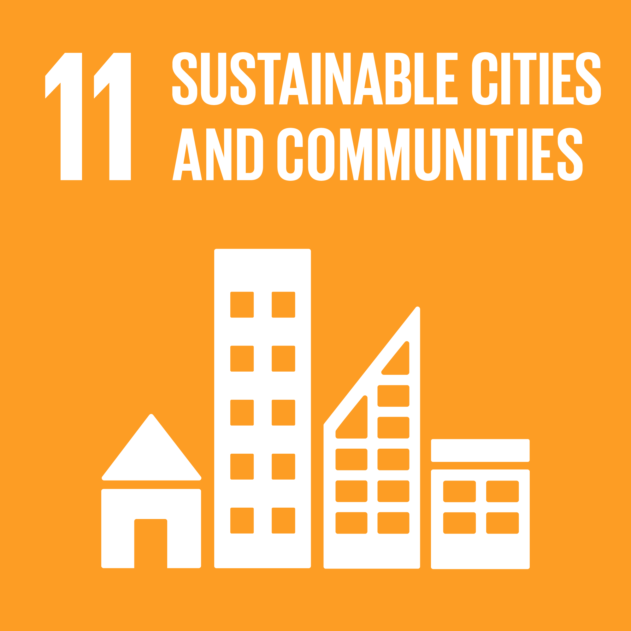
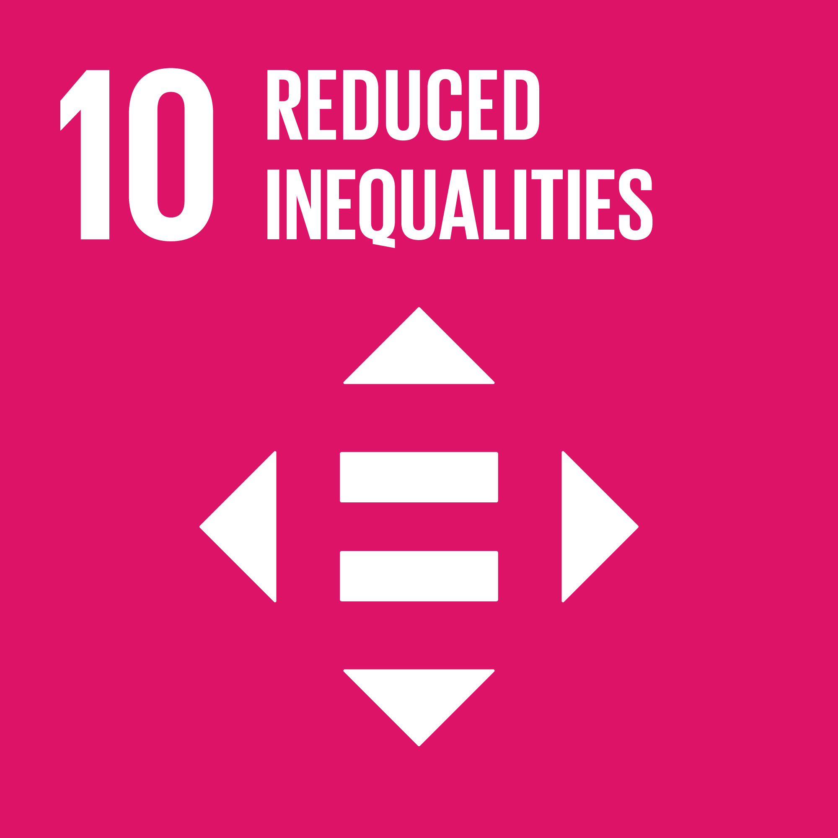
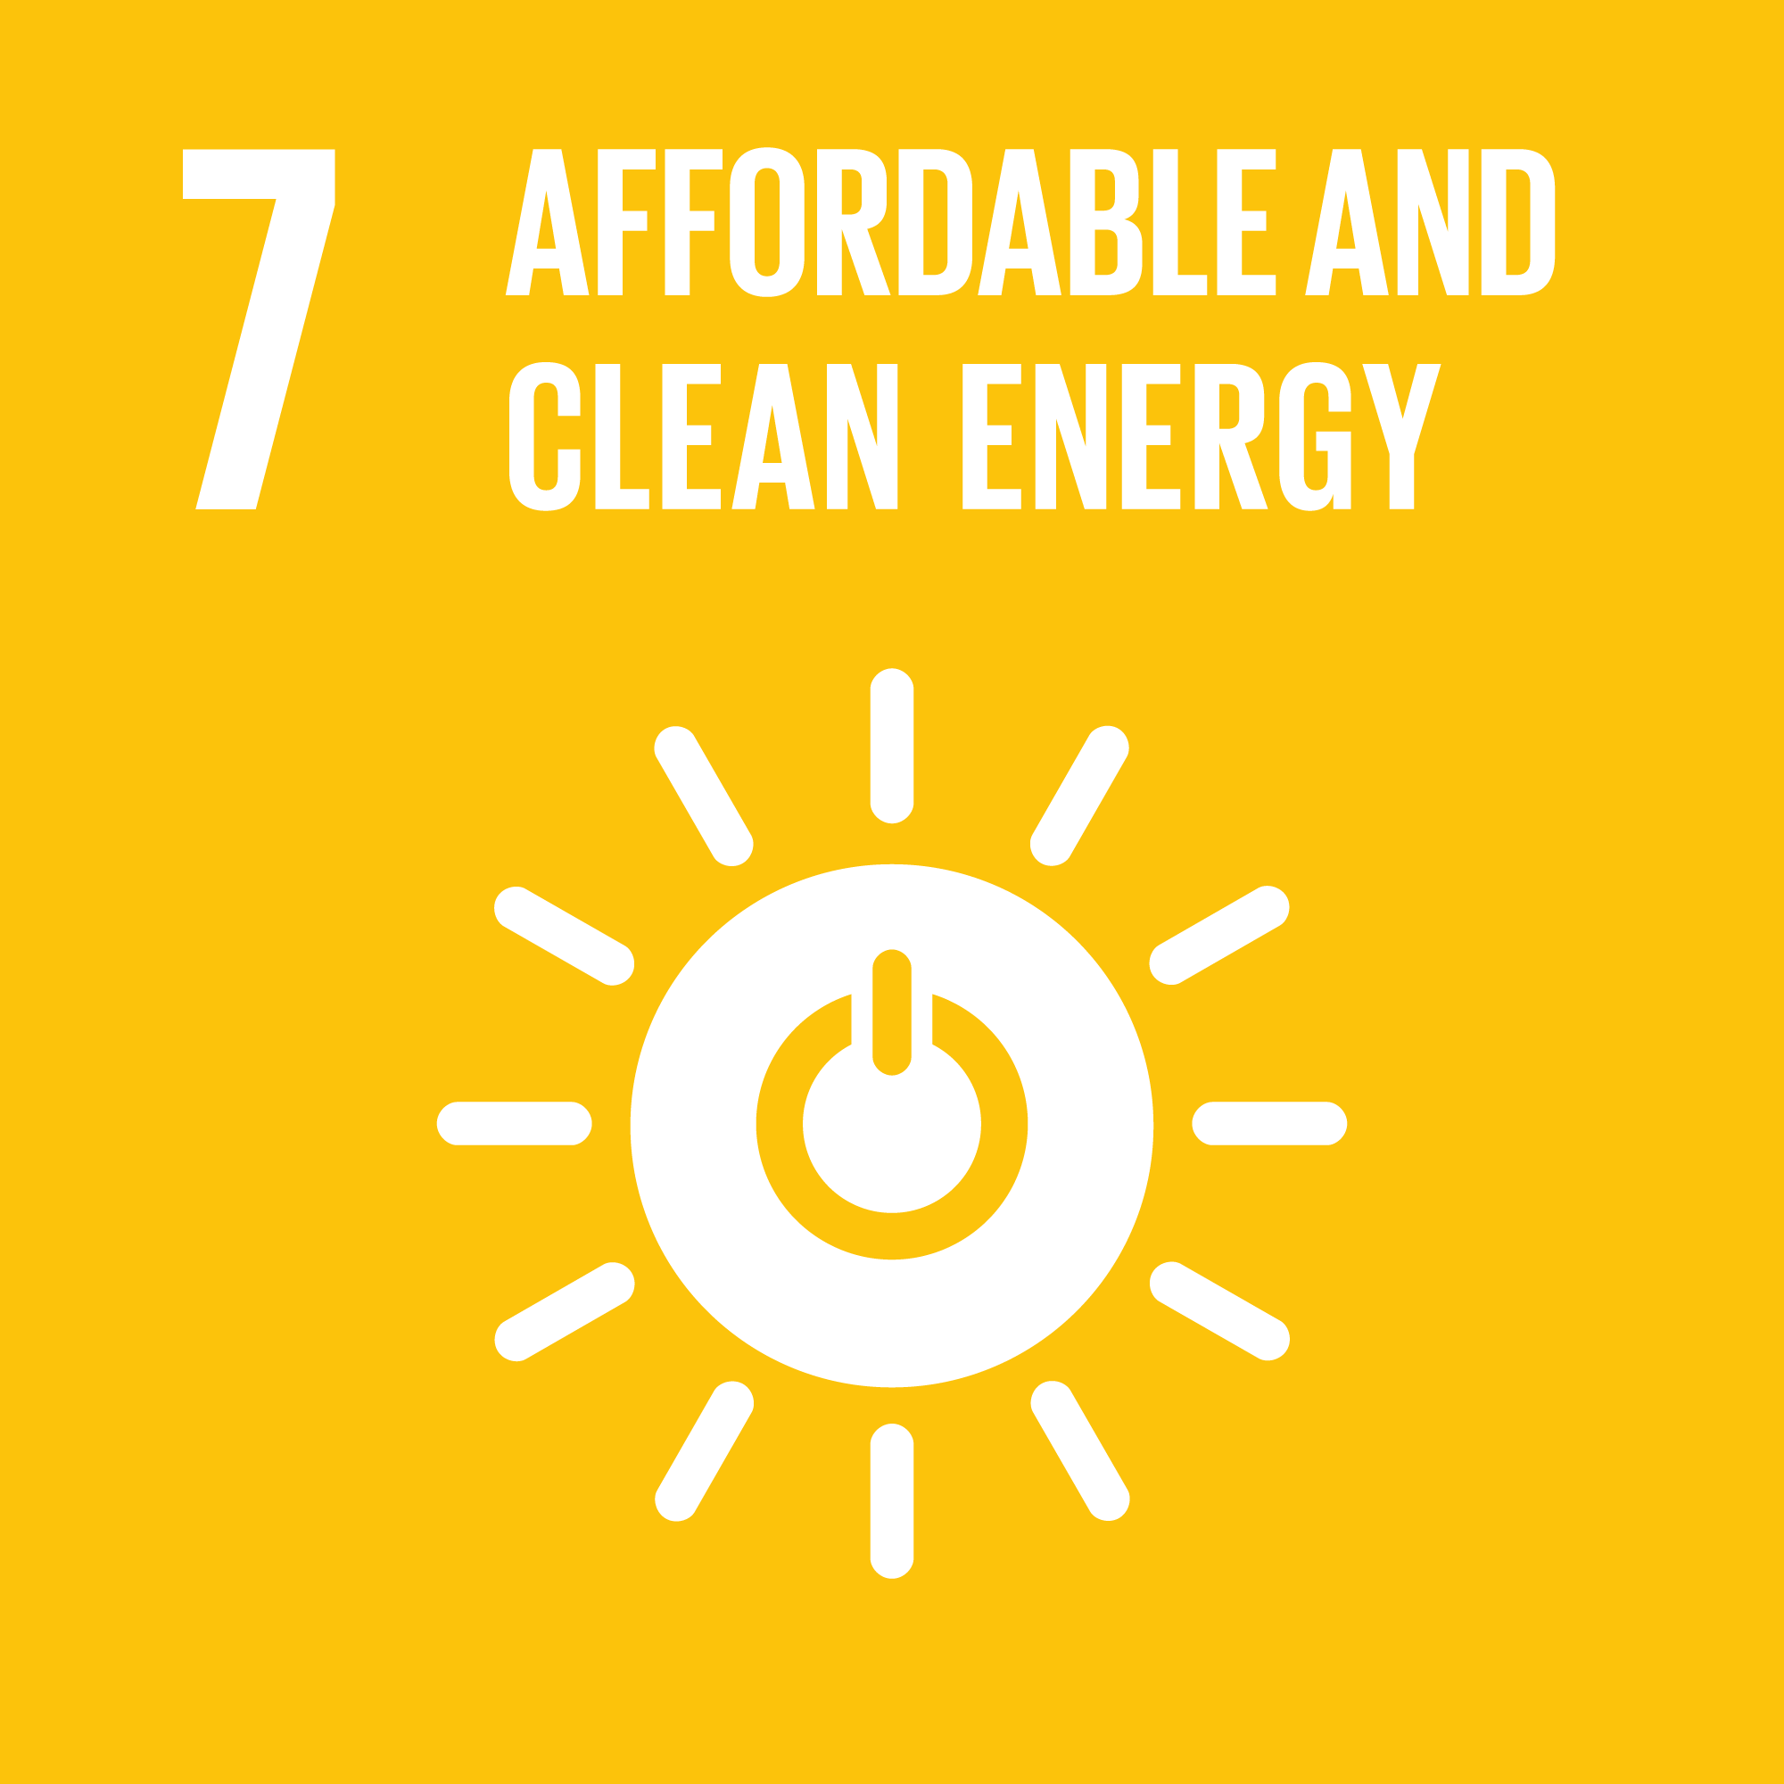
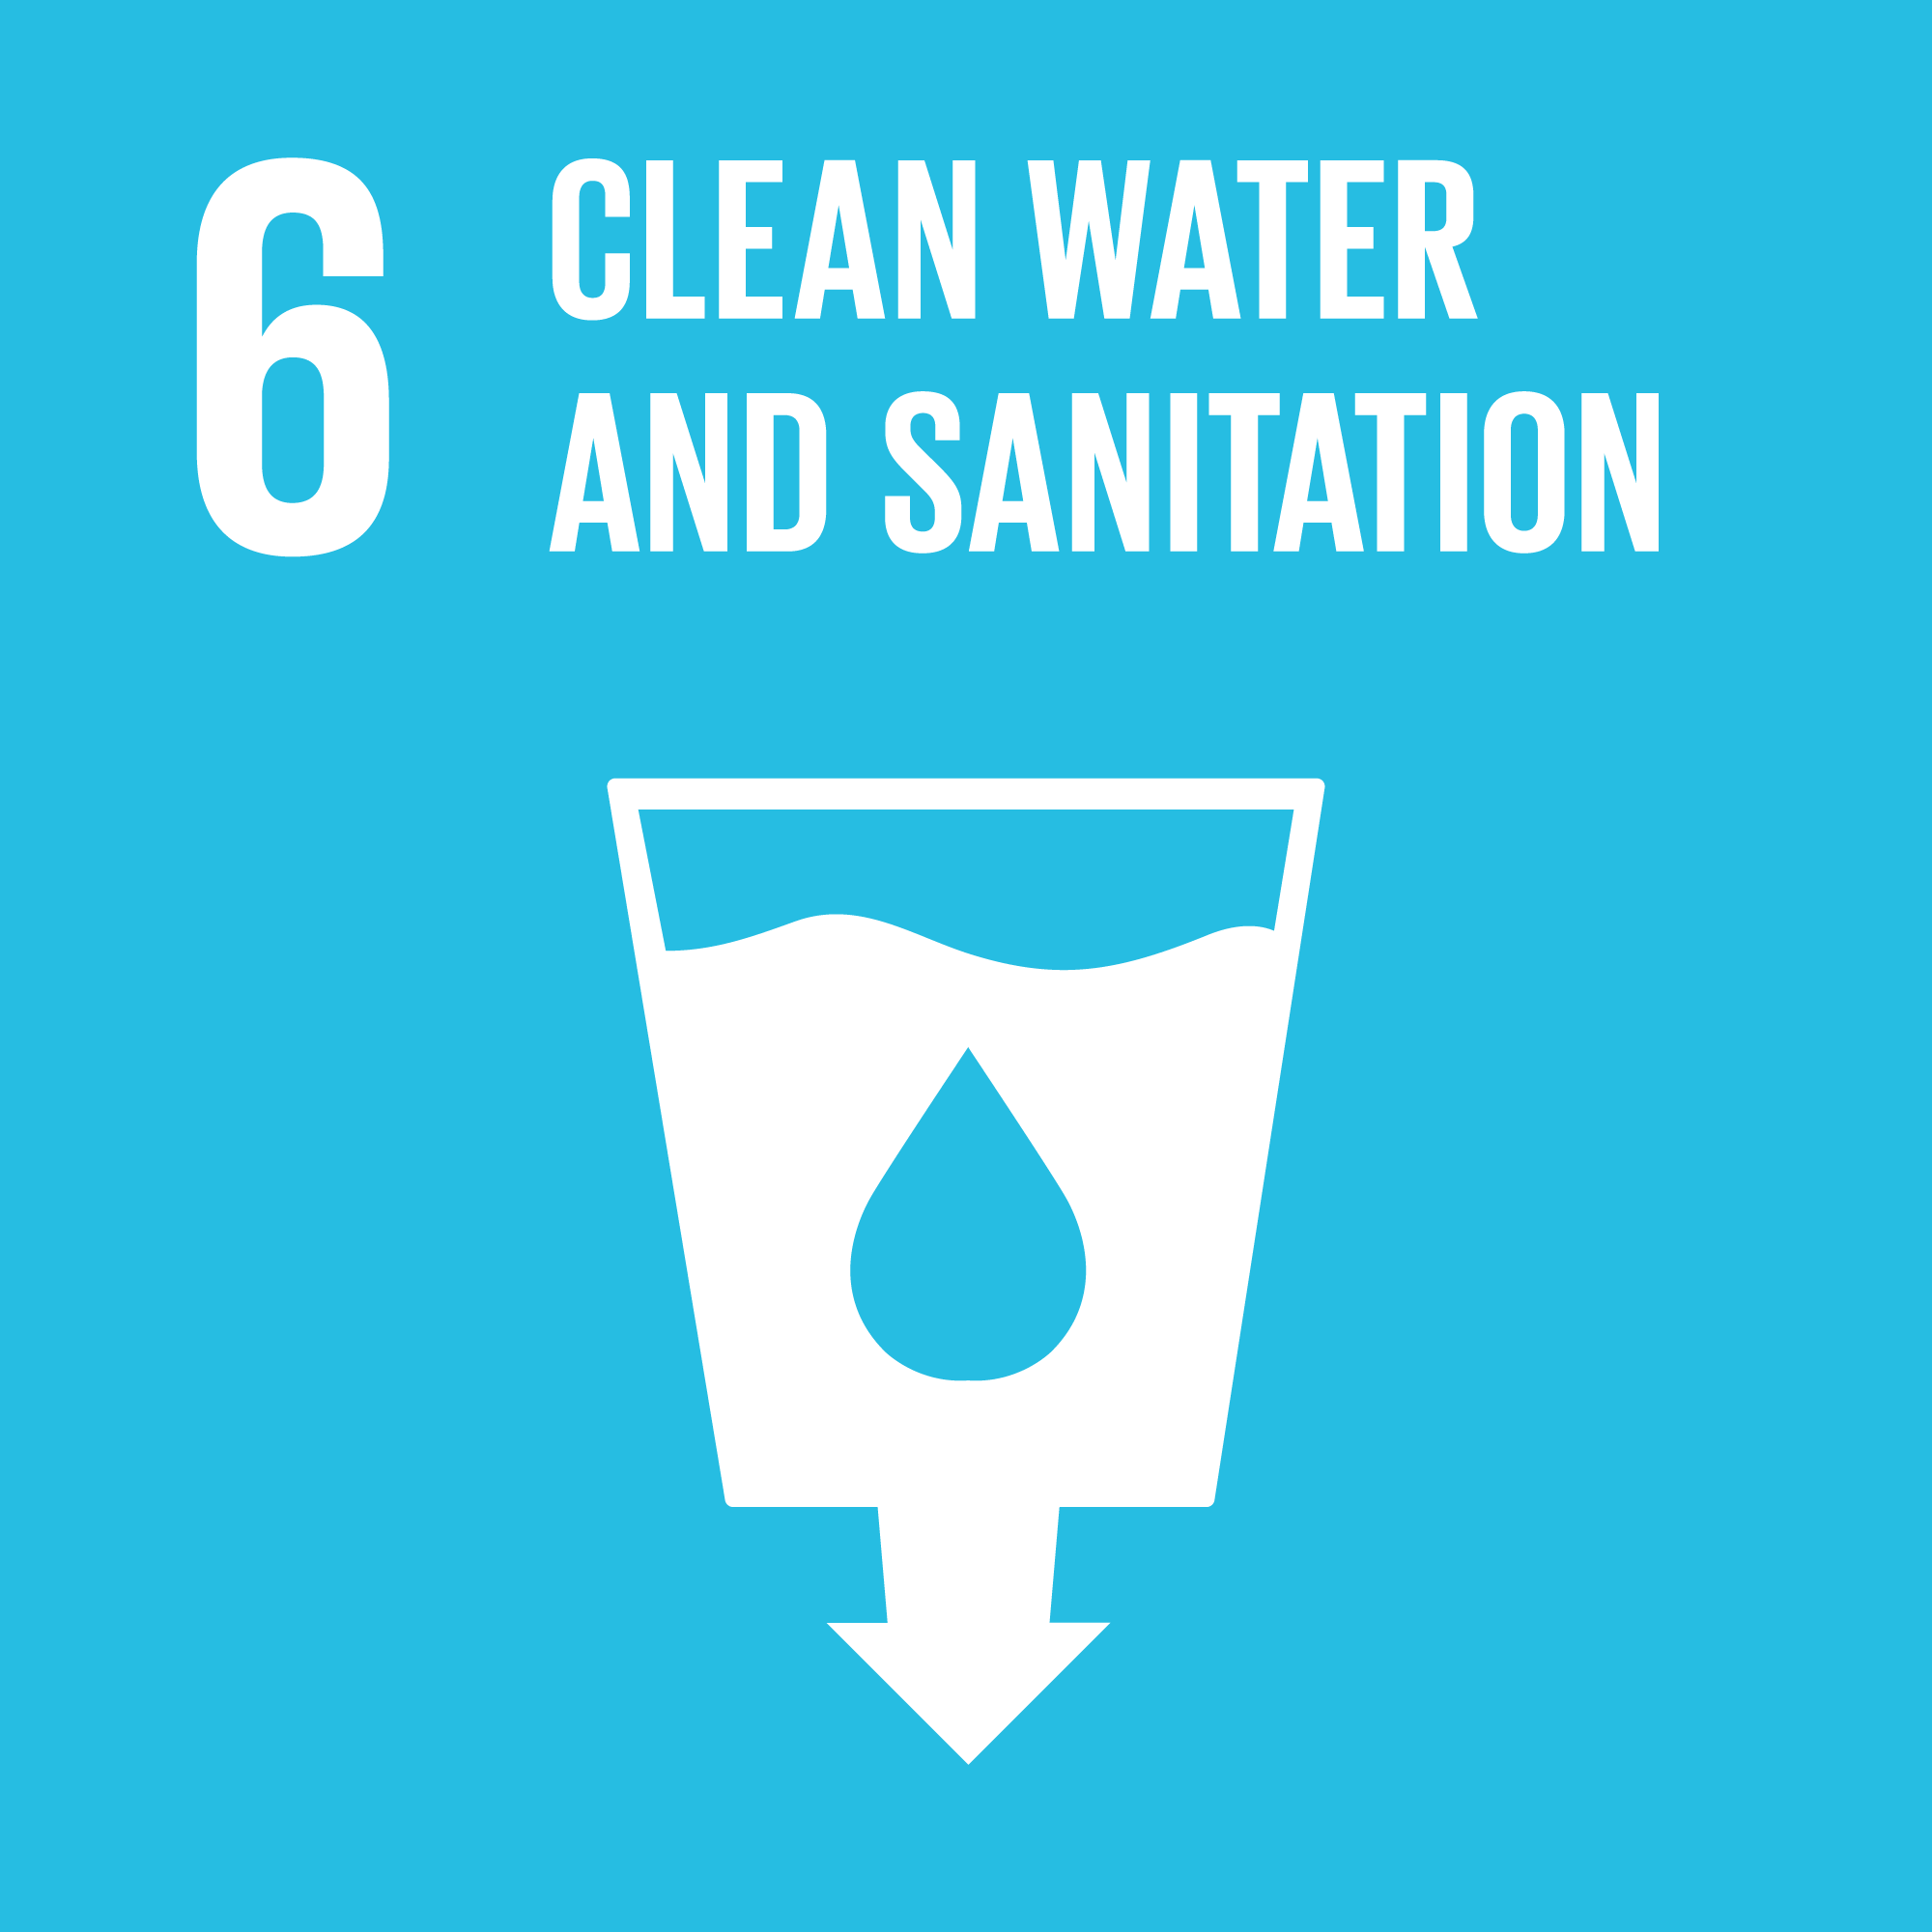
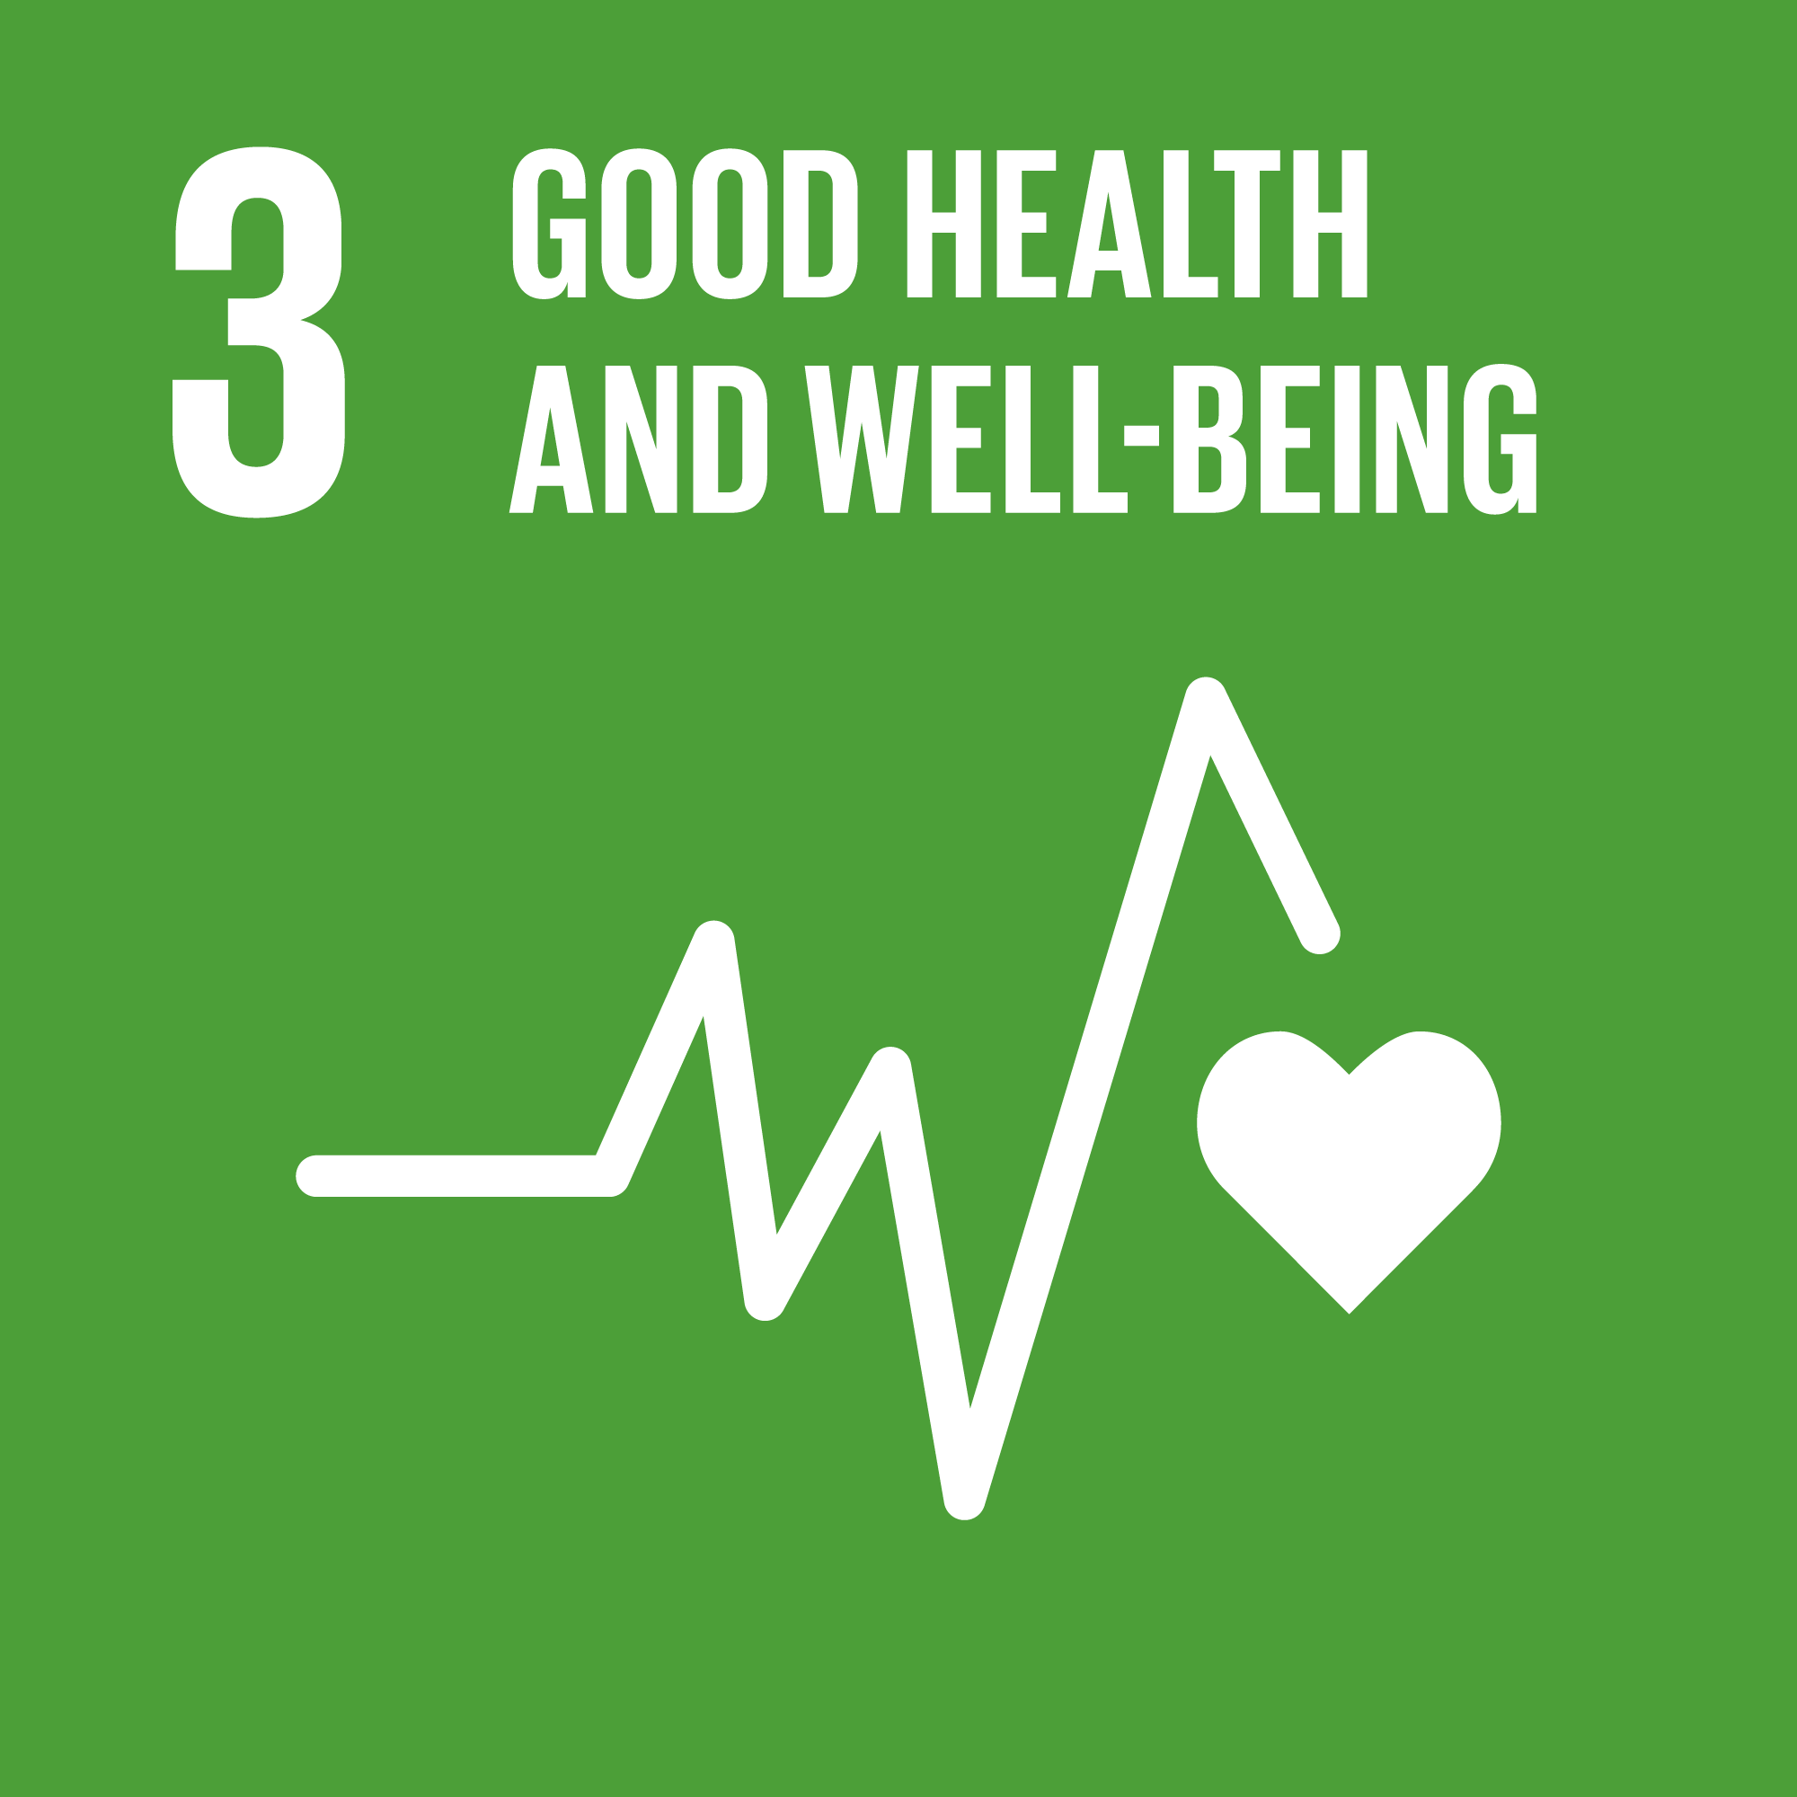
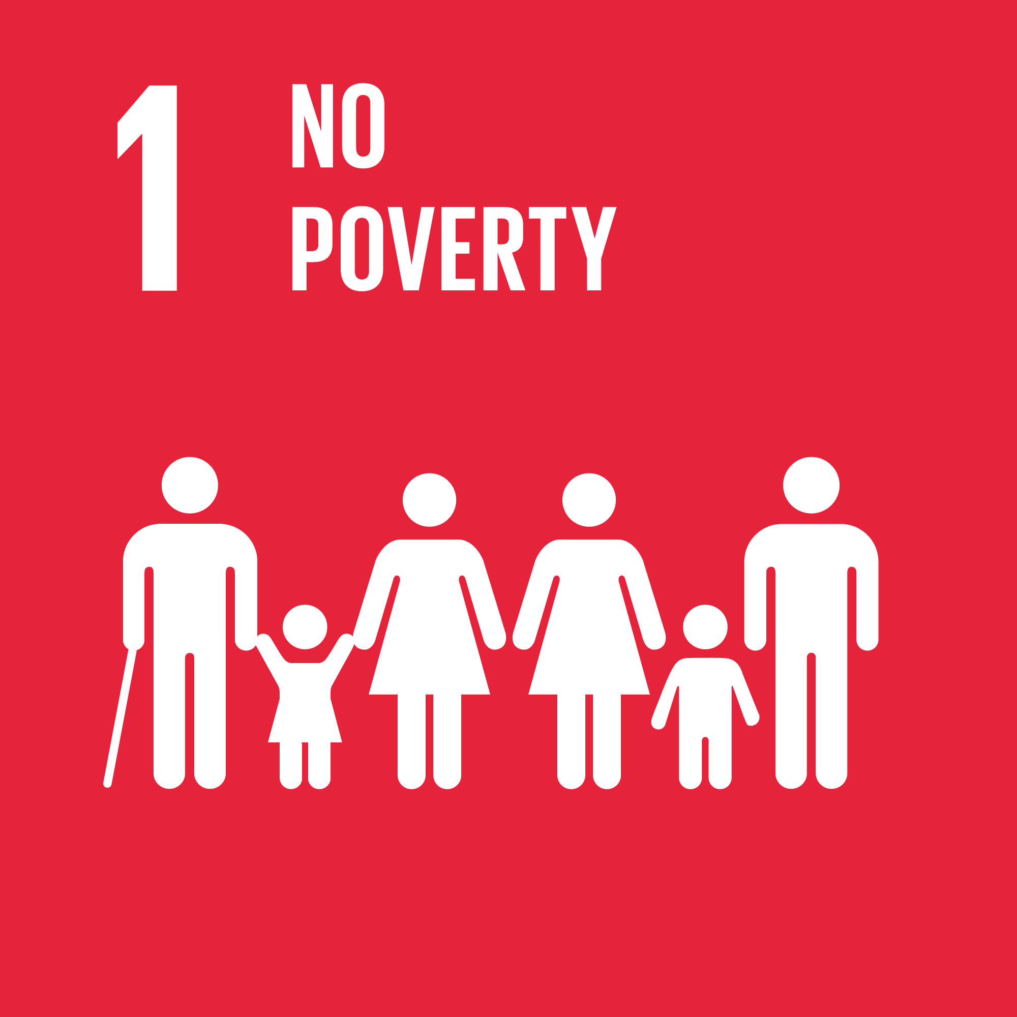
B. Impact of the conflict and COVID-19 on the population in the conflict zone

1. Freedom of movement in the context of COVID-19
37. During the reporting period, freedom of movement across the contact line remained severely restricted, mostly due to restrictions imposed by self-proclaimed ‘republics’, especially in Donetsk region. The number of monthly crossings (59,000 on average per month) remained 95 per cent lower compared to the same (pre-pandemic) period of 2019 (1.1 million crossings on average per month).
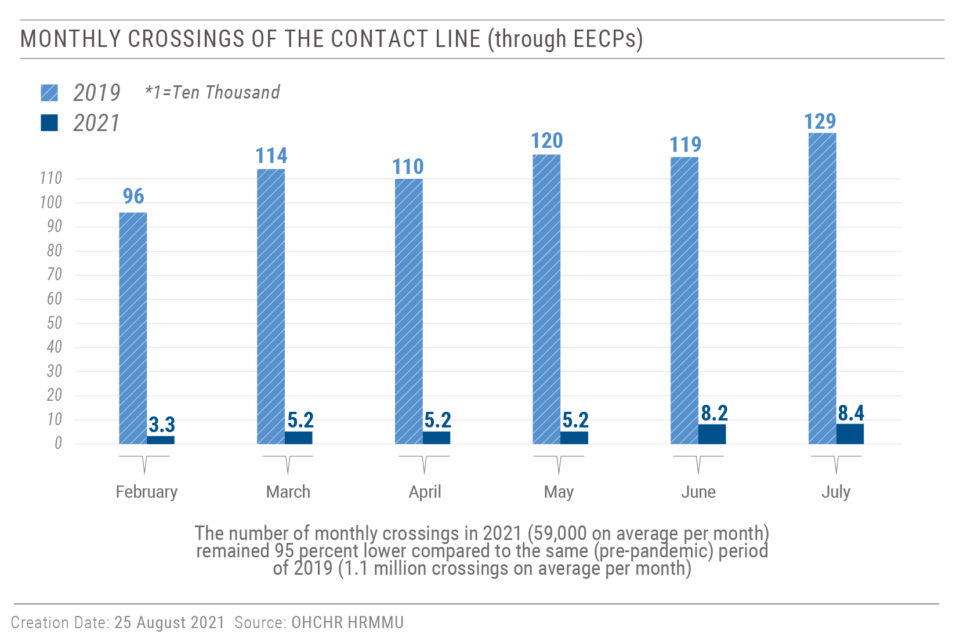
38. The Government continued to keep open all seven entry-exit crossing points (EECPs), including two additional EECPs in Shchastia and Zolote (both in Luhansk region). Since 17 June 2021, following the improvement of the epidemiological situation in the country, the Government cancelled obligatory self-isolation for people crossing the contact line into Government-controlled territory, and, accordingly, the requirements to install the ‘At home’ self-isolation tracking phone application and to undergo a COVID-19 test. On 28 July 2021, the Cabinet of Ministers reintroduced the restrictions, which entered into force on 5 August 2021.
39. Self-proclaimed ‘republics’, however, only allowed civilians to cross at two out of the five previously functioning EECPs, where they applied severe restrictions. Stanytsia Luhanska, a pedestrian crossing, remained the only functional EECP in the Luhansk region. Crossing from Government-controlled territory to territory controlled by ‘Luhansk people’s republic’ was allowed only to those with residence registered in the latter territory or to those on pre-approved lists and only once every 30 days. Novotroitske EECP remained the only EECP open for individuals who cross the contact line in the Donetsk region, however the side controlled by armed groups was only open two days a week and only to civilians registered in territory they control, or on pre-approved lists.
40. OHCHR welcomes the cancellation on 25 June 2021 of the obligation on children aged older than 14 to possess a ‘passport’ of ‘Donetsk people’s republic’ to cross from territory controlled by ‘Donetsk people’s republic’ to Government-controlled territory. This requirement, in place since 1 January 2021, negatively affected access to education, as many children who wanted to study in Government-controlled territory only had birth certificates.
41. Due to the restrictions on freedom of movement across the contact line, many residents of territory controlled by self-proclaimed ‘republics’ travelled up to 1,000 km for over 30 hours, to reach Government-controlled territory through the Russian Federation. They faced difficult crossing conditions, due to the lack of basic facilities, such as designated waiting areas, benches, cover from the sun and other weather conditions, insufficient number of toilets, and lack of drinking water, in some cases, having to spend up to 13 hours queuing. In addition, travelling this route, rather than passing through an official EECP, constituted a violation of Article 204.2 of the Code of Administrative Offences of Ukraine. Over the reporting period, Ukrainian Border Guards fined thousands of civilians an average of UAH 1,700 (approx. $60) each for violating Article 204.2.
42. As the number of civilians crossing through Milove BCP increased (27,665 average monthly crossings in July-December 2020, starting with 6,629 crossings in July and reaching 44,634 in December 2020; compared with 46,313 average monthly crossings in January-July 2021), the number of violations of Article 204.2 also increased (representing a 136 per cent increase from 3,651 violations in 2019 to 8,643 in 2020; and a further increase by 206 per cent with 17,891 violations during the half of 2021 comparing to the whole 2020), indicating that the majority of individuals (at least 77 per cent) come from armed group-controlled territory.
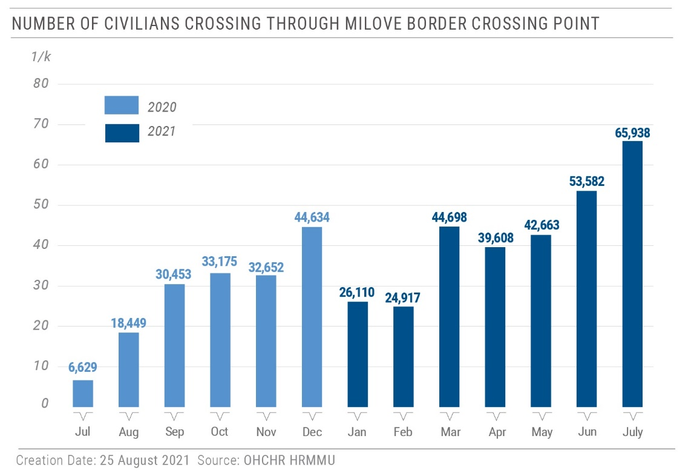
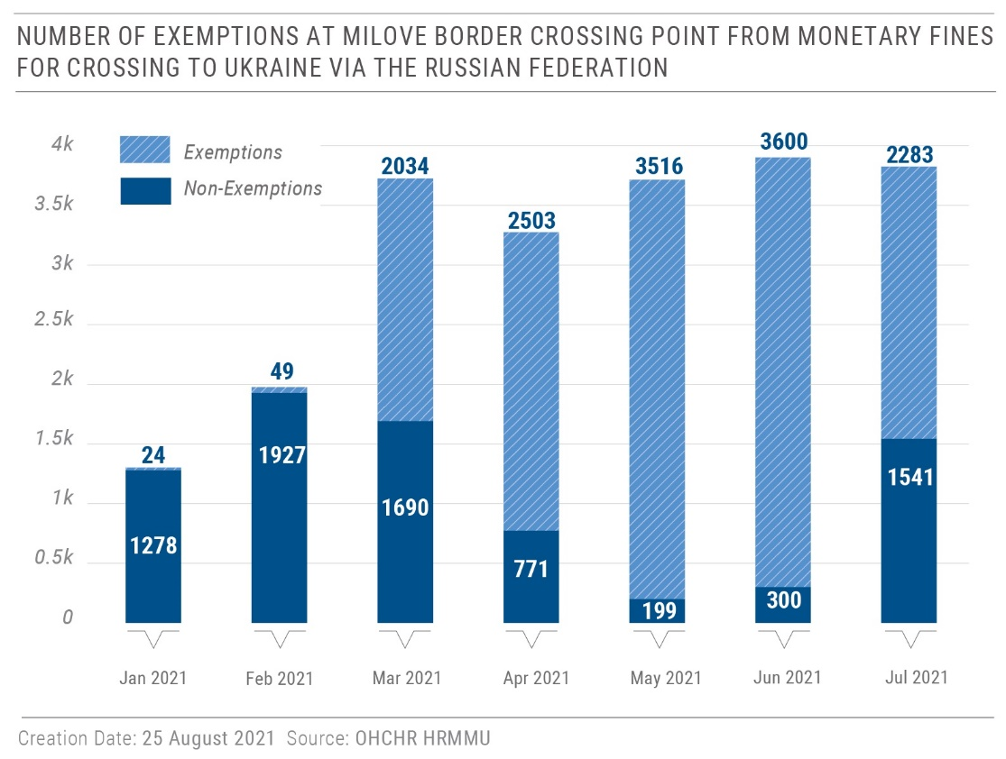
43. After advocacy efforts by OHCHR and other international and national organizations, Ukrainian Border Guards increased the number of exemptions from monetary fines by applying article 22 of the Code of Administrative Offenses (“insignificance of the violation”).
Further to this, a law that releases civilians crossing on humanitarian grounds from administrative responsibility when EECPs are only partially functional, was adopted by Parliament on 29 June 2021. OHCHR welcomes this development, and the President’s signature of the law on 22 July 2021, which came into force the following day.
2. Enjoyment of socio-economic rights by communities along the contact line
“We do not really live – we just exist here.”
- A man in his 60s from a settlement near the contact line

44. During the reporting period, OHCHR conducted 63 visits to settlements along the contact line. Residents described psychological distress caused by increased hostilities after a prolonged period of calm due to the strengthened ceasefire agreement in July 2020. The residents also complained about the infringement of their rights to an adequate standard of living, water and sanitation, healthcare and freedom of movement, and about not being able to receive or travel to see family members due to COVID-19 restrictions and military checkpoints.
45. Residents of Government-controlled Novooleksandrivka village (Luhansk region), informed OHCHR about consistent shelling that has led to civilian casualties and damage to their houses. The residents must walk three kilometres through potentially mined unpaved paths and fields to access pensions, food, transport and government services in the nearby town of Popasna. The police, ambulances, and local administration do not visit the village due to safety concerns, the military’s ban on vehicle movements, and lack of paved roads. Furthermore, village residents have not had access to electricity since 2014 and rely on humanitarian organizations to obtain coal or wood for heating during the winters. OHCHR highlights that the lack of access to basic services may amount to a violation of the right to an adequate standard of living. In a positive development, on 16 April 2021, electricity was finally restored to Opytne village (Donetsk region) after five years.
46. Residents of the outskirts of armed group-controlled Horlivka (Donetsk region), comprised mostly of older people, informed OHCHR about persistent shelling causing civilian casualties and damage to their houses, as well as lack of public transport or access to ambulance services.
3. Housing, land and property rights
Compensation for destroyed housing
47. OHCHR continued to monitor implementation of Cabinet of Ministers Resolution No. 947 establishing a compensatory mechanism for civilians whose housing in Government-controlled territory have been destroyed by hostilities. OHCHR welcomes this positive development but notes that although the relevant update to the resolution took effect on 2 September 2020, the majority of affected individuals have not yet received any compensation. As of 30 June 2021, only 193 owners received approval for compensation while around 50,000 houses have been damaged since the outbreak of the conflict. The majority of affected people are still excluded from the process due to their lack of ownership documents, lack of awareness of the availability of compensation, the cumbersome procedure, difficulties carrying out the required official assessments, and the requirement for prospective beneficiaries to waive their property rights before a decision on compensation can be taken.
48. OHCHR stresses the need for a comprehensive compensation mechanism that covers all civilians whose property has been damaged or destroyed due to the conflict. In this context, OHCHR is following the lengthy work on draft laws No. 5177 and 5177-1 that are pending consideration in the Parliamentary Committee on Legal Policy. Adoption of these laws would be a significant step forward in establishing a comprehensive compensation mechanism that should include all civilians who have been left out of the compensation process.
Expropriation of property in territory controlled by ‘Donetsk people’s republic’
49. OHCHR is concerned by the possible violation of the right to adequate housing of internally displaced persons (IDPs) and residents of territory controlled by ‘Donetsk people’s republic’. On 28 April 2021, a regulation was adopted that allows for the expropriation of immovable private property considered abandoned or left unclaimed following the owner’s death. OHCHR is following its implementation, as it not only risks infringement upon housing rights of IDPs, but may also endanger future restitution and create additional constraints for the return and reintegration of IDPs. Moreover, IDPs living in Government-controlled territory may be disproportionally affected, as, due to COVID-19-related restrictions on freedom of movement, they cannot access their property or take the actions necessary to secure their property rights.
4. Right to social security
50. OHCHR regrets that the Government did not create a mechanism to pay pensions for persons residing in armed group-controlled territory and continues to link the payment of pensions to IDP registration, thus depriving individuals of their pension if they cannot repeatedly cross the contact line in order to confirm their IDP registration. OHCHR welcomes the Government’s temporary suspension of the requirement to confirm IDP registration during the COVID-19 quarantine, and extension of the validity of Oshchadbank IDP bank cards to 31 August 2021. OHCHR also supports the Government’s declared plans to introduce remote identification of pension recipients in armed-group controlled territory. Regrettably, these measures only temporarily relieve thousands of pensioners, mostly older women, from the hardship and health risks caused by crossing the contact line, as remote identification is not yet available and the general policy regarding pensions remains unchanged.
51. For example, a 70-year-old woman residing in armed group-controlled Horlivka (Donetsk region) cannot access her pension, as her advanced age precludes her from making the journey across the contact line to Government-controlled territory in order to register as an IDP. Although she receives about RUB 5,000 (approx. $68) of ‘social support’ from ‘authorities’ of ‘Donetsk people’s republic’, this is not enough to cover food, healthcare, and utilities. As such, she was taken to ‘court’ by her utility provider and ordered to pay the outstanding bills, to the amount of RUB 10,000 (approx. $136), and now fears she may lose her apartment due to unpaid debts.
5. Transitional justice
52. OHCHR notes the elaboration, by the Ministry for Reintegration of the Temporarily Occupied Territories of Ukraine, of a draft framework law on the State policy on the de-occupation and reintegration of armed-group controlled territories and Crimea. OHCHR is concerned because the draft law is, inter alia, built around a definition of transitional justice that is not in line with international standards and does not ensure a victim-centred approach.
6. Discrimination on the basis of nationality in territory controlled by self-proclaimed ‘Luhansk people’s republic’
53. OHCHR is concerned by allegations that workers in territory controlled by ‘Luhansk people’s republic’ have been threatened by ‘authorities’ of ‘Luhansk people’s republic’ with dismissals or salary reductions if they do not obtain Russian citizenship. This differential treatment on the basis of the nationality of the individuals concerned does not seem to pursue any legitimate justification. To the contrary, it appears motivated to coerce Ukrainian nationals to obtain Russian citizenship. It would therefore be contrary to the prohibition on discrimination in international human rights law.
IV. Right to liberty and security of persons
“We will plant a grenade and an ‘LPR’ flag on your son if you don’t cooperate.”
– SBU officer to a female detainee

- Access to places of detention

54. OHCHR continued to enjoy unimpeded access to official places of detention in Government-controlled territory, allowing for confidential interviews with detainees. During the reporting period, OHCHR interviewed 28 detainees and prisoners (25 men and three women) in detention facilities in Bakhmut, Dnipro, Kharkiv, Odesa, Mariupol, Starobilsk, and Zaporizhzhia.
55. By contrast, in territory controlled by self-proclaimed ‘republics’, OHCHR continued to have no access to detainees and places of deprivation of liberty despite repeated requests. This was particularly concerning given the widespread and credible allegations of torture and ill-treatment in a number of facilities, and of detention conditions that do not meet international human rights standards.
- Arbitrary detention and ill-treatment
56. OHCHR documented three cases of individuals believed to be linked or affiliated with self-proclaimed ‘republics’ detained by law enforcement officials in violation of international standards. OHCHR documented a case where a man was kicked in his ribs by several SBU officers wearing masks while he was lying face down on the ground. He was taken to a minibus with his hands handcuffed behind his back. He told OHCHR that the SBU officers pressed his fingerprints onto grenades and fuses. In another case, a woman was threatened that if she did not cooperate immediately, the SBU would plant incriminating materials on her son.
57. During the reporting period, OHCHR documented 13 cases of conflict-related arbitrary detention in territory controlled by self-proclaimed ‘republics’. One case occurred in 2014, one in 2017, six in 2020 and five from February to July 2021. Six men and four women were detained in territory controlled by ‘Donetsk people’s republic’ and three men were detained in territory controlled by ‘Luhansk people’s republic’. The detention was usually carried out by ‘ministry of state security’ (‘mgb’) officers.
58. In one case, on 29 April 2021, a woman was arbitrary detained by ‘mgb’ officers in Khrestivka (formerly Kirovske) and held incommunicado for 22 days at a temporary detention facility (ITT) in Shakhtarsk. On 21 May 2021, she was told that she would be sent to Government-controlled territory and banned from entering territory controlled by ‘Donetsk people’s republic’ for five years. When she asked for written confirmation of the decision, the ‘mgb’ officer told her that she would not receive anything as she had no rights. Before she was forced to cross to Government-controlled territory, she was threatened with further arrest and detention if she attempted to return.
59. In another case, on 14 May 2021, a pregnant woman was arbitrary detained by ‘mgb’ officers of ‘Donetsk people’s republic’ when crossing from the Russian Federation to territory controlled by ‘Donetsk people’s republic’ via the "Marynovka" crossing point. She was held at the crossing point for four hours, and then taken to 'mgb' premises at 26 Shevchenko Boulevard in Donetsk. She was accused of espionage. A few days later, she was transferred to the ITT in Donetsk. In June, she was transferred to the Donetsk SIZO, where she continues to be detained.
60. On 11 June 2020, a Jordanian citizen was arbitrary detained by ‘mgb’ officers in Donetsk. He was accused of espionage and held at the ‘mgb’ pre-trial detention facility in penal colony No. 97 in Makiivka. His relatives have not been able to communicate with him since his detention began. They hired a lawyer who promised to help obtain his release, but after being paid by the family, he stopped responding to their phone calls.
- Situation in Oleksiivska penal colony No 25
61. OHCHR continued to monitor the situation at Oleksiivska penal colony No. 25 in Kharkiv. OHCHR received reports that prisoners who complained of torture faced retaliation. At least two prisoners were placed in solitary confinement for alleged violations of internal prison rules and told to withdraw their statements and reject their lawyers’ services. The investigation into their complaints by the State Bureau of Investigations (SBI) is ongoing. No one has yet been charged.
62. One prisoner informed OHCHR that he was pressured by the prison administration and an investigator from the SBI to refuse the services of his lawyer in writing. Additionally, the prisoner claimed that no forensic medical examination was performed on him 17 months after him complaining of torture.
63. In addition, a female lawyer who represented a different prisoner told OHCHR that the prison administration strongly suggested she reconsider visiting the penal colony because of her pregnancy at the time, which she considered as a veiled threat to drop her client. She eventually received a signed statement from her client, refusing her services.
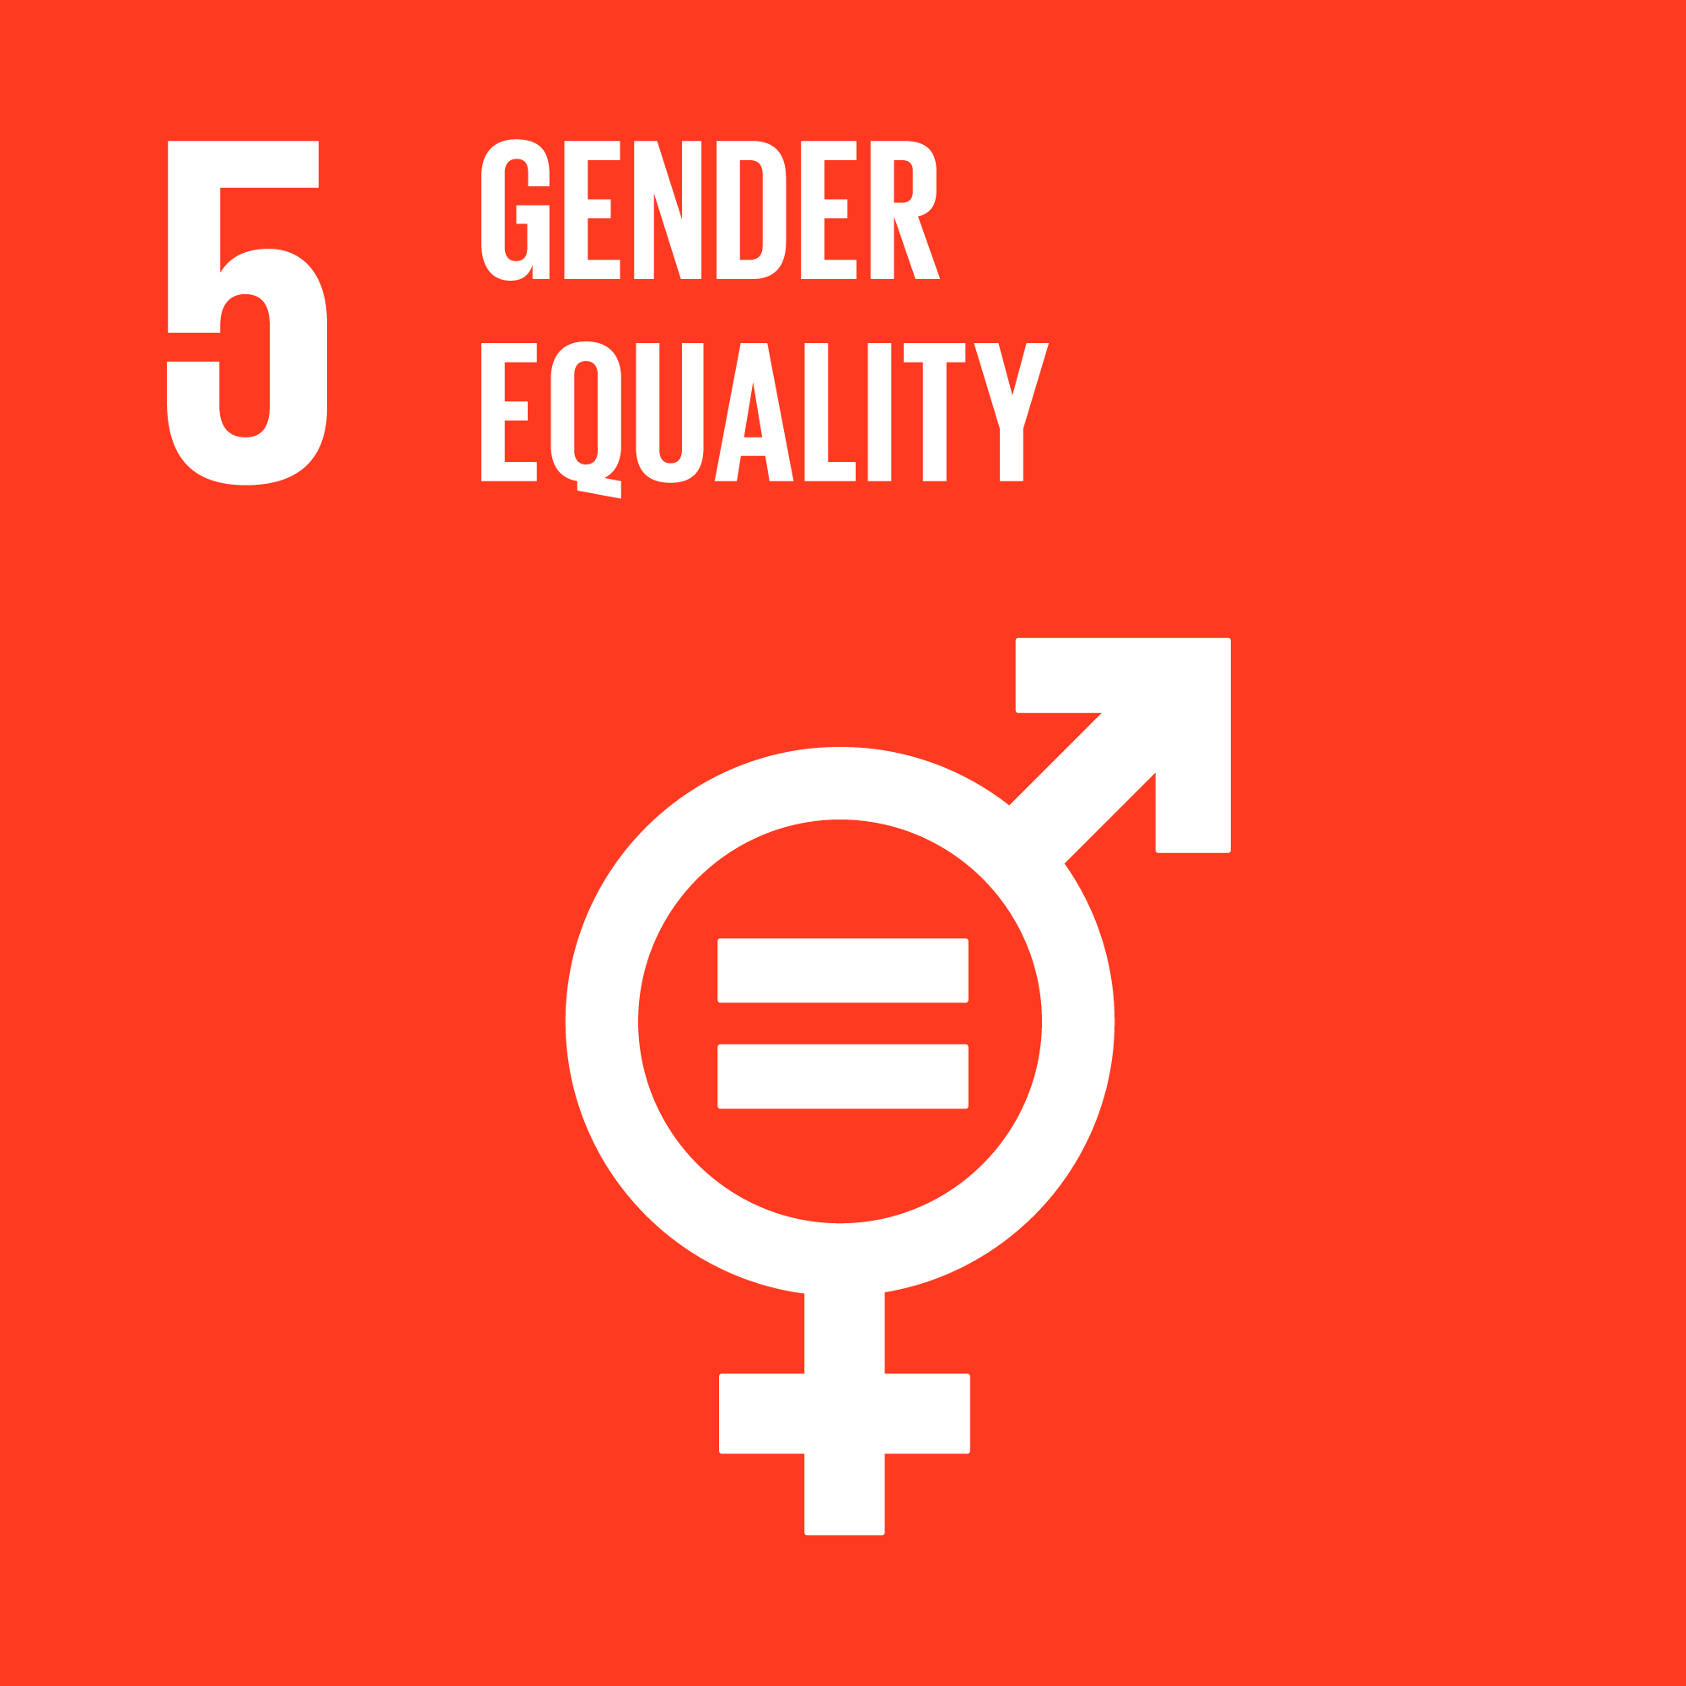
- Gender-based violence
64. During the reporting period, OHCHR monitored domestic violence in territory controlled by self-proclaimed ‘republics’ and found that women lacked adequate support and resources to protect themselves and their children from abusive family situations. Several women’s rights groups stated that support for domestic violence victims has declined since the beginning of the armed conflict in 2014.
65. In cases where victims were not seriously harmed, perpetrators were fined or placed on a domestic violence registry. However, no protection was provided to the survivors, who were predominantly women.
66. Very few women’s rights activists could continue to operate in the territory due to restrictions on independent activism. Those who continued to advocate for women’s rights did so at a risk to their own safety. In addition, several activists told OHCHR that they struggled to sustain services due to lack of funding and support. Further, the self-proclaimed ‘republics’ do not allow funding from international organizations to finance services or shelters for domestic violence survivors in territory they control. At least one activist was threatened with detention if she accepted such funding.
67. According to women’s rights activists, there is a severe shortage of shelters for victims of domestic violence in the territory, and no service centres or shelters in rural areas. OHCHR interviewed a women’s rights activist who was forced to shut down the shelter she had been running and move her organization after the armed conflict had started due to lack of funding and restrictions imposed on providing services to domestic violence survivors.
V. Administration of justice and accountability
“I would not have ended up there if not for my life circumstances [poverty].”
– An older woman being tried for participating in the ‘election commission’ during the 2014 ‘referendum’ on the status of territory controlled by armed groups.

- Administration of justice
68. OHCHR continued to document fair trial rights concerns in conflict-related criminal cases. The infographic below provides an overview of findings in relation to 167 verdicts in these cases. In 97 out of 167 cases, individuals were prosecuted for participation in so-called ‘referendums’ or ‘elections’ in territory controlled by self-proclaimed ‘republics’. Eighty-one per cent were women, many of whom joined the commissions administering these processes due to their dire financial situation and because they had previous experience in electoral administration. OHCHR notes that in almost all such cases, the defendants were not placed in detention, and received suspended sentences upon entering plea bargains or confessing their guilt. Leniency by prosecutors and courts towards such individuals is a positive development for fostering reconciliation.
69. The SBU and other law enforcement agencies continued to conduct arrests in conflict-related criminal cases without a court issued warrant and in violation of the in flagrante procedure as provided for by national law. During the reporting period, OHCHR documented nine such cases where individuals were arrested for crimes alleged to be committed in 2014-2016, based on an unduly wide interpretation of what constitutes a “continuous” crime. Further, in at least three cases, the unlawful arrests were followed by denial of prompt access to legal aid.
70. On 27 April 2021, Parliament amended the Criminal Procedure Code, removing the requirement to issue an Interpol Red Notice for suspects or defendants of in absentia investigations and trials, thus removing a major legislative impediment to such proceedings. OHCHR regrets that the law, as adopted, did not incorporate its recommendation to allow for a full retrial in such cases. The possibility of retrial, including after the verdict has been delivered, is required under international law in order to protect the right to be present during one’s trial.
71. Of concern, OHCHR found that in at least 19 cases, judges authorized in absentia investigations and trials without confirmation that the defendants or suspects had been informed or were aware of their criminal prosecution.
72. OHCHR commends the adoption on 20 May 2021 of a law harmonising domestic criminal law with international criminal law, which significantly expands the definitions of international crimes in line with the Rome Statute of the International Criminal Court and which paves the way to bringing perpetrators to account for international crimes. However, OHCHR is concerned that, as of 31 July 2021, the law had not yet been signed by the President.
B. Accountability for human rights violations
1. Accountability for grave human rights violations perpetrated in the context of armed conflict
73. On 1 July 2021, a local court in the Donetsk region sentenced an SBU officer to 12 years in prison for abducting and beating to death a civilian from Avdiivka, a town located in conflict-affected eastern Ukraine, in March 2017. OHCHR commends the Government’s efforts to prosecute conflict-related human rights violations regardless of the affiliation of alleged perpetrators. OHCHR notes, however, that although the pre-trial investigation was finished within eight months, the trial lasted three years and eight months, and saw major delays due to multiple referrals between local courts. Further, for almost the entire duration of the trial, the defendant continued to serve as an active SBU officer and was even promoted.
2. Accountability for killings and violent deaths during the Maidan protests and 2 May 2014 violence in Odesa
74. During the reporting period, investigations and prosecutions of killings and violent death during the Maidan protests and 2 May 2014 violence in Odesa progressed, in part due to the adoption of the 27 April 2021 amendments to the Criminal Procedure Code, which unblocked in absentia prosecution of some fugitives. During the reporting period, courts allowed for in absentia investigations against 12 individuals prosecuted in relation to killings during the Maidan protests and for in an in absentia trial against three former Berkut service members who were transferred to territory controlled by self-proclaimed ‘republics’ on 29 December 2019 as part of the simultaneous release of detainees.
75. OHCHR noted substantial progress in the prosecution of members of a ‘titushky’ group for the abduction and torture of two protesters, and the killing one of them, which was achieved after the case was transferred to the SBI. The SBI notified two men of suspicion for the abduction of the protesters and during the reporting period, sent a criminal case against one of them to trial. In addition, indictments against two individuals accused of abduction and torturing the protesters and killing one of them were referred for an in absentia trial. On 16 April 2021, a court in the Kyiv region sentenced the leader of the ‘titushky’ group to nine years in prison for abduction and torture, but acquitted him of charges of creating a criminal organization and murder.
76. During the reporting period, the SBI progressed in their investigation of the misconduct of two police officers on 2 May 2014 in Odesa. However, the absence of any tangible progress in all the other investigations and trials in relation to the killings and violent deaths on 2 May 2014 in Odesa is of concern.
C. Constitutional crisis and the rule of law
77. The constitutional crisis caused by the suspension, dismissal and criminal prosecution of two judges of the Constitutional Court, including the Chairperson of the Court, on 28 December 2020 continued to jeopardise the independence of the judiciary and rule of law in the country. On 27 March 2021, the President of Ukraine adopted Decree No.124/2021, which dismissed the judges by revoking his predecessor’s decrees regarding their appointments.
78. Both judges challenged the decree in the Supreme Court. On 14 July 2021, the Administrative Cassation Court of the Supreme Court found unlawful and annulled the decree, stating the President did not have the power to dismiss the judges, and that the previous decrees on the appointment of the judges could not be annulled as they had already been implemented. The Office of the President reported that they would appeal the judgement in the Grand Chamber of the Supreme Court. Of further concern, on 15 July 2021, the SBI opened criminal proceedings for abuse of power against the Supreme Court judges who rendered the judgement. OHCHR reiterates its call to resolve the situation in full compliance with constitutional and criminal procedures, as well as international norms and standards, on the independence of the judiciary.
VI. Civic space and fundamental freedoms
79. During the reporting period, OHCHR documented 22 new attacks and cases of threats against journalists, media workers, human rights defenders (including two women human rights defenders), and members of the LGBTI community, as well as two cases of violence related to tensions between Orthodox religious communities, and 21 hate speech incidents (four incidents targeted women and six LGBTI people), the majority directed against Roma. OHCHR monitored 75 assemblies, the large majority of which were peaceful and sufficiently secured by law enforcement.
A. Freedom of peaceful assembly and association
80. OHCHR monitored 75 assemblies, including large events held on 8 March 2021 in support of gender equality and women’s rights; on 9 May 2021 commemorating the end of World War II; and the annual procession of the Ukrainian Orthodox Church held on 27 July 2021. OHCHR noted an increase in the number of assemblies held compared with the two previous reporting periods. In the vast majority of these events, law enforcement agencies provided adequate security measures, prevented violence and promptly responded to security incidents.
81. Large assemblies were held in support of defendants in several high-profile criminal cases. During one of these assemblies, on 20 March 2021, unknown perpetrators vandalized the outer walls of the building of the President’s Office. While the police apprehended individuals allegedly involved, in at least one case, investigators failed to provide credible evidence. Even though the individual was released from home arrest after three weeks, several interlocutors from the human rights community told OHCHR that this case has had a chilling effect on civil society due to the perception this was retaliation for voicing critical opinion.
82. Violent attacks against opposition political party Partiia Shariia have decreased since 2020, however members and party staff continued to receive threats online. OHCHR continued to follow the criminal cases opened against members and staff of Partiia Shariia, as well as Opposition Platform – For Life, another opposition political party; and opinion leaders who openly supported or otherwise promoted these parties. OHCHR is also following developments related to the Ministry of Justice’s challenge to the formal registration of Partiia Shariia in the Kyiv District Administrative Court. OHCHR monitored assemblies by party supporters following court hearings in these cases, and notes that despite threats of attacks by groups that promote violence, police sufficiently secured the assemblies.
83. OHCHR documented five cases of violent attacks, threats and acts of intimidation (including intentional damage to property) by unidentified individuals against four environmental human rights defenders (three men and one woman) in Kyiv, Kharkiv and Odesa, and two human rights defenders (one man and one woman) working on corruption issues in Dnipro and Rubyzhne. In one case, on 15 July 2021, two unidentified perpetrators brutally beat a woman human rights defender from Dnipro working on corruption issues, placing her in hospital. The victim had been investigating and reporting on illegal takeovers of real estate projects. Two individuals have been apprehended and are currently suspected of attempted murder.
84. In territory controlled by self-proclaimed ‘republics’, the atmosphere of fear and self-censorship continued to prevail, narrowing opportunities to freely express opinions during peaceful assemblies. Despite the existing risks, several assemblies critical of ‘authorities’ have been held, including protests by coal miners against salary delays and at least one rally by local residents against lack of water supply. However, OHCHR is not aware of assemblies being held on more sensitive topics, including political issues.
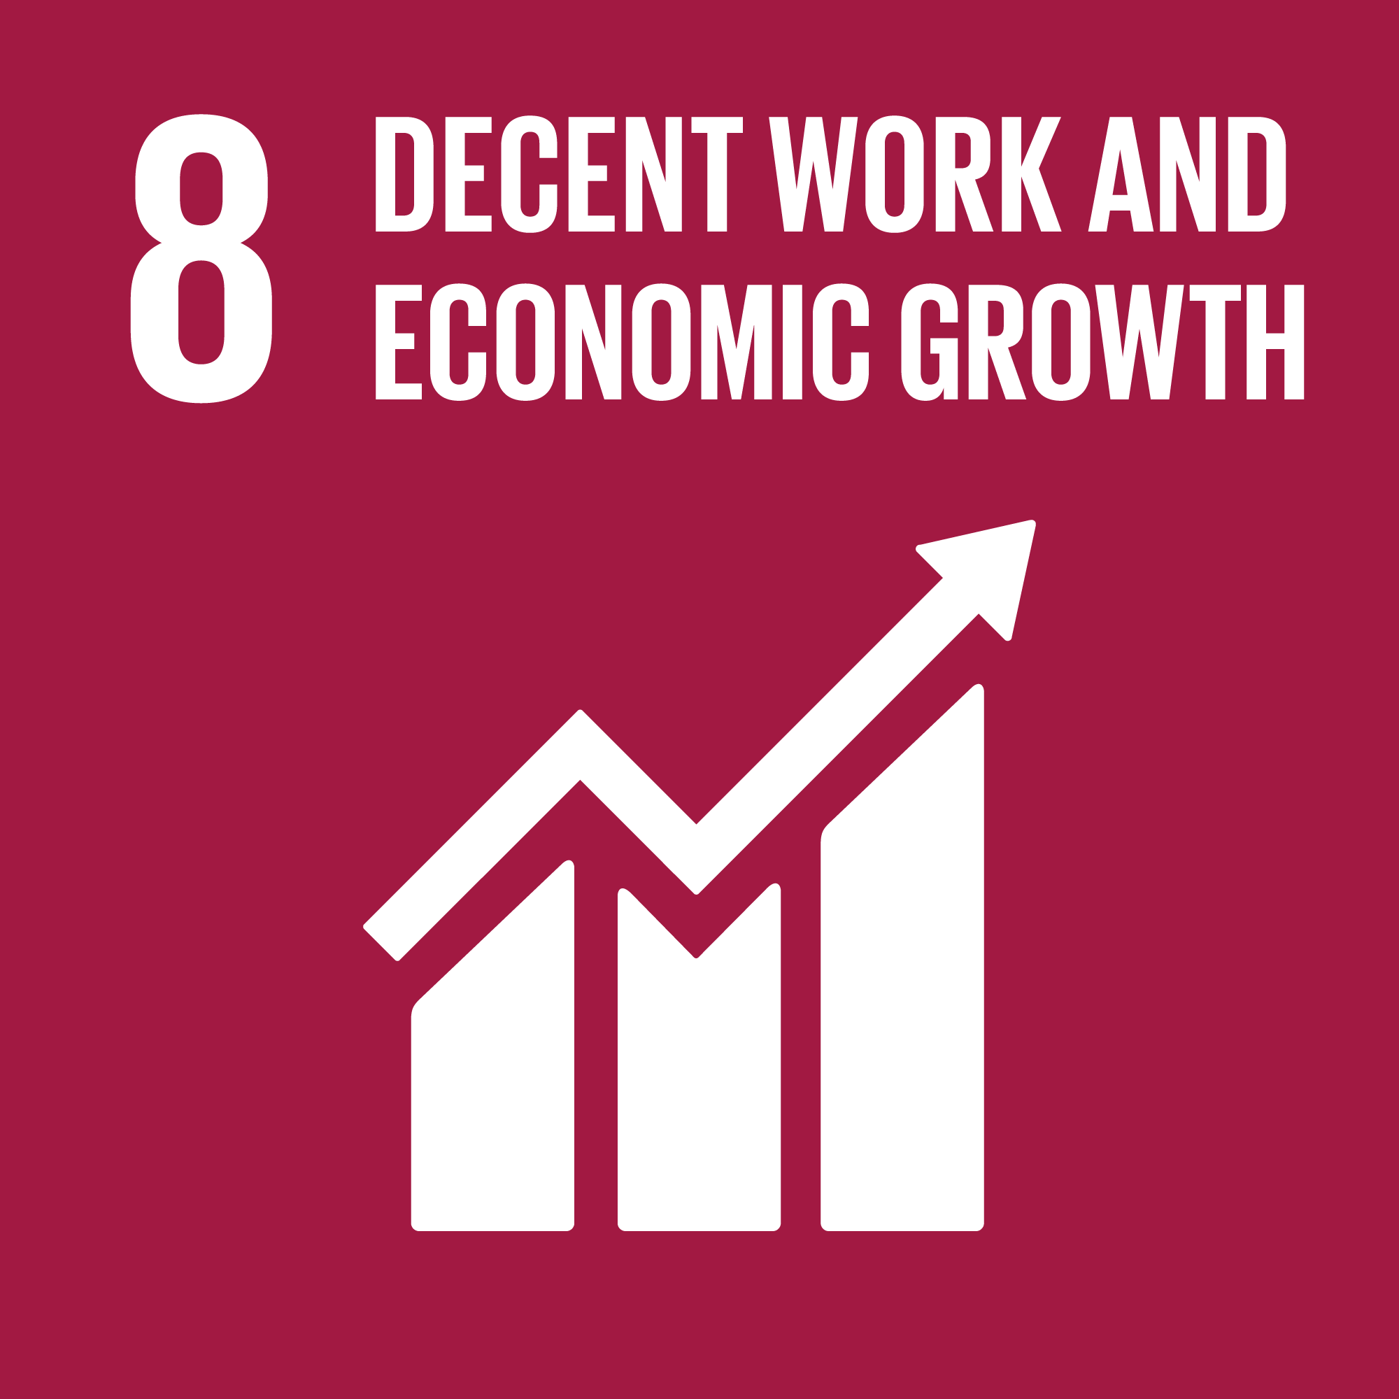
B. Freedom of opinion and expression
85. On 2 February 2021, the President endorsed the decision of the National Council for Security and Defence imposing individual sanctions against a member of the Ukrainian Parliament, Taras Kozak, and his eight companies, reportedly due to threats to national security. The sanctions imposed, inter alia, the revocation of television licenses and the termination of their telecommunication services. This resulted in the closure of the television channels “112 Ukraine”, “ZIK” and “NewsOne”. OHCHR is concerned that the decision to close the three television channels is not in line with international standards on the right to freedom of expression, as it was not taken by an independent authority, nor did it meet the requirements of necessity and proportionality. OHCHR is aware of at least ten cases pending in the Supreme Court following appeals to challenge the decision.
86. OHCHR documented five attacks against journalists and media workers in relation to their professional activities, and seven incidents of threats against bloggers and individuals who expressed opinions online. On 21 July 2021, an individual allegedly affiliated with several groups that promote violence attacked a journalist working for the online media outlet “Bukvy” in front of the Sixth Administrative Appeal Court in Kyiv. Several individuals verbally threatened the victim, and when a police officer escorted the victim out of the crowd, one individual punched the victim several times. The attack was committed in broad daylight, in the presence of police. Despite hearing the verbal threats against the journalist and the media outlet he represents, and trying to protect the victim at the time of the incident, police have initially classified the case as hooliganism only, disregarding the fact that the perpetrators targeted the victim for his professional activities.
87. The five attacks against journalists and media workers included cases of property damage, in alleged attempts to intimidate or otherwise influence their activities. On 17 March 2021, two unidentified individuals set on fire a fence surrounding the private house of a journalist from Sloviansk. The victim believes this incident was retaliation for his work. Police initiated an investigation but did not link it with the victim’s professional activities in the initial classification of the crime.
88. The seven incidents of threats against individuals who expressed their opinion online were part of a wave of hate speech, threats, intimidation, incitement to violence and online smear campaigns against persons who publicly criticised the law “On supporting the functioning of the Ukrainian language as the State language”, or who expressed positive views about the Russian language or otherwise expressed opinions perceived as pro-Russian. After peaking in late January 2021, a small number of incidents continued throughout the reporting period.
89. OHCHR notes the efforts of the Parliamentary Committee on Human Rights to engage representatives of national minorities and other relevant stakeholders in the drafting of the law on the rights of national minorities. OHCHR commends the inclusion in the draft law of several recommendations of relevant stakeholders, including those provided by the United Nations Country Team on ensuring the linguistic rights of national minorities. OHCHR urges that the draft law contain not only declaratory provisions, but specify the manner in which language rights of minorities will be enforced. OHCHR further urges that it amend the current legislation as recommended by the Venice Commission.
90. OHCHR observed further restrictions on civic space in territory controlled by self-proclaimed ‘republics’. While the ability to express critical opinions was already limited, actors of self-proclaimed ‘republics’ continued activities that discouraged criticism and participation in public affairs. OHCHR documented three cases of arbitrary detention of individuals who expressed opinions on online social networks in territory controlled by ‘Donetsk people’s republic’. In at least one case, an individual who expressed opinions through social media platforms also faced ‘prosecution’ of ‘extremism’, ‘activities against territorial integrity’ and ‘incitement to hatred’.
C. Freedom of religion or belief

91. OHCHR documented two cases of violence related to tensions between Orthodox religious communities. Both cases occurred in rural areas of western regions of Ukraine. In one case, investigators failed to identify any suspects even though the victim who was physically attacked recognized one of perpetrators.
92. The self-proclaimed ‘republics’ continued activities against several evangelical Christian denominations. For example, on 25 June 2021, the ‘prosecution’ requested the ‘arbitration court’ of ‘Donetsk people’s republic’ to ban activities of the Church of Evangelical Christian Baptists “Probuzhdenie” in territory it controls. Furthermore, on 20 July 2021, the Sverdlovsk (Dovzhansk) district ‘court’ reportedly declared four books published by the International Union of Evangelical Christian Baptists extremist literature.
D. Discrimination, violence, and manifestations of intolerance
93. During the reporting period, OHCHR documented six incidents of discrimination, violence and manifestation of intolerance targeting individuals belonging to minority groups or holding alternative or minority opinions.
94. In particular, OHCHR documented three attacks by groups that promote violence against events organized by LGBTI organizations in Kyiv and Odesa. In one case, on 27 May 2021 in Kyiv, representatives of the group “Solaris” disrupted a movie screening of “Let's be gay: dialogues about dignity” by smashing the windows and throwing a smoke grenade into the event venue. Police initiated a criminal case under hooliganism charges, disregarding the perpetrators’ bias motives despite existing legislation which would enable proper classification of the crime.
95. Furthermore, OHCHR documented two cases of attacks, threats and acts of intimidation against two LGBTI people and one person perceived to be LGBTI. In one case, an environmental human rights defender was attacked by unknown men in black clothes in Kyiv because he was perceived to be gay. He was seriously injured and had to be hospitalized. Although the perpetrators used homophobic expressions during the attack, police initiated a criminal case under hooliganism charges without taking into account the perpetrators’ presumed bias motives.
96. OHCHR continued to document attacks against the premises of LGBTI organizations. In one incident in Odesa, seven men in masks and black clothing threw stones at the windows and damaged one of the CCTV cameras of the office of the LGBTI association LIGA. Initially, police did not initiate a criminal case, and only upon the associations’ complaint did the court instruct the police to initiate a criminal case into the incident. The association’s offices in Odesa and Mykolaiv had previously been attacked by unknown perpetrators, and in 2021 had already received two false bomb threats.
97. OHCHR documented 21 hate speech incidents, the majority of which were directed against Roma (six incidents) and LGBTI persons (six incidents). Four targeted women, another four targeted people perceived to have pro-Russian views and one targeted people with disabilities. Some of the hateful expressions contained direct incitement to violence and discrimination against individuals belonging to these groups. Media sources, including social media, continue to contain stereotypes and discriminatory language when referring to Roma, in particular, pointing out the Roma ethnicity of alleged perpetrators in news pieces on crimes. Such behaviour often leads to open aggression and calls for violence against Roma on social media. OHCHR welcomes increased public condemnations of hate speech by the Ombudsperson’s Office. OHCHR calls on the Government to adopt an action plan to supplement the Roma Strategy adopted on 28 July 2021, and to provide adequate funding for its implementation. These documents should be aligned with relevant international human rights standards and other relevant national policies and programs.
98. OHCHR notes the adoption on 1 July 2021 of the law on indigenous peoples which provides the first detailed reference in legislation to the rights of indigenous peoples to self-determination and preservation of their culture, religion and languages. The law lists criteria to identify indigenous peoples, including the absence of a kin-State outside Ukraine, and recognizes three indigenous peoples in Ukraine (all of whom originated from Crimea): Crimean Tatars, Krymchaks and Karaimes. OHCHR is concerned that reference to the absence of a kin-State may restrict the right to self-identification of communities which consider themselves indigenous despite having a kin-State. Further, OHCHR is not aware of any consultations by the Government with communities that self-identify as indigenous peoples during development of the law or prior to its adoption. OHCHR is further concerned that the provision of the law which entitles the Cabinet of Ministers to decide on the consolidation or the removal of the legal status of representative bodies of indigenous peoples without consulting representatives of indigenous peoples is contrary to international human rights standards.
VII. Leave no one behind – economic and social rights
99. During the reporting period, OHCHR continued monitoring the exercise of social and economic rights by individuals and groups in situations of vulnerability, including homeless persons, persons with disabilities, Roma, and people living in rural and conflict-affected areas.
A. Homeless persons
100. OHCHR remains concerned about the lack of social housing and social services to address the needs of homeless people throughout the country. While OHCHR welcomes the opening of a new shelter for homeless persons in Zaporizhzhia in February 2021, it deplores the fact that five regions of Ukraine still have no shelters or places for overnight stays, and that the shelter in Mykolaiv still accepts only men, which significantly limits access of homeless women to shelter, water and hygiene (see infographic).
101. Homeless persons without identification documents have limited access to public healthcare services, which further limits their enjoyment of the right to housing. In some shelters visited by OHCHR, staff stated that public hospitals have refused to offer tuberculosis X-ray screening free of charge for persons without identification documents. This has forced staff to raise money from civil society and charities to cover the cost since such screening is required for admission to shelters.
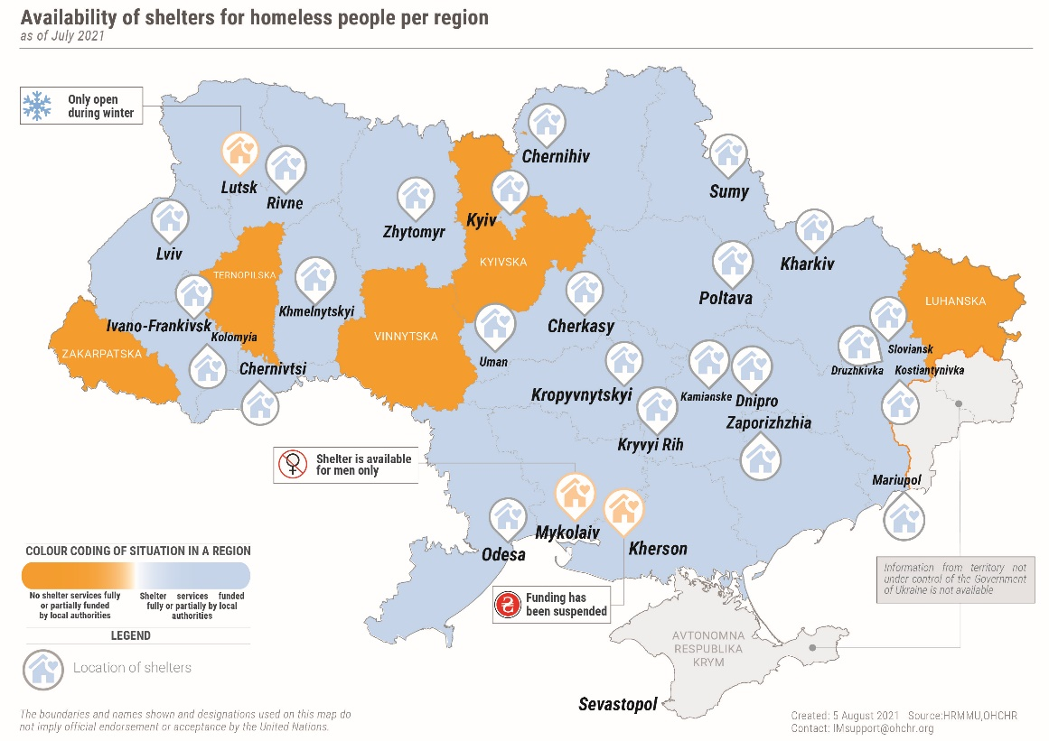

102. Another concern is the lack of social support and housing for persons with disabilities discharged from hospitals and long-term care facilities, which places them at risk of homelessness. OHCHR monitored the case of three men with disabilities who were discharged from the Odesa Regional Centre for Psychiatric Health on 4 June 2021. Allegedly, a hospital car had brought them to a cemetery in Odesa without wheelchairs, despite their movement impairments. Although they were then admitted to municipal shelter for homeless people, it was not adequately equipped to provide accommodation and care for persons with disabilities, and could only accept them on a temporary basis.
B. Persons with intellectual and psychosocial disabilities
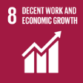

“Our wards are rarely discharged. Usually they die here.”
– The director of a long-term care facility in Kyiv.

103. OHCHR monitored the situation of persons with intellectual and psychosocial disabilities in long-term care facilities and found that some individuals faced difficulties accessing healthcare services outside the facilities. In some cases, this was due to the arbitrary requirement that a nurse from the facility accompany ambulance staff transporting residents to hospital, with nurses not available due to staff shortages.
104. OHCHR noted that restrictions on residents’ freedom of movement, despite the lifting of COVID-19 quarantine restrictions, led to lack of contact with the outside world. In some facilities visited by OHCHR, even residents with full legal capacity were not permitted to leave the facility unaccompanied by staff or family members, and in other facilities residents needed permission to go outside even for short periods of time. OHCHR also found a lack of work opportunities for residents of these facilities, even for those with full legal capacity. While OHCHR welcomes efforts by the administration of some facilities to facilitate professional training for residents, formal employment of residents inside the facilities was rare. Formal employment outside facilities visited by OHCHR was even more limited or not available at all. In addition, OHCHR is concerned that in some facilities, residents engaged in manual work without remuneration, and some were subjected to what may amount to forced labour. In particular, former residents of a long-term care facility in Kharkiv region alleged that the administration applied ill-treatment and forced labour.
105. OHCHR is concerned about the situation of sexual and reproductive rights of women living in such facilities. In particular, in some facilities, OHCHR received allegations that the administration had insisted female residents receive injections of hormonal contraception to prevent pregnancies. One resident told OHCHR that she was not provided information about the medication and felt unwell after the injections.
106. Further, lack of community-based services and social housing for persons with intellectual and psychosocial disabilities has led to a high level of institutionalization. A resident interviewed at a facility visited by OHCHR complained that even with full legal capacity, he was not able to live and work outside the facility due to lack of social housing for persons with a disability.
C. Access to housing subsidies
107. OHCHR is concerned about the negative impact of amendments introduced in April 2021 which tightened the eligibility criteria for receiving housing subsidies to pay for utilities. In particular, the new legislation excludes households with members who do not have any income and cannot register as unemployed, often due to persistent exclusion from the formal labour market, who do not earn a minimum wage to contribute to the social insurance system, or who work informally but still cannot afford housing and utility services due to low pay. This disproportionately affected persons and groups in situations of vulnerability, such as Roma, people living in rural and conflict-affected areas, and persons with disabilities, and in particular, women from these groups.
108. A single Roma mother with a disability from conflict-affected Donetsk region told OHCHR that she had been denied a subsidy due to her lack of formal employment, without which, she is forced to limit her spending on food, clothes and school supplies for her two children as most of her money is used for utilities and medication. Another Roma woman who has a son with disabilities informed OHCHR that she was unable to apply for a housing subsidy because she was not officially registered in the house where she resided. As a result, the majority of her monthly pension of 2,500 UAH (approx. $90) went towards utility costs, significantly limiting her spending on food and medication.
D. Just and favourable conditions of work
109. OHCHR received reports of salary arrears at businesses located in territory controlled by ‘Luhansk people’s republic’, in particular, at the Alchevsk metallurgical factory, one of the biggest employers in the region, which has led to labour strikes. OHCHR is concerned that the resulting lack of income affects the right to an adequate standard of living of people living in the conflict-affected area, which was already suffering from the socio-economic impact of the COVID-19 crisis.
VIII. Human rights in the Autonomous Republic of Crimea and the city of Sevastopol, Ukraine, temporarily occupied by the Russian Federation
“Telling the Russian authorities that I was tortured by the Russian authorities would be like telling a dog that it bites."
- A detainee from Crimea who had been tortured by the FSB when asked if he had complained to the authorities.

A. Freedom of peaceful assembly
110. The Russian Federation continued to enforce a blanket requirement of pre-authorization for public assemblies in Crimea. On 23 January 2021, people gathered in Simferopol and Sevastopol without authorization, following calls for protests against the Government by supporters of detained Russian opposition politician Alexei Navalny. Fearing prosecution for the unauthorized assembly, participants refrained from expressing political demands or displaying banners, and simply gathered peacefully. OHCHR documented arrests during the protests and in the following weeks. One man was arrested at the assembly, fined 5,000 Russian rubles (approx. $68) and apprehended two more times in the street in the following weeks together with his wife for interrogations by the police. In advance of another opposition gathering in April 2021, the court convicted the wife of dissemination of extremist material and ordered five days in detention, reportedly for a rap video posted on her social media page in 2014. Opposition activists consider this arrest and conviction a form of intimidation, to dissuade people from participation in further gatherings. OHCHR documented prosecutions against 46 people (36 men and 10 women) for participating in the two protests. Sanctions included fines, correctional labour, and detention of up to seven days.
111. OHCHR documented new prosecutions for participation in single-person pickets. On 21 May 2021, a court in Crimea found three Crimean Tatar women guilty of participation in an unauthorized public gathering. The women had each conducted a single-person picket in support of their sons who were being prosecuted in a Hizb ut-Tahrir case. One picket was interrupted by police, who ordered the woman to go the police station. Although each woman performed her picket at a different time and in a different location, the court decided that they comprised a single public assembly conducted under the guise of single-person pickets. The court fined one woman 5,000 Russian rubles (approx. $68) and the other two 10,000 Russian rubles (approx. $136) each for their lack of authorization for the assembly. The police had drawn up protocols for these offenses without informing the defendants or their lawyers, and as a result, the women first learned of the charges against them upon being summoned to the court hearing.
112. Law enforcement agencies continued to issue warnings in advance of commemorative dates for Crimean Tatars. As documented by OHCHR, ahead of the Day of the Crimean Tatar National Flag on 26 June 2021, which is typically marked by commemorative assemblies, the police and the prosecutor’s office gave written warnings to at least five Crimean Tatars (four men and one woman). These warnings contained a standard list of administrative and criminal sanctions and cautioned the recipients against organization of ill-defined “extremist assemblies aimed at destabilizing the situation”. One man was also invited for a “conversation” at a police station, where he was asked to write a personal commitment not to participate in or organize any public assemblies on 26 June.
B. Right to liberty and security of persons

113. During the reporting period, OHCHR documented three cases of torture and ill-treatment against Ukrainian citizens in Crimea (two men and one woman). In an emblematic case, on 10 March 2021, FSB officers detained journalist Vladyslav Yesypenko on suspicion of illegal possession of explosives. Following the arrest, FSB officers tortured the victim for several hours in order to coerce a confession of cooperating with Ukrainian intelligence agencies. Despite the victim’s identification of the alleged perpetrators, the Investigative Committee of the Russian Federation refused to launch a formal investigation into the torture. Although the refusal was quashed by the prosecutor’s office, as of 31 July 2021, the investigation had still not been launched.
114. Oleksii Chyrnii, a former university teacher and a high-profile detainee from Crimea, was released on 7 May 2021 after serving a seven-year prison sentence. The FSB arrested and tortured Mr. Chyrnii in May 2014, and accused him of being a member of an alleged “terrorist cell” coordinated by Oleh Sentsov. After his arrest, on the FSB premises in Simferopol, masked men placed a gas mask on his head and blocked the breathing holes. They also beat him; further suffocated him with a plastic bag over his head; and deprived him of sleep. The torture forced the victim to “confess” and implicate others as members of a “terrorist cell”. He was deported to the Russian Federation about two weeks after his arrest to stand trial and serve his sentence. During his seven years of detention, Mr. Chyrnii was held in numerous penal colonies across Russia, thousands of kilometres from Crimea, including on the Russian Pacific coast, and often placed in punishment cells with poorer conditions than in the rest of the colony. Upon his release, he was banned indefinitely from traveling to the Russian Federation, de facto denying him the right to enter Crimea where his family still lives, impacting his right to family life.
C. Administration of justice and fairtrial rights
115. On 1 June 2021, following a trial in absentia, a court in Crimea sentenced Refat Chubarov, the Chairman of the Mejlis currently living in mainland Ukraine, to six years of imprisonment for organizing “mass disturbances” during a rally before the Crimean Parliament on 26 February 2014.
116. In violation of the principle of legality and international humanitarian law, the Russian Federation authorities prosecuted Mr. Chubarov retroactively for acts which preceded the imposition of the Russian Federation legal framework on the peninsula. The victim complained that he had never been duly notified about the date and place of his trial, or subpoenaed to attend it. The fairness of the defendant’s trial was further undermined by the arbitrary recusal of his privately contracted lawyer, which may amount to a violation of the right to have a legal counsel of one’s own choosing.
117. During the reporting period, OHCHR documented three other prosecutions in absentia of Crimean Tatar men living in mainland Ukraine and perceived to be opponents of the occupying authorities in Crimea, in circumstances raising significant concerns as to the defendants’ right to a fair hearing. In one in absentia criminal trial, the defendant, a former Mejlis Chairman and prominent leader of Crimean Tatar people, Mustafa Dzhemilev, was unable to attend because the Russian authorities had banned him from entering Crimea until 2034.
D. Access to public services in mainland Ukraine
118. OHCHR welcomes the cancellation by the Parliament of Ukraine of non-resident taxpayer status for people originating from Crimea. The status negatively affected those with a registered address in Crimea in their passport and created obstacles accessing banking services in mainland Ukraine.
IX. Technical cooperation and capacity-building
119. Over the reporting period, OHCHR provided technical assistance through the publication of one thematic report, two briefing notes, and three updates on civilian casualties, which contained targeted recommendations regarding, inter alia arbitrary detention, torture and ill-treatment in the context of armed conflict in eastern Ukraine, economic and social rights, and enforced disappearances in Crimea. OHCHR also contributed significantly to the United Nations policy paper on strengthening social protection in Ukraine, which was launched by the United Nations High Commissioner for Human Rights as part of the OHCHR Hernán Santa Cruz dialogue series.
120. Analytical papers were also drafted by OHCHR jointly with other UN agencies, and shared with the authorities, on behalf of the United Nations Country Team, to provide guidance on bringing national legislation in line with international standards, including on three draft laws (on minority rights, on prisoners of war and internees, and on transitional justice). OHCHR also shared with the authorities and the international community an analytical note analysing the 2 February 2021 decision on sanctions, which had resulted in the closure of three television channels. OHCHR also supported the United Nations Country Team in the implementation of the UN Human Rights Due Diligence Policy on support for Non-UN Security Forces.
121. OHCHR also supported the Government authorities to develop the National Human Rights Strategy and its Action Plan 2021 – 2023, and represents the United Nations Country Team on the interagency working group established to assess implementation of the Strategy.
122. OHCHR disseminated information on international human rights legal standards to relevant stakeholders. For example, OHCHR translated into Ukrainian General Comment 1 on “Article 12: Equal recognition before the law” of the Committee on the Rights of Persons with Disabilities, and shared it with national stakeholders, including the Working Group on the Civil Code, Supreme Court and Ministry of Social Policy. OHCHR organized seven webinars to introduce international experience, for example, in counting homeless persons, and on the right to equal recognition before the law, as well as to assess implementation of recommendations issued by the Independent Expert on sexual orientation and gender identity following his visit to Ukraine in 2019.
123. OHCHR conducted two online capacity-building trainings, including one on hate speech monitoring for 31 regional representatives of the Ombudsperson’s Office, and one on cooperation with Special Procedures of the Human Rights Council for 12 defence lawyers (8 men, 4 women) practicing in Crimea. OHCHR also briefed seven male military lawyers on the protection of civilians in armed conflict and specific human rights concerns in relation to the conduct of hostilities by Ukrainian Armed Forces.
124. OHCHR issued two op-eds and 98 social media posts, and appeared in over 650 media articles.
X. Conclusions and recommendations
125. As Ukraine marks the milestone of 30 years of independence, it presents an opportunity to take stock of the human rights situation across the country, and to renew efforts to address issues which threaten to prevent the full enjoyment of rights and freedoms and to retard efforts to build back better. The Government must act now to stem the increase in hostilities in eastern Ukraine and reduce potential further costs to civilian life, property and socio-economic well-being.
126. While the continuing COVID-19 pandemic presents significant challenges, further easing of restrictions on movement across the contact line would improve access to essential services and family life for the populations on both sides.
127. The free expression of opinions, including online, and civic space must be better protected across the entire territory of Ukraine, to ensure that journalists, activists, and members of civil society can carry out their work, including to promote and protect human rights, without fear of threats or violence. In particular, intimidation against individuals who voice unpopular opinions, such as those who publicly criticised the law “On supporting the functioning of the Ukrainian language as the State language”, or who are perceived as “pro-Russian” must be addressed promptly and adequately by law enforcement authorities.
128. In view of pre-existing vulnerabilities within the population, which were brought to light by the COVID-19 crisis, the Government, other duty bearers and partners must provide support, with a gender-sensitive approach, to groups at risk of being left behind, in particular homeless people, persons with disabilities including intellectual and psychosocial disabilities, and low-income families in need of housing subsidies. These efforts must be supported with adequate funding from national and international sources.
129. In territory controlled by self-proclaimed ‘republics’, persisting grave violations of human rights, including arbitrary detention, torture and ill-treatment, must be immediately halted. Services must be made available to respond to gender-based violence, and repression against those who express critical or independent views must stop.
130. In Crimea, continuing violations of international humanitarian law and international human rights law by the occupying Power must be recognized and addressed, and concrete steps taken to protect the right to freedom of peaceful assembly, the right to be free from torture and ill-treatment, and fair trial rights.
131. OHCHR conducted an assessment of the implementation of 344 measurable recommendations it had issued in its past 31 periodic and eight thematic reports. This assessment showed that the Government of Ukraine has fully implemented 13 per cent of the recommendations made by OHCHR, and partially implemented 56 per cent, leaving 31 per cent unimplemented; the Russian Federation has not fully implemented any OHCHR recommendations, and partially implemented three per cent, leaving 97 per cent of recommendations unimplemented; and self-proclaimed ‘republics’ have fully implemented three per cent of OHCHR recommendations, partially implemented 18 per cent, leaving 79 per cent of recommendations unimplemented. In making these recommendations, OHCHR seeks to provide concrete, practical and actionable steps that, if implemented, would considerably improve the human rights situation of the population in Ukraine.
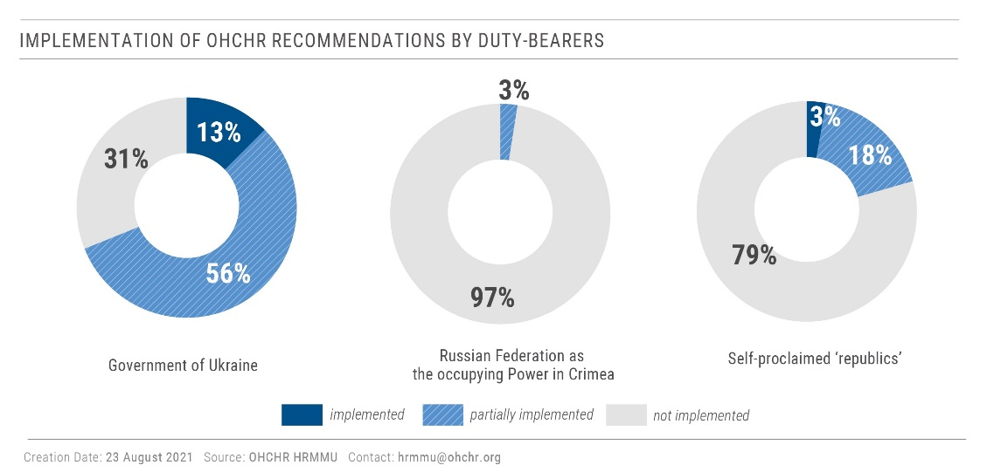

132. Based on its findings from the current reporting period, OHCHR urges the implementation of the following recommendations.
133. To the Ukrainian authorities:
(a) Continue improving the quality of services for homeless people with a gender-sensitive approach, including by expanding the number of public shelters throughout the country, and facilitating prompt restoration of identification documents;
(b) Strengthen efforts towards deinstitutionalization reform and increasing access of persons with intellectual and psychosocial disabilities to social housing and supported residential facilities, as well as a range of in-home, residential and other community support services; and
(c) Ensure that all members of society may access affordable and adequate housing, including necessary utility services, and the habitability of housing, without discrimination, through better identification of groups in vulnerable situations and effective mechanisms of social protection for those in need.
To the President of Ukraine:
(d) Sign law No. 1164-IX “On amendments to certain legislative acts of Ukraine concerning the implementation of provisions of international criminal law and humanitarian law”.
To the Parliament and the Cabinet of Ministers:
(e) Establish a comprehensive compensation mechanism that covers all property destroyed or damaged due to the conflict, starting with the adoption of draft law 5177 or 5177-1 on protection of property rights of civilians;
(f) Prioritise adoption of draft law No. 2083-D enabling access to a pension for all individuals, including those residing in territory controlled by self- proclaimed ‘republics’ and IDPs;
(g) Amend Resolution No. 767, regulating compensation for housing destroyed due to hostilities, to simplify the process and to ensure that a lack of ownership papers does not hinder access to compensation;
(h) Ensure full compliance with international standards when elaborating policies on transitional justice;
(i) Resolve the constitutional crisis in full compliance with constitutional and criminal procedures, as well as international norms and standards on the independence of the judiciary, and in line with the recommendations of the Venice Commission;
(j) Ensure consultations with representatives of indigenous peoples on matters affecting their rights and freedoms;
(k) Elaborate, without delay and in close consultation with a gender-balanced representation of national minorities, a draft law on the protection of national minorities and particularly of their language rights;
(l) Amend national legislation to include hate crimes against LGBTI people by specifying sexual orientation and gender identity as grounds in article 161 (1) and (2) of the Criminal Code, as well as in all the aggravated forms of offences and the general provisions on aggravating circumstances under article 67 (1) (3); and
(m) Adopt an action plan to supplement the Roma Strategy adopted on 28 July 2021, and provide adequate funding for its implementation.
To Border Guards Service of Ukraine:
(n) Improve conditions at the Interstate Border Crossing Point Milove to ease the hardships of citizens crossing to Government-controlled territory.
To State and local authorities:
(o) Provide access to basic services, including transportation, ambulance, social protection, clean water and electricity, to civilians living in settlements along the contact line;
(p) Promptly and publicly condemn all instances of hate speech, incitement to violence, and discrimination against any group, expressed online and offline;
(q) Publicly condemn all violent attacks, threats, and intimidation targeting human rights defenders, including women human rights defenders, anti-corruption and environmental activists, journalists, media professionals and bloggers; and
(r) Establish a network of qualified hate crimes focal points within the National Police of Ukraine and the Office of the General Prosecutor to enhance and supervise investigation of hate crimes.
To the Office of the Prosecutor-General, State Bureau of Investigations and other law enforcement agencies, investigative bodies and courts:
(s) Ensure that legal safeguards for persons deprived of their liberty are fully implemented without exception;
(t) Ensure that in absentia trials are held in accordance with the guarantees of the right to be present during the trial provided in international human rights law;
(u) Ensure timely and effective investigations into all allegations of human rights violations perpetrated by military and law enforcement agents, including torture and ill-treatment, and ensure alleged perpetrators are duly prosecuted, including persons in positions of command;
(v) Halt the practice of applying a broad interpretation of the in flagrante exception defined in the national legislation to justify arbitrary and unlawful arrests and detentions of individuals believed to be affiliated or linked with armed groups; and
(w) Proactively and efficiently investigate all cases of violent crimes including hate crimes, threats and incitement to violence, with particular attention to those committed by members, affiliates or supporters of groups that promote violence, and ensure that all perpetrators, including the instigators, planners and organizers of attacks, are brought to account through a fair trial without undue delays.
To the Command of the Joint Forces Operations:
(x) Take all necessary measures to protect civilians, and prevent and minimize damage to their housing, land and property.
134. To all parties involved in the hostilities in Donetsk and Luhansk regions, including the Joint Forces Operation of Ukraine and armed groups of self-proclaimed ‘Donetsk people’s republic’ and self-proclaimed ‘Luhansk people’s republic’:
(y) Strictly implement measures to strengthen the ceasefire agreed within the Trilateral Contact Group in Minsk and enacted from midnight on 27 July 2020; and
(z) Ensure implementation of mine action activities in accordance with international law, including the 1997 Anti-Personnel Mine Ban Convention and the 2003 Protocol V of the Convention on Certain Conventional Weapons.
135. To self-proclaimed ‘Donetsk people’s republic’ and self-proclaimed ‘Luhansk people’s republic’:
(a) Avoid arbitrary interference with the property rights of civilians, including expropriation of their property;
(b) Fully re-open all entry-exit crossing points without excessive restrictions, together with clear measures to reduce the spread of COVID-19;
(c) Provide unimpeded and confidential access by OHCHR and other independent international monitors to all detainees and places of deprivation of liberty;
(d) Cease the practice of arbitrary incommunicado detention, including practices of ‘administrative arrest’ and ‘preventive detention’;
(e) Treat all persons deprived of their liberty humanely, including those held in connection with the conflict, and ensure conditions of detention are in accordance with international norms and standards; immediately provide information on the whereabouts of all detainees to their families and lawyers; and
(f) Ensure that survivors of domestic violence have access to services, including medical and psychosocial care, shelters, and socioeconomic support, including by refraining from creating obstacles for such service providers.
136. To the international community, including the Government of the Russian Federation:
(g) Use all available channels to influence the self-proclaimed ‘republics’ to respect international human rights and international humanitarian law and, in particular, to implement the recommendations in paragraphs 134 and 135 above.
137. In the context of the Autonomous Republic of Crimea and the city of Sevastopol, Ukraine, temporarily occupied by the Russian Federation, to the Government of the Russian Federation:
(i) Uphold its obligations as a duty bearer in Crimea under international human rights law and respect its obligations as an occupying Power pursuant to international humanitarian law;
(j) Ensure full and unimpeded access of international human rights monitoring missions and human rights non-governmental organizations to Crimea, pursuant to United Nations General Assembly resolutions 71/205, 72/190, 73/263, 74/168 and 75/192;
(k) Ensure that trials held in absentia are carried out in full compliance with international human rights standards, and refrain from retroactively prosecuting Ukrainian citizens for acts committed or opinions expressed before the commencement of the occupation;
(l) End the requirement for prior authorization for peaceful assemblies, and refrain from issuing warnings to, voicing threats against or otherwise intimidating potential participants in those assemblies;
(m) Refrain from prosecution of individuals for participation in peaceful assemblies, regardless of the political or other views expressed;
(n) Comply fully with the absolute prohibition of torture and ensure the independent, impartial and effective investigation of all allegations of torture or ill-treatment;
(o) Refrain from deporting detainees to the Russian Federation to serve prison sentences, and return to Crimea all those who have been previously deported; and
(p) End the practice of arbitrary placement of detainees in punishment cells.

* Reproduced as received in the language of submission only.
HRMMU was deployed on 14 March 2014 to monitor and report on the human rights situation throughout Ukraine, with particular attention to the Autonomous Republic of Crimea, eastern and southern regions of Ukraine, and to propose recommendations to the Government and other actors to address human rights concerns. For more information, see UN Human Rights Council, Report of the United Nations High Commissioner for Human Rights on the situation of human rights in Ukraine, 19 September 2014, A/HRC/27/75, paras. 7-8, available at www.ohchr.org/EN/HRBodies/HRC/RegularSessions/Session27/Documents/A-HRC-27-75_en.pdf.
Shelling, small arms and light weapons (SALW) fire, and drone strikes.
Incidents in which civilians were killed or injured by mines (antipersonnel or anti-vehicle) or explosive devices triggered in the same way, such as booby traps, or by explosive remnants of war (ERW) that are inadvertently detonated by unsuspecting civilians.
Hereinafter ‘Donetsk people’s republic’ and ‘Luhansk people’s republic’, and collectively as self-proclaimed ‘republics’.
Ukraine, Draft law “On the Principles of State Policy of the Transitional Period” (2021).
Bodies of the Russian Federation and their representatives in Crimea shall be considered as “occupation authorities of the Russian Federation”. General Assembly resolution 75/192, para. 12. All reference to organs and officials of the Russian Federation in Crimea in this report are to be understood as referring to the occupation authorities of the Russian Federation.
With 551 men and 645 women.
See OHCHR, Report on the human rights situation in Ukraine, 16 February to 15 May 2019, para. 20, available at www.ohchr.org/Documents/Countries/UA/ReportUkraine16Feb-15May2019_EN.pdf.
Heidi Grau, Special Representative of the OSCE Chairperson-in-Office in Ukraine and in the TCG, “Press Statement of Special Representative Grau after the regular Meeting of Trilateral Contact Group on 22 July 2020”, Kyiv, 23 July 2020, available at www.osce.org/chairmanship/457885.
“ERW handling” refers to manipulation of an ERW for a certain period of time with additional efforts to detonate it (for instance, by trying to dismantle it). Civilian casualties includes those who manipulated an ERW as well as persons in the immediate vicinity.
“Police detained a Donetsk resident, who had threatened to kill his family”, 31 May 2021, available at https://мвдднр.рус/news/politseiskie-zaderzhali-donchanina-kotoryi-ugrozhal-svoei-seme-ubiistvom.
Three of which did not cause any damage.
Both ‘decrees’ were issued on the basis of the ‘laws on military service’, which provide that military service is mandatory (Article 32 of the ‘Luhansk people’s republic’ ‘law’ on ‘military duty and military service’ and article 29 of the ‘Donetsk people’s republic’ ‘law’ on ‘military duty and military service’).
Born between 1994 and 2003.
Article 406 of the Criminal ‘code’ of ‘Luhansk people’s republic’’ and article 388 of the Criminal ‘code’ of ‘Donetsk people’s republic’.
The Ukrainian authorities have prosecuted individuals for serving in armed groups of self-proclaimed ‘republics’ on charges of membership in a terrorist organization or in an unlawful armed formation. These crimes carry different punishments (see OHCHR, Human Rights in the Administration of Justice in Conflict-Related Criminal Cases in Ukraine from April 2014 - April 2020, para. 92). Article 258.3 of the Criminal Code of Ukraine punishes membership in a terrorist organization with a term in prison ranging from eight to 15 years, whilst article 260 punishes participation in unlawful paramilitary or armed formations with a term in prison ranging from two to 15 years.
Amending Cabinet of Ministers Resolution No.1236 of 9 December 2020.
Individuals who are not registered in territory controlled by ‘Luhansk people’s republic’, must seek approval from the ‘ministry of foreign affairs' to enter territory controlled by ‘Luhansk people’s republic’, which takes at least 14 days. While some humanitarian exemptions apply, they exclude visits to close relatives or for family reunification.
To cross the contact line, civilians who are not registered in territory controlled by ‘Donetsk people’s republic’ must request approval, citing one of five humanitarian exemptions, from the ‘interdepartmental operational headquarters for preventing the spread of COVID-19’, which is often slow to respond to such requests, or does not respond at all. Similarly, individuals registered in territory controlled by ‘Donetsk people’s republic’ are not allowed to cross to Government-controlled territory unless they fall under a humanitarian exception and obtain approval. For more information, see OHCHR, Report on the human rights situation in Ukraine, 16 February to 31 July 2020, para. 49, available at https://www.ohchr.org/Documents/Countries/UA/30thReportUkraine_EN.pdf.
Due to the absence of government services in the villages, and lack of public transport and passable roads.
Stipulated in article 11 of the International Covenant on Economic, Social and Cultural Rights.
Principle 21.3 of the Guiding Principles on Internal Displacement states that “[p]roperty and possessions left behind by internally displaced persons should be protected against destruction and arbitrary and illegal appropriation, occupation or use.”
OHCHR interview, 12 May 2021.
Draft law “On the principles of State policy for the transitional period”, (after registration in the Parliament, it is currently draft law No.5844 of 9 August 2021 "On the principles of State policy for the transitional period").
On 11 January and 4 June 2021, the Ministry of Reintegration of Temporary Occupied Territories published draft versions of the bill and invited interested parties to comment. On 4 June 2021, the Ministry requested the Venice Commission to issue an opinion on the draft law.
OHCHR also notes that the Working Group on Reintegration of Temporarily Occupied Territories of the Legal Reform Commission submitted to the President of Ukraine for approval a draft State Policy Framework on the Protection and Restoration of Human Rights and Fundamental Freedoms during the Armed Conflict, which outlines a transitional justice strategy for the country. To avoid overlap, consideration should be given to developing a single coherent and consistent strategy on transitional justice, after holding wide-ranging consultations, based on which a decision can be taken on the specific transitional justice mechanism the country will adopt. This strategy could be then complemented, if needed, by specific amendments to the current legislation.
OHCHR adjusted its work to minimize the risk of spreading the virus, carrying out activities in person only when it is possible to do so safely.
OHCHR interview, 28 April 2021.
OHCHR interview, 11 May 2021.
OHCHR interview, 31 May 2021.
OHCHR interview, 24 May 2021.
OHCHR interview, 25 May 2021.
OHCHR visit, 17 May 2021; OHCHR, Report on the human rights situation in Ukraine, 16 November 2019 to 15 February 2020, para. 54, available at https://www.ohchr.org/Documents/Countries/UA/29thReportUkraine_EN.pdf.
The SBI Territorial Department in Poltava is investigating criminal offenses under part 2 of article 365, part 2 of article 127 of the Criminal Code of Ukraine. Procedural guidance in criminal proceedings is carried out by the Prosecutor’s General Office and the Kharkiv Regional Prosecutor's Office. According to the SBI, a number of investigative actions were carried out, including interrogations of 49 prisoners, 20 penitentiary staff, and the 55 forensic examinations of victims.
OHCHR interviews, April-June 2021.
OHCHR interviews, April-June 2021.
OHCHR interview, 6 May 2021.
These are cases involving crimes against national security (articles 109-1141, chapter I of the Special Part of the Criminal Code), certain crimes against public security (articles 258-2585, chapter IX of the Special Part of the Criminal Code) and certain crimes against peace and humanity (articles 436-438 of the chapter XX of the Special Part of the Criminal Code) which were previously rarely applied.
In 96 out of 97 cases.
See OHCHR, Human Rights in the Administration of Justice in Conflict-Related Criminal Cases in Ukraine from April 2014 - April 2020, para. 36-39, available at https://www.ohchr.org/Documents/Countries/UA/Ukraine-admin-justice-conflict-related-cases-en.pdf.
See OHCHR, Human Rights in the Administration of Justice in Conflict-Related Criminal Cases in Ukraine from April 2014 - April 2020, para. 176. The same recommendation was shared with the Parliament on 3 March 2021, before the law was put for the vote in the second reading.
In the case of trials in absentia, article 14, paragraph 3 (a) of the International Covenant on Civil and Political Rights requires that, notwithstanding the absence of the accused, all due steps have been taken to inform accused persons of the charges and to notify them of the proceedings. See also CCPR/C/GC/32, para. 31.
However, in at least 84 cases judges refused to authorize in absentia investigations and trials, concluding that sending notifications to the last known place of residence of suspects/defendants or publishing such notifications on government websites cannot be considered due notification when it relates to criminal prosecution.
Law No. 1164-IX “On amendments to certain legislative acts of Ukraine concerning the implementation of provisions of international criminal law and humanitarian law”.
Under the legislative process, the President should have signed the law by the end of June, or vetoed and returned it for revision by Parliament.
Sviatoshynskyi court of Kyiv, ruling, 2 June 2021, available at https://reyestr.court.gov.ua/Review/97362736
“Titushky” is a term used to refer to armed civilians, sometimes wearing camouflage and masks, often with criminal records, who were, as the investigation concluded, recruited and equipped by law enforcement agencies to attack protesters.
Boryspilskyi City District Court of the Kyiv Region, Case No. 359/5760/18, Verdict (16 April 2021), available at https://reyestr.court.gov.ua/Review/96317638.
On 7 June 2021, the SBI referred for trial the criminal case against the former Deputy Head of the Odesa City Police whose misconduct resulted in destroyed private property. On 27 July 2021, the SBI notified of suspicion a former deputy commander of the patrol police company of the city police department, who failed to prevent criminal activities and arrest perpetrators on 2 May 2014.
See OHCHR, Report on the human rights situation in Ukraine, 1 August 2020 to 31 January 2021, paras. 62-64, available at https://www.ohchr.org/Documents/Countries/UA/31stReportUkraine-en.pdf.
Decree No. 124/2021 “On certain issues of ensuring the national security of Ukraine” of 27 March 2021, available in Ukrainian at www.president.gov.ua/documents/1242021-37701. The President’s justification for the decree was that the judges posed a threat to state security because they had been appointed by former President Yanukovych, who, according to the decree, usurped state power from 2010 to 2014 and undermined state security.
Administrative Cassation Court of the Supreme Court, Case No. 9901/96/21 (14 July 2021), available at https://reyestr.court.gov.ua/Review/98306624.
Groups, communities, or organizations that openly engage in violence, threats of violence, and incitement to violence, or otherwise acknowledge violence as an acceptable tool for achieving political, ideological, or other goals.
These TV channels are perceived as “pro-Russian”, usually by political opponents from the Opposition Platform – For Life party and by supporters of competing political parties. Notably, representatives of opposition parties and opinion leaders critical of the Government often appeared on these channels. They were among the 10 most popular nationwide channels, according to a 2020 survey of service providers.
International Covenant on Civil and Political Rights, art. 19(3). The decision of the National Council for Security and Defence failed to demonstrate the link between the functioning of these channels and the threat to national security, and failed to use the least intrusive measures, for example, by blocking certain content.
OHCHR interview, 17 August 2021.
OHCHR interview, 1 April 2021.
The Committee organized a series of in-person and online meetings with representatives of national minorities in May and June 2021, published revisions of the draft law on 1 June and 14 July, and invited interested parties to provide comments.
The Venice Commission recommended to, inter alia, address the differential treatment between official languages of the European Union and other languages of national minorities (see Venice Commission, Opinion on the Law on Supporting the Functioning of the Ukrainian Language as the State Language, Opinion No. 960/2019 (9 December 2019), available at www.venice.coe.int/webforms/documents/?pdf=CDL-AD(2019)032-e; Venice Commission, Opinion on the provisions of the law on education of 5 September 2017, Opinion No. 902/2017 (11 December 2017), available at www.venice.coe.int/webforms/documents/default.aspx?pdffile=CDL-AD(2017)030-e).
‘Prosecutor’s office’ of ‘Donetsk people’s republic’, “The prosecutor’s office has filed a lawsuit to ban the activities of the religious organization Church of Evangelical Christians-Baptists ‘Awakening’”, 25 June 2021, available at http://www.gpdnr.su/news/2052-prokuratura-podala-iskovoe-zayavlenie-o-zaprete-deyatelnosti-odnoy-iz-religioznyh-organizaciy.html.
Article 161 of the Criminal Code of Ukraine provides penalties for “violating the equality of citizens” based on race, nationality, religion or other characteristics.
Law No. 1616-IX “On indigenous peoples of Ukraine.
Whilst States enjoy a certain discretion in identifying indigenous peoples, the absence of a kin-State as a criterion is not found in international human rights standards (see E/CN.4/Sub.2/AC.4/1996/2, para. 69; E/CN.4/Sub.2/1986/7 and Adds. 1–4 cited in Indigenous Peoples and the United Nations Human Rights System, Fact Sheet No. 9/Rev.2 (United Nations Publication, 2013), pp. 2-3). Furthermore, self-identification should be the primary criterion in identifying indigenous communities (see United Nations Declaration on the Rights of Indigenous Peoples, art. 33; E/CN.4/Sub.2/1986/7/Add.4, para. 381; E/CN.4/2002/97, para. 100; United Nations Human Rights Office of the High Commissioner, The United Nations Declaration on the Rights of Indigenous Peoples - A Manual for National Human Rights Institutions, HR/PUB/13/2, pp.6-7).
See OHCHR, Report on the human rights situation in Ukraine, 1 August 2020 to 31 January 2021, para. 97, available at https://www.ohchr.org/Documents/Countries/UA/31stReportUkraine-en.pdf. According to information received from the Ministry of Social Policy, 947 persons with disabilities and older persons live in supported living facilities, of which there are 28 across the country; and 66 persons with disabilities and older persons receive daytime care services in eight facilities. In 2021, a total of 38,944 persons were living in long-term care facilities.
OHCHR interview, 6 July 2021.
OHCHR interview, 27 May 2021.
The Human Rights Committee noted that having to apply for permission from the authorities to hold any assembly “undercuts the idea that peaceful assembly is a basic right”. See CCPR/C/GC/37, para. 70.
Under Russian Federation laws, single-person pickets do not require pre-authorization.
For more details on the victim’s torture, see HRMMU, Update on the human rights situation in Ukraine, 1 February – 30 April 2021, p. 6, available at www.ohchr.org/Documents/Countries/UA/HRMMU_Update02_2021-05-01_EN.pdf.
For details on the case of Oleh Sentsov, see OHCHR, Report on the human rights situation in Ukraine, 16 August to 15 November 2019, para. 99, available at https://www.ohchr.org/Documents/Countries/UA/28thReportUkraine_EN.pdf.
This deportation of a protected person outside the occupied territory is a violation of Geneva Convention (IV), art. 49.
Rule 59 of the United Nations Standard Minimum Rules for the Treatment of Prisoners (Mandela Rules) states “prisoners shall be allocated, to the extent possible, to prisons close to their homes or their places of social rehabilitation”.
Mr. Chyrnii claimed to have been placed in punishment cells approximately thirty times, based on arbitrary application of conduct rules for such violations as “sleeping outside designated hours”, “being absent from his bed”, and generic “inconsiderate behaviour” and “obstructing a search”. Penitentiary records analyzed by OHCHR indicate he was labelled as “inveterate offender” and spent no less than one year and two months in punishment cells of various types.
This denial of entry into Crimea violates article 12 of the International Covenant on Civil and Political Rights, which guarantees the right to liberty of movement and freedom to choose one’s residence within the borders of a State. As it concerns a resident of occupied territory, it is also a violation of Geneva Convention (IV), art. 49.
The same verdict also found Mr. Chubarov guilty of two counts of “public calls to violate the territorial integrity of the Russian Federation”. He was exempted from criminal liability under these charges due to the decriminalization of this offense if committed for the first time.
During the rally, pro-Ukrainian and pro-Russian protesters faced off, leading to a stampede and the death of two pro-Russian demonstrators.
According to Geneva Convention IV (art. 70), protected persons shall not be arrested, prosecuted or convicted by the occupying Power for acts committed before the occupation, with the exception of breaches of laws and customs of war.
Under international human rights law, a person convicted in absentia must be able to obtain from a court a fresh determination of the merits of the charge where it has not been established that the defendant waived their right to appear or that they intended to escape trial. See European Court of Human Rights, Sejdovic v. Italy, Judgment (Grand Chamber), 1 March 2006, para. 82.
In total, three out of four documented cases resulted in prison terms, while the fourth case is pending trial.
He is accused of attempting to “illegally cross the Russian border” for trying to enter Crimea in May 2014, as well as “negligent storage of firearms” and “illegal possession of ammunition” in connection with a firearm incident in May 2013.
Ukraine, Draft Law 5502-д (1 July 2021), pending signature by the President as of 31 July 2021, available at http://w1.c1.rada.gov.ua/pls/zweb2/webproc4_1?pf3511=72323.
On banking discrimination, see OHCHR, Report on the human rights situation in Ukraine, 16 November 2017 to 15 February 2018, para. 130, available at https://www.ohchr.org/Documents/Countries/UA/ReportUkraineNov2017-Feb2018_EN.pdf.
OHCHR, Arbitrary detention, torture and ill-treatment in the context of armed conflict in eastern Ukraine, 2014-2021, available at https://www.ohchr.org/Documents/Countries/UA/UkraineArbDetTorture_EN.pdf.
HRMMU, Briefing Note on the impact of the COVID-19 pandemic on healthcare workers in Ukraine, available at https://ukraine.un.org/en/124052-briefing-note-impact-covid-19pandemic-healthcare-workers-ukraine.
HRMMU, Enforced disappearances in the autonomous republic of Crimea and the city of Sevastopol, Ukraine, temporarily occupied by the Russian Federation, available at https://ukraine.un.org/index.php/en/123652-enforced-disappearances-autonomous-republic-crimea-and-city-sevastopol-ukraine-temporarily.
Available at https://ukraine.un.org/en/124888-un-policy-paper-social-protection-ukraine.
See supra at para. 80.
On 24 March 2021, the President signed Decree No.119/2021 endorsing a new version of the National Human Rights Strategy. On 23 June 2021 (published on 13 July 2021) a new Action Plan 2021 – 2023 on the implementation of the Strategy was adopted.

