Country Policy and Information Note

Myanmar: 2021 coup and protests

Version 1.0
March 2021

Preface
Purpose
This note provides country of origin information (COI) and analysis of COI for use by Home Office decision makers handling particular types of protection and human rights claims (as set out in the Introduction section). It is not intended to be an exhaustive survey of a particular subject or theme.
It is split into two main sections: (1) analysis and assessment of COI and other evidence; and (2) COI. These are explained in more detail below.

Assessment
This section analyses the evidence relevant to this note – i.e. the COI section; refugee/human rights laws and policies; and applicable caselaw – by describing this and its inter-relationships, and provides an assessment of, in general, whether one or more of the following applies:
- A person is reasonably likely to face a real risk of persecution or serious harm
- The general humanitarian situation is so severe as to breach Article 15(b) of European Council Directive 2004/83/EC (the Qualification Directive) / Article 3 of the European Convention on Human Rights as transposed in paragraph 339C and 339CA(iii) of the Immigration Rules
- The security situation presents a real risk to a civilian’s life or person such that it would breach Article 15(c) of the Qualification Directive as transposed in paragraph 339C and 339CA(iv) of the Immigration Rules
- A person is able to obtain protection from the state (or quasi state bodies)
- A person is reasonably able to relocate within a country or territory
- A claim is likely to justify granting asylum, humanitarian protection or other form of leave, and
- If a claim is refused, it is likely or unlikely to be certifiable as ‘clearly unfounded’ under section 94 of the Nationality, Immigration and Asylum Act 2002.
Decision makers must, however, still consider all claims on an individual basis, taking into account each case’s specific facts.

Country of origin information
The country information in this note has been carefully selected in accordance with the general principles of COI research as set out in the Common EU [European Union] Guidelines for Processing Country of Origin Information (COI), dated April 2008, and the Austrian Centre for Country of Origin and Asylum Research and Documentation’s (ACCORD), Researching Country Origin Information – Training Manual, 2013. Namely, taking into account the COI’s relevance, reliability, accuracy, balance, currency, transparency and traceability.
The structure and content of the country information section follows a terms of reference which sets out the general and specific topics relevant to this note.
All information included in the note was published or made publicly available on or before the ‘cut-off’ date(s) in the country information section. Any event taking place or report/article published after these date(s) is not included.
All information is publicly accessible or can be made publicly available, and is from generally reliable sources. Sources and the information they provide are carefully considered before inclusion. Factors relevant to the assessment of the reliability of sources and information include:
- the motivation, purpose, knowledge and experience of the source
- how the information was obtained, including specific methodologies used
- the currency and detail of information, and
- whether the COI is consistent with and/or corroborated by other sources.
Multiple sourcing is used to ensure that the information is accurate, balanced and corroborated, so that a comprehensive and up-to-date picture at the time of publication is provided of the issues relevant to this note.
Information is compared and contrasted, whenever possible, to provide a range of views and opinions. The inclusion of a source, however, is not an endorsement of it or any view(s) expressed.
Each piece of information is referenced in a brief footnote; full details of all sources cited and consulted in compiling the note are listed alphabetically in the bibliography.

Feedback
Our goal is to continuously improve our material. Therefore, if you would like to comment on this note, please email the Country Policy and Information Team.

Independent Advisory Group on Country Information
The Independent Advisory Group on Country Information (IAGCI) was set up in March 2009 by the Independent Chief Inspector of Borders and Immigration to support him in reviewing the efficiency, effectiveness and consistency of approach of COI produced by the Home Office.
The IAGCI welcomes feedback on the Home Office’s COI material. It is not the function of the IAGCI to endorse any Home Office material, procedures or policy. The IAGCI may be contacted at:
Independent Advisory Group on Country Information
Independent Chief Inspector of Borders and Immigration
5th Floor
Globe House
89 Eccleston Square
London, SW1V 1PN
Email: chiefinspector@icibi.gov.uk
Information about the IAGCI’s work and a list of the documents which have been reviewed by the IAGCI can be found on the Independent Chief Inspector’s pages of the gov.uk website.
Contents
Assessment 6
1. Introduction 6
1.1 Basis of claim 6
2. Consideration of issues 6
2.1 Credibility 6
2.2 Exclusion 7
2.3 Convention reason(s) 7
2.4 Risk 7
2.5 Protection 10
2.6 Internal relocation 10
2.7 Certification 10
Country information 11
3. Context to the February 2021 coup 11
3.1 What happened, when and why? 11
3.2 Timeline of events 11
4. Protests: background 14
4.1 Size 14
4.2 Profile of protestors 15
4.3 Leadership and organisation of protests 17
4.4 Symbols of the protests: red-coloured displays 17
4.5 Symbols of the protests: the “Hunger Games” films salute 18
4.6 Symbols of the protests: broken down car ‘blockades’ 19
5. State response to protests 22
5.1 Internet blocks 22
5.2 Use of excessive violence and lethal force against protestors 24
5.3 Police defections 30
5.4 Monitoring 30
5.5 Legal restrictions and curfews 30
5.6 Changes to privacy laws and impact on arrest procedures 31
6. Arrests 34
6.1 Arrests: numbers 34
6.2 Arrests of NLD figures 36
6.3 Arrests of protestors 37
6.4 ‘Night arrests’ 39
6.5 Neighbourhood night patrols 40
6.6 Arrests of election officials 41
6.7 Arrests of journalists 42
6.8 Arrests and pressure against civil servants and other professionals 43
6.9 Arrests and pressure on trade unions 44
6.10 Arrest warrants for high profile critics 44
6.11 Treatment of ethnic nationality civilians since the coup 45
Terms of Reference 46
Bibliography 47
Sources cited 47
Sources consulted but not cited 52
Version control 53

Assessment
Updated: 06 March 2021

Introduction

Basis of claim
    - Fear of persecution and/or serious harm by the state because the person has, or is perceived to have, participated in protests (or wider civil disobedience movement) against the February 2021 military coup.
Back to Contents

Consideration of issues

Credibility
    - For information on assessing credibility, see the instruction on Assessing Credibility and Refugee Status.
    - Decision makers must also check if there has been a previous application for a UK visa or another form of leave. Asylum applications matched to visas should be investigated prior to the asylum interview (see the Asylum Instruction on Visa Matches, Asylum Claims from UK Visa Applicants).
    - Decision makers should also consider the need to conduct language analysis testing (see the Asylum Instruction on Language Analysis).

Back to Contents

Exclusion
    - Decision makers must consider whether there are serious reasons for considering whether one (or more) of the exclusion clauses is applicable. Each case must be considered on its individual facts and merits.
    - If the person is excluded from the Refugee Convention, they will also be excluded from a grant of humanitarian protection.
For further guidance on the exclusion clauses and restricted leave, see the Asylum Instructions on Exclusion under Articles 1F and 33(2) of the Refugee Convention, Humanitarian Protection and Restricted Leave.

Back to Contents

Convention reason(s)
    - Actual or imputed political opinion.
    - Establishing a convention reason is not sufficient to be recognised as a refugee. The question is whether the person has a well-founded fear of persecution on account of an actual or imputed Refugee Convention reason.
    - For further guidance on Convention reasons see the instruction on Assessing Credibility and Refugee Status.
Back to Contents

Risk
    - After the November 2020 election saw the National League for Democracy (NLD) win the majority of votes in a landslide victory, the military-backed opposition party claimed electoral fraud. Consequently, on 1 February 2021, the military arrested leader Aung San Suu Kyi and other prominent members of the NLD, seizing control, and transferring power to commander-in-chief General Min Aung Hlaing. An 11-member junta has since been established to rule under a year-long declared state of emergency (see What happened, when and why? and Timeline of events).
    - Following the coup, protests against it and calling for the return of former leader Aung San Suu Kyi have taken place in many towns and cities, both small and large, across Myanmar. They have drawn daily participation of tens, if not hundreds, of thousands of people from a range of different backgrounds and professions. Sources have described the protests as the biggest since the ‘Saffron Revolution’ in 2007 and they have continued to increase in size throughout February and into March 2021, with the UN estimating that millions have demonstrated since the coup (see Size of protests and ‘Profile’ of protestors).
    - The protests have formed part of a wider civil disobedience movement. This has also included creating roadblocks or barriers using cars and other vehicles, as well as strikes, ‘sit ins’ and other work stoppages (see ‘Profile’ of protestors, ‘Leadership’ and organisation of protests).
    - The military have responded by restricting access to both social media channels and the internet (see Internet blocks).
    - Police responses to the protests have been mixed. Many have proceeded without incident. However, there have been reports of the police using water cannons, tear gas, stun grenades, batons and rubber bullets at protestors. The United Nations has also confirmed the use of live ammunition, as well as human rights violations including murder, arbitrary detention, beatings, torture and probable enforced disappearances. It also appears that the use of violence to subdue and dissuade protestors is increasing as the protests continue and more than 300 people have been killed at the time of writing this CPIN (see Other responses to, including violence against, protestors).
    - The authorities have also made over 2,900 arrests including in the immediate aftermath of the coup and during protests. These have included:
- Members of parliament – particularly party members of the NLD
- Members of the Union Election Committee
- Civil servants
- Members of civil society organisations, activists and human rights defenders
- Journalists
- Protesters (see Arrests).
    - There are also reports of the police making arrests – including arbitrarily – at night (see “Night arrests”).
    - The authorities have issued multiple arrest warrants for a variety of individuals who they see as influencing the protests (see Arrest warrants for high profile critics).
    - In the Country Guidance case TS (Political opponents –risk) Burma/Myanmar CG [2013] UKUT 281 (IAC), heard on 11, 12 and 13 March 2013 and promulgated on 25 June 2013, the Upper Tribunal held:
‘In order to decide whether a person would be at risk of persecution in Burma because of opposition to the current government, it is necessary to assess whether such activity is reasonably likely to lead to a risk of detention. Detention in Burma, even for a short period, carries with it a real risk of serious ill-treatment, contrary to Article 3 of the ECHR and amounting to persecution/serious harm within the meaning of the Qualification Directive.
‘A person is at real risk of being detained in Burma where the authorities regard him or her to be a threat to the stability of the regime or of the Burmese Union.
‘The spectrum of those potentially at risk ranges from those who are (or are perceived to be) actively seeking to overthrow the government to those who are in outspoken and vexing opposition to it. Whether a person is in need of protection will depend upon past and future political behaviour. This assessment has to be made against the background of a recently reforming government that carries a legacy of repression and continues to closely monitor those in opposition. The evidence points to a continuing anxiety over the break up of the state and the loss of its power.
‘The question of risk of ill-treatment will in general turn upon whether a returnee is detained by the authorities at any stage after return…
‘It is someone’s profile in the eyes of the state that is the key to determining risk.
‘In general, none of the risks identified above is reasonably likely to arise if an individual’s international prominence is very high. The evidence shows that the government is keen to avoid adverse publicity resulting from the detention of internationally well-known activists.’ (paragraphs 83(i)-(iv) and (viii) to (ix)).
    - The country guidance case of TS was promulgated under a ‘recently reforming government’, prior to the November 2020 election results and the military’s ‘coup’ and it is too early to be sure if recent events indicate a significant and durable change in how the current military government will react to its critics. It is also worth noting that TS was promulgated in 2015, prior to the NLD taking power. However, its response to the protests against the coup would appear to indicate that its tolerance of what it considers a threat to the state (and its control) has not changed significantly since TS was heard (see Context to the February 2021 coup and Arrests).
    - Therefore, decision makers should continue to follow the findings in TS, taking into account recent events as documented in this note. As the situation is rapidly evolving, it is vital that up-to-date country information is sought before making an assessment.
    - Many thousands of people have been involved in the protests and a person is unlikely to be able to establish a well-founded fear of persecution or serious harm simply by virtue of participating in the protests. However, a person is likely to be at risk if:
- Their activities, connections and networks prior to leaving the country are likely to be known to the authorities;
- They are otherwise seen as someone who can influence others to participate, and would therefore be likely to be known to the authorities as such;
- They are a journalist reporting on the protests;
- They are of an ethnicity that is seen by the government to be destabilising the country or if the person’s activity is of a kind that has an ethnic, geo-political or economic regional component, which is regarded by the Burmese government as a sensitive issue;
- They are fleeing an arrest warrant or may be at risk of detention, regardless of length.
    - However, each case must be considered on its facts, with the onus on the person to demonstrate that they face a particular risk.
    - For further guidance on assessing risk, see the instruction on Assessing Credibility and Refugee Status.
Back to Contents

Protection
    - Where the person has a well-founded fear of persecution from the state, they are unlikely, in general, to be able to avail themselves of the protection of the authorities.
    - For further guidance on assessing the availability of state protection, see the instruction on Assessing Credibility and Refugee Status.
Back to Contents

Internal relocation
    - Where the person has a well-founded fear of persecution from the state, they are unlikely to be able to relocate to escape that risk.
    - For further guidance on internal relocation see the instruction on Assessing Credibility and Refugee Status.
Back to Contents

Certification
    - Myanmar is not listed as a designated state under section 94(4). Where a claim is refused, it is unlikely to be certifiable as ‘clearly unfounded’ under section 94 of the Nationality, Immigration and Asylum Act 2002.
    - For further guidance on certification, see Certification of Protection and Human Rights claims under section 94 of the Nationality, Immigration and Asylum Act 2002 (clearly unfounded claims).
Back to Contents

Country information
Section 3 updated: 6 March 2021

Context to the February 2021 coup

What happened, when and why?
    - From 1962 until 2011, Myanmar was governed by the military junta under a totalitarian military dictatorship. After the National League for Democracy (NLD) won the fairest election for 25 years in 2015, Aung San Suu Kyi, leader of the NLD, formed a government. The Tatmadaw (Myanmar Armed Forces) have retained significant control of the government of Myanmar under the 2008 constitution, with 25% of seats in the Parliament of Myanmar having been reserved for serving military officers,.
    - Despite the control the military already retained over the government of Myanmar, allegations of electoral fraud by the military-backed opposition party began after the NLD won more than 80% of the vote in the November 2020 elections. On 1 February 2021, it was announced on the army’s television station that the leadership of the country had been taken over by commander-in-chief Min Aung Hlaing, who has since established an 11-member junta to rule under a year-long state of emergency, during which they will be able to ‘wield extraordinary powers over the public’. Aung San Suu Kyi, President Win Myint and other leaders of the NLD were subsequently arrested.
    - The military junta have since announced that another election will take place within a year, but have yet to provide details on when this will be exactly.
Back to Contents

Timeline of events
    - Monday 1 February 2021 – Aung San Suu Kyi, President Win Myint and other senior figures from the National League for Democracy (NLD) were detained in an early morning raid. The military declared a state of emergency for a year, and said it carried out the detentions in response to alleged election fraud, handing power to army chief Min Aung Hlaing.
    - Wednesday 3 February 2021/ Thursday 4 February 2021 – Access to Facebook and WhatsApp was temporarily blocked until 7 February.
    - Thursday 4 February 2021 – A group of protesters waved banners and chanted anti-coup slogans in Mandalay in the first such street protest against the army takeover. At least three protesters were arrested, as well as another leading figure within the NLD.
    - Saturday 6 February 2021 / Sunday 7 February 2021 – access to the internet was temporarily restricted and service providers were ordered to block access to Twitter and Instagram. Tens of thousands of people take to the streets to protest against the coup in Yangon and other cities.
    - Monday 8 February 2021 – a nightly curfew (generally 8pm-4am) was introduced across numerous towns and cities, and gatherings of more than 5 people were banned; nevertheless, protests continued.
    - Saturday 13 February 2021 – the new State Administration Council (SAC) made changes to privacy laws which now allows authorities to enter private residences without warrants for search and arrest purposes and to detain people for more than 24 hours without permission from a court. It also threatened action against civil servants who refused to return to work and ordered the arrest of ‘well-known backers of mass protests’.
    - Sunday 14 February 2021 – the civil disobedience movement spreads, disrupting methods of travel.
    - Monday 15 February 2021 – armoured vehicles are deployed in the main cities and internet access is blocked.
    - Tuesday 16 February 2021 – Deposed Aung San Suu Kyi now faces also charges of violating thr country’s Natural Disaster Law.
    - Wednesday 17 February 2021 – thousands more people demonstrate and use vehicles in Yangon park to disrupt the army’s attempts to break up protests.
    - Saturday 20 February 2021 – multiple sources describe this as the most violent day of the protests to date. Reuters and Al Jazeera both reported that two people were killed, Myanmar Now tweeted that ‘Two protesters were killed, and dozens injured yesterday in Mandalay’, whereas the Irrawaddy (a news website based in Thailand) reported ‘Four Dead, More Than 100 Wounded’.
    - Sunday 21 February 2021 – violent clashes between pro-military and military opponents take place in Yangon city centre.
    - Monday 22 February 2021 – a general strike was put in place across the country as part of the protests/civil disobedience movement.
    - Friday 26 February 2021 – ‘A military-appointed elections official invalidates results of the November 2020 election’.
    - Saturday 27 February 2021 – ‘Police launch a sweeping crackdown, arresting hundreds and shooting and wounding at least one’.
    - Sunday 28 February 2021 – becomes the new deadliest day of the protests, with at least 18 protesters killed.
    - Wednesday 3 March 2021 – 38 people killed, and the United Nations dub it the ‘bloodiest crackdown yet on peaceful demonstrations’ .
    - Tuesday 16 March 2021 – UN report that at least 149 people have been killed since the protests started.
    - Monday 22 March 2021 – BBC news journalist Aung Thura released from detention.
    - Tuesday 23 March 2021 – death toll reaches 260 following three more deaths, including that of a seven-year-old girl who was shot and killed by the military during a raid on her family home.
    - Wednesday 24 March 2021 – more than 600 anti-coup protesters were reportedly released from detention, including a journalist for the Associated Press news agency. NLD leader Aung San Suu Kyi has court date postponed for a second time, until 1 April.
    - Friday 26 March 2021 – number of protesters killed since the beginning of the coup passes 320.
    - See also:
- Reuters, ‘Timeline: The week since Myanmar's coup’, updated 7 February 2021
- Reuters, ‘Timeline: The two weeks since Myanmar's coup’, 15 February 2021
- Al Jazeera, ‘Timeline of events in Myanmar since February 1 coup’, 23 February 2021
Back to Contents
Section 4 updated: 28 February 2021

Protests: background

Size
    - The BBC noted that the internet blockage ‘failed to stop large nationwide protests on Saturday [6 February 2021]’ and that ‘Sunday [7 February 2021] saw the country's largest protests since the so-called Saffron Revolution in 2007.’
    - A 7 February 2021 article on Voice of America reported that ‘An internal note for U.N. staff estimated that 1,000 people joined a protest in Naypyidaw while there were 60,000 in Yangon alone. Protests were reported in the second city of Mandalay and many towns and even villages across the country’.
    - On 11 February 2021, the Associated Press reported that ‘tens of thousands of protesters have marched daily in Yangon and Mandalay, the country’s biggest cities — and the demonstrations have spread throughout the country, showing depth of the resistance.’
    - A Guardian article of 11 February 2021 also noted that ‘Protests were held in Myanmar for a sixth consecutive day on Thursday with tens of thousands marching in the capital, Naypyidaw, and the country’s largest city, Yangon.’
    - A subsequent Guardian article of 17 February 2021 put the count at ‘more than a hundred thousand’ who had protested across the country since 1 February. The Irrawaddy reporting on 21 February 2021 put the figure at ‘hundreds of thousands’.
    - On Sunday 21 February 2021, Myanmar Now tweeted that ‘hundreds of thousands of [Mandalay’s] residents’ were protesting on Sunday, despite the killing of two protestors the previous day.
    - The UN Special Rapporteur on the situation of human rights in Myanmar, Thomas H. Andrews, reported that in the aftermath of the coup and despite ‘junta’s threats’, ‘millions have demonstrated in hundreds of townships opposing military rule.’
Back to Contents

Profile of protestors
    - Reuters updated timeline of events of 7 February 2021 noted that, as of 3 February 2021, ‘Staff at 70 hospitals and medical departments across Myanmar stop work to protest against the coup.’
    - On 10 February 2021, the Irrawaddy reported on how ‘Over 100 Central Bank of Myanmar staff, including employees from the headquarters in Naypyidaw and branches in Yangon and Mandalay, had joined the civil disobedience movement by Tuesday. Around 80 Yangon staff and 20 in Mandalay and a few in Naypyidaw joined the movement against the military coup, a Yangon employee told The Irrawaddy on condition of anonymity.’
    - Frontier Myanmar (a news and business magazine based in Yangon) noted in a tweet of 10 February 2021 that at 8am on Wednesday, uniformed civil servants in Naypyidaw joined the nationwide civil disobedience movement, as did monks. On 10 February, Reuters noted that ‘in the capital, Naypyidaw, hundreds of government workers marched in support of a growing civil disobedience campaign.’
    - The same Reuters article noted that ‘A group of police in Kayah state in the east marched in uniform with a sign that said "We don't want dictatorship", according to pictures published in the media.’ On 10 February 2021, Frontier Myanmar tweeted ‘A video captured what looked like an entire police department joining protests against military rule today. Turns out it wasn't the *entire* department, but it was by far the largest defection of police officers so far.’
    - On 11 February 2021, the Wall Street Journal produced a picture story of the protests, with one such picture including the caption ‘Students, political activists, doctors, factory workers and government servants have joined the protests, despite an escalating use of force by authorities.’
    - On 11 February, the Associated Press (AP) reported on how ‘Members of Myanmar’s ethnic minorities marched through streets in traditional dress and floated on wooden long boats in a scenic lake Thursday to protest last week’s coup, a sign of the broad and growing resistance to the military takeover.’. The same article added that ‘The rallies have drawn people from all walks of life, despite an official ban on gatherings of more than five people. Factory workers and civil servants, students and teachers, medical personnel and people from LGBTQ communities, Buddhist monks and Catholic clergy have all come out in force.’.
    - On 13 February 2021, Deutsche Welle (DW) reported that ‘The protests continued unabated on Saturday in Yangon, the capital Naypyidaw, the second city Mandalay, and other towns. Airline staff, health workers, engineers and school teachers were among groups protesting.’
    - On 20 February, the US TV station CBS included a piece in its ‘This Morning’ programme which noted the inclusion of both Buddhist monks in the protests in Yangon (see picture 1 below) and the LGBTI community ‘holding a pride parade in solidarity’ (see pictures 2 and 3 below).
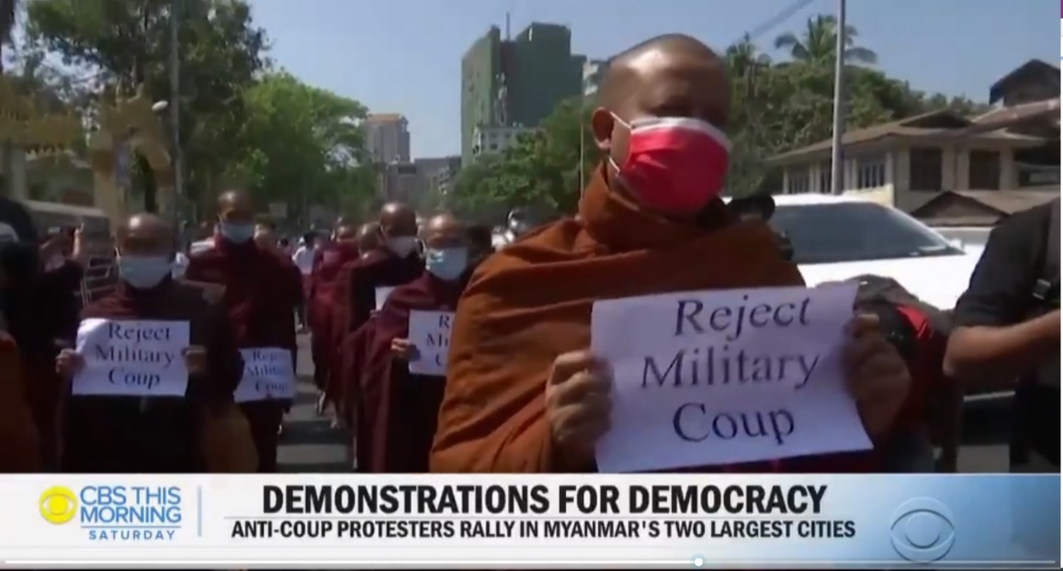
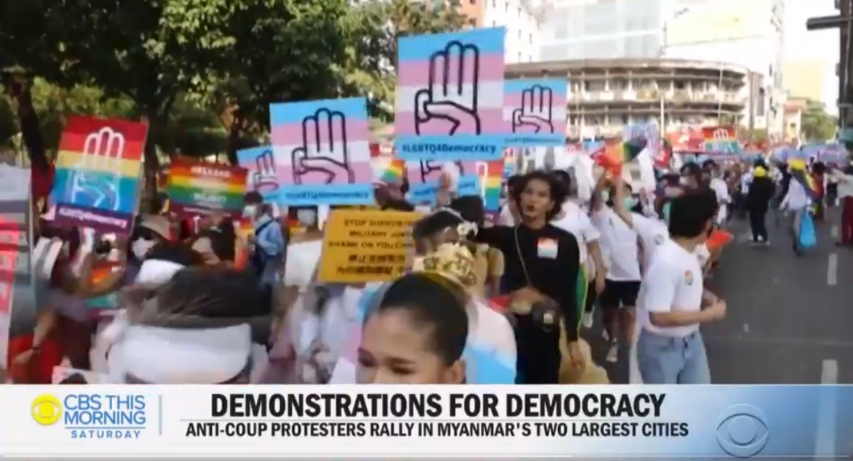
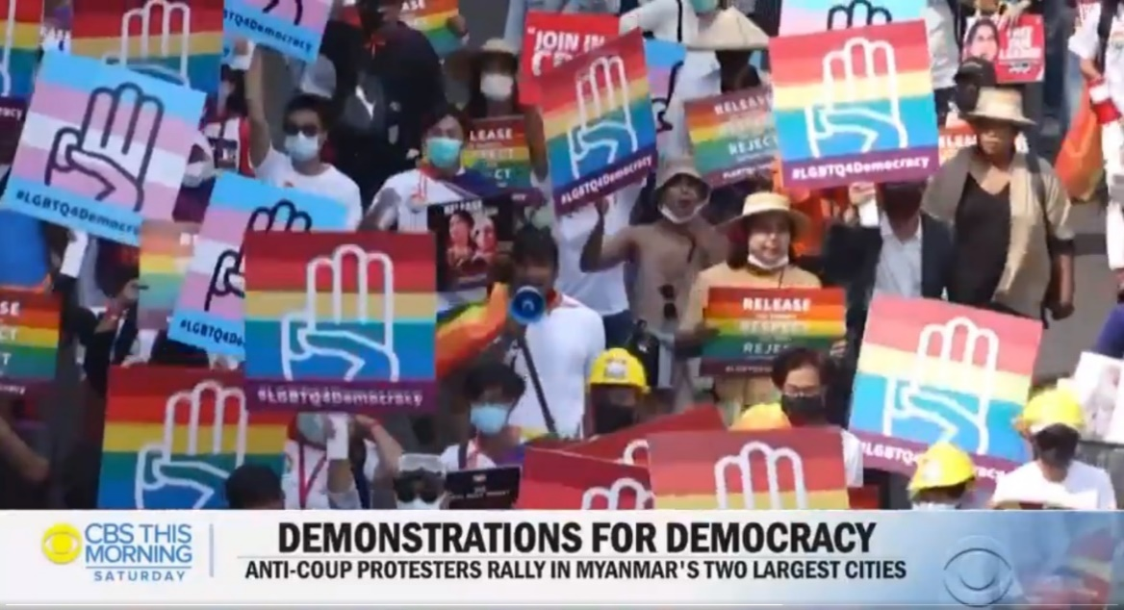
Back to Contents

Leadership and organisation of protests
    - An AP article noted that there was no leadership, instead describing it as simply ‘the Civil Disobedience Movement, a loosely organized group leading resistance to the army’s Feb. 1 [2021] takeover.’
    - According to the International Crisis Group’s Senior Adviser, Richard Horsey, ‘This is a leaderless movement. It is a spontaneous reaction. The vast majority of the population is against the coup and wants to show that they are against it. Clearly there are some very intelligent, politically connected and committed people involved, but the protests and civil disobedience are not led by the NLD, or a fixed committee of people, or a labour movement, or a charismatic union leader. Instead, many different groups of people have converged on the same ideas, often in chat rooms or on Facebook.’
Back to Contents

Symbols of the protests: red-coloured displays
    - A 7 February 2021 Voice of America (VOA) article noted ‘crowds in the biggest city, Yangon, sported red shirts, red flags and red balloons, the color of Suu Kyi’s National League for Democracy Party (NLD).’. Joyce Karam, Senior Correspondent at the National (@TheNationalNews) – whose Twitter bio describes itself as ‘the UAE and Middle East's premier news source, with top stories, special features and more’ – and Adjunct Professor at George Washington University also explained in a tweet on Sunday 7 February that ‘Red flags are of [Aung San Suu Kyi’s] NLD party ….’
    - Reuters updated timeline of events on 7 February 2021 also noted the wearing of red ribbons as part of the civil disobedience campaign.
Back to Contents

Symbols of the protests: the “Hunger Games” films salute
    - A 3 February 2021 article by the New York Times also included a picture showing ‘Doctors at one hospital posed together, each with three fingers raised in a defiant salute from the “Hunger Games” films.’
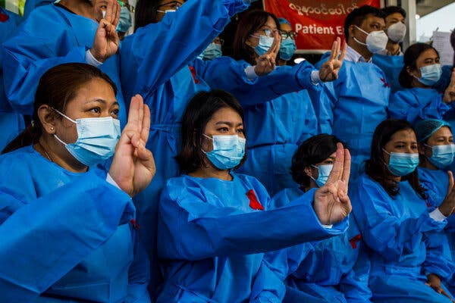
    - A 7 February 2021 article on Voice of America also included the following picture of people showing the three-finger salute
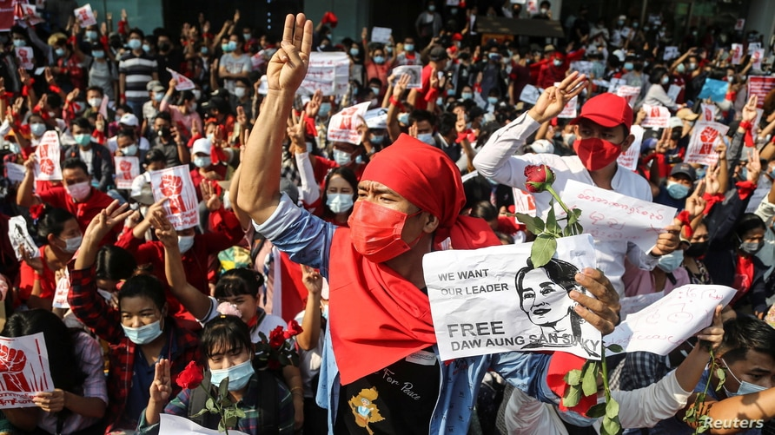
    - Joyce Karam explained in a tweet on Sunday 7 February 2021 that the ‘… Salute is of “resistance” inspired by Hunger Games.’
    - A 17 February 2021 article by three artists from Yangon explained ‘We take selfies of our three fingers raised – a sign of rebellion against the military coup. Once a symbol of dissent in The Hunger Games (2012); now a sign of our revolution against military dictatorship.’
    - A 15 February 2021 article in the Indian Express explained the origins: ‘The gesture, which traces its origins to the Hunger Games books and movies by Suzanne Collins, was first used by medical workers in Myanmar protesting against the coup. It was then adopted by youth protesters, and subsequently was seen at the massive protests in Yangon on Monday, a week after the forceful takeover.’
Back to Contents

Symbols of the protests: broken down car ‘blockades’
    - A Guardian article of 17 February 2021 explained how ‘Major junctions were blocked by a “broken down” rally, where drivers left their cars parked across the roads, with bonnets open, and by sit-down protests.’
    - On 18 February 2021, the BBC explained how on Wednesday 17 February ‘Drivers in Yangon staged a break-down protest, blocking key roads as loosely-organised civil disobedience grew.’
    - The same article added that ‘Wednesday's rallies nearly paralysed traffic in central Yangon (Rangoon). A campaign on social media calling for protesters to deliberately block roads in the country's main city started gaining traction early on Wednesday. Its aim was apparently to stop civil servants from going to work and hinder the movements of security forces.’
    - Photos from social media users show the extent:
Photo 1,
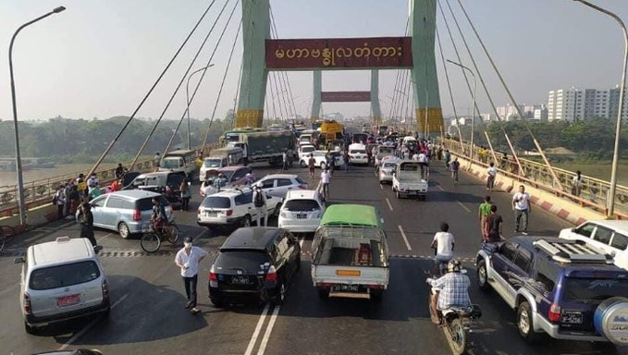
Photo 2
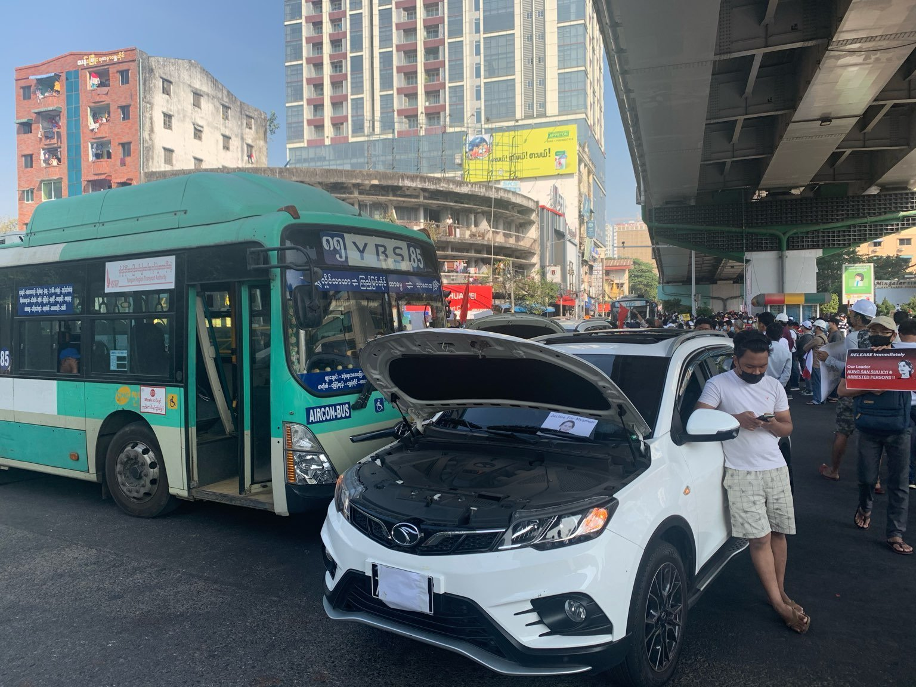
Photo 3
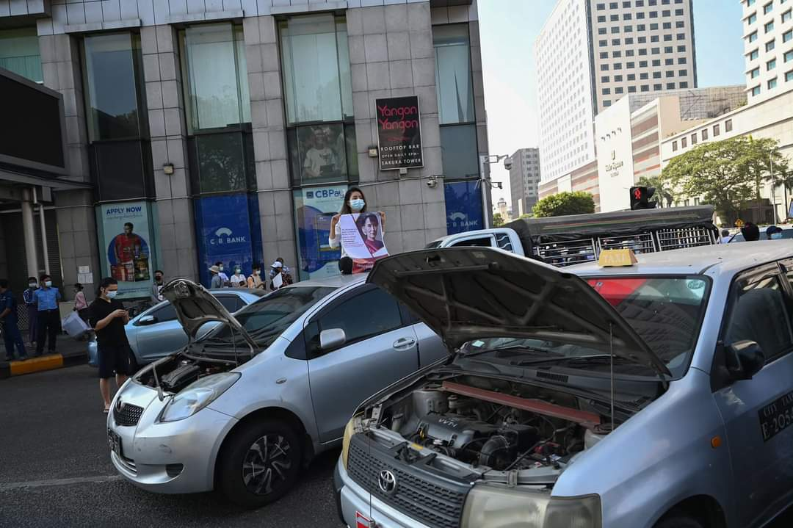
Back to Contents

Section 5 updated: 28 February 2021

State response to protests

Internet blocks
    - At 14:28 (UK time) on 1 February, internet supplier Telenor tweeted to explain ‘There have been disruptions in our network in some areas due to the ongoing situation in #Myanmar. @Telenor_mm is working to fully restore connectivity for our customers as soon as possible.’
    - A 2 February 2021 blog written by Peter Guest, enterprise editor for RestofWorld claimed that ‘Phone networks around the capital, Naypyidaw, and the largest city, Yangon, went down at around 3 a.m., and TV stations went off the air.’ Although the same blog post noted ‘The internet was sporadically available throughout the day of the coup. Mobile data services were very unreliable, but some people found their ISPs still operating and were able to connect to Wi-Fi at home and in offices.’. BBC also reported that there had been an internet blockage.
    - Joyce Karam’s tweet on Sunday 7 February 2021 referenced a ‘social media crackdown.’. A Bloomberg article of 4 February 2021 noted that ‘Myanmar’s military-run government has ordered internet service providers to temporarily block access to Facebook’, and a further 6 February 2021 article also reported that ‘Myanmar’s military-run government … ordered service providers to block Twitter and Instagram’. The BBC also reported on the military’s blocking of Facebook on Wednesday 3 February 2021 and added that ‘The authorities have said blocks on Facebook will remain in place until 7 February.’
    - At 09:49 (UK time) on 6 February, internet supplier Telenor tweeted to explain ‘Internet in #Myanmar is temporarily shut down by order of MoTC.’ A subsequent tweet at 08:02 (UK time) on 7 February explained that ‘Internet services from @Telenor_mm have now been restored in #Myanmar.’
    - The website Netblocks, which describes itself as ‘an internet monitor working at the intersection of digital rights, cyber-security and internet governance’, showed the following pictures to illustrate that:
‘Network data from the NetBlocks Internet Observatory indicate the onset of widespread internet disruptions in Myanmar on Sunday 31 January 2021 (UTC) amid reports of a military uprising and the detention of political leaders including Aung San Suu Kyi.
‘The telecommunication disruptions beginning approximately 3:00 a.m. Monday morning local time have significant subnational impact including the capital and are likely to limit coverage of events as they take place. Continuing disconnections have been monitored with national connectivity falling initially to 75% and subsequently 50% of ordinary levels by 8:00 a.m. local time.’
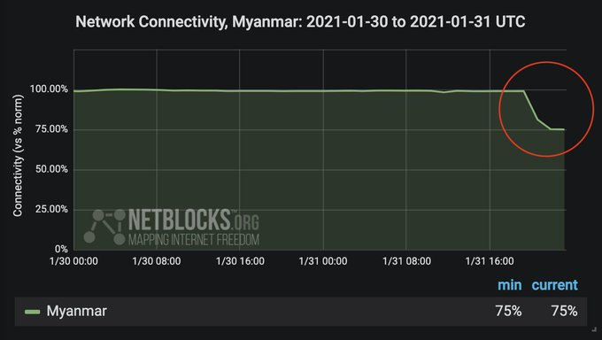
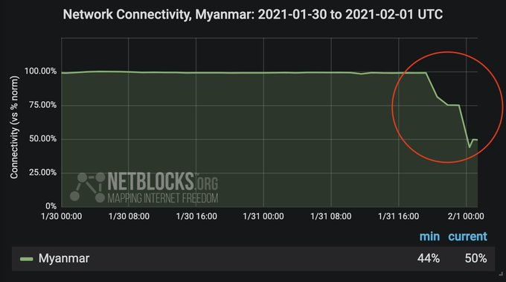
    - The BBC also referenced the work of Netblocks (above) and further explained that ‘Some parts of Myanmar … were more restricted than others’ and that ‘By midday on Monday, internet connectivity had returned to 75% of normal activity.’
    - See Netblocks’ more detailed report for the full extent of internet outages.
    - Internet outages have reportedly continued nightly for more than two weeks, since 15 February, between the hours of 01:00 (18:30 GMT) and 09:00 (02:30 GMT). There has been widespread speculation as to the purpose of the nightly internet black-outs. The Diplomat, an international online news magazine, and Al Jazeera, reporting on the internet blocks, highlighted one theory behind the blackouts to be that the government is installing a firewall system that provides the ability to intensely monitor most, or all, online activity.
    - The UN Special Rapporteur on the situation of human rights in Myanmar, Thomas H. Andrews, reported that 'The SAC is severely restricting the people of Myanmar’s freedom of expression and attempting to disrupt the CDM and the flow of information to civil society through a series of Internet shutdowns.
‘Since 15 February, the junta has enforced curfew-style nationwide Internet blackouts from 1am to 9am daily. National connectivity during these nightly blackouts hovers around 12 to 14 percent of regular daytime levels, as some Mytel users and select virtual private networks (VPNs) report Internet access. These shutdowns provide impunity for security forces carrying out arrests and violent crackdowns throughout the night, and inhibit lawful community organizing. At the time of writing, the junta has disabled Internet access nationwide for the fifteenth consecutive night. While the Internet is typically restored in full after 9 am, daytime restrictions on social media and certain websites, such as Wikipedia, continue to increase.’
Back to Contents

Use of excessive violence and lethal force against protestors
    - The Frontier Myanmar site; a Yangon-based news magazine focusing mainly on local politics, in a running stream of events, noted in an update at 5:45pm (local time) on 8 February 2021 that ‘protests have wound down largely without incident in Yangon, despite a tense standoff at Hledan Junction between tens of thousands of protesters and around 100 police manning a barricade at the entrance to University Avenue.’ And that ‘In downtown Yangon, a few hundred protesters were still active around 5pm at City Hall, chanting directly at police on the opposite side of a barricade.’
    - However, the Frontier Myanmar site’s live updates also noted that, in Mandalay and Naypyidaw, ‘police fired water cannon, tear gas, rubber bullets.’ and ‘This evening, videos on social media showed police in Mandalay leaving their barricades and rushing demonstrators on 38th Street, hitting them with their batons.’. Reuters also noted that on that day ‘Three other people were being treated for wounds from suspected rubber bullets after police fired guns, mostly into the air, and used water cannon to try to clear protesters in the capital Naypyidaw.’
    - The same Reuters article added ‘State television reported injuries to police during their attempts to disperse protesters - its first acknowledgement of the demonstrations taking place in the country.’ This appeared to follow a tweet they issued earlier in the day of a video showing both the police allegedly firing into the air and protestors subsequently throwing stones and other missiles against the police barricade.
    - The same Frontier Myanmar article also reported the potential use of live rounds of ammunition by the police against protesters and specifically added that ‘A woman aged around 20 is in intensive care after being hit by what appears to be a live round in Nay Pyi Taw.’ Reuters also noted that ‘a doctor said one woman was unlikely to survive a gun wound in the head.’
    - On 10 February, Reuters noted that ‘There were no reports of violence on Wednesday and in many places protests took on a festive air, with bare-chested body builders, women in ball gowns and wedding dresses, farmers on tractors and people with their pets.’ In an update of 7pm (local time) on 10 February 2021, Frontier Myanmar’s live updates of the protest also noted that ‘the situation in both Mandalay and Nay Pyi Taw today has been a lot less tense than [the preceding day].’
    - On 12 February 2021, the BBC reported that ‘the protests continued on Friday. They remained mostly peaceful, although Radio Free Asia footage showed police charging at protesters in the city of Mawlamine. A Red Cross official told Reuters three people were injured by rubber bullets.’ Channel News Asia reported that, on Friday 12 February ‘Officers cleared a sit-in protest by university students in the port city of Mawlamyine on Friday with rubber bullets, injuring several demonstrators.’
    - On 19 February, a video shared on social media appeared to show a soldier firing a catapult at people fleeing a police charge in Myitkyina.
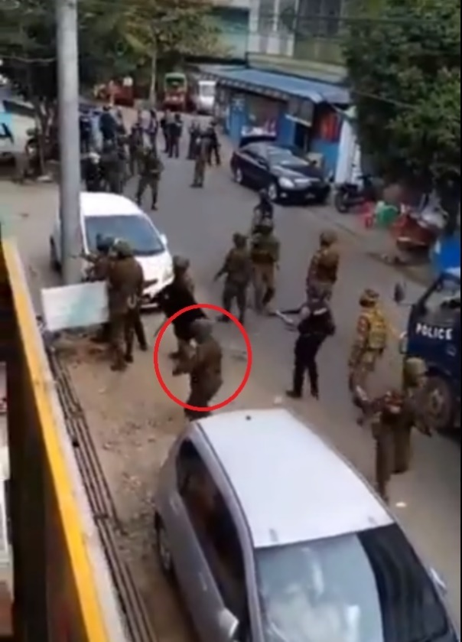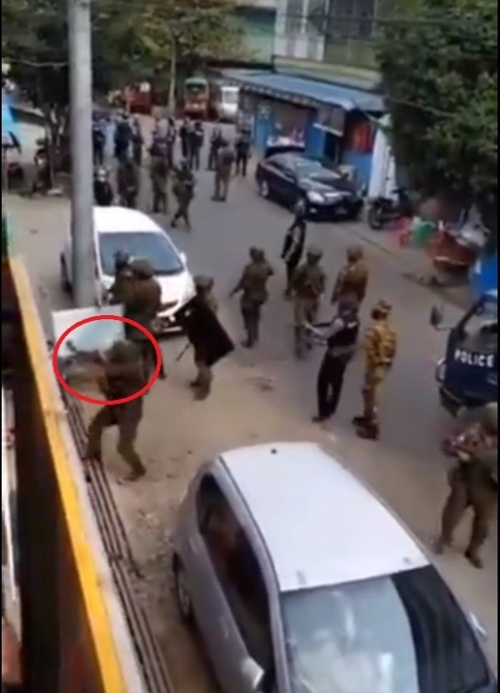
    - On 21 February 2021, Al Jazeera noted the state’s differing approach to protests in Yangon as opposed to elsewhere. It reported ‘The country’s biggest city, Yangon, has seen the biggest protests with hundreds of thousands taking to the streets, but so far there has been no violent crackdown on demonstrations there. It has been a different story in Mandalay and other parts of Myanmar, where police and soldiers are using increasingly violent methods to snuff out protests.’
    - On 26 February 2021, Myanmar Now reported that ‘Security forces attacked peaceful anti-coup protesters in Myanmar’s three biggest cities on Friday [26 February], firing guns, tossing stun grenades and swinging batons at fleeing crowds.’ The article described it as ‘the severest use of force yet against protesters in Yangon, where police and soldiers had been relatively restrained compared to other parts of the country.’
    - On 28 February 2021, Al Jazeera and the NY Times both cited ‘credible information received by the UN Human Rights Office’ to report that at least 18 people were dead and over 30 wounded across the country. This appeared in a tweet from UN Human Rights Asia’s account. The Associated Press cited The Democratic Voice of Burma as reporting ‘19 confirmed deaths in nine cities, with another 10 deaths unconfirmed’. Social media users circulated the following infographic,, which put the figure of those killed at as many as 26 across 8 different locations in the country.
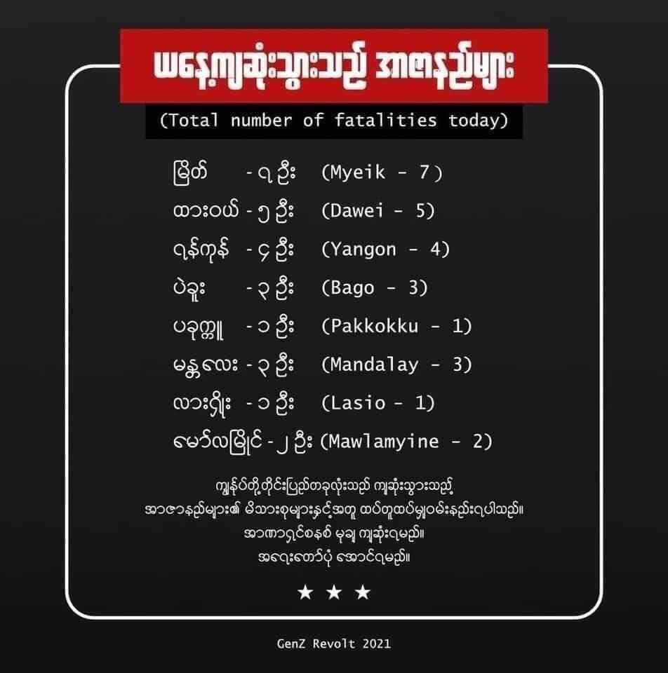
    - An Al Jazeera article added that on 28 February 2021, ‘Police were out in force early and opened fire in different parts of Yangon after stun grenades, tear gas and shots in the air failed to break up crowds in Myanmar’s largest city. Soldiers also reinforced police.’
    - The NY Times article reported ‘In the southern city of Dawei, the police opened fire on a crowd of hundreds, witnesses told The New York Times. At least three people were killed and more than 50 wounded, said Dr. Tun Min, who was treating the injured at a hospital. A second doctor, who asked not to be named for fear of retaliation, confirmed those numbers.’ and ‘Doctors in Mandalay confirmed three fatal shootings there, and killings also took place in Yangon and the city of Mawlamyine, The New York Times was able to confirm.’
    - Nikkei Asia reported that ‘In Mandalay, several thousand people took to the streets on Sunday morning, and violent clashes were reported between police and crowds. Violence between security forces and protesters was also reported in ethnic-dominated areas including Hpa-an and Myawaddy in Kayin state, Lashio and Taunggyi in Shan state, Myitkyina in Kachin state and Mawlamyine in Mon state.’
    - The UN stated that in the week beginning 1 March at least 54 people have been killed in the protests, with hundreds more wounded and that they have received confirmed reports that many of those who died were killed by live ammunition
    - Amnesty International found that ‘The Myanmar military is using increasingly lethal tactics and weapons normally seen on the battlefield against peaceful protesters and bystanders across the country […] Amnesty International’s Crisis Evidence Lab can confirm that security forces appear to be implementing planned, systematic strategies including the ramped-up use of lethal force. Many of the killings documented amount to extrajudicial executions […] Further analysis of photos and videos show that the military units involved in this lethal repression include the Yangon Command, Northwestern Command, and the 33rd, 77th and 101st Light Infantry Divisions (LID), often operating alongside – and sometimes lending their weapons to – police officers’.
    - The UN Special Rapporteur on the situation of human rights in Myanmar, Thomas H. Andrews, reported that in the aftermath of the coup, ‘the junta began committing human rights violations, including murder, arbitrary detention, beatings, and probable enforced disappearances. The SAC also instituted laws and policies to suppress freedom of expression, freedom of peaceful assembly and association, and the right to privacy. The coup completely overturned the rule of law in Myanmar.’
    - He further stated:
‘Since 1 February [2021], the junta arbitrarily detained over 1,200 individuals and killed at least twenty-three people. At the time of writing, violent confrontations and arbitrary detentions are increasing at an alarming rate. Facing an economy shrivelling under the weight of a powerful civil disobedience movement, Min Aung Hlaing threatened striking civil servants with “disciplinary actions” if they failed to return to work. The people are undeterred.
‘These most recent killings demonstrate that Myanmar forces are now engaging in systematic murders throughout the country. Security forces in disparate locations are unlikely to have engaged in these murders on the same day without express approval of the seniormost leadership of the junta, including Min Aung Hlaing. As investigations are conducted, liability should extend to those highest in the chain of command in accordance with international law.’
    - The UN Commission for Human Rights noted during a press briefing note on 16 March 2021:
‘The death toll has soared over the past week in Myanmar, where security forces have been using lethal force increasingly aggressively against peaceful protesters, and continue to arbitrarily arrest and detain people throughout the country. Deeply distressing reports of torture in custody have also emerged. Hundreds of people who have been unlawfully detained remain unaccounted for and have not been acknowledged by the military authorities, and this amounts to enforced disappearances.
Confirming information is becoming increasingly difficult, particularly with the imposition of martial law in a number of townships in and around Yangon and in Mandalay, but also because many of the working class neighbourhoods where people have been killed and displaced are easier to cut off through State-imposed communication blackouts.
We have, however, managed to confirm that at least 149 people have been arbitrarily deprived of their lives since 1 February, as a result of unlawful use of lethal force against peaceful protestors in Myanmar. Of these, at least 11 were killed on Monday, and 57 over the weekend. There are many more reports of further killings that we have been not been able to corroborate yet.’
    - On 26 March 2021, New Delhi Television Limited (NDTV), an Indian news media company, reported that:
‘Myanmar's military junta warned that its forces would shoot protesters in the head, state television said, as anti-coup activists called for a huge show of defiance on the country's Armed Forces Day on Saturday.
In the first acknowledgement of a shoot-to-kill order by the army, a broadcast on the MRTV news channel directed at protesters said: "You should learn... that you can be in danger of getting shot to the head and back."
At least 320 people have been killed in weeks of unrest since the military seized power on February 1, according to figures as of Thursday night from the Assistance Association for Political Prisoners (AAPP) activist group.’
    - On 26 March 2021, The Guardian reported that the same day, three anti-junta protesters were shot after the military opened fire on crowds waving flags in Myeik. Two of the casualties were reportedly shot in the head.

Back to Contents

Police defections
    - The BBC has spoken to several police men and women who have left Myanmar for India. The police officers, from both large and small cities, claim that they were ordered to shoot at protestors and feared for their own safety if they refused. The BBC noted that it had been unable to independently verify these people’s accounts.
Back to Contents

Monitoring
    - Human Rights Watch highlighted in March 2021:
‘The Myanmar military junta’s access to a new public camera system equipped with facial recognition and license plate recognition technology poses a serious threat to basic rights in the country, Human Rights Watch said today. Increased surveillance abilities through artificial intelligence technology are a heightened concern after the February 1 military coup, as the junta has increasingly used deadly force against protesters and others expressing opposing views.
‘On December 14, 2020, Myanmar authorities rolled out the first phase of its “Safe City” initiative and started using a system of 335 surveillance cameras in eight townships in the capital, Naypyidaw. The cameras, from the technology company Huawei, come installed with artificial intelligence technology that automatically scans faces and vehicle license plates in public places and alerts authorities to those on a wanted list. Myanmar’s Safe City plan envisions similar systems in Mandalay by mid-2021, and later, in Yangon, the commercial capital.’
Back to Contents

Legal restrictions and curfews
    - The Frontier Myanmar site’s live updates also reported that ‘All of urban Mandalay and parts of Yangon are subject to a section 144 order that puts in place an 8pm and 4am curfew and bans gatherings of five or more people. Those caught violating the order face up to six months in prison.’
    - Voice of America (VOA) noted on 8th February 2021 that ‘ the military announced an 8 p.m. to 4 a.m. curfew would be imposed in the cities of Yangon and Mandalay.’. The Associated Press (AP) reported the same, adding this ban included ‘motorized processions’.
    - On 9 February 2021, the Myanmar Times noted the restrictions on explained how this had extended to ‘a total of 90 townships in 30 cities’ which included all 44 townships in Yangon. It added that ‘Other areas affected include Nay Pyi Taw, Lewe, Tatkone, Zeyar Thiri, Mandalay, Magwe, Sagaing, Monywa, Shwebo, Kalay, Waingmaw, Bamaw, Mokaung, Shweku, Monyin, Hpakant, Loikaw, Mawlamyine, Thanphyu Zayat, Ye, Kyaikhto, Kengtung, and Taunggyi.’
    - The same article also noted that this ‘did not deter protestors from taking to the streets, and more were seen out demonstrating across Myanmar the day after the ban.’
    - In a separate article on 8 February 2021, the Myanmar Times noted:
‘An 8pm-4am curfew has been imposed in seven townships in Mandalay - Aung Myay Tharzan, Maha Aung Myay, Amarapura, Patheingyi, Pyigyitakon, Chan Aye Tharzan and Chan Myay Tharzi, effective February 8 in what appears to be efforts to contain protesters who have taken to the streets for the third consecutive day.
‘The list of townships under curfew was later expanded to include San Chaung, Dala, Shwe Pyi Thar and Kamayut townships in Yangon Region, Shwe Bo, Monywa, Sagaing, Kalay townships in Sagaing Region, Bago township in Bago Region, Myaungmya township in Ayeyarwady Region and Phar Song township in Kayah State.
…
‘Other cities and divisions of Mandalay such as Myingyan, Monywa, Shwebo and Sagaing have also received similar orders.’
Back to Contents

Changes to privacy laws and impact on arrest procedures
    - On 13 February 2021, Reuters reported:
‘An order signed by military ruler General Min Aung Hlaing suspended three sections of laws “protecting the privacy and security of the citizens”, which had been introduced during the gradual liberalisation.
‘Those sections include the requirement for a court order to detain prisoners beyond 24 hours and constraints on security forces’ ability to enter private property to search it or make arrests. The suspensions also free up spying on communications.
‘The statement gave no specific end date.’
    - On 14 February 2021, the Irrawaddy reported that ‘the military regime has suspended laws to allow the authorities to arrest citizens and search private properties without a warrant.’
    - The same Irrawaddy report added:
‘The authorities are now allowed to enter into private properties to search, seize evidence and arrest without a warrant.
‘Private messages can be intercepted and the authorities can demand personal telephonic and electronic communications data from telecoms providers. The military regime also suspended the requirement for a court to approve the seizure and destruction of possessions and property.
‘The authorities can now open, search, seize or destroy private correspondence, which was previously prevented by the Privacy Law.’
    - On 14 February, Myanmar Times explained that:
‘The newly formed Myanmar State Administration Council (SAC), headed by the Tatmadaw Senior General Min Aung Hlaing, has enacted Law No 4/2021, which involves amendments to existing privacy protection laws.
‘The Amendment of Law Protecting the Privacy and Security of the Citizens revokes sections 5,7 and 8 of the law under Article 420 of the State Constitution. This allows the Commander-in-Chief of the Defence Services to temporarily restrict or suspend the fundamental rights of citizens, until power is transferred to a newly elected government.
‘… the law allows authorities to enter private residences without warrants for search and arrest purposes and detain people for more than 24 hours without permission from court.’
    - On 14 February, Kyodo News also reported on this but explained the effect of the changes as being ‘The law banned detention without court approval and made it necessary to obtain a court-issued warrant to search private property or seize communications data and private mail.’
    - Human Rights Watch highlighted: ‘Myanmar’s State Administration Council (SAC), appointed by the country’s military after it overthrew the elected civilian government on February 1, 2021, has dictated key revisions to the country’s legal system that criminalize even peaceful protests, and enable violations of the right to privacy and arbitrary arrests and detention. The changes were made through orders signed by the Commander-in-Chief, Sr. Gen. Min Aung Hlaing, on behalf of the SAC, and outside the parliamentary process.’ The same report particularly noted the following legal changes:
- arbitrarily suspended sections of the Law Protecting the Privacy and Security of Citizens (2017), removing basic protections, including the right to be free from arbitrary detention and the right to be free of warrantless surveillance and search and seizure;
- amended the Penal Code to create new offenses and expand existing offenses to target those speaking critically of the coup and the military, and those encouraging others to support the “Civil Disobedience Movement,”
- amended the Ward and Tract Administration Law to reinstate the requirement to report overnight guests;
- amended the Code of Criminal Procedure to make the new and revised offenses non-bailable and subject to warrantless arrest; and
- amended the Electronic Transactions Law to prevent the free flow of information and criminalize the dissemination of information through cyberspace, including expression critical of the coup or the acts of the junta.
Back to Contents
Section 6 updated: 28 February 2021

Arrests

Arrests: numbers
    - On 19 February 2021, Reuters tweeted the following infographic based on figures from The Assistance Association for Political Prisoners (Burma) (AAPP), a Thailand and Myanmar-based human rights organization, and what Reuters describe as their own reporting to show the breakdown of who had been arrested as of 17 February.
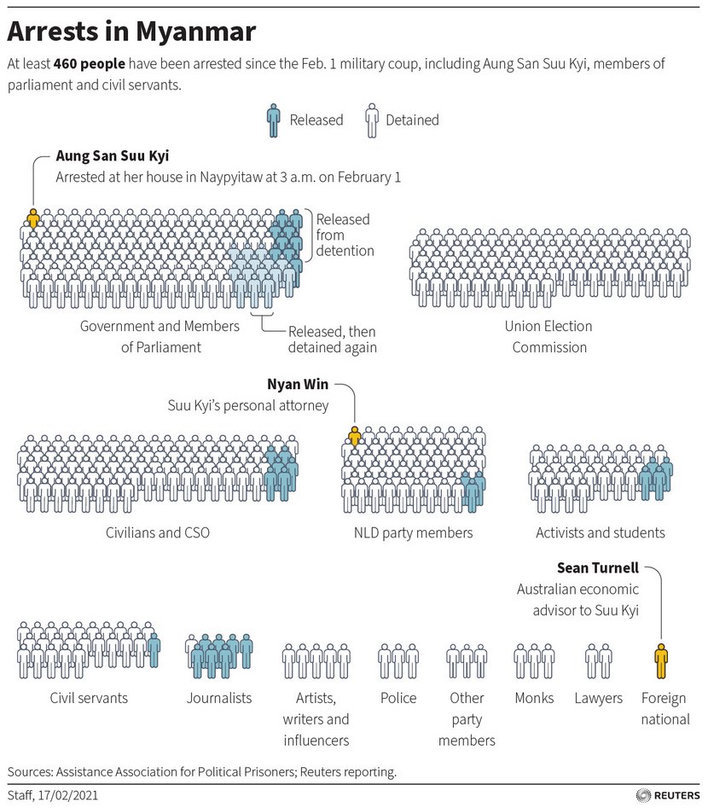

    - On 25 March 2021, the AAPP posted the following infographic with an update of those arrested as of 25 March 2021.
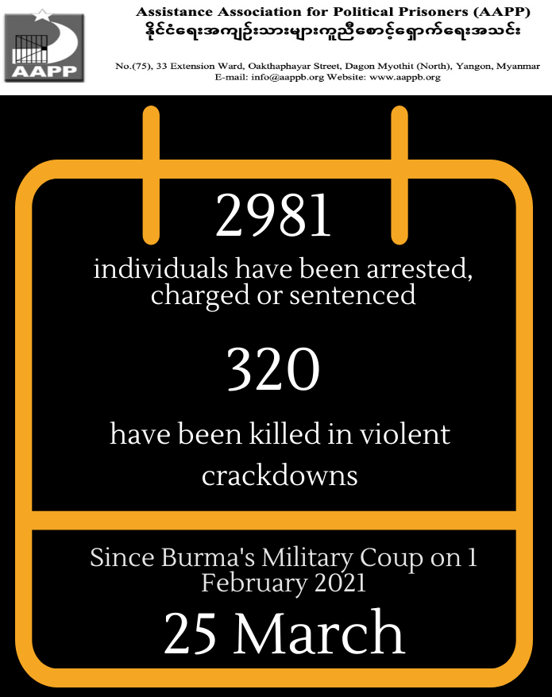
    - For more detail on the specific groups or profiles of those arrested, see the sub-sections below. The AAPP’s website also includes updated daily lists of persons it claims have been arrested, see: https://aappb.org/.
    - The UN News agency reported on 8 March 2021 that according to the Office of the High Commissioner for Human Rights (OHCHR) over 1,700 people have been arbitrarily arrested and detained. On 26 February 2021 UN human rights experts ‘expressed concern that at least 700 people had been detained since the coup, including high-profile leaders of the civilian government. Some are being kept under house arrest with no outside contact and in most cases their whereabouts are unknown. The lack of official charges or acknowledgement of detention is also disturbing, they said.’
    - The UN News agency reported on 8 March 2021 that according to the Office of the High Commissioner for Human Rights (OHCHR) over 1,700 people have been arbitrarily arrested and detained and that those detained included ‘members of parliament, political activists and election officials, authors, human rights defenders, teachers, healthcare workers, civil servants, journalists, monks, and celebrities. However, the actual number of those detained is likely to be much higher, given that demonstrations are reported to have taken place in 537 locations throughout the country where monitoring developments has not always been possible.’
    - AAPP reported on 25 March 2021 that as many as 2981 people have been arrested, charged or sentenced in relation to the protests as of that day.
Back to Contents

Arrests of NLD figures
    - On 5 February 2021, Channel News Asia (CNA) cited National League for Democracy (NLD) press officer Kyi Toe as saying that ‘as far as [they] knew, [Aung San Suu Kyi] was under house arrest’ and that they had ‘learnt that […she was] in good health (in Naypyidaw)’. On 9 February 2021, The Associated Press (AP) also reported that she was ‘now back under house arrest.’. On 28 February 2021, Nikkei Asia reported that ‘her [Aung San Suu Kyi] whereabouts are unknown, and she has been unable to meet her lawyer, although she made an appearance by video link at the first hearing [of her trial] held on Feb. 17.’
    - Reuters reported that Aung San Suu Kyi was charged with additional criminal offences on 1 March in a further court hearing via video link. Her lawyer commented that she ‘looked healthy’.
    - The charges levelled against Aung San Suu Kyi were initially ‘illegally importing six walkie-talkie radios’ and ‘violating a natural disaster law by breaching coronavirus protocols’. Her lawyer said that the two added subsequently were one under a section of a colonial-era penal code banning publication of information that may ‘cause fear or alarm’, the other under a telecommunications law stipulating licences for equipment.
    - CNA noted on 5 February that ‘So far, at least 14 activists and prominent pro-democracy figures have been arrested, according to AAPP [Assistance Association for Political Prisoners (AAPP), a Yangon-based group that monitors political arrests in Myanmar]’ who were also cited in the article as having claimed that ‘more than 130 officials and lawmakers have been detained in relation to the coup.’. However, on 9 February 2021, The Associated Press (AP) also cited the AAPP as saying that ‘165 people, mostly politicians, had been detained since the Feb. 1 coup, with just 13 released.’.
    - On 8 March 2021, Reuters reported that Khin Maung Latt and Zaw Myat Linn, both NLD officials, have died whilst in police custody after being arrested just days ago. Their cause of death remains unknown.
    - The UN Special Rapporteur on the situation of human rights in Myanmar, Thomas H. Andrews, reported that the following specific group was targeted for arbitrary detention:
‘The NLD: State Counsellor Aung San Suu Kyi, President Win Myint, and nearly the entire NLD Central Executive Committee are believed to be detained. Reportedly, both the State Counsellor and President appeared before a court via video link on 16 February and 1 March. Aung San Suu Kyi has been charged under the Natural Disaster Management Law for allegedly violating Covid-19 restrictions while campaigning, under the Import-Export Law for possession of walkie-talkies, possession of an unlicensed telecommunication device under Section 67 of the Communications Law, and under Section 505 (b) of the Penal Code for inciting unrest. Win Myint has been charged under the Natural Disaster Management Law and under Section 505 (b). The next hearing for both is reportedly set for 15 March. Numerous other NLD figures have been charged, some appearing at secret hearings before a judge without access to legal representation. Myanmar police have also carried out night raids on the NLD’s offices and headquarters, including on 9 February, confiscating its computer system. The junta is working to systematically dismantle the NLD leadership and party.’
Back to Contents

Arrests of protestors
    - Reuters updated timeline of events on 7 February 2021 reported that the first street protests began in Mandalay on Thursday 4 February 2021 and that ‘at least three’ were arrested.
    - On 5 February 2021, Channel News Asia (CNA) reported that:
‘Police in Mandalay, Myanmar's second largest city, detained more than 20 people for banging pots and pans. They were sentenced on Friday [5 February 2021] to seven days in prison for violating a public disorder law.
‘Another four university students from Mandalay, arrested at a small rally were charged on Friday for protesting without permission and breaking coronavirus rules.’
    - Joyce Karam tweeted on Sunday 7 February that ‘Thousands protesting in #Myanmar today against the Military coup. Biggest protests yet despite continued detentions & social media crackdown.’. However, it was unclear whether this was detention of protestors, or the detention of Aung San Suu Kyi, President Win Myint and other senior figures from their National League for Democracy (NLD) (see Arrests of NLD figures).
    - On 10 February 2021, Reuters noted that ‘U.N. human rights investigator Thomas Andrews … said that “hundreds of arbitrary detentions” had been recorded since the coup.’
    - In an update of 7pm (local time) on 10 February 2021, Frontier Myanmar’s live updates of the protest noted that ‘About 200 people arrested at protests in Mandalay yesterday were freed this afternoon. They were held overnight by the Tatmadaw’s Light Infantry Battalion 119 before being taken to Patheingyi Township Court, where they were told to sign a pledge not to continue demonstrating.’
    - On 26 February 2021, Myanmar Now reported that ‘At least eight protesters [at a protest in Hledan Junction in Yangon] were arrested and detained at the Sanchaung police station.’
    - The UN Special Rapporteur on the situation of human rights in Myanmar, Thomas H. Andrews, reported that:
‘At the time of writing and, the junta has arbitrarily detained over 1,200 people since the beginning of the coup. Political prisoners include members of the NLD, Members of Parliament, UEC officials, political activists, civil society members, civil servants, journalists, lawyers, teachers, medics, students, and celebrities. The junta issued arrest warrants for at least 32 others who reportedly went into hiding. At the time of writing, the authorities convicted at least four of the 900 detainees and sentenced them to prison terms ranging from seven days to two years.
‘The police, military, plain-clothed authorities, and General Administration Department officers such as township and ward administrators have all carried out arbitrary detentions since the coup.
‘Security forces arbitrarily detained people during protests and from their homes during unlawful night-time raids without warning or warrant and sometimes blindfolded. Once detained, security forces confiscated phones, effectively cutting communications with family members, lawyers, or others. In the overwhelming majority of arrests, there is no indication of charges against detainees. The majority of the families of detainees received no information from the junta’s forces as to the wellbeing or whereabouts of their family members. Many of these detentions may thus amount to enforced disappearances.’
    - On 25 March 2021, AAPP reported that 2981 people overall have been arrested since the beginning of the coup.
Back to Contents

‘Night arrests’
    - On 13 February, Deutsche Welle (DW) described how ‘News of [night] arrests circulated widely on social media, including in memes captioned: "Our nights aren't safe anymore" and: "Myanmar military is kidnapping people at night."’. On 13 February, Reuters also published an article about this but described it as ‘reports of night raids’ rather than confirmation of such.
    - Searches via Twitter’s advanced search feature and Tweetdeck shows references to how the Myanmar military arrested people at night in the past, references to people being arrested for banging pots and pans as part of the early stages of the protests. The first such tweet about ‘night arrests’ appears to be at 11:44 (UK time) on 5 February and is in response to HRW Executive Director Kenneth Roth retweeting and commenting on an article by AP.
    - The next tweet referencing ‘night arrests’ or ‘arrests at night’ then appears to be at 16:12 (UK time) on 5 February, in response to what appears to be a random introductory tweet by a teacher in Seoul, South Korea but is followed by a replica to other accounts:
- Twice at 16:13 (UK time) on 5 February,
- 16:14 (UK time) on 5 February
- 16:16 (UK time) on 5 February
- 16:17 (UK time) on 5 February
- 16:24 (UK time) on 5 February
- 16:29 (UK time) on 5 February, this time in response to HRW Executive Director Kenneth Roth retweeting and commenting on an article by Reuters.
    - Night arrests continued into March 2021 . Similarly, Amnesty International noted in a statement delivered on 12 March 2021 that ‘Night raids on homes are being used to stoke fear…’.
    - Reuters reported on an overnight siege in Yangon on 8 March 2021. This had come to international attention after the United Nations had called on the military to allow the youths to leave the area in safety: ‘Overnight, police arrested about 50 people who had been cornered by security forces in a district of Yangon, a rights group said. But hundreds managed to escape the encirclement after crowds of demonstrators rallied in their support in defiance of a night-time curfew.’.
Back to Contents

Neighbourhood night patrols
    - On 13 February 2021, Channel News Asia reported ‘People in Yangon skirted a junta ban on Facebook to organise neighbourhood watch groups that warned of rumoured arrests. They signalled calls to gather outside buildings by banging pots and pans - a nightly phenomenon in the days after the coup that is traditionally associated with driving out evil.’
    - On 14 February, the Irrawaddy explained ‘Residents of Myanmar’s major cities have organized night-time vigilante groups to deter thugs and mobs rumored to have been dispatched by the junta to create community disturbances at a time the whole country is reeling from a week-long anti-coup protest.’.
    - A 14 February article on Arab News described how ‘Widespread fear and panic among Yangon residents and elsewhere in Myanmar has become the norm since the military’s coup on Feb. 1.’ which had led to neighbourhoods ‘patrolling in groups to “protect themselves” at night.’
    - A 15 February article on France24 also noted ‘Reports have so far been difficult to verify, but more neighbourhoods are mobilising to guard against intruders.’
    - Frontier Myanmar reported on how ‘An avalanche of disinformation, misinformation and dangerous rumours has circulated on new platforms and mediums since the coup, and the junta’s internet restrictions have only stoked the fires of falsehood.’ and gave a the specific example of how the commuting of sentences and release of around 23,000 prisoners – done regularly as part of Union Day on 12 February – had caused social media to go ‘… into overdrive with rumours of recently released prisoners being drugged up and dropped off in Yangon neighbourhoods to cause mayhem. But was this really happening? Certainly, many people seemed to think so, but little concrete evidence to support this narrative has emerged.’
    - A 14 February article on Myanmar Times claimed that:
‘a recent spate of crimes including arson have been reported at numerous wards in Yangon during curfew hours. Some of these have coincided with the release of 23,000 prisoners from Insein Prison by the military on the same day.
‘The Myanmar Times reporters noted that members of the public have resorted to setting up their own community security teams to ensure the safety of each ward.
‘The community security teams have reported the arresting of two to four strangers in every ward in Yangon, as well as in other states.’
    - The UN Special Rapporteur on the situation of human rights in Myanmar, Thomas H. Andrews, reported that in the aftermath of the coup:
‘So-called “neighborhood watch” committees have sprung up throughout Myanmar based on the well-founded fear of assaults and criminal activity by suspected junta proxies and police-led night-time raids and arbitrary arrests. Neighbors share intelligence on movements of soldiers and police, as well as the presence of unknown individuals. When residents spot police or possible proxies in their neighborhoods, residents bang pots and pans to warn their neighbors.’
Back to Contents

Arrests of election officials
    - On 11 February 2021, the Irrawaddy newspaper reported that:
‘Myanmar’s military regime has rounded up dozens of officials of the ousted government’s Union Election Commission (UEC) for questioning, making good on its vow to investigate what it claims was mass electoral fraud in the November poll.
‘On Wednesday and Thursday, many UEC officials at the state, regional, district and township levels in Rakhine, Ayeyarwady and many other parts of the country were taken away from their homes. UEC offices have been sealed off by police since last week.
‘The exact number of officials rounded up is not yet available, but is believed to be in the dozens.’
    - A 11 February 2021 article on Myanmar now reported that the military had requested election data from the UEC but made no references to arrests or detentions. It noted that ‘While it was not clear what the military intended to do with the data it requested, Gyi Myint [a lawyer who has been following the ongoing dispute] suggested that its broader goal was to weaken the authority of the UEC.’
Back to Contents

Arrests of journalists
    - On 26 February, Myanmar Now reported that ‘Security forces also targeted journalists who were covering the protests [in Yangon] and ensuing crackdowns.’, adding ‘Two local journalists were also briefly detained at the [protest in Hledan Junction in Yangon]. Wai Yan, who works for the Xinhua News Agency, told Myanmar Now he was detained while photographing the crackdown from behind the line of police officers.’
    - On 28 February 2021, the Associated Press reported that one of their journalists had been taken into police custody on Saturday morning while providing news coverage of the protests.
    - Reporters Without Borders stated in March 2021 its dismay ‘by the sudden intensification of the ruling junta’s crackdown on journalists’ and reported that:
‘In all, at least 28 journalists have been arrested in the course of the past month of pro-democracy street protests, against which, after hesitating for weeks, the junta suddenly began making much wider use of deadly force three days ago.
‘But, whereas reporters covering past protests were quickly released after being arrested, things have changed radically in the past few days, and at least eleven journalists were in detention as of this morning (2 March).’
    - The Independent reported on 6 March 2021 that the UN Special Envoy for Myanmar had told a closed UN Security Council meeting that ‘Journalists are increasingly targeted, including specific assaults aimed at them at the protest scenes’.
    - The UN Special Rapporteur on the situation of human rights in Myanmar, Thomas H. Andrews, reported that:
'In addition to arbitrary detention, reporters have also faced intimidation and harassment from officials and plain-clothed officers. In Mandalay and Yangon, security forces and pro-military provocateurs attacked reporters with sticks and batons. In Naypyitaw and Yangon, security forces shot rubber bullets and live ammunition at protesters, including a journalist shot in the back with a rubber bullet. Numerous reporters have gone into hiding, are under junta surveillance, or are openly quitting reporting. The arrests, detentions, and intimidation of journalists risk creating a severe chilling effect.
‘Finally, the junta’s restrictions on freedom of expression and assembly infringe on journalists’ rights. The 8:00 pm to 4:00 am curfew imposed under Section 144 restricts reporters’ freedom of movement and ability to report on late-night arrests. The forced Internet outage from 1:00 am to 9:00 am, restricting Facebook, Twitter and media websites, also restricts reporters’ ability to receive and impart information.
‘On 11 February, the Ministry of Information issued a directive to journalists warning media to not to refer to the SAC as the “coup government,” “military government,” or “military council” as the SAC had legitimately taken power. The SAC stressed it would soon start taking legal action against those who continued to use the banned words.’
    - AP reported on 24 March 2021 that, after three weeks in detention, Thein Zaw, a journalist for the Associated Press, was released from detention with all charges dropped after the judge in his case found that he was ‘doing his job’ when he was arrested. The BBC also reported on 22 March 2021 that, after around a week in detention, a journalist for the BBC, Aung Thura had also been released from detention.
Back to Contents

Arrests and pressure against civil servants and other professionals
    - On 24 February, Myanmar Now reported that ‘Foreign ministry staff are among 11 detainees who have been charged under Section 505a of the Penal Code for participating in the Civil Disobedience Movement (CDM), family members have said.’. The article lists the 11 persons and describes them as including ‘one parliamentary staffer and an employee from the Ministry of Planning and Finance’.
    - The same article also noted that:
‘Kaung Htike Soe, an assistant education officer in Myittha township, Mandalay region, said on Facebook on Sunday that he had been charged with section 505a for his role in the CDM. He is suspected of leading teachers to join the movement in Myittha.’ and that ‘Four doctors participating in the Civil Disobedience Movement in Kyauktaga township, Bago state have been charged under 505 (a) by the township chief police officer on February 22.’
    - On 28 February, the NY Times cited ‘witnesses’ to report that the police had arrested ‘… at least 100 medical students in Yangon as they were preparing to march in their white coats in a separate protest.’ It added that ‘Doctors have been at the forefront of the civil disobedience movement, and many have refused to go to their jobs at government hospitals, which the coup brought under military control.’
    - On 16 March 2021, it was reported by The Irrawaddy that the control of the bank accounts of George Soros, Chairman of the Open Society Foundation (OSF) which provides cash assistance to international NGOs/INGOs/Media/CSOs in Myanmar, had been seized. It was further reported that arrest warrants had been issued for 11 staff members of the OSF in Myanmar.
Back to Contents

Arrests and pressure on trade unions
    - The UN Special Rapporteur on the situation of human rights in Myanmar, Thomas H. Andrews, reported that
‘The junta further restricted freedom of assembly and association by banning most trade unions. Trade unions have become an important force in mobilizing worker participation in the CDM’s general strike. On 26 February the junta announced it had banned (albeit without proper authority) at least sixteen trade unions for not being properly registered under the Labour Organization Law and threatened legal action against them if they did not follow the ban. The Special Rapporteur has received numerous reports that trade union leaders are in hiding, with police and military conducting door-to-door searches at their homes and residencies.
    - On 11 March 2021, The Irrawaddy reported that:
‘The Myanmar military issued arrest warrants on Thursday for 23 anti-regime activists accused of inciting civil servants to join the civil disobedience movement (CDM), as the regime stepped up its crackdown against the nationwide demonstrations protesting the Feb. 1 coup that overthrew Myanmar’s civilian government. Those targeted for arrest include activists from student unions, trade unions and five members of three different political parties.’
Back to Contents

Arrest warrants for high profile critics
    - On 13 February 2021, Reuters reported how ‘on Saturday [13 February 2021], the army said arrest warrants had been issued for seven high profile critics of military rule over their comments on social media.’ On 14 February, the Irrawaddy also reported that ‘On Saturday, the military also issued arrest warrants for seven people, including veteran democratic activists and leaders of the 1988 uprising, U Min Ko Naing and Kyaw Min Yu, also known as Ko Jimmy, accusing them of undermining peace and order.’ Whereas a 14 February article on Myanmar Times claimed that ‘The Tatmadaw have also charged seven well known artists, online influencers, anti-military supporters and 88th generation members, including leading democracy activist Min Ko Naing, under Article 505(b) of the law.’
    - On 17 February 2021, The Irrawaddy reported that arrest warrants had been issued for 13 celebrities after they had publicly encouraged civil servants to take part in protests against the regime’s takeover.
Back to Contents

Treatment of ethnic nationality civilians since the coup
    - The UN Special Rapporteur on the situation of human rights in Myanmar, Thomas H. Andrews, reported that he:
‘received credible reports of clashes between the Myanmar Army and EAOs, and daily mortar and shooting attacks by the Myanmar Army against ethnic nationality civilians in Kayin (Karen), Shan, and Kachin states.
‘The Myanmar Army increased attacks on civilian-populated areas in Kayin (Karen) villages since the coup, and in the weeks before and since the coup, attacks forcibly displaced more than 7,000 civilians, including an estimated 5,000 in Butho, Dwe Lo, and Luthaw townships, Papun District and 1,500 in Mone and Ler Doh townships, Nyaunglebin District. Since the coup, the attacks by the Myanmar military have displaced an estimated 3,500 Kayin (Karen) civilians. Reportedly, frequent shelling and the threat of being used as forced labor have caused civilians to flee. The Special Rapporteur received reports that the Myanmar military was building up troops and supplies in the area, with over 100 truckloads of supplies arriving in northern Kayin (Karen) State.
‘Since the coup, the Special Rapporteur received information on armed clashes in several townships in Shan State, including Kyaukme, Hsipaw, Muse, and Namtu. This fighting resulted in 2,290 newly displaced people since 1 February.’
Back to Contents

Terms of Reference
A ‘Terms of Reference’ (ToR) is a broad outline of what the CPIN seeks to cover. They form the basis for the country information section. The Home Office’s Country Policy and Information Team uses some standardised ToRs, depending on the subject, and these are then adapted depending on the country concerned.
For this particular CPIN, the following topics were identified prior to drafting as relevant and on which research was undertaken:
- Context to the February 2021 coup
  - What happened?
  - When – timeline
- Key feature(s) of the protests
  - Size of protests
  - ‘Profile’ of protestors
  - ‘Leadership’ and organisation of protests
  - Symbols and features of the protests
- State response to protests
  - Internet blocks
  - Legal restrictions and curfews
    - Changes to privacy laws and impact on arrest procedures
  - Other responses to, including violence against, protestors
- Arrests
Back to Contents

Bibliography

Sources cited
Assistance Association for Politcal Prisoners (Burma) ‘Daily briefing in relation to the military coup 53 days ago’, 26 March 2021. Last accessed 26 March 2021
ABC, ‘At least 149 killed in Myanmar since protests against military started: UN’, 16 March 2021
Al Jazeera,
‘Myanmar police kill 2 in bloodiest day of anti-coup protests’, 20 February 2021. Last accessed: 21 February 2021
‘A ‘war zone’: Witnesses describe violence at Myanmar protests’, 21 February 2021. Last accessed: 21 February 2021
‘At least 18 killed in bloodiest day of Myanmar anti-coup protests’, 28 February 2021. Last accessed: 28 February 2021
‘Timeline of events in Myanmar since February 1 coup’, 23 February 2021. Last accessed: 8 March 2021
‘Why is Myanmar’s military blocking the internet?’, 4 March 2021. Last accessed: 9 March 2021
Amnesty International, ‘Myanmar: Vast arsenal and notorious troops deployed during nationwide ‘killing spree’ protest crackdown – new research’, 11 March 2021. Last accessed 9 March 2021
Anadolu Agency (AA), ‘Myanmar: Military coup imposes overnight curfew’, 8 February 2021. Last accessed: 9 February 2021
Arab News, ‘Sleepless in Yangon: Myanmar residents share night patrol duties to avoid arrests’, 14 February 2021. Last accessed: 26 February 2021
Art Review, ‘Beaten Pots, Three Finger Salutes and Car Horns: The Art of Protest in Myanmar’, 17 February 2021. Last accessed: 21 February 2021
Associated Press (AP),
‘AP journalist Thein Zaw released from detention in Myanmar’, 24 March 2021. Last accessed 26 March 2021
‘Myanmar junta imposes curfew, meeting bans as protests swell’, 9 February 2021. Last accessed: 9 February 2021
‘Ethnic minorities protest Myanmar coup, as opposition grows’, 11 February 2021. Last accessed: 12 February 2021
‘Myanmar protest call for general strike draws junta threat’, 22 February 2021. Last accessed: 26 February 2021
‘UN Human Rights Office says 18 killed in Myanmar crackdown’, 28 February 2021. Last accessed: 28 February 2021
BBC,
‘Myanmar coup: Aung San Suu Kyi detained as military seizes control’ 01 February 2021. Last accessed 6 March 2021
‘Myanmar coup: Aung Thura released’, 22 March 2021. Last accessed 26 March 2021
‘Myanmar country profile’, 01 February 2021. Last accessed: 6 March 2021
‘Myanmar coup: How the military disrupted the internet’, 4 February 2021. Last accessed: 9 February 2021
‘Myanmar coup: Deadliest day of protests as police open fire on protesters’ 28 February 2021. Last accessed 6 March 2021
Myanmar coup: Detained BBC journalist Aung Thura released,’ 22 March 2021. Last accessed 24 March 2021
‘Myanmar coup: Detained Aung San Suu Kyi faces charges’, 03 February 2021. Last accessed 6 March 2021
‘Myanmar coup: What is happening and why?’, 7 February 2021. Last accessed: 7 February 2021
‘Myanmar coup: MPs urge UN to investigate 'gross human rights violations’’, 12 February 2021. Last accessed: 12 February 2021
‘Myanmar coup: Mass protests defy military and gridlock Yangon’, 18 February 2021. Last accessed: 19 February 2021
‘Myanmar’s coup: Why now – and what’s next?’ 01 February 2021. Last accessed: 6 March 2021

‘New Burma constitution published’, 09 April 2008

‘Why does military still keep 25% of the seats Myanmar Parliament?’, 01 February 2016. Last accessed 6 March 2021
‘Myanmar coup: Seven-year-old shot as she ‘ran into father’s arms’’, 24 March 2021
Bloomberg,
‘Myanmar Blocks Facebook as Post-Coup Protests Gain Traction’, 4 February 2021. Last accessed: 9 February 2021
‘Myanmar Chokes Internet, Blocks Twitter Amid Anti-Coup Protests’, 6 February 2021. Last accessed: 9 February 2021
Channel New Asia (CNA),
‘Aung San Suu Kyi in good health under house arrest, says NLD, as teachers join civil disobedience’, updated 5 February 2021. Last accessed: 9 February 2021
‘Myanmar protesters block arrests as UN demands Aung San Suu Kyi's release’, 13 February 2021. Last accessed: 19 February 2021
Deutsche Welle (DW), ‘Myanmar coup: Neighborhood groups block night arrests’, 13 February 2021. Last accessed: 16 February 2021
The Diplomat, ‘Myanmar Protests…Second Night of Internet Shutdown’ 16 February 2021. Last accessed 8 March 2021

Forbes, ‘Myanmar’s Military Guarantees Elections Will Be Held but Tacks Another Criminal Charge on Ousted Leader Suu Kyi’ 16 February 2021. Last accessed 8 March 2021
France24, ‘Myanmar residents on night patrol as coup tensions deepen’, 15 February 2021. Last accessed: 26 February 2021
Frontier Myanmar,
‘Myanmar Protests Live’, 8 February 2021. Last accessed: 9 February 2021
‘Myanmar Protests Live’, 10 February 2021. Last accessed: 10 February 2021
‘Tweet dated 07:36 UK Time, 10 Feb 2021’. Last accessed: 3 March 2021
‘Twitter and SMS: Myanmar’s new frontiers of fear’, 24 February 2021. Last accessed: 26 February 2021
The Guardian,
‘UN council to meet on Myanmar as junta tells protesters to go back to work’, 11 February 2021. Last accessed: 11 February 2021
‘Myanmar: more than 100,000 protest in streets against coup’, 17 February 2021. Last accessed: 19 February 2021
‘Number of protesters killed since Myanmar coup passes 320’, 26 March 2021. Last accessed 26 March 2021
Human Rights Watch, ‘Myanmar: Facial Recognition System Threatens Rights’, 12 March 2021. Last accessed 23 March 2021

Human Rights Watch, ‘Myanmar: Post-Coup Legal Changes Erode Human Rights’, 2 March 2021. Last accessed 23 March 2021

The Irrawaddy,
‘Arrest warrants target Myanmar activists for encouraging civil servants to strike’, 11 March 2021. Last accessed 24 March 2021
‘Central Bank of Myanmar Staff Join Anti-Coup Protests’, 10 February 2021. Last accessed: 10 February 2021
‘Four Dead, More Than 100 Wounded as Myanmar’s Military Regime Cracks Down on Anti-Coup Protesters’, 21 February 2021. Last accessed: 21 February 2021
‘Myanmar Military Rounds Up Former Election Commission Officials’, 11 February 2021. Last accessed: 11 February 2021
‘Myanmar Vigilante Groups Formed to Handle Night Thugs’, 14 February 2021. Last accessed: 21 February 2021
‘Myanmar Military Junta Suspends Laws Protecting Citizens’ Privacy to Crack Down on Opposition’, 14 February 2021. Last accessed: 21 February 2021
‘Myanmar Regime Seizes Bank Accounts of Soros' Open Society Foundation’ 16 March 2021. Last accessed 24 March 2021
‘Six more Myanmar celebrities to face arrest for support of civil disobedience movement’, 17 February 2021. Last accessed 24 March 2021
‘Random brutality by Myanmar security forces in Mandalay pushes death toll to 260’ 23 March 2021. Last accessed 24 March 2021
Indian Express, ‘Explained: What the ‘three-finger salute’ seen at Myanmar protests means’, 15 February 2021. Last accessed: 21 February 2021
International Crisis Group, ‘A Close-up View of Myanmar’s Leaderless Mass Protests’, 26 February 2021. Last accessed: 01 March 2021

Kyodo News, ‘Myanmar suspends court involvement in arrest, search approvals’, 14 February 2021. Last accessed: 26 February 2021
Myanmar Now,
‘Military insists on right to election data in ongoing dispute with UEC’, 11 February 2021. Last accessed: 11 February 2021
‘Striking doctors, foreign ministry staff charged as junta continues crackdown on Civil Disobedience Movement’, 24 February 2021. Last accessed: 26 February 2021
‘Police and soldiers attack protesters in Myanmar’s three biggest cities with guns, batons and stun grenades’, 26 February 2021. Last accessed: 28 February 2021
Myanmar Times,
‘UPDATED Curfews imposed in townships across Myanmar amid widespread protests’, 8 February 2021. Last accessed: 9 February 2021
‘90 townships in 30 cities across Myanmar under curfew order’, 9 February 2021. Last accessed: 9 February 2021
‘Myanmar enacts new privacy laws as public unrest escalates’, 14 February 2021. Last accessed: 26 February 2021
NDTV, ‘Myanmar military says protestors will be “shot in the head”: Report’, 26 March 2021. Last accessed 26 March 2021
Netblocks,
‘Our Work’, u/d. Last accessed: 9 February 2021
‘Internet disrupted in Myanmar amid apparent military uprising’, 31 January 2021. Last accessed: 9 February 2021
New York Times (NYT),
‘After Coup, Myanmar Military Charges Aung San Suu Kyi With Obscure Infraction’, published 3 February; updated 5 February 2021. Last accessed: 11 February 2021
‘More Protesters Are Killed in Myanmar as Crackdown Escalates’, 28 February 2021. Last accessed: 28 February 2021
Nikkei Asia, ‘Myanmar sees most bloodshed since coup as junta escalates violence’, 28 February 2021. Last accessed: 28 February 2021
RestofWorld, ‘How misinformation fueled a coup in Myanmar’, 2 February 2021. Last accessed: 10 February 2021
Reporters Without Borders, ‘At least eleven journalists currently held in Myanmar’, 11 March 2021. Last accessed: 23 March 2021
Reuters,
‘Myanmar junta blocks Facebook, clamping down on opposition to coup’, 3 February 2021. Last accessed: 10 February 2021
‘Timeline: The week since Myanmar's coup’, updated 7 February 2021. Last accessed: 7 February 2021
‘Myanmar police fire to disperse protest, four hurt, one critical’, 9 February 2021. Last accessed: 9 February 2021
‘Myanmar's anti-coup protesters defy crackdown with humour’, 10 February 2021. Last accessed: 10 February 2021
‘Residents patrol Yangon neighbourhoods amid fears after coup’, 13 February 2021. Last accessed: 13 February 2021
‘Myanmar army suspends laws limiting forces, hunts protest backers’, 13 February 2021. Last accessed: 19 February 2021
‘Suu Kyi’s Myanmar court hearing postponed until April 1 – legal aide’, 24 March 2021. Last accessed 24 March 2021

‘Huge crowds in Myanmar undeterred by worst day of violence’, 21 February 2021. Last accessed: 21 February 2021
‘Second Myanmar official dies after arrest, junta steps up media crackdown’, 8 March 2021. Last accessed 9 March 2021
Twitter.com,
CBS This Morning (@CBSThisMorning on Twitter.com), ‘Tweet dated 12:35 UK Time, 20 Feb 2021’. Last accessed: 21 February 2021
Frontier Myanmar (@FrontierMM on Twitter.com), ‘Tweet dated 07:36 UK Time, 10 Feb 2021’. Last accessed: 10 February 2021
Frontier Myanmar (@FrontierMM on Twitter.com), ‘Tweet dated 11:10 UK Time, 10 Feb 2021’. Last accessed: 10 February 2021
Joyce Karam (@Joyce_Karam on Twitter.com), ‘Twitter Bio’, undated. Last accessed: 7 February 2021
Joyce Karam (@Joyce_Karam on Twitter.com), ‘Tweet dated 15:07 UK Time, 7 Feb 2021’. Last accessed: 7 February 2021
Joyce Karam (@Joyce_Karam on Twitter.com), ‘Tweet dated 15:18 UK Time, 7 Feb 2021’. Last accessed: 7 February 2021
Myanmar Now (@Myanmar_Now_Eng on Twitter.com), ‘Tweet dated 07:57 UK Time, 21 Feb 2021’. Last accessed: 21 February 2021
The National (@TheNationalNews), undated. Last accessed: 7 February 2021
Reuters (@Reuters on Twitter.com), ‘Tweet dated 09:24 UK Time, 9 Feb 2021’. Last accessed: 9 February 2021
Reuters Graphics (@ReutersGraphics on Twitter.com), ‘Tweet dated 01:25 UK Time, 19 Feb 2021’. Last accessed: 19 February 2021
Telenor (@Telenor_mm on Twitter.com), ‘Tweet dated 14:48 UK Time, 1 Feb 2021’. Last accessed: 19 February 2021
Telenor (@Telenor_mm on Twitter.com), ‘Tweet dated 09:49 UK Time, 6 Feb 2021’. Last accessed: 19 February 2021
Telenor (@Telenor_mm on Twitter.com), ‘Tweet dated 08:02 UK Time, 7 Feb 2021’. Last accessed: 19 February 2021
UN Human Rights Asia (@OHCHRAsia on Twitter.com), ’Tweet dated 13:34 UK Time, 28 Feb 2021’. Last accessed: 28 February 2021
UN Human Rights Council, ‘Report of the Special Rapporteur on the situation of human rights in Myanmar, Thomas H. Andrews’, 4 March 2021. Last accessed: 22 March 2021
UN News, Myanmar: ‘UN calls for safe release of trapped protesters in Yangon’, 8 March 2021
UN News, ‘Myanmar: Military must restore democracy, allow people to protest and express themselves, say UN experts’ 26 February 2021
Voice of America (VOA),
‘Protests Sweep Myanmar to Oppose Coup, Support Suu Kyi’, 7 February 2021. Last accessed: 12 February 2021
‘Myanmar Junta Imposes Curfew Amid Protests’, 8 February 2021. Last accessed: 9 February 2021
Vox, ‘Myanmar’s pro-democracy protest movement is strengthening’, 22 February 2021. Last accessed: 28 February 2021
Wall Street Journal (WSJ), ‘Photos: Myanmar Protesters Confront Military as Tensions Grow Over Coup’ ,11 February 2021. Last accessed: 11 February 2021
The West Australian, ‘More than 600 protestors freed in Myanmar’, 24 March 2021
Back to Contents

Sources consulted but not cited
Al Jazeera, ‘New arrests in Myanmar, as US moves to sanction coup leaders’, 11 February 2021. Last accessed: 11 February 2021
The Guardian, ‘Myanmar's internet shutdown: what's going on and will it crush dissent?’. Last accessed: 21 February 2021
The Irrawaddy, ‘Myanmar Military Detained 220 Political Prisoners Since Coup: AAPP’, 11 February 2021. Last accessed: 11 February 2021
Reuters, ‘Timeline: The two weeks since Myanmar's coup’, 15 February 2021. Last accessed: 11 February 2021
Back to Contents

Version control
Clearance
Below is information on when this note was cleared:
- version 1.0
- valid from 29 March 2021

Changes from last version of this note
First version of this note.
Back to Contents

BBC News, Myanmar country profile, 01 February 2021
BBC News, ‘Myanmar’s coup: Why now – and what’s next?’ 01 February 2021
BBC News, Myanmar country profile, 01 February 2021
BBC News, ‘Why does military still keep 25% of the seats Myanmar Parliament?’, 01 February 2016
BBC News ‘New Burma constitution published’, 09 April 2008
BBC News, ‘Myanmar’s coup: Why now – and what’s next?’ 01 February 2021
BBC News, ‘…coup: Aung San Suu Kyi detained as military seizes control’ 01 February 2021
BBC News, ‘Myanmar coup: Detained Aung San Suu Kyi faces charges’, 03 February 2021
Forbes, ‘Myanmar’s Military Guarantees Elections Will Be Held…’ 16 February 2021
BBC News, ‘…coup: Aung San Suu Kyi detained as military seizes control’, 01 February 2021
Forbes, ‘Myanmar’s Military Guarantees Elections Will Be Held…’ 16 February 2021
Reuters, ‘Timeline: The week since Myanmar's coup’, updated 7 February 2021
Reuters, ‘Myanmar junta blocks Facebook, clamping down on opposition to coup’, 3 February 2021
Reuters, ‘Timeline: The week since Myanmar's coup’, updated 7 February 2021
Reuters, ‘Timeline: The week since Myanmar's coup’, updated 7 February 2021
Al Jazeera, ‘Timeline of events in Myanmar since February 1 coup’, 23 February 2021
Reuters, ‘Timeline: The week since Myanmar's coup’, updated 7 February 2021
Al Jazeera, ‘Timeline of events in Myanmar since February 1 coup’, 23 February 2021
Reuters, ‘Timeline: The two weeks since Myanmar's coup’, 15 February 2021
Al Jazeera, ‘Timeline of events in Myanmar since February 1 coup’, 23 February 2021
Al Jazeera, ‘Timeline of events in Myanmar since February 1 coup’, 23 February 2021
Al Jazeera, ‘Timeline of events in Myanmar since February 1 coup’, 23 February 2021
Al Jazeera, ‘Timeline of events in Myanmar since February 1 coup’, 23 February 2021
Al Jazeera, ‘Timeline of events in Myanmar since February 1 coup’, 23 February 2021
Reuters, ‘Huge crowds in Myanmar undeterred by worst day of violence’, 21 February 2021
Al Jazeera, ‘Myanmar police kill 2 in bloodiest day of anti-coup protests’, 20 February 2021
Myanmar Now (@Myanmar_Now_Eng on Twitter.com), ‘Tweet dated 07:57 UK Time, 21 Feb 2021’
The Irrawaddy, ‘Four Dead, More Than 100 Wounded ...’, 21 February 2021
Al Jazeera, ‘Timeline of events in Myanmar since February 1 coup’, 23 February 2021
Dhaka Tribune, ‘Strike shuts Myanmar, anti-coup protesters defy junta warning’, 22 February 2021
Al Jazeera, ‘Timeline of events in Myanmar since February 1 coup’, 23 February 2021
Al Jazeera, ‘Timeline of events in Myanmar since February 1 coup’, 23 February 2021
Al Jazeera, ‘Timeline of events in Myanmar since February 1 coup’, 23 February 2021; BBC, ‘Myanmar coup: Deadliest day of protests as police open fire on protesters’ 28 February 2021
Al Jazeera, ‘UN: 38 killed in ‘bloodiest day’ since coup hit Myanmar’, 3 March 2021
ABC, ‘At least 149 killed in Myanmar since protests against military started: UN’, 16 March 2021
BBC, ‘Myanmar coup: Detained BBC journalist Aung Thura released,’ 22 March 2021
TI, ‘…brutality by Myanmar security forces in Mandalay pushes death toll to 260’ 23 March 2021
BBC, ‘Myanmar coup: Seven-year-old shot as she ‘ran into father’s arms’’, 24 March 2021
The West Australian, ‘More than 600 protestors freed in Myanmar’, 24 March 2021
Reuters, ‘Suu Kyi’s Myanmar court hearing postponed until April 1 – legal aide’, 24 March 2021
The Guardian, ‘Number of protesters killed since Myanmar coup passes 320’, 26 March 2021
BBC, ‘Myanmar coup: What is happening and why?’, 7 February 2021
BBC, ‘Myanmar coup: What is happening and why?’, 7 February 2021
VOA, ‘Protests Sweep Myanmar to Oppose Coup, Support Suu Kyi’, 7 February 2021
AP, ‘Ethnic minorities protest Myanmar coup, as opposition grows’, 11 February 2021
The Guardian, ‘UN council to meet on Myanmar …’, 11 February 2021
The Guardian, ‘Myanmar: more than 100,000 protest in streets against coup’, 17 February 2021
The Irrawaddy, ‘Four Dead, More Than 100 Wounded ...’, 21 February 2021
Myanmar Now (@Myanmar_Now_Eng on Twitter.com), ‘Tweet dated 07:57 UK Time, 21 Feb 2021’
UN, ‘…Special Rapporteur on the situation of human rights in Myanmar…’, para. 5, 4 March 2021
Reuters, ‘Timeline: The week since Myanmar's coup’, updated 7 February 2021
The Irrawaddy, ‘Central Bank of Myanmar Staff Join Anti-Coup Protests’, 10 February 2021
Frontier Myanmar @FrontierMM on Twitter.com), ‘Tweet dated 07:36 UK Time, 10 Feb 2021’.
Reuters, ‘Myanmar's anti-coup protesters defy crackdown with humour’, 10 February 2021
Reuters, ‘Myanmar's anti-coup protesters defy crackdown with humour’, 10 February 2021
Frontier Myanmar @FrontierMM on Twitter.com), ‘Tweet dated 11:10 UK Time, 10 Feb 2021’.
WSJ, ‘Photos: Myanmar Protesters Confront Military as Tensions Grow Over Coup’ ,11 Feb 2021
AP, ‘Ethnic minorities protest Myanmar coup, as opposition grows’, 11 February 2021
AP, ‘Ethnic minorities protest Myanmar coup, as opposition grows’, 11 February 2021
DW, ‘Myanmar coup: Neighborhood groups block night arrests’, 13 February 2021
CBS This Morning (@CBSThisMorning on Twitter.com), ‘Tweet dated 12:35 UK Time, 20 Feb 2021’
AP, ‘Myanmar protest call for general strike draws junta threat’, 22 February 2021
ICG, ‘A Close-up View of Myanmar’s Leaderless Mass Protests’, 26 February 2021
VOA, ‘Protests Sweep Myanmar to Oppose Coup, Support Suu Kyi’, 7 February 2021
The National (@TheNationalNews on Twitter.com), ‘Twitter Bio’, undated.
Joyce Karam (@Joyce_Karam on Twitter.com), ‘Twitter Bio’, undated.
Joyce Karam (@Joyce_Karam on Twitter.com), ‘Tweet dated 15:18 UK Time, 7 Feb 2021’
Reuters, ‘Timeline: The week since Myanmar's coup’, updated 7 February 2021
NYT, ‘ …Myanmar Military Charges … Suu Kyi With Obscure Infraction’, updated 5 Feb 2021
VOA, ‘Protests Sweep Myanmar to Oppose Coup, Support Suu Kyi’, 7 February 2021
Joyce Karam (@Joyce_Karam on Twitter.com), ‘Tweet dated 15:18 UK Time, 7 Feb 2021’.
Art Review, ‘ …The Art of Protest in Myanmar’, 17 February 2021
Indian Express, ‘Explained: What the ‘three-finger salute’ … means’, 15 February 2021
The Guardian, ‘Myanmar: more than 100,000 protest in streets against coup’, 17 February 2021
BBC, ‘Myanmar coup: Mass protests defy military and gridlock Yangon’, 18 February 2021
BBC, ‘Myanmar coup: Mass protests defy military and gridlock Yangon’, 18 February 2021
https://twitter.com/PhuePyae2/status/1362021597490466819/photo/1
https://preview.redd.it/uhc3lhosiyh61.jpg?width=960&format=pjpg&auto=webp&s=a94fb34b79342ad43669d14cb0f2ad4249483ca5
https://twitter.com/PhuePyae2/status/1362021597490466819/photo/4
https://twitter.com/ChrissyThinzar/status/1361997448307089413/photo/3
Telenor (@Telenor_mm on Twitter.com), ‘Tweet dated 14:48 UK Time, 1 Feb 2021’
RestofWorld, ‘How misinformation fueled a coup in Myanmar’, 2 February 2021
RestofWorld, ‘How misinformation fueled a coup in Myanmar’, 2 February 2021
BBC, ‘Myanmar coup: What is happening and why?’, 7 February 2021
Joyce Karam (@Joyce_Karam on Twitter.com), ‘Tweet dated 15:07 UK Time, 7 Feb 2021’.
Bloomberg, ‘Myanmar Blocks Facebook as Post-Coup Protests Gain Traction’, 4 February 2021
Bloomberg, ‘Myanmar Chokes Internet, Blocks Twitter Amid Anti-Coup Protests’, 6 February 2021
BBC, ‘Myanmar coup: How the military disrupted the internet’, 4 February 2021
Telenor (@Telenor_mm on Twitter.com), ‘Tweet dated 09:49 UK Time, 6 Feb 2021’
Telenor (@Telenor_mm on Twitter.com), ‘Tweet dated 08:02 UK Time, 7 Feb 2021’
Netblocks, ‘Our Work’, undated
Netblocks, ‘Internet disrupted in Myanmar amid apparent military uprising’, 31 January 2021,
BBC, ‘Myanmar coup: How the military disrupted the internet’, 4 February 2021
Al Jazeera, ‘Why is Myanmar’s military blocking the internet?’, 4 March 2021
The Diplomat, ‘Myanmar Protests…Second Night of Internet Shutdown’ 16 February 2021
UN, ‘… Special Rapporteur on the situation of human rights in Myanmar…’, para. 74, 4 March 2021
Frontier Myanmar, ‘Myanmar Protests Live’, 8 February 2021
Frontier Myanmar, ‘Myanmar Protests Live’, 8 February 2021
Frontier Myanmar, ‘Myanmar Protests Live’, 8 February 2021
Reuters, ‘Myanmar police fire to disperse protest, four hurt, one critical’, 9 February 2021
Reuters, ‘Myanmar police fire to disperse protest, four hurt, one critical’, 9 February 2021
Reuters (@Reuters on Twitter.com), ‘Tweet dated 09:24 UK Time, 9 Feb 2021’
Frontier Myanmar, ‘Myanmar Protests Live’, 8 February 2021
Reuters, ‘Myanmar police fire to disperse protest, four hurt, one critical’, 9 February 2021
Reuters, ‘Myanmar's anti-coup protesters defy crackdown with humour’, 10 February 2021
Frontier Myanmar, ‘Myanmar Protests Live’, 10 February 2021
BBC, ‘Myanmar coup: MPs urge UN to investigate 'gross human rights violations’’, 12 Feb 2021
CNA, ‘Myanmar protesters block arrests as UN demands [ASSK’s] release’, 13 February 2021
https://twitter.com/MonLay20048392/status/1362653212457783297
Al Jazeera, ‘A ‘war zone’: Witnesses describe violence at Myanmar protests’, 21 February 2021
Myanmar Now, ‘Police and soldiers attack protesters ...’, 26 February 2021
Al Jazeera, ‘At least 18 killed in bloodiest day of Myanmar anti-coup protests’, 28 February 2021
NY Times, ‘More Protesters Are Killed in Myanmar as Crackdown Escalates’, 28 February 2021
UN Human Rights Asia (@OHCHRAsia on Twitter.com), ’Tweet dated 13:34 UK Time, 28 Feb 2021
AP, ‘UN Human Rights Office says 18 killed in Myanmar crackdown’, 28 February 2021
https://twitter.com/SandarA41131467/status/1366062856966262785/photo/1
https://twitter.com/BuuBuu80282216/status/1366071440810921984
https://twitter.com/vvienroance/status/1366071311345180672
Al Jazeera, ‘At least 18 killed in bloodiest day of Myanmar anti-coup protests’, 28 February 2021
NY Times, ‘More Protesters Are Killed in Myanmar as Crackdown Escalates’, 28 February 2021
NY Times, ‘More Protesters Are Killed in Myanmar as Crackdown Escalates’, 28 February 2021
Nikkei Asia, ‘Myanmar sees most bloodshed since coup as junta escalates violence’, 28 Feb 2021
UN News, Myanmar: ‘UN calls for safe release of trapped protesters in Yangon’, 8 March 2021
Independent, ‘UN envoy calls for urgent action to reverse Myanmar coup’, 6 March 2021
Amnesty International, ‘…troops deployed during nationwide ‘killing spree’…’, 11 March 2021
Amnesty International, ‘…troops deployed during nationwide ‘killing spree’…’, 11 March 2021
UN, ‘…Special Rapporteur on the situation of human rights in Myanmar…’, para. 5, 4 March 2021
UN, ‘…Special Rapporteur on the situation of human rights in Myanmar…’, para. 5, 4 March 2021
UN News, ‘Press briefing notes on Myanmar’, 16 March 2021
NDTV, ‘Myanmar military says protestors will be “shot in the head”: Report’, 26 March 2021
The Guardian, ‘Number of protesters killed since Myanmar coup passes 320’, 26 March 2021
The Guardian, ‘Number of protesters killed since Myanmar coup passes 320’, 26 March 2021
BBC News, ‘…“We were told to shoot protesters”, say police who fled’, 10 March 2021
Human Rights Watch, ‘Myanmar: Facial Recognition System Threatens Rights’, 12 March 2021
Frontier Myanmar, ‘Myanmar Protests Live’, 8 February 2021
VOA, ‘Myanmar Junta Imposes Curfew Amid Protests’, 8 February 2021,
AP, ‘Myanmar junta imposes curfew, meeting bans as protests swell’, 9 February 2021
Myanmar Times, ‘90 townships in 30 cities across Myanmar under curfew order’, 9 February 2021
Myanmar Times, ‘90 townships in 30 cities across Myanmar under curfew order’, 9 February 2021
Myanmar Times, ‘90 townships in 30 cities across Myanmar under curfew order’, 9 February 2021
Myanmar Times, ‘UPDATED Curfews imposed in townships across Myanmar ...’, 8 February 2021
Reuters, ‘Myanmar army suspends laws limiting forces, hunts protest backers’, 13 February 2021,
The Irrawaddy, ‘... Military Junta Suspends Laws Protecting Citizens’ Privacy ...’, 14 February 2021
The Irrawaddy, ‘... Military Junta Suspends Laws Protecting Citizens’ Privacy ...’, 14 February 2021
Myanmar Times, ‘Myanmar enacts new privacy laws as public unrest escalates’, 14 February 2021
Kyodo News, ‘Myanmar suspends court involvement in arrest, search approvals’, 14 Feb 2021
Human Rights Watch, ‘Myanmar: Post-Coup Legal Changes Erode Human Rights’, 2 March 2021
Human Rights Watch, ‘Myanmar: Post-Coup Legal Changes Erode Human Rights’, 2 March 2021
Reuters Graphics (@ReutersGraphics on Twitter.com), ‘Tweet dated 01:25 UK Time, 19 Feb 2021’
Vox, ‘Myanmar’s pro-democracy protest movement is strengthening’, 22 February 2021
AAPP (Burma) ‘Daily briefing in relation to the military coup 53 days ago’, 26 March 2021
UN News, Myanmar: ‘UN calls for safe release of trapped protesters in Yangon’, 8 March 2021
UN News, ‘…Military must restore democracy, allow people to protest… 26 February 2021
UN News, Myanmar: ‘UN calls for safe release of trapped protesters in Yangon’, 8 March 2021
UN News, ‘Myanmar military must stop murdering and jailing protestors – Bachelet’, 4 March 2021
AAPP, ‘Daily briefing in relation to the military coup 53 days ago’, 25 March 2021
CNA, ‘Aung San Suu Kyi in good health under house arrest, says NLD ...’, updated 5 Feb 2021
AP, ‘Myanmar junta imposes curfew, meeting bans as protests swell’, 9 February 2021
Nikkei Asia, ‘Myanmar sees most bloodshed since coup as junta escalates violence’, 28 Feb 2021
Reuters, ‘Myanmar court files more charges against Suu Kyi…’, 28 February 2021
Reuters, ‘Myanmar court files more charges against Suu Kyi…’, 28 February 2021
CNA, ‘Aung San Suu Kyi in good health under house arrest, says NLD ...’, updated 5 Feb 2021
AP, ‘Myanmar junta imposes curfew, meeting bans as protests swell’, 9 February 2021
Reuters, ‘Second Myanmar official dies after arrest…’, 8 March 2021
Reuters, ‘Second Myanmar official dies after arrest…’, 8 March 2021
UN, ‘…Special Rapporteur on the situation of human rights in Myanmar…’, para. 56, 4 March 2021
Reuters, ‘Timeline: The week since Myanmar's coup’, updated 7 February 2021
CNA, ‘Aung San Suu Kyi in good health under house arrest, says NLD ...’, updated 5 Feb 2021
Joyce Karam (@Joyce_Karam on Twitter.com), ‘Tweet dated 15:07 UK Time, 7 Feb 2021’.
Reuters, ‘Myanmar's anti-coup protesters defy crackdown with humour’, 10 February 2021
Frontier Myanmar, ‘Myanmar Protests Live’, 10 February 2021
Myanmar Now, ‘Police and soldiers attack protesters ...’, 26 February 2021
UN, ‘…Rapporteur on the situation of human rights in Myanmar…’, paras 53-55, 4 March 2021
AAPP, ‘Daily briefing in relation to the Military coup 53 days ago’ 26 March 2021
DW, ‘Myanmar coup: Neighborhood groups block night arrests’, 13 February 2021
Reuters, ‘Residents patrol Yangon neighbourhoods amid fears after coup’, 13 February 2021
https://twitter.com/ilovemilktea__/status/1357656354283003904
https://twitter.com/KenRoth/status/1357650395884052481
https://apnews.com/article/myanmar-coup-politicians-a576dcd73070070877e8d567ec5e8a5c
https://twitter.com/CJTineTine/status/1357723902068232195
https://twitter.com/ChangThaw/status/1357087734792286209
https://twitter.com/CJTineTine/status/1357723964966019075
https://twitter.com/CJTineTine/status/1357724072017158145
https://twitter.com/CJTineTine/status/1357724265445920768
https://twitter.com/CJTineTine/status/1357724907132489730
https://twitter.com/CJTineTine/status/1357725092160045059
https://twitter.com/CJTineTine/status/1357726872730103809
https://twitter.com/CJTineTine/status/1357727978436796416
https://twitter.com/KenRoth/status/1357703968269488135
https://www.reuters.com/article/us-myanmar-politics/protests-against-myanmar-junta-spread-despite-arrests-idUSKBN2A42K5
VoA, ‘Myanmar Security Forces Arrest at Least 3 in Night Raids’, 7 March 2021
Irrawaddy, ‘Myanmar Regime Launches Late Night Raids…’, 7 March 2021
Amnesty, ‘United Nations must move beyond statements…’, 12 March 2021
Reuters, ‘Second Myanmar official dies after arrest…’ 8 March 2021
CNA, ‘Myanmar protesters block arrests as UN demands [ASSK’s] release’, 13 February 2021
The Irrawaddy, ‘Myanmar Vigilante Groups Formed to Handle Night Thugs’, 14 February 2021
Arab News, ‘Sleepless in Yangon ...’, 14 February 2021
France24, ‘Myanmar residents on night patrol as coup tensions deepen’, 15 February 2021
Frontier Myanmar, ‘Twitter and SMS: Myanmar’s new frontiers of fear’, 24 February 2021
Myanmar Times, ‘Myanmar enacts new privacy laws as public unrest escalates’, 14 February 2021
UN, ‘...Special Rapporteur on the situation of human rights in Myanmar…’, para. 44, 4 March 2021
The Irrawaddy, ‘Myanmar Military Rounds Up Former Election Commission Officials’, 11 Feb 2021
Myanmar Now, ‘Military insists on right to election data in ongoing dispute with UEC’, 11 Feb 2021
Myanmar Now, ‘Police and soldiers attack protesters ...’, 26 February 2021
AP, ‘UN Human Rights Office says 18 killed in Myanmar crackdown’, 28 February 2021
Reporters Without Borders, ‘At least eleven journalists currently held in Myanmar’, 11 March 2021
Independent, ‘UN envoy calls for urgent action to reverse Myanmar coup’, 6 March 2021
UN, ‘…Rapporteur on the situation of human rights in Myanmar…’, para. 78-80, 4 March 2021
AP, ‘AP journalist Thein Zaw released from detention in Myanmar’, 24 March 2021
BBC, ‘Myanmar coup: Aung Thura released’, 22 March 2021
Myanmar Now, ‘Striking doctors, foreign ministry staff charged …’, 24 February 2021
Myanmar Now, ‘Striking doctors, foreign ministry staff charged …’, 24 February 2021
NY Times, ‘More Protesters Are Killed in Myanmar as Crackdown Escalates’, 28 February 2021
TI, ‘Myanmar Regime Seizes Bank Accounts of Soros' Open Society Foundation’ 16 March 2021
UN, ‘…Special Rapporteur on the situation of human rights in Myanmar…’, para. 87, 4 March 2021
TI, ‘…warrants target Myanmar activists for encouraging civil servants to strike’, 11 March 2021
Reuters, ‘Myanmar army suspends laws limiting forces, hunts protest backers’, 13 February 2021
The Irrawaddy, ‘... Military Junta Suspends Laws Protecting Citizens’ Privacy ...’, 14 February 2021
Myanmar Times, ‘Myanmar enacts new privacy laws as public unrest escalates’, 14 February 2021
TI, …celebrities to face arrest for support of civil disobedience movement, 17 February 2021
UN, ‘…Rapporteur on the situation of human rights in Myanmar…’, paras. 88-90, 4 March 2021

