LOI Submission to the UN Committee on the Elimination of Discrimination Against Women
(80th Pre-Sessional Working Group)
Uyghur Human Rights Project
January 2021
The Uyghur Human Rights Project (UHRP) writes in advance of the 80th Pre-Sessional Working Group (PSWG) of the Committee on the Elimination of Discrimination Against Women (“the Committee”) relating to China’s ninth cycle review and compliance with the Convention on the Elimination of All Forms of Discrimination Against Women (CEDAW).
The following submission makes recommendations to the List of Issues (LOI) to be raised with the People’s Republic of China during the PSWG and addresses issues related to articles 7, 11, 12, 13, and 14 of the Convention.
Summary:
The government of China is perpetrating human rights abuses on a significant scale in the Xinjiang Uyghur Autonomous Region (Uyghur Region). Since the Committee’s Concluding Observations in 2014, the human rights situation has significantly deteriorated for Uyghur women, who face forced sterilization, forced labor, arbitrary detention, and religious persecution.
Hundreds of thousands of Uyghur women are now subject to a program to “cleanse” them of their “extremist” thoughts through “re-education” and forced labor camps. The government of China’s campaign involves exploiting the labor of Uyghur women detained in internment camps as well as through coerced labor at workplaces throughout the Uyghur Region and across several regions in China.
China’s ban on Uyghur women wearing niqabs, burkas, and other religious symbols is a clear, gender-specific violation of Uyghur women’s right to participation in cultural life. The state-imposed policy of reducing the accreditation of Uyghur language teachers in public schools is a clear strategy to prevent Uyghur girls from learning in, and about, their native language.
Finally, forced sterilizations and coerced IUD implants for Uyghur women represents a clear violation of the Convention’s protections over a women’s bodily autonomy, as well as previous recommendations by the Committee in 2014 for China to end the practice of forced sterilization.
Many observers have classified the policy to intentionally reduce Uyghur birth rates as meeting the threshold of “acts constitutive of genocide under the UN Convention,” which explicitly forbids measures intended to reduce births of a national, ethnic, racial or religious group.
Below, we focus on five issues related to the Convention, and present for each: the 2014 Concluding Observations from the Committee; the State Party’s 2017 follow-up report; our suggested questions for the State Party government during the upcoming PSWG; and relevant information for the Committee to consider during the review process.
- Right to participation in public and cultural life (Articles 7 and 13)
Concluding Observations (2014): “The Committee calls upon the State party to vigorously pursue efforts aimed at eliminating the multiple and intersecting forms of discrimination experienced by ethnic and religious minority women and women with disabilities, which affect their access to health, education, employment and participation in public life and the enjoyment of their cultural identity and practices.” (para. 47)
State Party response (2017): “The Government has protected freedom of religion or belief for ethnic minority women. The five major religions in China, while observing their respective traditions, have earnestly promoted the rights of women to participate.”
Suggested questions:
- How will the Chinese government ensure Uyghur women have the ability to participate in religious and cultural life?
- Will the Chinese government stop the detention of Uyghur women for religious teaching?
- The government of China’s restrictions on Uyghur cultural and religious expression extend to Uyghur women who serve as büwi—a religious role which includes various duties in the community. A 2009 report found that in one county, authorities assembled büwi from ten surrounding villages to train them in “state-approved religious policies.” Uyghur women serving as büwi were also required to sign pledges promising to refrain “from wearing veils or long dresses, teaching religious texts, and forcing others to participate in religious activities.”
- Uyghur women have been banned from wearing long skirts or burqas as part of a campaign to assimilate Uyghur women into Han-Chinese culture. Police have stopped Uyghur women in the street to forcibly cut the length of traditional skirts.
- In 2011, government officials launched “Project Beauty,” a five-year multimedia propaganda initiative encouraging Uyghur women “to shun the niqab and jilbab” in lieu of modern fashion. Since then, fashion shows and beauty pageants have aimed to encourage “Chinese modern fashion” with the public goal of “transforming” Uyghur women’s way of life.
- In order to implement the numerous municipal bans on head-scarf wearing, officials have repeatedly harassed and restricted the rights of headscarf-wearing Uyghur women. In 2014, officials in the cities of Qaramay and Ghulja banned Uyghur women from entering public spaces, government offices, and public buses if they were wearing face veils, jilbab, hijab, or a piece of “star-and-crescent” themed clothing.
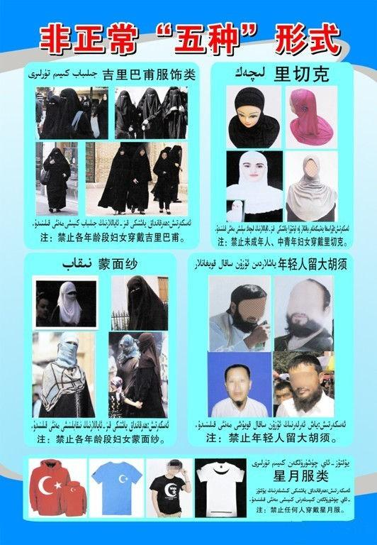

A 2014 government flyer alerting Uyghur women in the city of Karamay that they may not board public buses while wearing hijabs, face coverings, or any kind of Uyghur or Islamic-themed clothing.

- Equal pay for equal work/Adequate working and living conditions (Articles 11 and 14)
Concluding Observations (2014): “Ensure that all women who were subjected to the re-education through labour system receive adequate compensation, and consider abolishing the custody and education programme, which may be used to justify the arbitrary detention of women.” (para. 29)
“To take measures to reduce the number of women in detention, including through targeted prevention programmes aimed at addressing the causes of women’s criminality” (para. 49)
“To immediately take measures to abolish extralegal detention facilities and adequately penalize perpetrators, including non-State actors.” (para. 49)
State Party response (2017): None.
Suggested questions:
- What steps will the government of China take to dismantle programs that promote or facilitate state-imposed forced labor of Uyghur women?
- How will the government of China end its “labor transfer” programs for unmarried Uyghur women?
- China continues to coerce Uyghur women to work in factories where there are strong indications of forced labor, often as a means of social control, including during the Covid-19 pandemic.
- In November 2020, UN CERD wrote that it was aware of, and gravely concerned about, the continued operation of forced-labor camps: “The Committee, however, remains alarmed by multiple reports that large numbers of Uighurs and members of other minorities are arbitrarily detained in extrajudicial detention facilities operating as education and training centres and in forced labor camps in the State party’s territory, in contravention to any recognized legal process with fair trial rights.”
- The conditions in China’s forced-labor facilities endanger Uyghur women’s health and violate their rights to safe working and living conditions. One Uyghur woman testified to the United States Congress that she had been arbitrarily detained by officials on three separate occasions. She stated that while in a detention camp, she and other Uyghur women were forced to sleep in turns, use the toilet in front of security cameras, and were made to take unknown medication. She stated that nine women died in her cell alone during her three months of detention.
- Other Uyghur women who managed to escape described the facilities as “prison-like,” with cameras and microphones monitoring them day and night. Numerous Uyghur women have shared stories of sexual abuse, saying that they were forced to undergo abortions or were given contraceptive or permanently-sterilizing medicine against their will.
- The government of China has for years used a complex system of “labor export programs” which coercing unmarried Uyghur women to work in factories outside the Uyghur Region under the promise of higher wages. Simultaneously, the Chinese government has forcibly sent an estimated 80,000 Uyghur laborers to other parts of China in factories under conditions which strongly indicate forced labor.
- The government of China specifically targets young, rural, and unmarried Uyghur women as participants for many of its labor export programs. Since 2007, authorities have deployed a number of deceptive tactics to lure young Uyghur women away from their homes in the countryside and into forced-labor factories. By first targeting young Uyghur women aged 16-25 living in rural, economically-depressed agricultural regions, authorities incentivize impoverished families with higher wages and relocation benefits working in far-away cities.
- After “accepting” these contract offers and relocating to factories in Eastern China, Uyghur women have been denied their expected wages and adequate living conditions upon arrival. One young Uyghur woman told researchers at the UHRP in 2008 that “We call this place a prison. I think that there is no difference between here and a prison.”
- In the garment industry—which represents one of the largest employers of women in the Uyghur Region—forced labor has been found to be present in all stages of the production process, including in the planting, harvesting and processing of cotton, the spinning of yarn, the weaving of textiles and the manufacture of finished garments. In 2020, the Fair Labor Association found that reports it had received of forced labor as so “widespread” and “credible” that it urged all of its commercial affiliates to review primary and secondary sourcing of cotton from the Uyghur Region.
- Forced sterilization (Article 12)
Concluding Observations (2014): “The Committee reiterates its previous recommendation (CEDAW/C/CHN/ CO/6, para. 18) and urges the State party (...) to intensify the implementation of existing legal measures to address sex-selective abortions, forced abortions and sterilizations and the infanticide of girls.” (para. 25).
State Party response: None.
Suggested questions:
- Based on government statistics, why was the use of IUDs among Uyghur women in 2018 substantially higher than the rest of the Chinese population?
- What steps will the government of China take to ensure that Uyghur women are not subjected to forced or coerced IUD placements?
- What did the Chinese Embassy in the U.S. mean when it called Uyghur women “no longer baby-making machines” on Twitter while touting its forced sterilization campaign in the region?
- For decades, the government of China has made efforts to purposely reduce the birthrate of Uyghur women through coercive family planning—including the forced sterilization of women. In 2018, 80 percent of all IUD placements in China were performed in the Uyghur Region, despite the region making up 1.8 percent of the country’s total population. The policy is intended to reduce the Uyghur population in the Uyghur Region by reducing its birthrate relative to Han Chinese, in a move that experts have dubbed “a demographic genocide.”
- Birth rates among Uyghur women plummeted from 2015-2018, with population growth in the Uyghur Region falling by over 84 percent in that period in the two largest Uyghur prefectures. Population growth rates also declined further in several minority regions in 2019. In 2020, Chinese authorities in one Uyghur prefecture set a “near-zero birth rate target,” aiming to reach a birth rate of 1.05 per mile, down from 19.66 per mile two years earlier. Officials wrote that a zero birthrate would primarily be achieved through “family planning work.”
- Government documents have revealed that local authorities are instructed to punish Uyghur women who “violate” birth control targets with extrajudicial internment and “vocational skill” training camps. In May 2018, the government of Qiemo (Uy: Cherchen) county issued a public notice that any woman who had violated state birth-limits would be forced to “adopt birth control measures with long-term effectiveness (i.e., forced sterilizations) and be subjected to vocational skills education and training (i.e., internment camps).”
- The “Qaraqash List”—a leaked document which contained the Chinese government’s “rationale” and “evidence” behind the extrajudicial detention of hundreds of Uyghurs—showed a strong connection between the extrajudicial internment of Uyghur women and the Chinese government’s campaign to reduce Uyghur birthrates. In one county, the most frequently cited reason for internment of Uyghur women was “a violation of birth control regulations.” Separately, a Qaraqash county official in a 2018 government work report stated that “[by] severely curbing behaviors that violate birth control [policies], birth and natural population growth rates have declined dramatically.”
- Chinese authorities have planned a campaign of mass female sterilization in rural Uyghur regions, noting in documents they wish to target 14 and 34 percent of all married women of childbearing age in two Uyghur counties that year. The campaign aims to permanently sterilize rural minority women with three or more children, as well as some with two children, criteria which would cover at least 20 percent of all childbearing-age women. In 2018, one Uyghur prefecture publicly set a goal of leading its rural populations to accept widespread sterilization surgery.
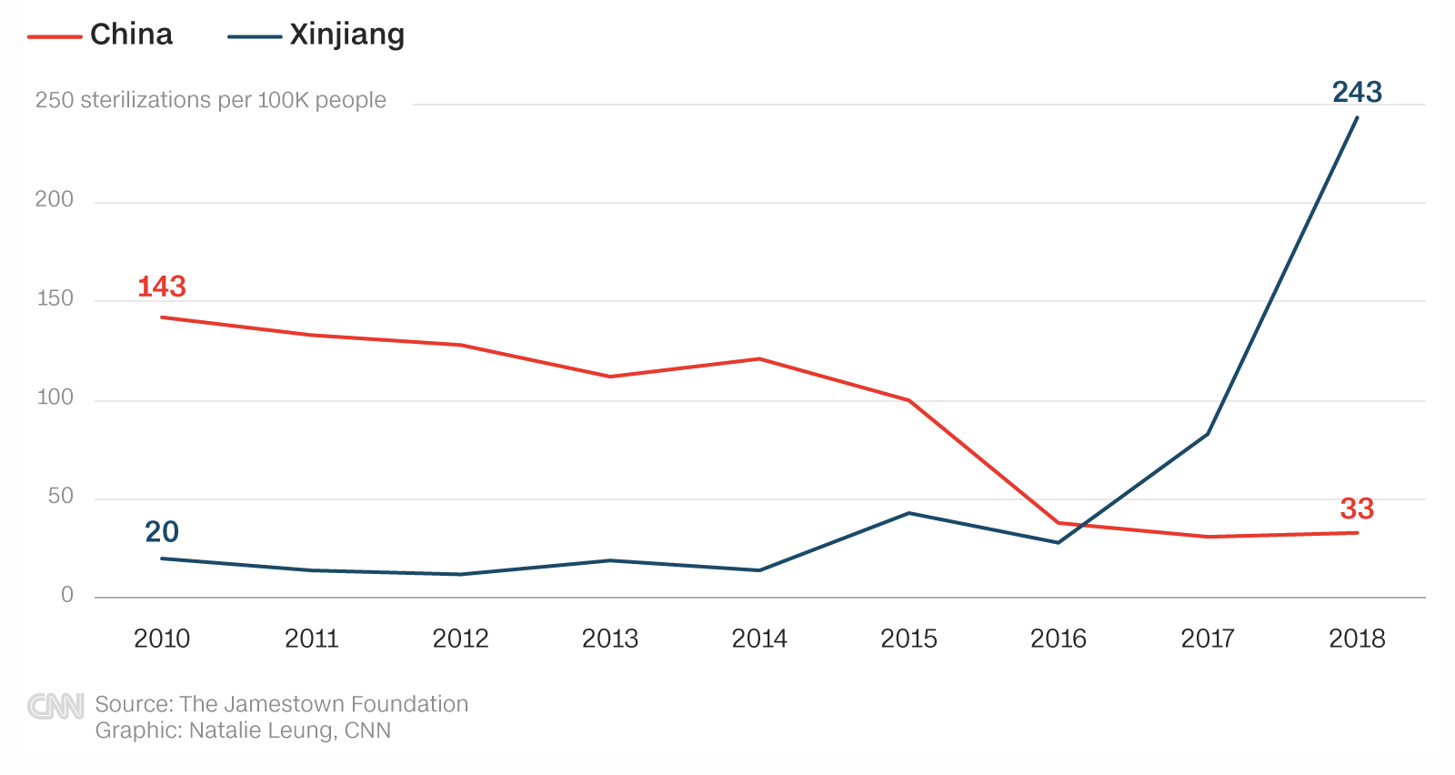

According to local government statistics, there were almost 1,000 new IUD implants per 100,000 people in the Uyghur Region in 2018—accounting for 80% of China's total IUD implants for that year.
- Right to education (Article 13)
Concluding Observations (2014): “The Committee is also concerned about the limited access to education for women and girls with intellectual disabilities and ethnic and religious minority women and girls, such as Tibetans and Uighurs.”
State Party response: None.
Suggested questions:
- How does the government of China ensure that Uyghur girls provided equal access to Uyghur-language instruction in schools at all education levels?
- How does the government ensure Uyghur girls are able to study in their mother tongue?
- In 2017, the Hotan Prefecture Education Department banned the use of the Uyghur language “at all education levels up to, and including secondary school, in favor of Mandarin.” It also instructed authorities in Hotan Prefecture to “prohibit the use of Uyghur language, writing, signs and pictures in the educational system and on campuses.” The directive also called upon local schools to “resolutely correct the flawed method of providing Uyghur language training to Chinese language teachers.”
- In January 2018, four UN Special Rapporteurs issued a Joint Other Letter to the government of China regarding its ban of the Uyghur language in schools, writing: “We would like to express our serious concern over the directive issued by the Education Department in Hotan Prefecture on 28 June 2017 and its potential negative impact on the enjoyment of the right to education without discrimination by the Uyghur minority in the Xinjiang Uyghur Autonomous Region of China, their right to use their own language freely without interference or any form of discrimination and to take part in cultural life, and the right of members of a linguistic and ethnic minority to use their own language among themselves.”
- The government of China’s implementation of “bilingual education” programs in the Uyghur Region beginning in the mid-1980s has intentionally weakened teaching and the use of the Uyghur language. In practice, “bilingual education” is a policy designed to transition Uyghur students at all levels of education to speak and learn only in Mandarin Chinese, rather than having them learn simultaneously in their native tongue.

* * *

About the Uyghur Human Rights Project:
UHRP promotes the rights of the Uyghurs and other Turkic Muslim peoples in East Turkistan, referred to by the Chinese government as the Xinjiang Uyghur Autonomous Region, through research-based advocacy. UHRP publishes reports and analysis in English and Chinese to defend Uyghurs’ civil, political, social, cultural, and economic rights according to international human rights standards.
UHRP documents violations; highlights human rights defenders, survivors, and victims; and researches avenues for defense and positive promotion of Uyghurs’ human rights, especially in the arenas of policymaking, grassroots action, and cultural rights promotion. We emphasize bringing forward Uyghur voices and Uyghur experiences to international fora and decision-makers.

The Chinese government’s terminology, see, for example, “‘Eradicating Ideological Viruses’: China’s Campaign of Repression Against Xinjiang’s Muslims,” Human Rights Watch, September 9, 2018, https://www.hrw.org/report/2018/09/09/eradicating-ideologicalviruses/chinas-campaign-repression-against-xinjiangs.
Committee on the Elimination of All Forms of Discrimination against Women, “Concluding observations on the combined seventh and eighth periodic reports of China,” 2014, https://tbinternet.ohchr.org/_layouts/15/treatybodyexternal/Download.aspx?symbolno=CEDAW%2fC%2fCHN%2fCO%2f7-8.
Ibid, p. 34.
State Party Response to the CEDAW’s 8th Cycle Review of China, 2017, https://documents-dds-ny.un.org/doc/UNDOC/GEN/N17/029/05/PDF/N1702905.pdf
Uyghur Human Rights Project, “Sacred Right Defiled: China’s Iron-Fisted Repression of Uyghur Religious Freedom,” p. 29, https://docs.uyghuramerican.org/Sacred-Right-Defiled-Chinas-Iron-Fisted-Repression-of-Uyghur-Religious-Freedom.pdf
Ibid.
Dearden, Lizzie, “China bans burqas and 'abnormal' beards in Muslim province,” The Independent, March 2017, https://www.independent.co.uk/news/world/asia/china-burqa-abnormal-beards-ban-muslim-province-xinjiang-veils-province-extremism-crackdown-freedom-a7657826.html
Chan, Tara, “Police are reportedly cutting too-long dresses off ethnic minority women in the middle of streets in China,” Business Insider, July 2018, https://www.businessinsider.com/police-cutting-dresses-off-uighur-women-in-xinjiang-china-2018-7?r=US&IR=T
Palash, Ghost, “Project Beauty: Chinese Officials Pressure Uighur Muslim Women In Xinjiang To Drop Their Veils, Men To Cut Beards,” IBTimes, November 2013, https://www.ibtimes.com/project-beauty-chinese-officials-pressure-uighur-muslim-women-xinjiang-drop-their-1487184
Grose, Timothy, “Why China Is Banning Islamic Veils,” ChinaFile, February 2015, https://www.chinafile.com/reporting-opinion/viewpoint/why-china-banning-islamic-veils
Henochowitz, Anne, “Minitrue: No Beards on Xinjiang busses,” China Digital Times, August 2014, https://chinadigitaltimes.net/2014/08/minitrue-beards-xinjiang-busses/
“Beards, Veils Banned on Buses in Northwest Chinese City,” The Wall Street Journal. August 2014. Available at: https://www.wsj.com/articles/BL-CJB-23483
Congressional-Executive Commission on China, “Staff Research Report: Global Supply Chains, Forced Labor, and the Xinjiang Uyghur Autonomous Region,” March 2020.
France 24 (December 2020). “A huge game-changer’: Report says more than 570,000 Uighurs forced to pick cotton,” https://www.france24.com/en/asia-pacific/20201215-a-huge-game-changer-report-says-more-than-570-000-uighurs-forced-to-pick-cotton
UN CERD Concluding Observations, November 2020, https://tbinternet.ohchr.org/Treaties/CERD/Shared%20Documents/CHN/INT_CERD_FUL_CHN_43684_E.pdf
Congressional-Executive Commission on China, “Transcript: House Hearing, 115th Congress — the communist party's crackdown on religion in china,” November 2018, https://www.congress.gov/event/115th-congress/house-event/LC64946/text?s=1&r=9
Meixler, Eli (November 2018). “‘I Begged Them to Kill Me.’ Uighur Woman Tells Congress of Torture in Chinese Internment Camps,” Time Magazine, https://time.com/5467628/china-uighur-congress-torture/
Danilova, Maria (November 2018). “Woman describes torture, beatings in Chinese detention camp,” Associated Press. Available at: https://apnews.com/article/61cdf7f5dfc34575aa643523b3c6b3fe
Amie Ferris Rottman, “Abortions, IUDs and sexual humiliation: Muslim women who fled China for Kazakhstan recount ordeals,” The Washington Post, October 2019, https://www.washingtonpost.com/world/asia_pacific/abortions-iuds-and-sexual-humiliation-muslim-women-who-fled-china-for-kazakhstan-recount-ordeals/2019/10/04/551c2658-cfd2-11e9-a620-0a91656d7db6_story.html
Ibid.
Uyghur Human Rights Project, “Deception, Pressure, and Threats: The Transfer of Young Uyghur Women to Eastern China,” August 2008, http://docs.uyghuramerican.org/Transfer_uyghur_woman.pdf.
Xu, Vicky (March 2020). “Uyghurs for sale: ‘Re-education’, forced labour and surveillance beyond Xinjiang,” Australian Strategic Policy Institute, https://www.aspi.org.au/report/uyghurs-sale.
Uyghur Human Rights Project, “Deception, Pressure, and Threats.”
Ibid, p. 2.
Ibid, p. 6.
Fair Labor Association, “Fair Labor Association Statement on Sourcing From China And Forced Labor Risk.” March 2020, https://www.fairlabor.org/blog/entry/fair-labor-association-statement-sourcing-china-and-forced-labor-risk.
Halliday, Ellen, “Forced abortion and secret sterilisation: how China has abused Uighur women for decades,” The New Statesmen, October 2020, https://www.newstatesman.com/world/asia/2020/10/forced-abortion-and-secret-sterilisation-how-china-has-abused-uighur-women.
Zenz, Adrian (July 2020). “Report: Sterilizations, IUDs, and Coercive Birth Prevention: The CCP’s Campaign to Suppress Uyghur Birth Rates in Xinjiang,” The Jamestown Foundation - China Brief Volume: 20 Issue: 12, p. 3, https://jamestown.org/wp-content/uploads/2020/06/Zenz-Internment-Sterilizations-and-IUDs-UPDATED-July-21-Rev2.pdf.
Associated Press, “China cuts Uighur births with IUDs, abortion, sterilization,” June 2020, https://apnews.com/article/269b3de1af34e17c1941a514f78d764c.
Wong, Chu (September 2020). “Xi Says China Will Continue Efforts to Assimilate Muslims in Xinjiang,” The Wall Street Journal. Available at: https://www.wsj.com/articles/xi-says-china-will-continue-efforts-to-assimilate-muslims-in-xinjiang-11601133450.
Zenz, Adrian (July 2020). “Report: Sterilizations, IUDs, and Coercive Birth Prevention,” pp. 9–21.
Ibid, p. 9.
Ibid, p. 15.
Chavkin, Sasha, “New Leak Shows How China Targets Uighurs in Xinjiang,” International Consortium of Investigative Journalists, February 2020. Available at: https://www.icij.org/investigations/china-cables/new-leak-shows-how-china-targets-uighurs-in-xinjiang/.
Shepherd, Christian, “The Karakax list: how China targets Uighurs in Xinjiang,” The Financial Times, February 2020, https://www.ft.com/content/e0224416-4e77-11ea-95a0-43d18ec715f5.
Zenz, Adrian (July 2020). “China’s Own Documents Show Potentially Genocidal Sterilization Plans in Xinjiang,” Foreign Policy. Available at: https://foreignpolicy.com/2020/07/01/china-documents-uighur-genocidal-sterilization-xinjiang/.
Ibid.
Zenz, Adrian (July 2020). “Report: Sterilizations, IUDs, and Coercive Birth Prevention,” pp. 9–21.
Ibid, p. 2.
Watson, Ivan, “Xinjiang government confirms huge birth rate drop but denies forced sterilization of women,” CNN, September 2020, https://edition.cnn.com/2020/09/21/asia/xinjiang-china-response-sterilization-intl-hnk/index.html
“Concerning the directive on bilingual education issued on 28 June 2017 by Hotan’s Education Department,” OHCHR, January 2018, https://spcommreports.ohchr.org/TMResultsBase/DownLoadPublicCommunicationFile?gId=23557.
Uyghur Human Rights Project (May 2019). “Resisting Chinese Linguistic Imperialism: Abduweli Ayup and the Movement for Uyghur Mother Tongue-Based Education.” Available at: https://docs.uhrp.org/pdf/UHRP_Resisting_Chinese_Linguistic_Imperialism_May_2019.pdf.
“Concerning the directive on bilingual education issued on 28 June 2017 by Hotan’s Education Department,” OHCHR.
Uyghur Human Rights Project (May 2015). “Uyghur Voices on Education: Chinese Assimilative ‘Bilingual Education’ Policy in East Turkistan,” https://uhrp.org/press-release/uhrp-releases-report-bilingual-education-east-turkestan—uyghur-voices-education.html.

