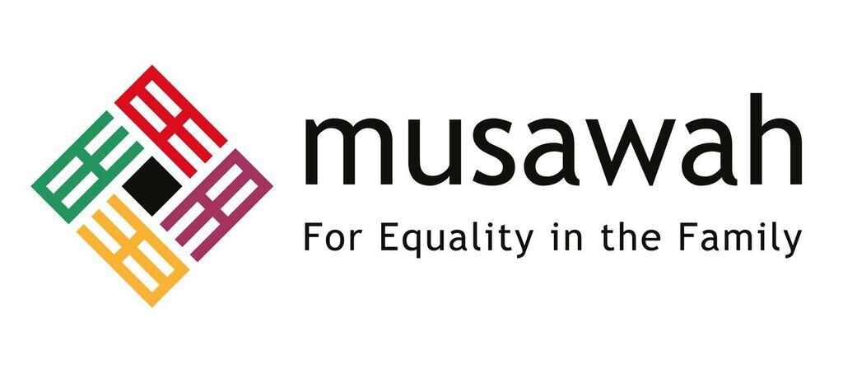
THEMATIC REPORT ON ARTICLE 16, MUSLIM FAMILY LAW AND MUSLIM WOMEN’S RIGHTS IN
PAKISTAN

75th CEDAW Session
Geneva, Switzerland
February 2020

Musawah
15 Jalan Limau Purut, 59000 Kuala Lumpur, Malaysia
Tel: +603 2083 0202Fax: +603 2202 0303
Email: musawah@musawah.org
Website: www.musawah.org

A. INTRODUCTION

Musawah, the global movement for equality and justice in the Muslim family, submits this Thematic Report on Article 16 and related concerns for consideration by the CEDAW Committee in its review of the Government of Pakistan, reporting before the 75th CEDAW Session in February 2020.
In particular, this report examines Pakistani laws and practices that enforce de jure and de facto discrimination against women in the following areas: child marriage, forced marriage, polygamy and unequal provisions for divorce under the Muslim family laws.

We hope that the CEDAW Committee will utilize this report as a key resource during its Constructive engagement with the State party, and in follow-up activities on the Concluding Observations. Musawah would like to acknowledge the vital input and feedback from national women’s rights activists and lawyers into this report.

B. LEGAL BACKGROUND

Article 25 of the Constitution of Pakistan provides for equality before the law and prohibits discrimination on the basis of sex. Article 35 of the Constitution obligates the State to protect the marriage, the family, the mother and the child.

Marriage and family relations of Pakistan’s non-Muslim minority communities are governed by their own laws and customs, while a number of acts and ordinances govern the matters pertaining to marriage and family affairs of Pakistani Muslims. These include the following:
- Muslim Family Laws Ordinance (MFLO) and the following codified laws:
- Dissolution of Muslim Marriages Act (DMMA);
- Child Marriage Restraint Act;
- Dowry and Bridal Gifts (Restriction) Act;
- Guardians and Wards Act; and
- Family Court Act.

There is a legal presumption that the majority of Muslims in Pakistan follows the Hanafi school of Islamic jurisprudence (fiqh), therefore any case falls under the rules of Hanafi jurisprudence unless either party proves to the contrary. A sizeable population in Pakistan follows the Shia Ithna Ashari school and there is a legal presumption that Shia Muslims follow this school in terms of its application of family law.

The Muslim Family Laws Ordinance (MFLO) adopts a moderate interpretation of Muslim family law. Marriage is not specifically defined in the MFLO nor the rights and obligations of the husband and wife explicitly detailed except for Section 9. Section 9 of the MFLO provides that if any husband fails to maintain his wife adequately, or where there are more wives than one, fails to maintain them equitably, the wife, or all or any of the wives may, in addition to seeking any other legal remedy, apply to the Arbitration Council (consisting of Chairperson of the Union Council which is the second tier of local government and representatives of each of the parties) to determine the matter.

Family matters including dissolution of marriage, provision of maintenance and child custody are administered via the Family Courts established through the Family Courts Act of 1964.

C. KEY ISSUES AND LIVED REALITIES

1. CHILD & FORCED MARRIAGE

  - CHILD MARRIAGE
UNICEF estimates that Pakistan has the sixth highest number of child brides in the world with around 21% of girls being married before their 18th birthday (3% before 15 years). A number of factors have contributed to this high rate of child marriage including traditional customs in rural areas that involve the bartering of young brides and family practices that involve marrying girls to their immediate cousins.

In 1961 the Child Marriage Restraint Act was amended to make the minimum legal age for marriages 16 for females and 18 for males. The Act criminalised and penalised the following:
- Males over 18 who contract a child marriage;
- Whoever performs, conducts or directs any child marriage;
- Parents or guardians who do any act to promote a child marriage, permit it to be solemnised or negligently fail to prevent it from being solemnized.

In February 2017, Pakistan toughened penalties for those guilty of being involved in child marriages. Under the new law, offenders will face a minimum of five years in prison and may serve up to 10 years. They also face a fine of up to one million rupees. A prospective bride must provide her age and National Identification Card number to the marriage registrar, who in turn, must verify the age of the persons getting married. However, as per case law courts have argued that while the marriage of a female below 16 constitutes an offence, the marriage is valid if the female has attained puberty, as under principles of Muslim laws.

In 2013, the minimum legal age for marriage in the Sindh province as per Section 2 of the Sindh Child Marriages Act was raised to 18 years for both females and males, without exceptions. The Act criminalises and penalises acts relating to child marriages.

According to women’s rights activists there is a lack of implementation of the law. A gap remains regarding girls who have been previously married below 16 or 18 years. In cases of elopement or when minor brides cannot be sent back to their families for whatever reason, they are being referred to the Women’s Crisis Centers which does not provide them the services they need.

Recent attempts at law reform

In April 2018, Senator Sherry Rahman representing the Pakistan People’s Party presented the Child Marriage Restraint Bill (which proposed raising the minimum age of marriage to 18 without exceptions) in the Senate. In April 2019, the Bill was passed in the Senate despite opposition from Senators from religious parties including Jamiat Ulema-e-Islam and Jamaat-e-Islami who opposed the bill, citing that it was against Islamic values.

The Bill was referred by the National Assembly to the Standing Committee on Law and Justice for further consultations including with the Council of Islamic Ideology (CII) before being presented once again before the National Assembly. In August 2019, the bill was rejected by the National Assembly’s Standing Committee on Law and Justice, with strong opposition from the likes of Minister for Religious Affairs and Minister of State for Parliamentary Affairs.

Resistance to the Bill has been primarily from conservative groups who argue that Islam allows for minor girls to be given in marriage after puberty. This is despite the fact that data and cases of lived realities and evidence pertaining to health and wellbeing of women and girls have been presented by women’s rights advocates. The government must move to consider positive legal developments from other Muslim countries, that have raised the minimum age of marriage to 18 years, using Islamic jurisprudential evidence and various tools from Islamic legal tradition, as well as international human rights principles.
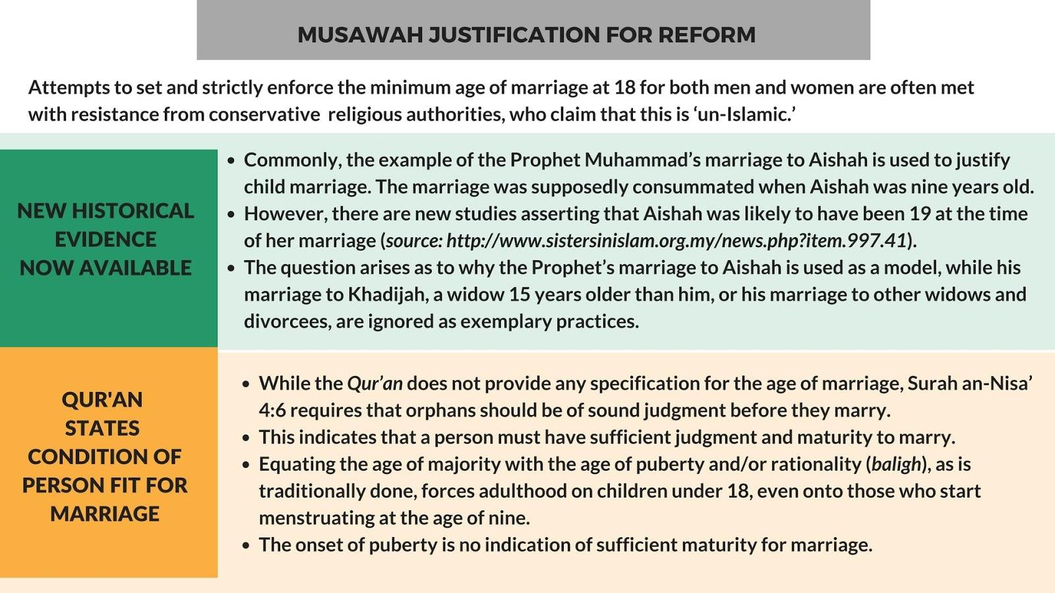

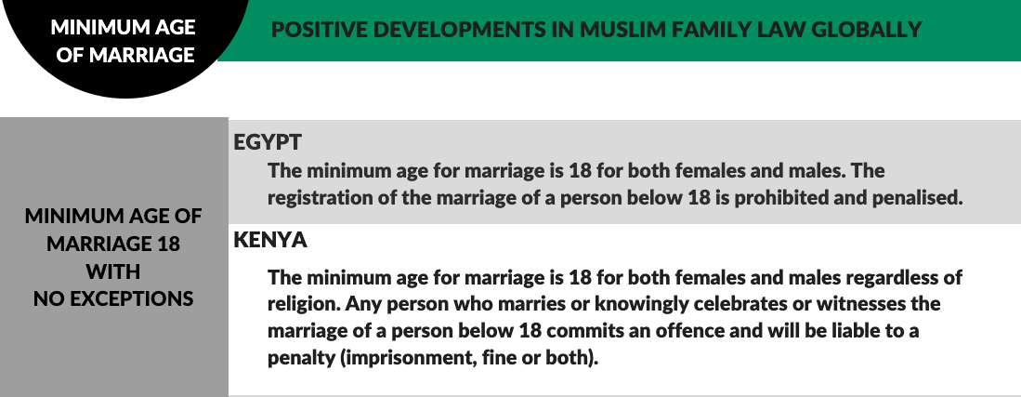

1.2. FORCED MARRIAGE
Despite legal provisions in place penalising forced marriages, the practice continues to occur across Pakistan. In rural areas in particular, the practice is exacerbated by poverty, insecurity and lack of access to support services. Activists report that most of the marriages in Pakistan are arranged by families, and in many instances some degree of coercion is involved. In recent years, there has been a surge of reporting of young women living abroad in countries like the UK and Scotland who are brought to Pakistan and forced or coerced into marriage. So called ‘honor-based’ violence and killings have also been reported of women and men who have chosen to marry against family wishes.

RECOMMENDATIONS

We recommend the CEDAW committee to urge the State party to:
- Ensure that government passes and enacts legislation to raise the minimum age to 18 without exceptions and for this standard minimum age of marriage to apply uniformly across all religious groups and provinces in Pakistan.
- Establish a dedicated program and service to combat child and forced marriages with outreach to rural and high-risk areas. The Forced Marriage Unit in the UK is a good example of government led effort to address the issue.
- Provide support services (including specialized shelters and legal aid) for minor girls who have undergone and/or are vulnerable to child and forced marriages, especially in high risk areas.
- Ensure proper data collection of the number of cases of child and forced marriages and number prosecutions and penalties imposed on persons responsible for child and forced marriages.

2.POLYGAMY

Section 6 of the MFLO requires the husband to apply for written permission from the Arbitration Council (Union Council Chairperson plus a representative each of the husband and wife or wives) to contract another marriage. His application must include reasons for the proposed marriage and whether the consent of his existing wife or wives has been obtained. It also mandates the Arbitration Council to permit the polygamous marriage only if it is satisfied that the proposed marriage is necessary and just, subject to such conditions (if any) as may be deemed fit.

The Arbitration Council is obligated to record its reasons for its decision regarding the proposed polygamous marriage. It is a criminal offence for any man who contracts a polygamous marriage without the permission of the Arbitration Council. According to information gathered by the Immigration and Refugee Board of Canada and media reports, the Arbitration Council is not effective as a procedural check against polygamous marriages that do not meet the injunctions of the Qur’an for reasons that include: (i) lack of acceptance of the law by men; (ii) lack of awareness of the law by women; (iii) As such, many mend do not seek the permission of the Arbitration Council and instances where they do, the permission of the Arbitration Council is a mere formality.

According to women activists, in many cases of polygamy husbands find it difficult to provide maintenance to support multiple families and the implementation of maintenance of children provisions via the courts remains weak. Usually only a small percentage of the maintenance awarded to the mother as the per the decision of the courts.

RECOMMENDATIONS

We recommend the CEDAW committee to urge the State party to:
- Undertake research and collection of data, cases and evidence of the impacts of polygamy on Pakistani families, especially women and children.
- Ensure family law reform to prohibit polygamy by Pakistani Muslim men, following examples of other Muslim countries like Tunisia and Turkey which have abolished the practice in the best interest of family well-being.

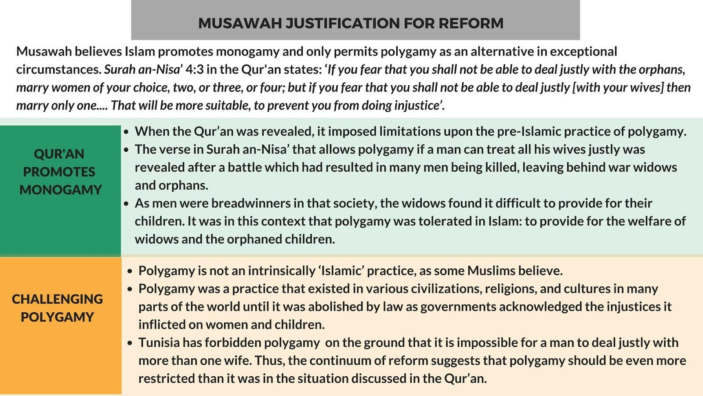

3.UNEQUAL PROVISIONS FOR DIVORCE

Pakistani law provides for different mechanisms for divorce, including: 1) Divorce by way of unilateral repudiation (talaq) by husbands; 2) divorce by mutual consent of both parties (mubarat); 3) redemptive divorce (khul’) by wife after repayment of compensation to husband and; 4) divorce by way of judicial decree (faskh) by wife based on fault grounds.

According to a civil society groups, a closer examination of divorce rights between women and men shows that divorce rights between the two genders are unequal. For instance, a man may by way of talaq need only send a notice to the Arbitration Council of the pronouncement, go through a reconciliation and if reconciliation is not possible, the divorce stands.

However, a woman has to prove a ground for divorce in court if her husband does not consent to a divorce or she has not been delegated the right to divorce. With regard to the latter, often times, families and elders cross out the clause delegating the right of divorce in the standard marriage contract at the time of marriage saying that it is a ‘bad omen’ to talk about divorce. Redemptive divorce (khul’) is available to the wife, but she may not necessarily be able to compensate her husband for such a divorce.

RECOMMENDATIONS

We recommend the CEDAW committee to urge the State party to:

- Embark on a consultative process with full involvement of women’s groups and National Commission for the Status of Women to assess the areas of discrimination faced by women and men pertaining to divorce and family matters and access to justice in family courts.
- Undertake family law reform including equalizing conditions and procedures of divorce for women and men.
- In the short term, ensure training of Marriage (Nikah) Registrars for accurate filling of the marriage contract and full implementation of the family law on delegated right of divorce to the woman.

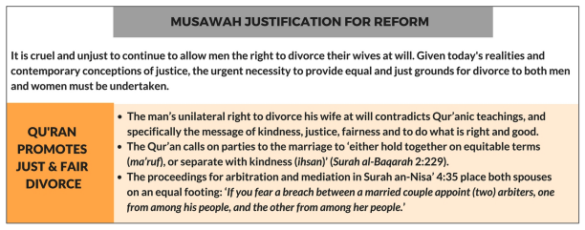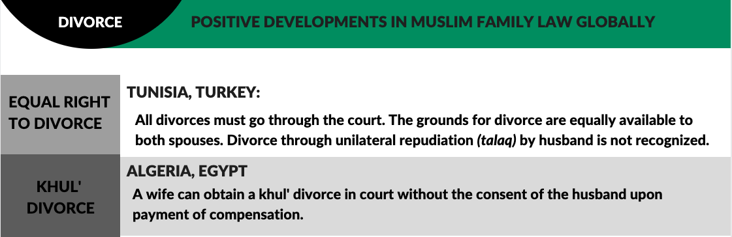

ANNEXE 1:

MUSAWAH VISION FOR THE FAMILY
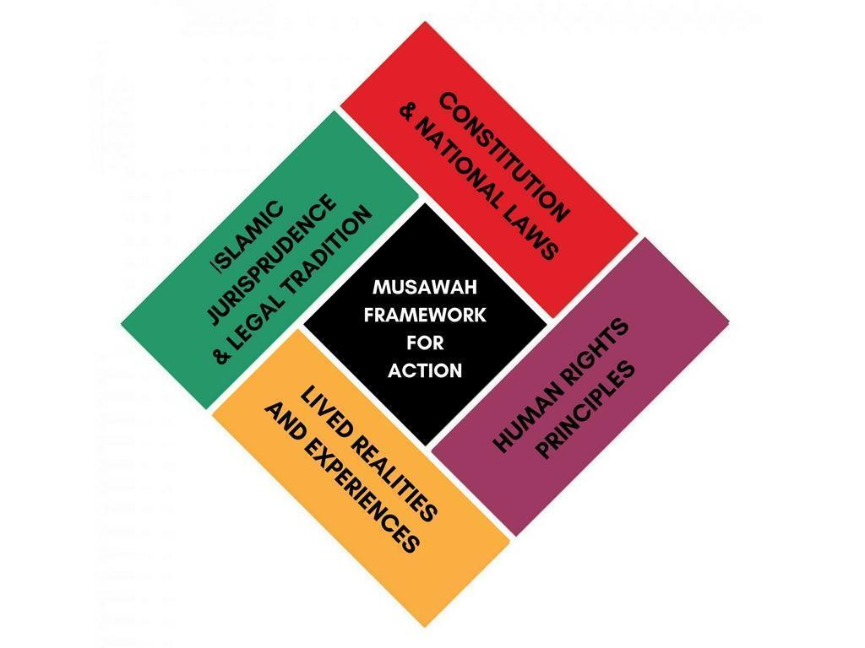
Musawah asserts that in the twenty-first century, there cannot be justice without equality. Many provisions in Muslim family laws, as defined by classical jurists and as reproduced in modern legal codes, are neither tenable in contemporary circumstances nor defensible on Islamic grounds. Not only do these family laws fail to fulfill the Shari’ah requirements of justice, but they are being used to deny women rights and dignified choices in life. These elements lie at the root of marital disharmony and the breakdown of the family.
Musawah believes that Qur’anic principles and the richness of the Islamic juristic tradition enable us to formulate Muslim family laws today that are egalitarian and reflect the needs of contemporary societies. Islamic teachings and universal human rights standards, including the CEDAW Convention, are fully compatible and are dynamic and constantly evolving, based on changing times and circumstances. Inspired by the Qur’anic vision of justice and gender relations, Musawah contends that gender equality and non-discrimination can only be achieved with laws that transform power relations in the family and in society in the direction of just outcomes.
It is our hope that the CEDAW Committee will encourage Governments everywhere, and particularly those purporting to speak for and in the name of Islam and Muslim communities, to:
- Recognize the diversity of opinions, laws and practices in the Muslim world and the growing scholarship in Islam that recognizes equality and justice and the possibility and necessity for reform of Muslim family laws today.
- Promote human rights standards as intrinsic to the teachings of Islam, national guarantees of equality and non-discrimination, and the lived realities of men and women today.
- Encourage open and inclusive public debate regarding diversity of opinion and interpretations in Muslim laws and principles relating to family laws and practices.

Article 25 of Pakistan’s Constitution (1973), https://www.constituteproject.org/constitution/Pakistan_2015.pdf?lang=en
Article 35 of Pakistan’s Constitution (1973), https://www.constituteproject.org/constitution/Pakistan_2015.pdf?lang=en
For instance Christian Marriage Act (1872), http://pakistancode.gov.pk/english/UY2FqaJw1-apaUY2Fqa-a54%3D-sg-jjjjjjjjjjjjj; Divorce Act (1869), http://pakistancode.gov.pk/english/UY2FqaJw1-apaUY2Fqa-a5Y%3D-sg-jjjjjjjjjjjjj; Parsi Marriage and Divorce Act (1936), http://pakistancode.gov.pk/english/UY2FqaJw1-apaUY2Fqa-b56a-sg-jjjjjjjjjjjjj
Source: Ghulam Shabbir v Mst Bakhat Khatoon [2009] SCMR 644
Muslim Family Laws Ordinance (1961), http://pakistancode.gov.pk/english/UY2FqaJw1-apaUY2Fqa-cJyX-sg-jjjjjjjjjjjjj
Sharmin Osmarny, “Family Laws and Judicial Protection”, http://www.supremecourt.gov.pk/ijc/articles/21/2.pdf
Dissolution of Muslim Marriage Act (1939), http://pakistancode.gov.pk/english/UY2FqaJw1-apaUY2Fqa-cJaW-sg-jjjjjjjjjjjjj
Child Marriage Restraint Act (1929), http://pakistancode.gov.pk/english/UY2FqaJw1-apaUY2Fqa-ap%2Bb-sg-jjjjjjjjjjjjj
Dowry and Bridal Gifts (Restriction) Act (1976), http://pakistancode.gov.pk/english/UY2FqaJw1-apaUY2Fqa-bpuUY2Rp-sg-jjjjjjjjjjjjj
Guardians and Wards Act (1890), http://pakistancode.gov.pk/english/UY2FqaJw1-apaUY2Fqa-cJc%3D-sg-jjjjjjjjjjjjj
Family Court Act (1964), http://punjablaws.gov.pk/laws/177.html; see also Rizvi Sah, “Composition, Jurisdiction and Powers of Family Courts in Pakistan”, http://www.zklawassociates.com/wp-content/uploads/2012/03/Family-Courts-in-Pakistan.pdf
Martin Lau, “Sharia and National Law in Pakistan”, in Sharia Incorporated: A Comparative Overview of the Legal Systems of Twelve Muslim Countries in Past and Present, ed. Jan Michiel Otto (Leiden, The Netherlands: Leiden University Press, 2010), p. 415, https://openaccess.leidenuniv.nl/bitstream/handle/1887/21170/file221087.pdf?sequence=1
Section 9 of the Muslim Family Laws Ordinance (1961), http://pakistancode.gov.pk/english/UY2FqaJw1-apaUY2Fqa-cJyX-sg-jjjjjjjjjjjjj
Adult women are also subject to traditional practices of bartering. Source: Girls Not Brides – Pakistan https://www.girlsnotbrides.org/child-marriage/pakistan/. Accessed July 23 2019.
Section 2 of the Child Marriage Restraint Act (1929), http://pakistancode.gov.pk/english/UY2FqaJw1-apaUY2Fqa-ap%2Bb-sg-jjjjjjjjjjjjj
Sections 4-6 of the Child Marriage Restraint Act (1929), http://pakistancode.gov.pk/english/UY2FqaJw1-apaUY2Fqa-ap%2Bb-sg-jjjjjjjjjjjjj
Before the change in law, offenders faced a minimum of three years in prison and a fine of 500,000 rupees. More info: Saleem Shaikh and Sughra Tunio, “Pakistan seeks to curb child, forced marriages with hasher punishment”, Reuters, 7 February 2017, http://www.reuters.com/article/us-pakistan-child-marriage-idUSKBN15M274
A National Identification Card is granted to an individual at 18 years.
Bilquees Bano, “Factors Reinforcing Girl Child Marriages in Pakistan”, Save the Children, 2015, https://everyone.savethechildren.net/articles/factors-reinforcing-girl-child-marriages-pakistan; Immigration and Refugee Board of Canada, “Pakistan: Information on marriage registration, including mixed marriages”, 2013, https://www.justice.gov/sites/default/files/eoir/legacy/2014/03/04/PAK104253.E.pdf
Women Living Under Muslim Laws, “Knowing Our Rights: Women, Family Laws and Customs in the Muslim World”, (Nottingham, UK: The Russell Press, Third Edition, 2006), p. 71, http://www.wluml.org/sites/wluml.org/files/import/english/pubs/pdf/knowing%20our%20rights/kor_2006_en.pdf Case law: Behram Khan v Mst. Akhtar Begum (PLD 1952 Lahore 548); Allah Diwaya v Mst. Kammon Mai (PLD 1957 Lahore 651); Bakhshi v Bashir Ahmed (PLD 1970 SC 323) Zafar Khan v Muhammad Ashraf Bhatti and another (PLD 1975 Lahore 234).
In February 2017, Pakistan toughened penalties for those guilty of being involved in child marriages. Under the new law, offenders will face a minimum of five years in prison and may serve up to 10 years. They also face a fine of up to one million rupees. More info: Saleem Shaikh and Sughra Tunio, “Pakistan seeks to curb child, forced marriages with hasher punishment”, Reuters, 7 February 2017, http://www.reuters.com/article/us-pakistan-child-marriage-idUSKBN15M274
Ahmed, Ashfaq (May 1st 2019). Pakistani parliamentarian again oppose the child marriage prohibition bill. Gulf News Asia https://gulfnews.com/world/asia/pakistan/pakistani-parliamentarian-again-oppose-the-child-marriage-prohibition-bill-1.1556720215025
Muhammad Anis, 22 August, 2019. Ahmed Ashfaq (May 2019) NA body on Law rejects Child Marriage Restraint Bill https://www.thenews.com.pk/print/515514-na-body-on-law-rejects-child-marriage-restraint-bill
VOA News, July 28,2019. Access here: https://www.youtube.com/watch?v=YEHv0InkVws and here https://www.youtube.com/watch?v=0xPpxokogPY
Wilkinson, Bard. May 23, 2018. CNN ‘UK mother jailed for forcing daughter to marry in Pakistan’. Access here: https://edition.cnn.com/2018/05/23/asia/forced-marriage-uk-pakistan-intl/index.html
BBC News Scotland. 12 July 2019. ‘I was forced to marry my cousin’. Access here: https://www.bbc.com/news/uk-scotland-48949483
Baloch, Meer Shah. May 17, 2019. The Guardian. ‘Pakistan authorities record a dozen cases of 'honour' killing in a fortnight’. Access here: https://www.theguardian.com/global-development/2019/may/17/pakistan-authorities-record-a-dozen-cases-of-honour-killing-in-a-fortnight
Section 6 of the Muslim Family Laws Ordinance (1961), http://pakistancode.gov.pk/english/UY2FqaJw1-apaUY2Fqa-cJyX-sg-jjjjjjjjjjjjj
Immigration and Refugee Board of Canada, “Pakistan: Practice of Polygamy, including legislation rights of the first wife versus the second, including whether she has the right to refuse a second wife”, Responses to Information Requests, 18 December 2013, http://www.refworld.org/docid/52eb9ea04.html
Shaqufta Omar, “Dissoluation of Marriages: Practices, Laws and Islamic Teachings” Institute of Policy Studies Policy Perspective 4:1, http://www.ips.org.pk/islamic-thoughts/1120-dissolution-of-marriage-practices-laws-and-islamic-teachings
Aurat Foundation, “Pakistan: NGO Alternate Report on CEDAW” Submission to the CEDAW Committee for the 54th Session, 2012, pp. 91-92, http://tbinternet.ohchr.org/Treaties/CEDAW/Shared%20Documents/PAK/INT_CEDAW_NGO_PAK_13269_E.pdf

