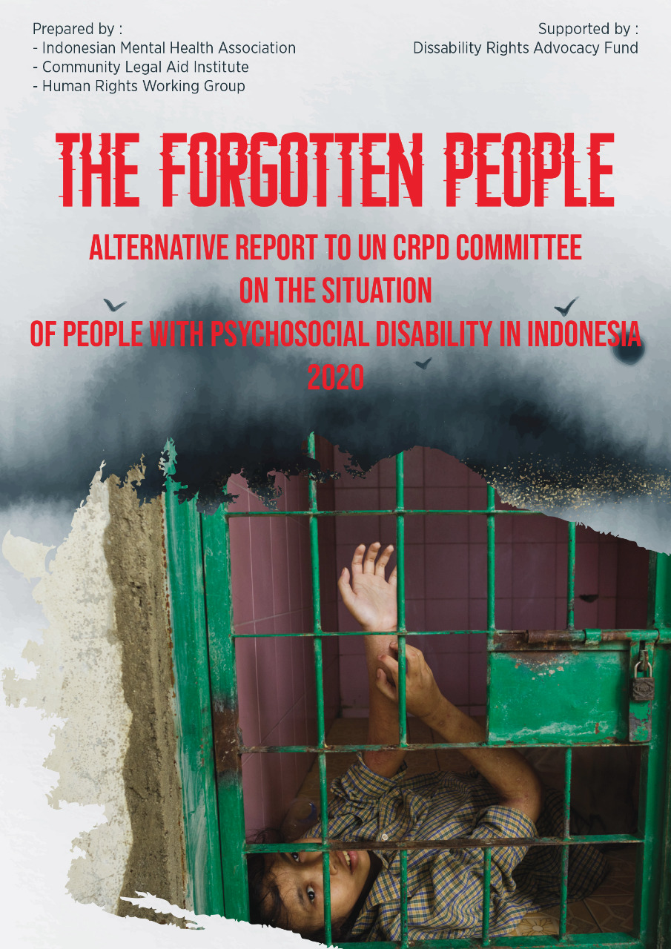

Introduction
Persons with psychosocial disabilities (PWPD) in Indonesia are a forgotten group of people. They are often considered to be not fully human, and are therefore deemed not to have human rights.
Human rights violations occur, some of which are quite severe, in almost all aspects of the lives of persons with psychosocial disabilities in Indonesia. These violations take place in the everyday practices of the community and are also reaffirmed in various laws and regulations.
Organizations of persons with disabilities in Indonesia have attempted to change the Indonesian Government’s stigmatize view of persons with psychosocial disabilities, which influences the programs and regulations they create. In doing so, we have encountered many problems in changing perceptions that have been in place for decades.
We hope that this alternative report can assists the UN CRPD committee in providing constructive recommendations, as we have gathered in the proposed List of Issues (on page 71), to the Indonesian Government .
We sincerelly hope that with the recommendation from the Committee, laws, regulations and policies as well as customary practices in the society that conflict with the human rights of persons with psychosocial disabilities would be amended and that in the near future we could see the improvement of the situation of persons with psychosocial disabilities in Indonesia.

Submitting Organizations
This alternative report is compiled and submitted by:
Perhimpunan Jiwa Sehat (PJS) - Indonesian Mental Health Association (IMHA)
PJS was founded in 2008 as the first organization in Indonesia to be initiated and run by persons with psychosocial disabilities with the purpose of advocating for the fulfillment of rights of person with psychosocial disability. PJS has succeeded in pushing the issue of psychosocial disability, which was previously a very marginal issue, to become one of the main issues in the disability movement in Indonesia.
PJS is a member of Pokja Koalisi Nasional Disabilitas, a national coalition of seven disability organizations representing different disabilities in Indonesia that advocated for the new Indonesian Disability Act and monitoring its implementation.
PJS is also a founding member and steering committee member of TCI Asia Pacific (Transforming Communities for Inclusion - Asia Pacific), a regional organization of people with psychosocial disabilities in the Asia Pacific region. In carrying out its work, apart from disability organizations PJS also works closely with national human rights institutions in Indonesia.
Lembaga Bantuan Hukum Masyarakat (LBHM) - Community Legal Aid Institution
The community legal aid institution (LBHM) is a legal aid organization that provides free legal assistance services to the underprivileged and victims of human rights violations, especially in regards to the issues of the death penalty, mental health, drugs, LGBTIQ, and HIV/AIDS. Since 2015, LBHM has been actively involved in conducting research, campaigns, and providing legal assistance in relation to mental health and the rights of persons with psychosocial disabilities.
Human Rights Working Group (HRWG)
The Indonesia’s NGO Coalition for International Human Rights Advocacy (HRWG) was established by a the majority of NGOs working in different issues but share interest in human rights to serve the need for elaborate advocacy works already in place with the aim of maximizing the goals and putting more pressures on the Indonesian government to execute its international and constitutional obligations to protecting, fulfilling, respecting and promoting human rights in the country.
Report Writing Team:
Yeni Rosa Damayanti (Indonesian Mental Health Association)
Fadel Basrianto (Indonesian Mental Health Association)
Andrea Star Reese (Photo Journalist-Indonesian Mental Health Association Associate)
Wira Leonardi (Indonesian Mental Health Association)
Albert Wirya (Community Legal Aid Institute)
Hisyam Ikhtiar Mulia (Community Legal Aid Institute)
Muhammad Hafiz (Human Rights Working Group)
Acknowledgement:
We thank Disability Rights Advocacy Fund (DRAF) for their support that enabled us to write this alternative reports.

Methodology
This alternative report was compiled based on data collected since 2016 through field visits and investigation, interviews with various parties especially people with lived experiences as well as government officials, institution managers, family members and other related parties, case studies, observation and research on specific topics, documenting and analysis of court decisions, documenting and analysis of mass media report, documenting and analysis of laws and regulations, reports from partner organizations especially Human Rights Watch, Indonesian National Commission of Human Rights, Indonesian Commission on Violence against Women.
The analysis of this report is based on the perspective and point of view of persons with psychosocial disabilities and the data were examined using CRPD, CRPD general comments and CRPD guidelines.
We compiled this report based on specific topics, which we considered to be the most significant and influential at the current time in relation to the situation of persons with psychosocial disabilities in Indonesia. The topics are:
- Legal capacity
- Human rights violations in mental institutions
- Shackling
- The right to employment and education
- Civil and political rights
- Violence against women and children
- The right to health
- Disasters
- Stigma and awareness-raising
- Access to justice
This alternative report will present:
- The situation and experiences of persons with psychosocial disabilities in different issues in Indonesia.
- The determining factors and causes of the situation
- Laws and regulations that contribute to the situations (or lack thereof)
- Violations of specific CRPD articles
- The extent to which the state of Indonesia is fulfilling its obligation according to CRPD.
- Obstacles to the fulfillment of the rights of persons with psychosocial disabilities
- Constructive recommendations to the government of Indonesia
- Proposed List of Issues to the Indonesian Government’s initial report to the CRPD Committee

Abbreviations
BPS : Badan Pusat Statisik (Central Bureau of Statisctics
CRPD : Convention on the Rights of Persons with Disabilities
DPD : Regional Represetatives Council (DPD)
DPO : Disabled Persons Organizations
DPR : People’s Representative Council
DPRD : District/Provincial People’s Representatives Councils
ECT : Electroconvulsive Therapy
HRW : Human Rights Watch
HRWG : Human Rights Working Group
IMHA : Indonesian Mental Health Association
Komnas Anak : The National Commission on Child Protection
Komnas HAM : The National Commission on Human Rights
Komnas Perempuan: The National Commission on Violence Against Women
KTP : National identity card
LBH Masyarakat :Lembaga Bantuan Hukum Masyarakat (Community Legal Aid Institute)
LOI : List of Issues
MMPI : Minnesota Multiphasic Personality Inventory
MoU : Memorandum of Understanding
NGOs : Non-Government Organizations
NHRI : National Human Rights Institutions
NIK : Single Identification Number
PJS : Perhimpunan Jiwa Sehat
Polri : Indonesian National Police
Puskesmas : community health centres
PWPD : Persons with Psychosocial Disabilities (PWPD)
PWPD : Persons with Disabilities
Satpol PP : Public order Agency
SOE : State Owned Enterprises
Supas : Inter-Census Population Survey
UDHR : Universal Declaration of Human Rights

Table of contents

Introduction 2
Submitting Organizations 2
Methodology 4
Abbreviations 6
The Alternative Report 11
Chapter 1: Legal Capacity and Guardianship 13
A. Deprivation of Legal Capacity and Placement Under Guardianship Without Legal Process (Informal Guardianship) 13
A1. Involuntary admission to a mental hospital and the absent of informed consent 13
A.2. Involuntary admission to social care institutions 14
A.3. Involuntary medical and non-medical treatment 15
A.4.Right to inheritance 15
A.5. The Right of Child Care 15
A.6. Political Rights 15
A.7. Government Attitude 15
B. Formal Guardianship Based on a Court Decision 16
B.1. Procedural and evidentiary requirements are very easy 16
B.2. A very rapid process 17
B.3. No second opinions, expert witnesses or defense arguments from the PWPD 17
B.4. Hardly any guardianship applications are rejected 17
B.5. Most guardianship are granted unlimited authority 17
B.6. Guardianship is unlimited in time. 17
B.7. Economic reasons are behind most guardianship applications 18
Recommendations 18
Chapter 2: Social Care Institutions as Arbitrary Detention Centre 19
A. People Living with Psychosocial Disabilities are committed to Institutions without Their Consent. 19
B. No Certainty as to when PWPD put in Institutions will come out 19
C. Forced Pickup with the use of Violence 20
D. The Room Resembles a Prison or Cage 20
E. Detained Using Chains 21
F. Isolation Cells 22
G. Forced Treatment 22
H. Lack of medical services 24
I. Starvation 26
J. Shaving Head 27
K. There are no beds or matrasses 27
L. Sanitation issues 27
M. Forced to bath in the open, female residents were bathed by male staff 28
N. Deprivation of right to raise children 28
O. Violence Against Women and Children 29
P. No separation between male and female residents and minors. 29
Q. There are no rights to privacy or to have personal belongings 29
R. There is no complaint and protection mechanism related to violence 29
S. Social institutions become business opportunities and to attract public donation 30
T. The state still strengthens institutionalisation by actions, regulations and funding 31
T.1. Regulations and Actions 31
T.2. Legal bases of forced institutionalization and social care institution 31
T.3. Funding the social care institutions 32
T.4. The government has no plans for de-institutionalisation 33
Recommendations 34
Chapter 3: Critique of the 'Indonesia Free of Shackling' program 37
A. Problems with the “Free From Shackling Program” in Indonesia 38
A.1. The medical model approach 39
A.2. Substituting one cage for another. 39
A.3. Shackling victims are treated like criminals 40
Recommendations 41
Chapter 4: The Right to Work and the Right to Education 43
A. Discrimination through the requirement of a Mental Health Certificate for job seekers. 43
B. Dismissed from employment due to having mental health issues 45
C. Lack of reasonable accommodation 45
D. Psychosocial Disabilities Eliminated from Various Work and Training Programs 46
E. The Right to Education 46
Recommendations 47
Chapter 5: Civil and Political Rights 49
A. The right to be registered as citizen. 49
B. The right to vote in elections 49
C. The right to be elected as a legislators and public official 50
Recommendations 51
Chapter 6: Violations of the Rights of Women and Children 52
A. Violence against women with psychosocial disabilities in social institutions 52
B. Sexual violence against women with psychosocial disabilities on the street and in shackling 53
C. Forced sterilisation 54
D. Violations against children in social institutions 55
Recommendations 56
Chapter 7: Health 58
A. Medical treatment administered without free and informed consent 58
B. Beside forced treatment, there are several other issues found at mental hospitals 59
B.1. Violence committed by psychiatric hospital staff 59
B.2. Shaving 59
B.3. Isolation rooms 59
B.4. Binding 60
B.5. Treatment rooms that resemble prison cells and over capacity 60
B.6. Forced Sterilisation 60
B.7. Inequality in the availability of medication between urban and rural areas 60
B.8. The government does not provide generic versions of the patented drugs required 61
B.9. Self harms and suicide attempt is not covered by National Health Insurance. 61
Recommendations 62
Chapter 8: The Abandonment of People with Psychosocial Disability (PWPD) during Disasters. 63
Recommendations 64
Chapter 9: Awareness-raising 65
Recommendations 66
Chapter 10: Access to Justice for People with Psychosocial Disabilities (PWPD) 68
Recommendations 69
List of Issues 71
Legal capacity and guardianship 71
Social care institution as arbitrary detention center 71
Critique of the “Indonesia free of Shackling” Program 72
The right to work and the right to education 72
Political and Civil Rights 73
Health 74
The abandonment of PWPD during Disasters 75
Awareness-raising 76
Access to Justice for PWPD 76
Appendix 77
References 140

The Alternative Report
- Data on Psychosocial Disability in Indonesia
- Based on the 2015 Inter-Census Population Survey (Supas) conducted by the Central Bureau of Statistics (BPS), the population of Indonesia was projected to reach 266.91 million in 2019.
- Indonesia does not yet have census data on the number of persons with disabilities. There is only the 2015 Inter-Census Population Survey (SUPAS) which estimated the number of persons with disabilities in Indonesia to be 8.56% of the total population. This disability data was collected using a modified Washington Group Short Set of Question. See appendix no. 1.
- Based on the survey, the number of persons who experience difficulties remembering/concentrating is 2.82 percent (7,444,800 people). Meanwhile, the number of persons with emotional/behavioral disorders is 1.32 percent. (3,484,800 people). It is unknown whether there is an overlap between these two figures and the methodology to determine what constitutes an emotional/behavioral problem is unclear. See appendix no.2.
- The survey only categorizes disability data based on difficulties experienced, gender, and age. The data is not yet sorted based on other variables, such as urban-rural, education, work.

Chapter 1: Legal Capacity and Guardianship
The main article violated is article 12.
However, this issue also violates articles 3, 4, 5, 6, 12, 13, 14, 23, 25 and 29.
- Under CRPD Article 12 Paragraphs 1 and 2, States Parties reaffirm that persons with disabilities have the right to recognition everywhere as persons before the law and shall recognize that persons with disabilities enjoy legal capacity on an equal basis with others in all aspects of life.
- However, in Indonesia, these rights have proven easily revoked - either formally in law courts or informally without any legal process.

Deprivation of Legal Capacity and Placement Under Guardianship Without Legal Process (Informal Guardianship)
- Most commonly, removal of legal capacity and placement under guardianship for people with psychosocial disability (PWPD) in Indonesia involves no legal process. It is a long established cultural tradition that remains unchanged until the present.
- Most of Indonesian people regard persons with psychosocial disability (PWPD) as automatically losing their legal capacity whereby they should be placed under the guardianship of their family. No legalization is required nor is the need for such questioned. This situation is regarded as normal and healthy. See appendix no.3.
- It is not only applied as common practice amongs community but also accepted as a legitimate truth among government institutions, law enforcement and various private bodies, ministries and agencies, law enforcement and various private bodies. See appendix no.4.
- This phenomena leads to numerous violations of the rights of persons with psychosocial disabilities including:

A1. Involuntary admission to a mental hospital and the absent of informed consent
- In Indonesia family members can place PWPD in mental hospitals without the consent of the person being committed. This can happen without the family members appointed as their legal guardian, nor the person being commited declared as legally incompetent by the court.
- According to a study at Grashia Mental Hospital, Yogyakarta, in 2014, approval of medical treatment is given once by the family / government agency responsible for the patient for all medical actions in the form of injections, infusions, isolation, binding, electro convulsion therapy, and others, which will then be carried out on the patient while the patient is underGovernment of Indonesiang treatment in the hospital. See appendix no. 5.
- The misconception that PWPD have no legal capacity lies so deep in society. In an interview with IMHA even the Director of the government’s largest mental health hospital stressing that signing an informed consent form by family members was indeed a form of voluntary admission instead of involuntary admission.
- This practice has even been adopted under Indonesian law. Article 21, paragraphs 3 and 4 of Mental Health Act (Law No. 18. 2014) mentions that when a duty doctor receives a PWPD for admission, he may designate that person incompetent to make a decision and then refer the decision over the PWDP’s admission solely to the family. No legal process or court order is required for this. See appendix no. 6.

A.2. Involuntary admission to social care institutions
- The same ease of admission applies to social care institutions. A person can be placed in one of these institutions without legal proof, or provision of a court order, establishing a lack of his/her legal capacity. You can even be admitted without a health examination or medical diagnosis, enough that you are assumed to have a mental disorder.
- Nobody questions the legal capacity of people admitted to institutions nor inquire the authority of those admitting them to that institutions. See appendix no. 7.
- Human Right Watch had found the same thing in 2016 when they traced 65 cases of people being arbitrarily held by mental hospitals, social care institutions or by traditional and religious healing centers operated by private entities. See appendix no. 8.
- With no time limit on how long a person can be detained, if a family so wishes, PWDP can be effectively incarcerated in an institution for life. See appendix no. 9.

A.3. Involuntary medical and non-medical treatment
- Medical and non-medical interventions for institutionalized patients are also conducted without the consent of those receiving it. See appendix no. 10.
- Ignoring the legal capacity of PWPD may even result in compulsory sterilization or forced contraception. See appendix no. 11.

A.4.Right to inheritance
- PWDP are generally regarded as having no rights to receive or manage an inheritance. There are numerous cases of PWDP’s rightful inheritance falling arbitrarily to the hands of a sibling or other family member without the safeguard of any legal process.

A.5. The Right of Child Care
- PWDP in social care institutions lose the right to care for their children. See appendix no. 12.

A.6. Political Rights
- Indonesian PWDP could be deemed incompetent to vote in an election without legal process. See appendix no. 13. Everybody including field voter registrar can declare the PWDP incompetent to vote.
- Recently, after a Judicial Review by disability organizations, the Constitutional Court decreed that a PWPD can only denied a vote if he/she is declared by a doctor/psychiatrist that he/she suffers permanent mental disorder which results in an inability to vote in election. As the examination by doctor/psychiatrist is not conducted by a legal process, no opportunity is provided for PWPD to defend him/herself or seek a second opinion.

A.7. Government Attitude
- In response, the government has done nothing to date to stop the community practices that arbitrarily placing PWPD as someone who have no legal capacity and to be put under guardianship.
- This government negligence puts it in breach of CRPD Article 4 Paragraphs 1 point b, see appendix no. 14.

Formal Guardianship Based on a Court Decision
- Although most loss of legal capacity and guardianship in Indonesia takes place without legal process, there are cases where guardianship has been fixed by legal procedures and court decisions.
- Legal products that declaredd that PWPD can be deprived of their rights of legal capacity and placed under guardianship are:
- Indonesian Civil Code (KUH Perdata) chapter 433, 439, 459. See appendix no. 15.
- Indonesian Disability Act (UU no 8 th 2016) chapter 32 and 33. See appendix no. 16.
- Community Legal Aid Institute (LBH Masyarakat) has documented 49 cases of guardianship granted over PWDP that are listed on the website of the Supreme Court from 2015 – 2018. IMHA documented 8 cases that took place between 2015-2018. Although not all cases are listed this provides a good general view of the guardianship process in Indonesia.
- Compared with other countries, Indonesia’s legal process for guardianship applications is far worse. There are several factors that contribute to this ;

B.1. Procedural and evidentiary requirements are very easy
- Chapter 32 and 33 of Indonesian Disability Act (UU no.8 th 2016) shows that the requirement to file a case of legal incapacity and guardianship of a PWPD in court is ludicrously easy: It only need “a clear and compelling reason to do so or attach evidence from a physician, psychologist, and / or psychiatrist”. No other procedures or conditions are required. Even the presence of the person to be stripped of his/her legal capacity is not required. The decision will be made by a single judge.
- However, all guardianship court processes in Indonesia have been conducted using Indonesian Civil Code (KUHPerdata) in which the process is equally easy.
- The Community Legal Aid Institute found that evidence put before the courts in guardianship applications was totally inadequate. The majority of guardianship applications were granted based on documents put to the court (87.75%).
- Often times the documents were only patient cards, medical treatment notes, prescriptions for medication, referral letters or even other health information letters that were not issued by medical professionals.

B.2. A very rapid process
- The process for determining legal competence and granting guardianship is highly accelerated. Cases reviewed show court proceedings lasted for an average of 22 days. There was even a case decided in a single day.

B.3. No second opinions, expert witnesses or defense arguments from the PWPD
- From the 49 court sessions examined, input from PWPD themselves was not recorded. Clearly their preferences were ignored. According to Article 439 of the Indonesian Civil Code state courts are not obliged to have the object of custodial applications attend at court. See appendix no. 17.

B.4. Hardly any guardianship applications are rejected
- Community Legal Aid Institute research on custodial cases shows that courts are very liberal in granting applications that come before them. Of the 49 cases reported between 2015 – 2018, 46 were approved, 2 were rejected, and one remains unclear. See appendix no. 18.
- Of 8 other guardianship cases documented by IMHA from 2015-2018, all guardianship petitions were granted by the judges.
- There was a case in which a person who was put under guardianship suing back the appointed guardian and appeal to the court to revoke the guardianship decision on him. The person also sued the guardian to return inheritance money the guardian took from him.The case’s detail revealed how guardianship was granted easily by the court, how the proof of incompetence was arbitrarily obtained, and how legal process was used to deprive PWPD of their inheritances. See appendix no 19.

B.5. Most guardianship are granted unlimited authority
- The absence of specified authority limitation of the guardian suggest that the legal incompetence of PWPD is also limitless. The person put into guardianship is stripped of all his/her legal capacity. See appendix no. 20.

B.6. Guardianship is unlimited in time.
- The Community Legal Aid Institute found no custodial time limit clearly set by the judge among 46 custodial applications that were granted. Of 8 cases documented by IMHA, all guardians were granted unlimited time of guardianship. See appendix no. 21.

B.7. Economic reasons are behind most guardianship applications
- Most of guardianship petitions documented by LBHM and IMHA were based on economic interests such as the selling of property, division of inheritances and to collect PWPD’s wages.
- The guardianship mechanism used to strip PWPD of the right to undertake economic activity breaches legal capacity provisions under the CRPD despite that Article 12 Paragraph 5. See appendix no. 22.

Recommendations
- The state must guarantee the rights of PWDP to have legal capacity on an equal basis with others and as a person before the law.

- All laws and regulations declaring that PWPD do not have legal capacity must be revised. This includes Indonesian Disability Act, Indonesian Mental Health Act, the Indonesian Civil Code and other legal products.

- The state must strictly forbid all discriminative practices that place PWPD as persons without any legal capacity and incompetent to undertake actions on their own behalf.

- The state must promptly set up a supported decision making mechanism accessible by all people with disabilities.

Chapter 2: Social Care Institutions as Arbitrary Detention Centre
The main articles violated are article 19, 14 and 15.
However, this issue also violates articles 3, 4, 5, 6, 7, 8, 12, 13, 16, 17, 18, 22, 23, 24, 25, 27, 28, 29, and 30.
- Almost all social care institutions in Indonesia, whether they be government owned or private, in practice are arbitrary detention centers where the residents are not allowed out of the institutional complex. They are only allowed out at mealtimes and at certain times if there are activities taking place
- In many institutions, residents are not even allowed to come out of their cell or room where they are detained. Some of them even do all their daily activities, such as sleeping and Government of Indonesiang to the toilet, in the same room. This can go on for years while they live in the facilities.
- In addition to being confined, many institution residents experience shackling/restrain using chains that bind their feet and hands.

Persons with psychosocial disabilities are committed to Institutions without their consent.
- Anyone can easily be committed to an institution. People can be committed to institutions without medical assessment, without a diagnosis, and without legal determination from a court stating that they do not have legal capacity and have been placed under guardianship. It is enough for a person to be admitted to a mental hospital based only on the assumption that he/she has a mental disorder
- Nearly all residents of institutions whom IMHA met during visits were detained without their free and infomed consent. Human Right Watch had found the same thing in 2016 when they traced 65 cases of people being arbitrarily held by mental hospitals, social care institutions or by traditional and religious healing centers operated by private bodies.

No Certainty as to when PWPD put in Institutions will come out
- Residents of an institution also cannot decide when they will leave an institution. A discharge decision can only be issued by the management with family consent.
- Essentially, someone who is placed in an institution can be detained indefinitely. During field visits, IMHA and HRWG met people who had been detained from a few months to 10 yeras.
- All institution residents interviewed stated a strong wish to leave the facilities. However, they were unable to leave as their family were yet to provide consent or because they no longer had family who would accept them.
- A former resident said the worst part was not knowing when he would be free. He stated that prison inmates are luckier than those detained in social care institutions, because at least prisoners know when they will be released. Just like seeing light at the end of a tunnel, it is the foundation of their hope in living life in prison. People imprisoned in social care institutions are not so lucky, they do not have this hope.

Forced Pickup with the use of Violence
- Many people with psychosocial disabilities were taken by force to the institution with the use of violence. The use of handcuff, chain, ropes and sedatives are common.

The Room Resembles a Prison or Cage
- Many institution buildings are shaped like prisons using iron bars on the doors, windows and walls so that it looks like an animal cage. The residents, both men and women, are confined in these wards. One ward can have dozens of people in it. See appendix no. 23.

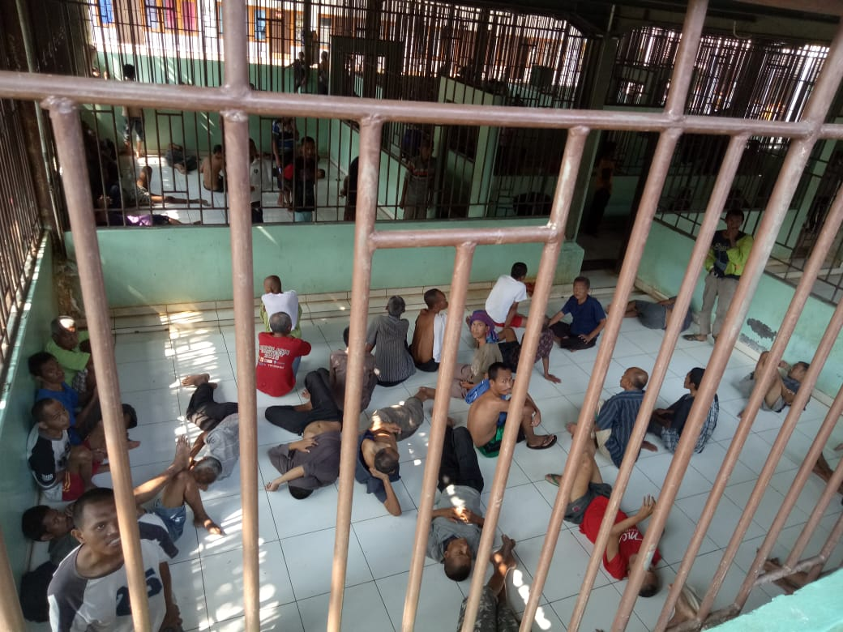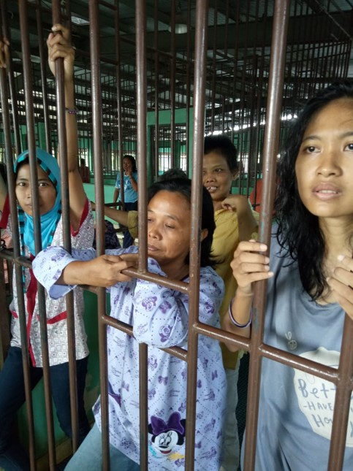
Galuh social care institution in Bekasi City, not far from Jakarta, October 2018. Photo by IMHA

Apart from large wards, there are also institutions that place people with psychosocial disabilities in small individual cells about 1.5 x 2,5 meters in size.

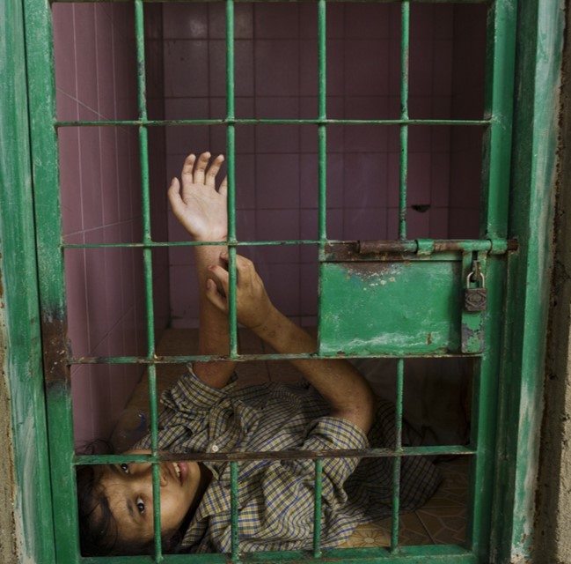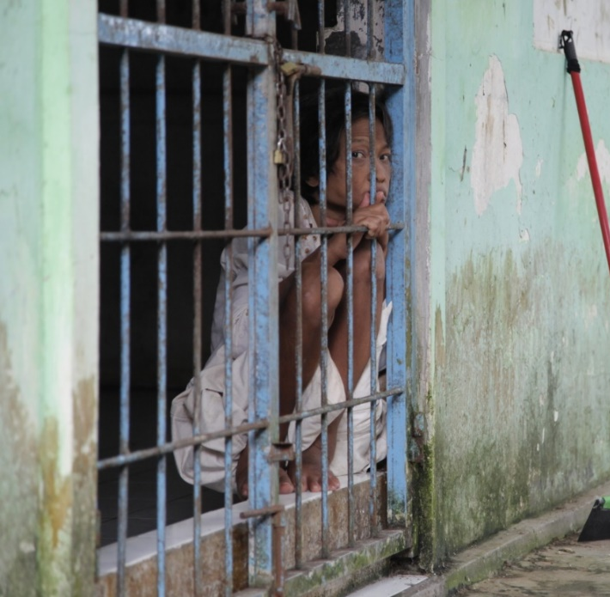

Cell for women residents at social institution in Cilacap, 2018, left, photo by Andrea Star Reese and Brebes 2017, right, photo by IMHA

Detained Using Chains
- In some institutions, residents, male, female and minors, are not only detained but also chained by binding their hands, feet or both using iron chains.
- Of the 25 institutions visited, 17 of them used chains to detain residents. See appendix no. 24.
- At Padepokan Mbah Marsiyo in Kebumen District, Central Java Province shackling is exceptionally cruel. The majority of residents are all subject to shackling, chained to large round cement weights. Even those working around the premises have chains wrapped around their ankles. Much of the facility is open to the elements. Residents do not appear to have extra clothing, some are in rags. All are terribly hungry.
- The institution residents who are shackled do everything in the place where they are chained, including sleeping, eating and drinking. If they are lucky, they are allowed to defecate in the toilet. However, quite a few have to defecate in the same place. In several institutions visited, the shackled residents sleep next to their own filth.

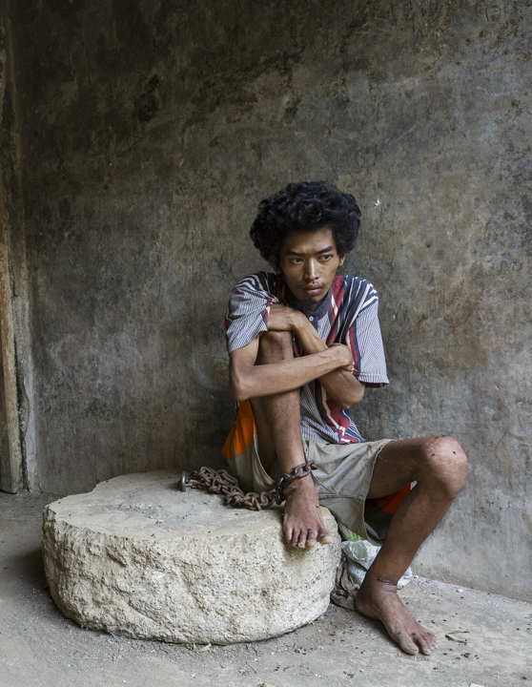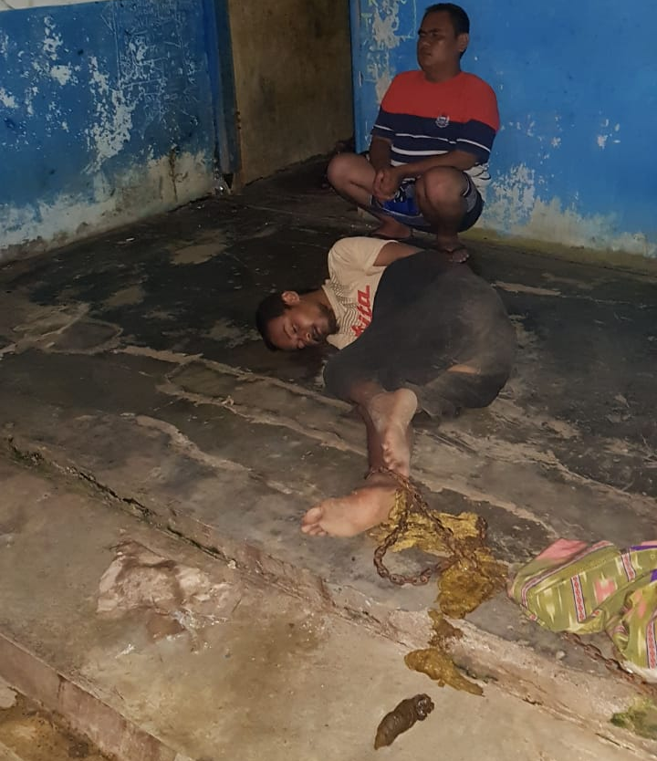

Mbah Marsiyo social care institution in Kebumen, Central Java, 2019, left (Photo by Andrea Star Reese) and Al Ridwan, Cilacap, Centarl Java, 2019, residents laid next to his filth, right, photo by IMHA

Isolation Cells
- Residents of the institutions who are considered to be breaking the rules or considered dangerous can be locked in isolation confinement where they are not allowed to go out at all even to eat and have to do all activities in the cell. They could be kept in isolation cells for months. See appendix no. 25.

Forced Treatment
- Anti-psychotic drugs are given arbitrarily without adequate examination and without informed consent.
- IMHA’ observations at the Galuh social care institution in October 2018 found that all residents in Galuh social care institution were injected with anti-psychotic drugs without examination and determination of the individual diagnosis. All residents of Galuh social care institution, numbering around 400, regardless as to whether they were adult or minors, having psychotic diagnose or not, were all injected with the same drug at the same dosage. The residents could not refuse the injection which was given once every two weeks.
- Some residents even said they did not know what drugs were injected. One of the social institution residents PJS succeeded in interviewing said that he did not know what drug was injected into him. He complained that his body was always stiff and sore without knowing why.
- Based on information from management of institutions, the drug injected is Sikzonoate (Fluphenazine Decanoate) which is an anti-psychotic drug indicated for the treatment of chronic schizophrenia. Sikzonoate is an old generation anti-psychotic that has severe side effects including dyskinesia, dystonia, akathisia, and hyperreflexia which cause symptoms such as stiffness, stiff and inarticulate tongue, drooling, the continual movement of fingers, and so forth.
- The violation is made worse when it was discovered from institution managers that the person injecting this anti-psychotic drug is not health worker but merely regular worker who do not possess license as health worker. However, this person introduces himself to the residents as a doctor.
- The National Committee on Violence against Women (Komnas Perempuan) found several institutions in Wonosobo and Semarang, Central Java Province, where residents were infected with scabies, treated the infection with a carbolic and sulfur mixture applied directly to the infected skin. See appendix no. 26.
- In addition to medical treatment, many institutions use traditional non-medical treatments. include vigorous painful massage, submerged in water, spray with water, midnight bath, drinking herbal concoctions, reciting of scripture close to the ears.
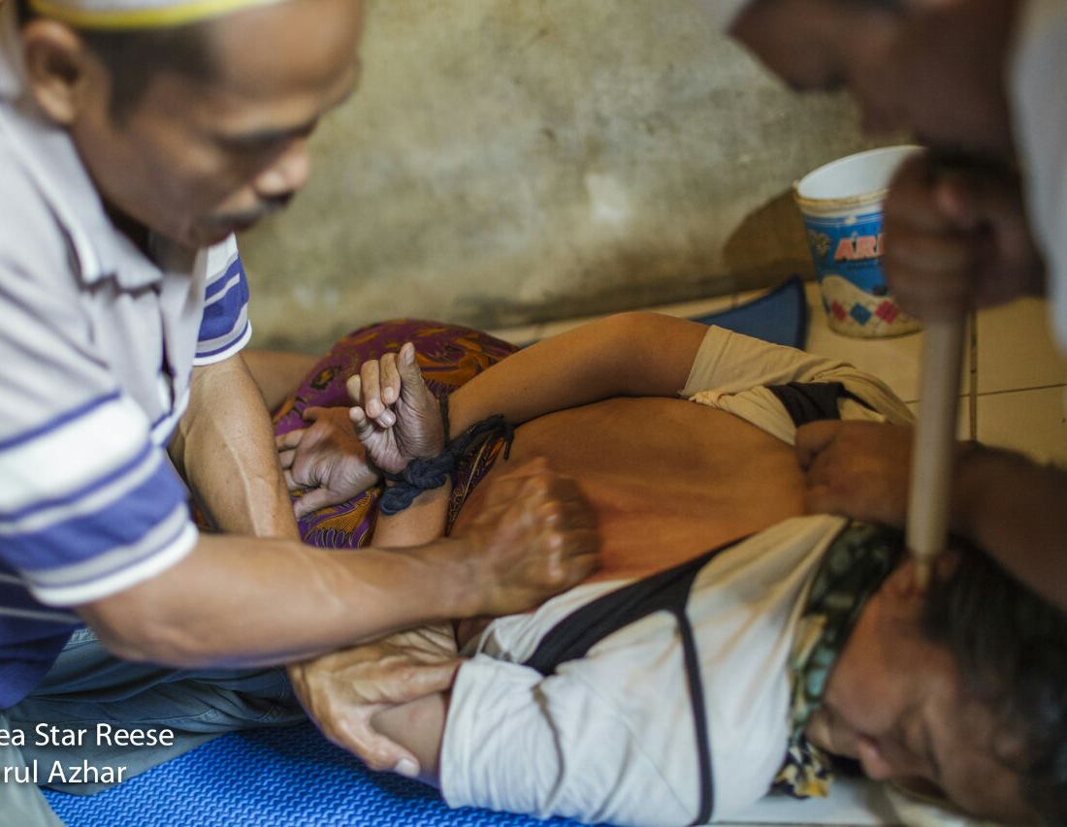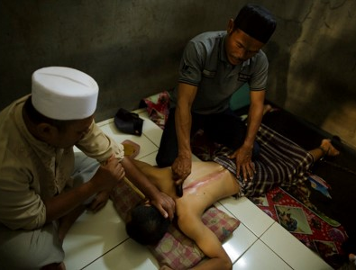
Vigorous painful massage, reciting of scripture close to the ears in Cianjur, West Java. Photo by Andrea Star Reese

- As with medical treatments, these non-medical treatments were also given without informed consent. This was confirmed by the National Commission on Human Rights' (Komnas HAM) findings in 2018 at six social institutions in Java. All institution residents interview by Komnas Ham admitted that they were not given clear information or requests for consent prior to actions being taken on them.

Lack of medical services
- Mortality rates in institutions are quite high. Based on IMHA observations and interviews with residents in several social care institutions in Bekasi it was found that every month someone dies. In Al Fajar Berseri, Bekasi district, information boards about patients, including patients who died in social care institutions, every month 1 to 6 people died (average 3 to 4 persons per month) There were even three residents in Aura Welas Asih institution, Sukabumi, West Java who died on the same day at the institution.

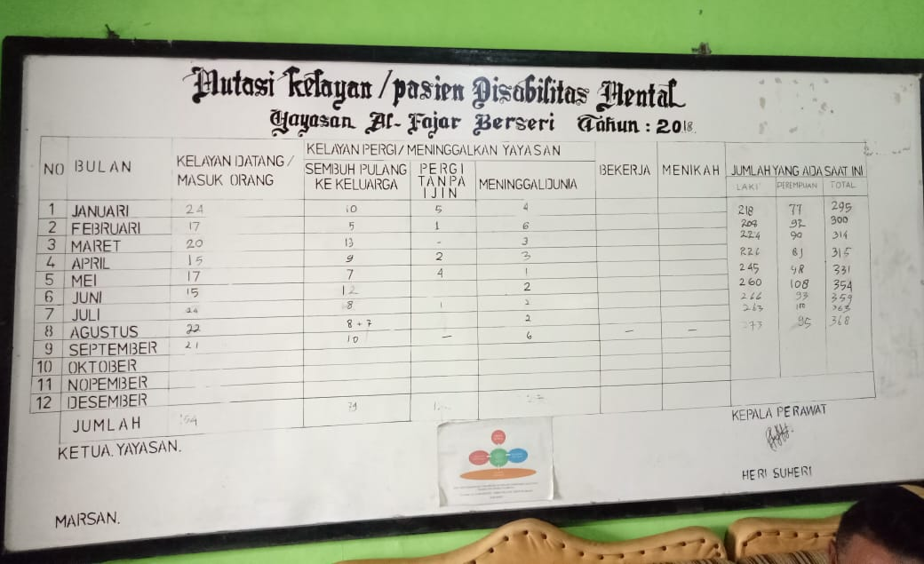
Information boards about residents in Fajar Berseri social care institutions, including residents who died, from January to September 2018. Every month 1 to 6 residents died.

- The high mortality rate in institutions is never discussed among policy makers including within the ministry of health and social affairs and local health and social service. Institution residents die quietly without anyone making a fuss.
- Many of female residents who were pregnant did not get adequate health checks or at all including during childbirth. Delivery were often conducted just by institution’s staff without medical knowledge. There was a case in an institution in Bekasi where both the mother and her child died in childbirth. The institution managers said this occurred because there was no medical assistance during delivery.
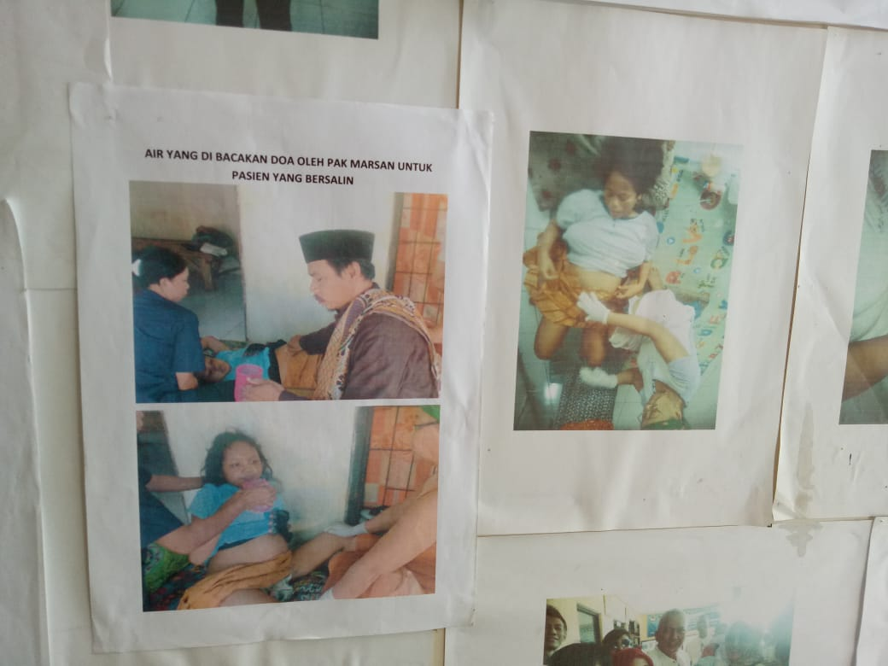 L
Left: pictures of Fajar Berseri’s women residents giving birth asisted only by the institution’s staff
Right: Photo of a Fajar Berseri’s women resident and her baby, both died during delivery in the institution without medical assitance.

Starvation
- There were several institutions where residents have been left to starve, including Padepokan Mbah Marsiyo in Kebumen. A resident interviewed said that he was very hungry and only received inadequate meals twice a day. Some of the residents were very thin and skeletal-like. At another institution in Sragen District, Sehat Waras Sejahtera Foundation, the residents appeared to be hungry and subdued.

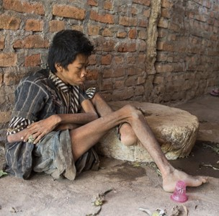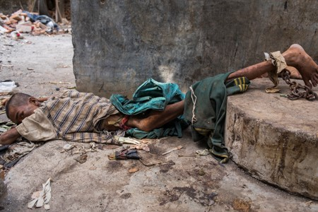
Starving residents at Mbah Marsiyo social care institution, Kebumen, Central Java, 2019 (Photo by Andrea Star Reese)

Shaving Head
- Many institutions, including government-owned institutions, shave the head of both male and female residents without consent of the person. The institution’s management argue that this shaving is done because the residents have lice or ulcers on their head. A female institution resident we interviewed said that she had been shaved twice. She felt very humiliated and abused by this treatment but was unable to do anything. When asked what would have happened if she refused she said there was a risk she could be beaten.

There are no beds or matrasses
- Most of the inhabitants of these institutions sleep on the floor of their cells without any mattrases.

Sanitation issues
- Hygiene problems are also cause for concern. The Galuh social care institution has shallow gutters that cross the room. The residents defecate in these gutters. When IMHA visited this institution in October 2018, a foul odour wafted from the direction of the wards. At Padepokan Mbah Marsiyo in Kebumen, the place where they live is full of rubbish.

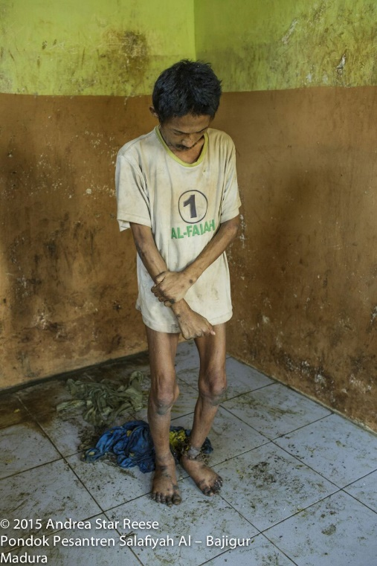

Men defaceted in their cell, Galuh institution, left, Al-Bajigur, Madura, right

Forced to bath in the open, female residents were bathed by male staff
- Another form of degrading treatment is being bathed or forced to bath in the open. This has happened to both male and female residents. During a visit to an institution, IMHA found female residents bathing in an open place while male staff passed by. There was an institution where female residents were bathed by male staff.

Deprivation of right to raise children
- The manager of an institution in Bekasi interviewed by IMHA explained that the institution sometimes accommodates woman who are pregnant. When asked if the children were then cared for in the institution, the manager said that because the mother was a person with a mental disorder, she was obviously incapable of caring for the child. So, the institution gave these children away to other people without the mother’s formal consent.
- Indonesian Commission on Violence Against Women’s monitoring also found that the child born in the institution was then taken to a children’s shelter in Salatiga. It is almost certain that people with psychosocial disabilities who are pregnant and then give birth in an institution will lose their child, except if the person with psychosocial disabilities has family or neighbours who are prepared to adopt and take care of the child.

Violence Against Women and Children
- Violence Against Women and Children will be discussed separately in the chapter on women and children.

No separation between male and female residents and minors.
- Male and female residents are not separated at least in the following institutions: Bina Lestari Mandiri, Central Java; Kyai Syamsul Maarif Healing Centre, Brebes, Central Java; and Padepokan Mbah Marsiyo.
- IMHA observations found several of the underage residents were placed in the same facilities or even in the same rooms as adults in an institution in Bekasi.

There are no rights to privacy or to have personal belongings
- In many institutions, the residents have to live together in wards or rooms filled with many people. Often these rooms are open or walled with iron bars like a cage. This makes the residents have no privacy at all. Even toilets do not have doors, including the toilets for female residents.
- In addition, the residents are also not allowed to own or store personal belongings. Nearly all residents visited by IMHA were not allowed to have personal belongings. Residents were forced to only use items lent by the institution, including clothes, sandals, and toiletries. This contradicts one of the human rights principles that states that everyone has the right to own property as stated in Article 17 of the Universal Declaration of Human Rights (UDHR).
- A male resident informed that he had a child but that since being forcibly institutionalized the child had been taken by his older sister and raised as her own without his consent. He sadly reported how he had been allowed no contact with his child for the 3.5 years of his incarceration.

There is no complaint and protection mechanism related to violence
- In all the institutions visited there were no complaint mechanisms that could be used by the residents to report violence experienced. There are many institutions where residents do not even have access to use the telephone. Everything that happens inside the institution takes place in a closed manner with almost no outsiders knowing what takes place on the inside.
- In interviews with institution residents, we often heard complaints about violence, sexual harassment, and so forth. However, the residents were too afraid to report these incidents, mainly because many of the perpetrators were institution officials. This places residents in a very vulnerable and helpless position.

Social institutions become business opportunities and to attract public donation
- Part of the reason for the establishment of institutions is because many families do not want people with psychosocial disabilities to be discharged from the mental hospital even when there are no longer medical reasons for continuing treatment. This has been seen as a business opportunity by employees in mental hospitals, particularly psychiatrists and nurses as well as other employees.
- Not surprisingly, institutions are a lucrative business. In one institution, owned by a fairly well-known psychiatrist in Jakrta, the cost per month range from US$ 322 (class 3) to US$ 1070 (class 1) or about more than three times Jakarta's minimum wage.
- Still, people who are admitted to those institutions are not asked for their informed consent. In addition, those places still behave like a prison where residents were locked inside the facilities. These two things make the institutions owned or managed by psychiatrists remain an arbitrary detention centre.
- In some cases, social institutions are a family business. Almost all the social care workers at the Galuh Foundation still have a blood relation with the founder of the foundation. See appendix no. 27.
- Several institutions receive donations from various parties, whether in the form of money, goods, infrastructure development, and so forth. Galuh Foundation has received Rp 11,7 billion from a charity foundation within 2 years.

The state still strengthens institutionalization by actions, regulations and funding

T.1. Regulations and Actions
- Point 30 of CPRD General Comment No. 5 on Article 19 requires the state in providing services to persons with psychosocial disabilities to be inclusive in the community and not to provide services in the form of social institutions and mental hospitals that segregate and limit individual autonomy. However, in Indonesia the state has become an active party in the institutionalization by establishing many social care institutions and sending people with psychosocial disabilities to social care institutions.

T.2. Legal bases of forced institutionalization and social care institution
- Obligation of forced confinement to PWPD to an institution on the grounds of social rehabilitation is also carried out by the social ministry, provincial government and district / city government through various regulations. See appendix no. 28.
- Article 92 Paragraph 2 of Indonesian Disability Act states that social rehabilitation are conducted through persuasive, motivated, and coercive action by families, communities, and social institutions.
- PJS has recorded as many as 5 provincial regulations and 7 regency / city level regulations on the handling of people with social welfare problems that become the reference for local governments to carry out forced rehabilitation for PWPDs to institutions and have the authority to determine whether PWPDs are eligible to leave the institution. See appendix no. 29.
- In addition, Government Regulation No. 32 of 2012 regarding the implementation of social welfare provides a very easy space for anyone to establish a rehabilitation center.
- These regulations form the legal basis for the police, the public order agency (Satpol PP) and other state officials to forcefully take people with psychosocial disabilities found on the street to social care institutions.
- In February 2018, the police together with public order agency and the Bogor City Social Affairs Department conducted a raid on homeless people who were considered to be mentally ill. In just 10 days, the police arrested 90 people who were considered mentally ill from the streets and took them by force to social institutions.
- In addition to playing an active role, the state also acts by omission, allowing the private sector to establish social institutions. The state plays the role of providing legality for establishment permits and operational licenses for social institutions in Indonesia. See appendix no. 30.
- Permission to set up social care institution is easy. See appendix no. 31.
- On various occasions, public officials including Minister of Social Affairs have said they would increase the number of social institutions in several areas to accommodate people with psychosocial disabilities. See appendix no. 32.

T.3. Funding the social care institutions

- CRPD General Comment Article 19 point 51 mandates that state parties should ensure that public or private funds are not spent on maintaining, renovating, establishing buildings or creating any form of institutions or institutionalisation. In addition, the state must also ensure that no new social institutions are established by the private sector.
- However, in Indonesia, the state in fact continuously allocates public funds to repair and increase the number of social institutions. See appendix no. 33.
- In addition, the state also does not make regulations related to the prohibition of donations from private funds or contributions from the community to build and expand social care institutions. In Indonesia, many parties provide assistance for daily operational costs and renovating social institutions. These funds are given by the community directly to the management of social institutions or channelled through social media platforms and collected by social care institutions.
- Al-Fajar Berseri social care institution acquired US$ 26,252. through social media platform that aims to collect public contributions See appendix no. 34.
- Bina Lestari Mandiri, a social care institution in Brebes received US$ 178.257 from a Singaporean NGO . See appendix no. 35.
- Kyai Jasono social care institution in Cilacap received US$ 178.147 assistance from a Singaporean organization See appendix no. 36.
- The Galuh Foundation receives funds from the Semesta Foundation that reach US$ 835.714. The foundation also provides operational support to meet the patients' everyday needs, including the caregivers' wages. The Semester Foundation raises public funds to do this. See appendix no. 37.
- Despite the large donation, the development does not change the nature of the institution. At Galuh, the residential ward still remains in the form of iron bars cells. At Kyai Jasono and Bina Lestari institutions, the residents remained shackled.

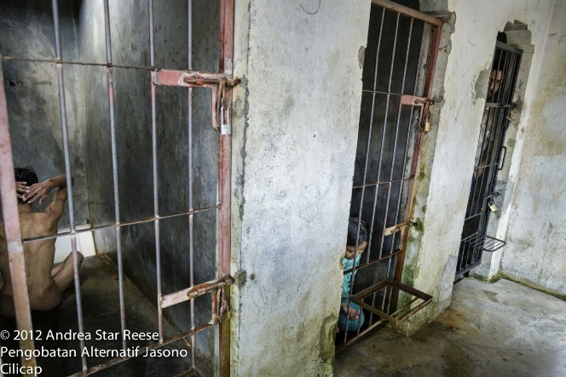
Kyai Jasono social care institution in 2012 before renovation, left, and in 2019 after big money renovation funded by charity. Photos by Andrea Star Reese

T.4. The government has no plans for de-institutionalisation

- Point 42 CPRD General Comment on Article 19 affirmed that "States parties have the immediate obligation to enter into strategic planning, with adequate time frames and resourcing, in close and respectful consultation with representative organizations of persons with disabilities, to replace any institutionalized settings with independent living support services. "
- However, At the time of the writing of this report, there was not a single policy or program issued by the Indonesian government related to de-institutionalisation efforts. On the contrary, the government is trying to increase the number of institutions and mental hospitals in Indonesia.
- Article 52, Law No. 18/2014 on Mental Health, a law that was passed after Indonesia ratified the CRPD in 2011, requires all provincial governments to establish at least one psychiatric hospital in their respective regions. Various other government regulations guarantee the establishment of social care institutions.
- There are no plans nor programs by the government to release people with psychosocial disabilities from social institutions and return their right to live independently and be involved in the community.
- The Ministry of Law and Human Rights and various National Human Rights Institutes have monitored social institutions and acknowledge that human rights violations have occurred in these institutions. However, these investigations and reports do not resulted in a change of government policy and program , let alone systematic plan to de-institutionalise.
- The government has not shown any progress towards the realisation of chapter 19 of the CRPD by maximising state-owned resources, in line with the mandate of CRPD General Comment Article 19 points 14, 96 and 97.
- One of the biggest reason why PWPD are kept in social care institutions for years is because they have no where else to go beside their families. If the families do not want them back then they are stuck in the institution. For de-institutionalization to be succeed, the government first of all must ensure, that accommodation or public housing are provided for PWPD before they are discharged from the institutions.

Recommendations
- From the above explanations it could be concluded that the issue of social institutions in Indonesia is exactly the same as those described in General Comment No. 5 on Article 19.
In accordance with the problems outlined above, here are our recommendations:
- The government must immediately make a de-institutionalization strategy and stop all support that perpetuates the practice of institutionalizing people with psychosocial disabilities.
- The government must immediately create and implement regulations that prohibit all forms of institutionalization and forced treatment of any kind to people with psychosocial disabilities.
- The government must change all forms of legislation and practices in the community that deprive people's right to legal capacity, including Law No. 8/2016 on Persons with Disabilities, Law No. 18/2014 on Mental Health, and the Indonesian Civil Code.
- The government must revise all regulations that legalized forced institutionalization including Law No. 8/2016 on Persons with Disabilities, Law No. 18/2014 on Mental Health.
- The state must release all people with psychosocial disabilities confined in social institutions and provide all forms of support required so that people with psychosocial disabilities released from institutions shall live well, safely, independently, inclusively in society. These facilities include housing, work/livelihood support, social protection, health, transportation, and other necessary support.
- The state must ensure that there is a specific budget for implementing de-institutionalisation.
- The state must organize human rights and CRPD trainings for key stakeholders within the government who are authorised to plan and implement programs related to people with psychosocial disabilities.
- The government is obliged to educate the public on the right of people with psychosocial disabilities to live independently in the community and the poor practices of institutionalisation.
- The government must create an adequate legal framework and budget to ensure adequate support in all sectors of life including social protection, employment, housing, health, education, and other support needed, for people with psychosocial disabilities and their families to ensure the rights of people with psychosocial disabilities to live independently and participate fully in the community.
- The state must ensure that there are complaints mechanisms for people with disabilities, including people with psychosocial disabilities, who are victims of violence.
- The state must involve disability organizations in planning, implementing, and monitoring service programs for people with disabilities, including organizatios pf people with psychosocial disabilities.
- The state shall not use the excuse of regional autonomy to avoid the responsibility of respecting, protecting and fulfilling the rights of people with psychosocial disabilities.

Chapter 3: Critique of the 'Indonesia Free of Shackling' program
The main article violated is article 19.
However, this issue also violates articles 3, 4, 5, 8, 12, 13, 14, 15, 17, and 25.

- Shackling are a deprivation of the freedom of movement usually carried out against persons with psychosocial disabilities who are considered to be dangerous.
- Shackling can take place in various forms: clamping of feet with a wooden block, chaining of hands and feet, being locked in a cage, cell or room. Persons may be shackled indoors or outside, near a residential area or in a village, or they may also be shackled in remote areas, relatively far from residential areas. In some cases, persons with psychosocial disabilities are bound in the open without any protection (a roof or walls) at all.
- People may be shackled for months or decades and some have even died in their shackling.
- Based on IMHA observations, which were also made by Human Rights Watch, people are shackled as a result of the pervasive stigma and a lack of support, especially from the government, for persons with psychosocial disabilities and their families.

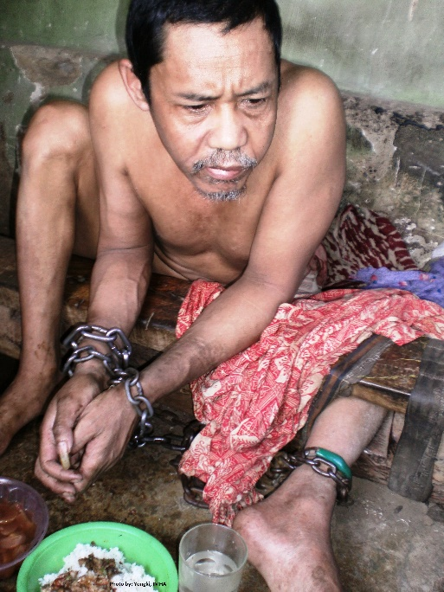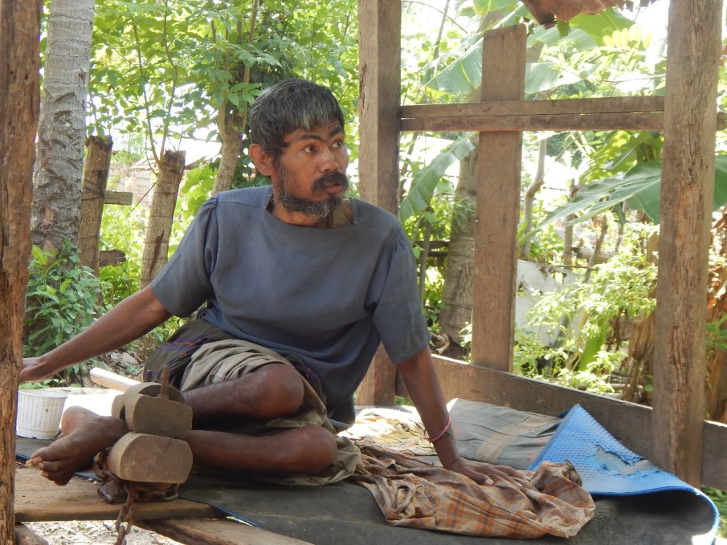
People Shackled in a village in, West Java, 2012 and in Central Sulawesi 2018, (Photo by IMHA)
- The practice of using shackling has been banned in Indonesia since 1977. In 2010, the Ministry of Health launched the “Indonesia Free of Shackling” program, which was strengthened by the “Stop Shackling” program by the Ministry of Social Affairs in 2016. The Indonesian Government aimed to free Indonesia of the practice of shackling by 2019.
- Per 2019 “Free from Shackling” program was far from the targeted goal. However, the programs have shown that progress has been made in the number of persons with psychosocial disabilities who are held or shackled in locked rooms. This number has decreased from almost 18,800 in 2016 to 12,800 in July 2018.

Problems with the “Free From Shackling Program” in Indonesia
- The biggest problem obviously is that the program is not fast enough. There are still more than 12.000 people in Indonesia who are shackled. The government should give this issue a top priority and involves all parties, as well as provide adequate budget.
- Other than that, there are other pressing issues relating to Indonesian government “Free From Shackling Program”

A.1. The Medical Model Approach

- Our main criticism of the approach to solve the issue of shackling in Indonesia is that it is very much a medical model approach.
- The issue of shackling must be addressed comprehensively with the aim of enabling persons with disabilities to live independently and participate fully in the community in accordance with Article 19 of the CRPD. To live independently, victims of shackling require support starting from housing, employment, social protection, education/skills, involvement in community social activities etcetera.
- However, until now the shackling free program in Indonesia has only focused on administering drugs (most of the time without free and informed consent) and rehabilitation in institutions that resemble prisons. See Appendix no. 38.
- The narrowness of the parties involved in the Indonesia Free of Shackling program is also evident in the Memorandum of Understanding (MoU) between the Social Affairs Ministry, Health Ministry, the Police, and National Helath Insurance See appendix no. 39.This MoU only involves the above-mentioned parties. No other significant ministries to ensure independent living were involved.
- Health Ministerial Regulation No. 54/2017 on the Prevention of the shackling of Persons with Mental Disorders has shown improvements by explaining the need for cross-sectoral support. However, this support was outlined in the explanation section of the regulation, not in the body and more over, in practice, almost no cross-sectoral support is carried out in a structured and systematic manner.

A.2. Substituting one cage for another.

- Mental hospitals and social institutions are still the main answer in solving the problem of shackling in Indonesia. There are many institutions where part of the residents are people who previously had been freed from schackling. The owner of an institution in Cianjur revealed that sixteen of the fifty residents of his institution are people who had been freed from shackling. See appendix no. 40.
- Various government regulations play a role in moving people from shackling into social institutions as reflected in Social Affairs Ministerial Regulation No. 12/2018 on the Prevention and Handling of the shackling of Persons with Psychosocial disabilities.
- It appears that in this Social Affairs Ministerial Regulation, the last step in the Shackling Free Program is to refer shackling victims to healthcare and social rehabilitation services, which in Indonesia are mostly institutions. In the appendices, the process of removing people from shackling into psychiatric hospitals/social institutions only requires consent from the family. For more information see appendix no.41.
- Essensial social supports such as housing, employment, social protection, etc, are hardly mentioned.

A.3. Shackling victims are treated like criminals

- When releasing shackling victims, often the police and military are involved. The victim is released from their chains, then usually they are shackled again, sometimes using handcuffs and then forcibly escorted by the police to a mental hospital or institution. In addition, in many cases victims are forcibly shaven before being taken away.
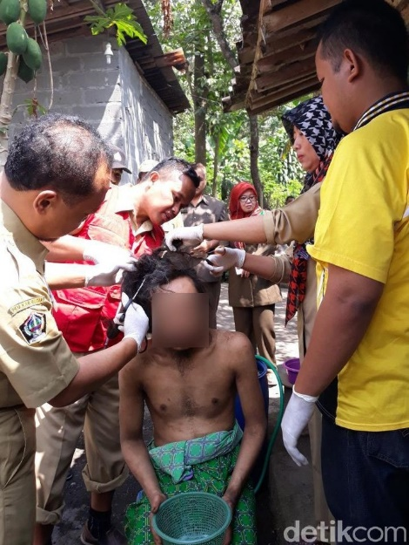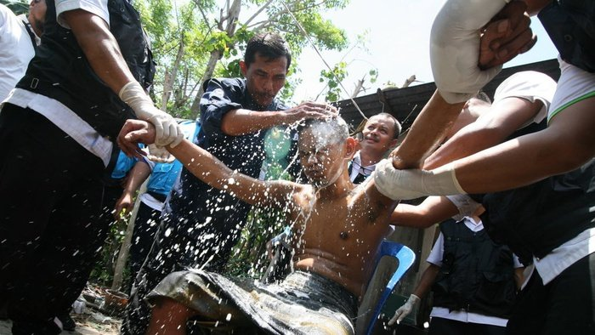
Pictures in the media of people freed from shackling, forced head shaving and forced bath.
Photo from detik.com 2019, left and ANTARA 2019, right
- More concerning is that this attitude is not only a social practice in the community, but also the attitude of the governing bodies stipulated in official regulations. Social Affairs Ministerial Regulation No. 12/2018 states that after becoming aware that a person is being shackled somewhere, the next step is the formation of an outreach team. One of the teams formed comprises of Indonesian National Police and Army (TNI) personnel.
- This indicates that persons with psychosocial disabilities are considered to be dangerous and viewed as criminals.

Recommendations
- The government must immediately change the approach of the Indonesia Free of shackling program from a medical approach that only focuses on administering drugs, to a social, human rights-based approach with the main purpose of facilitating persons with psychosocial disabilities to live independently and to participate in the community.
- The government must involve multisectoral parties from outside the ministries of Social Affairs and Health in preventing and solving the shackling issue. For example, the Housing Ministry, Labour Ministry, SMEs Ministry, Education Ministry and their respective departments, etcetera.
- The government must allocate sufficient funds to carry out the above programs.
- The government must immediately stop the practice of replacing shackling with other forms of confinement in psychiatric hospitals and social institutions.
- The government must ensure that all actions toward persons with psychosocial disabilities who are victims of shackling are carried out after obtaining informed consent from the person.
- The government must immediately stop degrading practices during the process of freeing persons with psychosocial disabilities from shackling, such as shaving, binding/chaining, or treating persons with psychosocial disabilities like criminals by involving the police and the arm force in the processes.
- The government must prevent the occurrence of shackling by providing the required support to persons with psychosocial disabilities and their families in a comprehensive and multisectoral manner.
- The government must provide a sufficient budget to prevent shackling using a comprehensive and multisectoral approach.

Chapter 4: The Right to Work and the Right to Education

The main articles violated are articles 24 and 27.
However, this issue also violates articles 3, 4, 5, 19, 22, and 26.

- Article 27 of CRPD affirms that States Parties recognise the right of persons with disabilities to work, on an equal basis with others and forbids discrimination on the basis of disability with regard to all matters concerning all forms of employment, including conditions of recruitment, hiring and employment, continuance of employment, career advancement and safe and healthy working conditions.

Discrimination through the requirement of a Mental Health Certificate for job seekers.
- We found that the Indonesian Government systematically and structurally commits discrimination against persons with psychosocial disabilities relating to their right to work.
- This discrimination takes place in the form of Mental Health Certificate requirements that must be fulfilled by every job seekers in Indonesia who wish to apply to be a civil servant, state-owned enterprises (SOEs) and private companies.
- A Mental Health Certificate (Surat Keterangan Sehat Rohani) is a letter issued by a health services agency to prove that the holder has no mental disorder.
- The certificate is provided after completing a series of psychological examinations including the Minnesota Multiphasic Personality Inventory (MMPI). “MMPI is a psychological test that assesses personality traits and psychopathology. It is primarily intended to test people who are suspected of having mental health or other clinical issues”. In addition to this test, during the examinations job seekers are interviewed by psychiatrists.
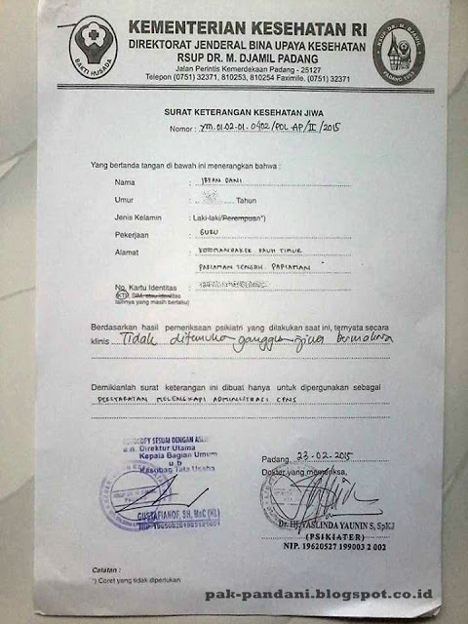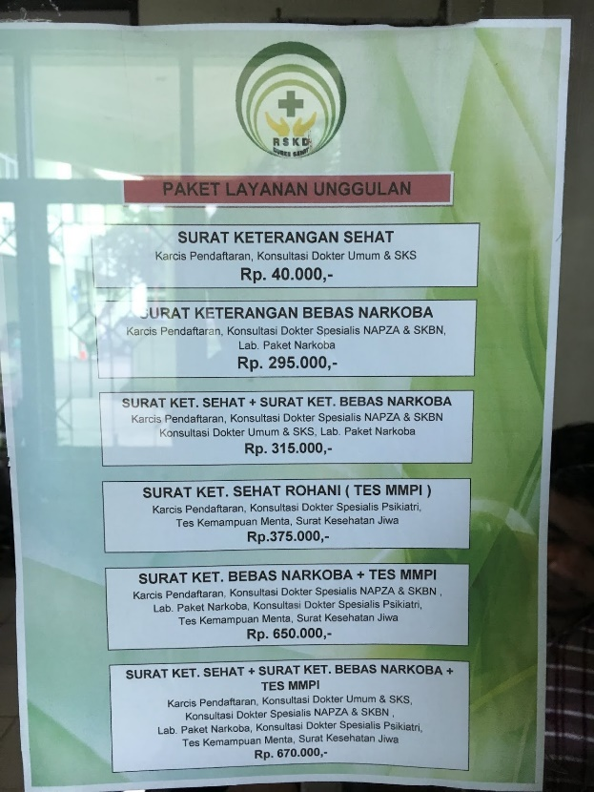
Left: Mental Health Certificate released by a psychiatrist from M.Djamil Hospital in Padang, West Sumatra 2015. The letter stated that based on psychiatric examination, there was no mental disorder in the person examined. It is also stated that the certificate was made as administrative requirements for civil servants application.
Right: Advertisement of best health examination packages available at Duren Sawit Hospital in Jakarta. One of them is psychiatric examination, including MMPI test, for Mental Health Ceritificate, 2019.
- Previously, the physical health certificate also included physical and sensory disabilities as physical health problems. Currently there has been a reinterpretation of the physical health certificate in which physical and sensory disabilities are no longer included as a category of physical problems.
- However, the psychological health requirements have still not changed. These requirements and the methods used to test them still aim to detect the mental health of a person through psychiatric examinations.
- The requirement for a mental health certificate is based on Government Regulation No. 11/2017 on the Management of Civil Servants.
- Article 23 of the regulation states that all persons who wish to apply to become a civil servant must be physically and mentally sound in accordance with the requirements of the position being applied for.
- This regulation has been adopted by all ministries and agencies, including ministries that should have a better perspective, such as the Social Affairs, Health, and Law and Human Rights ministries.
- In the lead up to each opening of the registration of prospective civil servants, hospitals in Indonesia are overrun by prospective applicants requesting a certificate of mental health. The cost to obtain the mental health certificates is quit high for Indonesian standard.

Dismissed from employment due to having mental health issues
- We encountered cases of persons with psychosocial disabilities being dismissed from employment after it became known that they had a mental disorder. One person was made redundant after she submitted a doctor’s certificate explaining that she had not been to the office for some time due to illness. The company became aware that she had experienced mental health problem as the doctor’s certificate provided was issued by a psychiatric ward. This eventualy led to her dismissal from the company

Lack of reasonable accommodation
- After hearing unpleasant stories of those who have been dismissed from employment because of mental illnesses, most people with psychosocial disabilities do not dare to inform the employer of their mental condition. As a result, they cannot access reasonable accommodation in cases where accommodation is provided by the employer. See appendix no. 42.

Psychosocial Disabilities Eliminated from Various Work and Training Programs
- Persons with psychosocial dissabilitie are not only excluded from general work, trainings and job certification opportunities, they are even excluded from government and private sector’s programs that aimed for people with disabilities.
- In 2019, IMHA volunteer attempted to register for a program held by the Communications and Information Ministry to attain professional IT certification through a special disability channel. However, there was no psychosocial disability options in the disabilities column on the registration form. The organisers clarified that persons with psychosocial disabilities would not be accepted to take part in the program. See appendix no. 43.
- During the 2018 Asian Para Games held in Jakarta, the committee opened registration for volunteers with disabilities who wished to get involved in the running of the event. However, people with psychosocial disabilities were excluded. They could not apply for this great opportunity. See Appendix no. 44.
- Even though Law No. 8/2016 on Persons with Disabilities stipulates a quota of two percent in the government and one percent in the private sector, all applications through public channels require a Mental Health Certificate that is clearly a barrier for persons with psychosocial disabilities. Even through the disability channels, persons with psychosocial disabilities are often prohibited from applying. See cases in appendix no. 45.

The Right to Education
- Paragraph 2 of Article 24 of the CRPD confirms that the state must ensure that reasonable accommodations are made for the individual needs of persons with psychosocial disabilities and provide the support needed in public education to facilitate effective education.
- Many persons with psychosocial disabilities in Indonesia drop out of school, especially at the higher education level, because there is no reasonable accommodation for when they encounter mental health problems.
- Many students who experience mental health problems cannot attend classes and are eventually expelled as their study period has expired. IMHA advocated several cases of students about to be expelled from universities. In many cases there is a lack of understanding and support from the university towards students who experience such issues. See appendix no. 46.
- Law No. 8/2016 on Disabilities has mandated the availability of adequate accommodations and disability service units for persons with disabilities in schools and higher education facilities but requires implementing regulations to realise this. Various OPDs have provided recommendations to the Ministry of Education on appropriate accommodations that need to be made for various disabilities, as draft government regulation materials. However, until now the draft regulation has not been passed and there are always concerns that the recommendations from OPDs will be omitted from draft regulation.

Recommendations
Right to Work
- The government must immediately remove mental health requirement and serificate (surat keterangan sehat rohani) that discriminate against persons with psychosocial disabilities from all process of civil servant recruitment.
- The government is obliged to make regulations that prohibit mental health requirements in the recruitment of employees by the private sector.
- The government must create regulations that prohibit discrimination based on disability, including psychosocial disabilities, in workplaces.
- The government must draw up regulations that regulate reasonable accommodation at all stages of work for persons with psychosocial disabilities in government agencies and private companies.
- The government must ensure that persons with psychosocial disabilities shall not be excluded from all opportunities and affirmative action programs targetting persons with disabilities.
Right to Education
- The government must provide reasonable accommodations for persons with psychosocial disabilities in all level and all kind of education.
- The government is obliged to consult closely and accommodate the input of persons with disabilities in drafting all regulations that regulates reasonable accommodation for students with disabilities in education istitutions of all levels.
- The government shall pass the draft of government regulation on reasonable accommodation in educational institutions and take into account the draft proposed by OPDs.

Chapter 5: Political and Civil Rights
The main article violated is article 29.
However, this issue also violates articles 3, 4, 5, 12, 18, 22, and 27.

The right to be registered as citizen.
- Many persons with psychosocial disabilities are not legally registered as Indonesian citizen. They do not have Citizen Identification Number (NIK) and National Identity Card (KTP)
- The implications of not having an identity card are extremely broad. Without identification, persons with psychosocial disabilities cannot access health insurance; social protection services; obtain driving license, employment; schooling; they can not vote, get married; open a bank acount and so on. appendix.
- This is caused by cultural view that persons with psychosocial disabilities are not normal human beings, even considered as less than human, and to not have awareness or feelings. They are, therefore, not considered to have rights as human beings, including the rights of citizens.

The right to vote in elections
- For a long time, persons with psychosocial disabilities in Indonesia have been considered incapable of voting in election. This is confirmed in a number of laws and regulations. See appendix no. 47.
- This incompetence is determined without any legal process. Anyone, including a voter registrar in the field, can declare someone with a psychosocial disability to be incapable of voting.
- For years, organizations of persons with disabilities have fought to eliminate these discriminatory regulations, including by submitting a judicial review against discriminatory article of Regional Election Law (see appendix) to the Constitutional Court.
- The Constitutional Court did not remove the article, but tightened the requirements to declare a person unable to vote.
- Where previously anyone could declare a person with a psychosocial disability unable to vote, the Constitutional Court stipulated that a person with a psychosocial disability can only be determined incapable of voting by means of a doctor’s certificate. This is contrary to CRPD article 29. For more see appendix no. 48.
- During elections, many of the residents of social care institutions were not registered as voters. See Appendix no. 49.
- There are two reasons why persons with psychosocial disabilities, especially in institutions, are not registered as voters:
- Many do not have a citizen identification number (NIK) and National ID Card.
- A doctor’s certificate states that the person is currently ill or being rehabilitated.
- In addition to social care institution, several mental hospitals also rejected the Jakarta General Elections Commission’s efforts to register patients in their hospitals to vote. See appendix no. 50.

The right to be elected as a legislators and public official
- Law No. 7/2017 on General Elections states that a person can only nominate themselves as a member of the Regional Representatives Council (DPD) or the People’s Representative Council (DPR) if they are physically and mentally sound.
- Regional Elections Law 10/2016 states that candidates for governor and deputy governor, district head and deputy district head, as well as candidates for mayor and deputy mayor must meet the physical and psychological requirements based on the results of a thorough examination.
- Mental wellbeing must be proven through a series of psychiatric examinations including the Minnesota Multiphasic Personality Inventory (MMPI) examination conducted by a team of doctors and psychologists, which is determined by the provincial or district/municipal level General Elections Commission.
- Surprisingly, to become a commissioner of all four of National Human Rights Institutes in Indonesia (National Commission of Human Rights, National Commission on Violence Against Women, or the National Commission on Child Protection and Ombudsman) which are responsible for the enforcement of human rights in Indonesia, psychological tests including MMPI are also required.
- This requirement also applies to the National Commission of Human Rights commissioner selection committee. See appendix no. 51. This is a breach to Article 29 point a of the CRPD.

Recommendations
- The Indonesian Government must ensure that PWPD could fully participate without any requirements, including psychiatric examinations, in the election processes both as voters and as candidates for legislators as well as head of regions.
- The government must abolish all discriminatory regulations and practices that prevent PWPD to participate in the elections both as voters and as candidates including removing the requirement of psychiatric examination.
- The Indonesian Government must abolish all discriminatory regulations and practices, including psychiatric examinations, that discriminate PWPD from the public office positions, including positions in all government offices as well as positions in National Human Rights Institutes

Chapter 6: Violations of the Rights of Women and Children
The main articles violated are articles 6 and 7. However, this issue also violates articles 3, 4, 5, 12, 13, 14, 15, 17, 19, 23, 24, and 25.

Violence against women with psychosocial disabilities in social institutions
- Women with psychosocial disabilities who are held in social institutions are vulnerable to sexual harassment. IMHA, Human Rights Watch as well as National Commission on Violence Against Women found cases of gender based violence during visits to social care institutions. Often the preptrators are the staff of the institutions. See cases in appendix no. 52.
- Frequently, bathrooms and toilets are open without doors, that male staff members are able to see the women’s bodies.
- We observed a female resident being bathed by male staff members while naked and in chains at the Syamsul Healing Center, Brebes District, Central Java.. We encountered female residents bathing in open spaces while male staff passed by. See Appendix no. 53.
- The risk of sexual violence in social institutions is also a result of the limited number of female staff. Almost in all institutions observed, the number of male staff are much higher than female staff.
- Many female residents are cared for by male staff. Male staff also easily enter women's rooms including in the evenings. See appendix no. 54. \
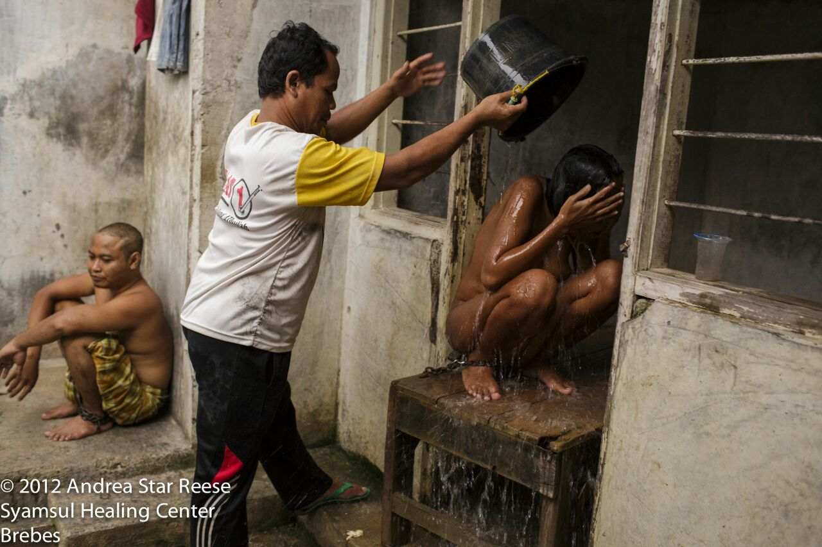
A female resident being bathed by male staff members while naked and in chains at the Syamsul Healing Center, Brebes District, Central Java, 2012. Photo by Andrea Star Reese

- All the women we interviewed claimed to be too afraid to report this, especially since most of the perpetrators were institution’s staff.
- Protection mechanisms available to women victims of sexual violence outside of the institutions such as legal assistance, shelters, safe houses, conselors are not available for them.

Sexual violence against women with psychosocial disabilities on the street and in shackling
- Women with psychosocial disabilities who are shackled/restrained are also extremely vulnerable to experiences of sexual violence. Some of them was raped and became pregnant while in shackling.
- After giving birth, the baby usually are given away to other people or put in institutions. For cases, see appendix no. 55.
- Women with psychosocial disabilities who live on the street are also at extreme risk of sexual violence including rapes. See appendix no. 56.
- There are quite a lot of news reports about women with psychosocial disbility who are raped and discovered to be pregnant in the mass media.
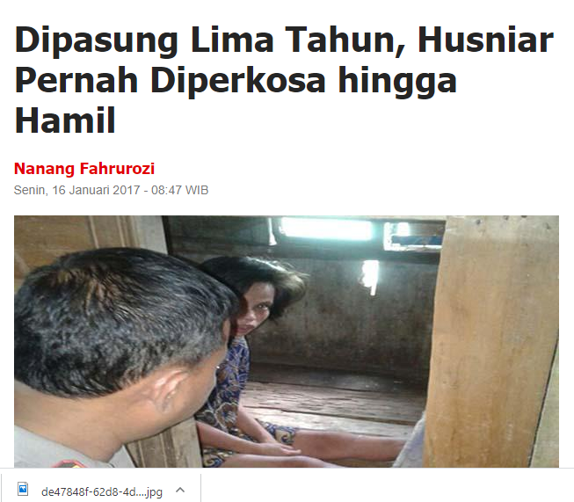
Sindo News Report, 2017 “Shackled for five years, Husna was raped until she became pregnant “
- Unfortunately, although these cases continue to appear in news, very rarely is there an effort from law enforcement agencies to trace the perpetrators of sexual violence against women with psychosocial disabilities.

Forced sterilisation
- Women with psychosocial disabilities who are placed in social institutions and psychiatric hospitals are also vulnerable to forced contraception and forced sterilisation. See appendix no. 57.
- According to observations made by Komnas Perempuan at the Margo Widodo Social Institution, Semarang, Central Java, the institution inserted contraceptive implants into female residents of childbearing age.
- Meanwhile, the Dr Amino Regional Psychiatric Hospital performs tubectomy on female patients. All without direct consent of the women involved. See appendix no. 58.
- LBHM collected data on the decisions of district courts throughout Indonesia from 2011 to 2018 and found that in 7 years only thirteen cases of sexual violence against women with psychosocial disabilities were taken to court. Three of these cases were committed against minors.
- The number of cases that go to court does not compare to the actual number of cases that occur on the street, at home, or in social institutions, and this highlights the state’s failure to provide optimal legal protection for women with psychosocial disabilities.
- Law enforcement institutions, such as the police, the public prosecutor's office and the courts are not adequately accessible to victims seeking justice and protection from possible retaliation from perpetrators.

Violations against children in social institutions
- Some institutions, such as the Galuh Foundation, Al-Fajar Berseri, and the Bani Syifa Institution in Banten, have child residents. They are placed together with adult residents.
- We witnessed a child being harassed by an adult resident while institution staff members did nothing to stop the harassment.
- During visit in October 2018, IMHA discovered children being detained at two institustions (Galuh and Fajar Berseri) in Bekasi.
- One girl was placed in the same cell as an adult resident, where she had been for some years. According to the residents, the child was often bullied by other residents in the institution.
- Based on PJS observations of the institutions visited, none of the children have access to education.
- During visits to this facilities, IMHA were accompanied Ombudsman. However, Ombudsman has yet to take any concrete steps in stopping the various violations that occur in these institutions.

Recommendations
- The state must immediately release children who are detained in social institutions for persons with psychosocial disabilities and prohibit this from occurring in the future.
- The state must stop neglecting cases of sexual violence committed against women with psychosocial disabilities. The state must take all necessary steps to ensure that all cases of sexual violence against women with psychosocial disabilities are handled seriously by law enforcement officials and that the perpetrators are investigated and receive appropriate punishment.
- The state must immediately cease all practices that violate the reproductive rights of women with psychosocial disabilities. All forms of pregnancy prevention may only be conducted with the informed consent of the person with psychosocial disabilities in question.
- The state must ensure the availability of all required services, including legal aid services, psychological counselling, and safe houses/shelters for women with psychosocial disabilities who are victims of sexual violence.
- The state must ensure that all supports that are currently available to non-disabled women who experience sexual violence can also be accessed by women with psychosocial disabilities.
- The state must place strict sanctions on mental hospitals and social institutions that allow sexual violence to occur within their institutions.
- The state must educate law enforcement officials to enhance their understanding of the rights of persons with disabilities, especially women with psychosocial disabilities who are dealing with the legal system, and especially those who are victims of sexual violence.

Chapter 7: Health
The main article violated is article 25.
However, this issue also violates articles 3, 4, 5, 8, 12, 13, 14, 15, 17, 19, 22, 23, 24, 27, 28, 29, and 30.

Medical treatment administered without free and informed consent
- Article 25 of the CRPD states that health professionals must provide care of the same quality to persons with disabilities as to others, including on the basis of free and informed consent by, inter alia, raising awareness of the human rights, dignity, autonomy and needs of persons with disabilities through training and the promulgation of ethical standards for public and private health care.
- In Indonesia many psychiatric health services are forced upon persons with psychosocial disabilities without their free and informed consent. Consent is more often provided by the family. As a result, almost all patients in psychiatric hospitals are involuntary patients
- According to a study at Grashia Mental Hospital, Yogyakarta, in 2014, approval of medical treatment, as a form of informed consent, is given once by the family / government agency responsible for the patient for all medical actions which will then be carried out on the patient, in the form of injections, infusions, isolation, binding, electric convulsion therapy, and others, while the patient is underGovernment of Indonesiang treatment in the hospital
- In conversation with a psychiatrist based in Jakarta, he informed that forms for informed consent in some mental hospitals only provide a column for the signature of the family.
- Human Rights Watch (HRW) found that patients in four of the psychiatric hospitals they visited were given electroconvulsive therapy (ECT) without consent.

Beside forced treatment, there are several other issues found at mental hospitals

B.1. Violence committed by psychiatric hospital staff
- There are many cases in which persons with psychosocial disabilities are treated badly, ranging from degrading treatment to verbal and physical violence, by hospital staff. In a video that went viral in Indonesia, a patient from Soeharto Heerjan Psychiatric Hospital in Jakarta who left the hospital perimeters was beaten by a group of hospital security officers.
- There are several cases in which the patients ended up died in the hands of hospital workers. See appendix no. 59.
Many persons with psychosocial disabilities are forcibly taken to psychiatric hospitals using violent methods, including the use of handcuffs and sedative injections. See appendix no. 60.

B.2. Shaving
- Some psychiatric hospital patients, both male and female, have their hair shaved off by force. Reason given by the hospital is to prevent head lice.

B.3. Isolation rooms
- Psychiatric hospitals in Indonesia still put patients in isolation rooms for various reasons. While in isolation rooms, patients may not interact with other people, including visiting family members. Patients may be detained in an isolation room for days at a time.

B.4. Binding
- Patients in psychiatric hospitals in Indonesia are often bound. Binding is conducted without clear procedure on how long the patient is to remain bound or how they are to be assessed.

B.5. Treatment rooms that resemble prison cells and over capacity
- Quite a few psychiatric hospitals in Indonesia still resemble prisons, with iron bar walls and doors. Various psychiatric hospitals accommodate a total number of patients that exceeds their capacity. As a result, treatment wards are overcrowded. In some places, patients are not allowed to leave the ward or room where they are treated.

B.6. Forced Sterilisation
- As previously explained in the chapter on gender-based violence, Komnas Perempuan uncovered the practice of forced sterilisation of female patients at the Margo Widodo Psychiatric Hospital in Semarang. Until now, the government has taken no action to stop such practices.

B.7. Inequality in the availability of medication between urban and rural areas
- CRPD Article 25 paragraph (c) states that state parties shall provide these health services as close as possible to people’s own communities, including in rural areas.
- In Indonesia there is a disparity between the mental health services and medications available in big cities and rural areas as shown in Health Ministerial Decree No. 328/Menkes/SK/VIII/2013 on the National Formulary.
- This decree regulate the availability of medications in different level of health facilities from community health services to district, province and national level hospitals.
- As a result, in basic healthcare services closest to the community (community health centres, puskesmas) the choice, quantity and quality of psychiatric medications are very limited.
- Many persons with psychosocial disabilities must travel really far, sometimes even to another islands to access the necessary healthcare services.
- Even with the limited allocation of drugs, many community health centre do not submit requests for supplies of psychiatric medication to the local health office. Various puskesmas sources stated that they do not request the medications because they have a limited understanding of psychiatric health issues.

B.8. The government does not provide generic versions of the patented drugs required
- Many older psychiatric medications, have severe side effects. The newer drugs has much lesser side effect. But they are expensive because they are patented with no generic versions available.
- One of the main problems with the availability of newer medication in Indonesia is that when the patent period has expired, the government and pharmaceutical SOEs do not create generic versions of the patented drugs, causing high prices in medications.
- As a result, only a small number of people can access the drugs with lesser side effects. Most patients have no choice but to use older drugs, including the old typical anti psychotic drugs with severe side effects including Parkinson.
- In addition, with the limited national health insurance budget, the newer drugs are only provided at hospitals located in the provincial capitals and are not available at district-level puskesmas or in rural areas.

B.9. Self harms and suicide attempt is not covered by National Health Insurance.

- One of the issues experienced by with people with psychosocial disability are self harms and suicide attemps that often needs medical treatment.
- Unfortunately, according to Republic of Indonesia presidential regulation no 8 2018 regarding health insurance, the two problems are not covered by national health insurance. It is considered as the person's own fault therefore they have to pay the medical bills by themselves.

Recommendations
- The government must ensure that under all laws and regulations, internal hospital regulations, and other relevant regulations, all medical treatment carried out on persons with psychosocial disabilities is given with free and informed consent.
- The government must take steps to eliminate the inequality in the availability of health service drugs between urban and rural areas.
- The government must expand the availability of the types, quality and quantity of medication required by people with psychosocial disabilities.
- The government must produce generic versions of new psychiatric drugs in order to increase the number of persons with psychosocial disabilities who can access good quality psychiatric drugs with low side effects.
- The national health insurance must cover all related medical situation, including suicide attemps and self harms.
- The government take all necessary steps, including making regulations, monitoring and evaluation, to prevent acts of violence against psychiatric patients in all healthcare services.
- All perpetrators of violence against persons with psychosocial disabilities in healthcare services must be held legally responsible and their institutions should be sanctioned.
- The government must educate all health workers so that they understand psychiatric health problems and understand the ethics of interacting with persons with psychosocial disabilities and their rights as patients.

Chapter 8: The Abandonment of People with Psychosocial Disability (PWPD) during Disasters.
The main article violated is article 11.
However, this issue also violates articles 3, 4, 5, 8, and 25.

- Indonesia is a regular victim of natural disasters such as tsunami, earthquakes and volcanoes by being located on the Ring of Fire, an area highly prone to volcanic and seismic activity on the borders of the Pacific Ocean Plate.
- After a major quake in Palu, Central Sulawesi in September of 2018, IMHA carried out an investigation to collect information about the fulfillment of human rights for people with psychosocial disability throughout the before, during and after period of disaster.
- We found five major points:
- Quite a number of people with psychosocial disability in the area were shackled prior to the disaster
- There were no special measures taken in respect of preparing or evacuating people with psychosocial disability including those who were in shackling.
- When the earthquake came, the people with psychosocial disability that were shackled were abandoned by their families and other villagers as they fled to save themselves. The villagers escaped to higher ground and stayed there for several days in fear of further tsunamis and aftershocks.
- While the government evacuated the general populace to relief centers, most of the shackled people were left behind. They were abandoned in empty villages, often still left bound up or encaged – or both, for up to a few weeks while still at risk of further quakes. Their homes were often damaged and compromised after the quake and at risk of collapsing.
- There had been no improvement in the post-disaster recovery phase. The people who were shackled prior to the disaster remained in shackles after the recovery program. Those that were released and evacuated were placed back in shackles. This conflicts with priority 4 of the Sendai Framework which commits to “build back better” as a guiding principle during recovery, rehabilitation and reconstruction. For further information see appendix no. 61.
- Regulation of the Head of the National Disaster Management Agency Number 14, 2014 regarding the Management, Protection and the Participation of the People with Disabilitiy during the Disaster Prevention is a relatively good regulations to carry out data collection, programs, mapping, mitigation, managing of persons with disabilities in disaster risk areas.
- However, IMHA investigation into disaster area in Palu, Central Sulawesi in 2018 discoveres that the implementation of the regulation, especialy related to PWPD, was nearly zero. People with psychosocial disabilities did not receive attention in the process of disaster management.
- During earthquake in Aceh in 2012, officials at local mental hospitals panicked and released all patients but left them to fend for themselves. There were no planned evacuation procedures to follow as patients running around with no direction for safety. Many patients were lost and the the hospital had a hard time to find them.
- This gives an overview of the extent to which Indonesia has failed to implement the proscriptive of Article 11 of the CPRD detailing state obligations to protect the disabled at the time of disasters.

Recommendations
- The state should compile data on the people with disability in areas prone to disaster in order to mitigate the impact and better facilitate their evacuation if a disaster occurs.
- The state should be responsible for socializing disaster responses involving the people with psychosocial disability.
- The State is responsible to plan disaster management with special attention to the people with psychosocial disability in mental hospitals, social care institutions and those who live in shackles or confinement.
- The state is obliged to take steps in line with the Sendai Framework according to the principle of “build back better” to govern recovery, rehabilitation and reconstruction efforts on behalf of the people with disability.

Chapter 9: Awareness-raising
The main article violated is article 8.
However, this issue also violates articles 3, 4, and 5.
- CRPD Article 8 paragraph 1 letters a, b, and c mandate the government to raise social awareness, including at the family level, regarding persons with disabilities, and to foster respect for the rights and dignity of persons with disabilities as well as to combat stereotypes, prejudices and harmful practices relating to persons with disabilities.
- In spite of this, Indonesian government has never run a systematic education and campaign to eliminate stigma and negative messages against persons with psychosocial disabilities.
- As a result of this lack of education, many families lose hope and do not want to accept family members with psychosocial disabilities and choose lock them in the house or send them to social institutions.
- Likewise, the government has never taken firm action against negative campaigns regarding persons with psychosocial disabilities on social media See appendix no. 62.
- An example of this missleading messages is the provision of humanitarian awards by community leaders and philanthropic bodies to social institutions that confine persons with psychosocial disabilities.
- Andy F. Noya, a philanthropist and the host of a famous TV talk show “Kick Andy” gave numerous awards to several prison like institutions that kept people with psychosocial disabilities in inhuman condition. See appendix no. 63.
- So far, the government has done nothing to correct this false perception. Instead, several Head of Districs also gave awards to these facilities.
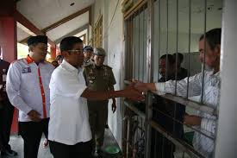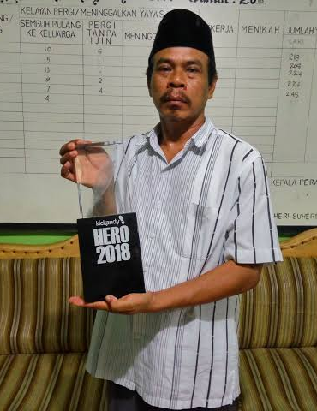
Left: Minister of Social Affair visited Aura Welas Asih institution in West Java 2018. The head of this institution later on received an award from West Java governor.
Right: Head of Fajar Beseri from Bekasi showed his Kick Any Hero Award 2018

- Bekasi, a city where there are many prison like social institutions with a lot of violations towards persons with psychosocial disabilities, ironically was honoured with “Human Rights Care City Award” from the Ministry of Law and Human Rights on International Human Rights Day on 10 December 2019.
- With this, the government, in fact, disseminates negative messages about persons with psychosocial disabilities and imply that persons with psychosocial disabilities do not have legal capacity, and that the deprivation of freedom of persons with psychosocial disabilities is normal.

Recommendations
- The state must make every effort to stop all actions that perpetuate the stigma that persons with psychosocial disabilities do not have the right to self-determination and that detaining persons with psychosocial disabilities in social institutions is a good thing.
- The state must immediately reprimand those who give awards to perpetrators of human rights violations and perpetrators of violence against persons with psychosocial disabilities, both from the private sector and from within the government itself.
- The state must systematically educate government officials to not discriminate against persons with psychosocial disabilities in providing public services.
- The government must create a public education campaign, including in the form of public service announcements in the media, public spaces, print media, television, internet and other media platforms to inform the community that persons with psychosocial disabilities are not dangerous and are capable of participating in community activities.
- The state must educate the families of persons with psychosocial disabilities regarding the rights of persons with psychosocial disabilities so that families do not confine, hide, or treat these persons badly.
- The state should encourage people working in the media to create positive content to raise public awareness that persons with psychosocial disabilities can also excel.

Chapter 10: Access to Justice for People with Psychosocial Disabilities (PWPD)
The main article violated is article 13.
However, this issue also violates articles 3, 4, 5, 10, 14, and 16.
- Only a small number of cases involving PWPD as victims of violence cases that brought to court.
- In the seven years period from 2011 until June of 2018, Community Legal Aid only found 36 criminal cases involving people with disabilities as victims or witnesses that came before the courts, an average of 5 per annum.
- Meanwhile, only in one year (2017) there were 159 reported cases of violence against people with psichosocial disabilities reported in the public media . See appendix no. 64.
- Comparing this figure with the recorded criminal cases, it means that only 3.5% of cases getting to court. It is a clear breach of Article 13 Paragraph 1 of the CRPD that guarantees equal treatment for people with disabilities in court.
- The research conducted by Community Legal Aid Institute regarding PWPD who faced criminal justice system found that only 60.75% of defendants were represented by legal counsel.
- In 2018 the Community Legal Aid Institute reviewed court decisions involving PWPD as perpetrators, victims and witnesses over the 2011-2018 period. The results indicate that experts on disability are inadequately provided at court hearings, see appendix no. 65.
- The dearth of experts in disability cases makes the guarantee of access to justice difficult to achieve. See appendix no. 66.
- The poor quality of legal support accessibility for PWPD indicates how Indonesia is not capable in fulfilling the rights of PWPD as accorded by Article 13 Paragraph 2 of the CRPD. See appendix no. 67.
- Detention places in Indonesia generally do not provide reasonable accommodation for persons with disability – including for the PWPD. The lack of legal support and reasonable accommodation at courts also affected a case handled by the Community Legal Aid Institute and the Indonesian Mental Health Association when accompanied Rodrigo Gularte, a Brazilian death row prisoner who had long diagnosed with bipolar and schizophrenia.
- He was arrested with two colleagues at the airport on charges of drug trafficking. His two colleagues, who were persons without disabilities, were simply deported back to Brazil without facing any legal charges, leaving Rodrigo alone.
- Without proper legal support, including expert witnesses and psychological examination, Rodrigo was sentenced to death. Rodrigo was executed by firing squad in 2015. See appendix no. 68.
- Our own visits to several social care institutions gave indications of the extent of violence against PWPD residents that was unable to be reported by them.
- This is resulted by the absence of complaint and protective mechanisms for the residents who become victims of violence.
- Noting that many Indonesian social care institutions for persons with disabilities are closed off and resemble jails, there is no way a resident can go to the police station to lodge a report.

Recommendations
- The state must educate law enforcement agencies on the human rights of persons with disability, including the rights of PWDP who faces criminal justice system.
- In handling criminal cases involving the PWDP, law enforcement officers must involve experts in disability and OPDs.
- The state must set up a complaint mechanism to protect persons with disability residing in institutions, including social service or mental health hospitals.
- Law enforcement officers must be proactive in preventing and handling violence directed against the PWDP without having to wait for a report from the victim or the family.

List of Issues
Based on this situation, we would like to propose list of issues as follows:

Legal capacity and guardianship
- Several Indonesian national laws still place persons with psychosocial disability as persons without legal capacity, including Article 32 and 33 of Indonesian Disability Act (UU No 8, 2016) and Article 433 of Indonesian Civil Code (KUH Perdata).
The legal process for determining the incapacity of persons with disabilities in court is also very easy. This is a breach of article 12 CRPD.
What steps will Indonesian government take so that all legal products that eliminate the legal capacity of persons with disabilities, particularly psychosocial disabilities are eliminated from all legal products in your country?
- Even without the court decision, customs and practices that occur in the society automatically place the PWPD as persons without legal capacity. What will Indonesian government do to eliminate these discriminatory practices?
- Article 21 of the Mental Health Act states that PWPD can be admitted to a mental hospital only by the consent of their family. This is a breach of article 25 CRPD.
What steps will Indonesian Government take to amend this article?

Social care institution as arbitrary detention center
- In Indonesia there are many social care institutions which incarcerate persons with psychosocial disabilities without their consent. We are informed that a lot of violations of the rights of persons with disabilities occur within these institutions. This situation violates many articles in the CRPD including article 14,15 and 19.

What will Indonesian government do to free all persons with psychosocial disabilities from social care institutions that confine them?

- In order for people with psychosocial disabilities, especially those released from social institutions, to live independently and participate in the community as stated in article 19, states parties must provide the necessary support, including housing, livelihoods, social protection.

What steps will Indonesian government take to ensure this is done?

- Many people with psychosocial disability continue to be confined in social institutions because they do not have families or families do not want them back. This cannot be a justification for confining them. These people have the right to live independently and participate in society as stated in article 19.

What steps will Indonesian government take to facilitate them so they can leave the institution, including housing support, livelihoods and social protection?

- We are informed that currently there are many violations occured in social care institutions, including binding them with chain, kept them in the rooms/cells, gender based violence, forced treatments etc. What steps will Indonesian government take to immediately stop these violations?

- What will Indonesian government do to deliver justice and give restitution to the victims of human rights abuses in social care institutions?

Critique of the “Indonesia free of Shackling” Program
- The “Free from Shackling” program in Indonesia still focus mainly in the provision of medications. Even many people who have been released are taken to social care institutions.

This still reflects the medical model approach and is not in line with the CRPD. There are many factors beyond medicine to enable persons with psychosocial disabilities to live independently and participate in the community.

What will Indonesian government do to improve this program to ensure that people freed from shackling are able to live independently and participate in society including by providing housng support, livelihoods, education, employment, social protection, community acceptance to so that it is in line with the CRPD?

The right to work and the right to education
- In Indonesia to apply for a job in the government as well as private applicants must include a certificate of spiritual health. This is also stated in various government regulations and policies. This is a form of discrimination of the right to work for psychosocial disabilities against psychosocial disabilities and violates many articles in the CRPD.
What will the Indonesian government do to remove this provision from all regulations and cutomary practices in Indonesia?
- Many people with psychosocial disabilities are at risk of being dismissed from work after it is known that the person has mental health problems.

What will Indonesian government do to stop this siruation, including by making or enforcing the necessary regulations?

- Persons with psychosocial disabilities need adequate accommodation so that they can work in the workplace optimally. Until now the proper accommodation has not been provided.

What will be done to ensure that suitable accommodation is provided?

Civil and Political Rights
- Many people with psychosocial disabilities in Indonesia do not have citizen identification number (NIK) and national identity card KTP). This situation contributes greatly to the forfeiture of rights as citizens because they are not legally registered as Indonesian citizens.

What will Indonesian government do to ensure that all people with psychosocial disabilities obtain all citizen documentation including citizen identity number (NIK) and national identity card (KTP)?

- Persons with psychosocial disabilities still face obstacles to be registered as voters in elections. This violates article 29 of the CRPD.

What will Indonesian government do to ensure that all persons with psychosocial disabilities can enjoy their right to vote in the elections (including by amending the laws that prevent the fulfillment of this right) without any conditions or requirements?

- According to Indonesian laws and regulations, to be a legislative candidate from local to national levels or head of government, from local to national levels one must go through a series of psychiatric examinations. This impedes the rights of persons with psychosocial disabilities to become candidates in elections and violates article 29 of the CRPD.
What will Indonesian government do to eradicate of all the discriminative laws and regulations?.
- To become a public official in Indonesia, including officials in state institutions such as the National Human Rights Institutes, a psychiatric examination is also conducted and this is a form of discrimination that violates articles in the CRPD.

What will Indonesian government do to eradicate this discriminative policies?

Health
335. One of the most important rights for persons with disabilities in the health sector is the right to provide Free and Informed Consent for all medical treatments they receive.

In Indonesia these rights are still ignored, including through various laws and regulations, such as the Mental Health Act that allows persons with psychosocial disabilities to be admitted to a mental hospital only with the consent of their families.

What will Indonesian government do to change the laws and practices that violate the right of persons with psychosocial disabilities of free and informed consent before receiveng any treatments?

- In Indonesia newer medications with far less side effects are very expensive because almost all of them are still patented. Why don’t Indonesian government make a generic version of this medications? What steps will you take to make these newer medications available at low prices?

- There are huge gap in the availability of medications between comunity health center at the local level and hospitals in the district and province’s capitals. As a result, many people with disabilities who live in rural areas cannot access quality medications near where their live. What will Indonesian government do to overcome this problem?.

The abandonment of Persons with Psychosocial Disabilities during Disaster
- At the time of the disaster in Central Sulawesi in 2018, many people with psychosocial disabilities who were in restraint/shackling/confinement were left behind during evacuation process and were left in empy houses and empty villages sometimes still chained, caged or both facing the risk of aftershocks.

There was no clear program for disaster mitigation, especially for people with psychosocial disabilities. This certainly violates the rights of persons with disabilities to get protection in the event of a disaster.

What will Indonesian government do to rectify the situation so it will not happen again in the future?

What will Indonesian government do to ensure that there are concrete plans and programs to provide protection to persons with psychosocial disabilities from pre-disaster stages to post-disaster stages?

- Not many changes have taken place in the situation of persons with disabilities, especially those with psychosocial disabilities, at the time of post disaster recovery.
Persons with psychosocial disabilities who were restrained/shackled or locked up before disaster are still restrained after recovery programs. This is contrary to the Sendai Framework principles regarding Build Back Better.
What will Indonesian government do to remedy this situation?

Awareness-raising
- Stigma contributs greatly to the current situation of persons with psychosocial disabilities. What steps will Indonesian government take to provide education to the community, government officials, and families to remedy stigma and the false conception of a person with a mental disability as a dangerous person without any hope?

- Many institutions that have committed human rights violations have received awards from both the government and the private sector. This gave the wrong message to the community that confining PWPD in social institutions was normal and fine which eventually hampers the project of deinstitutionalization.

What steps will Indonesian government take so that the wrong messages like this are no longer conveyed either by the government or the private sector?

Access to Justice for PWPD
- The number of cases that went to court and was settled legally is still very small compared to the daily criminal acts taking place against people with psychosocial disabilities.
What is the government's plan to ensure that any acts of violence that occur to the persons with psychosocial disabilities get justice?
- One reason why many cases where persons with psychosocial disabilities becomes a victim does not reach the court is because there are still no supporting facilities, such as safe houses and free legal assistance.
How does the Indonesian government respond to the lack of support systems for people with psychosocial disabilities who are victims of violence, including protection services, shelters, safe houses, psychosocial assistance, and legal assistance?
What has done, since the ratification of the CRPD, to educate and sensitize law enforcement officials with regard to the rights of persons with disabilities, especially for psychosocial disabilities?

Appendix
- This survey covers persons who experience difficulties with vision, hearing, walking/climbing stairs, the use of their hands/fingers, remembering and concentrating, as well as emotional/behavioural disorders, and difficulties taking care of themselves.
- We can only predict the number of persons with psychosocial disabilities based on data of persons who experience difficulties remembering and concentrating, as well as data on persons with emotional/behavioural disorders. However, the survey does not provide a concrete definition of what constitutes an emotional/behavioural disorder, including methods for recognizing them. If we take the current population of Indonesia, which is 264 million, the number of persons who experience difficulties remembering/concentrating would be 7,444,800 and the number of persons with emotional/behavioral disorders would be 3,484,800. It is unknown whether there is an overlap between these two figures.
- This phenomena of guardianship without legal process leads people with psychosocial disability (PWPD) losing their legal rights easily and arbitrarily in the absence of any protective rules and regulations.
- These include health services, community and social welfare support services, education and social care institutions, job providers, police and public order officers.
- In conversation with a psychiatrist based in Jakarta, he informed that forms for informed consent in some mental hospitals only provide a column for the signature of the family. This means that the PWPD is automatically assumed incapable of informed consent; thus dispensing with the need for a signature despite nearly all PWPD having never been declared legally incompetent nor consigned to legal guardianship.
- One sole doctor can determinate the fate PWPD whether they would be incarcerated in mental hospital or not. It is even worse that after admission, they may be kept for an indefinite period of care. The explanation always offered is that when the PWDP is brought to the hospital he/she is agitated/disturbed and is a danger to self and other people - However when a PWDP has stabilized, the right of informed consent is not restored and it remains with the family to make all decisions.
There are no provisions that limit the time for which a person can be detained at a mental hospital. In practice this means that a person can be held as long as the hospital fees are met, particularly in the case where the family pays for the PWDP’s care at the hospital privately without using national health insurance.
Since the establishment of The National Health Insurance, mental hospitals somehow limits their inpatient care only up to several weeks. But in the case, where the family pays for the PWDP’s care at the hospital privately without using national health insurance, there is no limits on how long the patients would be kept. In this event the patient can be held by the hospital for an unlimited time - even years - as long as the family are prepared to meet costs. The PWDP remains confined in the hospital even when the medical justification no longer remains just because the family want it so . The hospital thus serves not only as a medical care facility but as a custodial care facility.
The PWDP cannot leave the hospital before his/her family or the hospital’s management agree for him/her to do so. We repeat that we’re talking about people who have never been declared legally incompetent or placed under a guardian by the court
- On several visits to social care institutions, IMHA met and talked with scores of residents. Many had lived there for up to decades without being allowed to go out. None of the residents had been declared legally incompetent by a court.
- The residents have no right to decide for themselves when to leave the facilities. The decision for their release can only be by their family. If they have no family, the management of the institution will decide.
- Everyone the IMHA team met in these places indicated a strong wish to get out, but they were unable to do so because either family or facility management would not allow it. This was despite that these people legally still hold legal capacity – none of which had been removed by a court or guardianship order citing any legal incompetence to justify denying them the right to act on their own behalves
- In several social care institutions providing medication for mental disorders the residents didn’t even know what medications they were getting or why they were being given them. They suffered from from the side effect of the drugs without knowing why. One resident we interviewed told how he received injections of an undisclosed nature once every two weeks. He complained of stiffness and pain. Based on our conversation with administrators, we found that he was receiving sikzonoate injection, an older generation anti-psychotic drug with severe side effects that include triggering Parkinsons, which, among other symptoms, is known to stiffen the limbs.
Based on administrator’s information it became clear that all of the more than 400 residents - regardless of their problems or diagnosis - received similar anti-psychotic drug with the same dosage, including some under age children who were also ensconced there.
Traditional non-medical treatment including harsh painful massage, midnight bath, soaking and so on were forcely conducted to the residents without consent.
These findings were strengthened by observations by the national human rights commission, Komnas HAM, in 2019 made at 6 Java based social care institutions. They found that none of the residents they were able to interview had received clear information or had been asked for consent when being subject to treatments.
- The National Commision on Violence Against Women Komnas Perempuan) found a Semarang based social care institution that compelled contraception on female PWPD of childbearing age at the time of their admission. If the patient was admitted by family, permission was requested from the family, but if the admission was by public security and order officials (Satpol PP) after street raids, the procedure was applied without the informed consent of the patients. Here we see how the whole process from admission to a rehabilitation center / hospital and through treatment and other interventions is conducted without reference to a PWDP’s right to exercise his/her own will or preferences it is as if he/she has no legal capacity to do so. Because these rights are informally dispensed with, the parties that should be held accountable for giving treatment can act arbitrarily in dictating how PWPD should be treated.
- If a resident gave birth while in the facility, the child would be given away to other people for adoption without the mother’s formal consent.
A male resident informed that he had a child but that since being forcibly institutionalized the child had been taken by his older sister and raised as her own without his consent. He sadly reported how he had been allowed no contact with his child for the 3.5 years of his incarceration.
Evenmore, a government on mental hospital in Semarang, the capital city of Central Java conducted sterilization in the form of tubectomy to the female residents.
- Since times long past, PWDP in Indonesia have been deemed incompetent to vote and this idea has found manifest in various election regulations. This incompetence to vote and denial of right has been determined without legal process.
- That state must to take all appropriate measures, including legislation, to modify or abolish existing laws, regulations, customs and practices that constitute discrimination against persons with disabilities and point e To take all appropriate measures to eliminate discrimination on the basis of disability by any person, organization or private enterprise as well as Article 12. What has happened, moreover, the government has actively compromised these rights of Indonesia’s PWPD through various legislations such as mental health act, disability act, Indonesian civil code and others.
- Article 433 Indonesian Civil Code: “setiap orang dewasa yang selalu dalam keadaan dungu, sakit otak atau mata gelap harus ditaruh di bawah pengampuan, bahkan ketika ia kadang-kadang cakap menggunakan pikirannya. (every adult who is always in a state of stupidity, brain pain, or dark eyes must be put under guardianship, even when he/she is sometimes capable of using his mind)”.
Article 439 Indonesian Civil Code: “Pangadilan Negeri setelah mendengar atau memanggil dengan sah orang-orang tersebut dalam pasal yang lalu, harus mendengar pula orang yang dimintakan pengampuan, bila orang itu tidak mampu untuk datang, maka pemeriksaan harus dilangsungkan di rumahnya oleh seorang atau beberapa orang Hakim yang diangkat untuk itu, disertai oleh panitera, dan dalam segala hal dihadiri oleh jawatan Kejaksaan. Bila rumah orang yang dimintakan pengampuan itu terletak dalam jarak sepuluh pal dari Pengadilan Negeri, maka pemeriksaan dapat dilimpahkan kepada kepala pemerintahan setempat. Dan pemeriksaan ini, yang tidak perlu dihadiri jawatan Kejaksaan, harus dibuat berita acara yang salinan otentiknya dikirimkan kepada Pengadilan Negeri. Pemeriksaan tidak akan berlangsung sebelum kepada yang dimintakan pengampuan itu diberitahukan isi surat permintaan dan laporan yang memuat pendapat dari anggota-anggota keluarga sedarah (the District Court after hearing or calling lawfully these people inside the last article, you must also hear the person who is asked for forgiveness, if that person is not able to come, then the inspection must be carried out at his home by a person or a number of Judges are appointed to this end, accompanied by court clerks, and in all matters attended by the Prosecutors Office. If the house of the person requested for assistance is located within ten pals from District Court, then the examination can be delegated to the head of government local. And this examination, which does not need to be attended by the Prosecutors Office, must be made minutes of authentic copy sent to the District Court. The examination will not take place before the person requested is requested notified of the contents of the request letter and the report containing the opinions of the members blood family.”
Article 459 Indonesian Civil Code: “Tiada seorang pun, kecuali suami isteri dan keluarga sedarah dalam garis ke atas atau ke bawah, wajib menjalankan suatu pengampuan lebih dari delapan tahun lamanya setelah waktu itu lewat, pengampu boleh minta dibebaskan dan permintaan ini harus dikabulkan ( no one, except husband and wife and family in line up or down, must carry out a support more than eight years after that time through, the person may ask to be released and this request must be granted.).
- Indonesian Disability Act Article 32: Persons with Disabilities may be declared non-compliant based on the determination of a state court. Article 33 (1) The determination of a state court as referred to in Article 32 shall be filed by application to the state court of residence of persons with Disabilities in accordance with the provisions of the law. (2) The application of the stipulation as referred to in paragraph (1) is based on a clear and compelling reason to present or attach evidence from a physician, psychologist, and / or psychiatrist. (3) The Disability Family reserves the right to appoint a person to represent his or her interests at the time the Disability Persons are appointed by a state court.
These often failed to set out the constraints on decision making experienced by PWPD that left them in need of guardianship.
- The judge may attend directly at the home of the person subject to the guardianship application to do an examination. This regulation reveals discriminative legal standing between the guardianship petitioner and the object of that petition. This is in breach of section 12 Article 1 of the CPRD mentioning that people with disabilities have the right to recognition before the law. Even in a hearing so vital in determining their future, the Indonesian legal system does not support an equal status for PWPD with other people.
- One case was rejected when the petitioner did not appear again after lodging a petition. One was rejected for lack of evidence. The ease with which these guardianship orders are granted is clearly a breach of Article 12 of the CRPD.
- Ripin, a man from West Sumatra through a lawsuit No. 13 / Pdt.G/2018/PN Sungai Penuh, sued two of his older brothers for depriving him of the inheritance of his parents for US $ 38,000. Two of Ripin's brothers seized the inheritance by submitting a request for legal incompetence and guardianship against Ripin. To prove it, Ripin was forcibly taken to the Padang Mental Hospital by handcuffing. Arriving at the mental hospital, the handcuffs were opened but replaced with straps. This makes Ripin forced to urinate in his pants. He brought Ripin to Padang Mental Hospital, which was used as evidence to show his brother's request for forgiveness against Ripin. The judge of Sungai Penuh District Court granted this submission and put Ripin under the support of his two brothers through the Decree of the Sungai Penuh District Court Number 9 / PDT.P / 2016 / PN.SPN on May 12, 2016. Both of his brothers used this powers to control the inheritance.
Ripin filed a lawsuit back to his two brothers to the Sungai Penuh state court to overturn the decision on his retribution and return his property taken. However, the suit was rejected by the Sungai Penuh District Court. Ripin's efforts were only successful when Ripin appealed to the High Court in 2018.
This case demonstrates how easy and arbitrary the process of establishing a conviction in a court in Indonesia. Ripin is the only counter-suit case found. Other PDMs may not have access and support to file similar claims.
- The legal framework for Indonesian guardianship applications does not consider the scope of authority to be given to the guardian. Thereby Indonesia does not distinguish between full and partial guardianship. The research shows that in most cases the guardian were granted unlimited custodial authority. Only 39% of cases where the judge specifically set out the authority of the guardian; the remaining 61% were granted unlimited custodial authority. Of 8 cases recorded by IMHA, all guardians were granted unlimited authority.
- According to Article 459 of Indonesian Civil Code, the time limit for a guardianship is that point when the issues behind the need for a guardianship decision have been resolved but the annulment mechanism must follow the same course as the guardianship application and must decided by court. There are, however, no clear regulations covering when the underpinning causes of the custodial application can be deemed no longer to apply.
The legal vacuum and facts in the field indicate that Indonesia doesn’t protect the legal capacity of PWPD as set out in Article 12 Paragraph 4 of the CRPD. An emergency mechanism to fill in while a PWPD is unable to manifest his/her own wishes and desires should be as short as possible and uphold “the best interpretation of the will and preferences” of PWPD.
- Article 12 paragrapg 5 clearly mandates state parties to certify the rights of all PWPD to own property and to control their own financial affairs. LBHM found that 71.4% of petitions among the 49 guardianship application cases brought were based on economic interests such as the selling of property, division of inheritances and to collect PWPD’s wages. 7 out of 8 cases found by PJS are all motivated by the economy starting from the sale of land, controlling inheritance, to taking salaries.
- The space in which residents live, both male and female residents, often resembles a prison cell with iron bars on doors, windows and walls. At the Galuh social care instituttion, an institution not far from the capital Jakarta, the entire walls of the ward where residents live are made of iron bars such that they resemble animal cages in a zoo.
Wards in social institutions usually house dozens of people. In some institutions in Bekasi, a 45-minute drive from Jakarta, for example, a ward that is not too large can be filled with 30 to 40 people.
- Andrea’ observations in 2018-2019
08.13.18_Brebes_Yayasan Bina Lestari
NOTES_ASR From observations and photographic evidence:
All residents are shackled, some have more then one limb shackled. . No access to medications or mental healthcare.
No Doctor care on site. Staffcare is not gender appropriate, women at risk of inappropriate touching.
Poor physical plant, Inadequate furnishings, no access to phones, insufficient access to sanitation facilities. Residents must eat sleep defecate while shackled in place. No apparent provisions for sanitary needs., extra clothing, extra clothing healthcare supplies for illness and injury.

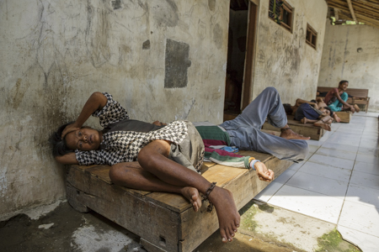

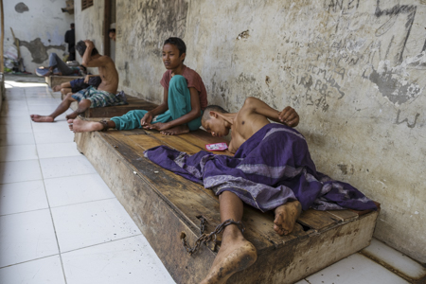

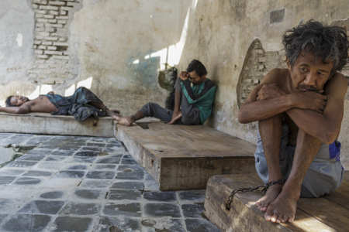

08.14.18_Brebes_Kyai Syamsul Ma’arif Healing Center
10.05.18
NOTES_ASR From observations and photographic evidence:
Excepting for one person, all residents were shackled No access to medications or mental healthcare. No Doctor care on site. Staffcare is not gender appropriate, women at risk of inappropriate touching. Residents are sometimes unclothed. Rats are a problem.
Poor physical plant, Inadequate furnishings, no access to phones, insufficient access to sanitation facilities. No apparent provisions for sanitary needs, extra clothing, extra clothing healthcare supplies for illness and injury.
Residents must eat sleep defecate while shackled in place..

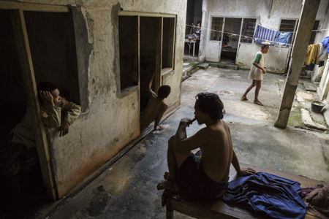

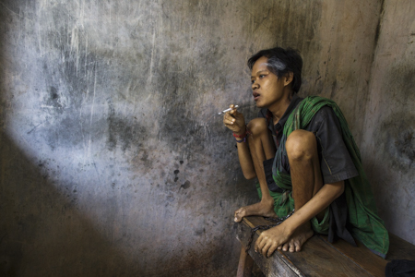

10.15.18_Bekasi_ Yayasan Galuh Rehabilitation Center
NOTES_ASR From observations and photographic evidence:
Facility is overcrowded. Some residents unclothed. Psychiatrist visits, but no Doctor visits. No apparent provisions for sanitary needs. No privacy. Staffcare is not always gender appropriate
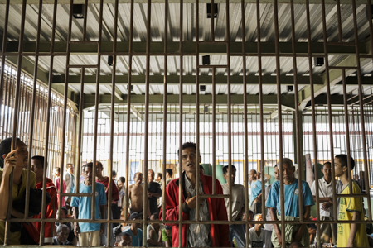

10.02.18 Bekasi_Yayasan Al Fajar Bersari
NOTES_ASR From observations and photographic evidence:
Facility is overcrowded. Some residents unclothed. No apparent provisions for sanitary needs. No privacy. Staffcare is not always gender appropriate. Abuse of residents (rough handling) including children witnessed. Undersge and child residents in close proximity of adult residents. (In 2019 shackling witnessed) No access to medications or mental healthcare.

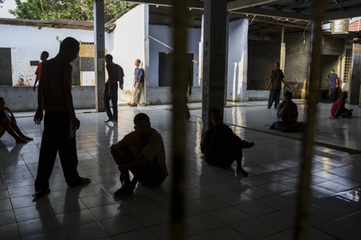
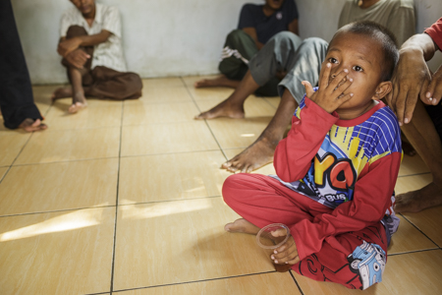

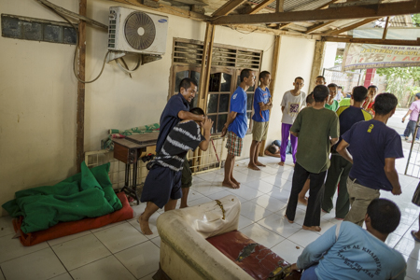

10.08.18_Cianjur_ Pengobatan Nurul Azhar _Haji Hamden
10.09.18

NOTES_ASR From observations and photographic evidence:
Vigorous painful rubbing massage with hard implement is employed as a daily healing method. Some Shackling, Most residents locked in cells. No access to medications or mental healthcare. Staffcare is not gender appropriate. While the building is new there remains Inadequate furnishings, common areas, etc, no access to phones.
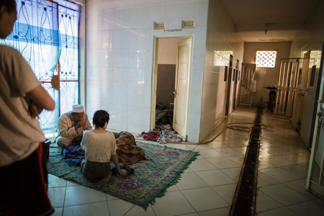

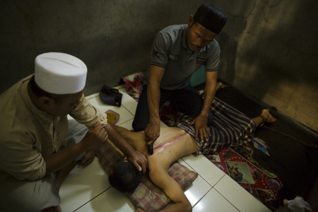

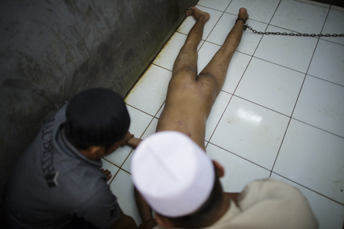
10.08.18 Cianjur_ Yayasan Istana KSJ_Nurhammad

NOTES_ASR From observations and photographic evidence:
The women survivors and residents tell me they are safe and are not bothered by the male residents and staff. However one women was subjected to shackling with handcuffs when she was agitated. Medications and visits to Psychiatrist at clinic are provided for residents paid for by their govt insurance. Staffcare is not always gender appropriate.

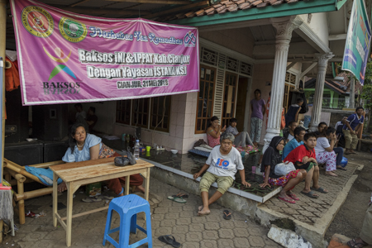

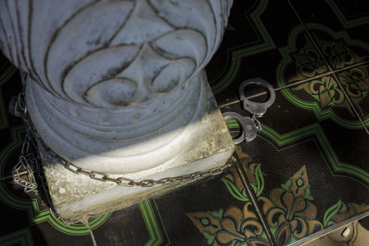
10.20.18_ Kecamatan Ngrambe, Ngawi _Ponpes Rehabilitasi Jiwa Assyifa

NOTES_ASR From observations and photographic evidence:
A mix of resident lodging. Some residents have shared rooms and are free to move about, or work in nearby fields or at the facility. The majority of residents are locked in communal areas. Others are locked in communal cells, and isolation cells.
Please refer to 2019 audio recordings. Inadequate physical plant, Inadequate furnishings, no access to phones,
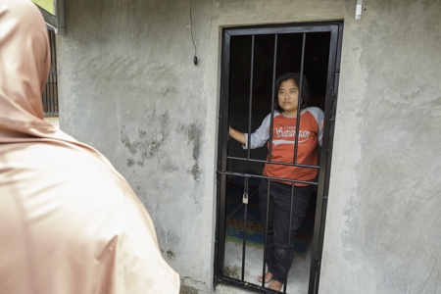

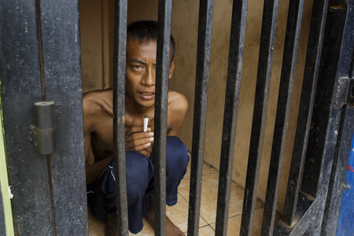

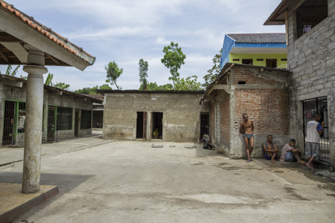

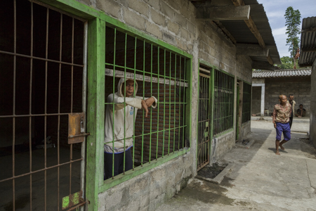

10.20.18_ Kabupaten Sragen _Yayasan Sehat Waras Sejahtera Sragen_

NOTES_ASR From observations and photographic evidence:
The residents appear to be hungry and subdued. No smoking allowed. (which may be good but is not appreciated by residents) I was not allowed to see residents living arrangements. Three men in isolation cells were seen. No access to medications or mental healthcare.
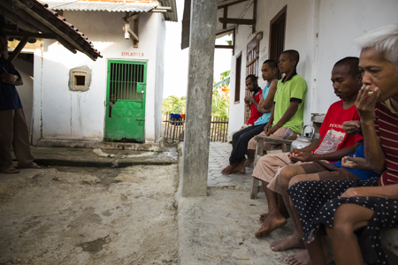

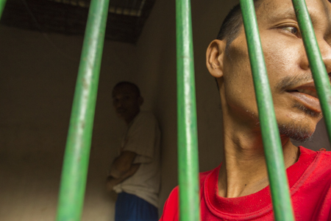

10.21.18_ Semarang_Pondok Pesantren Maunatul Mubarok.

NOTES_ASR From observations and photographic evidence:
Staffcare is not always gender appropriateMethod of shackling employed is exceptionally cruel. Some residents are free to move around the compound. Others are locked in cells. . Inadequate furnishings in cell like residential areas.
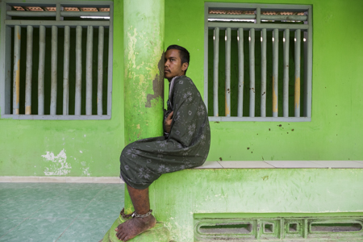

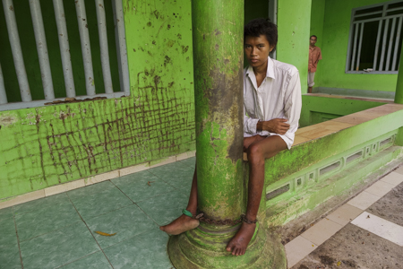

10.23.18_Cilicap_Jasono Healing Center
NOTES_ASR From observations and photographic evidence:
While some residents have a degree of freedom and have well built rooms that resemble bedrooms, some residents are still locked in cells. No access to medications or mental healthcare. No Doctor care on site. Staffcare is not always gender appropriate. Although the facility has been greatly improved the cell area is dismal with Inadequate furnishings., .Staffcare is not always gender appropriate. Inadequate furnishings in cells.

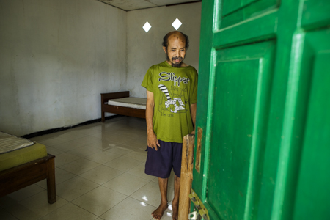

10.23.18 Cilicap_ Pesantren Ar-Ridwan

NOTES_ASR From observations and photographic evidence:
Some residents are shackled or locked in cells. Vigorous painful rubbing massage with hard implement is employed as a healing method. No access to medications or mental healthcare. No Doctor care on site. Staffcare is not always gender appropriate. Poor physical plant in most areas, Inadequate furnishings, no access to phones, insufficient access to sanitation facilities. .Staffcare is not always gender appropriate. Inadequate furnishings

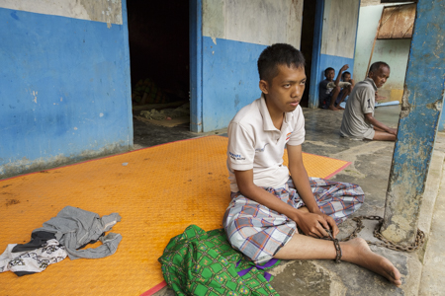

10.24.18_Kebumen_ Padepokan Mbah Marsiyo

ASR notes: Shackling is exceptionally cruel. The majority of residents are all subjected to shackling, chained to large round cement weights. Even those working around the premises have chains wrapped around their ankles. Much of the facility is open to the elements. Residents do not appear to have extra clothing, some are in rags. All are terribly hungry. Only receiving inadequate meals two times a day. Staffcare is not always gender appropriate.
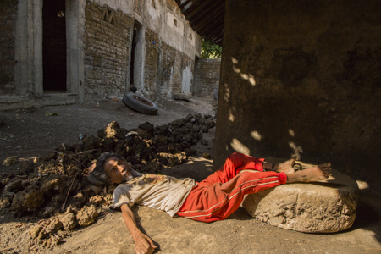

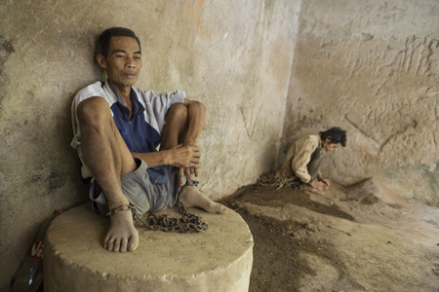

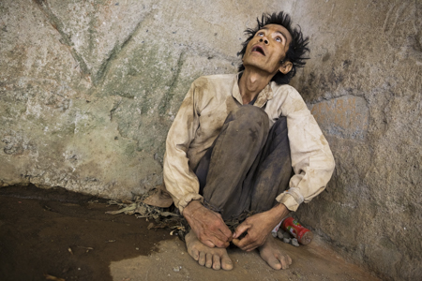

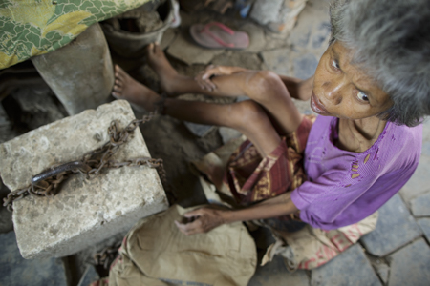

10.24.18_Kebumen_ Pondok Pesantren Asy Syaamiyyah

NOTES_ASR From observations and photographic evidence:
Appears to function as a supportive housing residence. Residents can go out to work and take care of most of their needs.
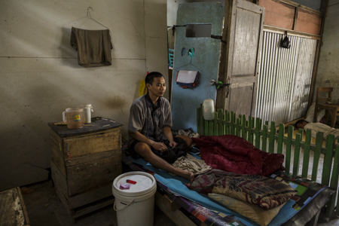

10.25.18 Subang_ Yayasan Darul Iman

NOTES_ASR From observations and photographic evidence:
Residents are locked or lodged in one of two large rooms.

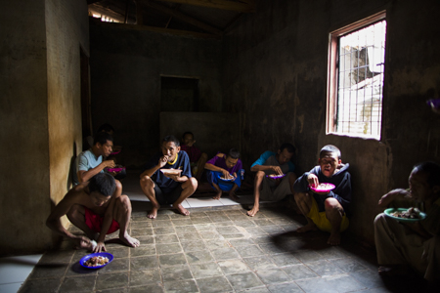
10.28.18_Bekasi_Jamrud Buru

NOTES_ASR From observations and photographic evidence:
Some residents are shackled. Inadequate physical plant.. No access to medications or mental healthcare. No Doctor care on site. Staffcare is not always gender appropriate., Inadequate furnishings, no access to phones,. Residents are taken outside for walks. Sleeping area is one large room. There is a living area for difficult residents that I have been unable to enter. One staff member carried a gun during outing. Another staff member prodded a resident in his genital area with a stick see photo.

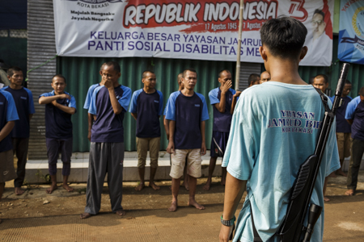

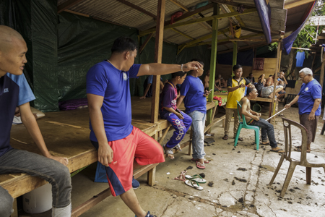

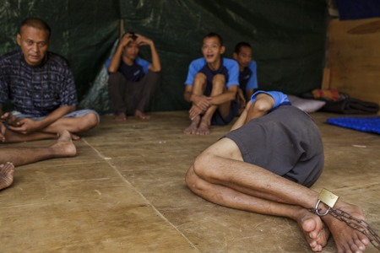
2019_Andrea Star Reese Documentary_ Visits to Pantis, Pesantrens , Healing and Mental Rehabilitasi Centers: Bold Font = previous visits

10.06.19_ Bekasi Jamrud Buru
11.28.19
NOTES_ASR From observations and photographic evidence:
see recorded intvw No access to medications or mental healthcare.
The facility has suffered deterioration. In danger of insufficient funds for rent. Shackling continues. I was prevented from photographing shackled residents on 2nd visit. A medical Doctor came to inspect the residents and treat those who were sick.

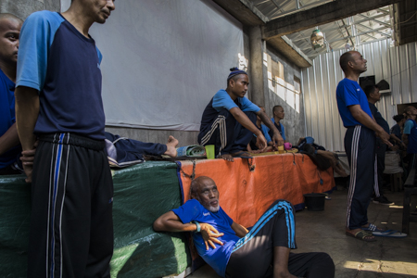

10.06.19Bekasi_ Yayasan Al Fajar Bersari
NOTES_ASR From observations and photographic evidence:
see recorded intvw No access to medications or mental healthcare.
All women were moved into two isolation blocks to make more room for mens lodging. New buildings under construction for senior residents. My first observation of a shackled resident.

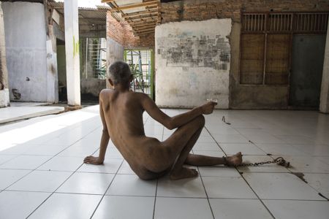

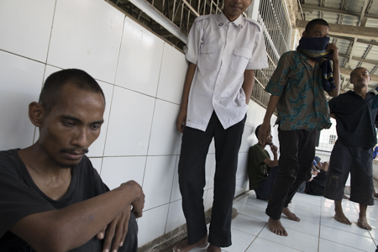
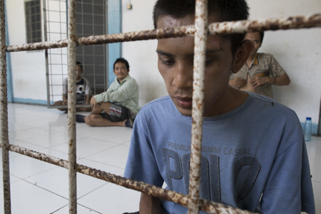

10.06.19_ Bekasi_ Yayasan Galuh Rehabilitation Center
NOTES_ASR From observations and photographic evidence:
I was stopped by staff from photographing despite permission from an administrator. The administrator told me that the Ministry of Social Affairs had retaliated against galuh cutting funding after photographs and interviews at Galuh was included in the 2016 Human Rights Watch Repor The administer told me they need Doctors on premises. I observed this injury.

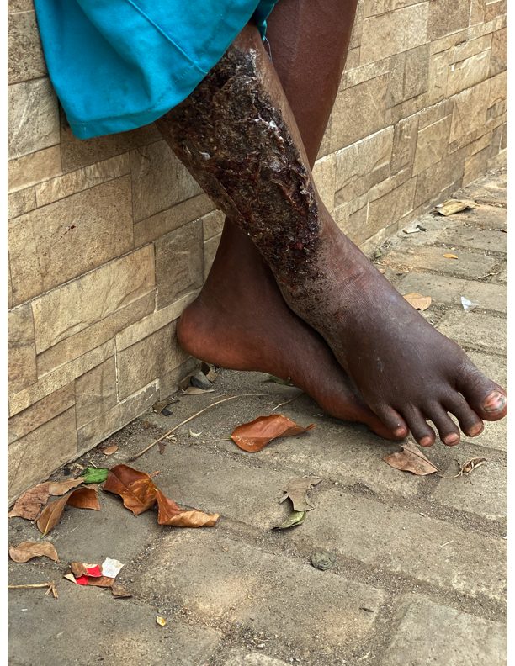

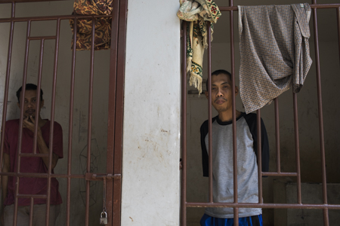

10.11.19_Brebes_Yayasan Bina Lestari

recorded intvw. New structure from One time Private Donation. Residents still are shackled. . No access to medications or mental healthcare. I was told the Ministry of Social Affairs retaliated cutting funding for this panti after photographs and interviews at the panti were included in the 2016 Human Rights Watch Report. However the exposure led to the private donation.

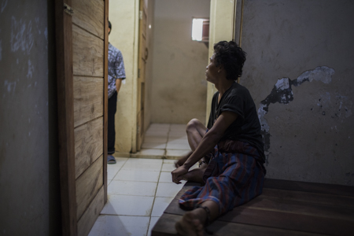

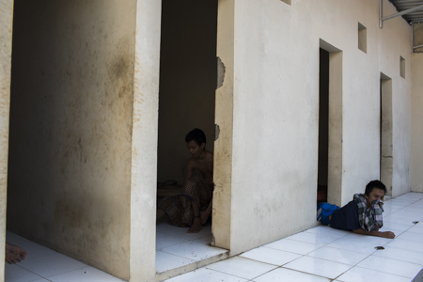

0.12.19_Brebes_ Kyai Syamsul Ma’arif Healing Center

NOTES_ASR From observations and photographic evidence:
I was not allowed in the back area. However I was told I could visit again and photograph in 2020. No access to medications or mental healthcare

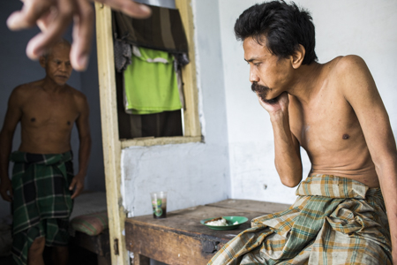
10.13.19_ Semarang_Pondok Pesantren Maunatul Mubarok.

NOTES_ASR From observations and photographic evidence:
Owner was away. No shackling observed. However many people in cell like enclosures and isolation cells. Some residents were able to wander the premises, watch a communal TV, pray at a small mosque, or were in their rooms. No access to medications or mental healthcare
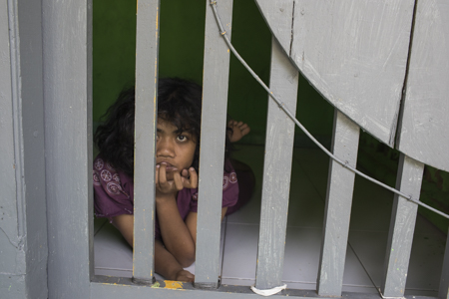

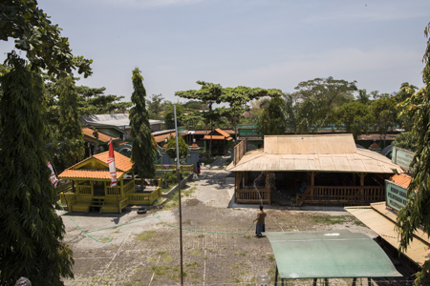

10.13.19_ Semerang_Pesantren …
NOTES_ASR From observations and photographic evidence:
I was unable to view the isolation rooms. I was informed that shackling was used when residents were difficult. The residents were described as schizophrenic. No access to medications or mental healthcare

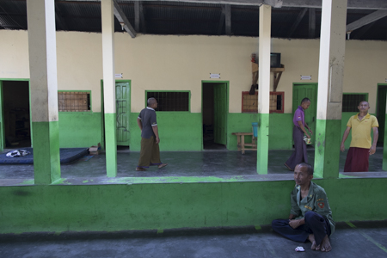

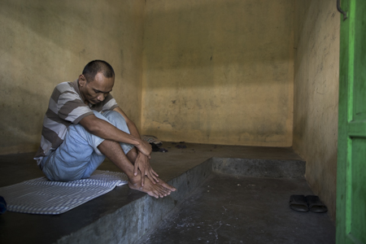

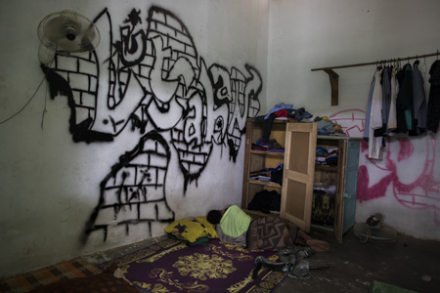

10.14.19_Solo_Martial Arts Pesantren

NOTES_ASR From observations and photographic evidence:
Residents were free to wander the premises even near the road. Some were able to work outside the center in the surrounding community. No shackling, noisolation cells. A secret recipe herbal drink was used according to Silat martial arts methods.. Most of the residents appeared to be happy and friendly to and unafraid of the owner. That stood out for me as unusual and remarkable. No access to medications or mental healthcare

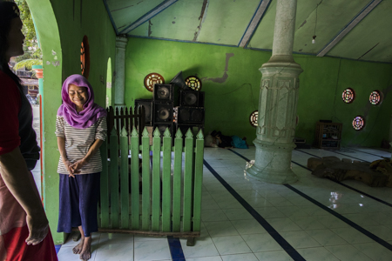

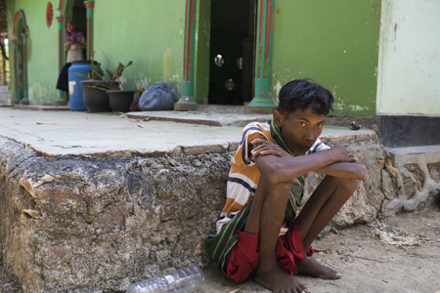

10.15.19_ Kecamatan Ngrambe, Ngawi _Ponpes Rehabilitasi Jiwa Assyifa

. NOTES_ASR From observations and photographic evidence:
recorded sound of residents singing and talking about their personal experience. The Rehabilitasi is basically unchanged from 2018 although the facility has undergone some physical changes possibly to accommodate more women. No access to medications or mental healthcare

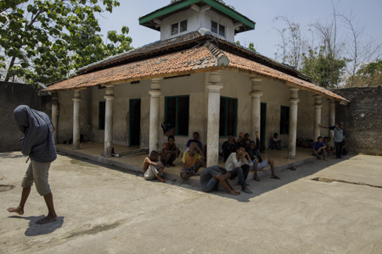

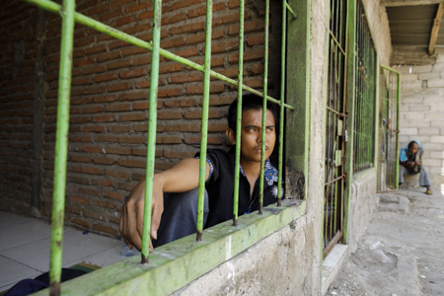

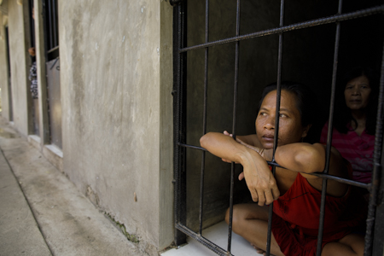

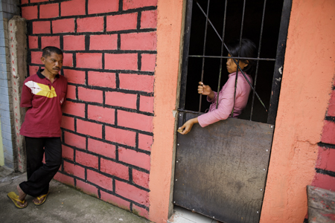

10.18.19_Wonosobo_ Panti Dzikrul Ghofilin _Ibu Utiyah
10.20.19

. NOTES_ASR From observations and photographic evidence:
The owner Ibu Utiyah, a woman, has experienced depression following childbirth that necessitated treatment in a mental healthcare hospital. A Psychiatrist visits the residents every three months courtesy of the Ministry of Health. Ibu Utiyah said the Panti needs funding to improve the physical plant. Shackling is used and I was not allowed to photograph those residents that are shackled. They were at the building in the background behind the men. There were three women in an isolation room.

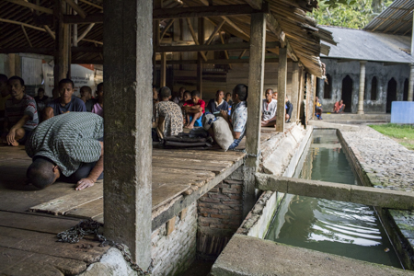

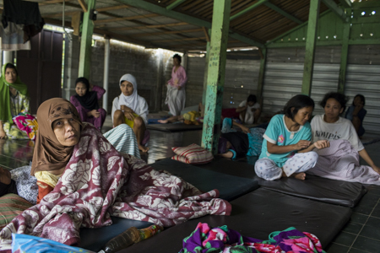
10.19.19_Cilicap_ Pesantren Ar-Ridwan

NOTES_ASR From observations and photographic evidence:
Much is the same for the men. The women have been moved into a new structure composed of many small isolation cells and a common area as opposed to the previous shackling. No access to medications or mental healthcare

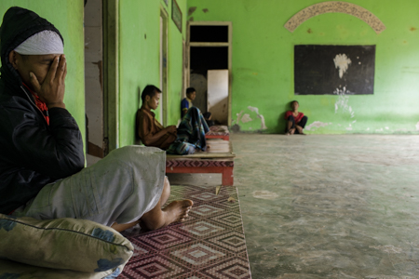

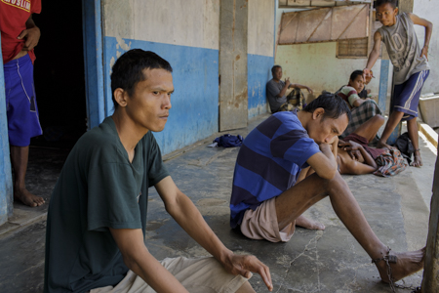

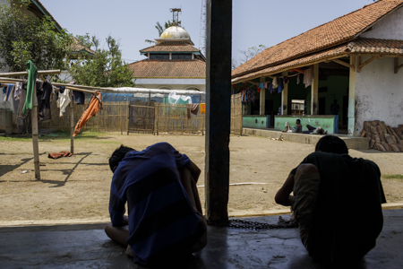

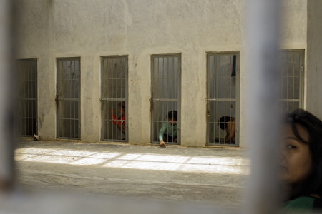

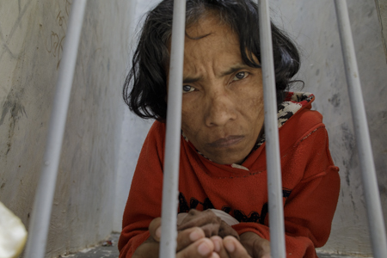
10.19.19_Cilicap_ Jasono Healing Center
NOTES_ASR From observations and photographic evidence
Unchanged from 2018 notes. There is new building underway.
No access to medications or mental healthcare

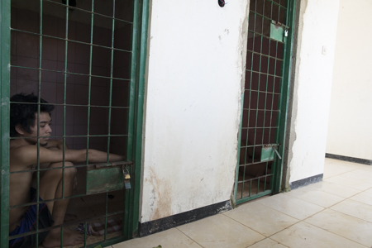

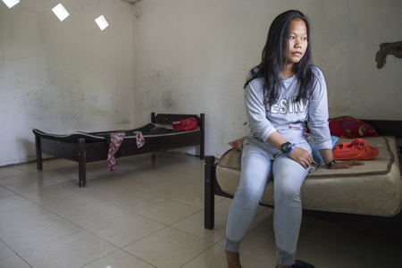

10.20.19_Kebumen_ Padepokan Mbah Marsiyo
11.09.19

NOTES_ASR From observations and photographic evidence
I was told by Muji, 24yrs old that they only receive two meals a day consisting of rice, cassava, and tomato. They are very very hungry. He told me his shackles are a violation against Human Rights. Muji said a Docyor came a month ago and did nothing to treat him.

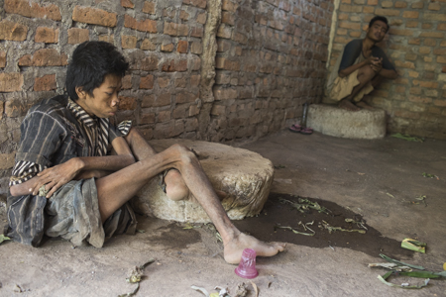

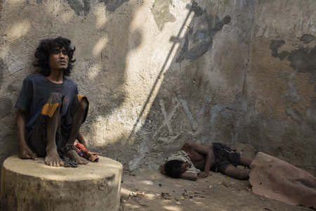

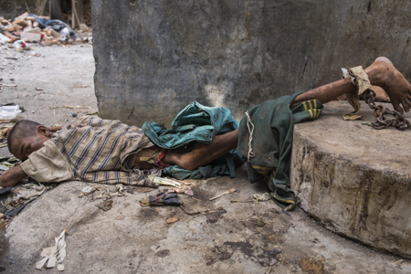

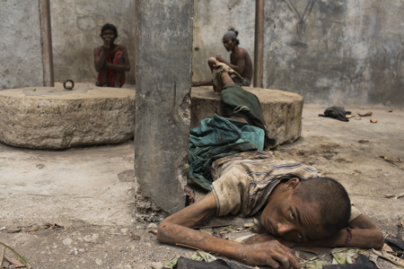

10.31.19_Bogor_Rumah Marzoek Mahdi_
NOTES_ASR From observations and photographic evidence
The Occupational therapy I had come to photograph did not happen that day.
Dance therapy and group therapy did happen

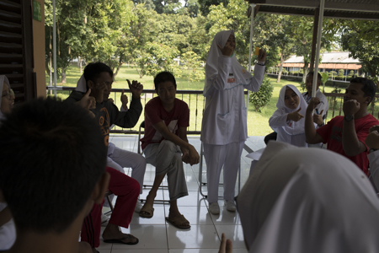

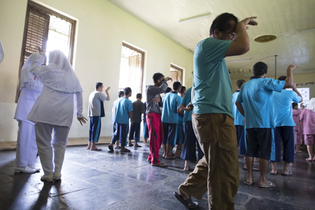

10.31.19_Bogor Panti Rahman
NOTES_ASR From observations and photographic evidence
Inadequate physical plant. Inadequate funding. No access to medications or mental healthcare

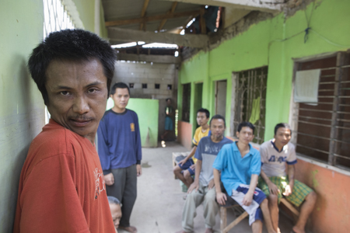
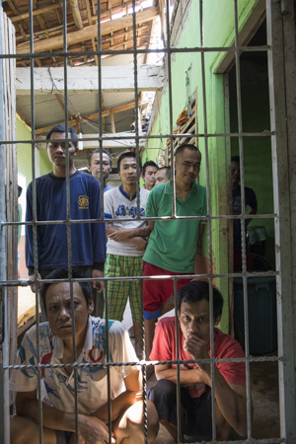

11.01.19_ Banten_Yayasan Bani Syifa

NOTES_ASR From observations and photographic evidence:
Children in the same area as adults. One young adolescent was being teased and harassed by an adult male that I told to stop., although the staff on site did nothing to interfere. One man was shackled. Inadequate funding. No access to medications or mental healthcare

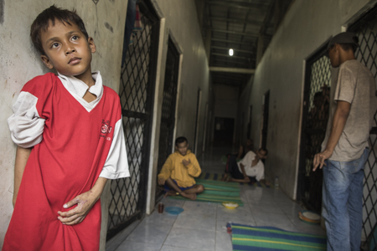

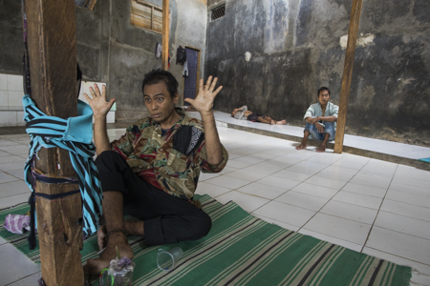

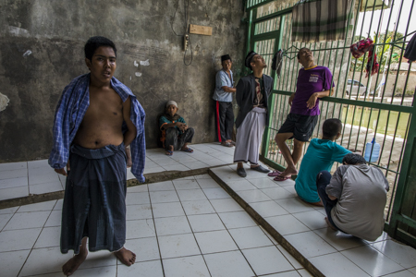

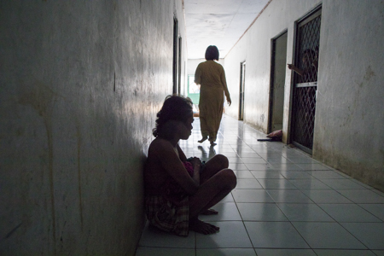

11.04.19_Pasuruan Pondok Paesantren Nailul Falah

NOTES_ASR From observations and photographic evidence
Inadequate physical plant. Inadequate funding. No access to medications or mental healthcare
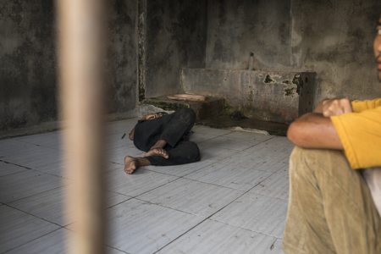

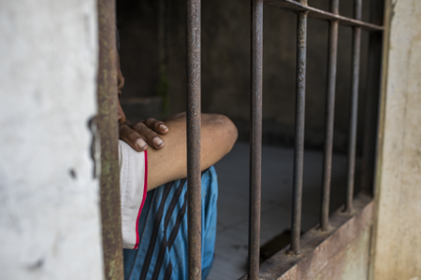

11.05.19 _Bondowoso_ Pondok Pesantren Al-Ghafur

NOTES_ASR From observations and photographic evidence
Inadequate physical plant. Shackling. Inadequate funding. No access to medications or mental healthcare shackling.
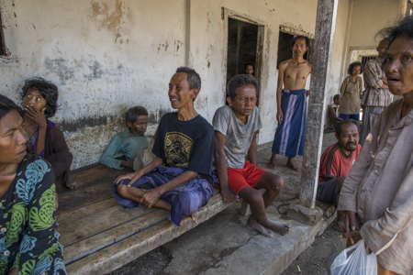

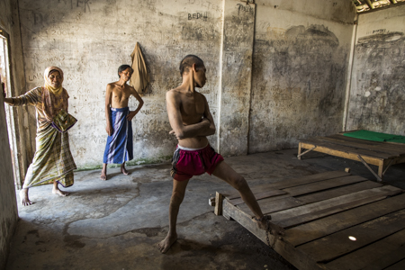

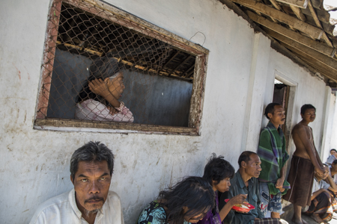

11.08.19_Kediri_Pondok Singgah dan Pesantren Sapujagad_

NOTES_ASR From observations and photographic evidence
Inadequate physical plant. Shackling. Inadequate funding. No access to medications or mental healthcare. One man was naked, covered in bits of old food and exposed to the elements..

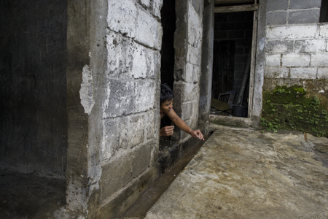

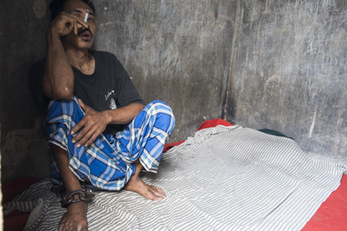

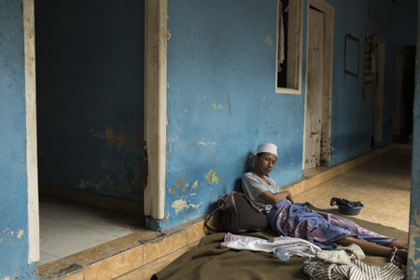

11.08.19 Kediri_ Pesantren Mental Bloran

NOTES_ASR From observations and photographic evidence
Inadequate physical plant. Shackling. Inadequate funding. No access to medications or mental healthcare.

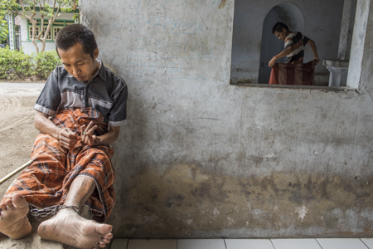

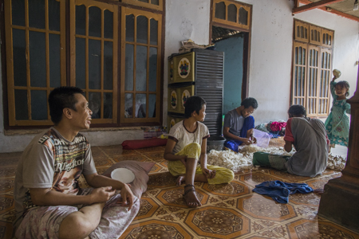

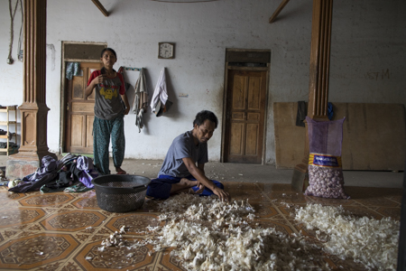

- During a visit to an institution in Bekasi, IMHA met with people confined in solitary confinement. On a visit to the same institution five months later, these people were still in solitary confinement.
- According to institution staff in Margo Widodo in Semarang, institution residents infected with scabies are smeared with carbolic acid mixed with sulphur as it is cheap and considered effective. Scabies skin disease could be treated with improving the living condition and other means. There is no need for painful treatment.
- PJS' observations in Galuh Foundation social institution found that families who entrust their family members there must pay US$ 75 or a quarter of the size of the minimum wage for Bekasi City, while the residents were placed in wards with iron bars where one ward could contain dozens of people, without sleeping mats or adequate sanitation.
- Government Regulation No. 52 of 2019 concerning the implementation of social welfare for persons with disabilities (article 4), Social Minister Regulation no 9 2018 concerning basic technical service standards on minimum service standards in the social sector in provinces and districts / cities (articles 6, 7, 8), Permensos 6 of 2019 concerning national standards for social rehabilitation (explanation, articles 8, 9, 53)
- PJS has recorded as many as 5 provincial regulations and 7 regency / city level regulations on the handling of people with social welfare problems that become the reference for local governments to carry out forced rehabilitation for PWPDs to institutions and have the authority to determine whether PWPDs are eligible to leave the institution. See this table:
Province and Region or Regency | Regulations
DKI Jakarta Province | Peraturan Gubernur Provinsi Daerah Khusus Ibukota Jakarta Nomor 157 Tahun 2015 Tentang Penanganan Orang Dengan Masalah Kejiwaan Dan/Atau Orang Dengan Gangguan Jiwa Yang Terlantar Dan/Atau Mengganggu Ketertiban Umum (Regulation of the Governor of the Jakarta Special Province No.157/ 2015 concerning the Handling of People with the Problems of the Soul And / or People With the Soul Disorders that are Being Out of And / or Disturbing General Rules)
Central Java Province | PERATURAN DAERAH PROVINSI JAWA TENGAH NOMOR 6 TAHUN 2015 TENTANG PENYELENGGARAAN KESEJAHTERAAN SOSIAL (Regional Regulation of Central Java Province No. 6/2015 concerning the Provision of Social Welfare)
West Java Province | PERATURAN DAERAH PROVINSI JAWA BARAT NOMOR 10 TAHUN 2012 TENTANG PENYELENGGARAAN KESEJAHTERAAN SOSIAL (Regulation of West Java Province No. 10/2012 concerning the provision of social welfare)
Serang Region | PERATURAN DAERAH KOTA SERANG NOMOR 6 TAHUN 2016 TENTANG PENYELENGGARAAN KESEJAHTERAAN SOSIAL (Regulation of Serang Region No. 6/2016 concerning the provision of social welfare)
Salatiga Region | PERATURAN DAERAH KOTA SALATIGA NOMOR 12 TAHUN 2018 TENTANG PENANGANAN PENYANDANG MASALAH KESEJAHTERAAN SOSIAL (Regional Regulation of Salatiga Region No. 12/2018 concerning Handling of Social Welfare Problems)
Aceh Special Province | QANUN ACEH NOMOR 11 TAHUN 2013 TENTANG KESEJAHTERAAN SOSIAL (Aceh Special Province Regulation No. 11/2013 concerning social welfare)
Karawang Regency | PERATURAN DAERAH KABUPATEN KARAWANG NOMOR : 8 TAHUN 2012 TENTANG PENYELENGGARAAN KESEJAHTERAAN SOSIAL (Regulation of Karawang Regency No. 8/2012 concerning the provision of social welfare)
Bantul Regency | PERATURAN DAERAH KABUPATEN BANTUL NOMOR 01 TAHUN 2010 T E N T A N G PENYELENGGARAAN KESEJAHTERAAN SOSIAL BAGI PENYANDANG MASALAH KESEJAHTERAAN SOSIAL (Regional Regulation of Bantul Regency No. 1/2010 concerning Social Welfare Implementation for Social Welfare Receivers)
Padang Region | WALIKOTA PADANG PROVINSI SUMATERA BARAT PERATURAN DAERAH KOTA PADANG NOMOR 3 TAHUN 2015 TENTANG PEMENUHAN DAN PERLINDUNGAN HAK-HAK PENYANDANG DISABILITAS (Mayor Padang Regulation No. 3/2015 concerning meeting and protection of Rights with Disabilities)
Berau Regency | BUPATI BERAU PROVINSI KALIMANTAN TIMUR PERATURAN DAERAH KABUPATEN BERAU NOMOR 9 TAHUN 2015 TENTANG PENYELENGGARAAN DAN PENANGANAN PENYANDANG MASALA H KESEJAHTERAAN SOSIAL (Berau Regency Regulation No. 9/2015 concerning the implementation and handling of social welfare problem)
Surabaya Region | PERATURAN DAERAH KOTA SURABAYA NOMOR 2 TAHUN 2012 TENTANG PENYELENGGARAAN KESEJAHTERAAN SOSIAL SOSIAL (Regional Regulation of Surabaya Region No. 2/2012 concerning Handling of Social Welfare Problems)
Riau Province | PERATURAN DAERAH PROVINSI RIAU NOMOR 18 TAHUN 2013 TENTANG PERLINDUNGAN DAN PEMBERDAYAAN PENYANDANG DISABILITAS (Riau Province Regulation No. 13/2013 concerning Protection and Empowerment of People with Disbailities)

- Permits for the establishment of social care institutions are issued by the Ministry of Law and Human Rights, while operational licenses are issued by the Regional Social Affairs Services.
- Article 57 paragraph 4 Government Regulation No. 39, 2012 Penyelenggaraan Kesejahteraan Sosial (implementation of social welfare) states: pendaftaran sebagaimana dimaksud pada ayat (1) dilaksanakan dengan cepat, mudah, dan tanpa biaya (registration as referred to in paragraph (1) is carried out quickly, easily, and without fees).
- In May 2018, Social Affairs Minister Idrus Marham conducted a series of work visits to several private institutions in West Java. In a psychosocial disabilities institution, in addition to providing financial assistance, the minister also announced that the regional government had prepared 2,000 square metres of land for the construction of the institutions’ new building. The minister said this was done in an effort to take care of people with psychosocial disabilities and rehabilitate them properly.
During the opening of an event attend by OPDs and government officials on November 22, 2019 the Social Affairs Ministry's Director of Social Rehabilitation for Persons with Disabilities stated that all provinces have social institutions. Some provincial level Social Affairs Services also plan to build social institutions. For example, the Head of Social Rehabilitation of West Java Provincial Social Service, Ipik Supena has plans to build a social care institution in an area as large as 2-3 hectares. He has a vision to build a big social care institution with a capacity of 1000 people which required a large funding.
- When visiting a private social institution in Sukabumi, West Java in 2018, Social Affairs Minister for the 2018 period, Idrus Marham, provided financial assistance to the management of the institution to the value of US$ 6725. In addition, management was asked to prepare a plan for the budgetary requirements to build a new social care institution. The Sukabumi Regional Government has prepared 2000 metres of land to build this new institution.
- Appendix: Marsan Susanto, chairman of the Al-Fajar Berseri social care institution through kitabisa.com — a social media platform that aims to collect public contributions — campaigned that his institution needed US$ 25,000 to build a new building in the complex. Funds collected exceeded the target, namely US$ 26,252
- Two private institutiosn in the district of Brebes, received US$ 178.257 from a Singaporean organization. This assistance was given after the conditions of people with psychosocial disabilities who were shackled in the institution were raised in a Human Right Watch (HRW) report entitled Living in Hell (2017). During the most recent visit in July 2019, PJS found there had been improvements to the institution building, but that residents remained shackled.
- Kyai Jasono social care institution in Cilacap received US$ 178.147 assistance from a Singaporean organization was used to construct a new building as a measure to repair the institution. However, during PJS' last visit in July 2019, the new building erected turned out to be shaped like a prison with very small cells, and doors with bars, similar to solitary cells. Each cell contained one person with psychosocial disabilities.
- The Galuh Foundation receives funds from the Semesta Foundation which first became involved by developing its infrastructure which consist of 3000 square meters of residential wards, 33 staff compounds, and other facilities. The total fund reach US$ 835.714.
- Through the restraint free program, the government usually releases the person in question, takes them by force to a psychiatric hospital, possibly holds them there in an isolation room, gives them a pile of medicine and then when they are “stable” some are taken to a social rehabilitation institution to be “treated” (read: locked up). Some are also taken straight to an institution if there are no psychiatric hospitals in the area.
After being in the psychiatric hospital some are sent home. However, there are few follow-up programs in place for persons with psychosocial disabilities to facilitate independent living and participation in the community.
- Health Ministry, Home Affairs Ministry, Indonesian National Police and the National Healthcare Insurance Administering Body (BPJS Kesehatan) No.01/2017, No. HK.03.01/MENKES/28/2017, No. 03/MOU/0117, No. B/18/II/2017 and No. 440/899/SJ on the Prevention and Handling of the Restraining of Persons with Psychosocial disabilities/Mental Disorders.
In order to solve the problem of restraint, a comprehensive, cross-sectoral approach is required which must involve more ministries, such as: the Public Works and Housing Ministry in order to provide decent and affordable housing for persons with psychosocial disabilities; the Cooperatives and MSMEs Ministry to increase the economic productivity of persons with psychosocial disabilities; the Labour Ministry to ensure the work rights of persons with psychosocial disabilities; the Education Ministry to provide adequate accommodation of persons with psychosocial disabilities in the education sector; and the National Development Planning Agency (Bappenas) to budget development programs involving persons with psychosocial disabilities who are victims of restraint, etcetera.
- The head of an institution owned by the Central Java Provincial Government stated that some of the residents had been freed from restraints. The results of an investigative media report in 2017 also revealed that of 56 victims of restraint, 19 were referred to hospitals and institutions (15 to hospitals and 4 to institutions).
- This can be seen in the following scheme outlined in Social Affairs Ministerial Regulation 12/2018. This scheme indicates that the final process in abolishing restraints is to refer persons with psychosocial disabilities to psychiatric hospitals and social institutions, either state or privately owned.
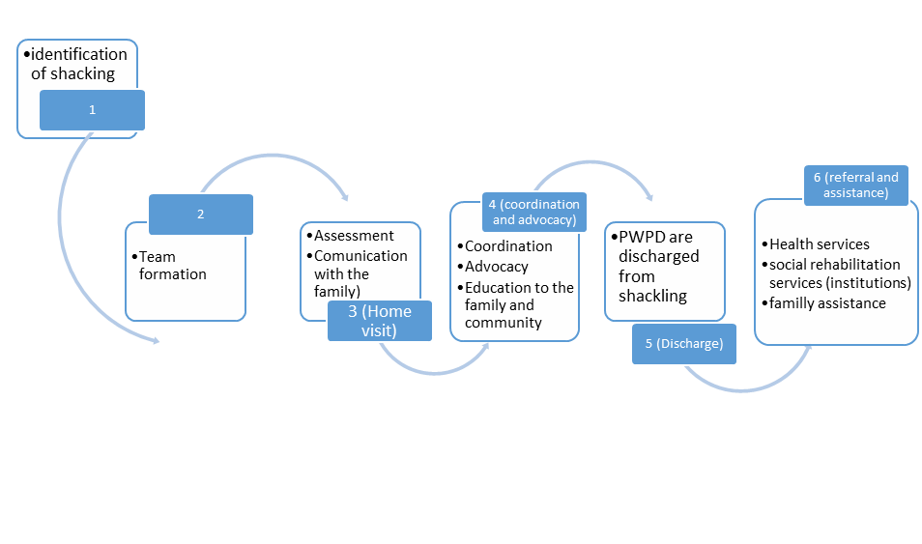
- For example, a person with a psychosocial disability who worked for an IT company was not brave enough to request regular breaks. They were also afraid of asking permission to seek treatment, because they were worried that the medical certificate issued would come from a psychiatrist. As a result, they were thought to be skipping work often which resulted in dismissal.
- In 2019, IMHA volunteer attempted to register for a program held by the Communications and Information Ministry to attain professional IT certification through a special disability channel. They hoped that through this channel there would be affirmative action and reasonable accommodation if required. However, there were no psychosocial disability options in the disabilities column on the registration form. They attempted to clarify with the organisers and were told that persons with psychosocial disabilities would not be accepted to take part in the program.
- Registration was open to both persons with and without disabilities. A person with a psychosocial disability attempted to register through the disability channel, but there were no psychosocial disability options on the registration form under the types of disabilities. Nonetheless, the individual attempted to register by writing psychosocial disabilities in the blank space on the form. In the end, they were not accepted while other persons with disabilities who registered at the same time were accepted as volunteers.
- Examples of this include the 2019 recruitment round for prospective civil servant positions at the Social Affairs Ministry and the 2018 recruitment round for SOEs. In the announcement of the 2019 recruitment round for prospective civil servants at the Social Affairs Ministry, there was no quota for persons with psychosocial disabilities while other types of disabilities were given a quota through the disability channel. When SOEs created a scheme to recruit employees from a disability channel via the Human Capital Forum, they stated that they would not accept persons with psychosocial disabilities.
- One form of reasonable accommodation required by persons with psychosocial disabilities is flexibility in their study period. A few times, IMHA advocated for persons with psychosocial disabilities who have been expelled from several well-known public universities in Indonesia because they exceeded the maximum study period of 12 semesters. Adequate accommodations should be made for students without the need for pressure from disability organizations.
In addition to a flexible study period, many other accommodations need to be made so that students with psychosocial disabilities can complete their studies, including flexibility in working on assignments and taking tests, counselling services, and so forth. Until now, higher education institutions in Indonesia have not provided appropriate accommodations.
- Law related to requirements to vote
a. LAW OF THE REPUBLIC OF INDONESIA NUMBER 8 OF 2015 CONCERNING AMENDMENT TO LAW NUMBER 1 OF 2015 CONCERNING DETERMINATION OF GOVERNMENT REGULATION REPLACING FOR LAW OF GOVERNMENT NUMBER 1 OF 2014 CONCERNING SELECTION OF THE GOVERNOR, REGENCY, AND LOCAL GOVERNMENT
b. REGULATION OF THE GENERAL ELECTION COMMISSION OF THE REPUBLIC OF INDONESIA NUMBER 11 YEAR 2018 CONCERNING THE PREPARATION OF ELECTION REGULATIONS IN THE STATE FOR SELECTION
- In General Elections Commission Regulation No. 11/2018 on Local Voter Registration for General Elections, Article 4 states that one requirement for being registered as a voter is not having a psychiatric or memory impairment, which must be proven by a doctor’s certificate. The regulation was finally revised following intense advocacy from organizations of persons with disabilities led by IMHA. However, the revision has taken a long time to be implemented and many persons with psychosocial disabilities failed to be registered as voters in the general elections.
- The 2017 Jakarta elections, hundreds of persons with psychosocial disabilities at the social care institution PSBL 1, owned by the Jakarta provincial government, were not granted the right to vote on the grounds that they had mental disorders. This was reinforced by a statement released by the Duren Sawit mental hospital stating that all residents of PSBL 1 were deemed incompetent to vote. This incident was repeated in the 2018 elections. PJS found a number of social institutions in Bekasi where the residents had not been recorded by the General Elections Commission (KPU). PJS found that 413 of the residents of the social care institution Galuh Foundation, 50 residents of the social care institution Zamrud Biru and 15 persons of the social care institution Assalam Cilacap Foundation were not registered to vote by the General Elections Commission.
- One mental hospital that insisted on refusing was the Soeharto Heerjan mental hospital in Jakarta, which is considered to be one of the best mental hospitals in Indonesia.
- Law 37/2008 on the Ombudsman also requires candidates for national and regional Ombudsman commissioner positions to be physically and mentally sound.
- When visiting Galuh Social Institution in Bekasi we encountered a female resident who admitted that her breasts were often touched by a staff at the institution. She was afraid and unable to report these occurrences because she was required to stay in the institution. She also stated that a number of other female residents had experienced the same thing. The perpetrator was a person who had been providing health services even though they are not a health worker. This sexual harassment occurred in a health clinic room. As a result, female residents were afraid to attend the clinic when they fell sick.
A Human Rights Watch report also highlighted similar cases of sexual violence in various institutions in Indonesia. For example, a resident at an institution in Brebes stated that a staff member at the institution had touched her vagina.
- The Human Rights Watch found that one cause of the high risk of sexual violence is that the toilets do not have doors and male staff members are able to see the women’s bodies, including at night-time. Komnas Perempuan also discovered open bathrooms in Ngudi Rahayu Social Institution, Kendal, and at the Dzikrul Gofilin Private Rehabilitation Institution.
- In a number of institutions and psychiatric hospitals observed by Komnas Perempuan, the number of female nurses was far smaller than the resident population. For example, in Bina Karsa Psychiatric Hospital, Medan, only one male officer and one female officer were in charge of supervising a total of 28 residents during the evening shift.
- Husniar (34), a woman with psychosocial disabilities who lives in Merangin District, Jambi, was restrained for five years in a vacant house. Because her family rarely checked on her, she was raped resulting in her falling pregnant and giving birth to a child. The current circumstances of the child are unknown. According to the local village head, the child was taken by a social institution.
- One such woman is Lasmi who was first found on the side of the Lintas Sumatra Highway in Central Lampung in February 2019. Due to her weak condition, residents took Lasmi to hospital. After underGovernment of Indonesiang examinations, it was discovered that Lasmi was 32 weeks pregnant. The authorities suspect that this was a case of rape.
- The administrators of social institutions and psychiatric hospitals hold the view that women with psychosocial disabilities do not have the mental capacity to participate in sexual intercourse and therefore each case of pregnancy is assumed to be the result of rape, even though forced sterilisation is itself a form of sexual violence.
- None of them The consent was given either by family members or government officers.These contraceptive methods are conducted based on the family’s consent if the patient is admitted by their family. However, if the patient is dropped off by the Public Order Agency (Satpol PP) after a raid on the streets, the contraceptive procedure is conducted without the informed consent of the person involved. Only few cases of violence end up in court.
- In April 2019, a person with a psychosocial disability was forcibly taken to Malang Psychiatric Hospital by hospital staff members. The young man was handcuffed and injected with sedatives. Upon arrival at the hospital, he was no longer alive. In another case, in June 2019, a 52-year-old patient at Magelang Psychiatric Hospital died with bruises to their face and stomach. Autopsy results revealed that the bruises were a result of violence. Several health workers at the psychiatric hospital were examined by the police on suspicion of involvement in the death of the patient.
- One person with a psychosocial disability stated that the treatment they experienced when they were taken to the psychiatric hospital made them feel like an animal and not a human being. They admitted that the trauma they suffered from that event haunted them for years.
- With recovery still in progress, PJS conducted observations in the cities of Palu, Donggala and Sigi in Central Sulawesi.During the 5 days investigation, we found that 9 people with psychosocial disability had either been shackled or locked in a jail-like confinements. They were very thin and had not received proper care – including for sores from their chains/shackles. Medical services had not reached them during or after the disaster – including any services relating to the special needs for the people with disabilitiy. The people with psychosocial disabilitiy were not even listed among victims needing evacuation. They were left shackled in homes that were often damaged and compromised by the disaster. They received no government assistance of any kind.
- One negative campaign targeting persons with psychosocial disabilities appeared during the 2019 elections. Many memes were circulated that were extremely insulting towards persons with psychosocial disabilities and discredited them as not being capable of participating in the election. Some political parties also took part in insulting persons with psychosocial disabilities. As the election organiser, the government did not correct negative content about persons with psychosocial disabilities or hold training on the political rights of persons with psychosocial disabilities during the election.
Persons with psychosocial disabilities are also the target of fake news. In 2017, a fake news article was circulated about child kidnappers who pretended to be persons with psychosocial disabilities living on the street. This fake new story was produced based on negative stigma about persons with psychosocial disabilities being aggressive and dangerous to others. As a result of this fake news story, many incidents of beatings of persons with psychosocial disabilities took place on the streets, some resulting in death. The government did not make a comprehensive effort to prevent the spread of this fake news, resulting in casualties.
- Andy F. Noya granted the Kick Andy Award and Kick Andy Hero award to the Galuh Foundation and Al Fajar Berseri Foundation social institutions. Both of these institutions detain persons with psychosocial disabilities in places that resemble prisons, as previously explained in the chapter on social institutions
People who establish institutions for persons with psychosocial disabilities are often considered to be community heroes and are invited to various television events, disregarding the various violations that occur in social institutions. In the view of the community, the needs of persons with psychosocial disabilities are simply to be fed and sheltered. Anyone who can provide these two things is viewed as an exceptional person. They do not consider factors beyond food and shelter to be important for persons with psychosocial disabilities.

References
Book, journal, and report
Asia Pacific Observatory on Health Systems and Policies. (2017). The Republic of Indonesia Health System Review. Health Systems in Transition, Vol. 7 (1).
Chuzaifah et al. (2019). Hukuman tanpa Kejahatan (Punishment without Mistake). Jakarta: The National Commission on Violence against Women.
Darmini, N. & Widyaningtyas, R.S. (2014). Informed Consent Atas Tindakan Kedokteran di Rumah Sakit Grhasia Pakem Yogyakarta (Informed consent for medical treatment at Grhasia Mental Hospital, Pakem, Yogyakarta). Mimbar Hukum, Vol. 26, No. 2.
Felani and Isnenningtyas. (2018). HAM Penyandang Disabilitas Mental Di Panti Rehabilitasi Sosial (PWPD’s Human Rights in social care institution). Jakarta: The National Commission on Human Rights of Republic Indonesia.
Human Rights Watch. (2016). Living in Hell: Abuses against People with Psychosocial Disabilities in Indonesia. USA: Human Rights Watch.
LBH Masyarakat. (2018). Monitoring and Documentation from 2018: Paranoid policies, shackling the PWDP victims of psychosocial disability. Jakarta: LBH Masyarakat.
Octavian, Yosua and Wirya, Albert. (2018). The state of human rights protection for the mentally disabled in the criminal justice system. Jakarta: LBH Masyarakat.
Wirya, Albert. (2018). Kebijakan yang Paranoid: Kekangan terhadap Disabilitas Psikososial [Paranoid Policies: Restraints on Psychosocial Disabilities]. Jakarta: LBH Masyarakat.

Electronic Media

Alamsyah, Syahdan. (2018, May 25). Di Sukabumi, Mensos Temui Orang Gangguan Jiwa dan Beri Bantuan (In Sukabumi, Minister of Social Affairs meets and gives assistance PWPD). Retrieved from detik.com: https://news.detik.com/berita-jawa-barat/d-4037950/di-sukabumi-mensos-temui-orang-gangguan-jiwa-dan-beri-bantuan
Basso, A. (2019, April 22). Mengamuk, Disuntuk, Diborgil, Malah Pria ini Tewas saat Perjalanan ke RSJ (a man with a psychosocial disabilities died while on his way to a mental hospital after being injected and handcuffed). Retrieved from jatimtimes.com: https://www.jatimtimes.com/baca/192029/20190422/111200/mengamuk--disuntik-diborgol-malah-pria-ini-tewas-saat-perjalanan-ke-rsj
Framingham, Jane. (2018). The Minnesota Multiphasic Personality Inventory. Retrieved from https://psychcentral.com/lib/minnesota-multiphasic-personality-inventory-mmpi/
Habibie, N. (2019, December 12). Kasus Satpam Aniaya Pasien RSJ Grogol yang Viral Berujung Damai (The case of a security guard who mistreated a Grogol Mental Hospital patient that ended in peace). Retrieved from liputan6.com:https://www.liputan6.com/news/read/4132458/kasus-satpam-aniaya-pasien-rsj-grogol-yang-viral-berujung-damai
https://kitabisa.com/campaign/bantupakmarsan
In Pictures: Indonesian Mental Health Association Investigation in Central Sulawesi. (2019, August 28). Madinasia.org. Retrieved from https://madinasia.org/2019/08/in-pictures-indonesian-mental-health-association-investigation-in-palu-central-sulawesi/
Indonesia: Shackling Reduced, But Persists. (2018, October 2). Retrieved from Hrw.org: https://www.hrw.org/id/news/2018/10/02/323022
Jumlah Penduduk Indonesia 2019 Mencapai 267 Juta Jiwa (Total Indonesian Population in 2019 Reaches 267 Million People). (2019, January 4). Katadata.co.id. Retrieved from https://databoks.katadata.co.id/datapublish/2019/01/04/jumlah-penduduk-indonesia-2019-mencapai-267-juta-jiwa
Kurniawan, S. (2019, November 21). Gara-gara syarat sehat jasmani-rohani, RSUD di Yogyakarta diserbu pelamar CPNS (Because of the physical and mental health assessment required, the Yogyakarta hospital be visited by civil service applicants). Retrieved from elshinta.com: https://elshinta.com/news/193317/2019/11/21/garagara-syarat-sehat-jasmani-rohani-rsud-di-yogyakarta-diserbu-pelamar-cpns-
Lukihardianti. (2019, October 13). Jabar akan dirikan panti rehabilitasi untuk mantan ODGJ (West Jawa province will build institutions for PWPD). Retrieved from: republika.co.id: https://nasional.republika.co.id/berita/pzbfje368/jabar-akan-dirikan-panti-rehabilitasi-untuk-mantan-odgj
Pasca Gempa, 80 Pasien Rumah Sakit Jiwa Aceh Hilang (After the Earthquake, Scores of 80 Patients in Aceh Mental Hospital Disappeared). (2012, April 13). Retrieved from Republika.co.id: https://www.republika.co.id/berita/nasional/umum/12/04/13/m2f7j0-pasca-gempa-80-pasien-rumah-sakit-jiwa-di-aceh-hilang
Polisi Periksa Empat Perawat (The police are investigating the four nurses). (2019, July 16). Retrieved from radarjogja.jawapos.com: https://radarjogja.jawapos.com/2019/07/16/polisi-periksa-empat-perawat/
Rikin, A.S. (2014, Febuary 25). Kemsos Verifikasi Keberadaan Panti dan Yayasan Sosial (Ministry of Social Affairs is verifying social care institution). Retrieved from Beritasatu.com: https://www.beritasatu.com/kesra/168081/kemsos-verifikasi-keberadaan-panti-dan-yayasan-sosial
Septianto, Bayu. (2019, April 6). Kampanye PKS Singgung Disabilitas, Aliansi: Kok Dijadikan Lelucon? (Prosperous Justice Party-PKS campaign’s using psychosocial disabilities issue as a joke. Civil society alliance: How come jokes?) Retrieved from tirto.id: https://tirto.id/kampanye-pks-singgung-disabilitas-aliansi-kok-dijadikan-lelucon-dlgw
Sufa, T. (2018, February 26). Bogor Police rescue dozens of mentally ill homeless people. Retrieved from Thejakartapost.com: https://www.thejakartapost.com/news/2018/02/26/bogor-police-rescue-dozens-of-mentally-ill-homeless-people.html
Sujarwoko, D.H. (2019, September 2). Dinsos Trenggalek Evakuasi Korban Pasung ke-150 (Trenggalek’s Social Departement evacuation 150th PWPD shacled). Retrieved from Antaranews.com: https://www.antaranews.com/berita/1041248/dinsos-trenggalek-evakuasi-korban-pasung-ke-150
Tribunnews.com. (2019). Pengelola Panti Aura Welas Asih Kebingungan, Dalam Sehari Tiga Penghuni Panti Meninggal (Management of Aura Welas Asih social care institution confused, 3 residents died in the one day). (2019, November 2). Tribunnews.com. Retrieved from: https://www.tribunnews.com/regional/2019/11/02/pengelola-panti-aura-welas-asih-kebingunan-dalam-sehari-tiga-penghuni-meninggal
Wanita Hamil yang diduga idap gangguan jiwa ini ditemukan tergeletak di jalan (a women who suspect as a PWPD was founded lie in the street). (2019, February 20). Retrieved from tribunnews.com: https://www.tribunnews.com/regional/2019/02/20/wanita-hamil-yang-diduga-idap-gangguan-jiwa-ini-ditemukan-tergeletak-di-jalan?page=all

Interview, observation, and public discussion

Andrea Star Reese’s observations at the Syamsul Healing Center, Brebes District, 2012. Attach photo.
Andrea Star Reese’s observations in Padepokan Mbah Marsiyo, Kebumen, Central Java on 24 October 2018.
Andrea Star Reese’s observations in Sehat Waras Foundation, Sragen District, Central Java on 20 October 2018.
Andrea Star Reese's observations in Cianjur and Cilacap in 2018.
IMHA Interview with Ade Nawir, one of Galuh social care institution’s resident on June 1, 2018.
IMHA interview with institution management in Bekasi, October 2018.
IMHA interview with management and residents in several social care institutions in Bekasi on October 2, 2018
IMHA interview with one of the psychiatrists from the Ministry of Health on January 1, 2020.
IMHA interview with Prima Guna Bhakti social institution receptionist, Jakarta, on January 3, 2020.
IMHA interview with social care managements in Bekasi on October 2, 2018.
IMHA interview with the director of government mental hospital in the Bogor area in June 2018.
IMHA’s investigation and interview with some PWPDs in 2012-2018.
IMHA’s observations in Bina Lestari social care institution on November 16-17th 2018.
Interview by IMHA with a Psychiatrist from Ministry of Health on December 27, 2019.
Interview with dr Irmansyah on January 1, 2018.
Interview with Fathiyah Ahmad, one of PWPD in September 2019.
Interview with Galuh social care institution’s residents on June 1, 2018
Interview with Galuh social care institution’s staff on June 1, 2018
Interview with Kinanti, one of PWPD on January 3, 2020.
Interview with Tengku Jefrizal, former social care institution resident, in June 2018.
Interview with the commissioner of Regional General Election Commission of West Jakarta in 2017.
Interview with the owner of an institution in Cianjur on 1 January 2020.
Observation by IMHA, the National Commission on Human Right of Republic Indonesia (Komnas HAM RI), Ombudsman RI, and Ministry of Law and Human Rights in Galuh and Al-Fajar Berseri social care institutions on October 2, 2018.
Public Discussion on human rights violations in social institutions held by the Ministry of Human Rights on December 6, 2018.
Result of a consultation meeting held between the Human Capital Forum Indonesia and DPOs on August 6, 2018.
Results of a meeting with the Central Java Social Affairs Department on October 30, 2019.

Jumlah Penduduk Indonesia 2019 Mencapai 267 Juta Jiwa (Total Indonesian Population in 2019 Reaches 267 Million People). (2019, Januanry 4). Katadata.co.id. Retrieved from https://databoks.katadata.co.id/datapublish/2019/01/04/jumlah-penduduk-indonesia-2019-mencapai-267-juta-jiwa
Darmini, N. & Widyaningtyas, R.S. (2014). Informed Consent Atas Tindakan Kedokteran di Rumah Sakit Grhasia Pakem Yogyakarta (Informed consent for medical treatment at Grhasia Mental Hospital, Pakem, Yogyakarta). Mimbar Hukum, Vol. 26, No. 2.
IMHA interview with the director of government mental hospital in the Bogor area in June 2018.
Human Rights Watch. (2016). Living in Hell: Abuses against People with Psychosocial Disabilities in Indonesia. USA: Human Rights Watch, page 5.
Chuzaifah et al. (2019). Hukuman tanpa Kejahatan (Punishment without Mistake). Jakarta: The National Commission on Violence against Women, page 91.
Human Rights Watch. (2016). Living in Hell: Abuses against People with Psychosocial Disabilities in Indonesia. USA: Human Rights Watch, page 5.
Interview with Tengku Jefrizal, former institution resident, in June 2018.
IMHA Interview with Ade Nawir, one of Galuh social care institution’s resident on June 1, 2018.
Information from institution officers when visited by IMHA on October 2, 2018.
Human Rights Watch and IMHA observations in 2016
Felani and Isnenningtyas. (2018). HAM Penyandang Disabilitas Mental Di Panti Rehabilitasi Sosial (PWPD’s Human Rights in social care institution). Jakarta: The National Commission on Human Rights of Republic Indonesia, pp: 33-34.
IMHA interview with management and residents in several social care institutions in Bekasi on October 2, 2018
Tribunnews.com. (2019). Pengelola Panti Aura Welas Asih Kebingungan, Dalam Sehari Tiga Penghuni Panti Meninggal (Management of Aura Welas Asih social care institution confused, 3 residents died in the one day). (2019, November 2). Tribunnews.com. Retrieved from: https://www.tribunnews.com/regional/2019/11/02/pengelola-panti-aura-welas-asih-kebingunan-dalam-sehari-tiga-penghuni-meninggal
IMHA interview with institution management in Bekasi, October 2018.
Andrea Star’s observations in Padepokan Mbah Marsiyo, Kebumen, Central Java on 24 October 2018.
Andrea Star’s observations in Sehat Waras Foundation, Sragen District, Central Java on 20 October 2018.
IMHA interview with social care managements in Bekasi on October 2, 2018.
Chuzaifah et al. (2019). Hukuman tanpa Kejahatan (Punishment without Mistake). Jakarta: The National Commission on Violence against Women, page 74.
Interview with IMHA at Galuh social care institution in October 2018
PJS interview with one of the psychiatrists from the Ministry of Health on 1 January 2020.
PJS interview with Prima Guna Bhakti social institution receptionist, Jakarta, on 3 January 2020.
See. http://semestafoundation.org/yayasan-galuh-bekasi/
One example is when the Bogor City Police, together with Satpol PP and and the Bogor Social Affairs Department brought 90 people with psychosocial disabilities on the street to the social institution. Sufa, T. (2018, February 26). Bogor Police rescue dozens of mentally ill homeless people. Retrieved from Thejakartapost.com: https://www.thejakartapost.com/news/2018/02/26/bogor-police-rescue-dozens-of-mentally-ill-homeless-people.html
Alamsyah, Syahdan. (2018, May 25). Di Sukabumi, Mensos Temui Orang Gangguan Jiwa dan Beri Bantuan (In Sukabumi, Minister of Social Affairs meets and gives assistance PWPD). Retrieved from detik.com: https://news.detik.com/berita-jawa-barat/d-4037950/di-sukabumi-mensos-temui-orang-gangguan-jiwa-dan-beri-bantuan
See https://kitabisa.com/campaign/bantupakmarsan
Information from organization “Club Heal” , Singapore.
Information from organization “Club Heal” , Singapore.
Komnas Ham’s report, Komnas Perempuan’s report and Public Discussion on human rights violations in social institutions held by the Ministry of Human Rights in December 2018.
Human Rights Watch, “Living in Hell: Abuses against People with Psychosocial Disabilities in Indonesia.”
Home Affairs Ministerial Letter No. PEM.29/6/15, dated 11 November 1977.
Indonesia: Shackling Reduced, But Persists. (2018, October 2). Retrieved from Hrw.org: https://www.hrw.org/id/news/2018/10/02/323022
Interview with the owner of an institution in Cianjur on 1 January 2020.
Social Affairs Ministerial Regulation 12/2018 on the Guidelines for the Prevention and Handling of the Shackling of Persons with Psychosocial disabilities.
Sujarwoko, D.H. (2019, September 2). Dinsos Trenggalek Evakuasi Korban Pasung ke-150 (Trenggalek’s Social Departement evacuation 150th PWPD shacled). Retrieved from Antaranews.com: https://www.antaranews.com/berita/1041248/dinsos-trenggalek-evakuasi-korban-pasung-ke-150
Framingham, Jane. (2018). The Minnesota Multiphasic Personality Inventory. Retrieved from https://psychcentral.com/lib/minnesota-multiphasic-personality-inventory-mmpi/
Kurniawan, S. (2019, November 21). Gara-gara syarat sehat jasmani-rohani, RSUD di Yogyakarta diserbu pelamar CPNS (Because of the physical and mental health assessment required, the Yogyakarta hospital be visited by civil service applicants). Retrieved from elshinta.com: https://elshinta.com/news/193317/2019/11/21/garagara-syarat-sehat-jasmani-rohani-rsud-di-yogyakarta-diserbu-pelamar-cpns-
Case reported to IMHA, January 2019.
PJS intensive observation during General and Regional Elections from 2017-2019
Komnas HAM Regulation No. 3/2016 on the Establishment of a Selection Committee for Prospective Members for the National Commission on Human Rights.
Observation of Andrea Star at the Syamsul Healing Center, Brebes District, 2012.
Observation in Galuh institution, on October 2, 2018
Darmini, N. & Widyaningtyas, R.S. (2014). Informed Consent Atas Tindakan Kedokteran di Rumah Sakit Grhasia Pakem Yogyakarta (Informed consent for medical treatment at Grhasia Mental Hospital, Pakem, Yogyakarta). Mimbar Hukum, Vol. 26, No. 2.
.Interview by PJS with a Psychiatrist from Ministry of Health on December 27th 2019.
Human Rights Watch. (2016). Living in Hell: Abuses against People with Psychosocial Disabilities in Indonesia. USA: Human Rights Watch, page. 11.
Habibie, N. (2019, December 12). Kasus Satpam Aniaya Pasien RSJ Grogol yang Viral Berujung Damai (The case of a security guard who mistreated a Grogol Mental Hospital patient that ended in peace). Retrieved from liputan6.com:https://www.liputan6.com/news/read/4132458/kasus-satpam-aniaya-pasien-rsj-grogol-yang-viral-berujung-damai
PJS investigations in Palu, Central Sulawesi
Pasca Gempa, 80 Pasien Rumah Sakit Jiwa Aceh Hilang (After the Earthquake, Scores of 80 Patients in Aceh Mental Hospital Disappeared). (2012, April 13). Retrieved from Republika.co.id: https://www.republika.co.id/berita/nasional/umum/12/04/13/m2f7j0-pasca-gempa-80-pasien-rumah-sakit-jiwa-di-aceh-hilang
Octavian, Yosua and Wirya, Albert. (2018). The state of human rights protection for the mentally disabled in the criminal justice system. LBH Masyarakat.
LBH Masyarakat (2018). Monitoring and Documentation FROM 2018: Paranoid policies, shackling the PWDP victims of psychosocial disability.
.Interview by PJS with a Ministry of Health Psychiatrist on December 27th 2019.
Interview with Ade Nawir in Galuh social care institution on June 1, 2018.
Interview with Galuh social care institution’s staff on June 1, 2018
Ibid.
Felani and Isnenningtyas. (2018). HAM Penyandang Disabilitas Mental Di Panti Rehabilitasi Sosial (PWPD’s Human Rights in social care institution). Jakarta: The National Commission on Human Rights of Republic Indonesia, pp: 33-34.
Chuzaifah et al. (2019). Hukuman tanpa Kejahatan (Punishment without Mistake). Jakarta: The National Commission on Violence against Women, page 91.
Observation by IMHA, the National Commission on Human Right of Republic Indonesia (Komnas HAM RI), Ombudsman RI, and Ministry of Law and Human Rights in Galuh and Al-Fajar Berseri social care institutions on October 2, 2018.
Interview with Galuh social care institution’s staff on June 1, 2018
Observation by IMHA, the National Commission on Human Right of Republic Indonesia (Komnas HAM RI), Ombudsman RI in Galuh and Al-Fajar Berseri social care institutions on October 2nd 2018.
Chuzaifah et al. (2019). Hukuman tanpa Kejahatan (Punishment without Mistake). Jakarta: The National Commission on Violence against Women.
Lukihardianti. (2019, October 13). Jabar akan dirikan panti rehabilitasi untuk mantan ODGJ (West Jawa province will build institutions for PWPD). Retrieved from: republika.co.id: https://nasional.republika.co.id/berita/pzbfje368/jabar-akan-dirikan-panti-rehabilitasi-untuk-mantan-odgj
Alamsyah, Syahdan (2018, May 25) detik.com Accessed via https://news.detik.com/berita-jawa-barat/d-4037950/di-sukabumi-mensos-temui-orang-gangguan-jiwa-dan-beri-bantuan
Results of a meeting with the Central Java Social Affairs Department in October 2019.
Interview with Kinanti, one of PWPD on January 3, 2020
Interview with Fathiyah Ahmad, one of PWPD in September 2019.
Result of a consultation meeting held between the Human Capital Forum Indonesia and DPOs on August 6, 2018. .
Results of an interview with the West Jakarta KPU.
Human Rights Watch. (2016). Living in Hell: Abuses against People with Psychosocial Disabilities in Indonesia. USA: Human Rights Watch, page 13.
Human Rights Watch. (2016). Living in Hell: Abuses against People with Psychosocial Disabilities in Indonesia. USA: Human Rights Watch, page 11.
Chuzaifah et al. (2019). Hukuman tanpa Kejahatan (Punishment without Mistake). Jakarta: The National Commission on Violence against Women, page 49.
Chuzaifah et al. (2019). Hukuman tanpa Kejahatan (Punishment without Mistake). Jakarta: The National Commission on Violence against Women, page 49.
Wanita Hamil yang diduga idap gangguan jiwa ini ditemukan tergeletak di jalan (a women who suspect as a PWPD was founded lie in the street). (2019, February 20). Retrieved from tribunnews.com: https://www.tribunnews.com/regional/2019/02/20/wanita-hamil-yang-diduga-idap-gangguan-jiwa-ini-ditemukan-tergeletak-di-jalan?page=all.
Chuzaifah et al. (2019). Hukuman tanpa Kejahatan (Punishment without Mistake). Jakarta: The National Commission on Violence against Women, page 50.
Basso, A. (2019, April 22). Mengamuk, Disuntuk, Diborgil, Malah Pria ini Tewas saat Perjalanan ke RSJ (a man with a psychosocial disabilities died while on his way to a mental hospital after being injected and handcuffed). Retrieved from jatimtimes.com: https://www.jatimtimes.com/baca/192029/20190422/111200/mengamuk--disuntik-diborgol-malah-pria-ini-tewas-saat-perjalanan-ke-rsj
Polisi Periksa Empat Perawat (The police are investigating the four nurses). (2019, July 16). Retrieved from radarjogja.jawapos.com: https://radarjogja.jawapos.com/2019/07/16/polisi-periksa-empat-perawat/
https://madinasia.org/2019/08/in-pictures-indonesian-mental-health-association-investigation-in-palu-central-sulawesi/
https://tirto.id/kampanye-pks-singgung-disabilitas-aliansi-kok-dijadikan-lelucon-dlgw
Albert Wirya, Kebijakan yang Paranoid: Kekangan terhadap Disabilitas Psikososial [Paranoid Policies: Restraints on Psychosocial Disabilities], (Jakarta: LBH Masyarakat, 2018), pg. 23.

