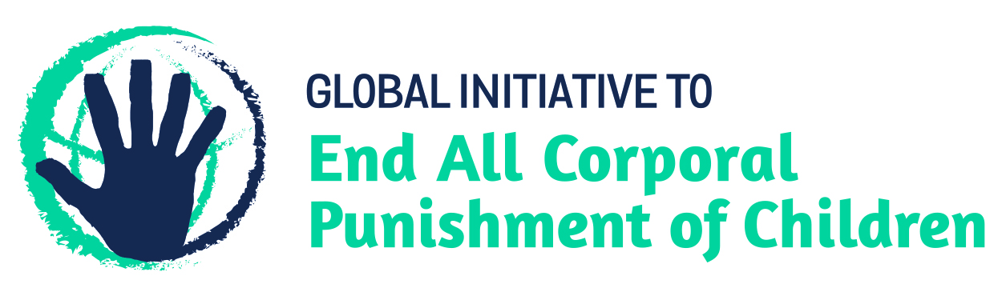
BRIEFING ON THE STATE OF PALESTINE FOR THE COMMITTEE ON THE RIGHTS OF THE CHILD, SESSION 83 PRE-SESSIONAL WORKING GROUP – June 2019
From the Global Initiative to End All Corporal Punishment of Children, February 2019
This briefing describes the legality of corporal punishment of children in the State of Palestine. In light of the Committee’s General Comment No. 8 on “The right of the child to protection from corporal punishment and other cruel or degrading forms of punishment”, the importance of eradicating this form of violence given by the UN Secretary General’s Study on Violence against Children, and the new global commitment to ending all violence against children in the context of the 2030 Agenda for Sustainable Development, we hope the Committee will:
- in its List of Issues for the State of Palestine, raise the issue of corporal punishment of children, in particular asking what steps are being taken to draft legislation prohibiting all corporal punishment of children; and,
- in its concluding observations on the initial report of the State of Palestine, recommend that legislation is immediately enacted to explicitly prohibit corporal punishment of children, in all settings including the home, and to repeal any legal defence for its use, throughout the territory, as a matter of priority.

1 The report of the State of Palestine to the Committee on the Rights of the Child
  - At time of writing, the state party report was only available in Arabic.
  - The State of Palestine is one of the handful of state parties to the Convention which are yet to receive a recommendation on corporal punishment from the Committee on the Rights of the Child. Issuing a recommendation on corporal punishment of children to every single state party to the Convention would send a powerful statement to all governments that the issue must be prioritised in order to fulfil their obligations under the Convention.

2 The legality and practice of corporal punishment of children in the State of Palestine
2.1 Summary: Corporal punishment of children is not fully prohibited in any settings throughout the state of Palestine.
2.2 Home (lawful): Corporal punishment is lawful in the home. In the West Bank (except East Jerusalem), article 62 of the Jordanian Penal Code 1960 states that the law allows “forms of discipline inflicted on children by their parents, as permitted by general custom”. In Gaza, there appears to be no defence for the use of corporal punishment in the British Criminal Code 1936, though it is likely that the English common law defence of “reasonable chastisement” applies.
2.3 In both the West Bank (except East Jerusalem) and Gaza, children have legal protection from violence in PA laws. Article 29 of the Amended Basic Law 2003 states that children have the right to “protection from harmful and cruel treatment” and “not to be subjected to beating or cruel treatment by their relatives”, but this is not interpreted as prohibiting all forms of corporal punishment by parents. Article 42 of the Child Law 2004 (amended 2012) states that children “shall have the right to protection from violence, abuse, ill-treatment and exploitation and that the State “shall take all necessary legislative, administrative, social, educational and preventive actions and measures to secure the said right”.
2.4 In East Jerusalem, child protection law is the same as for the state of Israel, where corporal punishment is unlawful in the home. In 2000, the Israeli Supreme Court ruled against all violence in childrearing and the “reasonable chastisement” defence was removed from criminal law the same year. However, a poor level of enforcement and discriminatory application of the law to Palestinian children has been documented.
2.5 In 2009, a number of new laws had been drafted, including a draft Social Affairs Law, draft amendments to the Child Law, a draft Penal Code, a draft Juvenile Justice Law, and a draft Constitution. The Child Law 2004 was amended in 2012 without addressing corporal punishment. In 2016, the Juvenile Protection Law was signed into law. We have no further information.
2.6 A draft Law on the Protection of Family from Violence is being considered. Its provisions would reportedly define violence in the family as “any behaviour carried out in the context of the family by one member against another, or any sex-based act that results in, or is expected to result in, psychological or physical or sexual harm, whether through an act, the threat of such, or compulsion to such, whatever the means used for that purpose, and whether the incident takes place within or outside the home”. The Personal Status Code is being reviewed.
2.7 Alternative care settings (lawful): There is no explicit prohibition of corporal punishment in alternative care settings. In the West Bank (except East Jerusalem) and Gaza, the defences for the use of corporal punishment in, respectively, article 62 of the Jordanian Penal Code 1960 and in English common law presumably apply to carers in alternative care settings as for parents. The prohibition of all corporal punishment in domestic Israeli law should apply to all alternative care settings in East Jerusalem.
2.8 Day care settings (lawful): There is no explicit prohibition of corporal punishment in all early childhood care and all day care for older children. In the West Bank (except East Jerusalem) and Gaza, the defences for the use of corporal punishment in, respectively, article 62 of the Jordanian Penal Code 1960 and in English common law presumably apply to day care as for parents. The prohibition of all corporal punishment in domestic Israeli law should apply to day care in East Jerusalem.
2.9 Schools (partially lawful): Schools in Gaza and the West Bank (excluding East Jerusalem) are run by the PA, UNRWA or private bodies. Ministerial directives advise against the use of corporal punishment in government (PA) schools, but there is no explicit prohibition in law. Under article 39 of the Child Law 2004, the State shall “take all arrangements to foster the dignity of the child, particularly when adopting decisions or developing programs, which aim at prohibiting all forms of violence in schools, regardless of the source”, and article 42 protects children from violence, but the Law does not prohibit corporal punishment. In Gaza, education law and regulations passed under the British Mandate apply, and do not prohibit corporal punishment. Similarly, the Jordanian education law and regulations in force in the West Bank do not prohibit corporal punishment. It has been prohibited in UNRWA schools since 1993. In East Jerusalem, education comes under Israeli law, which prohibits corporal punishment.
2.10 Penal institutions (partially lawful): There is no explicit prohibition of corporal punishment as a disciplinary measure in penal institutions. In Gaza and the West Bank (excluding East Jerusalem), Palestinian Detention Centres and Prisons are governed by the Child Law 2004, which prohibits cruel and degrading treatment and protects human dignity (arts. 68 and 69), but does not explicitly prohibit corporal punishment. Similarly, the Juvenile Protection Law no. 4 of 2016 which also applies in Gaza and PA-controlled areas of the West Bank does not explicitly prohibit corporal punishment but prohibits cruel and degrading treatment. Article 7.3 states (unofficial translation): “It is prohibited to use force with the juvenile except in cases where the rebellion or the ferocity shows that it is required, and only to the extent necessary”. Israeli Detention Centres and Prisons are governed by Israeli military orders. Military Order No. 863 punishes “a soldier who hits or abuses a person under detention”; article 65 of Israeli Military Jurisdiction Law 1995 punishes “a soldier who hits or abuses a person under detention if not necessary”.
2.11 In East Jerusalem, corporal punishment is unlawful under Israeli domestic law, but the law is poorly implemented and is frequently applied in a discriminatory way against Palestinian children.
2.12 Sentence for crime (partially lawful?): Corporal punishment appears to be unlawful as a sentence for crime but there is no explicit prohibition. The Child Law 2004 states that child offenders may not be subjected to any cruel, degrading or humiliating treatment (art. 68) and that young offenders should be treated in a way which protects their honour and dignity (art. 69). Articles 36 and 46 of the 2016 Juvenile Protection Law (applicable in territories controlled by the PA) lists possible sanctions for juveniles and does not include corporal punishment.
2.13 In the West Bank (excluding East Jerusalem), the Jordanian Penal Code 1960 does not provide for judicial corporal punishment. The Reformation of Juvenile Law (No. 16) 1954 previously applicable in the West Bank was repealed by the Juvenile Protection Law of 2016. In Gaza, the 2016 Law also repealed the Juvenile Offenders Ordinance 1937 which previously applied and whose article 12 allowed for juveniles to be sentenced to whipping. There is no provision for judicial corporal punishment in the British Penal Code 1936.
2.14 In East Jerusalem, judicial corporal punishment is unlawful under Israeli law. Palestinians throughout the West Bank and Gaza, including children and young people, may also be charged with offences under Israeli military law and tried in Israeli military courts. These are governed by Military Orders, applicable to all Palestinians over the age of 12. We have no information regarding sentences available under these Orders, other than detention.

Briefing prepared by the Global Initiative to End All Corporal Punishment of Children
www.endcorporalpunishment.org; info@endcorporalpunishment.org

Natalie Bako v The State
7 May 2018, CEDAW/C/PSE/Q/1/Add.1, Reply to list of issues, para. 43
7 May 2018, CEDAW/C/PSE/Q/1/Add.1, Reply to list of issues, para. 9
DCI International – Palestine Section (2008), Palestinian Child Prisoners 2007; Trojan, V. (2008), Child Rights Situation Analysis: Right to Protection in the occupied Palestinian territory – 2008, Ramallah/Jerusalem: DCI-Palestine/Save the Children Sweden

