Country Policy and Information Note

Yemen: Security and humanitarian situation

Version 4.0
January 2019

Preface

Purpose
This note provides country of origin information (COI) and analysis of COI for use by Home Office decision makers handling particular types of protection and human rights claims (as set out in the basis of claim section). It is not intended to be an exhaustive survey of a particular subject or theme.
It is split into two main sections: (1) analysis and assessment of COI and other evidence; and (2) COI. These are explained in more detail below.

Assessment
This section analyses the evidence relevant to this note – i.e. the COI section; refugee/human rights laws and policies; and applicable caselaw – by describing this and its inter-relationships, and provides an assessment on whether, in general:
- A person is reasonably likely to face a real risk of persecution or serious harm
- A person is able to obtain protection from the state (or quasi state bodies)
- A person is reasonably able to relocate within a country or territory
- Claims are likely to justify granting asylum, humanitarian protection or other form of leave, and
- If a claim is refused, it is likely or unlikely to be certifiable as ‘clearly unfounded’ under section 94 of the Nationality, Immigration and Asylum Act 2002.
Decision makers must, however, still consider all claims on an individual basis, taking into account each case’s specific facts.

Country of origin information
The country information in this note has been carefully selected in accordance with the general principles of COI research as set out in the Common EU [European Union] Guidelines for Processing Country of Origin Information (COI), dated April 2008, and the Austrian Centre for Country of Origin and Asylum Research and Documentation’s (ACCORD), Researching Country Origin Information – Training Manual, 2013. Namely, taking into account the COI’s relevance, reliability, accuracy, balance, currency, transparency and traceability.
The structure and content of the country information section follows a terms of reference which sets out the general and specific topics relevant to this note.
All information included in the note was published or made publicly available on or before the ‘cut-off’ date(s) in the country information section. Any event taking place or report/article published after these date(s) is not included.
All information is publicly accessible or can be made publicly available, and is from generally reliable sources. Sources and the information they provide are carefully considered before inclusion.
Factors relevant to the assessment of the reliability of sources and information include:
- the motivation, purpose, knowledge and experience of the source
- how the information was obtained, including specific methodologies used
- the currency and detail of information, and
- whether the COI is consistent with and/or corroborated by other sources.
Multiple sourcing is used to ensure that the information is accurate, balanced and corroborated, so that a comprehensive and up-to-date picture at the time of publication is provided of the issues relevant to this note.
Information is compared and contrasted, whenever possible, to provide a range of views and opinions. The inclusion of a source, however, is not an endorsement of it or any view(s) expressed.
Each piece of information is referenced in a brief footnote; full details of all sources cited and consulted in compiling the note are listed alphabetically in the bibliography.

Feedback
Our goal is to continuously improve our material. Therefore, if you would like to comment on this note, please email the Country Policy and Information Team.

Independent Advisory Group on Country Information
The Independent Advisory Group on Country Information (IAGCI) was set up in March 2009 by the Independent Chief Inspector of Borders and Immigration to support him in reviewing the efficiency, effectiveness and consistency of approach of COI produced by the Home Office.
The IAGCI welcomes feedback on the Home Office’s COI material. It is not the function of the IAGCI to endorse any Home Office material, procedures or policy. The IAGCI may be contacted at:
Independent Advisory Group on Country Information
Independent Chief Inspector of Borders and Immigration
5th Floor
Globe House
89 Eccleston Square
London, SW1V 1PN
Email: chiefinspector@icinspector.gsi.gov.uk
Information about the IAGCI’s work and a list of the documents which have been reviewed by the IAGCI can be found on the Independent Chief Inspector‘s pages of the gov.uk website.

Contents
Assessment 6
1. Basis of claim 6
2. Consideration of issues 6
2.1 Credibility 6
2.2 Exclusion 6
2.3 Assessment of risk 7
2.4 Internal relocation 10
2.5 Certification 10
Country information 11
3. Demography 11
4. Overview of the conflict 11
5. Timeline of events 12
6. Key actors 13
6.1 Houthis 13
6.2 The government of Yemen 14
6.3 Ali Abdullah Saleh loyalists 14
6.4 Southern separatists 14
6.5 Jihadist militants 15
6.6 International actors 15
7. Humanitarian situation 16
7.1 Overview 16
7.2 Numbers of people who need humanitarian assistance 16
7.3 Severity of need by location 16
7.4 Food security 17
7.5 Water, sanitation and hygiene (WASH) 18
7.6 Healthcare 19
7.7 Education 20
7.8 Impact on the economy 20
7.9 Impact on daily life 21
7.10 Humanitarian support 22
7.11 Humanitarian access 24
7.12 Internally Displaced Persons (IDPs) and returnees 26
8. Security situation 27
8.1 Maps of Yemen 27
8.2 Developments in southern Yemen 28
8.3 Developments in northern Yemen 29
8.4 Nature of violence 30
8.5 Control of territory and state 31
8.6 Level of violence and number of casualties 33
8.7 Vulnerable groups 35
8.8 Freedom of movement 36
Terms of Reference 37
Bibliography 38
Version control and contacts 42

Assessment
Updated: 14 December 2018

Basis of claim
    - That the general humanitarian situation in Yemen is so severe as to make removal to this country a breach of Articles 15(a) and (b) of the European Council Directive 2004/83/EC of 29 April 2004 (the Qualification Directive)/ Articles 2 and 3 of the European Convention on Human Rights (ECHR); and/or
    - That the security situation in Yemen presents a real risk to a civilian’s life or person such that removal to this country would be in breach of Article 15(c) of the Qualification Directive (serious and individual threat to a civilian’s life or person by reason of indiscriminate violence).
Back to Contents

Consideration of issues

Credibility
    - For information on assessing credibility, see the Asylum Instruction on Assessing Credibility and Refugee Status.
    - Decision makers must also check if there has been a previous application for a UK visa or another form of leave. Asylum applications matched to visas should be investigated prior to the asylum interview (see the Asylum Instruction on Visa Matches, Asylum Claims from UK Visa Applicants).
    - Decision makers should also consider the need to conduct language analysis testing (see the Asylum Instruction on Language Analysis).
Back to Contents

Exclusion
    - Parties on all sides of the conflict have reportedly been responsible for numerous serious human rights abuses (see Nature of violence). If it is accepted that the person has been involved with such a party (see Key actors) then decision makers must consider whether one (or more) of the exclusion clauses is applicable. Decision makers must nevertheless consider each case on its individual facts and merits.
    - For further guidance on the exclusion clauses and restricted leave, see the Asylum Instruction on Exclusion: Article 1F of the Refugee Convention and the Asylum Instruction on Restricted Leave.
Back to Contents

Assessment of risk

a. Refugee Convention
    - Decision makers must first consider if the person faces persecution for a Refugee Convention reason noting that a state of civil instability and/or where law and order has broken down does not of itself give rise to a well-founded fear of persecution for a Convention reason.
    - For general guidance, see the Asylum Instruction on Assessing Credibility and Refugee Status.
Back to Contents

b. Humanitarian Protection
    - Where the person qualifies under the Refugee Convention, decision makers do not need to go on to assess the need for Humanitarian Protection. It is only if the person does not qualify under the Refugee Convention that decision makers need to assess the need for protection firstly under Articles 15(a) and (b) of the Qualification Directive/Articles 2 and 3 of the European Convention on Human Rights (ECHR) and, if that is unsuccessful, under Article 15(c) of the Qualification Directive.
    - For general guidance on Humanitarian Protection (HP), see the Asylum Instruction on Humanitarian Protection.
Back to Contents

c. Humanitarian situation
    - A person is entitled to Humanitarian Protection (HP) if the humanitarian conditions to which they would be returned breach Articles 15(a) and/or (b) of the Qualification Directive/Articles 2 and/or 3 of the ECHR.
    - Yemen is experiencing a severe humanitarian crisis as a result of the ongoing conflict and the UN has declared a Level 3 emergency response (activated in the most complex and challenging humanitarian emergencies when the highest level of mobilisation is required) (see Humanitarian situation – Overview). Areas in which people are in severest need are in the north and west of the country controlled by the Houthi rebels, which sees open fighting, including Saudi-led aerial bombardment (see Severity of need by location and Security situation – Developments in northern Yemen).
    - Yemen has a population of approximately 28 million. Of those, the UN assessed that 80% (22.2 million) need humanitarian assistance (including 11.3 million people in ‘acute’ need) (see Numbers of people who need humanitarian assistance).
    - Those in humanitarian need includes 18.8 million (64% of people) who are food insecure, of which 8.4 million (30% of people) are in ‘severe’ need. The UN Office for the Coordination of Humanitarian Affairs (OCHA) assessed in October 2018 that the total number of people facing pre-famine conditions - meaning they are entirely reliant on external aid for survival - could soon reach 14 million (half the total population of the country) (see Food security).
    - Those in need also include 16 million (57% of people) who need basic water, sanitation and hygiene assistance. There is an ongoing outbreak of cholera, which has killed more than 2,300 people, particularly in the north and in Abyan governorate in the south (see Water, sanitation and hygiene (WASH)). Those in need also include 16.4 million (59% of people) who lack access to adequate healthcare (see Healthcare).
    - Around two million people are internally displaced (see Internally Displaced Person (IDPs) and returnees).
    - The war has had a severe effect on the economy, causing significant rising prices, depreciation of the currency and loss of jobs. Basic services have been seriously affected (see Impact on the economy and Impact on daily life).
    - Humanitarian support has reached 46% (10.2 million people) of those in need (see Humanitarian support). There are restrictions on humanitarian access (see Freedom of movement) to some parts of the country – Al Jawf, Saada, Hajjah, Marib, Shabwah, Al Bayda, Taizz and Al Hudaydah governorates are particularly hard for humanitarian partners to access (see Humanitarian access). The UN Office for the Coordination of Humanitarian Affairs (OCHA) has had a continual presence across the country (in all 333 of Yemen’s districts) although such support is challenged by the impact of the war (see Humanitarian support).
    - Humanitarian conditions in the country are likely, in most cases, to breach Article 15(b) of the Qualification Directive.
    - For guidance on Article 15 of the Qualification Directive see the Asylum Instruction on Humanitarian Protection.
Back to Contents

d. Security situation
    - Article 15(c) of the Qualification Directive defines serious harm as ‘serious and individual threat to a civilian's life or person by reason of indiscriminate violence in situations of international or internal armed conflict.’ Article 15(c) applies only to civilians, who must be genuine non-combatants and not those who are party to the conflict. This could include former combatants who have genuinely and permanently renounced armed activity.
    - Yemen is a complicated civil war involving several actors (see Background to the conflict and Key actors).
    - In February 2015, Houthi rebel forces forced the government to flee to Aden (see Background to the conflict). The frontlines have been relatively fixed, but the government now no longer effectively controls Aden, which is now controlled by the United Arab Emirates (UAE)-backed Southern Transitional Council (STC), a southern separatist group. The UAE has intensified operations against Al Qaeda in the Arabian Peninsula (AQAP) and Daesh (Islamic State) in the south; despite this, these jihadist militants have renewed attacks in areas in the south including Aden and Bayda (see Developments in southern Yemen and Control of territory and state).
    - The Houthis and their allies continue to control northern areas, including Sana’a and its surrounding provinces. A coalition of Gulf countries headed by Saudi Arabia continue to bomb Houthi-held areas in the north. There is current fighting in Ta’izz and in the strategically important port city of Hudaydah, which displaced 345,0000 people in August 2018 (see Developments in northern Yemen and Internally Displaced Persons (IDPs) and returnees).
    - There are reports of indiscriminate and unlawful violence by all parties, including the use of internationally banned cluster bombs and landmines, and repeated attacks on civilian homes, hospitals, schools, markets and factories (see Nature of violence).
    - According to the monitoring group Armed Conflict Location and Event Data Project (ACLED), between September 2016 and September 2018, from a low point in overall casualties in late 2017, casualties have steadily increased in 2018. The UN High Commissioner for Human Rights (UNHCR) reported that, from March 2015 to 9 August 2018, there were 17,062 civilian casualties (6592 dead; 10,470 injured). Most of these casualties (10,471, or 61%) were the result of Saudi air-strikes (see Level of violence and number of casualties).
    - In September 2018, ACLED found that comparatively more fatalities occur along the southwest coast and Yemen’s northwest border with Saudi Arabia, and a majority of fatalities take place during events between state forces (see Level of violence and number of casualties).
    - The pattern of civilian casualties varies across the country. Western Yemen (the Highlands) is generally the most violent area of the country, followed by Ta’iz, the Northern Tribal Areas and Southern Yemen. Casualties are particularly heavy in Hudaydah (see Level of violence and number of casualties).
    - The Northern Tribal Areas and Southern Yemen show the largest variations in civilian casualties inflicted by different actors; Southern Yemen, for example, has lower civilian casualties inflicted by foreign forces than other areas, although has the highest number of civilian casualties inflicted by non-state actors (see Level of violence and number of casualties).
    - Eastern Yemen is statistically the least violent part of Yemen, and has lower fatality levels across all categories of perpetrators (see Level of violence and number of casualties).
    - While there is violence in Aden, most of the violence against civilians in the country occurs in other areas. Furthermore, more displaced people have returned to Aden than anywhere else; returns to Aden account a third of all returns (see Internally Displaced Persons (IDPs) and returnees).
    - Except in Eastern Yemen (the least populous area of the country – see Demography) and Aden and surrounding areas in the south, the level of indiscriminate violence is likely to be at such a level that substantial grounds exist for believing that a person, solely by being present there, faces a real risk of harm which threatens their life or person. This engages Article 15(c) of the Qualification Directive.
    - Even though the high threshold needed to engage Article 15(c) risk is not countywide, decision makers must consider whether there are particular factors relevant to the person’s individual circumstances which might nevertheless place them at risk on return.
    - For information and guidance on Article 15(c), including consideration of enhanced risk factors, see the Asylum Instruction on Humanitarian Protection.
    - For further information and guidance on assessing risk, see the Asylum Instruction on Assessing Credibility and Refugee Status.
Back to Contents

Internal relocation
    - Travel within Yemen is restricted by the high and fluctuating levels of violence throughout most of the country, as well as severe fuel shortages (see Freedom of movement).
    - Societal discrimination severely restricts the freedom of movement of women, although restrictions vary by location (see Freedom of movement).
    - It is not reasonable for a person to relocate to an area that engages Articles 15 (b) and (c) of the Qualification Directive.
    - For further information on considering internal relocation and the factors to be taken into account, see the Asylum Instruction on Assessing Credibility and Refugee Status.
Back to Contents

Certification
    - Where a claim is refused, it is unlikely to be certifiable as ‘clearly unfounded’ under section 94 of the Nationality, Immigration and Asylum Act 2002.
    - For further information and guidance on certification, see the Appeals Instruction on Non-Suspensive Appeals: Certification Under Section 94 of the NIA Act 2002.
Back to Contents

Country information
Updated: 23 November 2018

Demography
    - Yemen has population of about 28 million.
    - The population density is shown on the below map:
Map showing population density in Yemen
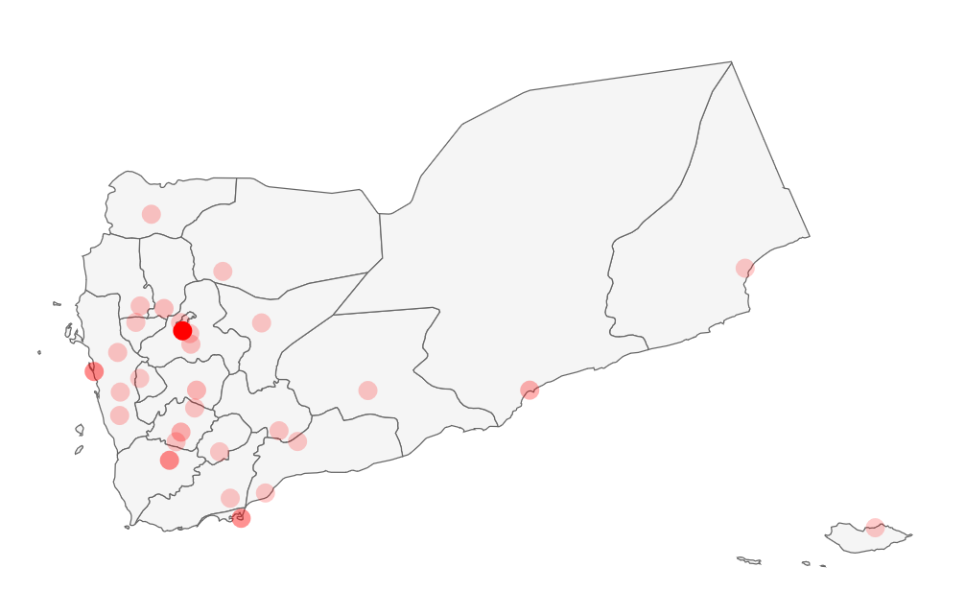
    - The five most populous cities are: Sanaa (1.9 million), Hudaydah (618,000), Taizz (615,000), Aden (551,000) and Mukalla (258,000).
Back to Contents

Overview of the conflict
    - Jane’s By IHS Markit, in an update of 11 October 2018, summarised the conflict in Yemen:
‘Yemen is currently embroiled in a civil war between the Houthi Movement and the internationally recognised government, supported by Saudi-led military forces.
‘The collapse of the alliance between the Houthis and former president Ali Abdullah Saleh, who was killed by Houthi militants on 4 December 2017, has further isolated the Houthi movement in northern Yemen. Despite the increasing Saudi and Houthi interest in ending the conflict, the prospects for an expedited deal capable of suddenly ending the civil war are low. Jihadist activity has expanded unchecked across south and central Yemen as a result of the vacuum of state authority. Similarly, pro-secessionist sentiments across southern Yemen are continuing to grow.
‘The principal external rival players in the civil war are Saudi Arabia, backing the internationally recognised Yemeni government led by President Hadi, and Iran, indirectly backing the Houthi Movement, which struck an alliance of convenience with former president Saleh. Both approach the Yemeni conflict within the context of the Sunni versus Shia sectarian narrative and are emphasising the importance of expanding their regional influence at one another's expense. US and UN mediation is unlikely to lead to a quick resolution to conflict or install a new government capable of reversing or even containing the spread of jihadist groups, including the Islamic State.’
    - For further information, see the Immigration and Refugee Board of Canada (IRBC)’s National Documentation Package on Yemen, which contains various resources, including background information.
Back to Contents

Timeline of events
2011
November | President Abdullah Saleh is forced from power; he is succeeded by is deputy, Abdrabbuh Mansour Hadi
2011-14 | The failure to reach a stable political settlement
2014
September | Houthis take control of most of the capital, Sanaa
2015
February | The Houthis force the Hadi government to relocate to Aden
March | The Houthis march towards southern Yemen; Hadi flees to Saudi Arabia. A Saudi-led coalition of Gulf Arab states launches air strikes against Houthi targets and imposes a naval blockade
June | Leader of Al-Qaeda in the Arabian Peninsula (AQAP), Nasser al-Wuhayashi, is killed in a US drone strike in Yemen
September | Hadi returns after Saudi backed forces recapture the city
2016
April  2017  June-November | Start of UN-sponsored talks between the government on one side and Houthis and former President Saleh’s General People’s Congress (GPC) on the other  Cholera breaks out in the country
December  2018  January | The Houthis assassinate Saleh in Sanaa  Southern separatists – backed by the United Arab Emirates (UAE) – seize control of Aden
November | US calls for cease-fire, after months of fighting around the key Houthi-held port of Hudaydah and a mounting humanitarian crisis.
See also: Security situation
Back to Contents

Key actors

Houthis
    - The Houthi movement (also known as Ansar Allah or Partisans of God) is a predominantly Zaydi Shiite revivalist political and insurgent movement (Zaydism is an offshoot of Shia Islam but its legal traditions and religious practices are similar to Sunni Islam).
    - The movement was formed in the northern Yemeni province of Saada in 2004 under the leadership of members of the Houthi family. It originally sought an end to what it viewed as efforts to marginalize Zaydi communities and beliefs, but its goals grew in scope and ambition in the wake of the 2011 uprising and government collapse to embrace a broader populist, anti-establishment message.
    - It fought a series of rebellions against the Saleh government. After the political transition to Hadi, the Houthis seized control of their northern heartland of Saada province, and neighbouring areas. They were supported by many ordinary Yemenis (including Sunnis) who were disillusioned with the political transition.
    - The movement allegedly cooperates with Iran. The Congressional Research Services (CRS)’s Yemen report of August 2018 noted that ‘many observers agree’ that Iran (and Lebanese Hezbollah) support the Houthis with advice, training and shipments. However, it also noted that Iran has ‘few institutionalized links to the Houthis’, that ‘questions remain about the degree to which Iran and its allies can control or influence Houthi behaviour’ and that the scale of Iranian commitments in Yemen do not match that of its commitments elsewhere in the Middle East.
Back to Contents

The government of Yemen
    - The President of Yemen is Abdu Mansour Hadi, who succeeded Ali Abdullah Hadi in 2012.
    - The BBC noted that ‘Mr Hadi struggled to deal with a variety of problems, including attacks by al-Qaeda, a separatist movement in the south, the continuing loyalty of many military officers to Mr Saleh, as well as corruption, unemployment and food insecurity.’
    - Hadi fled to Saudi Arabia in March 2015 following attempts by the Houthi-Saleh alliance to take over the whole country.
    - Government allies included predominantly Sunni southern tribesmen and separatists.
Back to Contents

Ali Abdullah Saleh loyalists
    - Ali Abdullah Saleh was President of the Yemen Arab Republic (North Yemen) from 1978 and then President of the Yemen Arab Republic after the country was unified in 1990. He ceded power in February 2012 to his deputy, Abdu Mansour Hadi, following protests against his rule.
    - Following the failure of the National Dialogue Conference in 2013, forces loyal to Hadi made an ‘alliance of convenience’ with the Houthis against the government. In early December 2017, the Houthi-Saleh alliance unravelled after Saleh attempted to come to an agreement with Saudi Arabia in return for them ending their attacks on Yemen, and Saleh was killed by the Houthis on 4 December 2017.
Back to Contents

Southern separatists
    - Southern separatists are known variously as Al-Harakat al-Janubiyya, Southern Movement, al-Harakat al-Salmiyya lil-Janub or the Peace Movement of the South.
    - Southern separatists seek a return to the independence of south Yemen, which it was before unification with the north in 1990.
    - Jane’s Sentinel Security Assessment, in a profile updated on 6 December 2017, noted that the ‘Southern Movement is characterised by a lack of central leadership’. It continued: ‘The Southern Movement is an umbrella movement comprising a number of different political factions in southern Yemen that united in their opposition to the administration of former president Ali Abdullah Saleh, and their desire to re-establish an independent southern Yemen.’
    - Southern separatists formed an alliance with the Hadi government against the Houthis and in defence of Aden. However, this alliance broke down and in January 2018 the separatist Southern Transitional Council (STC) accused the government of corruption and mismanagement, and demanded the removal of Prime Minister Ahmed bin Daghar.
    - The website of Southern Hirak has a list of leaders and representatives.
Back to Contents

Jihadist militants
    - Al Qaeda in the Arabian Peninsula (AQAP) are jihadist militants seized control of parts of the south and carried out attacks, notably in Aden, following the political transition in 2012. Their militant rivals, Daesh (Islamic State), also operate in Yemen.
    - Al Qaeda and Daesh are proscribed terrorists organisations in the UK.
Back to Contents

International actors
    - Following unrest after the fall of Saleh and his replacement by Hadi, a proposed National Dialogue Conference in 2013 failed to reach a political consensus. Following Hadi’s fleeing to Saudi Arabia in 2013, Saudi Arabia and an international coalition began a military offensive aimed at restoring the Hadi government. Saudi Arabia were concerned that the Houthis were backed by Iran, their regional rival. The coalition consisted of Saudi Arabia and eight mostly Sunni Arab states and received logistical and intelligence support from the USA, UK and France.
    - The CRS’s August 2018 report noted that, as per the FY2018 National Defense Authorization Act Certification Agreement, the USA restrict funds for in-flight refuelling of coalition aircraft until their government submits a ‘specific certification regarding coalition operations’ or issues a waiver and reports to Congress on specific criteria (this does not apply to operations against AQAP or Daesh (IS)).
    - There are divisions within the Saudi-led coalition: Saudi Arabia reportedly backs Hadi, who is based in Riyadh, while the United Arab Emirates (UAE) is closely aligned with the southern separatists. The monitoring group Armed Conflict Location and Data Project (ACLED) describe the UAE as ‘a military power on the rise within an increasingly militarised region.’
    - See also: Annex 1 in the UN Human Rights Council’s August 2018 report on the situation of human rights in Yemen, which contains a detailed profile of the actors in the conflict.
Back to Contents

Humanitarian situation

Overview
    - The UN Office for the Coordination of Humanitarian Affairs (OCHA), as of 1 October 2018, declared a Level 3 (L3) emergency response for Yemen. ‘L3 Responses are activated in the most complex and challenging humanitarian emergencies, when the highest level of mobilization is required, across the humanitarian system, to ensure that the right capacities and systems are [in] place to effectively meet needs.’ Yemen became a UN OCHA Level 3 emergency in July 2015 and it was reviewed and extended in February 2017.
Back to Contents

Numbers of people who need humanitarian assistance
    - The UN OCHA, as of 1 October 2018, stated that:
- 22.2 million people (about 80% of the population) ‘need some kind of humanitarian or protection assistance’ – an increase from 15.9 million in need in 2015 and 18.3 million people in 2017.
- 11.3 million people (about 40% of the population) are in ‘acute need’
Back to Contents

Severity of need by location
    - The UN OCHA’s 2018 Humanitarian Response Plan (HRP) shows their assessment of the severity of humanitarian needs, by district:
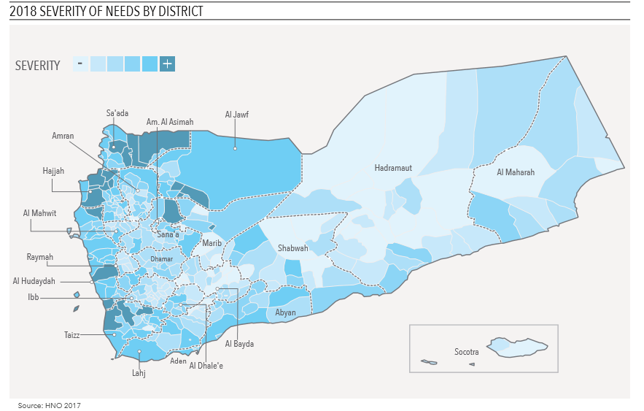
Back to Contents

Food security
    - The UN OCHA’s 2018 HRP found that:
- 17.8 million people (about 64% of the population) are food insecure
- 8.4 million (about 30% of the population) are ‘severely’ food insecure and at risk of starvation (an increase of 24% since April 2017)
- 1.8 million children and 1.1 million pregnant or lactating women are ‘acutely malnourished’
- 7.5 million people (about 27% of the population) need ‘nutrition assistance’
    - The CRS’s report on Yemen, updated August 2018, noted: ‘Although food is available to purchase in markets, the war has devastated the Yemeni economy … Food prices have skyrocketed, with the World Food Program reporting in May 2018 that the national average retail prices of wheat flour, sugar, vegetable oil, and red beans were 60%, 42%, 39%, and 104% higher than in the prewar period, respectively.’
    - The Famine Early Warning Systems Network (Fews Net) provided the following maps showing the phases of food insecurity in Yemen’s governorates.
Maps showing acute food insecurity phases in Yemen’s governorates, September 2018 and projection for October 2018 – January 2019
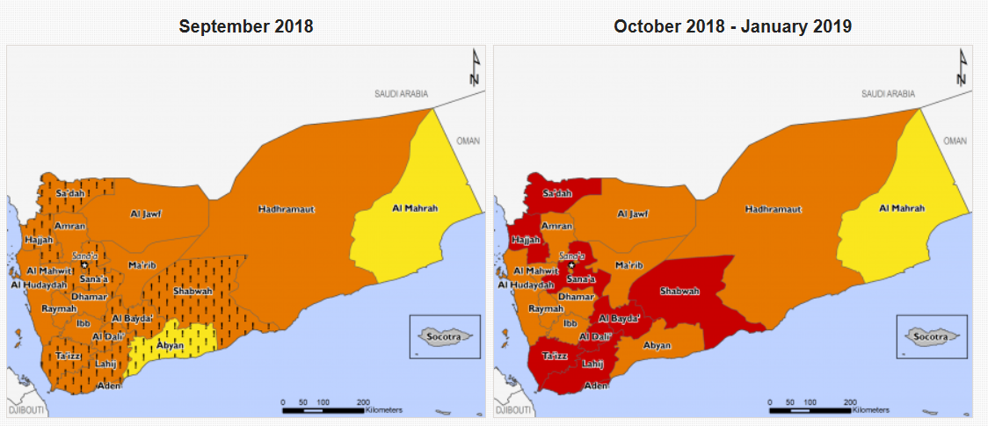
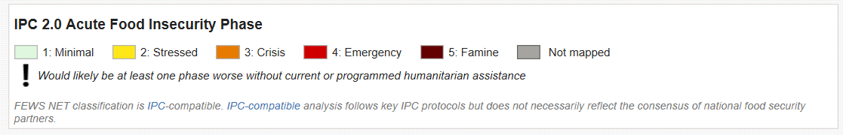
    - The UN OCHA, in October 2018, noted: ‘Revised assessments show that the total number of people facing pre-famine conditions - meaning they are entirely reliant on external aid for survival - could soon reach 14 million – 3 million more than last month’s estimates. That is half the total population of the country.’
Back to Contents

Water, sanitation and hygiene (WASH)
    - The UN OCHA’s 2018 HRP stated that:
- about 16 million people (about 57% of the population) need assistance to establish or maintain access to safe water, basic sanitation and hygiene facilities
- 11.6 million of the above (about 41% of the population) are in ‘acute’ need
    - The CRS report of August 2018 reported:
‘Yemen also is experiencing the world's largest ongoing cholera outbreak. The World Health Organization (WHO) estimates that from late April 2017 to July 2018, there have been 1,115,378 suspected cholera cases and 2,310 associated deaths. Cholera is a diarrheal infection that is contracted by ingesting food or water contaminated with the bacterium Vibrio cholerae. Yemen’s water and sanitation infrastructure have been devastated by the war. Basic municipal services such as garbage collection have deteriorated and, as a result, waste has gone uncollected in many areas, polluting water supplies and contributing to the ongoing cholera outbreak. In addition, International human rights organizations have accused the Saudi-led coalition of conducting airstrikes that have unlawfully targeted civilian infrastructure, such as water wells, bottling facilities, health facilities, and water treatment plants …
‘In August 2018, Yemeni authorities launched an oral cholera vaccination campaign, which has vaccinated 375,000 people since it began. On April 3, 2018, the United Nations, Switzerland, and Sweden cohosted a high-level pledging conference in Geneva to fund the U.N.’s 2018 Humanitarian appeal, which aims to raise $2.96 billion. Donors pledged approximately $2 billon at the conference, $930 million of which came from the combined pledges of Saudi Arabia and the UAE [United Arab Emirates]. The United States pledged $87 million and urged “all parties to this conflict to allow unhindered access for all humanitarian and commercial goods through all points of entry into Yemen and throughout the country to reach the Yemenis in desperate need.”’
    - The UN OCHA’s 2018 HRP provided a map showing the number of suspected cholera cases by district (up until 25 October 2017):
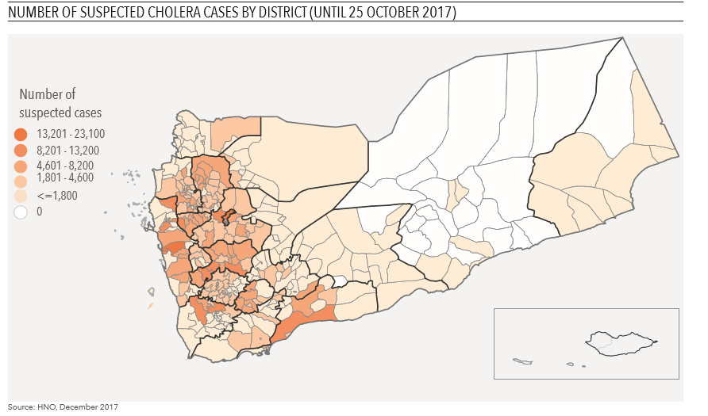
Back to Contents

Healthcare
    - The UN OCHA’s 2018 HRP stated that:
- 16.4 million people (about 59% of the population) lack access to adequate healthcare
- 9.3 million of the above (about 33% of the population) are in ‘acute’ need of healthcare
- half of all health facilities are functioning – and those that are functioning face ‘severe’ shortages in medicines, equipment and staff
    - The UN OCHA’s 2018 HRP noted that the 2017 cholera outbreak was ‘followed by a rapidly spreading suspected diphtheria outbreak attributed to low vaccination coverage.’
Back to Contents

Education
    - The UN OCHA’s 2018 HRP stated that:
- the 2017/18 school year started with delays in 13 out of 22 governorates because teachers were not paid
- 21% of schools are ‘unfit for use for educational activities’ due to conflict-related damage hosting of IDPs or occupation by armed groups
- about 4.1 million school-aged children require assistance to continue their education
Back to Contents

Impact on the economy
    - The UN OCHA’s 2018 HRP stated: ‘Already ailing before the escalation of the conflict, the Yemeni economy is being willfully destroyed, facing an extraordinary fiscal challenge in 2018.’ It continued that:
- Gross Domestic Product (GDP) declined by 41.8% between 2015 and 2017 (equivalent to a loss of US$32.5 billion)
- the Yemeni Riyal depreciated by 13% in October to December 2017 (to 441 YER/US$), following a 28% loss of value between January to October 2017 and more than 100% decrease in value when compared to 2015
- there have been price spikes in fuel and basic commodities
- Yemen is experiencing a liquidity crisis in which people struggle to transfer money into and within the country
    - The UN OCHA’s 2018 HRP continued:
‘The severe economic decline is driving significant losses of livelihoods. Private sector companies have reduced their operating hours and/or suspended activities due to a lack of inputs, especially fuel. Similarly, the agriculture sector has been severely constrained by a shortage of agricultural inputs such as vaccines, drugs, feeds and other essential commodities for the livestock, fishery and poultry sector. The escalation of conflict along the coast has disrupted contributed to the disruption of fishing activities threatening the lives of 83,000 small-scale fisheries and their families … Approximately 1.25 million civil servants have not received salaries or received them only intermittently since August 2016. This salary gap is estimated to affect a quarter of the population – civil servants and their families. Ultimately, while basic commodities are becoming scarcer and more expensive, people’s livelihoods opportunities and access to cash are diminishing.’
    - The HRP continued:
‘Economic decline and import restrictions are impacting the availability and price of basic goods in markets. Despite liquidity shortages, price inflation and increased costs of transport, markets remain mainly functional in most areas. According to WFP [World Food Programme] monthly bulletins, the domestic food prices are high, volatile, and likely to increase further throughout 2018.’
    - The HRP continued that, following the closure of Yemen’s port and the depreciation of the currency by 10% in November 2017, ‘prices of key commodities soared’. These increases were given as:
- up to a 70% increase in fuel prices within one month, and an increase by more than 150% since the pre-crisis period – although prices varied between markets (they are worse in active conflict areas)
- a 12% increase from October to December 2017 in the average cost of the monthly minimum food basket (47% higher than in the pre-crisis period)
- a 60% increase in the price of water trucking
Back to Contents

Impact on daily life
    - The UN OCHA, as at 1 October 2018, stated that the ‘ongoing conflict continues … to cause extensive damage to public and private infrastructure.’
    - The 2018 HRP noted that: ‘Essential basic services and the institutions that provide them are at the brink of total collapse.’
    - The same source noted: ‘Around eight million conflict-affected individuals require livelihoods assistance to enhance their self-reliance to address basic needs and reduce dependency on relief assistance. Communities require support to promote resilience, including clearance of landmines and other explosives in various locations.’
Back to Contents

Humanitarian support
    - The 2018 HRP targeted 13.1 million people (about 59% of those in humanitarian need) for humanitarian assistance. As of November 2017, 10.2 million people (about 46% of those in humanitarian need) had been reached.
    - The Humanitarian Response Plan requires $2.96 billion in funding. In 2017 the Plan met 70% of its funding target.
    - The OCHA Yemen Country Office was established in Sana’a in 2010 (in response to the widespread flooding in Yemen at that time). As at 1 October 2018
‘OCHA’s presence has been continual, across the country, since the escalation of conflict in March 2015. Within the L3 framework, expanding operational presence has been a key priority for the Yemen operation. OCHA staff is deployed in the four Operational Hubs of Al Hudaydah, Ibb, Saada and Aden, in addition to the main office in Sana’a. A supporting Yemen office operates from Amman. The Amman hub leads the areas of information management; communications and reporting; analysis; humanitarian financing; and administration. A small team based in Riyadh also supports the Yemen operation. This office focuses mainly on de-confliction support to all humanitarian operations in Yemen for overland movement, flights and shipping of humanitarian goods, as well as ensuring an information and advocacy link between the Yemen Humanitarian Country Team (HCT) and representatives of the Saudi-led Coalition and Government of Yemen officials based in Riyadh. A UN Verification Mechanism team further supports the Yemen operation from Djibouti.’
    - The UN OCHA, as at 1 October 2018, stated:
‘Collapse in the public sector is increasingly pressuring humanitarian organizations to compensate for the absence of government spending, which goes beyond their mandate and capacity to respond. For example, the recent cholera outbreak has forced humanitarian partners to cover the operating costs of hospitals and health facilities and to pay incentives to public servants in critical roles, especially health care. This sets a potentially problematic precedent by stretching scarce humanitarian resources beyond their mandate and into the public sector to compensate for the failing social services.
‘Just as humanitarian assistance cannot compensate for public institutions, it also cannot replace commercial imports and functioning local markets to meet the vast majority of Yemenis’ survival needs.’
    - The 2018 HRP shows how many humanitarian organisations were working in Yemen, where in the country they were based and the breakdown of people targeted per ‘hub’ (area).
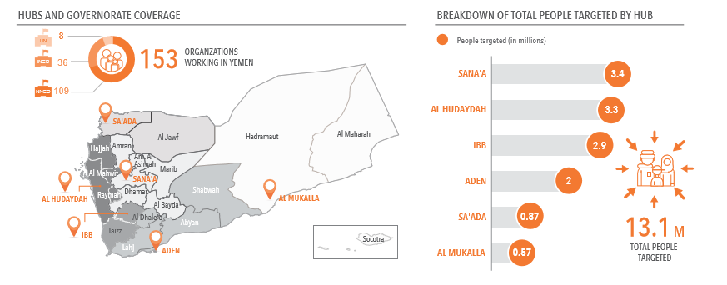
    - The 2018 HRP provided assistance packages, addressing needs for famine prevention, cholera and displacement. The below information from the HRP shows what these packages consist of:
Household level package includes:
- emergency food assistance (through either general food distribution, cash or voucher transfers)
- provision of emergency agricultural (seeds, farm implements etc.), livestock (feed blocks, feed concentrates, dry fodder, restocking etc.) and fishery inputs support (nets, cooler boxes etc.)
- income generating activities
- implementation of the minimum health service package (pre-natal and post-natal care, messaging, child vaccination, response to outbreaks, management of sick)
- providing consumable hygiene kits, jerry cans, ceramic filters
- providing sustainable access to safe potable drinking water
- latrine construction through community mobilization approaches
- screening and referral of children with severe or moderate acute malnutrition and PLW [pregnant and lactating women] with acute malnutrition
- the possibility of providing the FSAC [food security and agriculture] and WASH [water, sanitation and hygiene] components through a multi-purpose cash grant will be explored.
Health facility level package includes:
- treatment of the acute malnutrition in children and women through the community management of acute malnutrition
- targeted food distribution to care givers of malnourished children, primary and secondary health care
- ensuring sustainable access to safe water and functional and appropriate sanitation services
- maintenance of WASH services
- distribution of the consumable hygiene kits and ceramic water filters to caregivers of malnourished children along with health and hygiene education.
Community level package includes:
- mother to mother support groups for the behavior change communication on infant and young child feeding
- blanket supplementary feeding programmes
- sustainable access to safe drinking water and appropriate sanitation solutions (including solid waste and sewage services)
- community-based health interventions
- mass livestock vaccinations
- basic agro processing (e.g. sesame oil extraction), rehabilitation and resilience building through cash for work, food for work, cash for assets, food for assets schemes
- community plots
Back to Contents

Humanitarian access
    - The 2018 HRP provided the following map showing perceived levels of access constraints by district
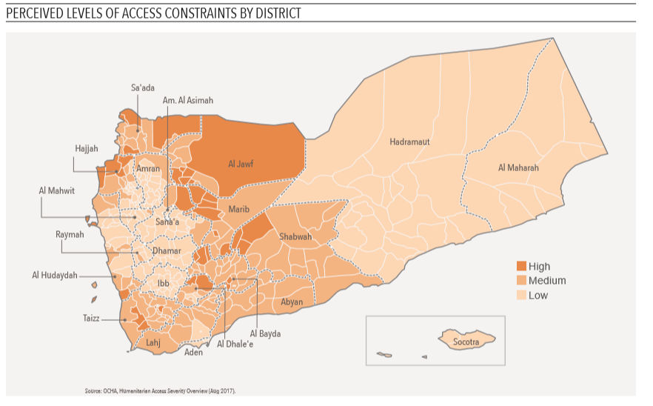
    - The OCHA provided the following map showing the presence of humanitarian organisations in the country, as at September 2018. It shows that humanitarian organisations are present in all of Yemen’s 333 districts.
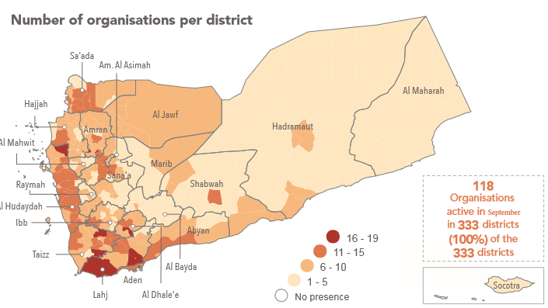
    - A House of Commons briefing paper on the war in Yemen, dated October 2018, stated:
‘Aid and commercial imports are being hampered because of the conflict. Overland access to Hodeidah, is still limited by continuing fighting. Agencies are concerned that the port’s facilities may be damaged by fighting. The UN High Commission for Refugees warehouse in Hodeidah remains temporarily closed due to the security situation and a World Food Programme warehouse has been damaged.’
See also: Freedom of movement
Back to Contents

Internally Displaced Persons (IDPs) and returnees
    - According to the International Organisation for Migration (IOM), as of June 2018, 2.3 million people were displaced ‘long term’.
    - 345,000 IDPs were displaced by the emergency in Al Hudaydah in August 2018. In November 2018, following more than 200 air attacks, the United Nations put the figure at 445,000.
    - As of June 2018 1 million people had returned to their areas of origin.
    - The 2018 HRP provided the following information showing numbers of IDPs and returnees by district:
District | IDPs | Returnees
Abyan | 20,000 | 10,000
Aden | 40,000 | 330,000
Al Bayda | 30,000 | 10,000
Al Dhale’e | 30,000 | 30,000
Al Hudaydah | 110,000 | 5000
Al Jawf | 50,000 | 10,000
Al Maharah | 4000 | 10,000
Al Mahwit | 40,000 | 10,000
Am. Al Arimah | 160,000 | 190,000
Amran | 160,000 | 20,000
Dhamar | 120,000 | 30,000
Hadramaut | 2000 | 40,000
Hajjat | 380,000 | 40,000
Ibb | 140,000 | 10,000
Lakj | 60,000 | 70,000
Marib | 70,000 | 20,000
Raymah | 40,000 | 0
Saada | 110,000 | 30,000
Sana’a | 130,000 | 2000
Shabwah | 20,000 | 10,000
Socotra | 2000 | 0
Taizz | 320,000 | 0
Total | 2 million | 1 million
    - The 2018 HRP noted that 77% of IDPs live in host communities.
Back to Contents

Security situation

Maps of Yemen
    - Sources often refer to ‘South/ern Yemen’ and ‘North/ern Yemen’. These areas broadly correspond with the boundaries of the former Yemen Arab Republic (North Yemen) and People’s Democratic Republic of Yemen (South Yemen). Although referred to as north and south, these boundaries geographically correspond to west/south-east and east/south-west. The following map shows the division between north and south Yemen:
‘North/Northern’ and ‘South/Southern’ Yemen, corresponding to the boundaries of the former Yemen Arab Republic (North Yemen) and People’s Democratic Republic of Yemen (South Yemen)

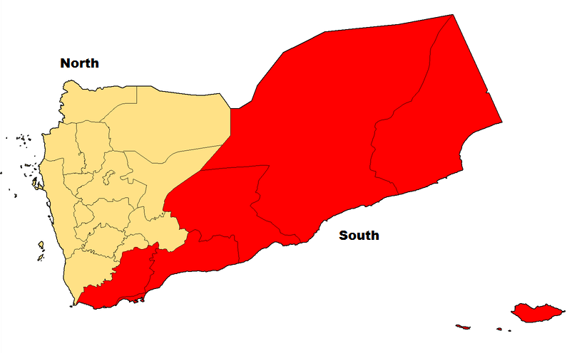

Map of Yemen
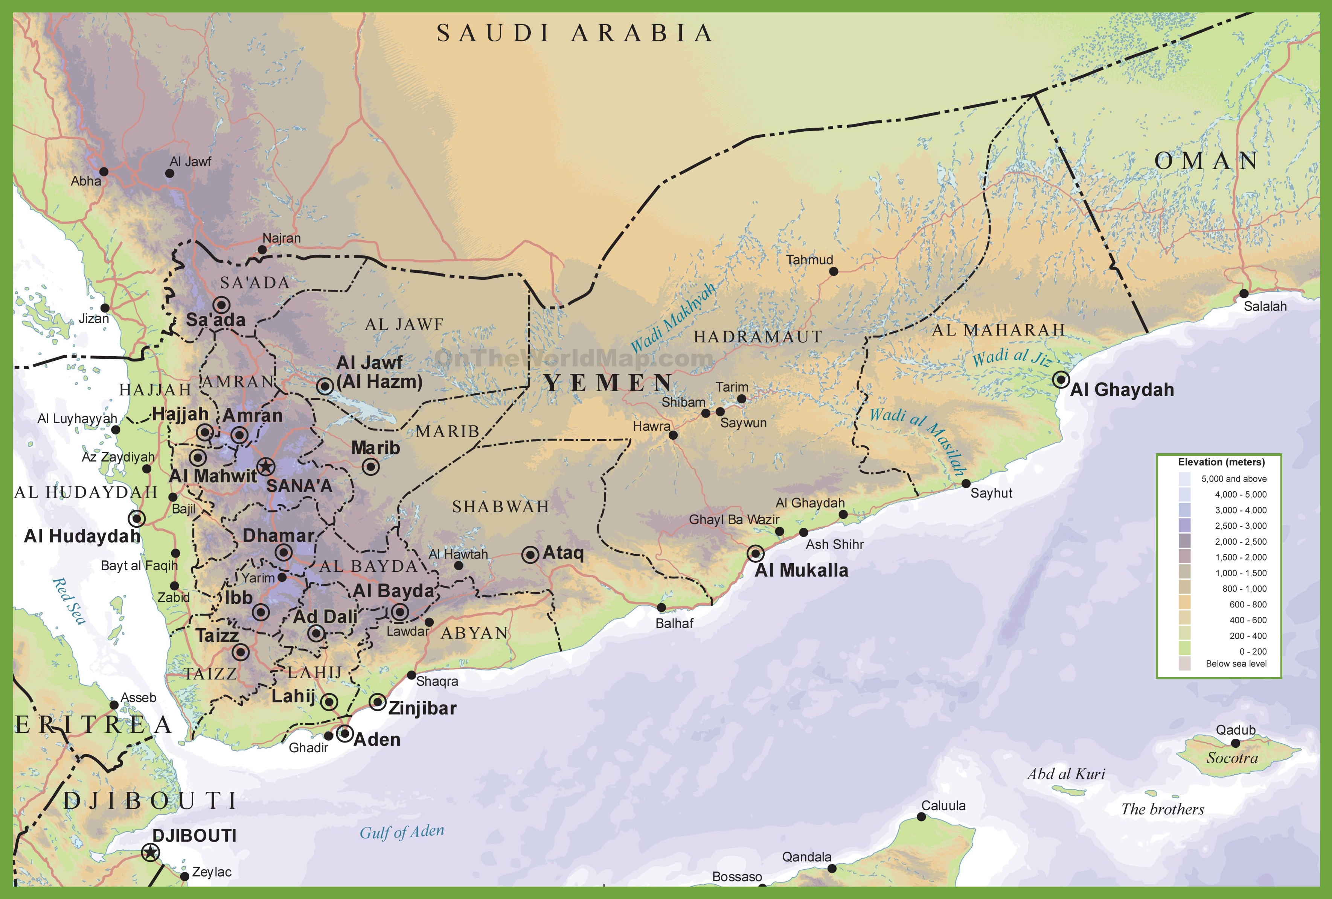
Back to Contents

Developments in southern Yemen
    - The CRS, in their 2018 report on Yemen, noted that:
- the UAE are focused on the south and west of the country, allying with local forces and southern separatists against AQAP and the Houthis, while distancing themselves from the government (unlike Saudi Arabia)
- in January 2018 the Southern Transitional Council (STC) seized control of most of Aden; they have since handed back the coalition’s military installations to the Hadi government as part of their collective fight against the Houthis, but Hadi has a government in Aden in ‘name only’
- the UAE supported the formation of the STC and effectively control Aden, the seat of the government, through the presence of its own troops or allied tribal militia (known as the ‘Southern Belt’, or ‘Al Hizan’ in Arabic)
- there are periodic clashes between government forces and UAE-sponsored southern separatists
    - Jane’s, in an update of 11 October 2018, stated:
‘Since January 2018, the UAE has intensified its operations in southern Yemen aimed at degrading AQAP's presence in the area. UAE-led efforts have followed a two-fold approach: first, restoration of a measure of authority in those cities under its control and, second, mounting clearing operations from there aimed at dislodging AQAP and intended to progressively expand the area controlled by its local proxies. However, AQAP's ongoing attacks against UAE-backed forces, coupled with renewed Islamic State activity in Aden and Bayda, point to a still-fragile risk environment across southern provinces that calls into question UAE claims that its counter-terrorism operations have greatly degraded the jihadists' capabilities.
Back to Contents

Developments in northern Yemen
    - The CRS, in their 2018 report on Yemen, noted that
- on 12 June 2018, the Saudi-led coalition launched Operation Golden Victory to re-take the strategically important Red Sea port city of Hudaydah, currently held by the Houthis
- the coalition has taken most of Hudaydah airport. The Houthis have laid landmines, trenches and barricades around the city
- on 23 June, fighting paused while the Special Envoy of the UN Secretary-General for Yemen was allowed to attempt to negotiate a ceasefire
- by August, fighting had shifted to the districts surrounding the city
- the Houthis continue to control Sanaa
- the Houthis periodically target commercial shipping in the Red Sea
- the Houthis are using short-range ballistic missiles from the old Soviet Union and North Korea, originally acquired by the Government, to attack Saudi Arabia
- the Saudis continue to provide materiel and advice to the government, while waging an air campaign against the Houthis and their allies, including by targeting civilian infrastructure
- Saudi Arabia blockaded Yemen after the Houthis fired a missile into Saudi Arabia in November 2017 (although in December 2017 they ended the blockade on Hudaydah for a 30-day period)
    - During the first two weeks in November 2018 there were more than 200 air attacks reported in Hudaydah.
    - In August 2016 the coalition closed Sanaa airport to commercial aviation; this remains the case.
    - A House of Commons briefing paper on the war in Yemen, dated October 2018, stated:
‘The intensity of fighting has increased, particularly since the Coalition’s campaign began in June to take control of the port city of al-Hodeidah, the crucial port for supplies to conflict-stricken areas. There was a pause in hostilities in July for the political process, although clashes continued in August and fighting resumed in September, after the failure of the Geneva meeting. [UN Special Envoy attempt at reconciliation]. The Hodeidah campaign is being waged by Yemeni militia backed by UAE, which is reported to be controlling the campaign, and Saudi-led Coalition air support.’
    - The UN Human Rights Council, in their August 2018 report, commented on the situation in Taizz:
‘The situation in Ta’izz is complicated due to the large number of armed groups operating in the city, including Houthi-Saleh forces, pro-Hadi forces, Salafist militias, Islah militias and jihadist groups. Many parties fighting in Ta’izz have been responsible for civilian casualties. While the constant clashes have resulted in shifting front lines within the city, the Houthi-Saleh forces have maintained control of the highlands surrounding the city since the start of the conflict. The Group of Experts gathered reports of shelling by Houthi-Saleh forces from the highlands and areas of the city under their control resulting in the majority of civilian casualties.’
Back to Contents

Nature of violence
    - Human Rights Watch (HRW), in their 2018 World Report (covering events of 2017) observed that violence included the use of:
- ‘indiscriminate’ and ‘disproportionate’ airstrikes by the Saudi-led coalition, killing civilians (HRW documented 85 apparently unlawful airstrikes, including six since Saudi Arabia pledged in 2017 to reduce civilian harm in coalition attacks)
- six types of cluster munitions by the coalition (cluster munitions are banned by international law, although neither the coalition countries or Yemen are party to the 2008 Convention on Cluster Munitions), used in populated areas
- ‘hundreds’ of landmines (banned by international law) by the Houthi-Saleh alliance, in ‘at least’ six governorates, including Sanaa, Marib, Aden and Taizz
- ‘indiscriminate’ artillery by the Houthi-Saleh alliance
- ‘numerous’ suicide and other bombings by AQAP and Daesh
- increasing US drone strikes, resulting in civilian deaths
    - The US State Department (USSD)’s 2017 report stated: ‘Yemeni and international observers criticized all parties to the conflict for civilian casualties and damage to infrastructure resulting from shelling and airstrikes.’ Such violence was characterised as ‘disproportionate’ and ‘indiscriminate’.
    - The UN Human Rights Council, in their August 2018 report, stated: ‘Coalition air strikes have caused most of the documented civilian casualties. In the past three years, such air strikes have hit residential areas, markets, funerals, weddings, detention facilities, civilian boats and even medical facilities.’
    - The UN Human Rights Council’s ‘Group of Experts’, based on their report, concluded they had reasonable grounds to believe that:
‘(a) In the absence of any apparent military objective in the vicinity, the objects struck raise serious concerns about the respect of the principle of distinction and how military targets were defined and selected. The use of precision-guided munitions would normally indicate that the object struck was the target;
‘(b) The number of civilian casualties raises serious concerns as to the nature and effectiveness of any proportionality assessments conducted;
‘(c) The timing of some attacks and the choice of weapons raise serious concerns as to the nature and effectiveness of any precautionary measures adopted;
‘(d) The failure to ensure that all relevant commanders have access to the no-strike list raises serious concerns about the ability of the coalition to comply with the special protections accorded to such objects;
‘(e) The use in some cases of “double strikes” close in time, which affect first responders, raises serious concerns as to whether updated proportionality assessments and precautionary measures were carried out for the second strikes.’
    - The UN Human Rights Council noted shelling and sniper attacks in the Hajjah, Lahij, Ma’rib and Ta’izz governates, resulting in ‘large numbers’ of civilian casualties.
    - The source also stated that: ‘The [UN] Group of Experts is concerned by the alleged use by the Houthi-Saleh forces of weapons with wide area effect in a situation of urban warfare, as the use of such weapons in an urban setting is indiscriminate. Such acts would be violations of international humanitarian law.’
Back to Contents

Control of territory and state
    - The UN Human Rights Council, in their August 2018 report, stated:
‘The well-established front lines remain largely unmoved after three years of fighting, although control of territory continues to change hands at the local level. The United Arab Emirates has established control across southern Yemen, both by its direct action and through its proxy forces, namely the Security Belt Forces, the Hadrami Elite Forces and the Shabwani Elite Forces, despite resistance from President Hadi, who has disavowed those forces.’
    - The source added: ‘The simplistic view of a binary conflict between the Government and the Houthi Saleh alliance, while never accurate, had become increasingly muddled as loyalties shifted, armed groups proliferated and factions fragmented.’
    - The USSD 2017 report stated: ‘Civilian authorities did not maintain effective control over the security forces. Houthi-Saleh rebels controlled most of the security apparatus and state institutions. Competing family, tribal, party, and sectarian influences also reduced government authority.’
    - The CRS’s report of August 2018 provided a map showing control of territory in Yemen as at 23 July 2018:
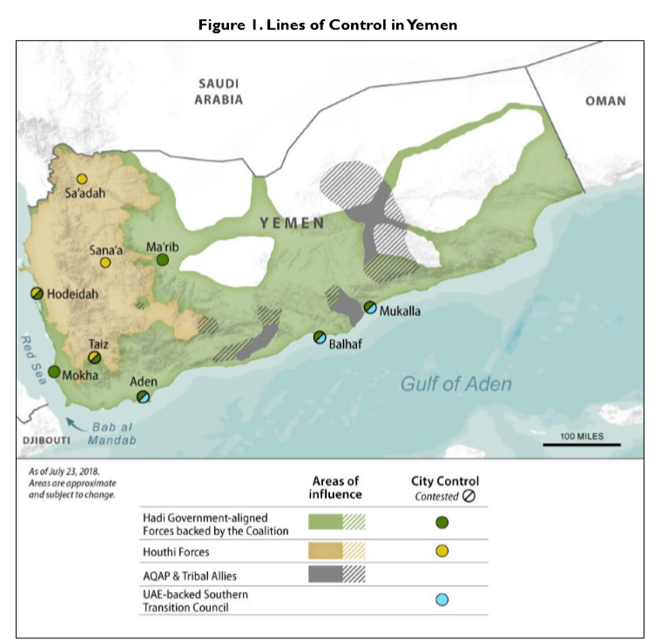

    - A report by the monitoring group Armed Conflict Location and Event Data (ACLED), dated October 2018, provided a map showing the reported activity of Al Qaeda in the Arabian Peninsula (AQAP) in 2016-2018:
Map showing reported activity of Al Qaeda in the Arabian Peninsula (AQAP), 2016-2018
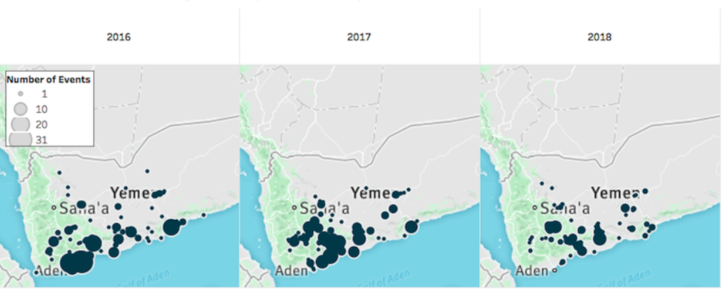
Back to Contents

Level of violence and number of casualties
    - Using data from the Armed Conflict Location and Event Data (ACLED), the Austrian Centre for Country of Origin and Asylum Research and Documentation (ACCORD) produced the following graph showing casualties from September 2016 to September 2018. Note that these show all casualties, not only civilians, although it puts the level of violence into perspective:
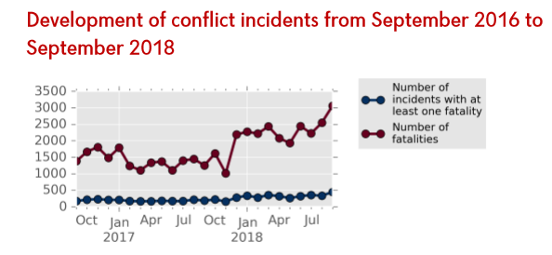
    - The UN OCHA, as at 1 October 2018, stated that the ‘ongoing conflict continues to inflict civilian casualties’ and that: ‘All parties to the conflict display a disregard for International Humanitarian Law (IHL) and International Human Rights Law and impede the principled and timely delivery of humanitarian assistance.’
    - The UN High Commissioner for Human Rights (UNHCR) noted that, from March 2015 to 9 August 2018, there have been 17,062 civilian casualties (6592 dead; 10,470 injured). Most of these casualties (10,471, or 61%) have been the result of Saudi air-strikes.
    - The 2018 HRP explained that ‘an average of 60 people have been killed or injured every day in the past two and a half years. Given that only 50 per cent of health facilities remain functional, and acknowledging the limited reporting capacity across the country, this number is significantly underreported.’
    - A briefing by Save the Children noted: ‘According to monitoring group ACLED (Armed Conflict Location and Event Data), Hodeidah accounted for 51 per cent of all civilian casualties in Yemen between June and August this year. During that three-month period there were at least 349 civilian deaths, with a national total of 685 civilians killed.’
    - In November 2018, the monitoring group ACLED provided a map showing civilian fatalities across the country (ACLED estimated that over 6000 civilians were killed from 2016-2018, with the overall number killed during the war nearly 60,000):
Map showing reported civilian casualties in Yemen, November 2018
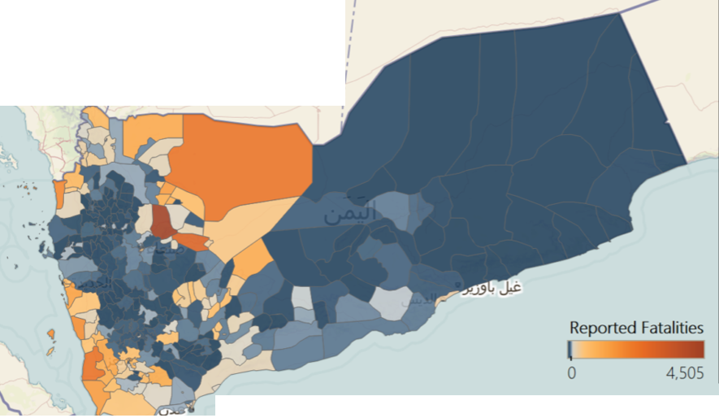
    - ACLED explained this map as follows: ‘Comparatively more fatalities occur along the southwest coast and Yemen’s northwest border with Saudi Arabia, and a majority of fatalities take place during events between state forces. However, an examination of the more than 6,000 fatalities resulting from events involving civilians underscores the fact that fatalities do not look the same across the country.’
    - ACLED also produced a graph showing relative levels of civilian fatalities across regions:
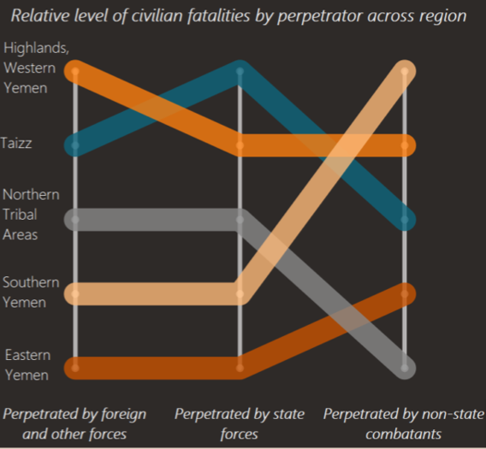
    - ACLED explained the graph as follows:
‘Above, each colored line represents a region of Yemen, and its position on each vertical line shows the relative level of civilian fatalities pepetrated [sic] by each type of actor. The Highlands (orange) and Eastern Yemen (red) – generally the most and least violent areas of the country, respectively – rank consistently in civilian fatality levels across all categories, shown by the relatively flat slopes of their lines. The stakest [sic] differences are between Northern (gray) and Southern Yemen (yellow); these high-conflict area respectively have thw [sic] lowest and highest level of civilian fatalities pepetrated by non-state actors, indicating the regions’ different actor landscapes.’
Back to Contents

Vulnerable groups
    - The 2018 HRP noted: ‘Half of the Yemeni population live in areas directly affected by conflict, many of whom are suffering from the deliberate targeting of civilians and civilian infrastructure, and other apparent violations of International Humanitarian Law (IHL).’
    - The 2018 HRP further noted: ‘The scope and complexity of the crisis in Yemen are impacting population groups differently, with some at greater risk than others. Within the total 22.2 million people in need, the most vulnerable can often be found among people affected by displacement, women, children, minorities, and refugees and migrants.’
Back to Contents

Freedom of movement
    - The USSD’s 2017 report stated: ‘The law provides for freedom of internal movement, foreign travel, emigration, and repatriation.’ However, it also stated: ‘All parties to the conflict routinely imposed severe restrictions on movements of people, goods, and humanitarian assistance’ and:
‘Rebel forces, resistance forces, security forces, and tribesmen maintained checkpoints on major roads. In many regions, especially in areas outside effective central security control, armed tribesmen frequently restricted freedom of movement, operating their own checkpoints, sometimes with military or other security officials, and often subjected travelers to physical harassment, extortion, theft, or short-term kidnappings for ransom…’
See also: Humanitarian access
    - The source also stated:
‘Social discrimination severely restricted women’s freedom of movement. Women in general did not enjoy full freedom of movement, although restrictions varied by location. Some observers reported increased restrictions on women in conservative locations, such as Safadi. Oxfam reported that men at checkpoints increasingly insisted on adherence to the “mahram” system, the cultural obligation of women to be accompanied by male relatives in public, in areas controlled by radical Islamic groups, such as AQAP…
‘Local observers reported that Yemenis from Houthi-controlled areas faced increasing discrimination and difficulties when traveling in southern Yemen.’
Back to Contents

Terms of Reference
- Background to the conflict
- Key actors
- Humanitarian situation
- Numbers who need humanitarian assistance
- Food security
- Water, sanitation and hygiene (WASH)
- Healthcare
- Education
- Impact on the economy
- Impact on daily life
- Humanitarian support
- Humanitarian access
- Internally Displaced Persons (IDPs)
- Returnees
- Security situation
- Key developments
- Nature of violence
- Control of territory
- Level of violence
- Numbers of casualties
- Vulnerable groups
- Freedom of movement

Bibliography
Sources cited
Al Jazeera, ‘Battle for Hodeidah: More than 40 Houthis killed in 24 hours’, 11 November 2018, https://www.aljazeera.com/news/2018/11/battle-hodeidah-40-houthis-killed-24-hours-181111064016259.html. Last accessed: 23 November 2018
Austrian Centre for Country of Origin and Asylum Research and Documentation (ACCORD),
‘Exposing (in)stability: the UAE’s role in Yemen and the Horn of Africa’, 9 October 2018, https://www.acleddata.com/2018/10/10/exporting-instability- the-uaes-role-in-yemen-and-the-horn-of-africa/. Last accessed: 23 November 2018
Yemen, Third Quarter 2018, Update on incidents according to the Armed Conflict Location & Event Data Project (ACLED), 12 November 2018, available at: https://www.ecoi.net/en/file/local/1450178/‌1226_‌1542095133_2018q3yemen- en.pdf. Last accessed: 23 November 2018
Armed Conflict Location and Event Data Project (ACLED), Fatalities in the Yemen conflict, 8 November 2018, https://www.acleddata.com/2018/11/08/fatalities-in-the-yemen-conflict/. Last accessed: 23 November 2018
BBC News,
‘Ali Abdullah Saleh, Yemen’s dominant force’, 4 December 2017, https://www.bbc‌.co.uk/news/world-middle-east-10984704. Last accessed: 12 October 2018
‘Yemen crisis: Who is fighting whom?, updated 30 January 2018, https://www.bbc.‌co.uk/news/world-middle-east-29319423. Last accessed: 12 October 2018
‘Yemen profile – Timeline’, updated 24 April 2018, http://www.bbc.co.uk/‌news/world-middle-east-14704951. Last accessed: 1 October 2018
(US) Central Intelligence Agency (CIA), The World Factbook, People and society, updated 26 September 2018, https://www.cia.gov/library/publications/the-world-factbook/geos/ym.html. Last accessed: 1 October 2018
Congressional Research Service (CRS), Yemen: Civil War and Regional Intervention, updated 24 August 2018, https://fas.org/sgp/crs/mideast/R43960.pdf. Last accessed: 9 October 2018
Famine Early Warning Systems Network (Fews Net) – Yemen, September 2018, http://fews.net/east-africa/yemen. Last accessed: 23 November 2018
UK Home Office, Proscribed Terrorist Organisations, https://assets.publishing.service.gov.uk/government/uploads/system/uploads/attachment_data/file/670599/20171222_Proscription.pdf. Last accessed: 6 November 2018
House of Commons Library, Briefing Paper Number CBP 8433, Yemen update autumn 2018, 31 October 2018, http://researchbriefings.files.parliament.uk/‌documents/CBP-8433/CBP-8433.pdf. Last accessed: 8 November 2018
Human Rights Watch (HRW), World Report 2018 – Yemen, January 2018, https://www.hrw.org/world-report/2018/country-chapters/yemen. Last accessed: 6 November 2018
Immigration and Refugee Board of Canada (IRBC), National Documentation Packages – Yemen, updated 31 October 2018, https://www.irb-cisr.gc.ca/en/country-information/ndp/Pages/index.aspx?pid=9465. Last accessed: 23 November 2018
International Organisation for Migration (IOM), Displacement Tracking Matrix (DTM) Yemen, https://www.globaldtm.info/yemen/ Las accessed: 10 October 2018
Jane’s By IHS Markit,
Yemen, Non-state armed groups, 6 December 2017. Subscription only. Last accessed: 12 October 2018
Yemen – Executive Summary, updated 11 October 2018. Subscription required. Last accessed: 12 October 2018
OnTheWorldMap, Large detailed map of Yemen with cities and towns, undated, http://ontheworldmap.com/yemen/large-detailed-map-of-yemen-with-cities-and-towns.html. Last accessed: 7 November 2018
Southern Movement Al-Hirak, http://www.southernhirak.org/p/abouthirak.html. Last accessed: 6 November 2018
UN High Commissioner for Human Rights (UNHCHR), ‘Press briefing notes on Yemen civilian casualties’, 10 August 2018, http://ye.one.un.org/content/unct/yemen/en/home/news-centre/news/press-briefing-notes-yemen-civilian-casualties-august-2018.html. Accessed: 12 October 2018
UN Human Rights Council, Annual report of the United Nations High Commissioner for Human Rights and reports of the Office of the High Commissioner and the Secretary-General, Situation of human rights in Yemen, including violations and abuses since September 2014, 17 August 2018, available at: https://reliefweb.int/sites/reliefweb.int/files/resources/A_HRC_39_43_EN.pdf. Last accessed: 7 November 2018
UN Office for the Coordination of Humanitarian Affairs (OCHA),
About OCHA Yemen, undated, http://www.unocha.org/yemen/about- ocha-yemen. Last accessed: 1 October 2018
Current Emergencies, undated, https://www.unocha.org/where-we- work/current-emergencies. Last accessed: 1 October 2018
Humanitarian Response Plan, January – December 2018, Yemen, January 2018, https://www.humanitarianresponse.info/en/operations/‌yemen/document/yemen-humanitarian-response-plan-january-december-2018. Last accessed: 10 October 2018
‘”A clear and present danger of an imminent and great big famine is engulfing Yemen” – UN Humanitarian Chief’, 23 October 2018, https://www.unocha.org‌/story/clear-and-present-danger-imminent-and-great-big-famine-engulfing-yemen-un-humanitarian-chief. Last accessed: 8 November 2018
Yemen, Organisations Monthly Presence, September 2018, available at: https://reliefweb.int/sites/reliefweb.int/files/resources/ochayemen_3W_presen ce_monthly_product_September_2018.pdf. Last accessed: 23 November 2018
US State Department (USSD), Country Reports on Human Rights Practices for 2017 – Yemen, March 2018, https://www.state.gov/documents/organization/277517.pdf. Last accessed: 7 November 2018
World Population Review, Yemen population 2018, http://worldpopulationreview.com/countries/yemen-population/. Last accessed: 23 November 2018
Back to Contents
Sources consulted but not cited
Civilian Impact Monitoring Project, Civilian Impact Monitoring Report, August – October 2018, https://reliefweb.int/sites/reliefweb.int/files/resources/civilian_impact_monitoring_report_august_-_october_2018.pdf. Last accessed: 16 December 2018
Critical Threats, Yemen Situation Report, 28 June 2018, https://www.criticalthreats.org/briefs/yemen-situation-report/2018-yemen-crisis-situation-report-june-28. Last accessed: 8 November 2018
Freedom House, Freedom in the World 2018 – Yemen, January 2018, https://freedomhouse.org/report/freedom-world/2018/yemen. Last accessed: 8 November 2018
International Crisis Group (ICG), ‘Yemen: Averting a Destructive Battle for Hodeida’, 11 June 2018, https://www.crisisgroup.org/middle-east-north-africa/gulf-and-arabian-peninsula/yemen/b59-yemen-averting-destructive-battle-hodeida. Last accessed: 8 November 2018
The Jamestown Foundation, ‘What the battle for Hodeida Means for Yemen and the Region’, 10 August 2018, https://jamestown.org/program/what-the-battle-for-hodeidah-means-for-yemen-and-the-region/. Last accessed: 8 November 2018
Medicins Sans Frontieres, Yemen, https://www.msf.org.uk/country/yemen-0?utm_expid=.wYQI1vs5R6mZhXhB50iPKg.1&utm_referrer=https%3A%2F%2Fwww.google.com%2F. Last accessed: 8 November 2018
Save the Children, ‘Civilian casualties soar in Hodeidah since devastating offensive that began in June’, 24 September 2018, https://www.savethechildren.net/article/civilian-casualties-soar-hodeidah-devastating-offensive-began-june. Last accessed: 8 November 2018
Terrorism Monitor, quoted in The Jamestown Foundation,
‘The UAE’s Divisive Strategy in Yemen’, Volume 16: Issue 8, 23 April 2018, https://jamestown.org/program/the-uaes-divisive-strategy-in-yemen/. Last accessed: 8 November 2018
‘‘Security Belt’: The UAE’s Tribal Counterterrorism Strategy in Yemen’, Volume: 16 Issue 12, 14 June 2018, https://jamestown.org/program/security- belt-the-uaes-tribal-counterterrorism-strategy-in-yemen/ Last accessed: 8 November 2018
UN Office for the Coordination of Humanitarian Affairs (OCHA),
Yemen: Humanitarian Needs Overview (HNO), 4 December 2017, https://www.humanitarianresponse.info/en/operations/yemen/document/yeme n-2018-humanitarian-needs-overview. Last accessed: 8 November 2018
Yemen page (various resources), https://reliefweb.int/updates?sort=latest&search=%28primary_country.iso3%3 A%22yem%22%29%20AND%20ocha_product%3A%22Thematic%20Map%2 2%20AND%20source%3A%22UN%20Office%20for%20the%20Coordination %20of%20Humanitarian%20Affairs%22#content. Last accessed: 23 November 2018

Version control and contacts
Clearance
Below is information on when this note was cleared:
- version 4.0
- valid from 4 January 2019

Changes from last version of this note
Updated country information and assessment

Back to Contents

CIA, The World Factbook, updated 26 September 2018, url
World Population Review, Yemen population 2018, url
World Population Review, Yemen population 2018, url
Jane’s By IHS Markit, Yemen, 11 October 2018 (Executive Summary). Subscription required.
IRBC, National Documentation Packages – Yemen, url
BBC News, Yemen timeline, updated 24 April 2018, url
CRS, Yemen, August 2018 (p.1), url
CRS, Yemen, August 2018 (p.1), url
BBC News, ‘Yemen crisis’, updated 30 January 2018, url
CRS, Yemen, August 2018 (p.1), url
CRS, Yemen, August 2018 (p.9), url
BBC News, ‘Yemen crisis’, updated 30 January 2018, url
BBC News, ‘Yemen crisis’, updated 30 January 2018, url
BBC News, ‘Yemen crisis’, updated 30 January 2018, url
BBC News, ‘Yemen crisis’, updated 30 January 2018, url
BBC News, ‘Ali Abdullah Saleh’ profile, 4 December 2017, url
BBC News, ‘Yemen crisis’, updated 30 January 2018, url
Jane’s, Yemen, Non-state armed groups, 6 December 2017. Subscription only.
BBC News, ‘Yemen crisis’, updated 30 January 2018, url
Jane’s, Yemen, Non-state armed groups, 6 December 2017. Subscription only.
BBC News, ‘Yemen crisis’, updated 30 January 2018, url
Southern Movement Al-Hirak, url
BBC News, ‘Yemen crisis’, updated 30 January 2018, url
Home Office, Proscribed Terrorist Organisations, url
CRS, Yemen, August 2018 (p.1), url
BBC News, ‘Yemen crisis’, updated 30 January 2018, url
CRS, Yemen, August 2018 (p.14), url
BBC News, ‘Yemen crisis’, updated 30 January 2018, url
ACLED, ‘Exposing (in)stability’, 9 October 2018, url
UN Human Rights Council, Situation of human rights in Yemen, August 2018 (Annex I), url
UN OCHA, Current Emergencies, undated, url
OCHA, Yemen, undated, url
OCHA, Yemen, undated, url
OCHA, 2018 HRP – Yemen, January 2018 (p. 4), url
OCHA, Yemen, undated, url
OCHA, 2018 HRP – Yemen, January 2018 (p. 9), url
OCHA, 2018 HRP – Yemen, January 2018 (pp. 7, 9), url
CRS, Yemen, August 2018 (p. 19), url
Fews Net – Yemen, September 2018, url
OCHA, ‘”A clear and present danger”’, 23 October 2018, url
OCHA, 2018 HRP – Yemen, January 2018 (p. 8), url
CRS, Yemen, August 2018 (pp. 19-20), url
OCHA, 2018 HRP – Yemen, January 2018 (p. 22), url
OCHA, 2018 HRP – Yemen, January 2018 (pp. 5, 8), url
OCHA, 2018 HRP – Yemen, January 2018 (p. 5), url
OCHA, 2018 HRP – Yemen, January 2018 (p. 9), url
OCHA, 2018 HRP – Yemen, January 2018 (p. 6), url
OCHA, 2018 HRP – Yemen, January 2018 (p. 6), url
OCHA, 2018 HRP – Yemen, January 2018 (p. 6), url
OCHA, 2018 HRP – Yemen, January 2018 (pp. 6-7), url
OCHA, Yemen, undated, url
OCHA, 2018 HRP – Yemen, January 2018 (p. 5), url
OCHA, 2018 HRP – Yemen, January 2018 (p. 9), url
OCHA, 2018 HRP – Yemen, January 2018 (pp. 3, 24), url
OCHA, 2018 HRP – Yemen, January 2018 (pp.3, 23), url
OCHA, Yemen, undated, url
OCHA, Yemen, undated, url
OCHA, 2018 HRP – Yemen, January 2018 (p.15), url
OCHA, 2018 HRP – Yemen, January 2018 (pp.19-20), url
OCHA, 2018 HRP – Yemen, January 2018 (p. 25), url
OCHA, Yemen Organisational Monthly Presence, September 2018 (p. 1), url
HoC Library, Yemen update autumn 2018, 31 October 2018 (p. 4), url
IOM, DTM Yemen, url (accessed 10 October 2018)
IOM, DTM Yemen, url (accessed 10 October 2018)
Aljazeera, ‘Battle for Hodeidah’, 11 November 2018, url
IOM, DTM Yemen, url (accessed 10 October 2018)
OCHA, 2018 HRP – Yemen, January 2018 (p. 62), url
OCHA, 2018 HRP – Yemen, January 2018 (p. 42), url
OnTheWorldMap, map of Yemen, url
CRS, Yemen, August 2018 (pp. 2-19), url
Jane’s By IHS Markit, Yemen, 11 October 2018 (Executive Summary). Subscription required.
CRS, Yemen, August 2018 (pp. 2-19), url
Aljazeera, ‘Battle for Hodeidah’, 11 November 2018, url
UN Human Rights Council, Situation of human rights in Yemen, August 2018 (para 18), url
HoC Library, Yemen update autumn 2018, 31 October 2018 (p. 3), url
UN Human Rights Council, Situation of human rights in Yemen, August 2018 (para 41), url
HRW, World Report 2018, January 2018, url
USSD, 2017 Yemen human rights report, March 2018 (section 1g), url
UN Human Rights Council, Situation of human rights in Yemen, August 2018 (para 28), url
UN Human Rights Council, Situation of human rights in Yemen, August 2018 (para 38), url
UN Human Rights Council, Situation of human rights in Yemen, August 2018 (para 40), url
UN Human Rights Council, Situation of human rights in Yemen, August 2018 (para 45), url
UN Human Rights Council, Situation of human rights in Yemen, August 2018 (para 20), url
UN Human Rights Council, Situation of human rights in Yemen, August 2018 (para 23), url
USSD, 2017 Yemen human rights report, March 2018 (Executive Summary), url
CRS, Yemen, August 2018 (p. 3), url
ACLED, ‘Exposing (in)stability’, 9 October 2018, url
ACCORD, Third Quarter 2018, Yemen, update on incidents (ACLED data), 12 November 2018, url
OCHA, Yemen, undated, url
UNHCR, Yemen civilian casualties, 10 August 2018, url
OCHA, 2018 HRP – Yemen, January 2018 (p. 5), url
Save the Children, ‘Civilian casualties soar in Hodeidah’, 24 September 2018, url
ACLED, Fatalities in the Yemen conflict, 8 November 2018, url
ACLED, Fatalities in the Yemen conflict, 8 November 2018, url
ACLED, Fatalities in the Yemen conflict, 8 November 2018, url
OCHA, 2018 HRP – Yemen, January 2018 (p. 5), url
OCHA, 2018 HRP – Yemen, January 2018 (p. 16), url
USSD, 2017 Yemen human rights report, March 2018 (Sections 1g, 2d), url
USSD, 2017 Yemen human rights report, March 2018 (Section 2d), url

