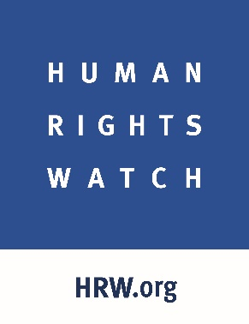
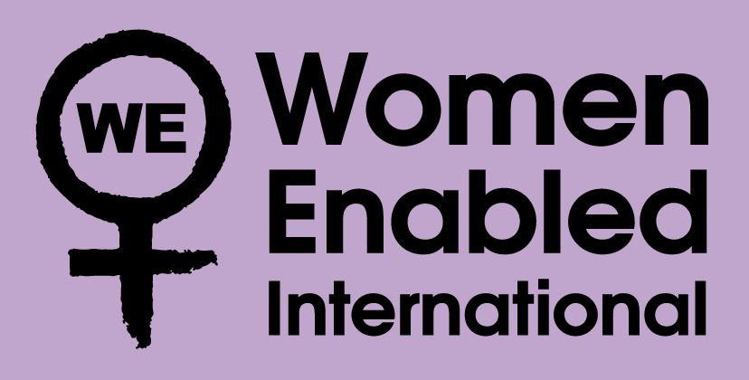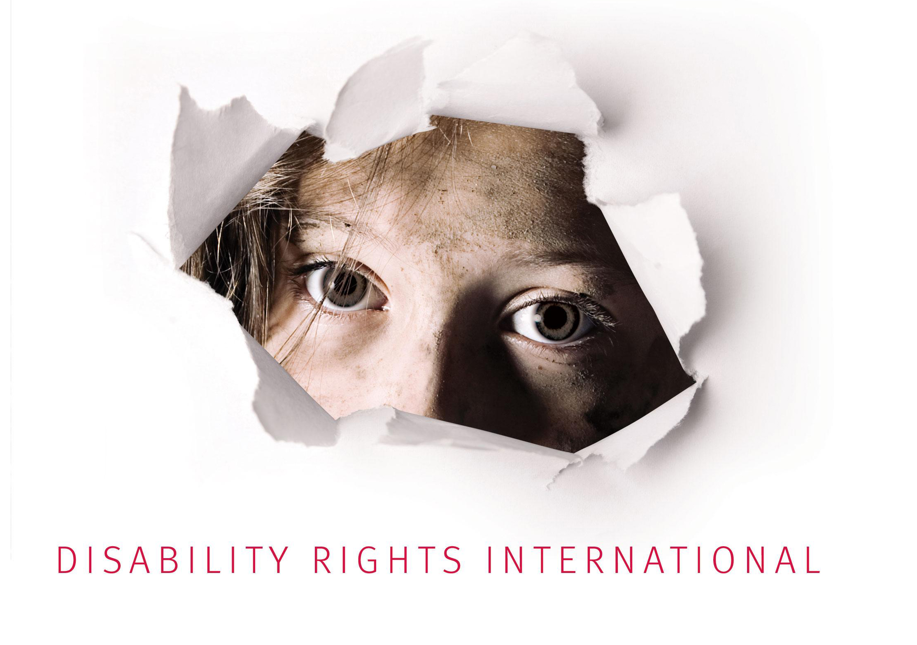

Disability Rights International, Human Rights Watch, and Women Enabled International Submission to the United Nations Committee on the Elimination of Discrimination against Women:

Review of Serbia
January 2019

Introduction
This submission to the United Nations Committee on the Elimination of Discrimination against Women (“CEDAW Committee”), ahead of its review of Serbia, highlights areas of concern that Disability Rights International, Human Rights Watch, and Women Enabled International hope will inform the CEDAW Committee’s consideration of the Serbian government’s compliance with the Convention on the Elimination of All Forms of Discrimination against Women (“CEDAW”). This submission focuses on violations of sexual and reproductive health and rights, particularly forced and coerced reproductive health interventions performed on women with disabilities and violence in Serbian institutions, in violation of articles 1, 2, 12, and 23 of CEDAW.
This submission provides a detailed account of violations of sexual and reproductive rights, particularly forced reproductive health interventions, in Serbian institutions, documented by Human Rights Watch in 2015 and in follow-up interviews in 2018-2019 and Disability Rights International’s Belgrade office (MDRI-S) in 2016 and 2017. It also outlines relevant human rights standards, including recent concluding observations on Serbia from CEDAW and other mechanisms. The submission concludes with suggested questions for the CEDAW Committee’s interactive dialogue with Serbia, as well as proposed recommendations for Serbia in its concluding observations.

Forced and Coerced Reproductive Health Interventions on Women with Disabilities in Serbian Institutions
This section draws from research conducted in 2015 in Serbia, published in a 2016 report by Human Rights Watch, It is My Dream to Leave This Place: Children with Disabilities in Serbian Institutions, and follow-up interviews carried out in December 2018 and January 2019 with six local and international non-governmental organizations, including two organizations of persons with disabilities (DPOs). It also draws from comprehensive research and documented violence against girls and women with disabilities in residential institutions in 2016-2017 in Serbia conducted by MDRI-S, published in the report Here walls have ears, too: Testimonials of women with mental disabilities about gender-based violence in residential institutions; and in the study Violence against women with mental disabilities in residential institutions.
In its 2015 report, based on 118 in-depth interviews with children and adults with disabilities and their families, disability advocates, staff of institutions, and government officials, and visits to five institutions for people with disabilities, Human Rights Watch documented that some women living in these institutions were subjected to invasive medical interventions to prevent or terminate pregnancy and for cancer screening, without their consent. These included forced insertion of intrauterine devices (IUDs), uninformed administration of contraceptive pills, forced or coerced termination of pregnancy, and non-consensual administration of pap smear tests (Papanicolaou test—a screening procedure for cervical cancer).
During 2016 and 2017, MDRI interviewed 13 women with disabilities and conducted group interviews with 30 women who confirmed they were subjected to non-consensual sexual and reproductive medical interventions in the institutions where they lived. Women were given contraceptive pills with their other medication or had IUDs inserted without their knowledge or consent and without receiving prior information on the interventions and their effects. All women interviewed by MDRI were between 25 and 60 years old, and either had a history of institutionalization or lived in an institution at the time of the interview. Some of these women had spent about 20 years on average in various residential institutions.
I.1. Reproductive health interventions without consent
The medical staff in three institutions that Human Rights Watch visited in 2015 acknowledged carrying out reproductive health interventions without the free and informed consent of the women but said the women’s guardians had given consent. In violation of international human rights standards, current Serbian law states that health care providers do not need to obtain the consent for a medical procedure of a person who has been deprived of legal capacity and placed under guardianship.
Staff in one of the institutions visited by MDRI in 2016, similarly said, “We seek consent from their guardians. Whatever we do, we cannot do it without the consent of the guardian.”
Under Serbia’s Family Law, an adult who has an intellectual or physical disability can be deprived of his or her legal capacity and placed under full or partial guardianship. In this case, legal guardians—often the Center for Social Work, a state agency—make all or most decisions for them, including with regards to medical care and procedures. Serbia’s Law on the Rights of Patients further provides that medical interventions can be performed on people deprived of legal capacity solely on the basis of a guardian’s consent. While this law requires that a health care professional involve the patient stripped of legal capacity in decision-making, it does not define what “involvement” entails. Based on interviews with medical staff in institutions in Serbia in 2015 and follow-up interviews with six NGOs in 2018 who provide support and services to women with disabilities and/or are mandated to assess conditions inside institutions for people with disabilities, Human Rights Watch found that little to no effort is made to involve women with disabilities in decisions about their reproductive health.
For example, when Human Rights Watch in 2015 asked the doctor in Sremčica Home for children and adults with disabilities if there had any efforts to get the informed consent of a woman whose pregnancy was terminated in the institution in 2014, the doctor said that her consent was not required because her sister—who is also the woman’s guardian—gave consent. In a meeting with Human Rights Watch in October 2017, the Serbian government confirmed they do not require consent of women deprived of legal capacity, nor do they involve these women in decision-making before undertaking any medical interventions.
In 2015, Human Rights Watch documented several examples of forced or coerced reproductive health interventions in Serbian institutions. For instance, doctors in three institutions explained that they would put women under general anesthesia if they did not consent to a medical intervention. “When female residents don’t cooperate, for example, during a sonogram or the administration of a Pap smear test, you have to put them under anesthesia to conduct the intervention,” said a doctor in one of the institutions visited by Human Rights Watch. Another doctor told Human Rights Watch that sexual relationships are not prohibited in the institutions but that the reproduction is controlled, “The last time we had someone pregnant was in 1997.” Some of the women are forced to take contraceptives, while others have contraceptive devices inserted.
I.1.a. Non-consensual administration of contraceptives
One form of this control is through non-consensual administration of contraceptives. The doctor at the Sremčica Home for children and adults with disabilities told Human Rights Watch that 20 women living in the institution have intrauterine devices for birth control, all of which were placed during procedures with the guardians’ consent but not that of the women themselves. In follow-up interviews in December 2018, Disability Rights International and another local NGO in Serbia that provides services to women with disabilities told Human Rights Watch that birth control pills are often mixed in daily therapy medication and given to women without their knowledge.
“As soon as you get to the institution, they put IUD in you. And that’s it. Those who get pregnant, need to have abortion” a woman living in one of the institutions visited by MDRI said. An employee told MDRI, “They [women] are not generally asked. Their guardians are asked about the form of contraception at the recommendation of a gynecologist. Younger girls are given pills and older women are given intrauterine device.”
In January 2019, Fem Platz, a local NGO working on the promotion of human rights of women and girls belonging to marginalized groups, including women with disabilities, reported to Human Rights Watch that contraceptives are administered sometimes even without consent from guardians under the institutions’ justification that it helps with hormonal issues and that the institutions must do it because “women behave promiscuously.” Based on Fem Platz’s observations during its visits to institutions, it appears that staff inform guardians after the contraception has already been administered. The situation is similar when it comes to informing women about inserting intrauterine devices. “Usually women with disabilities are taken in for a general check up with a doctor and then put under general anesthesia,” a Fem Platz representative said. “Once they are awake, they do not know which medical treatments they have undergone or what their guardians had agreed to.”
In some of the institutions visited by MDRI in 2016 and 2017, staff similarly explained that a guardian’s consent is required for the insertion of IUDs, but not for administrating contraceptive pills because they are regarded as part of the therapy, and guardians are only informed about it. One woman told MDRI, “They put intrauterine device in me. They put it, they did not ask anything. They just asked me when they finished if I was OK, whether I want to vomit.”
I.1.b. Forced abortions
Forced and coerced abortions also occur in Serbian institutions. In addition to the 2014 case cited above, a local non-governmental organization, which provides services and support to women with disabilities who live in institutions, informed Human Rights Watch in 2018 about a case of a woman who was subjected to a non-consensual abortion when she was four months pregnant. The woman lived with her partner in an institution and, according to the NGO, had her pregnancy terminated on her doctor’s recommendation and with the consent of her legal guardian. The woman told an NGO representative that she wanted to keep the baby but was advised by her doctor and her sister to abort so she eventually consented. The doctor told her that the baby may have health issues because she was taking strong medication during pregnancy. It is not clear if there were legitimate risks to the baby’s health and whether the woman was offered any information about continuing the pregnancy so she could make an informed decision.
The organization Fem Platz told Human Rights Watch that institution staff coerce women who have legal capacity to terminate their pregnancies, including by threatening to kick them out of institutions if they refuse to terminate. Currently, there is inadequate housing and support to live in the community for many people with disabilities in Serbia, which means that these pregnant women are placed in the situation of deciding between continuing with a pregnancy or having a place to live.
Furthermore, Disability Rights International documented in 2017 that the state immediately removes babies born to women with disabilities living in institutions and places them in orphanages, foster care or with relatives. The information was received both from staff and residents in institutions and Fem Platz confirmed these findings.
Sterilization is prohibited by the Law on Protection of Persons with Mental Disabilities, but it is not criminalized in the criminal code. While there has been no documentation of regular or widespread forced sterilization of women with disabilities in Serbian institutions, during the research conducted in 2016 and 2017, MDRI spoke with one woman who was recently sterilized and no one asked her for consent. This was confirmed by staff who work in the institution.
I.2. Violence and lack of reporting mechanisms
Equally critical is the partner violence that women with intellectual disabilities experience in residential institutions by partners who live in the same institutions. During visits to institutions and through conversations with women and staff, MDRI documented that violence against women is not reported or adequately recognized by the institutions’ staff.
While the recently-adopted Law on Protection from Domestic Violence is important progress, women from vulnerable and disadvantaged groups are not able to benefit from the practical implementation of this law. Their ongoing institutionalization and the guardianship regime deny women with disabilities in institutions of the possibility of using shelters and similar forms of protection for women victims of violence.
While there are protocols in place on how to prevent and respond to violence in social-care institutions in Serbia—which include an internal team for prevention of violence—in 2016 and 2017 MDRI documented that the policies in place are not being implemented in practice. Names of the members of the team and their phone numbers are not put in visible places in the institution, clients are not informed about the existence of the team, and the number of complaints that have been filed is negligible. This leaves women without any complaint and appeal mechanism and without any possibilities for redress and adequate support.

CEDAW and Other International Human Rights Mechanisms
II.1 Previous relevant human rights recommendations to Serbia
In its 2013 concluding observations, the CEDAW Committee recommended that Serbia “take the measures necessary to ensure the full and effective realization of the right of women with disabilities to sexual and reproductive health by eliminating prejudices, training medical personnel and increasing the number of health facilities equipped to address their needs.” Furthermore, in its 2016 review of Serbia, the Committee on the Rights of Persons with Disabilities (“CRPD Committee”) recommended that Serbia investigate and prohibit “all medical interventions without the prior consent of persons with disabilities and provide sufficient remedies and compensation to those subjected to such procedures.” The CRPD Committee also expressed concern that persons with disabilities are subjected to contraceptive treatments, abortions and sterilization against their will, and urged Serbia to “take all necessary measures to ensure their right to free, prior and informed consent for any kind of treatment that may affect a person with a disability, regardless of her/his legal capacity.” The CRPD Committee recommended that “support for decision making regimes for persons with disabilities is provided when necessary.”
Our recent interviews and ongoing monitoring indicate/demonstrate that Serbia has not taken adequate measures to halt these abusive practices despite the CEDAW and CRPD Committees’ recommendations and the specific request by the CRPD Committee that measures be taken within 12 months (from April 2016) to prohibit “medical interventions without the prior consent of persons with disabilities concerned.”
In your deliberations, we hope you draw on the previous CEDAW Committee positions on these issues. The CEDAW Committee has consistently found that forced and coerced reproductive health interventions violate the rights of women and girls, particularly women and girls with disabilities, in several respects. In particular, the CEDAW Committee has found that forced or coerced reproductive health interventions violate Articles 12 and 23 of CEDAW. The CEDAW Committee has interpreted the right to health to include a right to acceptable health care, including health care based on informed consent of the woman herself. Indeed, in its General Recommendation No. 24 on women and health, the CEDAW Committee found that “Women have the right to be fully informed, by properly trained personnel, of their options in agreeing to treatment or research, including likely benefits and potential adverse effects of proposed procedures and available alternatives.”
The CEDAW Committee has frequently applied this standard specifically to reproductive health interventions. For instance, in the case of A.S. v. Hungary, following the sterilization of a Roma woman without her consent during an emergency caesarean section, the CEDAW Committee found that, in allowing the procedure under these circumstances, Hungary had violated several of A.S.’s rights, including her right to information to make an informed choice, the right to informed consent implied by the right to acceptable health care, and the right to decide on the number and spacing of her children.
Furthermore, the CEDAW Committee has found that forced or coerced reproductive health interventions violate rights implicit in CEDAW. For instance, it has found that forced or coerced reproductive health interventions are forms of gender-based violence. The CEDAW Committee also recognized in its General Recommendation No. 35 on gender-based violence that some sexual and reproductive rights violations, including forced reproductive health interventions, may amount to torture or ill-treatment. Although CEDAW does not contain specific provisions outlining women’s rights to be free from gender-based violence or from torture or ill-treatment, the CEDAW Committee has interpreted Articles 1 and 2 of CEDAW to protect rights that are not otherwise enumerated in the treaty, when State policy, action, or inaction has a discriminatory impact on women’s exercise of those rights. These standards have also been reinforced by other treaty monitoring bodies, including the CRPD Committee in its General Comment No. 3 on women and girls with disabilities, which notes that any medical procedure performed without free and informed consent is a form of violence and may constitute torture or ill-treatment.
We also hope that, in its recommendations to Serbia, the CEDAW Committee will draw from its previous recommendations to states on forced reproductive health interventions, including:
- Repeal legal provisions and amend policies that allow medical interventions on women with disabilities without their consent and adopt positive legislation that protects women with disabilities from these abuses;
- Repeal legal provisions that prevent or deter women from reporting abuse, including guardianship laws that deprive women of legal capacity and may limit their ability to testify in court;
- Take steps to ensure that consent for reproductive health interventions comes from the woman or girl herself, even if that woman is deprived of legal capacity, and provide support to women to decide whether they want to give consent for these interventions;
- Provide accessible information for women with disabilities on legal and social resources available to victims of abuse;
- Provide “mandatory, recurrent and effective capacity-building, education and training” on preventing and addressing all forms of gender-based violence, including for “social and welfare personnel, including those working with women in institutions such as residential care homes;”
- Monitor facilities to ensure that forced reproductive health interventions are not occurring; and
- Ensure effective investigations of allegations of forced reproductive health interventions, including in institutions, and provide appropriate sanctions when these rights are violated.

Conclusions and Recommendations
In the upcoming review, Disability Rights International, Human Rights Watch, and Women Enabled International urge the CEDAW Committee to question the government of Serbia about measures it has taken to ensure that all women, including women with disabilities, enjoy their right to medical treatment on the basis of free and informed consent, as well as their rights to sexual and reproductive health, to decide on the number and spacing of children, to legal capacity, to be free from gender-based violence, and to be free from torture or ill-treatment including:
- What measures have been adopted to ensure that health care services, including all sexual and reproductive health care services, are based on the free and informed consent of the person concerned? Is there an oversight mechanism to protect women with disabilities from forced medication and medical interventions to control their fertility and family planning?
- What mechanisms are in place to protect women with disabilities from abuse, exploitation and/or neglect in situations where their decisions, choices and preferences are substituted with those of their guardians?
- What steps has Serbia taken in order to build the confidence and skills of women with disabilities so that they can exercise their right to legal capacity?
- How many women with disabilities are currently living in an institution?
- How many women with disabilities who live in institutions are on contraceptive medication and/or have intrauterine devices inserted on the basis of a guardian’s consent?
- How many women with disabilities have had their pregnancy terminated on the basis of a guardian’s consent in the last five years?
- How many women with disabilities have been separated from their children on the basis of their disability and/or have had their parental rights terminated?
- What is the legal framework for the use of forced general anesthesia in non-emergency cases and without the consent of the individual concerned?
- How has the government been effectively monitoring whether women with disabilities have been subjected to sterilization without their consent?
- How does the recently-adopted Law on Protection from Domestic Violence also benefit at-risk groups such as women with disabilities? Are women with disabilities living in institutions able to access services and protections for victims of domestic abuse?
- How many women with disabilities are currently living in shelters for women victims of domestic violence?
- What safeguards, including any confidential complaint mechanism, exist for women with disabilities who live in institutions which would make it possible for them to report violence and abuse?
We also urge the CEDAW Committee to make the following recommendations to Serbia, in order to end abuse against women and girls with disabilities in institutions:
- While moving towards a system of non-institutional, community-based services and support for persons with disabilities:
  - Increase monitoring of social care institutions to ensure that reproductive health screenings and interventions are being performed only with the full free and informed consent of the woman involved;
  - Train all social, health, and welfare personnel on the rights of women with disabilities, including the right to informed consent to medical procedures, and on how to prevent and address abuses against this group.
- Repeal guardianship laws that allow third parties to make reproductive health decisions for women with disabilities. Replace this with a system of support, when needed and requested, to allow women with disabilities to make these decisions for themselves;
- Ensure access to legal remedies for women in institutions, including accessible information on sexual and reproductive health and rights and legal remedies, so that they can effectively pursue justice when their rights are violated; and
- Conduct effective investigations into allegations of forced or coerced reproductive health interventions in Serbian institutions, with adequate sanctions for perpetrators of these abuses.
We hope you will find the information in this submission useful and would welcome an opportunity to discuss them further with you. Thank you for your attention to our concerns, and with best wishes for a productive session.
If the CEDAW Committee has any questions or comments on this submission, please do not hesitate to contact Emina Cerimovic of Human Rights Watch at cerimoe@hrw.org, Amanda McRae of Women Enabled at a.mcrae@womenenabled.org, and Dragana Ciric at Disability Rights International at dciric@driadvocacy.org.

Human Rights Watch, It is My Dream to Leave This Place: Children with Disabilities in Serbian Institutions, June 8, 2016, https://www.hrw.org/report/2016/06/08/it-my-dream-leave-place/children-disabilities-serbian-institutions.
Developed as part of the project “Deinstitutionalize and End Violence against Women with Disabilities in Custodial Institutions” implemented by MDRI-S and supported by United Nations Trust Fund to End Violence against Women and Girls, 2016-2018 (results published in publication “Here walls have ears too: testimonials of women with mental disabilities about gender-based violence in residential institutions”, Biljana Janjic, Dragana Ciric Milovanovic, 2017, https://www.mdri-s.org/wp-content/uploads/2018/02/Publikacija-engleski.pdf); and study “Violence against women with mental disabilities in residential institutions,” Kosana Beker and Tijana Milosevic, 2017, available in Serbian https://www.mdri-s.org/wp-content/uploads/2018/01/Istrazivanje-knjizni-blok.pdf [accessed January 28, 2019].
Centre for the protection of infants, children, and youth “Zvečanska,” Home for children and persons with disabilities “Stamnica,” Home for children and youth with disabilities “Veternik,” Home for children with disabilities “Kolevka,” Centre for children and youth “Sremcčica”
Though the primary focus of the research conducted in 2015 was the violations of the rights of children and young people with disabilities in Serbia, Human Rights Watch also uncovered and documented violations of reproductive health rights of women living in the institutions. The research included 91 interviews with children and young people with disabilities, their families, civil society organizations, legal experts, the UNICEF, the Serbian Ombudsperson, the Commissioner for Equality, and government officials and visits to five large social welfare homes and three small group homes in Belgrade, Niš, and Aleksinac for children and young people with disabilities.
Biljana Janjic, Dragana Ciric Milovanovic, Here Walls Have Ears Too: Testimonials of Women with Mental Disabilities About Gender-based Violence in Residential Institutions, December 2017, Belgrade, page 44-46; http://www.mdri-s.org/wp-content/uploads/2018/02/Publikacija-engleski.pdf.
Kosana Beker and Tijana Milosevic, Violence against women with disabilities in residential institutions [In Serbian: Nasilje nad ženama sa invaliditetom u rezidencijalnim institucijama], December 2017, page 110, available in Serbian at http://www.mdri-s.org/wp-content/uploads/2018/01/Istrazivanje-knjizni-blok.pdf [accessed January 6, 2019].
Family Law, Official Gazette of the Republic of Serbia, No. 18/2005, 72/2011, 6/2015, Article 146.
Ibid.
Law on Rights of Patients, Official Gazette of the Republic of Serbia, No. 45/2013, Article 19.
Human Rights Watch interview with medical doctor in Stamnica Home for children and adults with disabilities, October 21, 2015; Human Rights Watch interview with medical doctor in the Institution for children and adults with disabilities in Veternik, October 20, 2015; Human Rights Watch interview with a medical doctor, Sremčica Home for children and adults with disabilities, November 16, 2015. The staff in all three institutions did not provide Human Rights Watch with the exact number of young women who were subjected to these treatments.
Ibid.
Ibid.
Human Rights Watch interview with Dragana Ciric Milovanovic, Director, Europe Regional Office, Disability Rights International, December 12, 2018; Human Rights Watch interview with an NGO in Serbia which prefers to stay unidentified, December 24, 2018.
Biljana Janjic, Dragana Ciric Milovanovic, Here walls have ears too: testimonials of women with mental disabilities about gender-based violence in residential institutions, 2017, p. 45; http://www.mdri-s.org/wp-content/uploads/2018/02/Publikacija-engleski.pdf
Human Rights Watch interview with Biljana Janic from Fem Platz, January 10, 2019.
“Here walls have ears too: testimonials of women with mental disabilities about gender-based violence in residential institutions”, Biljana Janjic, Dragana Ciric Milovanovic, 2017, p. 45; http://www.mdri-s.org/wp-content/uploads/2018/02/Publikacija-engleski.pdf
Human Rights Watch, It is My Dream to Leave This Place: Children with Disabilities in Serbian Institutions, June 8, 2016, https://www.hrw.org/report/2016/06/08/it-my-dream-leave-place/children-disabilities-serbian-institutions, page 20.
Mental Disability Rights Initiative (MDRI-S), Disability Rights International, Submission for country briefing on the Republic of Serbia to Human Rights Committee, February 2017, Belgrade., page 7, https://www.ecoi.net/en/document/1399334.html.
Law on Protection of Person with Mental Disabilities, Official Gazette of the Republic of Serbia, No. 45/2013, Article 56. Criminal Code of Serbia, Official Gazette of the Republic of Serbia, No.85/2005, 88/2005 - ispr., 107/2005 - ispr., 72/2009, 111/2009, 121/2012, 104/2013, 108/2014 i 94/2016.
Biljana Janjic, Dragana Ciric Milovanovic Here walls have ears too: testimonials of women with mental disabilities about gender-based violence in residential institutions, 2017, pp. 31-34, http://www.mdri-s.org/wp-content/uploads/2018/02/Publikacija-engleski.pdf.
Law on Protection of Domestic Violence, Official Gazette of the Republic of Serbia, No. 94/2016.
Biljana Janjic, Dragana Ciric Milovanovic Here walls have ears too: testimonials of women with mental disabilities about gender-based violence in residential institutions, 2017, pp. 51-64, http://www.mdri-s.org/wp-content/uploads/2018/02/Publikacija-engleski.pdf.
Ibid. pp. 51-52.
CEDAW Committee, Concluding Observations: Serbia, para. 33(c), U.N. Doc. CEDAW/C/SRB/CO/2-3 (2013).
Committee on the Rights of Persons with Disabilities, Concluding observation on the initial report of Serbia, CRPD/C/SRB/CO/1, April 21, 2016, para. 34. https://tbinternet.ohchr.org/_layouts/treatybodyexternal/Download.aspx?symbolno=CRPD/C/SRB/CO/1&Lang=En.
Ibid para., 37
Ibid., para. 38
Ibid.
Committee on the Rights of Persons with Disabilities, Concluding observation on the initial report of Serbia, CRPD/C/SRB/CO/1, April 21, 2016, para. 70.
For a summary of all CEDAW Committee legal standards on this issue, see Women Enabled international, accountABILITY Toolkit: Briefing Paper on Sexual and Reproductive Health and Rights (2018), https://www.womenenabled.org/atk.html.
See, e.g., A.S. v. Hungary, CEDAW Committee, Commc’n No. 4/2004, paras. 11.2-11.4, U.N. Doc. CEDAW/C/36/D/4/2004 (2006); CEDAW Committee, General Recommendation No. 24: Article 12 (women and health), para. 22, U.N. Doc. CEDAW/C/GC/24 (1999).
CEDAW Committee, General Recommendation No. 24: Article 12 (women and health), para. 20, U.N. Doc. CEDAW/C/GC/24 (1999).
For a summary of CEDAW Committee legal standards on this issue, see Women Enabled International, accountABILITY Toolkit: Briefing Paper on Sexual and Reproductive Health and Rights (2018), https://www.womenenabled.org/atk.html.
A.S. v. Hungary, CEDAW Committee, Commc’n No. 4/2004, paras. 11.2-11.4, U.N. Doc. CEDAW/C/36/D/4/2004 (2006).
CEDAW Committee, General Recommendation No. 35 on gender-based violence against women, updating general recommendation No. 19, para. 18, U.N. Doc. CEDAW/C/GC/35 (2017).
Ibid.
See Alyne da Silva Pimentel v. Brazil, CEDAW Committee, Commc’n No. 17/2008, paras. 2.12 & 7.6 , U.N. Doc. CEDAW/C/49/D/17/2008 (2011) (recognizing a violation of the right to life under Article 2 of the CEDAW Convention, despite this right not being explicitly enumerated in the CEDAW Convention); CEDAW Committee, General Recommendation No. 35 on gender-based violence against women, updating general recommendation No. 19, paras. 1-2, U.N. Doc. CEDAW/C/GC/35 (2017) (citing General Recommendation No. 19 and noting that this General Recommendation recognized a right to be free from gender-based violence under Article 1 of the CEDAW Convention, despite the lack of an explicit prohibition on gender-based violence in the CEDAW Convention, and noting that this prohibition is now a principle of customary international law).
CRPD Committee, General Comment No. 3: Article 6 (women and girls with disabilities), para. 32, U.N. Doc. CRPD/C/GC/3 (2016).
CEDAW Committee, General Recommendation No. 35 on gender-based violence against women, updating general recommendation No. 19, para. 31(a), U.N. Doc. CEDAW/C/GC/35 (2017); A.S. v. Hungary, CEDAW Committee, Commc’n No. 4/2004, para. 11.5, U.N. Doc. CEDAW/C/36/D/4/2004 (2006).
CEDAW Committee, Concluding Observations: India, para. 37, U.N. Doc. CEDAW/C/IND/CO/4-5 (2014); Kuwait, ¶ 49, U.N. Doc. CEDAW/C/KWT/CO/3-4 (2011).
CEDAW Committee, General Recommendation No. 35 on gender-based violence against women, updating general recommendation No. 19, para. 31(c), U.N. Doc. CEDAW/C/GC/35 (2017).
CEDAW Committee, Concluding Observations: Vietnam, para. 33, U.N. Doc. CEDAW/C/VNM/CO/7-8 (2015); Finland, para. 29, U.N. Doc. CEDAW/C/FIN/CO/7 (2014); Hungary, para. 33, U.N. Doc. CEDAW/C/HUN/CO/7-8 (2013); Cape Verde, para. 29, U.N. Doc. CEDAW/C/CPV/CO/7-8 (2013).
CEDAW Committee, Concluding Observations: Belgium, para. 35, U.N. Doc. CEDAW/C/BEL/CO/7 (2014).
CEDAW Committee, General Recommendation No. 35 on gender-based violence against women, updating general recommendation No. 19, para. 43, U.N. Doc. CEDAW/C/GC/35 (2017)
CEDAW Committee, General Recommendation No. 35 on gender-based violence against women, updating general recommendation No. 19, para. 38, U.N. Doc. CEDAW/C/GC/35 (2017)
A.S. v. Hungary, CEDAW Committee, Commc’n No. 4/2004, para. 11.5, U.N. Doc. CEDAW/C/36/D/4/2004 (2006).
CEDAW Committee, Concluding Observations: Slovakia, para. 33, U.N. Doc. CEDAW/C/SVK/CO/5-6 (2015); Namibia, para. 37, U.N. Doc. CEDAW/C/NAM/CO/4-5 (2015); Concluding Observations: Lithuania, para. 37, U.N. Doc. CEDAW/C/LTU/CO/5 (2014); China, para. 32, U.N. Doc. CEDAW/C/CHN/CO/6 (2006).
A.S. v. Hungary, CEDAW Committee, Commc’n No. 4/2004, para. 11.5, U.N. Doc. CEDAW/C/36/D/4/2004 (2006); CEDAW Committee, Concluding Observations: Japan, para. 25, U.N. Doc. CEDAW/C/JPN/CO/7-8 (2016); Czech Republic, para. 29, U.N. Doc. CEDAW/C/CZE/CO/6 (2016); Uzbekistan, para. 28, U.N. Doc. CEDAW/C/UZB/CO/5 (2015); Slovakia, para. 33, U.N. Doc. CEDAW/C/SVK/CO/5-6 (2015); Namibia, para. 37, U.N. Doc. CEDAW/C/NAM/CO/4-5 (2015); Lithuania, para. 37, U.N. Doc. CEDAW/C/LTU/CO/5 (2014); Peru, para. 22, U.N. Doc. CEDAW/C/PER/CO/7-8 (2014); Cape Verde, para. 29, U.N. Doc. CEDAW/C/CPV/CO/7-8 (2013); Chile, para. 35, U.N. Doc. CEDAW/C/CHL/CO/5-6 (2012).

