EXECUTIVE
SUMMARY

WOMEN AND PEACE IN COLOMBIA: IN SEARCH OF FULL RIGHTS

SHADOW REPORT OF THE MONITORING GROUP FOR THE
IMPLEMENTATION OF CEDAW IN COLOMBIA

COMMITTEE FOR THE ELIMINATION OF DISCRIMINATION
AGAINST WOMEN - CEDAW

WOMEN AND PEACE IN COLOMBIA: IN SEARCH OF FULL RIGHTS
EXECUTIVE SUMMARY
SHADOW REPORT OF THE MONITORING GROUP FOR THE IMPLEMENTATION OF CEDAW IN COLOMBIA
COMMITTEE FOR THE ELIMINATION OF DISCRIMINATION AGAINST WOMEN - CEDAW

Authors:
Grupo de Monitoreo para la Implementación de la CEDAW en Colombia

General Coordination:
Beatriz Helena Quintero - Red Nacional de Mujeres

Editorial Board:
Claudia Mejía
Constanza Fletcher
Juliana Martínez
Sandra Milena Cardozo
Beatriz Helena Quintero

Compilation:
Claudia Cecilia Ramírez

Proof Reading:
Miriam Cotes

Translation:
Miriam Cotes
Claudia Bermúdez

Cover Layout:
Liliana Flórez

Bogotá - Colombia

January 2019

This publication may be copied totally or partially quoting the source. No written authorization by the copyright owner is required.

With support from:

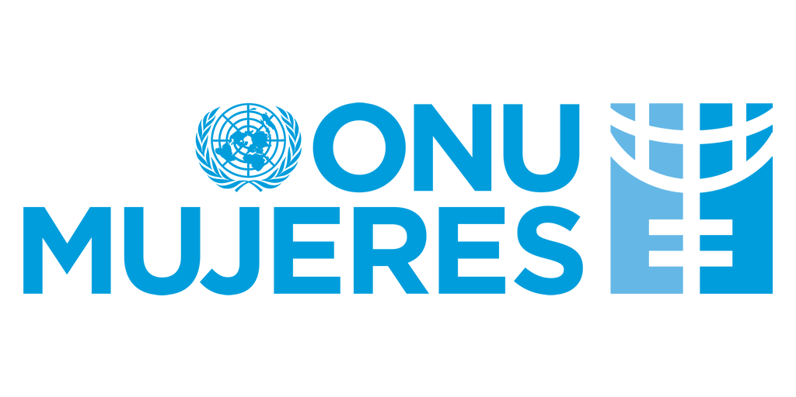


Prepared by the Monitoring Group for the Implementation of CEDAW in Colombia, composed by the following organizations:

- Católicas por el Derecho a Decidir (CDD)
- Cedetrabajo
- Colombia Diversa
- Comisión Colombiana de Juristas,
- Comisión Intereclesial de Justicia y Paz
- Corporación Casa de la Mujer
- Corporación Colectiva Justicia Mujer,
- Corporación Humanas
- Corporación Sisma Mujer
- Cladem-Colombia
- Fian Colombia
- Iniciativa Pro Equidad de Género
- Instituto Latinoamericano para una Sociedad y un Derecho Alternativos (Ilsa)
- La Mesa por la Vida y la Salud de las Mujeres
- Liga Internacional de Mujeres por la Paz y la Libertad (Limpal)
- Diálogo Intereclesial por la Paz (Dipaz)
- Programa de Acción por la Igualdad y la Inclusión Social (Paiis)
- Red de Educación Popular Entre Mujeres (Repem)
- Red Nacional de Mujeres-Nodo Barranquilla, Nodo Bogotá, Nodo Bolívar, Nodo Cauca, Nodo Chocó, Nodo Manizales, Nodo Magdalena Medio, Nodo Medellín, Nodo Pasto, Nodo Provincia de Ubaté, Nodo Puerto Colombia, Nodo Risaralda, Nodo San Andrés y Providencia, Nodo Santander, Nodo Tolima, Nodo Valle
- Socios de la Alianza por la Niñez Colombiana: Fundación Plan y Save the Children Colombia
- World Vision Colombia

Presented at the 72nd sessions period, February 18 to March 8, 2019. Convention on the Elimination of All Forms of Discrimination against Women.

January 2018
This document can be published on the website of the CEDAW Committee.

Acronyms and abbreviations

FPA: Final Peace Agreement
CEDAW: Convention for the Elimination of All Forms of Discrimination against Women
OAG: Office of the Attorney General
NILM: National Institute of Legal Medicine
VIP: Voluntary Interruption of Pregnancy
LBT: Lesbian, bisexual and transgender women
LGBT: Lesbian, gay, bisexual and transgender people
OHCHR: Office of the United Nations High Commissioner for Human Rights
NDP: National Development Plan

Between 2013 and 2018, Colombia experienced a series of political, institutional and social changes. The signature of the FPA, signed in 2016, became a milestone in the national scenario. Among its provisions, this agreement incorporated measures aimed at guaranteeing the human rights of women victims and members of armed groups. Since its enactment, organized women in the country have followed up its implementation. Concomitantly, they have sought to advance in broadening the horizon of attention of structural discriminations which, for years, have remained outside the public agenda due to the need to focus on the differential effects and requirements of women who have been victims of violence in the framework of the armed conflict.

All these situations have a differentiated and serious impact on women and their possibilities of access to a life free of discrimination, with effects that have a greater impact on rural women, girls, Afro-Colombian and indigenous women, women with disabilities, the LBT population and women migrants from Venezuela, among others.

In terms of structural discrimination against women, this document summarizes information on the period from 2013 to 2018, regarding implementation gaps by the Colombian State between the provisions of the Convention and the reality of women in relation to CEDAW´s following articles: Political measures and guarantee of human rights; gender roles and stereotypes (article 5); human trafficking and prostitution (article 6); political and public life (article 7); education (article 10); employment (article 11); health (article 12); rural woman (article 14), and marriage (article 15).

Despite some advances in the generation of information and statistical data on discrimination against women in the country, its precariousness makes it impossible to produce comprehensive diagnoses. Those that advance in the consideration of sex and/or gender variables still lack differential approaches, so the call for attention to the Colombian State refers to the need to qualify the existing information systems so that the differential approach is no longer an empty statement.

Regarding political measures to eliminate discrimination, the distance between what is envisaged by norms and the attention women victims of violence actually receive is related to the limited institutional capacity to deal with a problem of such a great magnitude. The Presidential Office for the Equality of Women continues to operate with scarce financial and administrative resources and, in turn, the municipalities do not assume their responsibility for the strengthening of Family Welfare (Comisarías de Familia hereafter), municipal entities in charge of providing protection measures related to domestic violence against women. Regarding protection and care measures for female victims, it is expected that after ten years of non-compliance, the Ministry of Health will comply with the provisions of Law 1257/2008 in relation to housing, food and transport measures for women victims of violence.

Regarding the guarantee of human rights, NILM’s official figures show an ongoing growth of violence which, in many cases, ends up in death. The same happens with sexual violence. Follow-up to the reincorporation process of ex-combatants shows the absence of a gender perspective and an integral approach to their situation. Attention is especially drawn to the situation of girls. From the total information on criminal acts related to sexual violence received by the National Police in the first semester of 2018 (01/17/2018 to 06/2018), 72% occurred against children under 14 and, of these children, 85% were girls.

In terms of the provision of the public education service, the Colombian State hasn´t assumed its responsibility to provide training in gender roles and stereotypes to contribute to the elimination of discrimination against girls and women. There is also no progress in structuring a training program on sexual and reproductive rights directed to the education sector. The National School Coexistence System (Sistema Nacional de Convivencia Escolar, SNCE), implemented in 2013, has not produced impact measurements on the situation of the rights of girls and the LGBT population. Initiatives in this regard continue to be hampered by conservative sectors who, from the international level, have positioned the so-called "gender ideology" in the collective imaginary to demonize the progress in the rights of some people, especially women and the LGBT population.

In the educational field, there are also no baselines disaggregated by sex, ethnicity or age, as the CEDAW Committee has suggested, and there is no disaggregated information on permanence of students and drop-out rates or on the effect of the few existing programs in the field. There are no policies to guarantee the reincorporation and permanence of pregnant girls to public educational institutions.

Regarding human trafficking and prostitution, 72% of victims of trafficking for sexual exploitation are girls and women in vulnerable situations. Deficiencies in information do not permit to know the number of victims of trafficking rescued by the State, nor whether it is internal or external, among other variables. There is also no information on the number of victims of sexual exploitation. Thus, in 2016 only one victim of trafficking received protection from the Office of the Attorney General (OAG). We highlight the formulation of the National Strategy to Combat Trafficking (2014) but, unfortunately, it has not reached most of the regions nor does it respond to the contexts of different areas of the country which have been permeated by sex tourism, drug trafficking, extractive industries and other situations which, definitively, have an impact on the occurrence of these crimes.

Regarding the participation of women in political and public life, discrimination persists. As a result of the 2018 elections for Congress, out of 107 seats, 23 are occupied by women (21%) and 84 by men (79%). Out of 308 women running for Senate, only 23 managed to get a seat. At high decision-making levels, even though there is a law requiring 30% of the positions to be occupied by women, it hasn´t been fully applied. The discussion in the Congress of the political reform proposed by the government, by which closed lists could allow alternation between sexes in the lists of political parties and movements to guarantee parity, was eliminated in the last term (second semester of 2018). The Government is expected to defend its proposal in the next legislature in order for parity to finally exist. All through the history of the country, only 6 Afro-descendant women have managed to get a position in the Congress and their participation in other instances is lower than that of mestizo women.

Discrimination against women in relation to employment persists: the unemployment rate is 12% for women, while for men it is 7.1%, and among young people it reaches 21.6% for women and 11.9% for men. On average, women's wages continue to be lower than those of men, with a current gap of 19%. Regarding child labor, official figures show that 796,000 children and adolescents were victims of it in 2018. Policies aimed at modifying this situation, such as the Gender Subcommittee of the Ministry of Labor, have not been able to participate in national salary discussions.

In terms of health, there is no disaggregated information system on the provision of VIP services. Regarding girls and women with a disability, thanks to the issuance of Resolution 1904/ 2018, non-consensual sterilizations have been reduced, but they continue to be carried out. Social organizations have detected the persistence of access barriers to VIP in cases already decriminalized by the Constitutional Court. Similarly, according to figures from the OAG, women are still criminalized by VIP derived from decriminalized causes. We highlight the cases of 41 girls between 11 and 14 years old.

Discrimination faced by rural women in the country is serious and it violates all their rights, beginning with the right to life. Large-scale agricultural crops are undermining their food security. Their access to land ownership is very limited, as well as their access to credit, machinery and technical assistance. Additionally, these women face greater barriers to the restitution of land. The FPA foresees specific policies but their implementation lags behind.

Regarding same-sex marriages, despite the fact that several judgments have ordered their legal recognition, in the practice, public officials resort to unjustified delays, discriminatory interpretations and unforeseen requirements to ignore this right.

The chapter dedicated to peace highlights the formulation of the Framework Plan for the Implementation of the FPA which appropriately responds to the gender approach of the Agreement. The civil society has led a thorough process to follow up its results, where some progress has been made, but there are also setbacks, associated to the activity of parties such as Centro Democrático – currently in power - and other political and economic stakeholders, public officers and different state agencies who are opposed to the implementation of the agreement and seek to undermine its scope.

The significant number of people who voted against the plebiscite convened by President Santos for the endorsement of the peace agreement (2016), in whose decision the so-called "gender ideology", as propaganda generating aversion and fear of progress in the rights of women, had an important weight, accounts for an adverse context for the achievement of equality and non-discrimination against women and the LGBT population.

Regarding the situation of human rights defenders, although in 2017 murders associated to the armed confrontation were reduced to zero, problems identified by the OHCHR in its report on the human rights situation in Colombia such as the lack of security, violence linked to illegal economic activities in contexts of dispute between illegal armed groups and organized crime, and the consolidation of armed groups and criminal organizations in large areas of the territory, are generating serious violations of the human rights of the entire population, with differential effects on women. We highlight the extreme violence and brutality against these human rights defenders in the last period, evidenced by traces of sexual violence and torture in their corpses. During the period of time reviewed by the Committee, the government has created several protection programs and guarantees but has failed in their implementation. The current national administration shows no political will to make them effective.

To move forward in the guarantee of the rights already obtained, and to demand from the Colombian State the compliance of international, constitutional, legal and ethical obligations in relation to the achievement of equality for women, the shadow report constructively contributes with approaches to the reality of women, State attention to their problems and situation, and proposals for governmental action to effectively aim at this common objective.

Information provided in the framework of the hearing: "Women and Law 1257/ 2008: a decade of struggles to eradicate violence and discrimination" (“Mujeres de cara a la ley 1257 de 2008: una década de luchas por erradicar la violencia y la discriminación”), carried out in the Office of the Attorney General. Bogotá, November 22, 2018.
The Anne Frank Corporation reports, according to the OAG 2016 response, that only one person received protection and several had to go into exile to protect their lives.
Red Nacional de Mujeres. Infographics on Congress elections, 2018.
Ministry of Labor. Bulletin available at: http://www.mintrabajo.gov.co/web/guest/prensa/comunicados/2018/diciembre/ministra-del-trabajo-alicia-arango-lanza-estrategia-para-prevenir-y-erradicar-el-trabajo-infantil-en-colombia
"The Peace Agreement between the government and the extinct FARC guerrillas marked a drastic reduction in combat deaths. According to statistical data from the Centro de Recursos para el Análisis de Conflictos (CERAC), while in 2002 there were 2,799 deaths in combat (including members of the Public Force, FARC and civilians), in 2017 there were no cases at all”. https://colombia2020.elespectador.com/pais/la-reduccion-de-muertes-en-el-conflicto-despues-del-acuerdo-con-las-farc
Annual report of the United Nations High Commissioner for Human Rights on the situation of human rights in Colombia (Unpublished version, March 2, 2018. A / HRC / 37 / add3).

