Republic of Colombia

Submission to the Committee on the Elimination of Discrimination Against Women

RELATING TO ACCESS TO JUSTICE, DISCRIMINATORY GENDER STEREOTYPES, AND VIOLENCE AGAINST WOMEN

Submitted by The Advocates for Human Rights,

a non-governmental organization in special consultative status,

and

The Humphrey School of Public Affairs, University of Minnesota

Human Rights Research Project on Implementation of

Colombia’s Laws on Violence against Women

72nd Session (18 February – 8 March 2019)
Submitted January 28, 2019

Founded in 1983, The Advocates for Human Rights (The Advocates) is a volunteer-based non-governmental organization committed to the impartial promotion and protection of international human rights standards and the rule of law. The Advocates conducts a range of programs to promote human rights in the United States and around the world, including monitoring and fact finding, direct legal representation, education and training, and publication.
The Humphrey School of Public Affairs, University of Minnesota is one of the United States’ top ranked professional public policy and planning schools widely recognized for its success in advancing the common good. Since 2015, Humphrey School Associate Professor Greta Friedemann-Sánchez, Ph.D. and researcher Margaret M. Grieve, J.D., M.A., have undertaken research in Colombia, funded in part by a Human Rights Gran from the University of Minnesota, to evaluate the implementation of Colombia’s laws on violence against women from the perspective of judicial service providers, charged with protecting the fundamental human right of women to live a life free from domestic violence. A report of the project will be published in 2019.

Colombia fails to uphold its obligations to protect women from violence under the Convention on the Elimination of all Forms of Discrimination against Women
- This report addresses matters in the Committee’s List of Issues tied to Access to Justice, Violence Against Women and Gender Stereotypes, the State party replies, and the Committee’s 2013 Concluding Observations. Based on data published by Colombian and UN officials, non-governmental organizations, and research conducted by Dr. Friedemann-Sánchez and Ms. Grieve in Colombia during 2015-2017, this report focuses on the impacts of post-conflict demobilization and the recent surge in criminal activities in formerly Revolutionary Armed Forces of Colombia (FARC) controlled territories and along the border with Venezuela, and, in particular the increased intimate partner violence (IPV) against women and domestic violence (DV), including sexual violence, against girls. The research’s design sought information from judicial service providers, especially comisarias de familia (Family Commissioners or FCs) and other officials charged with providing access to justice and services to Colombian women experiencing IPV in municipalities with different levels of institutional capacity and relationships to the conflict and criminal bands (BACRIM).
- A total of 128 interviews were conducted, 54 with FCs and the remainder with their interdisciplinary teams, prosecutors, police, family court judges, advocates and victims. Much of the research was in Bogotá (43 interviews) and Medellín (48 interviews), the two cities with the greatest level of resources and strongest institutions and likely to present the “best case” scenario in the laws’ implementation. The research was conducted in rural, urban, and former conflict areas in different sized municipalities in the department of Boyacá (14 interviews). Additionally, interviews (23) were held with FCs from smaller, rural, and more remote municipalities throughout the country, some located in former FARC conflict zones and areas with BACRIM presence.
II. Violence Against Women in Post-Conflict Colombia
- Colombia set an example for the world with its inclusion of women in the peace process. But, There remains a critical need to address IPV/DV in post-conflict throughout Colombia, including where criminal bands flourish.
- IPV and DV typically surge during post-conflict. Research shows that when ex-combatants return, violence in the home increases. With the 2006 demobilization of the Autodefensas Unidas de Colombia paramilitaries, FCs saw a tsunami of violence in the family and its intensity, particularly against women, among those reintegrated into society. FCs express concern that the current demobilization will mean more DV of greater severity—particularly because many of Colombia’s combatants, male and female, have never known a time without armed conflict and use violence as their standard dispute resolution tactic. The surge in DV may not be reflected in statistics. To the extent that ex-combatants become part of criminal organizations, FCs tell us that women do not report IPV, adding to Colombia’s chronic IPV underreporting. According to the nationally representative 2015 Demographic Health Survey, only 20% of women victims of violence in Colombia reported the events to a state authority.
- Post-conflict DV perpetrated by ex-combatants in Colombia is violent. FCs report the violence they see among ex-combatants since the 2006 demobilization is vicious and terroristic, reflecting the conflict’s violent strategies. Bogotá FCs serving areas with combatants, BACRIM, and criminal violence tells us almost all women who seek help for IPV have experienced severe bodily injury and threats to kill and dismember. Typical death threats are “I will see you in heaven”, “ I’m going to strangle you”,“ I’m going to dismember you, chop you into pieces and feed the pieces to the dogs ” and “ I’m going to tear your head off”. Keeping women/girls chained or imprisoned also is usual.
- IPV/DV and Colombia’s criminal organizations. With the 2006 demobilization, many ex-combatants formed criminal bands, BACRIM. Today, BACRIM members include newer generations who continue to employ violence as a conflict resolution tactic. FCs serving BACRIM social groups see high and intense IPV, child maltreatment and sexual abuse, prostitution, teen pregnancy, adolescent and young women with much older men, serial relationships, women with several children by different fathers, abandonment of children by parents and of older parents by adult children. They report that women with BACRIM partners are reluctant to seek help for DV. If their partners enjoy impunity for violent crimes including assaults, assassinations, and dismemberments, a protective order from the State is meaningless. Women tell FCs, “if they haven’t captured him for homicide, if he has committed far more serious crimes (than IPV), what can a Family Commissioner do? Nothing is going to happen to him”.
- A Bogotá FC shared this example of IPV by a BACRIM boss:
A young woman of 24 explained that her companion was verbally violent. Because of his work with BACRIM she had left him, moved to her father’s house with her three-year-old son, and wanted a protective order. As a child she lived in the Bronx, the seediest neighborhood in Bogotá known as a drug, arms sales, and human-trafficking hub. A family member assaulted her. By nine years of age, she was drug addicted and living on the street. By age fifteen, she was unkempt, bald, and sick.
Her “savior,” 20 years her senior, came to the rescue. He moved her into an apartment, got her off drugs, and took care of her. She was beautiful. They had a son. The young woman explained that her companion was the Sayayin del Bronx. When the FC heard this, she recognized the danger. She urged the young woman to leave her father’s house and go to a Casa de Refugio, a shelter operated by Bogotá’s Secretaría Distral de la Mujer, for her own safety and that of her child.
The woman refused. Armed with a provisional protective order, she returned to her father´s house. Soon thereafter, she opened the door and found her ex-partner. He attacked. He started by repeatedly kicking her in the vagina. Next, he grabbed a knife. Starting at her pubic bone he carved straight up through her abdomen. Then he moved to the face. As he attacked, he kept repeating, “I didn’t make you beautiful so that another man could [obscenity] you”.
The father turned to the child who was clamoring for his attention. Somehow the woman escaped out the front door. The commotion attracted others. She was taken to the hospital. Her injuries were so severe that Colombia’s National Institute of Legal and Forensic Medicine’s (Medicina Legal) said she needed over 50 days of disability. She told the FC she no longer could bear to look in the mirror. She does not recognize herself. “It is clear that he wanted to destroy her essence as a woman,” explained the FC, “she was his property and he believed he could do what he wanted with her”.
Many former FARC combatants have formed new criminal groups as reflected on the below map , a development that negatively will impact women who partner with them and their children as the tactics of war get replicated at home.

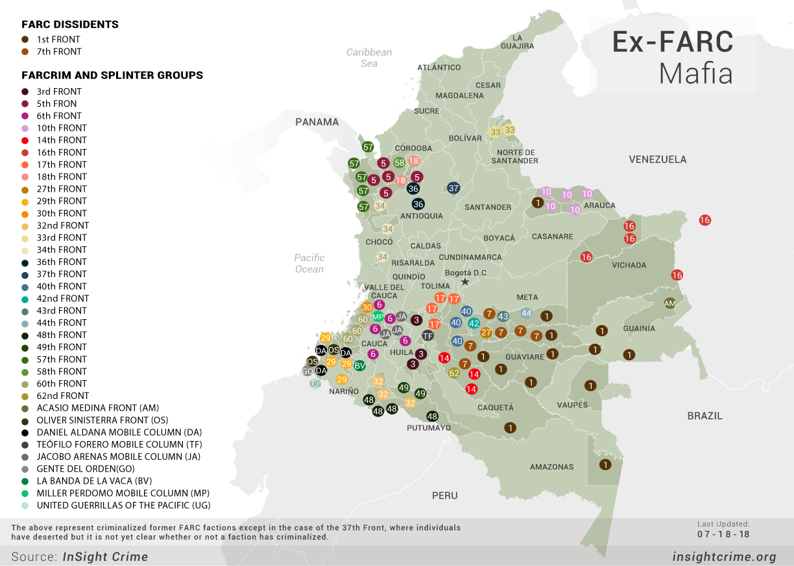

- List of Issues Paragraph 2: Access to Justice for Survivors of VAW
- In its List of Issues, the Committee requests that Colombia indicate whether steps have been taken to measure the impact of legislative provisions to strengthen women’s access to justice. The Committee asked Colombia to indicate its measures to coordinate and monitor the implementation of FC procedures and ensure that DV civil protective orders include cases of violence by all ex-partners.
- Colombia has made progress since its last 2013 review by the Committee and the Ministry of Justice and Law (Ministry of Justice) has endeavored to improve access to justice for women victims of IPV and violence against women (VAW) within the legal constraints of its authority over FCs. However, until the State party addresses the fundamentally flawed institutional design of its FC offices, Colombian women and girls will be denied their rights to live free from violence. According to the Ministry of Justice, FCs are “the principal portal for victims of (DV) to access justice” and the key institution authorized to issue permanent civil protective orders critically needed for security, safety, health, shelter, and access to essential services for Colombia’s women victims of IPV and girl suffering DV.
- Women’s access to justice in Colombia depends on strong FCs. Civil protective orders are the primary and critical remedy for women victims of IPV, offering the fastest and most effective way to deter future violence. While a protective order will not stop all violence, studies confirm its value in increasing the likelihood of victim safety and delivering ancillary benefits to the woman and her children. In Colombia, the FC is to issue a provisional protective order within 4 hours of a request. and hold a hearing/issue a permanent protective order within 5-10 days thereafter.
- Prosecutors disclosed that they send women reporting DV for prosecution in the criminal justice system to FCs who can issue a provisional protective order within 4 hours rather than wait the 3/4 months before a criminal judge (or in some locations, a juez de garantias) schedules a hearing for a provisional protective order. In any case, criminal judges must refer women to FCs for them to get a permanent protective order.
- Unavailability of protective orders against certain ex-partners. Due to the narrow definition of “family” under Colombia’s Law 294, some women, victims of IPV, cannot secure immediate FC provisional protective orders. Instead, they must seek help from Judges of Guarantees where there is often a 4-month waiting period. Circumstances where FCs believe they cannot issue a provisional or permanent protective order under Law 1257 include:
- Violence by a boyfriend with whom a woman is not co-habitating, and
- Violence by an ex-intimate partner where there are no children.

- Ministry of Justice tools for FCs have not improved access to justice. With the best of intentions, the Ministry of Justice/Presidential Advisor for Equity of Women created model procedures for FCs (see Paragraph 19 in Colombian response to Issues) to (1) assess risk of DV and femicide, (2) standardize FC internal office procedures for IPV/DV, (3) monitor FC protective orders, and (4) assess effectiveness of an FC office’s operations. They miss the mark because they are untethered to the reality of FC conditions on the ground. FCs who tried them, abandoned them as irrelevant/ineffective. FCs report the risk assessment tool always produces the same result: all cases involve high IPV?DV risk. Its wording must be re-interpreted for women with little education, it takes too long to administer, and, contrary to best practices, requires rigid application. The model procedures further assume FC’s only task is issuing protective orders and that they have personnel and infrastructure they lack.
- Contrary to best practices endorsed by the UN and research, Colombia ties a woman’s request for a civil protective order to the criminal justice system, creating a barrier that prevents many women from seeking the protection/services offered by a protective order. When a woman requests a protective order, the FC is required to send related information to the Prosecutors’ Office. The prosecutor must determine whether to criminally prosecute the aggressor. By seeking a protective order a woman may trigger prosecution of her intimate partner for the crime of DV, a crime that in Colombia carries a maximum sentence of eight years. FCs tell us this is a significant barrier. Many women refuse to request a protective order when they learn that information related to it is transmitted to prosecutors who may commence criminal prosecution of the aggressor.
- The woman may be apprehensive about invoking the criminal justice system and appearing in court. She may be economically dependent on her partner. The fear of eight years without support for a poor woman who is wholly dependent on her intimate partner for her survival and that of her children is truly terrifying. She may fear (justifiably) that a criminal investigation may trigger her partner to take his anger out on her. Finally, a woman may not want to send the father of her children to jail.
- A FC argued that because the Constitution provides that a woman does not have to testify against a family member, she should be given the choice to decide whether a request for a protective order is transmitted to prosecutors. This approach would be consistent with research-validated best practice of keeping civil protective orders separate from criminal justice.
- List of Issues Paragraph 7: Discriminatory Gender Stereotypes
- Continued efforts to combat patriarchal stereotypes are key to combatting VAW. Yet the government of Colombia has failed to take steps to adequately address discriminatory gender stereotypes. FCs from across the country report that violence is so normalized women often are unaware that the abuse they suffer is not the accepted social or legal norm. In Boyacá, we were told that the culture is “terribly chauvinistic” and, overall, DV is terrible because “people here are very violent” and the population is “too conflictive”. A Boyacá prosecutor put it bluntly: the woman is a “domestic servant” with an obligation to bear children. Another prosecutor, phrasing it more delicately, said from time immemorial culturally gendered schemas have held “Man as a superior being and women as an accessory” In parts of Boyacá, imprisoning a woman is commonplace and locks can be seen on the outside of structures.
- A long-time social worker explained that women who are physically beaten in their own homes often refuse to act to change their situation: “this is how it was for my grandmother, this is how it is for me”. A psychologist from a large municipality says that many women, victims of IPV, blame themselves: “I provoked him”. The schema involves the understanding that violence is a sign of affection “if he hits me, he loves me”. A psychologist and social worker noted the Catholic Church’s teachings on marriage have been misconstrued by many women as requiring a woman to submit to any violence that her spouse may wish to inflict, no matter how brutal. “I am not going to separate, only until death comes. If he has to kill me, so be it” or “until death separates us” are frequent refrains.
- List of Issues Paragraph 8-10: VAW
- In its List of Issues, the Committee requested the State party to indicate steps taken to strengthen institutional capacity for the effective implementation of Law 1257, as previously recommended by the Committee. Colombia notes in its Replies efforts to strengthen the ability of FC units to address and prosecute cases of gender-based violence and to develop and disseminate various tools related to protective measures.
- Until the deeply flawed institutional design of FCs is addressed, the rights of Colombian women and girls to lives free of violence guaranteed them under Colombia’s Constitution and Law 1257 will remain out of reach. The institutional design of FCs is deeply flawed. The number of FC offices is inadequate to meet demand. Staffing is woefully insufficient. Notwithstanding their judicial role, FCs are divorced from the judicial branch of national government and placed under the executive branch of local government exposing them to political clientelism. FCs have too many responsibilities.
- FCs were not created to address VAW. Judges initially were given the responsibility for DV civil protective orders but complained that these “minor” DV matters were clogging their dockets. In 2000, the judicial power to issue DV civil protective orders was removed from the judiciary and transferred to FCs where it remains. FCs were created in 1989 with no role in IPV/DV/VAW under the predecessor law to Colombia’s 2006 Child Welfare Code. The Code continues to govern FC creation, staffing, reporting lines, and most of their responsibilities. FCs are part of the Colombian system for child and family welfare, but are not part of the national Colombian Institute for Family Welfare (ICBF) even though ICBF is responsible for issuing technical guidance for FC operations and FCs must discharge the job of ICBF Family Defender for children/adolescents in all but 12% of the country’s municipalities.
- Even though FCs perform a critical role in the judicial system, they are not part of/ overseen by the judiciary. Strangely, for an institution exercising an important judicial administrative function, FCs are not subject to judicial oversight, lack the political clout to force collaboration with the national level institutions that must fulfill protective order measures, and are systematically excluded from national strategy and policy making bodies for gender-based violence even though FCs have the greatest day-to-day experience in confronting gender-based violence against women and girls. FCs are made part of the local executive branch of government (under local mayors), lack centralized management, and are not a national institution. Each FC is dependent upon his/her local municipal government (the local mayor) and operates independently from the country’s other FCs. Chart 2, Annexes, illustrates FC isolation and dependence on local government.
- FCs are overburdened with too many responsibilities not tied to VAW, reflecting the State’s lack of commitment to dedicate resources necessary to combat VAW. FCs must re-establish rights of children and adolescents where violence from a family member is involved, including taking children under protective custody and finding State-sponsored housing even when such housing is limited or non-existent. FCs must mediate matters related to custody, support, visitations, and separations under Law 640. They must handle “family conflicts” under Law 1098. FCs must accompany police on “busts” to bars, adult entertainment venues, and shops where there are under-aged patrons in violation of law. They have responsibilities under the law on school violence. They manage traffic court for minors who violate transit laws, they take youth who bring weapons or alcohol to a sporting event into custody, hold hearings and mete out sanctions, and “rescue” children and adolescents from dangerous situations, accompanying heavily armed forces on early morning drug raids because children. These tasks are time-consuming, demanding, at times, dangerous, and often unrelated to combatting VAW. One frustrated Medellín FC asks, “What does going to sporting events and fining parents of teens who get drunk or take drugs at a match have to do with to core (DV) responsibilities?”
- In approximately 88% of Colombia’s municipalities where ICBF has no presence, the FC must assume all responsibilities of an ICBF Family Defender of children and adolescents, a second full-time job whose focus is familistic and does not embrace Law 1257’s differentiated treatment for women and girls, victims of VAW.
- Local mayors in smaller municipalities burden FCs with extraneous time-consuming tasks: drafting and supervision of school cafeteria contracts, serving as traffic police, managing the municipal jail, and creating and implementing public policy on family and youth topics. We have not identified a legal basis for imposition of these responsibilities.
- Colombia’s own Departamento Nacional de Planeación/ Escuela Superior de Administración Pública evaluative report (DNP Study) on FCs recommended materially decreasing FC responsibilities to improve effectiveness on VAW, several years ago the then Minister of Justice called for elimination of the FC obligation to mediate family matters under Law 640, and the staff of a now-disbanded Accidental Congressional Committee to restructure FC responsibilities recommended removing responsibilities, including that of Family Defender, so FCs could concentrate on serving women, girls, and other victims of DV.
- FCs in rural and urban areas told us “We are like a Christmas tree, the government decorates us with one responsibility after another”. The below “Christmas Tree” illustrates how the State has over-burdened FCs with non/VAW-responsibilities.

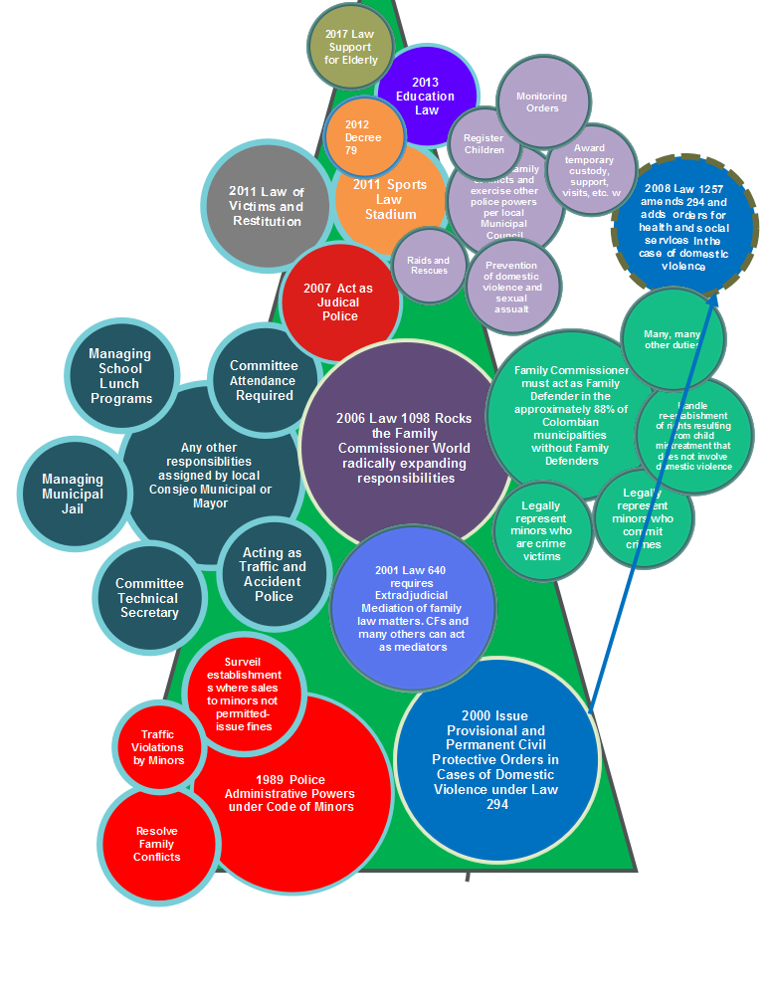

- The number of FCs per municipality is inadequate to meet victim needs and does not reflect local contexts. National requirements setting the mandatory number of FCs per municipality are based on population. This fails to consider important sociodemographic characteristics that affect VAW prevalence, intensity, sociocultural, and legal complexities. Without exception, FCs report that their workload, the number of requests for DV protective orders, and the severity and intensity of physical violence, is dependent on population characteristics. FCs identified characteristics related to the conflict – e.g., displaced persons, ex-combatants (paramilitaries, guerilla groups, or the military), FARC controlled or influenced rural areas, and presence of BACRIM, as particularly salient. (Chart 2, Annexes, describes how VAW manifests based on sociodemographic characteristics). A 2017 geospacial review of femicides and VAW published in Medicina Legal’s Forensis showed dramatic concentrations in parts of Bogota, supporting the need for criteria in addition to population.
- Law 1098’s embeds the illogical assumption that the largest cities are less violent than smaller cities. Law 1098 mandates one FC for every 150,000 people in a level 1 city, but only one FC for every 250,000 people in a special category city, like Bogotá or Medellín. Apart from being illogical, Medicina Legal’s numbers regarding cities with the greatest incidence of IPV show that four of the five cities with the highest incidence of IPV are special cities.
- A Law 1098 legal loophole authorizes inadequate FC staffing. Law 1098 assigns responsibilities to FC offices on the assumption they will have an interdisciplinary team consisting of a psychologist, social worker, and secretary and then, paradoxically, provides that municipalities levels 6-2 (with populations of under 7,000 to 100,000 or approximately 97% of Colombia’s municipalities) are not required to have an interdisciplinary team. Our research shows that many Colombian FCs lack the necessary staff to support their operations. Some offices operate with just the Family Commissioner. Other offices, even in capitals of department, lack complete staff and rely on short-term university interns. Chart 3, Annexes, reflects the different staffing patterns.
- Placement of FCs under the local executive results in a system where mayors outside of the largest cities cavalierly ignore legally mandated FC civil service requirements, harass FCs, and engage in other improper labor practices. Since 2000, Colombian law has provided that the position of FC is a national civil service position enjoying certain labor protections. In 2011, the National Ombudsman reported that 66% of the country’s FCs lacked the requisite civil service classification and ordered mayors to remedy this deficiency. FCs explain little has changed.
- FCs from Bolivar, Boyacá, Casanare, Cundinamarca, and Nariño from levels 2-6 municipalities report many mayors continue to assert, incorrectly, that the FC position is a political appointment and mayors have the unfettered right to hire/fire FCs at will, without cause. Even where mayors know the FC is not technically a political appointment, they improperly pressure and harass FCs to force resignations so they can appoint his/her candidates. The harassment discourages qualified candidates. A long-time Medellín FC rightly observed that non-civil service FC appointments weaken the institution: “the position is not held because of competitive application and merit by individuals committed to careers in public service. Those who hold the position may have no intention of pursuing a long-term career as a Family Commissioner”. And, it is the women, victims of IPV, who bear the consequences of potentially unqualified FCs.
- Short-term contracts. Mayors hire FC staff under short-term contracts to control costs and in smaller municipalities use them as a political patronage tool. When a contract ends, the mayor hires “his/her” person for the position. One Boyacá FC explained that she had multiple different mayor-appointed psychologists in one year. When a contract ends there is often a hiatus of 2-3 months where FCs must operate without needed staff. One FC’s “prayer” for the hiatus period “Please, no fighting, no arguing, no asking for anything”. One can only wonder what happens to IPV victims during contract hiatus periods. Do battered women give up, tired of waiting their turn at the FC office? Do they fail to receive notice when hearings for permanent protective orders are rescheduled or fail to appear for a rescheduled hearing because they had to wait for 2-3 months for the first hearing date instead of the legally set 10 days?
- The current administrative and budgetary system discourages cities from appointing additional FCs. For a city to maintain independence to act in certain matters, the city must satisfy various ratios related to fiscal and management efficiency. This incentivizes cities to minimize overhead, which includes FC compensation and many FC operating expenses. Even in cities where there might be resources to hire additional FCs, Municipal Councils may be reluctant to authorize positions to avoid negatively impacting these ratios. The current formula serves as a disincentive for municipalities to create additional FC positions, but easily could be addressed by eliminating FC costs from overhead for the purposes of government accounting ratios.
- Local municipalities may spend the national government funds intended to cover FC compensation and expenses for other purposes. Funds for FCs are included in a general transfer that encompasses various municipal expenses. Transfers made by the national government to municipalities, such as those for health and education, are subject to earmarks to assure transferred funds are used for their intended purpose. Funds intended for FCs are not similarly earmarked.
- Even if all national funds intended to support FC operation were earmarked, they remain insufficient to cover basic FC operations. Lack of funding is a serious obstacle to combatting VAW. The DNP Study demonstrates that funds transferred from the national government are insufficient to support FCs operation. Large cities, like Bogotá and Medellín, report their FC operations are supported mainly from municipal revenues: if they relied solely on the funds from the national government, they could not begin to meet the needs of women, victims of DV.

- Many of the country’s FCs lack essential infrastructure critical for basic operation, hindering their ability to meet victim needs. FCs outside of Bogotá and Medellín lacked some, and in a few cases all, of functioning printers, computers, paper, ink, a secretary, access to internet, storage space, office furniture, government insurance if they are injured or killed in the line of duty, and, at times, adequate bathroom facilities. Even in Bogotá and Medellín, FCs reported lack of printer ink and paper towards the end of the month, difficulty in repairing broken equipment, and municipal systems upon which FC work depends repeatedly going offline, sometimes for days.
- Low FC compensation leads to turnover to the detriment of the quality of judicial services provided victims: FC compensation generally lags far behind comparable official positions and varies significantly. FCs report that law schools, even where FCs earn special degrees, do not prepare lawyers to become FCs. FCs. must learn on the job, and high turnover and inexperience means that victims’ access to justice suffers. As one FC noted, “no matter how committed a FC, they often leave for better paying jobs to meet the needs of their family.” The Ombudsman’s 2010 survey of the country’s FCs, found that 70.4% of Colombia’s FCs, earned less than 2 million pesos (US$ 681) per month and less than any other municipal official. Interviewed FCs reported compensation ranging from a low of 1.5 million pesos (US$ 512) per month to a high, in rare instances in Bogotá, of 8.5 million pesos (US$ 2,897) per month. According to FCs, ICBF Family Defenders, whose job many FCs must discharge in addition to that of FC, earn substantially more than most FCs. Congress was requested to increase Family Defender pay packages to equal that of a circuit court judge (9,069,607 pesos, US$ 3,088 per month) because Family Defenders perform administrative judicial functions. This argument is equally, if not more persuasive in the case of FCs as FC responsibility for issuing DV protective orders initially was assigned to judges—as it still is many other countries.
- ICBF’s design encourages dysfunctional and unconstructive competition with FCs to the detriment of the most vulnerable. According to FCs, especially those who also are Family Defenders in rural municipalities, “ICBF is your worst enemy”. FCs must secure ICBF approval to place abandoned and/or abused children/adolescents removed from their homes in ICBF temporary or permanent housing. Demand for spaces is high. ICBF is incented to keep slots for use by its own Family Defenders. FCs report that denial of spaces is a regular occurrence. We were told that ICBF Family Defenders try to transfer workload to FCs by characterizing a matter as DV even when this is not the case.
- FCs report that legal norms addressing family violence proliferate but provisions may conflict, regulations often are confusing, unclear, or insufficient. FCs told us that when there is DV against a child or adolescent, they are expected to use the ICBF re-establishment of rights process and not the more agile provisions of Law 294 on DV, even though Law 294 clearly covers DV in the case of children/adolescents. Yet, there is no law or regulation that requires this. FC psychologists and social workers are supposed to act as forensic experts in their fields and provide evaluations to FCs as evidence to be used in DV hearings, but there is no unified criteria explaining how to discharge this forensic responsibility. FCs we interviewed said that they did not mediate violence against women but noted that Law 294 continues to authorize mediation and does not limit its scope to family law matters involving support, custody or visitation.
- Lack of Interinstitutional Coordination; Ministry of Health; National Police; Others. Law 1257’s monitoring committee and other national policy and strategy efforts on IPV and VAW excludes FC participation. Even though FCs have extensive first-hand experience in applying the IPV and DV laws and are the gateway for women, victims of IPV, to access justice and services, their expertise and input is not sought to the detriment of the State’s efforts to combat VAW.
- Little knowledge by key national level officials on scope of FC responsibilities and realities of implementation. The lack of knowledge about FC responsibilities, the needs of the victims, and obstacles to operations such as local mayor demands and inadequate infrastructure and staff mean national efforts to create procedures for FCs and train them often miss the mark and are a poor use of scarce resources. Further, no amount of training on gender issues, the dynamics of VAW, and the law can overcome the profound structural failures in FC institutional design and the lack of inter-institutional coordination.
- Colombia’s Law 1257 requires an integrated “whole of the State” approach to addressing VAW. While beautiful on paper, reality is another story. Colombian Laws 1257 and 294 allow FCs to order a wide range of measures in civil protective orders as well as any measure necessary to fulfill the goals of Colombia’s laws on DV. Execution of the measures in FC protective orders, however, is the responsibility of national level institutions like the national police, the Ministry of Health, and, in the case of children, ICBF. Failure of these institutions to fulfill their legal obligations and coordinate with each other and FCs remain a major barrier for women and girls.
- Given the FC institutional design, FCs lack necessary political clout. Lone FCs cannot force other national level institutions to fulfill their obligations to women.
- Police often are obstacles. In different parts of the country police refuse to execute evictions, siding with the aggressor or themselves may be aggressors. FCs and advocates have instituted/threatened tutela legal proceedings against the police to force execution of evictions. In some rural communities, even where the police are willing to help, they are bound by rules that do not let them, for example, leave the urban center after 6 p.m.
- Contrary to Law 1257, the Ministry of Health steadfastly refuses to provide mandated services for at-risk women consisting of housing (shelter), support for a woman and her children, their transportation costs, medical care, and psychological and psychiatric care. Shelters, to the extent they exist, are created and funded by municipal governments to meet the needs of their citizens. Shelters are unavailable to the many Colombian women who do not live in a city that sponsors its own shelter. The process to certify that a woman is “at risk” is cumbersome, time-consuming, and places decision-making authority in the hands of institutions other than the FC. FCs report that psychological care for victims of DV is available only to the extent that psychological care is available to anyone under Colombia’s universal healthcare system unless a specific municipality has created and funded its own program. FCs explained that the number of psychological visits varies, but usually consists of a total of no more of eight visits of twenty minutes duration. Appointments may take several weeks to secure and require significant travel. In rural Colombia, there may be no access at all to psychological support needed by victims of DV.
- Systems used by FCs do not tie into either a single system for all FCs or the prosecutors’ system so that FCs/prosecutors can determine whether an aggressor previously has been involved in DV, a serious deficiency.
- In its List of Issues, the Committee requested information regarding the establishment of an integrated information system on gender-based violence. SIVIGE, the system developed by Colombia, was designed without meaningful input from FCs. FC data issues are not adequately addressed. Access to combined prosecutor/FC offender information is not solved. While SIVIGE is an important advance, it was designed without meaninful FC input whose protective order data is critical for any national statistical system on VAW. Today, there is no standardized national system for FC data. Each municipality creates its own system; many have no system at all. Even relatively large municipalities refuse to purchase excel software for tracking matters. To the extent any Colombian national system depends on access to the internet, data will be omitted—many rural areas have no access to internet or the only municipal computers with access are controlled by the local mayor that FCs cannot access.
- Suggested Recommendations for the State Party
Access to Justice
- Amend Law 294 to increase its scope to cover boyfriends and all ex-partners. Alternatively clarify for FCs and all justice providers that Article 18, Law 1257 can cover these situations.
- Implement UN/Research recommended best practices to delink civil protective laws and criminal justice system. Amend Law 294 to give women requesting a protective order the choice to determine whether their request is to be sent to the Prosecutors’ office, severing the link between civil protective order requests and criminal DV prosecution.

Combat Harmful Stereotypes
- Encourage the State to create a sustained permanent communications effort devoted to combatting harmful stereotypes, including within all primary/secondary schools, and conduct tolerance surveys every 2-3 years.
Violence against Women
The State must remedy deficiencies in the institutional design of FC offices, including by taking the following actions:
- Materially reduce the number of legal responsibilities assigned to FCs, including mediating family matters under Law 640, handling family conflicts under Law 1098, addressing infractions by minors under traffic, sports, and alcohol, etc. laws. Eliminate the ability of local mayors to assign unrelated tasks like managing municipal jails, school lunch programs, and acting as traffic police.
- Longer-term, restructure FCs to remove them from the local executive branch of government and place them under the judicial branch of government.
- Train the leadership in Congress, ICBF, Ministry of Health, the National Police and the National Prosecutors’ Office on the full scope of FC responsibilities, especially their dual role of Family Defender, their jurisdictional powers (& limits), the reality of their chronic understaffing/underfunding and roles that each institution must play in implementing protective order measures and fighting VAW.
- Legally mandate that population characteristics, as well as absolute population size, be employed as determinants for the number of required FCs. Eliminate the illogical assumption that the largest cities need fewer FCs than smaller cities.
- Eliminate level 2-6 municipalities ability to avoid providing their FCs with interdisciplinary teams.
- Enforce FC civil service requirements, labor laws that prohibit harassment by local mayors. Educate local mayors on FC responsibilities and limits on their ability to alter them.
- Require management of short-term contracts to avoid contract hiatus periods, and their use as a political patronage vehicle.
- Eliminate incentives discouraging creation of additional FCs by exempting FC overhead from fiscal ratio calculations.
- Increase funding to FCs to provide parity in compensation to other officials who perform comparable roles: pay for essential infrastructure.
- End the unhealthy and counterproductive incentives for ICBF to compete for resources with CFs, to the detriment of Colombia’s women and children. Assure FCs enough spaces in ICBF facilities for abandoned/abused children/adolescents.
- Require, support, and finance FC participation on the Law 1257 Committee and other national strategy and policy making efforts involving IPV and VAW.
- Redesign SIVIGE with FC input, assure that prosecutors/FCs can access combined aggressor information. Assure FCs a permanent role in SIVIGE design and implementation.
Address Conflicting Legal Norms
- The State needs to legally clarify whether FCs are to handle DV against adolescents/children, both boys and girls, under Law 1098 re-establishment of rights or under Law 294 protective orders. If DV against girls is to be handled under Law 1098 re-establishment of rights, clarify how the differentiated treatment to be afforded girls victims of violence under Law 1257 is to be provided.
- Amend Law 294 and the relevant decrees so that law is consistent with Law 1257’s mandates.
Require All Organizations to Fulfill Legal Obligations to Women and Girls, Victims of DV, and Coordinate with Each Other
- Provide the funding and the political will to require Colombia’s Ministry of Health to fulfill Colombia’s legal obligations under Law 1257 to provide medical and related services to at-risk women, DV victims. and immediately create long-overdue and critically needed victims’ shelters.
- Train police on their obligations under Colombia’s laws on violence against women, especially to execute evictions.

Note that endnotes were excluded from this document for word count purposes. The citations are available in Annex 1.
.

