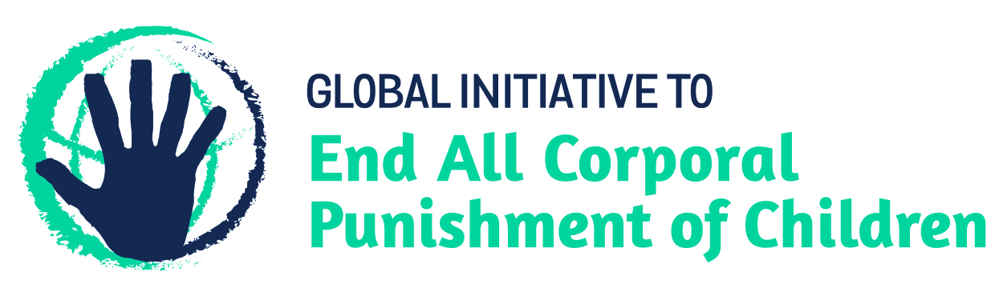
Ending family violence in Kazakhstan – challenging physical punishment of girls and boys
Information for the Committee on the Elimination of Discrimination Against Women, Pre-Sessional Working Group for the 74th session,
from the Global Initiative to End All Corporal Punishment of Children (www.endcorporalpunishment.org), January 2019

Introduction: family violence in Kazakhstan and CEDAW’s examination of the fifth state party report
Provisions in the Marriage and Family Code 2011, the Law on the Rights of the Child 2002 and the Law on Prevention of Domestic Violence 2009 provide some protection from family violence, but those provisions and others in domestic legislation are not interpreted as prohibiting all corporal punishment of children.
We hope the Committee on the Elimination of Discrimination Against Women will raise the issue of violent punishment of girls and boys in its examination of Kazakhstan. In particular, we hope the Committee will:
- in its list of issues for Kazakhstan, ask what progress is being made on enacting legislation to prohibit all physical punishment of children, and
- in its concluding observations on the fifth state party report, recommend that Kazakhstan ensure that no form of violence within the domestic sphere is condoned, including by parents against their children, and that legislation is enacted to prohibit domestic violence against all family members, including the violent punishment of girls and boys.

The remainder of this briefing provides the following further details:
- The current law relating to family violence and corporal punishment of children in Kazakhstan.
- Treaty body and UPR recommendations on the issue made to Kazakhstan to date.

1 Laws on domestic violence and corporal punishment of children in Kazakhstan
Summary
1.1 Provisions in the Marriage and Family Code 2011, the Law on the Rights of the Child 2002 and the Law on Prevention of Domestic Violence 2009 provide some protection from family violence, but the law is not interpreted as prohibiting all forms of physical punishment of children.

Detail
1.2 Corporal punishment is lawful in the home. The Government reported to the UN Committee on the Rights of the Child in 2003 that all violence and corporal punishment is prohibited. However, while there is no confirmation in law of a “right” of parents to punish their children, there is no explicit prohibition of all forms of corporal punishment in childrearing. Article 60 of the Marriage and Family Code 2011 states that the child “has the right to be educated by the parents, ensuring its interests, full development and respect for human dignity” (unofficial translation). Article 72 states that in the exercise of parental rights, parents “do not have the right to harm the physical and mental health or moral development of the child” and that “methods of education must exclude neglectful, cruel, brutal or degrading treatment or abuse, humiliation or exploitation”. But it does not explicitly prohibit all corporal punishment, however light.
1.3 The Law on the Rights of the Child 2002 confirms the child’s right to respect for human dignity the state’s obligation to protect the child from physical and mental abuse and cruel, inhuman or degrading treatment (art. 10) and confirms parents’ duty to educate and care for children (art. 24) but does not explicitly prohibit all corporal punishment. Similarly, there is no prohibition of all corporal punishment in childrearing in the Law on Prevention of Domestic Violence 2009 (amended 2014): it defines domestic violence as “an intentional illegal act (action or failure to act) by one person in the sphere of the family and household relations concerning another (others) causing or containing threat of causing of physical and (or) mental suffering” (art. 1(3)) and states that this can take the form of, among other things, physical abuse, defined as “intentional harm to health by use of force and causing of physical pain” (art 4(2)). Neither the Criminal and Executive Code 2014 nor the Code on Administrative Offences 2014 prohibits all corporal punishment in childrearing.
1.4 Prohibition of all violent punishment of children – which is critical in laying the legal foundations for efforts to reduce child abuse and domestic violence – requires an explicit ban in legislation. We hope the Committee will urge the Government of Kazakhstan to enact legislation as a matter of urgency to clearly prohibit all corporal punishment of girls and boys.

2 Recommendations by human right treaty monitoring bodies and during the Universal Periodic Review
2.1 The Committee on the Rights of the Child has on three occasions recommended to Kazakhstan that all corporal punishment of children be prohibited, including in the home – in its concluding observations on the state party’s initial report in 2003, on the second/third report in 2007, and on the fourth report in 2015.
2.2 In 2011, the Human Rights Committee expressed concern at the legality of corporal punishment in the home and foster care and recommended the promotion of non-violent forms of discipline as well as measures to end corporal punishment in schools and institutions.
2.3 Kazakhstan was reviewed in the first cycle of the Universal Periodic Review in 2010. No recommendations were made specifically on corporal punishment of children, but the Government accepted recommendations to further refine laws aimed at protecting children’s rights. In the second cycle review in 2014 the Government accepted a recommendation to criminalise all forms of violence against children including in the family, but stated that this was already implemented.

Briefing prepared by the Global Initiative to End All Corporal Punishment of Children
www.endcorporalpunishment.org; info@endcorporalpunishment.org

24 July 2003, CRC/C/SR. 886, Summary record of 886th meeting, para. 15
10 July 2003, CRC/C/15/Add.213, Concluding observations on initial report, paras. 37 and 39
19 June 2007, CRC/C/KAZ/CO/3, Concluding observations on second/third report paras. 36 and 37
2 October 2015, CRC/C/KAZ/CO/4 Advance Unedited Version, Concluding observations on fourth report, paras. 28 and 29
19 August 2011, CCPR/C/KAZ/CO/1, Concluding observations on initial report, para. 15
23 March 2010, A/HRC/14/10, Report of the working group, paras. 95(9) and 95(44)
10 December 2014, A/HRC/28/10, Report of the working group, para. 124(8)

