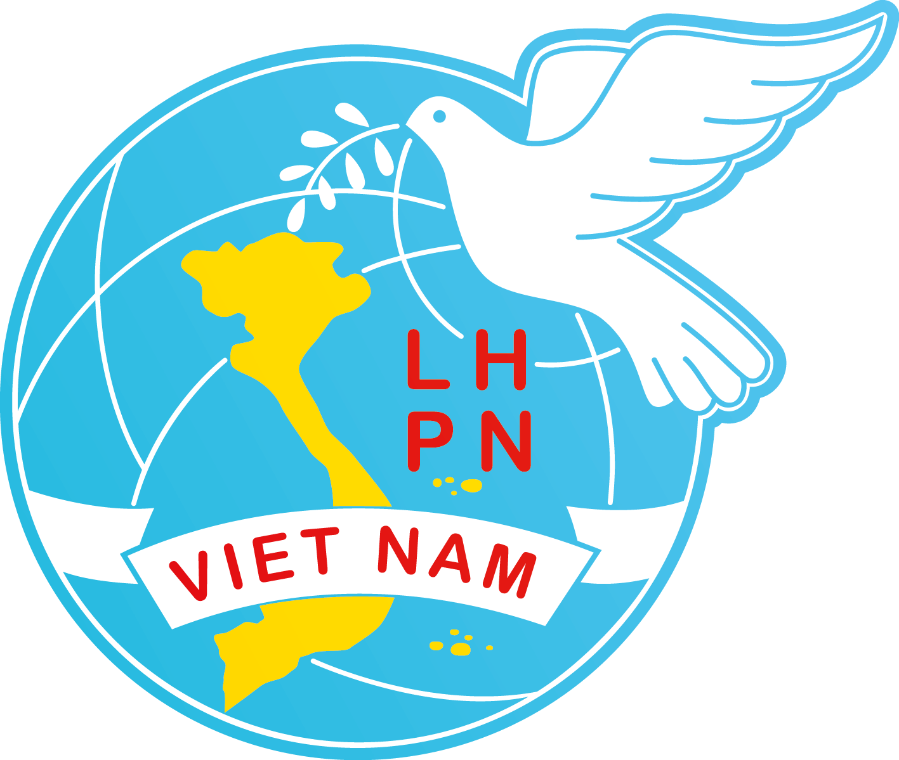 | VIET NAM WOMEN’S UNION  39 Hang Chuoi Street, Hanoi – Viet Nam  Tel: +84 4 39719886; Fax: +84 4 39713143  Website: http://www.hoilhpn.org.vn  Email: vwuebulletin@gmail.com

Hanoi, 28 January. 2019
REPORT ON
ENSURING AND PROMOTING WOMEN’S RIGHTS
(submitted to the Human Rights Committee of the United Nations on the International Covenant on Civil and Political Rights for the consideration of the Third periodic report submitted by Viet Nam (CCPR/C/VNM/3) during the examination of Viet Nam in the 125th Session)

I. GENERAL INTRODUCTION OF THE VIET NAM WOMEN’S UNION
1. The Viet Nam Women’s Union (VWU) is a socio-political organization, representing legal rights and legitimate interests of Vietnamese women across all levels of society. The VWU strives for women’s development and gender equality. The VWU is a member of the Viet Nam Fatherland Front, Women's International Democratic Federation (WIDF) and ASEAN Confederation of Women's Organizations (ACWO). The VWU was founded in 1930 and operates throughout Viet Nam at the central, provincial, district, and commune levels. Currently, the VWU has approximately 17 million members.
Goals: Protecting legal rights and legitimate interests of women; striving for gender equality and women’s development.
Main tasks:
- Providing information, mobilizing, and supporting women in their comprehensive development and building happy families
- Mobilizing and supporting women in business start-ups, economic development and environmental protection
- Building a stronger VWU organization; participating in Party and government building; supervising the implementation of the law and providing social feedback on draft laws and policies; strengthening people-to-people foreign affairs.
II. ACHIEVEMENTS IN ENSURING AND PROMOTING WOMEN’S RIGHTS
2. Women’s Unions (WUs) at all levels have focused on activities that ensure and promote women’s rights in accessing information, improving their capacity and awareness. Our team of communicators and outreach workers has gradually increased, the communication methods increasingly diversified through, for example, direct communication, competitions/contests, awareness campaigns, documentary films, reportages, publications, galleries, exhibitions, building and maintaining women’s bookshelf, communal women’s library and women’s reading room… The VWU has communicated national policies and laws related to women, disseminated scientific, technological knowledge, life skills to the Union’s members and women from different walks of life and applauded outstanding collectives and individuals.
3. To perform its roles in building a rule-of-law state, the VWU has proactively participated in drafting and monitoring the implementation of laws and policies related to gender equality, providing critics and contributing to gender mainstreaming in the laws, codes, legal normative documents.
The VWU has conducted a review of 10 years of implementation of the Politburo Resolution No.11/NQ-TW and advised the Party Secretariat on the issuance of the Directive No.21-CT/TW in 2018 on further promoting women work in the current global and national context (the new factor is that the Directive specifies special and disadvantaged groups of women to be supported with appropriate and effective policies; gives policy orientation to encourage and support women start-ups, establishment of women-owned cooperatives and joint production groups...). The VWU has also reviewed progress of 10-year implementation of the Law on Gender Equality within VWU system in order to propose amendments to the Law.
The VWU has provided inputs to various national, regional and international socio-economic development plans such as the Government Report on the implementation of the national targets on gender equality 2017; One Strategic Plan 2017-2021 between the Government of Viet Nam and the United Nations in Viet Nam (2017); ASEAN Declaration on Gender-Responsive Implementation of ASEAN Community Vision 2025 and Sustainable Development Goals (SDGs) (2018); Viet Nam Report for Voluntary National Review on SDGs Implementation (2018).
The VWU has also been successful in creating a policy mechanism through the development and submission to the Government for approval of the "Communication, education, mobilization and support for women in solving women-related social problems in the 2017-2027 period” project, "Supporting women business start-up in the 2017-2025 period" project; Proposed the Government to integrate VWU campaign of building the family of 5 Without-s and 3 Clean-s (5 without-s: Without poverty, violation of law and social evils, domestic violence, violation of population policies, and having malnourished and school drop-out children; 3 Clean-s: Clean house, kitchen and surrounding streets) into the National Target Program of building new rural areas; Signed a joint program with the Vietnamese Government and Viet Nam Farmer’s Union on promoting the production and trading of safe food and agricultural products for community health in the 2017-2020 period. This is an important policy framework to mobilize social participation and promote women’s role and ownership in solving women-related issues, while creating a mechanism for provincial/municipal WUs to proactively develop their plans to submit to Provincial People’s Committees (PPC) for approval and budget allocation. By the end of 2017, VWU plans for the 2 projects had been approved by the PPCs in 26 provinces/cities; and budget had been allocated from the new rural development program for WU plan implementation in all 63 provinces and cities.
The VWU has provided inputs with a gender perspective approach to 18 draft laws, 7 draft decrees and circulars, and 17 other draft documents, notably the revised Labor Code. A number of the VWU’s recommendations have been reflected and adopted in legal documents such as adding children and domestic violence victims having economic difficulty as recipients of Government legal aid under the Legal Aid Law (2017). WUs at all levels have contributed inputs to 11,397 draft legal documents, plans, socio-economic development programs, and others directly related to women and children; 35 provincial/municipal WUs have proposed 124 policies, programs, and projects related to women. The VWU system has focused on monitoring two areas: First, Government maternity assistance for poor, remote ethnic minority women who give birth in line with national population policy as stipulated in Government Decree No. 39/2015/ ND-CP dated 27 April, 2015; Second, food hygiene and safety. Supervising the implementation of the Decree No. 39/2015/ND-CP shows that seven provinces have not yet allocated budget; two provinces have not yet implemented the decree. The VWU, therefore, has reported and proposed to the Government for guidance.
4. To ensure and promote women’s rights in politics, the VWU has developed its action plan, proactively nominated eligible female candidates to participate in the personnel planning for Party Committees, National Assembly (NA), State, Government, ministries/agencies, and localities. The VWU has participated in political consultations, organized trainings to enhance capacity for female candidates to the NA and People’s Councils at all levels. Women’s participation in political activities has increased quantitatively and qualitatively and its effectiveness has been increasing. In the 2016 – 2021 term, the percentage of women deputies to the 14th NA is 26.72%, which is higher than the two previous terms and the world average (23.6%) and is ranked relatively high in the region. The percentage of the women members of People’s Councils at three levels has increased compared with that of the previous term. Especially, for the first time, Viet Nam has a Chairwoman at the NA.
The VWU, for the first time, established in May 2017 a network of women leaders – members of VWU 12th National Executive Committee who are leaders and managers from different ministries and agencies, aiming at strengthening the connection, promoting experience sharing, and improving the efficiency of coordination between sectors and the VWU, thus contributing to improving the quality of female leaders’ participation in politics as well as VWU performance.
5. To promote women’s rights in the economic, labor and employment areas, the VWU has focused on rolling out the “Supporting women business start-up in the 2017 – 2025 period” project, which focuses on communication, training on business start-up, competitions for innovative ideas and loan provisions for implementation of such ideas. In this regard, special attention has been paid to communication and training on business start-ups for ethnic minority women. The budget allocated for assisting women business start-ups at the Central level for the last two years has reached VND 16 billion.
The VWU has continued to setup and replicate poverty reduction models; provide loans, knowledge, breeding plants and animals; and create jobs for women. Poor and rural women are supported in accessing credit.
The total loan outstanding from different sources by June 30, 2017 had reached VND80,000 billion (more than US$3.5 billion). From 2016 to June 30, 2017, nearly two million women’s households had been provided with loans and other forms of support such as capacity building, work days, animals breeding and so on.
Currently, the VWU has 35 vocational training establishments nationwide. Vocational training is conducted not only at these premises but also in mobile classes with a priority given to rural and disadvantaged women. From 2016 to June 30, 2017, the VWU at all levels had provided communication, job counseling, organized and co-organized trainings for roughly 100,000 female workers in different localities.
6. The VWU has also paid due attention to ensuring and promoting women’s rights in building happy and sustainable families. The models of home daycare, transporting children to and from school, elderly care and domestic help services have been being piloted. New models on family and marriage counseling and support, and prevention of and combat against domestic violence have been implemented. Through the “Supporting and developing private daycare services in industrial, export and processing zones until 2020” project, the VWU has set-up 283 private daycare establishments, surpassing the set target by 83. WUs at local levels have reviewed and improved the operation of community-based trusted addresses to support victims, organized communication activities on domestic violence prevention and control, and enhanced capacity for VWU staff on gender equality and domestic violence prevention and control. The Central VWU sustains the model of “Peace Houses” shelter to support women - victims of domestic violence or human trafficking, while strengthening the information gathering, raising stronger voice and supporting women and children victims of physical and sexual violence and abuse in a number of cases.
7. The VWU has carried out many activities to ensure and promote the rights of ethnic minority women in difficult areas and women of other disadvantaged groups.
Most border areas, where the ethnic minorities live, are mountainous and remote with economic disadvantages. Therefore, the VWU has supported women in these localities by launching a special campaign “Sharing with and supporting women in border communes” for the 2018 – 2020 period, aiming at mobilizing social resources to support WUs, the Union’s members and women in 110 most underprivileged border communes for poverty reduction and economic development through the construction of social welfare facilities; providing scholarships; free health check-ups and medication; upgrading working facilities and supporting to improve the performance of WU in these communes; presenting gifts, etc. Ten months after the launch, more than VND 37 billion has been mobilized including over VND 1.4 billion raised in collaboration with the Viet Nam Red Cross Society through the text massage system.
To support people at high risk of getting infected or living with HIV/AIDS, women and children who are returned victims of trafficking, the “Centers for supporting disadvantaged women and providing legal counseling” in different provinces/cities have paid visits to, provided counseling, psychological support, health care, vocational training, and job creation and placement to the target groups. For the first half of 2017, more than 300 victims of human trafficking have been rescued and received, over 60 percent of which have been supported to reintegrate into the community. To help vulnerable women to settle down and be reintegrated into the community, the VWU has built up many intervention models such as Clubs on trafficking in women and children prevention and combat; Club on social evils prevention and control; Happy family Club; Women and legislation Club etc., attracting the participation of many families and the community. The VWU has also implemented many activities to support Agent Orange victims, particularly women and children such as visiting, encouraging, presenting gifts, distributing free medicines, launching movements to support the victims, actively raising voice to seek support at international forums and events, and raising funds from international organizations for community-based projects and initiatives to support this target group.
For the last two years, WUs at provincial level have mobilized social resources to build 7,363 affection houses for poor women. Nearly VND 650 billion has also been raised by VWU at different levels to support victims of natural disasters and for charity and humanitarian activities.
8. Strengths and advantages for the Union to carry out its activities in promoting women’s rights and gender equality:
- Adequate legal system: The Constitution and laws have regulations on gender equality and VWU status and roles;
- The Government has provided care and support through the policy system and resources allocation;
- Social awareness on gender equality and women’s status and roles has been increased in parallel with improved living standards;
- VWU network of 4 levels nationwide and its staff’s enthusiasm and commitment.
9. Challenges to gender equality persist, such as:
+ Domestic violence, abuse of and trafficking in women and children are still taking place with complexity; the family education has not been paid due attention to.
+ Rural women, ethnic minority women and disadvantaged women (poor women, women with disabilities, single women, etc.) have limited access to information technology, education and healthcare services; few opportunities of studying, vocational training, and capacity building. They have not met requirements of the period of national industrialization and modernization, and international integration.
+ Despite their high share in the labor force, women mainly work as low-skilled and manual laborers with lower wage compared to their male counterparts. Some enterprises attempt to terminate the labor contract with workers aged over 35 – a trend in which the rate of women sufferers is increasing, particularly in labor intensive and female-dominated sectors and industries. Women’s participation in high-skilled jobs and leadership and managerial positions is disproportionate to their capacity, potential, strengths and the development of female human resources.
+ Gender gaps exist in vocational training and wage. The rate of trained female workers has been increased from 17.3% in 2015 to 18% in 2016 but is still lower than that of trained male workers (22.4% and 23% respectively). The monthly average wage of men is 10.7% higher than that of women. The gender pay gap is present in every profession and tends to be widened in highly technical professions.
+ A gap in access to reproductive healthcare services between rural and urban women needs to be addressed.
+ There are challenges in collecting gender-disaggregated statistics which leads to the lack of necessary and reliable data for gender analysis and mainstreaming, and policy making.
+ There is a lack of policies to support women working in the informal sector.
ON BEHALF OF VWU PRESIDIUM

VICE PRESIDENT

(Signed)

Bui Thi Hoa

Loans from the Viet Nam Bank for Social Policies, Viet Nam Bank for Agriculture and Rural Development and VWU microfinance programs.
In 2017 alone, the Peace House Shelter received 267 women victims
Source: Government Report on the implementation of the national targets on gender equality 2017

