Country Policy and Information Note

Iraq: Security and humanitarian situation

Version 5.0
November 2018

Preface
Purpose
This note provides country of origin information (COI) and analysis of COI for use by Home Office decision makers handling particular types of protection and human rights claims (as set out in the basis of claim section). It is not intended to be an exhaustive survey of a particular subject or theme.
It is split into two main sections: (1) analysis and assessment of COI and other evidence; and (2) COI. These are explained in more detail below.

Assessment
This section analyses the evidence relevant to this note – i.e. the COI section; refugee/human rights laws and policies; and applicable caselaw – by describing this and its inter-relationships, and provides an assessment on whether, in general:
- A person is reasonably likely to face a real risk of persecution or serious harm
- A person is able to obtain protection from the state (or quasi state bodies)
- A person is reasonably able to relocate within a country or territory
- Claims are likely to justify granting asylum, humanitarian protection or other form of leave, and
- If a claim is refused, it is likely or unlikely to be certifiable as ‘clearly unfounded’ under section 94 of the Nationality, Immigration and Asylum Act 2002.
Decision makers must, however, still consider all claims on an individual basis, taking into account each case’s specific facts.

Country of origin information
The country information in this note has been carefully selected in accordance with the general principles of COI research as set out in the Common EU [European Union] Guidelines for Processing Country of Origin Information (COI), dated April 2008, and the Austrian Centre for Country of Origin and Asylum Research and Documentation’s (ACCORD), Researching Country Origin Information – Training Manual, 2013. Namely, taking into account the COI’s relevance, reliability, accuracy, balance, currency, transparency and traceability.
The structure and content of the country information section follows a terms of reference which sets out the general and specific topics relevant to this note.
All information included in the note was published or made publicly available on or before the ‘cut-off’ date(s) in the country information section. Any event taking place or report/article published after these date(s) is not included.
All information is publicly accessible or can be made publicly available, and is from generally reliable sources. Sources and the information they provide are carefully considered before inclusion.
Factors relevant to the assessment of the reliability of sources and information include:
- the motivation, purpose, knowledge and experience of the source
- how the information was obtained, including specific methodologies used
- the currency and detail of information, and
- whether the COI is consistent with and/or corroborated by other sources.
Multiple sourcing is used to ensure that the information is accurate, balanced and corroborated, so that a comprehensive and up-to-date picture at the time of publication is provided of the issues relevant to this note.
Information is compared and contrasted, whenever possible, to provide a range of views and opinions. The inclusion of a source, however, is not an endorsement of it or any view(s) expressed.
Each piece of information is referenced in a brief footnote; full details of all sources cited and consulted in compiling the note are listed alphabetically in the bibliography.

Feedback
Our goal is to continuously improve our material. Therefore, if you would like to comment on this note, please email the Country Policy and Information Team.

Independent Advisory Group on Country Information
The Independent Advisory Group on Country Information (IAGCI) was set up in March 2009 by the Independent Chief Inspector of Borders and Immigration to support him in reviewing the efficiency, effectiveness and consistency of approach of COI produced by the Home Office.
The IAGCI welcomes feedback on the Home Office’s COI material. It is not the function of the IAGCI to endorse any Home Office material, procedures or policy. The IAGCI may be contacted at:
Independent Advisory Group on Country Information
Independent Chief Inspector of Borders and Immigration
5th Floor
Globe House
89 Eccleston Square
London, SW1V 1PN
Email: chiefinspector@icinspector.gov.uk
Information about the IAGCI’s work and a list of the documents which have been reviewed by the IAGCI can be found on the Independent Chief Inspector‘s pages of the gov.uk website.

Contents
Assessment 6
1. Introduction 6
1.1 Basis of claim 6
1.2 Points to note 6
2. Consideration of issues 6
2.1 Credibility 6
2.2 Exclusion 7
2.3 Assessment of risk 7
2.4 Internal relocation 12
2.5 Certification 13
Country Information 14
3. Demography 14
4. Conflict in Iraq: 2003 to present 15
5. Protagonists 15
5.1 Iraqi Army 15
5.2 Kurdish Peshmerga 15
5.3 Daesh 17
5.4 Other Sunni anti-government groups 17
5.5 Shia militia and Popular Mobilization Units (PMUs) 17
6. Humanitarian situation 18
6.1 General living standards and conditions 18
6.2 Numbers and profile of people in need 19
6.3 Location of people in need 20
6.4 Severity of need by location 20
6.5 Vulnerable groups 21
6.6 Numbers of Internally Displaced Persons (IDPs) 21
6.7 Origin and location of IDPs 22
6.8 Shelter types of IDPs 23
6.9 Numbers of returnees and places of return 23
6.10 Prevented returns 25
6.11 Conditions in places of return 25
6.12 Employment and financial security 28
6.13 Food security 29
6.14 Health and healthcare 29
6.15 Water, sanitation and hygiene (WASH) 30
6.16 Education 30
6.17 Evictions 30
7. Humanitarian support 31
7.1 UN Humanitarian Response Plan 31
7.2 Numbers and reach of humanitarian partners 32
7.3 Numbers and profile of people targeted for assistance 34
7.4 Public Distribution System (PDS) 34
7.5 Effectiveness of humanitarian support 35
7.6 Effectiveness of humanitarian support: Mosul 36
8. Security situation 37
8.1 Overview: the war against Daesh (Islamic State) 37
8.2 Overview: situation in the ‘Baghdad Belt’ 39
8.3 Overview: situation in the ‘disputed’ areas 40
8.4 Control of territory 42
8.5 Security incidents 43
8.6 Civilian fatalities 44
8.7 Civilian injuries 45
8.8 Nature of violence 46
8.9 Impact on vulnerable groups 46
Annex A: Map of Iraq 47
Terms of reference 48
Bibliography 50
Version control and contacts 55

Assessment
Updated: 16 November 2018

Introduction

Basis of claim
    - That the general humanitarian situation in Iraq is so severe as to make removal to this country a breach of Articles 15(a) and (b) of the European Council Directive 2004/83/EC of 29 April 2014 (the Qualification Directive)/ Articles 2 and 3 of the European Convention on Human Rights (ECHR); and/or
    - That the security situation in Iraq presents a real risk to a civilian’s life or person such that removal to this country would be in breach of Article 15(c) of the Qualification Directive (serious and individual threat to a civilian’s life or person by reason of indiscriminate violence).
Back to Contents

Points to note
    - Previous Home Office assessments of the security situation in Iraq had differentiated the ‘contested’ and ‘non-contested’ areas of the country. The:
- ‘contested’ areas were Anbar, Diyala, Kirkuk (aka Tam’in), Ninewah and Salah al-Din governorates; and
- ‘non-contested’ areas were Baghdad governorate, ‘the south’ (Babil, Basra, Kerbala, Missan, Muthanna, Najaf, Qaddisiyah, Thi-Qar and Wasit governorates) and the Kurdistan Region of Iraq (KRI) (Dohuk, Erbil, Halabja and Sulamaniyah governorates).
    - However, the security situation has changed since these definitions were first used and no longer reflects the security situation on the ground (see Security situation).
    - Furthermore, sources sometimes refer to ‘contested’ (or ‘disputed’) areas as the areas where sovereignty or control is disputed between the Government of Iraq (GoI) and the Kurdistan Regional Government (KRG). Therefore, to avoid any confusion, the ‘contested’ and ‘non-contested’ definitions in the context of the security situation in Iraq will no longer be used.
Back to Contents

Consideration of issues

Credibility
    - For guidance on assessing credibility, see the Asylum Instruction on Assessing Credibility and Refugee Status.
    - Decision makers must also check if there has been a previous application for a UK visa or another form of leave. Asylum applications matched to visas should be investigated prior to the asylum interview (see the Asylum Instruction on Visa Matches, Asylum Claims from UK Visa Applicants).
    - Decision makers should also consider the need to conduct language analysis testing (see the Asylum Instruction on Language Analysis).

Back to Contents

Exclusion
    - Various groups have been responsible for serious human rights abuses (see Protagonists). If it is accepted that the person has been involved with such a group then decision makers must consider whether one (or more) of the exclusion clauses is applicable. Decision makers must nevertheless consider each case on its individual facts and merits.
    - For further guidance on the exclusion clauses and restricted leave, see the Asylum Instruction on Exclusion: Article 1F of the Refugee Convention and the Asylum Instruction on Restricted Leave.
Back to Contents

Assessment of risk

Refugee Convention
    - Decision makers must first consider if the person faces persecution for a Refugee Convention reason noting that a state of civil instability and/or where law and order has broken down does not of itself give rise to a well-founded fear of persecution for a Convention reason.
Back to Contents
b. Humanitarian Protection
    - Where the person qualifies under the Refugee Convention, decision makers do not need to go on to assess the need for Humanitarian Protection. It is only if the person does not qualify under the Refugee Convention that decision makers need to assess the need for protection firstly under Articles 15(a) and (b) of the Qualification Directive/Articles 2 and 3 of the European Convention on Human Rights (ECHR) and, if that is unsuccessful, under Article 15(c) of the Qualification Directive.
    - For general guidance on Humanitarian Protection (HP), see the Asylum Instruction on Humanitarian Protection.
Back to Contents

c. Humanitarian situation
    - A person may claim that the state of his or her documentation means that they cannot access support. For information and assessment on documentation matters, see the country policy and information note on Iraq: internal relocation, civil documentation and returns
    - In February 2018, the UN Office for the Coordination of Humanitarian Affairs (OCHA) assessed that 8.7 million people needed humanitarian support, down from 10 million in January 2017 (this number represents the ‘aggregate’ rather than the ‘absolute’ number – a person may be counted more than once if they have multiple needs) (see Numbers and profile of people in need).
    - 80% of those in humanitarian need are in Ninewah, Kirkuk and Anbar (46% are in Ninewah alone). Needs are also concentrated in the Kurdistan Region of Iraq, which hosts 30% of all Internally Displaced Persons (IDPs) (see Location of people in need and Location of IDPs). Needs are at their most severe in Ninewah (see Severity of need by location).
    - Of those in humanitarian need there are some groups who are particularly vulnerable, including children, women, the elderly and ‘highly vulnerable residents’ (families living in camps and substandard accommodation) (see Vulnerable groups).
    - Food, employment and medical care are the top three humanitarian needs in nearly all governorates (see Employment and financial security, Food security, Health and healthcare, Water, sanitation and hygiene (WASH) and Education).
    - As of August 2018, the International Organisation of Migration (IOM) estimated that nearly 1.9 million civilians were displaced, the lowest figure since November 2014 (see Numbers of Internally Displaced Persons (IDPs)). 61% of IDPs live in private dwellings, 29% in camps and 9% in ‘critical shelters’. The experiences of IDPs varies by location; for example, in Ninewah and Dohuk nearly half of IDPs live in camps (see Shelter types of IDPs).
    - According to the IOM, as of August 2018 nearly 4 million people have returned to their home areas, a continuing upward trend, particularly to Ninewah, Anbar, Salah al-Din and Kirkuk, explained by improvements in the security situation, although there is some secondary displacement. Return trends are stable in Baghdad, Diyala and Erbil. The vast majority of returnees have gone back to their old homes (see Numbers of returnees and places of return).
    - The UN High Commissioner for Refugees (UNHCR) reported that government-affiliated armed groups and members of the community prevented some IDPs, particularly from Anbar and Ninewah, from returning to their homes because of their suspected Daesh affiliation (see Prevented returns).
    - Ninewah and Dohuk host more IDPs than any other individual governorates (see Location of IDPs). Most IDPs originate from Anbar, Ninewah and, most recently, Kirkuk (reflecting the displacement of Kurds following the re-taking of the governorate by the Iraqi authorities in response to the Kurdish independence referendum in September 2017) (see Origin of IDPs). The experiences of IDPs vary depending on location, shelter types and priority needs, as well as their individual circumstances. 61% of IDPs live in private dwellings, 29% in camps (mainly in Ninewah and Dohuk) and 9% in ‘critical shelters’ (mainly in Salah al Din, Dohuk and Ninewah) (see Shelter types of IDPs).
    - Returnees may face explosive hazards, substandard accommodation and deteriorating public services. The World Bank estimates that it will take at least a decade to rebuild parts of Iraq. However, some rebuilding of affected areas is now taking place (see Conditions in places of return).
    - In the Country Guidance case of AA (Article 15(c)) (Rev 1) Iraq CG [2015] UKUT 544 (IAC) (30 September 2015), heard on 18-19 May 2015, the Upper Tribunal found that there is evidence of ‘numerous organisations operating in Baghdad that provide assistance to displaced persons’ (paragraph 200).
    - However, since 2015 the international humanitarian response has contracted significantly overall, although it has expanded into some areas as Anbar, Kirkuk, Ninewah and Salah al-Din have become newly accessible. Support efforts concentrate on the most vulnerable. Efforts in Mosul have been significant, with a million people now being helped in the city (see UN Humanitarian Response Plan, Numbers and reach of humanitarian partners and Effectiveness of international support: Mosul).
    - There are some gaps in humanitarian assistance. The UN Humanitarian Response Plan has targeted about 40% of those in humanitarian need. REACH reported that the vast majority of returnee and host community households in accessible areas reported that they have not received humanitarian assistance (although this does not mean that all of those who reported this have been defined as those needing such assistance) (see Numbers and profile of people targeted for assistance and Effectiveness of international support).
    - There is a nationwide Government programme, the Public Distribution System (PDS), which subsidies food and fuel. Those in camps access the system more regularly than those outside of camps. Of the non-displaced population, access to the system varies between governorates (9% of people have accessed the system in Salah al-Din; it is 100% in Najaf for example). In Kirkuk, most non-displaced people do not have access to the system. A large majority who access this service receive half rations (see Public Distribution System (PDS)).
    - The humanitarian situation is serious, but, according to the UN, no longer one of the ‘most complex and challenging humanitarian emergencies’ (see General living standards and conditions).
    - In general, the humanitarian situation is not so severe that a person is likely to face a breach of Articles 15(a) and (b) of the Qualification Directive / Articles 2 and 3 of the ECHR, requiring a grant of Humanitarian Protection (HP). However, decision makers must consider each case on its merits. There may be cases where a combination of circumstances means that a person will face a breach of Articles 15(a) and/or (b) of the Qualification Directive/Articles 2 and 3 of the ECHR on return. In assessing whether an individual case reaches this threshold, decision makers must consider:
- where the person is from (as humanitarian conditions are more severe in some areas than others, and this may also impact on whether the person becomes an IDP on return, if they were not already prior to leaving the country);
- a person’s individual profile and circumstances, including, but not limited to, their age, gender and ethnicity;
- whether the person can access a support network.
Back to Contents

Security situation
    - An assessment of protection needs under Article 15(c) of the Qualification Directive must only take place if a claimant is unable to establish a need for refugee protection or subsidiary protection under Article 15(a) or 15(b).
    - A claim for protection based on indiscriminate violence must be assessed by applying the test set out in (QD (Iraq) v SSHD [2009] EWCA Civ 620): “Is there in [country] or a material part of it such a high level of indiscriminate violence that substantial grounds exist for believing that an applicant would, solely by being present there, face a real risk which threatens their life or person?”
    - Civilians must be genuine non-combatants and not those who are party to the conflict. Civilian status could extend to former combatants who have genuinely and permanently renounced armed activity.
    - For further guidance on the application of Article 15(c) of the Qualification Directive, see the Asylum Instruction on Humanitarian Protection.
    - In AA, the Upper Tribunal found, based on evidence up to May 2015, that the degree of armed conflict in Iraq did engage Article 15(c) in:
- Anbar
- Diyala
- Kirkuk (aka Tam’in)
- Ninewah
- Salah al-Din; and
- the parts of the ‘Baghdad Belt(s)’ (the urban environs around Baghdad City) that border Anbar, Diyala and Salah al-Din (paragraph 204).
    - The Upper Tribunal, in BA (Returns to Baghdad) Iraq CG [2017] UKUT 18 (IAC) (23 January 2017), heard on 24-25 August 2016, reaffirmed that conditions in Baghdad (city) do not breach Article 15(c): ‘The level of general violence in Baghdad city remains significant, but the current evidence does not justify departing from the conclusions of the Tribunal in [AA]’ (paragraph 107 (i)). BA considered violence in Baghdad only; it did not consider violence in other parts of Iraq.
    - The Upper Tribunal in AA found that the list of factors relevant to whether an area engaged Article 15(c) is ‘non-exhaustive’ but includes:
- the conduct, and relevant strength, of the parties to the conflict;
- the number of civilian deaths and injuries, including psychological injuries caused by the conflict;
- levels of displacement; and
- the geographical scope of the conflict (paragraph 89).
    - However, the security situation has changed significantly since May 2015, the point up to which AA considered evidence.
    - Iraq is still the scene of internal armed conflict. The Government maintains counterinsurgency operations against Daesh (Islamic State), the Sunni insurgency group, who continue to launch sporadic attacks, including on civilians, for example in Hawija, Diyala and Salah al-Din (see Overview: the war against Daesh (Islamic State)).
    - The nature of much of the violence affects civilians indiscriminately, with Improvised Explosive Devices (IEDs) and shootings the most common forms of violence (see Nature of violence).
    - However, since 2015, Daesh’s territorial control has collapsed and their operational capability has significantly degraded. The Iraqi government officially declared victory against Daesh in December 2017. The threat from Daesh has not disappeared entirely, but the group are confined to small pockets and the conflict has changed in nature from open conflict to periodic assymetric attacks by Daesh in Anbar, Baghdad, Diyala, Kirkuk, Ninewah and Salah al Din (see Overview: the war against Daesh (Islamic State)).
    - Iraqi Security Forces (ISF), the Shia militia Popular Mobilisation Units (PMUs) (aka Hashd al Shabi) and the Kurdish Peshmerga have re-established control over most of Iraq’s territory (see Control of territory).
    - Since 2014, security incidents, fatalities and injuries have significantly declined across all governorates. The number of security incidents are at the lowest for fifteen years. Since the summer of 2014, when Daesh captured Mosul (Iraq’s second-biggest city), the six governorates worst affected by violence – Anbar, Baghdad, Diyala, Kirkuk, Ninewah and Salah al-Din – have overall seen consistent and significant decline in security incidents and civilian fatalities and injuries; the current numbers are typically tens of times lower than they were in mid-2014 (see Security incidents, Civilian fatalities and Civilian injuries).
    - Since 2015 displacement has significantly declined and there has been a significant increase in people returning to their homes (see Number of Internally Displaced Persons (IDPs) and Numbers of returnees and places of return).
    - The Court of Appeal, in the case of SG (Iraq) v Secretary of State for the Home Department [2012] EWCA Civ 940 (13 July 2012), heard on 20-21 June 2012, found that ‘decision makers and tribunal judges are required to take Country Guidance determination into account, and to follow them unless very strong grounds supported by cogent evidence, are adduced justifying their not doing so’ (paragraph 47).
    - For the reasons given above, there are strong grounds supported by cogent evidence to depart from AA’s assessment that any areas of Iraq engage the high threshold of Article 15(c). This is not to say that the security situation is no longer serious; it is that there is no longer a high level indiscriminate violence anywhere in Iraq such that substantial grounds exist for believing that an applicant would, solely by being present there, face a real risk which threatens their life or person.
    - Even though there is no longer a general Article 15(c) risk, decision makers must consider whether the person has any circumstances which might nevertheless place them at such risk.
    - For general guidance on assessing risk, see Asylum Instruction on Assessing Credibility and Refugee Status and for guidance on Article 15(c), including consideration of enhanced risk factors, see the Asylum Instruction on Humanitarian Protection.
Back to Contents

Internal relocation
a. General
    - For further information and guidance, see the country policy and information note on internal relocation, civil documentation and returns
Back to Contents
b. Kurdistan Region of Iraq (KRI)
    - In the Country Guidance case AAH (Iraqi Kurds - internal relocation) (CG) [2018] UKUT 212 (IAC) (26 June 2018), heard on 27-28 February 2018 (hereafter ‘AAH Iraq’), the Upper Tribunal (UT) of the Immigration and Asylum Chamber (IAC) examined the humanitarian situation in the KRI and specific findings about internal relocation. The UT found:
‘If … [a person] has family members living in the IKR [Iraqi Kurdistan Region] cultural norms would require that family to accommodate … [the person]. In such circumstances … [a person] would, in general, have sufficient assistance from the family so as to lead a 'relatively normal life', which would not be unduly harsh. It is nevertheless important for decision-makers to determine the extent of any assistance likely to be provided by … [a person’s] family on a case by case basis.’ (paragraph 135 (8))
    - The UT in AAH further found:
‘For those without the assistance of family in the IKR [Iraqi Kurdish Region] the accommodation options are limited:
(i) Absent special circumstances it is not reasonably likely that … [a person] will be able to gain access to one of the refugee camps in the IKR; these camps are already extremely overcrowded and are closed to newcomers. 64% of IDPs are accommodated in private settings with the vast majority living with family members;
(ii) If … [a person] cannot live with a family member, apartments in a modern block in a new neighbourhood are available for rent at a cost of between $300 and $400 per month;
(iii) [A person] … could resort to a 'critical shelter arrangement', living in an unfinished or abandoned structure, makeshift shelter, tent, mosque, church or squatting in a government building. It would be unduly harsh to require … [a person] to relocate to the IKR if … [the person] will live in a critical housing shelter without access to basic necessities such as food, clean water and clothing;
(iv) In considering whether … [a person] would be able to access basic necessities, account must be taken of the fact that failed asylum seekers are entitled to apply for a grant under the Voluntary Returns Scheme, which could give … [a person] access to £1500. Consideration should also be given to whether … [a person] can obtain financial support from other sources such as (a) employment, (b) remittances from relatives abroad, (c) the availability of ad hoc charity or by being able to access PDS rations.’ (paragraph 135 (9))
    - The UT in AAH also found:
‘Whether … [a person] is able to secure employment must be assessed on a case-by-case basis taking the following matters into account:
(i) Gender. Lone women are very unlikely to be able to secure legitimate employment;
(ii) The unemployment rate for Iraqi IDPs living in the IKR is 70%;
(iii) [A person] … cannot work without a CSID [Civil Status ID];
(iv) Patronage and nepotism continue to be important factors in securing employment. A returnee with family connections to the region will have a significant advantage in that he would ordinarily be able to call upon those contacts to make introductions to prospective employers and to vouch for him;
(v) Skills, education and experience. Unskilled workers are at the greatest disadvantage, with the decline in the construction industry reducing the number of labouring jobs available;
(vi) If … [a person] is from an area with a marked association with ISIL, that may deter prospective employers.’ (paragraph 135 (10))
    - For general guidance on internal relocation, see the Asylum Instruction on Assessing Credibility and Refugee Status.
Back to Contents

Certification
    - Where a claim is refused, it is unlikely to be certifiable as ‘clearly unfounded’ under section 94 of the Nationality, Immigration and Asylum Act 2002.
    - For guidance on certification, see the Certification of Protection and Human Rights claims under section 94 of the Nationality, Immigration and Asylum Act 2002 (clearly unfounded claims).

Country Information
Updated 5 November 2018

Demography
    - The US Central Intelligence Agency (CIA) estimated the population at 39.2 million in July 2017.
    - The Iraqi Central Statistical Organisation (CSO)’s Annual Statistical Abstract for 2017 produced projected population figures per governorate:
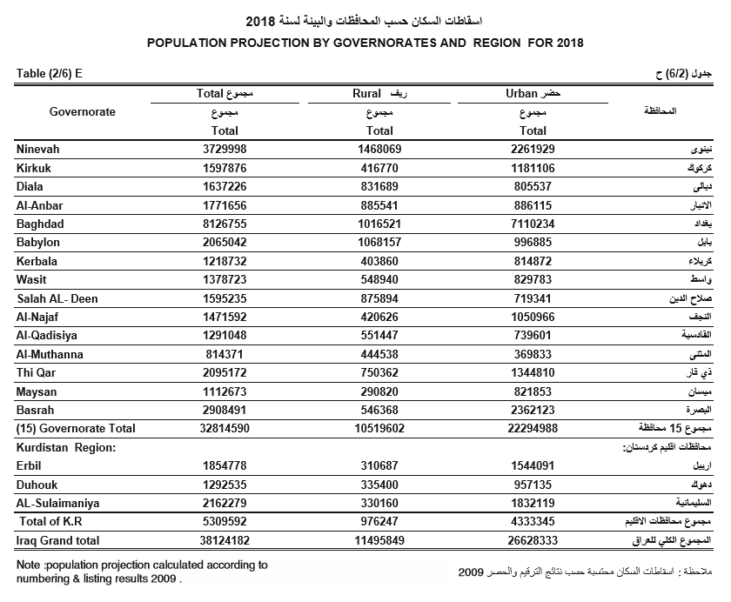
    - Iraq is due to have a census every ten years but it has been continually postponed because of the violence in the country; the last official census was held in 1987, which showed a population of just over 16 million.
    - See Annex A for a map of Iraq.
Back to Contents

Conflict in Iraq: 2003 to present
    - To see how the conflict has evolved, see the BBC’s timeline of events.
Back to Contents

Protagonists

Iraqi Army
    - Jane’s by IHS Markit, in a briefing updated 11 June 2018, explained:
‘Founded in 2003 by the Coalition Provisional Authority (CPA) to replace the Saddam-era military, the Iraqi Army (IA) has been tasked with ensuring the territorial integrity of the state as well as to combat any internal insurgencies that arise. However, the force has been severely tested since its establishment, initially proving ineffective at conducting COIN [counter-insurgency] operations in 2013 and incapable of effectively defending Iraqi borders in 2014 with the invasion of Islamic State militants. Since the nadir reached in the wake of the Islamic State advance, the IA and security services slowly gained momentum in successive operations against the militant group, wresting strategic terrain from the Islamic State until capturing the last urban population centres in late 2017. The IA and Iraqi security forces formally declared the war with Islamic State concluded in December 2017 after capturing the final bastion of Islamic State-held territory along the Iraqi-Syrian border.
‘The campaign has undoubtedly reshaped many aspects of IA doctrine, as well as modifying the force's current and future procurement priorities…’
    - Jane’s noted that the Iraqi Army numbered 195,000, with the ‘primary combat units’ consisting of one armoured division and 13 infantry divisions. The source noted: ‘Due to recent conflict, figures for active personnel strength are unlikely to accurately reflect current strength. Figure does not include Kurdish Peshmerga or Popular Mobilization Units, nor the Iraqi Counter Terrorism Service of the Ministry of the Interior.’
Back to Contents

Kurdish Peshmerga
    - The Peshmerga are the armed units of the Kurdistan Democratic Party (KDP) and the Patriotic Union of Kurdistan (PUK), formed to resist the central government in Baghdad.
    - A 2015 report on the Kurds by the Austrian Federal Ministry of the Interior commented:
‘In 2009 the KDP and the PUK created the Ministry of Peshmerga Affairs whose aim was to centralize administrative tasks and establish joint KDP-PUK brigades commanded by officers graduated from a military academy. However, the new ministry was not able to fulfill its tasks against the partisan politicians due to the lack of political support. Thus when the Iraqi-Kurdish region was confronted with the emergence of IS [Islamic State – Daesh], the Peshmerga forces were not a unified army at all.’
    - Jane’s commented:
‘With the invasion of the Islamic State in 2014, the largely independent security apparatus of the autonomous KRG [Kurdistan Regional Government] coalesced to form defensive forces to defend the Kurdish population within the Kurdistan Region of Iraq (KRI) from the encroachment of Islamic State militants. Offensives against the Islamic State from 2014 to 2017 allowed the Peshmerga to recapture territory outside of the borders of the KRI, including territory along Iraq's northern border with Syria as well as the oil-rich territory surrounding Kirkuk.
‘The Peshmerga is primarily constituted of two factions, each aligned with the major political parties in the KRI, the KDP, and the PUK. The disposition of the forces is largely defined along geographical boundaries, with the KDP being responsible for territory in the northern portion of the KRI abutting the Syrian border, while the PUK controlled areas in the south of the KRI, along Iraq's northeastern border with Iran.
‘This security forces collectively received training and support from external states in an effort enable counter-offensives to be conducted in territory seized by the Islamic State. The United States established training operations in 2015 and would later equip two light infantry brigades and two artillery battalions…
‘The future of the Peshmerga in the security apparatus of the Iraqi state remains in question after the KRG held a referendum for independence in September 2017. Peshmerga forces consisting of elements of the KDP and the PUK withdrew from areas in the vicinity of Kirkuk in the face of advancing Iraqi federal forces, following an Iraqi government demand that all military and civil infrastructure be handed over in October 2017.’
    - The 2017 USSD’s human rights report noted:
‘The two main Kurdish parties, the KDP and PUK, had their own security apparatuses. Under the federal constitution, the KRG has the right to maintain internal security forces, supported financially by the federal government but under the KRG’s operational control. Accordingly, the KRG’s Ministry of Peshmerga Affairs oversees 14 infantry brigades and two support brigades, but the PUK and KDP controlled tens of thousands of additional military personnel, including militia forces generally referred to as the Peshmerga 70s and 80s brigades.’
Back to Contents

Daesh
    - Daesh are also known as Islamic State (IS), ISIS (Islamic State of Iraq and Syria) or ISIL (Islamic State of Iraq and the Levant). Daesh is the name used by the UK Government.
    - Daesh are an Islamic jihadist insurgent group which emerged from al-Qaeda in Iraq (AQI). In December 2013 the group took control of Fallujah before capturing Mosul, Iraq’s third-biggest city, in June 2014, advanced towards Baghdad and declared the creation of an Islamic Caliphate. However, since then Daesh suffered setbacks as Iraqi government forces and their allies regained control of territory (see Control of territory). For further background see the BBC profile on Daesh.
    - In July 2018, the UN Security Council reported:
‘Some Member States estimate the total current ISIL [Daesh] membership in Iraq and the Syrian Arab Republic to be between 20,000 and 30,000 individuals, roughly equally distributed between the two countries. Among these is still a significant component of the many thousands of active foreign terrorist fighters … It seems likely that a reduced, covert version of the ISIL core will survive in Iraq.’
See: Overview: the war against Daesh (Islamic State)
Back to Contents

Other Sunni anti-government groups
    - Although Daesh are the main insurgent group in Iraq, other Sunni anti-government groups included Jaysh Rijal-al Tariqah al-Naqshabandia (JRTN); the General Military Council of Iraqi Revolutionaries and Ansar al-Islam. For further information, see the country policy and information note on Ba’athists.
Back to Contents

Shia militia and Popular Mobilization Units (PMUs)
    - There are also Shia militias operating in Iraq. A March 2016 Congressional Research Service report stated that estimates of the total Shia militiamen in Iraq number about 110,000-120,000. The main armed Shia groups operating in Iraq are the Badr Brigades, Asa’ib Ahl al-Haq (AAH) and Kata’ib Hizbullah. For further information on the Shia militia, see the Iraq country policy and information note on Sunni (Arab) Muslims.
    - Jane’s commented on the Popular Mobilization Units (PMUs):
‘Organised in the immediate wake of the invasion by the Islamic State, Popular Mobilization Units (PMUs) are primarily Shia militias affiliated to particular ethnic or religious leaders. Most are believed to be heavily subsidised and supported by Iran, and the PMUs have become better trained and equipped during the conflict with the Islamic State. The PMUs have been recognised by the state as legitimate security actors and are under the authority of the Ministry of the Interior.
‘In combat operations they are nominally under control of IA commanders but have been seen to act largely independently of centralised command. Estimated to number approximately 10,000 militiamen, PMUs have been guaranteed a role in the future security apparatus of the Iraqi state, likely in the form of a regionally-based national guard. With their deployment against Kurdish Peshmerga in October 2017, the PMUs have been further legitimised as a federal security actor of the state, despite calls from the US to disband the organisation in a post-IS security environment.’
Back to Contents

Humanitarian situation
For the latest data and information, see the UN Office of the Coordination of Humanitarian Affairs (OCHA)’s Humanitarian Response webpage on Iraq and the International Organisation for Migration (IOM)’s Displacement Tracking Matrix

General living standards and conditions
    - In 2016 (the latest assessment), the UN Human Development Index, which measures length and health of life, level of education and standard of living, ranked Iraq as 121st out of 188 countries, in the category of ‘medium human development’. The Human Development Index uses four categories of human development: very high, high, medium and low.
    - Using data from the International Monetary Fund (IMF), the following graph shows Gross Domestic Product (GDP) per capita, in constant prices (adjusting for price inflation) from 2003 to 2020 (figures from 2014 onwards are projected estimates).

    - GDP was projected to fall by 0.78% in 2017 and grow by 3.1% in 2018.
    - The World Bank published several statistics on Iraq’s economy.
    - In January 2017, the UN categorised the situation in Iraq as a Level 3 emergency. Level 3 emergencies are ‘activated in the most complex and challenging humanitarian emergencies, when the highest level of mobilization is required, across the humanitarian system, to ensure that the right capacities and systems are place to effectively meet needs.’ In June 2018, Iraq is no longer listed as an emergency. The 2018 Humanitarian Response Plan confirmed that Iraq was ‘deactivated’ as a Level 3 emergency in December 2017.
Back to Contents

Numbers and profile of people in need
    - In August 2015 the OCHA’s assessment was that 8.2 million needed humanitarian assistance. In January 2017 the OCHA revised that figure upwards to 10 million. In February 2018 the OCHA assessed that there were 8.7 million people in need in Iraq. These were broken down as:
- 1.5 million Internally Displaced Persons (IDPs)
- 2.1 million returnees
- 0.3 million newly or secondarily displaced people
- 3.8 million ‘highly vulnerable residents’ in host communities (‘highly vulnerable’ is defined as families living in camps or substandard accommodation)
- 0.6 million non-displaced people in newly accessible areas
- 0.25 million refugees
    - OCHA explained that this number ‘represents the aggregate, rather than absolute number of people who will need some form of assistance’ (as some people who fall into more than one category could be counted more than once).
Back to Contents

Location of people in need
    - The OCHA’s Humanitarian Response Plan of February 2018 explained:
‘Nearly 80 per cent of the estimated 8.7 million people requiring assistance are concentrated in Ninewa, Kirkuk and Anbar governorates. Ninewa remains the epicentre of the crisis. Fortysix per cent of the Iraqis who need assistance, four million people, live in Ninewa. In Kirkuk, 1.6 million people require assistance, including people in newly accessible areas of Hawiga district. In Anbar, 1.3 million people require humanitarian assistance. Needs are also concentrated in Dahuk, Erbil and Sulaymaniyah governorates in Iraq’s Kurdistan Region, which together host 30 per cent of all displaced people in Iraq and 226,000 refugees from Syria. Dahuk and Erbil host the second and third largest displaced population respectively, many of whom have been displaced since August 2014. More than 140,000 vulnerable residents in host communities in the Kurdistan Region of Iraq are also estimated to require humanitarian assistance.’
Back to Contents

Severity of need by location
    - The below map, from the OCHA, shows the areas of Iraq in which people need humanitarian assistance, with indicators of severity of need, as at February 2018:
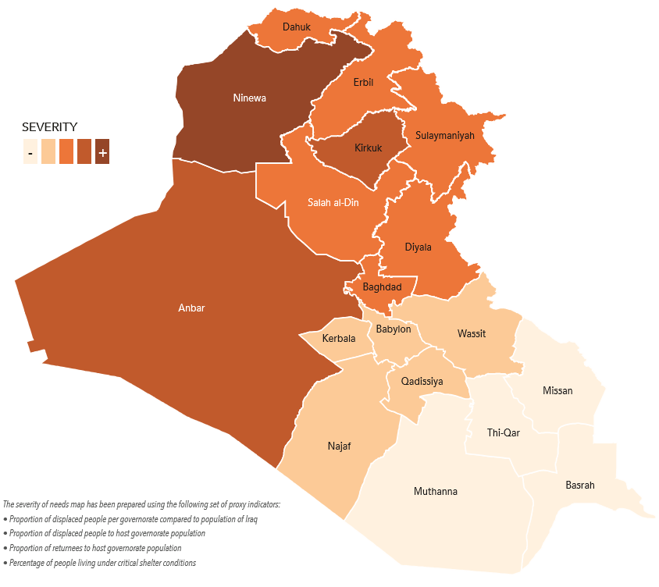

Back to Contents

Vulnerable groups
    - The OCHA, in February 2018, noted that there were 14 million people living in ‘conflict-related areas’ (down from 15 million in December 2016) and that, of the 8.7 million in need of humanitarian assistance:
- 3.8 million (44%) are ‘highly vulnerable residents in host communities’
- 4.2 million (48%) are children
- 0.4 million (5%) are elderly (defined as 59 and over)
- 4.3 million (50%) are female
Back to Contents

Numbers of Internally Displaced Persons (IDPs)
    - As of 15 October 2018 1,879,938 individuals (313,323 families) were displaced in Iraq across 3,276 locations (IOM’s figures cover displacement from January 2014).
    - OCHA noted that half of IDPs have been displaced for more than three years. On 31 May 2018, the UNHCR summarised the patterns of population movement as ‘mixed’. These patterns included
‘…protracted displacement, return, and secondary / tertiary displacement, including return to camps after unsuccessful attempts to return to areas of origin. Arrivals to camps and secondary displacement are mainly dictated by a lack of economic opportunities in areas of return, destruction of property and limited access to services. Protracted displacement is mainly dictated by security concerns, fear of retaliation, or results from communal tensions.’
    - The IOM produced the following graph showing the number of IDPs from May 2014 to October 2018:
Graph showing the number of Internally Displaced Persons (IDPs) in Iraq, May 2014 to 2 October 2018
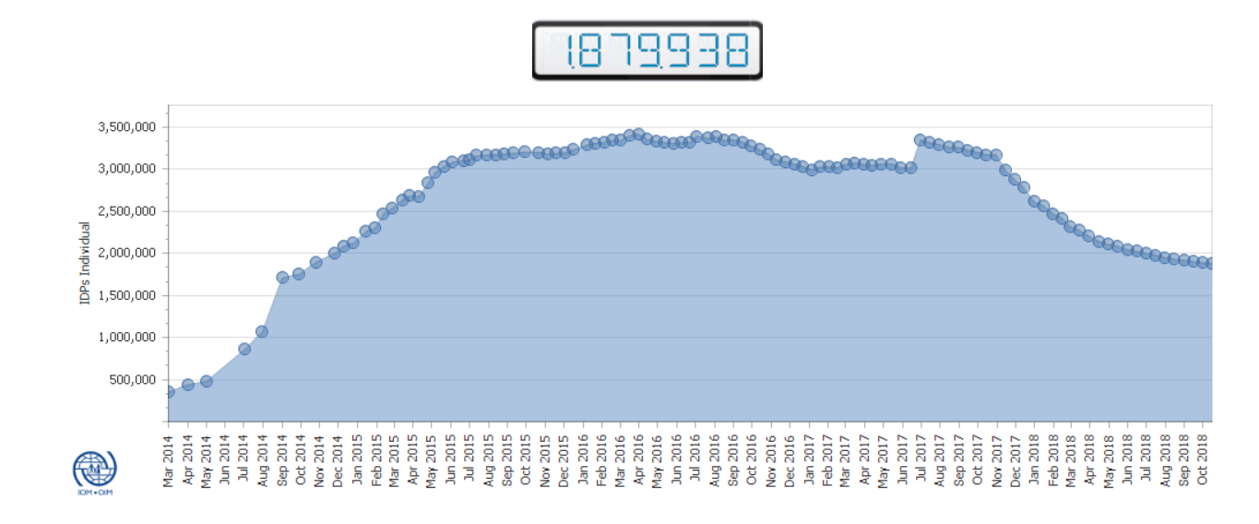
Back to Contents

Origin and location of IDPs
    - The IOM provided the following chart showing the origin of IDPs and their current location, as at August 2018:
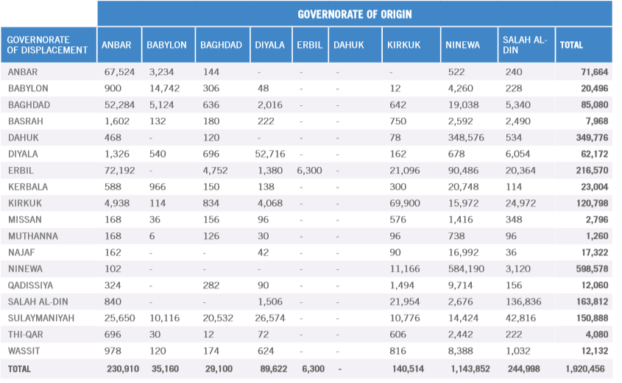

Back to Contents

Shelter types of IDPs
    - The IOM, in August 2018, summarised that approximately:
- 62% live in private settings
- 29% live in camps (78% of whom are in Ninewah (51%) and Dohuk (27%) – nearly half of IDPs in these governorates live in camps)
- 9% live in ‘critical shelters’ (informal settlements, religious buildings, schools and unfinished or abandoned buildings) (nearly 70% of whom are in Salah al-Din, Dohuk and Ninewah).
- 167,604 people (about 9% of IDPs) live in ‘the most vulnerable conditions’ (mostly in Dohuk, Salah al Din, Ninewah and Kirkuk)
Back to Contents

Numbers of returnees and places of return
    - The IOM, in August 2018, identified that 4,028,994 people (691,449 families) had returned to their places of origin. The top governorates (and districts) of return are:
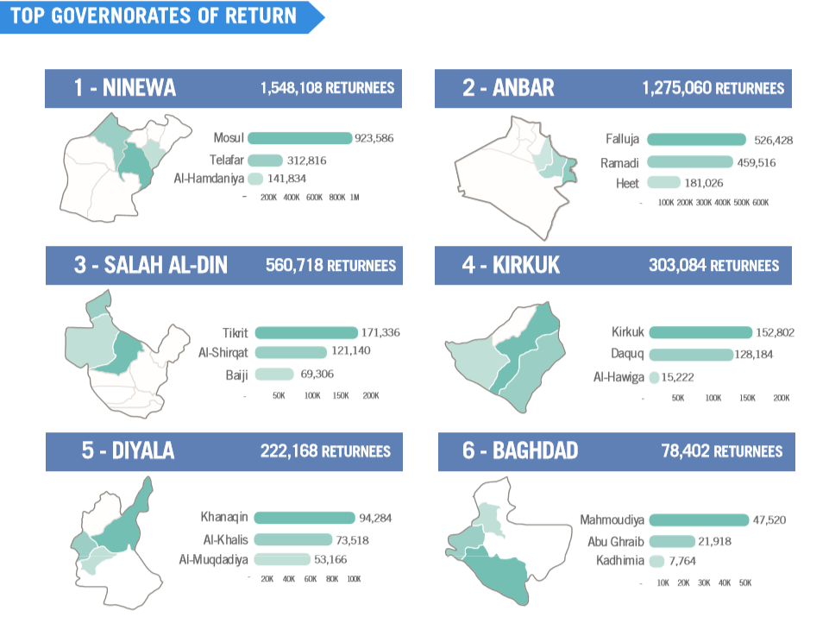
    - The IOM noted that, of returnees:
- 98% have returned to their habitual residence
- 2% live in private settings
- less than 1% live in critical shelters (mostly in Salah al-Din)
    - The OCHA provided a timeline of returns (and IDPs), as of 30 September 2018:
Graph showing IDP and return trends, 2014 to 30 September 2018
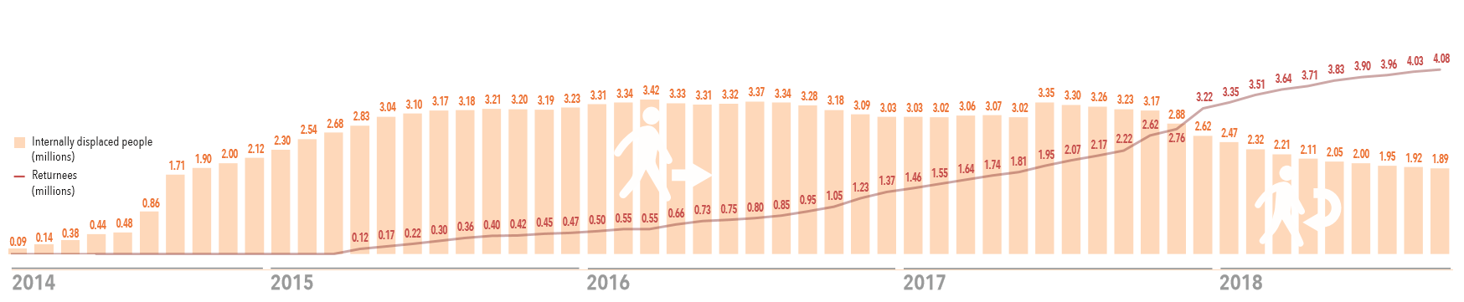
    - In June 2018, the IOM commented: ‘Returns have been sustained since July 2016, when the campaign against ISIL [Daesh] intensified, with the periods October –November 2016 (aftermath of the offensive to retake the Anbar districts of Ramadi, Heet and Fallujah as well as eastern districts of Ninewa), May–June 2017 (Mosul operations) and September–December 2017 (last advance of the retaking campaign) witnessing the highest numbers of returns.’
    - The OCHA’s August 2018 Humanitarian Bulletin noted:
‘Return movements of displaced people continued steadily but at a slower-than-expected pace. Only 600,000 people have returned by the end of May [2018] while some new and secondary displacements were reported. The majority (86 per cent) of returns have occurred from out-of-camp locations, raising concerns over protracted displacement of a large number of people in camps which may have to remain open longer than earlier planned. Damaged infrastructure, lack of basic services and livelihood opportunities, insecurity, explosive hazard contamination and challenges with social cohesion have been noted as key deterrents to returns.’
Back to Contents

Prevented returns
    - The UN High Commissioner for Refugees (UNHCR), in a briefing dated June 2018, explained:
‘Denial of return for families with perceived affiliation with extremists continues to be reported across Iraq. UNHCR has spoken to many IDPs returning to camps after having been denied access by government-affiliated armed groups at checkpoints or having been forced to leave their areas of origin due to threats from the community. These families originate from Anbar (Al Qa’im), Kirkuk (Hawiga), Ninewa (Rabea, Qayarrah, Beiji, Sinjar, Badush, Al-Hawija, Telafar, parts of Mosul city) and Salah al-Din (Shirqat, Baiji). Some families also reported relatives being arrested while trying to return. Three families in Ninewa said their property had been burned by community members or was being used by security actors. Others said that due to fear over arbitrary arrest or acts of revenge they did not plan to return in the foreseeable future.’
Back to Contents

Conditions in places of return
    - The 2018 OCHA Humanitarian Response Plan explained:
‘Retaken areas are being cleared of explosive hazards and rubble and major efforts are underway to restore electricity, water and sewage grids, re-establish the Government’s social protection floor, jump-start local economies and open schools and health centres. Displaced camps are being consolidated and decommissioned and modalities are being put in place for ensuring that the highly vulnerable families who are currently receiving assistance from humanitarian partners are covered under the Government’s new Poverty Reduction Strategy…
‘It will take years to rebuild Iraq. Damage and loss assessments conducted by the Ministry of Planning and analysed by the World Bank estimate that reconstruction will take at least 10 years and cost well over US$88 billion…
‘Although major efforts are being made by the Government of Iraq and Kurdistan Regional Government to incentivize and facilitate returns, many vulnerable families are unable to return without assistance. Displaced people from areas which are not yet stable are likely to delay going home until conditions improve and will continue to need support. Families living in camps and substandard accommodation are highly vulnerable and host communities throughout the country, most particularly in the Kurdistan Region, are facing widespread unemployment and deteriorating public services.’
    - In their monthly protection update of 28 May – 1 July 2018, UNHCR noted:
‘Most new arrivals continue to report that they came to camps, unable to cope with living conditions in their areas of return or secondary locations. The volatile security situation, economic conditions and a lack of services are key factors that continue to lead to widespread re-displacement of returnees. A lack of livelihood opportunities and shelter due to destruction of homes, families’ inability to pay rent as well as disputes with relatives who previously hosted IDPs remain among the reasons that continue to be cited by families returning to camps in recent months. In a number of cases, the lack of progress in clearing areas of explosive hazards was also a factor.’
    - The OCHA Humanitarian Bulletin, dated July 2018, commented on the situation in Ninewah governorate:
‘Drawing on damage and loss assessments conducted by the Ministry of Planning, the World Bank estimates that reconstruction [of Mosul] will take at least 10 years, with a financial requirement of at least $80 billion…
‘UNICEF has supported the rehabilitation of one third of the 638 schools that have reopened, enabling more than half a million girls and boys to return to local schools. Moreover, 107,217 children under the age of five have been vaccinated against polio in coordination with WHO [World Health Organisation] and the Ministry of Health. UNICEF [United Nations Children’s Fund] has also supported the local authorities with the repair of damaged water supply systems. As a result, clean drinking water was provided to 800,000 residents in Ninewa governorate…
‘WHO has restored basic primary healthcare services for returnees in Ba’aj, Hatra, Mosul, Talafar, and Sinjar districts and established six primary health care centres. Basic health consultations were offered to more than 216,000 people and at least 532,000 people were reached in remote areas through the provision of 17 mobile medical clinics.
‘As ISIL had closed most maternity wards and hospitals during its occupation of Mosul, UNFPA [United Nations Population Fund] responded to the staggering reproductive health and protection needs and was already supporting a delivery room in East Mosul in December 2016. UNFPA also established 55 reproductive health facilities in and around Mosul between October 2016 and July 2017. During the last three months of 2017, UNFPA provided reproductive health consultations to more than 472,000 displaced women and girls…
‘Between July 2017 and June 2018, UNMAS [United Nations Mine Action Service] removed from Mosul more than 44,000 explosive hazards, including 1,000 IEDs [Improvised Explosive Devices], from roads, bridges, schools, universities, hospitals, clinics, water treatment plants and municipal buildings in Mosul city. In addition, 450 suicide belts were discovered, many from human remains that are still being found. UNMAS has also cleared to date 550 critical infrastructure locations of explosive hazards, allowing for the resumption of basic services for Mosul residents and returnees.
‘More than 1,200 households in 12 neighbourhoods in East Mosul have benefitted from UNHabitat’s provision of legal assistance, thereby helping returning residents to address housing, land and property issues. In addition, UN-Habitat has rehabilitated 257 conflict damaged houses in West Mosul, which allowed almost 3,000 people to return home.’
    - iMMAP reported on 4 October that:
‘The process of returning IDPs has begun on a scant scale and a big portion of IDPs are unable to return to their areas due to the contamination and huge damage incurred to the infrastructure in their living areas. While there is a big hope for the residents that situation and economy will boom after the expulsion of ISIS and return of local business but lack of most pressing services and fluctuated security situation still remain a big challenge.
The iMMAP’s security incidents and infrastructure data show that there are still incidents ongoing in the liberated areas, which have caused the sluggishness of the economy and whole infrastructure development. Almost all parts of the areas affected by the military operations have incurred damage to the infrastructure, with some areas completely destroyed and requiring years to rebuild. The majority of inflicted infrastructures are hospitals, schools, working places, governmental buildings and religious and historical sites.’
    - The 2018 OCHR Humanitarian Response Plan explained the situation in the KRI:
‘Pressures on local services, including schools, water and sanitation, solid waste management, health facilities and competition for jobs have increased each year, contributing to a sharp decline in living standards across the three governorates. Conditions worsened in the aftermath of the Kurdish referendum in late September [2017] when international flights to the airports in Erbil and Sulaymaniyah were suspended, impacting economic activity and commerce. In mid-October [2017], as security forces realigned in Kirkuk and a number of disputed districts, more than 180,000 people fled their homes, the majority seeking safety and support in Erbil and Sulaymaniyah.’
    - In October 2018, iMMAP produced the following map showing landmine and explosive remnants of war (ERW) contamination areas:
Map showing landmine and explosive remnants of war (ERW) contamination areas
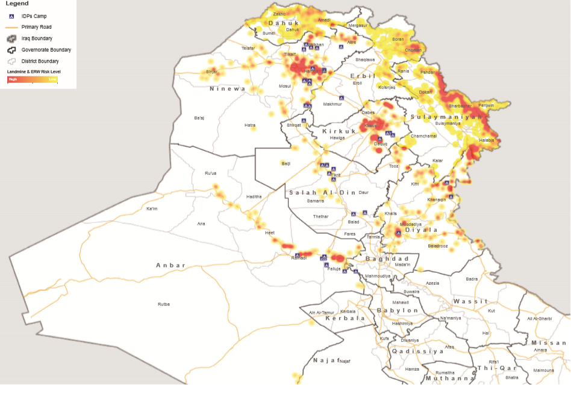
Back to Contents

Employment and financial security
    - In December 2017 REACH published their assessment of the humanitarian situation in Iraq, based on interviews across the whole country with 1,571 household surveys, 262 ‘KI’ (key informant) interviews and 12,613 household surveys available from secondary data. The assessment covered both in- and out-of camp IDPs; returnees; and non-displaced people in newly retaken and conflict areas. Their assessment found that employment opportunities were ‘consistently identified as a priority need across all population groups in accessible areas’, reported as a need by KIs across all districts assessed in hard-to-reach areas, and raised by KIs as a need for non-displaced populations.
    - The 2018 OCHA Humanitarian Response Plan stated:
‘Agricultural production has declined 40 per cent compared to pre-conflict levels when crop production, including wheat, barley, maize, fruits and vegetables in Ninewa and Salah al-Din provided nearly 70 per cent of household income. The poverty rate in the areas most impacted by the fighting exceeds 40 per cent. Poor households and close to one-third of displaced families are currently relying on negative coping strategies.’
Back to Contents

Food security
    - In February 2018, the OCHA reported that nearly 1.9 million Iraqis were food insecure, down from 2.9 million in December 2016.
    - REACH’s December 2017 humanitarian assessment found that
‘…the priority needs of all population groups, both in accessible and in hard-to-reach areas, remain centred on improved access to basic necessities such as food … Food was consistently identified as a priority need across all population groups in accessible areas … In hard-to-reach areas, returnee KIs reported the need for food … across all districts assessed. For non-displaced populations … needs raised included access to… food.’
Back to Contents

Health and healthcare
    - In February 2018, the OCHA reported that 7.3 million people required healthcare, down from 10.3 million in December 2016.
    - REACH’s December 2017 humanitarian assessment found that ‘the priority needs of all population groups, both in accessible and in hard-to-reach areas, remain centred on improved access to basic necessities such as … healthcare services’, that medical care was ‘consistently identified as a priority need across all population groups in accessible areas’ and as a need raised by KIs for non-displaced populations. REACH added: ‘The impact of the conflict can also be seen in the health [sector] … as evidenced by the reported lack of medicines available at hospitals and inability to afford medicines from pharmacies.’
    - The 2018 OCHA Humanitarian Response Plan stated that the health sector had been ‘…particularly hardhit. The number of consultations performed in health clinics has increased eightfold since 2014. Thirty-six per cent of health centres in Salah al-Din are damaged or destroyed and only half of health facilities in Ninewa are fully functional.’
Back to Contents

Water, sanitation and hygiene (WASH)
    - In February 2018, the OCHA reported that 5.4 million needed water and sanitation assistance, down from 8.3 million in December 2016.
    - REACH’s December 2017 humanitarian assessment found that: ‘For non-displaced populations … needs raised included access to water’ and that: ‘The last few years of conflict have impacted the state of critical infrastructure, especially in hard-to-reach areas. In particular, non-displaced populations in recently retaken and conflict areas have potentially seen greater damage to water infrastructure.’
    - OCHA’s August 2018 Humanitarian Bulletin stated:
‘Iraq is currently facing water shortage that is expected to worsen in the short-to-medium term. Southern governorates, especially Basra, have been particularly affected. … Low water levels are contributing to an increase in salinity, making what limited water available unsuitable for agricultural usage, triggering the migration of approximately 630 families (3,780 people) who are unable to continue their livelihoods. In parallel, aging pipes and infrastructure have contributed to contamination of water supplies, prompting several hundred residents of Basra to seek hospitalization during August. Health practitioners are reporting shortages of both funding and supplies, and concerns exist over a possible cholera outbreak.’
Back to Contents

Education
    - REACH’s 2017 humanitarian assessment concluded: ‘The impact of the conflict can also be seen in… education… [as] the poor physical condition of schools was a commonly reported barrier to accessing education for non-displaced and returnee populations in hard-to-reach areas.’
    - In February 2018, the OCHA noted: ‘Schools in conflict-affected areas are operating double and triple shifts. Last year alone, more than 150 schools were damaged or destroyed. Nearly 50 per cent of children in displaced camps do not have access to quality education and 3.2 million children attend school irregularly or not at all.’ In December 2016 it noted that 3.5 million children were in need of education support.
Back to Contents

Evictions
    - In May and June 2018, the UNHCR noted evictions from Kirkuk city (of IDPs mainly from Hawija and Salah al Din) and that threats of evictions were reported in Al-Karama and informal settlements in Salah al-Din; the Dream City complex (Tikrit), Al-Ramadhaniyah village (along the main road between Baghdad and Ninewah); Al-Jamaia’a camp (Baghdad); and that camp closure was discussed by local authorities in Anbar.
Back to Contents

Humanitarian support

UN Humanitarian Response Plan
    - The 2018 OCHA Humanitarian Response Plan explained:
‘During 2018, the humanitarian operation will contract significantly. Rather than allowing this contraction to evolve haphazardly or to increase vulnerabilities, the process will be managed in conjunction with the Government’s High Level Advisory Team and Crisis Management Cell, supported by the Joint Coordination and Monitoring Centre (JCMC) in Baghdad and the Joint Crisis Coordination Centre (JCC) in Erbil. During the year, as camps are consolidated and de-commissioned and authorities accelerate reconstruction, humanitarians will work closely with counterparts to ensure that families are able to choose whether to remain where they are, return to their homes or resettle. High priority will be given to helping vulnerable families access the Government’s social protection floor and every effort will be made to ensure services continue to be provided in camps and areas with a high concentration of at-risk populations. Of the 8.7 million Iraqis who will need some form of assistance in 2018, humanitarian partners will provide support to a subset of highly vulnerable people. In line with the HRP’s strategic objectives, partners will:
- provide services and assistance packages to 1.5 million displaced people living in camps and informal settlements
- provide assistance packages to 350,000 highly vulnerable people who are unable to return unless helped
- help to secure safe access to and provide sequenced emergency packages to 300,000 people who may be newly or secondarily displaced during the year
- provide assistance packages and facilitate access to services for 1.25 million highly vulnerable people who are not covered by the Government’s social protection floor
- provide specialized assistance and protection for 2.2 million people’
    - The Humanitarian Response Plan also noted:
‘Displaced and destitute families continue to show an overwhelming preference for cash assistance. In 2018, 25 per cent of all humanitarian programming channelled through the Humanitarian Response Plan will be cash programming, including grants and vouchers for food, school-costs, hygiene and household items. Cash programming will also include multipurpose cash transfers and cash-for work activities. Members of the Cash Working Group are coordinating closely with national authorities to agree on modalities for helping families access Government support services and to ensure that the cash assistance being provided by humanitarian partners does not undermine or duplicate the Government’s own transfer programmes.’
Back to Contents

Numbers and reach of humanitarian partners
    - The 2018 OCHA Humanitarian Response Plan stated:
‘Humanitarian access and operational capacity are continuing to expand; 179 partners are currently active in 46 major operational areas. During 2017, as Iraqi security forces retook major cities and districts in Salah al-Din, Kirkuk, Anbar and Ninewa governorates, nearly five million civilians became newly accessible. With support from the JCMC [Joint Coordination and Monitoring Center] in Baghdad and JCC [Joint Crisis Coordination Center] in Erbil, operational capacity in retaken areas increased 113 per cent in Ninewa during 2017, 52 per cent in Salah al-Din, 47 per cent in Kirkuk and 13 per cent in Anbar. In Mosul city, humanitarian partners accessed and provided assistance in 76 neighbourhoods in 2016 and reached all 145 neighbourhoods with assistance in 2017.
‘Although a number of constraints on the movement of staff and goods were experienced following the restriction on flights to the Kurdistan Region of Iraq in late September and the military realignment in disputed areas in mid-October, authorities are working closely with OCHA to facilitate NGO registration, issue visas and arrange permits and cargo clearance. Since late September, more than 1,000 emergency visa requests have been processed by Baghdad authorities, including 900 for NGOs. OCHA’s civil-military liaison team continues to secure access and coordinate with authorities to address instances of extortion, harassment and delays and closures at checkpoints. Restrictions on national staff because of sectarian, ethnic and tribal affiliations are also being addressed through the good offices of the Humanitarian Coordinator.’
    - The following map from the OCHA shows the location of the 179 organisations that responded to humanitarian needs in 2017:
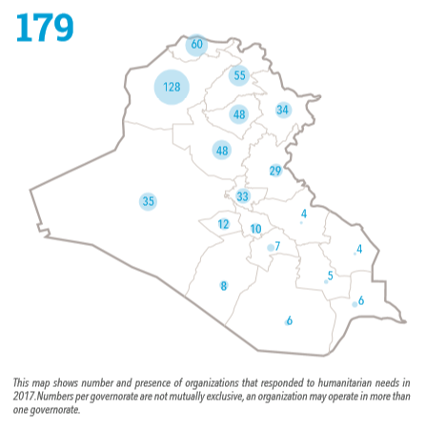
    - The Plan broke down the numbers of humanitarian organisations participating in the Plan for 2018 in the KRI, showing a contraction.

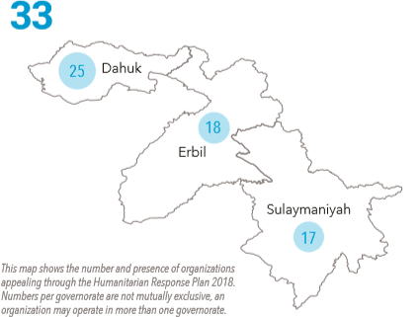
    - The Plan explained:
‘Many humanitarian organizations which had been operating in the country with Kurdistan Regional Government authorization are now required to regularize their status with authorities in Baghdad. Communities in the Kurdistan Region of Iraq continue to be generous, providing for families when they have nowhere else to turn, but local capacities are stretched and the Kurdistan Regional Government requires significant assistance from the international community to continue supporting large numbers of displaced in the year ahead.’
Back to Contents

Numbers and profile of people targeted for assistance
    - The 2018 UN Humanitarian Response Plan noted that 3.4 million out of the 8.7 million people in need are being targeted for humanitarian assistance. The Plan broke these down as follows:
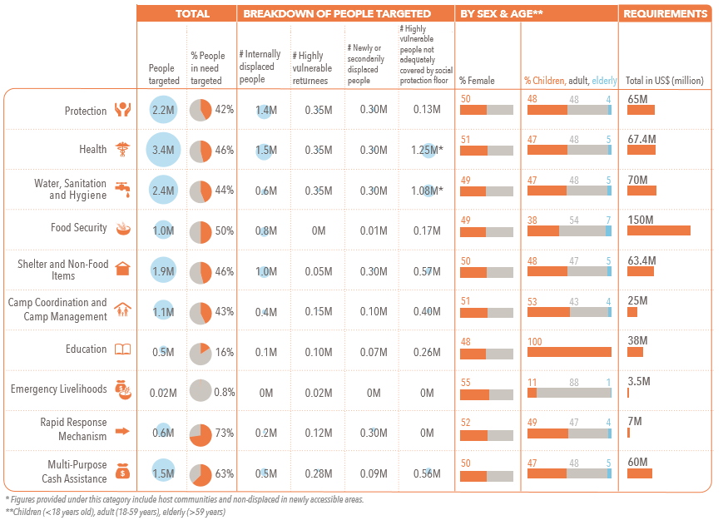
Back to Contents

Public Distribution System (PDS)
    - The US State Department (USSD)’s human rights report covering 2017 reported:
‘All citizens are eligible to receive food under the Public Distribution System (PDS); however, authorities implemented the PDS sporadically and irregularly, with limited access in recently retaken areas. Authorities did not distribute all commodities each month, and not all IDPs could access the PDS in each governorate. Low oil prices further limited funds available for the PDS. Citizens could only redeem PDS rations at their place of residence and within their registered governorate, causing loss of access and entitlement following displacement.’
    - REACH, in their December 2017 humanitarian assessment, explained that the Public Distribution System (PDS) is a ‘government-subsidised food and fuel assistance programme administered nationwide’. The paper explained that PDS rations ‘are not a sufficient means of addressing all household food needs, [although] the assistance supplements food consumption by providing a supply of staple food items’. It continued that
- 68% of in-camp IDPs
- a third of out-of-camp IDPs (with considerable variation within governorates – ranging from 9% in Salah al Din to 100% in Najaf)
- 16% of returnees; and
- 19% of host community households
reported receiving PDS assistance in the same month as data collection; and
- a ‘large majority’ (90+% in all groups) received a half-ration
- the majority of non-displaced people in Hawija (Kirkuk) did not have access to PDS assistance
- the majority of returnees had access to PDS assistance (within varying degrees), apart from in Kirkuk city where the majority did not
Back to Contents

Effectiveness of humanitarian support
    - REACH’s 2017 humanitarian assessment noted that, in ‘accessible areas’:
- 12% of returnees; and
- 24% of host community households
had not received humanitarian assistance; and that
- humanitarian assistance was primarily in the form of cash or food
    - The 2018 UN Humanitarian Response Plan noted:
‘On the ground, clusters are working more closely together than ever before, using common methodologies to assess needs and sharing real-time information to help improve targeting and response. Starting with the Mosul operation, inter-cluster mobile teams are collecting first-hand information and disseminating this to partners working in areas receiving displaced populations, including transit points, screening sites and in emergency camps. In difficult-to-reach areas, clusters are engaging more regularly with local leaders and organizations, helping to improve situational awareness. Clusters are also continuing to improve cluster-specific mechanisms for collecting, processing and analyzing data and are using dashboards to measure progress against agreed targets. The Iraq IDP Information Centre continues to receive inputs and suggestions from displaced people who call the hotline, often with concerns about gaps in service delivery. This information is being immediately shared with clusters, helping partners to respond quickly to emerging problems. At the strategic level, the Government of Iraq and Kurdistan Regional Government continue to jointly monitor progress during meetings of the High Level Advisory Team. The Government’s Crisis Emergency Cell meets regularly, developing plans and monitoring progress against these. In the Kurdistan Region of Iraq, strategic monitoring is being done under the leadership of the Ministry of Interior, with support from the JCC. The Humanitarian Country Team continues to regularly progress against the strategic objectives in the Humanitarian Response Plan, adapting and correcting course, where necessary, in response to emerging priorities.’
    - OCHA’s Humanitarian Bulletin, dated July 2018, explained:
‘At the end of July, donors have contributed $362.3 million to the $569 million humanitarian response plan.
‘Based on the percentage of donor funding received so far, the 2018 Iraq HRP is one of the best-funded response plans globally. Paid donor contributions have reached $235 million, that is 41 per cent of the total funding requirements. At the end of this month, the payment of $128 million that was pledged by donors remains however pending. It is important to note that funding requirements and levels vary across clusters. The largest gaps are found in the food security; health; water, sanitation and hygiene; and non-food items clusters.
‘Unless the funding requirements are met for this year’s highly prioritized HRP, the implementation of some critical humanitarian projects could be affected and lead to the closure of programmes and thus denying the most vulnerable Iraqis with assistance.’
Back to Contents

Effectiveness of humanitarian support: Mosul
    - The OCHA observed, in July 2018:
‘One year later [following the retaking of the city], the humanitarian community has recorded significant achievements in Mosul. According to the 2018 Humanitarian Response Plan (HRP), nearly half of the 8.7 million people (4 million or 46 per cent) estimated to require humanitarian assistance in Iraq are located in Ninewa governorate.
‘As of 30 June 2018, humanitarian partners reached almost one million people in this governorate. This figure represents 148 per cent of Ninewa’s population that was targeted in the 2018 HRP (that is, 930,814 people of the 626,834 targeted). The reason for this high achievement is due to the generous contributions received from donors who were able to address the emerging needs in Mosul’s changing environment. It has resulted in sufficient funding for activities and allowed the provision of significant assistance, especially in the health and protection clusters. In spite of this assistance, critical gaps remain in nearly all other sectors (food security; education; shelter and non-food items; camp coordination and camp management; multi-purpose cash assistance; and water, sanitation and hygiene).’
Back to Contents

Security situation

Overview: the war against Daesh (Islamic State)
    - The Congressional Research Service (CRS), in a paper dated 4 October 2018, explained ‘Iraq’s government declared military victory against the Islamic State organization (IS, aka ISIS/ISIL) in December 2017, but insurgent attacks by remaining IS fighters threaten Iraqis as they shift their attention toward recovery and the country’s political future. Security conditions have improved since the Islamic State’s control of territory was disrupted, but IS fighters are active in some areas of the country and security conditions are fluid.’
    - The source continued
‘In July 2017, Prime Minister Haider al Abadi visited Mosul to mark the completion of major combat operations there against the Islamic State forces that had taken the city in June 2014. Iraqi forces subsequently retook the cities of Tal Afar and Hawijah, and launched operations in Anbar Governorate in October amid tensions elsewhere in territories disputed between the Kurdistan Regional Government (KRG) and national authorities. On December 9, 2017, Iraqi officials announced victory against the Islamic State and declared a national holiday. Although the Islamic State’s exclusive control over distinct territories in Iraq has now ended, the U.S. intelligence community told Congress in February 2018 that the Islamic State “has started—and probably will maintain—a robust insurgency in Iraq and Syria as part of a long-term strategy to ultimately enable the reemergence of its so-called caliphate.”
‘As of October 2018, Iraqi security operations are ongoing in Anbar, Ninewa, Diyala, and Salah al Din against IS fighters. These operations are intended to disrupt IS fighters’ efforts to reestablish themselves and keep them separated from population centers. Iraqi officials warn of IS efforts to use remaining safe havens in Syria to support infiltration of Iraq. Press reports and U.S. government reports describe continuing IS attacks, particularly in rural areas of governorates the group formerly controlled. Independent analysts describe dynamics in these areas in which IS fighters threaten, intimidate, and kill citizens in areas at night or where Iraq’s national security forces are absent.2 In some areas, new displacement is occurring as civilians flee IS attacks.’
    - The UN Security Council, in a paper dated 17 April 2018, noted that ‘pockets of ISIL elements’ ‘continued to carry out asymmetric attacks across the country’, providing examples in February in Hawika (Kirkuk) against PMU fighters and in March on the Baghdad-Kirkuk road, including against civilians.
    - The International Crisis Group (ICG), in a post dated July 2018, commented:
‘Islamic State (ISIS)-related insecurity continued in Kirkuk, Diyala and Saladin provinces, with militants increasingly abducting and killing soldiers and officials. Army, police and Kurdish peshmerga forces 4 July launched joint operations in Kirkuk, Diyala and Saladin provinces targeting ISIS forces. Peshmerga fighters 16 July claimed to have killed fourteen ISIS militants in northern Qarachukh mountain region, Erbil province, six peshmerga fighters also killed. In Erbil, capital of Kurdistan, three gunmen took over governorate building until forced out 23-24 July, two gunmen and one civilian killed; no group claimed responsibility but mayor blamed ISIS.’
    - The Terrorism Monitor Volume, in July 2018, reported:
‘IS has lost all of its urban strongholds in Iraq, including Mosul, which it occupied in June 2014 and which was reclaimed by Iraqi forces last year with significant U.S. support. However, the recent surge in IS activity indicates that the group is now pursuing its old hit-and-run tactics in Iraq, and serves to illustrate how IS could exploit the divisions that remain among Iraqi factions…While most of the recent attacks have been on relatively small targets, IS carried out a number of larger operations against Iraqi forces and Shia militias in Saladin province in May and June. These challenge the Iraqi authorities’ claim that the situation in Iraq is stable and back under the government’s control.’
    - In September 2018, the Combating Terrorism Center highlighted that the Hamril Mountains, which straddle Kirkuk, Salah al Din and Diyala, had been a ‘safe haven’ for Daesh, who tunnelled into them and which were key to their insurgent campaign in northern Iraq before the Caliphate collapsed. It opined that there was a risk that the focus on clearing these areas may ‘ebb’ because a new government had not been formed following the May 2018 elections (although a new government has since been formed).
    - The Institute for the Study of War (ISW) reported on 2 October 2018:
‘The Islamic State of Iraq and al Sham (ISIS) is reconstituting a capable insurgent force in Iraq and Syria despite efforts to prevent its recovery by the U.S. Anti-ISIS Coalition ... ISIS is waging an effective campaign to reestablish durable support zones while raising funds and rebuilding command-and-control over its remnant forces. On its current trajectory, ISIS could regain sufficient strength to mount a renewed insurgency that once again threatens to overmatch local security forces in both Iraq and Syria….ISIS is finding new sources of revenue and rebuilding command-and-control over its scattered remnant forces in order to prepare for a future large-scale insurgency in both Iraq and Syria.’
    - The same source added:
‘ISIS Emir Abu Bakr al-Baghdadi released an audio message on August 22 calling for his followers to “wage attack after attack” and “unite and organize” against their opponents. ISIS similarly appealed in publications in March - April 2018 for the activation of sleeper cells. These messages suggest that ISIS deliberately embedded operatives to conduct future attacks in recaptured areas across Iraq and Syria. The public orders nonetheless signal that ISIS may lack control mechanisms to issue direct commands to its forces. ISW has observed at least four indicators that ISIS is reconstituting an operational-level command structure in Iraq and Syria as of October 1 [2018].'
    - The same source produced a map showing ISIS ‘operating areas’, as of 1 October 2018:
Map showing ISIS operational areas, 1 October 2018
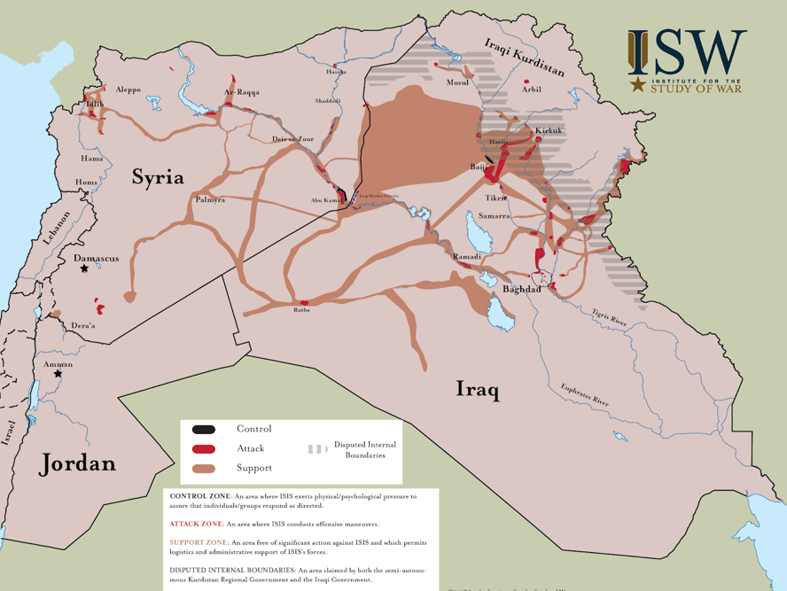
    - Also see regular updates in Joel Wing’s blog, ‘Musings on Iraq’.
Back to Contents

Overview: situation in the ‘Baghdad Belt’
    - The ISW, in an undated briefing, explained:
‘The Baghdad belts are residential, agricultural, and industrial areas that encircle the city, and networks of roadways, rivers, and other lines of communication that lie within a twenty or thirty mile radius of Baghdad and connect the capital to the rest of Iraq. Beginning in the north, the belts include the cities of Taji [Baghdad governorate], clockwise to Tarmiyah [Baghdad governorate], Baqubah [Diyala governorate], Buhriz [Diyala governorate], Besmayah and Nahrwan [Baghdad governorate], Salman Pak [Baghdad governorate], Mahmudiyah [Baghdad governorate], Sadr al-Yusufiyah [Baghdad governorate], Fallujah [Anbar governorate], and Karmah [Anbar governorate]. This "clock" can be divided into quadrants: Northeast, Southeast, Southwest, and Northwest.’
    - A blog post in Joel Wing’s ‘Musings on Iraq’, dated 16 February 2018, noted:
‘Since the start of 2018, Baghdad has driven violence in Iraq. There were 21 incidents there during the week. A car bomb was discovered and dismantled, showing another attempt at a mass casualty bombing by IS. Last week, a woman suicide bomber was chased into a school where she detonated her device in Tarmiya. That raised fears that there was more insurgent activity in the Baghdad belts. It’s not the Baghdad belts in general that are the problem, but the north and the south where most attacks have come from for more than a year now.’
    - An article in Task & Purpose, a US military and veterans publication, in an article dated 19 March 2018, quoted Jennifer Cafarella, a senior intelligence planner with the Institute for the Study of War (ISW): ‘Sunni jihadists remain active from Hawijah to Tuz Khurmatu in northern Iraq; in eastern Iraq’s Diyala province, where a group calling itself “The White Banner” has emerged; in the “Baghdad Belts” surrounding the city; and in Ramadi and other parts of Anbar province in western Iraq.’
    - The Terrorism Monitor Volume, in July 2018, reported that ‘[d]ozens of people have been killed in a series of attacks launched by Islamic State (IS) in locations north of Baghdad over the past few months, prompting fears that the terrorist group is reconstituting itself in parts of Iraq.’
    - The ISW, in October 2018, reported ‘In Baghdad, ISIS’s attack pattern indicates that it is likely reconstituting support and logistical networks throughout the Baghdad Belts, replicating its safe havens in 2006 - 2007. ISIS has not yet returned to the systematic use of vehicle-borne IEDs (VBIEDs), which were a hallmark of its resurgence in 2011 - 2013. ISIS may cross this threshold soon. The Iraqi Ministry of Interior claimed to disrupt an ISIS VBIED cell north of Baghdad on September 6.’
Back to Contents

Overview: situation in the ‘disputed’ areas
    - In September 2017, the Kurdistan Regional Government (KRG) held a referendum on the independence of the Kurdistan region and the areas disputed between the Kurdish authorities and the Iraqi government (GoI). In response to the referendum, the Iraqi government sent in troops to retake the ‘disputed’ areas. The International Crisis Group (ICG), in a paper dated October 2017, explained how Kurdish forces left Kirkuk and Iraqi government forces were able to take the city with ‘relatively little resistance’:
‘In the early hours of 16 October [2017], Iraqi federal forces launched a drive toward Kirkuk city that Prime Minister Haider al-Abadi said was aimed at retaking oil fields, an air base, the airport and federal installations lost in June 2014 when the Iraqi army collapsed in the face of an onslaught by the Islamic State (ISIS). The military move, which met with relatively little resistance, reportedly was enabled by a deal between the Abadi government and a faction of the Patriotic Union of Kurdistan (PUK). The PUK mostly withdrew, while forces of the rival Kurdistan Democratic Party (KDP) of Masoud Barzani, president of the Kurdish region, who staged a popular referendum on Kurdish independence in late September, fled. In the end, federal forces established control not only of the oil fields, but of an even more emotional prize, the city of Kirkuk.’
    - The CRS paper explained about the situation in the areas ‘disputed’ between the GoI and the KRG, principally Kirkuk:
‘The Kurdistan Region of northern Iraq (KRI) enjoys considerable administrative autonomy under the terms of Iraq’s 2005 constitution, and the Kurdistan Regional Government (KRG) held legislative elections on September 30, 2018. The KRG had held a controversial advisory referendum on independence in September 2017, amplifying political tensions with the national government, which moved to reassert security control of disputed areas that had been secured by Kurdish forces after the Islamic State’s mid-2014 advance. Iraqi and Kurdish security forces remain deployed across from each other along contested lines of control, while their respective leaders are engaged in negotiations over a host of sensitive issues…
‘In October 2017, the national government imposed a ban on international flights to and from the KRI[], and Iraqi security forces moved to reassert security control of disputed areas that had been secured by Kurdish forces after the Islamic State’s mid-2014 advance. Much of the oil-rich governorate of Kirkuk—long claimed by Iraqi Kurds—returned to national government control, and resulting controversies have riven Kurdish politics. Iraqi and Kurdish security forces remain deployed across from each other along contested lines of control while their respective leaders are engaged in negotiations over a host of sensitive issues.’
    - Also see regular updates in Joel Wing’s blog, ‘Musings on Iraq’.
Back to Contents

Control of territory
    - The CRS provided the following map showing Daesh’s territorial control from 2015 to August 2018. Data comes from the CRS, IHS Markit Conflict Monitor, ESRI and USSD.
Map showing Daesh’s territorial control, 2015-18
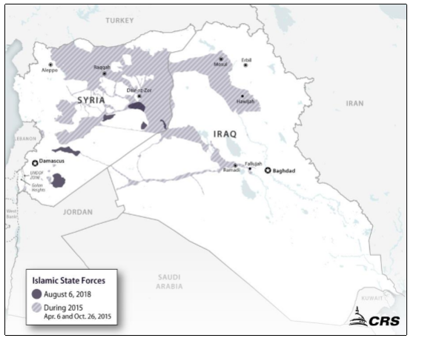

    - The CRS provided the following map showing areas of influence in ‘disputed’ territories as of 17 September 2018. Data comes from CRS using ArcGIS, IHS Markit Conflict Monitor, the US government and the UN.

Map showing areas of influence in areas disputed between Iraqi Kurdish Forces and Iraqi Government Forces, as of 17 September 2018
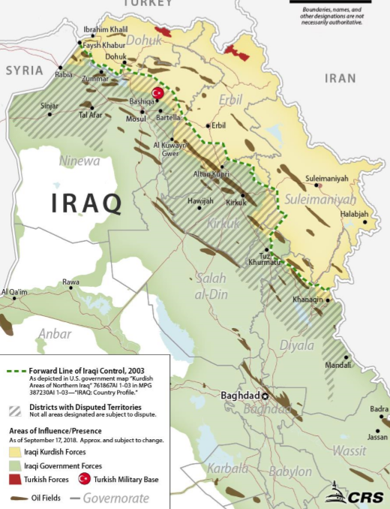
    - iMMAP, in their security report of October 2018, provided maps showing ‘primary’ and ‘secondary’ risks on roads and camps in Anbar, Diyala, Kirkuk, Salah al Din and Ninewah. Refer to the maps directly for further information
    - Also see regular updates in Joel Wing’s blog, ‘Musings on Iraq’.
Back to Contents

Security incidents
    - Joel Wing’s blog, ‘Musings on Iraq’ , in a blog dated April 2018, explained:
‘Iraq is currently witnessing the fewest security incidents since the overthrow of Saddam Hussein. In 2003, there were an average of 10 to 35 incidents per day. In the first three months of 2018, there has been an average of 9 incidents. After the Islamic State seized Mosul in the summer of 2014 attacks steadily declined even before the government forces went on the offensive and liberated all of the conquered territory. There were 28 incidents per day in 2014, 23 in 2015, 20 in 2017, and 15 in 2017. At the end of that last year the Islamic State decided to switch to an insurgency rather than continue to suffer high casualties in a losing cause. That was the reason why they barely put up a fight in the last clearing operations in Ninewa and Anbar. The number of incidents has been flat since October 2017 as a result.’
    - The same blog post provided the following chart showing a decline in the number of security incidents in 2018:
Chart showing the number of security incidents in Iraq
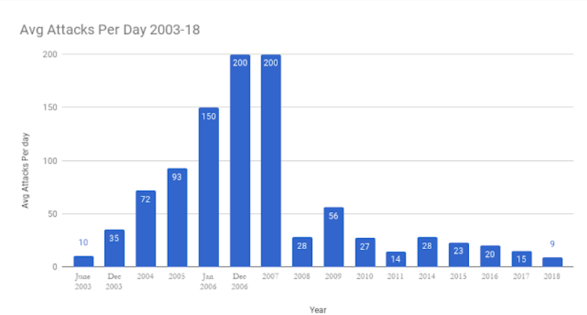
    - See also: the Austrian Centre for Country of Origin and Asylum Research and Documentation (ACCORD)’s regular updates on incidents and the Armed Conflict Location and Event Data Project (ACLED)’s data on Iraq
Back to Contents

Civilian fatalities
    - The following graph, using data from the UN Assistance Mission for Iraq (UNAMI), shows civilians killed in the six worst-affected governorates between June 2014 and October 2018. The UN’s data is collected from the worst-affected governorates, and therefore does not typically include the south or the KRI. For some months no data is available. UNAMI caveats the data as follows:
‘UNAMI has been hindered in effectively verifying casualties in certain areas; in some cases, UNAMI could only partially verify certain incidents. Figures for casualties from Anbar Governorate are provided by the Health Directorate … Casualty figures obtained from the Anbar Health Directorate might not fully reflect the real number of casualties in those areas due to the increased volatility of the situation on the ground and the disruption of services. For these reasons, the figures reported have to be considered as the absolute minimum.’
Graph showing civilian fatalities in the six worst-affected governorates, June 2014 to October 2018

    - Data from Iraq Body Count (IBC) goes up to 28 February 2017.
    - Joel Wing, like UN Iraq and IBC, does provide data on civilian fatalities, although this data has not been used in this document. Generally, the data follows the same pattern as that provided by UN Iraq and IBC, although at higher levels, reflecting differences in data collecting methodologies. Refer directly to the blog for more information.
    - See also: the Austrian Centre for Country of Origin and Asylum Research and Documentation (ACCORD)’s regular updates on incidents and the Armed Conflict Location and Event Data Project (ACLED)’s data on Iraq
Back to Contents

Civilian injuries
    - Using data from the UN Assistance Mission in Iraq (UNAMI), the following graph shows a comparison between the six worst-affected governorates of civilians injured between June 2014 and October 2018:

Graph showing civilian injuries in the six worst-affected governorates, June 2014 to October 2018

Back to Contents

Nature of violence
    - Data on security incidents compiled by Joel’s Wing’s Musings on Iraq shows the nature of violent attacks. Shootings and Improvised Explosive Devices (IEDs) are consistently the most common forms of violent attacks. Other forms include car bombs, sticky bombs, suicide bombs and mortars. Refer directly to the blog for more information.
    - iMMAP’s October 2018 security review noted that incidents included airstrikes, explosive hazards and landmines.
Back to Contents

Impact on vulnerable groups
    - The OCHA’s 2018 Humanitarian Response Plan identified security issues for vulnerable people. These were:
- retaliation against people associated with Daesh and sectarian-related violence in sensitive areas
- explosive devices, including the deliberate booby trapping of homes and civilian infrastructure, particularly in former conflict affected areas
Back to Contents

Annex A: Map of Iraq
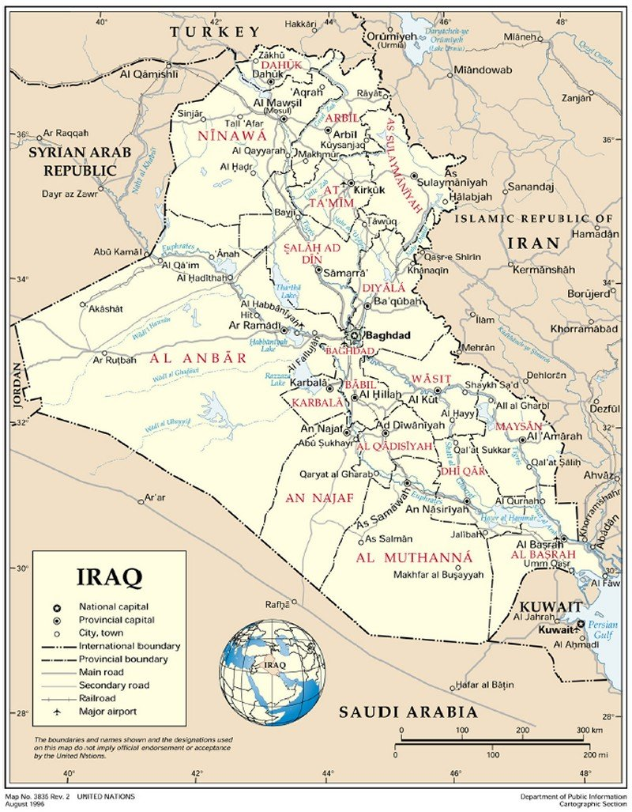 Back to Contents

Terms of reference
A ‘Terms of Reference’ (ToR) is a broad outline of what the CPIN seeks to cover. They form the basis for the country information section. The Home Office’s Country Policy and Information Team uses some standardised ToRs, depending on the subject, and these are then adapted depending on the country concerned.
For this particular CPIN, the following topics were identified prior to drafting as relevant and on which research was undertaken:
- Demography
- Conflict in Iraq
- Protagonists
- Iraqi Army
- Kurdish Peshmerga
- Daesh
- Other Sunni anti-government groups
- Shia militia and Popular Mobilization Units (PMUs)
- Humanitarian situation: general
- Numbers and profile of people in need
- Projected numbers of people in need
- Location of people in need
- Severity of need by location (projected numbers)
- Vulnerable groups
- Humanitarian situation: Internally Displaced Persons (IDPs)
- Numbers of Internally Displaced Persons (IDPs)
- Location of IDPs
- Origin of IDPs
- Shelter types of IDPs
- Numbers of returnees and places of return
- Prevented returns
- Coercion to return
- Conditions in places of return
- Employment and financial security
- Food security
- Health and healthcare
- Water, sanitation and hygiene (WASH)
- Education
- Evictions
- Mosul operation
- Humanitarian support
- UN Humanitarian Response Plan
- Numbers and reach of humanitarian partners
- Numbers and profile of people targeted for assistance
- IDPs assisted
- Public Distribution System (PDS)
- Effectiveness of international support
- Effectiveness of international support: Mosul
- Security situation
- Overview
- Control of territory
- Security incidents
- Civilian fatalities
- Civilian injuries
- Nature of violence
- Impact on vulnerable groups
Back to Contents

Bibliography

Sources cited
Armed Conflict Location and Event Data Project (ACLED), Iraq, https://www.acleddata.com/tag/iraq/. Last accessed: 3 October 2018
Austrian Centre for Country of Origin and Asylum Research and Documentation (ACCORD), Updates on incidents, available at: https://www.ecoi.net/en/document-search/?country%5B%5D=irq&countryOperator=should&srcId%5B%5D=10979&srcIdOperator=should&documentTypeId%5B%5D=11595&documentTypeIdOperator=should&sort_by=origPublicationDate&sort_order=desc&useSynonyms=Y. Last accessed: 3 October 2018
Austrian Federal Ministry of the Interior, ‘The Kurds: History, Religion, Language, Politics’, 2015, p.149, http://www.bfa.gv.at/files/broschueren/KURDS_Monographie_2015_11.pdf. Last accessed: 26 June 2018
BBC News,
‘What is “Islamic State?”, 2 December 2015, http://www.bbc.co.uk/news/world-middle-east-29052144. Last accessed: 26 June 2018
‘Iraq profile – timeline’, 21 May 2018, https://www.bbc.co.uk/news/world- middle-east-14546763. Last accessed: 26 June 2018
‘New Iraq President Barham Saleh names Adel Abdul Mehdi as PM’, 3 October 2018, https://www.bbc.co.uk/news/world-middle-east-45722528. Last accessed: 5 November 2018
Central Intelligence Agency (CIA), The World Factbook – Iraq, updated 20 June 2018, https://www.cia.gov/library/publications/the-world-factbook/geos/iz.html. Last accessed: 26 June 2018
Combating Terrorism Center (CTC), ‘From Caliphate to Caves: The Islamic State’s Assymetric War in Northern Iraq’, Volume 11, Issue 8, September 2018, https://ctc.usma.edu/caliphate-caves-islamic-states-asymmetric-war-northern-iraq/. Last accessed: 5 November 2018
Congressional Research Service (CRS),
‘Iraq: Politics and Governance’, March 2016, https://www.fas.org/‌sgp/crs/mideast/RS21968.pdf. Last accessed: 26 June 2018
‘Iraq: Issues in the 115th Congress’, 4 October 2018, https://fas.org/sgp/crs/mideast/R45096.pdf. Last accessed: 5 November 2018
Home Office (UK), Country Policy Information Note (CPIN), ‘Iraq: Internal relocation, civil documentation and returns’, October 2018, https://assets.publishing.service.gov.uk/government/uploads/system/uploads/attachment_data/file/749781/Iraq_-_IFA__docs__rtn_-_CPIN_-_v8.0__Oct_2018_.pdf. Last accessed: 5 November 2018
iMMAP, Humanitarian Access Response, Monthly Security Incidents Situation Report, September 2018, 4 October 2018, available at: https://reliefweb.int/sites/reliefweb.int/files/resources/immap-ihf_humanitarian_access_response_-_monthly_security_incidents_situation_report_september_2018.pdf. Last accessed: 5 November 2018
Institute for the Study of War (ISW),
‘Baghdad belts’, undated, http://www.understandingwar.org/region/baghdad- belts. Last accessed: 22 August 2018
‘ISIS’s Second Resurgence’, 2 October 2018, http://iswresearch.blogspot.com/search/label/Iraq. Last accessed: 2 November 2018
International Monetary Fund (IMF), World Economic Outlook Database, https://www.imf.org/external/pubs/ft/weo/2018/01/weodata/index.aspx. Last accessed: 26 June 2018
Gov.uk, ‘Daesh: UK government response’, https://www.gov.uk/government/topical-events/daesh. Last accessed: 26 June 2018
International Crisis Group (ICG),
‘Oil and Borders: How to Fix Iraq’s Kurdish Crisis’, Crisis Group Middle East Briefing No 55, 17 October 2017, https://www.crisisgroup.org/middle-east- north-africa/gulf-and-arabian-peninsula/iraq/55-settling-iraqi-kurdistans- boundaries-will-help-defuse-post-referendum-tensions. Last accessed: 23 August 2018
CrisisWatch, Iraq, July 2018, https://www.crisisgroup.org/crisiswatch/july- 2018#iraq. Last accessed: 23 August 2018
International Organization for Migration (IOM), Displacement Tracking Matrix (DTM),
DTM page, http://iraqdtm.iom.int/. Last accessed: 13 September 2018
DTM Round 102, August 2018, http://iraqdtm.iom.int/LastDTMRound/Round102_Report_English_2018_Augu st_IOM_DTM.pdf. Last accessed: 2 November 2018
DTM, updated 15 August 2018, http://iraqdtm.iom.int/. Last accessed: 20 August 2018
IDPs, updated 15 August 2018, http://iraqdtm.iom.int/IDPsML.aspx. Last accessed: 20 August 2018
Iraq Body Count (IBC), https://www.iraqbodycount.org/. Last accessed: 22 August 2018
Iraq Central Statistical Organisation (CSO), Annual Statistical Abstract 2017, http://cosit.gov.iq/AAS2017/Annual%20Abstract%20of%20Statistic%20_2017.pdf. Last accessed: 16 November 2018
Jane’s by IHS Markit, Iraq – Army, 11 June 2018, subscription required. Last accessed: 26 June 2018
Joel Wing, ‘Musings on Iraq, http://musingsoniraq.blogspot.com/. Last accessed: 22 August 2018
‘Security Trends in Iraq 2017’, 6 December 2017, http://musingsoniraq.blogspot.com/2017/12/security-trends-in-iraq-2017.html. Last accessed: 22 August 2018
‘Security in Iraq, Feb 8-14, 2018’, http://musingsoniraq.blogspot.com/2018/02/security-in-iraq-feb-8-14- 2018.html. Last accessed: 22 August 2018
‘Iraq Witnessing Fewest Security Incidents Since 2003’, 5 April 2018, http://musingsoniraq.blogspot.com/2018/04/iraq-witnessing-fewest- security.html. Last accessed: 22 August 2018
Nations Online Project, Map of Iraq, http://www.nationsonline.org/‌oneworld/map/iraq_map.htm. Last accessed: 23 August 2018
Niqash, ‘Counting Iraqis – why there may never be a census again’, 20 June 2013, http://www.niqash.org/en/articles/politics/3238/. Last accessed: 26 June 2018
REACH, ‘Iraq – Multi-Cluster Needs Assessment’, December 2017, https://www.humanitarianresponse.info/sites/www.humanitarianresponse.info/files/assessments/reach_irq_report_multi-cluster_needs_assessment_december_2017_0.pdf. Last accessed: 21 August 2018
Task & Purpose, ‘15 Years After The US Overthrew Saddam Hussein, Iraq Is Still At War With Itself’, 19 March 2018, https://taskandpurpose.com/iraq-to-the-future/. Last accessed: 22 August 2018
Terrorism Monitor Volume, ‘Is Islamic State Making Plans for a Comeback in Iraq?’, Volume 16, Issue 15, quoted in The Jamestown Foundation, 28 July 2018, https://jamestown.org/program/is-islamic-state-making-plans-for-a-comeback-in-iraq/. Last accessed: 5 November 2018
UN Assistance Mission in Iraq (UNAMI), Civilian Casualties, http://www.uniraq.org/index.php?option=com_k2&view=itemlist&task=category&id=159:civilian-casualties&lang=en&limitstart=0. Last accessed: 22 August 2018
UN Development Programme (UNDP), Human Development Report 2016, 2016, http://hdr.undp.org/sites/default/files/2016_human_development_report.pdf. Last accessed: 26 June 2018
UN High Commissioner for Refugees (UNHCR),
Flash Update, Iraq, 31 May 2018, available at: https://reliefweb.int/sites/reliefweb.int/files/resources/UNHCR%20Iraq%20Flash%20Update%20-%2031MAY18.pdf. Last accessed: 2 November 2018
Iraq: Monthly Protection Update, 28 May – 1 July 2018, June 2018, available at: https://reliefweb.int/sites/reliefweb.int/files‌/resources/20180713%20Iraq%20Protection%20Update%20-%20June%202018.pdf. Last accessed: 5 November 2018
UN Inter-Agency and Analysis Unit (IAAU), Salah al-Din Governorate Profile, July 2009, https://reliefweb.int/sites/reliefweb.int/files/resources/0BDD36464B63B98DC12576000033A01F-Full_Report.pdf. Last accessed: 23 August 2018
UN Office for the Coordination of Humanitarian Affairs (OCHA),
Humanitarian Response page, https://www.humanitarianresponse‌.info/en/operations/iraq. Last accessed: 13 September 2018
Humanitarian Needs Overview 2015 - Iraq, 12 August 2015, https://www.humanitarianresponse.info/en/system/files/documents/files/2015_ iraq_humanitarian_needs_overview_0.pdf. Last accessed: 20 August 2018
2017 Humanitarian Response Plan - Iraq, Advanced Executive Summary, Iraq, 16 December 2016, https://www.humanitarianresponse.info/en/operations/iraq/document/irqadvan ceexecsummaryhrp2017. Last accessed: 20 August 2018
UN Office for the Coordination of Humanitarian Affairs (OCHA), Humanitarian Bulletin - Iraq, December 2016 (issued 15 January 2017), https://www.humanitarianresponse.info/en/operations/iraq/document/ocha- iraq-humanitarian-bulletin-december-2016-issued-15-january-2017. Last accessed: 20 August 2018
2018 Humanitarian Response Plan – Iraq, February 2018, https://www.humanitarianresponse.info/sites/www.humanitarianresponse.info/ files/documents/files/iraq_2018_hrp.pdf. Last accessed: 20 August 2018
Humanitarian Bulletin, July 2018, available at: https://reliefweb.int/report/iraq/iraq-humanitarian-bulletin-july-2018-issued-31- july-enarku. Last accessed: 21 August 2018
Humanitarian Bulletin, August 2018, available at: https://reliefweb.int/‌sites/reliefweb.int/files/resources/OCHA%20Iraq%20Huma nitarian%20Bulletin%20-%20August%202018.pdf. Last accessed: 2 November 2018
Timeline of displacement and returns (as of 30 September 2018), found at: https://reliefweb.int/sites/reliefweb.int/files/resources/timeline_of_displacement _and_returns_30_sept._2018.pdf. Last accessed: 2 November 2018
‘Where we work – Current Emergencies’, undated, http://www.unocha.org/where-we-work/current-emergencies. Last accessed: 26 June 2018
UN Security Council,
Report of the Secretary-General pursuant to Security Council resolution 2367 (2017), 17 April 2018, available at: https://www.ecoi.net/en/file/local/‌1431998/1226_1525868293_n1809914.pdf. Last accessed: 23 August 2018
Letter dated 16 July 2018 from the Chair of the Security Council Committee pursuant to resolutions 1267 (1999), 1989 (2011) and 2253 (2015) concerning Islamic State in Iraq and the Levant (Da’esh), Al-Qaida and associated individuals, groups, undertakings and entities addressed to the President of the Security Council, 27 July 2018, http://undocs.org/S/2018/705. Last accessed: 2 November 2018
US State Department (USSD),
International Religious Freedom Report for 2017 – Iraq, Section 1. Religious Demography, August 2017, https://www.state.gov/documents/organization/281228.pdf. Last accessed: 26 June 2018
Country Reports on Human Rights Practices for 2017 – Iraq, April 2018, https://www.state.gov/documents/organization/277487.pdf. Last accessed: 26 June 2018
The World Bank,
Country Profile – Iraq, undated, http://databank.worldbank.org/data/views/reports/reportwidget.aspx?Report_N ame=CountryProfile&Id=b450fd57&tbar=y&dd=y&inf=n&zm=n&country=IRQ. Last accessed: 3 October 2018
Databank, World Development Indicators, Preview – Iraq, undated but copyrighted 2018, http://databank.worldbank.org/data/reports.aspx?source=2&country=IRQ&seri es=&period=. Last accessed: 26 June 2018
Back to Contents

Sources consulted but not cited
Australian Government, Department of Foreign Affairs and Trade (DFAT), DFAT Country Information Report Iraq, 26 June 2017, https://dfat.gov.au/about-us/publications/Documents/country-information-report-iraq.pdf. Last accessed: 13 September 2018
Bertelsmann Stiftung, BTI 2018 Country Report — Iraq, 2018, https://www.bti-project.org/fileadmin/files/BTI/Downloads/Reports/2018/pdf/BTI_2018_Iraq.pdf. Last accessed: 13 September 2018
Congressional Research Service (CRS), Iraq: In Brief’, 5 March 2018, https://fas.org/sgp/crs/mideast/R45096.pdf. Last accessed: 22 August 2018
NGO Coordination Committee for Iraq (NCCI), Iraqi Governorate Profiles, undated, https://www.ncciraq.org/en/about/about-iraq/iraqi-governorate-profiles. Last accessed: 23 August 2018

Back to Contents

Version control and contacts
Clearance
Below is information on when this version of the note was cleared:
- version 5.0
- valid from 16 November 2018

Changes from last version of this guidance
Updated statistics, COI and guidance (in which we depart from the CG case of AA 2015 in respect of the security situation, and which reflects new caselaw (AAH Iraq 2017))
Back to Contents

CIA World Factbook – Iraq (People and Society), 20 June 2018, url
Iraq CSO, Annual Statistical Abstract 2017 (p. 56), url
Niqash, ‘Counting Iraqis’, 20 June 2013, url
BBC News, ‘Iraq profile’, 21 May 2018, url
Jane’s, ‘Iraq – Army’, 11 June 2018, subscription required
Jane’s, ‘Iraq – Army’, 11 June 2018, subscription required
Austrian Ministry of the Interior, ‘The Kurds’ (p.149), 2015, url
Austrian Ministry of the Interior, ‘The Kurds’ (p.149), 2015, url
Jane’s, ‘Iraq – Army’, 11 June 2018, subscription required
USSD, Country Reports – Iraq (section 1), March 2018, url
Gov.uk, ‘Daesh: UK government response’, url
BBC News, ‘What is “Islamic State?”, 2 December 2015, url
BBC News, ‘What is “Islamic State?”, 2 December 2015, url
UN Security Council,16 July 2018, Chair of Sec. Council Cmmttee (para 3), 27 July 2018, url
CRS, ‘Iraq: Politics and Governance’ (p.17), March 2016, url
Jane’s, ‘Iraq – Army’, 11 June 2018, subscription required
OCHA, Humanitarian Response page, url
IOM, DTM, url
UN HDI 2016, url
IMF, World Economic Outlook Database, url
IMF, World Economic Outlook Database, url
World Bank, Country Profile – Iraq, undated, url
OCHA, ‘Current emergencies’, undated, url
OCHA, 2018 Humanitarian Response Plan – Iraq (p.14), February 2018, url
OCHA, Humanitarian Needs Overview – Iraq (p.2), 12 August 2015, url
OCHA, Humanitarian Bulletin – Iraq (p. 1), December 2016 (issued 15 January 2017), url
OCHA, 2018 Humanitarian Response Plan – Iraq (pp. 2, 5, 8), February 2018, url
OCHA, 2018 Humanitarian Response Plan – Iraq (p.8), February 2018, url
OCHA, 2018 Humanitarian Response Plan – Iraq (p.10), February 2018, url
OCHA, 2018 Humanitarian Response Plan – Iraq (p.10), February 2018, url
OCHA, 2017 Humanitarian Response Plan – Iraq (p.6), 16 December 2016, url
OCHA, 2018 Humanitarian Response Plan – Iraq (p.9), February 2018, url
IOM, DTM, updated October 2018, url
OCHA, Iraq: Timeline of displacement and returns (as of 30 September 2018), url
UNHCR, Flash Update, Iraq, 31 May 2018, url
IOM, DTM, IDPs, updated 2 October 2018, url
IOM, DTM Round 102, August 2018 (p. 4), url
IOM, DTM Round 102, August 2018 (pp. 3, 6), url
IOM, DTM Round 102, August 2018 (pp. 1-2), url
IOM, DTM Round 102, August 2018 (p. 3), url
OCHA, Iraq: Timeline of displacement and returns (as of 30 September 2018), url
IOM, DTM, Returns Dashboard (p.1), June 2018, url
OCHA, Humanitarian Bulletin - Iraq, 31 August 2018, url
UNHCR, Monthly Protection Update (p.3), June 2018, url
OCHA, 2018 Humanitarian Response Plan – Iraq (p.5), February 2018, url
UNHCR, Iraq: Monthly Protection Update, 28 May – 1 July 2018, June 2018 (p. 2), url
OCHA, Humanitarian Bulletin (pp.1-4), July 2018, url
iMMAP, Humanitarian Access Response, 4 October 2018 (section 2), url
OCHA, 2018 Humanitarian Response Plan – Iraq (p.32), February 2018, url
iMMAP, Humanitarian Access Response, 4 October 2018 (section 1.2), url
REACH, Multi-Cluster Needs Assessment (pp.2-4), December 2017, url
OCHA, 2018 Humanitarian Response Plan – Iraq (p.5), February 2018, url
OCHA, 2018 Humanitarian Response Plan – Iraq (p.5), February 2018, url
OCHA, 2017 Humanitarian Response Plan – Iraq (p.4), 16 December 2016, url
REACH, Multi-Cluster Needs Assessment (p.4), December 2017, url
OCHA, 2018 Humanitarian Response Plan – Iraq (p.5), February 2018, url
OCHA, 2017 Humanitarian Response Plan – Iraq (p.4), 16 December 2016, url
REACH, Multi-Cluster Needs Assessment (p.4), December 2017, url
OCHA, 2018 Humanitarian Response Plan – Iraq (p.5), February 2018, url
OCHA, 2018 Humanitarian Response Plan – Iraq (p.5), February 2018, url
OCHA, 2017 Humanitarian Response Plan – Iraq (p.4), 16 December 2016, url
REACH, Multi-Cluster Needs Assessment (p.4), December 2017, url
OCHA, Humanitarian Bulletin - Iraq, 31 August 2018 (p. 1), url
REACH, Multi-Cluster Needs Assessment (p.4), December 2017, url
OCHA, 2018 Humanitarian Response Plan – Iraq (p.5), February 2018, url
OCHA, 2017 Humanitarian Response Plan – Iraq (p.4), 16 December 2016, url
UNHCR, Flash Update, Iraq, 31 May 2018, url
UNHCR, Monthly Protection Update (p.3), June 2018, url
OCHA, 2018 Humanitarian Response Plan – Iraq (p.12), February 2018, url
OCHA, 2018 Humanitarian Response Plan – Iraq (p.12), February 2018, url
OCHA, 2018 Humanitarian Response Plan – Iraq (p.13), February 2018, url
OCHA, 2018 Humanitarian Response Plan – Iraq (p.14), February 2018, url
OCHA, 2018 Humanitarian Response Plan – Iraq (pp.31-32), February 2018, url
OCHA, 2018 Humanitarian Response Plan – Iraq (p.18), February 2018, url
USSD, Country Reports on Human Right Practices for 2017 – Iraq, April 2018 (section 2), url
REACH, Multi-Cluster Needs Assessment (pp.74-75), December 2017, url
REACH, Multi-Cluster Needs Assessment (p.4), December 2017, url
OCHA, 2018 Humanitarian Response Plan – Iraq (p.15), February 2018, url
OCHA, Humanitarian Bulletin (p.4), July 2018, url
OCHA, Humanitarian Bulletin (pp.1-2), July 2018, url
CRS, ‘Iraq: Issues in the 115th Congress’, 4 October 2018 (p. 1), url
CRS, ‘Iraq: Issues in the 115th Congress’, 4 October 2018 (pp. 4-5), url
UN Security Council, Report of the Secretary-General (para 18), 17 April 2018, url
ICG, CrisisWatch, Iraq, July 2018, url
Terrorism Monitor Volume, ‘Is Islamic State Making Plans for a Comeback’, 28 July 2018, url
CTC, ‘From Caliphate to Caves’, September 2018, url
BBC News, ‘Iraq President Barham Saleh names Adel Abdul Mehdi as PM’, 3 October 2018, url
ISW, ‘ISIS’s Second Resurgence’, 2 October 2018, url
ISW, ‘ISIS’s Second Resurgence’, 2 October 2018, url
ISW, ‘ISIS’s Second Resurgence’, 2 October 2018, url
Joel Wing, ‘Musings on Iraq’, url
ISW, ‘Baghdad belts’, undated, url
Joel Wing, ‘Security in Iraq, Feb 8-14, 2018’, url
Task & Purpose, ‘Iraq Is Still At War With Itself’, 19 March 2018, url
Terrorism Monitor Volume, ‘Is Islamic State Making Plans for a Comeback’, 28 July 2018, url
ISW, ‘ISIS’s Second Resurgence’, 2 October 2018, url
ICG, ‘Oil and Borders’, 17 October 2017, url
The suspension of international flights to the KRI has now been lifted. See the Country Policy Information Note (CPIN) on internal relocation, civil documentation and returns
CRS, ‘Iraq: Issues in the 115th Congress’, 4 October 2018 (Summary, pp. 1-2), url
Joel Wing, ‘Musings on Iraq’, url
CRS, ‘Iraq: Issues in the 115th Congress’, 4 October 2018 (p.4), url
CRS, ‘Iraq: Issues in the 115th Congress’, 4 October 2018 (p.11), url
iMMAP, Humanitarian Access Response, 4 October 2018 (section 2), url
Joel Wing, ‘Musings on Iraq’, url
Joel Wing, ‘Iraq Witnessing Fewest Security Incidents Since 2003’, 5 April 2018, url
Joel Wing, ‘Iraq Witnessing Fewest Security Incidents Since 2003’, 5 April 2018, url
ACCORD, Updates on incidents, url
ACLED, data on Iraq, url
UNAMI, Civilian Casualties, url
Graph compiled by the author based on data from UNAMI, found at url
IBC, url
Joel Wing, ‘Musings on Iraq’, url
ACCORD, Updates on incidents, url
ACLED, data on Iraq, url
UNAMI, Civilian Casualties, url
Graph compiled by the author based on data from UNAMI, found at url
Joel Wing, ‘Musings on Iraq’, url
iMMAP, Humanitarian Access Response, 4 October 2018 (section 1), url
OCHA, 2018 Humanitarian Response Plan – Iraq (pp.6, 86), February 2018, url
Map of Iraq, Nations Online Project, url

