29 April 2018
UPDATE

Submission to the UN Human Rights Committee CCPR
Prior to the Adoption of the List of Issues
In the absence of a State report

(123rd Session of the UN Human Rights Committee –– 2 to 27 July 2018)

Eritrea

Contact address: Rue d'Argile 60, 1950 Kraainem (Brussels), Belgium
Tel.: ++ 32-2-782 00 15 - Fax: ++ 32-2-782 05 92 - E-mail: JWitnesses@be.jw.org

Table of Contents
SUMMARY OF THE SUBMISSION 1
I. Introduction 2
II. Alleged Violations of the International Covenant on Civil and Political Rights (ICCPR - Articles 1, 2, 3, 7, 9, 10, 12, 14, 16, 17, 18, 19, 21, 22, and 27) 3
III. Conclusions and Recommendations 7

SUMMARY OF THE SUBMISSION
This report to the Human Rights Committee (CCPR) on Eritrea highlights violations of the provisions of the International Covenant on Civil and Political Rights (“ICCPR”) prior to the adoption of the List of Issues in the absence of a State report. The due date for the initial report for Eritrea was April 2003.
Jehovah’s Witnesses in Eritrea and as a worldwide organization respectfully request the government of Eritrea to:
- Allow Jehovah’s Witnesses to register as a religion, to have full rights as citizens, and to manifest religious beliefs individually and jointly with others in the peaceful exercise of freedom of religion and freedom of assembly
- Recognize the right to conscientious objection to military service and provide for alternative civilian service so that Jehovah’s Witnesses may serve their country with a clean conscience
- Meet with representatives of Jehovah’s Witnesses to discuss these issues

I. Introduction
  - The European Association of Jehovah’s Witnesses (EAJW) is a charity registered in the United Kingdom. It assists adherents of the faith of Jehovah’s Witnesses in various areas of the world.
  - Jehovah’s Witnesses experience their most intense persecution in Eritrea. The government has consistently imprisoned, tortured, and harassed Jehovah’s Witnesses since Eritrea became an independent country in 1993.
- Eritrea currently imprisons 53 of Jehovah’s Witnesses.
- Eritrean officials refuse to meet with representatives of Jehovah’s Witnesses

  - This submission focuses on the blatant violations of the rights protected by the International Covenant on Civil and Political Rights (“ICCPR”).

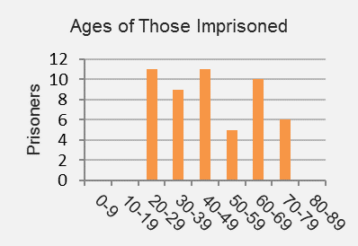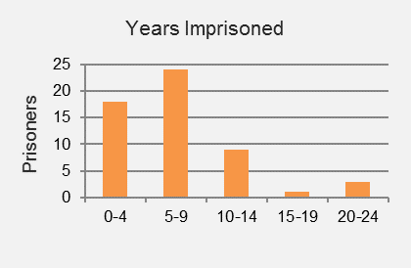

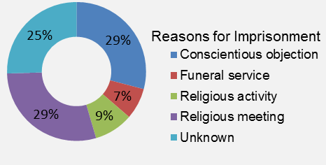
Many seniors are imprisoned:
Nine are in their 60s and six are in their 70s.
Three male Witnesses have been in prison for 23 years without formal charges against them.

II. Alleged Violations of the International Covenant on Civil and Political Rights (ICCPR - Articles 1, 2, 3, 7, 9, 10, 12, 14, 16, 17, 18, 19, 21, 22, and 27)
Restrictions on Religious Freedom
  - Background. The persecution of Jehovah’s Witnesses in Eritrea escalated after a presidential decree dated 25 October 1994 declared that Jehovah’s Witnesses who are Eritrean by birth revoked their citizenship “by their refusal to take part in the referendum and have reconfirmed their position by refusing to take part in the National Service.” Consequently, the government stripped Jehovah’s Witnesses in Eritrea of their basic civil rights.
  - The government does not allow Jehovah’s Witnesses to work in government offices, revokes their business licenses, and confiscates their identity cards and travel documents.
A photocopy of the presidential decree banning Jehovah’s Witnesses
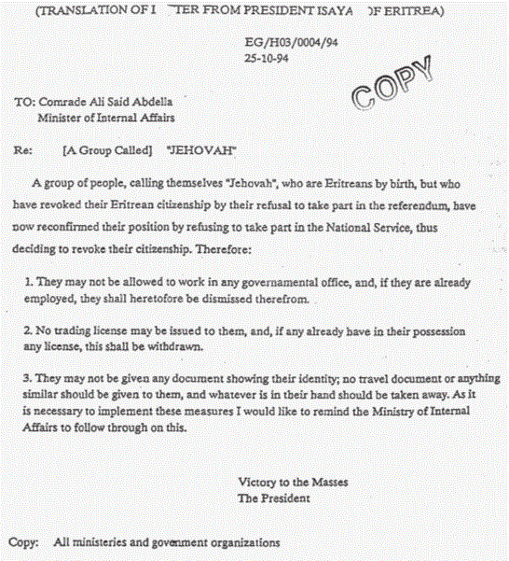
  - Jehovah’s Witnesses cannot receive a full secular education. Upon completing the 11th grade, high school students are obliged to register at the Sawa military camp to complete their 12th-grade education while receiving military training. Therefore, in order to maintain their conscientious stand to refrain from military training and military service, Jehovah’s Witnesses do not register.
  - Since 2008, Eritrean authorities have further oppressed Jehovah’s Witnesses, arresting and imprisoning elderly men, several women, and children. Many Witnesses have fled the country; those who remain must exercise extreme caution in their religious activity and worship.
UN Human Rights Council Resolution A/HRC/29/L.23, dated 2 July 2015, calls upon the government of Eritrea to “respect everyone’s right to freedom of expression and to freedom of thought, conscience and religion or belief.”

International Body Draws Attention to the Persecution of Jehovah’s Witnesses
  - The Commission of Inquiry on Human Rights in Eritrea (COIE) determined in its second report, dated 9 May 2016 (A/HRC/32/47), that the severe and uninterrupted persecution of Jehovah’s Witnesses since 1991 amounts to a crime against humanity.
The COIE report states: “Jehovah’s Witnesses have been targeted since May 1991 … Persecution has been an integral part of the Government’s efforts to maintain its authority in a manner contrary to international law. The commission therefore finds that Eritrean officials have committed the crime of persecution, a crime against humanity, in a widespread and systematic manner since May 1991.”—Paragraph 88.

Status of Prisoners
  - Of those currently imprisoned, 16 are known to have been arrested for their conscientious objection to military service. Police arrested others while they were attending religious meetings or publicly sharing their faith or for undisclosed reasons. Of all those imprisoned, only one has ever been tried in court and sentenced. Most do not know how long they will remain in prison.
Harsh Treatment in the Meitir Camp
  - On 5 October 2011, all 25 male Witnesses imprisoned at the Meitir Camp were transferred from the regular prison facility to an area for special punishment and were placed in a half-buried metal building. They remained in the special punishment area until August 2012. In the summer months, the intense heat made it unbearable to stay inside the building during the day. The men remained outside under an open-air structure with a thatched roof and then returned to the metal building at night. After this experience, the health of several of the Witnesses was in a critical state, having also been diminished by inadequate food and insufficient water.
  - In July 2017, it was learned that all Witnesses at the Meitir Camp were transferred, along with other prisoners, to the Mai Serwa prison just outside of Asmara, where conditions may be more bearable.

Deaths in prison camps or after release from prison
  - Four of Jehovah’s Witnesses who died while imprisoned in Eritrea: Yohannes Haile and Misghina Gebretinsae died in the Meitir prison.
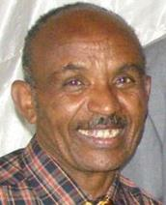 | Yohannes  Haile,  died at age 68  in the Meitir Camp on  16 August 2012. | 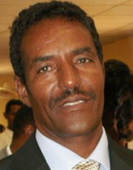 | Misghina  Gebretinsae,  died at age 62  in the Meitir Camp in  July 2011.

  - Habtemichael Tesfamariam and Habtemichael Mekonen died in the Mai Serwa Prison
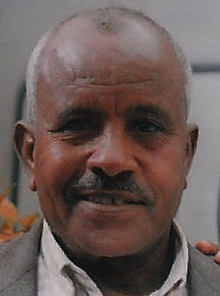 | Habtemichael Tesfamariam,  died at age 76  in the Mai Serwa Prison  on 3 January 2018 | 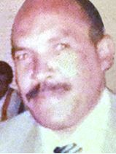 | Habtemichael  Mekonen,  died at age 77  in the Mai Serwa Prison on 6 March 2018

  - Kahsai Mekonnen, arrested in October 2008 when he was 76 years old, was released from the Meitir Camp a year later because of serious health problems. He died in 2013 as a result of the conditions he endured while imprisoned at an advanced age. Two other Witnesses—Tsehaye Tesfamariam and Goitom Gebrekristos—respectively died on 30 November 2016 and 29 December 2014 after their release from the Meitir Camp.
UN Human Rights Council report of Special Rapporteur Sheila B. Keetharuth, dated 13 May 2014, recommended that the government of Eritrea “guarantee the physical integrity of all prisoners; ensure access to medical treatment for those in need . . . and improve the conditions of detention in accordance with international standards.”

Denial of Right to Religious Assembly
  - A number of those currently in prison were arrested for attending peaceful religious meetings with fellow Witnesses. In April 2014, police arrested members of the Saba Congregation of Jehovah’s Witnesses who were attending the annual commemoration of Jesus’ death. They were released on bail, and the matter remained pending in court until 21 March 2016, when 54 of them were finally charged with “illegal assembly.” The court fined 53 of the Witnesses about 18 euros each. However, one Witness, 28-year-old Saron Gebru, pleaded not guilty and was released on bail, pending the hearing of her case. This was the first time that a Witness had been formally charged in court.
  - On 5 April 2016, the court sentenced Saron Gebru to a six-month prison term. She was held without opportunity to appeal in the Haz Haz Women’s Prison in Asmara and was released on 5 October 2016.
Recent Arrests
  - On 9 April 2016, Samuol Dawit, 27 years old, was arrested for conscientious objection to military service. On 30 March 2017, her sister, Hadas Dawit, 38 years old, was arrested for an unknown reason. Both are detained in the Mai Serwa Camp. In September 2017, two young male Witnesses were arrested for their religious activity and detained in an Asmara jail.
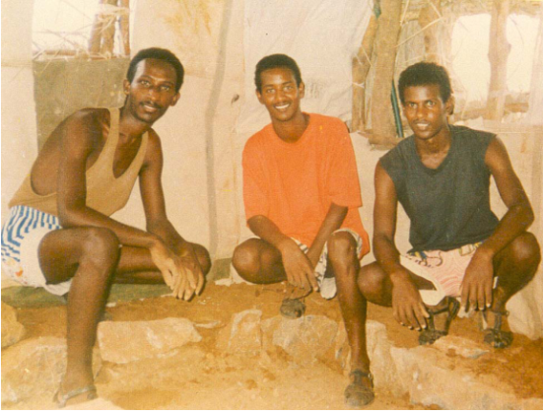
Denial of Right to Conscientious Objection to Military Service
  - Eritrea has no regulations or provisions in its national military service requirement for conscientious objection. To avoid arrest by the ever-present military police, who patrol the streets, most male Jehovah’s Witnesses between the ages of 18 and 40 live in hiding. The police arrest those whom they find and take them to a military camp. Once the men express their conscientious objection to military service, police detain and usually torture them. Some who are of military age have fled the country to avoid persecution; others have been caught while attempting to flee.
  - The government has imprisoned Paulos Eyassu, Isaac Mogos, and Negede Teklemariam in Sawa prison since 24 September 1994 because of their conscientious objection to military service. In the intervening 23 years, the government has neither filed charges against them nor given them a hearing in court.
  - Other male Witnesses have been imprisoned under the same circumstances for many years for their conscientious objection to military service. Aron Abraha has been in prison since 2001; Mussie Fessehaye since 2003; Ambakom Tsegezab since 2004; and three others since 2005.
UN Human Rights Council Resolution A/HRC/29/L.23, dated 2 July 2015, calls upon the government of Eritrea to “provide for conscientious objection to military service.”

Right to Education
  - Jehovah’s Witnesses cannot receive a full secular education. Upon completing the 11th grade, high school students are obliged to register at the Sawa military camp to complete their 12th-grade education while receiving military training. Therefore, in order to maintain their conscientious stand to refrain from military training and military service, Jehovah’s Witnesses do not register.

III. Conclusions and Recommendations
  - Jehovah’s Witnesses in Eritrea and as a worldwide organization respectfully ask that the Committee make the following recommendations to the government of Eritrea:
- Allow Jehovah’s Witnesses to register as a religion, to have full rights as citizens, and to manifest religious beliefs individually and jointly with others in the peaceful exercise of freedom of religion and freedom of assembly
- Recognize the right to conscientious objection to military service and provide for alternative civilian service so that Jehovah’s Witnesses may serve their country with a clean conscience
- Meet with Jehovah’s Witnesses to discuss the issues raised in this submission
All of the above is respectfully submitted by
The European Association of Jehovah’s Witnesses

The European Association of Jehovah’s Witnesses (EAJW) has separately filed a submission similar to this with the African Commission on Human and Peoples' Rights (ACHPR), occasioned by Eritrea filing its long-delayed “National Report” with the ACHPR on 22 February, 2018 containing untrue and damaging allegations justifying its mistreatment of Jehovah’s Witnesses. The consideration of Eritrea’s report will take place during the next Ordinary session of the ACHPR (25 April to 9 May, Nouakchott, Mauritania).

