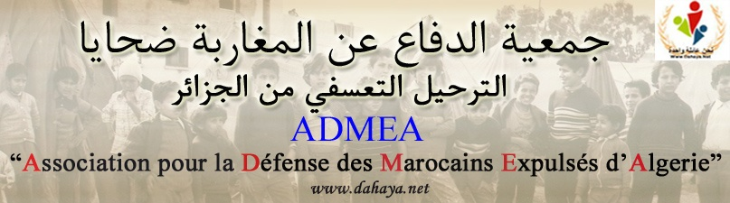
المكتب الوطني Bureau National

To the chairman of the Committee on the Protection of the Rights of all Migrant
Workers and Members of their Families ( CMW ) Palais Wilson – Genève

Subject : a pleading about the cause of Moroccan workers expelled from Algeria in 1975
In relation to Algeria’s submission of a report about the implementation of the international convention on the rights of all migrant workers and members of their families to the competent committee of the UN on April 27th and 28th,2010, and taking into consideration the powers of the experts in monitoring the implementation of the convention and the possibility of expressing the committee’s concerns and recommendations ( what was called “final notes” ), the committee will listen to the explanations of the Algerian commission on the occasion of the proceedings of the 28th session for the protection of the rights of all migrant workers and members of their families on April 10th and 11th at Palais Wilson , Genève . And – as included in the agenda ( term 7 ) - the committee will also listen to the list of issues related to the second sessional report submitted by Algeria on December 14th,2017.
The experts of the committee will have the occasion to ask the Algerians for additional explanations on the issue of the rights of Moroccan workers forcedly displaced from Algeria and the non-activation of paragraphs 24,25,34 and 35 found in document ( CMW/C DZA /1 ) from the final remarks issued by the committee on may 5th, 2010 which Algeria considered inappropriate and inacceptable.
The objective of the association for the defense of Moroccans expelled from Algeria (ADMEA ), an independent Moroccan human rights association that is concerned with the case of Moroccans victims of a forced displacement from Algeria in 1975 , is to provide the committee with information about the rights of the expelled workers. Their legitimate rights that Algeria still ignores for more than four decades

atiallah.admea@gmail.com E-mail : 658449523 GSM : (00212) 615617589

We seek Mr chairman’s acceptance and response to the following pleading:
The rights of workers are among the main principles of human rights which can not be disregarded nor partitationed . Workers should be granted their rights according to the international charters , to the universal declaration of human rights, and to the international convenants on human rights. The international law recommends the protection of workers’ rights aming at : the organization of competation , the support of international peace, the dissemination of social justice, the development of labour laws, and the support of reform movements.
The event of Algeria’s collective and brutal displacement of 45 thousand Moroccan families in inhuman conditions started in December 1975. Moroccan legal workers were among the displaced community . Our focus will be on these victims who were dismissed from their jobs without following the procedures of expulsion and dismissal and without compensation for the unfair and illegal dismissal by the Algerian authorities .
The act of dismissal is considered a crime act which was succeded by crimes against humanity that were embodied in the forced displacement and the imprisonment of individuals in secret detention areas depriving them of visits and torturing them and resorting to the expropriation of their properties. This is considered a vicious abuse of the rights of individuals when referring to the international convention for the protection of the rights of all migrant workers and members of their families which Algeria signed and therefore should be committed to its terms. The convention insisted on the protection of the interests of migrant workers and their legal rights .
As Moroccan migrant workers in Algeria were employed legally and legitimately, they possessed residence certificates , employement contracts signed by the state, and registration cards in the national social security fund of Algeria. This shows that Moroccan workers in Algeria were employed legally and therefore should have equal rights as the Algerian workers . This was stated by the international convention that was adopted by the decision 185/15 on December 18th,1990, part 2 entitled: (“ non – discrimination of rights” . However, the Algerian authorities breached all the charters and laws and committed torture, racism and ill-treatment in their policy towards Moroccan workers and members of their families simply because these victims expressed their opinions freely about their Moroccan identity and stayed attached to it . Consequently, they were deprived of their properties and their personal freedom was violated . Taking into account the fact that it is the duty of Algeria to protect the workers

from violence,threats and intimidation . Instead, the workers should be treated humanly with respect to their cultural identity . The Algerian authorities did not abide by article 12 of the convention and the articles that followed . According to article 22 of the convention , migrant workers should be given reasonable opportunity before or after departure to settle any claims for wages. Unfortunately, the Algerian authorities deprived them of the right of suing and the demand of compensation for arbitrary dismissal , the benefit from social security and health care, and the transfer of savings and personal properties to their native countries .
Algeria still ignores and avoides this human rights cause. It still continues in violating a set of laws in order to hide its crimes . In 2010 , the state issued new requirements for the law of finance chapter 42( published in the official gazette No 78 on December 31th , 2009 ) states :
- Attachment and inclusion of real property related to names that no longer exist in reality to the real estate of Algeria – including the properties of Moroccans expelled in 1975 .
The chapter also requested the deletion of names of propreties ( abanded lands) from the real estate conservation agency .
All these events are evident regarding the fact that official documents proving the acts are signed by Algerian authorities. In addition there are testimonies of Moroccan workers deprived of their rights who suffered from physical and moral torture . Given the fact that these workers were victims ,The Algerian authorities should offer apporopiate compensations to the them and members of their families, grant them material reparation , make an official apology and work for the retrieval of their confiscated estates and properties . Besides , Algerian authorities should facilitate the reunification of families of workers in Morocco and Algeria. The forced displacement of Moroccan migrant workers from Algeria in 1975 will not be forgotten through the years . It was a crime against humanity .

Signature
President of the national beureau Rabat in: 29/03/2018
Mohamed elherouachi

