Committee for Economic, Social and Cultural Rights

Submitted by Roma Women Platform “ROMNI” (RWP “ROMNI”) from RM, August 2017

Contact data:
Elena Sîrbu, Chair of the Roma Women Platform “ROMNI”
tel: 373-6811-3429, e-mail: petaloromano-elena@mail.ru

1. About the Roma Women Platform “ROMNI”
RWP “ROMNI” is a nongovernmental, apolitical, nonprofit organization established in September 2016. The main objectives of the organization are:
- to ensure the political, civil, economic, social, and cultural rights of the persons of Roma ethnicity, regardless of the age and gender
- to raise community awareness about the rights and obligations provided in the national and international legislation
- to promote equality, to prevent and combat domestic violence and discrimination
- to promote Roma women’s rights provided in the international conventions.

The members of the organization are persons aged 18-65 years old, Roma and non-Roma men and women, who recognize and support the objectives of the association.

2. Considerations regarding the observance of the right to work
Roma population continues to encounter a multitude of discrimination forms, especially in the area of education, health, employment or participation in public, political, economic, and cultural life. Due to the role that many of them are imposed to play in their families, the Roma women and girls are particularly vulnerable in relation to the fulfilment of their right to education, employment, and access to health services. According to the study on situation of Roma women and girls in the Republic of Moldova, carried out by UN WOMEN, UNDP, OHCHR in 2014, Roma women and girls may be described as one of the most deprived groups in the Republic of Moldova. Moreover, gender inequalities occur in Roma households and interfamily relations, in Roma communities, and in the society in general, and this fact makes Roma women particularly vulnerable to social exclusion and discrimination.

According to statistics, only 21% of able-bodied Roma people (aged 15-64 years old) are employed, as compared with 46% of people from non-Roma able-bodied population. Very eloquent in relation to their work involvement would be also the data showing the length in service for Roma people, which is for 13,6 years as compared with 23 years in case of non-Roma people. About 19% of Roma are permanently employed as compared to 69% of non-Roma people.

Roma women encounter significant barriers on the labor market, including as a result of the anti-Roma attitude which results in discrimination. The limited access on the labor market and the law employment level are caused by the low level of education, lack of professional qualification, lack of information about existing vacancies, lack of employment opportunities and residential segregation, as well as uncontested discrimination on the labor market.

Frequently, the women having a job work as day workers in the neighboring households, agriculture, small trade and entrepreneurship. Because of the working in informal economy, the monthly income of Roma women is extremely unsafe and frequently insufficient to cover the elementary needs. In the context of the limited employment opportunities and lack of professional skills requested on the labor market, many Roma women chose to migrate to work abroad or, especially in case of Roma women in urban areas – to get employed in small trade activities after procuring some goods from abroad

On the other hand, it should be mentioned that the efforts undertaken by the authorities for providing skills and employing Roma persons on the labor market are insufficient or lack efficiency. For instance, cases were identified when the Roma persons registered with the National Employment Agency were offered jobs as drivers, while the candidates did not have a driving license, thus having to refuse the offer or situations when the applicants were offered jobs as sewers while they did not have any knowledge and skills in the respective area. At the same time, the territorial employment agencies do not provide specialized qualification or requalification courses for the vulnerable categories of the population, especially for the Roman women.

At the same time, the repeated refusal of an offer leads to deleting the person from the employment records, withdrawal of the unemployment allocation, and exclusion from the category of the beneficiaries of social assistance. In these conditions, the majority of Roma people have to leave abroad for seasonal work or to emigrate to the Russian Federation or Ukraine to look for a job.

In the localities with opportunities to work on their own account (cities, big villages), Roma people have the possibility to sell the goods they manufacture and handicraft (blacksmiths) or sell goods procured in bulk. Even so do not offer jobs, the cities offer more opportunities for Roma people who work as day workers or look for an occasional income. The rural population has to migrate for seasonal work to the northern part of the country for several months in a row, taking with them the entire family and thus depriving their children from the possibility of going to school. As well, “day worker” option was most frequently checked by Roma people as their occupation and income source. These sources generate a monthly average income between 500 MDL (23 Euro) and 2500 MDL (119 Euro), depending on the number of family members and their social status – a fact that leads to perpetuating extreme poverty within Roma communities.

When the visa regime facilitation occurred, about 1700 persons (entire families) have migrated to such countries as Germany, France, Switzerland. Based on the discussions with the members of families that have left, it was found out that Roma people request for political asylum, but most of them beg on the streets of the big cities of the countries they have ended up in.

3. Conclusions regarding the identified inequality causes:
- Low level of education among the Roma population as compared with the rest of population and lack of trainings and qualifications. The lack of professional qualification determines the Roma people to get employed in jobs with small revenues or to perform activities on their own account. According to their statements, the territorial employment agencies offer to Roma unemployed people unqualified jobs (sweepers, cleaning personnel) with low remuneration or which do not correspond to the professional profile of the candidate.
- Lack of legal culture and high costs for official employment of unqualified workers lead to Roma people’s employment without performing all the official formalities. The big majority of persons stated that they have never concluded a work contract and that the employment opportunities were based on verbal agreements, hence limiting Roma people’s access to social benefits, including to health insurance policy and age-limit pension. Moreover, the lack of length in service records, which were lost or disappeared when the collective farms came to an end, implies big problems for an eventual employment or age-limit pension calculation when reaching the retirement age.
- There is discrimination and marginalization in a number of areas, but mainly the differential treatment applied by employers, which is sometimes concealed by invoking some reasons which refer to the insufficient level of education or experience, or lack of other professional skills. The level of social exclusion of Roma people is amplified also by the behavior of employers and personnel at work. The majority of persons complained on the discriminatory environment at their places of work.
- Some Roma leaders recognize that many of Roma people gave up the traditional handicraft and got specialized in trade, including the trade abroad. It should be mentioned that the traditional occupations of the Roma people, such as blacksmiths and fiddlers are not in demand anymore on the labor market, hence Roma people have to identify other activities for maintaining their families.
- Geographical isolation of the communities compactly populated by Roma people
- Communication barrier and interaction between the Roma people and official institutions
- The persons from the Roma communities are not connected to the general flow of information and do not know about the opportunities provided by the National Employment Agency.

All these causes place the Roma people in unequal positions as compared to the majority population and hinder the possibility to obtain revenues for meeting the vital needs; and thus, this situation creates preconditions for increased poverty level within Roma population, as well as massive migration abroad.

4. Recommendations:

- To promote entrepreneurship among the local communities with a significant share of population belonging to Roma minorities, with a solution to make more active the local partners and to find solutions for the complex problems of the local communities;

- To identify some work opportunities based on flexicurity for the vulnerable groups, especially for the women belonging to Roma minority (flexible jobs with paid social insurance), income-generating activities and small business for families, apprenticeships or mentoring programs together with support for access to education and care services: nurseries and kindergartens, “school after school”;

- To train Roma community mediators in the area of employment on the labor market to facilitate the access to National Employment Agency’s services for Roma minority (Information Services and Self-Service Services);

- To train the personnel of the National Employment Agency to be familiarized with the peculiarities of the Roma population, for the purpose of eliminating communication barriers and interaction during the process of provided specialized services;

- To develop the National Employment Agency’s services (professional orientation and vocational training), which would be customized for the needs and peculiarities of the Roma community;

- To establish the courses for vocational training/qualification according to the traditional crafts in Roma communities;

- To set some binding quota for participation of Roma population in the services provided by the National Employment Agency;

- To include in the Action Matrix for the implementation of the National Employment Strategy some separate measures meant for every vulnerable group separately;

- To carry out a pilot project which would last for 2 years and test the implementation of the National Employment Strategy for the Roma group.

- To create a mechanism for collecting information and monitoring the situation on Roma people involvement on the labor market and their situation as beneficiaries of the National Employment Agency’s services, based on voluntary participation criteria

To introduce in the descriptive part of the National Employment Strategy for 2017-2021 a component dedicated to the situation of every vulnerable group separately (persons with disabilities, Roma people, youth, immigrants and returned migrants, etc.).

Annexes:
1. Infographic on level of education of Roma women
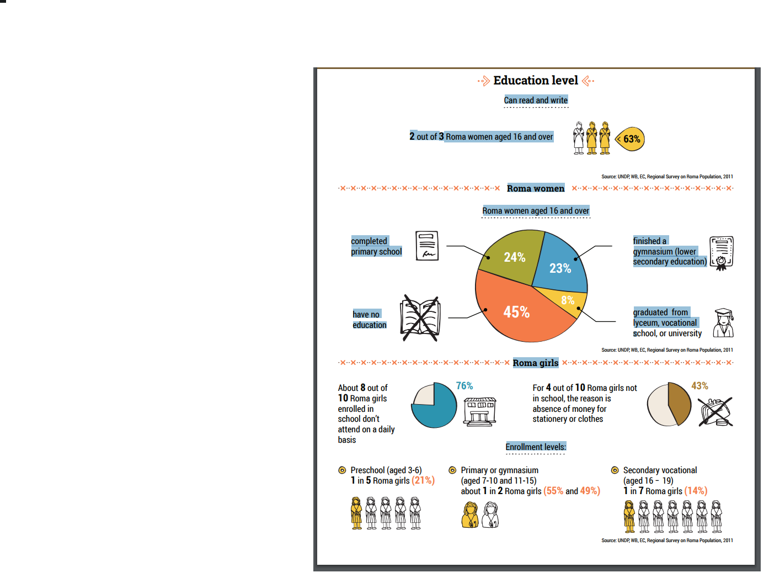

2. Infographic on access to work for Roma women 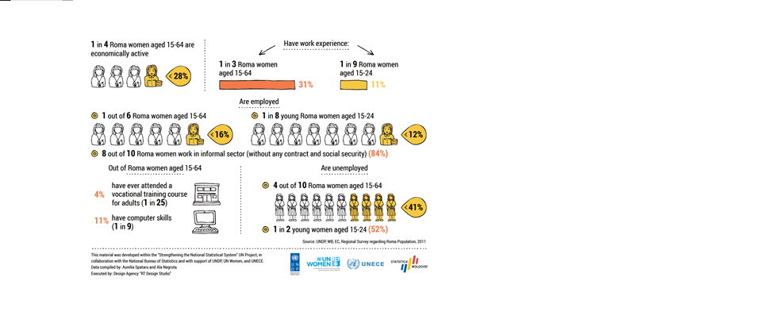

http://md.one.un.org/content/dam/unct/moldova/docs/pub/Studiu_cu_privire_la_situatia_femeilor_si_fetelor_rome_din_Republica_Moldova_ro.pdf
http://md.one.un.org/content/dam/unct/moldova/docs/pub/Studiu_cu_privire_la_situatia_femeilor_si_fetelor_rome_din_Republica_Moldova_ro.pdf
http://md.one.un.org/content/dam/unct/moldova/docs/pub/Studiu_cu_privire_la_situatia_femeilor_si_fetelor_rome_din_Republica_Moldova_ro.pdf
According to the survey on Roma Women’s and Girls’ Profile in RM, April 2017, carried out by UN WOMEN, UNDP, NBS https://issuu.com/un_moldova/docs/femeilerome_cabc77cc154e9b

