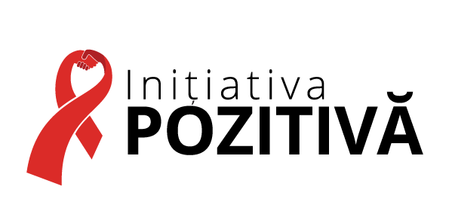

ALTERNATIVE REPORT
to the UN Committee on Economic, Social and Cultural Rights
for the consideration of the 3rd periodic report
of the Republic of Moldova

Introduction
- This submission has been prepared by the Public Association (non-governmental organization) “Positive initiative” (registered in 2011), which is a network of organizations with a rich experience in the field of HIV/AIDS and drug use in Moldova, with focus on MARPs (Most at Risk Populations). The organization is oriented towards defending the rights and represent the interests of people living with HIV, drug users, women and children with HIV or affected by HIV, and other affected and interconnected communities.
Summary
- This report is focused on the:
  - Right to the highest attainable standard of health: the issue of transparency in public procurement of medicines and on access to the treatment of Hepatitis C by people living with HIV and drug users;
  - Cultural rights: the issue of unjustifiable regress in the official recognition of names of people belonging to ethno-linguistic minorities as an essential element of their culture.

Maximum available resources (art. 2 (1)): procurement of medicines
- Access to information and participation in the process of public procurement of medicines for the treatment of HIV and hepatitis C is extremely limited. Information on the implementation of procurement at all stages – starting with drafting of the requirements and terms of reference to evaluation of proposals and prices received from suppliers – is not transparent and is closed to beneficiaries, whose lives depend on these life-saving medicines. Therefore, there are concerns on the efficient use of the public resources for the procurement of the life-saving medicines, and this situation undermines the State’s obligation to fulfill the right to health to the maximum of the available resources.
- Due to Ministry of Health’s cooperation with UNDP Moldova in 2017 more transparency was brought to the procurement of medicines for the treatment of HIV and other diseases. In addition to this, a) the medicines were procured and delivered in time respecting the deadlines, b) there were procured qualitative medicines according to the international standards, and c) due to the application of international procurement processes considerable savings, up to 23% of funds, and more life-saving medicines can be procured now.
- At the same time, the situation with the procurement of medicines for the treatment of hepatitis C remains to be non-transparent. The National Health Insurance Fund is responsible for the procurement of medicines to treat hepatitis C.
- The “Positive Initiative” recommends:
- To include in the public procurement working commissions representatives of the beneficiaries at all levels of procurements;
- To insure timely publication of ads and conditions of the procurement process and results of the final decision on suppliers, prices and name of the purchased medicines;
- Both the Ministry of Health and the National Health Insurance Fund to make use of international procurement mechanisms directly or through international development organisations, including for Hepatitis C treatment;
- To introduce electronic system for public procurement of medicines, to increase the transparency of the procurements.

Non-discrimination (art. 2 (2))
- The national wide survey shows that the most discriminated and socially excluded groups in the society are LGBT, people living with HIV, detained persons and ex-detainees (more details are in the chart below). All these groups are directly affected by HIV, Hepatitis C or use of drugs and thus are in need of access to qualitative health services, which can be undermined by the discriminatory attitudes.
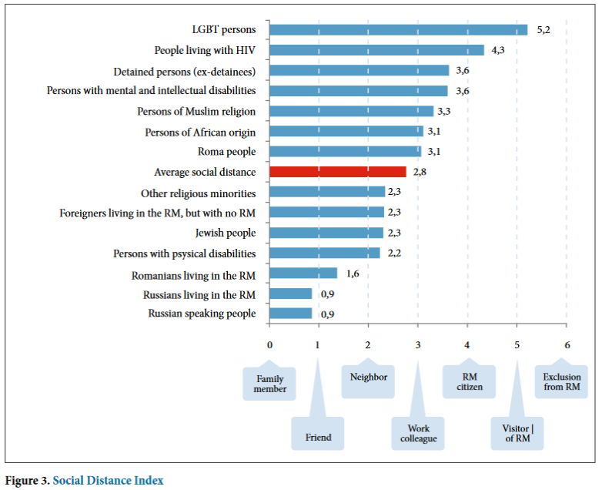
- The “Positive Initiative” recommends:
- Public authorities to take measures for the efficient promotion of equality and combating prejudices against the most discriminated and socially excluded groups, including LGBT, people living with HIV and former detainees;
- To provide sufficient resources for the functioning of the Council on the Prevention and Elimination of Discrimination and Ensuring Equality;
- To fully implement decisions of the Council, including by the amendment of the legislation where necessary.

Right to physical and mental health (art. 12): accessibility of Hepatitis C treatment
- According to the official estimations, there are about 300,000 people living with Hepatitis C in the Republic of Moldova. Every year 3,000 of them die due to the leak of accessible treatment. The situation is complicated by the fact that 70% of HIV positive persons are co-infected with Hepatitis C and 80% of injectable drug users live with Hepatitis C.
- At the same time, until 2017, the National Program for the treatment of Hepatitis C provided free of charge treatment only for 300 persons per year. The cost of a single course of treatment has been 15,000 Euros/person with the treatment period of 1 (one) year. In the countries from our region, such as Ukraine and Georgia, the price per course of treatment is 2,5-5 times less than in Moldova. In many other countries Sofosbuvir is used as a less expensive and more effective treatment course for Hepatitis C. The price for such course is about 900 USD/person. This course is less toxic for the beneficiaries and it takes much shorter time: 3-4 months. The efficiency of the treatment is higher (it is successful in 90% of cases), than the treatment that the Moldovan state has offered offering (using Pegylated interferon).
- Only in 2017, due to the former Minister of Health Ms. Glavan and her staff, the progress has been registered in the treatment of people living with Hepatitis C. Cheap and high-quality generic medicines were registered in Moldova and the procurement of these medicines allows now:
- To treat 6,000 people from Hepatitis C in 2017 (20 times more than in 2016);
- To decrease the cost of treatment to about 800 USD/person (about 20 times cheaper than in 2016);
- To decrease the treatment period to 3 months (4 times shorter than in 2016).
- At the same time, there is a concern that pharmaceutical companies can register brand medicines in Moldova requiring at the same time to cancel the registration of the related generic medicines. Pharmaceutical companies may require this on the basis of Association Agreement and Deep and Comprehensive Free Trade Agreement (DCFTA) signed between Moldova and the European Union. This situation can reverse the achieved 2017 progress in the treatment of people living with Hepatitis C because of the commercial interest, and considerable regress is possible in the availability and accessibility of Hepatitis C treatment.
- Another serious problem lies in the lack of informational accessibility of Hepatitis C treatment: the system of registering to the waiting list for the state-paid treatment is non-transparent. There are cases when persons with Hepatitis had to pay bribes in order to be registered for treatment in spite of the fact that normally this should be free of charge. Moreover, when the person is already in the treatment list it is almost impossible for this person to find out what is his/her place number in the list and how long this person still needs to wait to be treated.
- The “Positive Initiative” recommends:
- To further increase the number of beneficiaries of the National Program for the treatment of Hepatitis C;
- To ensure transparency in registering and processing of the waiting list for the state-paid treatment of Hepatitis C;
- Not to undermine the availability and accessibility of Hepatitis C treatment because of the commercial interest of pharmaceutical companies possessing brand medicines.

Cultural rights (art. 15)
- People living with HIV are also belonging to different other groups of Moldovan society, including to ethno-linguistic minorities. Therefore, “Positive Initiative” is concerned about the rights of people belonging to ethno-linguistic minorities, specifically about the unjustifiable regress in the official recognition of their entire names (including patronymic names - father’s name put in a specific form) as part of their traditions and cultures.
- In 1994 a Law on ID Documents and the National Passport System was adopted. According to this Law:
- Names in national ID document were written in Romanian language (Latin alphabet), in Russian (in Cyrillic alphabet) and English (in Latin alphabet);
- Patronymic names were written in national ID document in Russian and English (patronymic names are traditional and culturally important names for most of ethnic minorities in Moldova, including Bulgarians, Gagauzians, Russians, Ukrainians and others).
- In 2012 the Law on ID Documents and the National Passport System was modified and as a result:
- Names in national ID document are not written any more in Russian (in Cyrillic alphabet) and English (in Latin alphabet);
- Patronymic names are not written in national ID document at all and therefore not recognized any more.
- The authorities explained that it is not possible to keep the names in several languages and to keep patronymic name in the national ID documents, because the size of the ID document has been decreased according to the European Union standards. At the same time, in other countries of the region, for example in Bulgaria, names (including patronymic names) are written in the national ID documents in Bulgarian (in Cyrillic alphabet) and in English (in Latin alphabet). Therefore, the size of the ID document is not a valid reason to violate cultural rights of ethno-linguistic minorities, as the entire names can be written there using the proper design of the ID documents.
- Therefore, there are no reasonable and objective justification for regress in the official recognition of patronymic names and in writing names in Russian (in Cyrillic alphabet) in the national ID documents. We do not understand, why it was possible to recognize the names in Russian language, including patronymic names, during 18 years, and it became impossible since 2012. Ethno-linguistic minorities are still living in Moldova in big numbers and they are willing to preserve and use their culture, including their culturally-responsive names, including patronymic names.
- The “Positive Initiative” recommends:
- To reintroduce the official recognition of names in Russian (in Cyrillic alphabet) and in other languages of ethno-linguistic minorities in the national ID documents;
- To reintroduce the official recognition of patronymic names in the national ID documents.

http://www.md.undp.org/content/moldova/en/home/presscenter/pressreleases/2017/07/04/pnud-a-livrat-peste-jum-tate-din-volumul-de-medicamente-necesare-pentru-9-programe-na-ionale-i-speciale-de-s-n-tate-din-republica-moldova-.html
Study on Equality Perceptions and Attitudes in the Republic of Moldova (by Equality Council, OHCHR, UNDP, year 2015), page 18: http://md.one.un.org/content/dam/unct/moldova/docs/pub/ENG-Studiu%20Perceptii%202015_FINAL_2016_Imprimat.pdf

