THE CITIZENS` LABOUR RIGHTS PROTECTION LEAGUE (Azerbaijan)

INTERNATIONAL CONVENTION ON THE ELIMINATION OF ALL FORMS OF RACIAL DISCRIMINATION

THE ALTERNATIVE (thematic) REPORT

TO SEVENTH TO ELEVENTH PERIODIC REPORTS OF THE REPUBLIC OF ARMENİA SUBMITTED TO THE COMMITTEE ON THE ELIMINATION OF RACIAL DISCRIMINATION (CERD)

This alternative (thematic) report is to be submitted to the UN Committee on the Elimination of All Forms of Racial Discrimination with a title Dissemination of Hatred and Racial Prejudice against the persons of Azerbaijan origin. It has been developed by the Citizens` Labor Rights Protection League.

Citizens' Labour Rights Protection League
Baku AZ1078, A. Huseynov str.,7, quarter 1061, entrance # J, apt.,347
Azerbaijan
Telephone: +(994 12) 530 86 25;
Mobile: +(994 50) 314 49 15
Fax: +(994 12) 510 42 71
e-mail: sahib.mammadov@gmail.com ; office@labourrights-az.org
http://labourrights-az.org/en

BAKU-2017

Information about organization
Citizens' Labor Rights Protection League was founded in 1997, and upon passing the state registration in 2000, it acquired the status of a legal entity. One of the main directions of its activities is to prepare alternative reports and information for the UN treaty and statutory bodies. CLRPL also collaborates with special rapporteurs of the UN Human Rights Council, and submits the prepared reports to them, and cooperates in various forms. Since 2008, CLRPL sends alternative reports to the periodic reports of the Government of Azerbaijan, participates in the open and closed sessions of the relevant committees. It follows the concluding observations of the UN Committees in relation to Azerbaijan, and prepares reports. In addition, CLRPL prepares information within the framework of the Universal Periodic Review procedure, and participates in a follow-up process. In the other countries of the region, CLRPL prepares alternative reports on the status of implementation of UN agreements which are its monitoring mechanisms.
This report prepared by the CLRPL is presented as an alternative to the periodic report 7.11 introduced by Armenia, another South Caucuses country, in accordance with the Convention on the Elimination of All Forms of Racial Discrimination. The report allowed no use of offense and harsh language against the participants of the Convention.

Brief history
The ruling elite of Armenia works systematically towards increasing the hatred toward Azerbaijanis (Turks), raising the younger generation in the spirit of hatred. All mass media of the country including print, electronic and broadcast media air the programs enhancing the hatred towards the Azerbaijani (Turkish) people. Secondary and high school books provide the distorted information about the historical events, and inculcate the sense of antipathy. Thousands of historical, religious, cultural monuments belonging to Azerbaijanis were demolished; toponymical and geographic names changed, and cemeteries destroyed in the territory of the current Armenia as well as Azerbaijani territories occupied by Armenia. Some monuments were later restored and armenianized or registered as the monuments of other nations.
In 1920, Zangazur and a number of Azerbaijani lands were announced as the territories of Armenia. At later stages, some new tools were implemented to expand the policy on deportation of Azerbaijanis from these territories. They succeeded adoption of the special decree of the Council of Ministers of the USSR on 23 December 1947 "On the resettlement of collective-farm workers and other members of the Azerbaijani population to the Kura-Araks Lowland of Azerbaijan SSR", and mass deportation of Azerbaijanis, on the state level, from their historical lands during the period from 1948 to 1953. More than 100.000 Azerbaijanis were deported from their historical homelands.
In 1988, within one week 250.000 people were deported from Armenia with particular violence. Hundreds of elderly people, women and children were killed or died in cold weather as they were crossing over the mountains during deportation. The deported had mixed nationalities, but all were Muslims. There were representatives of other national minorities as well as Muslim Kurds among the deported.
Starting from 1988, as a result of military invasion of the Armenian armed forces 20% of Azerbaijani lands - Nagorno-Karabakh and seven surrounding regions (Lachin- 18 May 1992, Kalbajar-2 April 1993, Aghdam- 23 July1993, Jabrayil- 23 August 1993, Fizuli- 23 August 1993, Gubadli- 31 August 1993, Zangilan- 29 October 1993) were occupied, 700 thousand Azerbaijanis from Nagorno-Karabakh and surrounding regions, as well as from the settlements bordering with Armenia or Nagorno-Karabakh were deprived of their permanent places of residence, and became internally displaced persons, and got temporarily settled in 62 cities and districts, and more than 1600 settlements with high density.
20% of Azerbaijan's territory, including Nagorno-Karabakh, as well as seven regions adjacent to it -Aghdam (62.8 per cent is under occupation), Jabrayil, Fuzuli (79.3 per cent is under occupation), Kalbajar, Gubadlı, Lachın, Zangilan and a number of settlements bordering with Armenia- one in the Nakhchıvan Autonomous Republic (Kerki), 13 in the Terter District (Chardaqlı, Umudlu, Ortakend, Talısh, Hesenqaya, Shıkharkh, Canatagh, Chaylı, Aghdere, Kichik-Garabey, Gızıloba, Aghabeyyalı, Ulu-Garabey) and 7 in the Gazakh District (Yukharı Eskipara, Ashaghı Eskipara, Baghanis-Ayrım, Kheyrimli, Barkhudarlı, Sofulu, Gızılhacılı) have been under the occupation by Armenia's military forces for the past 24 years.
Armenian military aggression caused occupation of 17 thousand sq. km of the most fertile land, destruction of 900 settlements, 150.000 houses, 7.000 public buildings, 693 schools, 855 kindergartens, 695 medical institutions, 927 libraries, 44 temples, 9 mosques, 473 historical monuments, palaces and museums, 40.000 museum exhibits, 6.000 industrial and agricultural enterprises, 2.670 km highways, 160 bridges, 2.300 km water communications, 2.000 km gas communications, 15.000 km power lines, 280.000 hectare forests, 1.000.000 hectare agricultural lands and 1.200 km irrigation systems of the republic.
As a result of Armenian military aggression, 20 thousand Azerbaijanis were killed, 100 thousand people were wounded, 50 thousand people became disabled by cause of injuries of various degrees and 4.011people went missing.
Since the start of 1992, Armenian armed forces continuously occupied the last settlements of the upper Karabakh populated by Azerbaijanis. Thus, Malibeyli and Gushchular villages of Shusha district were captured by Armenian armed forces. During February 13-17, 118 people (child, woman, elderly) were taken captives, 33 people shot as a result of armed attack to the Garadaghly village of Khojavand region. At the same time, all the killed and wounded residents were buried in the wells. 68 captives were brutally murdered, 50 people were rescued with great difficulty. Later, 18 of these rescued people passed away due to incurable injuries.
The main purpose of Armenians for committing the Khojali genocide, the massacre committed with particular cruelty, was to wipe out this ancient settlement of Azerbaijan from the earth. With the population of more than 7,000 Azerbaijanis, Khojaly was the biggest and the most ancient residential area encircled by the villages inhabited by Armenians. The ancient historical monuments there survived into the modern era. It is well-known that the samples of Khojaly-Gadabay culture dating back to the 4th-7th centuries BC were existing near Khojaly. In February 1992, after the massacre of the Khojaly population with the help of the 366th soviet regiment, Armenian armed forces destroyed Khojali monuments, the examples of unique heritage important not only for Azerbaijani people but also to the humanity.
As per official figures, as a result of the genocide, 613 people were killed, among which 63 children, 106 women, and 70 elderly. 8 families were completely murdered. 487 people became disabled, among which 76 were children. In addition, 1.275 people were taken hostages, 150 of whom went missing.

Wrong and biased information included into the periodic report of Armenia
In the Article 23 of the report, Armenian Government informs about establishing contacts with the national minorities of Armenian in the neighboring countries, but provides distorted information to the UN Committee on Elimination of All Forms of Racial Discrimination about the reasons why this “collaboration” doesn’t work with Azerbaijan.
Afterwards, in the Articles 25 and 26, false information about quasi massacre against Armenians in some regions of Azerbaijan was presented.
On 7 July 1923, the Nagorno-Karabakh Autonomous Oblast (NKAO) was established in the mountainous part of Karabakh, where majority of the population were Armenians. The town of Khankandi was defined as the administrative center of the autonomy. In September 1923, the name of the town was changed to Stepanakert in honor of Stepan Shaumian, dashnak and “Bolshevik” leader.
The borders of the NKAO were defined in a way to ensure the Armenian population were in majority. According to the population census of 12 January 1989, the population of the autonomous oblast was about 189.000 people. Out of them, about 139.000 were Armenians (73, 5%), 48.000 Azerbaijanis (25, 3%) and 2.000 (1.2%) representatives of other nationalities. 320.000 Azerbaijanis densely settled in Armenia though were refused even cultural autonomy both by the central government of the USSR and the government of the Armenian SSR.
As for the allegations of discrimination against the Armenian population of Nagorno-Karabakh, critical researches prove the opposite: the NKAO possessed all principal elements of self-government.
The NKAO was developing more quickly than Azerbaijan. For example, while industrial production in the republic increased threefold during 1970-1986, in the NKAO, it grew by 3.3 times (the growth rate was 8, 3% higher). In 1986, 3.1 times more real estates were launched in the oblast while in the republic this figure was 2.5. As to the main indicators of social development, NKAO had higher standards of living dimension than that of the republic. Substantial progress was observed in the development of cultural institutions, both throughout the republic and in the oblast.
During the 1988-1989 academic year, there were 136 secondary general education schools (16.120 pupils) and 13 international schools (7.045 pupils) in Nagorno-Karabakh where the language of instruction was Armenian. In Azerbaijan, in the same academic year, there were 181 Armenian schools (20.712 pupils) and 29 international schools (12.766 pupils). More than 2.130 students, with majority being Armenians, were studying in Azerbaijani, Armenian and Russian divisions of Khankendi State Pedagogical Institute. In addition, in Nagorno-Karabakh, there were dozens of specialized secondary schools and vocational training schools with education in Armenian and Russian.
As mentioned above, and shown by the existence and development of the NKAO within Azerbaijan, the form of autonomy was fully reflecting the specific economic, social, cultural and national characteristics of the population, and the way of life in the autonomous region.
Currently, there are 35.000 Armenians living in the other regions of Azerbaijan. They can exercise their citizen rights and freedoms like others.

Instilling hatred and insults for Azerbaijanis (turks) in the mass media and textbooks
Leading mass media of Armenia regularly demonstrates articles increasing hatred towards Azerbaijan and Azebaijanis (turks). As a rule, defamatory articles about the violent behavior of Azerbaijanis towards Armenians is widely used. Armenians who used to live in Azerbaijan share their “memories” of the cruelty and brutality of Azerbaijanis towards them.
Panorama.am, panarmenian.net, Voice of Armenia, Yerkir, Armenpress. Armenian News Agency, Aravot, Voskanapart İnfo analytical portal and other print and electronic media, Armenian Public Television, other television and radio companies provide wide range of antiazerbaijani propaganda to create dangerous enemy image of Azerbaijan and hatred among Armenians.
These mass media give the following titles to the articles humiliating and insulting Azerbaijanis (Turks): “Animals and their offsprings don´t have hearts”, “How to explain to a sheep that people are individuals?” etc.
Articles denying the truth about the origin of Azerbaijani people (Turks) (for example: Karabakh was a part of an ancient Armenian kingdom and Azerbaijanis were nomads). There are many articles describing the origins of ancient Azerbaijani (turkish) monuments, toponyms belonging to other nations.
Armenian mass media says:
“This style is peculiar to radical Islamists, their inhuman behavior featured in the beasts. Azerbaijanis-the same turks are barbarians, and do not differ in any ways from them. They should not be in the world”

Articles humiliating and insulting the Azerbaijani people (Turks) are placed on information portals, mass media using the domains of Armenia and different countries. Azerbaijanis are presented as barbaric and savage people.

Saqatel Bakveshinyan in his article named “Animals and their offsprings don´t have hearts” writes in another Armeninan portal:
“Transformation of Turks into human beings was hopeless and meaningless from the beginning because we were not then aware of the major touches of genetic science. Turks do not learn from us and other neighbours. Their only source of learning is the wolf genes of the immoral boy who was the ancestor of Black Sheep and White Sheep Oghuzs (hints at White Sheep and Black Sheep tribal federations- CLRPL)”
“It is not accidental that despite living in the neighbourhood for centuries, they have not even learned to build houses; even though the number of floors of these houses are more than 20. Transcaucasian Turks (Azerbaijanis-CLRPL) are now living in the imitative reality built by themselves and do not understand the meaning of their actions. This behavior of traditional nomads and White and Black Sheep ancestors look very hilarious from outside”.
Later Saqatel Bakveshinyan writes:
“How to explain to a sheep that people are individuals?”
“I think poor and exhausted Transcaucasian Turks cannot understand these things.Despite the spirit derives from the word heart. Excuse me for repeating the words I have used in my previous article- The world religions teach that animals and their descendents do not have hearts”

Various articles and programs are demonstrated in the press, television and radio, textbooks towards creation of a vandal image of Azerbaijanis (turks). For example, Yerkir prints the following type of articles:
“In our previous articles, we have mentioned that we are an exceptional nation that always has enemies, and their number doesn´´t decrease, on contrary, increases. And from two sides. Or rather three sides. If by the end of the past century, our main enemies were Turkey and Turkish people, starting from the end of 80s of the past century, it included Azerbaijan and azerbaijani people as well. According to the current situation, both of them are considered enemies, and those of us who do not accept it, are betrayers. Despite being our eternal enemies, they are also our eternal neighbours. They, only Azerbaijanis and Turks are in continuous search of their belonging. Their appearance in the civilisation is remembered by destruction of temples and cities, burnt libraries and million killed people. Attempts to link these actions with some cultural heritage always turn into new lies for them. By calling all the ancient nations of the Near East their relatives, they look for their ancestors among sumerians, medians, albans...”
The main issue of concern: Dissemination of Hatred and Racial Prejudice against the persons of Azerbaijan origin
The Committee’s observations regarding the implementation of the fifth and sixth periodic reports of Armenia (CERD/C/ARM/5-6) expressed concern about:
The Committee requests the State party, on the basis of the census to be held in 2011 and with respect to the principle of self-identification, to include in its next periodic report up-to-date data on the composition of its population, including Assyrians, Azeris, Roma and other small ethnic groups. In this regard, the Committee refers the State party to paragraphs 11 and 12 of its reporting guidelines (CERD/C/2007/1) and to general recommendations No. 4 (1973) and No. 24 (1999) respectively on demographic composition of the population and on reporting of persons belonging to different races, national/ethnic groups. The Committee further requests data on women from those groups.
While noting the extensive information provided in the State party’s report on the legal provisions guaranteeing non-discrimination in the enjoyment of rights contained in article 5 of the Convention, the Committee regrets the lack of disaggregated statistical data regarding the de facto enjoyment by national minorities and non-citizens, of the rights protected under the Convention, as without such data, it is difficult to assess the socioeconomic situation of different groups in the State party (arts. 1 and 5).
The Committee recommends that the State party take account of the Durban Declaration and Programme of Action, adopted in September 2001 by the World Conference against Racism, Racial Discrimination, Xenophobia and Related Intolerance, and the Outcome Document of the Durban Review Conference, held in Geneva in April 2009, in the preparation and implementation of the National Programmer on Human Rights Protection. The Committee refers the State party to its general recommendation No. 33 (2009) on follow-up to the Durban Review Conference.
We are extremely concerned not only by the fact that these recommendations were not implemented but rather by the today’s reality, notably raising tendencies and intolerance, dissemination of hate and racial prejudice, against persons of Azerbaijan origin. During reporting period Armenian authorities did not undertake any measures to combat that phenomenon. Although in the submitted Report officials claim that all the mechanisms for combating dissemination of intolerance and hatred are available in Armenia, no one was brought to justice, responsibility or even verbally condemned by Armenian government for anti-Azerbaijan and anti-Turkish hate speech and other kinds of demonstration of intolerance.
During the reporting period the Armenian authorities violated provisions of the Convention and unleashed a large-scale Anti-Azerbaijan campaign deliberately disseminating hatred and intolerance in the Armenian society. Anti-Azerbaijan propaganda extends in different directions.
The fact of Anti-Azerbaijan hatred and hate speech in Armenia was recorded and raised by the European Commission against Racism and Intolerance (ECRI). ECRI in its report on Armenia (Fifth monitoring cycle, adopted on 28 June 2016, published on 4 October 2016) noted that “ECRI finds a similar trend in other forms of public discourse. ECRI notes intolerant statements against Azerbaijanis, as demonstrated by the incident that has related to an Azerbaijani film screening”.
We would like to present your attention the views of some Armenian leaders and writers, which you will, no doubt, find gravely offensive, virulent, and blatantly racist.
Please note that these quotations are not from ordinary Armenians, therefore, cannot be readily dismissed as hapless repartee by some ignorant or extremist Armenians.
The bigoted Armenian leaders who wrote these horrible comments were unfortunately the same ones who influenced, formulated, manipulated, and/or dictated Armenian policies before, during, and after the WWI.
"They (The Turks) have assimilated the blood of slaves from east and west, north and south. Originally Mongolian, they are now partly Negroid, Semitic, and in lesser degree Aryan.... It would be interesting to have a competent ethnologic and genetic study made of the effect of polygamy and of such unparalleled miscegenation upon the vitality of the people...the Turk today is, according to unanimous testimony, inferior in mental equipment and sustained energy to the native Christians and Jews."
To which the Armenian editor added his own ingenious analysis as a footnote:
"The Turks of Turkey are basically of the most primitive and backward branch of the Mongolian race.... Of this blending of the primitive, the savage, the stupidly brutal and atavistic products is composed the Turk of today. The retention by him of his primordial traits is explained by the Mendelian Law,..."
"All Turkish children also should be killed as they form a danger to the Armenian nation?"
"In Soviet Armenia today there no longer exists a single Turkish soul..."
"We closed the roads and mountain passes that might serve as ways of escape for the Turks and then proceeded in the work of extermination?."
Unfortunately one of the unique characteristics of dissemination of Anti-Azerbaijan campaign by Armenian is the highest level state sponsorship. High level officials, including president of the state, don’t avoid hate speech and making intolerant anti-Azerbaijan assessments during their public speeches. The most illustrative example of the abovementioned is the following speech by former president Robert Kocharian made on January 16, 2003:
“Azerbaijanis and Armenians were "ethnically incompatible" and it was impossible for the Armenian population of Karabakh to live within an Azerbaijani state”
After two top Council of Europe officials criticizes Armenian president. Speaking on 30 January in Strasbourg, Council of Europe Secretary-General Walter Schwimmer said Kocharian's comment was tantamount to warmongering. Parliamentary Assembly of the Council of Europe President Peter Schieder said he hopes Kocharian's remark was incorrectly translated, adding that "since its creation, the Council of Europe has never heard the phrase "ethnic incompatibility"".

Persecution of Armenian intellectuals and other persons willing to create peace

Persecution of human rights defenders

During the reported period, discrimination and persecution against human right defenders, civil society activists were administered by the Armenian government. We would like to bring to the attention of the Committee members that the aggressive and hostile policy of Armenia towards its neighbour countries especially Azerbaijan, and persecution and death threats of Armenian human rights defenders who sought refuge in Azerbaijan objecting the violation of human rights in Armenia cause particular concerns.
Leader of the opposition organisation “National Freedom Movement” of Armenia Vaan Martirosyan and his family members – wife and mother were exposed to violence by the ruling party member, member of parliament Mqera Sedrakyan. As a result, V.Martirosyan´s wife has lost her baby.

V. Martirosyan and his family members facing continuous pressures by the state bodies and authorities of the Republic of Armenia, requested shelter in Azerbaijan and arriving in the country hold a press conference and informed the world about the cases of violation of human rights in Armenia.
After V.Martirosyan and his wife found refuge in Azerbaijan, intolerable cases of insult and persecution increased. Even on the Armenian internet pages, their personalities were humiliated, and appeals called to beat and kill them.
“In armenian society, infamy conduct of Martisosyan and his wife caused absolutely adequate interpretation. And no wonder that many of our fellow citizens who knew this bastard personally wrote email to him not hiding who they think he was”.
“In fact, it is normal that many people want to punch his face. I would personally have a pleasure of doing so too if I had such a chance”
The other publicist, writer and public figure Vahe Avetyan who participated in a peaceful conference travelling to Azerbaijan, and placed flowers in front of the memorial of Khojali genocide victims was subject to persecution and the death threats by Armenian public figures, officials and Armenian terror organisation ASALA. He wrote this on his Facebook page.
An interview calling for violence against the armenian intellectuals and human right defenders who came to Azerbaijan on peace mission was conducted on 1in.am information portal. Titled “If necessary, the betrayers should be physically destructed”, the article states that “...Suzi, Vaan and Vaqe Avetyan who call themselves arstakh writers are mentally ill...They were all obviously bribed, I don´t think they do it free of charge. The duty of our National Security Service is to disable them by all possible means. I don´t mean physically destroy, but it is also important if it comes to that”.

One of the young activists Lusibe Nersisyan who wanted to join the “Platform for peace between Azerbaijan and Armenia” that was established by these people together with a group of Azerbaijani intellectuals, and who gave statement about it was arrested by the security agencies.

Another example of discrimination and intolerant attitude towards human right defenders is the human rights violations committed towards the former Ombudsman of Moldova Ms. Aurelia Grigoriu.
In her interview to German “Tabula Rasa”, Ombudsman of Moldova Ms. Aurelia Grigoriu analyzed the discrimination and human rights violations she faced in Armenia.
To the question of journalist about “Tell us about the events related to your stay in Armenia in early July this year” Moldovan Ombudsman Aurelia Grigoriu responded:
“I arrived in Yerevan on July 4, 2013 to participate in the "European Scientific and Practical Conference", the theme of which was "European standards of the rule of law and limits of the discretion of the authorities in the member states of the Council of Europe." The presentation which I performed was called "Respect for human rights on the territories of "frozen" conflicts."
….My goal is to prevent future similar violations of human rights in these areas and ensure that there can be only peaceful means to resolve these conflicts. My interpretation of the Armenian policy of aggression against Azerbaijan is fully consistent with the content of the four UN Security Council resolutions (№ 822 (1993), № 853 (1993), № 874 (1993) and # 884 (1993) and Decree number 62/243 (March 2008) of the UN General Assembly.
After the speech, I realized that the principle of the rule of law, which is one of the key components of human rights and fundamental freedoms, is not applied in Armenia. Already directly at the event, which was held at Parliament House, false accusations of political bias and dissemination of Azerbaijani propaganda were voiced against me. (It should be noted that the Vice-Speaker of the Armenian Parliament Ermine Naghdalyan encouraged participants from more than 30 countries around the world to condemn my performance in the final document of the conference, but this initiative was not supported.)
In addition, measures were taken to "punish" me for my speech. In my hotel room I received calls with threats of physical violence. My Facebook page was inundated with threats and insults. The Armenian media have published my photos and articles calling for the use of violence against all human rights defenders. Leaving the country was difficult for me. Only at the insistence of Romanian (Romania as an EU member) and Georgian diplomats was I allowed to leave the country. The Yerevan lesson of "European standards" will remain unforgettable for me.
After my return to Moldova I still receive new threats, in particular, from Armenian citizens of the United States, a country that is considered the cradle of modern democracy. The Armenian diaspora has attempted to make me resign from my post.

The case when a person dealing with the protection of human rights, an official representative of a foreign state is facing threads and limitation of rights for sounding the historic facts and truth acknowledged, by the world community and international organizations, in a civilized country, in a parliament - a place commonly accepted as the cradle of free speech, once again proved that Armenia is not a legal and democratic state.
The Republic of Armenia as the member-state of the United Nations, Council of Europe always demonstrates disrespectful behavior towards the resolutions and other documents, adopted by these organizations, as well as to the commitments taken as a party to number of the international agreements.
Pursuant to the article 13 of the Universal Declaration of Human Rights, as the fundamental documents in the area of human rights, everyone has the right to freedom of movement and residence within the borders of each state and to leave any country, including his own, and to return to his country. Moreover, according to the article 12 of the International Covenant on Civil and Political Rights, that Armenia has signed up to, everyone lawfully staying within the territory of a state shall, within that territory, have the right to liberty of movement and shall be free to leave any country. One of the substantial requirements of the pact is that no one shall be arbitrarily deprived of the right to enter his own country.
As it is obvious, limitation of the right to liberty of movement of A. Grigoriu by the relevant agencies of Armenia, as well as creation of obstacles for her return to own country is a grave violation of the provisions of the international legal acts.
Interruptions of the speech of A. Grigoriu by the official representatives of Armenia, obvious and open threads against her by the official bodies and the pressure she was exposed to is a grave violation of the European Convention on Human Rights and other international documents.
The bans towards ethnic Azerbaijanis who are the citizens of other countries
Azerbaijanis (Turks) who are the citizens of other countries but Azerbaijanis (Turks) by origin were banned from the entry into the country. In Georgia, which is bordering with Armenia, majority (more than 150.000 people) of the populations of the regions adjacent with Armenia are ethnic Azerbaijanis. Although the citizens of Georgia can enter Armenia without visa, for ethnic azerbaijanis the entrance is prohibited. Azerbaijanis (Turks) who are the citizens of other countries but Azerbaijani (Turk) by origin are also prohibited from entering Armenia.
Monoethnic policy and its results
Although the population composition of Armenia Soviet Socialist Republic formated during the birth of USSR (1922) was rich, current Armenia is the one the most monoethnic countries of the world. It is because currently population of Armenia consists of 98.1% armenianas, 1.1% of Yezidi Kurds, 0.7% of other ethnic groups and nations. During the last 100 years, the number of Azerbaijanis (Turks) continuously decreased and currently is 0%. During the USSR-wide census of 1979, Azerbaijanis constituted 6.5% of the population in Armenia, however this indicator was close to 50% in the beginning of 20th century.
In 1988, 250.000 Azerbaijanis were forcibly deported, and currently this indicator is 0%.
Currently, Yezidi Kurds are the second for their numbers (1.1%) in Armenia. This national minority has limited or almost no access to education and their mother tongue. The situation of women is especially challenging. Yezidi kurdish children are deprived of studying in their mother language whereas in 1934, there were 45 kurdish schools in Armenia. Currently, none is left.
Institute for War & Peace Reporting (or IWPR for short) shows in its report that, “The future of Armenia’s Yezidis depends crucially on the next children keeping the culture and language. Currently Armenia has no Yezidi schools or textbooks and all education is done in Armenian” .
The report demonstrates the hard-working conditions of women.“The women work all day, making cheese and milk and baking bread in special clay ovens. Even young children have their own responsibilities”
Armenian´s periodic report on CEDAW presented only general words about the state support to the minority nations. In relation to Yezidi Kurds, the report shows that “The Government of the Republic of Armenia pays special attention to educational and cultural problems of ethnic communities residing within the territory of the Republic of Armenia and having no national statehood. Currently, these are the Yezidies, Assyrians and Kurds” . In reality, no events, financial allocations or other activities back up this statement, and not substantiated by any indicators towards implementation of the convention.
High level of early marriages is characteristics of Yezidi Kurds. There are social reasons behind that. Yezidi Kurdish girls are deprived of studying in their mother language. Up to date, they have not managed to have their national alphabet being accepted. In addition, as most of the Yezidi Kurds live in rural areas, they do not know Armenian language well and therefore cannot also study in Armenian. As a result, they cannot get normal education at school. This doesn´t allow to continue further education and get relevant jobs.
United Nations Population Fund´s (UNFPA) report titled “Child Marriage in Armenia” shows that “Rates of child marriage are much higher among the Yezidi minority than among the general population Armenia; in addition, rates of unregistered marriages are also very high in these communities.Yezidis live mainly in rural communities” .
According to the official statistics, in 1989, number of Russians in Armenia was 51.555 which was 1.6% of the total population. In 2001, this number decreased by 3.3 times and made 14.660 which was 0.5% of the total population. Aging process was fast among the Russians. Young Russians left the country seeing no perspectives. As most men migrated to Russia or other countries to earn money, the majority of staying were women (elderly women). Unemployment is high among Russian women. Russian women have no relevant job opportunities due to the closure of Russian schools (16 out of 20 were closed), use of Armenian language in the budget organizations and state bodies.

Destruction of monuments, cemeteries and other cultural heritage belonging to Azerbaijanis (Turk) or their reconstruction to get armenianized
With particular cruelty, Armenia destroyed Azerbaijan´s cultural objects constituting the cultural heritage of Azerbaijan on its own territories and those occupied by Armenia. They robbed and burnt 12 museums, 6 art galleries, 9 palaces of historical importance on the occupied territories. 40 thousand museum wealth and exhibits of unique historical importance were plundered, 44 temples and 9 mosques were insulted. Four million six hundred thousand books and rare manuscript samples were destroyed in 927 demolished and burnt libraries.
Armenia seriously hinders the creation of international commission to research the historical, architectural, cultural and geographical monuments ruined (or signs proving the relevance to Azerbaijan changed) on the territories of Armenia and occupied Azerbaijani lands. Natural resources of the occupied territories including thermal sources, forests are destroyed or used irrationally.

Cemetry belonging to Azerbaijanis in the Yexangnadzor village of Armenia
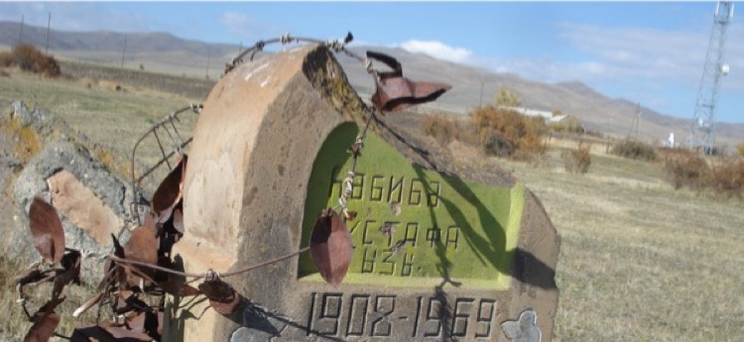

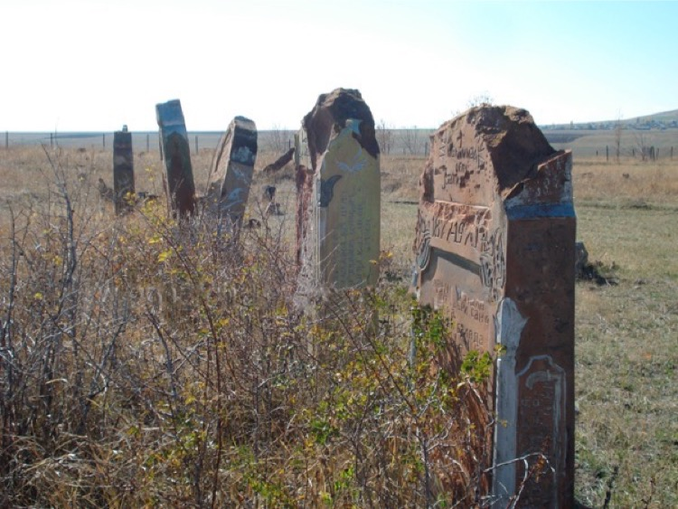

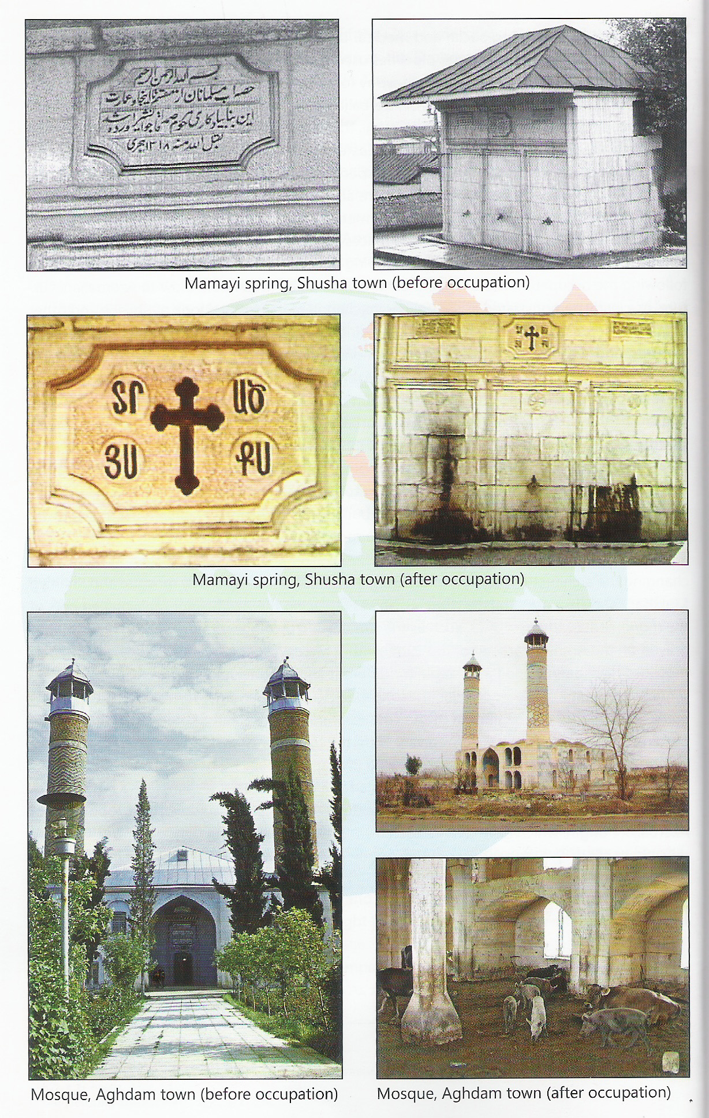

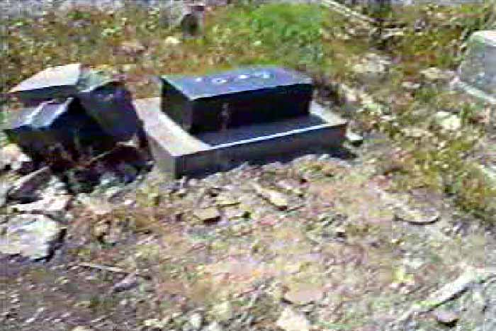
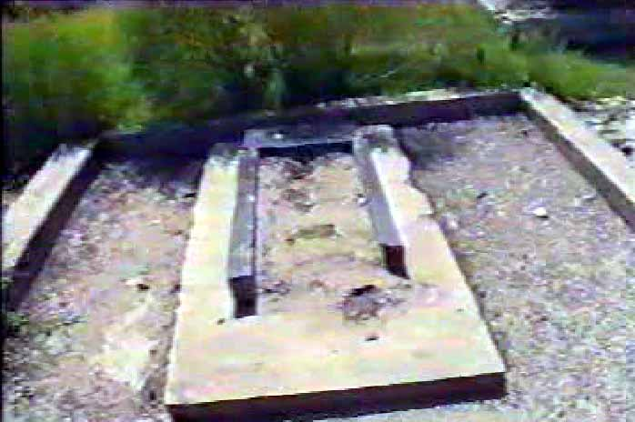

Destroyed Azerbaijani cemetry

Destroyed Azerbaijani cemetry

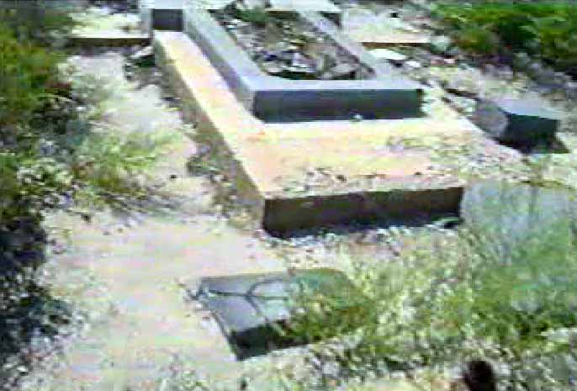

Destroyed graves

Blue mosque in Erevan
The construction of the Blue mosque which is considered a rare example of eastern architecture
started in 1760, and was completed in 1765 during the reign of Huseynali khan. The mosque that was situated opposite the central covered market of Irevan, by its composition and form of the main chapel, was similar to the Juma mosque built in Ganja in 1616 during the reign of Shah Abbas.
Despite being used as a mosque, it is described as an example of persian architecture. Presenting
Azerbaijani architecture pieces as architecute of other nations is a part of Armenia´s discrimination and anti-azerbaijani (Turk) campaign.
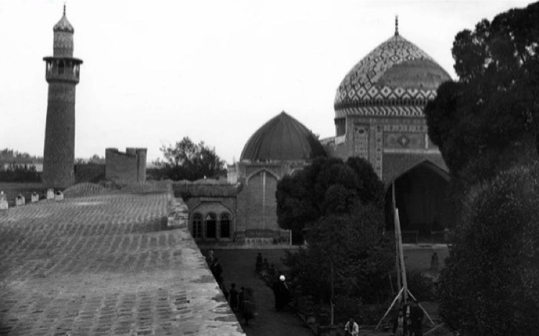

Change of tomonymic names
Mass changes of geographical names, toponyms, names of administrative-terrotorial units of Azerbaijani (Turk) origin in the territory of current Armenia or their armenization started after the creation of Armenia Soviet Socialist Republic within USSR. Just between 1924-1988, more than 1.000 toponymic names were changed.
Mainly between 1935-1970, 345 village names of turkish origin were changed in the Republic of Armenia. As a result, the previous ancient names of these villages entered the passive toponymy fond. Although the old names of these villages are used orally among the population, all the official documents and papers carry the new names and therefore ancient names are gradually forgotten. As the population of the villages densely occupied by Azerbaijanis were focibly deported to Azerbaijan in 1988, those villages were populated by Armenian families. There is no doubt that the ancient names of these villages have been forgotten.
At later stages, the last phase of the changes to the names of Azerbaijani origin were implemented. As informed by the head of the Armenian State Cadastre Manuk Vardaryan, in 2006-names of 57 settlements, in 2007-names of 21 settlements were changed. Head of cadastre service explained that the process took longer due to the search of relevant names of Armenian origin.
While the names of the administrative-territorial units were changed, in parallel, the monuments, cemeteries belonging to Azerbaijanis were destroyed.

http://1905.az/en/order-that-deported-100000-azerbaijanis-from-armenia/#more-32083
http://1905.az/en/nagorno-karabakh-basis-and-reality-of-soviet-era-legal-and-economic-claims-used-to-justify-the-armenia-azerbaijan-war/
Armenpress. Armenian News Agency http://armenpress.am/rus/news/842364/obezglavlivanie-ryadovogo-sloyana-so-storoniy-azerbaiydzhancev.html
Voskanapart İnfo analtik portalı: http://voskanapat.info/?p=6380
Voskanapart İnfo analtik portalı: http://voskanapat.info/?p=6293%20
http://www.yerkir.am/ru/news/view/54662.html
http://www2.ohchr.org/english/bodies/cerd/docs/A.66.18.pdf
http://www2.ohchr.org/english/bodies/cerd/docs/A.66.18.pdf
https://www.coe.int/t/dghl/monitoring/ecri/Country-by-country/Armenia/ARM-CbC-V-2016-036-ENG.pdf
http://armenians-1915.blogspot.com/2011/02/3220-armenia-racism-intolerance-report.html
Source: Cardashian, Vahan, "The Turks"; An Address delivered before The American Academy of Political and Social Science, in The Lausanne Treaty - Turkey and Armenia., The American Committee Opposed to the Lausanne Treaty, New York (1926), p 106, http://armenians-1915.blogspot.com/2011/02/3220-armenia-racism-intolerance-report.html
Source: Hamparsum Boyaciyan, a former Ottoman parliamentarian who led Armenian nationalist forces, http://armenians-1915.blogspot.com/2011/02/3220-armenia-racism-intolerance-report.html
Source: Sahak Melkonian, Preserving the Armenian Purity, 1920, http://armenians-1915.blogspot.com/2011/02/3220-armenia-racism-intolerance-report.html
Source: Ohanus Appressian, describing incidents in 1919; Memoirs of an Armenian officer, Men Are Like That, 1926, http://armenians-1915.blogspot.com/2011/02/3220-armenia-racism-intolerance-report.html
http://www.rferl.org/a/1065626.html
http://www.rferl.org/a/1142847.html
https://news.am/rus/news/282300.html
http://www.azadliq.org/a/27255919.html
http://russia-armenia.info/node/29522
http://russia-armenia.info/node/29522
http://russia-armenia.info/node/29522
http://haqqin.az/news/85307
http://ru.1in.am/1176667.html
http://haqqin.az/news/87456
http://vestnikkavkaza.net/interviews/politics/44299.html
https://www.youtube.com/watch?v=PlBU0JkALZg
http://www.un.org/en/ga/search/view_doc.asp?symbol=S/RES/822(1993)
http://www.un.org/en/ga/search/view_doc.asp?symbol=S/RES/853(1993)
http://www.un.org/en/ga/search/view_doc.asp?symbol=S/RES/874(1993)
http://www.un.org/en/ga/search/view_doc.asp?symbol=S/RES/884(1993)
http://www.un.org/en/ga/search/view_doc.asp?symbol=A/RES/62/243
http://vestnikkavkaza.net/interviews/politics/44299.html
http://vestnikkavkaza.net/interviews/politics/44299.html
Source: http://www.indexmundi.com/armenia/demographics_profile.html
Source: Institute for War & Peace Reporting (or IWPR for short)https://iwpr.net/global-voices/armenias-yezidi-kurds
Source: Institute for War & Peace Reporting (or IWPR for short)https://iwpr.net/global-voices/armenias-yezidi-kurds
Source: http://tbinternet.ohchr.org/_layouts/treatybodyexternal/Download.aspx?symbolno=CEDAW%2fC%2fARM%2f5-6&Lang=en
Source: UNFPA official web site: http://eeca.unfpa.org/sites/default/files/pub-pdf/unfpa%20armenia%20summary.pdf
http://www.refugees-idps-committee.gov.az/az/pages/16.html

