WRITTEN SUBMISION OF THE UGANDA COALITION ON ECONOMIC, SOCIAL AND CULTURAL RIGHTS TO THE 53RD SESSION OF THE COMMITTEE ON ECONOMIC, SOCIAL AND CULTURAL RIGHTS – PRE-SESSIONAL WORKING GROUP ON UGANDA

List of Issues in connection with the Initial Report of Uganda

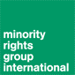
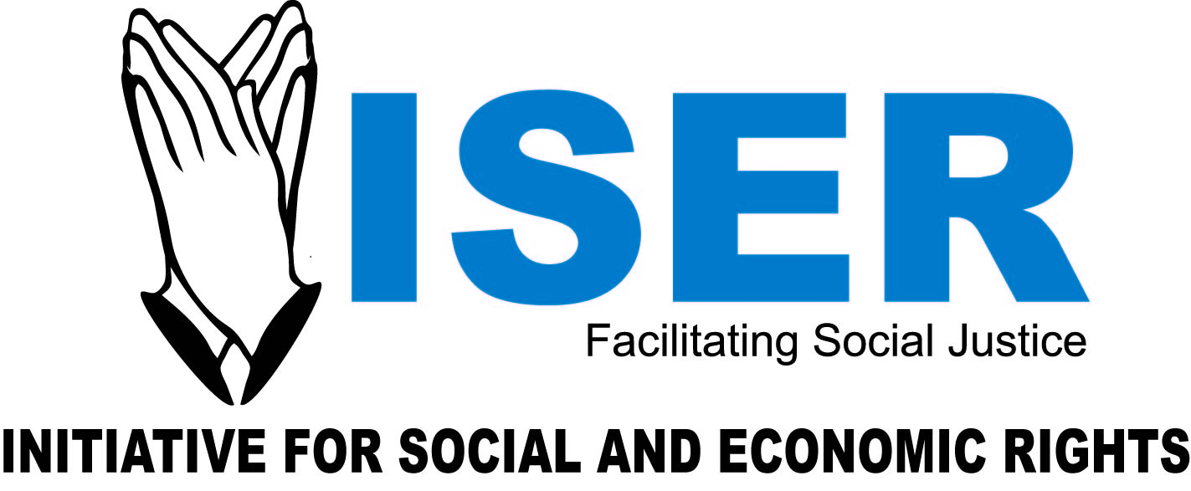
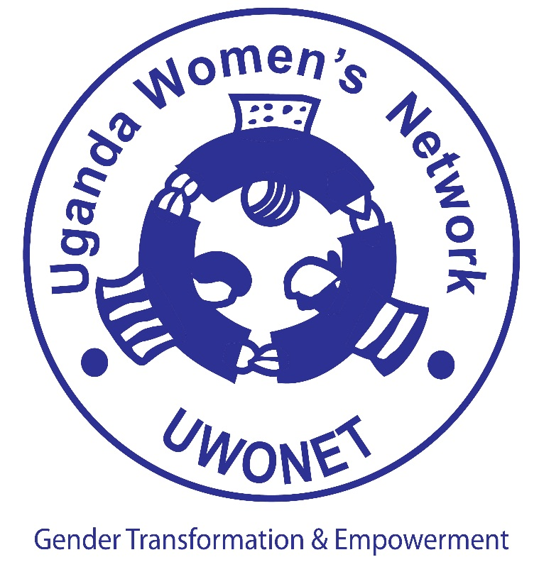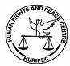

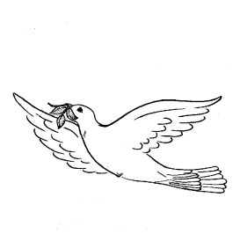

R E C E S V I D

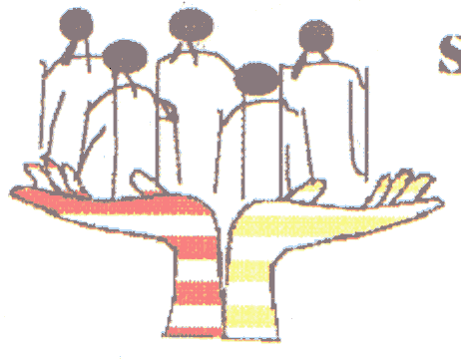  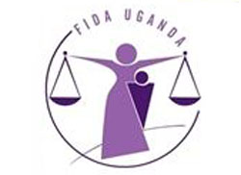  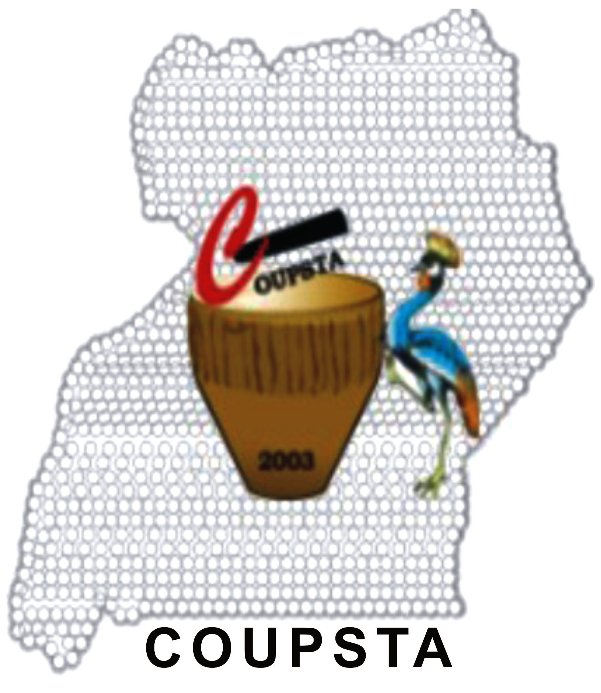 | 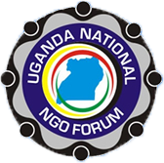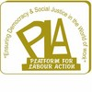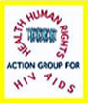

GENERAL INFORMATION AND ISSUES

General legal framework for human rights protection

  - Background
In Uganda, the bulk of economic, social and cultural rights (ESCRs) protected by the International Covenant on Economic, Social and Cultural Rights (ICESCR) are only protected in the Constitution as part of the National Objectives and Directive Principles of State Policy (NODPSP). Although in 2005 the Government amended the Constitution by introducing Article 8A to provide that the country “shall be governed based on the principles of national interest and common good enshrined” in the NODPSP, there are still doubts whether the NODPSP are justiciable. What this means in effect is that the Government has not fully domesticated the ICESCR since the rights are given full legal protection. Only the right to education appears in the country’s Bill of Rights. Although Government has recently unveiled plans to amend the Constitution, there is no indication in the Government proposals that ESCRs will be made justiciable.

  - Proposed Issue
The Government could be requested to provide information on the measures it has taken towards fully domesticating the ICESCR in order to make the rights it protects justiciable and on the plans it has to include the right to health, social security, food, housing, and water, among others, in the Bill of Rights of the 1995 Constitution. The Government could also be asked to provide information on the plan it has as far as ratifying the Optional Protocol to the ICESCR which allows complaints to be brought against the state before the Committee.

- National implementation of Specific Rights
  - Right to Self-determination
    - Background
Uganda has recently discovered Oil in the Western parts of the country, which has been followed by vigorous action by the Government to exploit the oil. Government has granted concessions to exploration and oil mining companies. However, Government and the prospecting and mining companies, including Tullow Oil, Heritage and Dominion, have kept a tight lid on information about the industry. The Government has declined to make details of the Production Sharing Agreements (PSAs) signed with the oil companies public. The contents of the Production Sharing Agreements have remained closely guarded by both the Government and oil companies, only releasing de-contextualized snippets. Litigation efforts by journalists to use Access to information laws to obtain information have proven unsuccessful, with the courts citing confidentiality clauses in the contracts. The Oil wells are also secured by the elite Special Forces Group. Civil society has not been involved not only in the prospecting process but also in the processes leading to the adoption of policies and laws relevant to the oil industry. Additionally, cultural leaders in the Western Uganda Kingdom of Bunyoro and other local communications, where most of the oil wells are located, have indicated that they have not been involved in the oil exploration and exploitation processes in their Kingdom.
    - Proposed Issue

Government could be requested to provide information on the extent to which it has involved both civil society and local communities in the exploitation of such national resources as oil and the extent to which local communities are sharing in the proceeds from the oil. The Committee could also ask Government to provide information on the extent to which the principles of transparency and participatory decision making have been adhered to in the area of exploitation of natural resources and why some of the agreements the Government has signed in this regard have not been made public. This is in addition to information on the rights of local communities in the areas where natural resources have been respected by for instance ensuring that those whose land is affected receive adequate and timely compensation.

  - Prohibition of discrimination

There are a number of factors in Uganda which result into inequitable access to socio-economic goods and services. Gender related inequalities manifest in the disparities of access to such natural resources as land and other income generating activities. For instance, women own only 14% of mortgage titles in Uganda, compared to the men’s 68%. In addition to gender inequalities, there are many cases of marginalisation. In 2011, HURINET-U with the support of Minority Rights Group (MRG) and the European Union (EU) conducted a study entitled ‘The Most Vulnerable among the Vulnerable; Exploring the Case of Select Minority Populations’ Access to ESCR’S in Uganda. The Study shows that a number of ethnic minorities and indigenous groups are denied access to socio-economic goods and services and are not enjoying equal opportunities on the same basis as dominant groups. Examples of these marginalized groups include the Ik of Karamoja District, who have suffered special neglect since the colonial times; the Basongora in Kasese District evicted from Virunga Ranges in DRC as well as Queen Elizabeth National Park in Uganda at different times. Another group which has suffered historical injustices includes the Banyabindi, a Runyoro-Rutoro (Runyakitara).
Research conducted by the Public Interest Law Clinic (PILAC) of the School of Law, Makerere University in January 2014 entitled Public Interest Litigation and the Provision of Legal Aid Services to Indigenous Communities: The Case of the Batwa in Bundibugyo, shows that the eviction of the Batwa from Bwindi, Mgahinga and Semliki national parks has denied this indigenous population access to land and such natural resources as forest products which they use for food, medicines and for religious and cultural purposes.

    - Proposed Issue
The Government could be requested to give information on the measures it has adopted to ensure that such marginalized communities as the Batwa, the Benet, Basongora, and Banyabindi have access to economic goods and services and on the measures in place to ensure that communities deposed of land for the creation of nature reserves and parks are adequately protected and allowed to exercise their rights related to access to land and natural resources. The Government could also be requested to give information on the measures it has adopted to ensure that women have access to economic goods and services and natural resources on an equitable basis.

  - The right to work
    - Background
The minimum wage was set way back in 1984 at Ug shs 6,000 (approximately US $ 2) per month and has not been revised since then. Several proposals to raise the minimum wage have not been acted upon by the Government, which has left most low cadre employees without protection. As a matter of fact, the Government is reluctant to set a minimum wage
Unemployment levels remain high, affecting mostly the youth population, a group which constitutes approximately 83% of Uganda’s population. Although government has adopted a number of policies, which, as indicated in the State Report, include the National Employment Policy, these policies remain in a paper arsenal that needs concrete and practical interventions that will accommodate enforcement of the policies to realise a reduction in unemployment and under-employment.
In addition to the above, there are a number of problems that afflict employment in civil service, which include low salaries not commensurate with the prevalent costs of living. It is common for some civil servants, including teachers and police officers, to go for several months without salary and in some cases civil servants are deleted from the payroll without following due process. On 21st July 2014, the Daily Monitor (a reputable newspaper) reported the case of Edward Serujongi who had gone for over 15 years without a salary.

    - Proposed issue
The Committee could request Government to elaborate the measures it has adopted to revise the minimum wage and the time-table for this. The Government could also be requested to provide information on the plans it has in place to tackle the problem of youth unemployment and the steps it has taken to implement the National Employment Policy. Additionally, Government could be requested to explain the measures it has taken to ensure that all civil servants are paid in a timely manner and that those deleted from the payroll during the payroll clean-up process are reinstated.

  - Right to just and favourable conditions of work

    - Background
Although Government has adopted laws to regulate the work environment and provide workman’s compensation, these laws lack effective monitoring and enforcement mechanisms. Although some key aspects of labour administration have now been decentralized to the districts, majority of districts have not been able to appoint labour officers and those in place are not adequately trained to discharge their quasi-judicial functions. Also, the Directorate of Labour, Employment and Occupational Safety in the MGLSD is not adequately funded to enable it effectively discharge its mandate. Yet, although the law provides for the Industrial Court to handle labour disputes, it took over 5 years to appoint only one judge to man this Court, which has a case backlog of over 2,000 cases and still growing.

    - Proposed Issue
The Committee could request Government to provide information on the measures it has adopted to ensure that all districts have labour officers who are properly trained and facilitated to carry out their mandate. The Government could also be requested to provide information on the measures put in place to ensure that the Industrial Court functions properly in order to effectively handle cases and clear the huge case-backlog it has.

  - The Right to form and belong to a trade union

    - Background
Although Uganda has over 40 trade unions, the effectiveness of these unions has been affected by infighting among and have not adequately put workers’ issues before government. Additionally, although the Labour Union Act has greatly improved the organizational and substantive rights of workers, the Ministry of Finance Planning and Economic Development has not yet allocated sufficient resources to enforce the new legislation, and yet the government has in addition not yet recognized any public sector unions, including those of teachers.
It is also true that Unions in Uganda haven not been able to organize casual and temporary workers, despite the fact that workers with a permanent contract are a tiny minority, amounting to less than 5% of the labour force. Yet, the proportion of the persons in the labour force who are unionised still remains small. This low enrolment rate could be explained by the ignorance of employees of their rights and the failure of Government to take measures to ensure that employers recognise and encourage their employees to form trade unions. There have also been incidents of blatant violation of the rights of workers, including violation of the right to withdraw one’s labour and demand for compensation in cases of injury sustained at work.

    - Proposed Issues
Government could be asked to give information on the measures it has taken to stop the infighting which has affected the effectiveness of trade unions, in addition to the measures it has taken to ensure that all employers recognize trade unions and that all workers in the formal sector are unionized. The Government could also be asked to give information on the steps it has taken to implement the Labour Union Act of 2006.

  - Right to social security

    - Background
Most workers in the formal sector have their retirement benefits deposited with the National Social Security Fund (NSSF), a statutory contributory scheme. The biggest challenge though is that NSSF has become a victim of perennial mismanagement and abuse of workers’ savings. Recently, the Fund invested UGX 70,000,000,000 (approximately US$ 26 million) in the electricity distributor UMEME without following proper procedures, which includes getting the full approval of the NSSF Board and endorsement by the Minister of Finance, Planning and Economic Development as required by the law. The Minister had indicated that the proposed price of the shares was higher than the market price.
It should also be noted that presently there are no social security schemes for informal sector workers, a group which constitutes 95% of the country’s labour force. The social cash transfer scheme that government has recently established under the ‘Expanding social protection programme’ is largely donor dependant, which raises questions of sustainability.
The public service pension and retirement benefits scheme is not any different. In 2012, it emerged that over UGX 64,000,000,000 (approx. US$ 25m) had been lost to “ghost pensioners” created by officials of the Ministry of Public Service to siphon pension funds for personal gain. Later, it turned out that the money lost could be up to UGX 165,000,000,000 (approx. US $ 66 millions). Besides the acts of corruption and abuse of office, the Pension sector in the Ministry of Public Service is disorganised and characterised with maladministration and mismanagement.

    - Proposed Issue
The Committee could request the Government to provide information on the measures it has taken to stop the perennial mismanagement and loss of funds in the NSSF and how it plans to recover money which has already been lost. The Committee could also request Government to provide information on the measures it has put in place to ensure that the civil service pension scheme is effectively managed and pension and retirement benefits are processed in a timely manner. This is in addition to information on measures taken to recover funds lost from the scheme through fraudulent means.

  - Family Rights

    - Background
Although the Government should be commended for adopting the National Strategic Programme Plan of Intervention for Orphans and other Vulnerable Children, Fiscal Year 2005/6 – 2009/10 (the NSPPI), the Programme has not fully been implemented. Yet, not all vulnerable children have been helped to realise their full potential and have their rights and aspirations fulfilled. One category of such children that has not benefitted from the NSPPI is street children. The problem of street children has among others arisen from the failure to effectively address the factors that push children to the streets. The factors include rural–urban migration, family breakdown, child abuse, child labour, sexual exploitation, and alcohol and drug abuse. Government has not adopted a systematic programme to remove children from the streets, rehabilitate them and re-integrate them into family environments. For instance, although Kampala Capital City Authority (KCCA) has rounded up children, and sent them back to such places as Karamoja, the children return to the streets within a few days.
The Government has also failed to ensure that vulnerable families get appropriation social protection and assistance which would enhance their capacity to provide for their children and avoid them living off streets. The vulnerability of families has also among others resulted into early marriages. These marriages are also attributed to some negative cultures and practices. UNICEF studies show that Uganda is one of the countries with the highest levels of early marriages of adolescents between 15 – 19 years.
Another challenge facing the Country is the problem of high infant and maternal mortality rates. Government has recently acknowledged that the country is lagging behind in meeting the Millennium Development Goal (MDGs) target of reducing maternal mortality to 131 per 100,000 births by 2015. The rate at the moment lies at 435, having slightly reduced from 505 in 2001.

    - Proposed Issue
The Committee could request Government to give more information on the measured it has adopted to deal with the problem of street children including addressing the factors that push children to the streets and those which would ensure the rehabilitation and reintegration of these children into family environments. The Government should also be asked to provide information on the measures it has adopted to end forced marriages by addressing the factors that push families to marry off their children and the negative cultural practices responsible for this.

  - Right to adequate Housing

    - Background
There are various factors which have hindered enjoyment of the right to adequate housing in Uganda. One of the biggest obstacles in this regard is the lack of security of tenure on land for many populations. This has among others arisen from the failure to operationalise provisions of the Land Act that would ensure that all forms of tenure, including the customary tenure, are secured with certificates of title. Additionally, the bulk of Uganda’s urban population lives in informal settlements which are strewn across the outskirts of major urban centres without legal title to the land. Provisions of the Land Act which would protect such populations against evictions have not been implemented.
The Government has also aggravated the housing problem by carrying out evictions from what it considers to be Government land without verifying and respecting the rights of occupants or providing evictees with alternative housing and evicting them in accordance with the international laws and principles on forced evictions as contained for instance in the Committee’s General Comment on Forced Evictions. A recent example of this is the recent eviction by Kampala Capital City Authority (KCCA) of over 80,000 residents believed to have settled on the rail line reserve. The brutal eviction saw houses bulldozed in the middle of the night and household and business property destroyed.
Another factor affecting the right is that the rapid increase in the urban population is not being matched with growth and development in basic physical infrastructure, housing, social amenities, management and skills. This has led to overcrowding, growth of slums and informal settlements, dilapidated housing and poor sanitation.

    - Proposed Issue
The Committee should request the Government to provide information on the steps it has taken to implement provisions of the Land Act that would ensure that persons with different tenures, including bona fide occupants, have certificates of title that would guarantee their tenure and ensuring that their legal rights including protection from eviction are realised. The Government could also be requested to provide information on the measures it has taken to ensure that those evicted, including those evicted by such authorities as KCCA, are provided with alternative accommodation and that evictions follow the international principles and standards which govern forced evictions.

  - The right to adequate food

    - Background
The Government should be commended for adopting the Uganda Food and Nutrition Policy (UFNP) which if implemented would enhance access to food and ensure food security for many Ugandans. While the National Food and Nutrition Strategy (NFNS) would also enhance access to food and food security, this Strategy has not been approved by Cabinet since the Draft was completed in November 2005. Additionally, although the process of drafting the Food and Nutrition Bill started way back in 2008, the promulgation of the Bill into law has suffered inordinate delay. The failure to promulgate the Bill has made it difficult to implement the UHNP because of the absence of such legal structures as the Uganda Food and Nutrition Council (UFNC) as provide for in the yet promulgated law.
While Government has adopted programmes which would enhance food security such as the National Agricultural Advisory Services (NAADS), this has not achieved much. NAADS was designed to provide advisory services to farmers as a means of empowerment and a stimulus to commercialised and value added agricultural production. However, NAADS has a number loopholes including fraudulent procurement, corruption, bribery, forgery and delayed payments of service providers among others. In addition, what started out as an agricultural development initiative is now increasingly being viewed as bearing an intricate political agenda. Many of the procurement committees have been chaired by the ruling party (National Resistance Movement) Sub County Chairpersons. In a recent twist, the President has entrusted the management of the NAADS programme to the military without evidence that the military has the technical expertise to manage the Programme.
It is also true that the Ministry of Agriculture, Animal Industry and Fisheries (MAAIF), has remained an underfunded yet very important national sector. MAAIF has continuously had budget cuts. The low and near constant budget allocation towards the Agriculture sector has been linked to the decline of the Ministry of Agriculture’s share of the national economy from 54% in 1988 to 32% in 2004.
In the Financial Year 2010/2011, the budgetary allocation to agriculture was 5%, far way below the 10% to which government committed by signing on to the 2003 African Union (AU) Maputo Declaration on Agriculture and Food Security. In Year 2012/2013, the allocation of UGX 379.04 billion which is 3.5% of the total national budget is an indicator of a worryingly declining trend.

    - Proposed Issue
The Government could be requested to provide information on the measures it has taken to implement the Uganda National Food and Nutrition Policy and the plans in place for the approval of the National Food and Nutrition Strategy by Cabinet. The Committee could also request the Government to provide information on the schedule for the promulgation of the Food and Nutrition Bill. Additionally, the Government could be asked to provide information on the plans it has to increase the budgetary allocations to the Agricultural Sector and on the reasons which explain the retrogressive allocations to this Sector.

  - The right to adequate water and sanitation

    - Background
Although recent statistics and data show that safe water coverage has been increasing, the number of people accessing water is still low. Piped water and sewage services are available for only 8% of urban dwellers while the rest of the urban dwellers predominantly use pit latrines. Additionally, rapid population growth (above 3% per annum), coupled with unplanned urbanization, continue to place considerable strain on the provision of safe water and adequate sanitation especially for urban dwellers. Yet, access to water at an average distance of 1km for people in rural areas is still a long distance that could compromise the quantity actually accessed. There are also disparities between rural and urban populations at 69.5% and 92.3% respectively. This could be explained by the fact that piped water provided by the National Water and Sewerage Corporation (NWSC) is restricted to urban areas.
The 2005/6 National Household Survey identified a number of problems relating to sanitation. For instance, one in ten households did not use any type of toilet facility, yet of the 86% that use pit latrines, only 3 percent of these have ventilated pit latrines. The Northern and Eastern parts have the largest proportions of people not using toilet facilities at 21% and 16% respectively. Although the 2009/2010 Household Survey shows some improvements, these are still unsatisfactory. The number of people without any type of toilet facility had dropped to 8.7% nationally and to 11.4% for Eastern Uganda. Unfortunately for the Northern region, the number had increased from 21 to 24.9%.

    - Proposed Issue
The Committee could request Government to provide information on the plans it has in place to extend piped water and sewerage services to rural populations and how it intends to lower the cost of such services for this category of people. This is in addition to measures to ensure that all people have access to sanitation facilities including ventilated pit latrines, and particularly householders in Northern and Eastern parts of the country.

  - Right to the highest attainable standard of mental and physical health

    - Background
One of the biggest challenges impacting on realisation of the right arises from the fact that the right to health is not expressly protected in the Bill of Rights in the Constitution. A positive aspect though is the fact that the right is recognised in a number of health policies, strategies and programmes such as the National Health Policy and the Health Sector Strategic Plan (HSSP). The biggest challenge though arises from the fact that rather than move towards legislating to guarantee the right to health, Government is adopting laws which negatively impact on the right.

An example is the HIV Prevention and Control Act that was passed by Parliament in May 2014 and signed into law by the President of Uganda on July 31st 2014. The Act contains provisions that discriminate against people living with HIV/AIDS, by requiring the mandatory testing of pregnant women and their partners, and allows medical providers to disclose a patient’s HIV status to others. In prescribing a maximum 10-year jail sentence and fine of about five million shillings (or both) for anyone who wilfully and intentionally transmits HIV/AIDS to another person, the legislation will likely deter HIV/AIDS testing; raising clear public health implications. In addition to these recent laws, there also exist a number of out-dated pieces of legislation that may also serve to procure negative public health effects. The Public Health Act 1935, for instance, is in need of updating. In particular, it contains a number of archaic provisions on smallpox; a disease that global efforts have now eradicated, and criminalizes individuals suffering from an infectious disease, who expose themselves to the public without taking “proper precautions” or without notifying specified individuals.
Budgetary allocations to the health sector continue to be below the annual HSSIP 2012/2013 target of 9.8% and well below the international health financing target as is set in the Abuja Declaration on HIV/AIDS, Tuberculosis and other Related Infectious Diseases of 15%.

Table 1 Percentage of GoU budget allocation to health as a % of total gov’t budget
FY | 2009/10 | 2010/11 | 2011/12 | 2012/13 | Abuja Target | HSSIP Target
% | 8.6 | 8.9 | 8.3 | 7.4 | 15 | 9

Source: Ministry of Health, “Annual Health Sector Performance Report: Financial Year 2012/2013” p.25.

Amidst the inadequate resources, the country is ironically experiencing problems with the absorption of its funds. One of the areas where this is visible is in drug procurement and distribution. While there are drug stock-outs, the National Medical Store (NMS) during FY 2009/2010 had some 41.96 billion unutilized funds which had to be returned to the treasury. According to the Ministry of Finance, Planning and Economic Development (MFPED), “….the biggest chunk of unutilized money was for roads, under the works ministry and drugs under the National Medical Stores.” The MFPED attributed the problem to poor planning by ministries and inadequate specifications of output.
The resource inadequacies in the health sector have also been exacerbated by the abuse of funds and the lack of commitment to accountability. Corruption and theft is rife. Evidence of this is seen from the 2005 loss through fraud and misallocation of over USD 367 million funds from the Global Fund to fight Tuberculosis, HIV/AIDS and Malaria. This fraud, which was a subject of Judicial Inquiry, saw over 300 people being implicated. Five years down the road, although over 300 people were implicated, only 4 have been prosecuted.
World Health Organization reports indicated that at present, Uganda “does not have nationally representative data on non-communicable diseases” and “The country also lacks a comprehensive non-communicable disease policy, strategic plan, and standards and guidelines for managing non-communicable diseases.“
Average staffing levels have gone up from 55% in 2011/12 to 60.5% in 2012/2013. The Government has also adopted a Human Resource Policy (2006) and a Strategy for Retention of Health Workers in hard to reach areas/underserved areas. The Retention Strategy provides for a minimum package of motivational incentives at health facilities for staff working in the targeted areas. In spite of some developments that have been made, human resource development, recruitment and utilization have, in general, not been effectively managed.
The approved staffing level is still low and some districts still lag behind, particularly at the lower Health Centre II levels. The low rate of recruitment and retention could be explained by low wages, poor health infrastructure, heavy workload, high stress and the lack of suitable accommodation available for health workers that are posted to rural settings.
Although new budgetary measures that give the National Medical Store (NMS) a vote on the budget have been adopted, their impact is yet to be felt. Reports reveal that although there are stocks of drugs at NMS, some districts also still experience stock-outs. Delays in procurement, poor quantification, late orders from facilities and poor records keeping are among the management problems experienced in this regard. This is in addition to health facility infrastructure obstacles which compromise access to Essential Medicines and Health Supplies (EMHS).
Valuable progress has been made in increasing access to HIV/AIDS services. The uptake of ART services is at 329,060 for persons living with HIV (PLHIV). There have been increased efforts to prevent infection, reduce stigma and increase access to social support services. In spite of these achievements, there are still many challenges that limit access to services for PLHIV. Close to 40% of those living with HIV in Uganda are not receiving treatment and only 32% of children that are eligible for treatment are able to access it. New infections are also re-emerging and the number of people being infected annually is now more than the number of people put on ART in the same period.
Generally, universal access to reproductive health is far from being realized in Uganda. The maternal mortality ratio is around 438 deaths per 100,000 live births. This is exceptionally high, especially relative to the MDG target ratio of 131/100,000 for 2015. Whereas the Government has put in place policies and Strategies such as the Road Map for Accelerating Reduction of Maternal and Neonatal Mortality and Morbidity in Uganda (2007-2015), and the Child Survival Strategy, implementation is lacking.
With regards to the provision of emergency obstetric care, according to the Ministry of Health’s HSSIP mid-term review (2013) only 36% of HC IVs were providing such care, as compared to the 50% set by the Ministry to be achieved by 2015. Other reproductive health indicators, particularly in rural areas, remain poor. The Contraceptive Prevalence Rate (CPR) has increased from 2.7% as indicated by the 2000 Uganda Demographic and Health Survey (UDHS) to 26% in 2011 (UDHS, 2011).
Under Ugandan law, induced abortion is permitted in limited circumstances. However, the circumstances under which it may take place are extremely unclear. Legal abortions are very rare, given the restricted grounds, the demanding process for obtaining approval (for example, providers typically require certification from three doctors, even though the law does not require this). Unsafe abortion is one of the leading causes of maternal mortality in the country. The Ugandan Ministry of Health has estimated that abortion-related causes account for 26% of all maternal mortalities, and it was recently reported as being the second major cause of death in Uganda. Such deaths are compounded by physicians’ hesitancy to offer safe and open abortion and post abortion care services in Uganda, out of their fear of being criminally sanctioned.
At least 45,000 new born children are reported to die each year in Uganda, with an equal number being stillborn. As a result, Uganda is thought to have the fifth highest number of newborn deaths in sub-Saharan Africa. Moreover, Uganda’s neonatal mortality rate of 29 deaths per 1,000 live births has remained fairly constant over the past 15 years, illustrating the need for more effective and targeted actions.
A major challenge to the smooth operation of health facilities in Uganda is the lack of adequate or reliable supply of utilities. Hospitals around Uganda have been subject to water and electricity outages procured by insufficient resources, their lack of supply and load shedding practices, among others. The impact of such factors on individuals’ right to the highest attainable standard of health has been significant. It was reported for instance, that over 150 patients had died in the space of a few months at Jinja referral hospital as a result of the unstable power supply procured by load shedding practices by Uganda’s main electricity supplier Umeme Ltd.
There is no available baseline data on the incidence of mental health disorders in Uganda however it is estimated that over 11.5 million Ugandans are suffering with mental disorders. For the last 10 years, Uganda has been developing a policy on mental health. The draft is yet to be approved by cabinet. The greatest challenge to mental health services is the general lack of specialized mental health personnel especially in rural areas. The ratio of one psychiatrist to two million people and one psychiatric clinical officer to 500,000 patients is alarming. Moreover, with the new drug distribution system where NMS supplies a predetermined stock of EMHS to Health center IIs and IIIs, Psychotherapeutic medicines such as Chlorpromazine and Phenytoin which are on the essential medicines list have been excluded from the supply.

    - Proposed Issue
The Committee could request Government to provide information on the likely impact of the recently promulgated HIV legislation and how the criminalization of various activities related to HIV and the compulsory disclose of one’s HIV status in some cases.

The Government could also be requested to provide information which explains the retrogressive budgetary allocations to the Health Sector and the failure to meet the international commitments as regards the proportion of the national budget to be allocated to health.

The Committee could also request Government to provide information on the measures it has taken to ensure that adequate attention is directed towards communicable diseases and that data on these diseases is compiled and utilized.

Government could also be asked to provide information on the measures it has put in place to ensure that the staffing deficiencies of health facilities, and particularly those in rural areas, are met and how the needs of health workers are to be met. This is in addition to giving information on the measures in place to ensure effective supply of medicines and avoiding stock-outs as has been the case at many facilities.

Government could also be requested to provide information on the measures it has adopted to ensure universal access to HIV related treatment for persons living with HIV/AIDS. The Committee could also request Government to give information on the measures it has adopted to reduce the incidents and negative consequences of induced abortions, and particularly measures which have been taken from a legislative perspective. Additionally, Government could be requested to prove information on measures in place to reduce the infant and mortality rates and particularly measures to improve access to emergency obstetric care for poor and rural populations.

The Committee could also request Government to provide information on the steps it has taken to ensure that health facilities have adequate and operational facilities and infrastructure, including water, electricity, medical technology, buildings and housing for medical workers. Government could furthermore be asked to provide information on the steps it has taken to ensure access to mental health care services, including access to medicines and psychiatric care.

  - Right to take part in cultural life

    - Background
Culture as a sector is nationally marginalized, with no line ministry of its own; the Culture sub-department within the MGLSD is entitled to minimum human and financial resource. The Sector commands about 0.03% of the national budget. Due to inadequate funding, statutory bodies like the Uganda National Culture Center and the Uganda Museum cannot deliver on their mandates. The National Culture Policy remains largely unimplemented since its launch 8 years ago and there is up to present no plan of action for its implementation. Although the introduction of Universal Primary Education (UPE) has increased the number of children taking part in the cultural festivals, there are still challenges. There is a gap of access to spaces for participation for children who are not school-going. There is also no culture programme put in place by the state for vulnerable children.

Although as indicated in paragraph 342, the Government reinstated traditional kingdoms, recently, there has been consistent repression from the state concerning freedom of speech and expression. There have also been clashes between the state government and the cultural institutions regarding the role of the overseer over regional resources on behalf of the indigenous community. Government has always insisted cultural leaders should not participate in politics but without giving a clear definition of what “participation in politics” means.

Under the 1967 Historical Monuments Act, the state provides for the protection of heritage against destruction. However, this law is outmoded and largely ineffective as it spells penalties as small as UGX 2000 (less than a 1 US$) for the destruction of a heritage site. This has subsequently led to the loss of cultural heritage sites and monuments through destruction by fire, violence and investor-developments. Secondly, the Act narrows the concept of heritage to immovable heritage (Archaeological sites, Monuments etc), to the exclusion of movable and intangible heritage.

The Government has also not taken deliberate measures to engage the British Government to return the artefacts which were illegally taken by the colonial government of Britain. Examples here include artefacts and traditional which were taken from the Kingdom of Bunyoro. It has been indicated that over 300 artefacts, including the 9 legged stool used to enthrone kings, were taken from the Kingdom in the 1890s.
Although as indicated in paragraph 348 of the State Report the Persons with Disability Act 2006 in section 21 (1) urges government authorities to promote the right of Persons with Disabilities (PWDs) to access information though there has not been actual implementation of the Act. Most of the provisions in the law have not been implemented. The National Council for Disability, established in 2003 as the principal organ to monitor implementation of disability laws is not effective because of budgetary deficits.

Government should also be commended for provisions in the Constitution that guarantee the right to equality. The problem though is that there is no specific law that protects the cultural rights of indigenous people against exploitation and dispossession from their cultural environment by government programs and investor developments. A case in point is the marginalization of the Batwa, a minority group in Bwindi Impenetrable Forest who have suffered exploitation and displacement because of the Gorilla Tourism Industry.

    - Proposed Issue
Government could be requested to provide information on the plans it has in place to enhance the budgetary allocations to the culture sector and ensuring that all institutions in this Sector are adequately funded to enable them discharge their mandate. The Committee could also request Government to provide information on the measures it has taken to ensure that vulnerable children, including children not in school, take part in cultural activities including cultural festivals. This is in addition to information on steps taken to preserve and protect the culture and indigenous knowledge of such groups as the Batwa. Government should also provide information on the measures it has taken to implement the 1967 Historical Monuments Act.

See Uganda Human Rights Commission 16th Annual Report, which indicates that there was minimal efforts, in some cases no effort at all, to enable the local communities understand what was happening in the industry, UHRC 16th Report, at 164.
Ibid
PILAC Working Paper No. 1 (January 2014).
Uganda Human Rights Commission 16th Annual Report (2013), at p 108.
See Industrial Court begins work with 2,000 cases next month, Daily Monitor, 26th June 2014. See also Workers MPs ask gov’t to expedite operationalization of industrial courts, New Vision 21st April 2014.
Available at <http://www.mglsd.go.ug/ovc/downloads/Policies_12.pdf > (accessed on 21 June 2006) [Hereinafter referred NSPPI (2004)].
P 22.
See Sexton, A., ‘Street children: The situation in East and Southern Africa and the need for a strategic global response’, Statement made to the United States House of Representatives House Committee on International Relations Subcommittee on Africa, Human Rights and Global Operations Hearing on Protecting Street Children: Vigilantees or the Rule of Law?, (September 2005), available at <http://www.streetchildren.org.uk/reports/Street%20Children;%20The%20Situation%20in%20East%20and%20Southern%20Africa.pdf> (accessed on 15 June 2006), at p 4. [Hereinafter referred to as Sexton (2005)].
UNICEF Early Marriages: Child Spouses (2001) Innocenti Digest, at 4.
National Planning Authority National Development Plan, (2010/2011 – 2014/2015), para 62, at 21.
Committee on Economic, Social and Cultural Rights, General Comment 7, Forced evictions, and the right to adequate housing (Sixteenth session, 1997), U.N. Doc. E/1998/22, annex IV at 113 (1997), reprinted in Compilation of General Comments and General Recommendations Adopted by Human Rights Treaty Bodies, U.N. Doc. HRI/GEN/1/Rev.6 at 45 (2003).
NDP Report, paragraph 439, at p 171.
Government of Uganda, Ministry of Water and Environment Water and Environment Sector Performance Report, 2010, at 5.
Uganda National Bureau of Statistics Uganda National Household Survey 2005/2006: Report on the Socio-economic module (December 2006)
At p 105.
At p 106.
Uganda National Bureau of Statistics Uganda National Household Survey 2009/2010: Abridged Report (November 2010)
As above, at 119.
Public Health Act 1935 Sections 46 and 47.
Ibid. at Section 20.
<http://health.go.ug/docs/AHSPR_2013.pdf> at 26
OAU/SPS/ABUJA/3, Adopted by the African Union Special Summit of Heads of State and Government, 26 – 27 2001, Abuja, Nigeria.
NEW VISION: “Ministries fail to spend sh700b” Monday, 24th May, 2010.
See Ministry of Finance, Planning and Economic Development, Semi-Annual Performance Report 2009/2010, p. 18 and 52.
Charges have been laid in two cases-meaning investigations have been finalised in eight cases, fifteen cases are in advanced stages of investigations; twenty two cases are under investigation and the remaining cases have been assigned to investigation teams. See The Global Fund, Progress Report of the Office of the Inspector General, October 2009-February 2010.
World Health Organization Regional Office for Africa, online: <http://www.aho.afro.who.int/profiles_information/index.php/Uganda:Analytical_summary_-_Non-communicable_diseases_and_conditions>.
Republic of Uganda, Ministry of Health Annual Sector Performance Report 2012/2013 FY at 23. http://health.go.ug/docs/AHSPR_2013.pdf
Ministry of Health, Motivation and Retention Strategy for Human Resources for Health (October 2009)
Ministry of Health, UGANDA HEALTHWORKFORCE, Satisfaction and Intent to Stay Among Current Health workers, April 2009; Arthur Baguma, Is Uganda losing the Battle to retain health workers? THE NEW VISION, Thursday April 7 2009 at p.25
Ministry of Finance, Planning and Economic Development BMAU Briefing Paper [6/13] (2013) online: <http://www.finance.go.ug/dmdocuments/6-13%20Health%20Workers%20Shortage%20in%20Uganda%20May%202013.pdf> at 3.
HEPS Uganda, Tracking Uganda’s Health Sector in Financing and Delivery of Essential Medicines, June 2010
Civil society organisation (CSO) Shadow Report on The Performance of the Health Sector in 2012/2013 p. 22.
Uganda AIDS Commission Global AIDS Response Progress Report” Country Progress Report Uganda 2012 at 34.
Ministry of Health, Midterm Review Report of the Health Sector Strategic and Investment Plan (HSSIP) 2010/11-2014/15 (2013) online: <http://health.go.ug/docs/MTRRVOL_1.pdf> at 36.
Uganda Demographic and Health Survey 2011, Preliminary Report, online: <http://dhsprogram.com/pubs/pdf/PR18/PR18.pdf>.
Center for Reproductive Rights (CRR), 10 key points about Uganda’s laws and policies on termination of pregnancy, Fact Sheet, New York: CRR, 2011.
Guttmacher Institute, “Abortion in Uganda” (2013) online: <http://www.guttmacher.org/pubs/FB-Abortion-in-Uganda.html>.
http://news.ugo.co.ug/second-highest-cause-death-uganda-abortion/ (Which states, “Sarah Achieng Opendi, a 2013 Ministry of health study revealed that abortion is the second highest cause of deaths in Uganda coming second to malaria.”)
Ministry of Health. Situation analysis of newborn health in Uganda: current status and opportunities to improve care and survival. Kampala: Government of Uganda. Save the Children, UNICEF,WHO; 2008. At 8
Lawn J, Kerber K, eds, Opportunities for Africa’s Newborns: practical data, policy and programmatic support for newborn care in Africa. Cape Town: PMNCH, Save the Children, UNFPA, UNICEF, USAID, WHO, 2006.
See also, Tracking Uganda’s health Sector in Budgeting, Financing and Deliverty of Essential Medicines (2010) online: http://tap.resultsfordevelopment.org/sites/tap.resultsfordevelopment.org/files/resources/Heps_Report_Final%5B1%5D.pdf
Centre for Health, Human Rights and Development, “Human rights implications of load-shedding” Fact Sheet, online: CEHURD <http://www.cehurd.org/wp-content/uploads/downloads/2012/06/Load-shedding-factsheet.pdf>.
Ministry of Health, Health Sector Strategic & Investment Plan: Promoting People’s Health to Enhance Socio-economic Development 2010/11-2014/15 at p.81
New Vision, Over 11.5 million Ugandans suffer disorders, online: <http://www.newvision.co.ug/D/9/34/715142>.
Mental Health Bill, 2009
Ovuga Emilio, Boardman Jed and Wasserman Danuta, Integrating Mental Health into Primary Healthcare: local initiatives from Uganda, WORLD PYSCHIATRY 2007; 6: 60-61; Patience Aber, Poor Healthcare services worry psychiatrists, THE DAILY MONITOR, April 23, 2009 at 18,
Ministry of Health, Essential Medicines List for Uganda (2007); Ministry of Health, Circular of 26th April 2010 arising from Policy Shift in the Financing of Essential Medicines and Health Supplies (2010)
This percentage is calculated on the basis of recurrent and development expenditure for both the office of culture within the Ministry of Gender, Labor and Social Development, and the department of Museums and Monuments in the Ministry of Trade and Industry.
The infamous Kampala riots of September 2009 were a result of the state’s intervention in Buganda’s affairs, sabotaging a planned visit of the Kabaka to an area within the kingdom, and subsequently abusing the rights of the Baganda to express their concerns on the issue. Three local radio stations were closed and one, belonging to the kingdom has still not been re-opened one year later.
See ‘Should Britain return the artifacts allegedly stolen from Bunyoro in the 1890s?’ New Vision Newspaper, 27th August 2014.

