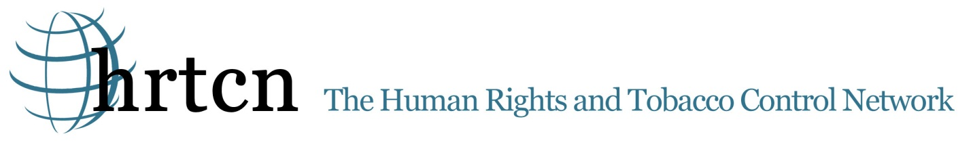
Human Rights and Tobacco Control Network
Submission to the Committee on Economic, Social and Cultural Rights
Pre-Sessional Working Group, 49th Session, 21-25 May 2012

Tobacco Control and the Right to Health - Azerbaijan
Tobacco will kill an estimated one billion people in the 21st century in the absence of aggressive action by governments to advance tobacco control and smoking cessation. Eighty percent of these deaths will be in developing countries – those least able to manage this epidemic. One in two people with a lifetime history of smoking will die from a tobacco related disease and 50% of these deaths will be in middle age. The human stories behind these statistics are so often heartbreaking. Not only illness and death, but also the impact on families due to loss of primary breadwinners, the toxic exposures and lost educational opportunities for children who work in tobacco farming, environmental degradation through deforestation and runoff of pesticides into rivers and streams, and the contribution of tobacco purchases to increased poverty and malnutrition. The World Health Organization projects increasing numbers of people who smoke, particularly as populations grow, over the next 20 years, with women in low- and middle-income countries being a particular target of tobacco marketing.
A broad evidence base supports a combination of legal, policy, medical, environmental and behavioral interventions that governments can take to control tobacco and improve health. Tobacco taxes, clean indoor air laws, comprehensive bans on advertising and promotion, public information campaigns, graphic warning labels on tobacco products and smoking cessation have all been shown to reduce tobacco consumption and dependence. As such, States Parties to the Convention on Economic, Social and Cultural Rights are obligated to pursue tobacco control under their duties to respect, protect and fulfill Article 12: the Right to the Highest Attainable Standard of Health.
The following submissions to the 49th Pre-Sessional Working Group of the Committee on Economic, Social and Cultural Rights summarizes the tobacco control content within each State Party report. Each submission concludes with four- six key recommendations for improvement that the Committee can raise to country representatives to encourage stronger tobacco control policies. HRTCN believes that these tobacco control strategies and recommendations sit at the heart of government obligations to respect, protect and fulfill the right to the highest attainable standard of health.
HRTCN works to advance a human rights based approach to tobacco control – utilizing the legal remedies and reporting requirements of current treaties and conventions, including the recent Framework Convention on Tobacco Control, the Convention on the Rights of the Child (CRC), the Convention on the Elimination of Discrimination Against Women (CEDAW) and the Covenant on Economic, Social and Cultural Rights. HRTCN will educate on and utilize measures that are currently accessible and will encourage adoption of new measures in order to decrease the morbidity and mortality of the people with the least agency to claim their rights.

The Human Rights Tobacco Control Network (HRTCN) has reviewed Azerbaijan’s report to the Committee on Economic, Social and Cultural Rights with respect to tobacco control and the right to health. HRTCN recognizes that Azerbaijan for its accession of the WHO Framework Convention on Tobacco Control on November 1 2005.
While most of Europe has banned smoking in public places, protecting the health of non-smokers as well as smokers, Azerbaijan does not have any such laws. Azerbaijan has considered a ban on smoking in public places, including restaurants, cafes, social facilities, transport means, workplaces and other public sites, but no public smoking bans have been passed. Further, cigarette packages carry a small notice that is barely visible. The proportion of males currently smoking any tobacco product in Azerbaijan was 41.2% in 2009.
Despite increasing rates of smoking in Azerbaijan and the risk of associated non-communicable diseases, such as cardiovascular disease and cancer, tobacco use was mentioned only once in the Azerbaijan’s report to the Committee as part of a project on reproductive health education for youth. National initiatives include a government program on diabetes, and a program to ensure availability of chemotherapy for cancer patients. HRTCN commends the Azerbaijan Health Communication Association and the Azerbaijan Republic Ministry of Health Public Health and Reforms Centre in receiving a Johns Hopkins University Bloomberg Initiative tobacco control grant managed by the Union’s Department of Tobacco Control in 2009. This provides ample opportunity for further initiatives to improve national capacity in tobacco control, under the National Tobacco Control Strategy project.
Recommendations
1. Implement and enforce a comprehensive smokefree law in all workplaces and public places aligned with the FCTC.
- Significantly increase the price of tobacco products, by taxation to decrease the extremely high smoking prevalence (in males). Use a portion of these tax proceeds to substantially support a comprehensive tobacco control program.
- Implement and enforce a comprehensive ban on all tobacco advertising in all venues.
- Implement a tobacco cessation program that is widely available in the community, in clinics and hospitals.
- Establish a robust tobacco surveillance program to monitor the effectiveness of the tobacco control program on a regular basis.

