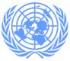
UN - Iraq Humanitarian Update
April 2005
United Nations Assistance Mission for Iraq (UNAMI)
UN Country team for iraq CONSISTS OF:

ESCWA , FAO , ILO , IOM , OHCHR , UNDP , UNEP , UNESCO , UNFPA , UN-HABITAT , UNHCR , UNICEF, UNIDO, UNIFEM, UNOPS, WFP, WHO

Background

As part of UNAMI’s mandate to coordinate and deliver essential humanitarian assistance, the UN Country Team (UNCT) in collaboration with NGO partners and Iraqi authorities, has taken a leading role in emergency preparedness and response activities for Iraq. By using the Cluster approach to address areas of common concern, UN agencies have combined resources and expertise to implement coordinated humanitarian responses. UNAMI continues to advocate on issues related to the humanitarian situation in Iraq, such as provision of basic services, the need for humanitarian space, and respect of international humanitarian standards.

In support of the establishment of a national emergency preparedness and response plan, the UNCT in coordination with aid agencies drafted a Contingency Plan for Iraq. This working document has been translated into Arabic and will be shared shortly with the relevant Iraqi ministry counterparts for initial discussions.

Humanitarian Overview

The UN Country Team for Iraq continues to monitor the humanitarian situation in flashpoints across Iraq, such as Fallujah, Ramadi, Kirkuk, Mosul and Al-Qa’im. Particular attention focused on the material and protection needs of internally displaced persons (IDPs) due to either military conflict or ethno-religious tensions.

The situation in Fallujah remained tense in April. An estimated 80% of IDPs from Fallujah returned, although it was not sure that they had remained in the city. Access to the city remained difficult and time-consuming, with residents expected to show their Public Distribution System (PDS) cards, official IDs, as well as badges provided by the MNF-I (Multi-National Forces-Iraq). Similar access restrictions were also reported by aid agency personnel. The water and electricity situation remained precarious, as three districts of Fallujah were solely dependant on water tankering and seven districts were without electricity.

Medical access for residents improved to some degree when the MNF-I relocated to two kilometres away from the main hospital in the city. According to the Education Department of Fallujah, of the 104 schools listed within the city,functioning normally? seven school buildings were severely damaged, 53 are in need of rehabilitation to some degree, and 15 schools in the city remained occupied by the MNF-I. It was reported that the presence of mines and unexploded ordinances (UXOs) in the north and south parts of the city contributed to delays in reconstruction efforts. Due to these various constraints, the reconstruction efforts were restricted in scope, but still ongoing. MNF-I has done some substantial reconstruction work in the Fallujah area since the end of the operation, complementing the activities and support of the aid agencies and the Iraqi government.need to clarify the math!

Humanitarian Response Activities
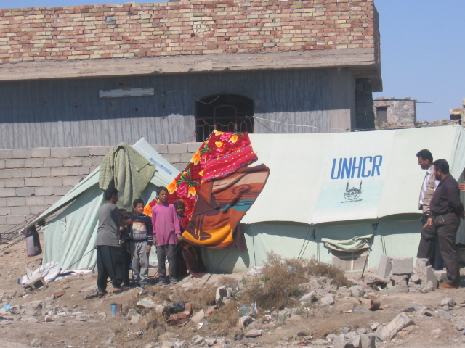
During the last two weeks of the month UNHCR, working through an implementing partner, distributed 800 tents, 440 lanterns, 2000 mattresses, and 1000 cooking stoves to a total of 1000 families resident in Fallujah. In addition, IOM has worked with two NGO partners to continue distributions of non-food items to 3680 Fallujah IDP families currently displaced across Al-Anbar and Baghdad Governorates. Through the Ministry of Education, UNICEF distributed 36,200 school bags and stationery kits to primary and intermediate school students across Fallujah.

UNICEF tankered sufficient drinking water to cover the needs of 180,000 beneficiaries in Eastern Baghdad. Additionally, 19 water treatment plants in Baghdad were provided with water purification chemical supplies to service 2.4 million people for the next six months.

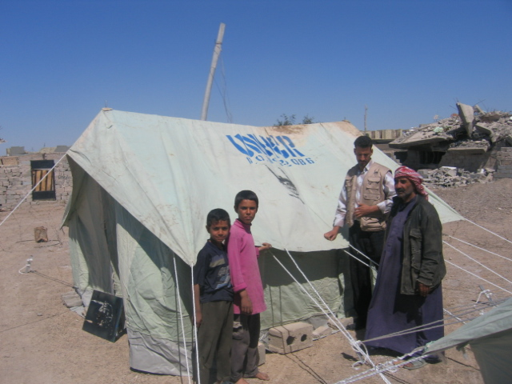
A depot in Kirkuk was set up by IOM to cater for the emergency needs of 1000 families in times of crisis. This complements the two existing depots in Baghdad and Samawah, capable of ? catering for 6000 families.

Assessments
As part of its ongoing monitoring of returnees, a UNHCR partner undertook a needs assessment of 890 returnee families located in the governorates of Baghdad, Al-Anbar, and Diyala, highlighting certain protection issues. A similar assessment was conducted in 400 villages across the Lower South governorates, indicating a need for improved shelter, access to safe water, medical facilities, and school infrastructure.

UNICEF carried out an assessment of 20 primary schools in Fallujah in coordination with the Ministry of Education, where physical rehabilitation of the schools was identified as a major need.

Humanitarian Alert: Al-Qa’im
Over the past week, the military offensive “Operation Matador” has resulted in the beginnings of a humanitarian situation requiring immediate response. Although it has been announced that the Operation is concluded, an estimated 2000 families have fled the city, seeking refuge in neighboring towns such as Anah, Rawa, and Al-Ubaydi, or into the surrounding desert in order to escape the fighting. Some Internally Displaced Persons (IDPs) are said to have sought refuge as far away as Fallujah and Baghdad. While some families were able to flee into Syria in the earlier stages of the Operation, the border has now been closed, forcing these families to find a second place of refuge.

The United Nations Assistance Mission for Iraq (UNAMI) and the UN Humanitarian Coordinator’s office convened the Emergency Working Group (EWG) to coordinate the response of humanitarian actors. Working in concert with the EWG in Baghdad, information is being shared and response coordinated to ensure that resources reach those most in need. Of prime concern is to reach the Internally Displaced Persons (IDPs) with basic needs such as water, shelter, food and essential medical care.

Initial efforts were hindered by the lack of access to the area, particularly Al-Qa’im itself, resulting in the inability of the agencies to accurately assess and respond to the needs of the civilian population. Of particular concern are reports that the medical facilities have been severely damaged, and that wounded civilians are unable to access treatment. However, some access is now possible, and agencies are beginning the process of delivering initial assistance while assessing more concretely immediate and longer term needs.

The UN and its partners urge the relevant authorities to respect the right for humanitarian space and the human rights of the civilians, and facilitate the access of humanitarian actors to those in need. Dialogue has been initiated with the Transitional Government of Iraq and the MNF-I to secure access.

UNAMI Amman, Jordan / Baghdad, Iraq / Kuwait City, Kuwait Contact us at: unami-access@un.org

