Ms. Gabriella Habtom
Secretary
United Nations Committee on the Elimination of Racial Discrimination
UN OHCHR
1211 Geneva 10
Switzerland

14 July 2015

REPORT ON THE GRAVE AND PERSISTENT VIOLATION OF INDIGENOUS PEOPLES’ RIGHTS
IN COSTA RICA
(87TH SESSION OF THE COMMITTEE ON THE ELIMINATION OF RACIAL
DISCRIMINATION, 3-28 AUGUST 2015)

- Executive Summary
- This report is respectfully submitted to the United Nations Committee on the Elimination of Racial Discrimination (“the Committee”) in light of the upcoming examination of the report submitted by the Republic of Costa Rica. It is submitted by the Asociación de Mujeres Mano de Tigre (Orcuo Dbön), Asociación Cultural Indígena Teribe, Centro de Investigación Indígena Oropopo, Asociación Compartimos Raíces Internacional, Servicio de Paz y Justicia en Costa Rica (SERPAJ-Costa Rica), Observatorio de Derechos Humanos y Autonomía Indígena (ODHAIN), Frente Nacional de Pueblos Indígenas, COECOCEIBA-Amigos de la Tierra Costa Rica, Kus Kura S.C., and the Forest Peoples Programme, an international NGO (“the Submitting Organizations”).
- This report addresses the pattern of pervasive, long-standing and inter-connected violations or denials of the rights of indigenous peoples in the Republic of Costa Rica (“the State” or “Costa Rica”), and the ongoing situation of impunity in which they occur and persist. These violations, in their majority addressed by the Committee since the late nineties, as elaborated below, include the massive and illegal occupation of titled indigenous lands, the persistent violence and threats against the indigenous communities, their leaders and members, the absence of adequate procedures to address rights to traditional lands outside of these titled areas, stalled legislative reforms, the unconstitutional advance of the Diquís Hydroelectric Project in the territories of indigenous peoples, and denials of indigenous peoples’ rights to juridical personality and to govern their internal affairs through institutions of their choice. For example, studies document that almost three-quarters of the 24 legally-recognized indigenous territories are at least 40 percent illegally occupied and a quarter is 80 to 98 percent illegally occupied. Costa Rica’s acts and omissions related to the continuation and/or facilitation of this occupation, at the least, jeopardize indigenous peoples’ physical and cultural survival and integrity in violation of numerous international standards and even extant national law. This situation is described in greater detail below and in the report, "Violations of Indigenous Peoples Territorial Rights: The Example of Costa Rica" (the "Report"). Both invite and compel the international scrutiny and action of the Committee.
- To be sure, the scale of the dispossession of indigenous lands, their consequent displacement from these lands, and the State’s wilful disregard for this situation and its consequences, on aggregate, violate rights that are essential to the right to life and survival of indigenous peoples as distinct cultural, territorial and political entities. In this respect, Article 8 of the UN Declaration on the Rights of Indigenous Peoples (“UNDRIP”) provides that indigenous peoples “have the right not to be subjected to forced assimilation or destruction of their culture”. In connection with this, the Human Rights Committee has affirmed that “states shall provide effective mechanisms for prevention of, and redress for: … [a]ny action which has the aim or effect of dispossessing them of their lands, territories or resources….” This Committee has called also “upon States parties to recognize and protect the rights of indigenous peoples to own, develop, control and use their communal lands, territories and resources and, where they have been deprived of their lands and territories traditionally owned or otherwise inhabited or used without their free and informed consent, to take steps to return those lands and territories.”
- The situation of the Cabécar people of the China Kichá indigenous territory of Costa Rica is illustrative of the State's disregard for this right. In 1956 China Kichá was declared as an indigenous territory, comprising an area of approximately 4400Ha. In 1982 the legal protection of this territory was removed by the State following a “technical study” by the National Commission on Indigenous Affairs and the Institute of Agrarian Development, both state entities. In 2001, 20 years later, following long-standing demands of the Cabécar people of China Kichá, the State re-established and redefined its boundaries. The redefinition of the boundaries represented a loss of 3300Ha, leaving the territory in a mere 25 percent of its original extension. The Cabécar people of China Kichá were never compensated for the dispossession of 75 percent of their lands. Currently the remaining 1100Ha, corresponding to the titled territory, is 97 to 98 percent illegally occupied by non-indigenous individuals. The effects were documented by a government agency in 2007, which bluntly stated that “[t]hey have lost the material basis of reproduction of their cultural specificity, such as land, the forest and rivers. They live on donations by the State, working [on their own lands] as labourers in cattle farms and coffee [plantations], and from small-scale subsistence farming.” This is precisely the situation that Articles 8, 25 and 26 of the UNDRIP, Article 5 of the International Convention on the Elimination of All Forms of Racial Discrimination ("ICERD") and related international norms are intended to prevent, yet, rather than decisively and urgently intervene and provide effective remedies, Costa Rica allows it to persist for decades unabated and with impunity. This is the case despite the fact that Costa Rica itself highlighted in 1985 that “a number of indigenous communities are currently disappearing.” The ILO explained in this respect that “the Government noted that the lands in certain Indian reserves in the South Pacific region of the country had been almost completely overrun, endangering the existence of at least four Indian reserves.”
- The UN Special Rapporteur on the Rights of Indigenous Peoples (“SRIP”) carried out an on-site visit to Costa Rica from 24 to 27 April 2011 and issued a report with recommendations shortly thereafter. While his report addresses the situation of non-consulted indigenous peoples affected by the El Diquís hydroelectric project, it nonetheless also contains recommendations on many of the structural and other issues raised in this communication. Despite the passage of over four years and little in the way of fundamental changes, Costa Rica's claims that it is a new government with a new vision and programme of activities with indigenous peoples. The results, however, only can be summarized as dialogue. The State's own periodic report confirms that it is all about dialogue. Indeed, there have been no concrete results on substantive issues. Costa Rica has failed to make meaningful progress on implementing any of the SRIP´s recommendations. This unreasonable inaction is all the more disturbing in light of the UNSRIPs conclusion that “decisive steps need to be taken urgently to find solutions that would allow indigenous peoples to recover the land in their territories.” He additionally explained that “the possession of large tracts of indigenous territories by non-indigenous persons is an underlying problem in Costa Rica and should be addressed by the Government as a matter of priority.”
- While Costa Rica asserts in its latest periodic report to this Committee that "the theme of indigenous peoples rights is of great importance to the Costa Rican state, Costa Rica has failed to heed similar recommendations continually adopted by UN treaty bodies for more than a decade; by the Inter-American Commission on Human Rights (“IACHR”); and repeatedly by the ILO’s Committee of Experts on the Application of Conventions and Recommendations (“CEACR”) between 1999 and 2014 pursuant to its supervision of Convention No. 169. Though not highlighted in the State's report to the Committee, Costa Rica has failed to implement recommendations made by the its own national Ombudsman, as well as urgent calls to prevent violence against indigenous peoples. Furthermore, as noted by this Committee in 2007, Costa Rica has even failed to implement decisions of the Constitutional Chamber of the Supreme Court upholding indigenous peoples’ property and associated rights. Costa Rica has yet to demarcate previously designated indigenous lands. This failure to comply with its domestic and international obligations has led to a further deterioration of the situation of indigenous peoples in the years since the SRIP visited Costa Rica. In some cases, the State’s failure to comply has led to urgent situations that irreparable harm is imminently threatened, prompting the IACHR to adopt precautionary measures in April 2015 in relation to the Bribri people of Salitre and the Teribe people. In its order the IACHR observed that the grave violence and threats made against the Bribri and Teribe (including attacks by armed men, burnings of homes, displacement of families, violent attacks and beatings resulting in serious injuries, and death threats) and the impunity for the perpetrators of these crimes are directly linked this situation of the persistent, massive and illegal occupation of lands in their territories. This was a conclusion shared by the UN Office in Costa Rica and Costa Rica’s Human Rights Ombudsman, the OHCHR regional office for Central America, and others.
- These issues have also received attention at the highest levels of the UN. For example, the situation in Costa Rica was even commented on by the Secretary General in his opening remarks at the ‘World Conference on Indigenous Peoples’ in September 2014. He stated that “In July [2014], I held talks with indigenous leaders in Costa Rica. … They were worried about land, resources and their rights. I repeated my pledge to address the exclusion and marginalization facing many indigenous peoples around the world.” The UNDG Resident Coordinator for Costa Rica has also explained that the SRIP concluded that the massive, illegal occupation of indigenous territories is “an unacceptable situation.”
- The Submitting Organizations respectfully suggest that the Committee recommends:
- That the State party urgently follow up on the recommendations made by the SRIP in his 2011 report, both as related to the specific issues related to the El Diquís hydro project and the structural issues of general application; and
- with respect to Diquís, the Submitting Organizations respectfully stress that attention must also be given to substantive rights rather than solely a focus on the procedural requirements related to an FPIC process (this includes, among others, land rights, rights to choose their forms of government, required information disclosure, and to determine their own membership); and
- request that the State suspend the re-installation of the ADI in Teribe territory and reconsider the continuation in other territories where the affected people so desire it, and enter into formal discussion with them about alternative forms of service provision and governance until the Teribe and other peoples have identified and finalised their own governance arrangements in accordance with their customs and traditions;
- That the State party, in good faith, starts the land recuperation process:
- this could start with the removal of a select group of non-indigenous trespassers in the four territories: Ngöbe of Coto Brus, Cabécar Bajo Chirripó, Ngöbe of Osa and the Cabécar of Nairi-Awari (detailed below in the paragraph 38) and those in the Bribri territory of Salitre that the State has already issued administrative orders of eviction but have failed to implement. If only as a good faith gesture and confidence building measure, to learn lessons and as a model to be applied elsewhere;
- the situations of the Teribe and the Bribri of Salitre are unique. Each are presently subject to pending legal proceedings before the IACHR. While their interests are shared by other indigenous peoples in Costa Rica, and they need to feed into the national dialogue on indigenous peoples rights', their specific issues also need to be addressed bilaterally (as required by the IACHR in the case of implementation of precautionary measures) and within the confines of the extant legal processes.
- The State party not only implement in conjunction with the affected peoples the required precautionary measures to address the violence and impunity plaguing these communities, but also formally commit to a friendly settlement procedure before the IACHR to achieve a negotiated settlement of the underlying petition filed by the Teribe.
- Promote the need for a national survey of unresolved – and presently unresolvable due to the absence of domestic legal provisions – indigenous land rights outside of the boundaries of the existing reserves is important. For instance, when the Teribe’s territory was recognised in November 1956, over 60% percent of the traditional lands of the Teribe were left out of the title, including entire communities such as the Teribe community of Macho Monte. This community was simply excluded from the territory and today enjoys no legal protection for its lands. Its exclusion from the reserve continues to lack any factual or legal justification today;
- Promote the adoption of the Autonomy Bill, including by making a presentation on the urgent need to enact this law before Costa Rica’s legislature;
- Appeal to the State to urgently employ, in consultation with the affected indigenous peoples, whatever law enforcement and judicial measures are necessary to not only protect the lives and physical integrity of the indigenous peoples, but also to enable improved investigations and prosecutions of those responsible for violence against indigenous peoples, especially its defenders of human rights, including members of the Municipality of Buenos Aires involved in the declaration of persona non grata of a Bribri Indigenous leader. The Committee previously has addressed this situation and the Submitting Organizations regret the State’s response to these recommendations has been silent while violence has continued. The current land tenure situation, along with the pervasive impunity for those that would seek to harm indigenous peoples, has created an untenable and dangerous environment for indigenous peoples that should not be tolerated in a State that holds itself out to be a leader of human rights in the hemisphere;
- Carries out the necessary legal reforms to sanction as a crime the illegal sale and purchase of indigenous lands by non-indigenous individuals. The current legal framework does not sanction these illegal transactions, tacitly promoting these illegal sales and purchases;
- Promote the elevation of indigenous rights to the constitutional level as this would provide indigenous peoples with greater leverage and security in domestic judicial and other venues as well as demonstrate a greater commitment to those rights by the state. This should be accompanied by dedicated training programmes for the judiciary, civil service and indigenous peoples themselves about indigenous rights and the measures required to respect, protect and fulfil those rights in the Costa Rican context; and
- Finally, indigenous peoples are a tiny minority of Costa Rica’s population and largely invisible in the electoral and political systems. There has never been an indigenous member of the legislature, for example, and the electoral system as currently designed marginalizes indigenous peoples. This invisibility, together with opposition from powerful competing interests, has in large part contributed to the current situation. In order to further address and safeguard indigenous peoples’ rights additional forms of indigenous representation are therefore required to ensure that indigenous peoples are adequately represented in both the legislative and executive branches of government. A number of countries – Colombia, New Zealand and Burundi, for example – employ specific indigenous electoral roles that may be used as models and which serve to ensure that indigenous peoples have designated seats in the legislature, separate from political party affiliations and loyalties, to raise concerns about indigenous rights when necessary. While not capable of fixing all problems, indigenous concerns could at least be aired and debated prior to the adoption of measures that may affect them and measures for their benefit could be independently proposed within the legislative process.

_____________________________________

- Introduction
- This report addresses the pattern of pervasive, long-standing and inter-connected violations or denials of the rights of indigenous peoples in the Republic of Costa Rica (“the State” or “Costa Rica”), and the ongoing situation of impunity in which they occur and persist. These violations, in their majority addressed by the Committee since the late nineties, as elaborated below, include the massive and illegal occupation of titled indigenous lands, the persistent violence and threats against the indigenous communities, their leaders and members, the absence of adequate procedures to address rights to traditional lands outside of these titled areas, denials of indigenous peoples’ rights to juridical personality and to govern their internal affairs through institutions of their choice, and the unconstitutional actions of the State in relation to the Diquís Hydroelectric dam. For example, studies document that almost three-quarters of the 24 legally-recognized indigenous territories are at least 40 percent illegally occupied and a quarter is 80 to 98 percent illegally occupied. Costa Rica’s acts and omissions related to the continuation and/or facilitation of this occupation, at the least, jeopardize indigenous peoples’ “survival” and integrity in violation of numerous international standards and even extant national law. This situation is discussed in detail in Violations of Indigenous Peoples Territorial Rights: The Example of Costa Rica (hereinafter, the Report") and summarized below. Both invite and compel international scrutiny and action by this Committee.
- Illegal Occupation of Titled Lands
- There are eight indigenous peoples in Costa Rica with a population of 104,143 persons, comprising approximately 2.4 percent of the national population. Many of them live in 24 legally-recognised and titled indigenous territories as well as in lands traditionally occupied but presently not included in these titled territories. These 24 territories are ostensibly protected by the 1977 Ley Indígena, the law implementing ILO 169, ratified by Costa Rica in 1993, and other international human rights treaties to which Costa Rica is a party. While the State asserts in its latest report to CERD that there "exists a favourable juridical framework with respect to tenure and recuperation of indigenous lands", it is worth highlighting that Costa Rica has not respected nor implemented its own legal framework. Furthermore, contrary to the majority of other Latin American states, there are no specific constitutional guarantees for indigenous property or cultural rights.
- The 1977 Ley Indígena prescribes that indigenous territories are “inalienable” and “exclusive” to indigenous peoples and that non-indigenous “persons cannot rent, lease, purchase or acquire by any other means” lands therein. This has been a prominent principle of Costa Rican law since 1939. Article 5 of that law requires the State to remove all persons in occupation of lands declared to be indigenous territories whether they are ‘good faith possessors’ or otherwise. The former are entitled to compensation from a fund established by the law. The same article unambiguously states that “If afterwards there are invasions of non-indigenous persons in the reserves, the competent authorities immediately shall proceed with their eviction with no payment of compensation whatsoever.”
- In direct contravention of this law, studies reveal that 6,087 non-indigenous persons illegally occupy some 43 percent of the total lands in the 24 titled indigenous territories. In almost 30 percent of the titled indigenous territories, the indigenous owners are in possession of a mere 2 – 22 percent of their lands. In only two territories (8.3%) are indigenous peoples in possession of 100 percent of their lands. Domestic remedies to address illegal occupation are ill-defined, underfunded and demonstrably ineffective. The fact that nationally more than 6,000 non-indigenous persons continue to illegally possess almost half of the area titled to indigenous peoples nationwide almost 40 years after the Ley Indígena was adopted speaks for itself.
- Illegal occupation of indigenous territories has been a serious and notorious problem since at least the 1960s. Yet, it has not been, and is not now, the subject of any meaningful or concerted remedial action. Indeed, the State tacitly approves of this illegal occupation despite the fact that a draft law that is intended to correct this situation has been pending before the legislature since 1995. For instance, Costa Rica itself informed the UN that its 2000 census revealed that “in the indigenous territories only 1 out of every 10 hectares is in conformity with the law…” and; five years later, in 2005, Costa Rica’s Office of the Ombudsman unambiguously observed that “no steps have been taken to recover land for indigenous communities, which is one of the principal, as yet, unmet obligations of the Costa Rican State.” Further demonstrating Costa Rica’s persistent disregard for the basic rights of indigenous peoples and its tacit approval of this situation, the Ombudsman stated just in June 2015 that the State “practically” has not realized any process for the recovery of lands in the 24 titled indigenous territories. Costa Rica’s tacit approval to the illegal occupation adds to the impunity that prevails among non-indigenous individuals in most indigenous territories, but particularly in the South-Pacific region. In this region illegal occupiers freely enjoy the exclusive lands of indigenous peoples and violently attack them in retaliation to their land claims. Indeed, while the Government states to this Committee that "it has been supporting the efforts of indigenous peoples, rejecting the invasions of indigenous lands by non-indigenous and supporting requests for eviction", it omits the fact that in the Bribri territory, for example, seven parcels have been under a State ordered eviction notice for approximately a year, but the State has failed to evict a single trespasser. Meanwhile the same remain in the territory and threatened its indigenous residents regularly. In the past month (while presumably under the precautionary measures of the Inter-American Commission on Human Rights), one of these prominent non-indigenous trespasser --along with three other cohorts-- forcibly entered the home of an indigenous family, and for over three hours shouted racial remarks and death threats at the mother and her two sons (both minors), all at the point of a knife and gun. The mother called the police twice while the assailants were present, and no authorities arrived -- not even afterwards to take a statement and ensure the security of the indigenous family.
- Despite clear and authoritative evidence that this situation of non-indigenous occupation and resulting hostilities are a serious derogation from its domestic laws and the international obligations incorporated therein, Costa Rica allows it to persist and even worsen. As a result, indigenous peoples continue to lose more lands each year and with it the enjoyment of related rights. For example, the indigenous territories of Boruca, (Rey) Curré and Térraba have on average lost an additional 40.5 percent of their titled lands to illegal occupation since 1964, when illegal occupation was already 37.2 percent. The territory of China Kichá was 60 percent illegally occupied in 1964; today, of the remaining 25 percent recognised by the State, it is 97 to 98 percent illegally occupied. Again, Costa Rica is well aware of this situation, yet indigenous peoples’ rights continue to be violated with impunity and their cultural integrity continues to be undermined and threatened by the invasion and illegal alienation of their lands throughout the country.
- In response to serious outbreaks of violence related to illegal occupation in Puntarenas province, Costa Rica established a “Mesa de Diálogo” (“the Mesa”) in 2013. The Mesa, presumably part of its new approach to indigenous peoples, is a roundtable for high-level dialogue between the State and the seven indigenous territories of said province (so not indigenous peoples nationally), and was intended as a mechanism for discussing and resolving issues of concern, including illegal occupation. The territories participating in the Mesa are also those in the affectation area of the Diquís project. While the State and others have incessantly promoted the Mesa as an important means of resolving disputes, the Submitting Organizations consider that it has done very little to address either the pressing structural issues that continue to impede and negate the exercise of indigenous peoples’ rights nationally or the specific issues in the seven territories that send representatives to its meetings. The Mesa is a perfect example of a forum for talking but not doing. This was confirmed by the UNDG Resident Coordinator, who explained in March 2015 that “the slow pace of progress in the implementation of agreements reached in the Mesa de Diálogo could risk the collaboration, buy-in and the sense of ownership of Indigenous Peoples.”
- Additionally, the Mesa – which was inoperative for over nine months, held only one meeting in the past year and seems to have been called off by the State – distracts the State from dealing with certain pressing issues bilaterally in the affected territories. This was emphasized by the Bribri of Salitre in a letter dated 16 May 2015 and copied to the Committee, and cited as one of the reasons for their withdrawal from the Mesa (attached at Annex B). They also expressed the view that the Mesa suffers from a number of serious methodological problems, which they have objected to on a number of prior occasions, and that renders it of limited utility in addressing their specific concerns --these include the absence of key government officials that have authorities over departments required for the adequate resolution of indigenous land tenure matters. This is deeply troubling given that violence against the Bribri of Salitre by some of the illegal occupants of their territory and others was the primary reason that Costa Rica established the Mesa in the first place.
- In February 2015, the government announced an agreement with the Centro Agronómico Tropical de Investigación y Enseñanza, CATIE, to “work on a proposal of the situational study to analyse land tenure in five priority indigenous territories”. Five months later, after announcing this agreement as a fundamental step in “reaffirming that the mechanism for [land] recuperation" it has not been signed between CATIE and the State, and the dates by which this process will be concluded have been ignored.
- Continued Violence and Impunity from Non-Indigenous Trespassers
- As noted above, the increased violence in the territory of the Teribe as well as the territory of the Bribri in Salitre (both in the Puntarenas province) prompted the Inter-American Commission on Human Rights in April of this year to order precautionary measures to ensure that the State is taking measures to protect the lives and physical integrity of the concerned indigenous peoples. Contrary to the Commission's orders, the State has not taken any measures to address these measures in consultation with the concerned peoples. Both the Bribri and Teribe confirm that the State has not reached out to them once since the precautionary measures were issued in order to discuss security priorities and measures.
- Since the update filed with the CERD in 2012 and 2013 by the Forest Peoples Programme, there have been new acts of violence as well as a shameful and continued lack of detentions, prosecutions, and even completion of investigations of all incidents previously reported to this Committee as well as those described below:
(i) On Sunday 1 September, 2013, Jerhy Rivera, an indigenous member of the Teribe people was brutally attacked by a non-indigenous person. The brutal attack was in response to the work that the Environment Commission of the Teribe people was carrying out at that time, The members of the Commission were investigating reports of illegal cut down of trees in the Teribe Territory. While leaving the scene of the illegal activity to report the activity to the authorities, Mr. Rivera was attacked. He was left unconscious for several minutes and when he regained consciousness he was left with a broken arm, his eyes full of blood, and severily injured in various parts of his body.
(ii) On July 5, 2014, one of the most grave and violent actions against indigenous peoples in Costa Rica happened in the indigenous territory of the Bribri of Salitre. A group of approximately 100 armed non-indigenous individuals blocked the only entrance to the Bribri territory of Salitre and burned down houses of the Bribri peoples who previously participated in the peaceful recuperation of lands illegaly held by non-indigenous persons within their titled territory. The right of the Bribri people to freely enjoy their territory, to their freedom of movement, to get supplies, to adequate housing, and to their security, among others was seriously undermined. Furthermore, these actions generated an atmosphere of fear and trauma among members of the Bribri.
It is important to recall that the crisis in Salitre happened while the Mesa de Diálogo was active, demonstrating that the repeated requests of the Bribri were not acted upon by the State in the Mesa de Diálogo. The Ombudsman reported that the government was not able to channel the necessary institutional efforts to clear the entrance to the Teribe territory. They were therefore woefully delayed in proucing the removal of the non-indigenous attackers and opening of the only road entering the territory, as no State institution was able to effectively respond. Finally when the attackers were removed not one of the perpetrators were detained.
Indeed, to date, no person has been held responsible for these violations against the rights of the Bribri people.
(iii) On November 19, 2014, three armed men entered the Bribri Territory of Salitre, fired various gunshots and burned down the house of the indigenous members, Natalio and Camelia Ortiz. The Bribri family ran to the mountains and hid to protect themselves. The Ombudsman reported that during a visit on October 29, just two weeks before the attack, they visited the territory and observed no increase of security in Salitre. The Ombudsman stated that this was the case even though the were presumably reached between the government and the Bribri on July 5 committing the government to “attend the conflict of lands in the indigenous territory of Salitre.” As explained by the Ombudsman “during a visit I carried out to that Territory, I verified there is no police check point, no record of entrances and exits of the territory and I observed no patrolling.”
- The State's response to the violence reported has been wholly inadequate. As recently reported by the State, typically when incidents occur, the State merely augments the police in the area in a temporary manner. In the face of the Commission's precautionary measures, the presence of police has been increased in the territory of the Teribe and the Bribri, but as the Bribri has reported to the Forest Peoples Programme, this presence has been wholly ineffectual. The police are from the province and are sympathetic to the non-indigenous occupants. They tend to question and stop the indigenous peoples at checkpoints, more often than non-indigenous individuals attempting to enter the territory. As noted above, see paragraph 13, incidents of violence and threats against indigenous peoples continue and remain wholly unaddressed by these officers.
- Lack of Adequate Procedures to Address Rights to lands outside of Titled Territories
- As discussed above, the land tenure situation of indigenous peoples in titled territories in Costa Rica has been documented in a number of studies. Very little information, however, has been gathered about the situation of indigenous peoples’ lands that lie outside of a titled territory and which are not presently recognised or protected by domestic law. Costa Rica has reported to the ILO that 18 percent of indigenous persons reside on the “periphery” of indigenous territories and this may provide some indication of the extent of this problem, and it is well known that there are indigenous communities situated outside of the boundaries of a titled territory (see further discussion below). This likely has occurred because most of the reserves presently recognized in Costa Rica were delimited on the basis of studies undertaken without indigenous participation and without reference to the traditional tenure systems and customary norms that underlie and give rise to indigenous property rights in international law.
- Costa Rica has ratified ILO 169 and incorporated it into domestic law and it clearly provides that parties “shall take steps as necessary to identify the lands which the peoples concerned traditionally occupy, and to guarantee effective protection of their rights of ownership and possession;” and that “[a]dequate procedures shall be established within the national legal system to resolve land claims by the peoples concerned.” Similar norms are also set forth in Article 26 and 27 of the UNDRIP, the Committee's jurisprudence related to Article 5, as well as regional international law as articulated by the IACHR and Inter-American Court. Despite this, and despite concerns raised by the ILO CEACR more than once, Costa Rica has yet to enact any formal laws or procedures by which indigenous people may seek recognition of and protection for their traditionally owned lands that are situated outside of the 24 titled territories.
- The situation of the Teribe people is illustrative of this problem, but by no means unique. When the Teribe territory was delimited in 1956 (and again in 2004, excising roads, rivers and other public domain properties) the boundaries established by the State excluded approximately 60 percent of their traditional territory. Currently a community known as Macho Monte, inhabited mainly by Teribe people was left outside of the titled territory, despite the fact that its lands were and remain contiguous to the boundary of the titled territory, only separated by the Térraba River. It presently remains without any legal protection for its traditional lands, much of which is occupied by non-indigenous persons, and its exclusion from the reserve continues to lack any factual or legal justification today. To make matters worse, their livelihood has been seriously undermined, almost all of its farm lands have been occupied by non-members, it lacks any potable water – as many of the sources are within the lands held by non-indigenous individuals, and the State has failed to respond to its requests for at least a bridge and access road that would allow its members to freely access the titled Teribe territory where extended family and precious resource are accessible. In addition, they must deal with excruciating bureaucracy in order to prove they are Teribe to access the State’s social programmes for indigenous peoples, such as housing and poverty reduction. Their situation has become so dire – a situation entirely of the State’s making – that they have even requested to be relocated inside the titled territory, which would leave their claimed area wholly occupied by trespassers. In effect, the State’s neglect for their situation coupled with the lack of adequate laws and procedures that would allow Macho Monte to obtain protection for its lands, is forcing the community to abandon those lands in order to survive.
- Denial of Indigenous Peoples’ Rights to Juridical Personality and Self-Government
- The Ley Indígena nominally recognises and protects traditional indigenous governance institutions and procedures. However, less than one year after it was adopted, this protection was rendered null and void by Decree No. 8487 of 1978, which established Integral Development Associations (ADI in Spanish) in indigenous territories, the form of local government employed throughout the country. The SRIP observed that this Decree has “effectively deprived indigenous peoples’ traditional institutions of the authority to represent them in matters of sustainable development, establishing the ADIs for this purpose.” ADIs are official government bodies and part of the Costa Rican State that, by law, “represent” and govern each indigenous territory and exercise legal personality on behalf of indigenous peoples. The ADIs are also designated as empowered to hold title to indigenous territories. This means that when a State does process titles to indigenous lands and such titles are held by the ADIs, the State is actually granting title to itself.
- The preceding is the case despite the fact that the ADIs, created by law in the 1960s, are alien and imposed State-created structures that do not take into account indigenous peoples’ traditions and customs and are perceived to be discredited, unrepresentative and unaccountable entities by most indigenous peoples, a fact acknowledged by the SRIP in his 2011 report. Further, the ADIs may operate, and often do, with less than 20 percent of the population of the territory as members, even though they presume to act as the internal government of that territory. In some cases, indigenous persons even have been forced to petition the Supreme Court to obtain membership in the ADI after being denied membership.
- In May 2015, the State reinstalled the ADI in the Teribe’s peoples’ territory despite the fact that it has been responsible for the illegal alienation of land to non-members in their territory and it is rejected by many Teribe. The Teribe have established a Council of Elders to represent them, including for the purposes of determining their membership in relation to the participatory processes identified as necessary by the SRIP in his 2011 report (such as the consultation process for the Diquís project), especially since many non-indigenous persons participated in the people’ decision making. Members of the Teribe people have even filed a constitutional challenge asserting that the ADI is incompatible with indigenous peoples’ rights. Consistent with prior judicial decisions upholding the legality of the ADI system as it affects indigenous peoples, this legal challenge was rejected by the Supreme Court reaffirming the ADI's authority. Reviewing this situation, the University of Texas Law School Human Rights Clinic concluded that “the practical operation of the ADI in Térraba renders it ineffectual to prevent further land loss, redress past losses, ensure the effective exercise of self-government, and enable the Teribe peoples to exercise their rights of effective participation, consultation, and consent….” Despite this, Costa Rica is again imposing the ADI on the Teribe. The latest case during June 2015 there were two exercising presidents of the ADI. One appointed by the Executive, validating an Assembly of the ADI (denounced by many as irregular given that non-members participated in the voting) and another by Judiciary as precautionary measures given that the Teribe had no government (ADI) for several months. This is a clear indication of how the Costa Rican State violates the right to self-government of indigenous people.
- The ADIs as currently constituted deprive indigenous peoples’ their right to collective juridical personality (being the entity that holds title to the indigenous territory and possessing the sole right to seek collective remedial actions in the courts to vindicate violations); to effectively determine their membership for the purposes of collective action; to freely choose their own representatives in order to participate in decision making; and greatly impede their rights to freely pursue their economic, social and cultural development and to effectively control their traditional territories through their own autonomous, self-governing institutions. These rights are all upheld in the Committees jurisprudence, UNDRIP, numerous UN international human rights treaties ratified by Costa Rica, and ILO 169, and have been emphasized as fundamental to indigenous peoples’ well-being and the enjoyment of their rights by, inter alia, the Inter-American Court of Human Rights in the Saramaka People, Sarayaku and other cases.
- In Saramaka People, the Court held that the Saramaka people, as a people, has a collective right to juridical personality (i.e., not just as individuals and certainly not via an entity created in addition to, and outside of the people itself, like the ADI). It ruled that the right to collective juridical personality is “one of the special measures owed to indigenous and tribal groups in order to ensure that they are able to use and enjoy their territory in accordance with their own traditions.” It further explicated and ordered that the state must recognize indigenous peoples’ collective legal personality in law and through judicial and administrative measures, all of which guarantee them “the use and enjoyment of their territory in accordance with their communal property system, as well as the rights to access to justice and equality before the law.” In Sarayaku, the Court stressed that international law recognizes indigenous peoples and their rights “as collective subjects,” and that they “exercise certain rights recognized by the [American] Convention on a collective basis,” including the right to legal personality. The IACHR has also emphasized this point.
- In short, as the SRIP has observed, the establishment of ADIs in indigenous territories have “effectively deprived indigenous peoples’ traditional institutions of the authority to represent” them in violation of a series of interdependent international guarantees. This includes the complete denial of their rights to autonomous self-government and collective legal personality as well as “their right to manage, distribute, and effectively control [their] territory, in accordance with their customary laws and traditional collective land tenure system.” The right to effective control of traditional territory is a wide-ranging and substantial power, and presupposes that indigenous peoples are able to exercise it through their own freely identified institutions not those established by the State, and that these autonomous institutions are established consistent with the customs and traditions of the indigenous peoples themselves, not those of the national government. Rather than correct this serious problem, Costa Rica persists with this imposed system and even insists that the ADIs are the primary bodies to be consulted on issues affecting indigenous peoples (including those discussed in this communication). This is basically the State consulting itself as ADIs are state agencies and denies indigenous peoples their right to freely identify their own representatives, through their own procedures, in order to participate in and determine crucial decisions pertaining to their territories.
- Stalled Legislative Reforms
- Given the absence of effective judicial and other remedies to address the imposition of the ADIs and the invasion and expropriation of their lands, indigenous peoples have sought to correct this situation through the legislature. This led to the drafting, over a seven-year long period, of the Proyecto de Ley de Desarrollo Autónomo de los Pueblos Indígenas (the Bill for Autonomous Development of Indigenous Peoples (“Autonomy Bill”)), which was first submitted for debate in the Congress in 1995. It was subsequently modified and reconsidered by the Congress in 2002 after an extensive round of consultations during which indigenous peoples’ freely chosen representatives overwhelmingly supported the Bill.
- As The Committee observed in 2002, the Autonomy Bill is “aimed at granting full autonomy to indigenous peoples and recognizing their right to enjoy their own cultures, as well as the right to administer their territories.” It also details (currently inadequate) procedures for resolving illegal occupation of lands in indigenous territories, a fund for the expropriation of illegally occupied lands, and the replacement of ADIs with ‘indigenous territorial councils’. If adopted and effectively implemented, this law could go far towards correcting the long-standing problems affecting indigenous peoples in Costa Rica, including those highlighted herein.
- Nonetheless, despite the Committee’s repeated recommendations to adopt the Bill, it continues to languish in the Congress in 2015 due to lack of political will, opposition from powerful vested interests, some of whom illegally occupy lands in indigenous territories, as well as from the prior government, which perceived the Bill to be a threat to its national development initiatives. The previous government, for example, explained that it will not present the Bill for adoption as its requirement that indigenous peoples’ consent be obtained may threaten the Diquís dam or other projects, a statement that was strongly criticized by the Committee in September 2011. This has essentially paralyzed the legislative process for the past 19 years and today the Bill is again in danger of being completely withdrawn from consideration. In December 2014, coincidently after a period of silence from the government with regard to violent outbreaks in Salitre, the government presented the Autonomy Bill to the extraordinary sessions of the Parliament. Three months later earlier this year, the government withdrew the Autonomy Bill from parliament and there was no further communication as to whether it was presented again or if there are plans to do so in the near future. It becomes evident that the rhetoric model is being replicated, leading to dialogues, a necessary part of the process, but with no concrete actions on substantive matters such as land rights, autonomy and self-government.
- Diquís Hydroelectric Project
- In November 2014 the Council of Elders of the Teribe sent a note to the Executive President of the Costa Rican Institute of Electricity (“ICE”) requesting detailed information about the Diquís Project. The information requested included: methodology and outcomes of the environmental and social impact assessments, feasibility studies: including inter alia its technical and financial components, funding mechanisms, concessions and lifespan of the project. ICE’s response denied the request of information stating that this request was being analysed by the Superior Administration of the Institute. In a recent visit of the Executive President of ICE to Térraba –invited by the ADI- a group of Teribe people stated their concern of the lack of compliance of ICE with regards to the recommendations of the SRIP, specifically with regards to “engage in a transparent consultation process in which the indigenous parties have access to comprehensive information.” Serious concerns arose with the statement of the Executive President of ICE with regard to the request of information, stating that ICE differs with the UNSRIP on the recommendation to disclose the environmental and social impact assessments. It is contradictory and hypocritical that “the Government reiterates its commitment that the dialogues about the Diquís Hydroelectric Project shall be transparent and respectful of Human Rights” but refuses to share information about the project with the affected communities.
- Furthermore, it is deeply concerning that a Consultation Protocol seems to be under development by the State, but there is no information available about this process, neither has it been open to participation of indigenous peoples. In this regard, the Ombudsman has “urged the State to guarantee the indigenous consultation in the Diquís Hydroelectric Project” and the need for the State “to define a state body responsible of organising the consultation processes required in the indigenous territories”
- With the recent developments around the Diquís Hydroelectric Project, the State’s official communications and the lack of transparency with regards to the information of the project, it is fundamental that the Committee’s requests and recommendations “that the State party provides information on the measures taken to ensure the effective participation of the Térraba people and the other indigenous peoples whose decision making regarding all aspects and stages of the dam Diquís plan has been affected, and to obtain the free, prior and informed consent in relation to this project” are followed by the State. The latter has two elements of utmost importance. The first is good faith action to build trust between the State and indigenous peoples. The second is to bring to reality the right of indigenous peoples to refrain or give their consent with regards to the proposed dam, as information is a fundamental element in the decision-making. Furthermore, in the same line, the Submitting Organizations request that the recommendations of the SRIP are implemented by the State beyond rhetoric and dialogue.

- Requests
- The Ministry responsible for indigenous issues has stated in meetings with indigenous leaders and publicly that the above described situation is a “conflict [that] has dragged on because the integral solution required is structural and has to counteract 30 years of institutional inertia;” and is “the result of a long-seated problem that cannot be solved in a few months.” This is a long-standing problem with both structural and specific elements and the current government has inherited this severe problem. However, while it has expressed a willingness to address some of the issues, it has yet to take meaningful action and, instead, more than suggests that the Mesa is sufficient. As such, the "inherited" problem has now become one that the current government now fully owns and is complicit in its continuance. The problems associated with the Mesa are discussed above and as currently constituted it clearly will not address the underlying national structural problems or perhaps even the specific issues faced by the territories of the Puntarenas province participating therein. Conclusion is all the more apparent given that the State has yet to adequately and diligently follow through on the limited agreements reached at the Mesa. The same may also be said, to date, of Costa Rica’s compliance with the precautionary measures adopted by the IACHR. The State has failed –almost eight weeks later -- to consult with the affected peoples on the measures to be implemented, as specifically required by the IACHR's order.
- Furthermore, the State is hiding behind the notion that the problem is complex, took long to create and will now take a long time to address. This is not so. There are plenty of immediate steps the State can take if it has the political will to do so. For example, these include, as describe below, the immediate removal of a small number of bad faith non-indigenous occupiers within indigenous territories --including in the case of the Bribri those trespassers that are already subject to a State eviction order. The State could also procure the immediate release by ICE of even baseline information about the Diquís project currently being withheld from the Teribe and others. Costa Rica can also replace current police postings within the territory of indigenous peoples in Puntarenas with officials from outside of the province, thereby bringing in impartial individuals capable of properly, and without discrimination, policing the area and protecting the lives and physical integrity of threatened indigenous peoples.
- While indigenous peoples have suffered, and continue to suffer, serious and long-term harm that requires urgent remediation and redress, the situation in Costa Rica is not yet irredeemable. Many of the illegal occupants in indigenous territories are far from being poor migrants and individually hold large areas of land. Consequently, in most territories, the recovery and restoration to indigenous peoples of these large land holdings would involve the expropriation of only a limited number of properties. This means a large dent in the problem of illegal occupation can be addressed immediately through actions impacting only a few. Compensation will be required in some cases, but in many cases the illegal occupants are not entitled to compensation and may be evicted and relocated elsewhere at little or no cost to the State. This means it is a political issue rather than a financial one. In the Ngöbe of the Coto Brus territory, for instance, three non-indigenous persons possess 1,500 hectares (20 percent of the territory) and in the Cabécar Bajo Chirripó territory nine illegal occupants hold 4,696 hectares (about 25 percent of the territory). In the Ngöbe Osa and the Cabécar Nairi-Awari territories there are a total eight illegal occupants in possession of 10 and 11 percent, respectively, of the indigenous lands. To resolve illegal occupation in these four territories would thus require compensating or removing a mere 20 persons and would immediately treble the number of territories 100 percent possessed by their indigenous owners. In other words, dealing with illegal occupation by 20 persons would remedy this problem in one-quarter of the indigenous territories.
- In this light the Submitting Organizations respectfully suggest that the Committee recommends:
- That the State party urgently follow up on the recommendations made by the SRIP in his 2011 report, both as related to the specific issues related to the El Diquís hydro project and the structural issues of general application; and
- with respect to Diquís, the Submitting Organizations respectfully stress that attention must also be given to substantive rights rather than solely a focus on the procedural requirements related to an FPIC process (this includes, among others, land rights, rights to choose their forms of government, required information disclosure, and to determine their own membership); and
- request that the State suspend the re-installation of the ADI in Teribe territory and reconsider the continuation in other territories where the affected people so desire it, and enter into formal discussion with them about alternative forms of service provision and governance until the Teribe and other peoples have identified and finalised their own governance arrangements in accordance with their customs and traditions;
- That the State party, in good faith, starts the land recuperation process:
- this could start with the removal of a select group of non-indigenous trespassers in the four territories identified in paragraph 38 and those in the Bribri territory that the State has already issued orders of eviction -a year ago- but have failed to implement- if only as a good faith gesture and confidence building measure, to learn lessons and as a model to be applied elsewhere;
- the situations of the Teribe and the Bribri of Salitre are unique. Each are presently subject to pending legal proceedings before the IACHR. While their interests are shared by other indigenous peoples in Costa Rica and also they need to feed into the national dialogue on indigenous peoples rights' their specific issues would need to be addressed bilaterally (as required by the IACHR in the case of implementation of precautionary measures) and within the confines of the extant legal processes.
- The State party not only implement in conjunction with the affected peoples the required precautionary measures to address the violence and impunity plaguing these communities, but also formally commit to a friendly settlement procedure before the IACHR to achieve a negotiated settlement of the underlying petition filed by the Teribe.
- Promote the need for a national survey of unresolved – and presently unresolvable due to the absence of domestic legal provisions – indigenous land rights outside of the boundaries of the existing titled territories is important. For instance, when the Teribe’s territory was recognised in November 1956, over 60% percent of the traditional lands of the Teribe were left out of the title, excluding entire communities such as the Teribe community of Macho Monte, which has no legal protection for its lands. Its exclusion from the territory continues to lack any factual or legal justification today;
- Promote the adoption of the Autonomy Bill, including by making a presentation on the urgent need to enact this law before Costa Rica’s legislature;
- Appeal to the State to urgently employ, in consultation with the affected indigenous peoples, whatever law enforcement and judicial measures are necessary to not only protect the lives and physical integrity of the indigenous peoples, but also to enable improved investigations and prosecutions of those responsible for violence against indigenous peoples, especially its defenders of human rights. The Committee previously has addressed this situation and the Submitting Organizations regret the State’s response to these recommendations has been silent while violence has continued. The current land tenure situation, along with the pervasive impunity for those that would seek to harm indigenous peoples, has created an untenable and dangerous environment for indigenous peoples that should not be tolerated in a State that holds itself out to be a leader of human rights in the hemisphere;
- Carries out the necessary legal reforms to sanction as a crime the illegal sale and purchase of indigenous lands by non-indigenous individuals. The current legal framework does not sanction these illegal transactions, tacitly promoting these illegal sales and purchases;
- Promote the elevation of indigenous rights to the constitutional level as this would provide indigenous peoples with greater leverage and security in domestic judicial and other venues as well as demonstrate a greater commitment to those rights by the state. This should be accompanied by dedicated training programmes for the judiciary, civil service and indigenous peoples themselves about indigenous rights and the measures required to respect, protect and fulfil those rights in the Costa Rican context; and
- Finally, indigenous peoples are a tiny minority of Costa Rica’s population and largely invisible in the electoral and political systems. There has never been an indigenous member of the legislature, for example, and the electoral system as currently designed marginalizes indigenous peoples. This invisibility, together with opposition from powerful competing interests, has in large part contributed to the current situation. In order to further address and safeguard indigenous peoples’ rights additional forms of indigenous representation are therefore required to ensure that indigenous peoples are adequately represented in both the legislative and executive branches of government. A number of countries – Colombia, New Zealand and Burundi, for example – employ specific indigenous electoral roles that may be used as models and which serve to ensure that indigenous peoples have designated seats in the legislature, separate from political party affiliations and loyalties, to raise concerns about indigenous rights when necessary. While not capable of fixing all problems, indigenous concerns could at least be aired and debated prior to the adoption of measures that may affect them and measures for their benefit could be independently proposed within the legislative process.

Annex A – Letter from the Ombudsman to Minister of Presidency on the Urgency of Immediate Measures in Salitre
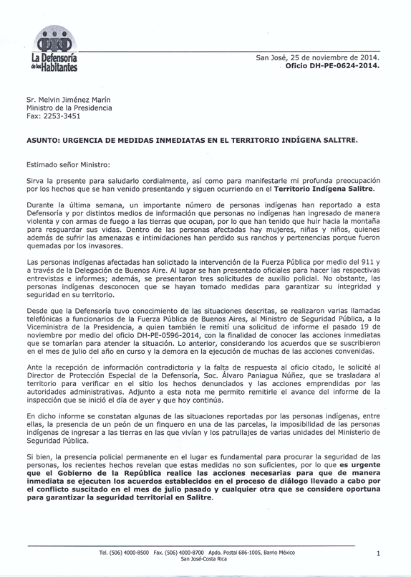
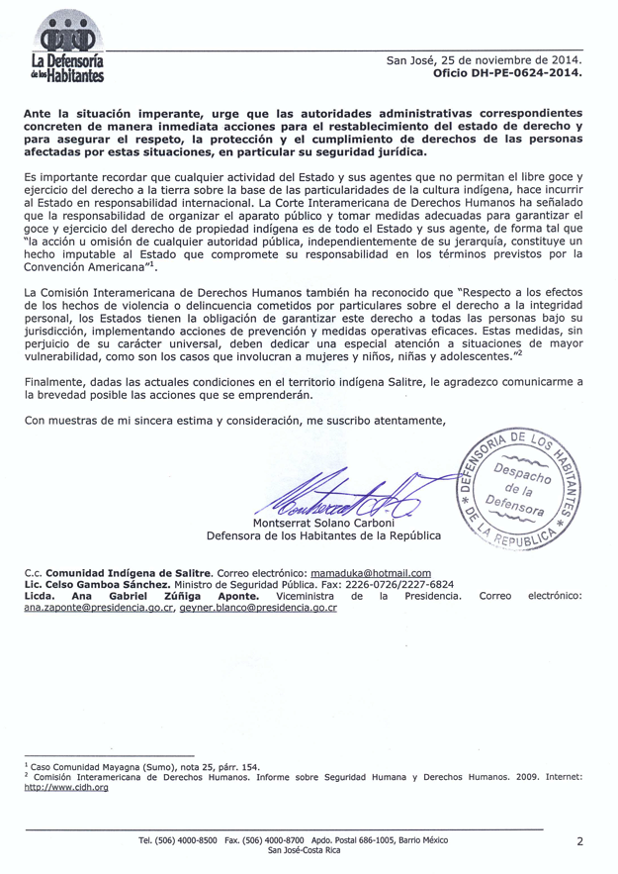
Annex B – Letter of the Bribri people of Salitre to the State of Costa Rica
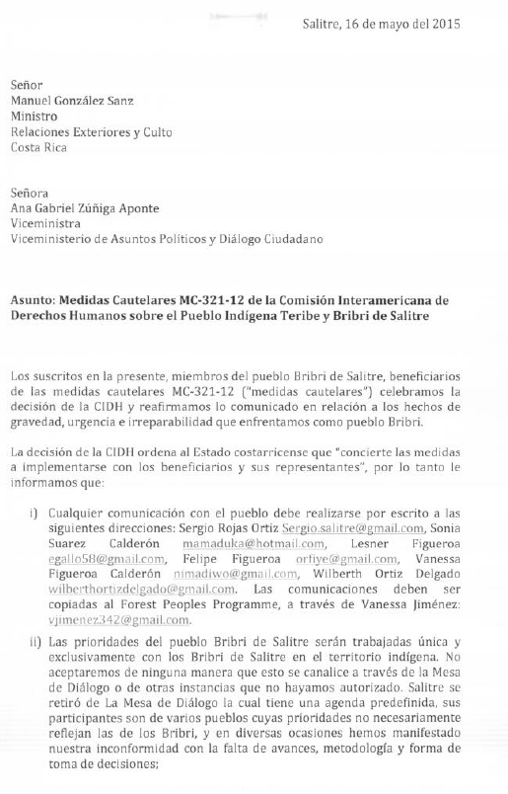
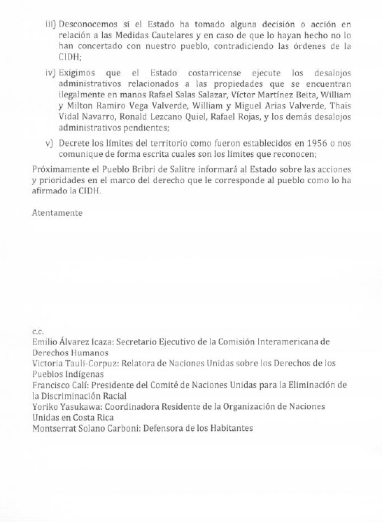
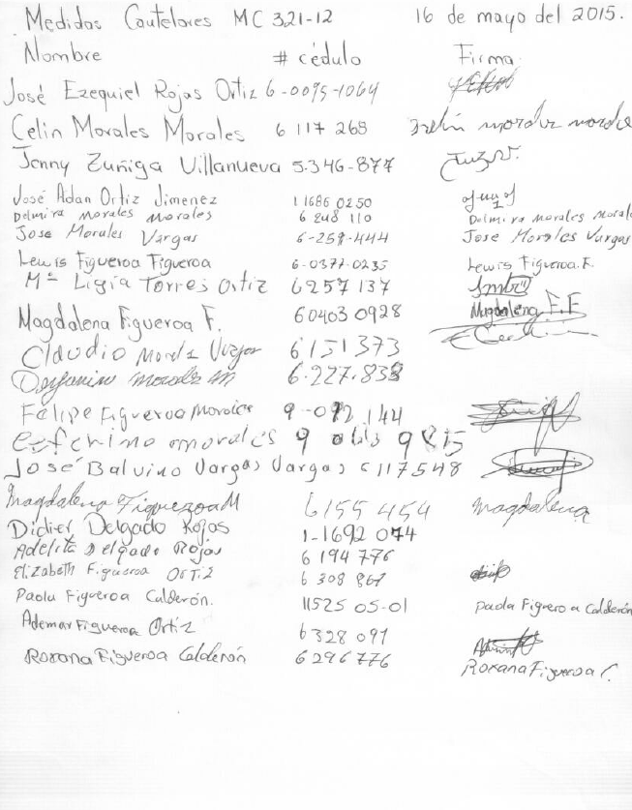
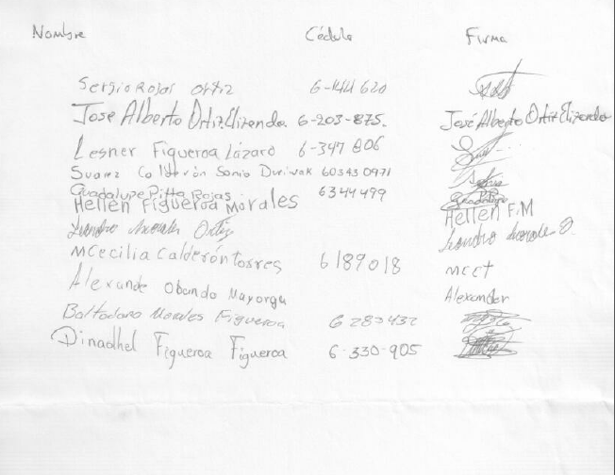
Annex C – Letter of the Ombudsman to the Vice minister of Presidency on the violence in Salitre
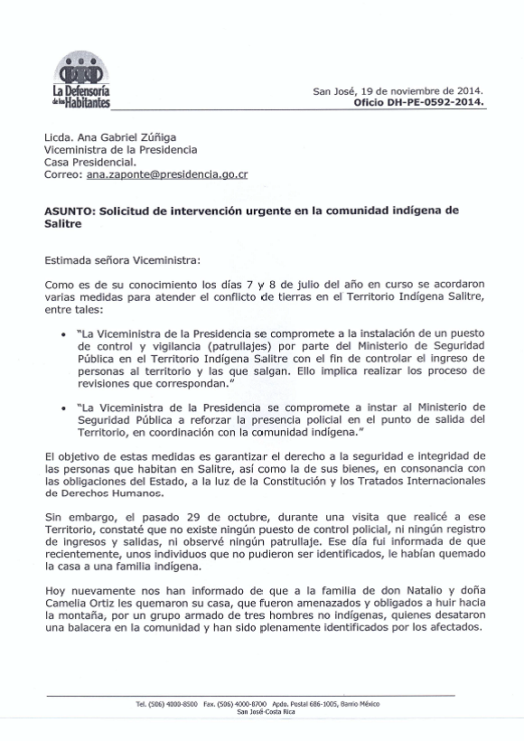
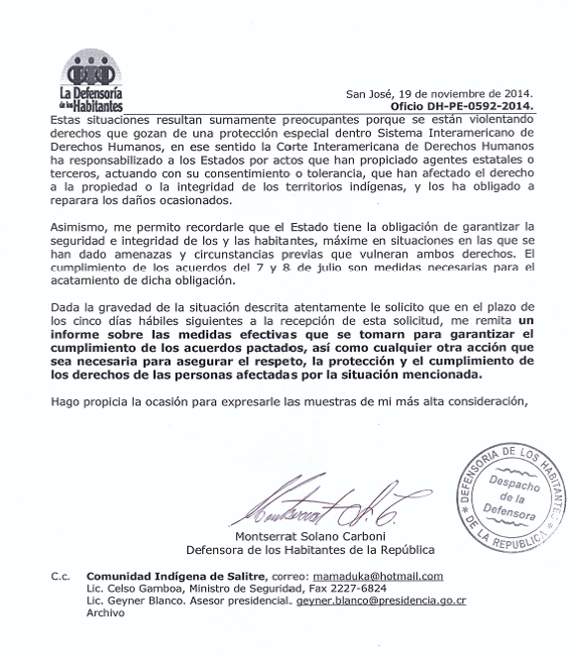

See F. MacKay & A. Morales Garro, Violations of Indigenous Peoples Territorial Rights: The Example of Costa Rica (Forest Peoples Programme, January 2014), available at http://www.forestpeoples.org/sites/fpp/files/publication/2014/02/violationsterritorialrightscostaricaenglishfeb2014.pdf).
In Saramaka People, the Inter-American Court of Human Rights defined the term ‘survival’ to mean indigenous peoples’ “ability to ‘preserve, protect and guarantee the special relationship that they have with their territory’, so that 'they may continue living their traditional way of life, and that their distinct cultural identity, social structure, economic system, customs, beliefs and traditions are respected, guaranteed and protected’.” Saramaka People v. Suriname, Merits and Reparations, Judgment, 2007 Inter-Am. Ct. H.R. (ser. C) No. 172 (28 November 2007), at paras. 129-134. Applying this definition to the situation in Costa Rica, it is no exaggeration to say that the vast majority of indigenous peoples are denied or, at a minimum, substantially obstructed in their ability to maintain their various relationships with their territories and, thus, their distinct cultural identity is neither respected or protected. The Court emphasized this point in its 2012 Sarayaku judgment, stating that, given the “intrinsic connection that indigenous and tribal peoples have with their territory, the protection of property rights and the use and enjoyment thereof is necessary to ensure their survival.” Kichwa Indigenous People of Sarayaku, Judgment, 2012 Inter-Am. Ct. H.R. (ser. C) No. 245, at paras. 146 & 147.
In its Report on the Situation of Human Rights of a Segment of the Nicaraguan Population of Miskito Origin, OEA/Ser.L/V/II.62, Doc. 26 (1984), at p. 76 and 81, the IACHR held that “special legal protection” is recognized for indigenous languages, cultures, economies, ecosystems and natural resource base, religious practices, “ancestral and communal lands,” and the establishment of an institutional order that facilitates indigenous participation through their freely chosen representatives. Two years later in its Report on the Situation of Human Rights in the Republic of Guatemala, OEA/Ser.1/V/II.67, Doc. 9 (1986), at p. 114, the IACHR characterized the preceding as “human rights also essential to the right to life of peoples.”
See also ICCPR, Article 27, which requires that indigenous peoples “shall not be denied” their right to enjoy their cultures. This article also relates the enjoyment of cultural rights to security of tenure over traditionally owned lands and resources and, when read in conjunction with Article 1(2) of the ICCPR, additionally guarantees their rights to “effective possession” of and “effective control” over the same. Apirana Mahuika et al. vs. New Zealand, (Communication No. 547/1993, 15/11/2000), UN Doc. CCPR/C/70/D/547/1993 (2000). See also in accord, Saramaka People v. Suriname, supra note 2, at para. 194.
See Committee on the Elimination of Racial Discrimination “General Recommendation No. 23: Indigenous Peoples” 18 August, 1997, at para. 5.
Executive Decree 34 of November 15, 1956 “Declares and Demarcates Zones as Indigenous Reserves” identifying 3 lots: Lot 1 (comprising what currently are the territories of Boruca, Térraba and Rey Curré); Lot 2 (comprising what currently are the territories of Cabagra, Salitre and Ujarrás); and, Lot 3 comprising the territory of China Kichá.
See Executive Decree 13570-G “Deroga Reserva Indígena de China Kicha” of April 30, 1982.
See Executive Decree 29447-G “Restablece la Reserva de China Kicha y redefine sus límites” of March 21, 2001.
C. Borge Carvajal, Consulta en los territorios Indígenas del pacífico de Costa Rica, (1st. Ed.) (San José: Unidad Ejecutora Programa de Regularización del Catastro y Registro, 2007), at p. 8.
ILO CEACR, Costa Rica: Direct Request, 74th ILC session (1987), at para. 13. See also ILO CEACR, Costa Rica: Direct Request, 78th ILC session (1991), Articles 11 to 14, at para. 14 (containing the same information).
Id.
The situation of the indigenous peoples affected by the El Diquís hydroelectric project in Costa Rica, A/HRC/18/35/Add.8, 11 July 2011 (“SRIP Report on El Diquís”), para. 41-8.
See CERD: Examen de los informes presentados por los Estados partes en virtud del artículo 9 de la Convención, 19.º a 22.º informes periódicos que los Estados partes debían presentar en 2012, Costa Rica, CERD/C/CRI/19-22 (16 April 2014), paras. 293-294 ("Costa Rica CERD Report 2014") (providing: "The Costa Rican Government is in the best position to enter into a process of dialog with the indigenous communities of the country, with the purpose of jointly build formulas to implement the recuperation of land to which it aspires. ... the country has generated a process of exchanges and closer knowledge between the State and indigenous peoples." (English translation unofficial).
Id. at para. 44.
Id at para. 24. In 2002, 2007 and 2010, the CERD likewise emphasized that urgent action was required to address this long-standing problem. See Costa Rica: CERD/C/CRI/CO/18, 17 August 2007, at para. 15. See also Costa Rica: CERD/C/60/CO/3, 20 March 2002, at para. 11 and; Communication of the UNCERD to Costa Rica, (27 August 2010), www2.ohchr.org/english/bodies/cerd/docs/early_warning/CostaRica27082010.pdf, (expressing profound concern about the lack of guarantees for the Teribe in relation to the Diquís dam and reiterating prior recommendations that Costa Rica effectively secure and protect indigenous lands, and specifically mentioning the Teribe as requiring urgent attention in this respect).
See Costa Rica CERD Report 2014, para. 289 (English translation unofficial).
Costa Rica: CERD/C/CRI/CO/18, 17 August 2007, at para. 15. See also Costa Rica: CERD/C/60/CO/3, 20 March 2002, at para. 11 and; Communication of the UNCERD to Costa Rica, 27 August 2010. See e.g., Communication of the UNCERD to Costa Rica (27 August 2010).
See http://www.oas.org/en/iachr/media_center/PReleases/2013/023A.asp (stating that “situations of utmost concern to the IACHR include the illegal occupation of more than one third—in some cases, reportedly close to 90 percent—of the legally recognized territories of indigenous peoples in Costa Rica”). The Commission held a hearing on this issue at its 147th period of sessions, video available at: https://www.youtube.com/watch?v=x31DzXxmXD0&list=PLkh9EPEuEx2st1_l-W6cr0o3oH9DxBSDc&index=4.
See e.g., ILO CEACR, Costa Rica: Observation, adopted 1999, published 88th ILC session (2000) (requesting “the Government to indicate the progress made in returning lands to their indigenous owners in the light of the Government’s statement in its previous report that there are large areas of indigenous lands in the hands of non-indigenous persons” and; “notes the Government’s statement that provisions to prevent the penetration into indigenous lands by non-indigenous persons is laid down in Indigenous Act No. 6172 and other associated Acts”). See also ILO CEACR, Costa Rica: Direct Request, adopted 2003, published 92nd ILC session (2004), at para. 15; ILO CEACR, Costa Rica: Observation, adopted 2009, published 99th ILC session (2010); ILO CEACR, Costa Rica: Observation, adopted 2013, published 103rd ILC session (2014) (reiterating the same concerns) and ILO CEACR, Costa Rica: Direct Request, adopted 2013, published 103rd ILC session (2014) (calling on the State “to take the necessary steps to ensure the protection of the indigenous territories, including through the recovery of lands traditionally occupied…”).
Articles 14(2) and 18, respectively, of ILO 169, in force for Costa Rica, emphasize that states parties shall “guarantee effective protection of rights of ownership and possession;” and that “[a]dequate penalties shall be established by law for unauthorised intrusion upon, or use of, the lands of the peoples concerned, and governments shall take measures to prevent such offences.”
Ombudsman letter DH-PE-0592-2014 of November 19, 2014 (Annex A), the Ombudsman reported and requested information from the Vice minister of Presidency “on October 29, during a visit I carried out to that Territory, I confirmed there is no police check point, no record of entrances and exits, neither did I observe any patrolling. That day I was informed that recently, individuals who could not be identified, had burned the house of an indigenous family.” And requests “Considering the gravity of the described situation, I kindly request… you send me a report of the effective measures taken to guarantee the compliance of the agreements, as well as any other necessary action to ensure the respect, the protection and the fulfilment of the rights of the affected people by the situation described.”
Costa Rica: CERD/C/CRI/CO/18 (17 August 2007), at para. 15 (recommending that “the State Party should take measures in order to carry out the ruling of the Constitutional Court (Vote N0. 3468-02) to delimit the lands of the Rey Curré, Térraba and Boruca communities, and to get back the indigenous lands wrongfully alienated”). See also Concluding observations of the Human Rights Committee: Costa Rica. 08/04/99. CCPR/C/79/Add.107, at para. 21 (stating that the Human Rights Committee “remains concerned at the lack of effective remedies for indigenous people in Costa Rica”).
Inter-American Commission on Human Rights, PM 321/12 - Teribe and Bribri of Salitre Indigenous People, Costa Rica, 30 April 2015, http://www.oas.org/es/cidh/decisiones/pdf/2015/MC321-12-ES.pdf.
Id. para. 22, 24.
See e.g., La Defensoría de los Habitantes y el Sistema de Naciones Unidas (SNU) en Costa Rica, ‘Preocupación por los hechos de violencia ocurridos en el territorio indígena de Salitre’, Press Release, January 2013 (calling for “these situations to be solved by peaceful means, within the legal framework and guaranteeing the rights of indigenous persons to their territory”), http://www.pnud.or.cr/index.php?option=com_content&view=article&id=1510:preocupacion-por-los-hechos-de-violencia-ocurridos-en-el-territorio-indigena-de-salitre&catid=49:reduccie-la-pobreza-desigualdad-y-exclusi&Itemid=101.
See J. Rodríguez Oconitrillo, Costa Rica, in DIAGNOSTICO SOBRE LA SITUACIÓN DE LOS DERECHOS HUMANOS DE LOS PUEBLOS INDÍGENAS EN AMÉRICA CENTRAL (Oficina Regional del Alto Comisionado de Naciones Unidas para los Derechos Humano: Panama, 10 February 2012), http://www.oacnudh.org/wp-content/uploads/2012/10/COSTA-RICA.pdf.
See e.g., ‘Human rights mission warns of “militarization” of Costa Rica’s treatment of indigenous peoples’, Tico Times, 30 August 2013 (referring to the findings of Argentine Nobel Peace Prize winner Adolfo Pérez Esquivel in the 2013 International Observation Mission on Human Rights and Indigenous Autonomy, which observed that “there was evidence of ‘persecution, threats and violent repression’ by Costa Rican authorities against indigenous people, especially when suppressing land invasions”), http://www.ticotimes.net/2013/08/30/human-rights-mission-warns-of-militarization-of-costa-rica-s-treatment-of-indigenous-peoples.
Secretary-General's remarks at the Opening of the World Conference on Indigenous Peoples, New York, 22 September 2014, http://www.un.org/sg/statements/index.asp?nid=8015. See also Secretary-General's lecture at the Inter-American Court of Human Rights: "Costa Rica and the United Nations: Challenges and Opportunities in the 21st Century" San Jose, Costa Rica, 30 July 2014 (stating that “I welcome Costa Rica’s openness to the recommendations of the United Nations Special Rapporteur on Indigenous Issues. All countries must ensure that indigenous peoples are consulted on the use of natural resources and infrastructure projects on their territories. Indigenous peoples must exercise their right to free, prior and informed consent”), http://www.un.org/sg/statements/index.asp?nid=7898.
See ‘A New Visibility of Indigenous Peoples’ Issues: An interview with the Resident Coordinator of Costa Rica’, UNDG Web page, 6 March 2015 (explaining that The UN Special Rapporteur on the Rights of Indigenous Peoples “pointed out the need to address structural issues underlying the conflict over the Diquís project, including land rights and governance in indigenous territories;” and “38% of the land in the 24 territories legally recognized under the Indigenous Law of Costa Rica enacted in 1977 is in non-indigenous hands and the Special Rapporteur has indicated that this is an unacceptable situation”), https://undg.org/home/undg-mechanisms/undg-hrm/knowledge-management/newsletter-content/a-new-visibility-of-indigenous-peoples-issues-an-interview-with-the-resident-coordinator-of-costa-rica/.
Very little information, however, has been gathered about the situation of indigenous communities’ lands that lie outside of a titled territory and which are not presently recognised or protected by domestic law. Costa Rica has reported to the ILO that 18 percent of indigenous persons reside on the “periphery” of indigenous territories and this may provide some indication of the extent of this problem. See ILO CEACR, Costa Rica: Observation, adopted 2003, published 92nd ILC session (2004).
Although no definitive study has been undertaken about traditional tenure outside of the existing reserve system, this situation is not unique to the Teribe and it is expected that significant modifications would need to be made to these reserves to account for traditional tenure and present-day occupation and use by indigenous peoples.
For instance, in October 2008, the Costa Rican Congress passed a new biodiversity law without any prior consultation with indigenous peoples, despite the fact that this law directly affects their rights and interests. It also disregarded a decision of the Constitutional Chamber of the Supreme Court requiring that a consultation process be designed and executed with indigenous peoples. See COSTA RICA: Indigenous People Still Largely Invisible, IPS, 29 October 2008 (observing that “In Costa Rica, the most advanced country in Central America in terms of human development, indigenous people tend to be neglected and forgotten. The country’s native peoples have the highest poverty rates and lowest levels of human development, and their views and interests receive little attention from the government”), http://www.ipsnews.net/2008/10/costa-rica-indigenous-people-still-largely-invisible/.
See EMRIP, Final report of the study on indigenous peoples and the right to participate in decision-making, Report of the Expert Mechanism on the Rights of Indigenous Peoples, UN Doc. A/HRC//18/42 (17 August 2011), para. 40-47 (containing examples of direct and differentiated indigenous representation in legislative bodies).
See F. MacKay & A. Morales Garro, Violations of Indigenous Peoples Territorial Rights: The Example of Costa Rica (Forest Peoples Programme, January 2014), available at: http://www.forestpeoples.org/sites/fpp/files/publication/2014/02/violationsterritorialrightscostaricaenglishfeb2014.pdf (hereinafter "the Report")).
In Saramaka People, the Inter-American Court of Human Rights defined the term ‘survival’ to mean indigenous peoples’ “ability to ‘preserve, protect and guarantee the special relationship that they have with their territory’, so that 'they may continue living their traditional way of life, and that their distinct cultural identity, social structure, economic system, customs, beliefs and traditions are respected, guaranteed and protected’.” Saramaka People v. Suriname, Merits and Reparations, Judgment, 2007 Inter-Am. Ct. H.R. (ser. C) No. 172 (28 November 2007), at paras. 129-134. Applying this definition to the situation in Costa Rica, it is no exaggeration to say that the vast majority of indigenous peoples are denied or, at a minimum, substantially obstructed in their ability to maintain their various relationships with their territories and, thus, their distinct cultural identity is neither respected or protected. The Court emphasized this point in its 2012 Sarayaku judgment, stating that, given the “intrinsic connection that indigenous and tribal peoples have with their territory, the protection of property rights and the use and enjoyment thereof is necessary to ensure their survival.” Kichwa Indigenous People of Sarayaku, Judgment, 2012 Inter-Am. Ct. H.R. (ser. C) No. 245, at paras. 146 & 147.
See the Report, supra note 34 at p. 8-32, for a detailed discussion.
Ley Indígena, N° 6172, 29 November 1977.
Ley Nº 7316, 12 October 1992.
See Costa Rica CERD Report 2014, para. 296 (English translation unofficial). Human rights instruments ratified by Costa Rica have constitutional status and, thus, Inter-American and universal human rights norms are incorporated into domestic law. See Article 48 and Article 7 of the Constitution, the latter providing that “Public treaties, international agreements and concordats duly approved by the Legislative Assembly shall have a higher authority than the laws upon their enactment or from the day that they designate.” The Constitutional Chamber of the Supreme Court of Costa Rica has recognised that international human rights treaties in some cases have supra-constitutional status placing them above constitutional norms. See Judgment No. 3435-92 and its Clarification No. 5759-93, and Judgment No. 2313-95.
Ley Indígena 1977, at Article 3, providing that “indigenous reserves are inalienable and imprescriptible, non-transferrable and exclusive for the indigenous communities that inhabit them. Non-indigenous persons may not rent, lease, purchase or acquire by any other means plots of land or estates on these reservations. Indigenous persons may only offer their land for sale to other indigenous persons. Any transfer, sale or bequest of land on indigenous reservations transacted between indigenous and non-indigenous persons shall be null and void, with all the legal consequences thereof.”
Ley de Terrenos Baldíos, N° 13, 10 January 1939, Article 8 (which provided that “it is declared inalienable and of exclusive property of the indigenous, a prudential zone in the judgment of the Executive Power in the places where their tribes exist, with the aim of conserving our autochthonous roots and to free them of future injustice…” See also Executive Decree 45 of 1945, creating the Board for Protection of the Aboriginal Races, reaffirming Article 8 of the Ley de Terrenos Baldíos, and providing that the lands “that are awarded to the indigenous cannot be sold, mortgaged or leased or in anyway alienated without prior authorization of the Board, and only can be made to the members of their tribe.”
Ley Indígena, Art. 5, provides, in relevant part, that “In the case of non-indigenous persons that are owners or good faith possessors within the indigenous reserves, IDA shall relocate them in other similar lands if they wish so; if it is not possible to relocate them or they do not accept the relocation, shall expropriate and compensate them in accordance with the procedures established in the Law of Expropriations. …”
The Ley Indígena defines ‘good faith possessors’ as non-indigenous persons that hold land in the reserves before they had any legal protection as such.
Article 5 of the Ley Indígena provides, in relevant part, that “The expropriations and compensations shall be financed with a contribution of one-hundred million colones in cash, that shall be consigned through four annual quotas of twenty-five million colones each, starting the first one in the year of 1979; such quotas shall be included in the general budgets of the Republic of the years 1979, 1980, 1981 and 1982. …”
G. Berger, M. Vargas & J. Carlos, Perfil de los Pueblos Indígenas de Costa Rica (San José: Costa Rica, 2000). See also SRIP Report on El Diquís, para. 43 (observing that, although Costa Rica “has granted legal protection to the indigenous territories …, these territories are in their majority inhabited by non-indigenous persons”).
See the Report, supra note 34 at p. 13.
See the Report, supra note 34 at Section IV discussing the Proyecto de Ley de Desarrollo Autónomo de los Pueblos Indígenas (the Bill for Autonomous Development of Indigenous Peoples), which was first submitted for debate in the Congress in 1995. It was subsequently modified and reconsidered by the Congress in 2002. The UNCERD observed in 2007 that “despite the recommendation contained in its final comments of 2002, the Autonomous Development of Indigenous Peoples Bill has not been adopted owing to legislative obstacles.” It added that it was “disturbed to learn that the bill may once again be shelved” and recommended that Costa Rica “remove without delay the legislative obstacles preventing [its] adoption….” UNCERD, Costa Rica: CERD/C/CRI/CO/18 (17 August 2007), at para. 9. Most recently, the UNCERD expressed “its concern on information received about statements made by the State party on the situation of El Diquís hydroelectric dam as a reason for not adopting the Autonomy Bill of Indigenous Peoples, which has been waiting the approval in Congress for 16 years.” See Communication of the UNCERD to Costa Rica (02 September 2011), www2.ohchr.org/english/bodies/cerd/docs/early_warning/CostaRica02092011.pdf.
Reports submitted by States Parties: Costa Rica, UN Doc. CERD/C/CRI/18 (30 August 2006), at para. 278, http://daccess-dds-ny.un.org/doc/UNDOC/GEN/G06/440/44/PDF/G0644044.pdf?OpenElement.
Id. at para. 279 (quoting the report of the Ombudsman and stating that “The Office of the Ombudsman has been very critical of the State institutions concerned by this issue and expressed this in no uncertain terms in its 2005 annual report…”).
‘Defensoría de los Habitantes rompió récord de recepción de denuncias en 2014’, La Nación, 15 June 2015, http://www.nacion.com/nacional/derechos-humanos/Defensoria-Habitantes-rompio-recepcion-denuncias_0_1493850695.html.
See Costa Rica CERD Report 2014, para. 299 (English translation unofficial).
See the Report, supra note 34 at p. 23, 26 and 27.
‘A New Visibility of Indigenous Peoples’ Issues: An interview with the Resident Coordinator of Costa Rica’, supra note 29
In an official letter of the Ombudsman, DH-PE-0197-2015, of March 17, 2015, addressed to Gerardo Vargas, Member of Parliament, the head of the Ombudsman reported that “The Mesa functioned in a continuous manner until April 2014; in July of that same year the first session of the new governmental administration was convened, but ever since no meetings have taken place. The Vice minister of Presidency, Ana Gabriel Zúñiga, in various meetings has informed to the Ombudsman that the Executive Branch will review this mechanism and define if it shall continue with it or not and in what terms it will do so.”
See “Gobierno reafirma ruta de diálogo y paz en cinco territorios indígenas” available at: http://presidencia.go.cr/prensa/comunicados/gobierno-reafirma-ruta-de-dialogo-y-paz-en-cinco-territorios-indigenas/
See Ombudsman Official Report “Informe de Observación Participativa en Salitre” 6-8 July, 2014 p. 4 available at: http://www.dhr.go.cr/biblioteca/documentos_interes/informe_observacion_salitre.pdf.
See Annex C – Letter of the Director of the Ombudsman, Montserrat Solano Carboni, directed to the Vice Minister of Presidency, Ana Gabriel Zúñiga re: Request of urgent intervention in the indigenous community of Salitre. (English translation unofficial).
Id. at p.1.
See Costa Rica CERD Report 2014, para. 298 (English translation unofficial) where Costa Rica refers to violence occurring in 2012 and the State's decision to "guarantee police presence in the indigenous territory of Salitre to maintain order." This presence, however was only temporary.
According to information submitted by Costa Rica, the ILO CEACR observes that of the total indigenous population, “42 percent live in indigenous lands, 18 percent live on the periphery of these lands and 40 percent in the rest of the country….” ILO CEACR, Costa Rica: Observation, adopted 2003, published 92nd ILC session (2004).
ILO 169, Article 14(2) and (3).
See e.g., ILO CEACR, Costa Rica: Direct Request, adopted 2003, published 92nd ILC session (2004), at para. 11 (stating that “Noting the failure to adopt Bill No. 12032, the Committee requests the Government to keep it informed of the administrative and legislative measures adopted or envisaged for: the identification of indigenous lands; the regulation of collective land ownership; and the resolution of disputes arising out of applications for the recognition of land claims”) and para. 12 (“reiterate[ing] its previous request to the Government to provide information on the measures adopted to safeguard the right of indigenous peoples to use lands not exclusively occupied by them, but to which they have traditionally had access for their subsistence and traditional activities, including sites of cultural, ceremonial, spiritual or archaeological importance, as well as sites used for gathering medicinal plants and other materials. It also requests the Government to provide information in its next report on the inclusion of these sites in the registers of indigenous lands”).
These are preliminary conclusions of a community-mapping project carried out by Kus Kura S.C., the Brörán Council of Elders (Teribe) and the Forest Peoples Programme.
See the Report, supra note 34 at p. 35-43.
Article 3 of the Decree provides that “To exercise the rights and fulfil the obligations referred to in article 2 of the Indigenous Act, the indigenous communities shall adopt the organization … of the Associations for Community Development.”
SRIP Report on El Diquís, at para. 46; and, at para. 26 (stating that “the ADIs in Costa Rica’s various indigenous communities are viewed as State agencies and not as institutions which truly represent indigenous people. It has been alleged that the ADIs were imposed on the communities and that they have weakened the traditional systems of representation. In both the Teribe territory and the other territories concerned, there are various organizations which represent the interests of the territories in some way and offer alternatives to the ADIs”).
See Article 5 of Executive Decree 8487-G (providing that “the Associations for Development, once legally inscribed, will represent said communities judicially and extra-judicially”). The status of ADIs as the sole entity with juridical personality to represent the community in which it is located has been recognized in numerous sources of Costa Rican law. In addition to Executive Decree 8487-G, ADIs’ position was confirmed in Executive Decree 13568-C-G of 30 April 1982, Article 1 (providing that “[t]he Associations of Integral Development have the legal representation of the indigenous communities and will act as their local governments”). The validity of this arrangement has been upheld by the judiciary, including in Judgment 6433-96, (file number 96-006433-0007-CO), Constitutional Chamber of the Supreme Court of Justice (1997) and; Judgment 2007-016213 (file number 07-011520-0007-CO), Constitutional Chamber of the Supreme Court of Justice (2007).
See inter alia Indigenous Peoples Sidelined in Plans for Dam, IPS 27 May 2009, http://ipsnews.net/news.asp?idnews=47000.
SRIP Report on El Diquís, inter alia, at para. 47 (stating that “Almost all the indigenous representatives who met with the Special Rapporteur during his visit claimed that the ADIs did not adequately represent the indigenous peoples, adding that indigenous peoples see the presence of the ADIs in their territories as a denial of their right to self-government and their right to make decisions regarding their land and communities. The ADIs are apparently regarded as State institutions that regularly make decisions without notifying or consulting the indigenous communities they supposedly represent”).
See inter alia Judgment 6433-96, (file number 96-006433-0007-CO), Constitutional Chamber of the Supreme Court of Justice (1997) and; Judgment 2007-016213 (file number 07-011520-0007-CO), Constitutional Chamber of the Supreme Court of Justice (2007). See also Swimming Against the Current: The Teribe Peoples and the El Diquís Hydroelectric Project in Costa Rica (University of Texas Law School Human Rights Clinic, July 2010), at p. 63-4 (discussing these cases), www.utexas.edu/law/clinics/humanrights/docs/swimming-english-report.pdf.
Unconstitutionality action filed by Pablo Sibas Sibas, 22 May 2009 (against articles 3, 4, 5, 6, 7 and 15 of the regulation of the Indigenous Law and the Executive Decree 13568-C-G). File: 09-7688-0007-CO.
Swimming Against the Current, supra note 70 at p. 18.
See Committee on the Elimination of Racial Discrimination “General Recommendation No. 23: Indigenous Peoples” 18 August, 1997. para. 5 stating “The Committee especially calls upon States parties to recognize and protect the rights of indigenous peoples to own, develop, control and use their communal lands, territories and resources…”
See e.g., UNDRIP Article 4, 5, 9, 18, 19, 20, 32, 33, 34 and 35.
See ILO 169, inter alia, Articles 6 and 7. The Governing Body of the ILO has repeatedly held that “indigenous peoples have the right to elect their own representative institutions;” and that, while ILO 169 “does not impose a model of what a representative institution should involve, the important thing is that they should be the result of a process carried out by the indigenous peoples themselves;” and that “it is essential to ensure that the consultations are held with the institutions that are truly representative of the peoples concerned.” See e.g., Report of the Committee set up to examine the representation alleging non-observance by Argentina of the Indigenous and Tribal Peoples Convention, 1989 (No. 169), made under article 24 of the ILO Constitution by the Education Workers Union of Río Negro (UNTER), local section affiliated to the Confederation of Education Workers of Argentina (CTERA) (GB.297/20/1):(GB.303/19/7), (2008), at para. 75.
Saramaka People, supra note 2, at para. 172.
Id. at para. 174. With respect to how the collective juridical personality of indigenous peoples is to be exercised, the Court explained, at para. 164, that this “is a question that must be resolved by the [people concerned] in accordance with their own traditional customs and norms, not by the State or this Court in this particular case.”
Kichwa Indigenous People of Sarayaku. Merits and reparations, Judgment, 2012 Inter-Am. Ct. H.R. (ser. C) No. 245, at para. 231 (June 27, 2012).
Indigenous and Tribal Peoples’ Rights over their Ancestral Lands and Natural Resources, OEA/Ser.L/V/II. Doc. 56/09 (30 December 2009), at para. 66 (stating that the “collective nature of indigenous and tribal peoples’ right to territorial property bears a direct incidence upon the content of other rights …, giving them a collective dimension. Such is the case of the right to juridical personality or of the right to effective judicial protection”) (footnotes omitted) (hereinafter “IACHR Indigenous Lands”).
SRIP Report on El Diquís, at para. 46; and, at para. 26 (stating that “the ADIs in Costa Rica’s various indigenous communities are viewed as State agencies and not as institutions which truly represent indigenous people. It has been alleged that the ADIs were imposed on the communities and that they have weakened the traditional systems of representation. In both the Teribe territory and the other territories concerned, there are various organizations which represent the interests of the territories in some way and offer alternatives to the ADIs”).
Saramaka People, supra note 2 at para. 194.
Readiness Preparation Proposal, Submitted to the World Bank FCPF, Government of Costa Rica (June 2010), p. 15 (stating that consultations have taken place with the ADIs “representing the interests of the indigenous peoples”), www.forestcarbonpartnership.org/fcp/sites/forestcarbonpartnership.org/files/Documents/PDF/Jun2010/ENGLISH-R-PP_Template_COSTA_RICA_14_June_2010.pdf.
See e.g., UNDRIP, Article 18 (providing that “Indigenous peoples have the right to participate in decision-making in matters which would affect their rights, through representatives chosen by themselves in accordance with their own procedures as well as to maintain and develop their own indigenous decision-making institutions”).
See the Report, supra note 34 at p. 43-6.
See Ley de desarrollo autónomo de los pueblos indígenas, File number 14.352, Asamblea Legislativa de la República de Costa Rica, at p. 3-4 (describing the consultation process and affirming, at p. 4, that the “members of the Standing Committee on Social Affairs concluded and certified that participation was within the parameters expected for electoral processes. They recall, moreover, that the proposals and concerns of the indigenous communities expressed during the consultation of the eight indigenous peoples were incorporated into the substantive text of the Bill”), www.cicaregional.org/archivos/download/14gd38200.pdf.
Costa Rica: CERD/C/60/CO/3, 20 March 2002, at para. 9.
According to the ILO CEACR, Articles 5, 6, 11, 12, 13 and 14 of the Bill govern a summary procedure for the reclaiming of lands. ILO CEACR, Costa Rica: Observation, adopted 2009, published 99th ILC session (2010) (quoted in the Report, supra note 34 at p. 44).
Supra note 85, Articles 6 and 11-14.
Id. Article 4(d).
Costa Rica: CERD/C/304/Add.71, 7 April 1999, at para. 18; stating “…In this regard, the approval by the Legislative Assembly of the bill for the autonomous development of indigenous people would be of great importance.” CERD/C/60/CO/3 Supra note 86, at para. 9. See Communication of the UNCERD to Costa Rica (02 September 2011) (where the UNCERD expressed “its concern on information received about statements made by the State party on the situation of El Diquís hydroelectric dam as a reason for not adopting the Autonomy Bill of Indigenous Peoples, which has been waiting the approval in Congress for 16 years”), available at: www2.ohchr.org/english/bodies/cerd/docs/early_warning/CostaRica02092011.pdf.
See Government stopped indigenous law for conflicting with hydroelectric plan, La Nación, 15 August 2010, www.nacion.com/2010-08-16/ElPais/NotasSecundarias/ElPais2481419.aspx.
Supra note 90. Communication of the UNCERD to Costa Rica (02 September 2011).
The Ombudsman reported and requested, through various letters to the Ministry of Presidency, the need to address the violent situation that arose in Salitre. See Annex A – Letter from the Ombudsman to the Minister of Presidency on the Urgent Need of Immediate Measures in the Indigenous Territory of Salitre.
See “Gobierno Convoca proyecto de Ley de Autonomía Indígena a Sesiones extraordinarias” Gobierno de la República stating “As faithful evidence of its commitment to the vindication of the rights of indigenous peoples in Costa Rica, ... the Government of the Republic shall convoke to extraordinary sessions of the Legislative Assembly the Bill of Autonomous Development of Indigenous Peoples. “ and The Vice minister stated that “Salitre is not the only territory where non indigenous persons possess lands. This is a problem in almost all 24 peoples” available at: http://presidencia.go.cr/prensa/comunicados/149-gobierno-convoca-proyecto-de-ley-de-autonomia-indigena-a-sesiones-extraordinarias/.
See “Retiran del Plenario Proyecto de Autonomía”, Diario Extra, March 9, 2014. http://www.diarioextra.com/Noticia/detalle/254782/retiran-del-plenario--proyecto-de-autonomia
SRIP Report on Diquís, at para. 21-22, which states that “However, the failure to release the completed feasibility studies has resulted in strong criticism and mistrust of the position of ICE and the Government as regards the project. The Special Rapporteur believes it would be advisable for ICE to seek a way of making these completed studies available, as a sign of its readiness to engage in a transparent consultation process in which the indigenous parties have access to comprehensive information.”
See “ICE se reúne con representantes de la Comunidad Térraba”, Casa Presidencial, stating “that this approach is part of the commitment of the Solís Rivera Administration of maintaining a transparent and respectful process of the Human Rights of all inhabitants of the involved territories, through the means of the social dialogue” (English translation unofficial) available at http://presidencia.go.cr/prensa/comunicados/ice-se-reune-con-representantes-de-la-comunidad-terraba/.
Id. stating that “The Government is in process of elaboration of a protocol with general parameters of consultation in which it shall have the participation of the 24 indigenous territories. Once this is ready, it shall proceed with the design of a consultation protocol specifically for the PH Diquís, that will involve only the affected indigenous territories of the region” (English translation unofficial).
See “Costa Rica must Guarantee the indigenous consultation for Diquís” July 6, 2015, available at: http://www.columbia.co.cr/index.php/nacionales/17115-costa-rica-debe-garantizar-la-consulta-indigena-en-el-proyecto-el-diquis.
‘IACHR Tackles Violence Against Native Peoples in Costa Rica’, InterPress Service, 11 May 2015, http://www.ipsnews.net/2015/05/iachr-addresses-violence-against-native-peoples-in-costa-rica/.
Perfil de los Pueblos Indígenas de Costa Rica, supra note 45 (finding that in 14 indigenous territories, almost 60 per cent of the 24 territories, the number of illegal occupants range from 3 and 399 persons. In five other territories the numbers are more daunting, ranging from 412 to 1,568 illegal occupants. In two, one of which is 97 to 98 per cent illegally occupied, there is no data on the number of illegal occupants).
See supra note 30 ILO CEACR, Costa Rica: Observation, adopted 2003, published 92nd ILC session (2004)
See supra note 31.
For instance, in October 2008, the Costa Rican Congress passed a new biodiversity law without any prior consultation with indigenous peoples, despite the fact that this law directly affects their rights and interests. It also disregarded a decision of the Constitutional Chamber of the Supreme Court requiring that a consultation process be designed and executed with indigenous peoples. See COSTA RICA: Indigenous People Still Largely Invisible, IPS, 29 October 2008 (observing that “In Costa Rica, the most advanced country in Central America in terms of human development, indigenous people tend to be neglected and forgotten. The country’s native peoples have the highest poverty rates and lowest levels of human development, and their views and interests receive little attention from the government”), http://www.ipsnews.net/2008/10/costa-rica-indigenous-people-still-largely-invisible/.
See EMRIP, Final report of the study on indigenous peoples and the right to participate in decision-making, Report of the Expert Mechanism on the Rights of Indigenous Peoples, UN Doc. A/HRC//18/42 (17 August 2011), para. 40-47 (containing examples of direct and differentiated indigenous representation in legislative bodies).

