The human rights of

PERSONS WITH ALBINISM in
KENYA

SUBMITTED TO: The Committee of the Convention on the Rights of Persons with Disabilities (CRPD)
STATE UNDER REVIEW: Kenya
DATE: August 11, 2015

JOINT SUBMISSION OF:
ORGANIZATION | LOGO | CONTACT
ALBINISM FOUNDATION OF EAST AFRICA  NGO | 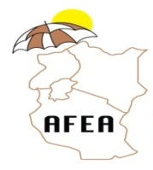 | Wambui Kairi  Managing Trustee  Email: info@afea.or.ke  Phone: +254-722 79 19 18  +254-734 51 86 52
ALBINISM SOCIETY OF KENYA  NGO |  | Isaac Maigua Mwaura  Mai Mahiu Rd, Off Langata Rd  P.O.Box 46656 00100  Tel: 0721864949, 0772122829
KENYA NATIONAL COMMISSION ON HUMAN RIGHTS  NHRI |  | Shatikha S. Chivusia  Commissioner, and  Miriam Nthenge  Email : schivusia@knchr.org  Web: http://www.knchr.org  Tel: +254-020-2717908/00/28
UNDER THE SAME SUN  NGO | 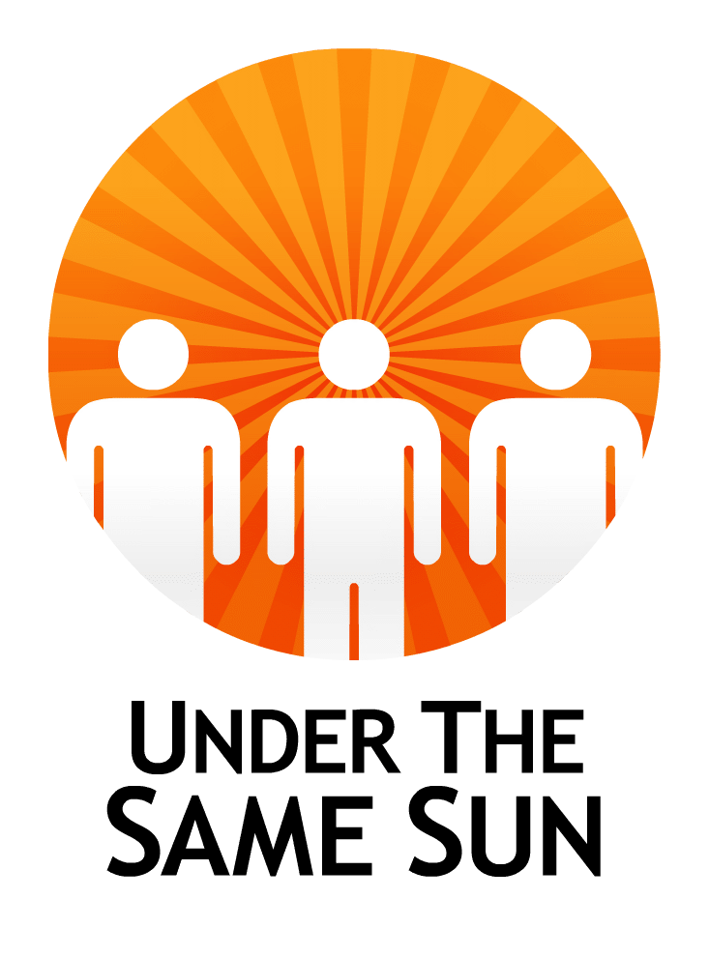 | Vicky Ntetema  Executive Director &/or  Peter Ash  Founder/CEO  Email:info@underthesamesun.com  Web: www.underthesamesun.com  Tel: +1(604)336-8868

TABLE OF CONTENTS
- Introduction
- Methodology
- Albinism
- Albinism in Kenya
- Government Response
- Economic Social and Cultural Rights
- Life, Security of Person, Torture and other Cruel Inhuman and Degrading Treatment
- Impunity
- Recommendations
……………………………………………

- Introduction

- Persons with albinism (PWA) in Kenya suffer terribly from pervasive myths and misconceptions about their condition. This negative public perception relegates most of them into isolation that locks them in a vicious cycle of poverty.

- While Kenya has taken steps to improve the lives of PWA including the ongoing attempt to expressly capture albinism into its laws on disability, an affirmative action program in the public service and an attempt has been made to create a sunscreen distribution program, it remains to be seen whether these steps will be followed-through and concretized so that benefits are clearly seen in the lives of PWA.

- Persons with albinism in the country continue to suffer from stigma and discrimination particularly in the education system where they are often mocked for their appearance and their low vision remains un-accommodated. The result causes a high dropout rate amongst PWA. This in turn leaves most of them un-skilled and un-equipped for jobs and relegates them to menial jobs, including jobs that expose them to the sun and subsequently to skin cancer which is the primary killer of persons with albinism in the region of Sub Saharan Africa.

- On the extreme end of stigma and discrimination against PWA are physical attacks and subsequent impunity leaving perpetrators undeterred.

- Methodology
- This report is written based on extensive research on the lives of PWA in Kenya. It is based on data gathered by UTSS and its agents on the ground. UTSS’ agents have visited PWA who have been victims of attacks to interview them and their families, document their account of what happened.

- This report is also based on written contributions from civil society groups based in Kenya including the Albinism Foundation of East Africa and Albinism Society of Kenya, both NGOs. Written contributions have also come from the Kenya National Commission on Human Rights, an active National Human Right Institute in Kenya. Some information have also come from Contributions from these bodies are classifiable as primary sources as well as extensive research using focus group discussions and work from experts in the field.

- Data from the media have rarely been relied on without additional confirmation from at least one contributor to this report.

- Limitations: Regarding records of attacks, information on attacks reported here was received directly from victims by UTSS in 2013. No comprehensive follow up on these cases have occurred since. This is because there is no unified legal monitoring of these cases whether by the State or civil society. Local civil society groups are often ill-equipped and underfunded and therefore unable to carry out these necessary tasks. Comprehensive and unified information on records of attacks post 2013 is therefore unavailable and meagre at best.

- Albinism

- Albinism is a rare, non-contagious, genetically inherited condition occurring in both genders regardless of ethnicity, in all countries of the world. Both the father and mother must carry the gene for it to be passed on even if they do not have albinism themselves.

- The condition results in a lack of pigmentation in the skin, hair and eyes, causing vulnerability to sun exposure and bright light. Almost all PWA are visually impaired, with the majority being classified as “legally blind.” Skin cancer is common amongst a majority of PWA living in the region of Sub Saharan Africa including Kenya.

D. Albinism in Kenya
- PWA in Kenya clearly stand out because nearly all others around them have a dark-pigmented skin tone. The result of this should not be underestimated because it means that PWA cannot hide even if they tried to and are therefore exposed to unusual attention and all the discrimination and stigma that comes with such attention everywhere they go.

- There are no exact data or statistics on the number of PWA in Kenya. However, given the available range of estimates in the Africa region, the number of PWA in Kenya could be anywhere from thousands to tens of thousands.

- There is a fundamental lack of understanding about albinism in Kenya. Myths are therefore the default school of knowledge and these myths are reinforced in the absence of adequate public awareness and education on the scientific and objective bases of the condition.

- PWA face high challenges in receiving services within the public and private sectors. Access to basics such as education, health services and employment remains very difficult.

- Government Response

- Taking the disability approach: There are ongoing efforts to amend the definition of disability in the current Persons with Disability Act (2003) to include persons with albinism. This is being done to oblige reasonable accommodation for persons with disabilities in key settings such as school and the workplace.

- Also, in 2011 the government of Kenya commissioned the National Council of Persons with Disability and employed at least one PWA. This Council registers PWA and has a fund allocated to them.

- Sunscreen Program: The government has launched a sunscreen program which aims to provide sunscreen to all PWA in Kenya. It is not clear how this is unfolding so far although some public hospitals are reported to have limited sunscreen available.

- Affirmative Action: The constitution of Kenya provides that at least 5% of members of elected and appointed bodies should be persons with disabilities. This has led to the appointment of a few high profile PWA including one Member of Parliament, Hon. Isaac Mwaura, one judge of the high court, Madam Justice Mumbi Ngugi and two county assembly representatives.

- Economic Social and Cultural Rights:
Education
- Families frequently neglect the education of children with albinism as they see their child with as a source of shame and believe their education is a waste of resources.

- Even when families take their child(ren) with albinism to school, they are sometimes turned away due to the myths and misconceptions held by the school. For example, the vision impairment of PWA has led to the assumption that they are all blind. This has frequently resulted in children with albinism being forced to enroll in special schools for the blind and forced to learn braille which in turn affects their employability.

- In mainstream schools, children with albinism tend to drop out due to the absence of reasonable accommodation. The effect being low education levels and the subsequent loss of the necessary social or economic tools to live productive lives.

- This is a fundamental issue that ought to be addressed, taking into account the correlation between education and acquisition of employment. Lack of proper education and skills has left many PWA living in abject poverty and having to depend on their relatives for sustenance.

Social Issues: Name-Calling, Bullying and Discrimination
- Persons with albinism in Kenya, both in schools and on the streets, often suffer from incessant teasing and bullying from classmates. Some of these names are used by teachers and other persons in authority causing grave demoralization and psychosocial issues in children and students as a whole.

- These names are often deeply derogatory and dehumanizing. These include names such as “dili” which means a monetary deal that can be earned from ritual killing of the PWA or ``Zeru Zeru``which refers to mystical or ghostlike beings. Another common term is ``mzungu`` which is a name typically used to refer to Caucasians. All of these names show a lack of understanding about albinism and in the former examples, a general perception of PWA as lesser beings.

- The effect of name-calling should not be under-estimated as it is pervasive across Kenya, even amongst figures of authority and agents of the state. As stated by a Kenyan woman with albinism:
“People just see you on the street [and say] ‘its that albino!’ instead of thinking ‘that is Jayne’…[because] they don’t see us like a person [sic] ; … I’ve been a victim of discrimination, I have been a victim of not getting resources, and , I’ve been a victim of ignorance …You are called money or walking bank notes.
- Even the rare PWA who has managed to beat the odds and become a contributing member of society has not been spared from publicly accepted derision. For example, Lady Justice Judge Mumbi Ngugi a woman with albinism recently appointed as Justice of the High Court was derided in public by a politician who attacked the fact that she had albinism.

- A member of parliament with albinism appointed relatively recently, Hon. Isaac Mwaura, was also mocked by a fellow member of parliament. The words of mockery were directed at Hon Mwaura’s wide-brimmed hat which PWA tend to use as a shield from the sun.

- These incidents directed against successful PWA shows a clear indication of low awareness about albinism in Kenya and the amount of public awareness work that remains to be done.

- In public settings, PWA must constantly endure the awkward gawks, stares and distances people form away from them. These public responses are linked to the myths and misconceptions about them including the erroneous myths that they are accursed and that they are contagious. Further, these public responses, amongst other social factors mentioned above, mean that PWA tend to prefer a private life rather than engaging with the public. A private life of self-seclusion guarantees less public abuse but often consigns PWA to isolation, a failure to integrate into their society and poverty.

Employment
- While the constitution of Kenya enshrines affirmative action by providing that at least 5% of elected and appointed bodies are persons with disabilities, this has not been realized. In most cases, PWA tend to be passed over for persons with other types of disabilities as most employers , government included, do not regard them as properly belonging to the category of persons with disabilities.

- Persons with albinism also suffer double discrimination in the field of employment as employers assume that their capacity to deliver within the workplace is below par. Sometimes they may also be subject to conditions that are hostile to their condition such as working directly under the hot sun or bright light which puts them at risk of skin cancer and /or further eye impairment.

Health
- The government has launched a free sunscreen program which aims to provide sunscreen to all PWA in Kenya. This is highly commendable because skin cancer is the number one killer of PWA in the Sub Saharan Africa region. Sunscreen distribution could reverse this trend. Yet, information about the program is sparse and whether the program has officially taken effect is unclear at this point.

- Life, Security of Person, Torture and other Cruel Inhuman and Degrading Treatment

- Twelve attacks have been documented against PWA in Kenya. Some of them qualify as torture given the extreme pain inflicted on the victim and the intent of the perpetrator. These attacks are discriminatory, witchcraft based beliefs that the body parts of a PWA can bring wealth and good luck when used in potions or amulets.

- Most attacks against PWA go unreported due to the `code of silence` and overall secretive nature of witchcraft.

- Further, attacks go unreported because the body parts of PWA are sold on a black market for thousands of dollars. Specifically, a limb can be sold for thousands of US dollars and a “complete set” of body parts goes for upwards of $75,000. In a country where the average annual income (using GDP per capita) is roughly $1,800 US dollars per year, the only people that can afford such prices are likely the rich elite who are also better placed to purchase the silence of perpetrators and police alike.

- These following cases of attacks in Kenya and are reported cases only. We believe that there are possibly more attacks that remain unreported.

Murdered Victims
- We have records of the following PWA murdered for their body parts in Kenya. Most of these cases were confirmed by UTSS. (Except where a case was widely reported in the media and has effectively become a matter of public record, the victim’s surname has been deleted to protect his or her identity):

  - ESTHER MORAA: On August 2, 2010, a 4 month old baby girl with albinism by the name of Esther Moraa was killed by her mother, Sara Kemunto Nyabuto, age 23, at Bokimweri sub location in Nyamache district, Kenya. The father was threatening divorce and had convinced her to kill the baby since she was born with albinism, hence a bad omen and a disgrace to the family. The mother has been sentenced to serve one year in jail in a Gucha court by Ogembo Resident Magistrate Richard Koech saying “the accused killed her child for being an albino.”

  - MARGARET K.: In January of 2008, Margaret was abducted by three men. Her body was found the following morning with her legs, genitals, breasts and hands removed.

  - JOYCE M.: On Sunday, March 4th, 2012 Joyce`s mother, Mrs. Mzungu took her daughter Joyce with her to church for the evening prayers. After prayers Mrs. Muzungu couldn’t find Joyce. She approached the pastor to enquire on the whereabouts of Joyce since he had ordered all children to be taken out of the church. The pastor responded by telling her to be patient and wait for Joyce by the rock outside the church and keep praying. The evening became darker Joyce`s mother couldn’t wait any longer, she went to the neighborhood looking for Joyce but there was no success. The next day, Monday, the Pastor called Mrs. Mzungu stating he has Joyce and they should meet on Thursday afternoon. That Thursday afternoon all the villagers gathered at the church. Instead of the Pastor coming he sent his assistant, which provoked the villagers to beat him. The Pastor sought police protection which triggered the villagers to burn down the church. Up to today Joyce has never been found. The pastor relocated to another place.

Survivors of Attacks & Attempts of Attack

- We have records of the following persons with albinism attacked with the aim of using their body parts. They survived the attack:

  - UNKNOWN: On March 15, 2013, a 7 year old boy with albinism in Embu, Kenya managed to escape relatives who tried to sell him for ritual purposes. He was kidnapped by his uncle together with other relatives who attempted to take off to an unknown destination where they were to meet the buyers. The boy said that the kidnappers threw him out of the window of a moving vehicle when he screamed for help and was rescued.

  - UNKNOWN: On August 16, 2011 a near death experience occurred for a girl with albinism when her father was caught in the act and charged with human trafficking. The arrest revealed that he was in the process of selling his daughter to a Tanzanian buyer for an undisclosed amount of money. This case was still before the courts on the date of the newspaper report.

  - ROBINSON MUKWHANA: Robinson used to work as a night guard at a shop in Kitale town and his best friend Nathan Mutai had promised to look for a better paying job for him in Nairobi. On 12th August 2010 Nathan tricked Robinson that he found a job for him in Tanzania and that they had to go there together. Robinson complied. Once in Tanzania, Nathan tried to sell Robinson in secret by negotiating with willing buyers. Unbeknown to him, the willing buyers were police undercover. Nathan was arrested and charged. His trial occurred after which he was sentenced to serve in Jail. Robinson was taken back to Kenya a free man but psychologically disturbed.

  - BETTYLYN A.: In the year 2008 “Betty” was two years old and used to love playing with umbrellas. One day in a market a stranger enticed her with an umbrella and due to her love of umbrellas she followed the stranger. Before she could leave the market with the stranger, a neighbor who knew her took Betty back to her mother. This incident caused her mother to take Betty to school earlier than the recommended age for her safety.

In 2011 while Betty was leaving home to school with other children, they noticed some men trailing them. The kids reported the incident to the school management. When her mother heard of the occurrence she decided to move to secretly to another place to find privacy and safety for her daughter.

In a third incident in In September of 2012 Betty was playing with other kids when a car with tinted windows parked outside their residence. They started sending passing-by kids to call for them the “Mzungu” (a reference to Betty being a PWA). One of the kids who was sent immediately reported to Betty’s Mom. When the occupants of the car saw Betty’s Mom approaching, the car sped off before she could check the number plate. She moved to another residential area and enrolled Betty for boarding school.

  - HENNERINAH BEATRICE: Beatrice runs a small business by the roadside near her home. One evening in March 2012 while walking home from her business with a friend, they noticed a car stopped abruptly in front of them and started reversing in their direction. Beatrice ran into a nearby cassava plantation and two men jumped out of the vehicle and ran after her. They didn’t bother with Beatrice’s friend and when she realized they were in pursuit of Beatrice she ran towards her home and informed neighbors. The neighbors were able to chase off the men in the car.

- Impunity

- Very little information is available as to the legal status of the above cases. The monitoring of court proceedings concerning these crimes by civil society actors is very rare, and associations of PWA often lack the financial means and expertise to conduct legal monitoring activities.

- Aside from the widely published case of Robinson Mukhwana in 2010 very little is known on the legal proceedings that should have occurred in every reported attack and murder.

- The impact of Impunity is twofold. First, it creates no deterrence for possible perpetrators. Second, it increases insecurity and fear amongst PWA. Without prosecution, PWA are unable to live without fear, including fear of entering proper relationships which they need to build an adequate social ring of protection and support.

- Recommendations

- Economic, Social and Cultural Rights

- Awareness-Raising: Government should intensify awareness-raising campaigns to educate the public on albinism as a way of curbing prejudice, stigma, discrimination and attacks
- Education: Teachers and social welfare workers need to be trained on dealing with children with albinism in the classroom, and support NGOs that provide such training services
- Employment: The constitutionally-protected affirmative action to hire persons with disabilities which has now been extended to include PWA needs to be enforced.
- Healthcare: Government, particularly the Ministry of Health, should ensure and facilitate programs to enhance health for PWA and prevent early death due to skin cancer. These include :
    - ensuring that the announced sunscreen program is effective;
    - supporting initiatives for producing sun protection cream locally;
    - permitting free skin cancer treatments at all hospitals across the country;
    - providing free or low cost visual aids so that PWA can be accommodated in their classrooms.

- Life, Security of Person, Torture and Other Cruel Inhuman and Degrading Treatment

- Adopt positive and specific measures to protect and preserve the rights to life, to security of person and the right not to be subject to torture or ill-treatment;

- Impunity

- Increase efforts to put an end to the various forms of crimes affecting PWA, strengthen the legal response to such crimes and bring perpetrators to justice through prompt and impartial investigations; and
- Guarantee victims’ right to justice and redress, and provide medical, psychosocial and legal support to victims of attacks.

Article 54(2).
The most helpful data in terms of qualitative & quantitative measures came from Hannah M. Njenga, Publics Perceptions of Albinism And Their Impact On Persons With The Condition: A Case Study Of Nairobi City (January 2011) as cited in AFEA, Rapid Study on The Extent of Marginalisation of Women with and Affected by Albinism in Kenya. (in partnership with the Ford Foundation, Kenya). [Henceforth “Njenga Study, 2011]
Persons with Albinism, UN Preliminary Report of the United Nations High Commissioner for Human Rights, 12 September 2013 [“UN Report”], at paragraph 68.
Njenga Study, 2011, note Error: Reference source not found above, at.p.14.
See note Error: Reference source not found below.
See On Beauty Webisode: Jayne Waithera, YouTube, accessed May 28, 2014, http://www.youtube.com/watch?v=aFfU8czbUoE
Article 54(2).
Njenga Study, 2011, note Error: Reference source not found above, at p.11.
Definition taken from article 1 of the Convention Against Torture and the assistive document for interpretation: Interpretation of Torture in the Light of the Practice and Jurisprudence of International Bodies, OHCHR, at p.3 http://www.ohchr.org/Documents/Issues/Torture/UNVFVT/Interpretation_torture_2011_EN.pdf, Accessed May 21, 2014.
“Code of silence” is from Simon Fellows, “Trafficking Body Parts in Mozambique and South Africa (2008),” Human Rights League, Mozambique, http://www.scribd.com/doc/23729111/Trafficking-Body-Parts-in-Mozambique-and-South-Africa-Mozambique-Human-Rights-League , accessed August 3, 2010.
International Federation of Red Cross and Red Crescent Societies, Through Albino Eyes (Advocacy Report), IFRC, accessed May 27, 2014, http://www.ifrc.org/Global/Publications/general/177800-Albinos-Report-EN.pdf
Facts on GDP is from CIA World FactBook, accessed April 7, 2014, https://www.cia.gov/library/publications/the-world-factbook/geos/tz.html. On the strong likelihood of the involvement of the rich in the economy of attacks against persons with albinism, see orbiter dicta comments in Masumbuko et al v. Tanzania (United Republic of), Criminal Appeal No. 318, 319 & 320 of 2009 (23rd September, 2009) per Ramadhani C.J., at p.23 (second to last paragraph).
Also see "Woman kills albino child to avoid bad omen," Standard Digital, August 25, 2010, accessed June 26, 2013, http://www.standardmedia.co.ke/?articleID=2000016790&pageNo=1)
Agent of Under The Same Sun in Kenya who visited and interviewed survivors of the victim (July, 2013).
Agent of Under The Same Sun in Kenya who visited and interviewed survivors of the victim (July, 2013).
See, "7 Year Old Escapes Deathly Ritual," Citizen News, March 15, 2013, accessed June 26, 2013, http://www.citizennews.co.ke/news/2012/local/item/8667-7-year-old-escapes-deathly-ritual).
See, "Child Traffickers on the Prowl," The Standard, August 17, 2011, accessed June 26, 2013, https://www.standardmedia.co.ke/?articleID=2000040932&story_title=child-traffickers-on-the-prowl&pageNo=1
Source: UTSS Agent, Kenya, July 2013. See also: "Kenyan arrested by Tanzania police over 'albino sale'," BBC News, August 17, 2010, accessed June 26, 2013, http://www.bbc.co.uk/news/world-africa-11001791).
UTSS Agent, Kenya, July 2013.
UTSS Agent, Kenya, July 2013.

