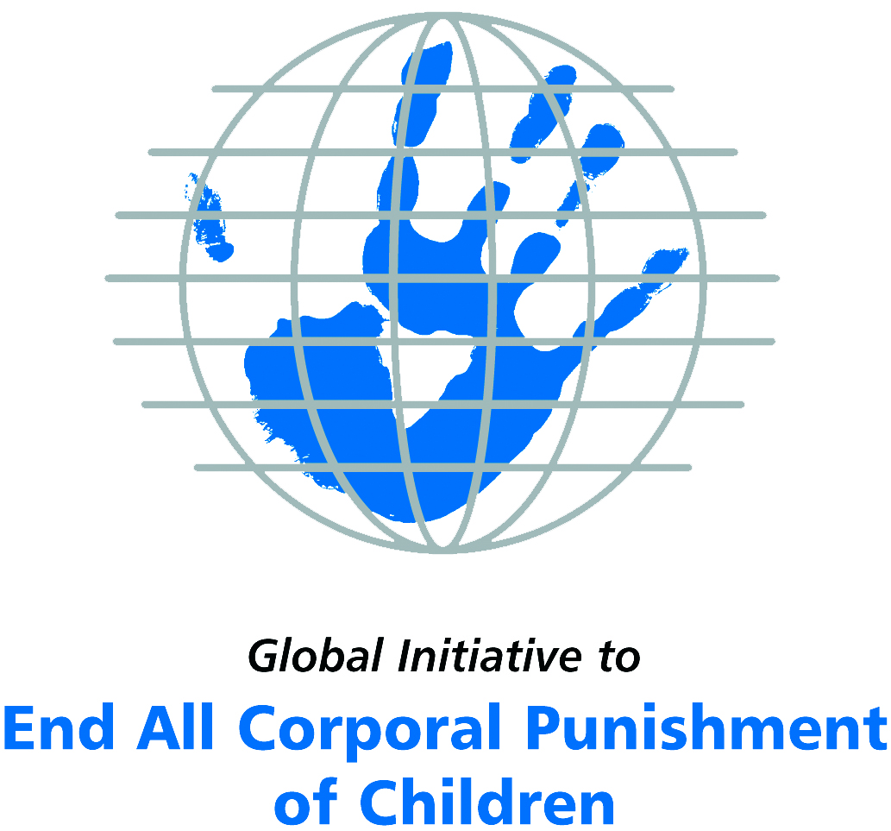
Briefing on Ethiopia for the Committee on the Rights of Persons with Disabilities, Pre-Sessional Working Group 5th session, March 2016
From Elinor Milne, Global Initiative to End All Corporal Punishment
of Children, elinor@endcorporalpunishment.org

(a) About the Global Initiative to End All Corporal Punishment of Children
1. The Global Initiative (www.endcorporalpunishment.org) promotes universal prohibition and elimination of corporal punishment in fulfilment of states’ obligations under the UN Convention on the Rights of the Child and other international treaties. Our aims are supported by UNICEF, UNESCO, human rights institutions and international and national NGOs. Since 2002, the Global Initiative has regularly briefed the Committee on the Rights of the Child on this issue, and since 2004 has similarly briefed the Committee Against Torture, the Committee on the Elimination of Discrimination Against Women, the Committee on Economic, Social and Cultural Rights, the Human Rights Committee and the Human Rights Council; we have briefed the Committee on the Rights of Persons with Disabilities since the beginning of its work.

(b) Summary
2. Corporal punishment of children is unlawful in schools and in the penal system in Ethiopia; it is prohibited in some but not all alternative care settings and day care; it is lawful in the home. This means that children with disabilities may lawfully be hit and hurt by parents/carers in the guise of “discipline”. Numerous research studies have documented widespread use of corporal punishment, including against children with disabilities.
3. With reference to articles 7, 15, 16 and 17 of the Convention on the Rights of Persons with Disabilities, and in light of the particular vulnerability of children with disabilities to corporal punishment by adults, the jurisprudence of the UN treaty bodies, the emphasis on eradicating this form of violence given by the UN Secretary General’s Study on Violence against Children and the importance of the issue to achieving target 16.2 on ending violence against children in the 2030 Sustainable Development Goals, we hope the Committee on the Rights of Persons with Disabilities will:
- include the issue of corporal punishment in its List of Issues for Ethiopia, in particular asking what steps have been taken to ensure that national legislation in Ethiopia fully protects children with disabilities from all violent punishment and that corporal punishment is explicitly prohibited in all settings, and what progress has been made towards explicitly repealing the right to ‘discipline’ in the Criminal and Family Codes;
- recommend to the Government of Ethiopia, in the Committee’s concluding observations on the initial report, that legislation is drafted and enacted to explicitly prohibit corporal punishment of all children in all settings, that the right to ‘discipline’ is explicitly repealed from the Criminal and Family Codes and that measures are put in place to ensure the law is properly implemented and that children with disabilities are not subjected to violent punishment.

(c) Detailed briefing
The right of children with disabilities not to be subjected to corporal punishment
4. The Convention on the Rights of Persons with Disabilities confirms that children with disabilities should enjoy all human rights and fundamental freedoms on an equal basis with other children (art. 7). The Convention also states that all persons have the rights to freedom from torture or cruel, inhuman or degrading treatment or punishment (art. 15), to freedom from exploitation, violence and abuse within and outside the home (art. 16) and to respect for their physical and mental integrity (art. 17). The jurisprudence of treaty monitoring bodies, led by the Committee on the Rights of the Child monitoring the Convention on the Rights of the Child, is clear that these rights put an obligation on states parties to prohibit and eliminate all corporal punishment of children, including within the family.
5. As confirmed in the UN Secretary General’s Study on Violence against Children, children with disabilities are particularly vulnerable to violence, including corporal punishment, and corporal punishment is a significant cause of impairment among children. Yet the obligation to prohibit corporal punishment is frequently ignored or evaded by governments. The near universal acceptance of violence in childrearing together with deeply held views that parents and other adults have a “right” to physically punish children can challenge efforts to achieve prohibition. It also means that corporal punishment – at least to some degree – is not readily perceived as violence in the same way as, for example, sexual and other socially unacceptable forms of violence.
6. The newly adopted Sustainable Development Goals under the 2030 Agenda include target 16.2 on ending all forms of violence against children. Violent punishment is the most common form of violence against children: ending it through the adoption and implementation of legislation prohibiting it in all settings including the home is critical.

The legality of corporal punishment of children with disabilities in Ethiopia
7. Corporal punishment of children is unlawful in schools and the penal system in Ethiopia; it is prohibited in some but not all alternative care settings and day care; it is lawful in the home. This means that children with disabilities may lawfully be hit and hurt by parents/carers in the guise of “discipline”.
8. Corporal punishment is lawful in the home. Article 576 of the Revised Criminal Code 2005 punishes maltreatment of children but states in paragraph 3: “The taking, by parents or other persons having similar responsibilities, of a disciplinary measure that does not contravene the law, for the purposes of proper upbringing, is not subject to this provision.” Provisions in the Civil Code 1960 allowing for “light bodily punishment” as an educative measure within the family were repealed but the Revised Family Code 2000 states that “the guardian may take the necessary disciplinary measures for the purpose of ensuring the upbringing of the minor” (art. 258). Provisions against violence and abuse in the Constitution 1995, the Criminal Code 2005 and the Revised Family Code 2000 are not interpreted as prohibiting corporal punishment in childrearing.
9. The Government reported to the Committee on the Rights of the Child in 2012 that the provision allowing parental discipline in the Revised Criminal Code is a “positive improvement” on the previous authorisation of “reasonable chastisement” in the Penal Code 1957 and that “federal and regional education institutions and justice bodies are working towards the abolishment of corporal punishment both in homes and schools”. But there was no indication of law reform to prohibit all corporal punishment in childrearing.
10. Corporal punishment is unlawful in some, but not all, alternative care settings. Corporal punishment is prohibited in child care institutions in article 36 of the Constitution 1995: “(1) Every child has the right … (e) to be free of corporal punishment or cruel and inhumane treatment in schools and other institutions responsible for the care of children.” We have yet to confirm that this applies to private as well as state provided care. There is no prohibition in relation to non-institutional childcare, where the provisions in the Revised Criminal Code 2005 (art. 576) and the Revised Family Code 2000 (art. 25) allowing for disciplinary measures by persons with parental authority are applicable.
11. Corporal punishment is unlawful in some, but not all, forms of day care. Corporal punishment is prohibited in institutions by article 36 of the Constitution 1995: we have yet to confirm that this applies to private- as well as state-run institutions. There is no prohibition in relation to non-institutional forms of day care, where the provisions in the Revised Criminal Code 2005 (art. 576) and the Revised Family Code 2000 (art. 25) allowing for disciplinary measures by persons with parental authority are applicable.
12. Corporal punishment is unlawful in schools. Corporal punishment is explicitly prohibited in schools in article 36 of the Constitution 1995.
13. Corporal punishment is unlawful as a disciplinary measure in penal institutions under the Constitutional prohibition of corporal punishment in institutions (art. 36).
14. Corporal punishment is unlawful as a sentence for crime. There is no provision for judicial corporal punishment in criminal law.

The prevalence of corporal punishment of children with disabilities in Ethiopia
15. In 2010, research was undertaken on the experiences of children with disabilities of violence against them. A report by The African Child Policy Forum on violence against children with disabilities in Cameroon, Ethiopia, Senegal, Uganda and Zambia documented a very high level of violence. Nearly a thousand 18-24 year olds took part in the study across the five countries, reporting on their experiences as children. In Ethiopia, 68% had experienced at least one type of physical violence during their childhood. Over 50% had been hit, punched, kicked or beaten; over 25% had been denied food. The most common perpetrators of physical violence were mothers (12.5%), fathers (12.1%) and other relatives (15%); much of the violence was inflicted in the guise of “discipline” and much of it resulted in physical injury. The report recommends prohibition of all corporal punishment, including in the home, as a way to minimise the risk of violence against children with disabilities.

Recommendations by human rights treaty monitoring bodies and during the UPR
16. The Committee on the Rights of the Child first expressed concern at corporal punishment in the home and other settings in Ethiopia in 1997, when it recommended that it be abolished. The Committee has subsequently and repeatedly expressed similar concerns and made recommendations that corporal punishment be prohibited in all settings. Ethiopia has now received these recommendations from the Committee four times – in 1997, 2001, 2006 and 2015 – but has still not prohibited all corporal punishment of children.
17. In 2011, the Committee Against Torture recommended that the Criminal Code and the Family Code in Ethiopia be amended so as to prohibit corporal punishment of children in the home.
18. In 2012, the Committee on Economic, Social and Cultural Rights urged the Government of Ethiopia to revise its Criminal and Family Codes to prohibit corporal punishment of children in the home and in alternative care settings.
19. In 2014, the African Committee of Experts on the Rights and Welfare of the Child expressed concern at corporal punishment of children in Ethiopia and recommended it be prohibited, including in the home.
20. At the Universal Periodic Review of Ethiopia in 2014, the Government confusingly accepted a recommendation to “abolish corporal punishment of children” but rejected a recommendation to “criminalise all forms of corporal punishment against children”.

(d) Proposals for the List of Issues and final recommendations
21. In light of the above information, we hope the Committee on the Rights of Persons with Disabilities will raise the issue of corporal punishment of children with disabilities in its List of Issues for Ethiopia and in the concluding observations on the state party’s initial report. We respectfully suggest the following texts:
- For the List of Issues: “What steps have been taken to ensure that national legislation in Ethiopia fully protects children with disabilities from all violent punishment and that corporal punishment is explicitly prohibited in all settings? What progress has been made towards explicitly repealing the right to ‘discipline’ in the Criminal and Family Codes?”
- For the Concluding Observations: “It is recommended that legislation is drafted and enacted to explicitly prohibit corporal punishment of all children in all settings, that the right to ‘discipline’ is explicitly repealed from the Criminal and Family Codes and that measures are put in place to ensure the law is properly implemented and that children with disabilities are not subjected to violent punishment.”

Briefing prepared by the Global Initiative to End All Corporal Punishment of Children
www.endcorporalpunishment.org; info@endcorporalpunishment.org
March 2016

Pinheiro, P. S. (2006), World Report on Violence against Children, Geneva: United Nations. See also Krug E. G. et al (eds) (2002), World Report on Violence and Health, Geneva: World Health Organisation
23 December 2013, CRC/C/ETH/4-5, Fourth/fifth state party report, paras. 98 and 100
The African Child Policy Forum (2010), Violence Against Children With Disabilities in Africa: Field Studies from Cameroon, Ethiopia, Senegal, Uganda and Zambia, Addis Ababa: The African Child Policy Forum
24 January 1997, CRC/C/15/Add.67, Concluding observations on initial report, paras. 13 and 27; 21 February 2001, CRC/C/15/Add.144, Concluding observations on second report, paras. 6, 38 and 39; 1 November 2006, CRC/C/ETH/CO/3, Concluding observations on third report, paras. 33 and 34; 3 June 2015, CRC/C/ETH/CO/4-5 Advance Unedited Version, Concluding observations on fourth/fifth report, paras. 41 and 42
20 January 2011, CAT/C/ETH/CO/1, Concluding observations on initial report, para. 28
31 May 2012, E/C.12/ETH/CO/1-3, Concluding observations on initial-third report, para. 18
[December 2014], Concluding observations on initial report, para. 23
8 May 2014, A/HRC/WG.6/19/L.12 Advance Unedited Version, Draft report of the working group, paras. 155(85) and 157(4); 7 July 2014, A/HRC/27/14, Report of the working group, para. 155; 17 September 2014, A/HRC/27/14/Add.1, Report of the working group: Addendum

