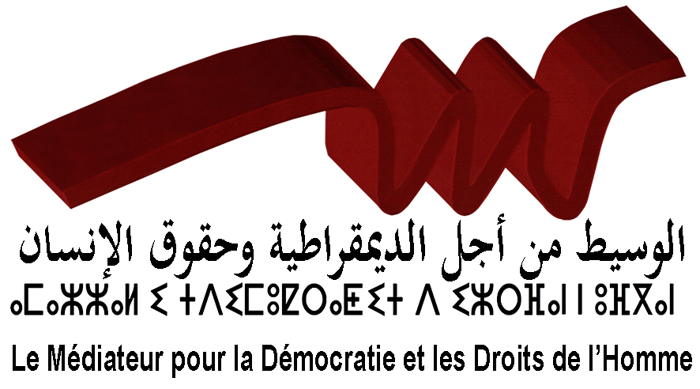

Parallel report to the sixth periodic report
of the Moroccan government regarding
the implementation of International Covenant on Civil and Political Rights
(ICCPR)

Prepared by:
"The Mediator for democracy and human rights" (MDDH)
MDDH is an independent, nonprofit organization,
founded in December 2007. It works on the evaluation of public policies,
the promotion and protection of human rights"

Rabat/Morocco in December 18th, 2015

- The General Context:
Throughout the period between the submission of the fifth report to the Human Rights Committee about the implementation of the provisions of the International Covenant on Civil and Political Rights in 2004 and the submission of the sixth report in 2015, Morocco has witnessed a series of developments:
- 2005-2011: the transitional justice process and the implementation of the recommendations of the Equity and Reconciliation Commission related institutional reforms, and the promotion of human rights through national policies and plans. This new trajectory has had a positive impact on the situation of human rights and the political atmosphere in Morocco.
- 2011-2016: the proactive and positive interaction of Morocco with the mass rallies for change in the region which raised demands for deep reforms. As an official answer to the mass uprising, which lasted one year raising political and social demands, Morocco has launched a reform-oriented process:
- March 09th, 2011: The Speech of the King of Morocco on the nature and the scope of the reforms to be initiated in Morocco as an interaction with the developments in the national and regional contexts;
- March 11th, 2011: The appointment of an advisory committee to review the constitution;
- July 01st, 2011: The organization of a referendum to vote on the draft constitution. 98% of those who voted supported the measure, with the participation of up to 72% of the electorate;
- November 25th, 2011: The organization of snap legislative elections, and the polls give victory to the Justice and Development Party, an Islamic party, for the first time in Morocco;
- January 03rd, 2012: the government forming of a coalition of four parties in its first version.
With reference to the concluding observations adopted by the Human Rights Committee on the fifth report of Morocco in 2004, regarding the extent of fulfilling of its obligations under the International Covenant on Civil and Political Rights, and on the basis of Morocco’s sixth report submitted on 15th, June 2015 to the same committee, the Mediator for Democracy and Human Rights introduces its observations about the progress made at this level, as well as the key challenges to the realization of some articles of the Covenant.

- Legislation and Conventional Practices:
- At the government level:
- If the 1992 Moroccan Constitution has for the first time, though hesitantly, provided for the protection of human rights, various actors acknowledge today that the Constitution of 2011 is considered a constitution of rights and freedoms, and its protection is contained in its preamble, and reiterated in the majority of its Articles. This constitution has also been decisive in relation to the hierarchy relationship between international law and national laws, as it recognized the supremacy of international conventions.
- Because the effective implementation of the constitution is possible only through the crafting and issuance of several constitutionalized legislative texts, the government has developed a legislative plan that aims to issue all laws during this government mandate (2011- 2016). But due to the absence of a participatory approach, nearly two years of the government mandate were spent to activate legislation, which has resulted in a significant slowdown in the process.
- Parallel debates were organized for the crafting of some laws, as is the case for the draft law of the Advisory Council for Youth and Associative Work, and the dialogue on civil society and its new constitutional roles, together with the laws on the reform of the justice system and the Press and Publication Law. However, civil organizations express their dissatisfaction from time to time for the government reluctance to adopt a participatory approach in the preparation of other laws, as is the case for laws of the Authority for Parity and Fight against All Forms of Discrimination, petitions and motions, laws activating the formalization of the Amazigh language, and the law of the National Authority for Integrity, Prevention and Fight against Corruption.
- The government mandate (2011-2016) has also known the ratification of many other laws related to civil and political rights, namely:
- The Optional Protocol to the Convention on the Elimination of All Forms of Discrimination against Women.
- The Optional Protocol to the International Covenant on Civil and Political Rights.
- The International Convention for the Protection of All Persons from Enforced Disappearances.
- The Optional Protocol to the Convention against Torture and Other Cruel, Inhuman or Degrading Treatment or Punishment.

- At the parliament level:
- The Moroccan parliament consists of two chambers. The first is the House of Representatives which comprises 395 members. During this legislative mandate 90 members were elected through national lists, including 60 seats reserved for women (15.18%) and 30 for youth (7.59%) as a positive discrimination in regional and national contexts that support a wider political participation of young people and women in 2011. Only 14 women who could find their way to the House of Councilors, the second chamber which consists of 120 members representing the territorial communities, employees and entrepreneurs, and this is due to the lack of measures to increase the representativity of women in this Council.
- Important debates were initiated in the parliament during the issuance of some laws like the Code of Military Justice, the organic law on the territorial communities and the organic law on political parties, with regard to the positive discriminatory measures contained in these laws for women, and the positive requirements relevant to internal democracy, the participatory approach and political participation.
The Mediator at this level notes the following:
- Notwithstanding the extension of the mandate of the parliament in the area of legislation, and although the new constitution calls on the government to devote at least one day every month to study the legislative proposals, including those submitted by the opposition as provided for in Article 82, only 12 laws proposed were approved so far, while 252 bills introduced by the government were approved during the ninth legislative mandate of the parliament (2011-2016), leading to the dominance of the executive power over the legislative initiative, while the legislature (parliament) is practically downgraded to secondary roles in legislation.
- The parliament’s role in legislation (the introduction of law proposals) seems unprolific during the current legislative mandate, which is coming to its end. The parliamentary groups have submitted to the various parliamentary committees 210 law proposals in the House of Representatives and 15 law proposals in the House of Councilors, but the bulk of these legislative texts is still on hold, noting that some of these law proposals relate to civil and political rights, such as the proposed law of the abolition of the death penalty, and the proposed law against racial discrimination and the fight against hate speech, and the proposed law for the freedom of association.

- At the level of public policies:
- The inception of the Inter-ministerial Delegation for Human Rights was in April 2011, pursuant to one of the recommendations of the Equity and Reconciliation Commission, in order to consolidate the national protection system in the field of human rights, especially after the constitutional recognition of rights and freedoms in 2011. The delegation made debut for the adoption of a governmental mechanism that oversees the coordination between the various sectors during the transversal preparation of public policies and national programs and plans, specifically during the preparation of the finance law and sectoral budgets especially in the media, education, culture and employment areas, in order to ensure the implementation of the constitutional provisions related to freedom and right to life, respect for diversity and the organization of plurality and the protection of personal life, and the realization of the principle of equality and non-discrimination at all levels.
The delegation’s missions are:
- The preparation and implementation of government policy in the field of protection and promotion of human rights and international humanitarian law, and the coordination with government departments and bodies concerned.
- The proposition of measures aimed at ensuring that the international humanitarian law and the international human rights treaties, in which Morocco is a State party, enter into force.
- The integration of the human rights approach in public policy areas through initiatives that take into account the powers entrusted to the various sectors and bodies concerned.
It is worth noting however that the government seems to deal with the Inter-ministerial Delegation for Human Rights as a sector with complementary tasks and not as a sector with a transversely strategic role in coordination and building harmony during the preparation and realization of the various public policies in relation to human rights standards.
- The government seems unable to fulfill the pledges announced in the government program on the revision of curricula, programs and textbooks to be in harmony with the principles and values ​​of human rights contained in the Constitution. Despite the efforts of previous governments over ten years, and despite the reviews conducted in 2003 and 2004 to initiate the human rights culture in textbooks, Morocco’s reluctance to recognize the supremacy of international human rights conventions over domestic laws has influenced the country’s general choices and orientations pertaining to the document framework adopted for the review of educational curricula and staff training programs together with the relevant books of specifications. This has led into the generation of some hierarchical rather than complementary categorization of values​. The textbooks introduce a three-category classification of values (religious values, national values ​​and human values), and this makes it difficult for the student to sort out values as outlined in textbooks, especially when it comes to values which are foundational for the human rights culture like freedom, dignity, equality and tolerance. Human rights values are in this sense subject to interpretation, which deepens the confusion with regard to the religious understanding of particularity and to the political context.
This finds proof in books of specifications adopted for subjects like the Arabic language, Islamic Education, Arts Education, History and Geography, and the French language, from 3 to 6 levels in the primary school.
The investment in the training of teachers remains limited in the government's policy, since more attention is given to the organization of activities in the field of human rights, instead of refashioning the continuous training programs and the trainings for teachers.
- Concerning the Implementation of Some Articles of the covenant:
Based on the concluding observations of the Human Rights Committee on the fifth report of Morocco for the year 2004, and on the contents of the sixth report submitted to the same committee on June 15, 2015, the Mediator for Democracy and Human Rights deems it necessary to introduce the following observations related to articles 1, 4, 6, 19, 21 and 22 of the International Covenant on Civil and Political Rights;
Article 1: The right of self-determination
- The report of the Moroccan State brings into limelight the achievements made in legislation as well as the national policies and plans effectuated for the realization of the rights and freedoms, and the launch of regionalization process as a step forward to activate the autonomy proposal presented by Morocco in the United Nations on April 11, 2007, being credible, serious and realistic as contained in the Security Council resolution 1754.
- In the observation number (8) of the concluding observations, the Committee has also expressed its concern over the lack of progress in the application of the right of the people of Western Sahara to self-determination in accordance with the requirements of article 1 of the Covenant.
- At this level, it is worth noting that the challenges posed in the face of the realization of the principle of self-determination for the Western Sahara region are not related to the existence of the will or not, whether for the State of Morocco or for the Polisario organization, but to objective factors summarized in the following:
- The bone of contention between the parties to the conflict is over the lists of the eligible voters to participate in the referendum in Western Sahara, which have been confined to the lists adopted in the 1974 Spanish census. These lists do not include the population that moved to Mauritania and southern Morocco, and was not covered by the census in 1974, nor do they include some elements of leadership of the Polisario organization, which would lead to deny large numbers of Sahrawis their right to self-determination through participation in the referendum, only because they were not covered by the 1974 census;
  - In addition to dispute over the application of UN-brokered standards agreed upon between the parties to the conflict in Manhasset, trying to remedy the socio-demographic changes taking place in the region after the 1974 census.
  - We find, for example, a member of a family in support of secession, and Morocco objects to his/her registration in the updated lists of the electorate, and in contrast, the Polisario stands against the registration of members of the same family who support the Western Sahara being part of Morocco.
- There is a growing number of Sahrawis who of left the camps Tindouf to settle in Europe and Mauritania, or chose to return to the Western Sahara or settle in different regions of Morocco, and no longer see the Polisario leadership as its representative that lives up to their aspirations.
- The instrumentalization of human rights discourse in the debate over the Western Sahara issue, during the negotiations between the parties to the conflict in the United Nations and the Security Council, instead of striving for finding a political solution, which is in fact the raison d'être of the negotiations since the cease-fire resolution.
- The increasing demand among the population of the Western Sahara to participate in all polls and consultations organized by the Moroccan administration in the region. A high voter turnout in the elections has been recorded in the Western Sahara, between 60% and 70% compared to the national rate which reaches 52%, in addition to the local population’s great interest in raising their representativity in the national institutions and institutions of governance as in the case of the regional committees of the National Council for Human Rights, and the Office of the Ombudsman of the Kingdom of Morocco as well as the focal points of the Economic and Social Council and the regional branch of the General Union of Moroccan Enterprises.
- The increasing demand to provide security in a regional context subject to the threat of terrorism and radical Islamic movements, and threats posed by organized crime, drugs and human trafficking and the smuggling of arms. This unstable regional context renders implausible the demand for secession from Morocco, and gives sense to the right of self-determination with security, good governance in the management of local affairs and equitable distribution of wealth as priorities for autonomy, noting that comparative perspectives confirm that the referendum mechanism proves ineffective in finding solutions appropriate to the problems and challenges posed.

Article 4: public emergency
- As for Article 4 of the covenant, it has been noted that Morocco has overcome the ambiguity of legislation with regard to the derogation issue in the requirements of Article 35 of the 1996 Constitution, which did not define the exceptions in which Morocco derogates from its obligations under the Covenant. The Constitution of 2011 has made a step forward in Article 59, in which the kingdom undertakes to enhance the guarantees for the respect of fundamental rights and freedoms during emergency cases, pursuant to the provisions of Article 4 of the Covenant, not to ignore the fact that the Constitution provides for the supremacy of international conventions over national legislation and laws, which is a clear commitment of Morocco to respect the requirements of Article 4 of the Covenant.

Article 6: the right to life
- Although the 2011 Constitution explicitly provides for the supremacy of the principle of the right to life in Article 20, and in spite of Morocco’s ratification of the Protocol to the International Covenant on Civil and Political Rights, which stipulates the abolition of the death penalty whatever the circumstances, contexts and particularities, although Morocco has suspended the execution of this penalty since 1993 on 268 people sentenced to death, the position of Morocco is still unclear at this level, as it fluctuates between the suspension of the death penalty in practice since 1992, and abstention from voting on a moratorium on the death penalty during the public session No. 68 of the United Nations.
- There also exists a delay in the harmonization of the laws related to the right to life, as 300 legal texts need to be amended at this level.

Article 19: Freedom of opinion and expression
- Although Articles 25 and 28 of the Constitution provide for the protection of freedom of opinion and expression and freedom of the press, there is a slowdown in the issuance of the press and publication law as the government pledged in the legislative plan in 2012.
- With regard to the fight of the civil society and professionals in the field of journalism for the abolition of custodial penalties in the field of press and publication, we express our concern about the draft law presented today to the parliament, which has retained the custodial penalties, through the transfer of these penalties from the press and publication law to the criminal law.
- The lack of proportionality between fines and damage in the requirements related to the press and publication.
- There are 690 press-related complaints between 2003 and 2015, distributed as follows:
- 384 complaints directly lodged to head of the government;
- 262 complaints lodged to the General Prosecutor's Office;
- 44 charges automatically made by the General Prosecutor.
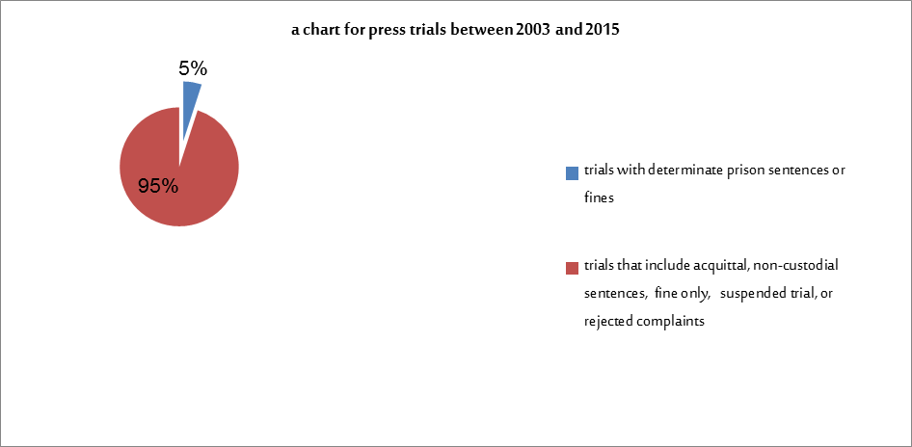
Article 21: The right of peaceful assembly
- With regard to Article 29 of the constitution, which guarantees the right to freedom of assembly and peaceful protest, the government did not yet harmonize the relevant laws (the 7600- law) with the constitutional provisions;
- Due to the growing protest social movements, being unstructured within political, civil or trade union organizations, it happens that two or more demonstrations are staged at the same time and the same place without prior permission as stipulated in law. The protests may continue sometimes for nearly a month in the same public space, which hinders or disrupts the public life (school transport, ambulances, shops and stalls...). These are new challenges posed by the realization of this right in relation to the State's responsibility for the management of public space and the protection of the rights of all citizens (the demonstrators and others), without the disproportionate use of force against the demonstrators.
- It has been noted that the authorities sometimes make unjustified decisions to ban demonstrations, and they don’t give written ban decisions to the organizers of demonstrations to enable them to exercise their right to appeal to the courts. The authorities do not follow the legal procedures set forth in the law, before proceeding to intervene through the use of force, with the necessity to give an ample warning through the loudspeakers prior to the intervention.
- The lack of implementation of jurisprudence with respect to freedom of assembly, especially peaceful sit-ins staged in a specific public place and for a specific time, which from the standpoint of the judiciary do not require any prior authorization.
- Lack of proactive dialogue and mediation mechanisms, to avoid violent confrontations and the disproportionate use of violence. The State should enhance the role of the civil bodies and organizations in mediation and the consciousness-raising among citizens.

Article 22: Freedom of association
- As stipulated in Article 12 of the Constitution, which guarantees the freedom of association, and with regard to the government pledges in its program to strengthen freedoms, on the basis of its commitment in the legislative plan to simplify administrative procedures for associations, under the 75-00 law, the Mediator highlights the following:
- The administrative authorities seek to turn the ‘declaration’ to form associations into an "authorization" for legal registration;
- The administrative authorities’ procrastination or non-compliance with the verdicts of the judiciary when they are in favor of the associations.

www.mediateurddh.org.ma www.mediateurddh.org.ma/voixdesjeunes www.facebook.com/jeunespourlademocratie www.facebook.com/mediateurpourddh
The last paragraph of the preamble of the constitution of 2011, p. 3.
The slowdown is determined by the realization and beginning of the implementation of the legislative plan relevant to the preparation and issuance of regulatory laws in the following data: - The legislative plan was presented to the government council over the year 2012, and approved only at the end of the year (22 November 2012), and be forwarded to the Parliament on February 21, 2013.
Article 36 of the Constitution and Law No. 113.12.
Bill No. 125.12
Bill No. 126.12
Bill No. 20.12
Bill No. 12-124
The Mediator notes that measures of positive discrimination towards women has made ​​it possible to double the reserved seats for women from 30 seats during the eighth legislative mandate (2007-2011), to 60 seat during this mandate (2011-2016), without counting the women winning seats within the local lists.
Its members were elected on October 2, 2015.
Issued by the Educational Guidance Committee, March 2001.
Can refer to the set of specifications relating to the formation and the production of the student textbook (Student Book and guide Professor / Ministry of National Education) September 2002.
See the relevant Supplement No. 1 within the Moroccan Organization for Human Rights report on the extent of the implementation of human rights values ​​in the school book, published in December 2004.
For example, you can refer to the reference in the field of human rights issued by the Ministry of Human Rights and the Ministry of National Education, which the Mediator tried to assess by sampling 1,000 teachers during their evaluation to the performance of parliamentarians to what relates to tutorial affairs, the conclusion was that this guide has not been circulated to the various components of the educational system, and private teachers, the same for the pedagogical booklets issued by the two ministries in 2001 and 2002.
According to a group of media sources the number of Sahrawis returned back to Western Sahara as registered in the data of the local authorities at Laayoune are around 8000 returners until 2008. See the following link: http://lavieeco.com/news/politique/comment-les-rallies-du-polisario-vivent-leur-retour-au-maroc-16319.html This number has increased to 13000 during the last years according to the data provided by the Advisory Council of Saharan Affairs. This growing number of returnees towards Western Sahara doesn’t include the informal returners and the hundreds of Sahrawis who settle in Mauritania or Europe mainly Spain.
Resolution No. 690 dated April 29, 1991.
Constitution of 2011 p. 24.
Constitution of 2011 p. 11
Held on December 20, 2014
See the Criminal Code.
Legislative plan, p. 15.
Source: Ministry of Justice
Article 19 of the Dahir No. 1.58.377 regarding public assembly of 1958 also modified and completed in accordance with the law 76-00 / Publication of Minister of Justice in connection with the mob in public ways on October 12, 2015.
Legislative plan, p. 15.

