
COAMEX ALTERNATE REPORT

Two years after the entry into force of the Convention on the Rights of Persons with Disabilities

Alternate report on the implementation of the rights to health, work and education of persons with disabilities in Mexico

Short Version

2008-2010

Presidentes de las Organizaciones que conforman la Coalición México por los Derechos de las Personas con Discapacidad (COAMEX):

APAC, I.A.P.
–Asociación Pro Personas con Parálisis Cerebral-

María Margara YarzaPrida
Leonor Ortiz Monasterio
Gabriela Molina Ortiz Monasterio

Confederación Mexicana de Organizaciones
a Favor de las Personas con Discapacidad Intelectual, A.C.

Javier Agustín QuijanoOrvañanos
Ernesto Velazco León
Juan Rodolfo Vidal Saldaña

Fundación Paso a Paso

Olga Montúfar Contreras

Libre Acceso A.C.

Federico Fleischmann Loredo

Equipo operativo de la COAMEX:

Dr. Enrique Garrido Ramírez
APAC, I.A.P. –Asociación Pro Personas con Parálisis Cerebral-

- Abigail Hernández Mejía

Patricia Ramírez Flores
Carolina Martínez Romo
Gabriela Martínez Olivares
Alin Valenzuela Cabrales
Confederación Mexicana de Organizaciones a Favor de las Personas con Discapacidad Intelectual, A.C.

Laura Bermejo Molina
Libre Acceso A.C.

Juan López Villanueva
Coalición México por los Derechos de las Personas con Discapacidad

Redacción.
Juan López Villanueva

Versión en Inglés.
Emmanuel Cárdenas

Versión en Náhuatl.
Epigmenio Galindo Cerón
Mario Licona Hueyotenco

Versión en Lectura Fácil
Paloma Quijano Castello
Patricia Ramírez Flores
Gabriela Martínez Olivares

Corrección de Estilo.
Carlos Juárez Hernández

COAMEX agradece a
Todas las Personas con Discapacidad y sus familias, que participaron e hicieron posible este proyecto.

Disability Rights Fund (DRF) por el financiamiento para la elaboración del presente informe y el apoyo técnico-administrativo recibido por parte de Catalina Devandas-Aguilar y Yolanda Muñoz González.

Los asesores:
Stefan Trömel
International Disability Alliance (IDA)

Jerry Mindes.
American Institute for Research (AIR)

Julian Quibell
Keyla González Hilario
Rocío Álvarez Montero
National Democratic Institute (NDI)

Edoardo Bazzaco
Diego Lorente
Asesores externos de NDI

Las personas con discapacidad que participaron en las entrevistas a profundidad:

- Avelino Castro
- Crisanta Roldán
- Cristina Hoffman
- Francisco Ávila, padre de Guadalupe Ávila, persona con discapacidad múltiple
- Gregoria Roldán
- Ildemaro Correa
- Jorge Santiago Jacinto,
- José Luis Martínez
- Marco Antonio Bautista
- Marco Antonio Castellanos
- Rafael Reyes

Todas las organizaciones y grupos amigos que participaron en este gran esfuerzo, a las organizaciones de la Red Nacional de la Confederación Mexicana de Organizaciones a Favor de las Personas con Discapacidad Intelectual, A.C. y los Centro Afiliados a APAC I.A.P. –Asociación Pro Personas con Parálisis Cerebral- a todos ustedes muchas gracias por su colaboración en la aplicación de la Encuesta Nacional que permitió la elaboración de este informe:

- Adelante Niño Down, A.C.
- Algo Especial en Discapacidad, A.C.
- Andares, A.B.P.
- APAC I.A.P. - Asociación Pro Personas con Parálisis Cerebral
- Apoyando a Angelitos con Autismo, A.C.
- Asociación Ciencias de la Conducta, A.C. Especialistas
- Asociación de Deportes sobre Silla de Ruedas de Yucatán, A.C.
- Asociación de Familias en Acción en Pro del Discapacitado Intelectual, A.C.
- Asociación de Padres “Esfuerzo Unido”, A.C.
- Asociación de Padres de Familia con Hijos Deficientes Mentales, A.C.
- Asociación de Padres de Familia de Hijos con Discapacidad Intelectual Benito Juárez, A.C.
- Asociación de Padres de Personas con Necesidades Especiales, A.C.
- Asociación Potosina en Pro del Deficiente Mental, A.C.
- Asociación Pro Deficiente Mental de Oaxaca, A.C.
- Asociación Pro Niños Excepcionales, A.C.
- Asociación Pro Parálisis Cerebral Colima, I.A.P.
- Asociación Pro Parálisis Cerebral Culiacán, I.A.P.
- Asociación Pro Parálisis Cerebral Fresnillo, A.C.
- Asociación Pro Parálisis Cerebral Querétaro, I.A.P.
- Asociación Pro Parálisis Cerebral Zacatecas, A.C.
- Asociación Tutelar, I.A.P.
- Asociación Yucateca de Padres de Familia Pro-Deficiente Mental, A.C.
- BestBuddies México, A.C.
- Calidad de Vida “Conóceme, A.C.”
- Capacitación, Industria y Artesanía –CINIA-
- Casa Hogar Vida Nueva, A.C.
- Centro Cultural Xalostoc
- Centro de Adiestramiento Personal y Social, A.C.
- Centro de Apoyo Psicopedagógico Aragón
- Centro de Asesoría Psicopedagógica, S.C.
- Centro de Atención al Autismo “Aura”, A.C.
- Centro de Atención al Niño y la Familia Pasos, A.C.
- Centro de Atención Especial “Nueva Luz, A.C.”
- Centro de Atención Integral “Lupita Hinojosa de Murat” Huajuapan de León.
- Centro de Atención Múltiple Jean Piaget, A.C.
- Centro de Atención Múltiple No 10 Atizapán
- Centro de Atención Múltiple No 73
- Centro de Atención Múltiple No. 1
- Centro de Atención Múltiple No. 5
- Centro de Capacitación Especial “Mundo Nuevo”, A.C.
- Centro de Capacitación para la Vida Independiente, A.C.
- Centro de Capacitación y Educación Especial “La Luz”, A.C.
- Centro de Educación Down, A.C.
- Centro de Educación Especial e Integración Social “Kandinsky”, S.C.
- Centro de Educación y Desarrollo Humano, Campus Tlalpan
- Centro de Educación y Rehabilitación Sembradores, A.C.
- Centro de Habilitación e Integración para Invidentes, I.A.P.
- Centro de Integración Psicológica y Aprendizaje, A.C.
- Centro de Investigación y Servicios de Educación Especial, A.C.
- Centro de Recursos e Información para la Integración Educativa -CREO Campeche-
- Centro de Recursos e Información para la Integración Educativa –CRIE Acapulco-
- Centro de Rehabilitación Celaya, A.C. “APAC Celaya”
- Centro de Rehabilitación Integral y Comunicación Aumentativa y Alternativa, A.C.
- Centro de Rehabilitación Voluntarias de Zoquiapan, I.A.P.
- Centro de Rehabilitación y Educación Especial CREE Santa Mónica, A.C.
- Centro de Rehabilitación y Educación, A.C.
- Centro de Rehabilitación y Terapia de San Juan Ixtayopan, I.A.P.
- Centro de Terapia Educativa Hidalguense, A.C.
- Centro de Terapia Ocupacional Remunerada, A.C.
- Centro Down de Tláhuac “Herminia Osorio Vda. de Cabrera”, A.C.
- Centro Educativo de Desarrollo Integral y Cultural, A.C.
- Centro Educativo Domus, A.C.
- Centro Educativo para Niños con Necesidades Especiales, A.C.
- Centro Integral de Rehabilitación Infantil, A.C.
- Centro Itari, A.C.
- Centro Laboral México, I.A.P.
- Centro Neuropsicomotriz Ángeles en Movimiento
- Centro Psicoeducativo Freire, A.C.
- Centro YMCA de Educación Especial, A.C.
- Clínica de Audición y Lenguaje Effeta, A.C.
- Clínica Mexicana de Autismo y Alteraciones del Desarrollo, A.C.
- Comunidad Agazzi, A.C.
- Comunidad Crecer, I.A.P.
- Comunidad Down, A.C.
- Confederación Mexicana de Organizaciones a Favor de las Personas con Discapacidad Intelectual, A.C.
- Departamento de Servicios Educativos de Educación Especial de la Secretaría de Educación de Guerrero.
- Desafíos de la Pedagogía Siglo XXI, A.C.
- Desarrollo Integral de la Familia, Otumba
- Educación Personalizada Año 2000, A.C.
- En – Co Mariposa Blanca, A.C.
- Escuela para Niñas Ciegas de Guadalajara, A.C.
- Excelencia Eduactiva, A.C.
- Fundación de Apoyo para la Educación Especial, A.C.
- Familiares y Amigos de Personas con Discapacidad Intelectual, A.C.
- Federación Sinaloense de Asociaciones a Favor de las Personas con Discapacidad Intelectual, A.C.
- Fundación CTDUCA, I.A.P
- Fundación Down de Puebla, A.C.
- Fundación para la Formación Integral en Busca de un México Mejor, I.A.P.
- Fundación Paso a Paso, A.C.
- Fundación por una Inocencia Feliz, A.C.
- Fundación Trébol de Puebla, A.C.
- Grupo Barreto, A.C.
- Grupo de Ayuda a Niños y Ancianos A.C.
- Iguales pero Diferentes A.C.
- Instituto de Lenguaje, Aprendizaje y Conducta, A.C.
- Instituto Down de Chihuahua, A.C.
- Instituto Guadalupe, A.C
- Instituto Irapuatense Down, A.C.
- Instituto Pedagógico de León, A.C.
- Integra Capacitación Laboral para Personas con Discapacidad Intelectual, A.C.
- Integración Down, I.A.P.
- Integración para Personas con Deficiencias Mentales, A.C.
- Integración Zacatecana, A.C.
- Kabah, Psicoterapia y Movimiento
- Kadima, A.C.
- La Casita de San Ángel, I.A.P.
- Libre Aceso, A.C.
- Mano con mano y es por ti Juan Carlos, A.C.
- Núcleo Integral de Personas con Capacidades Diferentes de Toloyucan, A.C.
- Nuevo Mundo en Educación Especial, Querétaro, I.A.P.
- Olimpiadas Especiales México, A.C.
- Proyecto Aliento de Vida, A.C.
- Red Instituciones a Favor de la Discapacidad –IFADI-
- Saber para Crecer, I.A.P.
- Secretaría de Desarrollo Social, Nuevo León.
- Taller de Expresión Integral, A.C.
- Taller Pro Discapacidad, A.C.
- Todos por la Inclusión, A.C.
- Un Espacio Una Oportunidad, A.C.
- Un Nuevo Sol Instituto para Niños Down, A.C.
- Una Luz en Oaxaca, A.C.
- Una Luz Hacia el Mundo para Ciegos y Débiles Visuales, I.A.P.
- Unidad de Servicios de Apoyo a la Educación Regular No. 96, Tamaulipas

Finalmente se otorga un reconocimiento especial a todos los encuestadores, entrevistadores, equipo de sistematización y captura, prestadores de servicio social y voluntarios que participaron en la organización de este informe.

In memoriam de
Abigail Hernández Mejía, Directora General de CONFE y piedra angular en el desarrollo de este proyecto.

1. Introduction 5
2. Applicable legal framework 5
3. General information of inputs 9
3.1 Information provided by the Mexican State 9
3.2 General description of the results of the national survey 11
4. Accessibility 14
4.1 Review of the applicable legal framework 15
4.2 Information provided by the Mexican State 16
5. Right to education 19
5.1 Information provided by the Mexican State 19
5.2 Key findings of the national survey 22
6. Right to Work 26
6.1 Review of applicable legal framework 27
6.2 Information provided by the Mexican State 28
6.3 Key findings of the national survey 30
7. Right to health 33
7.1 Information provided by the Information provided by the Mexican State 34
7.2 Key findings of the national survey 35
8. Groups in a situation of vulnerability 38
8.1 Information provided by the Mexican State 40
8.2 Key findings of the national survey 42
Section of Recommendations 46
Glossary of Defined Terms and Abbreviations 61

This is an alternate report to the Initial Report of Mexico regarding the implementation of the Convention on the Rights of Persons with Disabilities, drafted by organizations of persons with disabilities in Mexico and other experts on the rights of persons with disabilities. The purpose of this report is to complement the information of the Committee on the Rights of Persons with Disabilities upon reviewing the compliance of Mexico in the first two years after the entry into force of the Convention on the Rights of Persons with Disabilities in Mexico.
COAMEX would like to thank the organizations that supported the process of gathering the information necessary to conform this report, as well as the process to systematize the database created by the voluntary work of a huge number of people. This product is the result of the coordinated, transparent and complementary work of 275 organizations covering all regions of this country. Without their help and enthusiastic participation, this document would never have been completed, and neither would it have any sense.

To systematize the survey, COAMEX thanks all the volunteers that worked to purge the information, and systematize almost five thousand interviews, in a selfless labor that unites a long road towards the raising of awareness. We think that this process of documentation strengthened and moved thousands of minds, either at the time of applying the survey, as well as in the moment of strictly systematizing its results.

This document was completed thanks to the financial support of the Disability Rights Fund (DRF). The ideas and opinions depicted herein are only the responsibility of its authors and not of the Disability Rights Fund. The DRF does not expressly or implicitly guarantee the accuracy or exactitude of this document and can not accept any legal responsibility regarding any conclusion, assumption, mistake or omission that may have been carried out.

This report was drafted in Spanish language. An English version has also been prepared for its delivery to the Committee on the Rights of Persons with Disabilities.

1. Introduction
As it is widespread, the Convention on the Rights of Persons with Disabilities (the “CRPD”) was promoted and then adopted by Mexico. As a consequence, after two years from its entry into force, the Mexican Government needs to file before the Committee on the Rights of Persons with Disabilities (the “Committee”), a comprehensive initial report on its actions in the period running from May 2008 through May 2010, as provided under section 35.1 of the CRPD.
The Mexican Coalition for the Rights of Persons with Disabilities (Coalición México por los Derechos de las Personas con Discapacidad) (COAMEX) is conformed by four major organizations devoted to offer services to realize the exercise of the rights of persons with disabilities in Mexico, namely: APAC, I.A.P (Asociación Pro-Personas con Parálisis Cerebral), Confederación Mexicana de Organizaciones en Favor de la Persona con Discapacidad Intelectual, A.C. (CONFE), Fundación Paso a Paso, y Libre Acceso, A.C. Together, COAMEX works coordinately with 275 organizations or persons with disabilities in Mexico.
This report pretends to document the specific situation in Mexico of three rights contained in the CRPD: Education (Art. 24), Health (Art. 25), and Work & Employment (Art. 27), that shall be analyzed from the perspective of four cross sections: 1. Public policies and budgetary allocation (Art. 4.2); 2. Accessibility (Art. 9); 3. Groups with high rates of exclusion (women, children, and indigenous persons) (Arts. 5, 6, 7); and 4. Equal recognition before the law (Art. 12).

We think that the rights to Education, Health and Work & Employment are the main axis as, based in our experience, those are the rights are the rights that have the deepest impact on the life quality of persons with disabilities.
2. Applicable legal framework
To start our analysis we have given to this report a human rights perspective characterized by the following general principles: universality, integrality, progressivity, non-waiver-of-rights and enforceability. In the case of the persons with disabilities, this general background is complemented by the eight principles provided in article 3º of the CRPD, namely: Inherent dignity, non-discrimination, participation and inclusion, acceptance of human diversity, equal opportunities, accessibility, equality between men and women, and respect for the evolving capacities of children with disabilities.
The rights involved in this alternative report are foreseen in the Mexican Constitution, as well as in other secondary legislations. Some of the rights of the persons with disabilities are contained in the General Law of Persons with Disabilities (“GLPD”), in articles 7 (Health), 9 (Employment and training), and 10 (Education). Additionally, other federal laws regulate such rights, including the General Health Law, the Federal Labor Law and the General Education Law.
Generally speaking, the GLPD has today some applicability problems due to the fact that the Executive Power has failed to comply with the terms of transitory article 5 of the GLPD, which provides that the President has 180 days after the date of publication in the Federal Official Gazette, to issue the corresponding Regulations. Such date expired on December of 2005, more than 5 years ago. This is a problem that has been unattended by this as well as the past federal administration.
The issuance of regulations is a very important condition for a federal law to be applicable in Mexico; therefore, even when a right is acknowledged, the bodies in charge of its observance and development are impeded to apply thoroughly the law as there is no regulation that provides the terms and conditions for the application of the legal rule.
Therefore, it is advisable that the Mexican State improves and grants the proper attention and relevance to the process of issuance of disability-related laws and timely completes them with the corresponding regulations, and that such laws are harmonized among them, and with the CRPD, situation that, we insist, is not happening today in Mexico.
Likewise, the applicable federal laws, namely, the General Health Law, the Federal Labor Law and the General Education Law are today still not harmonized with the CRPD, and the federal legislative bodies have failed to carry out said harmonization in this initial period of the entry into force of the CRPD. This is a problem that has been unattended by this as well as the past conformation of the Federal Congress.
The draft of regulations of the General Law, promoted by the Ministry of Health, can be found in the web site of the Federal Commission of Regulatory Improvement (COFEMER), since April 12, 2010. The COFEMER has indicated no objections to the regulatory proposal, and since such date, the Legal Advisor of the President has pending review on said regulation. Currently (February of 2011), the final part of the legislative process of a new General Law for the Inclusion of Persons with Disabilities is on track, and for the preparation of such law there were not sufficiently consulted the organizations of persons with disabilities or even the Advisory Council of CONADIS (which is turn is referred as a consulting body in the initial report of the Mexican Government). This is an example of the lack of consulting and coordination of the federal authorities of Mexico with the organizations of persons with disabilities in the adoption of laws and policies of persons with disabilities, contradicting the provisions of section 4.3 of the CRPD.
The National Development Plan (NDP) 2007-2012, issued by the President, establishes the objectives for the national projects to be followed during the office term. Broadly speaking, we can say that NDP establishes —or should establish—, the general guidelines for structural and far-reaching public policies under which the budgetary policies would be analyzed.

Regarding the rights of persons with disabilities, the NDP provides:
STRATEGY 17.2 To advance in the concept of social security in order to expand the scope and coverage of the Governmental programs focused on the protection of vulnerable groups.
In accordance with the World Health Organization, it is estimated that al least 10% of the Mexican Citizens live with some kind of physical, mental or sensitive disability. For this reason, the incorporation of persons with disabilities to the different social programs of the three orders of Government will be promoted. The coordination between the Federal Public Administration and the state and local governments will be strengthened with the purpose of giving an integral support, avoiding the possibility of incurring in duplicity of attention.
Likewise, strategy 17.6 provides for the integral support that must be granted to persons with disabilities for their full inclusion in the productive and cultural activities, with full rights and independence. It establishes different actions in accordance to the type of disability in order to achieve a better access to health services. The proposed concepts are: insertion and participation opportunities in the labor market, as well as the inclusion of persons with disabilities in the design of public policies.
However, these general principles have not been taken into practice or materialized in specific actions by the Mexican State, one year before the end of the administration and the subsequent end of the NDP 2007-2012. It proves material that in the future the objectives and strategies of the next NDP are complied with and followed-through in favor of persons with disabilities and other groups of the population.
Regarding the above, it is important to remember that an evidence of the lack of legal harmonization of the rights of persons with disabilities is the fact that the Federal Labor Law does not acknowledge or protects specific rights in this matter, and as consequence, neither does the social security legislation. So, the process of legal harmonization must clearly include these rights in the referred law and in the respective legislations of the Social Security Mexican Institute and the National Institute of Social Security and Services for the State Workers.
In the subject of education it proves material not only to amend the General Law on the matter, but there shall also be harmonized to the CRPD the 32 state education laws, as well as the study plans, mechanisms, means and materials of support, as well as education public policies nationwide by cross-regulations between the Federal Powers and the different States of Mexico.
With respect to the new Law for the Inclusion of Persons with Disabilities, it must be noted: (i) that said law does not yet establish any specific legal sanction to the violation of persons with disabilities in Mexico; (ii) fails to regulate important rights of persons with disabilities in Mexico, such as Awareness-raising (Art. 8), Right to Life (Art. 10), Equal recognition before the law (Art. 12), Freedom from torture or cruel, inhuman or degradating treatment or punishment (Art. 15), Freedom from exploitation, violence and abuse (Art. 16), Protecting the integrity of the person (Art. 17), Liberty of movement and nationality (Art. 18) and materially, the right to live independently and being included in the community (Art. 19) amongst other articles that are not regulated in any way by the new law; likewise (iii) the new National Council for the Development and the Inclusion of Persons with Disabilities does not have any legal authority to investigate, sanction or even to issue any kind of recommendation regarding the respect and exercise of the rights of persons with disabilities.
As an example, regarding the Right to life (Art. 10) several criminal codes in Mexico continue to authorize abortion in case that the child could have a disability, which is highly concerning and regarding which the Mexican Government makes no mention in its Initial Report. Likewise, other severe violations to the rights of Protection against Torture (Art. 15) and the Right to live independently (Art. 19) have been reported and documented in Mexico. The Initial Report of the Mexican Government makes no reference to these violations and it is material that the Committee on the Rights of Persons with Disabilities investigates thoroughly on the matter.
These, amongst other elements show the important challenges in the Mexican legal framework that continue without harmonization and far from the promises, objectives and commitments of the Mexican Government upon adopting the CRPD.
3. General information of inputs
For the elaboration of this report, we must start from obtaining three general inputs:
- Specific questions to the transparency and access to public information of the Mexican State “INFOMEX Federal Government” system;
- Draft and application of a national survey directed to persons with disabilities as detailed in the following chapters;
- We performed eleven interviews with important content to several persons that, regarding their brilliant careers, have accomplished success in political, academic, professional, business, or sports life, and they deserve a close up through a formal interview.
Using these three inputs and international documentation, with particular emphasis in the Convention, the commitments assumed by the Mexican Government will be analyzed from a double perspective: integral public policies and budgetary policies for the effectiveness of rights to Education (Art. 24), Health (Art. 25), and Work (Art.27).
Following you will find the basic and general information contributed by some of the 18 public federal entities related with the strategic planning.
We decided to divide the obtained answers in two sections: proper strategic planning, and implementation of public policies in favor of persons with disabilities. The reason is because the Government entities answered in a vague manner: while our questions were directed towards strategic planning the answers came in the form of public actions.
We must highlight that all of the consulted public entities did actually answer, but only a few described the related matter with strategic planning in order to deal with international commitments in connection with the rights of persons with disabilities. In the case of the National Sports Commission and the Women National Institute (INMUJERES), the answers were that they lack the authority to answer regarding such information requirements, that such matter was attributable to the National Council of Persons with Disabilities (CONADIS), which is the public entity currently in charge of Persons with Disabilities in Mexico.
It is noteworthy that the Government entities do not refer the concepts of democratic planning, the National Development Plan (NDP), the National Program for the Development of Persons with Disabilities (PRONADIS), or the implementation of structural public policies in the matter. This is the best picture of an alarming reality: Even though the general program for the development of the rights of persons with disability (PRONADIS) exists since 2009, only a limited number of public entities know it, or abridge to its principles and contents; its important provisions have not transcended to the day to day activities of the analyzed institutions.
The contributed information has been summarized in its substantial parts and is presented in a literal manner, respecting the morphology and spelling, as provided in the corresponding official communication. Whoever reads this information will be able to determine -without cleaning up the information- the awareness and level of information held by the Mexican State as to this date regarding strategic planning and public actions and programs to strengthen the exercise of the rights of persons with disabilities in Mexico.

3.1 Information provided by the Mexican State
Entity | Information (reported by the entity)
Strategic Planning
INEGI | "Within the considered projects for exercise we do not have a direct budgetary allocation for the persons with disabilities because the budget is prepared by the integral project or by steps (design, training, treating, process, results, etc.), same that requires a series of technical and administrative activities in which a great number of persons from the different work teams of central, regional and local level; nevertheless, in the case of the Population and Living Census a question referred to the matter of disability is included in the basic and expanded questionnaire, with an estimated cost of 150 million pesos. "
Actions / Public Programs
INEGI | "In the expanded questionnaire, applied in a section of the boroughs of the country, it is also included a question regarding the cause of the disability, which may allow to identify and quantify the origin of the affectation that originated it, and in such sense, study in depth the knowledge of a person with disability and associate it with their social and economic characteristics"
SEDESOL | We do not have a national registry of persons with disabilities
CONADEPI | "We have information regarding native population with disabilities which is supported with information of the XII Population and Living National Census, performed in year 2000… information of native population with disabilities to a local level."
INEGI | "The Law of the National System of Informatics, Statistic and Geography established in its article 21 to create a group of key indicators that will attend, as minimum, the following topics: population and demographic dynamic, health, education, employment, income and poverty distribution, public security and justice administration, government and living; for which the Institute performs the Population and Living National Census, an Integrated System of National Surveys, and the Administrative Registries that allow to obtain information in the statistics and geographical matters. In the 2010 Population and Living National Census, the Institute is contemplating a question regarding disability that inquiry on the harshness of executing daily activities by persons, from which is possible to identify and quantify the number of persons with any type of disability and to know their principal demographic characteristics."
SS | "In the implementation process of the Convention on Rights of Persons with Disabilities and looking forward to comply specifically with Article 31 regarding the compilation of information and statistics, the CONADIS is promoting the creation and application of public policies in connection with the creation, compilation, process, use, maintenance and diffusion of access statistic information of Persons with Disabilities, securing its confidentiality and privacy, for which it has been necessary to include the topic of legislative harmonization within the framework of International Classification of Operation, Disability and Health (CIF) to guarantee their application and diffusion, gradual strategy that will take a considerable time."

In the best scenario, the National Institute of Informatics, Statistic and Geography el (INEGI) refers an appearance of the requirements when it describes the indicators that will attend three key issues. In such sense, the Ministry of Health (SS) seems to refer as well a strategic planning, at least embryonic, by referring an implementation process of the CRPD, but it charges such task to other entities and without a more detailed analysis, it associates such process to legislative harmonization, without referring any more details that justify such association.
In addition, the lack of an adequate terminology highlights the consequences of a lack of a strategic planning that initiates with the approach of the CRPD, its concrete articulation (each principle and each right) with the NDP, and the corresponding engagement of each public instance. The INEGI and the Ministry of Health were the only entities that named correctly the population with disabilities, which means a valuable advance.
3.2 General description of the results of the national survey
Following we analyze the general inputs obtained from the national survey prepared by COAMEX and applied with the collaboration of more than 150 organization from all regions of the country.
With the purpose of adequately measuring the nature and reach of the obtained information, we must remember that the survey has an exploratory but not representative perspective. This means, that the data may not be catalogued as a decisive sample of work. Once again it must be said that given the lack of statistic information regarding the composition of population with disability, the initial efforts to document them, are merely exploratory, because otherwise, the systematization and terminology of this report would be weak and easy to refute.
Regarding the quality of the database, in order to avoid the application to persons without disabilities and identify inconsistencies within the obtained answers, we prepare a series of filter questions and before the analysis, deleted some final answers. A pertinent clarification is that there are some questions that were not answered in the same survey. We decided that this circumstance was not an eliminatory factor, unless the question was intended to identify the disability, provided that it refers to our target population. Due to this non-elimination of unanswered questions, the majority of the filed analysis will not add the total number of applied surveys, mainly when we present a variable crossing: when an answer is missing, we can not include the case in the respective particular analysis, even though we include it in others analysis.
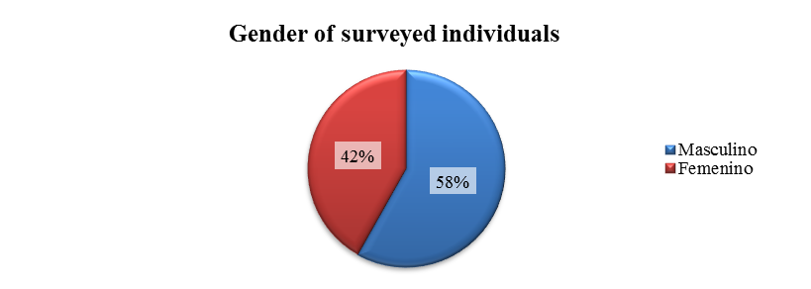
In the previous chart, we see what may be called a possible tendency: In the universe of those surveyed, we identified a sensible majority of men with some type of disability; with a difference of 16 points over women. It will be important to analyze the first results of the application of the 2010 national census, to value if for the first time we may have strict information regarding the gender proportion of persons with disabilities; and this directly affect the strategic planning and public and budget policies.
If statistic data of this part of the population do not exist, clearly we can not have strategic planning nor the consequent integral public policies and its necessary budget assignment, that may finally be subject of impact measure; and so, finally value if the whole process allow to conclude that it has been complied with the commitments assumed by Mexico upon signing and adopting the CRPD.
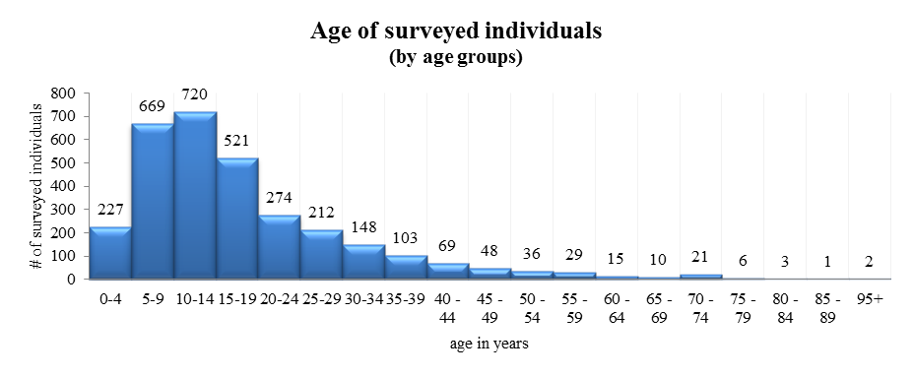
The age of surveyed individuals shows this tendency due to the system of convenience survey: the civil organizations that work with this population, generally young.
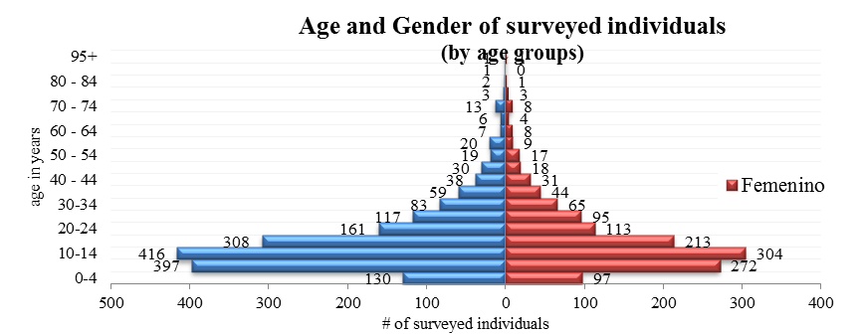

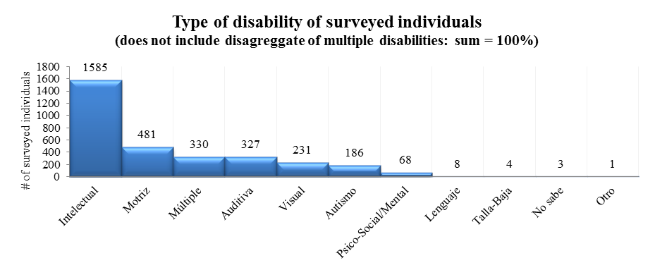
The information of this table equally reflects the type of applied survey. We cannot extrapolate this data as representative. This tendency does not imply that in our country the index of persons with intellectual disability is greater than those with the visual disability, instead it means that the organizations that support the survey application, principally work with the intellectual disability.

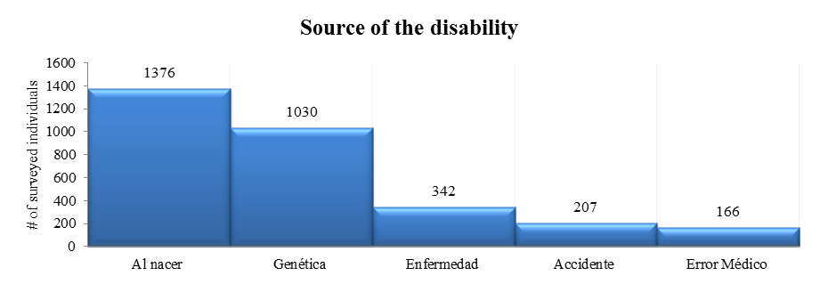
This data is also meaningful because it refers to the self-perception of the person with disability, or of the family that answered for such person the question. The fact that a person lives his reality, not necessarily means that he may understand it; this principle may be applied to the idea that one person has its own life circumstance, result from his education and level of social development. It may be confusion in the concepts of “when born”, “congenital” or “genetic”. This implies that the State must facilitate through national research entities, the sensibility of the persons with disabilities and their families, regarding the disability causes.
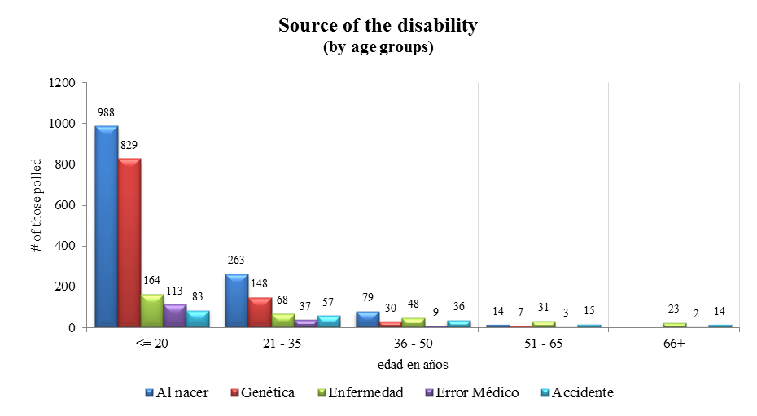
In the chart above we appreciate that within the surveyed population of over 36 years, the idea of genetic acquisition lowers in a sensitive manner. The chart suggests that a high percentage assumes that the source of the disability is genetic. Furthermore, it is important that in the process of raising awareness, we advance in the correct knowledge of the sources of disability, in a way that not only the mass of the population, but specifically the persons with disabilities and their families have the best available information.
Disability keeps being a “taboo” in Mexico, and thus it is material to strengthen the means of information and awareness-raising over the sources, consequences and supports that persons with disabilities require.
4. Accessibility
Among the consultations performed through the INFOMEX system, a common element was the accessibility matter, regarding the movable goods and real property infrastructure. Most of the answers referred, in the best of cases, to the accessibility for physical disability. This shows the concept that public authorities (and society in general) have on this matter, normally reduced to parking spaces and ramps for individuals using wheelchairs.
Very few public buildings have universal accessibility. COAMEX has knowledge of one of them, which is the building of the Federal District Human Rights Commission. The universal accessibility concept must be clearly established in public programs and must have its corresponding budgetary allocation, so that the governmental strategy results in an adequate project execution.
From the information gathered by the public authorities that were surveyed, it results that at least on this matter the Mexican Government tends to reduce the same to an integral system of ramps, decreasing the scope of the wide meaning of disability, only to wheelchair users. In any case, the term improvements is used more often than the term universal accessibility. Some institutions in charge of the defense and promotion of human rights said that they complied with this concept without there being any concrete evidence on such regard. None of the authorities that were consulted associated the universal accessibility to the strategic planning.
From a review of the NDP, we may conclude that the way in which this matter is approached should guarantee the effectiveness of the sixth principle of the CRPD: the accessibility, as defined in its article 9. However, the guidelines established in the NDP are not shown in the reports delivered by the authorities which were consulted, or in the documents that regulate the structure of public policies. These documents should clearly establish that the accessibility must guarantee at least the access to persons with disabilities in the same conditions as the rest of the population in the “physical environment, transport, information and communication… in urban areas, as well as rural…”.
Once again, it is noted that regarding the accessibility obligation, it is missing a specific follow-through by the responsible government entities of the principles set forth and its specific implementation and budgetary allocation in order to achieve actual results in favor of persons with disabilities.
4.1 Review of the applicable legal framework
Even when the constitutional text already mentions the term “disability” to specifically refer that for this reason the individuals shall not be discriminated, it has no mention to accessibility. The Federal Law to Prevent and Eliminate Discrimination, reduces the accessibility concept to use it for public transportation of general use. Even when this law was issued prior to the entry into force of the CRPD, it is noteworthy that the congressmen standpoint fails to cover the individuals with sight, hearing, intellectual and other disabilities, normally reducing the disability perspective to wheelchair accessibility actions.
The General Law for Persons with Disabilities, raises the concept to a category of principle, in its article 5. Article 15, section I, even when the same does not define the concept, it mentions that “universal accessibility” must be taken into consideration as guidelines for urban structure and determines the concept with the complement of “adapted for all individuals”. Additionally, such law dedicates a detailed article for public transportation of passengers, so that the same has the characteristics established under such legal provision. Regrettably none of these legal provisions have been able to be fully applied may be attended or verified due to the lack of a Regulations of the current General Law for Persons with Disabilities, as it has been addressed above.
It is material that in the future there are set forth legal provisions that are binding, mandatory and duly regulated for the government agencies and private entities to ensure the “universal accessibility” for all persons with disabilities.
4.2 Information provided by the Mexican State
Entity
Budget
IFE | 2009: Special Screen : $3,354,000.00 Instructions for the Special Screen: $61,705.14 Braille Pattern with instructions: $1,081,309.12
INEGI | Of the physical accessibility works of the site, "these actions implied an investment of $1,792,055.25"
Strategic Planning
IFE | “Since the Federal Election Process 2005-2006, the following is included in the “Manual for the procedure to determine the location of surveying booths”, issued by the Executive Department of Election Organization (Dirección Ejecutiva de Organización Electoral) (DEOE)… to endeavor in the elimination of such conditions that cause discrimination to citizens arising from any origin, same that establishes: …to endeavor in the elimination of such conditions that cause discrimination to citizens arising from any origin, but mainly from different capacities (sic)… will try to locate the election booths in places that ease the access for all citizens.” This manual contemplates wide accesses, flat land and unique level, ramps or other modifications and signs necessary in the event of not existing alternate locations, avoiding obstacles for individuals with weak sight.
INFONAVIT | Works using a “Code of Housing Building issued by the Housing National Commission, which contains the main characteristics for adaptable and accessible housing.”
SEP | The accessibility criteria is adapted from the construction of modifications for persons with disability in the federal staff as of 1998, such modifications consist in the collocation of support bars in WCs and restrooms, mirrors, ramps, parking spaces and signs.
SEP | "The SEMS has implemented as of 2008, an education assistance program for disabled (sic), which in 2009 was formulated as follows: “Guidelines of the Program for Medium and High Education Intended to persons with disability 2009”. To perform the necessary modifications to the infrastructure of educational facilities.”
Actions/ Public Programs
CNDH | 6 buildings have universal accessibility for PWD, all located in the Metropolitan area.
CNDH | Collaboration with Libre Acceso A.C. and the Federation of Architects Colleges of the Mexican Republic (Federación de Colegios de Arquitectos de la República Mexicana) in a National Sample-Diagnose of Accessibility of the Federal Public Administration Real Property, which was presented on February, 2010, available in its website.
CNDH | It is currently in process of modifying its website, to include measures regarding the universal accessibility and design
IFE | “Occupies a total of 646 buildings in all the Mexican Republic, from which 31 are owned by IFE, 598 are leased and 18 are under bailment.  - From the real property owned by IFE, regarding the buildings of its central location (Tlalpan) the sanitary facilities have been modified to make them completely accessible to persons with disability, in addition to adding ramps and exclusive parking spaces for such people. Regarding the other real property, they are working so that in a maximum term of two years, they shall also be completely accessible.  For the rest of the real property occupied by IFE, it has been requested to the owners to perform the necessary works for persons with disability, since in accordance with the internal regulations, the authorized resources to perform modifications to the same, are limited and are completely used to adequate the same for the purpose that the Institute is obliged constitutionally.”
IFE | “Since the Federal Election Process 2005-2006, the following is included in the “Manual for the procedure to determine the location of surveying booths”, issued by the Executive Department of Election Organization (DEOE)… to endeavor in the elimination of such conditions that cause discrimination to citizens arising from any origin, but mainly from different capacities (sic)… will try to locate the election booths in places that ease the access for all citizens.”
INEGI | “Currently the buildings owned by the Institute do not have an integral accessibility of 100%; however, they are working in the projects to achieve the necessary conditions and fully comply with the same.”
SEDESOL | From the 5 buildings located in the Federal District managed on a central level by the General Department of Material Resources: “the 5 buildings are accessible for persons with disability”.  In 2007, Braille plates were crafted for the elevators inside “Torre SEDESOL” and ”Torre Contigo”, In 2008, restrooms and 6 parking spaces were built for PWD inside “Torre SEDESOL”. In 2009, they report the “Construction of a ramp for physically handicapped (sic) individuals as well as the adaptation of spaces for individuals with different capacities (sic) inside “Torre SEDESOL” and “Torre Contigo”.
SEGOB | The only real property within the metropolitan area that has integral accessibility is the building of the National Counsel to Prevent the Discrimination. The rest of the buildings have certain level of accessibility, as it may be seen in the diagnosis chart that was sent as part of the answer (see attachment…)
Senate | None of the Senate buildings is considered to have integral accessibility; however, in each of them works, installations and modifications have been performed that allow the persons with disability to work or visit each building with the least possible obstacles.  On the other hand, it is worth mentioning that the security staff has the obligation to help any person with disability, as long as he is inside the facilities of this Chamber or its surroundings.
Senate | As of the LVIII Legislature, the Chamber of Senators’ website has incorporated a portal in which it is possible for any individual that has internet access to see and listen the plenary sessions.  During the current year, it has been installed in the equipments which are available to the public of the Melchor Ocampo library, a software reader of Jaws Pro screens in Spanish and software to recognize Open Book 6.01 letters of navigation and consult of the Senate website for individuals with sight disability. This software processes the graphical signs and converts them into voice, besides it allows saving the information scanned in format WAV or MP3.  Additionally, the new portal of the Social Communication Coordination has improved all its sections with audio and videos, regarding the activities performed by the legislators.  Finally, it is important to point out that the software manufacturers such as Microsoft and Apple, contribute in a daily basis with new applications that ease the navigation and use of informatics equipment for individuals with different capacities (sic) such as the screen size and change of color, as well as the letter size; furthermore, lately a magnifying glass (zoom) and sensitive zoom touch screens have been integrated.
SEP | “The main SEP building has TOTAL ACCESIBILITY for persons with disability.”  “We have information of modifications to 183 buildings, reported during 2009 of the total 3457 buildings within the Federal District and the Mexican Republic.”  They consider that all the federal buildings that depend on the DGCFT have modifications, created as of 1998, being in process the update of the reports by each building.  “Deriving from the institutional maintenance programs via SEMS, in 2004 the criteria for persons with disability were integrated in the remodeling of restrooms inside the participating buildings. Likewise, the CAPFCE (today the INIFED) has the necessary modifications in its prototypes of restrooms.”  The SEMS has implemented as of 2008, an education assistance program for disabled (sic) which in 2009, was formulated as follows: “Guidelines of the Program for Medium and High Education Intended to persons with disability 2009”. To perform the necessary modifications to the infrastructure of educational facilities.
SHCP | “All the buildings from the SHCP have accessibility for persons with disability”.
SS | “The facilities of each Ministry have been acquired gradually with a limited but consistent budget effort throughout many years; the Ministry of Health has kept its commitment to improve its facilities, modifying the same through the implementation of a plan to improve by assigning budget priorities… during May and June of 2008 they dedicated to evaluate and issue accessibility recommendations for National Institutes and Hospitals from the Ministry of Health, covering the areas with greater number of users: access, external consults, urgencies, laboratories for samples gathering.”
STyPS | From the eight buildings located in Mexico City, 4 are accessible. “The other four buildings were designed and built prior to the start of effectiveness of the regulatory provisions regarding accessibility matters for persons with disability, reason for which their architectonic elements, private areas, common areas, complimentary, internal and external circulation areas, as well as elevators, parking lots, accesses, horizontal and vertical circulation, furniture, restroom services, facilities, evaluation gadgets, etc., do not offer yet the conditions required to guarantee the complete use of the same by the employees or visitors with disability.

The CNDH and the National Council to Prevent the Discrimination stated that all of their buildings have universal accessibility; however, by direct experience, we know that such accessibility does not comply with the requirements of the CRPD.
The Federal Electoral Institute is the authority who better detailed the improvements regarding accessibility, specifically in the political participation and voting rights. In this point we must remember that it is still pending to solve the way in which the individuals with intellectual disabilities may exercise this right, provided that it is a common ground that persons with intellectual disabilities are usually factually deprived of their political and electoral rights and discriminated upon trying to exercise their vote in the different elections at a federal, state and local level.
The Human Rights Commission of the Federal District (CDHDF) has facilities that may be considered to have universal accessibility, and the same circumstance occurs with the facilities of the United Nations Development Program. COAMEX had the opportunity to know them in detail as well as the procedure to achieve such development level. The achievements are an example to be followed by all public authorities and may well be a model to implement the accessibility improvements in public and private environments, as the ideal standard of construction, with an inclusive perspective for all the persons with disability.
5. Right to education
Protected at a constitutional level, the education in Mexico will tend to harmonically develop all the human abilities, as provided under article 3 of the constitution. However, the current text of this article does not mention the concept of an inclusive education for any part of the components of population generally discriminated in our country such as persons with disabilities, native population, or illegal immigrants, to give some examples.
The Constitution should openly cover the right to an inclusive education in a context in which wide segments of the population live different discriminatory circumstances and of social exclusion. We think that the constitution is the best reference to enshrine the rights to education, health and work– in addition to other rights recognized by the CRPD- to be established as principles that rule the national legal system.
In this sense, article 3 could be amended to be in accordance with an inclusion perspective for the persons with disabilities, considering them in integrity and in harmony with their community environment. The Constitutional text represents the best platform to recognize that the education must be inclusive by its own nature, or it would not be education. The persons with disability must guarantee that the Government will give the maximum attention that each individual may achieve, regardless of his economic status or his family and community.
Additionally, the current provisions of the General Education Law fail to guarantee the right to an inclusive education of persons with disabilities, and instead seem to propose a system where the only option for this part of the population is the modality of “special education” to achieve education. That is a system where persons with disabilities are segregated and discriminated from the rest of alumni.
Therefore, it is necessary to reform the General Education Law in order to guarantee an inclusive system of education in all modalities of education and in all schools nationwide.
5.1 Information provided by the Mexican State
The Ministry of Public Education has a purpose as reference in its strategic planning, which appears as the second one: to increase the educational opportunities to reduce inequalities among social groups, to close gaps and promote equity. The purpose is not the strategic planning, nor vice versa. It is very interesting to read the SEP answer: it does not refer to any democratic planning. We do not know if it has it or not, but from its answer, we can not imply that there is one.
Additionally, we may observe that in the original answer, the pre-elementary and elementary educational levels were not included. SEP had the opportunity to refer the way in which the financial resources are be applied, as well as the guidelines of the NDP to guarantee the access to education for persons with disabilities, provided that the CRPD refers to an attention covering all the life term of a person with disability, as provided under its article 24.
In this sense, the predominant information is only from one of the parts of the national educational system: The Sub-Ministry of Middle-High Education (SEMS), which is not the only authority that performs activities related with the development plans for students with some kind of disability. And even with the abovementioned guidelines, as well as with the information provided by schools with students with disability, there was no data granted that may allow measuring the impact that has been achieved, as well as the quantity of evaluations of such results.

Actions/ Public Programs
SEP | “The Non Traditional Education High School Program for Persons with disability is in accordance with purpose 17 of the NDP, purpose 2 of the PSE… and since 2008 the Program is a more intense part of the Strategic Planning, as well as one of the operative programs of the Sub-Ministry of Medium-High Education (SEMS) which result, among other things, is the creation and operation of 46 Attention Centers in 2009.”
SEP | “Strategy of Medium High Education Intended for Individuals with Any Disability”, classrooms with adapted technology “Gilberto Rincón Gallardo, of the Annual Operative Programs of the General Direction of Industrial and Technological Education”.
SEP | “Results, the SEMS through its General Departments operates the following:  • Non Traditional Education High School in medium and high levels for students with disability: with the purpose to provide education in an equity environment (DGB and DGETI).  • Special Degree in Familiar and Health Assistance (DGCFT): with the purpose to prepare experts that support the disabled individuals (sic) to integrate to the society.  • Classroom POETA (DGCFT): with the purpose to promote the acquisition of working competence for the management of multimedia equipment linked to the working market and the working inclusion of disabled individuals (sic).  • Scholarships for the education of persons with disability.”
SEP | Due to the opening of the Special Degree of Familiar and Health Assistance which has courses for the attention of individuals with sight and hearing disability, the DGCFT has hired experts for the teaching of these courses, therefore, from 2009 to this date, they have 14 Braille teachers and 10 teachers of Mexican sign language. However, prior to such date, they already had a teacher of Mexican sign language.
SEP | The DGCFT offers the persons older than 15 years with disability, training in any of 255 courses given in the 198 CECATIs, as well as courses in the POETA classroom.
SEP | The Non Traditional Education High School began in February, 2009, with the opening of 41 Attention Centers for Students with sight, hearing, motor and intellectual disability, in schools of the General Department of Technological and Industrial Study (DGETI). Due to the demand of the service during the month of June 2009 in the Federal District, five more centers began their operations in facilities of the General Department of High Schools (DGB)  The educational model which is offered consists in:  - Open High School with 33 subjects.  - Entrance granted with an average of 6, without an admission exam.  - Study of the subjects in accordance with his level of development and possibilities.  - To decide the order to prepare and approve the subjects based on his previous knowledge.  - Having didactic material to promote the independent study and modified in accordance with the specific disability of the student.  Currently, 2,241 students are attended, having 23.2% a sight disability, 26.2% a hearing disability, 29.6% a motor disability and 21.0% an intellectual disability.

Without any doubt, the numbers granted by the SEMS are highly important since they allow establishing a national structure in the medium-high education segment. The creation of a nontraditional education high school may be an adequate formula for persons with disability who may normally have problems to move or transport. During the next years the first results may be evaluated, as the first generations graduate. However, there is still the circumstance of not being able to evaluate the existing advances in pre-elementary and elementary school. There are surely some advances, but the same were not reported.
Regarding the architectonic accessibility that SEP requires to public and private institutions, they informed us of two stages: the first one as of 1998 in modifications performed to federal schools, consisting of support bars in restrooms, as well as the installation of mirrors, ramps, parking spaces and signs. As of 2004, the restrooms of the participating schools were refurnished for persons with physical disabilities, primarily for persons in wheelchairs. The criteria of architectonic accessibility are not from SEP, but implemented by the Ministry of Public Function, through a resolution applicable nationwide.
In connection with the number of buildings with integral accessibility, and taking into consideration that this is an essential condition to enforce the right to education, SEP informed us that from a total of 3,547 buildings (information from 2009) located throughout the nation, in accordance with the inventory of the Institute for the Administration and Valuation of National Goods, 183 buildings (a little more than 5%) reported modifications during 2009, that must be added to the ones performed on 1998. It reported that only one building had total accessibility (only 0.0005%): its main and central building.
Notwithstanding the abovementioned, we must take into consideration an issue that shows the need to perform a substantial amendment to the law: the General Law of Education does not establish any guidelines for the construction of new schools nor for remodeling those that already exist, in order to guarantee the compliance with the universal accessibility criteria provided under the CRPD. In this sense, it is convenient for this law to have an specific chapter for accessibility, that may allow to establish the concepts and guidelines that must be considered by school authorities in the construction of new buildings or modifications to those already built, as well as the minimum and maximum modifications that would be acceptable, through permanent programs that allow to measure the advances achieved and correct the anomalies that may appear in the transition process.
We consider that it would be convenient for the Government to have a national authority that coordinates the different national programs, giving consistency to each one in connection with their corresponding work area.
On the other hand, in order to detect the level of congruence among the institutions, we asked the Ministry of Finance and Public Credit (SHCP) if the matter of persons with disabilities is part of their strategic planning. In their answer, they referred to program U22 “Education for Persons with Disabilities”, regarding section 11 “Public Education”, from the Federal Expenses Budget. Such document specifies in its section 11, the program “education for persons with disabilities” from which derives a total expense of $74,626,467.
However, in August 2010, the SHCP reported a public expense of 7,206 million pesos for the April-June quarter. The Ministry of Public Education and the Ministry of Communications and Transports were two of several authorities that reported during such quarter. In the case of SEP, its report for such term is for up to 1,766 million pesos. This would require a more detailed review to verify if part of the reported term affects the part of public programs destined to persons with disabilities.
5.2 Key findings of the national survey

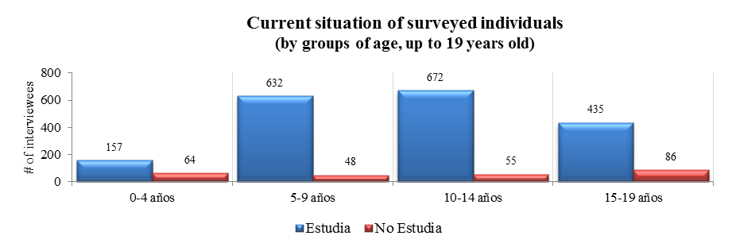
The information contained in the above chart represents the surveyed individuals that are 19 years old or younger, organized in groups of 5 years, with whom the Government has the commitment to provide educational services. Even when most of them study, that does not mean such tendency repeats at a national level for persons with disabilities, but only for the people who participated in the survey, which may show the kind of individual or family that commonly uses the services of any civil society entity, or has contact with the same.

The lack of direct information prevents us from knowing the real impact that public education has on national level for persons with disability.

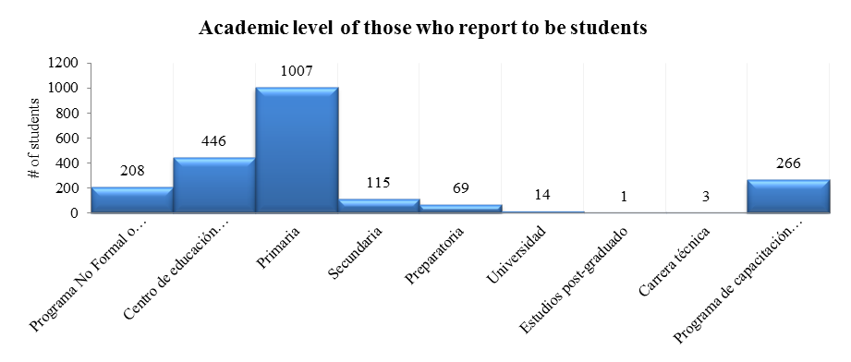
We may see in the above chart that the main tendency is in elementary school education, and it drops drastically in the subsequent levels. In the information delivered by SEP, we detect that the reported programs are located in medium education (high school), and there are no reports of specific educational programs for previous educational levels. It is ironic that the Government reports advances in the level that the survey shows as the less common, and does not refer any advances in educational levels in which the population of students with disability exercises their right to education.
In the case of educative institutions that manage the special education system, some of them (Centers of Multiple Attention or CAM) do not certify the studies of their graduates, which results in at least two circumstances: The Government seems to not recognize its own work, and the youth with disability has no way to certify their official training for a work offer.
We recommend that SEP certifies the studies of special education in which the formation of the youth with disability is carried out.
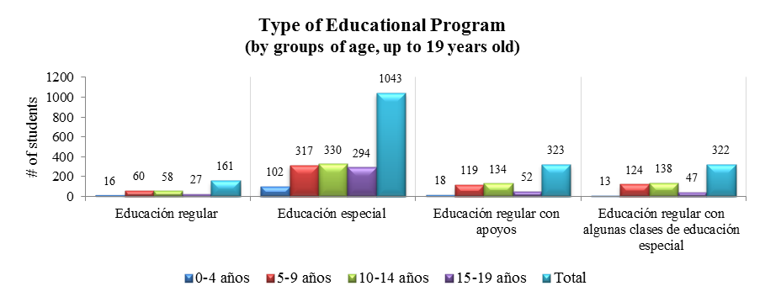
In this graphic we may appreciate how the surveyed individuals have a greater tendency to attend a special education system. Does this way of understanding the education for persons with disability promotes their educational, working and social inclusion, as provided under article 3 of the CRPD?

Regardless the lack of information about the advances in pre-elementary and elementary education provided by the Government, it may be appreciated that the process initiated with the amendments of 1994 to have just one national educational system, which among others regards to persons with disabilities, has not made a great impact in the national reality. The experience of COAMEX members indicates that there are few advances to achieve a real educational inclusion as a general rule and not as an exception. An evidence of the above may be seen in the evaluation of the National Program for Improving Special Education and Educative Integration.
If you could make suggestions to the President of Mexico: which would be your contribution? What would you like to prevent and what to promote?
First of all education. The existence of a special school and a traditional one is already an issue, the question is: why it is divided? There should be programs in which if a kid has some kind of disability, SEP should provide the necessary measures for him to study, or modify the schools so that the persons with disabilities may attend regular schools. As an example, all high schools have three levels with stairs that are completely inaccessible.
Rafael Reyes, musician and engineer.

Therefore, we suggest the Mexican Government to perform a diagnosis that allows to evaluate, based on the available statistic registries, how many boys, girls and teenagers with disabilities have access to inclusive education in terms of the CRPD, and how many are users of the special education system (public and private), to detect the reasons that difficult the inclusion and guide all the efforts in the right way.

In other words, until the Government has no trustworthy registries of the number of students with disability throughout the nation, it will not be possible to assure the advances of the inclusive education. On such regard, the National Counsel for the Evaluation of the Social Development Policy (CONEVAL), in its 2007 report, makes important reflections about the lack of integral policies and for the measure of results regarding inclusive education.

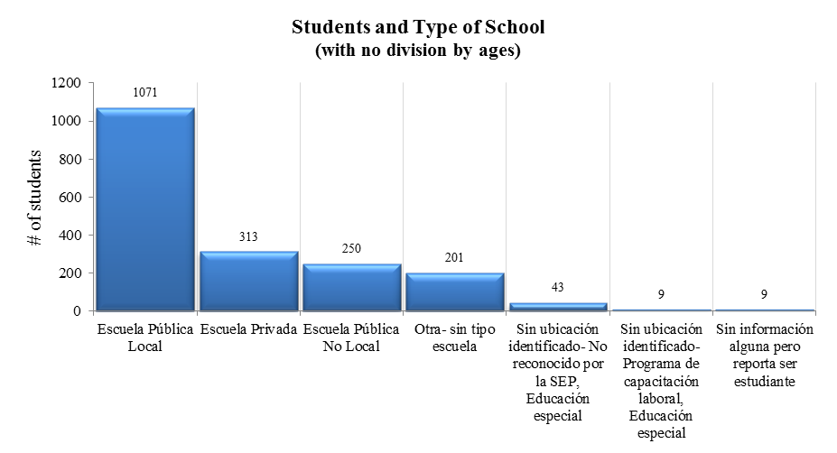
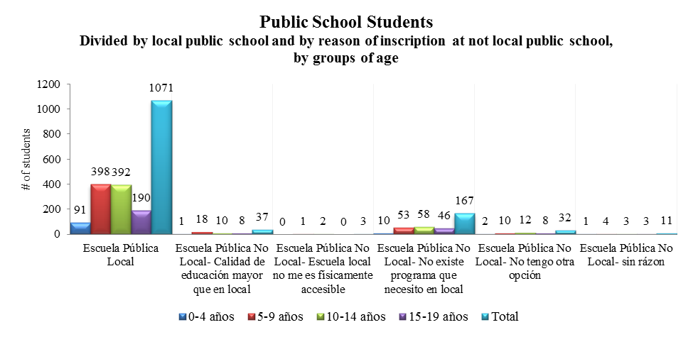
In the two graphics above, the interviewees refer relevant information: most of them are in public education system. The elements that allow the school to be accessible are necessarily conditioned to the user’s type and level of disability: it is not just a matter of accessibility through ramps, but structural inclusion. Regarding the references about the computer equipment that benefits persons with disabilities, they are relatively high but far from enough to attend all the population that was interviewed.
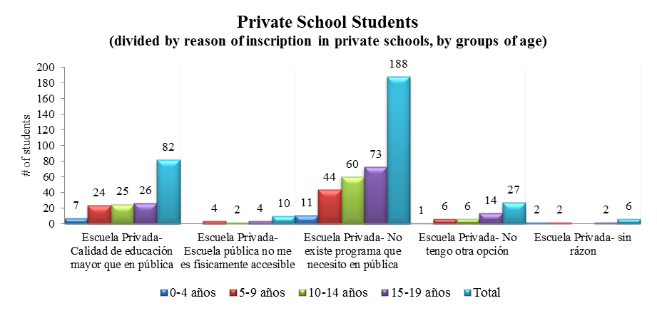
6. Right to Work
In a widespread crisis context, with open unemployment official numbers of 5.6% (according to INEGI´s data up to November 2010), the subject of the right to work for persons with disabilities, acquires a high relevance because of the invisibility of the subject being reviewed and the inexistence of a systematization for this social sector/segment. However, there are sufficient signs to assert that if persons without disabilities are going through a traumatic experience to obtain and maintain the employment, there are no better conditions for those who live with one or several kinds of disabilities. For the purposes of this report, we indistinctly use the terms work and employment, which are both used in the text of the CRPD, and that bear no special different meaning in Mexico.
6.1 Review of applicable legal framework
In the labor field we have a very complex problem: one of the most complicated types of disabilities for labor insertion are the deaf and blind persons who specially have the difficulty that as the vision is a sense that makes the execution of many tasks easier, when the person with visual disability arrives to a place, he/she stands marginalized because the businessman judges it as much more difficult and he/she is right in many ways, because most of the activities are visual or are executed with the motor visual coordination. Simply the fact of sweeping and mopping, ¿are you going to choose a boy with intellectual functional disabilities or a blind boy, to mop? Obviously you will choose the boy with intellectual disability, because the visual disability in this sense has more… difficulties.

Marco Antonio Contreras, psychologist with a masters degree, professor and musician.

The International Labor Organization (ILO), issued the Convention 159 for the Vocational Rehabilitation and Employment of Disabled Persons. This treaty came into force in June 1985, and Mexico ratified it on April 5th, 2001, and therefore it became biding and precedent nationwide, in terms of section 133 of the Mexican Constitution. One of the special features of this Convention is its conceptual poorness to properly deal with the subject of persons with disabilities, but suggests equal opportunities between the disabled workers and the rest of the workers. An additional concept is the professional rehabilitation as a commitment of the States party to this Convention. The definition of persons with disabilities back in 1983 (when the ILO issued the document) is well depicted in Convention 159:
Art. 1. For the purposes of this Convention, the terms disabled person means an individual whose prospects of securing, retaining and advancing in a suitable employment are substantially reduced as a result of a duly recognized physical or mental impairment.
Thus, Mexico agreed internationally since 1985, to “apply and periodically review the national policy of professional rehabilitation and employment for persons with disabilities”, as provided under article 2 of the Convention mentioned above. Obviously, the concept of rehabilitation (generally applicable and applied in Mexico to persons subject to a criminal procedure) is superseded by the third principle of the Convention: of inclusion/participation. In contrast, the CRDP establishes in its section 27 the double term work and employment. In it, it thoroughly describes the elements that make up the right to work and employment of the persons with disabilities.
There are many prejudices of the psychiatric diseases. If someone has a depression it arouses compassion. “Make some exercise and you will get better”, but in the case of psychotic diseases the impression is stronger, and undermines the conceptions of possible employers, and any person. The fear made me deny my disease. At the moment, in my work center my work colleague already know that I have schizophrenia. This allows to assume that under an informed context and with the appropriate psychiatric treatment, someone with psychological diseases may be as functional as any other person.
Ildemaro Correa, music performer.
The Mexican labor law has an atypical work definition, which must be deemed in favor of the labor rights of the social group of concern to this report. Because of its importance we will transcribe article 3 of the Labor Federal Law:
Art. 3. Work is a right and a social duty. It is no subject of commerce, it demands respect for the freedom and dignity of its provider and shall be executed under conditions that assure life, health and a decent economical standard for the worker and its family.
No distinctions may be established between the workers because of their race, sex, age, religion, political view or social condition.
There are few laws containing a definition of work. Regarding that, not even the human rights international instruments, even in labor matter, achieve to define what work is and which are the ethical unavoidable and minimum conditions that its definition shall contemplate. It is of fundamental importance to include it as part of the national legal system, but also in our social procedure in order to make the labor relations between employers and employees less unfair, including persons with disabilities.
In order to accomplish the aforementioned, it is advisable to amend this section within the process of legislative harmonization, in order to include the definition of persons with disabilities, in such sense that this specific social group does not become subject to discrimination and that the government agencies shall foster their employment in equal conditions pursuant to the available options and labor opportunities.
Finally, it is noteworthy that the Federal Labor Law currently fails to provide a chapter or provisions regulating the work of persons with disabilities, but the disabilities are only understood today as a consequence of a labor risk or disease and not a condition in which it is possible to work and that it shall be fostered an inclusive labor for persons with disabilities, as mandated by the CRPD.
Therefore, it proves necessary to amend the Federal Labor Law to guarantee the right to work of persons with disabilities and harmonize it with the CRPD.
6.2 Information provided by the Mexican State
Entity | Information (Reported by the Entity)
Budget
STyPS | “At an annual operative programs level”,  a. According to the aforementioned there is no existence of an allocation that may be identified for the budgetary indicated exercises.  b. As a result of the inexistence of a budgetary allocation, it cannot be itemized by chapters, items and concepts.

The Ministry in charge of the matters related with labor and labor relations, does not have a specific budgetary allocation for the labor inclusion of persons with disabilities, although it refers a strategic plan regarding the rights of persons with disabilities. The budget support of the right to work for this sector of the population is subject to the secondary or tertiary actions that each instance may understand, interpret and implement, separately. This is the case where a strategic plan is made but without any budgetary support.
Even though the federal authorities did not report a strategic or democratic plan within the requirements through the INFOMEX system, it is noticeable that regarding work promotion for persons with disabilities there are without doubt interesting incentives and progress, such as the case of the “Inclusive Company Gilberto Rincón Gallardo Award”.
We think that those programs shall be linked with a strategic-democratic plan which becomes part of the NDP or of a Development Structural Plan for the Persons with Disabilities, to which it shall be part of or be linked to; in such way that there should be clarity in the structural creation of the project, as well as an adequate implementation of the specific public policies, besides that said programs shall be launched through massive diffusion media, for the general public knowledge.

Persons with disabilities working at Government Agencies
Instance | # PWD | # Total | % PWD/Total
CNDH | 3
INEGI | 289 |  | 1.70%
Senate (Services provider) | 5
SEP: General Bureau of Centers of Labor Habilitation | 48 |  | 0.01%
SEP: General Bureau of Technologic Industrial Education | 1046
SEP: SEMS | 10 |  | 1.42%
SHCP | 101* |  | 1.86%
STyPS | 16 | 4,600 | 0.35%
*No specification of persons with disabilities but persons with any kind of physical impairment

Even though the Ministry of Work and Social Welfare (STyPS) reported that in 2009, it produced the Guidelines for Labor Inclusion for Persons with Disabilities for the public sector, we can appreciate that reality reflects totally insufficient circumstances to consider that the abovementioned guidelines have been properly received and implemented. It is possible that the figures of the surveyed government agencies do not reflect a labor reality of the Mexican State, or that there are really no relevant advances to report since the implementation of said document.
An example of the non-existence of a structural policy regarding the right to work of persons with disabilities is that after two years of the entry into force of the CRPD, not a single government agency reported a policy of public employment for to persons with disabilities in terms of section 27.1 of the CRPD. This causes a difficult scenario where, for instance the CNDH has only three persons registered with disabilities in its labor post, being that it is a government instance devoted to the defense and promotion of the human rights with a nationwide coverage.
According to data of the CNDH, until August 2010, the number of employees in said organism is of 1,090, from which only 3 have some kind of disability. That means that the percentage of public employment of persons with disabilities in CNDH is less than 0.003%. This figures contrasts with SEP figures, which raise up over a thousand persons with disabilities nationwide. The reported percentage of labor occupancy in the public sector (see table above), is of 0.89%. The rest of the federal public agencies to which information was required for this subject, did not contribute any information.
Something that the Mexican government shall include into its labor public policies is to raise the amount of employees with disabilities in every level. For that, it shall establish the guidelines of labor inclusion for persons with disabilities from the drafting of a democratic plan as provided under the Mexican Constitution.
6.3 Key findings of the national survey
From the obtained data, we can infer that the disability figures are also, the figures of open unemployment. One of the most painful pending matters is the one related to provide to each person with disabilities, the opportunity of a decent and well-paid employment, as it is established in section 3 of the Federal Labor Law.
The persons with disabilities that took part in the survey have referred a bigger possibility to access the education and health services, and the efforts seem to take a more articulated path each time. However, the access to work and social security situation is not promising, as it can be appreciated in the following charts.

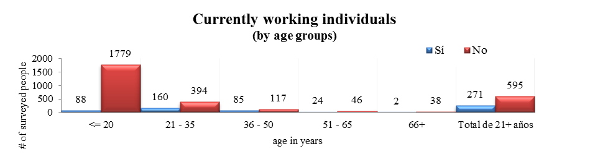
Within the universe of surveyed individuals, bearing in mind that the sample is at convenience and with an exploratory character, unemployment is predominant. In the fringe of age superior to 21 years, unemployment supersedes double of the employed people. This piece of information, seen from the context of information provided by STyPS allows us to assume that at a lack of democratic planning, no public or budgetary policies are created in order to satisfy the employment needs for an important fringe of the population with disabilities.
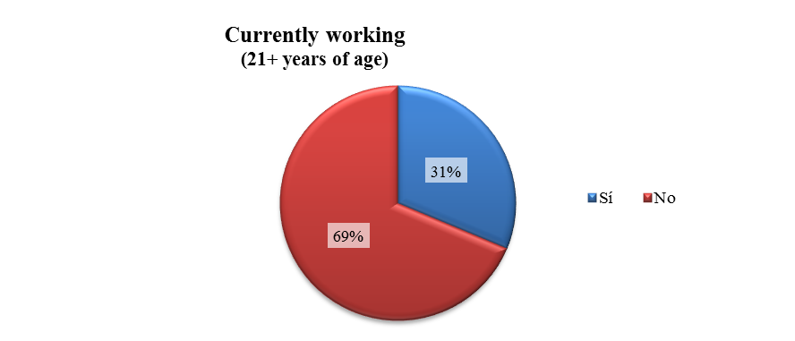
Empecé a tocar en el metro, como muchos. Yo me rehusé mucho tiempo porque me parecía indigno y un día la indignidad se me acabó y dije “bueno pues hay que darle”. Entonces empecé a tocar ahí, iba a la UAM -ya casi estaba terminando- , termine la UAM y empecé a tocar en el metro y tocando en el metro empecé a estudiar la maestría, yo creo que he sido el único ciego que toca en el metro y que estudia una maestría en la Ibero.
Marco Antonio Contreras, psicólogo con maestría, profesor y músico.
Once that the State systematically and structurally deals with the fulfillment of the CRPD guidelines, we will have the opportunity to verify if the obtained figures from our national survey make up not just a trend, but a reliable interpretation of the unemployment phenomenon. Unfortunately, the lack of an informatics database, makes difficult any possibility to appreciate in documents, the scale of the problem of unemployment of persons with disabilities.
Other factors to establish are the quality of the employment, the labor compensations, the access to social security and universal accessibility as well as the legal impact, as a result of the lawsuits filed by the workers or employees living with disabilities. The lack of this information prevents an adequate analysis of the real scale, of unemployment and the quality of this, when a person with disabilities achieves to access the so-called labor market.
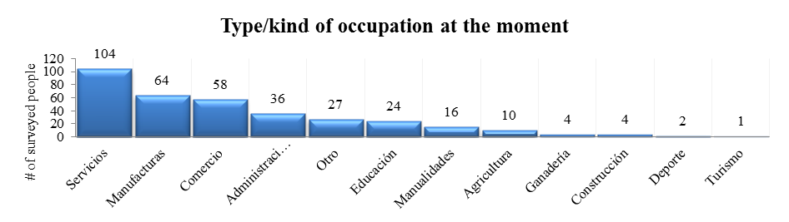
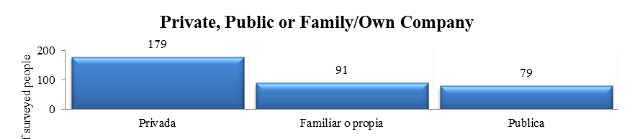
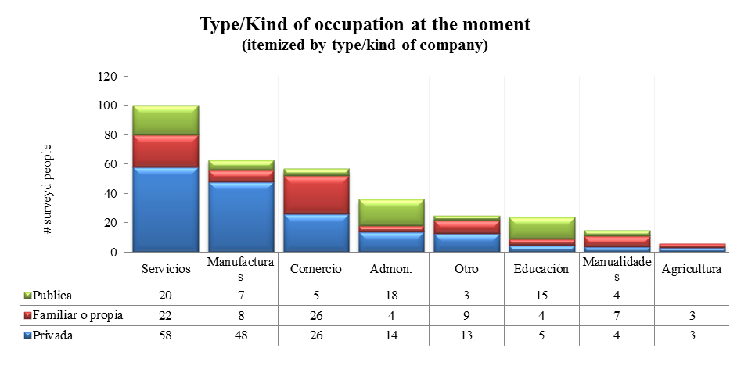
In the tables above we notice one coincidence within the small amount of reports provided by the surveyed government agencies: the public service does not favor the persons with disabilities, regardless of the Guidelines for Labor Inclusion of the Persons with Disabilities in the public sector. The Mexican government needs an inclusive policy in labor matters in order to grow from the actual average to a gradual sustained growth of at least 10%, which represents the figure that the World Health Organizations gives to the total population with disabilities.
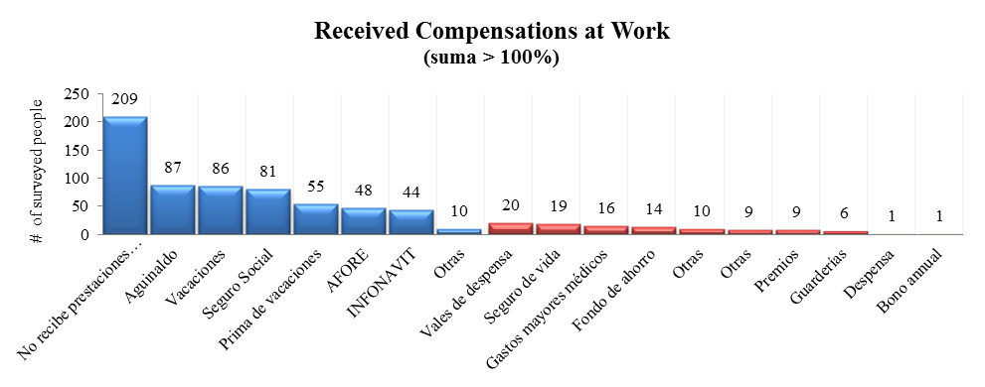
From the information of this table, it can be appreciated that a relevant sector of the persons with disabilities that were interviewed, maintains labor relations in precarious conditions as a consequence of the lack of recognition by law to the compensations and benefits. This suggests the existence of an generalized unemployment phenomenon in this population and, in the case of those who have an employment, a high percentage does not receive the compensations required by law: the few employments are usually marginal, lacking the legally recognized compensations.
¿Have you ever received attention from the government to take care of your eyes, in order to stop getting hurt by the light?

No. Nothing, nothing. I never look for it, because when you go they say they don´t have or they don´t help you. And with my daughter sick (polio effects), when I go to the doctor they tell me; “come this day” or “let see when will you come”. And if there is no one to take me I just can´t go. I don´t leave because I can´t if I could I would. ¡How would we leave? My poor daughter in a wheelchair and me with disabilities, I don´t see, I can´t. How would I do it, I hope I could tell my daughter: “I´ll take you, take you out to the road and we can go to La Venta”.
Crisanta, náhuatl native (Hidalgo), blind ,with one daughter with polio effects

7. Right to health
The right to health is usually considered only in the context of medical treatment. The CRPD starts to dissect from this view, to the point that it deals in different articles the right to health (Art. 25), and the right to habilitation and rehabilitation (Art. 26). Thus, this right is dealt integrally, including the training of medicine professionals in order for their services to be characterized by the benefits of adopting a human rights perspective and does not stick only to the medical standpoint of disability that, until recent times, was the only thinkable perspective.
Something as insignificant as giving for granted that disability is equivalent or even synonym of illness, is in fact one of the conceptual premises of discrimination: since it is rather the illness and not the person the governing element.
However, it is still commonly associated in Mexico the disability phenomenon to the concept of disease and even if the Mexican State has advanced in strengthening the new human rights perspective proposed by the CRPD, we still witness today important references to the past perspective.
The view that emerges from the CRPD is decisive: the correct term to refer to this sector of the population is “persons with disabilities”. Undoubtedly, the persons with disabilities precise specific attentions, such as access to health services, but that does not mean that they all have a disease A person with Down syndrome, or brain paralysis, does not necessarily has a disease. This is a perspective continues not being able to be fully settled in Mexico, even two years after the entry into force of the CRPD.
All of the contrary, we can say that today the right to health of persons with disabilities in Mexico is almost always linked to the medical perspective of the disability, and there are no health services that seek primarily to implement the new perspective by strengthening the exercise of rights and independence of persons with disabilities, or its inclusion on community, as mandated by the CRPD.
7.1 Information provided by the Mexican State.
Actions/ Public Programs
INEGI | "In projects where INEGI takes part with other organizations from the Health Sector they are developing Identification cards for Persons with Disabilities, which under the frame of the International Functionality Classification of Disability and Health, the International Health Organization issued in 2001, this pretends to become an administrative register in every level of the rehabilitation sector areas.”
SS | "Every program and services of the Health Ministry are free of charge and in those in which a recovery charge must be applied, this recovery charge is established through a socioeconomic research and on equal terms towards all of the population that the Ministry of Health takes care of, on the grounds of respect to the citizen rights.”
SS | "The Federal Public Administration (FPA) through the Ministry of Health (SS), offers attention and rehabilitation services to the population in general, with no distinction whatsoever, through its own hospitals, the hospitals of the Health Ministries of every State, as well as the IMSS, ISSSTE, SEDENA and SEMAR.”
SS | "Basic Units of Rehabilitation (BUR) that provide health promotion services, disabilities prevention and simple rehabilitation services. The attention scheme in the BUR involves the family and community participation. The staff that works at these units are people from the community which have a basic education and technical training as auxiliary therapists, trained in the DIF Rehabilitation Centers courses. Nowadays there are 1,311 BUR.”
SS | "Mobile Units of Rehabilitation (MUR) with the purpose of reaching remote communities where there are no centers or basic units for rehabilitation. These units provide health promotion services and prevention and detection of disabilities. These units are operated in coordination with federative entities and allow the expansion of the assistance services coverage.  • Keep an eye on the operation of the rehabilitation operative establishments in every State, as well as the compliance with the work schedules, according to the collaboration agreements executed with the DIF of each State.  • Participate on the regulations update in rehabilitation matters as well as in promotional and academic events regarding the attention to persons with disabilities.  • Participate in the elaboration of a directory of the rehabilitation services providers in the country.  • The incorporation of all the information of the institutional resources, the provision of services and the characteristics of the population which was taken care of by the national system of rehabilitation services.”

The project reported by INEGI of creating identification cards for persons with disabilities together with de Health Ministry (SS), is a very important step forward towards the implementation of public policies from a different, deeper standpoint in favor of persons with disabilities in Mexico: by securing more precise information on the number of persons with disabilities and their kind of disability, among other data that may derive from the documental information gathered at the moment of issuing this new identification card, it will be possible to elaborate democratic plans and to adjust the public policies in favor of the persons with disabilities in a broader scale. Otherwise the funds would depend only on the circumstantial application of the public officers, rather than from a clear and concise determination of a structured strategy.
However, the Mexican State will have to take care of not limiting or subjecting the exercise of the rights of persons with disabilities to the obtainment of an administrative registration, such as the new identification for persons with disabilities. At this moment COAMEX does not have any information that leads to the conclusion that this new identification card will have the purpose or effect of creating such a situation, but it will be important to monitor the development of this identification, once it enters into force.
7.2 Key findings of the national survey
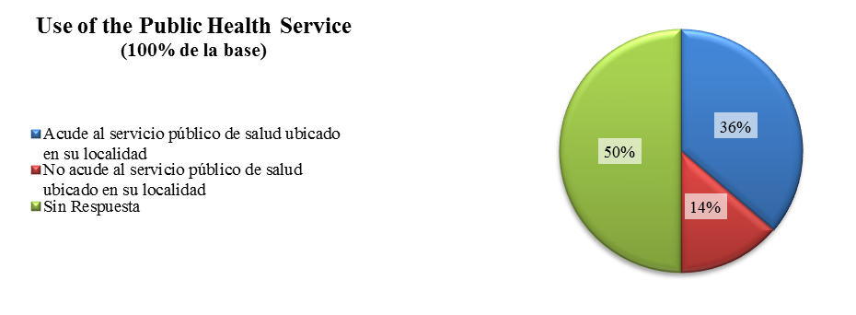
50% of the surveyed individuals were not able or did not know how to answer and 14% identified themselves apart from any public health services. The surveyed individuals, besides being persons with disabilities, were divided in a considerable portion of the national territory, as a consequence of this rural and urban population is taken into account. The possibility of persons with disabilities or their families not requesting any health services may also be considered.

Regardless, if we consider that the access to health services is usually a priority for persons with disabilities and their families, it is also possible to assert that this group of the population (as it seems, large), is not accessing health services in a full and equal manner (at least statistically) to the rest of the population. Thus, even if the users of health services generally do not report complaints, apparently the half of the surveyed individuals has not appeared before, or has not been able to receive attention from this public service.

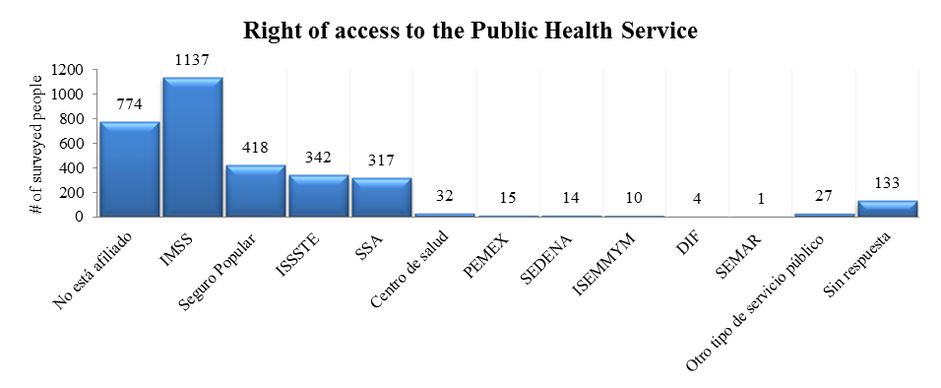

According to the above table, it shall be considered that the health access and habilitation-rehabilitation concepts are not necessarily related with the real application of the right to health. Persons with disabilities may have access to general health attention matters, but that does not necessarily means that the access to it has been covered, considering that the CRPD does not use the disability prevention term, because it deems it is risky towards the existence of public policies related with the physical elimination of embryos under these circumstances.
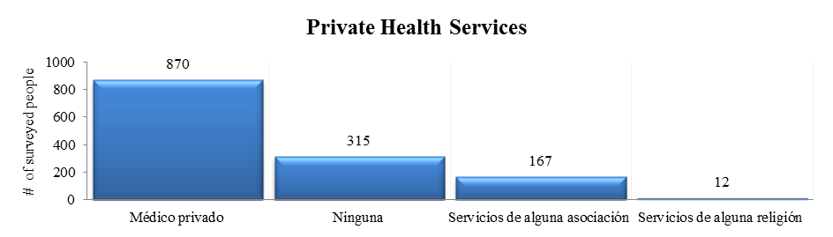

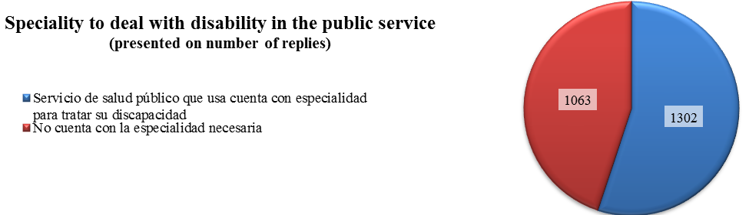

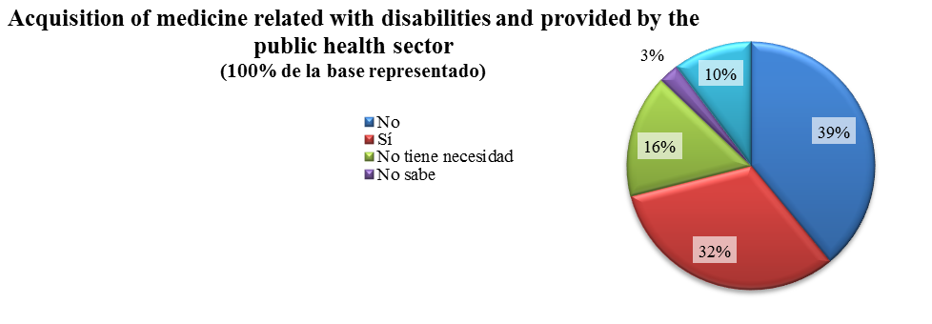
A broad margin of the surveyed individuals (39% of total) referred they were not able to obtain the medicines in the public sector. The surveyed government agencies did not report the quality of provided drugs, nor any specific government programs to cover such demand.

If we do not know the actual needs, we will hardly be able to know how to satisfy them, by means of a careful offer to the needs of the persons. We think that in order to be able to start solving this situation through the constitutional democratic plan, we shall start from the base of getting to know how many persons with disabilities live in the country, where do they live and what are their needs, amongst them of medicines.

Due to the fact that there is no at this moment trustworthy and sufficient information that enables us to determine the medical needs of persons with disabilities, it is impossible for us to assess in a reasonable manner the compliance of Mexico with the Right to Health for persons with disabilities under the CRPD. However, empirical information leads us to determine that the access is poor and that the persons with disabilities continued being discriminated and under-represented in the field of health services, additionally to the fact that available health services are not correctly directed entirely towards the new perspective of exercise of rights and community attention mandated by the CRPD.
As we have noted, the Government efforts to assure the access to health to the national population are a priority, but our documentary evidences, and even our own experience shows us that a huge percentage of the population with disabilities suffers from inaccessibility to the public health services: because of the distance, lack of equipment and specialty in the required services, as well as the shortage in medicine provision for their own needs, in addition to the common situations of discrimination and marginalization to which this group of the population is commonly subjected in Mexico regarding this, and other rights. The fact that more than half of the surveyed people do not receive gynecological attention, requires immediate actions of prevention and treatment, together with better and democratic planning that the federal agencies must implement for the to comply with the provisions of the CRPD, and other international commitments to which Mexico is a party.
Likewise, as short term measures, it is advisable that the Mexican government summons upon the Ministry of Health, CONADIS, and the National Committee for the Development of the Indigenous Communities for the elaboration of an action plan based in the census submitted by the federal instance specialized in Indigenous Communities, and to carry on a National Program of Disease Prevention for Women with Disabilities, for which case they shall seek to coordinate together with the three Government levels, particularly with ‘the municipal authorities due to their better knowledge of the remote communities.
Propaganda oficial de prevención de las adicciones… a costa de la discapacidad
8. Groups in a situation of vulnerability
The results of the national survey enable us to analyze the conformation its participants. The surveyed individuals do not belong to a specific social or economic status. In the case of persons with disabilities, if this circumstance meets with the circumstance of being a woman or belonging to an indigenous population, then the possibility that this results in a low social and economical level is high and directly proportional; and this is the point in which the State must revert the structures that produce this situation.
Our surveys were carried out in all regions of our country. Representatively, only a few were carried out in Mexico City, where better life conditions would be expected to assess the level of development of the rights of this sector of the population. Based on the numbers, we appreciate that the results represents all social and economic classifications. In fact, the borders of this classification are numerically lower compared whit the medium classification. In this way, the number of surveyed individuals from a higher social and economical degree is lower than the number of surveyed individuals within the range of alimentary poorness.
We think that the obtained information is very useful as an exploratory sample. It allows us to know how is distributed the wealth at the interviewed group, also the borders of the classification allows to observe if the cycle of poverty has its origin at the difficulties documented during the investigation: the impossibility of access to education, work and health. The social and economic status represents a useful tool to recognize the relation between poverty and disability, if we understand that the latter increases the former and vice versa.
An example of vulnerably conditions of the persons with disabilities is clear from the information presented by the Institute of the National Fund for the Workers Housing (INFONAVIT) about the lack of registrations of persons with disabilities accessing to public or private housing credits. These registrations do not exist or are not systematized, because of this, the real measure of the situation is difficult, respecting the performance of the right of access to an adequate level of life, based on the article 28 of the CRPD, as well as other important rights provided under the CRPD, such as the right to financial control (Art. 12.5), right to live independently and being included in community (Art. 19), respect of privacy (Art. 22), and particularly, respect for home and the family of persons with disabilities (Art. 23).
Awareness-raising and means of communication.
People do not know. Before, every disability was associated with mental retardation. Intellectual disability was not even defined as such. It was like a label that kept changing; subnormal, diseased person, retarded, handicapped, person with special needs and only from not long ago we are persons with disabilities. The Government should post every day in the media, informative programs about our subject. Not with pity. Because that is the other part. Persons with disabilities including myself walk by as clowns. And there we go to the show. Lately we do not appear in television as informative shows, but to cause shame. And there is no need to make the audience cry, and subsequently act. Everything at a morbid level. That kind of information cannot be provided to the people.

José Luis Martínez, masters in psychology.
All these rights not only seem to be inexistent from public programs, funding, laws and actions, but are also an important threshold towards reaching the real inclusion of persons with disabilities in all aspects of life, as a central element of the new perspective under the CRPD. To be clear, the new Law for the Inclusion of Persons with Disabilities (still unpublished) also fails to cover these issues, and this is an important social problem for persons with disabilities in Mexico that needs to be addressed by the Committee on the Rights of Persons with Disabilities.
Following, we analyze how the actions reported by the government are not precisely actions that aim to produce an structural change on the causes that made of the persons with disabilities a group in a vulnerability situation, and furthermore, that these actions would not seem to attend other specific circumstances provided for in some other place of the CRPD, such as women with disabilities (Art. 6) and children with disabilities (Art. 7) or even situations such as the particularities of persons with disabilities in indigenous populations, all of which are groups in a situation of vulnerability regarding which the strategic planning and structural programs of the Mexican State would not seem to take actions on the matter. In fact, the reported actions are not more than that: actions, and not a strategic or democratic planning as provided for in the Mexican Constitution.
8.1 Information provided by the Mexican State
Entity | Information (reported by the entity)
Actions and Strategic Planning
CONADEPI |  | Native Communities Development Plan 2009-2012, “To promote that native population counts with the technical help needed, adapted to the community conditions for its rehabilitation and the universal access.”
CONADEPI |  | Native Communities Development Plan 2009-2012, “leadership the programs, projects strategies and public actions for the full and sustainable development of native communities, considering the proposals of social, public and private groups.
SEDESOL |  | The Persons with Disabilities are part of the Regional Social Development National Plan (PSDS) based on the National Development Plan, 2007-2012. Strategy 2.3: “To promote the access to programs of social protection to vulnerably conditions persons”. The line of action derived of this strategy is. “[…] Exist other social groups in vulnerability conditions as: natives, children, women in violence conditions, persons with disabilities, and peasants. The SEDESOL (Social Development Ministry) will secure the access to social protection network, looking always for the full development.”
SEDESOL |  | “Better Living” (Vivir Mejor) Strategy: “To give a Social Protection Network, that avoids a catastrophic lost of the families facing sickness or unemployment. About the disability, states: will be reinforced the actions on favor of these groups, because exist a close relationship between poverty and disability. Disability increases the risk or poverty and the condition of poverty increases the risk of disability.
SS |  | National System for the Family Full Development (DIF) the public organization in charge of the instrumentation and application of public policy about the social assistance, through the Persons with Disabilities Attention Program, which object is rehabilitate the population with disabilities or in risk of disabilities, also organize and control the operation of the Centers, Basic Units, and Rehabilitation Mobile Units, with the purpose of contribute to the full social participation.

Actions / Public Programs
Senate | The Senate has a Vulnerable Groups Attention Commission, in charge, among others, of the attention and approval of law initiatives related with the protection, equity of opportunities, security and development for the vulnerable groups.
SS | “Rehabilitation and Special Education Centers” Non-hospital, that provides services of rehabilitation and social reintegration. Professionals highly qualified operate these Centers. DIF have more than 30 centers around 26 states and Mexico City, were are located also the High Adapted Technology Center (CTA), areas of treatment located at the rehabilitation centers equipped with specialized computers and software. Today exist 34 CTA all over the country, the programs are directed to the population with brain disabilities, deafness, intellectual, visual or learning difficulties.
Let us analyze closely the information presented by the SEDESOL (Social Development Ministry): propose a strategy (access to social protection instances) a responsible (SEDESOL), a line of action (access to social network) and an object (plenty and full development). This is a sample of the democratic strategy of one of the most important Ministries, if not the most important, for the implementation of the structural measures against poverty: A government Ministry that does not know the amount of persons to which its programs must be directed, or where such persons are, or what their specific or regional needs are, and foresees to “promote the access to programs of social protection… facilitating their access to social protection networks”.
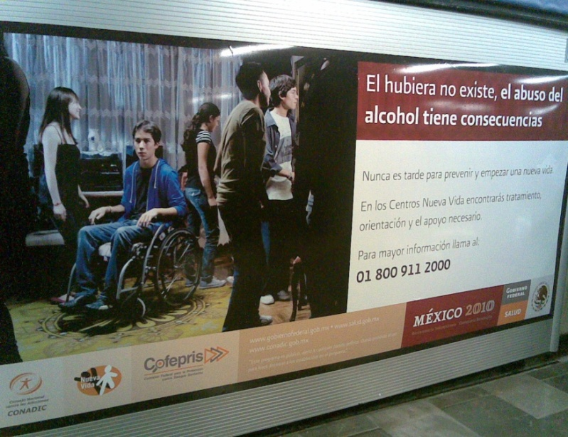
Analyzing the content of NDP, we can appreciate that is not coherent with the purpose of the CRPD. Because of this, is essential that the State retakes the design of its democratic strategy according to the international commitments. The current NDP, two years before ending its life, has few chances to be reformulated with a new real democratic view, with participation of all social groups specialized in the main topics about the development of the nation, but it is still time to gather the recommendations that the authors of this document ad well as other organizations of persons with disabilities file and will continue to file in the future as deriving from the information gathered for preparing this Alternate Report about the compliance of Mexico with the CRPD.
A true democratic strategy needs to be planed in a long term, and in its six years of enforcement we hardly see the first results. Because of this we consider appropriate that the Government guarantees a real democratic planning at the moment of its elaboration through the effective participation of those who have the experience to lead the project. In this way, we call for the elaboration a Structural Plan for the Development of Persons with Disabilities, with the full participation of the different social entities involved in the field.
Prevention of the alcoholism, against the disability.
8.2 Key findings of the national survey
In the case of the surveyed indigenous persons with disabilities, a constant was the inaccessibility to public services. We can appreciate that this social group has the lowest level of education compared with the other groups, and the lowest accessibility to work, health or rehabilitation programs. The NDP indentifies the members of native communities as a social group in risk of vulnerability, because of the historical condition of exploitation and marginalization. When these circumstances match with the condition of living with a disability, then the discrimination is an exponential reality that the state must cover.
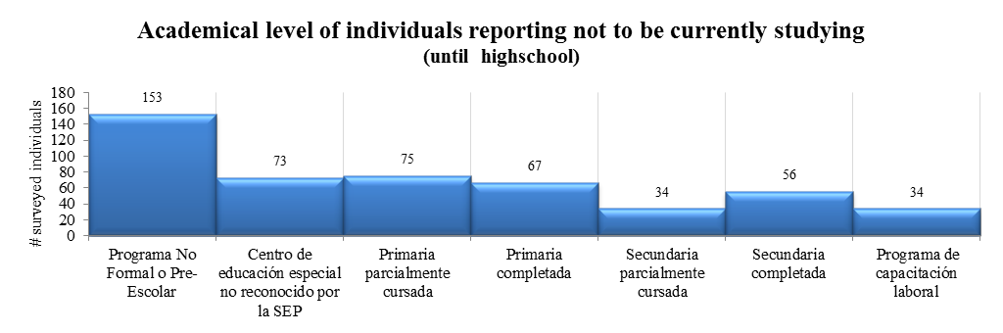
At PRONADIS (so far the best drafted public document about the matter) it is recognized the need of a restructuration of the public action about this issue:
“In Mexico different efforts have been carried out to measure the levels of disability since some decades ago. However, it is currently unknown the true dimension and historical behaviors of this indicator, provided that different concepts, classifications and sources of information have been used. Likewise, there have not been evaluated the impact of implemented programs and strategies in this country, which makes it difficult to design and direct correctly the public policies for the attention of persons with disabilities”..
This program pretends to be the leading document of public action for persons with disabilities. Even if it contains elements undoubtedly valuable to be taken into consideration, it has a deficiency that impacts on section 4.3 of the CRPD: There was an insufficient participation of persons with disabilities and the organizations representing them in the drafting of the planning of public and budgetary policies in the field contained therein.
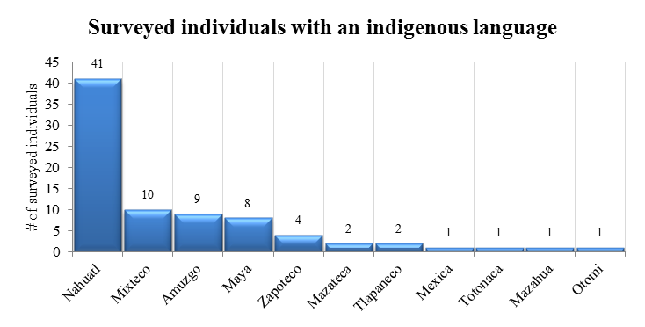
We hereby urge the State to include at the Structural Plan, that competent instances must work in the process of definition of the term “Persons with disabilities” and its translation to all different native language. In this way the native glossary for the persons with disabilities must include concepts contained in the CRPD, as the different types of disabilities and the principles contained in article 3º.
Additionally, PRONADIS, does not make any reference to the constitutional concept of “democratic planning” that provides that its elaboration must be done through the participation of the different social groups, will embrace the requirements and aspirations of society to incorporate them to the plan, and the development programs. The participation of social organizations was not opened, or broad, and it is not clear which of the elements of the participation of social organizations were taken into consideration.
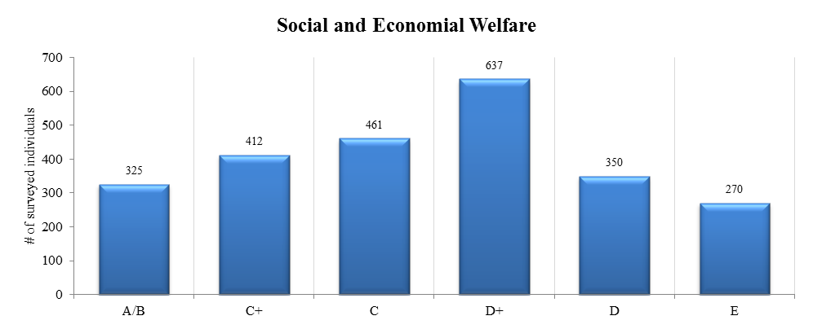
This program, even considering its proposed extensions, is a late delivery -2009- and it is not clear as to actual budgetary needs. In a national context marked by the short life of the programs of each government administration, it is in risk of terminating shortly and with no additional follow-up, for which it is a challenge for the Mexican government to achieve that programs like this surpass the brief political periods, generally comprising no more than six years. In COAMEX we think that the existence of PRONADIS has not implied structural changes or specific benefits for persons with disabilities.
Finally, the groups of the population in a situation of vulnerability continue in a historical challenge due to the fact that has little been analyzed: An integral system of exclusion that affects (invisibly) persons with disabilities. The national survey applied for documenting this alternate report, as well as the answers obtained from the federal authorities and the focus interviews reflect a hard reality: Mexican society lives the effects of a profoundly unfair social system, from which persons with disabilities are not excepted and towards which the State is not proposing a proper, organized and harmonized solution to the commitments assumed by the Mexican State two years ago upon ratifying the CRPD. When these categories cross their paths, we face peculiarities of extreme suffer: A person with disabilities, native and women, represents the edge of our discriminatory and excluding system. We call the State to analyze our historical reality and consequently act, with deep and long term measures, through a democratic planning, in order to achieve the basics of an including development, not only for persons with disabilities, but for all persons that live in this country.
Section of Recommendations of the Alternate Report by the Mexican Coalition for the Rights of Persons with Disabilities

Two years after the entry into force of the Convention on the Rights of Persons with Disabilities

Alternate report on the situation of the rights to health, work and education of persons with disabilities in Mexico

2008-2010

Recommendations for the implementation of the Convention on the Rights of Persons with Disabilities in Mexico two years after its entry into force

The Mexican Coalition for the Rights of Persons with Disabilities (Coalición México por los Derechos de las Personas con Discapacidad) (COAMEX) conformed by four major organizations devoted to offer services to realize the exercise of the rights of persons with disabilities in Mexico, namely: APAC, I.A.P (Asociación Pro-Personas con Parálisis Cerebral), Confederación Mexicana de Organizaciones en Favor de la Persona con Discapacidad Intelectual, A.C. (CONFE), Fundación Paso a Paso, y Libre Acceso, A.C., hereby respectfully presents before the Committee on the Rights of Persons with Disabilities the alternate report on the compliance of Mexico with the Convention on the Rights of Persons with Disabilities (the “CRPD”) two years after its entry into force, including this section of recommendations deriving thereof.
This section coincides with the main contents of the alternate report, and is an integral part thereof. In this section, we only perform a short recollection of the conclusions that summarize the main concerns of the more than 350 organizations nationwide in Mexico that are joined under the COAMEX.
The recommendations are basically of two types: general and specific to each right. The first ones are of a structural content, necessarily of a reach surpassing the present administration, which means a challenge to the Mexican government to guarantee the continuity in the long-run government planning. The rest refer to specific rights and may be understood as intertwining with the general, but that may also be applied in a shorter and independent timeframe, without the need to complete what is the main recommendation of this alternate report: the implementation of an Structural Plan for the Development of Persons with Disabilities.
A truly democratic planning, in depth and structural, is always a long-run strategy; its first six years of duration may only suffice to produce the very first results. Therefore, we think that it is necessary that the Government ensure that the planning is truly democratic at its roots, by fostering and effective and transcendental participation of those persons who have the experience to lead the process. We then urge the creation of an Structural Plan for the Development of Persons with Disabilities.

General Recommendations.
- The democratic planning must be the baseline from which to prepare Government actions regarding the implementation of integral and budgetary public policies, aiming at a conceptual level towards the principles of the CRPD and a broad human rights perspective, as mandated under the applicable international treaties subscribed, ratified and promulgated in Mexico.
- Thus, we urge the Mexican Government to prepare an Structural Plan for the Development of Persons with Disabilities in the short, medium and long term, to comply with the commitments of Mexico under the CRPD and to guarantee the inter-administration continuity in the execution of said projects.
  - This Plan should have as a priority the sectors of the population that are characterized by social and economical shortcomings, such as: rural communities, indigenous persons, persons living in the streets and in extreme poverty situation.
  - One of the first actions should be the development of an overview diagnostic of the status of social progress of persons with disabilities. To start an appropriate democratic planning it is necessary at least to know:
    - How many persons with disabilities live in this country, and where?
    - What types of disability does each one has?
    - What social- economic level characterizes each familiar group of the persons with disabilities?
    - What are their levels of access to education, health and work?
    - Which are their most urging needs, so that the State sets its attention on each case in a systematic and proactive way?
  - The Structural Plan should form part of the National Development Plan, as well as of the processes of harmonization of all laws nationwide.
- We think that it is extremely relevant to address one of the suggestions deriving of one of the in-depth interviews: the creation of a National Institute of Investigation for People with Disabilities, which has the necessary characteristics to articulate a scientific investigation about the needs of this social group and the way in which science and technology can improve the life quality of persons with disabilities and their families.
In the alternate, the strengthening and centralization of scientific research related with the rights of persons with disabilities and the state of their development and inclusion in Mexico may also be carried out through the new independent public entity (National Council for the Development and Inclusion of Persons with Disabilities) that will be created under the new General Law for the Inclusion of Persons with Disabilities.
In any case, the lack of accurate, trustworthy and systematized information is a very important shortcoming of Mexico, defaulting to its commitments acquired under the CRPD (Arts. 31, 33 and more generally Art. 4.1 of the CRPD) and that prevents in a relevant manner the creation of structural and coordinated public policies in the field, reason for which it is material to strengthen and professionalize scientific research in favor of persons with disabilities as follows:
  - We hereby urge the government of Mexico to take a decisive leap forward; consistent with international work that has been recognized to promote the creation of the CRPD. In addition to this, the work of investigation shall:
    - Systematize and centralize national and international researches regarding technical, technological and scientific advances in favor of persons with disabilities.
    - Update and systematize the general needs of the different types of disabilities and identify paradigmatic cases, in order to analyze them scientifically, based in the principles of the CRPD.
    - Scientific investigation of the specific issues of persons with disabilities, in order to give them clarity as well as facilitate to the different public o private, national or foreign entities, available information on the main developments and most urgent problems, overcoming the medical perspective with the universality of technical and technological applications enabling to better understand the characteristics of the different types of disabilities and the way to overcome the limitations that prohibit the full exercise of rights.
    - To offer general criteria over the different matters related to disability, to all public entities in the compliance of its strategic democratic planning. Therefore, the acquired knowledge will have different uses, ranging from statistical and informative value in general for all persons and the specialized researchers on the state of the development and the rights of persons with disabilities in Mexico to the necessary information to complete a proper formulation of public structural policies.
    - Further, based on the acquired information, this labor of research shall have as an objective to offer specialized opinions (including expert testimonies directed to administrative and judicial authorities) over the nature, barriers and necessary supports for the different types of disabilities, from a human rights perspective and particularly in the right to legal capacity of persons with disabilities, their social integration, life in community and regarding the support and decent treatment that must be granted to the different types of persons with disabilities.
    - To formulate a working program with the investigative works developed by other government agencies or of the private entities, such as persons with disabilities organizations, universities and centers of research.
- Article 33 of the CRPD provides at least two levels of monitoring for the implementation of the CRPD: that each State shall appoint one or more government entities, considering the possibility to establish or appoint a coordination mechanism to facilitate the adoption of measures in different fields and levels. And a framework that shall consist of different independent bodies for which it shall consider the function of national institutions to promote and protect human rights. Additionally, civil society and particularly, persons with disabilities shall be a part of this whole process.
  - In the case of the government of Mexico, the National Council for Persons with Disabilities (CONADIS) was legally drafted in year 2005 (before the entry into force of the CRPD) as an inter-institutional mechanism of coordination part of the Ministry of Health and, even when its efforts have been remarkable, we think that the process of monitoring the implementation of the CRPD requires a structural change under the principles of article 33 of the CRPD.
  - Current CONADIS has no legal or financial existence of its own and shall transform to a new public agency with its own legal personality and funding under the name National Council for the Inclusion and the Development of Persons with Disabilities, in accordance to the terms of the new legislation.
  - However, its is foreseeable that the authorities of this new legal entity will continue considerably limited and far from the degree of legal force that is required in a country like Mexico to achieve the compliance of the CRPD.
  - As an example of the shortcomings of this new public entity is that it will continue with no legal authority to investigate or sanction the violations to the rights of persons with disabilities, or to legally require information from the different government entities to monitor the implementation of the CRPD in Mexico. Likewise, the budget available for persons with disabilities programs has been historically limited in Mexico. Without the proper funding and legal force, this new government entity will continue having difficulties to foster the surveillance and implementation of the CRPD in Mexico.
  - We think that the efforts carried out by this new legal entity must be started by a careful initial and fundamental public planning, which may be carried out by means of the Structural Plan for the Attention of Persons with Disabilities outlined above as a part of the recommendations of this Report, or though any other document that guarantees the structural development of persons with disabilities in Mexico, throughout the different administrations.
  - With no structural plan of development, the efforts of the new government entity and of the Mexican State in general to implement the CRPD will continue to be disaggregated, uncoordinated and with the risk of achieve little in favor of persons with disabilities in Mexico along the next period of revision of the CRPD, as it has been the case so far in this initial two years.
  - The new national mechanism will have, among its purposes, to achieve the coordination through figures such as inter-institutional bonds, in order to equally apply public policies, as well as to facilitate the drafting and systematizing of information, even for the elaboration of Governmental reports. Such bonds must be, preferably, persons with disabilities that have the necessary aptitudes, o persons with disabilities with proved experiencie in the matter.
  - Additionally and as provided under article 33.2 of the CRPD, we recommend that the Mexican Government calls for an open forum in order to discuss the characteristics of the framework of independent bodies for the surveillance and implementation of the CRPD. In said forum, it shall be sought the participation of civil society in general and specifically of persons with disability and their sponsoring organizations (Art. 33.3). To achieve a major effect, the characteristics, legal nature and the extents of this independent framework shall be sufficient to achieve its effectiveness and fulfill the concept of independence envisioned by the CRPD.
  - The independent mechanism may be based in the appointment of an autonomous body such as the National Commission of Human Rights and may guarantee at all times the participation of civil society in the phase of drafting, planning and execution of all of its scopes, not only of persons with disability organizations, but also of researchers and scholars related to the rights of persons with disabilities and other persons with a proved experience in the field.
  - For this end, it must be used the experience and promoted the participation of disability organizations in all States of Mexico, by public callings that enable an inclusive, equal and transparent collaboration, so that civil participation is the best qualified and with the best experience on the field.
- The Government of Mexico shall revisit its system of information in order to reflect clearly a democratic and strategic planning in terms of article 26 of the Constitution, seeking to achieve better results, at least in the field of persons with disabilities.
  - Shall the users of the government information service INFOMEX require information of the structural and democratic planning, this government agency must refer clearly the roadmap between this information and its specific application to public policies: starting from the applicable constitutional provisions, the applicable sections under the National Development Plan (or its equivalent under the National Human Rights Program) and the way in which each public entity shall specifically implement said strategy to comply with the commitments of Mexico under the CRPD.
- It is material that the Mexican State creates an intensive program of statistic information of persons with disabilities throughout the National Institute of Statistics, Geography and Informatics, to homogenize the establishment of structural public policies, provided that the basis of all public function is the acquisition of systematized information on the field. The required statistics will need to contain, at least the following sections:
  - The complete and correct number of persons with disabilities living in our country.
  - The type of disabilities.
  - Sex, age, measurements, weight.
  - Geographical location in the different States and regions of this country, disaggregated as per the type of disability.
  - Kind of received medical attention, habilitation and rehabilitation, differentiating if it was on the public or private services.
  - Accessibility and proximity of the services of health and education.
  - Shall it be a financially active individual, its current occupational status.
  - Socioeconomic level.
  - Belonging to an indigenous population.
  - In case of individuals of legal age, if he or she has a Federal Voting ID Card.
  - Modality and perceived quality of the educational service that he or she receives, level of education, and academic degrees.
- The Mexican State shall make sure that public agencies use the correct terms to refer to persons with disabilities, as provided under the CRPD, and throughout the mass media of communication, by documents issued with public funds. The individuals responsible under the three branches and levels of Government shall raise its awareness regarding the decent treatment towards persons with disabilities, including the language upon referring the items related to persons with disabilities.
  - Through strategic planning, they shall be implemented permanent campaigns that seek to strengthen a culture of inclusion and respect for the human rights. The General Bureau of Radio, Television and Cinema (RTC) of the Ministry of Interior, in charge of the surveillance of the contents of means of communication in Mexico, shall raise its awareness of the concepts and definitions regarding persons with disabilities, with the purpose of establishing the terms of reference provided under the CRPD and to promote its implementation in Mexico. This planning must include the emissions of private entities through public telecommunications networks.
  - One of the objectives shall be the elimination of information by any mean with a content that demerits the conditions or the perception of persons with disabilities, particularly those situating disability as a situation of disgrace or inconvenience that must be avoided.
  - In the same sense, the competent entities will act in a coordinated manner, once they have received a training process, to regulate the promotional segments or regular programming, only to make sure they lack phobias or distortions that may conflict the awareness and objective information, make difficult the clarity perspective, or exploit the drama the specific persons or social groups currently live.
  - In such manner, the State is the principal regulator in order to reduce the inequality among the components of society. One of the points of this inequality is the manner how the different social groups are labeled between one another. Who do not live with disabilities; normally do not know how to treat some who has.
  - The Mexican State must be careful so that its prevention campaigns, including those addressed to persons with disabilities, do not include stereotypes, promote phobias or use examples not compatible with the human rights perspective of disability proposed by the CRPD. This regulation must include all means of mass communication, including all contents of private entities through public telecommunications networks.
- The Mexican State must issue guidelines (that could be implemented through a Mexican Official Standard (NOM)) regarding the way in which it must be handled advertising and contents in mass media, ensuring that its content is consistent with article 8 and other applicable provisions of the CRPD, with no kinds of stereotypes and that messages do not imply a decrease on the dignity of persons with disabilities, preventing ideas of pity or a mistaken thinking of persons with disabilities.
- To include the matter of persons with disabilities in the National Human Rights Program. The State must include in a detailed and systematized manner the nature and extents of CRDP in the reality of Mexico that shall be directly linked wit the NDP. The programmatic contents of each document shall be properly differentiated.

Specific Recommendations

Accessibility.
- The Mexican State shall identify the best public practices in the field of accessibility, and from them produce collaborations. Particularly, we recommend that CONADIS or the entity appointed by the Mexican State, systematize the experiences of the public entities that have universal accessibility in their facilities.
- The Mexican State must support in a more substantive and broad manner the civil organizations with sufficient experience and contributions in the field of research, application or use of accessibility technologies. Consequently with the preceding recommendation, the agency of the State in charge of systematize the experiences in the field, shall also carry out active and ongoing consultations with persons with disabilities and their sponsoring organizations.
- The Mexican State must make a bigger effort to produce structural collaborations for the implementation of universal accessibility measures for persons with disabilities, by increasing the amount of public budget and coordinating specific follow-up and evaluation programs for public works, but also in the requirements of construction and refurbishment of public and private premises.
  - The obligation of achieving universal accessibility for persons with disabilities must be set in a set of binding regulations, either in the form of an Mexican Official Standard (NOM) or through any other regulation applicable to public as well as to private entities.
  - In the case of the National Institute to Promote Workers Housing (INFONAVIT), the Mexican State must produce registrations of persons with disabilities in conditions to receive a housing credit, of those persons with disabilities that are on the row to complete this procedure and those that are already enjoying one as holders of this financial credit, in order to visualize the existence of persons with disabilities accessing to social security housing.
  - Additionally INFONAVIT shall strengthen its construction requirements, so that all social security housing have structures that guaranty an integral universal accessibility so that all persons with disabilities, and not only those with a wheelchair-related disability, have less barriers to access to these premises. For such extents, it shall search the assistance of other public instances that have reported remarkable advances on the field, such as the Federal Electorate Institute (IFE) or the Human Rights Commission of the Federal District (CDHDF).
- The Mexican State shall include in its Structural Plan (if such a document is issued) as well as in the different applicable and binding legal provisions in the field, the definition of universal accessibility, providing the nature and extents of said definition, as well as its main principles, so that the Ministries of State have a clear and specific regulation regarding the universal accessibility and not only one aiming towards persons with wheelchair-related disabilities. Among others, the obligation to design public buildings and refurbishments in an accessible manner, may be included and regulated specifically as to the minimal accessibility requirements for all persons with disabilities, in the Law of Public Works and Services Related thereto and its Regulations, as well as on the different provisions and related recommendations that the Ministry of Public Function may issue on the matter.
5. Considering that the cultural differences may result in unavoidable results for achieving universal accessibility, particularly for the members of indigenous populations, we found out that this social group is the one with the worst levels of studies, comparing it with other social groups; as well as the ones with the worst accessibility conditions to the work, health and habilitation or rehabilitation centers. Even the NDP locates this population as a social group in risk of vulnerability. When this circumstance meets with the fact of living with a disability, then discrimination turns into an exponential reality that the State must combat, for which we make the following recommendations:
  - In order to start with a perspective based on the indigenous populations or Mexican native populations, we hereby urge the Mexican Government, so that in its Structural Plan (if such a document is issued) as well as in the different applicable and binding legal provisions in the field, includes as a part of said planning, that the corresponding government agencies prepare some terms of reference to translate fully the term persons with disabilities and the CDPD and other materials with respect to the rights of persons with disabilities to the indigenous languages of Mexico. Thus, the terms of reference, and other materials that are produced shall incorporate the principles of the CRPD, such as the different types of disabilities and the principles of article 3.

Education.
- The Mexican State must amend the different laws, regulations and other legal provisions related to education in order to fully acknowledge the right to an inclusive education of persons with disabilities and direct the necessary budget sections to such end.
  - The applicable legal provisions must be amended pursuant to an inclusive perspective, and considered integrally and jointly with its community based background and a long run perspective that embraces all the life period of a person with disabilities, pursuant to its possible capacities.
  - Persons with disabilities shall have the guarantee that the State will provide the maximum level of attention that a person may reach, without affecting its finances or the separation from his or her family or community.
  - The right to an inclusive education must be acknowledged and implemented in all modalities of education and schools nationwide, and not only in special education schools, as currently happens.
  - This effort must be shared by the authorities at a Federal level as well as by State level authorities, considering that education is a concurrent responsibility of the Federation and the States in Mexico.
- In order to reach an inclusive education, the Mexican State must carry out a national diagnosis of how many boys and girls, teenagers and adults with disabilities are currently in an age proper for education and/or are in process of being educated or have an unfinished education due to the barriers to education faced by persons with disabilities.
- This information must determine how many persons with disabilities are users of both the regular and the special education system, either in private or in public schools, determine the reasons that difficult their educative inclusion and strengthen their efforts in the correct direction.
  - It is material that as part of the national diagnosis of inclusive education of persons with disabilities, it is incorporated the analysis of private schools. It is material to know if the application of educative programs are fully complied with, if the universal accessibility requirements are complied with in terms of the CRPD, and if an inclusive education is also being offered at said schools.
  - In order to reach an adequate diagnosis, it is material that the organizations of persons with disabilities that work in the fields of education towards the different types of disabilities, are able to participate in the different stages of the preparation of said analysis, from its planning to its final execution.
  - Likewise, it is material to promote the formation and employment of professors with disabilities, and professors qualified in the Mexican Signs Language and the Braille writing system and in the attention to persons with intellectual disabilities. In Mexico, professors with disabilities have been traditionally discriminated for eugenic reasons and teaching formation criteria, that the State must ensure its disappearance, in accordance to its commitments upon ratifying the CRDP.
- The Mexican State must work in an education policy that is inclusive and permanent towards persons with disabilities in all levels and modalities of education. In terms of article 24 of the CRPD, it shall ensure that from kindergarten to the highest academic degree, persons with disabilities are able to receive an inclusive education in accordance to its needs and seeking to strengthen its abilities, understanding that education is a life process just as the rights to health and work.
- Based on the results obtained from the national survey, as well as on the information provided by the public agencies, we notice two situations that must be thoroughly analyzed by Mexico: in the reality, each state has its own interpretation regarding the structuring and generalities of its educative system, which provokes a lack of uniform direction that may generate even opposed practices. On the other hand, we are still far from the objective of inclusive education, as we notice that some of the old measures subsist even deriving from previous regulations to the 1994 amendments. Therefore, it is necessary to complete an analysis over the implementation of the principles of inclusive education for students with disabilities.
- The Mexican State must apply the necessary budget sections as well as to facilitate the coordination between the authorities of the different Federative States in order to carry out a proper national diagnosis regarding inclusive education of persons with disabilities in Mexico, as well as to design a structural program and follow-up until the total implementation of the supports, materials and structural reforms necessary to ensure an inclusive education of persons with disabilities in all schools nationwide.

Work.
- The Mexican State must update its compliance with the Convention 159 of the ILO as to apply and review periodically the national policies in the professional rehabilitation and employment of “handicapped persons”, as it is provided under article 2 of the referred Convention. Evidently the concept of rehabilitation (currently applicable and applied in Mexico to persons subject to a criminal procedure), is overcome by the third principle of the CRPD: the principle of full inclusion and participation.
  - The update of the Mexican commitment to review periodically the abovementioned national politic, must be carried out in terms of the referred advances provided under article 27 of the CROD, in order to achieve the following actions:
    - To prohibit the discrimination related to disability in all labor mattes.
    - To protect the rights of persons with disabilities in equal conditions to all other persons.
    - To ensure the compliance of labor unions.
    - To enable effective access to technical training and labor finding services and of continual professional education.
    - To foster labor opportunities and their labor promotion.
    - To promote entrepreneurial opportunities and safe employment and collaborative efforts.
    - To employ persons with disabilities in the public branch.
    - To promote the employment of persons with disabilities in the private sector, by affirmative actions programs, employment expositions directed to persons with disabilities and general programs of promotion of persons with disabilities in the ordinary labor market.
    - To order and surveil the progressive realization of reasonable adjustments in labor premises.
    - To promote programs of vocational and employment rehabilitation in the ordinary labor market.
- The provisions of the Federal Labor Law currently in force provide a specific regulation for the employment of different groups of the population in conditions of vulnerability such as women and children; however, they fail to provide a specific section for the work of persons with disabilities. Likewise the labor legal provisions currently in force in Mexico understand disability only as a “labor disease” or situation that makes it impossible for a person to work, and not as a situation in which it is necessary to order the performance of reasonable adjustments to promote the inclusion and participation of persons with disabilities in all aspects of life.
  - The Federal Labor Law of Mexico and other applicable legal provisions relating to employment (private and public) nationwide, as well as those provisions on social security must be amended in order to include the new perspective of persons with disabilities and eliminate the legal inexistence of persons with disabilities in Mexican labor laws.
- Even when federal authorities did not report a strategic or democratic planning in the requests of information filed on the INFOMEX system regarding the right to work of persons with disabilities, it may be notices that there are some advances and interesting incentives as it is the case of the certification as an Inclusive Enterprise Gilberto Rincón Gallardo, granted by the Ministry of Labor and Social Security.
  - However, we recommend that said programs must be linked with a strategic-democratic planning that is part of the NDP or of an Structural Plan for the Development of Persons with Disabilities, that shall be a part thereof or that must be intertwined, in order to reflect a clear formulation of the project, as well as an adequate implementation of specific public policies, besides that said programs must be re-launched in order to foster its knowledge by the general public.
- One of the characteristics that must incorporate the Mexican government to its labor public policies is that the public service increases the amount of employees with disabilities in public offices of all levels. The quality of persons working is one of the indicators of an effective policy of inclusion.
  - Labor inclusion must consider all persons with disabilities and not only persons with wheelchair-related disabilities; the unemployment rates of persons with other kinds of disabilities decreases gradually until almost full unemployment in the case of persons with intellectual disabilities in Mexico. Therefore, public policies must include all persons with disabilities, fostering labor conditions through specific programs for each kind of disability.

Health.
- In the Structural Plan (if such a document is issued) as well as in the different applicable and binding legal provisions in the field, it shall be defined the way in which the democratic planning will ensure health services, and services of habilitation and rehabilitation for persons with disabilities from a general to a specific perspective. The budgetary allocations shall follow a similar path: each budget section shall include its base of strategic planning in order to prevent that there are public programs not referred to a structural planning.
  - The duration of programs need a preceding structure based on the NDP, same planning principle that is also provided under the CRPD (Art. 4.1.c). If there is no structural planning, the programs carried out are not true Democratic Planning, and turn into emergency actions, with no structure, objective or auditable results.
- In the structural treatment of the access to health, habilitation and rehabilitation, the Mexican State must implement in its Structural Plan (if such a document is issued) as well as in the different applicable and binding legal provisions in the field, specific measures to satisfy the demand of drugs, other elements and infrastructure for rehabilitation. This treatment must guarantee the access to persons with disabilities and their families that live far away from big urban spots, where big hospital centers are located, producing a spiral of discrimination for the rest of the population, including persons with disabilities.
  - For such extents, the Mexican Government must evaluate the advancements reached and the experiences accumulated by the National Institute of Rehabilitation, as an undeniable example of good practices that may be replicated in all regions of the country in a progressive timeframe, but as a priority measure.
  - A margin relatively big of the surveyed individuals (39% of the total amount) referred not having being able to acquire medicines in public hospitals. The consulted hospitals did not report the amounts or quality of medicines or programs by the Mexican State to cover demand. We insist that if we do not know the state of demand, we will hardly find out how to satisfy demand through a careful offer directed at the needs of individuals. We think that in order to start resolving this situation in a democratic planning, it must start in the basis of how many persons with disabilities live in this country and where do they live and which are their needs, among them, their needs of medicines.
  - In the aspects of preventive health for women, the fact that more than half of the women we surveyed report not having a gynecologic attention is concerning and it is material to undertake immediately actions of prevention and treatment; besides better planned and democratic actions that the federal authorities must implement to comply with the provisions of the CRPD.
  - It is advisable that, as short term measures, the Mexican State calls upon the Ministry of Health, the CONADIS (or the government agency replacing it in the future) and the National Commission for the Development of Indigenous Populations, and evaluate immediate measures to conform a roadmap based in the census obtained by the federal government agency in charge of Indigenous Populations, and to implement a National Program for the Prevention of Diseases of Women with Disabilities. For this, it must be sought the coordination with the three levels of government, particularly with municipal authorities considering its better knowledge of towns located far from urban spots.
  - For considering the best measures to adopt, regarding the foregoing paragraph, it must be taken into consideration the opinion of the more than 1,311 Basic Rehabilitation Units, as well as the Mobile Rehabilitation Units reported by the Ministry of Health.
  - The medical attention units must have full accessibility for persons with disabilities. Particularly, medical instruments with X rays must have due adjustments for the needs of persons with disabilities.
  - On this regard, the national health system must implement accessible mastographs for women with disabilities.

Legal Capacity.
- Regarding the legal capacity of persons with disabilities in Mexico, there have been throughout these two years of duration of the CRPD several discussions regarding the right to legal capacity of persons with disabilities in Mexico, ranging from the position that civil regulations currently in force in Mexico that seek to “protect” persons with intellectual and psycho-social disabilities through guardianship grant better rights to persons with disabilities than the CRPD, to more reasonable positions on the matter based on highlighting the need to create support mechanisms before acknowledging the right to full legal capacity of all persons with disabilities in terms of article 12 of the CRPD.
- We think that the following actions are necessary in the field:
  - To withdraw immediately the declarative interpretation filed by the Mexican State to article 12 of the CRPD.
    - We think that the declarative interpretation is contrary to the object and purpose of the CRPD, by providing fundamentally that the system of guardianship currently provided under Mexican local laws might be superior to the full legal capacity of persons with disabilities provided under article 12 of the CRPD.
    - In connection with the pro-person principle referred to in the declarative interpretation of Mexico to article 12, said principle is already provided for in article 4.4 of the CRPD, but the latter refers to the provisions that best guarantee the “exercise of the rights” of persons with disabilities, the declarative interpretation provides that it shall prevail the measures that “best protect” persons with disabilities.
    - This is relevant, considering that guardianship is a limitation to the direct exercise of rights by persons with disabilities.
    - This difference and the insistence of the Mexican State that the “protection” must prevail over the “empowerment” of persons with disabilities, are contrary to the ends of the CRPD, for which such declarative interpretation must be immediately withdrawn, as conflicting with the provisions of article 46.1 of the CRPD and also to article 19.C of the Vienna Convention on the Law of Treaties.
  - Initiate an amendment process to the Constitution in order to fully acknowledge the legal capacity, in terms of article 12. We must consider that currently an amendment process to the Constitution regarding human rights is taken place. In such process, the Government must incorporate the fully legal acknowledgment, which would open the possibility of legislative changes in a short period of time, and therefore a fulfillment to one pending commitment before the concert of nations must be done, but also before the organized civil society and millions of persons with disabilities, along with their families.
  - The Mexican State must carry out a broad consultation nationwide to eliminate guardianship in every and each of the 32 Civil Codes of the different Federative States and to replace such provisions for regulations that guarantee the full participation, empowerment and assisted decision making of persons with disabilities.
  - The Mexican State must direct sufficient funds for this discussion to be carried out nationwide and to provide necessary coordination with authorities in the administrative, legislative and judicial branches of all Federative States nationwide.
  - The Mexican State in coordination with the governments of each of the Federative States shall direct sufficient resources to create a system of support mechanisms for the exercise of legal capacity, including those mechanisms of support for community living and supports for the independence of persons with disabilities, with due regard to the provisions of article 19 of the CRPD.
  - The discussion must include at all times persons with disabilities and their supporting organizations, which must be consulted strongly and actively at all moments of the discussion, until the final adoption and implementation of structural public policies on the matter.
- The current limitations of legal capacity of persons with disabilities in Mexico affect not only the exercise of civil and financial rights of persons with intellectual and psycho-social disabilities, but also they negatively affect other aspects that must be analyzed and amended pursuant to the public and national consultation processes outlined above.
  - On the one hand, persons with intellectual and psycho-social disabilities are currently limited to file or defend criminal accusations against crimes committed to them or of which they were witnesses based on groundless criteria and that are on its last degree justified by the civil conceptions on guardianship.
    - These limitations place persons with intellectual and psycho-social disabilities in a particularly special and concerning situation of vulnerability in criminal matters.
  - Likewise, the restrictions to legal capacity of persons with disabilities has a negative impact in the access to justice of persons with disabilities.
    - Persons with disabilities are currently discriminated and limited their access to judicial procedures in Mexico.
    - Additionally, we do not know any effort that is currently being undertaken in the new procedures to implement oral trials in Mexico, which will make it in the future difficult for persons with disabilities to participate in these kind of procedures.
  - Thirdly, the restrictions to legal capacity of persons with disabilities have substantively negative effects on the involuntary internment of persons with disabilities in psychiatric hospitals in Mexico.
    - Groundless, some directors of psychiatric hospitals in Mexico tend to affirm that they are the legal guardians of all interned persons in said hospitals and with this supposed powers limit their liberties and independence, authorizing even in extreme cases chirurgical interventions of lobotomy, as it has been reported in Mexico by some national and international organizations.
  - Finally, persons with intellectual and psyco-social disabilities are limited also of their right to free movement not only as per different discriminating practices by private airlines that request medical certificates to allow the access of persons with disabilities, but also for the requirements provided in the regulations for issuing passports, prohibiting persons with intellectual and psycho-social disabilities of acting by themselves and obtaining a passport, even in the case when they have not been legally subjected to guardianship.
  - These and other violations of the rights of persons with disabilities recognized in the CRPD as well as in other international treaties are closely related to the right to legal capacity provided in article 12 of the CRPD.

Glossary of Defined Terms and Abbreviations
CRPD. Convention on the Rights of Persons with Disabilities
COAMEX. Mexican Coalition for the Rights of Persons with Disabilities (Coalición México por los Derechos de las Personas con Discapacidad).
COFEMER. Commission on the Improvement of Regulations (Comisión Federal de Mejora Regulatoria).
CDHDF. Human Rights Commission of the Federal District (Comisión Nacional de Derechos Humanos del Distrito Federal).
CNDH. National Human Rights Commision (Comisión Nacional de los Derechos Humanos).
CONADIS. National Council for Persons with Disabilities (Consejo Nacional para las Personas con Discapacidad).
DIF. Family Development Institute (Desarrollo Integral de la Familia)
INEGI. National Institute of Statistics, Geography and Informatics (Instituto Nacional de Estadística, Geografía e Informática),
INFONAVIT. National Fund for Workers Housing (Instituto del Fondo Nacional de la Vivienda para los Trabajadores).
IMSS. Mexican Social Security Institute (Instituto Mexicano de Seguro Social).
INFOMEX. System for the access of public information created by the Federal Institute for the Access of Information (Sistema de acceso a la información pública, creado por el Instituto Federal de Acceso a la Información).
ISSSTE. Social Security Institute for Employees at the Service of the State (Instituto de Seguridad Social y Servicio para los Trabajadores del Estado)
NDP. National Development Plan (Plan Nacional de Desarrollo).
PRONADIS. National Program for the Development of Persons with Disabilities (Programa Nacional para el Desarrollo de las Personas con Discapacidad).
SEP. Ministry of Public Education (Secretaría de Educación Pública).
SHCP. Ministry of Finance and Public Credit (Secretaría de Hacienda y Crédito Público).
SEDESOL. Ministry of Social Development (Secretaría de Desarrollo Social).
SEMS. Under-Ministry of Middle and Higher Education (Subsecretaría de Educación Media Superior).
SS. Ministry of Health (Secretaría de Salud).

This law was published in the Federal Official Gazette on June 10, 2005, during the term of office of President Vicente Fox, almost three years before the adoption of the Convention.
The COFEMER is the public entity in charge of verifying the viability of the regulatory drafts for the laws nationwide. In the case of the General Law of Persons with Disabilities, the process is currently on a study phase and has received comments from private parties, which must be taken into consideration.
Cf. Initial Report of Mexico regarding the implementation of the Convention on the Rights of Persons with Disabilities, eg. Paragraph 52.
The NDP is a document mandated by article 26 of the Constitution of the United Mexican States “The purposes of the national project contained in this Constitution, will determine the objectives of the planning. The planning will be democratic. Through the participation of several social sectors the aspirations and requests of the society will be gathered in order to incorporate them to the plan and the development programs. There will be a national development plan to which all programs of the Federal Public Administration will be compulsory subjected”.
The Convention is very careful with the use of this term, and in turn uses the word inclusion, which is used seven times in the Convention.
As, per example, under section iv) or article 154 of the Criminal Code of the State of Veracrúz, which provides an exclusion of criminal liability for abortion if “as certified by two physicians there is reasonable grounds to determine that the product of conception suffers an alteration that results in the birth of a being (sic) with severe physical or mental deficiencies”.
Cf. Disability Rights International and Comisión Mexicana de Defensa y Promoción de los Derechos Humanos, Abandoned & Disappeared: Mexico’s segregation and abuse of Children and Adults with Disabilities, Mexico 2010.
Additional elements of the applied methodology may be discussed further as per reader’s request.
Regarding this, we may consider this circumstance a mistake in the planning of the survey document. The characteristics that objectively may be established are: congenital (toward the birth and embryonic development, drugs influence or exposure to chemical or radioactive substances), genetic (genome alteration, Down syndrome, for example), hereditary (if the genetic disease is inherited by the parents, which not necessarily occurs in a strict genetic effects), when born, accident and by medical mistake.
Law published in the Federal Official Daily on June 11, 2003. See section VI of article 13 of such law.
Law published in the Federal Official Daily on June 10, 2005, also during the term of Vicente Fox, during which the Convention’s proposal was boosted.
Resolution by which the guidelines of accessibility in federal buildings for persons with disability are established, published in the Federal Official Daily on January 12, 2004. The first article of such resolution provides that: “The provisions of this Resolution are mandatory for the authorities and entities of the Federal Public Administration that use the real property owned by the Federation and its purpose is to regulate the design and performance of the architectonic and urban elements that ease the access, transport and use of the same by persons with disability, in the internal and external spaces of federal buildings in which the human activity is developed”.
CFR http://www.apartados.hacienda.gob.mx/presupuesto/temas/pef/2010/temas/tomos/11/r11_ppcer.pdf
Taken from the newspaper La Jornada, dated August 7, 2010, front page.
CFR.http://medusa.coneval.gob.mx/cmsconeval/rw/resource/coneval/EVALUACIONES/Recomendaciones_09_10/SEP/docTrab_Fortalecimiento%20Educacion%20Especial%20e%20Integracion.pdf;jsessionid=AD90DC4142FA516396DC6FFD2113E9BF?view=true
The Program refers a figure from INEGI: the general population with economic participation was 49.3% and regarding the population with disabilities, the indicator is of 25%.
The ILO defines three categories: Work, Employment and Decent Work. The first refers to the activities in general, the second to the accrued work, and the third to the one that enjoys of the minimum characteristics acknowledged by the human rights international instruments. In fact the ILO motto is: Decent Work for everyone. CFR: http://white.oit.org.pe/portal/especial.php?secCodigo=150
COAMEX knows the existence of a program that was not reported in the questions to the system INFOMEX. This program called National Program of Work and Training for Persons with Disabilities has interesting contributions, but it has lacked an appropriate budgetary support. It is regrettable that this program was not reported in the set of questions.
National Program for the Development of Persons with Disabilities (PRONADIS) 2009-2012 . Page 50.
Cf. Disability Rights International y la Comisión Mexicana de Defensa y Promoción de los Derechos Humanos, Abandonados y desaparecidos: Segregación y Abuso de Niños y Adultos con Discapacidad, México, 2010.

