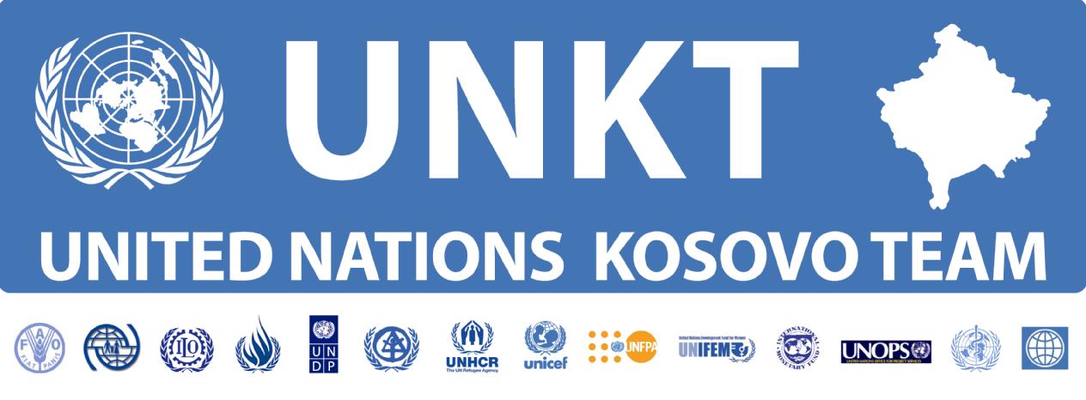

Initial Observations on Gaps in Health Care Services in Kosovo
(January 2007)

I. Introduction

1. Since 1999, considerable improvements have been achieved in the provision of health care services in Kosovo. With the support of international assistance and funds made available by the Provisional Institutions for Self-Government (PISG), many primary health care centers, hospitals, and other specialized health facilities have been rehabilitated. In spite of these improvements, however, numerous shortfalls continue to affect the proper functioning of the health care system. These are mainly related to a lack of health care personnel, lack of adequate management of health services, obsolete medical equipment, and insufficient supply of essential drugs, resulting in inadequate treatment and alleviation of medical conditions.

2. This information note is intended to assess, in a non-exhaustive manner, the availability of health care services in Kosovo and the areas where the delivery of such services is not up to acceptable standards. It is hoped that the document will raise awareness in respect of the humanitarian policies to be implemented for the benefit of people suffering from health conditions, whether physical or mental, and who cannot receive appropriate medical attention in Kosovo and enhance the understanding of the current deficiencies of the health care system and stress to donors the need for more resources to be dedicated to the improvement of health facilities in Kosovo.

II. Overview of the current status of the Kosovo Health Care System

3. The health care system in Kosovo consists of primary health care centers located in each municipality; secondary health care facilities at the regional level (hospitals); and tertiary health care centers – University Clinic Center and other specialized institutions. A referral system is in place, whereby the University Clinic Centre identifies cases with serious medical conditions requiring sophisticated treatment outside Kosovo and refers them to the Ministry of Health.

4. Since 2003, the Ministry of Health has been running the referral scheme which appears to be chronically under-funded. According to Ministry of Health officials, in the course of the current year the total funding available amounts to €500,000. From July 2003, when the scheme began, through the end of September 2006, 2,953 cases were approved for treatment outside of Kosovo by a 5- member medical committee within the Ministry of Health. During the same period, 836 cases only (28 percent) could receive medical attention overseas. The remainder of the referral cases is still on a waiting list due to lack of funds. The usual waiting period for referral is one to two years. Most critical cases are prioritized to the extent possible.

5. A number of serious medical conditions cannot currently be cured or treated in Kosovo. A non-exhaustive list of these conditions comprise leukemia, kidney failure involving transplantation of organs, all types of cardio surgeries, severe eye diseases, and treatment of cancer requiring radiotherapy.

III. PTSD and other Mental Disorders

6. A recent study revealed that the prevalence of PTSD, depression, and emotional distress in Kosovo remains high. There is also a marked increase in the number of suicides committed after the war compared to the pre-1999 period.

7. The current capacities of the mental health sector in Kosovo are far from being sufficient in effectively addressing the population needs in terms of mental disorders. WHO in Pristina confirms that there are eight outpatient mental health facilities (Community Mental Health Centers – CMHC) in Kosovo. Based on the total population of Kosovo, one CMHC is meant to cover a population of 250,000. Additionally, there are five community-based psychiatric inpatient units that are based in four district hospitals and one in the Pristina University Psychiatric Clinic. These five centers have a total capacity of 8.7 beds per 100,000 people.

8. There is also a lack of human resources engaged in the mental health sector. According to a recent WHO report on mental health, “the number of personnel in either public mental health facilities or private clinics per 100,000 population is 13.78. The following is the breakdown by profession per 100,000 individuals: 1.89 psychiatrists, 1.26 other medical doctors, 8.84 nurses, 0.32 psychologists, 0.52 social workers, 0.00 occupational therapists, and 0.47 other health or mental health workers (psycho-social counselors).” Below is a comparative table of mental health workers available in Kosovo and selected European countries:

 |  | Austria | Denmark | Germany | SCG | BiH | fYROM | Albania | Kosovo
per 100.000 pop. | No of psychiatrists | 11.8 | 16 | 11.8 | 12.8 | 1.8 | 7.5 | 2.2 | 1.9
per 100.000 pop. | No of psychologists | 49 | 85 | 51.5 | 1.2 | 0.5 | 2 | 0.2 | 0.3
per 100.000 pop. | No of psychiatric nurses | 37.8 | 59 | 52 | 19 | 10 | 24 | 4.2 | 8.8
per 100.000 pop. | No of social workers/ counselors | 103.4 | 7 | 477 | 0.5 | 0.03 | 1.5 | 0.4 | 0.5
Source: www.who.int

9. There is no indication that there will be any improvement in this regard in the near future. In 2006, only three percent of an already insufficiently funded health care budget is devoted to mental health. This percentage is expected to be even lower in the years to come, as result this will bring in question efficient functioning of community based mental health centers and other mental health institutions.

10. Mental health care in Kosovo has a biologically-oriented (drug) treatment with very limited or no socio-therapeutic or psycho-therapeutic complementary treatment. This is also proven by the low number of available psychologists (only 0.32 per 100,000 population) and psycho-social counselors (only 0.47 per 100,000). On the basis of their current capacities, mental health institutions can only provide health care to severely chronic mental illnesses, while cases of mental disorders such as PTSD and other forms of depression are hardly able to receive medical attention. As confirmed by WHO, 90-95 percent of persons with PTSD do not receive appropriate treatment. Mental health disorders require a complementary psycho-therapeutic follow-up treatment, as per WHO recommended protocols.

11. The Ministry of Health, supported by the Danish Refugee Council, has drafted a National Plan for Psycho-Trauma. The plan encompasses a capacity building approach targeting the primary and secondary health care levels, as well as the creation of the National Centre for Expertise for Psycho-Trauma. The Ministry of Health envisages that the implementation of the plan would cover the needs of the population with regard to psycho-traumatic disorders. Nevertheless, the plan cannot be implemented as there are no funds available. Its implementation depends on the availability of funds from the donor community.

IV. Conclusions

12. The current capacities within the health care institutions in Kosovo are limited and in many instances insufficient to provide adequate treatment to individuals with serious health conditions and mental disorders of a non-chronic nature. Given the multifaceted nature of the challenges affecting the health care system, it would be beneficial to adopt an approach whereby the UN agencies in Kosovo, with the support through the adequate provision of funding by the international community, combine their expertise and resources to contribute to the alleviation of the various problems hampering the delivery of health care services of an acceptable standard to the people of Kosovo.

United Nations Kosovo Team
January 2007

This is an initial information note on health care services in Kosovo which will be followed by a comprehensive health system analysis to be carried out by WHO in 2007.
Interview with Arben Cami, Director of Health Services, Ministry of Health. Pristina, Kosovo (September 2006).
Interview with Leman Safqi, Office for Medical Treatment Outside of Kosovo, Ministry of Health. Pristina, Kosovo (September 2006).
“Long-term Sequels of War, Social Functioning and Mental Health in Kosovo”, published by: KRCT, IRCT, Ministry of Health, WPA, and DRC. Pristina, Kosovo (August 2006).
According to KRCT, IRCT, MH, WPA, DRC report released in August 2006, approximately 22 percent of the population is affected by PTSD, 41 percent by depression, and 43 percent by emotional distress. According to some health experts these statistics overestimate the real magnitude of the mental health problems in Kosovo and are of the view that those percentages refer to people who have symptoms only of PTSD, depression and emotional distress.
Interview with Ismet Abdullahu, Mental Health Officer, Ministry of Health. Pristina, Kosovo (September 2006).
Ibid, Page 9.
Ministry of Health, “National Plan for Psycho-Trauma”. Pristina, Kosovo (March 2006).

