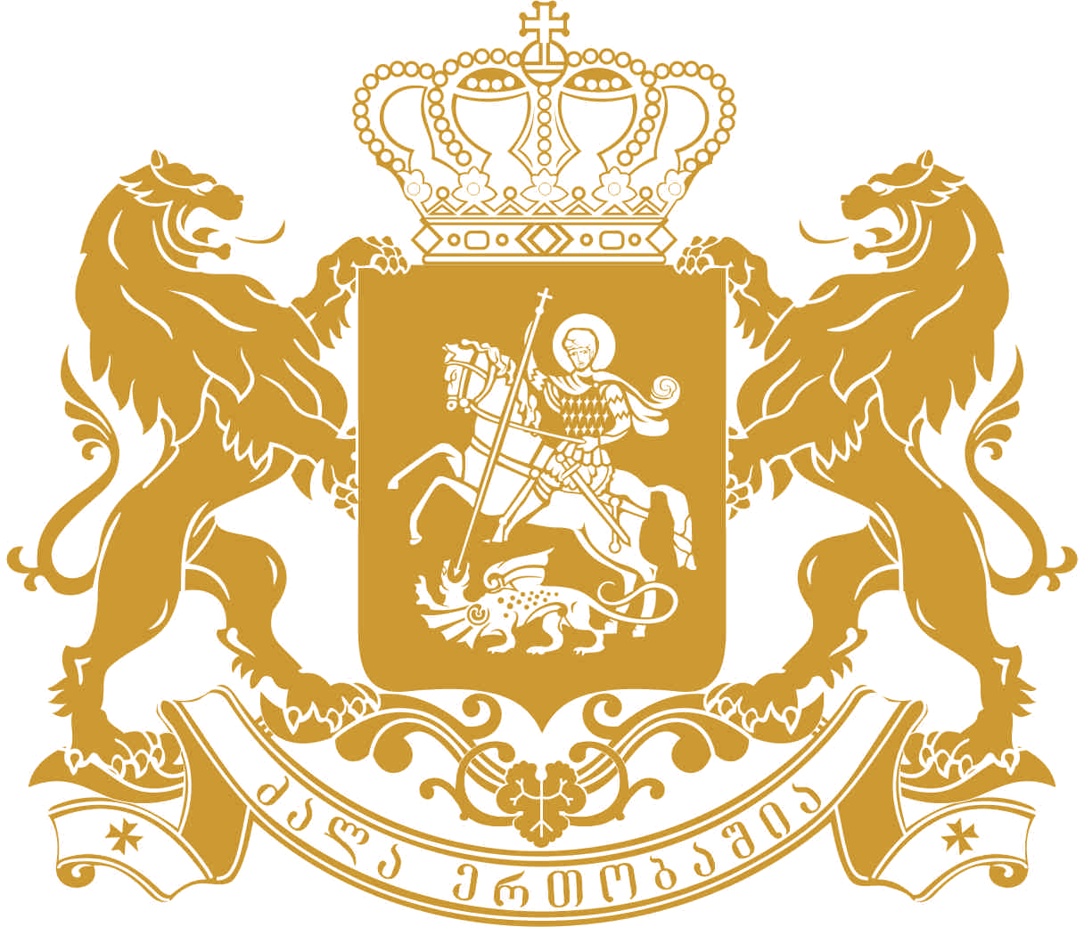
saqarTvelos saxalxo damcveli
Public Defender of Georgia

Written submission to the 79th Session of the Committee on the Elimination of Racial Discrimination
by the National Human Rights Institution – Public Defender (Ombudsman) of Georgia
15 August, 2011
The present submission focuses on the activities of the Public Defender in the field of fight against intolerance and racial discrimination, describes the processes pertinent to the situation of ethnic and religious minorities in Georgia and underscores major challenges and trends related to protection/promotion of their rights and civil integration over the period of 2005 – 2010.
Activities of the Public Defender’s Office in the area of equality and fight against discrimination
Effective protection of ethnic and religious minorities, fight against any manifestations of discrimination and xenophobia, promoting the culture of tolerance and equality and fostering civic integration are priority areas in the work of the Public Defender of Georgia.
According to the mandate provided under the Organic Law of Georgia, the Public Defender supervises the general situation of human rights and freedoms in the country, among them minority rights, addresses individual or group violations based upon complaints or ex officio inquiry and undertakes civic education and awareness raising activities. Major findings in the field of discrimination and intolerance, along with the measures undertaken by the Public Defender are further highlighted in Ombudsman’s annual parliamentary reports.
Regional offices are significant tools for the Public Defender to effectively carry out its functions throughout Georgia and promptly respond to human rights violations. In this regard, opening of Public Defender’s offices in Kvemo Kartli and Samtskhe-Javakheti (regions densely populated by minorities) was an important step forward in terms of ensuring accessibility of the Public Defender’s Office for minorities.
Tolerance Centre under the Public Defender’s auspices, Councils of Religions and National Minorities
With a view to furthering the work of the Public Defender along with the mentioned lines, the United Nations Development Program supported establishing the Tolerance Centre in the Public Defender’s Office (PDO) in 2006.
The Tolerance Centre is one of the major actors working on minority rights in the country and is regarded as a core partner in this area by all State institutions and civil society organizations, its work being actively hailed both by national and international stakeholders. Activities of the Tolerance Centre evolve mainly in the following directions: protecting the rights of religious and ethnic minorities, promoting their integration and conducting awareness raising/educational projects aimed at promoting tolerance. Awareness raising activities include trainings and seminars for different target groups (media and civil society representatives, minorities, students etc.), round-table discussions, competitions, publications. In 2008, the Tolerance Centre prepared and published two encyclopaedic reference books “Religions in Georgia” and “Ethnics in Georgia” featuring the history, culture, ethnography, traditions and current lifestyles of all ethnic communities and religious groups present in Georgia. The Tolerance Centre since 2006 is producing the Public Defender’s bi-monthly magazine “Solidaroba”, which covers problems of ethnic and religious minorities, as well as issues pertaining to social equality, rule of law, human rights and democratic development.
To this end, the Tolerance Centre works to create conditions favoring a constructive and comprehensive dialogue between the majority and minority groups; exposes incidents involving religious and ethnic discrimination or xenophobia, takes stock of the relevant trends and tendencies, and examines systemic problems. Based on the monitoring results, it highlights possible threats and dangers stemming from intolerance, xenophobia and discrimination, and works to define ways to address existing problems. The Tolerance Centre drafts relevant recommendations for the Public Defender; these recommendations, alongside with results of the analysis conducted by the Centre, are reflected in the Public Defender’s parliamentary reports and recommendations. The Tolerance Centre coordinates activities of the Religions’ and National Minorities’ Councils functioning under the Public Defender’s auspices.
The Council of National Minorities (CNM) under the Office of Public Defender was established in 2005. The Council unites approximately 80 ethnic minority organizations and diasporas both from the capital and the regions of Georgia. The main objectives of the CNM are: encouraging consultations and a dialogue between ethnic minorities and the government, providing recommendations and feedback in the process of elaboration of minority-related governmental policies and programs; giving timely response in cases involving breaches of minority rights and/or emergence of conflict situations, developing recommendations for the Public Defender and other officials.
In 2006, the CNM elaborated recommendations on the implementation of the Council of Europe’s Framework Convention for the Protection of National Minorities addressed to the Georgian government and the Public Service Broadcaster. Many of the recommendations were incorporated into the National Concept for Civil Integration and the Action Plan, adopted by the Government in 2009. At the same time the CNM is actively involved in monitoring implementation of the mentioned concept and action plan and in discussing relevant findings with the State agencies in charge. With a view to ensure smooth and regular exchange of information between minorities and the authorities, the CNM launched active cooperation with various State institutions and concluded memoranda of cooperation with different State agencies.
The Council of Religions (CR) under the auspices of the Public Defender of Georgia was established in 2005. The core principles guiding the work of the Council are: protecting religious freedom, facilitating a constructive multilateral dialogue between various religious groups, promoting tolerant, fair and peaceful environment, assuming shared social responsibility and engaging religious minorities in the process of civil integration. Currently, the CR unites 23 confessions and organisations.
In 2007-2009 the CR worked out a joint Social Concept presenting a shared vision on such issues as relationship between the State and religion, liberal values and democracy, social responsibility and cooperation, problems and challenges in penitentiary system and in education sector and many others.
Starting from 2010 the Tolerance Centre has organized a series of meetings of the CR in order to elaborate recommendations addressed to the state institutions and media. The recommendations deal with the most problematic issues, including: legislative framework, cultural heritage of the religious communities, education system and religious issues, coverage of religious minorities in media.

Ethnic Minorities and Civil Integration Processes
According to the monitoring carried out by the Public Defender’s Office and statistics of complaints filed in the PDO since 2005, the facts of direct ethnic discrimination were reported only on few occasions.Notwithstanding the above mentioned, in 2005-2007 ethnic minorities were facing significant challenges pertinent to full realization of their rights and effective civil integration. Impediments caused by insufficient knowledge of the State language, problems of access to education, low level of minority participation in the country’s social, political and economic life, limited employment opportunities, barriers related to accessibility of information in minority languages, negative perceptions and stereotypes existing within the society have been among the major obstacles encountered by the ethnic minorities in this period.
Significant progress has been achieved and tangible results can be outlined in terms of protection of ethnic minority rights and their civil integration over the last three years. In the light of the legislative and policy framework, the fact that Georgia has ratified major international instruments fostering equality and prohibiting discrimination, along with improvement of national legislation and adoption of the National Concept and Action Plan for Tolerance and Civil Integration can be outlined as an important step forward. At the institutional level, establishment and effective operation of the Civil Integration and Tolerance Council (CITC), Office of the State Minister on Reintegration and the State Interagency Commission played an important role in advancement and implementation of minority related policies and programmes. Effective forum of cooperation was established between the State institutions, the CITC and the CNM under the PDO, thus enabling minority representatives to actively participate not only in policy formation and decision making processes, but also in monitoring implementation of minority related programs and activities by the government.
Particular programs, such as rehabilitation of the road infrustructures in the regions densely populated by minorities as well as other infrastructure related initiatives implemented during the reporting period, reforms launched in the field of the educational system, different integration and awareness raising projects have significantly contributed to the civil integration of the ethnic minorities living in these regions.
Notwithstanding the positive developments, a number of persistent systemic problems can be identified: Insufficient knowledge of the State language by ethnic minorities still creates impediments for their full participation in the State’s political, economic and social life. In this regard, increase in the number of hours allocated for the Georgian language teaching and assignment of Georgian language teachers to almost all non-Georgian schools (the Public Defender and CNM have been underscoring need for such actions for several years already) deserves a special attention. However, the quality of the teaching still does not ensure appropriate Georgian language command by ethnic minorities. In a significant number of non-Georgian public schools located in the areas densely populated by ethnic minorities, lack of qualified Georgian language teachers remains problematic. As regards to the adults, number of persons willing to learn Georgian language has increased significantly which is one of the most important indicators for the civil integration process. Therefore, the scope of the Georgian language teaching programs should be further extended to ensure that the existing needs are fully met. As underlined in the Public Defender’s reports, until 2010 the problem of national minorities’ access to higher education was of a great concern, majority of non-Georgian speaking school graduates were not able to pass the Unified National Exams due to the language barrier. Hence, their motivation to enroll in the Georgian higher education institutions was very low. The amendments made to the Law of Georgia “On the Higher Education” in 2009 enabled Azerbaijani, Armenian, Ossetian and Abkhazian speaking school graduates to enter higher educational institutions only by passing the test on general skills in their native language. After enrolling in the higher educational institutions, students will study Georgian language for a year and then start mastering relevant profession. However, lack of information on the mentioned opportunities among the local population in regions densely settled by minorities was identified. Poor quality of translation of school textbooks into minority languages remains one of the acute problems in the education field.
Participation of ethnic minorities in the civil, political and social processes nationwide remains quite limited. The level of the ethnic minorities’ political participation is extremely low, underrepresentation of the ethnic minorities in the Parliament of Georgia as well as at the local self government level (except for the regions densely populated by ethnic minorities) remains concerning.
Although it is impossible to obtain exact statistical data on the minority representatives employed in the public service, according to general observations and information provided by ethnic minorities, the rate of their employment in the public entities remains quite low (regions densely populated by ethnic minorities are exception in this regard). The roots of this problem might lie in the lack of qualified human resources and insufficient level of the State language proficiency among minorities, along with a certain alienation existing within the society.
A number of problems related to the protection of the minority cultural heritage monuments of national importance and preservation of the identity elements for national minorities remain unresolved. A full inventory of the national minorities’ cultural monuments has not been carried out yet, condition of some of the monuments needs to be examined and the issue of their inclusion in the list of the cultural heritage sites needs to be addressed. A number of minority cultural monuments are in the hazardous condition and require urgent rehabilitation. Further enhancement of special programs aimed at getting majority and minority groups acquainted with each other’s culture, achievements, traditions and values can play significant role in the civil integration process. Special attention should be paid to strengthening the efforts aimed at preservation of identity for small minority groups (Kurds, Asyrians, Kists, Greeks, Roma, Udins etc).
Notwithstanding the positive trends in ensuring availability of information for minorities through airing of news programs in minority languages on a daily basis by the Georgian Public Broadcaster, the issue remains challenging. The TV signal of the GPB and the radio waves of the Public Radio do not fully cover Kvemo Kartli and Samtkhe Javakheti regions. At the same time, media outlets mostly do not pay appropriate attention to the developments occuring in the minority communities. Ethnic Georgians still lack information on culture, traditions and activities of various ethnic communities living in Georgia.
Stereotypes, negative perceptions existing within the society, xenophobic speeches towards minorities occuring in the media and in particular public discourses can also considered as impediments to the civil integration process.
It must be mentioned that one of the most vulnerable groups among ethnic minorities is Roma. Even though Government of Georgia established the importance of integrating national minorities into the mainstream society in its National Concept for Tolerance and Civic Integration and in subsequent action plan, Roma population are rarely considered in such documents. As a result, members of the Roma community are marginalized in various spheres of everyday life including education, employment and civil or political participation. Other problems are identified as lack of legal guarantees and access to healthcare. These problems are mainly due to the lack of identity documents obtained by persons belonging to this community. It is a positive step that last year Ministry of Justice of Georgia started the process of providing these individuals with the required documents, however, many of them still remain without birth certificates or IDs, preventing them to fully enjoy civil and political as well as economic and social rights.
Socio-economic conditions of Roma still remain a serious problem. Their living conditions are very low; most of the members of this community are officially unemployed and are occupied with commerce or beggary. In addition, Roma have no information on educational programs and do not attend schools or universities.
Religious Minorities
Situation pertinent to religious freedom had been quite problematic over the years in Georgia. Gaps in legislation, problems related to registration and legal status of religious groups, violence (physical, verbal assaults, attacks on the property, interference in religious rituals) towards religious minorities, inadequate and inefficient reaction to these incidents by law enforcement bodies , obstacles in obtaining construction permits for religious buildings, discrimination at public schools, unlawful detention of religious literature by customs and boarder authorities and other similar problems were impeding appropriate protection of freedom of religion and belief in Georgia.
Since 2005 a number of important positive trends can be outlined in the context of improving protection of freedom of religion and fight against religious intolerance in Georgia, along with the progress made at the legislative level, particular positive dynamics can be noted in practice as well. First of all, with intensive efforts by the Tolerance Center and the Council of Religions, dialogue has become more active between the government and religious minority representatives.
It should be noted that over the recent years, religious communities have encountered less obstacles in terms of construction of religious worship and social buildings (including Azerbaijani Muslim community and Armenian Apostolic Church). Discriminatory actions by public authorities have significantly decreased.
However, religious minorities are still facing important challenges that require further measures to be taken by the authorities:
Adequate reaction to each violation committed on the religious grounds is of crucial importance, since effective response by authorities contributes to prevention of manifestations of intolerance. Unlike the previous years, in 2006-2007 the work of the law enforcement bodies became relatively effective in terms of reaction to and prevention of crimes committed on religious grounds. The situation deteriorated in 2008 – 2009: in some cases the law enforcement bodies either did not take action at all, or the violent acts were usually qualified as hooliganism or infringement of property rights (instead of qualification under relevant articles of the Criminal Code envisaging crimes committed on the religious grounds), investigations were often procrastinated or closed. The instances of violence committed on the grounds of religious intolerance increased during the mentioned period. 2010 was remarkable for tangible progress in this area: the authorities became more active in terms of undertaking adequate legal measures towards the persons involved in the campaign aimed at cultivating intolerance and committing crimes on the religious grounds.
The restitution of the religious property confiscated from several religious groups during the Soviet period remains an acute problem for religious minorities.. Resolution of this problem is hindered due to the lack of political will from the government to address the issue and the resistance of the Georgian Orthodox Church towards return of the mentioned property to non-dominant religious groups. A certain part of this property is in a deplorable condition. Since no progress has been made in respect of settling the property issue so far, it is impossible to carry out restoration works required for preservation of the monuments.
In 2007-2010 realization of freedom of religion in the penitentiary institutions by religious minority representatives was quite problematic. According to the existing discriminatory practice, the access of the clergy of various religious groups to the penitentiary institutions required special permission from the Georgian Orthodox Church Patriarchy. The Public Defender and the Council of Religions raised concern in respect of this issue with the relevant State institutions on numerous occasions. As a result, in 2010 the Minister of Corrections and Legal Assistance adopted a special Order, which aims at effective realization of the rights of the accused/convicts to participate in religious rituals and to meet with the clergy. We hope that this Order will be implemented adequately to ensure equal possibilities for all religious groups to participate in religious rituals and meet with their clergy.

Particular norms of the Georgian tax legislation remain problematic from the perspective of equality. Although religious organizations are entitled to particular tax benefits, the existing tax regime places non-dominant religious groups in unequal position compared to the Georgian Orthodox Church.

As regards the educational system, it should be noted that the Law of Georgia “On General Education“ explicitly prohibits usage of educational process for the purpose of religious indoctrination, proselytism or coercive assimilation as well as display of religious symbols for non-academic purposes on the territory of public schools. Despite the detailed legislative regulation, adherence to the provisions of the law still remains challenging. Hence, ensuring equal environment at public schools is an issue that requires further attention from the authorities.
Developments related to the registration and legal status of religious organizations deserve special attention. Over the years, several religious groups (such as the Armenian Apostolic Church, Muslim community, Jewish community, Catholic Church, Evangelical-Baptist Church, Evangelical-Lutheran Church) refused to register in accordance with the Georgian legislation, given that they had to register as a non-commercial entity of private law. The mentioned religious groups were arguing that the existing form of registration was unacceptable for them and were requesting the status of Legal Entity of Public Law. This problem was raised on a number of occasions by the Public Defender and the Council of Religions. In July 2010 the Parliament passed amendments to the Civil Code of Georgia, enabling religious groups to register as Legal Entities of Public Law. This initiative was an important step forward, given that the religious communities, which have been refusing registration for several years already, will now be able to go through the registration process, receive legal status and use rights, freedoms and benefits enshrined in the Georgian legislation more effectively.
Notwithstanding the fact that discussions over the topics related to religious minorities have been initiated more frequently over the last two years, media coverage of religious minority related issues remains one of the serious problems. Quite often electronic and print media outlets either do not draw appropriate attention to the religious diversity topics in Georgia, or cover religious minority-related issues in a stereotyped, xenophobic way, using hate speech or publishing xenophobic rhetoric of the respondents without any journalistic or editorial comments. Regretfully, the level of religious tolerance within the general public remains concerning. The efforts of the civil society against xenophobia and intolerance have weakened, the civil society has been rather passive in demonstrating its critical approach towards the instances where the lack of religious tolerance and equality was shown in Georgia. The recent amendments pertinent to the legal status of religious minorities can be used as a clear demonstration of the above mentioned concerns. The adoption of the amendments were followed by escalation of intolerance; anti-Armenian, xenophobic and racist statements were used by political party and media representatives, experts, Orthodox clergy and representatives of some civil society organizations.
Human rights situation of refugees and asylum seekers is also very complex in Georgia. Gaps in the current legislation result in deprivation of the basic guarantees under international treaties.
First of all, Public Defender wishes to underline that “Law on Refugees of Georgia”, being currently in force, does not comply with the standards provided by the 1951 UN Convention on Status of Refugees. Public Defender welcomes the fact that government of Georgia has drafted a new law on “Refugees and Persons with Humanitarian Status.” (In country report it is mentioned as law on ,,Refugees and Temporary Asylum Seekers”) in 2008, however, it is regrettable that the draft law has not been submitted to the parliament of Georgia for its further considerations yet.
Georgian legislation does not provide list of conditions and subsequent procedures, after meeting of which persons will be granted status of an asylum seeker. As a result the outcome of the wide discretion of the state is ineffectiveness of the appellation for challenging the rejection.
Another crucial point is the lack of provisions that would determine tenure and procedures to leave the state by those individuals who have been rejected the status of an asylum seeker. As Public Defender has emphasized in his annual report of 2010, such regulation is important for avoiding criminal prosecution against such individuals. In addition, Public Defender emphasizes the importance of non-refoument principle for refugees and asylum seekers; however, it is disappointing that among the possibility of criminal prosecution, Georgian law on “International Cooperation in the Criminal Justice Field” does not guarantee non-refoulment principle for asylum seekers, but only for refugees. Therefore, adoption of a new law and amendments to the existing legislation, providing full compliance of national legal instruments with international obligations, is essential.
It is a positive trend that process of naturalization of refugees has started, but it is undertaken on the general terms and no simplified procedures for obtaining citizenship of Georgia have been established.
The crucial point is the criminal responsibility of those individuals, who have crossed the borders illegally, but requested asylum afterwards. According to the official sources, out of 162 criminal cases discussed by the judiciary during 2010, none of them were terminated on the basis of requesting asylum by the defendants.
Finally, it should be mentioned that notwithstanding the considerable efforts made by the Georgian authorities and important progress achieved in the field of fostering equality and non-discrimination, significant challenges persist and require further consolidated efforts, targeted and effective actions from the government. At the same time, the role of other relevant stakeholders, such as minority representatives, media and civil society are of crucial importance for achieving progress in enhancement of tolerance culture and fostering civil integration.

During the last four years the Public Defender’s Office received no single complaint related to ethnic discrimination, there were three complaints on the alleged discrimination on ethnic grounds submitted to the Public Defender’s Office in 2006.
The General Administrative Code of Georgia prohibits collection, processing, storage or transfer of the personal data pertinent to the ethnic origin by the public agency.
In 2005-2009 around 4 new Armenian apostolic churches and 5 mosques were built.
In 2006-2007, 17 persons were sentenced for committing crimes on religious grounds.
Seven violent actions committed on the grounds of religious intolerance were reported to the Public Defender, investigations were opened on 6 facts under the Article 156 of the Criminal Code of Georgia (religious persecution).
The Armenian Apostolic church claims the return of six religious buildings from the State. The Muslim Community claims the return of 18 historical mosques. The Catholic community claims the return of 5 churches.
The Georgian Orthodox Church was granted the status of the legal entity of public law by the Constitutional Agreement signed between the Church and the Government in 2002.

